Effects of Zeolite Dietary Supplementation in Nile Tilapia (Oreochromis niloticus Linnaeus 1758) on Zootechnical and Histopathological Parameters

Abstract:
In order to investigate the effects of zeolite incorporation in the diet of Nile tilapia on growth performance, body composition, survival rate, and histopathology, five experimental diets were formulated. Diet 1 contained groundnut cake without zeolite (0% Zeo), Diet 2 contained 0.5% zeolite (0.5% Zeo), Diet 3 contained 1% zeolite (1% Zeo), Diet 4 contained 1.5% zeolite (1.5% Zeo), and Diet 5 contained 2% zeolite (2% Zeo). The experiment was conducted in an open system at Cheikh Anta Diop University and lasted for two months. Prior to the feeding trial, fish were subjected to an acclimation period. Each diet was randomly assigned to three tanks, with a stocking density of 20 fish per tank, for a total of 300 fry with an initial mean weight of 0.3 g. Fish were reared in 50-L plastic tanks and fed three times daily (09: 00, 13: 00, and 17: 00) at feeding rates of 15%, 12%, and 10% of body weight during the first, second, third, and fourth two-week periods, respectively. Water temperature and dissolved oxygen were monitored twice daily (morning and evening). The results indicated that growth parameters (final mean weight, absolute mean weight gain, and relative mean weight gain) of fish fed diets containing 1%, 1.5%, and 2% zeolite did not show any significant differences. Fish fed the diet containing 0.5% zeolite exhibited the lowest growth performance. Feed conversion ratio (FCR) did not differ significantly among fish fed diets containing 0%, 1%, and 1.5% zeolite. Fish fed the diet containing 2% zeolite showed the best FCR, whereas those fed the 0.5% zeolite diet exhibited the poorest FCR. Survival rates ranged from 70% to 88.33%. Fish fed the diet containing 2% zeolite showed the lowest survival rate, while those fed diets containing 0.5% and 1.5% zeolite recorded the highest survival rate (88.33%). Villus degeneration in the small intestine was observed in fish fed diets containing 0%, 0.5%, and 1% zeolite. The posterior intestine of fish fed the 2% zeolite diet displayed a normal histological structure.
Keywords: Oreochromis niloticus, zeolite, growth, dose, histopathology

Introduction
The development of aquaculture is essential to meet the growing demand for fishery products and to ensure food security. ﻿Aquaculture has been rising tremendously over time and today, it accounts for around half of the animal protein consumed globally. Aquaculture, being the main animal protein industry, is expanding more quickly than other areas of food production (Ali and al., 2024).
Fish meal has long served as the primary ingredient in aquaculture feeds. Due to its high cost and environmental sustainability concerns, the aquaculture industry continuously seeks plant-based alternatives to replace or supplement fish meal in diets (Daniel, 2018). However, feeds containing high concentrations of plant-derived ingredients such as groundnut and soybean cakes, maize flour, and rice bran are particularly susceptible to mycotoxin contamination.
The increasing use of plant-based ingredients in fish feeds raises the risk of contamination by mycotoxins (aflatoxins, fumonisins, ochratoxin A, zearalenone, etc.) (Oliveira et al., 2020).
One of the major challenges facing the aquaculture industry is the elimination of exposure to dietary toxins, particularly aflatoxin B1 (AFB1). Among aflatoxin congeners, AFB1 is the most prevalent and most toxic, being highly carcinogenic, teratogenic, and mutagenic (Ziarati et al., 2024).
Furthermore, Ayyat et al. (2013) demonstrated that treating fish with clay, and coumarin reduced aflatoxin residues. The use of natural clays (zeolites, bentonites) as adsorbent agents in aquaculture feeds may be recommended to reduce the bioavailability and toxicity of AFB1, while limiting risks to fish health and human food safety.
Studies have also demonstrated the capacity of nano-zeolite to attenuate AFB1 toxicity in O. niloticus; moreover, nano-zeolite exerts beneficial effects in eliminating the negative impacts of AFB1 on tilapia health status (Hassaan et al., 2020).
The present study aims to confirm that the dietary inclusion of zeolite in Nile tilapia feeds can reduce mycotoxin (aflatoxin) levels. Specifically, this study evaluates the effects of zeolite supplementation on growth performance, body composition, survival, and intestine histopathology in juvenile tilapia.

2. Materials and Methods

2.1. Diet Formulation and Preparation
Five experimental diets were formulated: Diet 1 containing no zeolite (0%), Diet 2 (0.5% zeolite), Diet 3 (1% zeolite), Diet 4 (1.5% zeolite), and Diet 5 (2% zeolite). All diets were formulated using Diet Formulator software. The feed ingredients consisted of groundnut cake, rice bran, millet bran, maize flour, fish meal, fish oil, and vegetable oil. The diets differed primarily in their zeolite inclusion level. The ingredient composition of the five experimental diets is presented in Table I. All dry ingredients were first ground using a mortar and pestle to obtain fine particles and then sieved through a 1 mm mesh. Once all dry ingredients were thoroughly mixed, appropriate quantities of zeolite, fish oil, and vegetable oil were added according to the formula presented in Table I. Water was then added at approximately 30% of dry matter to obtain a workable dough. The dough was extruded through a 3.0 mm diameter die to produce spaghetti-like filaments using a Moulinex meat grinder.
The feeds were air-dried for two days in a well-ventilated area, away from direct sunlight. After drying, the feeds were re-ground using a mortar and pestle to obtain particles of an appropriate size for fish consumption. The resulting pellets were stored in airtight containers at room temperature until use. Measured quantities were withdrawn periodically to feed the fish throughout the experimental period.
Table I. Percentage composition of experimental diets (% dry matter).
Ingredient | Diet 1 (0% Zeolite) | Diet 2 (0.5% Zeolite) | Diet 3 (1% Zeolite) | Diet 4 (1.5% Zeolite) | Diet 5 (2% Zeolite)
Fish meal (g) | 25 | 25 | 25 | 25 | 25
Yeast (g) | 4 | 4 | 4 | 4 | 4
Groundnut cake (g) | 20 | 20 | 20 | 20 | 20
Rice bran (g) | 15 | 15 | 15 | 15 | 15
Maize flour (g) | 20 | 20 | 20 | 20 | 20
Vitamins (g)ᵃ | 1 | 1 | 1 | 1 | 1
Minerals (g)ᵇ | 1 | 1 | 1 | 1 | 1
Fish & vegetable oil (1:1) (mL) | 2 | 2 | 2 | 2 | 2
Zeolite (%) | 0 | 0.5 | 1 | 1.5 | 2
Millet bran (g) | 10 | 10 | 10 | 10 | 10
CMC binder (g) | 2 | 2 | 2 | 2 | 2
TOTAL | 100 | 100 | 100 | 100 | 100
Crude protein (%) | 33.82 | 33.82 | 33.82 | 33.82 | 33.82
Crude lipid (%) | 8.73 | 8.73 | 8.73 | 8.73 | 8.73

a Vit A 250,000 IU; Vit D₃ 250,000 IU; Vit E 5,000 mg; Vit B₁ 100 mg; Vit B₂ 400 mg; Niacin 1,000 mg; Ca pantothenate 2,000 mg; Vit B₆ 300 mg; Vit K₃ 1,000 g; Vit C 5,000 mg; Biotin 15 mg; Choline 100 g; BHT 1,000 mg.
b Phosphorus 7%; Calcium 17%; Sodium 1.5%; Potassium 4.6%; Magnesium 7.5%; Manganese 738 mg; Zinc 3,000 mg; Iron 4,000 mg; Copper 750 mg; Iodine 5 mg; Cobalt 208 mg; Calcium and ground attapulgite qs 1,000 g; Fluoride 1.5%.

2.2. Rearing Conditions
The experiment was conducted over a two-month period at Pr Omar Thiom THIAW Aquaculture Station of the Institute of Fisheries and Aquaculture, Cheikh Anta Diop University of Dakar. Tilapia fingerlings were obtained from the station’s broodstock. Prior to the start of the experiment, fish were acclimated and fed the control diet for two weeks.
At the beginning of the experiment, fish with an initial mean weight of 0.3 g were randomly distributed into 15 plastic tanks of 50 L capacity, each containing 20 fish. Each of the five experimental diets was allocated to three replicate groups for eight weeks. Physicochemical parameters (temperature and pH), siphoning, and water renewal were performed twice daily (morning and evening) before feeding to monitor water quality. Fish were fed at 15% of body weight, with the daily ration divided into three equal meals (09:00, 13:00, and 17:00 h). Every two weeks, the feeding rate was progressively reduced according to biomass. Each tank was continuously aerated via an air diffuser connected to an air compressor.
Feeding was discontinued 12 hours before each weighing session. All fish in each tank were sampled to determine the biochemical composition of each group. Fish were sacrificed, and three fish per tank were dissected to collect a section of the posterior intestine for histopathological analysis; the remaining carcasses were frozen for subsequent flesh analysis.

2.2.1 Physicochemical parameters
Water temperature and dissolved oxygen concentration were measured twice daily using a multi-parameter probe waterproof pHep by HANNA.

2.3. Biochemical Analysis of Fish Flesh
At the end of the experiment, all remaining fish from each dietary group were individually weighed and sacrificed. The carcasses were pooled by diet and stored in bags for subsequent proximate composition analysis.
Flesh analysis was carried out at ENSA de Thiès following AOAC (1995) procedures. Samples were dried to a constant weight at 105°C to determine moisture content. Ash content was determined by combustion at 540°C in a muffle furnace. Crude protein was determined by measuring nitrogen (N × 6.25) using the micro-Kjeldahl method (Kjeltec System 1002 Distilling Unit, Tecator, Hoeganaes, Sweden). Crude lipid was extracted using the Soxhlet method (Soxtec System, Foss, Model HT, Sweden).

2.4. Growth, Survival, and Feed Efficiency Parameters
Growth performance, survival rate, and feed efficiency were assessed every two weeks using the following formulas. Fish were weighed individually and mortalities were recorded prior to each calculation. After weighing, fish were returned to cleaned tanks with fresh water. Total biomass per tank was calculated to adjust the daily feeding ration accordingly.
Absolute weight gain (AWG):
AWG (g) = Final Average Weight – Initial Average Weight

Relative mean weight gain (RMWG)
$$RMWG (\%) = \frac{FAW-IAW }{IAW}×100$$
Specific Growth Rate (SGR)
$$SGR\left(\%/day \right)=\frac{(\ln\left(FAW\right)-\ln\left(IAW\right)}{rearing duration} x 100$$
Survival Rate (SR)
$Survival Rate \left(\%\right)=\frac{Final number of fish}{Initial number of fish}x 100$

2.5 Determination of feed efficiency parameters
Feed Conversion Ratio (FCR)
$$FCR=\frac{Amount of feed distributed per fish }{AWG }$$

2.6. Histopathological Analysis
Histological examination focused on the posterior intestine. At the end of the experiment, three fish per dietary group were dissected to collect a section of the posterior intestine. The collected samples were preserved in test tubes containing 10% formalin diluted in distilled water.
Fixation is a fundamental step in histology, ensuring the preservation of tissue architecture and cellular structures. In this study, samples were fixed by immersion in Dubosq-Brasil fixative. Small tissue fragments are preferred to ensure optimal fixative penetration. The volume of fixative must be at least 20 times the volume of the sample. Fixation duration depends on fragment size: a few hours for small fragments, one to three days for medium-sized fragments, and up to a week or more for large fragments.
After fixation, samples were washed in running water according to their size. Dehydration was then performed by immersing the samples successively in two to three baths of 96° alcohol followed by three baths of absolute ethanol.
The impregnation step was followed by paraffin embedding. Samples were placed in a butanol–paraffin mixture (1/2 butanol + 1/2 paraffin) and maintained in an oven at 56–60°C overnight to allow progressive tissue infiltration. Samples were then successively immersed in three paraffin baths, the third consisting of pure paraffin. Blocks were trimmed with a scalpel and sectioned at 4–6 μm thickness using a microtome.
For slide preparation, the heating plate was switched on and slides were cleaned with 70% alcohol. A thin layer of albumin was applied to the slides, followed by a drop of distilled water. Sections were then collected using a scalpel and placed on the slides. After spreading, excess water was drained and the slides were dried on the heating plate. Slides were labeled with a diamond pen indicating the material name, researcher name, and slide number, particularly for serial sections.
Staining involved deparaffinization and rehydration. For deparaffinization, slides were immersed in a first toluene bath (5 min), then a second toluene bath (5 min), followed by a first butanol bath (5 min), a second butanol bath (5 min), 95° alcohol (5 min), 70° alcohol (5 min), and finally rinsed in running water (5 min). Staining was performed progressively in successive baths: 70° alcohol (5 min), 95° alcohol (5 min), first and second butanol baths (5 min each), and finally first and second toluene baths (5 min each).
Sections were then mounted between slide and coverslip using a drop of Canada Balsam as mounting medium to ensure adhesion and preservation. The prepared slides were dried in an oven at 37°C for at least 24 hours. Histological observations were performed using a Beda brand optical microscope.

2.7. Statistical Analysis
Data were recorded and calculated using Microsoft Excel. Statistical analysis was performed using the Statistical Analysis System software (SAS-PC) (Joyner, 1985) and subjected to one-way analysis of variance (ANOVA). Duncan’s multiple range test was used to compare differences among treatments. A significance threshold of P < 0.05 was applied.

3. Results and Discussion

3.1. Results

3.1.1. Physicochemical Parameters
Table II shows that water temperature remained overall stable across dietary treatments, ranging from 27.04±0.05°C to 27.46±0.07°C (mean 27.25°C), although a statistically significant difference was observed. The pH varied slightly across diets, ranging from 8.43±0.02 to 8.61±0.04 (mean 8.55), with a tendency to decrease as the zeolite level increased.
Table II. Summary of mean water temperature and pH values across dietary treatments.
Diet | Mean water temperature (°C) | pH
0% Zeolite | 27.04 ± 0.05^{b} | 8.61 ± 0.04^{ab}
0.5% Zeolite | 27.46 ± 0.07ª | 8.53 ± 0.04^{bc}
1% Zeolite | 27.19 ± 0.18^{ab} | 8.43 ± 0.02^{d}
1.5% Zeolite | 27.41 ± 0.06ª | 8.49 ± 0.04^{cd}
2% Zeolite | 27.43 ± 0.15ª | 8.43 ± 0.02^{d}
Values sharing the same superscript letter are not significantly different (P < 0.05).

3.1.2. Growth Performance, Survival Rate, and Feed Efficiency
Data relating to absolute weight gain (AWG), relative weight gain (RWG), specific growth rate (SGR), feed conversion ratio (FCR), and survival rate (SR) are presented in Table III.

Table III. Growth performance, feed efficiency, and survival parameters.
Parameter | 0% Zeolite | 0.5% Zeolite | 1% Zeolite | 1.5% Zeolite | 2% Zeolite
IMW (g) | 0.30 | 0.30 | 0.30 | 0.30 | 0.30
FMW (g) | 2.63±0.37ª | 2.34±0.23ª | 2.49±0.11ª | 2.40±0.28ª | 2.49±0.08ª
AWG (g) | 2.33±0.38ª | 2.03±0.23ª | 2.18±0.10ª | 2.10±0.28ª | 2.19±0.08ª
RWG (%) | 765.4±127.7ª | 671.1±76.1a | 717.2±36.0a | 691.9±91.3a | 721.0±28.3ª
SGR (%/day) | 3.84±0.27ª | 3.64±0.18ª | 3.75±0.08ª | 3.69±0.20ª | 3.75±0.06ª
FCR | 2.56±0.24^{ab} | 2.79±0.31ª | 2.56±0.19^{ab} | 2.70±0.15^{ab} | 2.35±0.10^{b}
SR (%) | 75.0±5.0^{bc} | 83.3±5.8^{ab} | 75.0±8.7^{bc} | 88.3±2.9ª | 70.0±5.0^{c}
IMW: Initial mean weight; FMW: Final mean weight; AWG: Absolute weight gain; RWG: Relative weight gain; SGR: Specific growth rate; FCR: Feed conversion ratio; SR: Survival rate.
Values sharing the same superscript letter are not significantly different (P < 0.05).

No significant differences were observed among dietary treatments for any growth indicator (FMW, AWG, RWG, and SGR).
Survival rates ranged from 70% to 88.33%. Fish fed diets containing 0.5% and 1.5% zeolite exhibited the highest survival rates (83.33% and 88.33%, respectively). No significant differences in survival rate were observed among fish fed diets containing 0%, 1%, and 2% zeolite.
Fish fed diets containing 0%, 1%, and 1.5% zeolite showed no significant differences in FCR. Significant differences in FCR were observed between fish fed the 2% and 0.5% zeolite diets.

3.1.3. Flesh Composition
Proximate composition results after eight weeks of experimentation are presented in Table IV.
Table IV. Proximate composition of fish flesh (% dry matter).
Zeolite inclusion (%) | Ash (%) | Crude protein (%) | Crude lipid (%)
0% Zeolite | 3.51±0.10ª | 16.14±0.10^{d} | 8.58±0.18^{c}
0.5% Zeolite | 3.59±0.08ª | 15.92±0.09e | 9.15±0.10^{b}
1% Zeolite | 3.55±0.06ª | 16.63±0.09^{c} | 9.20±0.10^{b}
1.5% Zeolite | 3.43±0.09ª | 16.81±0.10b | 9.05±0.12^{b}
2% Zeolite | 3.44±0.08ª | 17.36±0.06ª | 9.93±0.09ª
Values sharing the same superscript letter are not significantly different (P < 0.05).

Ash content in fish flesh did not differ significantly across dietary treatments. The highest crude protein content was recorded in fish fed the 2% zeolite diet, while the lowest was observed in fish fed the control diet (0% zeolite).
Crude lipid content was not significantly different among fish fed diets containing 0.5%, 1%, and 1.5% zeolite. Fish fed the 2% zeolite diet exhibited the highest lipid content.

3.1.4. Histopathological Analysis
The fish intestine is a complex, multifunctional organ. Beyond digestion and nutrient absorption, the intestine plays a central role in immunity, fluid and electrolyte balance, endocrine regulation of digestion, and metabolism (Jiao et al., 2023).
According to Orbea et al. (2022), histopathological examination is widely recognized as a powerful integrative tool for investigating pathological alterations caused by chemical or biological infectious agents.
Histopathological analysis of intestinal sections from juvenile tilapia fed for 56 days was performed for each dietary treatment.
In fish fed the control diet (0% zeolite), intestinal villi exhibited marked necrosis and desquamation. Necrosis extended across the intestinal mucosa, with accumulation of enterocytes and tissue debris within the intestinal lumen. A significant reduction in villus length was also observed (Figures 1 and 2).
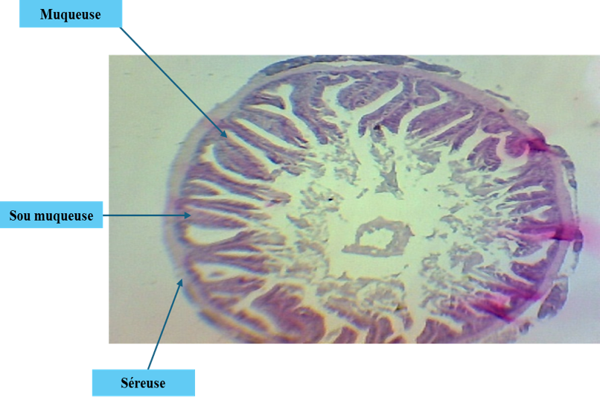
Mucosa
Submucosa

Serosa

Figure 1: Light microscopy observation of the small intestine of a fish fed the 0% zeolite diet. (light microscope ×40).
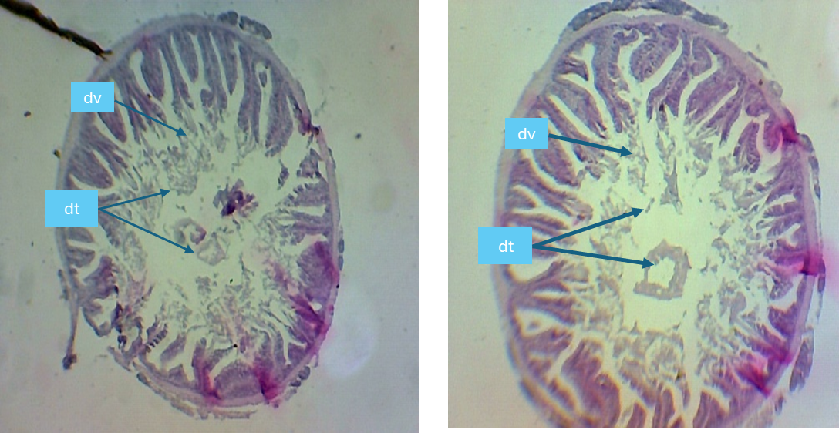
dv : villus degeneration dt : tissue debris
Figure 2: Histological sections of the intestinal epithelium showing villus degeneration in fish fed the 0% zeolite diet (light microscope ×40). dv: villus degeneration; dt: tissue debris.
Similar lesions were observed in fish fed diets containing 0.5%, 1%, and 1.5% zeolite; however, the severity of tissue damage decreased progressively with increasing zeolite inclusion levels (Figures 3, 4, 5, and 6).
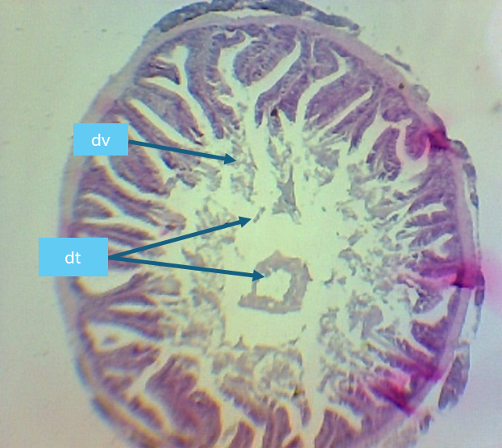
Figure 3: Histological sections of the intestinal epithelium showing villus degeneration in fish fed the 0% zeolite diet (light microscope ×40).
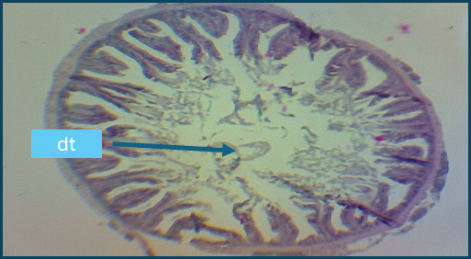
Figure 4: Histological sections of the intestinal epithelium showing villus degeneration in fish fed the 1% zeolite diet (light microscope ×40).

Figure 5: Histological sections of the intestinal epithelium showing villus degeneration in fish fed the 1.5% zeolite diet (light microscope ×40).

Serosa
Muscularis

Mucosal layer

Villus

Goblet cells

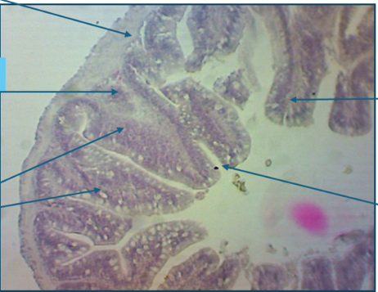

Figure 6: Histological sections of the intestinal epithelium in fish fed the 2% zeolite diet (light microscope ×40).
The posterior intestine of fish fed the 2% zeolite diet displayed a normal histological structure: the mucosa, submucosa, muscularis, serosa, and villi were all intact. Notably, a significant increase in goblet cell density was observed relative to the control group (0% zeolite) (Figure 6).

3.2. Discussion
In aquaculture, physicochemical water parameters particularly temperature and pH are essential indicators of water quality and its ability to support aquatic life. The mean physicochemical values recorded in this study fall within the recommended ranges for Nile tilapia Oreochromis niloticus rearing (Naiel et al., 2022; Azaza et al., 2008; Lazard, 2009), specifically 26–32°C and pH 8.41–8.69. The pH values obtained are consistent with those reported by El-Sayed (2020) and Konan et al. (2017), who recommend a pH range of 6.5–9.0 for fish culture.
Regarding feed conversion efficiency, fish fed the 2% zeolite diet achieved the best FCR (2.35), which outperforms the value reported by Yildirim et al. (2009) who obtained an FCR of 3.36 for a 2% zeolite diet.
In aquaculture, zeolite is typically incorporated into fish feeds at rates ranging from 1% to 5% of total feed weight, as noted by Abbas et al. (2021) and Jawahar et al. (2016).
Abbas et al. (2021) demonstrated that the inclusion of zeolite at 1%, 3%, and 5% in Nile tilapia (Oreochromis niloticus) diets can improve growth performance and enhance resistance to lead toxicity. Jawahar et al. (2016) showed that 4% (and even 6%) dietary zeolite inclusion in Channa striatus improved growth performance, hematobiochemical parameters, and immune response, though this slightly exceeds the conventional 5% upper limit.
Growth indicators (FMW, RWG, AWG, and SGR) showed that fish fed diets containing 1%, 1.5%, and 2% zeolite achieved good growth performance. Studies by Sheikhzadeh et al. (2017) reported enhanced growth following the dietary administration of zeolite (5 g/kg feed) (clinoptilolite) in rainbow trout, which is consistent with the results of the present study.
Regarding survival, fish fed the 2% zeolite diet recorded the lowest survival rate, whereas those fed the 0.5% and 1.5% zeolite diets achieved the highest survival rates. The observed mortalities were primarily attributed to handling stress during weighing operations. In addition, the 2% zeolite inclusion level promoted weight gain but negatively affected survival. These results differ from those reported by Nssar (2019), who indicated that zeolite supplementation in Nile tilapia feeds was not associated with adverse effects and was linked to reduced stress indicators, suggesting a favorable effect on survival.
Proximate composition analysis (crude protein, lipid, and ash contents) of fish flesh is used to assess the influence of diet on fish body composition. These data allow evaluation of the efficiency of nutrient transfer from feed to fish and contribute to the prediction of nutritional status.
Proximate analysis results showed that crude protein content was highest in fish fed the 2% zeolite diet.
Aflatoxin residue analysis in tilapia flesh was not conducted in the present study. This methodological choice is supported by prior scientific evidence demonstrating very low or negligible AFB1 bioaccumulation in tilapia muscle tissue. Indeed, Deng et al. (2010) reported that following administration of feeds contaminated with various AFB1 levels (19, 85, 245, 638, and 1,641 μg AFB1/kg feed), no detectable aflatoxin residues were found in fish flesh. Villus degeneration in the small intestine was observed in fish fed diets containing 0%, 0.5%, and 1% zeolite, and this may be attributed to the presence of mycotoxins (aflatoxins) in the feed.
The lesions observed included alterations in intestinal villus structure (villus atrophy, fusion or shortening of villi, reduced absorptive surface area, and the presence of dead and necrotic cells within the intestinal lumen). According to Barany et al. (2021), AFB₁ induced anterior intestinal lesions including epithelial desquamation with exudate, villus edema, necrosis of epithelial cells, mononuclear cell infiltration, and sub-epithelial spaces.
Imani and Mahmoudikiya (2023) and Krogdahl et al. (2010) demonstrated that the integrity of the gastrointestinal tract can be impaired by dietary fibers present in plant protein sources or by other antinutritional factors, as the intestine is the first organ exposed to ingested feed. Castro et al. (2019) suggested that zeolite can “scrub” worn intestinal villi and stimulate their regeneration, thereby contributing to improved nutrient absorption and utilization. Elshafy et al. (2023) reported that nano-zeolite alone at low doses (2 mg/kg) does not impair intestinal histology in tilapia. In the present study, zeolite powder incorporated at 2% of the diet was associated with the absence of intestinal degeneration, which may be explained by the reduction of aflatoxin through zeolite adsorption.
Dos Reis et al. (2024), in a systematic review of bentonite clays as adsorbent materials for mycotoxins in tilapia, confirmed that clay mineral supplementation significantly reduces aflatoxin absorption in fish, improving hematological parameters, immune status, and weight gain, while decreasing the bioavailability of AFB1 in the digestive tract. Gupta et al. (2011) confirmed that essential oils are broadly accepted as feed additives due to their safety, low toxicity, and biodegradability. Rasoli et al. (2008) reported that essential oils from certain plants suppress the growth of Aspergillus flavus and Aspergillus parasiticus as well as aflatoxin production in vitro.
Studies have confirmed the capacity of aluminosilicate clay minerals (kaolin, zeolite, bentonite) to adsorb aflatoxins and reduce their bioavailability in fish feeds, contributing to improved fish health and feed safety (Dos Reis et al., 2024).

4. Conclusion
Aflatoxins particularly AFB1 are mycotoxins produced by certain Aspergillus species (notably A. flavus and A. parasiticus). They are highly toxic, mutagenic, and carcinogenic to numerous species, including fish.
The histopathological lesions observed included epithelial destruction, loss of goblet cells, and inflammatory cell infiltration, leading to increased intestinal permeability and nutrient malabsorption. These alterations are dose-dependent: as AFB₁ concentration increases, the severity of histological and physiological changes intensifies.
Dietary zeolite supplementation in Nile tilapia (Oreochromis niloticus) at approximately 2% improved growth performance, protein utilization, and feed efficiency, likely through enhanced intestinal morphology. To prevent mycotoxin contamination of aquaculture feeds, the following measures are recommended:
- Strict control of raw materials (maize, cakes, etc.);
- Use of mycotoxin adsorbents in feeds (e.g., bentonite);
- Storage of feeds under low-humidity conditions.

References
- Abbas, H. H., El-Hakim, A., B., D., Y., & El-Kholy, K. F. (2021). Dietary zeolite improves growth and resistance to lead toxicity in Nile tilapia (Oreochromis niloticus). Aquaculture Reports, 20, 100732. DOI:10.1111/are.15537.
- Abbas, S., Ahmed, I., Salim, M., & Rehman, K. (2021).
Effect of dietary zeolite on growth performance and resistance against lead toxicity in Nile t tilapia (Oreochromis niloticus). Aquaculture Reports, 20, 100735.
- ﻿ Alagawany, M., Abd El-Hack, M. E., Farag, M. R., Tiwari, R., Yatoo, M. I., & Dhama, K. (2021). Nutritional and biological implications of Nile tilapia aquaculture. International Journal of Biometeorology, 65, 143–156. https://doi.org/10.1007/s00484-020-01987-0
- Ali, T., Hussain S., M., Yousaf, Z., Saleem, M., Ahmad, N., Riaz, D., and Ahmad, B. (2024). ﻿Dietary Phytase Supplemented Moringa oleifera Leaf Meal Improved Growth and Nutrient Digestibility in Cirrhinus mrigala. ﻿Pakistan Journal of Zoology, pp 1-8. ﻿DOI: https://dx.doi.org/10.17582/journal.pjz/20230804064512
- ﻿AOAC. (1995). Official Methods of Analysis (15th ed.). Association of Official Analytical Chemists,Washington,DC.
- Ayyat, M., S., Abd-Rhman, G., A., El-Marakby, H., I., Mahmoud, H., K., & Hessan, A., A., A. (2013). Reduction the aflatoxin toxicity in Nile tilapia fish. Egyptian Journal of Nutrition and Feeds, 16, 469-479.
- Azaza, M., S., Dhraïef, M., N., & Kraïem, M. M. (2008).
Effects of water temperature on growth and sex ratio of juvenile Nile tilapia (Oreochromis niloticus). Journal of Thermal Biology, 33, 98–105. https://doi.org/10.1016/j.jtherbio.2007.05.007
- Barany, A., Soliman, H. A., & Abd El-Ghany, W., A. (2021).
Aflatoxin B1-induced intestinal histopathological alterations in fish. Toxins, 13, 152.
- Doi: 10.1016/j.cbpc.2025.110227
- Castro, M. P., Castro, J. M., & Cunha, L. M. (2019). Zeolite as feed additive in animal nutrition: A review. Animal Feed Science and Technology, 253, 1–13.
- ﻿Danie L., N. (2018). A review on replacing fish meal in aqua feeds using plant protein sources. International Journal of Fisheries and Aquatic Studies, vol. 6, no. 2, pp. 164-179.
- Deng, S. X., Tian, L. X., Liu, F. J., Jin, S. J., Liang, G. Y., Yang, H. J., & Liu, Y. J. (2010). Toxic effects and residue of aflatoxin B1 in tilapia (Oreochromis niloticus). Aquaculture, 307, 233–240. DOI:10.1016/j.aquaculture.2010.07.029.
- Dos Reis, J. M., Barcellos, L. J. G., & Lissandro, G. (2024). Bentonite Clays as Adsorbent Material for Mycotoxins and the Hematological Parameters Involved in Tilapia Species: A Systematic Review. Aquaculture Research, 4899256. https://doi.org/10.1155/2024/4899256
- Elshafy, S. M., Hassan, M. S., & Soliman, A. A. (2023). Effects of nano-zeolite on growth and intestinal histology of Nile tilapia. Aquaculture Research, 54, 2112–2124.
- El-Sherif, M. S., & El-Feky, A. M. I. (2009). International Journal of Agriculture & Biology, 11, 297–300.
- El-Sayed, A. F. M. (2020). Tilapia Culture (2nd ed.). Academic Press, Elsevier. 323 p.
- Gupta, S., Sharma, A., & Kumar, A. (2011). Essential oils as safe feed additives in animal nutrition. Journal of Veterinary Science, 12, 345–353.
- Hassaan, M. S., Nssar K., M., Mohammady, E., Y., Amin A., Tayel, I., S. & El-Haroun, E., R. (2020). Nano-zeolite efficiency to mitigate the aflatoxin B1 (AFB1) toxicity in Nile tilapia (Oreochromis niloticus). Aquaculture, 523, 735-123.
- Imani, A., & Mahmoudikiya, Z. (2023). Introducing antinutritional factors in plant origin fish feed ingredients and strategies to reduce their contents. Journal of Fisheries, 76(3), 377–396. https://doi.org/10.22059/jfisheries.2023.352551.1356
- Jawahar, S., Balasubramanian, T., & Udayakumar, R. (2016). Effect of dietary zeolite on growth, hematobiochemical and immune response of Channa striatus. Fish & Shellfish Immunology, 56, 265–272.
- Jiao, L., Li, H., Li, X., Yang, H., & Yang, J. (2023).
A comparison of digestive strategies for fishes with different feeding habits: Digestive enzyme activities, intestinal morphology, and gut microbiota. Ecology and Evolution, 13(9), e10499. https://doi.org/10.1002/ece3.10499
- Konan, K. J., Kouassi, N. J., Ouattara, A., & Gourène, G. (2017). Physicochemical characteristics of water and growth performance of Nile tilapia. International Journal of Fisheries and Aquatic Studies, 5, 207–213.
- Krogdahl, Å., Penn, M., Thorsen, J., Refstie, S., & Bakke, A. M. (2010). Important antinutrients in plant feedstuffs for aquaculture. Aquaculture, 302, 1–17.
- Lazard, J. (2009). La pisciculture des tilapias. Cahiers Agricultures, 18(2-3): 393–401.
- Naiel, M. A. E., Negm, S. S., Ward, F. A., Shukry, M., Attia, M. M., & Amer, M. S. (2022). Effect of environmental factors on growth performance of Nile tilapia (Oreochromis niloticus). International Journal of Biometeorology, 66, 2183–2198. https://doi.org/10.1007/s00484-022-02347-6
- Nssar, S. A. (2019). Effect of dietary zeolite on growth performance and stress indicators in Nile tilapia. Journal of Fisheries Sciences, 13, 45–52.
- Orbea, A., Bilbao, E., & Cajaraville, M. P. (2022).
Assessing Adverse Effects of Legacy and Emerging Contaminants in Fish Using Biomarker Analysis and Histopathology in Active Monitoring Scenarios. In: Seiler, T.B., Brinkmann, M. (Eds.), In Situ Bioavailability and Toxicity of Organic Chemicals in Aquatic Systems. Methods in Pharmacology and Toxicology. Humana, New York. https://doi.org/10.1007/7653_2022_72.
- Oliveira, M., & Vasconcelos, V. (2020). Occurrence of mycotoxins in fish feed and its effects: A review. Toxins, 12(3), 160.
- Rasoli, M., Rezaei, M. B., & Owlia, P. (2008). Inhibition of Aspergillus flavus and aflatoxin production by essential oils. Food Control, 19, 107–112.
- Sheikhzadeh, N., Kordshouli, F., & Tayefi-Nasrabadi, H. (2017). Effects of dietary clinoptilolite supplementation on growth and antioxidant status in rainbow trout. Aquaculture Nutrition, 23, 1381–1389.
- Yildirim, Ö., Türker, A., & Çelik, I. (2009). Effects of dietary zeolite on growth performance and feed utilization of rainbow trout (Oncorhynchus mykiss). Aquaculture Nutrition, 15, 297–302.
- Ziarati, M., Ghasemi, H. A., Taherpour, K., & Shirzadi, H. (2024). A Brief Review on Aflatoxicosis in Aquaculture With a Focus on Fish. Aquaculture Nutrition, 2024, 28, 3130230. https://doi.org/10.1155/anu/3130230

