A preliminary report on the soil toxicity assessment of Bangalore and its adjoining areas: implications for health and toxicity

Abstract
Anthropogenic land use alterations of soil, which are among the most significant and persistent agents of change in the structure of landscapes, are primarily caused by urbanization, agricultural expansion, deforestation, industrial growth, and infrastructure expansion. The ecological, functional, and aesthetic aspects of landscapes all around the world are significantly impacted by these changes. Healthy soil is essential for agriculture, human health, and achieving the Sustainable Development Goals (SDGs). Soil samples from four sites in and around Bangalore were examined for acidity and macro and micronutrients in the current study. The results indicate that the pH levels of soils in residential areas and rubbish dumps are higher. Higher nitrogen amounts (0.20% and 0.14%, respectively) were found in the soil from the residential and industrial regions. Phosphorus levels are higher in residential and waste dump locations (0.04% and 0.06%, respectively). Potassium levels were higher (0.08%) in the waste-deposited area. Furthermore, the area where garbage was released showed higher calcium levels (0.04%). Finally, the magnesium concentration of the agricultural land was higher (0.03%). Bengaluru's Magadi Road residential sector (63.98 ppm) and garbage disposal area (77.54 ppm) had higher zinc concentrations. Agricultural fields have higher mercury levels (less than 0.1 ppm). The soil in the industrial region had a lot of copper (62.61 ppm). The iron content was greater in Bengaluru's Industrial Town (0.01) and Waste Dumped Area (0.02). The maximum acidity was found in agricultural fields (0.03%), followed by the industrial Rajajinagar area (0.01%). To guarantee food quality and nutritional security, land use planning and sustainable soil management are essential. The study is important because soil contamination is becoming more widespread, which has an impact on human health and plant health.
Key words: Soil toxicity; Chemical and biological weathering; Heavy metal contamination; Industrial pollution; Global Sustainable Development Goals.

Introduction
Along with water and air, soil is one of the three main natural resources. It is one of nature's wonderful creations, without which life would not exist (Burns, 2005). Agricultural productivity stems from healthy soil, which then leads to food. The three primary components of soil are the various living species that live there, organic matter, which includes the remains of plants and animals, and minerals that come from nearby or beneath rocks (Needelman, 2013). The kind of soil is determined by the ratio of each of these components. The formation of soil and the varieties of soil found in a given area are influenced by a variety of factors, including climate, vegetation, time, terrain, and human activities like farming, grazing, and gardening (Raymond and Nyle, 2017). Water or wind could transport soil. One example of soil carried by wind is the dust storms that occur on the American Great Plains (Lee and Gill, 2015). Along with degrading and storing materials, it also filters and purifies water (Keesstra et al., 2012). Fe, Mn, Ni, Co, Zn, Cu, Cr, V, Ti, Cd, Hg, Mo, and other trace metals like Se and F are found naturally in soils (Khudhair and Mazin, 2018). Soil is created by geological processes including modification and erosion of the geological subsurface components (Lucke, 2023). Generally, soil has a net release of carbon dioxide and nitrous oxide and a net absorption of oxygen and methane (Zhu et al., 2020; Bergh et al., 2024). In addition to providing plants with nutrients, air, water, temperature regulation, and physical support, soil also shields them from contaminants (Horel, 2024; Sharma et al., 2025). Soil has the ability to transform dead organic materials into different types of nutrients (Silver et al., 2021). Depending on the different iron minerals, soil mineralogy is the main factor influencing soil color (Sirisathitkul and Sirisathitkul, 2025). Chemical and biological weathering, particularly redox processes, are responsible for the formation and dispersion of color in a soil profile. The elements interact to form new, colorful compounds as the main minerals in the soil parent material weather (Vyshnavi et al., 2015).
Iron forms secondary minerals of a yellow or red color, organic matter decomposes into black and brown humic compounds, and manganese and sulfur can form black mineral deposits (Magnucka et al., 2023). These pigments can produce various color patterns within the soil. Natural attenuation is the process by which soil efficiently eliminates pollutants, eliminates disease-causing compounds, and breaks down pollutants (Balland-Bolou-Bi et al., 2022).
The fast expansion of the human population and the rising demand for various goods are the primary causes of the exponential rise in environmental issues in recent decades (Tal, 2025). While technical advancements have, on the one hand, improved people's quality of life, on the other hand, industrial growth has led to a rise in health risks (Rahman et al., 2021). Toxic chemicals released into the air, water, and soil enter the food chain, causing amplification and toxicity to plants and animals at every stage of the chain (Wild et al., 2020; Khattak et al., 2025). By entering into the biological system, they disturb the biochemical processes leading to several health abnormalities and few can be fatal in consequences (Steffan et al., 2018). Besides the parent material, the sources of contamination in soils are multifarious including vehicle emissions, industrial processes, weed, and plant disease treatment, as well as poor waste management (Liu et al., 2023). Also, agricultural activities (herbicide, pesticide) contribute to soil pollution (Rajak et al., 2023; Srivastava et al., 2025). The high levels of civilization-related soil pollution have recently become a major issue and the chemical analysis of soil is important for environmental monitoring and legislation (Williams et al., 2023). Heavy metal contamination in soil occurs in all parts of the world (Hou et al., 2020). Additionally, it harms ecosystems by acidifying streams and lakes, which causes an imbalance in aquatic life (Toivonen et al., 2020). Further it depletes soil of essential nutrients, endangering forests (Skidmore et al., 2024). Also, it reduces visibility and creates breathing problems in humans (Tong et al., 2023). In addition to soil pH, which indicates how basic or acidic a soil is, soil research also looks into macronutrients, particularly nitrogen, phosphorus, and potassium (NPK) (Parjono, 2019). By regulating the chemical forms of the nutrient, it particularly influences the availability of nutrients to plants (Chen et al., 2025). The biological characteristics and processes of soil exhibit significant interaction with chemical indicators of soil quality. Total carbon and nitrogen, pH, electrical conductivity, cation exchange capacity (CEC), and extractable nitrogen and phosphorus are examples of chemical markers of soil quality (Rocha Junior et al., 2020; Andrés et al., 2022). Firm understanding of environmental contamination and find solutions for sustainable crop production and land management, it is essential to measure and monitor soil health (Kabato et al., 2025). Basic plant nutrients including nitrogen (N), phosphorus (P2O5) (Kumar and Murali, 2023), potassium (K2O), humus content, calcium carbonate (CaCO3), accessible lime, organic matter, sulfur (S), and trace elements are all determined by analysis (Grishin et al., 2021; Laoufi et al., 2025). Since soils all over the world are discovered to be low in one or more micronutrients, micronutrient analysis in soil is becoming more and more crucial (Sagwal et al., 2023). Availability and proportion of micronutrients in the soil ensures higher farming productivity (Galić et al., 2025). Primarily focus of Soil analysis is to quantify elements such as potassium, calcium, magnesium etc., (Zhang et al., 2022). Whereas the primarily focus of micro minerals quantification include potassium, calcium, magnesium etc., (Faridullah et al., 2016). Mineral soil contaminants include arsenic, barium, cadmium, copper, mercury, lead, and zinc (Mazumder et al., 2023). These inorganic elements are generally non-biodegradable and tend to persist in the soil for long periods (Briffa et al., 2020). The origins of elements include both natural weathering and anthropogenic sources such as industrial waste, mining, and agricultural applications (Sparks et al., 2024; Adeleke et al., 2017). Regional and local studies of soil macro and micro nutrients would help in developing scientifically informed practical measures to improve and maintain the soil quality (Dasgupta et al., 2023). Further detailed research exploring the impact of anthropogenic land uses on soil characteristics is needed for management and preservation of the soil mantle (Santorufo et al., 2021).
The objectives of the present research were 1. Analysis of major nutrients - Nitrogen, Phosphorus and Potassium, 2. Analysis of secondary nutrients - Calcium and Magnesium 3. Analysis of minor nutrients - Lead, Mercury, Zinc, Copper, and Iron. 4. Assessment of Soil pH and Acidity from the soil collected from different places in and around Bengaluru.

Materials and methods
Soil sampling and sample preparation
Surface soil samples (0–15 cm depth) were collected from four representative land-use zones in and around Bengaluru, Karnataka, India, namely an agricultural field in Chikkaballapur (12°44′–13°45′ N, 77°12′–78°35′ E), a waste-dumped area at Kammavari Pete, Alappanahalli, Hoskote (13.0783° N, 77.7866° E), the industrial zone of Rajajinagar, Bengaluru (12.9803° N, 77.5501° E), and the residential locality along Magadi Road, Bengaluru (12.966° N, 77.533° E). At each sampling site, five subsamples were collected randomly using a stainless-steel auger and homogenized to obtain a representative composite sample.
All soil samples were collected following standard sampling protocols using sterile equipment to minimize contamination. The samples were immediately transferred to the laboratory in sterile polyethylene bags. Analytical reagent (AR)-grade chemicals and reagents were used for the estimation of soil macronutrients, micronutrients, acidity, and other physicochemical properties.
In the laboratory, the collected soil samples were air-dried at room temperature (25 ± 2°C), gently crushed using a porcelain mortar and pestle, and passed through a 2-mm mesh sieve prior to physicochemical characterization. For heavy metal analysis, the finer fraction passing through a 0.5-mm sieve was used. Deionized water was employed throughout all analytical procedures. All physicochemical analyses were carried out according to standard protocols using AR-grade reagents.
Estimation of pH
Atmospheric dust is known to be basic and raise the pH of soil (Hedin et al., 1996). The most important chemical property of soil as a medium for plant growth is its pH value or "hydrogen ion activity." Method followed was Electrometric (Jackson, 1973). Soil pH was determined by the electrometric (potentiometric) method using a calibrated digital pH meter.
Determination of total nitrogen content
Nitrogen (N) cycling in soils involves a complex interaction of chemical and biological processes. Nitrogen is essential for vigorous foliage growth and plays a major role in leaf development. It also imparts the characteristic green color to plants by supporting chlorophyll synthesis. In the present study, total N was estimated using the Kjeldahl digestion–distillation method as described by Bremner and Mulvaney (1982).
Estimation of phosphorous
Phosphorus (P) is essential for photosynthesis, energy transfer, and proper flower and fruit development. It plays a key role in root growth, flowering, and improving plant tolerance to harsh climatic and environmental stress conditions. Plants absorb phosphorus primarily in the form of phosphate ions (PO₄³⁻) derived from phosphoric acid compounds in the soil. In the present study, available P was estimated using the stannous chloride–reduced molybdophosphoric blue colorimetric method (Raptopoulou et al., 2016). The molybdenum blue colorimetric approach is a well-established method for phosphorus determination in soil extracts.
Determination of potassium levels
Potassium (K) strengthens plants, promotes early growth, and plays a vital role in water regulation within plant tissues. It also enhances plant resistance to diseases and insect attack. In the present study, available K was determined using a flame photometer after extraction with neutral 1 N ammonium acetate, following the method of Hanway and Heidel (1952).
Determination of Calcium
Calcium (Ca) plays an essential role in the growth and development of plant cell walls. Well-developed cell walls improve structural strength and enhance resistance to diseases. Calcium is also important in cellular metabolism and facilitates the uptake of nitrate (NO₃⁻) by plants. In the present study, Ca was determined by (EDTA) titrimetric method following Cheng and Bray (1951).
Estimation of magnesium
Magnesium (Mg) is an essential component of chlorophyll and therefore contributes to the green coloration of plants. In soil samples, exchangeable Mg was determined from the neutral 1 N ammonium acetate extract (pH 7.0), the same extract used for Ca estimation, followed by EDTA complexometric titration. The procedure followed the standard soil analytical protocol described by Page et al., 1982.

Estimation of acidity
Acidity was determined by the titrimetric method. Soil samples were extracted with 1 N KCl, and the extract was subsequently titrated against 0.01 N NaOH using phenolphthalein as the indicator, following the procedure described by Thomas (1982).
Estimation of heavy metals (Microwave digestion)
Heavy metals were determined after microwave-assisted acid digestion of the soil samples. Approximately 0.5 g of soil was digested with 10 mL HNO₃ and 2 mL H₂O₂ under microwave conditions at 210°C for 35 min. After digestion, the solution was diluted to 50 mL with deionized water and analyzed using inductively coupled plasma–optical emission spectrometry (ICP-OES), following the method of Giussani and Pozzi (2000).
Results
pH estimation
Soil pH varied across the studied land-use zones, ranging from 7.05 to 8.91. The agricultural soil from Chikkaballapur showed near-neutral pH (7.05), whereas soils from Hoskote, Rajajinagar, and Magadi Road were alkaline, with pH values of 8.91, 8.23, and 8.72, respectively (Table 1; Figure 1).
Estimation of Nitrogen
The nitrogen (N) content in soil samples ranged from 0.01% to 0.20% across the study locations. The highest N level was recorded in the residential soil from Magadi Road (0.20%), followed by the industrial soil from Rajajinagar (0.14%) and the agricultural soil from Chikkaballapur (0.13%). The lowest N content was observed in the waste-dumped soil from Hoskote (0.01%) (Table 2; Figure 2).
Estimation of phosphorus
The phosphorus (P) content in soil samples ranged from 0.004% to 0.06% across the study sites. The highest P concentration was observed in the waste-dumped soil from Hoskote (0.06%), followed by the residential soil from Magadi Road (0.04%) and the agricultural soil from Chikkaballapur (0.03%). The lowest P content was recorded in the industrial soil from Rajajinagar (0.004%) (Table 3; Figure 3).
Estimation of Potassium
The potassium (K) content in soil samples ranged from 0.03% to 0.08% across the study locations. The highest K concentration was recorded in the waste-dumped soil from Hoskote (0.08%), followed by the agricultural soil from Chikkaballapur (0.06%) and the residential soil from Magadi Road (0.04%). The lowest K content was observed in the industrial soil from Rajajinagar (0.03%) (Table 4; Figure 4).
Estimation of Calcium
The calcium (Ca) content in soil samples ranged from 0.02% to 0.04% across the study locations. The highest Ca concentration was recorded in the waste-dumped soil from Hoskote (0.04%), followed by the agricultural soil from Chikkaballapur (0.03%). The lowest Ca content was observed in both the industrial soil from Rajajinagar and the residential soil from Magadi Road, each recording 0.02% (Table 5; Figure 5).
Estimation of Magnesium
The magnesium (Mg) content in soil samples ranged from 0.01% to 0.03% across the study locations. The highest Mg concentration was recorded in the agricultural soil from Chikkaballapur (0.03%), followed by the waste-dumped soil from Hoskote and the industrial soil from Rajajinagar, each showing 0.02%. The lowest Mg content was observed in the residential soil from Magadi Road (0.01%) (Table 6; Figure 6).
Estimation of acidity
The highest acidity was recorded in the agricultural soil from Chikkaballapur (0.03%), followed by the industrial soil from Rajajinagar (0.01%). No measurable acidity was observed in the waste-dumped soil from Hoskote and the residential soil from Magadi Road, both recording 0.00% (Table 8; Figure 12).
Estimation of heavy metals
The concentrations of heavy metals and micronutrients, including Pb, Hg, Zn, Cu, and Fe, were determined in all soil samples. The corresponding data are presented in Table 7 and Figures 7–11, respectively.
and the elevated levels of heavy metals like Pb, Hg, Zn, Cu and Fe in soil samples collected from different areas of Bangalore, are represented in figure 13 to 17 respectively.

Discussion
The pedosphere refers to the body of soil on Earth (Targulian et al., 2019). Soil is composed of organic particles, minerals, gases, liquids, and living organisms that collectively sustain life. Soil can enter the human body through three primary routes: ingestion, inhalation, and dermal contact (Shetty et al., 2023). Contaminated soils are considered particularly hazardous to young children. Adults may also accidentally ingest soil through the consumption of vegetables contaminated with soil particles (Abrahams et al., 2012). Certain compounds present in soil are swallowed and enter the digestive system, while others are absorbed through the oral mucosa (Houck et al., 2012). These compounds may then be transported to the liver (Dashara, 2023). Once in the liver, many are returned to the digestive tract via bile, whereas others enter the bloodstream (Shulpekova et al., 2022). Some chemicals are metabolized to a certain extent in the liver before entering the bloodstream. Chemicals that are not absorbed and remain in the gastrointestinal tract generally do not cause adverse effects unless they exhibit direct toxicity to the gut lining. Soil can also enter the human body through inhalation, particularly during agronomic practices that release soil particles into the air (Rodrigues and Römkens, 2026). Very fine soil particles may lodge in the lungs, where contaminants may subsequently be absorbed into the bloodstream (Wang et al., 2022). Repeated long-term exposure to soil particles may increase adverse health effects (Sangkham et al., 2024).
More volatile organic substances are more likely to be absorbed through the skin. Although dermal exposure is generally of lesser concern, certain heavy metals, such as Cr (VI), the more toxic form of chromium, and inorganic Hg, can cause skin-related health issues (Franken et al., 2015). Soil contaminants may also enter the human food chain when they are taken up by plants and subsequently consumed by humans or agricultural livestock (Petruzzelli et al., 2025). Another important indirect consequence of soil contamination is the frequent elevation of Arsenic (As) levels in drinking water systems (Shrivastava et al., 2015). Groundwater may also naturally contain Arsenic (As).
When the body’s detoxification mechanisms are overwhelmed, pollutants become toxic (Genuis et al., 2013). When a chemical accumulates in tissues over time, it may eventually reach a critical toxic threshold (Clementsn and Casani, 2016). The rate of elimination through metabolism or excretion and the total body burden, defined as the number of substances stored in bodily tissues, are significant factors in this process (Phillips et al., 2014; Rodrigues et al., 2026). C, H, O, N, P, K, S, Ca, Mg, Fe, B, Mn, Cu, Zn, Ni, and Cl are the sixteen essential elements or nutrients commonly found in soil.
Toxicological studies using laboratory animals and experimental models are commonly employed to assess the concentrations of chemical pollutants that are likely to be harmful to human health (Suresh et al., 2024). The findings of the current study indicate that the residential and waste-disposal areas exhibited higher soil pH, suggesting contamination from multiple sources. Soil pH may increase due to elevated levels of Ca/Mg carbonates, accumulation of Na⁺ ions, carbonate compounds such as sodium bicarbonate/carbonate, fertilizers, and basic slag (Soto et al., 2023; Zhou and Yu, 2016). These factors may explain the elevated pH observed in Kammavari Pete, Alappanahalli, Hoskote (waste-dumping area) and the Magadi Road residential area, Bengaluru. The soil from Rajajinagar Industrial Town, Bengaluru showed lower N content (0.14%) compared to the Magadi Road residential area (0.20%). The primary causes of elevated N include chemical manufacturing, nitrogen-based industries, industrial explosives, and improper waste treatment (Kasiński et al., 2025). Additional sources include the decomposition of stored organic matter, such as food waste, sewage sludge, and other organic-rich materials present in landfills (Skrzypczak et al., 2024). Elevated P and K levels frequently accompany high total N, indicating substantial organic matter content in the disposed solid waste (Liu et al., 2024). Nitrogen (N) is highly essential for plant growth because it is a major component of chlorophyll, the pigment responsible for converting carbon dioxide and water into sugars during photosynthesis (Wagner, 2011). It also plays a critical role in amino acids, which serve as the building blocks of proteins (Acquisti et al., 2009). Low N levels in soil reduce chlorophyll synthesis, causing leaves to become pale yellow, with older leaves often turning completely yellow. In addition, flowering, fruiting, and the protein and starch contents of plants are significantly reduced under N deficiency (Chen et al., 2024).
Plant growth is inhibited when protein synthesis is reduced. In addition to affecting plant productivity, N pollution poses serious health risks by contaminating water and air with ammonia and nitrates (Juanjuan et al., 2021). Excess nitrate exposure may lead to methemoglobinemia (“blue baby syndrome”), while aerosolized nitrogen compounds may contribute to respiratory disorders (Johnson et al., 2019). The Magadi Road residential area, Bengaluru (0.04%) and Kammavari Pete, Alappanahalli, Hoskote (waste-dumping area) (0.06%) showed higher P concentrations. The major causes of elevated P include sewage discharge, untreated industrial liquid effluents, and the direct disposal of solid waste, all of which release phosphorus compounds into the environment (Shiba and Ntuli, 2017). Additional sources include the accumulation of industrial phosphorus, particularly from phosphorus-based industries (Li and Whelan, 2018). Although P is an essential nutrient for plant growth, excessive amounts can harm plants and degrade water quality, and such contamination may take years to remediate (Liu et al., 2021). The waste-dumping area of Kammavari Pete, Alappanahalli, and Hoskote recorded higher K levels (0.08%). Elevated K concentrations are mainly associated with anthropogenic activities such as leachate infiltration, improper solid waste disposal, and industrial effluent discharge (Szydełko et al., 2025). High K levels may indirectly affect human health through alterations in food composition and environmental contamination pathways (Fan et al., 2024). Similarly, although P is indispensable for life, excessive P accumulation in the soil ecosystem can contribute to water pollution and reduce the nutritional quality of food crops (Mikhailova et al., 2019).
The waste-dumping region of Kammavari Pete, Alappanahalli, and Hoskote showed higher Ca levels (0.04%). The accumulation of inorganic waste, industrial by-products, chemical reactions during waste decomposition, and dust released from construction and industrial activities are the major contributors to elevated Ca concentrations in waste-dump soils, particularly through landfill leachate (Nama et al., 2016; Yadav et al., 2021). The agricultural land at Chikkaballapur recorded a higher Mg content (0.03%). Long-term management practices such as the application of fertilizers, including calcium ammonium nitrate (CAN), mixed fertilizers, dolomitic lime (12% MgO), magnesian lime (3% MgO), and farmyard manure (FYM), may account for the elevated Mg levels (Zhang et al., 2021; Chairiyah et al., 2021). Elevated Mg may also result from inherent soil properties and Mg-rich slurry application (Qadir et al., 2018). Excess Mg degrades soil structure, creating sticky, poorly drained clay-like conditions, while also increasing alkalinity and reducing permeability (Ahmed et al., 2023). In humans, elevated Mg exposure may lead to nutritional imbalances and may increase the risk of hypomagnesemia-related metabolic disturbances (Wu et al., 2025). Elevated Pb concentrations were observed in Kammavari Pete, Alappanahalli, and Hoskote (21.38 ppm) and the Magadi Road residential area, Bengaluru (23.76 ppm). Lead (Pb) contributes significantly to environmental degradation by inhibiting plant growth, reducing soil biodiversity, and causing persistent ecosystem contamination. Human exposure to elevated Pb levels may result in permanent neurological damage, reduced IQ, behavioral disorders, anemia, kidney damage, hypertension, and reproductive complications (Collin et al., 2022; Wani et al., 2015). There is no known safe exposure limit for this cumulative toxin. Anthropogenic activities such as mining, smelting, and improper disposal of industrial and municipal wastes are the major sources of elevated Pb and Zn in dump-site soils (Adnan et al., 2024; Agbeshie et al., 2020).

The agricultural land at Chikkaballapur showed elevated Hg levels (<0.1 ppm). Higher Zn concentrations were detected in the Magadi Road residential area, Bengaluru (63.98 ppm) and Kammavari Pete, Alappanahalli, and Hoskote (77.54 ppm). Elevated Zn suppresses microbial activity, reduces soil biodiversity, disrupts nutrient cycling, and promotes hazardous bioaccumulation in food chains, thereby causing serious ecological damage (Balafrej et al., 2020; Van et al., 2024). In humans, excessive Zn exposure may lead to neurological disorders, renal damage, reproductive problems, developmental delays, and reduced IQ, posing particular risks to children and pregnant women (Jomova et al., 2025; Schoofs et al., 2024; Campagnolo et al., 2024). Mining, waste disposal, and industrial emissions are the primary anthropogenic sources of elevated Zn in urban soils (Wang et al., 2022; Han et al., 2023). The soil of Rajajinagar Industrial Town showed elevated Cu content (62.61 ppm). Excess Cu causes significant phytotoxicity by restricting photosynthesis, inducing chlorosis, reducing enzyme activity, and interfering with the uptake of Fe and Mn (Cai et al., 2021; Chen et al., 2022). Consumption of crops grown in contaminated soils poses greater human health risks than direct soil ingestion because Cu can accumulate in edible plant tissues (Fagnano et al., 2020; Bakshi et al., 2021; Shabbir et al., 2020).

Higher Fe content was recorded in Kammavari Pete, Alappanahalli, and Hoskote (0.02) and Rajajinagar Industrial Town, Bengaluru (0.01). Elevated Fe levels associated with mining, industrial activities, and excessive fertilizer use may pose long-term health concerns through food-chain transfer, leading to gastrointestinal irritation, organ damage, and impaired growth (Lucas da Silva-Rêgo et al., 2022; Malesza et al., 2022). Excess Fe also causes phytotoxicity, reducing crop yield and interfering with microbial activity (Mohamed et al., 2025). The figures 13-17 are a pictorial representation of the correlation of highest metal toxicity and the soil sample. This provides a spectrum of data on the soil toxicity and will enable remedial measures to reduce plant and animal risk. Chikkaballapur agricultural land exhibited the highest acidity (0.03%), followed by the Rajajinagar industrial area (0.01%). Agricultural practices such as continuous harvesting of high-yielding crops and forages, along with rainfall-induced leaching of base cations, accelerate soil acidification, often reducing pH below 5.5 (Goulding, 2016). Additional causes include the accumulation of organic acids and prolonged use of nitrogen-based fertilizers (Zhang et al., 2022). Low pH hampers crop growth by altering soil structure, reducing nutrient availability (P, Mg), and inducing aluminum toxicity (Xing et al., 2025). Acidic soils also increase the mobility and bioavailability of hazardous heavy metals such as Cd, Pb, and As, thereby posing severe risks to human health (Olaniran et al., 2013; Panqing et al., 2023). These contaminants may enter the food chain, water systems, or the respiratory tract through dust inhalation, leading to renal damage, neurological disorders, respiratory complications, and cancer (Mititelu et al., 2025; Tchounwou et al., 2012; Balali-Mood et al., 2021).

Conclusion
Soil health is intrinsically linked to food security, ecosystem stability, human well-being, and the achievement of the global Sustainable Development Goals (SDGs). In the context of rapid urbanization and increasing population pressure, anthropogenic land-use transitions are significantly altering soil nutrient balance, pH, and trace metal accumulation, with direct consequences for natural resource sustainability and ecosystem services. The present investigation revealed elevated concentrations of Zn, Cu, Fe, and other essential nutrients in urban, industrial, and waste-impacted soils, indicating increasing risks to plant productivity, food quality, and human health through trophic transfer. These findings underscore the urgent need for sustainable land-use planning, periodic soil monitoring, and targeted remediation strategies to preserve soil functionality and ensure long-term food and nutritional security in rapidly transforming landscapes.

Disclaimer (Artificial intelligence)
Author(s) hereby declare that NO generative AI technologies such as Large Language Models (ChatGPT, COPILOT, etc.) and text-to-image generators have been used during the writing or editing of this manuscript.

References
Abrahams, P. W. (2012). Involuntary soil ingestion and geophagia: A source and sink of mineral nutrients and potentially harmful elements to consumers of earth materials. Applied Geochemistry, 27(5), 954-968. https://doi.org/10.1016/j.apgeochem.2011.05.003
Acquisti, C., Kumar, S., and Elser, J. J. (2009). Signatures of nitrogen limitation in the elemental composition of the proteins involved in the metabolic apparatus. Proceedings of the Royal Society B: Biological Sciences, 276(1667), 2605–2610. https://doi.org/10.1098/rspb.2008.1960
Adeleke, R., Nwangburuka, C., and Oboirien, B. (2017). Origins, roles and fate of organic acids in soils: A review. South African Journal of Botany, 108, 393–406. https://doi.org/10.1016/j.sajb.2016.09.002
Adnan, M., Xiao, B., Ali, M. U., Xiao, P., Zhao, P., Wang, H., and Bibi, S. (2024). Heavy metals pollution from smelting activities: A threat to soil and groundwater. Ecotoxicology and Environmental Safety, 274, 116189. https://doi.org/10.1016/j.ecoenv.2024.116189

Agbeshie, A. A., Adjei, R., Anokye, J., and Banunle, A. (2020). Municipal waste dumpsite: Impact on soil properties and heavy metal concentrations, Sunyani, Ghana. Scientific African, 8, e00390. https://doi.org/10.1016/j.sciaf.2020.e00390
Ahmed, N., Zhang, B., Bozdar, B., Chachar, S., Rai, M., Li, J., Li, Y., Hayat, F., Chachar, Z., and Tu, P. (2023). The power of magnesium: Unlocking the potential for increased yield, quality, and stress tolerance of horticultural crops. Frontiers in Plant Science, 14, 1285512. https://doi.org/10.3389/fpls.2023.1285512
Andrés, P., Doblas-Miranda, E., Silva-Sánchez, A., Mattana, S., and Font, F. (2022). Physical, chemical, and biological indicators of soil quality in Mediterranean vineyards under contrasting farming schemes. Agronomy, 12(11), 2643. https://doi.org/10.3390/agronomy12112643
Arumugam, T., Kinattinkara, S., Vellingiri, K., Arumugam, M., Rajamani, J., and Jayaseelan, A. (2025). Assessment of agricultural soil quality in macro and micronutrient analysis of Kasargod, Kerala, India, using GIS techniques. Journal of Hazardous Materials Advances, 19, 100846. https://doi.org/10.1016/j.hazadv.2025.100846
Balali-Mood, M., Naseri, K., Tahergorabi, Z., Khazdair, M. R., and Sadeghi, M. (2021). Toxic mechanisms of five heavy metals: Mercury, lead, chromium, cadmium, and arsenic. Frontiers in Pharmacology, 12, 643972. https://doi.org/10.3389/fphar.2021.643972.
Balland-Bolou-Bi, C., Brondeau, F., and Jusselme, M. D. (2023). Can Natural Attenuation be Considered as an Effective Solution for Soil Remediation?. Soil Contamination-Recent Advances and Future Perspectives. https://dx.doi.org/10.5772/intechopen.108304

Bremner, J. M., and Mulvaney, C. S. (1982). Nitrogen—total. In A. L. Page, R. H. Miller, & D. R. Keeney (Eds.), Methods of soil analysis: Part 2. Chemical and microbiological properties (2nd ed., pp. 595–624). American Society of Agronomy and Soil Science Society of America.
Briffa, J., Sinagra, E., and Blundell, R. (2020). Heavy metal pollution in the environment and their toxicological effects on humans. Heliyon, 6(9). https://doi.org/10.1016/j.heliyon.2020.e04691
Burns, R. G., Nannipieri, P., Benedetti, A., and Hopkins, D. W. (2005). Defining soil quality. In J. Bloem, D. W. Hopkins, and A. Benedetti (Eds.), Microbiological methods for assessing soil quality (pp. 15–22). CABI. https://doi.org/10.1079/9780851990989.0015
Cai, L.-Y., Zhang, J., Ren, Q.-Q., Lai, Y.-H., Peng, M.-Y., Deng, C.-L., Ye, X., Yang, L.-T., Huang, Z.-R., and Chen, L.-S. (2021). Increased pH-mediated alleviation of copper-toxicity and growth response function in Citrus sinensis seedlings. Scientia Horticulturae, 288, 110310. https://doi.org/10.1016/j.scienta.2021.110310
Campagnolo, L., Lacconi, V., Bernardini, R., Viziano, A., Pietroiusti, A., Ippoliti, L., Moleti, A., and Sisto, R. (2024). Maternal exposure to zinc oxide nanoparticles causes cochlear dysfunction in the offspring. Frontiers in Toxicology, 6, 1323681. https://doi.org/10.3389/ftox.2024.1323681
Chairiyah, R. R., Ramija, K. E., and Batubara, S. F. (2021). Liming of acid soil and the interaction with soil pH and corn productivity. IOP Conference Series: Earth and Environmental Science, 807, 042071. https://doi.org/10.1088/1755-1315/807/4/042071
Chaurasia, M., Patel, K., and Rao, K. (2023). Soil organic carbon and nitrogen status in peri-urban landscape. International Journal of Ecology and Environmental Sciences, 49(4), 435–441. https://doi.org/10.55863/ijees.2023.294
Chen, G., Li, J., Han, H., Du, R., and Wang, X. (2022). Physiological and molecular mechanisms of plant responses to copper stress. International Journal of Molecular Sciences, 23(21), 12950. https://doi.org/10.3390/ijms232112950
Chen, L. H., Xu, M., Cheng, Z., and Yang, L. T. (2024). Effects of nitrogen deficiency on the photosynthesis, chlorophyll a fluorescence, antioxidant system, and sulfur compounds in Oryza sativa. International journal of molecular sciences, 25(19), 10409. https://doi.org/10.3390/ijms251910409
Chen, L., Xue, Y., Wang, N., Gao, H., Hu, G., Liu, J., Cao, L., and Zhou, Z. (2025). Soil properties influence the distribution and diversity of plant communities in the desert-loess transition zone. Catena, 254, 108976. https://doi.org/10.1016/j.catena.2025.108976
Cheng, K. L., and Bray, R. H. (1951). Determination of calcium and magnesium in soil and plant material. Soil Science, 72(6), 449–458.

Ciceri, E., Giussani, B., and Pozzi, A. (2000). Determination of heavy metals in soils and sediments by microwave-assisted digestion and inductively coupled plasma optical emission spectrometry analysis. Analytica Chimica Acta, 424(2), 289–296. https://doi.org/10.1016/S0003-2670(00)01123-5

Clements, B. W., and Casani, J. A. P. (2016). Chemical hazards and disasters. In B. W. Clements & J. A. P. Casani (Eds.), Disasters and public health (2nd ed., pp. 181–218). Butterworth-Heinemann. https://doi.org/10.1016/B978-0-12-801980-1.00008-8
Collin, S., Baskar, A., Geevarghese, D. M., Syed Ali, M. N. V., Bahubali, P., Choudhary, R., Lvov, V., Tovar, G. I., Senatov, F., Koppala, S., and Swamiappan, S. (2022). Bioaccumulation of lead (Pb) and its effects in plants: A review. Journal of Hazardous Materials Letters, 3, 100064. https://doi.org/10.1016/j.hazl.2022.100064
da Rocha Junior, P. R., Sturião, W. P., Nogueira, N. O., Passos, R. R., Donagemma, G. K., Passos Rangel, O. J., and Bhattarai, R. (2020). Soil quality indicators to evaluate environmental services at different landscape positions and land uses in the Atlantic Forest biome. Environmental and Sustainability Indicators, 7, 100047. https://doi.org/10.1016/j.indic.2020.100047
Dasgupta, S., Debnath, S., Das, A., Biswas, A., Weindorf, D. C., Li, B., Shukla, A. K., Das, S., Saha, S., and Chakraborty, S. (2023). Developing regional soil micronutrient management strategies through ensemble learning based digital soil mapping. Geoderma, 433, 116457. https://doi.org/10.1016/j.geoderma.2023.116457
Dashara, T. (2023). Functions of liver and pancreas in human digestion and metabolism. Pancreatic Disorders & Therapy, 13, 267.
Deng, X., Gibson, J., Song, M., Li, Z., Han, Z., Zhang, F., and Cheng, W. (2025). Agricultural land-use system management: Research progress and perspectives. Fundamental Research, 5(6), 2908–2925. https://doi.org/10.1016/j.fmre.2024.10.012
Fadhil Khudhair, M. (2018). Basic definitions and concepts: Soil components and phases. ResearchGate. https://doi.org/10.13140/RG.2.2.32017.68964
Fagnano, M., Agrelli, D., Pascale, A., Adamo, P., Fiorentino, N., Rocco, C., Pepe, O., and Ventorino, V. (2020). Copper accumulation in agricultural soils: Risks for the food chain and soil microbial populations. Science of The Total Environment, 734, 139434. https://doi.org/10.1016/j.scitotenv.2020.139434
Fan, Y., Wu, M., Li, X., Zhao, J., Shi, J., Ding, L., Jiang, H., Li, Z., Zhang, W., Ma, T., Wang, D., and Ma, L. (2024). Potassium levels and the risk of all-cause and cardiovascular mortality among patients with cardiovascular diseases: A meta-analysis of cohort studies. Nutrition Journal, 23(1), 8. https://doi.org/10.1186/s12937-023-00888-z
Faridullah, Qazi, W., Awan, S., Alam, A., and Ahmed, T. (2016). Study of potassium, calcium and magnesium in soil and rice irrigated from fresh and waste water canal. Fresenius Environmental Bulletin, 25, 2232–2242.
Franken, A., Eloff, F. C., Du Plessis, J., and Du Plessis, J. L. (2015). In vitro permeation of metals through human skin: A review and recommendations. Chemical Research in Toxicology, 28(12), 2237–2249. https://doi.org/10.1021/acs.chemrestox.5b00421
Galić, L., Vukadinović, V., Nikolin, I., and Lončarić, Z. (2025). Soil properties and microelement availability in crops for human health: An overview. Crops, 5(4), 40. https://doi.org/10.3390/crops5040040
Genuis, S. J., Sears, M. E., Schwalfenberg, G., Hope, J., and Bernhoft, R. (2013). Clinical detoxification: Elimination of persistent toxicants from the human body. The Scientific World Journal, 2013, 238347. https://doi.org/10.1155/2013/238347
Goulding, K. W. T. (2016). Soil acidification and the importance of liming agricultural soils with particular reference to the United Kingdom. Soil Use and Management, 32(3), 390–399. https://doi.org/10.1111/sum.12270
Grishin, I. Y., Timirgaleeva, R. R., Likhovskoy, V. V., and Vasylyk, I. A. (2021). Method of remote determination of humus content in soils of grape agrocenoses in southern regions of Russia. IOP Conference Series: Earth and Environmental Science, 723, 032060. https://doi.org/10.1088/1755-1315/723/3/032060
Gupta, A., Chitranshi, S., Dwivedi, A., and Johri, S. (2026). Study of physico-chemical properties in industrial areas of Chambal region soil. Agricultural Science Digest. Advance online publication. https://doi.org/10.18805/ag.D-5596
Han W, Zhao R, Liu W, Wang Y, Zhang S, Zhao K and Nie J (2023) Environmental contamination characteristics of heavy metals from abandoned lead–zinc mine tailings in China. Front. Earth Sci. 11:1082714. https://doi.org/10.3389/feart.2023.1082714
Hedin, L. O., and Likens, G. E. (1996). Atmospheric dust and acid rain. Scientific American, 275(6), 88-92.
Hinz, R., Sulser, T. B., Huefner, R., Mason-D’Croz, D., Dunston, S., and Nautiyal, S., et al. (2020). Agricultural development and land use change in India: A scenario analysis of trade-offs between United Nations Sustainable Development Goals (SDGs). Earth’s Future, 8, e2019EF001287. https://doi.org/10.1029/2019EF001287
Horel, Á. (2024). Soil-plant-water systems and interactions. Plants, 13(3), 358. https://doi.org/10.3390/plants13030358
Hou, D., O’Connor, D., Igalavithana, A. D., Alessi, D. S., Luo, J., Tsang, D. C. W., Sparks, D. L., Yamauchi, Y., Rinklebe, J., and Ok, Y. S. (2020). Metal contamination and bioremediation of agricultural soils for food safety and sustainability. Nature Reviews Earth & Environment, 1, 366–381. https://doi.org/10.1038/s43017-020-0061-y

Houck, M. M., Crispino, F., and McAdam, T. (2012). Preserving. In M. M. Houck, F. Crispino, & T. McAdam (Eds.), The science of crime scenes (pp. 177–185). Academic Press. https://doi.org/10.1016/B978-0-12-386464-2.00017-3
Jackson, M.L. (1973): Soil Chemical Analysis. Prentice Hall of India Pvt.Ltd., New Delhi,498.
Johnson, S. F. (2019). Methemoglobinemia: Infants at risk. Current Problems in Pediatric and Adolescent Health Care, 49(3), 57–67. https://doi.org/10.1016/j.cppeds.2019.03.002
Jomova, K., Alomar, S. Y., Nepovimova, E., Kuca, K., and Valko, M. (2025). Heavy metals: toxicity and human health effects. Archives of toxicology, 99(1), 153-209. https://doi.org/10.1007/s00204-024-03903-2
Kabato, W., Hailegnaw, N., Mutum, L., and Molnar, Z. (2025). Managing soil health for climate resilience and crop productivity in a changing environment. Science of the Total Environment, 1000, 180460. https://doi.org/10.1016/j.scitotenv.2025.180460
Kasiński, S., Kowal, P., and Czerwionka, K. (2025). Advanced technologies for nitrogen removal and recovery from municipal and industrial wastewater. Materials, 18(7), 1422. https://doi.org/10.3390/ma18071422
Kaushal, N. (2022). The role of Indian culture in enlightening the notions of environmental stewardship and sustainable living mechanism. In J. Marques (Ed.), Handbook of engaged sustainability. Springer. https://doi.org/10.1007/978-3-319-53121-2_61-1
Kaushik, J., Jaiswal, P., Dubey, A., and Sharma, K. (2020). An analytical assessment of macro and micro nutrient of soil of industrial region of Bilha, Bilaspur district (C.G.), India. International Journal of Bio-Pharmaceutical and Allied Sciences (IJB PAS), 9(11), 2965–2972.
Keesstra, S. D., Geissen, V., Mosse, K., Piiranen, S., Scudiero, E., Leistra, M., and van Schaik, L. (2012). Soil as a filter for groundwater quality. Current Opinion in Environmental Sustainability, 4(5), 507–516. https://doi.org/10.1016/j.cosust.2012.10.007
Khan, B., and Ameta, D. (2025). The history of Indian agriculture: Chapter 2. Vedic roots: Farming in ancient India.
Khattak, M. I. (2025). Heavy metals in air, soil, and water: Major sources, soil health impacts, and mechanisms underlying uptake, toxicity, and tolerance in plants. In N. A. Anjum, A. Masood, S. Umar, & N. A. Khan (Eds.), Heavy metals in air, soil and water. https://doi: 10.5772/intechopen.1013063
Krishna, N. R., Chandravamshi, P., and Ashok, L. B. (2017). Soil fertility status of major nutrients, micronutrients and mapping in Nicchapura-2 micro watershed of Davanagere district, Karnataka, India. International Journal of Current Microbiology and Applied Sciences, 6(9), 1178–1186.
Laoufi, H., Bachir, H., Hadj-Miloud, S., and Clark, K. (2025). Comparative assessment of three methods for soil organic matter determination in calcareous soils, eastern Algeria. Land, 14(10), 2030. https://doi.org/10.3390/land14102030
Lee, J. A., and Gill, T. E. (2015). Multiple causes of wind erosion in the Dust Bowl. Aeolian Research, 19(Part A), 15–36. https://doi.org/10.1016/j.aeolia.2015.09.002
Leiva Soto, A., Culman, S. W., Herms, C., Sprunger, C., and Doohan, D. (2023). Managing soil acidity vs. soil Ca:Mg ratio: What is more important for crop productivity? Crop, Forage & Turfgrass Management, 9, e20210. https://doi.org/10.1002/cft2.20210
Liu, L., Zheng, X., Wei, X., Kai, Z., and Xu, Y. (2021). Excessive application of chemical fertilizer and organophosphorus pesticides induced total phosphorus loss from planting causing surface water eutrophication. Scientific Reports, 11(1), 23015. https://doi.org/10.1038/s41598-021-02521-7
Lucke, B. (2023). Arid and semi-arid subtropical and tropical ecozone (II). In M. J. Goss and M. Oliver (Eds.), Encyclopedia of soils in the environment (2nd ed., pp. 332–342). Academic Press. https://doi.org/10.1016/B978-0-12-822974-3.00198-1
Magnucka, E. G., Kulczycki, G., Oksińska, M. P., Kucińska, J., Pawęska, K., Milo, Ł., and Pietr, S. J. (2023). The effect of various forms of sulfur on soil organic matter fractions and microorganisms in a pot experiment with perennial ryegrass (Lolium perenne L.). Plants, 12(14), 2649. https://doi.org/10.3390/plants12142649
Malesza, I. J., Bartkowiak-Wieczorek, J., Winkler-Galicki, J., Nowicka, A., Dzięciołowska, D., Błaszczyk, M., Gajniak, P., Słowińska, K., Niepolski, L., Walkowiak, J., and Mądry, E. (2022). The dark side of iron: The relationship between iron, inflammation and gut microbiota in selected diseases associated with iron deficiency anaemia—A narrative review. Nutrients, 14(17), 3478. https://doi.org/10.3390/nu14173478
Mazumder, P., Khwairakpam, M., and Kalamdhad, A. S. (2023). Assessment of multi-metal contaminant in agricultural soil amended with organic wastes, speciation and translocation – An approach towards sustainable crop production. Total Environment Research Themes, 5, 100025. https://doi.org/10.1016/j.totert.2023.100025
Mikhailova, E. A., Post, G. C., Cope, M. P., Post, C. J., Schlautman, M. A., and Zhang, L. (2019). Quantifying and mapping atmospheric potassium deposition for soil ecosystem services assessment in the United States. Frontiers in Environmental Science, 7, 74. https://doi.org/10.3389/fenvs.2019.00074
Mititelu, M., Neacșu, S. M., Busnatu, Ș. S., Scafa-Udriște, A., Andronic, O., Lăcraru, A.-E., Ioniță-Mîndrican, C.-B., Lupuliasa, D., Negrei, C., and Olteanu, G. (2025). Assessing heavy metal contamination in food: Implications for human health and environmental safety. Toxics, 13(5), 333. https://doi.org/10.3390/toxics13050333
Mohamed, H. I., Ullah, I., Toor, M. D., Tanveer, N. A., Din, M. M. U., Basit, A., Sultan, Y., Muhammad, M., and Rehman, M. U. (2025). Heavy metals toxicity in plants: Understanding mechanisms and developing coping strategies for remediation: A review. Bioresources and Bioprocessing, 12(1), 95. https://doi.org/10.1186/s40643-025-00930-4
Moya, J., and Phillips, L. A. (2014). A review of soil and dust ingestion studies for children. Journal of Exposure Science & Environmental Epidemiology, 24, 545–554. https://doi.org/10.1038/jes.2014.17
Naik, S., Gamare, D., and Bhopatrao, A. (2024). Chemical health hazards and toxicity of environmental pollutants on humans, animals and others: An overview. Journal of Toxicological Studies, 2, 1–19. https://doi.org/10.59400/jts.v2i1.1135
Nama, M., Singh, D., Dhobi, D. K., Sharma, G., and Vaisnav, D. (2016). Impact of solid industrial waste on soil. International Journal of Engineering Research & Technology (IJERT), NCACE – 2016, 4(23).
Needelman, B. A. (2013) What Are Soils? Nature Education Knowledge 4(3):2.
Olaniran, A. O., Balgobind, A., and Pillay, B. (2013). Bioavailability of heavy metals in soil: Impact on microbial biodegradation of organic compounds and possible improvement strategies. International Journal of Molecular Sciences, 14(5), 10197–10228. https://doi.org/10.3390/ijms140510197
Page, A. L., Miller, R. H., and Keeney, D. R. (Eds.). (1982). Methods of soil analysis: Part 2. Chemical and microbiological properties (2nd ed., Agronomy Monograph 9). American Society of Agronomy and Soil Science Society of America.
Panqing, Y., Abliz, A., Xiaoli, S., and Aisaiduli, H. (2023). Human health-risk assessment of heavy metal-contaminated soil based on Monte Carlo simulation. Scientific Reports, 13(1), 7033. https://doi.org/10.1038/s41598-023-33986-3
Parjono. (2019). The study of nutrient macro soil (N, P, and K) in profile soil forest land, agroforestry, and dryland agriculture. Musamus AE Featuring Journal, 1, 35–40. https://doi.org/10.35724/maef-j.v1i2.1847
Petruzzelli, G., Pezzarossa, B., and Pedron, F. (2025). The fate of chemical contaminants in soil with a view to potential risk to human health: A review. Environments, 12(6), 183. https://doi.org/10.3390/environments1206018
Prasanna Kumar, T. P., and Murali, T. (2023). Determination of nitrogen (N), phosphorous (P), potassium (K), pH and electrical conductivity of Jeevamrutham samples collected from different places of Telangana and Andhra Pradesh. Journal of Advanced Zoology, 44(S-5), 3275–3284.
Qadir, M., Schubert, S., Oster, J. D., Sposito, G., Minhas, P. S., Cheraghi, S. A. M., Murtaza, G., Mirzabaev, A., and Saqib, M. (2018). High‑magnesium waters and soils: Emerging environmental and food security constraints. Science of The Total Environment, 642, 1108–1117. https://doi.org/10.1016/j.scitotenv.2018.06.090
Rahman, M. M., Alam, K., and Velayutham, E. (2021). Is industrial pollution detrimental to public health? Evidence from the world’s most industrialised countries. BMC Public Health, 21, 1175. https://doi.org/10.1186/s12889-021-11217-6
Rajak, P., Roy, S., Ganguly, A., Mandi, M., Dutta, A., Das, K., Nanda, S., Ghanty, S., and Biswas, G. (2023). Agricultural pesticides – friends or foes to biosphere? Journal of Hazardous Materials Advances, 10, 100264. https://doi.org/10.1016/j.hazadv.2023.100264
Ramesh, N., and Krishnaiah, D. (2015). Assessment of characteristics of urban area soil around Bellandur Lake, Bangalore, Karnataka, India. International Journal of Engineering Research and General Science, 3(3, Part-2), 332.
Raptopoulou, C., Kalaitzidou, K., Tolkou, A., Palasantza, P. A., Mitrakas, M., and Zouboulis, A. (2016). Phosphate removal from effluent of secondary wastewater treatment: characterization of recovered precipitates and potential re-use as fertilizer. Waste and biomass valorization, 7(4), 851-860. https://doi.org/10.1007/s12649-016-9516-2
Rodrigues, S. M., and Römkens, P. F. A. M. (2026). Human health risks and soil pollution. In T. A. P. Rocha-Santos, A. Cachada, & A. C. Duarte (Eds.), Soil pollution (2nd ed., pp. 271–306). Academic Press. https://doi.org/10.1016/B978-0-443-33329-3.00010-6
Sagwal, A., Wadhwa, P., Shubham, and Kaushal, S. (2023). Essentiality of micronutrients in soil: A review. International Journal of Plant & Soil Science, 35(24), 56–65. https://doi.org/10.9734/ijpss/2023/v35i244297
Sangkham, S., Phairuang, W., Sherchan, S. P., Pansakun, N., Munkong, N., Sarndhong, K., Islam, M. A., and Sakunkoo, P. (2024). An update on adverse health effects from exposure to PM2.5. Environmental Advances, 18, 100603. https://doi.org/10.1016/j.envadv.2024.100603
Santorufo, L., Memoli, V., Panico, S. C., Esposito, F., Vitale, L., Di Natale, G., Trifuoggi, M., Barile, R., De Marco, A., and Maisto, G. (2021). Impact of anthropic activities on soil quality under different land uses. International Journal of Environmental Research and Public Health, 18(16), 8423. https://doi.org/10.3390/ijerph18168423
Sarika, N., Shashank, J., Shrikanth, S., Srushti, and Shivendra, B. T. (2021). Characterization of soils near Bellahalli dumping site, Karnataka, India. International Journal of Scientific Research and Engineering Development, 4(3), May–June.
Schoofs, H., Schmit, J., and Rink, L. (2024). Zinc toxicity: Understanding the limits. Molecules,
Seth, P., Chikkaramappa, T., Das, R., and Navya, N. C. (2017). Characterisation and classification of soil resources of Kumachahalli micro-watershed in Chamarajanagar, Karnataka, India. International Journal of Current Microbiology and Applied Sciences, 6(12), 319–329. https://doi.org/10.20546/ijcmas.2017.612.038

Shabbir, Z., Sardar, A., Shabbir, A., Abbas, G., Shamshad, S., Khalid, S., Natasha, Murtaza, G., Dumat, C., and Shahid, M. (2020). Copper uptake, essentiality, toxicity, detoxification and risk assessment in soil-plant environment. Chemosphere, 259, 127436. https://doi.org/10.1016/j.chemosphere.2020.127436
Sharma, N., Bakshi, A., Sharma, A., Kaur, I., and Nagpal, A. K. (2021). Health risk associated with copper intake through vegetables in different countries. IOP Conference Series: Earth and Environmental Science, 889, 012071. DOI 10.1088/1755-1315/889/1/012071
Sharma, N., Bakshi, A., Sharma, A., Kaur, I., and Nagpal, A. K. (2021, November). Health risk associated with copper intake through vegetables in different countries. In IOP Conference Series: Earth and Environmental Science (Vol. 889, No. 1, p. 012071). https://doi.org/10.1088/1755-1315/889/1/012071
Sharma, P., Reitz, T., Singh, S. P., Worrich, A., and Muehe, E. M. (2025). Going beyond improving soil health: Cover plants as contaminant removers in agriculture. Trends in Plant Science, 30(5), 539–552. https://doi.org/10.1016/j.tplants.2025.01.009
Shetty, S. S., D, D., S, H., Sonkusare, S., Naik, P. B., Kumari, N. S., and Madhyastha, H. (2023). Environmental pollutants and their effects on human health. Heliyon, 9(9), e19496. https://doi.org/10.1016/j.heliyon.2023.e19496
Shiba, N. C., and Ntuli, F. (2017). Extraction and precipitation of phosphorus from sewage sludge. Waste Management, 60, 191–200. https://doi.org/10.1016/j.wasman.2016.07.031
Shivakumar, D., and Shivanna, S. (2012). Heavy metals pollution assessment in industrial area soil of Mysore city, Karnataka, India. International Journal of Applied Science and Engineering Research, 1, 604–611. https://doi.org/10.6088/ijaser.0020101062

Shrivastava, A., Ghosh, D., Dash, A., and Bose, S. (2015). Arsenic contamination in soil and sediment in India: Sources, effects, and remediation. Current Pollution Reports, 1(1), 35–46. https://doi.org/10.1007/s40726-015-0004-2
Shulpekova, Y., Shirokova, E., Zharkova, M., Tkachenko, P., Tikhonov, I., Stepanov, A., and Ivashkin, V. (2022). A recent ten-year perspective: bile acid metabolism and signaling. Molecules, 27(6), 1983. https://doi.org/10.3390/molecules27061983
Silva-Rêgo, L. L., Almeida, L. A., and Gasparotto, J. (2022). Toxicological effects of mining hazard elements. Energy Geoscience, 3(3), 255–262. https://doi.org/10.1016/j.engeos.2022.03.003
Silver, W. L., Perez, T., Mayer, A., and Jones, A. R. (2021). The role of soil in the contribution of food and feed. Philosophical Transactions of the Royal Society B: Biological Sciences, 376(1834), 20200181. https://doi.org/10.1098/rstb.2020.0181
Sirisathitkul, Y., and Sirisathitkul, C. (2025). Decoding soil color: Origins, influences, and methods of analysis. Agri Engineering, 7(3), 58. https://doi.org/10.3390/agriengineering7030058
Skidmore, A. K., Abdullah, H., Siegenthaler, A., Adiningrat, D. P., Rousseau, M., Duan, Y., Torres-Rodriguez, A., and Neinavaz, E. (2024). Forest soils further acidify in core Natura 2000 areas amongst unaware government policy. Ecological Indicators, 159, 111621. https://doi.org/10.1016/j.ecolind.2024.111621
Skrzypczak, D., Trzaska, K., Gil, F., Izydorczyk, G., and Chojnacka, K. (2024). Guidelines for efficient nitrogen preservation in sewage sludge-based fertilizers. Science of The Total Environment, 947, 174460. https://doi.org/10.1016/j.scitotenv.2024.174460
Spandana, M. P., Suresh, K. R., and Prathima, B. (2013). Developing an irrigation water quality index for Vrishabavathi command area. Int. J. Eng. Res. Technol, 2(6), 821-830.

Sparks, D. L., Singh, B., and Siebecker, M. G. (2024). The chemistry of soil acidity. In D. L. Sparks, B. Singh, & M. G. Siebecker (Eds.), Environmental soil chemistry (3rd ed., pp. 381–410). Academic Press. https://doi.org/10.1016/B978-0-443-14034-1.00009-5
Srivastava, S., Raya, D., Sharma, R., Giri, S. K., Priya, K., Kumar, A., Singh, G., and Dhiman, S. S. (2025). Synergistic approaches for navigating and mitigating agricultural pollutants. Pollutants, 5(4), 37. https://doi.org/10.3390/pollutants5040037
Steffan, J. J., Brevik, E. C., Burgess, L. C., and Cerdà, A. (2018). The effect of soil on human health: An overview. European Journal of Soil Science, 69(1), 159–171. https://doi.org/10.1111/ejss.12451
Szydełko, D., Wdowczyk, A., and Gruss, I. (2025). The effect of landfill leachate treatment on ecotoxicological properties of Folsomia candida, with a focus on soil contamination risks. Scientific Reports, 15(1), 22688. https://doi.org/10.1038/s41598-025-07799-5
Tal, A. (2025). The environmental impacts of overpopulation. Encyclopedia, 5(2), 45. https://doi.org/10.3390/encyclopedia5020045
Targulian, V. O., Arnold, R. W., Miller, B. A., and Brevik, E. C. (2019). Pedosphere. In B. Fath (Ed.), Encyclopedia of ecology (2nd ed., pp. 162–168). Elsevier. https://doi.org/10.1016/B978-0-12-409548-9.11153-4
Tchounwou, P. B., Yedjou, C. G., Patlolla, A. K., and Sutton, D. J. (2012). Heavy metal toxicity and the environment. Molecular, clinical and environmental toxicology: volume 3: environmental toxicology, 133-164. https://doi.org/10.1007/978-3-7643-8340-4_6
Thomas, G. W. (1982). Exchangeable cations. In A. L. Page (Ed.), Methods of soil analysis: Part 2. Chemical and microbiological properties (2nd ed., pp. 159–165). American Society of Agronomy and Soil Science Society of America.
Toivonen, J., Hudd, R., Nystrand, M., and Österholm, P. (2020). Climatic effects on water quality in areas with acid sulfate soils with commensurable consequences on the reproduction of burbot (Lota lota L.). Environmental Geochemistry and Health, 42(10), 3141-3156. https://doi.org/10.1007/s10653-020-00550-1
Tong, D. Q., Gill, T. E., Sprigg, W. A., Van Pelt, R. S., Baklanov, A. A., Barker, B. M., and Vimic, A. V. (2023). Health and safety effects of airborne soil dust in the Americas and beyond. Reviews of Geophysics, 61(2), e2021RG000763. https://doi.org/10.1029/2021RG000763

van den Bergh, S. G., Chardon, I., Leite, M. F. A., Korthals, G. W., Mayer, J., Cougnon, M., Reheul, D., de Boer, W., and Bodelier, P. L. E. (2024). Soil aggregate stability governs field greenhouse gas fluxes in agricultural soils. Soil Biology and Biochemistry, 191, 109354. https://doi.org/10.1016/j.soilbio.2024.109354
Van, H.-T., Hoang, V. H., Nga, L. T. Q., and Nguyen, V. Q. (2024). Effects of Zn pollution on soil: Pollution sources, impacts and solutions. Results in Surfaces and Interfaces, 17, 100360. https://doi.org/10.1016/j.rsurfi.2024.100360
Vyshnavi, S., Islam, R., and Sundriyal, Y. P. (2015). Role of physical and chemical weathering in development of soil profile in the Garhwal Lesser Himalaya. Himalayan Geol, 36(2), 111-117.
Wagner, S. C. (2011). Biological nitrogen fixation. Nature education knowledge, 3(10), 15.
Walia, S. S., Dhaliwal, S. S., Gill, R. S., Kaur, T., Kaur, K., Randhawa, M. K., and Hossain, A. (2024). Improvement of soil health and nutrient transformations under balanced fertilization with integrated nutrient management in a rice-wheat system in Indo-Gangetic Plains–A 34-year Research outcomes. Heliyon, 10(4). https://doi.org/10.1016/j.heliyon.2024.e25113
Wang, D., Zheng, L., Ren, M., Li, C., Dong, X., Wei, X., Zhou, W., and Cui, J. (2022). Zinc in soil reflecting the intensive coal mining activities: Evidence from stable zinc isotopes analysis. Ecotoxicology and Environmental Safety, 239, 113669. https://doi.org/10.1016/j.ecoenv.2022.113669
Wang, W., Lin, Y., Yang, H., Ling, W., Liu, L., Zhang, W., Lu, D., Liu, Q., and Jiang, G. (2022). Internal exposure and distribution of airborne fine particles in the human body: Methodology, current understandings, and research needs. Environmental Science & Technology, 56(11), 6857–6869. https://doi.org/10.1021/acs.est.1c07051
Wani, A. L., Ara, A., and Usmani, J. A. (2015). Lead toxicity: A review. Interdisciplinary Toxicology, 8(2), 55–64. https://doi.org/10.1515/intox-2015-0009
Weil, R. R., and Brady, N. C. (2017). The nature and properties of soils (15th ed.). Pearson.
Wild, C. P., Weiderpass, E., and Stewart, B. W. (Eds.). (2020). World cancer report: Cancer research for cancer prevention. International Agency for Research on Cancer.

Williams, V. (2023). Importance of soil testing and analysis. Global Journal of Plant and Soil Science, 7(3), 1–2.
Wu, J., Bian, J., Wan, H., Ma, Y., and Sun, X. (2021). Health risk assessment of groundwater nitrogen pollution in Songnen Plain. Ecotoxicology and Environmental Safety, 207, 111245. https://doi.org/10.1016/j.ecoenv.2020.111245
Wu, W., Gong, M., Liu, P., Yu, H., Gao, X., and Zhao, X. (2025). Hypomagnesemia: exploring its multifaceted health impacts and associations with blood pressure regulation and metabolic syndrome. Diabetology & Metabolic Syndrome, 17(1), 217. https://doi.org/10.1186/s13098-025-01772-y
Xing, Y., Wang, X., and Mustafa, A. (2025). Exploring the link between soil health and crop productivity. Ecotoxicology and Environmental Safety, 289, 117703. https://doi.org/10.1016/j.ecoenv.2025.117703
Yadav, V. K., Yadav, K. K., Cabral-Pinto, M. M. S., Choudhary, N., Gnanamoorthy, G., Tirth, V., Prasad, S., Khan, A. H., Islam, S., and Khan, N. A. (2021). The processing of calcium rich agricultural and industrial waste for recovery of calcium carbonate and calcium oxide and their application for environmental cleanup: A review. Applied Sciences, 11(9), 4212. https://doi.org/10.3390/app11094212
Yousif, I. A. H., Abdel Hamid, A., Aldabaa, A. A., Hassanein, S. A., Rebouh, N. Y., Mohamed, E. S., and Shokr, M. S. (2025). Soil quality indicator-based land productivity modelling for agricultural sustainability. PLOS ONE, 20(1), e0316840. https://doi.org/10.1371/journal.pone.0316840
Zhang, T., Sun, F., Lei, Q., Jiang, Z., Luo, J., Lindsey, S., Xu, Y., and Liu, H. (2022). Quantification of soil element changes in long-term agriculture: A case study in Northeast China. Catena, 208, 105766. https://doi.org/10.1016/j.catena.2021.105766
Zhang, W., Liu, Y., Muneer, M. A., Jin, D., Zhang, H., Cai, Y., Ma, C., Wang, C., Chen, X., Huang, C., Tang, Y., and Wu, L. (2022). Characterization of different magnesium fertilizers and their effect on yield and quality of soybean and pomelo. Agronomy, 12(11), 2693. https://doi.org/10.3390/agronomy12112693
Zhou, Q. H., and Yu, H. L. (2016). Influence of soil surface sodium ion and soil pH on dispersion of cohesive soil. Chemical Engineering Transactions, 55, 427–432. https://doi.org/10.3303/CET1655072
Zhu, J., Li, M., and Whelan, M. (2018). Phosphorus activators contribute to legacy phosphorus availability in agricultural soils: A review. Science of the Total Environment, 612, 522–537. https://doi.org/10.1016/j.scitotenv.2017.08.095
Zhu, Y., Merbold, L., Leitner, S., Xia, L., Pelster, D. E., Diaz-Pines, E., and Butterbach-Bahl, K. (2020). Influence of soil properties on N2O and CO2 emissions from excreta deposited on tropical pastures in Kenya. Soil Biology and Biochemistry, 140, 107636. https://doi.org/10.1016/j.soilbio.2019.107636

Figures and tables

Fig.1. Graph depicting the pH of soil samples from different areas of Bangalore

FIG 2: Graph depicting the percentage of Nitrogen in soil samples from different areas of Bangalore

FIG.3. Graph depicting the percentage of Phosphorous in soil samples from different areas of Bangalore

FIG.4. Graph depicting the percentage of Potassium in soil samples from different areas of Bangalore

FIG.5. Graph depicting the percentage of Calcium in soil samples from different areas of Bangalore

FIG.6. Graph depicting the percentage of Magnesium in soil samples from different areas of Bangalore

FIG.7. Graph depicting concentration of Lead (ppm) in soil samples from different areas of Bangalore

FIG.8. Graph depicting the concentration of Mercury (ppm) in soil samples from different areas of Bangalore

FIG.9. Graph depicting the concentration of Zinc (ppm) in soil samples from different areas of Bangalore

FIG.10. Graph depicting the concentration of Copper (ppm) in soil samples from different areas of Bangalore

FIG.11. Graph depicting the concentration of Iron in soil samples from different areas of Bangalore

FIG.12. Graph depicting the percentage of Acidity in soil samples from different areas of Bangalore
Table-1. Estimation of pH in soil samples from different areas of Bangalore
Sample ID | pH
Gen/2018/03/0006 (Agricultural field, Chikkaballapur) | 7.05
Gen/2018/03/0025 (Waste dumped area, Hosakote) | 8.91
Gen/2018/03/0026 (Rajajinagar Industrial town) | 8.23
Gen/2018/03/0027 (Magadi Road Residential area) | 8.72

Table-2. Estimation of Nitrogen in soil samples from different areas of Bangalore
Sample ID | Sample weight | Titre value | Blank | Normality | Nitrogen factor | Nitrogen
Gen/2018/03/0006 (Agricultural field, Chikkaballapur) | 0.7010g | 23.4 | 24 | 0.1047 | 0.014 | 0.13%
Gen/2018/03/0025 (Waste dumped area, Hosakote) | 0.7053g | 29 | 28.9 | 0.1004N | 0.014 | 0.01%
Gen/2018/03/0026 (Rajajinagar Industrial town) | 0.7040g | 29 | 28.3 | 0.1004N | 0.014 | 0.14%
Gen/2018/03/0027 (Magadi Road Residential area) | 0.7059g | 29 | 28.0 | 0.1004N | 0.014 | 0.20%

Table-3. Estimation of Phosphorus in soil samples from different areas of Bangalore
Sample ID | Sample weight | Dilution (ml) | Aliquot (ml) | Second dilution (ml) | Sample Abs | Standard Abs | Phosphorus factor | Phosphorus
Gen/2018/03/0006 (Agricultural field, Chikkaballapur) | 2.0097g | 100 | 1 | 50 | 0.071 | 0.092 | 0.33 | 0.03%
Gen/2018/03/0025 (Waste dumped area, Hosakote) | 2.0584g | 100 | 1 | 50 | 0.213 | 0.221 | 0.33 | 0.06%
Gen/2018/03/0026 (Rajajinagar Industrial town) | 2.0553g | 100 | 1 | 50 | 0.020 | 0.036 | 0.33 | 0.004%  (or)  44.59 ppm
Gen/2018/03/0027 (Magadi Road Residential area) | 2.0258g | 100 | 2 | 50 | 0.145 | 0.124 | 0.33 | 0.04%

Table-4. Estimation of Potassium in soil samples from different areas of Bangalore
Sample ID | Sample weight | Dilution (ml) | Concentration | Potassium
Gen/2018/03/0006 (Agricultural field, Chikkaballapur) | 2.0097g | 100 | 11.27 | 0.06%
Gen/2018/03/0025 (Waste dumped area, Hosakote) | 2.0584g | 100 | 16.69 | 0.08%
Gen/2018/03/0026 (Rajajinagar Industrial town) | 2.0553g | 100 | 5.30 | 0.03%
Gen/2018/03/0027 (Magadi Road Residential area) | 2.0258g | 100 | 7.18 | 0.04%

Table-5. Estimation of calcium in soil samples from different areas of Bangalore
Sample ID | Sample weight | Dilution (ml) | Aliquot (ml) | Titre value (ml) | Normality | Calcium factor | Calcium (%)
Gen/2018/03/0006 (Agricultural field, Chikkaballapur) | 2.0058g | 100 | 50 | 0.8 | 0.0100N | 0.03 | 0.03%
Gen/2018/03/0025 (Waste dumped area, Hosakote) | 2.1190g | 100 | 50 | 2.0 | 0.0099N | 0.04 | 0.04%
Gen/2018/03/0026 (Rajajinagar Industrial town) | 2.1190g | 100 | 50 | 1.1 | 0.0099N | 0.04 | 0.02%
Gen/2018/03/0027 (Magadi Road Residential area) | 2.0518g | 100 | 50 | 1.0 | 0.0099N | 0.04 | 0.02%

Table-6. Estimation of Magnesium in soil samples from different areas of Bangalore
Sample ID | Sample weight | Dilution (ml) | Aliquot (ml) | Titre value (ml) | Normality | Magnesium factor | Magnesium  (%)
Gen/2018/03/0006 (Agricultural field, Chikkaballapur) | 2.0078g | 100 | 20 | Mg=1.3  Ca=0.8 | 0.0100N | 0.0.3 | 0.03%
Gen/2018/03/0025 (Waste dumped area, Hosakote) | 2.0055g | 100 | 20 | Mg=3.3  Ca=2.0 | 0.0099N | 0.0243 | 0.02%
Gen/2018/03/0026 (Rajajinagar Industrial town) | 2.0718g | 100 | 20 | Mg=2.9  Ca=1.1 | 0.0099N | 0.0243 | 0.02%
Gen/2018/03/0027 (Magadi Road Residential area) | 2.1278g | 100 | 20 | Mg=2.0  Ca=1.0 | 0.0099N | 0.0243 | 0.01%

Table-7. Estimation of lead, Mercury, Zinc, copper and Iron in soil samples from different areas of Bangalore
Sample ID | Lead in ppm
GEN/2018/03/0006  (Agricultural field, Chikkaballapur) | 0.2
GEN/2018/03 /0025  Waste dumped area, Hosakote) | 21.38
GEN/2018/03/0026  (Rajajinagar Industrial town) | BDL
GEN/2018/03/0027  (Magadi Road Residential area) | 23.76
Sample ID | Mercury in ppm
GEN/2018/03/0006  (Agricultural field, Chikkaballapur) | <0.1
GEN/2018/03/0025  (Waste dumped area, Hosakote) | BDL
GEN/2018/03/0026  (Rajajinagar Industrial town) | BDL
GEN/2018/03/0027  (Magadi Road Residential area) | BDL
Sample ID | Zinc in ppm
GEN/2018/03/0006  (Agricultural field, Chikkaballapur) | BDL
GEN/2018/03/0025  (Waste dumped area, Hosakote) | 77.54
GEN/2018/03/0026  (Rajajinagar Industrial town) | 41.02
GEN/2018/03/0027  (Magadi Road Residential area) | 63.98
Sample ID | Copper in ppm
GEN/2018/03/0006  (Agricultural field, Chikkaballapur) | BDL
GEN/2018/03/0025  (Waste dumped area, Hosakote) | 20.21
GEN/2018/03/0026 (Rajajinagar Industrial town) | 62.61
GEN/2018/03/0027  (Magadi Road Residential area) | 19.3
Sample ID | Iron in percentage
GEN/2018/03/0006  (Agricultural field, Chikkaballapur) | NIL
GEN/2018/03/0025  (Waste dumped area, Hosakote) | 0.02
GEN/2018/03/0026  (Rajajinagar Industrial town) | 0.01
GEN/2018/03/0027  (Magadi Road Residential area) | NIL

Table- 8. Estimation of Acidity in soil samples from different areas of Bangalore
Sample ID | Sample weight | Dilution (ml) | Titre value (ml) | Aliquot (ml) | Normality | Acidity factor | Acidity
Gen/2018/03/0006 (Agricultural field, Chikkaballapur) | 2.0035g | 100 | 0.6 | 50 | 0.0098N | 0.053 | 0.03%
Gen/2018/03/0025 (Waste dumped area, Hosakote) | 2.0121g | 100 | 0.0 | 50 | 0.0186N | 0.053 | Nil
Gen/2018/03/0026 (Rajajinagar Industrial town) | 2.0382g | 100 | 0.3 | 50 | 0.0186N | 0.053 | 0.01%
Gen/2018/03/0027 (Magadi Road Residential area) | 2.0206g | 100 | 0.0 | 50 | 0.0186N | 0.053 | Nil

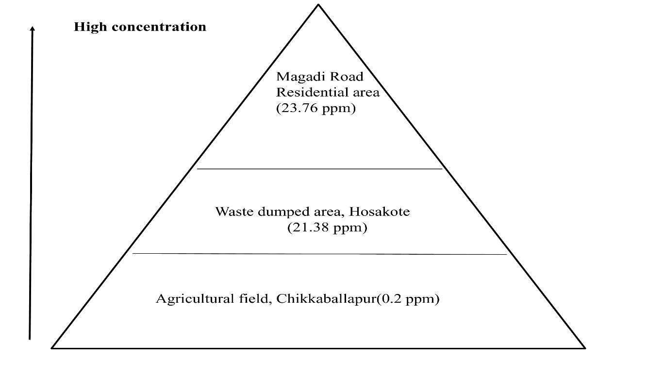
Figure 13: Pyramid showing the relative Pb concentration (ppm) in soil samples from three study sites.

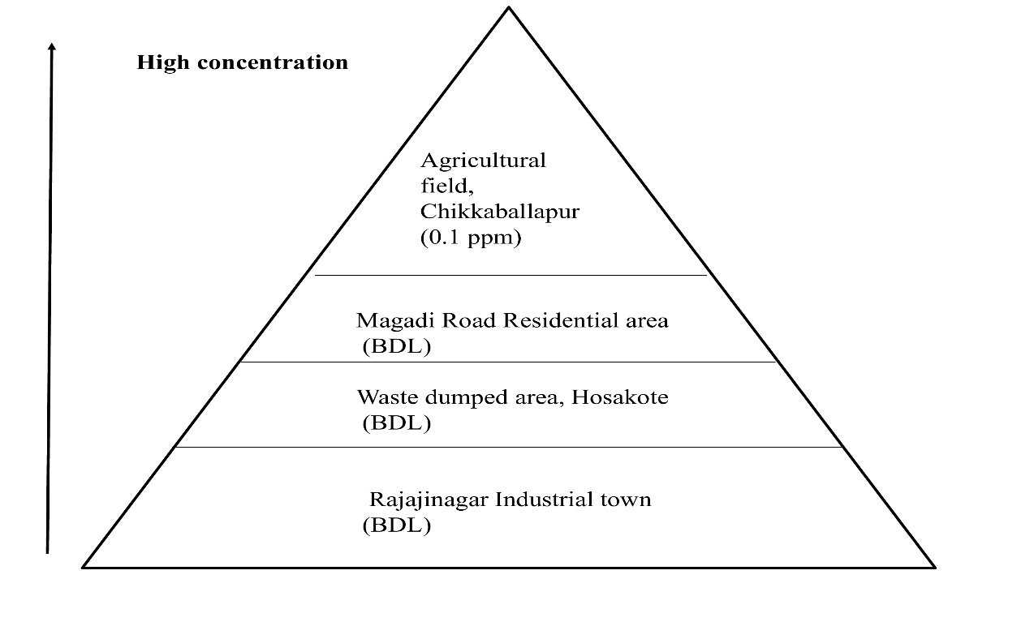
Figure 14: Illustration of elevated Hg concentration in various soil samples tested.

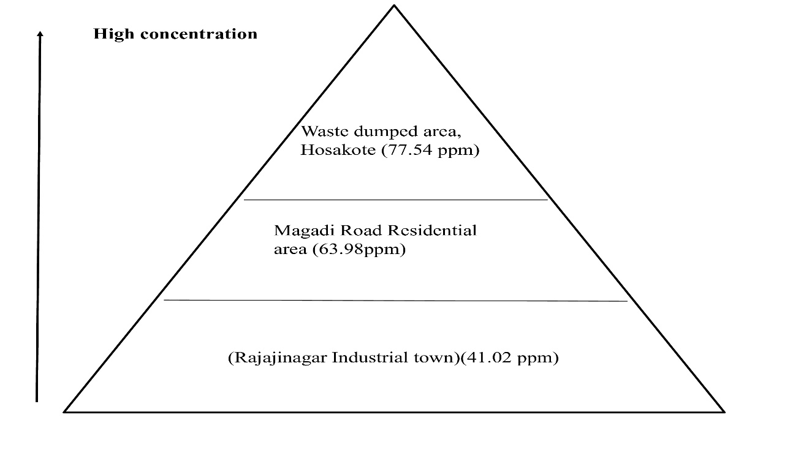
Figure 15: Illustration of elevated Zn concentration in different soil samples tested.

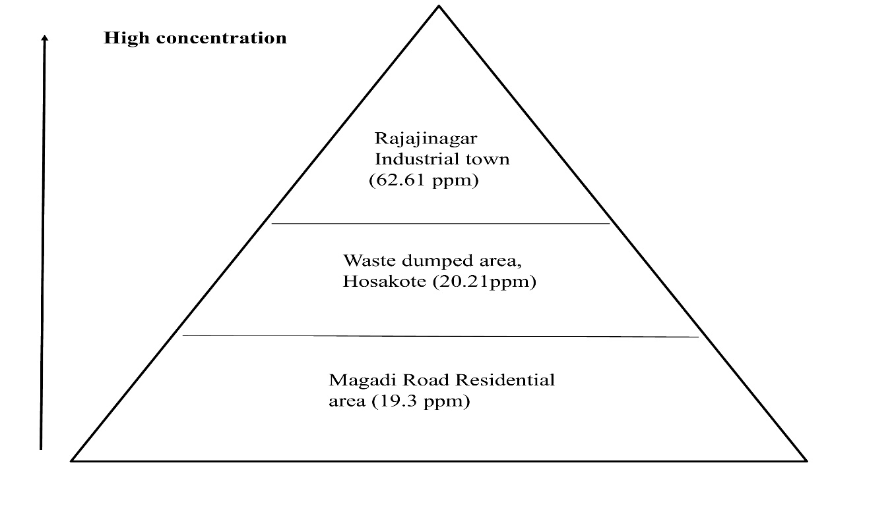
Figure 16: Illustration of elevated Cu concentration in various soil samples tested.

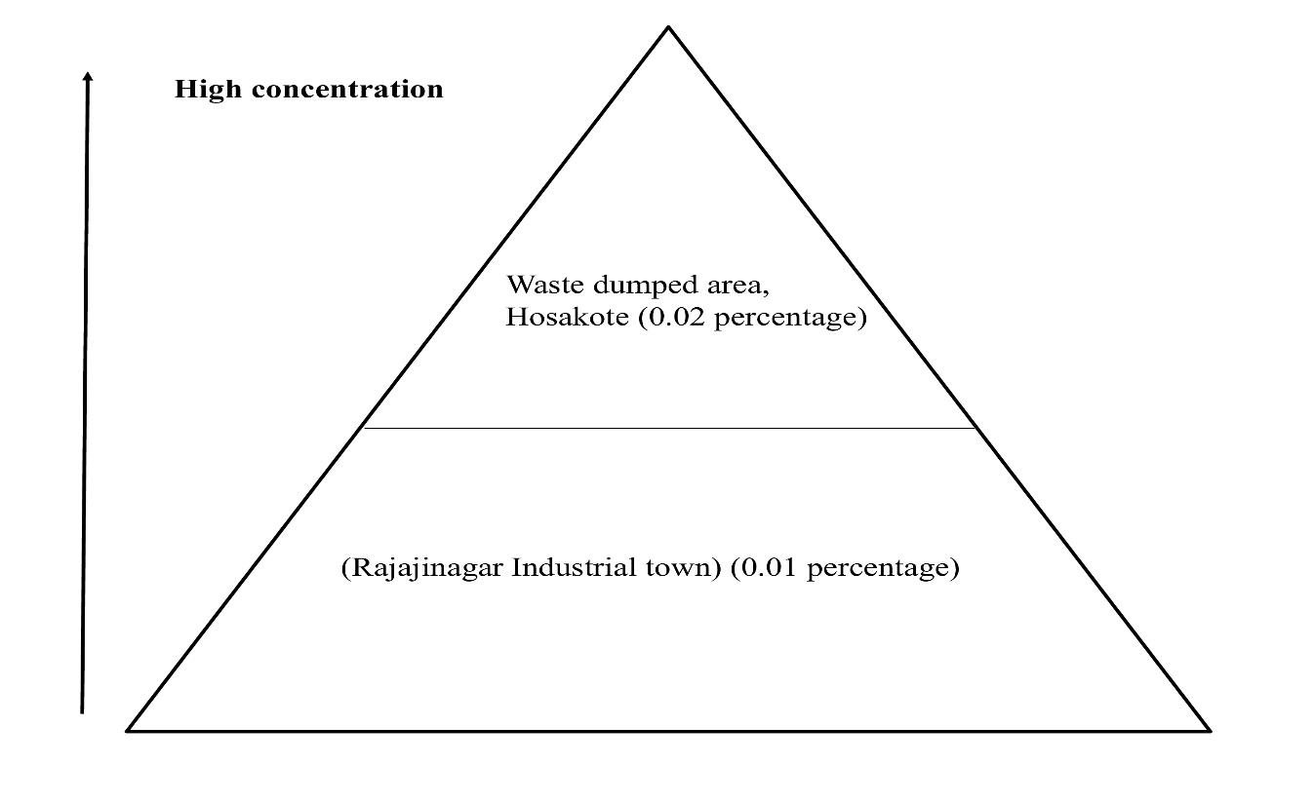
Figure 17: Illustration of elevated Fe concentration in various soil samples tested.

