Differential Effects of Lead and Cadmium Contamination on the Antioxidant Systems of Key Plant Species in South Caucasus Vegetation Communities

Abstract. Heavy metal contamination is an increasing threat to plant communities worldwide, yet most studies examine antioxidant stress responses in single target species. Here we report the effects of lead and cadmium contamination on the antioxidant system of ten plant species representing key elements of local vegetation in the South Caucasus (Georgia, the Caucasus), using sites with contrasting contamination levels near Tbilisi and the Bolnisi copper mining area respectively. Eleven antioxidant compounds and three associated enzyme activities were measured in fresh leaves, and data were standardised using the log response ratio (lnRR) to allow comparisons across species. Correlation of lnRR values between leaf heavy metal content and antioxidant variables was used to distinguish stress-specific (cross-species) from species-specific (idiosyncratic) responses. Under lead stress, 8 of 15 antioxidant variables showed cross-species correlations: most were negative, consistent with suppression under severe contamination, while ascorbic acid and nitrate reductase activity were positively correlated, suggesting active upregulation. Under cadmium stress, 4 of 13 variables correlated across species; phenolics and nitrate reductase activity were negatively correlated, while proline — a known osmoprotectant — showed a consistent positive response. The remaining variables responded idiosyncratically under both metals, reflecting substantial inter-species variation. Malva was the most sensitive species to lead and Rumex to cadmium, while Xanthium showed the least differential cadmium uptake between contamination levels. These findings highlight the coexistence of conserved and species-specific antioxidant strategies in plant communities exposed to heavy metals, and point to ascorbic acid, proline, and nitrate reductase activity as promising candidates for community-level biomonitoring.

Keywords: heavy metal stress; plant antioxidant system; log response ratio; lead and cadmium toxicity; South Caucasus vegetation; biomonitoring
Introduction
Plant survival, growth, and reproduction depend on their endurability to stresses of various types (Shanker et al., 2022; Du et al., 2024). The main physiological mechanism against environmental stress in plants is the antioxidant system, which includes low-molecular-weight organic compounds and enzymes of varied chemical nature: pigments, amino acids, vitamins, proteins, soluble carbohydrates, catalase, peroxidase, and others (Laxa et al., 2019; Iqbal et al., 2020). Industrial contamination is one type of stress that increasingly impacts living beings, and the pollution of ecosystems with heavy metals is particularly alarming (Morais et al., 2012). Research has shown that over the past few decades, the content of heavy metals in the environment, be it air, soil, or water, has been continuously increasing and is related to both industry and road transport, as well as the use of large amounts of fertilizers, pesticides, and herbicides (Tchounwou et al., 2012; Kumar et al. 2023). Plants, the producers of primary biomass in ecosystems, are the first to receive the impacts from heavy metal contamination. When plants detect heavy metal ions in their tissues, they activate their antioxidant system – a usual response of plants to many stress types (Mansoor et al., 2023; Mourato et al., 2012).
The role of antioxidant system in the protection of plants from heavy metal contamination is primarily studied on individual target species in specific habitats (Chen et al., 2025; Sharma et al., 2021). There are relatively few studies that deal with the comparative analysis of the antioxidant system of species growing under variable levels of pollution (Cakaj et al., 2023; Nadgórska-Socha et al., 2013). Even rarer or non-existent are works that study the impacts of heavy metal contamination on plant communities or at least on a group of key species of natural communities (Badridze et al. 2025). This gap must be due to certain challenges, both conceptual and logistic, hindering ecophysiological studies at plant community scale.
Conceptually, the question of how pollutants affect a group of plant species is complex since it includes many variables. The pollutants are various; lead, mercury, cadmium, and arsenic are among the most significant heavy metal pollutants due to their toxicity, persistence, and bioaccumulation in the environment (Himani et al, 2025), while the same plant species can respond to different pollutants differently. Logistically, the challenges include the necessity to test a diverse group of species and under different contamination levels, limiting the number of taxa that can be studied under consistent stress regimes. Also, such studies require metabolite-level laboratory analyses for each plant species, resulting in a prohibitive number of assays when many taxa are involved (Petrén et al., 2024).
On the other hand, it is reasonable to think that the antioxidant responses to heavy metal impacts do not vary at random and thus can be studied with appropriate experimental designs, even if the above challenges pose severe restrictions to such designs. The antioxidant system itself consists of many elements, and there is evidence that the responses to some stress types can be similar in many species (Badridze et al., 2025). At the same time, other responses can be species-specific and might seem idiosyncratic. Finally, some species can cope with pollution by avoiding the uptake of the contaminant, in difference with other species that readily absorb heavy metal ions from the soil.
The aim of our work was to study the responses of plant antioxidant system to the impacts of specific heavy metals and, to some extent, describe the variability in these responses. Due to the challenges and difficulties outlined above, we limited the number of target plant species to several key representatives of local vegetation, and examined the impacts of two metals – lead and cadmium – at two, moderate and heavy levels of contamination. To achieve our goal, we first measured the levels of lead and cadmium with various probability to be contaminated. We also determined lead and cadmium content in target plant leaves. Subsequently we determined the key antioxidant compounds and associated enzyme activities also in plant leaves. Since we were dealing with many variables – species, antioxidants and associated enzyme activities, heavy metals in soil and plant leaves – standardization of the data was particularly important. We used the logarithm of the ratio (lnRR) for standardization, which allowed us to to test our hypothesis by comparing different levels of heavy metal in the leaves and measure the impact of increasing this level on each element of the antioxidant system. The hypothesis was that the response of a given element of the antioxidant system in a leaf is stress-specific to an increase of a given heavy metal content. In other words, species identity does not matter and the response is essentially the same across species since the differences between species are negligibly small. Then we should expect a correlation between the content of a heavy metal in a leaf and an antioxidant response across species. An alternative hypothesis is that antioxidant responses are species-specific, which is why the correlation is broken. The non-linearity of antioxidant responses could also be a cause for the insignificant correlation. At this stage of the study, we were unable to distinguish between these two causes, so we describe this pattern of non-significant correlation as 'idiosyncratic'. The results obtained show both correlations and idiosyncratic patterns.

Materials and Methods
Study sites
The locations of our study sites were chosen by considering the recognized sources of pollution by lead and cadmium, currently the most prevalent pollutants in Georgia and wider in the region of the South Caucasus (see Table 1 for the sampling site locations and their heavy metal contamination levels). At the same time, there could be natural sources contributing to heavy metal levels in soils since sampling sites are located mostly along the volcanic zone of Trialeti (the Lesser Caucasus) where the rocks can naturally contain heavy metal ions such as copper, lead and zinc (Gabriadze 2022; Alloway 2013; Young 2012; Violante et al. 2010).
For lead soils were sampled at several sites located in the capital city of Tbilisi recognized as one of the most polluted urban areas (Kupatadze 2023; Kekelidze et al. 2022); in particular - from lawns along the main roads, namely, of Nutsubidze street. For the rural areas we sampled soils near the township of Manglisi (Table 1).
For cadmium contamination we sampled soils and river water at various distance from the copper mines and enrichment factory, which are recognized sources of cadmium contamination (Nikolaishvili et al. 2022; 2023; Withanachchi et al. 2018). These sites are located near the city Bolnisi, in the Mashavera river valley (Table 1).
Table 1. Soil and water sampling sites and the detected levels of heavy metals
Lead in soils | Pb, mg/kg ± SD | Coordinates
Site 1 | 56.4 ± 1,70 | N41º41′48.88′′, E44º22′24.51′′
Site 2 | 25.8 ± 1,90 | N41º43′28.52′′, E44º43′03.18′′
Cadmium in soils | Cd, mg/kg
Site 1 | 0.82 ± 0,20 | N41º21′44.60′′, E44º22′39.50′′
Site 2 | 0.80 ± 0,20 | N41º24′36.10′′, E44º25′26.01′′
Site 3 | 0.37 ± 0,10 | N41º22′33.21′′, E44º23′07.97′′
Site 4 | 0.24 ± 0,07 | N41º21′44.60′′, E44º22′39.50′′
Cadmium in river water | Cd, mg/l
Site 5 | 0.07 ± 0,004 | N41º22′33.21′′, E44º23′07.97′′
Site 6 | 0.03 ± 0,005 | N41º24′36.10′′, E44º25′26.01′′
Site 7 | <0,001 | N41º21′46.27′′, E44º22′40.10′′

These sites are not far away from each other and belong to the same province of Lower Kartli that extends from Tbilisi to south-west. Despite this the climate is variable owing to the mountainous terrain. Tbilisi has a humid temperate climate with considerable continental and semi-arid influences. Temperature ranges from 20-32 °C in summer, 1-7 °C in winter.
Manglisi is located on the southern slopes of the Trialeti Range, 56 km west of Tbilisi, in the Algeti river valley. It is located at about 1,200 m above sea level and enjoys a subtropical climate, with warm summers (average temperature in July, 19 °C) and mild winters (average temperature in January, −2 °C). Annual precipitation is 700 mm. Manglisi also functions as a mountain resort.
The climate in Bolnisi is also warm and temperate (average temperature in August and January are 22.4 °C and −1.8 °C, respectively), with annual precipitation of 699 mm.
Soils in Tbilisi mostly belong to cinnamomic (Cn) including cinnamomic-calcareous (Cn-Cr) and alluvial (Al) including alluvial-calcareous (Al-Cr) (Tulashvili et al. 2020). The soils in Manglisi, around Bolnisi and along the Mashavera river are mostly brown earth (Matchavariani 2019).

Target plant species and collection of plant material
The target plants were typical representatives of local vegetation growing at sites with different levels of heavy metal contamination (above). Soil lead contamination was tested on Ballota nigra L., Malva silvestris L., Plantago lanceolata L. and Sisymbrium irio L. Soil cadmium contamination was examined on Mentha longifolia (L.) Huds., Paliurus spina-Christi Mill., Polygonum aviculare L., Rumex obtusifolius L., Salvia nemurosa L. and Xantium strumarium L. These species are ubiquitous in our research areas. As each species represent a separate genus, hereafter we will use their generic names to refer these species. Importantly, all these species (except Ballota) are often used as herbal medicines (see Batsatsashvili et al. 2017 for Malva; Bussmann et al. 2020 for Polygonum; Bussmann et al. 2025a for Xanthium; Bussmann et al. 2025b for Mentha; Bussmann et al. 2025c for Paliurus; Bussmann et al. 2025d for Rumex; Bussmann et al. 2025e for Salvia; Mehdiyeva et al. 2025 for Sisymbrium; Paniagua-Zambrana 2024 for Plantago).
Plant material was collected in May, 2024 in Tbilisi and Manglisi to examine leaf lead levels in target species and measuring responses of antioxidant system to contamination.
Plant material for leaf cadmium levels and antioxidant measurements was collected in May and June, 2025. Individual plant species were collected, placed in paper bags, and transported to the laboratory in a cool box to prevent desiccation. All biochemical assays were conducted using fresh material, with the exception of anthocyanins and proline analysis, which was performed on tissue dried at 75°– 80 °C in a thermostat and subsequently stored under refrigeration.

Laboratory assays
The content of lead and cadmium was determined in the soil samples and water taken from the test locations (Mashavera River and mining quarry). Lead and cadmium in plant organs were studied by the ISO GOST 30538-97 method, lead in soil – spectrophotometrically (Fomin and Fomin, 2001). Cadmium in soil - by the ICP-MS method. Cadmium in water - by the ISO 11885:2007 method. All these analyzes were carried out by our order in the Multitest laboratory (https://multitest.ge/).
The analyzed antioxidant compounds included anthocyanins (ANT), ascorbic acid (ASC), carotenoids (CRT), chlorophylls a + b (CHL), flavonoids (FLV), nitrates (NTR) proline (PLN), soluble carbohydrates (CRB), soluble phenolics (PHE), tocopherols (TOC), and total proteins (PRT). Enzyme activities – catalase (CTL), nitrate reductase (NRD), peroxidase (POA) and total antioxidant activity (AOA) – were determined in the laboratory of the department of Plant Physiology, Institute of Botany of Ilia State University.
Anthocyanins were extracted using 96% ethanol with 1% HCl and quantified spectrophotometrically at 540 nm (Ermakov, 1987, pp. 113–114).
Ascorbic acid was measured via titration with a 0.001 M solution of 2,6-dichlorophenolindophenol (Ermakov, 1987, pp. 86–91).
Plastid pigments (chlorophylls and carotenoids) were extracted from fresh leaves in 96% ethanol and quantified at 560 nm (chlorophylls) and 470 nm (carotenoids) (Lichtenthaler & Buschmann, 2001).
Flavonoids were determined spectrophotometrically, using AlCl3. The absorbance was measured at 415 nm (Chang et al. 2002).
Nitrates were determined spectrophotometrically using disulphophenolic acid. Optical density was determined at 410 nm (Pleshkov 1985, pp. 203-206).
Proline was quantified spectrophotometrically at 520 nm using toluene extracts of ninhydrin-treated samples (Bates et al., 1973).
Soluble carbohydrates were measured at 620 nm in anthrone-treated samples (Turkina & Sokolova, 1971).
Soluble phenolics were quantified at 765 nm in samples treated with Folin–Ciocâlteu reagent (Ferraris et al., 1987).
Tocopherols were measured spectrophotometrically at 470 nm using 96% ethanol extracts (Fillipovich et al., 1982, pp. 40–60).
Total proteins were quantified following the method of Lowry et al. (1951).
Total antioxidant activity (AOA) was based on the mixing of plant ethanolic extracts with a solution of DPPH, incubating at room temperature for 30 min and measuring the decrease in absorbance at 515 nm spectrophotometrically (Koleva et al. 2002).
Catalase activity was determined gasometrically by measuring the volume of oxygen released during the decomposition of hydrogen peroxide. The reaction vessel was connected to a burette to capture and quantify the evolved gas (Pleshkov, 1985, pp. 203–206).
Peroxidase activity was measured spectrophotometrically using guaiacol; the absorbance of oxidized guaiacol products was recorded at 470 nm over 2 minutes (Ermakov, 1987, pp. 41–43).
Nitrate reductase activity was assayed spectrophotometrically at 520 nm by quantifying nitrite accumulation resulting from nitrate reduction (Ermakov, 1987, pp. 51–52).
All spectrophotometric measurements were performed using a SPEKOL 11 spectrophotometer (KARL ZEISS, Jena, Germany). All chemical assays were performed in triplicate for each species, and mean values were calculated for subsequent standardization and regression analyses (below)Data collection design and analysis
Data collection was designed to address the challenges posed by logistic problems of studying physiological effect in plant assemblages (the Introduction).
We paired the sampling sites for plant material collection based on the knowledge of soil lead and cadmium contamination levels (Table 1). Each pair consisted of one heavily contaminated site paired with a moderately contaminated one. Plant material from the target species were collected from each site and, after determining the levels of heavy metals and antioxidants, the data were standardized using log response ratio (lnRR). This is a numerical index that quantifies the magnitude and direction of a variable change (effect size) based on the difference in the values of the variable in two different states on a scale that is comparable across cases and studies (Pustejovsky and Ferron 2017). For example, the lnRR index is often applied to plant-plant interactions to quantify the response of a target plant on the removal of neighbors (Kikvidze and Armas 2010; Kikvidze et al. 2006). The index is calculated simply as:
lnRR = ln(A/B),
where A and B are the values of a variable (e.g., the concentration of a given heavy metal ions in leaves, or the level of an antioxidant in plant leaves) that correspond to the two states of a target system. If in state A the value of a variable is less than in state B, the lnRR values are negative and, vice versa, positive lnRR indicates that the value of the variable is higher in state A than in state B. For our study, states A and B correspond to moderate versus heavy content of lead and cadmium ions in a leaf. Accordingly, we calculated lnRR values for the concentration of the contaminant (lead or cadmium) in the leaves of each target species; likewise, we calculated lnRR values for each antioxidant in each species and used correlation analysis for detecting a relationship between the metal and antioxidant variables.
The main advantage of lnRR is that it is symmetrical around 0 and allows for data standardization (Armas et al. 2004). Importantly, these properties enabled us to test our hypothesis as follows: if the responses to increased level of a given heavy metal concentration in leaf tissues are similar across species, we shall observe correlation of the lnRR values between the metal and antioxidant concentration in the leaves across the target species. If species-specific responses prevail, then no correlation can be detected as the differences among species increase variability, albeit idiosyncratically. To discriminate between present and absent correlations, we used determination coefficient (R²). The correlation was regarded as “detected” if only R² > 0.1.
All statistical analyses were performed using software PAST 4 (Hammer and Harper, 2001).
Results
The concentration of lead in plant leaves was variable across species that grew at strongly and moderately contaminated sites (Table 2).
Table 2. Lead levels detected in plant leaves growing at highly and moderately contaminated soils (see also Table 1)
Plants | Pb in leaves, mg/kg
 | Highly contaminated soil | Moderately contaminated soil
Balotta | 1.50 ± 0,20 | 0.46 ±0,06
Malva | 1.90 ± 0,30 | 0.44 ±0,06
Plantago | 1.06 ±0,15 | 0.67 ± 0,06
Sisymbrium | 0.88 ± 0,09 | 0.74 ± 0,05

The most sensitive to lead contamination appeared to be Malva, the leaves of which contained the highest and lowest levels of lead at the strongly versus moderately contaminated sites, respectively. Similar, yet less pronounced patterns were shown also by other species, among which Sisymbrium was the least sensitive to soil lead levels. Out of 15 tested antioxidant compounds or associated enzyme activities, eight (CRT, ASC, TOC, PHE, ANT, PRL, CAT, NRA) varied similarly and resulted in the correlation of log response ratios between leaf lead and antioxidants (Figure 1).
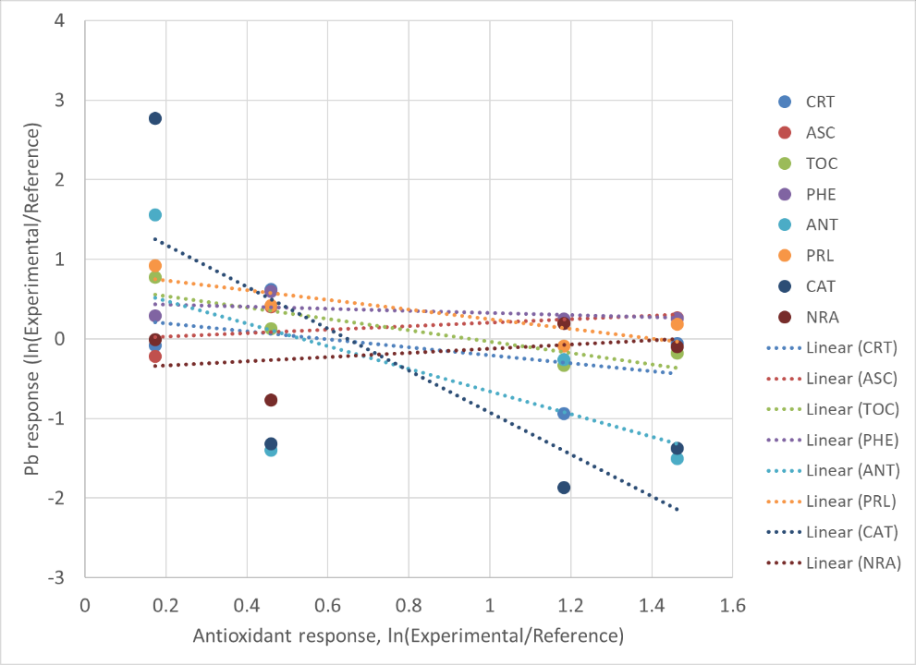
Figure 1. Responses to lead contamination in plant (lead content and antioxidant levels in plant leaves: correlation across species.
The correlations were positive only in two cases: ASC and NRA. Other correlations appeared to be negative, the slope of regression lines were especially steep in the case of CAT and ANT. The log response ratios were highly variable and rather idiosyncratic for the rest of tested antioxidant compounds or associated enzyme activities (CHL, FLA, PRT, CRB, POA, NTR, AOA); accordingly, no correlation between log response ratios were detected (Figure 2).
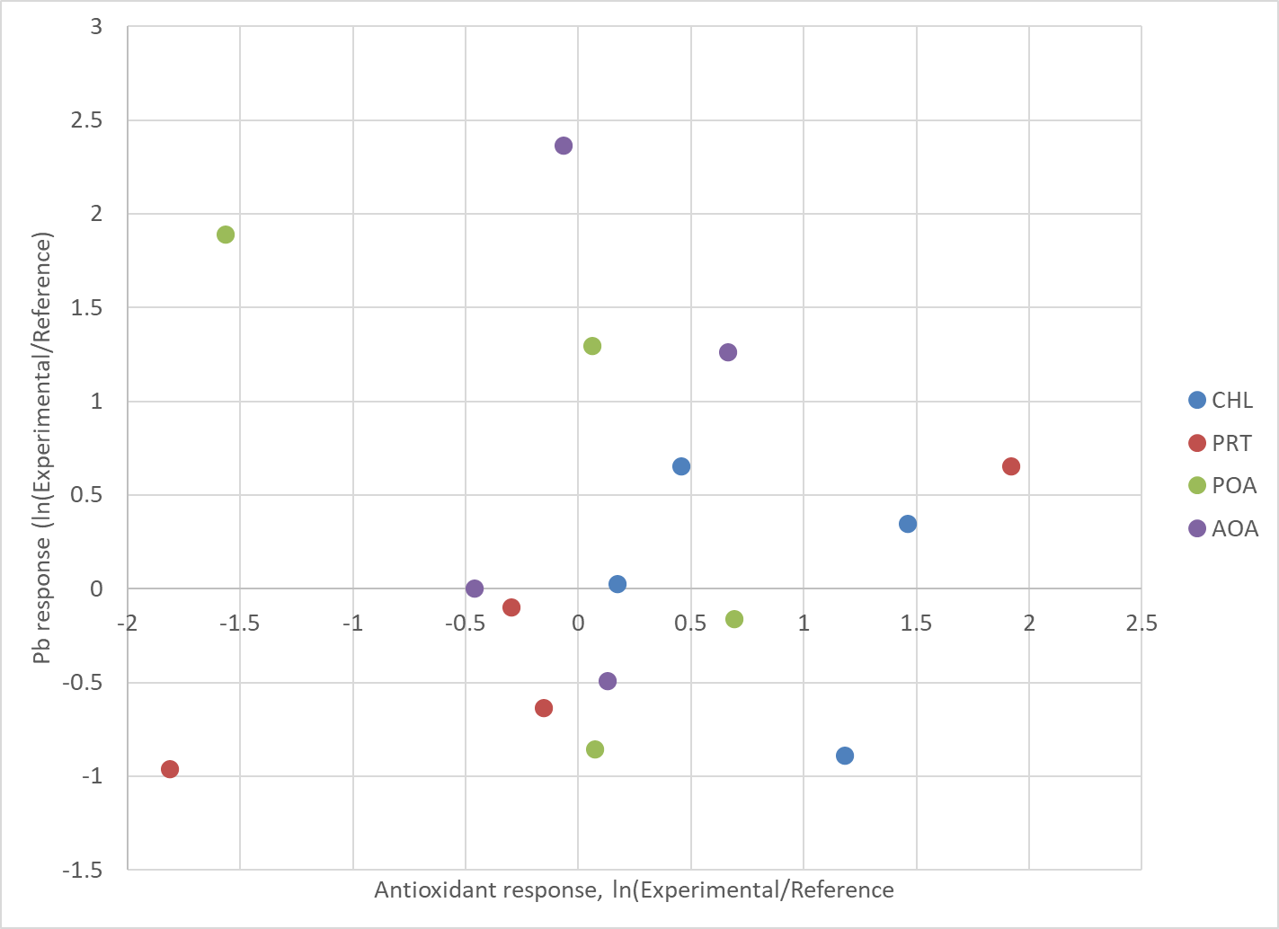
Figure 2. Idiosyncratic responses to lead contamination in plant (lead content and antioxidant levels in leaves).
The concentration of cadmium in plant leaves was also variable across species that grew at strongly versus moderately contaminated sites (Table 3).
Table 3. Cadmium levels detected in plant leaves growing at highly and moderately contaminated soils
Plants | Cd in leaves, mg/kg
 | Highly contaminated soil | Moderately contaminated soil
Mentha | 0.33 ± 0,055 | 0.03 ± 0,005
Paliurus | 0.04 ± 0,007 | 0.01 ± 0,003
Polygonum | 0.23 ± 0,070 | 0.13 ± 0,025
Rumex | 0.88 ± 0,080 | 0.03 ± 0,005
Salvia | 0.09 ± 0,004 | 0.02 ± 0,003
Xanthium | 0.08 ± 0,004 | 0.11 ± 0,02

Rumex emerged as the most sensitive species to the different levels of soil contamination; the leaves of this species contained the highest and lowest cadmium levels correponding to the strong and moderate contamination of soil. Similar, although less pronounced patterns were shown also by other species, among which Xanthium was the least sensitive to the variation in soil cadmium. Out of 13 antioxidant compounds or associated enzyme activities tested, four (ASC, PHE, PRL, NIT) produced log response ratios that correlated with those of cadmium concentrations (Figure 3). The correlation was positive only in the case of PRL; the rest three were negative with steep slope for PHE and NIT. For the rest of antioxidant compounds or associated enzyme activities (CHL, CRT, TOC, FLA, ANT, PRT, CRB, CAT, NRA) no correlations were detected (Figure 4); these responses were highly also variable but rather idiosyncratic.
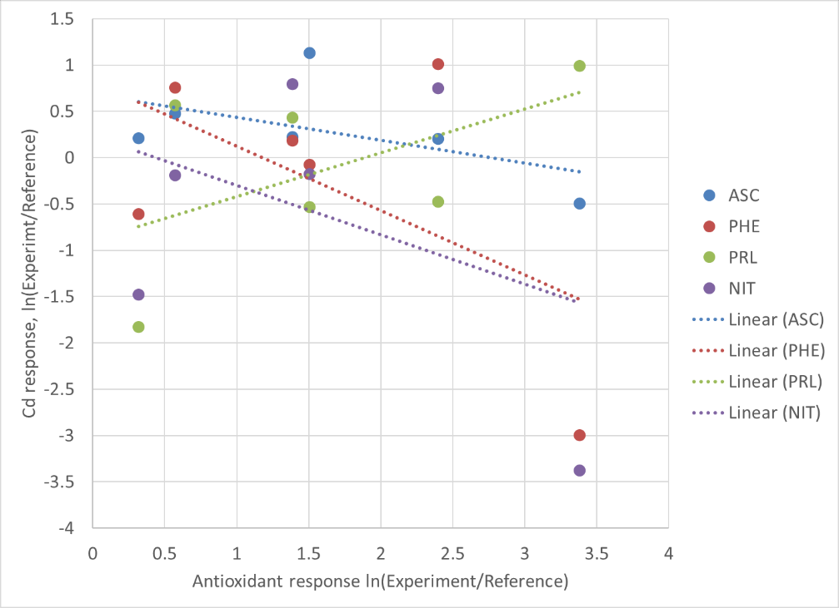
Figure 3. Responses to cadmium contamination in plant (cadmium content and antioxidant levels in leaves: correlation across species).
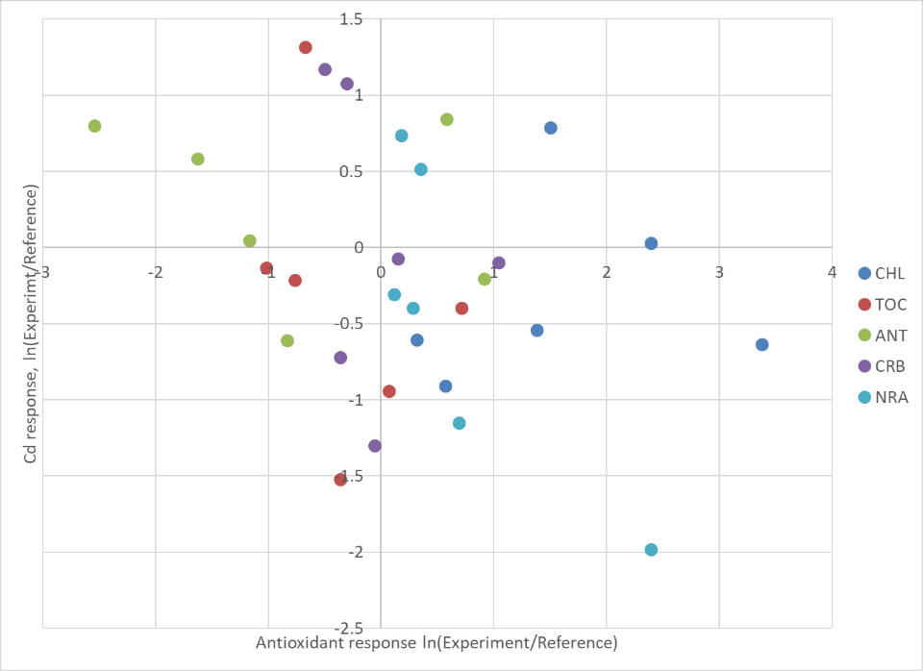
Figure 4. Idiosyncratic responses to cadmium contamination in plant (cadmium content and antioxidant levels in leaves).
Discussion
The present study applied a log response ratio approach to compare antioxidant responses across multiple plant species simultaneously, offering a community-level perspective that is rarely attempted in heavy metal ecophysiology. The results reveal a mixture of stress-specific and species-specific responses, with the balance between these two patterns differing between the two metals examined.
For lead contamination, more than half of the tested antioxidant variables (8 of 15) produced lnRR values that correlated across species, indicating that the direction and relative magnitude of their responses to increasing leaf lead were largely consistent regardless of species identity. The majority of these correlations were negative, meaning that the antioxidant compounds or enzyme activities in question — carotenoids, tocopherols, soluble phenolics, anthocyanins, and catalase activity — declined as leaf lead content increased from moderate to high contamination. This pattern most plausibly reflects suppression of these antioxidant elements under severe lead stress, rather than their active mobilisation.
Generally both Pb and Cd are non-essential and toxic metals that disrupt plant metabolism. They reduce seed germination and growth, damage cell membranes, inhibit photosynthesis and enzyme activity, and cause oxidative stress (Colin et al., 2022; Haider et al., 2021); and the steep negative slopes observed for catalase and anthocyanins (Figure 1) are consistent with a toxic overload that overwhelms rather than stimulates these particular defenses. By contrast, the positive correlations for ascorbic acid and nitrate reductase activity suggest that these two components are actively upregulated in response to increasing leaf lead, and may therefore represent the primary reactive defences deployed by these species against lead toxicity. This cooperative stress-protective activity of ASC and NR is easy to explain. According to recent studies, NR plays a crucial role in plant responses to heavy metal stress by linking nitrogen metabolism with stress signaling pathways. The enzyme contributes to stress tolerance through the production of nitric oxide, which in turn activates the ascorbate–glutathione cycle, and helps maintain reactive oxygen species homeostasis under stress conditions (Kaya et al., 2020; Gupta & Gupta, 2025). Ascorbic acid, from its side, plays a multifaceted role in plant tolerance to heavy metal stress, beyond its classical antioxidant function. It acts as a central regulator of cellular redox homeostasis and integrates metabolic and signaling pathways involved in stress responses. Furthermore, ascorbic acid contributes to metal detoxification mechanisms by supporting chelation processes and facilitating the sequestration of toxic ions into vacuoles. (Cárcamo-Fincheira et al., 2024; Mishra et al., 2024).
For cadmium, the proportion of correlated responses was considerably smaller (4 of 13), pointing to a greater degree of species-specificity in the antioxidant reaction to this metal. Among the correlated variables, phenolics and nitrate reductase activity again showed negative relationships with increasing leaf cadmium, paralleling the pattern seen under lead stress and suggesting that cadmium similarly suppresses these components when contamination is severe. The negative correlation for ascorbic acid under cadmium — in contrast to its positive response under lead — is noteworthy and indicates that the role of these antioxidants is metal-specific. This is proved by literary data demonstrating that exposure to heavy metal such as cadmium often inhibits nitrate reductase activity (Singh et al., 2019), presumably, from its side affecting ascorbate reduction.
Proline was the only compound to exhibit a positive correlation with leaf cadmium, increasing consistently as cadmium accumulation rose across species. This is in line with the well-established role of proline as an osmoprotectant and metal-chelating agent under heavy metal stress (Hosseinifard et al. 2022), and suggests it may be a particularly reliable indicator of cadmium burden in these species.
The majority of antioxidant variables produced idiosyncratic lnRR patterns under both metals, with no detectable correlation across species (Figures 2 and 4). Chlorophylls, flavonoids, total proteins, soluble carbohydrates, and peroxidase activity all fell into this category under at least one of the two metals. The high variability in these scatter plots reflects genuine biological heterogeneity: different species appear to regulate these components in fundamentally different ways under comparable contamination pressures. Whether this reflects differences in metal uptake and compartmentalisation strategies, differences in constitutive antioxidant capacity, or non-linear dose–response relationships that our two-level design cannot fully resolve, remains an open question. The contrast between Rumex — which accumulated the highest leaf cadmium levels — and Xanthium — which showed the least differential uptake between contamination levels — illustrates that species vary not only in their antioxidant responses but also in how much of the soil contaminant they absorb, a factor that inevitably contributes to the idiosyncratic patterns observed.
Taken together, the results demonstrate that the antioxidant system does not respond as a uniform block to heavy metal stress. Instead, certain components behave in a broadly conserved, stress-specific manner that transcends species boundaries, while others are governed primarily by species identity (Badridze et al., 2025). This distinction has practical relevance: antioxidant variables that produce consistent cross-species correlations — such as ascorbic acid and proline — are likely to be more informative and reliable indicators for biomonitoring purposes than those whose responses are highly idiosyncratic.

Conclusions
This study examined the effects of lead and cadmium contamination on the antioxidant system of ten plant species representing local vegetation communities in the South Caucasus, using a log response ratio framework to enable standardised comparisons across species and contamination levels. The findings demonstrate that antioxidant responses to heavy metal stress are neither wholly conserved nor wholly species-specific, but fall along a spectrum between these two extremes. Under lead stress, a majority of tested antioxidant components responded consistently across species, with most showing suppression at high contamination and ascorbic acid and nitrate reductase activity emerging as active upregulated defences. Under cadmium stress, cross-species consistency was more limited, with proline standing out as the most reliable positive indicator of metal burden. The remaining variables responded idiosyncratically, reflecting substantial inter-species variation that a two-level contamination design could not fully disentangle from possible non-linear dose–response effects. These results underscore the value of community-level ecophysiological approaches in revealing both the shared and species-specific dimensions of plant stress responses, and suggest that antioxidants showing consistent cross-species correlations — particularly ascorbic acid, proline, and nitrate reductase activity — merit priority consideration in biomonitoring frameworks for heavy metal-contaminated landscapes.
Disclaimer (Artificial intelligence)
Author(s) hereby declare that NO generative AI technologies such as Large Language Models (ChatGPT, COPILOT, etc.) and text-to-image generators have been used during the writing or editing of this manuscript.

References
Alloway, B. J. (2013). Sources of heavy metals and metalloids in soils. In Heavy metals in soils: Trace metals and metalloids in soils and their bioavailability (pp. 11–50). Springer Netherlands. https://doi.org/10.1007/978-94-007-4470-7_2
Armas, C., Ordiales, R., & Pugnaire, F. I. (2004). Measuring plant interactions: A new comparative index. Ecology, 85, 2682–2686. https://doi.org/10.1890/03-0650
Badridze, G., Chkhubianishvili, E., Kikvidze, M., Rapava, L., Chigladze, L., Tsiklauri, N., Tsartsidze, N., & Kikvidze, Z. (2025). Antioxidant system in species assemblages: Species and stress specific effects of abiotic stress in secondary meadows of the Caucasus Mountains. Asian Journal of Environment & Ecology, 24(9), 127–137.
Bates, L. S., Waldren, R. P., & Teare, I. D. (1973). Rapid determination of free proline for water-stress studies. Plant and Soil, 39, 205–207.
Batsatsashvili, K., et al. (2017). Malva neglecta Wallr.; Malva sylvestris L. (Malvaceae). In R. Bussmann (Ed.), Ethnobotany of the Caucasus. Springer. https://doi.org/10.1007/978-3-319-49412-8_115
Bussmann, R. W., Batsatsashvili, K., & Kikvidze, Z. (2020). Polygonum aviculare L.; Polygonum coriarium Grig. (Polygonaceae). In K. Batsatsashvili et al. (Eds.), Ethnobotany of the mountain regions of Central Asia and Altai. Springer. https://doi.org/10.1007/978-3-030-28947-8_108
Bussmann, R. W., Khojimatov, O. K., Paniagua-Zambrana, N. Y., Kikvidze, Z., & Batsatsashvili, K. (2025a). Xanthium spinosum L.; Xanthium strumarium L. (Asteraceae). In Ethnobotany of the Caucasus (pp. 5961–5969). Springer Nature Switzerland. https://doi.org/10.1007/978-3-031-91369-3_542
Bussmann, R. W., Paniagua-Zambrana, N. Y., Khutsishvili, M., Kikvidze, Z., Khojimatov, O. K., Fayvush, G., Aleksanyan, A., Mehdiyeva, N. P., Alizade, V. M., Nasab, F. K., & Zeraatkar, A. (2025b). Mentha species (Lamiaceae). In Ethnobotany of the Caucasus. Springer. https://doi.org/10.1007/978-3-031-91369-3_141
Bussmann, R. W., Paniagua-Zambrana, N. Y., Khutsishvili, M., Kikvidze, Z., Mehdiyeva, N. P., & Mursal, N. (2025c). Paliurus spina-christi Mill. (Rhamnaceae). In Ethnobotany of the Caucasus. Springer. https://doi.org/10.1007/978-3-031-91369-3_431
Bussmann, R. W., Paniagua-Zambrana, N. Y., Khutsishvili, M., Kikvidze, Z., Müller, L., Batsatsashvili, K., Sikharulidze, S., Tchelidze, D., Maisaia, I., Nasab, F. K., & Zeraatkar, A. (2025d). Rumex species (Polygonaceae). In Ethnobotany of the Caucasus (pp. 4939–4970). Springer Nature Switzerland. https://doi.org/10.1007/978-3-031-91369-3_131
Bussmann, R. W., Paniagua-Zambrana, N. Y., Kikvidze, Z., Batsatsashvili, K., Khutsishvili, M., Maisaia, I., Sikharulidze, S., Tchelidze, D., Mehdiyeva, N. P., Salimov, R., & Mursal, N. (2025e). Salvia species (Lamiaceae). In Ethnobotany of the Caucasus (pp. 5029–5062). Springer Nature Switzerland. https://doi.org/10.1007/978-3-031-91369-3_478
Cakaj, A., Lisiak-Zielińska, M., Hanć, A., Małecka, A., Borowiak, K., & Drapikowska, M. (2023). Common weeds as heavy metal bioindicators: A new approach in biomonitoring. Scientific Reports, 13(1), 6926. https://doi.org/10.1038/s41598-023-34019-9
Cárcamo-Fincheira, D., Cejudo, F. J., & Corpas, F. J. (2024). Ascorbic acid metabolism and its role in the mitigation of metal stress in plants. Plant Physiology and Biochemistry, 206, 108–120. https://doi.org/10.1016/j.plaphy.2024.108120
Chang, C. C., Yang, M. H., Wen, H. M., & Chern, J. C. (2002). Estimation of total flavonoid content in propolis by two complementary colorimetric methods. Journal of Food and Drug Analysis, 10(3), 178–182.
Chen, F., Pan, X., Luo, Z., Duan, X., Zou, M., & Ma, J. (2025). Enhancing rice (Oryza sativa L.) resilience to cadmium stress through nanoparticle and rhizobacterial strategies: A sustainable approach to heavy metal remediation. Environmental Pollution, 126847. https://doi.org/10.1016/j.envpol.2025.126847
Collin, S., Baskar, A., Geevarghese, D-M., Vellala Syed Ali, M. N., Bahubali, P., Choudhary, R., Lvov, V., Tovar G.I., Senatov F., Koppala S., Swamiappan S. (2022). Bioaccumulation of lead (Pb) and its effects in plants: A review. Journal of Hazardous Materials Letters. Volume 3,100064. https://doi.org/10.1016/j.hazl.2022.100064
Du, B., Haensch, R., Alfarraj, S., & Rennenberg, H. (2024). Strategies of plants to overcome abiotic and biotic stresses. Biological Reviews, 99, 1524–1536. https://doi.org/10.1111/brv.13079
Ermakov, A. I., Arasimovich, V. V., Iarosh, V. V., Peruanskiy, I. P., Lugovnikova, G. A., & Ikonnikova, M. I. (1987). Methods of biochemical analysis of plants. Agropromizdat.
Ferraris, L., Abbatista-Gentile, I., & Matta, A. (1987). Variations of phenolics concentrations as a consequence of stress that induce resistance to Fusarium wilt of tomato. Journal of Plant Diseases and Protection, 94, 624–629.
Fillipovich, I. M., Egorova, T. A., & Sevastianova, G. A. (1982). Practical handbook in biochemistry. Prosveshchenie.
Fomin, G. S., & Fomin, A. G. (2001). Soil quality control and environmental safety by international standards. Protector.
Gabriadze, N. (2022). Heavy metals—lead and cadmium distribution in the adjacent area of the Bolnisi and Dmanisi regions. ISJ Theoretical & Applied Science, 12(116), 1100–1107.
Gupta, P., & Gupta, R. (2025). Nitrate reductase-derived nitric oxide in plant stress signaling and adaptation. Journal of Experimental Botany, 76(22), 6634–6648. https://doi.org/10.1093/jxb/erad345
Hammer, Ø., & Harper, D. A. (2001). PAST: Paleontological statistics software package for education and data analysis. Palaeontologia Electronica, 4(1), 1.
Haider, F.U., Liqun, C., Coulter, J.A., Cheema, S. A., Wu, J., Zhang, R., Wenjun, M., Farooq, M. (2021). Cadmium toxicity in plants: Impacts and remediation strategies. Ecotoxicology and Environmental Safety.Volume 211, 111887. https://doi.org/10.1016/j.ecoenv.2020.111887.
Himani, K., Gaur, A., Joshi, H. C., & Pant, G. (2025). Heavy metals as ecological contaminants: Sources, persistence, human health risks, and pollution assessment indices. In V. Singh et al. (Eds.), Heavy metal contamination in wastewater and its bioremediation (pp. xxx–xxx). Springer. https://doi.org/10.1007/978-981-96-7878-5_8
Hosseinifard, M., Stefaniak, S., Ghorbani Javid, M., Soltani, E., Wojtyla, Ł., & Garnczarska, M. (2022). Contribution of exogenous proline to abiotic stress tolerance in plants: A review. International Journal of Molecular Sciences, 23(9), 5186. https://doi.org/10.3390/ijms23095186
Iqbal, A., Don, Q., Wang, X., Gui, H., Zhang, H., Zhang, X., & Song, M. (2020). High nitrogen enhances drought tolerance in cotton through antioxidant enzymatic activities, nitrogen metabolism and osmotic adjustment. Plants, 9(2), 178. https://doi.org/10.3390/plants9020178
Kaya, C., Ashraf, M., Alyemeni, M. N., & Ahmad, P. (2020). Nitrate reductase-associated nitric oxide enhances tolerance to cadmium stress in pepper (Capsicum annuum L.) plants by regulating antioxidant defense systems. Ecotoxicology and Environmental Safety, 190, 110122. https://doi.org/10.1016/j.ecoenv.2019.110122
Kekelidze, D., Tsotadze, G., Maisuradze, G., Akhalbedashvili, L., & Chkhaidze, M. (2022). Assessment of the soil cover quality in adjacent areas to landfills based on changes in heavy metal concentration. Journal of Ecological Engineering, 23(5), 271–277. https://doi.org/10.12911/22998993/146747
Kikvidze, Z., & Armas, C. (2010). Plant interaction indices based on experimental plant performance data. In F. I. Pugnaire (Ed.), Positive plant interactions and community dynamics (pp. 17–37). CRC Press.
Kikvidze, Z., Khetsuriani, L., Kikodze, D., & Callaway, R. M. (2006). Seasonal shifts in competition and facilitation in subalpine plant communities. Journal of Vegetation Science, 17, 77–82. https://doi.org/10.1111/j.1654-1103.2006.tb02425.x
Koleva, I. I., Van Beek, T. A., Linssen, J. P., Groot, A. D., & Evstatieva, L. N. (2002). Screening of plant extracts for antioxidant activity: A comparative study on three testing methods. Phytochemical Analysis, 13(1), 8–17. https://doi.org/10.1002/pca.611
Kumar, D., Malik, S., Rani, R., Kumar, R., & Duhan, J. S. (2023). Behavior, risk, and bioremediation potential of heavy metals/metalloids in the soil system. Rendiconti Lincei, 34(3), 809–831. https://doi.org/10.1007/s12210-023-01166-0
Kupatadze, K. (2023). Review of air pollution research results on the example of Tbilisi. Southern Journal of Sciences, 31(36), 9–19.
Laxa, M., Liebthal, M., Telman, W., Chibani, K., & Dietz, K. J. (2019). The role of the plant antioxidant system in drought tolerance. Antioxidants, 8(4), 1–31. https://doi.org/10.3390/antiox8040094
Lichtenthaler, H. K., & Buschmann, C. (2001). Chlorophylls and carotenoids: Measurement and characterization by UV–VIS spectroscopy. Current Protocols in Food Analytical Chemistry, 1(1), F4.3.1–F4.3.8. https://doi.org/10.1002/0471142913.faf0403s01
Lowry, O. H., Rosebrough, N. J., Farr, A. L., & Randall, R. J. (1951). Protein measurement with the Folin phenol reagent. Journal of Biological Chemistry, 193, 265–275.
Mansoor S, Ali A, Kour N, Bornhorst J, AlHarbi K, Rinklebe J, Abd El Moneim D, Ahmad P, Chung YS. 2023. Heavy Metal Induced Oxidative Stress Mitigation and ROS Scavenging in Plants. Plants. 12(16):3003. https://doi.org/10.3390/plants12163003
Matchavariani, L. (2019). The soils of Georgia. Springer. https://doi.org/10.1007/978-3-030-18509-1
Mehdiyeva, N. P., Mursal, N., Bussmann, R. W., Paniagua-Zambrana, N. Y., & Müller, L. (2025). Sisymbrium species (Brassicaceae). In Ethnobotany of the Caucasus (pp. 5199–5208). Springer Nature Switzerland. https://doi.org/10.1007/978-3-031-91369-3_495
Mishra, V., Singh, P., Tripathi, D. K., Chauhan, D. K., & Prasad, S. M. (2024). Ascorbic acid: A metabolite switch for designing stress-smart crops. Critical Reviews in Biotechnology. https://doi.org/10.1080/07388551.2023.2290000
Morais, S., Costa, F. G., & Pereira, M. D. L. (2012). Heavy metals and human health. Environmental Health: Emerging Issues and Practice, 10(1), 227–245. https://doi.org/10.5772/29869
Mourato, M., Reis, R., & Martins, L. L. (2012). Characterization of plant antioxidative system in response to abiotic stresses: A focus on heavy metal toxicity. Advances in Selected Plant Physiology Aspects, 12, 1–17.
Nadgórska-Socha, A., Kafel, A., Kandziora-Ciupa, M., Gospodarek, J., & Zawisza-Raszka, A. (2013). Accumulation of heavy metals and antioxidant responses in Vicia faba plants. Environmental Science and Pollution Research, 20(2), 1124–1134. https://doi.org/10.1007/s11356-012-1191-7
Nikolaishvili, M., Museliani, T., Jikia, G., & Omiadze, S. (2022). Concentration of heavy metal in soil of Bolnisi-Dmanisi region. Experimental and Clinical Medicine Georgia, (7). https://doi.org/10.52340/jecm.2022.07.04
Nikolaishvili, M., Museliani, T., Jikia, G., Dondoladze, K., Beriashvili, S., & Natadze, D. (2023). Monitoring of cadmium levels in River Mashavera coastline. Experimental and Clinical Medicine Georgia. https://doi.org/10.52340/jecm.2023.01.05
Paniagua-Zambrana, N. Y., Bussmann, R. W., Kikvidze, Z., & Khojimatov, O. K. (2024). Plantago species (Plantaginaceae). In Ethnobotany of the mountain regions of Eastern Europe. Springer. https://doi.org/10.1007/978-3-030-98744-2_224-1
Petren, H., Anaia, R. A., Aragam, K. S., Brautigam, A., Eckert, S., Heinen, R., Jakobs, R., Ojeda-Prieto, L., Popp, M., Sasidharan, R., & Schnitzler, J. P. (2024). Understanding the chemodiversity of plants. Ecological Monographs, 94(4), e1635.
Pleshkov, B. P. (1985). Practical handbook in plant biochemistry. Kolos.
Pustejovsky, J. E., & Ferron, J. M. (2017). Research synthesis and meta-analysis of single-case designs. In J. M. Kauffman et al. (Eds.), Handbook of special education (2nd ed.). Routledge.
Shanker, C., Padmavathi, C., Himabindu, P., & Repelle, N. (2022). Molecules to ecosystems—recent trends in chemical ecology. In A. K. Shanker & A. Anand (Eds.), Climate change and crop stress (pp. 361–410). https://doi.org/10.1016/C2017-0-03584-X
Sharma, P., Tripathi, S., Sirohi, R., Kim, S. H., Ngo, H. H., & Pandey, A. (2021). Uptake and mobilization of heavy metals through phytoremediation. Environmental Technology & Innovation, 23, 101629. https://doi.org/10.1016/j.eti.2021.101629
Singh P, Singh I and Shah K (2019) Reduced Activity of Nitrate Reductase Under Heavy Metal Cadmium Stress in Rice: An in silico Answer. Front. Plant Sci. 9:1948. doi: 10.3389/fpls.2018.01948
Tchounwou, P. B., Yedjou, C. G., Patlolla, A. K., & Sutton, D. J. (2012). Heavy metal toxicity and the environment. In Molecular, clinical and environmental toxicology (pp. 133–164). https://doi.org/10.1007/978-3-7643-8340-4_6
Tulashvili, E., Tutberidze, B., Akhalkatsishvili, M., Mtsariashvli, L., Chkhaidze, M., & Ambokadze, I. (2020). Cesium-137 in soils of Tbilisi city. Annals of Agrarian Science, 18(2).
Turkina, M. V., & Sokolova, S. V. (1971). Methods of determination of mono- and oligosaccharides. In O. A. Pavlinova (Ed.), Biochemical methods in plant physiology (pp. 20–26). Nauka.
Violante, A., Cozzolino, V., Perelomov, L., Caporale, A. G., & Pigna, M. (2010). Mobility and bioavailability of heavy metals in soil environments. Journal of Soil Science and Plant Nutrition, 10(3), 268–292.
Withanachchi, S. S., Ghambashidze, G., Kunchulia, I., Urushadze, T., & Ploeger, A. (2018). Water quality in surface water: Heavy metal contamination of the Mashavera River. International Journal of Environmental Research and Public Health, 15(4), 621. https://doi.org/10.3390/ijerph15040621
Young, S. D. (2012). Chemistry of heavy metals and metalloids in soils. In Heavy metals in soils: Trace metals and metalloids in soils and their bioavailability (pp. 51–95). Springer Netherlands.

