Original Research Article

Exploring Forest Cover Dynamics in Bangladesh: A Machine Learning and Google Earth Engine Approach

.
ABSTRACT
Aims: This study aims to explore forest cover dynamics in Bangladesh by applying machine learning techniques to satellite-derived data, and to evaluate the performance of different algorithms in detecting and forecasting land cover changes.
Study Design: A quantitative, remote sensing-based analytical study was conducted using multi-temporal satellite imagery and machine learning models to assess land cover transitions over time.
Place and Duration of Study: The study was conducted across Bangladesh, covering the period from 2012 to 2023, using data processed through the Google Earth Engine platform.
Methodology: Satellite-derived indices and classified land cover datasets were analyzed to detect changes in forest and other land cover types using Landsat 8 (OLI) (30m), and Landsat 9 (OLI-2) (30m), MODIS MCD12Q1 (500m) sensors. Multiple machine learning algorithms, including Long Short-Term Memory (LSTM) to capture temporal dependencies; Random Forest, Decision Trees, XGBoost, and Support Vector Machine (SVM), were implemented and compared based on their classification accuracy. Time-series analysis was applied to evaluate temporal patterns and improve prediction performance.
Results: Among the evaluated models, LSTM demonstrated the highest accuracy at 94%, followed by XGBoost (93%), Decision Trees (87%), and Random Forest (70%), while SVM showed the lowest performance at 67%. Land cover analysis revealed a substantial increase in waterbodies by 996.3 km² and built-up areas by 1,054.5 km², indicating changes driven by hydrological variation and rapid urbanization. In contrast, forest cover declined significantly by 1,999.8 km², along with a reduction in overall vegetation by 1,958 km², highlighting ongoing deforestation and ecosystem degradation.
Conclusion: The findings highlight significant transformations in Bangladesh’s land cover, particularly the alarming loss of forest resources. The superior performance of LSTM underscores its effectiveness in capturing temporal dependencies for accurate forest cover change detection and forecasting. This study emphasizes the urgent need for sustainable land management strategies and provides valuable insights into the complex interactions between human activities and forest ecosystems.

Keywords: Forest Cover Dynamics, Machine Learning, Google Earth Engine, LSTM, Deforestation, Land Use Change, Ecosystem Degradation

1. INTRODUCTION
The world’s forests face unprecedented threats, including rampant deforestation, climate change, and unsustainable land use practices. The Food and Agriculture Organization (FAO) reports that global forest cover has decreased by around 10% since 1990, leading to significant biodiversity loss and disruptions to essential ecosystems (UNEP, 2020). This concerning trend is not limited to developing nations; even developed countries are experiencing forest degradation, mainly due to urban expansion and industrial development (Grantham et al., 2020). In Asia, a region marked by rapid economic growth and increasing population density, forests are under tremendous pressure. Research indicates that countries such as Indonesia and Malaysia have witnessed severe deforestation, largely driven by agricultural expansion and logging (De Jong et al., 2017; Tsujino et al., 2016).
Turning to Bangladesh, we find a unique scenario in which a densely populated country strives to balance its developmental ambitions with environmental sustainability (Ahmed, 2019). Forest degradation in Bangladesh is not just an ecological issue. It is deeply intertwined with socio-economic challenges, such as poverty reduction, food security, and the livelihoods of communities reliant on forest resources (Al Faruq et al., 2017; Islam et al., 2021; McKenna, 2020; Nath et al., 2020). Given these pressing concerns, this research aims to unravel the complexities of forest cover changes in Bangladesh, focusing on the factors driving these transformations and their environmental consequences. The ongoing scientific discussion about forest dynamics brings together a variety of perspectives, each contributing uniquely to our understanding of forests and their complex nature. Bangladesh’s forests' challenges are multifaceted and can be better understood by examining the country’s diverse forest transition pathways (Hansen et al., 2008; Muzaffar et al., 2011; M. M. Rahman, 2021). Some regions in Bangladesh have experienced increased forest cover, while others have seen significant deforestation (Al Faruq et al., 2017; Biswas & Choudhury, 2007). These contrasting trends can be attributed to factors such as the effectiveness of forest management policies, local community involvement, and the socio-economic conditions of the population. Research highlights the importance of community-based forest management initiatives, which have successfully enhanced conservation efforts and promoted sustainable livelihoods in certain areas (Al Faruq et al., 2017). Other studies explore the attitudes and perceptions of local communities toward forest conservation, revealing both the challenges and opportunities for collaborative management (Islam et al., 2021).
This research builds on these insights by exploring the relationship between remote sensing techniques, forest cover changes, and the socio-economic factors influencing Bangladesh's land use and management practices. By combining perspectives from forestry, environmental science, and the social sciences, the study aims to provide a deeper understanding of the drivers and trends of forest cover change in the country. This approach challenges the traditional view of forests as static entities, emphasizing the dynamic interplay of ecological and socio-economic factors that influence forest dynamics. In this context, “forest dynamics” refers to the ongoing processes that affect forest cover, including natural influences, climate variability, and human activities like agricultural expansion and urban development (Tiefenbacher & Poreh, 2020). From an epistemological, technical and methodological standpoint, [user2.1]this study fills an important gap in the literature, knowledge, contemporary methodologies like deep-learning based implementation, and high resolution data usage on assessing forest cover dynamics in Bangladesh. Previous research has primarily relied on remote sensing, GIS analysis, and statistical modeling to track forest cover changes (Potapov et al., 2017; Redowan et al., 2014; Salam & Noguchi, 1998). However, these approaches often focus on one aspect of the issue, neglecting the need for an integrated framework for diverse data sources and methodologies. On a global scale, remote sensing technologies have proven effective in monitoring large-scale forest changes, such as in the Amazon rainforest, where satellite imagery has been used to track deforestation patterns over time (Clark et al., 2011; Hansen et al., 2008). Similarly, GIS has been widely applied in Asia to study forests' spatial distribution and drivers, providing important insights into land use changes (Sano et al., 2021). However, these methods often miss the finer details of forest dynamics like lack of high resolution data usage, or more dependable contemporary methodological implementation, especially in Bangladesh (Ericksen et al., 1993; S. Rahman, 2016).
This study aims to bridge this gap by adopting a more comprehensive approach integrating remote sensing data with socio-economic indicators and community perceptions. This research offers a more nuanced understanding of forest cover dynamics in Bangladesh by utilizing Google Earth Engine's extensive satellite imagery and geospatial datasets, along with Python programming for machine learning and statistical analysis (Aung et al., 2021; Tiefenbacher & Poreh, 2020). Integrating socio-economic data and environmental indicators allows for a thorough analysis of the drivers behind forest cover changes, providing evidence-based recommendations for sustainable land management and conservation strategies in the country.

2. methods

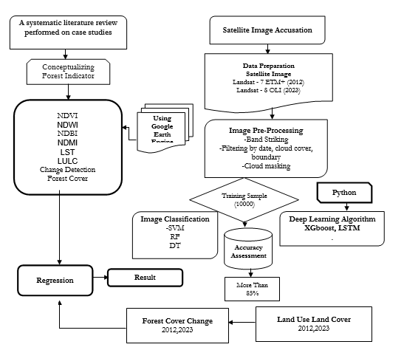
Python
Figure 1: Methodological Overview of the Research

2.1 Study Area
This analysis utilizes highly detailed, spatially structured data derived from various land use zones within Bangladesh, a country recognized as an agroecological hotspot in South Asia. Located between latitudes 20°34' and 26°38' N and longitudes 88°01' and 92°41' E (see Figure 2), Bangladesh encompasses a rich tapestry of coastal areas, wetlands, forests, and agricultural lands. Bangladesh covers the administrative area of approximately 147,570 square kilometers. Bangladesh shares border with India in west, north; and Myanmar in the southeastern part. In the southern part there is Bay of Bengal. The country's topography is characterized by a mixture of features, including flat alluvial plains in the central and coastal regions alongside hilly terrains in the southeast and northeast. A Landsat-based land use and land cover (LULC) change study conducted in the early 2000s highlighted Bangladesh's diverse terrain as a compelling case for analyzing LULC changes and their impacts, given its variable land uses and land cover types (Rai et al., 2017). Bangladesh's tropical monsoon climate significantly shapes its vegetation and agricultural cycles (Azad et al., 2022; Shahid, 2010).
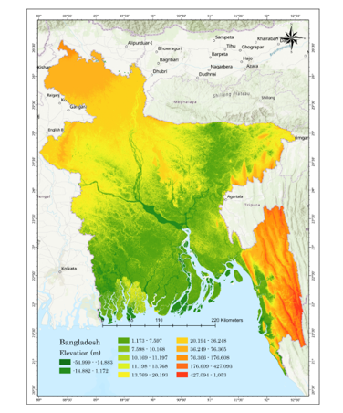
Figure 2: Study area Map of Bangladesh
2. Data
2.1 Data Sources
The study dataset integrates satellite-based imagery and global monitoring systems to track changes in forest cover and related environmental variables. The analysis employs multiple indices, such as the Normalized Difference Vegetation Index (NDVI) and Normalized Difference Moisture Index (NDMI), to assess forest health, moisture content, and built-up area impacts on forest landscapes. Table 1 outlines each dataset's specific data sources, resolutions, and descriptions.
Table 1: Data and Data source table
Data Type | Source | Spatial Resolution | Temporal Resolution | Description | Adapted Sources
NDVI | Landsat 7,8 | 30m | 16 days | Normalized Difference Vegetation Index (NDVI) quantifies vegetation health and density across time and space. | (28–30)
NDMI | Landsat 7,8 | 30m | 16 days | Normalized Difference Moisture Index (NDMI) monitors moisture content within vegetation and can detect drought stress. | (31–33)
NDBI | Landsat 7,8 | 30m | 16 days | Normalized Difference Built-Up Index (NDBI) helps identify urban and built-up areas within land use classifications. | (34–36)
LULC | Landsat, MODIS | 30m | Annual | Land Use/Land Cover (LULC) classification provides information on various land cover types (forest, agriculture, urban). | (37–39)
Forest Change | Global Forest Change dataset | 30m | Annual | Global Forest Change dataset monitors annual forest cover loss and gain globally, using consistent methods. | (40,41)
NDWI | Landsat 7,8 | 30m | 16 days | Normalized Difference Water Index (NDWI) detects waterbodies, aiding in identifying hydrological changes. | (42–44)

2.2 Preprocessing
To ensure accurate reflections of surface features atmospheric correction, geometric correction, and cloud removal (using the function of mask Fmask algorithm) were performed. Moreover, data normalization and dimensionality reduction were employed to scale features and mitigate computational complexity. To address the Scan Line Corrector (SLC-off) gaps in the 2012 Landsat 7 ETM+ imagery, a multi-temporal compositing approach was employed within Google Earth Engine. Specifically, we used the Mean/Median Reducer on a collection of images acquired throughout the target year. The data gaps in one scene were filled by valid pixels from overlapping scenes in the temporal stack by aggregating multiple scenes over the same geographic area.

2.3 LULC Classification
The Land Use and Land Cover (LULC) classification was a vital aspect of this study, which analyzed the spatial distribution and changes in land cover over time across Bangladesh (Table. 2). High-resolution satellite imagery from Landsat 7&8 (30m) and MODIS MCD12Q1 (500m) of <10% cloud cover from 2012 and to 2023 was taken selected for a detailed and accurate classification. The preprocessing involved atmospheric correction, radiometric calibration, and geometric alignment, ensuring the data were standardized and free from inconsistencies caused by atmospheric and sensor variations. For the training phase, a comprehensive dataset of 10,000 points was developed[user9.1] using the stratified random sampling strategy (stratified based on existing land cover maps to reduce bias towards dominant classes) on the ground truth data from visual interpretation of high-resolution Google Earth imagery and Landsat false-color composites, representing key land cover types, including waterbodies, built-up areas, barren land, vegetation, forest, and agricultural land. These points were carefully selected to account for the spectral diversity of each class, improving the classification accuracy. Several advanced algorithms were used to classify the LULC. Decision Trees and Support Vector Machines (SVM) were employed for their effectiveness in non-linear classification problems. Decision Trees provide a simple yet powerful way to partition data based on feature values. At the same time, SVM offers high accuracy by finding the optimal hyperplane that separates classes in feature space. Random Forest, an ensemble of decision trees, enhanced the classification's robustness and reduced overfitting by averaging predictions across multiple trees. Long Short-Term Memory (LSTM) networks, known for their ability to model sequential data, were applied to capture temporal dependencies in land cover changes, improving the detection of long-term patterns. XGBoost, a highly efficient gradient boosting algorithm, was also utilized for its speed and accuracy in handling large datasets. Its ability to correct errors iteratively and handle missing values made it ideal for this complex classification task. Post-processing techniques were applied to refine the classification results, reducing noise and enhancing the precision of the LULC maps. In Google Earth Engine, post-processing methods such as boundary smoothing, sieving to eliminate isolated pixels smaller than 0.5 ha, and majority filtering (3×3 kernel) were used to improve the spatial coherence of the LULC maps and lessen salt-and-pepper noise. Validation was conducted using a separate set of validation points to assess the models' accuracy, and metrics such as overall accuracy, user’s accuracy, producer’s accuracy, and the Kappa coefficient were calculated to ensure the reliability of the results.
Table 2: Description of Land Cover
LULC Type | Description
Waterbodies | Includes rivers, lakes, reservoirs, and other inundated areas.
Built-Up Areas | Areas covered by impervious surfaces like buildings, roads, and urban structures.
Barren Land | Areas with exposed soil, rocks, and minimal vegetation.
Vegetation | Includes grasslands, parks, and non-forest green areas.
Forest | Dense tree cover, including both natural and reforested areas.
Agricultural Land | Areas used for farming, including croplands and plantations.

2. 4 Change Detection Algorithms
In order to highlight cloud-based image processing and classification several change detection algorithms like Decision Trees (DT), Support Vector Machines (SVM), Random Forest (RF) machine learning algorithms; and XGBoost, Long Short-Term Memory (LSTM) deep learning algorithms were utilized in this study for identifying shifts in land use and land cover over time. In order to quantify changes between land cover classes, the final maps were compared pixel-by-pixel, with a focus on the dynamics of forest cover.

2.4.1 Traditional Machine Learning
Decision Trees (DT) are supervised learning models that iteratively divide data into groups using input feature values as criteria, resulting in a tree-like structure of decisions. In the context of LULC classification, DTs demonstrate effectiveness in tasks such as vegetation mapping, urban land classification, and land use change detection, primarily due to their simplicity and interpretability. They classify different land cover types based on spectral signatures derived from satellite imagery (Talukdar et al., 2020).
Support Vector Machines (SVM) are designed to find the optimal hyperplane that separates data into distinct classes while maximizing the margin between them. SVMs are particularly useful in LULC classification due to their ability to handle complex, non-linear decision boundaries and high-dimensional data. They effectively classify land cover types using a combination of spectral, textural, and contextual information extracted from remote sensing imagery, making them suitable for tasks such as land cover mapping, crop type classification, and change detection (Talukdar et al., 2020).
Random Forest (RF) is an ensemble learning algorithm aggregating predictions from multiple decision trees to enhance accuracy and robustness. RFs are adept at handling high-dimensional data and mitigating overfitting, providing reliable predictions across various applications. In LULC classification, RFs effectively classify land cover types by utilizing multi-spectral, temporal, and spatial features extracted from remote sensing data, making them valuable for land cover mapping, deforestation monitoring, and urban growth analysis (Rodrigues et al., 2020).

2.4.2 Deep Learning
XGBoost, or Extreme Gradient Boosting, is a robust machine learning algorithm that enhances computation speed and model accuracy through gradient boosting. Developed by Tianqi Chen, XGBoost constructs a series of decision trees, each aiming to correct its predecessor's errors. This method increases overall accuracy and reduces the risk of overfitting. Notably, XGBoost has shown significant efficacy in wildfire forecasting, as it can process extensive datasets from various sources, including meteorological and geospatial data, to predict fire occurrence and conditions effectively (Zhang et al., 2021).

Long Short-Term Memory (LSTM) networks are a specialized recurrent neural network (RNN) architecture designed to model sequences and time-series data. Unlike standard RNNs, LSTMs can learn long-term dependencies, making them particularly effective for tasks with crucial sequence context (Graves, 2012). In LULC classification, LSTMs are adept at analyzing temporal sequences in remote sensing data, enabling them to track variations in land cover across periods. Their application extends to crop monitoring, where they assess growth and health through time-series analysis of vegetation indices, and urban growth analysis, where they track expansion trends. By capturing and learning from temporal patterns in the data, LSTMs contribute to more accurate predictions, such as forecasting crop yield by analyzing sequences of remote sensing images throughout the growing season (Yuan & Ling, 2020). The temporal framework comprised a 12-step time series of spectral bands and indices (NDVI, NDMI, NDBI, and NDWI) made using annual median composites obtained from Landsat 7 and 8 imagery for every year from 2012 to 2023. In order to balance data accessibility, cloud-free coverage, and computational viability while enabling LSTM to capture inter-annual temporal correlations in forest cover dynamics, this annual structure was used.

2.3 Accuracy Assessment
The Land Use and Land Cover (LULC) classification accuracy was evaluated using an error matrix within the Google Earth Engine (GEE) environment. This matrix compared the classified LULC results with the validation points, allowing us to assess the model’s performance. For a robust evaluation, key metrics such as Kappa coefficient (K), overall accuracy (OA), user accuracy (UA), and producer accuracy (PA) were computed based on the confusion matrix. These accuracy measurements provide a thorough grasp of how well the model performed in distinguishing between different LULC classes, particularly considering variations in the quality of satellite images and the spatial distribution of the sample points.
The overall accuracy (OA) was computed by dividing the count of correctly classified pixels by the count of all reference pixels, as shown in Equation 2. User accuracy (UA) was determined for each LULC class by finding the proportion of accurately classified pixels in each category out of the overall reference pixel count in that class (Equation 3). Producer accuracy (PA) was also calculated for each class, measuring the proportion of reference pixels correctly classified, as per Equation 4. The Kappa coefficient (K) was also derived to account for the possibility of random agreement between the classified results and the reference data, calculated using Equation 5 (Fitzgerald & Lees, 1994).
The equations used for the accuracy assessment are as follows:
$$Overall accuracy= \frac{Total number of cor rected classified pixelx (diagonal)}{total number of reference pixels} *100 (2)$$
$$User Accuracy= \frac{number of cor rectly classified pixelxs in each catagory (diagonal}{total number of reference pixels in each category (row total)} *100 (3)$$
$$P.A= \frac{number of cor rectly classified pixelxs in each category (diagonal)}{total number of reference pixels in each category (column total)} *100 (4)$$
$$K.C(T)=\frac{Total number of Sample*Total Number of Cor rected Sample - \sum{\left(col.tot * row tot\right)}}{\left(Total number of Sample\right)2 - \sum{\left(col.tot * row tot\right)}} *100 (5)$$
Here P.A = Producer Accuracy
K.C (T) = Kappa Coefficient
Deep learning method like LSTM, was employed for the classification because of their superior capacity to capture complex spatial and temporal patterns in land cover data. These models were implemented using Python libraries and executed on Google Colab, where their performance was evaluated through Receiver Operating Characteristic (ROC) curves and the Area Under the Curve (AUC) metric. These metrics provided insight into the classification models' sensitivity and specificity, further validating the models' effectiveness in distinguishing between different LULC classes. The workflow was performed in the GEE platform and Python environment, including collecting training and validation points, classification, and accuracy assessments. The post-classification accuracy analysis provided a solid foundation for identifying LULC change patterns over time, allowing us to track land cover transitions from 2012 to 2023 (Figure 2).

3. results and discussion
The study presents the performance of various machine learning and deep learning algorithms applied to Land Use and Land Cover (LULC) classification and change detection in Bangladesh. Each algorithm's performance metrics were discussed, including overall accuracy, Kappa coefficient, and class-wise accuracy.
Performance of Machine Learning Algorithms
Table 1 summarizes the overall accuracy and Kappa coefficient for Decision Trees, Support Vector Machine (SVM), and Random Forest algorithms applied to LULC classification. Decision Trees achieved the highest overall accuracy of 87% with a Kappa coefficient of 82%, indicating its strong performance in classifying different LULC types. Random Forest exhibited a moderate overall accuracy of 70%, while SVM, despite being effective in specific applications, showed relatively lower performance with 67% overall accuracy and a Kappa coefficient of 65%. The observed lower performance of RF in this study may be explained by suboptimal hyperparameter tuning, high spectral similarity among some LULC classes in the complex Bangladeshi landscape, or the relatively small training sample size in relation to feature dimensionality, even though RF typically outperforms DT in ensemble settings due to variance reduction. These elements emphasize how crucial meticulous model optimization is in diverse settings.
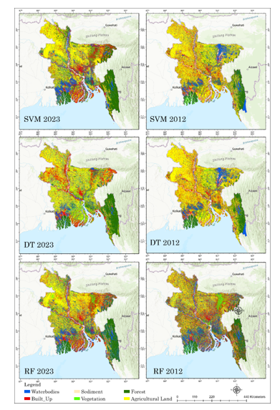
Figure 3: LULC classification Using Machine Learning Algorithm
This study compared the performance of three machine learning algorithms decision Trees, Support Vector Machine (SVM), and Random Forest for mapping Land Use/Land Cover (LULC) shown in (figure 3).
Decision Trees algorithm gave the best overall results, with an accuracy of 87% and a Kappa coefficient of 82. It was particularly good at classifying forest areas (92%) and waterbodies (90%), but it struggled the most with agricultural land (75%). The confusion matrix showed that Decision Trees correctly identified waterbodies (1840 points) and built-up areas (1700 points), but agricultural land was misclassified 100 times as other categories.
SVM algorithm had an overall accuracy of 67% and a Kappa coefficient of 65, which was lower than Decision Trees. SVM performed best on forest areas (80%) and vegetation (75%), but had trouble with built-up areas (60%) and agricultural land (55%). The confusion matrix revealed that agricultural land was often misclassified—233 times as barren land and 100 times as vegetation. It also had issues with correctly identifying waterbodies and built-up areas.
Random Forest algorithm performed better than SVM, with an overall accuracy of 70% and a Kappa coefficient of 65. It was especially good at classifying forest areas (82%) and vegetation (78%), while agricultural land was still the weakest category (65%). The confusion matrix for Random Forest showed fewer misclassifications than SVM. For example, 1367 points were correctly identified as forest, with fewer misclassifications than SVM.
Deep Learning Algorithms
Deep learning algorithm, LSTM was evaluated for LULC classification and change detection. LSTM demonstrated superior performance with an overall accuracy of 94%, outperforming XGBoost (93%), Random Forest (82%), and Decision Trees (87%). The ROC curve (Figure 4) for LSTM and XGBoost shows excellent sensitivity and specificity in predicting LULC classes. The LSTM model used a 12-step annual time series (2012–2023) built from median composites of Landsat 5, 8, and 9 images, even though the core LULC maps were created between 2012 and 2023. Compared to static models that handled each year separately, this temporal structure allowed LSTM to incorporate inter-annual dependencies in spectral indices and bands, providing contextual information that increased classification accuracy. In order to balance cloud-free data availability and computational efficiency in the Google Earth Engine environment, a modest temporal depth was chosen.
Receiver Operating Characteristic (ROC) curves and Area Under the Curve (AUC) under the one-vs-rest (OvR) method, which calculates a distinct ROC curve for each class versus all others, were used to further assess the model's performance for the multiclass LULC classification. Strong discriminative capacity was confirmed by this approach's high AUC values (ranging from 0.92 to 0.98 across classes), especially for the LSTM and XGBoost models.

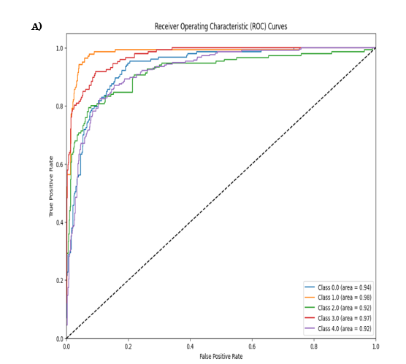
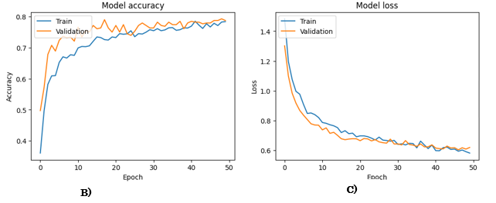
Figure 4: ROC Curve for Deep Learning Algorithms
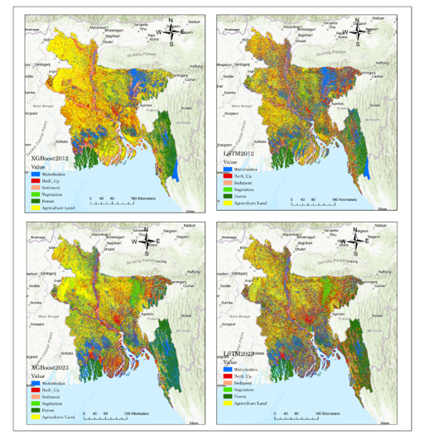
Figure 5: LULC Classification Using Deep Learning Algorithm
Selecting the Best Algorithm for Change Detection
In the context of change detection, LSTM emerged as the best-performing algorithm (Figure 7), achieving an overall accuracy of 94%, which significantly outperformed other machine learning methods, including Random Forest (Figure 6) and Decision Trees. LSTM's ability to capture complex temporal dependencies makes it particularly suitable for detecting changes in forest cover over time. XGBoost, with an accuracy of 93% (Figure 5), also demonstrated robust performance but was slightly less effective than LSTM in this specific application. Support Vector Machine (SVM), with an accuracy of 70%, lagged in this task. LSTM's superior accuracy and ability to model temporal patterns in the data make it the preferred choice for accurate change detection and forecasting in Bangladesh’s forest ecosystems.
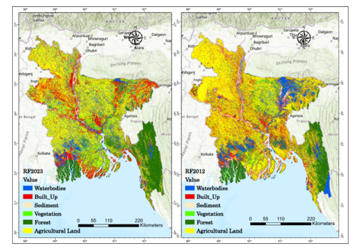
Figure 6: Best Machine Learning Algorithm for LULC Classification
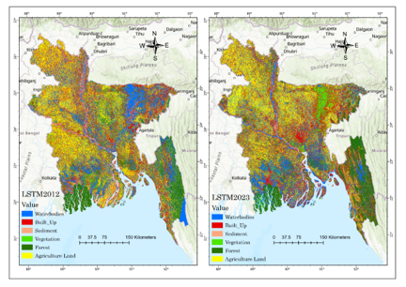
Figure 7: Best Machine Learning Algorithm for LULC Classification

Figure 8: Total Land cover area in sqkm in 2023
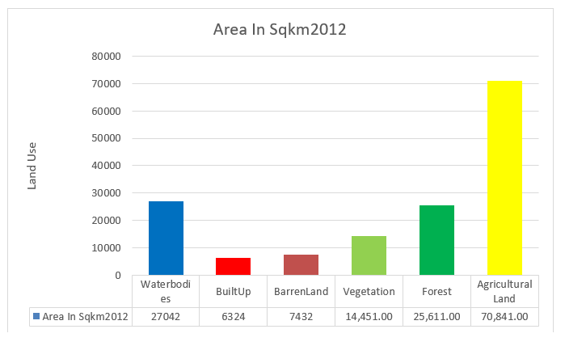
Figure 9: Total Land cover area in sqkm in 2012
The land-use analysis of Bangladesh between 2012 and 2023 shows (Figure 8 and Figure 9) significant changes in both environmental and human activities, highlighting challenges for sustainable development. Waterbodies grew from 27,042 km² to 28,038.3 km², possibly due to natural expansion or human interventions like reservoirs and better water management, although further investigation is required to establish causal relationships. Built-up areas increased from 6,324 km² to 7,378.5 km², reflecting rapid urbanization driven by population growth and economic development. At the same time, barren land decreased from 7,432 km² to 2,632 km², likely due to reforestation or redevelopment efforts. However, there was a worrying decline in forest cover, which dropped from 25,611 km² to 23,611.2 km², and vegetation areas fell from 14,451 km² to 12,493 km², pointing to deforestation and habitat loss. Agricultural land grew slightly from 70,841 km² to 73,785 km², reflecting efforts to meet rising food demands.
These changes show the complex relationship between human activities and environmental shifts, raising concerns about Bangladesh's land-use practices' sustainability. The expansion of urban and agricultural areas and the decline of natural habitats highlight the need for sustainable land management to balance environmental protection with socioeconomic growth.
To understand these dynamics further, a detailed forest cover change analysis was done using satellite data from Landsat, MODIS, and the Global Forest Change dataset. Vegetation indices like NDVI, NDMI, and NDBI were calculated to assess vegetation health and land characteristics. The study also used regression analysis to link vegetation indices with forest cover changes. The results revealed strong correlations, suggesting that satellite-derived indices can help predict forest cover changes, which is crucial for addressing deforestation and habitat degradation in Bangladesh

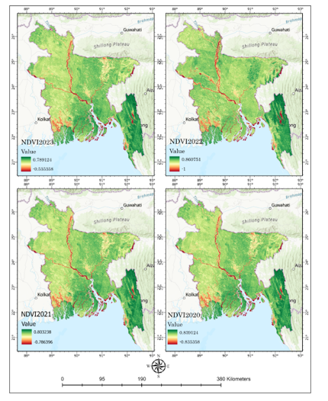
Figure 10: Normalized Vegetation Index from year 2023 to 2020
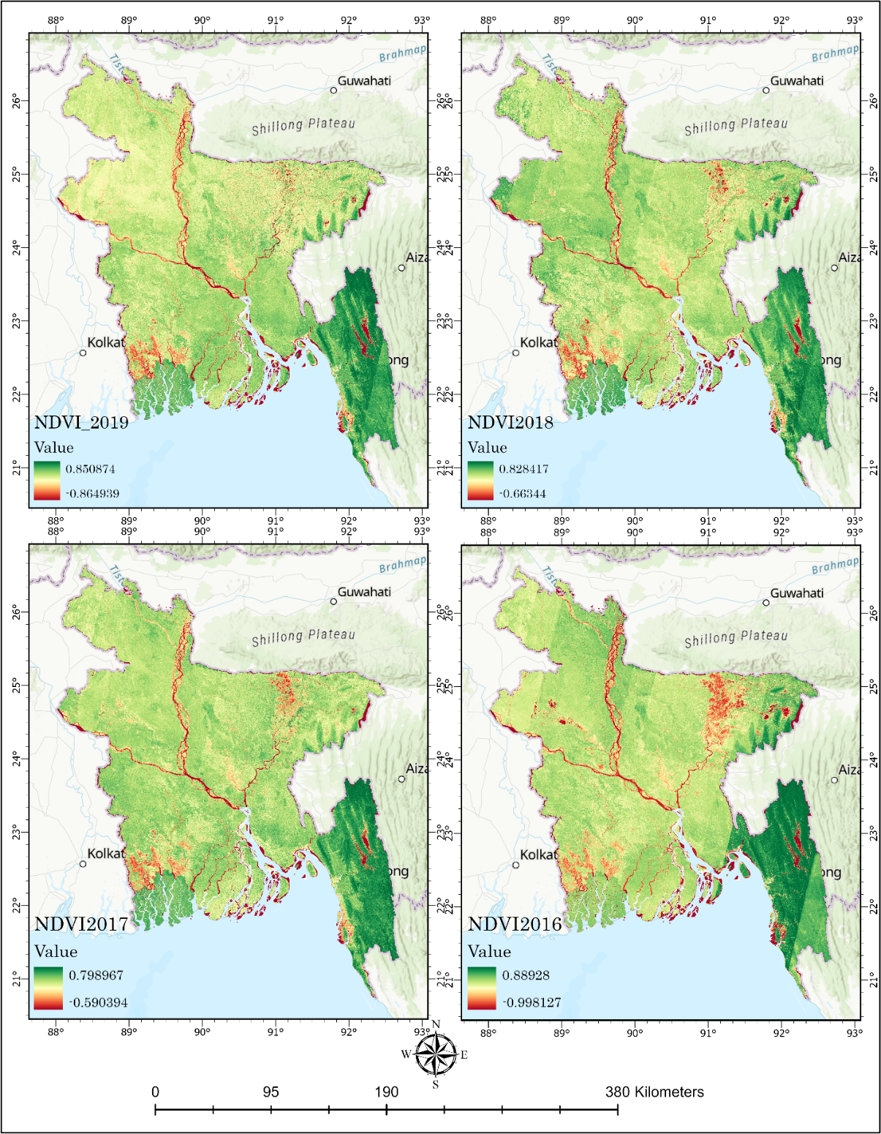
Figure 11: Normalized Vegetation Index from year 2019 to 2016

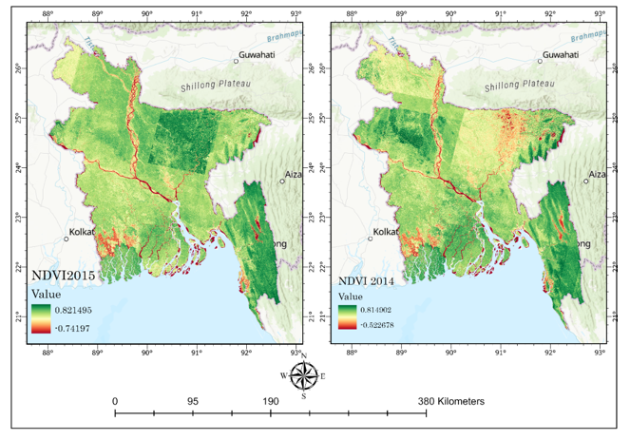
Figure 12: Normalized Vegetation Index from year 2015 to 2014
This analysis looks at changes in key environmental indices between 2012 and 2023 shows in (Figure 10-12) and how they relate to forest cover in Bangladesh. The NDVI ranged (Table 3) from -0.356 to 0.714 in 2012 and -0.317 to 0.712 in 2023, showing shifts in vegetation health linked to changes in forest cover. The Normalized Difference Built-Up Index (NDBI) increased from -0.192 to 0.694 in 2012 to -0.314 to 0.673 in 2023, reflecting urban growth driven by population increase and infrastructure expansion, which likely put pressure on nearby forests. The NDWI ranged from -0.614 to 0.447 in 2012 and -0.613 to 0.427 in 2023, indicating changes in water distribution that may influence forest habitats. Similarly, the NDMI ranged from 0.447 to 0.694 in 2012 and from -0.314 to 0.673 in 2023, suggesting shifts in moisture levels that are important for forest health, especially during drought or deforestation.

Table 3: Normalized Difference Vegetation Index (NDVI) from year 2012-2023
Indices | Year | Minimum Value | Maximum Value
NDVI | 2012 | -0.35634 | 0.713778
NDBI | 2012 | -0.192409 | 0.69375
NDWI | 2012 | -0.614147 | 0.446722
NDMI | 2012 | 0.446722 | 0.69374
NDVI | 2023 | -0.316794 | 0.71212
NDBI | 2023 | -0.313627 | 0.673196
NDWI | 2023 | -0.61296 | 0.42696
NDMI | 2023 | -0.313627 | 0.67319
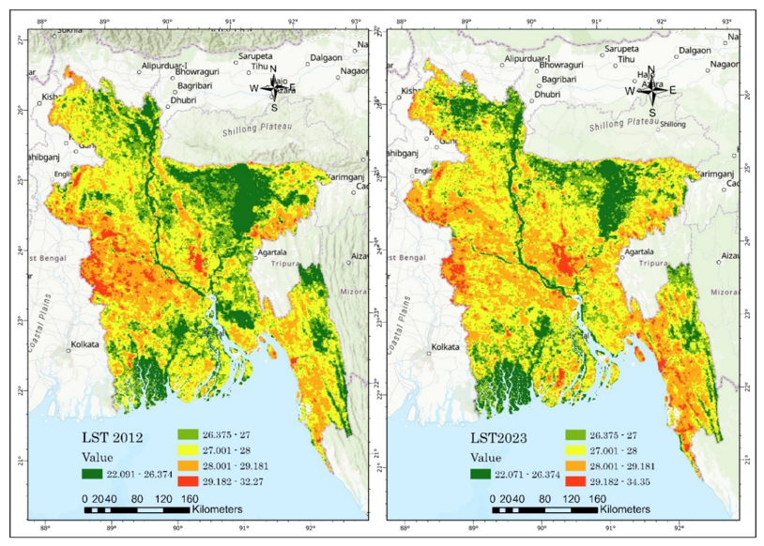
Figure 13: Land Surface Temperature map in between 2012 and 2023
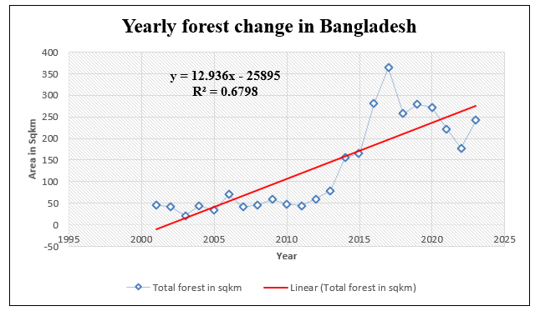
Figure 14: Forest Change Correlation graph
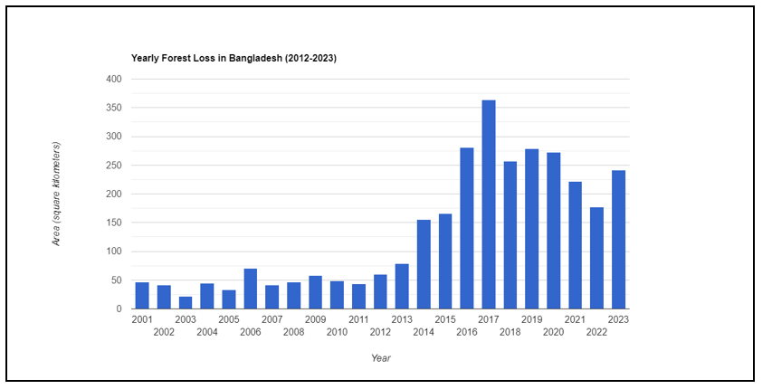
Figure 15: Overall Forest cover change map from 2001 to 2023
The forest change dynamics in Bangladesh between 2000 and 2023 were analyzed using the post-classification comparison to assess the patterns of forest loss and gain. The data reveals significant fluctuations in forest cover, with a marked decline in forested areas, particularly between 2012 and 2023 (Figure 15). In 2012, the forest loss was recorded at 59.675 square kilometers, signaling the beginning of a concerning downward trend. This decline accelerated in the following years, peaking in 2017 with a substantial loss of 363.608 square kilometers. Despite minor fluctuations, the forest loss remained high, exceeding 200 square kilometers annually in subsequent years. By 2023, the total forest loss had reached 241.735 square kilometers. These results highlight the urgent need for conservation strategies and sustainable land management practices to mitigate ongoing forest degradation. The preservation of forest ecosystems is critical for maintaining biodiversity and supporting the ecological services necessary for environmental stability and the livelihoods of local communities.

Regression Analysis and Results
The relationship between environmental indices and forest cover in Bangladesh from 2012 to 2023 was investigated using multiple linear regression analysis (Figure 14) . The analysis utilized a dataset incorporating various environmental indices: the Normalized Difference Water Index (NDWI2023), Normalized Difference Built-Up Index (NDBI_2023), Normalized Difference Vegetation Index (NDVI_2023), Normalized Difference Moisture Index (NDMI_2023), and Land Surface Temperature (LST2023) (Figure 13), with forest cover in 2023 as the dependent variable. The dataset was divided into a training set (80%) and a testing set (20%) to facilitate model development and validation. A linear regression model was developed and trained on the training dataset. The model was then used to predict forest cover values for the testing dataset, with the model's accuracy assessed using mean squared error (MSE). The total model explained 68.4% of the variation in forest cover (adjusted R² = 67.1%) and was statistically significant (F-statistic = 145.67, p < 0.001).The resulting regression equation is:
ForestCover2023 = 90.01 + 344.34 * NDWI2023 + 0.88 * NDBI_2023 + 413.35 * NDVI_2023 + 0.88 * NDMI_2023 - 4.48 * LST2023

Table 4 presents each variable's coefficients, statistical significance, and standard errors. The results indicate that NDVI and NDWI are significant predictors of forest cover, with positive associations suggesting that areas with higher vegetation density and greater water availability tend to have higher forest cover. Conversely, the negative coefficient for LST suggests that higher temperatures harm forest health. The regression findings underscore the complex relationship between environmental factors and forest cover dynamics, highlighting the importance of water availability and vegetation density in shaping forest ecosystems in Bangladesh.
NDWI2023 and NDVI2023 had a significant negative connection (r = -0.99) according to correlation analysis of the independent variables. According to the NDVI, pixels with higher water content tended to have lower vegetation density within the research area. But rather than being a general biological concept, this pattern is probably context-dependent, reflecting Bangladesh's abundance of wetlands, open water bodies, and flooded agricultural areas. Furthermore, modest positive correlations were found between NDWI, NDBI, and NDMI, suggesting that water availability may interact with urbanization and moisture content in complex ways. These insights contribute to a more nuanced understanding of the environmental drivers of forest change in Bangladesh, emphasizing the need for integrated land-use planning and effective conservation strategies.
Table 4: The coefficients and their statistical significance
Variable | Coefficient | Std. Error | t-value | p-value
const | 90.01 | 18.80 | 4.79 | <0.001
NDWI2023 | 344.34 | 49.73 | 6.92 | <0.001
NDBI_2023 | 0.88 | 6.26 | 0.14 | 0.888
NDVI_2023 | 413.35 | 45.83 | 9.02 | <0.001
NDMI_2023 | 0.88 | 6.26 | 0.14 | 0.888
LST2023 | -4.48 | 0.66 | -6.80 | <0.001
Figure 16: Correlation plot of Relation between forest change and Environmental Indicators
The correlation matrix (Figure 16) provides valuable insights into the relationships among environmental variables and their implications for forest cover dynamics. A striking observation is the strong negative correlation (-0.99) between NDWI2023 and NDVI2023, which suggests that areas with higher water content tend to have lower vegetation density. However, the high correlation suggests potential multicollinearity, which was considered during model fitting. Variance inflation factors (VIF) were examined and the value was found to be VIF>5, suggesting multicollinearity not to be severe. This finding aligns with ecological patterns, where reduced water availability often corresponds to vegetation decline, indicating potential risks of deforestation or ecosystem degradation in water-scarce regions. Moderate positive correlations between NDWI2023, NDBI2023, and NDMI2023 reveal more intricate interactions. While not strong, these relationships hint at connections between water availability and urbanization or moisture stress. Such patterns may reflect scenarios where urban development expands into water-rich areas or agricultural activities occur in regions experiencing moisture stress. On the other hand, weak negative correlations between NDVI2023 and NDBI2023 and NDMI2023 indicate that areas with higher vegetation density are less affected by urbanization and moisture stress. These trends highlight healthier forest ecosystems, where human activities such as urbanization or intensive agriculture exert minimal influence.

4. Discussion

This study provides important insights into Bangladesh's changing forest cover dynamics, using machine learning and satellite data from Google Earth Engine. We obtained a high classification accuracy of 94% by using the Long Short-Term Memory (LSTM) model on a 12-step annual time series taken from Landsat images (2012–2023), surpassing conventional machine learning techniques like Decision Trees (87%). In the context of this work, this improvement shows how LSTM can capture inter-annual temporal trends in spectral indices and bands, improving the identification of changes in forest cover over a 12-year period in Bangladesh. From 25,611 km² in 2012 to 23,611.2 km² in 2023, our data show a worrying decrease in forest cover. The observed rise in built-up areas and agricultural land during the same era suggests that this decline is probably related to concurrent urbanization, agricultural growth, and infrastructure development. However, further socioeconomic and policy-related research would be necessary to show direct causal linkages. A particularly steep decline in forest cover occurred in 2017, coinciding with rapid urban growth and agricultural land conversion. These trends highlight the urgent need for sustainable land management practices to counterbalance deforestation and its negative effects on biodiversity and ecosystem services. The analysis also explored the relationship between key ecological indices, such as NDVI, NDBI, and NDWI, and forest cover loss. The NDVI2023 and forest cover showed a somewhat favorable connection (r = 0.46), suggesting that regions with better vegetation density and health tended to preserve more forest cover. This association supports the use of NDVI as a helpful indicator of forest condition in the research area and is consistent with ecological predictions. Additionally, the rise in NDBI values points to the increasing impact of urbanization on forested areas, reinforcing the importance of integrated planning for sustainable land use. This research contributes to the broader understanding of forest cover dynamics in Bangladesh, offering valuable insights for policymakers looking to protect forests and promote sustainable development. This study illustrates the efficacy of cloud-based geospatial technology for scalable, multi-temporal analysis and precise detection of forest cover dynamics in data-intensive environmental management by combining machine learning algorithms with Google Earth Engine-based satellite monitoring. Looking ahead, further research should explore the socio-economic drivers behind land use changes and examine how climate variability impacts forest ecosystems. Expanding this work spatially and temporally will provide a more detailed picture of forest cover trends across Bangladesh, supporting more effective conservation strategies.

5. Conclusion
This study examined the dynamics of forest cover in Bangladesh over the past decade, providing critical insights into the causes and patterns of forest loss. The findings reveal a worrying decline in forest cover, primarily driven by urban expansion, agricultural growth, and infrastructure development. By applying the Long Short-Term Memory (LSTM) model, we achieved a high level of accuracy in classifying land cover, demonstrating its effectiveness in capturing complex patterns from satellite imagery. The study also found a significant link between forest loss and changes in vegetation health, as indicated by the NDVI. This highlights the importance of monitoring vegetation as a key indicator of ecosystem health and sustainability. The results stress the urgent need for conservation efforts, including better land management practices and reforestation, to combat deforestation and protect biodiversity. These findings underscore policymakers' importance in prioritizing forest conservation and sustainable development. More research is needed to understand the socio-economic factors influencing land use and how climate change may affect forest ecosystems. Ultimately, using data and technology to inform decisions, this research contributes to the ongoing effort to safeguard Bangladesh's natural resources for future generations.

Declarations

All authors have read, understood, and have complied as applicable with the statement on "Ethical responsibilities of Authors" as found in the Instructions for Authors.

Disclaimer (Artificial intelligence)
Author(s) hereby declare that NO generative AI technologies such as Large Language Models (ChatGPT, COPILOT, etc.) and text-to-image generators have been used during the writing or editing of this manuscript.

References

Ahmed, B. (2019). Environmental governance and sustainable development in Bangladesh: Millennium development goals and sustainable development goals. Asia Pacific Journal of Public Administration, 41(4), 237–245. https://doi.org/10.1080/23276665.2019.1698930
Ai, J., Zhang, C., Chen, L., & Li, D. (2020). Mapping annual land use and land cover changes in the Yangtze estuary region using an object-based classification framework and Landsat time series data. Sustainability, 12(2), 659.
Al Faruq, M. A., Zaman, S., & Katoh, M. (2017). Perceptions of local people toward community development and forest conservation in Bangladesh: The case of Sal forests. Journal of Forest Planning, 22(1), 1.
Aung, T. S., Overland, I., Vakulchuk, R., & Xie, Y. (2021). Using satellite data and machine learning to study conflict-induced environmental and socioeconomic destruction in data-poor conflict areas: The case of the Rakhine conflict. Environmental Research Communications, 3(2), 025005.
Azad, Md. A. K., Islam, A. R. Md. T., Ayen, K., Rahman, Md. S., Shahid, S., & Mallick, J. (2022). Changes in monsoon precipitation patterns over Bangladesh and its teleconnections with global climate. Theoretical and Applied Climatology, 148(3–4), 1261–1278. https://doi.org/10.1007/s00704-022-03996-8
Babalola, T. S., Ogunleye, K. S., Lawal, J. A., & Ilori, A. O. A. (2021). An Assessment of Degradation of Soil Properties in Kabba College of Agriculture, Kogi State, Nigeria. Nigerian Journal of Environmental Sciences and Technology (NIJEST) Vol, 5(1), 102–109.
Bai, X., McPhearson, T., Cleugh, H., Nagendra, H., Tong, X., Zhu, T., & Zhu, Y.-G. (2017). Linking Urbanization and the Environment: Conceptual and Empirical Advances. Annual Review of Environment and Resources, 42(1), 215–240. https://doi.org/10.1146/annurev-environ-102016-061128
Biswas, S., & Choudhury, J. (2007). Forest and Forestry in Bangladesh: The question of sustainability. International Forestry Review.
Clark, M. L., Roberts, D. A., Ewel, J. J., & Clark, D. B. (2011). Estimation of tropical rain forest aboveground biomass with small-footprint lidar and hyperspectral sensors. Remote Sensing of Environment, 115(11), 2931–2942. https://doi.org/10.1016/j.rse.2010.08.029
De Jong, W., Liu, J., & Youn, Y.-C. (2017). Land and forests in the Anthropocene: Trends and outlooks in Asia. Forest Policy and Economics, 79, 17–25.
Ejenma, E., Durumbah-Obi, F. M., Falana, O., & Susan, A. (2023). Analysis of Land Use and Land Cover Changes in Owerri Municipal and Its Environs, Imo State, Nigeria (2005–2015). Journal of Geography, Environment and Earth Science International, 27(5), 25–35.
Ericksen, N. J., Ahmad, Q. K., & Chowdhury, A. R. (1993). Socio-economic implications of climate change for Bangladesh. Citeseer. https://citeseerx.ist.psu.edu/document?repid=rep1&type=pdf&doi=2089d4eef5f00c41b742f1355ebc6c7f88931ca7
Fitzgerald, R. W., & Lees, B. G. (1994). Assessing the classification accuracy of multisource remote sensing data. Remote Sensing of Environment, 47(3), 362–368.
Giam, X. (2017). Global biodiversity loss from tropical deforestation. Proceedings of the National Academy of Sciences, 114(23), 5775–5777. https://doi.org/10.1073/pnas.1706264114
Grantham, H. S., Duncan, A., Evans, T. D., Jones, K. R., Beyer, H. L., Schuster, R., Walston, J., Ray, J. C., Robinson, J. G., & Callow, M. (2020). Anthropogenic modification of forests means only 40% of remaining forests have high ecosystem integrity. Nature Communications, 11(1), 5978.
Graves, A. (2012). Long Short-Term Memory. In A. Graves, Supervised Sequence Labelling with Recurrent Neural Networks (Vol. 385, pp. 37–45). Springer Berlin Heidelberg. https://doi.org/10.1007/978-3-642-24797-2_4
Hansen, M. C., Stehman, S. V., Potapov, P. V., Loveland, T. R., Townshend, J. R. G., DeFries, R. S., Pittman, K. W., Arunarwati, B., Stolle, F., Steininger, M. K., Carroll, M., & DiMiceli, C. (2008). Humid tropical forest clearing from 2000 to 2005 quantified by using multitemporal and multiresolution remotely sensed data. Proceedings of the National Academy of Sciences, 105(27), 9439–9444. https://doi.org/10.1073/pnas.0804042105
He, X., Ziegler, A. D., Elsen, P. R., Feng, Y., Baker, J. C., Liang, S., Holden, J., Spracklen, D. V., & Zeng, Z. (2023). Accelerating global mountain forest loss threatens biodiversity hotspots. One Earth, 6(3), 303–315.
Islam, Md. S., Uddin, Md. A., & Hossain, M. A. (2021). Assessing the dynamics of land cover and shoreline changes of Nijhum Dwip (Island) of Bangladesh using remote sensing and GIS techniques. Regional Studies in Marine Science, 41, 101578. https://doi.org/10.1016/j.rsma.2020.101578
Lu, Y., Yang, J., & Ma, S. (2021). Dynamic changes of local climate zones in the Guangdong–Hong Kong–Macao greater bay area and their spatio-temporal impacts on the surface urban heat island effect between 2005 and 2015. Sustainability, 13(11), 6374.
McKenna, M. F. (2020). The sounds around us. Physics Today, 73(1), 28–34. https://doi.org/10.1063/PT.3.4387
Muzaffar, S. B., Islam, M. A., Kabir, D. S., Khan, M. H., Ahmed, F. U., Chowdhury, G. W., Aziz, M. A., Chakma, S., & Jahan, I. (2011). The endangered forests of Bangladesh: Why the process of implementation of the Convention on Biological Diversity is not working. Biodiversity and Conservation, 20(7), 1587–1601. https://doi.org/10.1007/s10531-011-0048-6
Nath, T. K., Jashimuddin, M., & Inoue, M. (2020). Achieving sustainable development goals through participatory forest management: Examples from SOUTH‐EASTERN BANGLADESH. Natural Resources Forum, 44(4), 353–368. https://doi.org/10.1111/1477-8947.12209
Potapov, P., Siddiqui, B. N., Iqbal, Z., Aziz, T., Zzaman, B., Islam, A., Pickens, A., Talero, Y., Tyukavina, A., & Turubanova, S. (2017). Comprehensive monitoring of Bangladesh tree cover inside and outside of forests, 2000–2014. Environmental Research Letters, 12(10), 104015.
Rahman, M. M. (2021). Assessing the progress and pitfalls of the Ministry of Environment, Forest, and Climate Change in achieving SDGs in Bangladesh. Bangladesh Journal of Public Administration, 29(2), 140–158.
Rahman, S. (2016). Impacts of climate change, agroecology and socio-economic factors on agricultural land use diversity in Bangladesh (1948–2008). Land Use Policy, 50, 169–178.
Rai, R., Zhang, Y., Paudel, B., Li, S., & Khanal, N. R. (2017). A synthesis of studies on land use and land cover dynamics during 1930–2015 in Bangladesh. Sustainability, 9(10), 1866.
Redowan, M., Akter, S., & Islam, N. (2014). Analysis of forest cover change at Khadimnagar National Park, Sylhet, Bangladesh, using Landsat TM and GIS data. Journal of Forestry Research, 25(2), 393–400. https://doi.org/10.1007/s11676-014-0467-9
Rodrigues, M. A. A., Bendini, H. N., Soares, A. R., Körting, T. S., & Fonseca, L. M. G. (2020). Remote sensing image time series metrics for distinction between pasture and croplands using the random forest classifier. 2020 IEEE Latin American GRSS & ISPRS Remote Sensing Conference (LAGIRS), 149–154. https://ieeexplore.ieee.org/abstract/document/9165671/
Salam, Md. A., & Noguchi, T. (1998). Factors Influencing the Loss of Forest Cover in Bangladesh: An Analysis from Socioeconomic and Demographic Perspectives. Journal of Forest Research, 3(3), 145–150. https://doi.org/10.1007/BF02762135
Sano, E. E., Rizzoli, P., Koyama, C. N., Watanabe, M., Adami, M., Shimabukuro, Y. E., Bayma, G., & Freitas, D. M. (2021). Comparative analysis of the global forest/non-forest maps derived from SAR and optical sensors. Case studies from Brazilian Amazon and Cerrado biomes. Remote Sensing, 13(3), 367.
Shahid, S. (2010). Recent trends in the climate of Bangladesh. Climate Research, 42(3), 185–193.
Talukdar, S., Singha, P., Mahato, S., Pal, S., Liou, Y.-A., & Rahman, A. (2020). Land-use land-cover classification by machine learning classifiers for satellite observations—A review. Remote Sensing, 12(7), 1135.
Tiefenbacher, J. P., & Poreh, D. (2020). Spatial Variability in Environmental Science: Patterns, Processes, and Analyses. BoD – Books on Demand.
Tsujino, R., Yumoto, T., Kitamura, S., Djamaluddin, I., & Darnaedi, D. (2016). History of forest loss and degradation in Indonesia. Land Use Policy, 57, 335–347.
UNEP, F. (2020). The state of the world’s forests 2020. In Forests, biodiversity and people (p. 214). FAO Rome, Italy.
Weiskopf, S. R., Rubenstein, M. A., Crozier, L. G., Gaichas, S., Griffis, R., Halofsky, J. E., Hyde, K. J., Morelli, T. L., Morisette, J. T., & Muñoz, R. C. (2020). Climate change effects on biodiversity, ecosystems, ecosystem services, and natural resource management in the United States. Science of the Total Environment, 733, 137782.
Yuan, C. Z., & Ling, S. K. (2020). Long Short-Term Memory Model Based Agriculture Commodity Price Prediction Application. Proceedings of the 2020 2nd International Conference on Information Technology and Computer Communications, 43–49. https://doi.org/10.1145/3417473.3417481
Zhang, L., Bian, W., Qu, W., Tuo, L., & Wang, Y. (2021). Time series forecast of sales volume based on XGBoost. Journal of Physics: Conference Series, 1873(1), 012067. https://iopscience.iop.org/article/10.1088/1742-6596/1873/1/012067/meta

