Integrating Social–Ecological Systems and SEM-PLS Analysis in Formulating Sustainable Marine Ecotourism Development Strategies: Evidence from Lihaga Island, North Sulawesi, Indonesia

ABSTRACT

Marine ecotourism has emerged as a tourism development approach that seeks to balance marine ecosystem conservation, local community well-being, and long-term economic sustainability. The Social–Ecological Systems (SES) framework developed by Ostrom and McGinnis provides an analytical approach for understanding the complex interactions between ecological and social components within natural resource management systems. This study aims to formulate sustainable marine ecotourism development strategies on Lihaga Island by applying a Social–Ecological Systems (SES) framework in combination with Structural Equation Modeling–Partial Least Squares (SEM-PLS) analysis. The SES framework is employed to examine the interlinkages among resource systems, resource units, governance structures, and actors, while SEM-PLS is used to test the structural relationships among latent variables influencing the sustainability of marine ecotourism. The results indicate that although Lihaga Island possesses high ecological potential and strong tourism appeal, the sustainability of its development is constrained by weak governance, limited infrastructure, and insufficient integration of local communities into the marine ecotourism value chain. The recommended strategies include strengthening collaborative governance, protecting and rehabilitating coastal ecosystems, and promoting community-based economic empowerment through ecotourism initiatives. These findings are expected to provide a scientific basis for the formulation of marine ecotourism management policies in small island regions of Indonesia.
Keywords: Marine ecotourism; social–ecological systems; SEM-PLS; governance; sustainability

1. INTRODUCTION
Ecotourism represents a form of sustainable tourism that emphasizes environmental conservation, environmental education, and the active involvement of local communities in tourism planning and management (Ghaderi et al., 2022). In the context of coastal areas and small islands, marine ecotourism is widely regarded as a strategic instrument for stimulating local economic growth without compromising the ecological functions of marine ecosystems, such as coral reefs, seagrass meadows, and mangrove forests (Spalding et al., 2017). However, numerous studies have demonstrated that marine tourism development lacking strong, science-based governance frameworks may lead to environmental degradation and social inequities (Bawole, Raharjo, Tebaiy, Yuminarti, Kaber, Mudijrahayu, et al., 2026; Bawole, Raharjo, Tebaiy, Yuminati, et al., 2026; Hall, 2019). Small island contexts exacerbate these vulnerabilities due to limited spatial extent, high dependency on natural resources, and exceptional sensitivity to environmental disturbances (Klöck & Nunn, 2023). Sustainable marine ecotourism management must therefore integrate ecological assessments with social elements as tourism stakeholders in management processes, ultimately generating benefits for the economic sector while maintaining ecosystem integrity (Manembu et al., 2026).
The Social–Ecological Systems (SES) framework developed by Ostrom and McGinnis provides an analytical approach for understanding the complex interactions between ecological and social components within natural resource management systems (McGinnis & Ostrom, 2014). This framework is particularly relevant to marine ecotourism development, as its sustainability is strongly determined by the balance between resource utilization and the social and institutional capacities required for effective management (Partelow, 2018). In addition, the application of quantitative methods such as Structural Equation Modeling–Partial Least Squares (SEM-PLS) enables the examination of causal relationships among multidimensional and complex latent variables (Hair et al., 2017; Sarstedt et al., 2021). Both social–ecological systems analysis and social–technical systems analysis highlights the interconnectedness of human and environmental systems in marine space utilization. These approaches acknowledge the complexity of marine space use by incorporating diverse stakeholders, technological advancements, and environmental considerations. Both frameworks emphasize the significance of contextual knowledge, recognizing the unique social, economic, and environmental contexts of each marine area. Notably, social–technical systems research underscores the integration of social–ecological analysis with social–technical systems to address the environmental, social, and technological dimensions of marine space (Liu et al., 2025).
Lihaga Island, located in North Minahasa Regency, North Sulawesi Province, possesses considerable marine ecotourism potential, particularly for snorkeling, diving, and beach-based tourism activities (Bawole et al., 2026a). Nevertheless, the utilization of this potential continues to face several challenges, including limited infrastructure, suboptimal governance arrangements, and low levels of local community involvement in management processes and benefit distribution (Bawole et al., 2026c, in press). Based on these conditions, this study aims to analyze the integration of SES components and Structural Equation Modeling–Partial Least Squares (SEM-PLS) in the development of marine ecotourism on Lihaga Island and to formulate sustainable management strategies.

2. RESEARCH METHODS

2.1 Social–Ecological Systems Conceptual Framework
This study employs the SES framework, which consists of four main subsystems: the resource system, resource units, governance system, and actors (McGinnis & Ostrom, 2014). These subsystems are analyzed to identify the key factors influencing the sustainability of marine ecotourism development on Lihaga Island (Bawole et al., 2024; Bawole et al., 2026a; Bawole, et al., 2026b). The integrative application of the Social–Ecological Systems (SES) framework and Structural Equation Modeling–Partial Least Squares (SEM-PLS) in sustainable marine ecotourism development on Lihaga Island provides a robust, evidence-based foundation for addressing the complex interactions among ecological, social, economic, and institutional dimensions of small-island systems. This integration moves beyond conceptual analysis by functioning as a practical decision-support approach that enables adaptive, context-specific strategy formulation grounded in empirical data.
In practice, the SES framework is first employed to systematically map key system components, including ecological resources, actors, governance arrangements, and the broader socio-economic context, thereby revealing causal relationships, feedback loops, and trade-offs between conservation and tourism use. These SES-derived relationships are subsequently operationalized through SEM-PLS to quantitatively test the influence of critical latent constructs—such as ecological condition, community participation, governance effectiveness, and local economic benefits—on sustainable marine ecotourism outcomes. This approach enables the identification of leverage variables and priority pathways based on statistically validated direct and indirect effects.
The integration of SES and SEM-PLS facilitates the formulation of phased and prioritized management strategies, where empirically dominant factors—such as coral reef health or institutional effectiveness—serve as strategic entry points for intervention. Moreover, the SEM-PLS model can be periodically updated to reflect changing social–ecological conditions, supporting adaptive management and long-term system resilience. As demonstrated by the Lihaga Island case, this integrative framework offers a transferable model for sustainable marine ecotourism development across small islands in Indonesia, ensuring alignment between ecosystem conservation objectives and local community well-being (Bawole, et al., 2026a).

2.2 Study Area
Administratively, Lihaga Island is located in North Minahasa Regency, North Sulawesi Province, Indonesia (Figure 1). The island is an uninhabited small island surrounded by highly transparent waters and relatively healthy coral reef ecosystems, making it a major attraction for marine tourism activities (Bawole et al., 2024; Bawole, et al., 2026a). The economic activities of communities in areas surrounding Lihaga Island, particularly Gangga Island, are predominantly based on small-scale capture fisheries, with tourism increasingly emerging as an alternative source of income. From an ecological perspective, the coastal ecosystems of Lihaga Island are highly vulnerable to anthropogenic pressures, including increasing tourist visitation and fishing activities (Bawole et al., 2026b in Pres). Consequently, marine ecotourism development on the island requires a management approach grounded in environmental carrying capacity assessments and the precautionary principle (Bawole et al., 2026b in press).

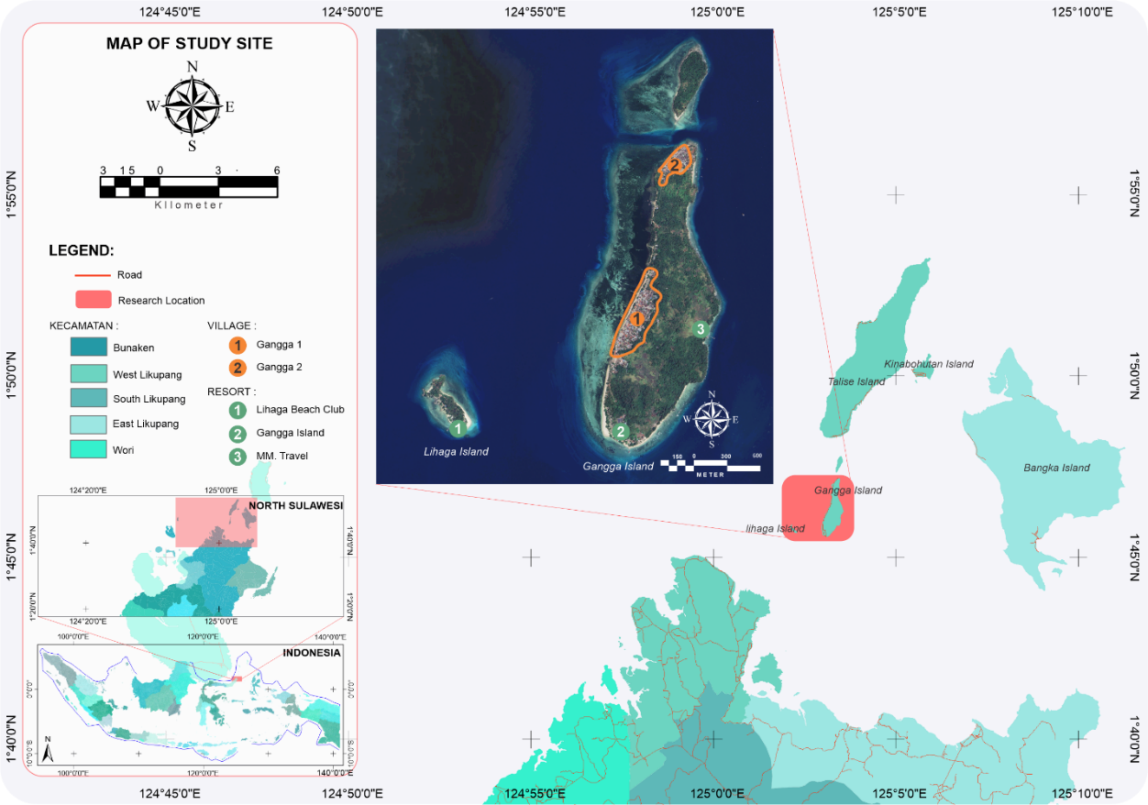
Fig 1. Map of the study area.

2.3 Data Collection
Primary data were collected through field observations, in-depth interviews with local communities, tourism operators, and local government officials, as well as the distribution of structured questionnaires. Secondary data were obtained from government reports, policy documents, and relevant scientific publications. The study variables include ecological conditions, infrastructure, governance, community participation, and economic benefits (Bawole et al., 2026a; 2026b in press).
Relevant institutions involved in the study include the Department of Culture and Tourism, the Regency Marine and Fisheries Office, the Environmental Agency, the Transportation Agency, the Regional Development Planning Agency (Bappeda), non-governmental organizations (NGOs), and tourism management entities. The villages selected as research sites were Gangga I and Gangga II, both of which maintain direct resource-use interactions with Lihaga Island. A total of 54 expert respondents participated in this study, representing national and regional (provincial and regency) levels, as well as community leaders, education stakeholders, and marine tourism managers associated with Lihaga Island.

2.4 Data Analysis
Data analysis was conducted using SEM-PLS to examine the structural relationships among latent variables within the SES framework. This method was selected due to its ability to accommodate relatively small sample sizes and its minimal requirements regarding data normality assumptions, making it particularly suitable for research conducted in small island contexts (Sarstedt et al., 2017). The data analyzed in this study were derived from the research findings of Bawole et al. (2026b; 2026c, in press).

3. RESULTS AND DISCUSSION

3.1 Variable Reduction and the Structure of the Social–Ecological System (SES)
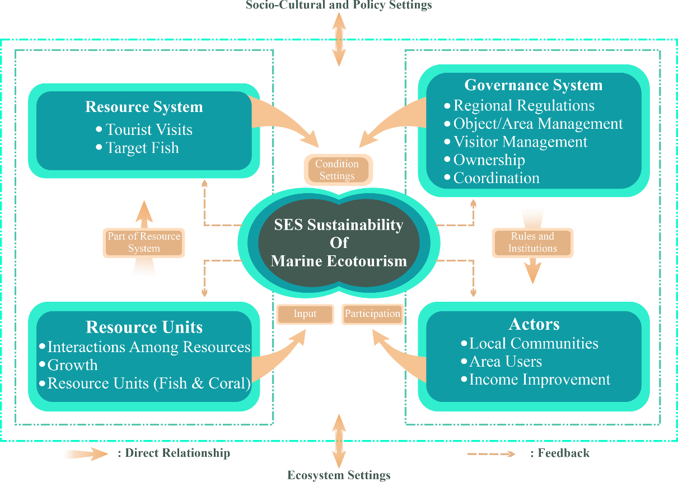
The results of variable reduction within the Social–Ecological System (SES) framework, conducted through SEM-PLS analysis, were used to depict the empirical linkages among the constituent components of the SES in the context of marine ecotourism development on Lihaga Island (Bawole et al., 2026a, in press). The reduction process yielded a set of latent variables and indicators that satisfied statistical validity and reliability criteria, thereby empirically representing the social, ecological, and institutional dynamics of the system under investigation (Bawole et al., 2026b, in press). The structural relationships among these latent variables were subsequently synthesized and visualized as an SES framework, as presented in Figure 2.
Fig 2. Social–Ecological Systems (SES) Framework for Sustainable Marine Ecotourism Development on Lihaga Island (adapted from McGinnis and Ostrom, 2014). 1 = Linkages between the resource system and resource units; 2 = Interactions between the resource system and actors;3 = Relationships between actors and the governance system; 4 = Linkages between governance and resource units; 5 = Relationships between governance and the resource system.
The SES approach adopted in this study refers to the conceptual framework developed by (McGinnis & Ostrom, 2014), which places system integration and outcomes at the core of the SES components. In the empirical context of Lihaga Island, SEM-PLS results indicate that the sustainability of marine ecotourism development is the most representative variable to be positioned as the central outcome of the SES.
Positioning sustainability as the analytical core is supported by the identified causal relationships linking social, ecological, and governance components to the sustainability of marine ecotourism development (Bawole et al., 2026b; 2026c in press). These relationships are visualized in Figure 2, which represents a synthesis of the SEM-PLS empirical results within a modified SES framework. The identified linkages among SES components include: (1) interactions between the resource system and resource units, (2) linkages between the resource system and actors, (3) interactions between actors and the governance system, (4) relationships between governance and resource units, and (5) linkages between governance and the resource system.
SEM-PLS analysis further indicates that not all SES subcomponents exert statistically significant effects on marine ecotourism sustainability (Bawole et al., 2026b; 2026c in press). Several subcomponents fall into the non-significant category yet remain structurally connected to other SES components. This finding suggests variability in the relative contributions of subcomponents to overall SES performance in marine ecotourism development on Lihaga Island.
The results consistently demonstrate that governance constitutes the weakest subsystem within the SES of marine ecotourism development on Lihaga Island (Bawole et al., 2026a in press). Limited coordination among stakeholders and the absence of comprehensive local regulations have constrained the ability of ecotourism-generated economic opportunities to significantly enhance community welfare. SEM-PLS results indicate that governance does not significantly influence sustainability—not because it lacks importance, but because it has not yet functioned effectively. This finding corroborates Pasape et al. (2017), who argue that weak governance often represents the primary limiting factor in sustainable ecotourism development.
Governance improvement is therefore viewed as a key strategy for reactivating the overall functioning of the SES. Strengthening collaborative governance is expected to promote better management practices, enhance community participation, and improve coordination across actors and institutions (Pasape et al., 2017). In the context of Lihaga Island, such strategies include establishing multi-stakeholder forums, formulating research-based local regulations, and regulating benefit-sharing mechanisms between resort operators and local communities.
This finding indicates that SES-based marine ecotourism development on Lihaga Island can only be sustainable if management strategies are designed with due consideration of inter-component linkages, feedback dynamics, and exogenous factors influencing the system (Bawole et al., 2026a in press). An SES approach operationalized through empirical analysis and adaptive strategies provides a robust foundation for marine ecotourism planning that prioritizes not only economic growth but also long-term social–ecological resilience.

3.2 Integrative Synthesis of the Social–Ecological System in Ecotourism Development
The sustainability of marine ecotourism development on Lihaga Island cannot be understood as the outcome of a single component, but rather as the result of dynamic interactions among the constituent components of the SES—namely the resource system, resource units, governance, and actors. SES component contributes specifically to sustainability; however, their effectiveness is largely determined by the strength of interconnections and feedback mechanisms among components.
The resource system and resource units serve as the primary biophysical foundation of marine ecotourism. Relatively healthy coral reefs, high reef fish diversity at specific sites, and distinctive tourism assets—such as hawksbill turtle beach attractions—constitute the ecological capital underpinning Lihaga Island’s tourism appeal. Nevertheless, this ecological capital is increasingly under pressure due to limited infrastructure, weather-dependent accessibility, and the potential for ecosystem degradation during periods of mass tourism. These findings underscore that ecological quality is not static, but highly sensitive to use intensity and exploitation patterns, thereby necessitating carrying capacity regulation and ecosystem rehabilitation.
From a governance perspective, SEM-PLS synthesis indicates that this component has not yet functioned optimally as a regulator of interactions between ecological systems and socio-economic activities. The absence of local regulations governing visitor allocation, entrance fees, benefit-sharing mechanisms, and weak monitoring and sanctioning systems has resulted in inequitable distribution of ecotourism benefits to local communities. Empirical evidence demonstrates that low stakeholder coordination has reduced governance capacity to promote sustainable ecotourism practices. These findings reinforce the argument that governance constitutes a critical node within the SES, where failure can undermine the positive contributions of other components—even when ecological and social capital are present.
The actor component within the SES of Lihaga Island exhibits emerging adaptive capacity that remains largely informal and un-institutionalized. Local communities have demonstrated adaptive behaviors, such as refraining from fishing during diving and snorkeling activities and acquiring environmental knowledge through interactions with tourists. However, community roles remain largely limited to tourism labor, while creative economic activities and local entrepreneurship remain underdeveloped. Consequently, ecotourism benefits are concentrated among specific actors, with limited improvements in broader community welfare. Strengthening actor roles through livelihood diversification, Micro, Small, and Medium Enterprises (MSMEs) development, village-owned enterprises, and community integration into the ecotourism value chain is therefore essential.
Conceptually, this study positions marine ecotourism sustainability as the integrative core of the SES, linking all system components. This approach modifies the classical SES framework by treating sustainability not merely as a final outcome, but as an integrative node that generates feedback effects on the resource system, resource units, governance, and actors. This perspective aligns with (McGinnis & Ostrom, 2014), who emphasize that successful commons governance depends on cross-scale interactions and adaptive feedback processes at the local level.
The synthesis also highlights the influence of exogenous factors—such as tourism market dynamics, regional development policies (e.g., the Likupang Special Economic Zone), and environmental change—which may affect the balance of the Lihaga Island SES. Consequently, marine ecotourism development strategies must be adaptive and responsive to evolving social, economic, and ecological contexts. Local governments play a crucial role in mediating these exogenous factors through evidence-based policy interventions.
This integrative synthesis confirms that sustainable marine ecotourism development on Lihaga Island can only be achieved through strengthened functional linkages among SES components, adaptive feedback-based management, and governance reform as the principal connector between ecological conservation and community welfare. Scientifically, this study contributes by operationalizing the SES framework not merely as a diagnostic tool, but as a basis for formulating contextual, applicable, and long-term social–ecological resilience-oriented ecotourism policies.

3.3 Strategies for Sustainable Marine Ecotourism Development
Conceptually and operationally, the SEM-PLS policy model developed in this study demonstrates that the sustainability of marine ecotourism on Lihaga Island is largely determined by the system’s capacity to transform natural resource endowments into equitable socio-economic benefits through adaptive governance and empowered local actors. Urgent strategies function as corrective mechanisms to address weak system pathways, while sustained strategies serve as anchors of social–ecological system stability. By positioning SEM-PLS as a policy simulation instrument, marine ecotourism development can be guided in a more precise, adaptive, and evidence-based manner.

3.3.1 Rationale for SEM-PLS as an Operational Policy Instrument
Sustainable marine ecotourism development requires analytical approaches capable of capturing complex interactions among ecological, social, economic, and institutional systems simultaneously. In this context, SEM-PLS is positioned not merely as a statistical tool, but as an operational policy instrument capable of simulating the impacts of interventions across the SES. SEM-PLS offers advantages in analyzing latent causal relationships within nonlinear systems, limited sample sizes, and heterogeneous indicators—conditions typical of small island marine ecotourism studies( Sarstedt et al., 2017).
Unlike conventional regression approaches that tend to exclude non-significant variables, SEM-PLS allows such variables to be retained as priority policy targets. Statistical non-significance is interpreted as an indication of structural weakness rather than conceptual irrelevance (Henseler, 2018). This principle aligns with Ostrom’s perspective that social–ecological sustainability is achieved not by optimizing already strong components, but by strengthening fragile subsystems to enhance system adaptability under external pressures (Ostrom, 2009).
Within an operational policy framework, SEM-PLS functions as an ex-ante simulation tool, enabling policymakers to test alternative intervention scenarios—such as governance strengthening, local actor empowerment, or visitor limitation—prior to on-the-ground implementation, consistent with evidence-based tourism planning approaches (Ruhanen et al., 2019).

3.3.2 Structure of the SEM-PLS Policy Model
The policy model adapts the SES framework of McGinnis and Ostrom with a key conceptual modification: marine ecotourism sustainability is positioned as the central latent construct rather than a terminal outcome. This approach emphasizes sustainability as a dynamic process continually produced through subsystem interactions.
Structurally, the model comprises four exogenous constructs—Resource System, Resource Units, Governance, and Actors—which simultaneously influence the endogenous construct of Marine Ecotourism Sustainability. Relationships among constructs are assumed to be adaptive and feedback-based rather than linear and symmetric. Similar patterns have been documented in Indonesian marine ecotourism contexts such as Karimunjawa and the Thousand Islands, where minor changes in governance or actor capacity have generated significant ecological and economic impacts (Aryunda, 2011; Destyananda et al., 2022). From a policy perspective, this model structure facilitates the identification of the most effective intervention points for enhancing sustainability through ecological, social, or institutional pathways.

3.3.3 Urgent Strategies through Policy Pathways and Operational Interventions
Initial SEM-PLS results indicate that several indicators within the Resource System and Actor constructs exhibit low loading factors and non-significant paths to sustainability. In policy terms, these findings reflect implementation gaps rather than system design failures. Accordingly, urgent strategies focus on strengthening weak pathways through targeted operational policies:
- Resource System → Actors. Strengthened through policies integrating local communities into the ecotourism value chain, including MSME training programs, local marine transport services, and coastal resource-based entrepreneurship. Community-based tourism studies consistently show that direct community involvement in tourism ownership and management significantly enhances social and economic sustainability (Zapata et al., 2013).
- Governance → Resource System. Strengthened through the formulation of marine ecotourism local regulations, establishment of multi-stakeholder forums, and implementation of adaptive monitoring mechanisms. Evidence from marine protected areas indicates that clear local governance frameworks combined with enforcement and community participation improve compliance and ecosystem conditions (Stone & Stone, 2011).
- Actors → Marine Ecotourism Sustainability. Strengthened through community empowerment, environmental literacy enhancement, and livelihood diversification. Studies in Southeast Asia demonstrate that fisher livelihood diversification into tourism and coastal services can reduce marine resource exploitation pressure by 20–40% while improving socio-economic resilience (Fabinyi, 2020).

3.3.4 Sustained Strategies through System Reinforcement and Operational Policies
In contrast to urgent strategies, sustained strategies focus on pathways that have already demonstrated significant effects within the SEM-PLS model. On Lihaga Island, the linkage between Resource Units and the Resource System exhibits strong influence, particularly through interactions among coral cover, reef fish distribution, and tourism visitation intensity.
Operational policies to maintain this pathway include the application of marine ecotourism carrying capacity as the basis for regulating visitor numbers and patterns, as well as coral reef rehabilitation through transplantation as part of educational tourism attractions. Policy simulations suggest that this approach not only enhances ecosystem quality but also strengthens destination value perception and tourist satisfaction, ultimately supporting local economic sustainability. These findings are consistent with studies in the Coral Triangle region highlighting positive feedback loops between tourism-based conservation and community welfare (Teh et al., 2013).
In public policy practice, the SEM-PLS model functions as an operational decision-support tool, particularly for designing short-, medium-, and long-term intervention scenarios. By simulating changes in indicator weights—such as governance or actor empowerment—policymakers can anticipate sustainability outcomes without waiting for long-term empirical changes. This approach bridges the gap between academic research and policy implementation and reinforces adaptive management principles in marine ecotourism governance, as recommended in evidence-based sustainable tourism planning literature (Ruhanen et al., 2019).

4. CONCLUSIONS
The integration of the Social–Ecological Systems framework and SEM-PLS analysis provides a comprehensive understanding of the factors influencing the sustainability of marine ecotourism on Lihaga Island. Despite high ecological potential, sustainable development is highly dependent on strengthened governance, enhanced community participation, and effective ecosystem protection. The findings offer a scientific foundation for formulating marine ecotourism management policies in small island regions of Indonesia.
Disclaimer (Artificial intelligence)
Author(s) hereby declare that NO generative AI technologies such as Large Language Models (ChatGPT, COPILOT, etc.) and text-to-image generators have been used during the writing or editing of this manuscript.

REFERENCES
- Aryunda, H. (2011). Dampak Ekonomi Pengembangan Kawasan Ekowisata Kepulauan Seribu. Journal of Regional and City Planning, 22(1). https://doi.org/10.5614/jpwk.2011.22.1.1
- Bawole, C. A., Kaber, Y., Sirami, E. V. I. Y., Coloay, C. G., Schaduw, J. N. W., & Mudjirahayu. (2024). Spatial variation of reef fish based on coral lifeform on Lihaga Island, Likupang, North Sulawesi, Indonesia. Int. J. Recent Adv. Multidiscip. Res., 10(1), 9539–9544.
- Bawole, C. A., Raharjo, S., Tebaiy, S., Yuminarti, U., Kaber, Y., Mudjirahayu, & Sirami, E. V. I. Y. (2026a). Integrating Coral Reef and Reef Fish Community Data to Support Sustainable Ecotourism Management in Lihaga Island, North Sulawesi, Indonesia. BIO Web Conf., 213. https://doi.org/10.1051/bioconf/202621301018
- Bawole, C. A., Raharjo, S., Tebaiy, S., Yuminati, U., Kabel, Y., Sirami, E. V. I. Y., Bawole, R., & Manumpil, A. W. (2026b). Sustainability Engineering of Marine Ecotourism in Small Island Coastal Systems: A Social–Ecological Systems Approach. Jounal of Ecological Modelling, (In Press).
- Bawole, C. A., Raharjo, S., Tebaiy, S., Yuminarti, U., Kaber, Y., Mudijrahayu, Bawole, R., & Manumpil, A. W. (2026c). Marine Ecotourism and the Social Construction of Coastal Spaces: Community Response and Participation from Gangga Island in the Management of Lihaga Island, North Sulawes, Indonesia. Jurnal Ilmu Dan Teknologi Kelautan Tropis, (in press).
- Destyananda, N. P., Suaedi, F., & Setijaningrum, E. (2022). Perencanaan Pengembangan Kawasan Pesisir dan Laut di Kepulauan Karimunjawa. Jurnal Litbang: Media Informasi Penelitian, Pengembangan Dan IPTEK, 18(1). https://doi.org/10.33658/jl.v18i1.284
- Fabinyi, M. (2020). The role of land tenure in livelihood transitions from fishing to tourism. Maritime Studies, 19(1). https://doi.org/10.1007/s40152-019-00145-2
- Ghaderi, Z., Shahabi, E., Fennell, D., & Khoshkam, M. (2022). Increasing community environmental awareness, participation in conservation, and livelihood enhancement through tourism. Local Environment, 27(5). https://doi.org/10.1080/13549839.2022.2048812
- Hair, J. F., Hult, G. T. M., Ringle, C. M., Sarstedt, M., & Thiele, K. O. (2017). Mirror, mirror on the wall: a comparative evaluation of composite-based structural equation modeling methods. Journal of the Academy of Marketing Science, 45, 616–632.
- Hair, J. F., Tomas, H. G., Ringle, C. M., & Marko, S. (2017). A primer on partial least squares structural equation modeling (PLS-SEM). International Journal of Research & Method in Education, 38(2).
- Hall, C. M. (2019). Constructing sustainable tourism development: The 2030 agenda and the managerial ecology of sustainable tourism. Journal of Sustainable Tourism, 27(7). https://doi.org/10.1080/09669582.2018.1560456
- McGinnis, M. D., & Ostrom, E. (2014). Social-ecological system framework: initial changes and continuing challenges. Ecology and Society, 19(2).
- Ostrom, E. (2009). A general framework for analyzing sustainability of social-ecological systems. Science, 325(5939), 419–422.
- Pasape, L., Anderson, W., & Lindi, G. (2017). Good governance strategies for sustainable ecotourism in Tanzania. In Ecotourism in Sub-Saharan Africa (pp. 51–71). Routledge.
- Ruhanen, L., Moyle, C. lee, & Moyle, B. (2019). New directions in sustainable tourism research. In Tourism Review (Vol. 74, Number 2). https://doi.org/10.1108/TR-12-2017-0196
- Sarstedt, M., Ringle, C. M., & Hair, J. F. (2017). Treating unobserved heterogeneity in PLS-SEM: A multi-method approach. Partial Least Squares Path Modeling: Basic Concepts, Methodological Issues and Applications, 197–217.
- Sarstedt, M., Ringle, C. M., & Hair, J. F. (2021). Partial least squares structural equation modeling. In Handbook of market research (pp. 587–632). Springer.
- Spalding, M., Burke, L., Wood, S. A., Ashpole, J., Hutchison, J., & zu Ermgassen, P. (2017). Mapping the global value and distribution of coral reef tourism. Marine Policy, 82. https://doi.org/10.1016/j.marpol.2017.05.014
- Stone, L. S., & Stone, T. M. (2011). Community-based tourism enterprises: challenges and prospects for community participation; Khama Rhino Sanctuary Trust, Botswana. Journal of Sustainable Tourism, 19(1), 97–114.
- Teh, L. S. L., Teh, L. C. L., & Sumaila, U. R. (2013). A Global Estimate of the Number of Coral Reef Fishers. PLoS ONE, 8(6). https://doi.org/10.1371/journal.pone.0065397
- Zapata, M. J., Hall, C. M., Lindo, P., & Vanderschaeghe, M. (2013). Can community-based tourism contribute to development and poverty alleviation? Lessons from Nicaragua. In Tourism and the Millennium Development Goals (pp. 98–122). Routledge.
- Klöck, C., & Nunn, P.D. (2023). Small island developing states and climate change: Transformative adaptation as a policy imperative.WIREs Climate Change,14(3), e824. https://doi.org/10.1002/wcc.824
- Manembu, I. S., Mamangkey, N. G., Manengkey, H. W., Rembet, U. N., & Rondonuwu, A. B. (2026). Integrated Ecological and Socio-Economic Assessment for Sustainable Marine Ecotourism Development in Lihaga Island: An Ecosystem Service-Based Approach. Journal Ilmiah PLATAX, 1(1), 105-116

- Liu, X., He, R., Ji, T., Shao, B., & Meng, H. (2025). A Social–Technical–Ecological Systems Analysis of Sustainable Development Paths for Marine Ranching in Guangdong Province, China. Water, 17(13), 1838. https://doi.org/10.3390/w17131838

