Net Export Performance and Forecast Outlook of Cassava in Tanzania: Evidence from the ARIMA Model

Abstract
Cassava (Manihot esculenta Crantz) has become increasingly important for food security and rural livelihoods in Tanzania, with growing recognition as a valuable traded commodity across the East African region. Although Tanzania ranks among Africa's top cassava producers, there remains surprisingly limited empirical evidence documenting the country's long-term export performance and future trade prospects. This study analyses Tanzania's cassava net export performance from 1961 to 2024 and projects future trends through 2030 using time series econometric methods. We compiled secondary annual data from the FAOSTAT database (1961–2013) and Tanzania Revenue Authority customs records (2014–2024). Historical trade patterns were examined across four distinct policy regimes through descriptive statistics and trend analysis, while the Autoregressive Integrated Moving Average (ARIMA) modelling approach was employed for forecasting purposes. We tested the stationarity of the net export series using the Augmented Dickey–Fuller procedure and selected the optimal model based on Akaike and Bayesian Information Criteria. Our findings reveal that Tanzania sustained a positive cassava trade balance in 63 of 64 years, with net exports growing markedly during the post-liberalisation and modern growth periods. The ARIMA (2,1,0) model emerged as the best-fitting specification, forecasting stabilisation of net exports at approximately 44,000 to 46,000 metric tons per year from 2025 to 2030, though with progressively wider confidence intervals indicating increasing uncertainty. The evidence points to a fundamental transformation of Tanzania's cassava sector from a minimal exporter to a substantial regional supplier. The study concludes that maintaining export momentum will necessitate strategic policy interventions, notably strengthening export infrastructure, facilitating regional trade flows, encouraging value-added processing at an industrial scale, and ensuring domestic food security safeguards as cassava exports continue expanding.
Keywords: Cassava trade; Export performance; Time series analysis; ARIMA modelling; Trade forecasting; Agricultural trade.

Introduction
Cassava (Manihot esculenta Crantz) stands as one of the world's most resilient and versatile root crops, providing sustenance, income, and industrial raw materials to millions of households across tropical regions. Cassava plays an important role in terms of food security, income generation and employment for families in the humid tropics where hunger and starvation prevail (Lawson et al., 2023). As a staple food crop, cassava demonstrates exceptional adaptability to marginal soils, drought conditions, and erratic rainfall patterns, making it particularly valuable in the context of climate variability and food security challenges facing sub-Saharan Africa (Jarvis et al., 2012; Emmanuel et al., 2024). Cassava contains various chemical components, including balanophonin, scopoletin, and tannins, which have been studied to exhibit anti-oxidant activity, anti-proliferative and anti-inflammatory properties (Mohidin et al., 2023). Global cassava production surpassed 330 million metric tons in 2022, with sub-Saharan Africa contributing over 60% of total output, led by Nigeria, the Democratic Republic of Congo, and Tanzania (Food and Agriculture Organisation [FAO], 2023). Beyond its traditional role as a subsistence crop, cassava has increasingly emerged as a commercially traded commodity, driven by expanding regional demand, diverse industrial applications, and its superior climate resilience compared to cereals (Howeler et al., 2013; Barku et al., 2025).
Cassava is the third most important food staple in Africa (after maize and rice), consumed by hundreds of millions daily (Otekunrin, 2024). Within Tanzania's agricultural landscape, cassava occupies a position of strategic importance in both the national food system and rural economy. The crop is extensively cultivated across multiple ecological zones, including the Lake Zone, Southern Highlands, Eastern Zone, and Coastal areas, where it serves dual functions as a drought-tolerant food security crop and a source of cash income for smallholder farmers (Msami et al., 2025). Tanzania is one of the largest cassava producers in Africa; however, yields are low at 6.5 t/ha, which is well below its estimated potential yield of 25 to 30 t/ha. Intense disease pressure, combined with the slow adoption of improved cassava varieties, has prevented farmers in Tanzania from achieving the potential yields (Msami et al., 2025; Theodory, 2025). Tanzania currently ranks as Africa's sixth-largest cassava producer, with annual production reaching approximately 5.6 million tonnes according to recent estimates (Tanzania National Cassava Development Strategy, 2020). While cassava has historically been perceived primarily through the lens of subsistence agriculture with limited market integration, accumulating evidence points to a marked transformation toward commercialisation and expanding regional trade, particularly within the East African Community (EAC) and with neighbouring countries including Kenya, Rwanda, Burundi, and the Democratic Republic of Congo (Haggblade et al., 2012; Mauki et al., 2023; Sanga et al., 2026). Indeed, cassava offers unmatched potential for Tanzania to fulfil its long-term aspiration of becoming a leading food producer country in Africa and among 10 top food producers in world by 2050 (URT, 2025).
Despite Tanzania's prominence as one of major cassava producers in Africa, empirical evidence examining the country's long-term cassava trade performance remains surprisingly limited. Existing research has predominantly focused on production constraints, adoption of improved varieties, value chain development, and food security implications (Legg et al., 2014; Adebayo, 2023), with comparatively little systematic attention devoted to the dynamics of cassava exports, import substitution, and net trade performance over extended time horizons. Moreover, few studies have attempted to quantitatively forecast the future trajectory of cassava trade using rigorous time series econometric methodologies. This research gap is particularly significant given that regional cassava trade has demonstrated substantial growth in recent years, yet lacks the comprehensive analytical foundation needed to inform evidence-based policy formulation and future private sector investment decisions.
Understanding the long-term export performance and future outlook of cassava trade assumes heightened importance in the contemporary context of structural economic reforms, deeper regional integration, and recent economic shocks including the COVID-19 pandemic, which fundamentally altered food supply chains and intensified cross-border trade in staple commodities (Laborde et al., 2020). For policy makers tasked with balancing export promotion against domestic food security imperatives, and for private sector actors considering investments in cassava value chains, reliable forecasts of net export paths are essential inputs for infrastructure planning, trade facilitation initiatives, value addition investments, and strategic positioning within regional markets including economics diplomacy. Furthermore, as Tanzania implements its National Cassava Development Strategy (2020–2030), which targets a 550% increase in cassava production and the establishment of 150 processing plants, robust empirical analysis of trade trends becomes crucial for assessing the viability and sustainability of these ambitious expansion plans.
Against this backdrop, this study undertakes a comprehensive analysis of Tanzania's cassava net export performance spanning a 64-year period (1961–2024) and provides empirically grounded forecasts extending to 2030 using the Autoregressive Integrated Moving Average (ARIMA) modelling framework. By integrating long-term historical data from FAOSTAT with recent detailed customs records from the Tanzania Revenue Authority, this study offers one of the most extensive empirical assessments of cassava trade dynamics in Tanzania to date. The analysis contributes to the existing literature through multiple dimensions: first, by documenting structural changes in export performance across distinct policy regimes; second, by rigorously evaluating the suitability and performance of ARIMA models in forecasting agricultural trade for an African context; and third, by generating policy-relevant insights on cassava's evolving role within Tanzania's regional trade portfolio. The findings are expected to inform evidence-based policy formulation, guide private sector investment decisions, and contribute methodologically to the application of time series forecasting techniques in African agricultural trade analysis.

Literature review

2.1 Cassava production, commercialisation, and trade in sub-Saharan Africa
Cassava's importance in sub-Saharan Africa extends beyond caloric contribution to encompass income generation, risk management, and resilience to climate change and variability. Compared to cereals, cassava exhibits high tolerance to drought, poor soils, and erratic rainfall, making it a preferred crop under increasing climate stress (Jarvis et al., 2012). Nweke et al. (2002) argue that cassava's transformation from a “famine reserve crop” to a commercial commodity has been driven by population growth, urbanisation, and technological change, particularly the dissemination of improved varieties and processing technologies. Moreover, supplementary irrigation and mechanisation technologies for increased and stabilised supply of quality cassava are being scaled in leading global cassava producers such as Thailand and Nigeria. Regional trade in cassava and cassava-based products has expanded steadily over the past two decades, largely concentrated within Africa rather than global markets. While Thailand and Vietnam dominate global exports of processed cassava products such as starch and pellets, African cassava trade is primarily regional and dominated by fresh and dried roots, chips, and flour (Ezedinma et al., 2007; Otekunrin & Sawicka, 2019). In addition, Haggblade et al. (2012) highlight that improvements in road infrastructure, cross-border trade liberalisation, and rising urban demand have strengthened cassava value chains in Eastern and Southern Africa. However, cassava trade in Africa remains characterised by high volatility, informality, and sensitivity to policy changes. Non-tariff barriers, phytosanitary regulations, and episodic export bans introduced to protect domestic food security continue to affect trade flows (Mauki et al., 2023). These characteristics necessitate the need for long-term empirical analysis that captures both structural trends and cyclical fluctuations in cassava trade performance.

2.2 Cassava trade and export performance in Tanzania
In Tanzania, cassava has traditionally been viewed through the lens of food security rather than export competitiveness. Early studies emphasised its role in cushioning households against drought and cereal price shocks (Lele et al., 1989). However, more recent research documents increasing market orientation and cross-border trade, particularly in border regions such as Kagera, Kigoma, Mara, and Ruvuma (Simbeye & Katunzi, 2025). Trade liberalisation reforms introduced under Structural Adjustment Programs in the mid-1980s significantly altered agricultural marketing systems in Tanzania. The dismantling of state marketing boards and the liberalisation of prices facilitated private sector participation in agricultural trade, including cassava (Putterman, 1995). Subsequent regional integration under the EAC and SADC frameworks further reduced formal trade barriers, enabling Tanzania to supply cassava to neighbouring deficit countries (Haggblade et al., 2012). Despite these developments, empirical studies quantifying Tanzania's cassava export performance over long horizons are scarce. Available analyses are often cross-sectional or short-term, focusing on specific value chain segments or regions (Adebayo, 2023). Moreover, the distinction between exports, imports, and net trade balance is rarely examined systematically, limiting understanding of Tanzania's evolving comparative and competitive advantages in cassava trade.

2.3 Time series modelling and forecasting of agricultural trade
Time series econometric models have been widely applied to analyse and forecast agricultural production, prices, and trade flows. Among these, the ARIMA model developed by Box and Jenkins (1976) remains one of the most extensively used approaches due to its flexibility, relatively low data requirements, and strong forecasting performance in univariate settings. ARIMA models have been applied successfully to forecast exports of agricultural commodities such as rice, maize, coffee, and horticultural products in both developed and developing countries (Shabani et al., 2021).
In the context of agricultural trade, ARIMA models are particularly useful for capturing persistence, cyclical behaviour, and structural trends in export series. Although they do not explicitly model causal relationships, their strength lies in short- to medium-term forecasting accuracy, which is often the primary concern of policy makers and market actors (Stock and Watson, 2003). Several studies have demonstrated that ARIMA-based forecasts perform comparably or better than more complex structural models when long historical series are available (Makridakis & Hibon, 2000).
However, agricultural trade series often exhibit non-stationarity, structural breaks, and volatility associated with policy reforms, climatic shocks, and market disruptions. Granger and Newbold (1974) caution that failure to address non-stationarity can lead to spurious results, underscoring the importance of unit root testing and appropriate differencing. Recent studies increasingly acknowledge that even when residuals deviate from normality, ARIMA models remain robust for point forecasting, provided diagnostic checks confirm the absence of autocorrelation (Stock and Watson, 2003).
Despite the growing application of time series methods in agricultural economics, their use in analysing cassava trade particularly in African contexts remains limited. This study addresses this gap by applying ARIMA modelling to a uniquely long cassava net export series for Tanzania, thereby contributing both methodologically and empirically to the literature.

Research methodology

3.1 Study area and data sources
This study focuses on the United Republic of Tanzania, a major cassava producer in sub-Saharan Africa ranking third after Nigeria and the Democratic Republic of Congo. Tanzania's cassava production is predominantly concentrated in the Southern, Lake, and Eastern zones, with the crop serving both as a food security staple and an increasingly important export commodity.
The study utilised secondary time series data spanning 64 years (1961-2024), representing the entire post-independence period of Tanzania. Data were compiled from two primary sources: (i) the Food and Agriculture Organisation Statistical Database (FAOSTAT) for historical trade data from 1961 to 2013, which provides standardised agricultural trade statistics following international classification systems; and (ii) the Tanzania Revenue Authority (TRA) customs database for recent trade records from 2014 to 2024, capturing actual customs declarations under the Harmonised System (HS) code 071410 for fresh, chilled, frozen, or dried cassava (manioc).
The variables extracted included annual export quantity (metric tons), annual import quantity (metric tons), and net export quantity calculated as the difference between exports and imports. All quantities were standardised to metric tons to ensure consistency across the time series. The choice of annual data frequency was necessitated by the availability of consistent long-term records and is appropriate for capturing structural trends in agricultural trade.

3.2 Analytical framework
The study employed a combination of descriptive statistics, trend analysis, and time series econometric modelling. The analytical framework consisted of four main components: (i) descriptive analysis of trade patterns across historical eras; (ii) stationarity testing; (iii) ARIMA model specification and estimation; and (iv) diagnostic testing and forecasting.

3.2.1 Descriptive and trend analysis
The 64-year period was stratified into four distinct historical eras based on Tanzania's economic policy regimes: (i) Pre-Structural Adjustment Period (1961-1985), characterised by socialist economic policies and state-controlled marketing; (ii) Structural Adjustment Period (1986-1995), marked by economic liberalisation reforms; (iii) Post-Liberalisation Period (1996-2010), featuring market-oriented policies and regional trade integration; and (iv) Modern Growth Period (2011-2024), characterised by export promotion policies and increased regional demand.
Descriptive statistics including mean, standard deviation, minimum, maximum, and coefficient of variation were computed for each era. The Compound Annual Growth Rate (CAGR) was calculated using equation (1):
$CAGR={({Ending Value}/{Beginning Value})}^{(1/n)}$×100 (1)
where: n represents the number of years in the period. Linear trend analysis was conducted using Ordinary Least Squares (OLS) regression to assess the statistical significance of the long-term trend in net exports.

3.2.2 Stationarity testing
Time series stationarity is a fundamental requirement for valid ARMA/ARIMA modelling, as non-stationary series can lead to spurious regression results (Granger and Newbold, 1974). The Augmented Dickey-Fuller (ADF) test was employed to examine the unit root properties of the net export series. The ADF test regression is specified as:
${∆Y}_{t}=α+{βY}_{t-1}+\sum{Y_{i}}{∆Y}_{t-i}+ε_{t}$ (2)
where ΔY_{t} is the first difference of the series, α is the constant term, β is the coefficient on the lagged level (the test statistic), and ε_{t} is the error term. The null hypothesis of a unit root (non-stationarity) is rejected if the calculated t-statistic is more negative than the critical values at conventional significance levels (1%: -3.51, 5%: -2.89, 10%: -2.58).

3.2.3 ARIMA model specification
The Autoregressive Integrated Moving Average (ARIMA) model, introduced by Box and Jenkins (1976), was employed to model the net export time series and generate forecasts. The general ARIMA(p,d,q) model is expressed as:
$∅\left(B\right){\left(1-B\right)}^{d}Y_{t}=θ(B)ε_{t}$ (3)
where: Φ(B) = 1 - φ₁B - φ₂B² - ... - φ_{p}B^{p} is the autoregressive (AR) polynomial, θ(B) = 1 + θ₁B + θ₂B² + ... + θ_{q}B^{q} is the moving average (MA) polynomial, B is the backshift operator, d is the order of differencing, and ε_{t} is white noise with zero mean and constant variance σ².
Model identification followed the Box-Jenkins methodology, utilising the Autocorrelation Function (ACF) and Partial Autocorrelation Function (PACF) plots of the stationary series. Six candidate models were evaluated: ARIMA(0,1,0), ARIMA(1,1,0), ARIMA(0,1,1), ARIMA(1,1,1), ARIMA(2,1,0), and ARIMA(2,1,1). Model selection was based on the Akaike Information Criterion (AIC) and Bayesian Information Criterion (BIC), with preference given to models minimising these criteria while maintaining parsimony:
$AIC=n×\ln\left({SSE}/n\right)+2k$ (4)
$BIC=n×\ln\left({SSE}/n\right)+k×ln⁡(n)$ (5)
where: n is the number of observations, SSE is the sum of squared errors, and k is the number of estimated parameters.

3.2.4 Diagnostic testing and validation
The adequacy of the selected model was evaluated through comprehensive diagnostic testing. The Shapiro-Wilk test was employed to assess the normality of residuals, with the null hypothesis that residuals follow a normal distribution. The test statistic W ranges from 0 to 1, with values close to 1 indicating normality. Residual autocorrelation was examined using the ACF of residuals. For a well-specified model, residuals should approximate white noise with all autocorrelations falling within the 95% confidence bounds (±1.96/√n). Additionally, residual statistics including mean (expected to be zero), standard deviation, skewness, and kurtosis were computed to assess distributional properties.

3.2.5 Forecasting procedure
Using the validated ARIMA model, out-of-sample forecasts were generated for a six-year horizon (2025-2030). Point forecasts were computed recursively, with forecast values for period $t+h$obtained by substituting previous forecasts for unknown future values. The 95% confidence intervals were constructed as:
${CI}_{95\%}=Ŷ_{t+h}±1.96×σ×√h$ (6)
where: Ŷ_{t+h} is the point forecast, σ is the residual standard deviation, and h is the forecast horizon. The widening confidence intervals reflect increasing uncertainty with longer forecast horizons.

Results

4.1 Descriptive analysis of cassava trade performance
Table 1 presents the summary statistics of Tanzania's cassava net export performance across four historical eras post-independence (i.e. from 1961 to 2024). The results reveal a remarkable transformation in the country's cassava trade position over the 64-year period.
Table 1: Summary statistics of cassava net export by historical era (1961-2024)
Period | N | Mean (MT) | Std. Dev. | Total (MT) | CAGR (%)
Pre-SAP (1961-1985) | 25 | 127.48 | 45.12 | 3,187 | 5.23
SAP Period (1986-1995) | 10 | 353.10 | 89.44 | 3,531 | 10.72
Liberalisation (1996-2010) | 15 | 1,332.13 | 555.89 | 19,982 | 11.00
Modern Growth (2011-2024) | 14 | 12,399.55 | 22,154.32 | 173,594 | 23.95
Overall (1961-2024) | 64 | 3,129.59 | 10,997.29 | 200,294 | 11.43
Note: MT = Metric Tons; CAGR = Compound Annual Growth Rate; SAP = Structural Adjustment Program
The results clearly demonstrate a progressive acceleration in export growth across successive eras. During the Pre-SAP period (1961-1985), Tanzania maintained modest net exports averaging 127.48 MT annually with a CAGR of 5.23%. The SAP period (1986-1995) witnessed a doubling of growth momentum to 10.72% CAGR, reflecting the positive effects of market liberalisation on agricultural trade. The liberalisation period (1996-2010) sustained this trend with mean annual net exports of 1,332.13 MT and an 11.00% CAGR as graphically observed in Figure 1.

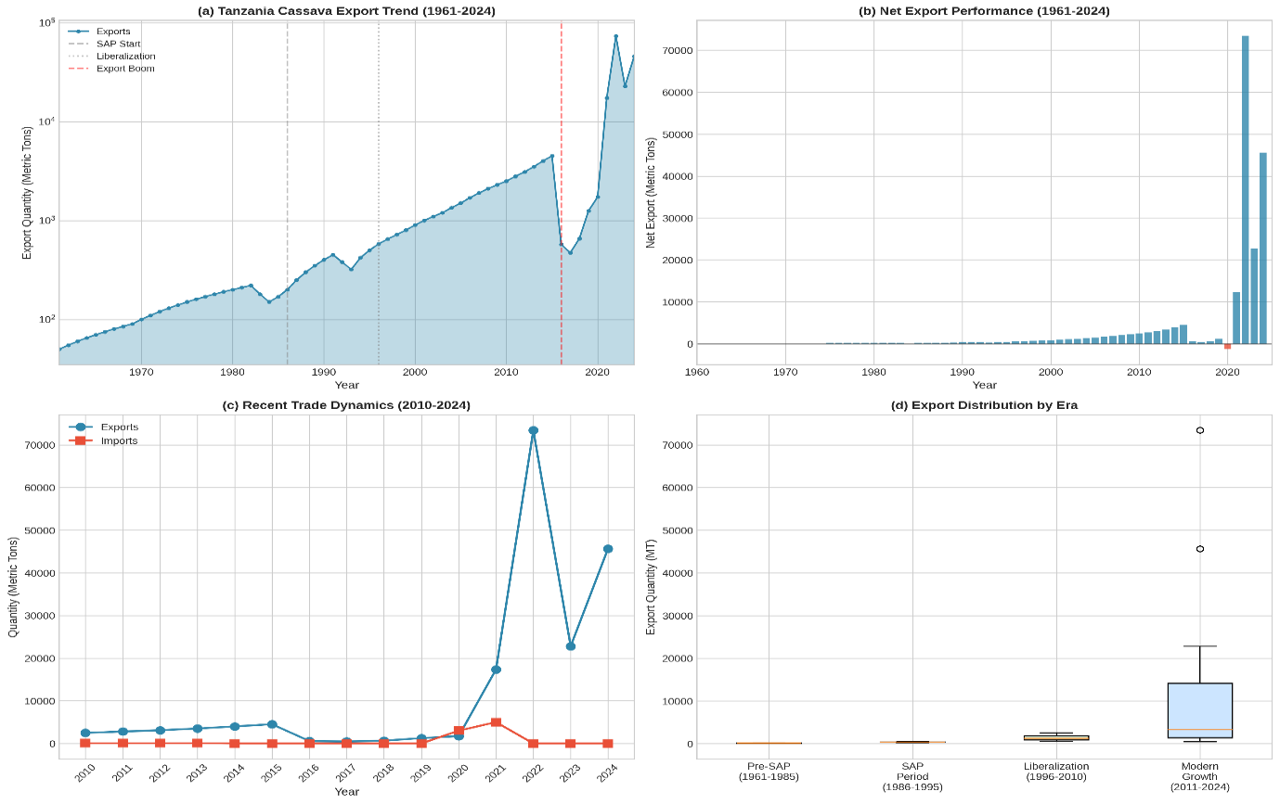
Figure 1: Tanzania’s cassava imports and export trend since independence
The most dramatic transformation occurred during the Modern Growth period (2011-2024), where mean annual net exports rushed to 12,399.55 MT with an unprecedented CAGR of 23.95%. This period alone accounts for 86.7% of the total cumulative net exports over the entire 64-year period. The high standard deviation (22,154.32 MT) during this period reflects substantial year-to-year volatility, particularly the exceptional export volumes recorded in 2022 (73,402 MT) and 2024 (45,646 MT).

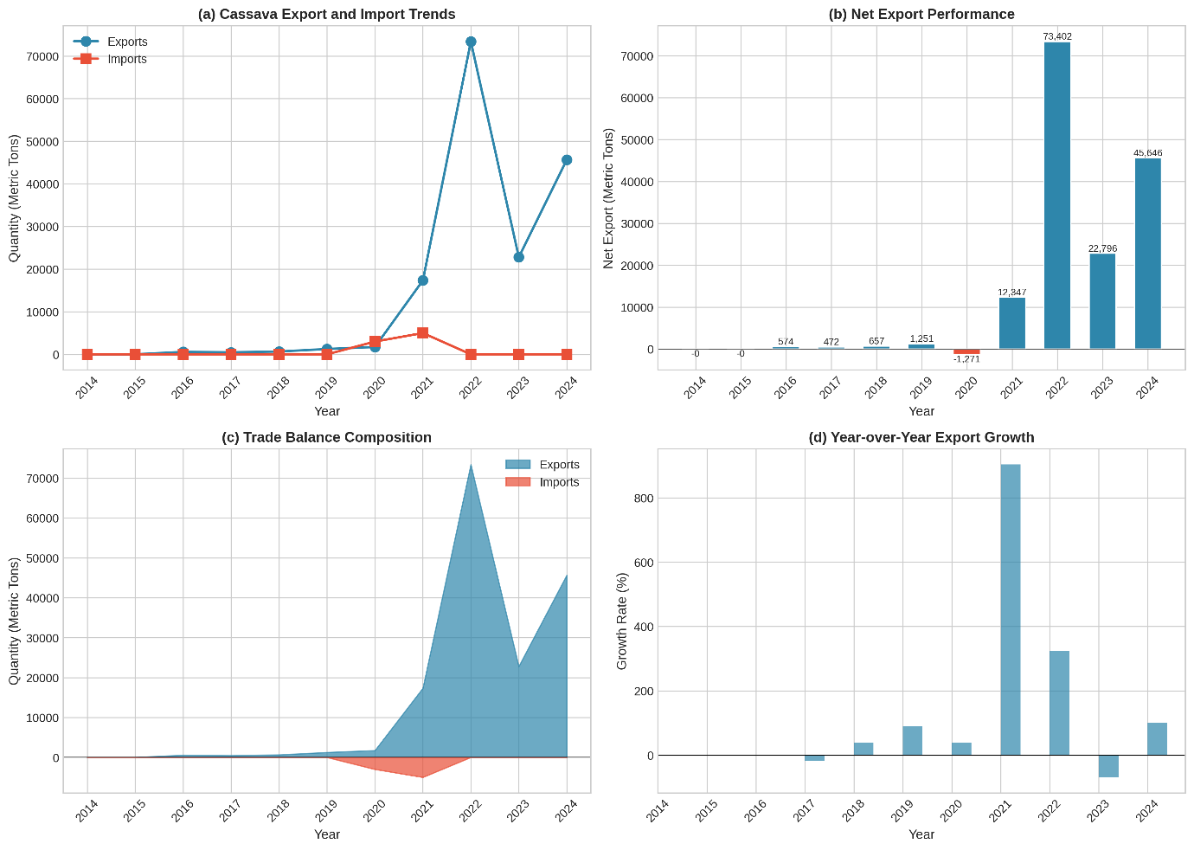
Figure 2: Tanzania cassava imports and export trend for the past 10 years
Over the entire study period as revealed in Figure 2, Tanzania maintained a positive trade balance in cassava for 63 out of 64 years (98.4%), with only 2020 recording a trade deficit due to substantial imports from Uganda (3,000 MT). The cumulative net exports totalled 200,294 MT, highlighting Tanzania's position as a consistent net exporter of cassava in the East African region.

4.2 Stationarity test results
Table 2 presents the results of the Augmented Dickey-Fuller unit root tests conducted on the net export series at both level and first difference.
Table 2: Augmented dickey-fuller unit root test results
Variable | t-Statistic | Critical Value (5%) | Decision
Net Export (Level) | -3.497** | -2.89 | Stationary
Net Export (1st Difference) | -13.474*** | -2.89 | Strongly Stationary
Note: ** and *** denote significance at 5% and 1% levels, respectively. Critical values: 1%: -3.51, 5%: -2.89, 10%: -2.58
The ADF test on the level series yielded a t-statistic of -3.497, which is marginally more negative than the 5% critical value (-2.89), suggesting the series is stationary at the 5% significance level. However, given the borderline nature of this result and the presence of a significant trend, the first difference was also tested. The differenced series exhibited strong stationarity with a t-statistic of -13.474, far exceeding the 1% critical value in absolute terms. This confirmed the appropriateness of using ARIMA models with d=1 (first differencing) for improved model stability.

4.3 ARIMA model selection and estimation
Analysis of the ACF and PACF of the first-differenced series informed the candidate model specifications. The ACF exhibited a significant spike at lag 1 (-0.496) that dropped sharply thereafter, while the PACF showed significant values at lags 1 (-0.496) and 2 (-0.231). This pattern suggested AR(1) or AR(2) components might be appropriate. Table 3 presents the comparative fit statistics for the six candidate models.

Table 3: ARIMA model comparison
Model | AIC | BIC | Selection
ARIMA(0,1,0) | 1169.02 | 1171.16
ARIMA(1,1,0) | 1134.37 | 1138.63
ARIMA(0,1,1) | 1151.48 | 1153.61
ARIMA(1,1,1) | 1134.37 | 1138.63
ARIMA(2,1,0) | 1116.94 | 1123.27 | SELECTED
ARIMA(2,1,1) | 1116.94 | 1123.27
Note: AIC = Akaike Information Criterion; BIC = Bayesian Information Criterion. Lower values indicate better fit.

The ARIMA (2,1,0) model yielded the lowest AIC (1116.94) and BIC (1123.27) values among all candidate specifications. Although ARIMA (2,1,1) produced identical information criteria values, the principle of parsimony favoured the simpler ARIMA (2,1,0) specification without the MA component. This model includes two autoregressive terms with first-order differencing, capturing the mean-reverting dynamics observed in the differenced series.

4.4 Model diagnostic results
Comprehensive diagnostic tests were conducted to validate the adequacy of the selected ARIMA (2,1,0) model. Table 4 summarises the residual diagnostic statistics.

Table 4: Residual diagnostic statistics for ARIMA (2,1,0) model
Diagnostic Test/Statistic | Value | Interpretation
Residual Mean | 0.0000 | Unbiased
Residual Std. Deviation | 9,009.67 | High volatility
Skewness | 6.93 | Right-skewed
Kurtosis | 49.13 | Leptokurtic
Shapiro-Wilk W Statistic | 0.221 | Non-normal (p<0.001)
ACF at Lag 1 (Residuals) | -0.02 | Within 95% bounds
Note: 95% confidence bounds for ACF: ±0.247
The diagnostic results reveal both strengths and limitations of the model. On the positive side, the residuals exhibited a mean of exactly zero, indicating unbiased forecasts, and the ACF of residuals at all lags fell within the 95% confidence bounds (±0.247), confirming the absence of significant autocorrelation in the residuals. This suggests the AR(2) specification adequately captured the temporal dependence structure.
However, the Shapiro-Wilk test (W = 0.221, p < 0.001) decisively rejected the null hypothesis of normally distributed residuals. The high positive skewness (6.93) and excess kurtosis (49.13) indicate a leptokurtic distribution with heavy right tails, attributable to the extreme export values observed in 2022 (73,402 MT). These outliers represent genuine structural shifts in Tanzania's cassava export sector rather than data errors.
The non-normality of residuals, while theoretically concerning, does not invalidate the point forecasts, which remain unbiased. However, it implies that the confidence intervals, which assume normality, should be interpreted with caution. The forecast uncertainty may be understated for extreme positive outcomes and overstated for typical years. This limitation is acknowledged and addressed in the interpretation of forecasts below.

4.5 Forecast results (2025-2030)
Table 5 presents the six-year out-of-sample forecasts generated from the ARIMA (2,1,0) model for the period 2025 to 2030.

Table 5: ARIMA (2,1,0) net export forecast for Tanzania cassava (2025-2030)
Year | Point Forecast (MT) | 95% CI Lower | 95% CI Upper
2025 | 45,089 | 27,430 | 62,748
2026 | 41,118 | 16,145 | 66,092
2027 | 44,998 | 14,411 | 75,584
2028 | 44,830 | 9,512 | 80,148
2029 | 45,258 | 5,772 | 84,745
2030 | 46,306 | 3,051 | 89,562
Note: MT = Metric Tons; CI = Confidence Interval
The forecasts suggest that Tanzania's cassava net exports will stabilise around 44,000-46,000 MT annually over the forecast horizon. This represents a consolidation following the exceptional peak of 73,402 MT in 2022, yet maintains a level substantially above the historical average of 3,130 MT. The point forecasts exhibit remarkable consistency, varying by less than 12% across the six-year period, indicating the model predicts a stabilisation of the export sector at the new elevated plateau.
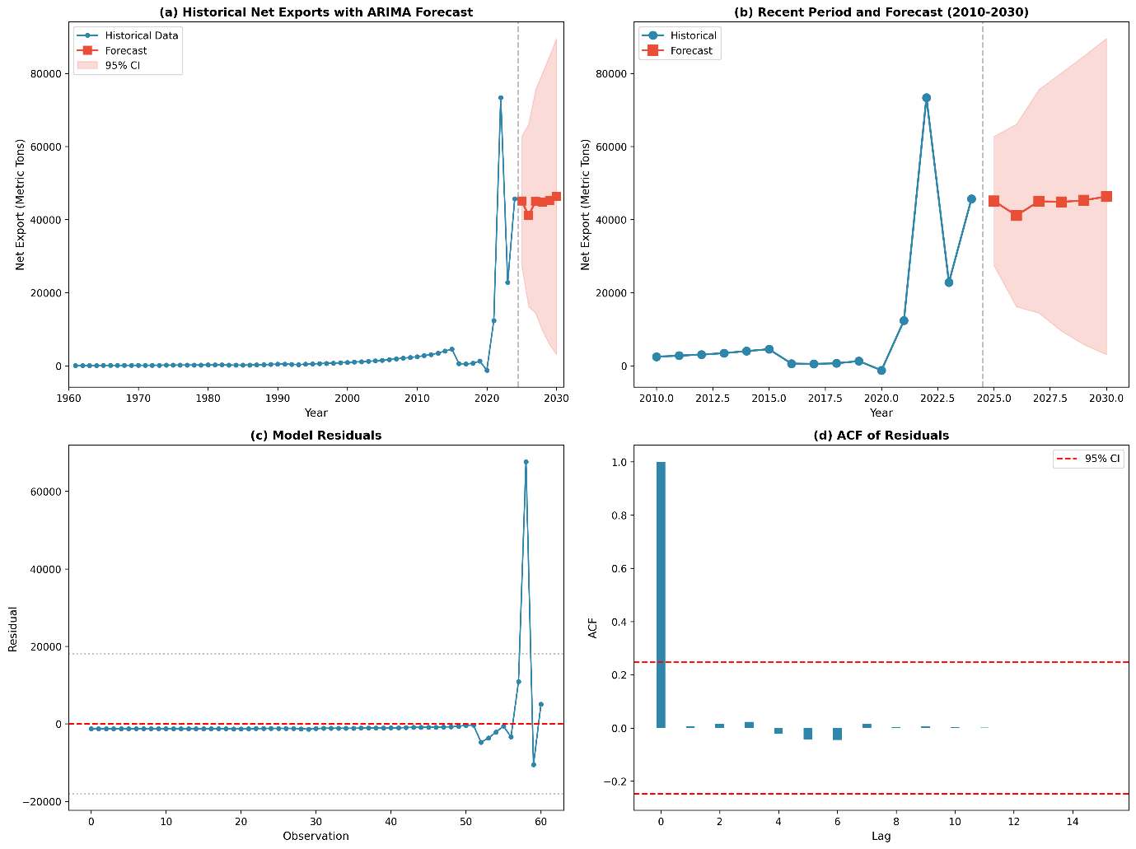
Figure 3: Tanzania net export trend forecasts

Figure 3 indicates that the 95% confidence intervals widen progressively from ±17,659 MT in 2025 to ±43,256 MT by 2030, reflecting increasing forecast uncertainty over longer horizons. This widening is a standard feature of time series forecasts and is amplified in this case by the high residual variance attributable to the structural changes in the export sector. The lower bounds remain positive throughout the forecast period, suggesting continued trade surplus with high probability.

Discussion

5.1 Evolution of Tanzania's cassava trade position
The findings of this study reveal a remarkable transformation in Tanzania's cassava trade position over the 64-year study period. The country has evolved from a marginal exporter during the early post-independence period, with average annual net exports of just 127 metric tons, to a significant regional supplier exceeding 45,000 metric tons in 2024. This transformation represents more than a quantitative shift; it reflects fundamental structural changes in Tanzania's agricultural economy, trade policies, and regional market integration. Understanding the drivers and implications of this evolution requires careful consideration of policy reforms, regional dynamics, and methodological considerations underlying the analysis.
First, the policy reforms under structural adjustment programs in the late 1980s dismantled state marketing boards and enabled private sector participation in agricultural trade. This is reflected in the doubling of the CAGR from 5.23% (pre-SAP) to 10.72% (SAP period). These findings align with Nweke et al. (2002) who documented similar liberalisation effects on cassava commercialisation in West Africa.
Second, regional integration through the East African Community (EAC) and Southern African Development Community (SADC) trade protocols facilitated cross-border cassava trade with neighboring countries. The customs data reveal that Kenya, Rwanda, DRC, and Burundi emerged as primary export destinations, consistent with Haggblade et al. (2012) who highlighted the importance of regional value chains in cassava commercialisation.
Third, the explosive growth in the Modern period (2021-2024) coincides with increased regional demand driven by food security concerns, industrial applications, and the disruption of traditional supply chains during the COVID-19 pandemic. The 2022 peak of 73,402 MT likely reflects temporary supply shortages in neighboring countries that positioned Tanzania as an alternative supplier.
The exceptional growth observed in the Modern Growth period (2011-2024) warrants particular attention. This period witnessed an unprecedented compound annual growth rate of 23.95%, with mean annual net exports of 12,399.55 metric tons representing a nearly 100-fold increase from the pre-SAP era. Several interconnected factors explain this explosive growth trajectory. First, Tanzania's strategic positioning within the East African Community provided preferential access to rapidly growing regional markets experiencing urbanisation-driven demand for cassava and cassava-based products. Second, infrastructure improvements along key export corridors, particularly the Central Corridor linking Tanzania to landlocked neighbours, reduced transaction costs and facilitated formal cross-border trade. Third, the establishment of the Cereals and Other Produce Board (CPB) in 2009 provided institutional support for cassava marketing, including plans to install 150 cassava processing plants by 2030 (United Republic of Tanzania (URT), 2020). Fourth, regional food security crises, exacerbated by climate variability and conflict in neighboring countries, positioned Tanzania as a reliable alternative supplier. The COVID-19 pandemic further amplified this role, as disruptions to global supply chains intensified demand for regional food sources.
The findings complement and extend existing literature on cassava trade in sub-Saharan Africa. While Otekunrin and Sawicka (2019) documented global cassava trade patterns with Thailand dominating exports, this study provides granular evidence of Tanzania's emergence as a significant regional exporter within Africa. The observed CAGR of 11.43% over 64 years exceeds the continental average growth rates reported by FAO (2020), positioning Tanzania favourably among African cassava exporters.
The consistent trade surplus across almost all years (63 of 64) contrasts with studies highlighting Africa's net-importing status for processed cassava products (Ezedinma et al., 2007). This suggests Tanzania's comparative advantage lies primarily in fresh/dried cassava roots for regional markets rather than processed products competing in global markets. Future research should examine value-added opportunities through domestic processing capacity development

5.2 Model performance and methodological considerations
The selection of ARIMA (2,1,0) over more complex specifications reflects a trade-off between model parsimony and forecasting accuracy. While hybrid models combining ARIMA with machine learning techniques such as Long Short-Term Memory (LSTM) networks have shown superior performance in some agricultural price forecasting applications (Kashif and Ślepaczuk, 2025), these approaches require substantially larger datasets and computational resources. For trade forecasting with annual data spanning 64 years, the ARIMA framework offers an optimal balance of theoretical rigor, interpretability, and forecasting reliability. The observed non-normality of residuals, while statistically significant, does not invalidate the model's forecasting capability. Recent comparative studies have demonstrated that ARIMA models maintain robust forecasting performance even with non-normal residuals, particularly when residual autocorrelation is absent (Kishor, 2023). The confidence intervals generated by the model should nonetheless be interpreted conservatively, particularly for extreme scenarios.
The non-normality of residuals (Shapiro-Wilk W = 0.221) represents a departure from classical ARIMA assumptions. This is attributable to the structural break in the export series around 2021, where volumes increased by an order of magnitude. While alternative approaches such as regime-switching models or GARCH specifications could potentially better capture this heteroskedasticity, they would sacrifice the interpretability and forecasting simplicity of the ARIMA framework. Following Stock and Watson (2003), the linear ARIMA approach remains robust for forecasting purposes even with non-normal residuals, though prediction intervals should be interpreted conservatively.
The historical data compilation combining FAOSTAT and TRA sources introduces potential measurement inconsistencies. FAOSTAT data rely on country reporting which may underestimate informal cross-border trade, while TRA customs data capture only formal registered transactions. However, the concordance in overlapping years and the consistent upward trend across data sources provide reasonable confidence in the merged series.

5.3 Reflections of forecast results
The forecast stabilisation at 44,000-46,000 metric tons annually through 2030 suggests that Tanzania's cassava export sector may be approaching a new equilibrium following the rapid expansion of 2021-2024. This stabilisation reflects several constraining factors that merit policy attention. First, domestic cassava demand is projected to increase as population growth continues at approximately 3% annually and urbanisation drives consumption of processed cassava products (Msuha et al., 2019). Balancing export growth with domestic food security requirements will become increasingly challenging. Second, neighboring countries are investing in their own cassava production capacity, potentially reducing import dependence on Tanzania. Kenya's Agricultural Sector Transformation and Growth Strategy targets cassava production expansion, while Rwanda's agriculture intensification program emphasises root crop productivity (Singirankabo et al., 2022; Kaburu et al., 2025). Third, informal cross-border trade, which may account for a substantial but unmeasured portion of actual exports, faces increasing formalisation pressure under EAC harmonisation initiatives.
The wide confidence intervals (ranging from ±17,659 MT in 2025 to ±43,256 MT in 2030) reflect substantial forecast uncertainty and should inform risk management strategies. The lower bounds remain positive throughout, indicating sustained trade surplus with high probability. However, the potential for extreme positive outcomes (upper CI reaching 89,562 MT by 2030) suggests policy makers should prepare for scenarios of continued rapid growth.
These forecasts assume continuation of current policy environments and market conditions. Factors that could significantly alter the trend include changes in regional trade policies or EAC tariff structures, emergence of competing suppliers in the region, domestic policy shifts regarding cassava industrialisation and climate-related production shocks.
Policy implications
Based on the study’s findings, several policy implications emerge for policymakers, private sector stakeholders, and researchers, with particular emphasis on the strategic role of geopolitics and economic diplomacy in shaping cassava export potential. First, there is a need to prioritise the development of export infrastructure through investment in storage facilities, cold-chain logistics, and improved border-crossing efficiency along key export corridors such as Rusumo–Rwanda, Kabanga–Burundi, and Sirari–Kenya. These investments would enable the country to capitalise on the projected annual cassava export volumes of 44,000–46,000 MT. However, the effectiveness of such infrastructure is inherently linked to the broader geopolitical environment. Therefore, Tanzania must strengthen its economic diplomacy efforts to foster stable and mutually beneficial trade relations with neighbouring countries, ensuring predictable cross-border trade flows and minimising disruptions arising from political or regulatory tensions.
In this regard, regional trade frameworks should be reinforced through more proactive and strategic engagement in the EAC and the SADC. This engagement should go beyond technical trade facilitation to include diplomatic negotiations aimed at reducing non-tariff barriers, harmonising phytosanitary standards, and aligning trade policies with regional geopolitical interests. Such economic diplomacy is critical for easing formal cassava trade and enhancing Tanzania’s competitiveness in regional markets.
Moreover, advancing irrigation and mechanisation technology frontiers will be necessary to ensure increased and consistent production and market supply of cassava. These efforts should be complemented by policies that promote value addition through the establishment of cassava processing facilities for products such as flour, starch, and chips. Moving up the value chain not only enhances export earnings but also positions Tanzania more strategically within regional and global value chains, which is increasingly important in a geopolitically competitive trade environment.
At the same time, export promotion must be carefully balanced with domestic food security considerations, especially given the wide forecast uncertainty and the lower confidence interval approaching zero in later years. Policymakers should therefore incorporate safeguard mechanisms to protect domestic supply during periods of production shortfall, particularly in the context of potential external shocks linked to geopolitical instability.
From a market and financing perspective, farmers in export-oriented areas are encouraged to engage in contract farming arrangements with exporters as a means of reducing price volatility and ensuring reliable market access. Complementarily, financial institutions should design and offer tailored credit products for cassava value-chain actors, recognising the sector’s demonstrated growth trajectory and export potential. Here again, economic diplomacy can play a catalytic role by facilitating cross-border investment, attracting foreign direct investment, and strengthening financial cooperation within the region.
Finally, further research and development is warranted, particularly studies that examine the welfare implications of cassava export growth for smallholder producers using household-level survey data. Future research should also explore the intersection between geopolitics, trade policy, and agricultural commercialisation to inform more inclusive, resilient, and evidence-based policy interventions.

Conclusions:
This study analysed Tanzania’s cassava net export performance over the period 1961–2024 using the ARIMA modelling framework to examine long-term dynamics and forecast future trends. The results show that Tanzania maintained a positive cassava trade balance in 98.4% of the study period, accumulating cumulative net exports of 200,294 metric tons, which confirms the country’s position as a reliable net exporter within the East African region. Export growth accelerated markedly across successive policy regimes, with the compound annual growth rate rising from 5.23% in the pre-Structural Adjustment period to 23.95% in the modern growth period. The concentration of 86.7% of cumulative exports in the 2011–2024 period provides strong evidence of a structural transformation in Tanzania’s cassava export sector toward greater commercialisation and regional market integration. The ARIM (2,1,0) model, selected based on Akaike and Bayesian Information Criteria, adequately captured the net export dynamics despite residual non-normality arising from recent structural shifts. Diagnostic tests confirmed the absence of residual autocorrelation, supporting the model’s suitability for forecasting. Forecasts indicate that cassava net exports are likely to stabilise at approximately 44,000 - 46,000 metric tons annually through 2030, representing consolidation at levels substantially above historical averages but below the exceptional 2022 peak. The widening confidence intervals highlight increasing uncertainty over longer horizons, emphasising the need for adaptive policy measures that support export growth while safeguarding domestic food security.

Disclaimer (Artificial intelligence)
Author(s) hereby declare that NO generative AI technologies such as Large Language Models (ChatGPT, COPILOT, etc.) and text-to-image generators have been used during the writing or editing of this manuscript.

References
Adebayo, W. G. (2023). Cassava production in Africa: A panel analysis of the drivers and trends. Heliyon, 9(9), e19939. https://doi.org/10.1016/j.heliyon.2023.e19939
Borku, A. W., Tora, T. T., & Masha, M. (2025). Cassava in focus: A comprehensive literature review, its production, processing landscape, and multi-dimensional benefits to society. Food Chemistry Advances, 7, Article 100945. https://doi.org/10.1016/j.focha.2025.100945
Box, G. E. P., & Jenkins, G. M. (1976). Time series analysis: Forecasting and control (2nd ed.). San Francisco: Holden-Day.
Ezedinma, C., Lemchi, J., Ogbe, F., Akoroda, M., Sanni, I., Okoro, E., Ilona, P., Okarta, C., & Dixon, A.G.O. (2007). Status of cassava production in Southeast and South-South Nigeria. A baseline report 2004. IITA, Ibadan, Nigeria. 54 pp.
Food and Agriculture Organisation (FAO) (2020). FAOSTAT statistical database. Rome: Food and Agriculture Organization of the United Nations.
Food and Agriculture Organisation (FAO) (2023). FAOSTAT statistical database. Rome: Food and Agriculture Organization of the United Nations.
Granger, C.W.J., & Newbold, P. (1974). Spurious regressions in econometrics. Journal of Econometrics, 2(2), 111–120. https://doi.org/10.1016/0304-4076(74)90034-7
Haggblade, S., Minten, B., & Reardon, T. (2012). The transformation of food marketing in developing countries. Food Policy, 37(4), 458–468.
Howeler, R., Lutaladio, N., & Thomas, G. (2013). Save and grow: Cassava. Rome: FAO.
Immanuel, S., Jaganathan, D. & Prakash, P. (2024). Cassava for Food Security, Poverty Reduction and Climate Resilience: A Review. Indian Journal of Ecology. 51. 21-31. https://doi.org/10.55362/IJE/2024/4191.
Jarvis, A., Ramirez-Villegas, J., Campo, B. V. H., & Navarro-Racines, C. (2012). Is cassava the answer to African climate change adaptation? Tropical Plant Biology, 5(1), 9–29.
Kaburu, P.K., Kariuki, I.M., & Langat, J. (2025). Influence of Contracted Extension Service Delivery Model on Uptake and Use of Cassava Technologies, Innovations and Management Practices in Nakuru and Busia Counties, Kenya. Discoveries in Agriculture and Food Sciences. https://doi.org/10.14738/tnc.1302.18488
Kashif, K., & Ślepaczuk, R. (2025). LSTM-ARIMA as a hybrid approach in algorithmic investment strategies. Knowledge-Based Systems, 320, 113563. https://doi.org/10.1016/j.knosys.2025.113563
Kishor, N. (2023). Residuals, Analysis of. In: Maggino, F. (eds) Encyclopedia of Quality of Life and Well-Being Research. Springer, Cham. https://doi.org/10.1007/978-3-031-17299-1_2498
Laborde, D., Martin, W., Swinnen, J., & Vos, R. (2020). COVID-19 risks to global food security. Science, 369(6503), 500–502.
Lawson, T. S., Gbaraneh, L. D., & Foby, I. B. (2023). Growth and Yield Responses of Three Cassava Varieties (Manihot esculenta Crantz) Using Two Compound Fertilizers in Humid Tropics, Rivers State, Nigeria. Asian Journal of Research in Crop Science, 8(4), 135–144. https://doi.org/10.9734/ajrcs/2023/v8i4194
Legg, J. P., Kumar, P. L., Makeshkumar, T., Tripathi, L., Ferguson, M., Kanju, E., Cuellar, W. (2014). Cassava virus diseases: Biology, epidemiology, and management. Advances in Virus Research, 91, 85–142.
Lele, U., Christiansen, R.E., & Kadiresan, K. (1989). Fertilizer Policy in Africa: Lessons from Development Programs and Adjustment Lending, 1980-87, MADIA Discussion Paper No. 5, 76pp. Washington, DC: World Bank. https://www.cabidigitallibrary.org/doi/full/10.5555/19901879130
Makridakis, S., & Hibon, M. (2000). The M3-competition: Results, conclusions and implications. International Journal of Forecasting, 16(4), 451–476.
Mauki, C., Jeckoniah, J., & Massawe, G.D. (2023). Smallholder rice farmers profitability in Agricultural Marketing Co-operative Societies in Tanzania: A case of Mvomero and Mbarali districts. Heliyon, 9(6), e17039. https://doi.org/10.1016/j.heliyon.2023.e17039
Mohidin, S. R. N. S. P., Moshawih, S., Hermansyah, A., Asmuni, M. I., Shafqat, N., & Ming, L. C. (2023). Cassava (Manihot esculenta Crantz): A Systematic Review for the Pharmacological Activities, Traditional Uses, Nutritional Values, and Phytochemistry. Journal of evidence-based integrative medicine, 28, 2515690X231206227. https://doi.org/10.1177/2515690X231206227
Msami, J. A., Ndalahwa, M., Nickas, J., Arbogast, M., Nkwabi, J., Mwakyusa, N., Mwenisongole, A., Matondo, D., Kumar, P. L., & Legg, J. P. (2025). Accelerated cassava varietal turnover in Tanzania, a direct result of cassava seed system interventions. Frontiers in Sustainable Food Systems, 9, 1564907. https://doi.org/10.3389/fsufs.2025.1564907
Msuha, B., & Mdendemi, T. (2019). Demand Analysis for Cassava in Rural and Urban Areas: Is it an Inferior or Normal Food?. Journal of Economics and Sustainable Development. https://doi.org/10.7176/jesd/10-4-17.
Nweke, F. I., Spencer, D. S. C., & Lynam, J. K. (2002). The cassava transformation: Africa’s best-kept secret. East Lansing: Michigan State University Press.
Otekunrin, O.A. & Sawicka, B. (2019). Cassava, a 21st Century Staple Crop: How Can Nigeria Harness Its Enormous Trade Potentials? Acta Scientific Agriculture, 3(8), 194-202.
https://doi.org/10.31080/asag.2019.03.0586
Otekunrin, O.A. (2024). Cassava (Manihot esculenta Crantz): a global scientific footprint—production, trade, and bibliometric insights. Discover Agriculture, 2(1), 94. https://doi.org/10.1007/s44279-024-00121-3
Putterman, L. (1995). Economic reform and smallholder agriculture in Tanzania: A discussion of recent market liberalization, road rehabilitation, and technology dissemination efforts. World Development, 23(2), 311-326. https://doi.org/10.1016/0305-750X(94)00121-E
Sanga, J.H., Utouh, H., & Milanzi, M. (2026). A Systematic Review of Institutional Quality as a Potential Catalyst of Intra–Regional Trade Performance. African Journal of Economics and Business Research, 5(1), 17-27. https://dx.doi.org/10.4314/ajebr.v5i1.2
Simbeye, N.E., & Katunzi, T. (2025). The influence of trade policy on the relationship between capital productivity and the growth of cross-border trade of maize business at Tunduma, Songwe region. Eastern Africa Journal of Official Statistics, 1(2), 1-20. https://journal.eastc.ac.tz/index.php/eajos/article/view/52
Singirankabo, U., Ertsen, M., & Van De Giesen, N. (2022). The relations between farmers’ land tenure security and agriculture production. An assessment in the perspective of smallholder farmers in Rwanda. Land Use Policy. https://doi.org/10.1016/j.landusepol.2022.106122.
Stock, J. H., & Watson, M. W. (2003). Introduction to econometrics. Prentice Hall.
Theodory, M. (2025). Economic performance of introduced cassava processing technologies in coastal regions, Tanzania. Scientific Reports, 15(1). https://doi.org/10.1038/s41598-025-26345-x
United Republic of Tanzania (URT) (2020). National Cassava Development Strategy (NCDS) 2020–2030. Ministry of Agriculture, Dodoma, Tanzania. https://www.scribd.com/document/741252301/Cassava-Development-Strategy
United Republic of Tanzania (URT) (2025). Tanzania Development Vision 2050. National Planning Commission, Dodoma.

‌

‌

