Original Research Article

Transition From Local Markets to Digital Platforms: A Study on Barriers to the Usage of Affordable Digital Marketing Tools Among Rural Women Entrepreneurs in Karnataka

Abstract
Aim: To determine the most critical obstacles to the utilisation of affordable digital tools and digital engagement among rural women entrepreneurs in Karnataka.
Study Design: A mono-method quantitative approach was applied based on descriptive research design.
Place and Duration of Study: The research was carried out throughout the state of Karnataka, including the North, South, Coastal, Central and Eastern regions. The collection of data was undertaken in the period between January and February 2026.
Methodology: Fifty rural women entrepreneurs were sampled through a stratified random sampling technique and multiple regression analysis was employed in the analysis of the data.
Results: Majority of participants (84%) are using digital marketing tools to a great or considerable extent. Regression results show that financial (b = 0.031, p = 0.895), social (b = 0.188, p = 0.079), security (b = 0.306, p = 0.072), and infrastructural barriers (b = 0.042, p = 0.820) were not statistically significant. Nevertheless, a lack of digital skills proved to be a significant obstacle to successful usage (b = 0.561, p = 0.005).
Conclusion: The paper indicates that despite the prevailing government programs on digital inclusion, a shift in priorities to practical and mobile based approach of digital marketing training is necessary. The effective use of these tools can be reinforced by increasing digital literacy and offering specific skill development programs that would foster business growth, better income opportunities and inclusive rural development.

Keywords: Affordable Digital Marketing Tools, Rural Women Entrepreneurs, Barriers to Usage, Karnataka.
1.0 Introduction
The Indian economy has experienced tremendous growth in entrepreneurship in the recent years because of favourable business environment and policies. A significant role in this growth has been depicted by women entrepreneurs who in turn are creating jobs and innovation (LP & Kalluraya, 2026; Paul, 2026). Micro, Small and Medium enterprises (MSME) are becoming increasingly important in India with more than 22 lakh women running them, which is close to 40 percent of the total (Press Information Bureau, 2025). In this changing environment, digital marketing has revolutionized how business enterprises access and interact with their clients. There are numerous affordable and low-cost digital marketing solutions that help the entrepreneurs to have a larger reach and drive sales. Further, digital inclusion acts as a catalyst for driving economic empowerment for women (B & Pai, 2025). Despite the availability of low-cost and free digital marketing tools, not all entrepreneurs are able to avail the fullest advantage of it.
Women entrepreneurs particularly in rural and underserved geographic location are facing distinct challenges in terms of lack of awareness about digital tools, poor digital literacy, infrastructural and sociocultural constraints in accessing these benefits. In many circumstances, women led rural enterprises still operate with conventional business network and have not recognized the potential of digital tools for enhancing growth and sustainability. Digital systems offers a transformative opportunity for rural women entrepreneurs, offering solutions to some of the most pressing challenges they face. With advancements in digital tools these women can access new markets, improve their operational efficiency and enhance customer engagement (Kaur & Jyotsana, 2025).However, the lacuna in basic digital skills remains a significant obstacle, preventing many rural women from fully capitalizing on these opportunities (X. Bai & Yang, 2025). Women entrepreneurs in rural areas encounter wide range of challenges that limit the growth and success of their businesses. These include limited access to financial resources, insufficient skill development opportunities, the struggle to balance business and family responsibilities, and societal biases that affect their confidence and business prospects (Srivastava & Mohan, 2025) .In general women encounter unique socio cultural challenge when trying to exhibit their entrepreneurial skills and these challenges are more in rural areas (Aravamudhan et al., 2024). Despite the technological and economic development, due to economic and gender disparity, digital divide is still prevalent in some of developing countries like Afghanistan and Kenya (Ameri et al., 2025) .Though rural women entrepreneurs are increasingly aware of the potential of digital marketing, the rate of adoption and its impact on success of businesses in rural areas varies a lot (Goel et al., 2024) .
All of these obstacles diminish the readiness and capability of the rural woman to take full advantage of the opportunity of digital marketing. Consequently, their enterprises might fail to access broader markets and attain targeted growth. Minimal empirical data is also available particularly to study these challenges in the context of Karnataka. In this context, this study is an attempt to understand the prevalence and usage of affordable and low-cost digital marketing tools among rural women entrepreneurs in Karnataka. The research will also explore barriers to adopting digital marketing tools amongst rural women entrepreneurs.

2.0 Literature Review
The boom of female run businesses shows that women have become increasingly critical in the growth of the economy. The rise can be attributed to business opportunities being low-cost and readily available through digital platforms such as social media (Al Omoush, 2024; Tanoto & Tahalele, 2024). However, studies in European, Chinese and African cities confirm that regardless of the opportunities that digital platforms provide, women continue to struggle. They encompass aspects such as gender norms, lack of equilibrium between work and personal life and lack of recognition (Kamberidou, 2020; Rudhumbu et al., 2020; Wang & Keane, 2020). Rural women are more affected by these challenges, particularly those in developing regions. Low awareness and financial constraints along with a lack of digital skills, remain as key hurdle in their usage of digital tools. Moreover, their participation is limited by infrastructural problems, aversion to change and the absence of training (Ameri et al., 2025; Kitole & Genda, 2024; Ongare, 2023). The need to have special training, affordable technologies and favourable policy initiatives became the focus of these studies.
Women entrepreneurs in rural India too face an array of issues related to social, economic and market environment (Aravamudhan et al., 2024). The challenges that are being faced by women entrepreneurs in rural India stem from deep rooted social stereotype to obstructive cultural norms that differentiates men and women entrepreneurs (Igwe et al., 2018). Most women encounter obstacles that include societal norms, digital illiteracy, lack of awareness as well as lack of training on how to use these tools (LP & Kalluraya, 2026; Paramasivam, 2022). In addition to socio cultural barriers, large proportion of women face infrastructural challenges like lack of network coverage, difficulties in accessing markets in remote areas and restricted mobility (Nsengimana et al., 2017). In spite of understanding the benefits of adopting digital marketing for market and business growth, they continue to encounter challenges such as lack of adequate technical skills, limited funding and poor access to capital and gender bias (Gupta, 2025; Mannummel & Jerome, 2024). Without digital literacy, rural women entrepreneurs are unable to identify and leverage technology-based business opportunities, limiting their growth potential (Rah et al., 2021).Thus, conducting a detailed study on these challenges is essential to enable rural women entrepreneurs to effectively leverage digital marketing for business sustainability and growth.

2.1 Research Gaps
Although prior literature has identified different impediments to digital adoption among women business owners, there is a degree of ambiguity on the impact of these barriers on the levels of usage of low-cost digital marketing tools, especially amongst rural women in Karnataka. There also exists a lacuna of research endeavour assessing whether affordable tools are indeed under-utilized or in fact are actively being used in spite of these challenges. Furthermore, much of the literature is general and lacks region-specific, empirical information. The research tries to fill these gaps with a structured, evidence-based discussion of both extent of usage and the main obstacles influencing them, which will allow gaining better insights on the issues of digital marketing usage among rural women entrepreneurs.
3.0 Study Objectives
- To analyse the level of usage of low-cost digital marketing tools by the rural women entrepreneurs of Karnataka.
- To identify the key barriers influencing the usage of low-cost digital marketing tools among rural women entrepreneurs of Karnataka.

4.0 Research Methodology
The research design used in the current study is descriptive as it will describe and analyse the barriers encountered by the rural female entrepreneur in the application of affordable digital marketing tools (Helen, 2015). The research population includes rural women entrepreneurs in Karnataka that operate small or medium sized enterprises and those who have embraced digital marketing tools. The research involved rural locations in various parts of Karnataka such as North, South, Coastal, Central and Eastern Karnataka in order to have wider representation (Madur, 2015). The sampling frame was secured through Karnataka State Women Development Corporation (KSWDC), which is a government organization that facilitates women development activities in the state (KSWDC, 2024). The research used a stratified random sampling method with the population stratified into five geographical strata in terms of regions of Karnataka (Swarooprani, 2022). Ten respondents were sampled in every stratum and the total sample was 50 rural women entrepreneurs. The sample size was found to be methodologically sufficient according to the rule of thumb or guideline recommended by (Green, 1991) that suggests at least 10 participants per predictor variable in multiple regression analysis. Since there are five predictor variables in the study, the sample size selected fulfils this parameter.
A structured questionnaire was used to gather data, with Likert-scale measuring items. The data was analysed using Multiple Regression Analysis (MRA) to investigate the effect of barriers on usage of low-cost digital tools. Data gathered were analysed through IBM SPSS version 21.
The conceptual framework developed for the study is shown in Figure 1. The framework illustrates the relationship between the various barriers and the extent of usage of affordable digital marketing tools. It hypothesizes that all these barriers have a direct bearing on the degree of utilization among rural women entrepreneurs.
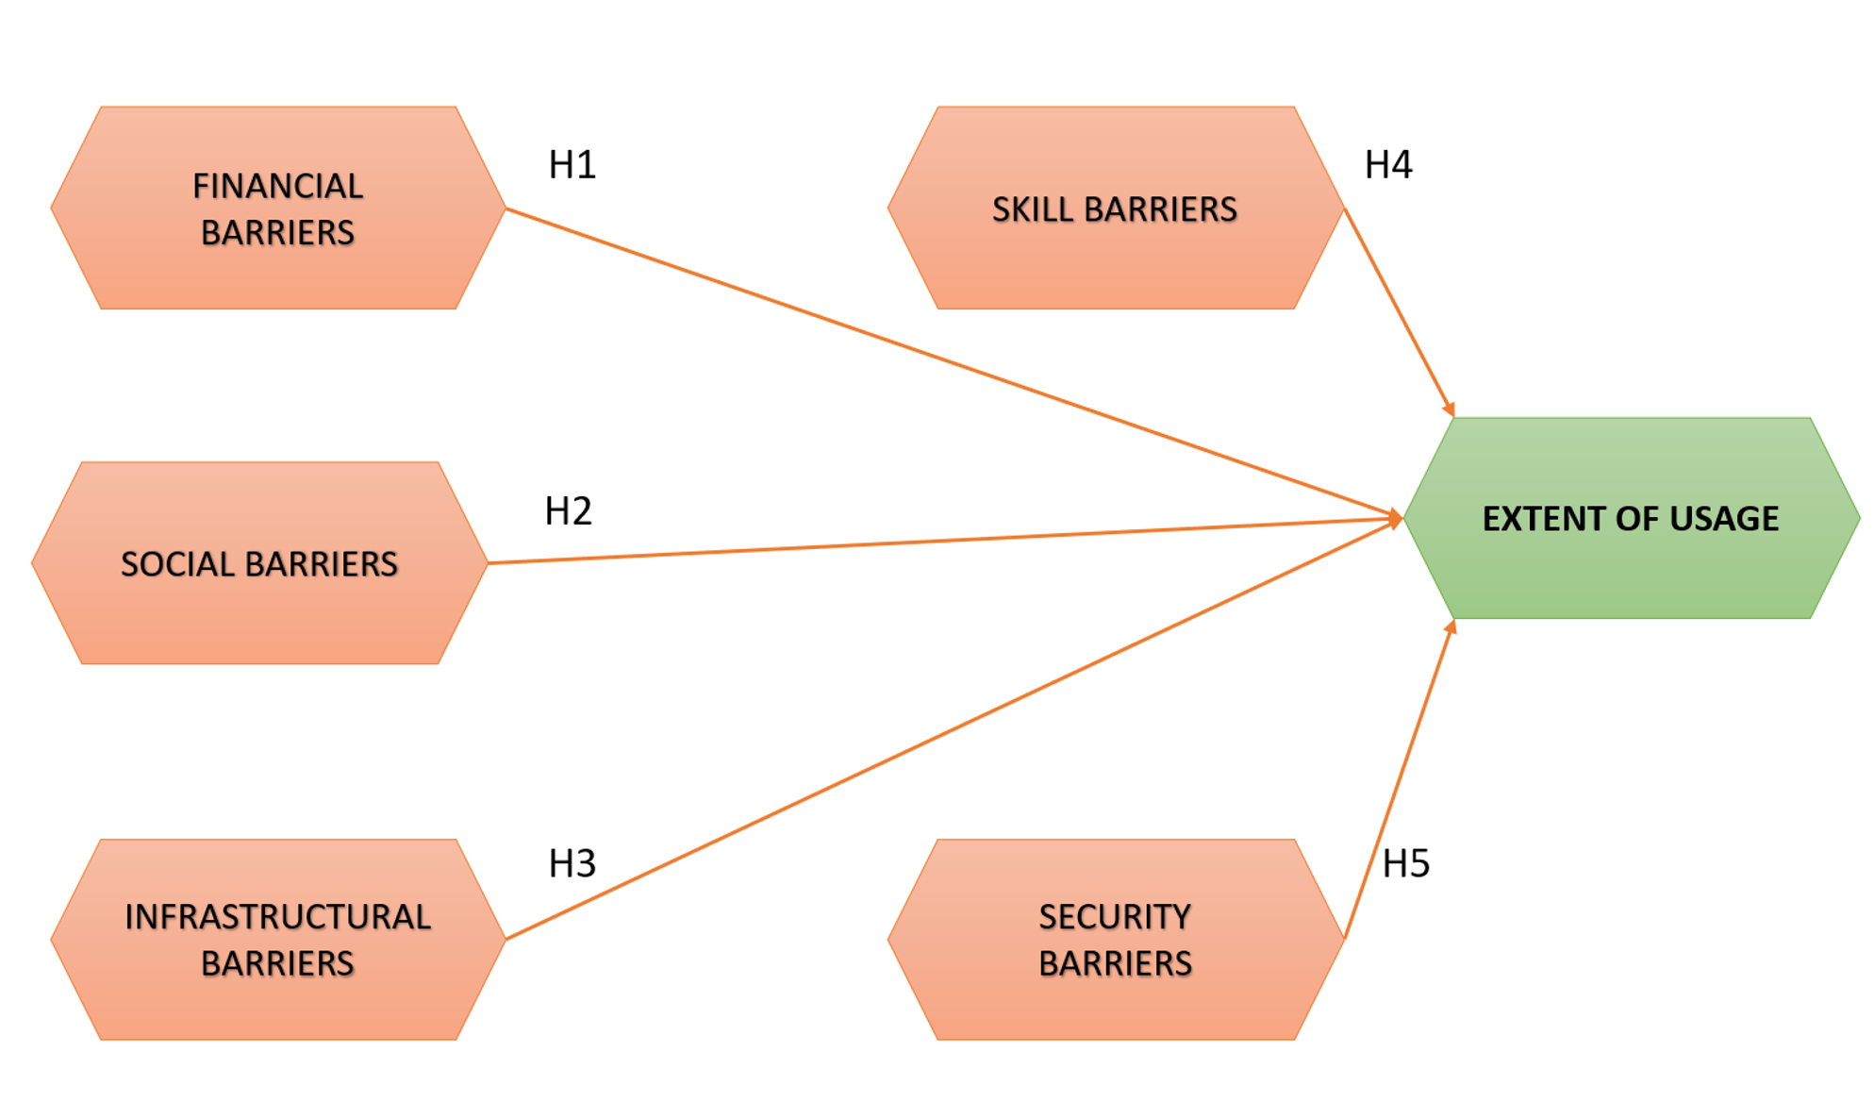
Figure 1: Conceptual Framework
Source: Created by Author
The hypotheses framed are as below:
H1: Financial Barriers have a significant negative impact on extent of usage of affordable digital marketing tools among rural women entrepreneurs
H2: Social Barriers have a significant negative impact on extent of usage of affordable digital marketing tools among rural women entrepreneurs
H3: Infrastructural Barriers have a significant negative impact on extent of usage of affordable digital marketing tools among rural women entrepreneurs
H4: Skill Barriers have a significant negative impact on extent of usage of affordable digital marketing tools among rural women entrepreneurs
H5: Security Barriers have a significant negative impact on extent of usage of affordable digital marketing tools among rural women entrepreneurs

5.0 Data Analysis and Interpretation
The process of data analysis was used to investigate the association between the identified barriers and the extent of adoption of affordable digital marketing tools among rural women entrepreneurs.
Table 1: Demographic and Business-Related Details
Variable | Category | Frequency | Percentage
Age | 20-30 | 18 | 36
Age | 31-40 | 22 | 44
Age | 41-50 | 8 | 16
Age | Above 50 | 2 | 4
Age | Total | 50 | 100
Educational Qualification | No formal education | 2 | 4
Educational Qualification | Primary | 8 | 16
Educational Qualification | Secondary | 13 | 26
Educational Qualification | PUC | 8 | 16
Educational Qualification | Graduation | 13 | 26
Educational Qualification | Postgraduation | 6 | 12
Educational Qualification | Total | 50 | 100
Marital Status | Single | 13 | 26
Marital Status | Married | 29 | 58
Marital Status | Widowed | 5 | 10
Marital Status | Divorced / Separated | 3 | 6
Marital Status | Total | 50 | 100
Size of Household | 1-3 | 23 | 48
Size of Household | 4-6 | 23 | 46
Size of Household | More than 6 | 3 | 6
Size of Household | Total | 50 | 100
Frequency of usage of affordable digital marketing tools for business | Very Frequently | 34 | 68
 | Frequently | 14 | 28
 | Moderately | 2 | 4
 | Rarely | 0 | 0
 | Never | 0 | 0
 | Total | 50 | 100

The demographic profile, as depicted in Table 1 indicates that the majority of the rural women entrepreneurs fall under the age group of 20-40 (80%), translating to most of the rural women being in their working age. Educational attainment indicates that most of the respondents have attained secondary education or higher (54%) indicating a fairly high level of literacy amongst the respondents. In terms of marital status, most of them are married (58%). The majority of the respondents live in small to medium-size households, with 48% of them containing members between 1 and 3 and 46% containing members between 4 and 6. The findings also show that adoption of tools of digital marketing is high, with 68% reporting that they utilize the same very frequently to conduct their business activities. Just 4% indicated moderate use, none out of them indicated rare use or no use. In general, the results imply that rural women entrepreneurs are vigorously adopting low-cost digital marketing resources to facilitate their businesses.
The extent of usage of affordable digital marketing tools among rural women entrepreneurs is depicted in the Figure 2.
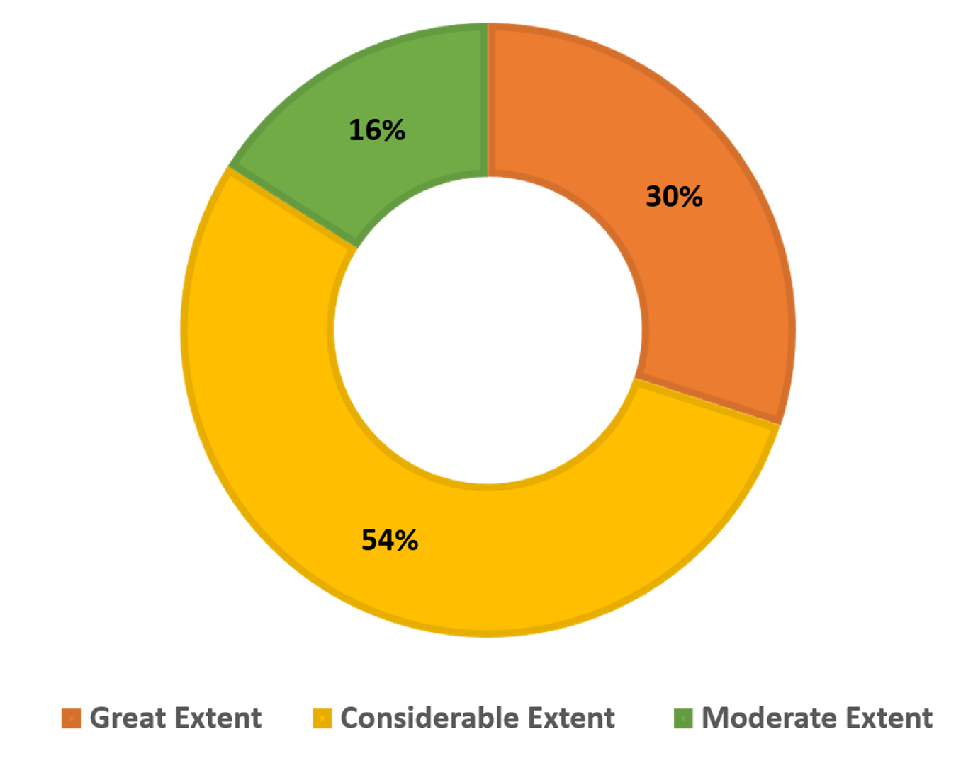
Figure 2: Extent of Usage of Affordable Digital Marketing Tools
Source: Created by Author
The findings indicate that most of the respondents use digital tools to great or considerable extent (84%). This means that rural women entrepreneurs are widely using affordable digital marketing tools to promote their businesses.
The research then sought to determine the obstacles that impede the use of affordable digital marketing resources among rural women entrepreneurs. In this regard, Multiple Regression Analysis was used. MRA helps in examining how several independent variables (barriers) together influence a single dependent variable, in this case the extent of usage of digital marketing tools (Halinski & Feldt, 1970).
Table 2: Model Summary
Model Summary
Model | R | R Square | Adjusted R Square | Std. Error of the Estimate
1 | .776ª | .602 | .557 | .446
a. Predictors: (Constant), Skill Barrier, Social Barrier, Infrastructural Barrier, Security Barrier, Financial Barrier

As shown in Table 2, the R square value of 0.602 is within the acceptable range of 0.51 to 0.99 and depicts that 60 percent of the usage variation can be attributed to identified barriers that include financial, infrastructural, security, social and skill barriers (Ozili, 2022).
Table 3: ANOVA Test
ANOVAª
Model |  | Sum of Squares | df | Mean Square | F | Sig.
1 | Regression | 13.263 | 5 | 2.653 | 13.328 | .000^{b}
1 | Residual | 8.757 | 44 | .199
1 | Total | 22.020 | 49
a. Dependent Variable: Extent of usage of affordable digital marketing tools
b. Predictors: (Constant), Skill Barrier, Social Barrier, Infrastructural Barrier, Security Barrier, Financial Barrier

Table 3 shows that the regression model is significant as the p-value is less than 0.05 (p < 0.001)
at 5% level of significance. This implies that a combination of the barriers that are taken into account in the study plays a major role in determining the extent to which rural women entrepreneurs utilize low-cost digital marketing tools.
Table 4: Regression Coefficients
Coefficientsª
Model |  | Unstandardized Coefficients |  | Standardized Coefficients | t | Sig.
 |  | B | Std. Error | Beta | t | Sig.
1 | (Constant) | .293 | .568 |  | .516 | .609
1 | Financial Barrier | .031 | .236 | .024 | .133 | .895
1 | Infrastructural Barrier | .042 | .184 | .032 | .229 | .820
1 | Security Barrier | .306 | .166 | .260 | 1.843 | .072
1 | Social Barrier | .188 | .104 | .192 | 1.798 | .079
1 | Skill Barrier | .561 | .189 | .524 | 2.974 | .005
a. Dependent Variable: Extent of usage of affordable digital marketing tools

Table 4 indicate that the impact of skill barriers on the use of affordable digital marketing tools is significant (b= 0.561, p=0.005) with the p value being less than 0.05. Financial (b= 0.031, p=0.895), social (b=0.188, p=0.079), security (b= 0.306, p=0.072) and infrastructural impediments (b= 0.042, p=0.820) were statistically insignificant as their respective p-values were above 0.05. Overall, the findings suggest that among the examined factors, lack of digital skills appears to be the most critical barrier affecting the use of affordable digital marketing tools among rural women entrepreneurs.

6.0 Results and Discussions
The demography related results indicate that the majority of respondents are aged between 31 and 40 which shows that women in this age bracket are more active, confident and open to new business practices. An appropriate level of education further underlines their capacity to learn and utilize these platforms effectively. The outcome corroborates with that of (Paul, 2026) and (Nayak & Nayak, 2025). Although most of them are married and home duties, their high usage indicates that they are highly motivated towards expanding their businesses. Although most of them are married, the majority of them having to fulfil household duties, their high frequency of usage demonstrates a strong motivation to develop their businesses, coinciding with findings of (Singh et al., 2023). Most of them are either in small to medium households and hence are able to devote more attention to entrepreneurial tasks.
The evidence on extent of usage suggests that rural women entrepreneurs are actively practicing digital marketing, which is a favourable development towards digital uptake (Md Faudzi et al., 2024). High percentage (54%) of participants indicating usage to considerable extent is indicative that usage is regular. Nevertheless, it might remain restricted to the fundamental applications than strategic usage. This brings out the difference between availability and effective use. A large number of women could be utilizing these tools to engage in mere communication as opposed to utilizing them to their fullest capabilities in marketing and business development. This opens the door to specific intervention with a practical hands-on training. The focus of training programs should be on real business application, which may include customer engagement, content creation and online selling. Confidence and sustained usage could be further enhanced by strengthening of peer networks and local support systems.
The regression analysis results indicate that social barriers did not significantly and negatively influence the utilization of low-cost digital marketing tools among the rural women entrepreneurs. Therefore hypothesis 2 (H2) is not upheld by the results. This finding is in contrast to findings of (LP & Kalluraya, 2026), (Saha et al., 2024), (Md Faudzi et al., 2024) and (Pathak & Varshney, 2017), who emphasized that socio-cultural norms and negative social attitudes play a role, with some women not accessing the internet because of social restrictions or unfavourable family conditions. The social barriers in the current study consisted of insufficient family support, peer encouragement as well as being judged by society over using digital platforms in conducting business. Nevertheless, the findings show that majority of the respondents do not see these factors as significant barriers. Instead, most women said that their families encouraged them, which allowed them to participate in digital marketing much more confidently. This observation is consistent with those of (Ghouse et al., 2017) which contend that family support, personal motivation and role models are significant in determining the entrepreneurial choices and career paths of women.
The financial and infrastructural barriers were determined to be statistically non-significant in affecting the degree of utilization of the available low-cost digital marketing tools, therefore refuting hypotheses 1 and 3. The affordability of digital tools, the recurring costs of mobile recharges and the cost of the internet were some financial barriers in this study. The findings indicate that the respondents tend to believe that digital marketing is an alternative cost-effective method to the traditional marketing techniques. The majority of the women business owners mentioned using WhatsApp Business, Instagram, Facebook Business accounts and Google Business pages that are either free or low-price and enable them to attract more customers. This is in line with the findings by (Goel et al., 2024) who remarked that digital marketing provides an affordable means of promotion to rural micro-entrepreneurs. This contrasts with findings reported by (Robert et al., 2021) and (Saha et al., 2024), who found financial limitations as a significant obstacle that does not allow women to own or gain control over digital devices. Regarding infrastructure, the respondents did not perceive challenges like unstable internet connectivity, power outages and absence of local technical assistance as significant obstacles. This implies that the area under study possesses digital infrastructure which is rather sufficient. These outcomes align with those of (Ameri et al., 2025), who emphasized the role of digital infrastructure in bolstering entrepreneurial journey of women in developing regions and (Amalia et al., 2025) observed that low access to infrastructure is one of the factors that can lead to the digital divide in rural areas.
The findings also expose that security barriers were not a key concern among most of the respondents. Therefore, the findings do not confirm hypothesis 5. Women in the study region did not cite major concerns about online privacy, online insecurity or unfavourable comments in their online business marketing. This observation agrees with (Ameri et al., 2025) and (Nayak & Nayak, 2025), who proposed that increased levels of digital security and a regulatory environment can increase trust and confidence in digital tools.
Skill barriers, however, were discovered to significantly and negatively influence the utilization of the low-cost digital marketing tools, leading to acceptance of H4. According to many respondents, it was challenging to use these tools to its full potential because of the limited knowledge about digital marketing practices and insufficient training. The results are in line with those highlighted by (Rani & Kumar, 2026) and (Mishra et al., 2020), who stated that the absence of digital skills may be a barrier to the uptake of technology among rural businesses. Equally, (Ghouse et al., 2017) observed that technical knowledge along with management skills could greatly empower the entrepreneurial capabilities of rural women. (Q. Bai et al., 2023) also pointed out that increased digital literacy enhances the capacity of women entrepreneurs to efficiently exploit digital mediums and also gives them greater confidence in entrepreneurial endeavours. (Kumar & Shobana, 2025) noted that effective training in such spheres as digital marketing, online business management and cybersecurity can assist rural entrepreneurs in entry to the digital marketplace, whereas (Aiswarya & Sangeetha, 2025) emphasized that better digitization competencies enhance the sustainability of businesses over the long term. Also,(Tamatur et al., 2026) (Aggarwal & Johal, 2021) noted that government promotion and training programs are important in ensuring women entrepreneurship. Even though there are a number of efforts being made to enhance digital inclusion, which could be in the form of Digital Shakti Campaign, PMGDISHA, Digital India and Common Service Centres (CSCs), most of their efforts are on basic computer literacy but not on mobile based, practical digital marketing. The little emphasis placed on mobile-based training makes the available programs less effective since digital marketing activities in rural regions are mainly undertaken using smartphones. As such, the rural women entrepreneurs require proactive measures in form of developing effective, smartphone based and practical-oriented training programs that are specific to digital marketing skills with a view of ensuring that the women in the rural regions make better use of digital platforms.

7.0 Implications of the Study
The research has valuable policy, practical and scholarly implications. In practical terms, it underscores the importance of going beyond digital access and investing in the development of digital skills that would promote the uptake of marketing tools in order to gain better business growth. The training programs need to be business-focused and specific to the actual business requirements. Policy-wise, there is a necessity to reform the current programs to focus on mobile-based digital marketing competencies instead of just basic digital literacy. Supportive initiatives and capacity-building programs on a local basis may also be effective. The study is also important in academic terms as it not only evaluates the obstacles, but also the level of usage and the effects such obstacles have on the level of usage. Although previous research has touched on most aspects of the financial, social and infrastructural barriers, this research also incorporates security barriers as a new dimension, thus enhancing its novelty. Moreover, unlike much of the literature available, the results indicate that the financial, social and infrastructural barriers were not material, suggesting a change in the nature of constraints on rural women entrepreneurs. All in all, the future of Karnataka rural women entrepreneurship can be considered bright and digitally oriented with appropriate support and skill-building.

8.0 Conclusion
The paper emphasizes that rural women entrepreneurs are increasingly adopting affordable digital marketing tools, which are generally viewed as affordable and useful in promoting businesses. The findings reveal that social, financial, infrastructural and security obstacles are not considered to pose any significant hindrance to the utilization of these tools in the study area. This implies that availability of supportive family environments, cost effectiveness of digital platforms and enhancement of digital infrastructure have been positively contributing factors towards their use. Nonetheless, the most noteworthy obstacles that influence the successful use of digital marketing platforms are the deficit of digital skills and awareness. To overcome this obstacle, specific attention needs to be paid to enhancing digital skills and offering effective training to rural female entrepreneurs. Development agencies and policymakers must develop specific programs to focus on mobile-based digital marketing skills and practical applications in business. Enhancing such efforts can boost the digital presence of rural women entrepreneurs and make rural economic development sustainable.

9.0 Limitations
The sample size used was relatively small as the study was aimed to be a preliminary regression analysis. A larger and more diverse sample of multiple regions could be a possible avenue of future research to understand digital marketing adoption more deeply and comprehensively. The findings may be further reinforced by adding longitudinal or mixed-method approaches. The external validity and the generalizability of the study could also be improved through such extensions.

Acknowledgement
The authors acknowledge the Indian Council of Social Science Research (ICSSR), New Delhi for the financial and institutional support rendered to them to conduct this study.

Disclaimer (Artificial intelligence)
Author(s) hereby declare that NO generative AI technologies such as Large Language Models (ChatGPT, COPILOT, etc.) and text-to-image generators have been used during the writing or editing of this manuscript.

References
Aggarwal, M., & Johal, R. K. (2021). Rural women entrepreneurship: a systematic literature review and beyond. World Journal of Science, Technology and Sustainable Development, 18(4), 373–392. https://doi.org/10.1108/WJSTSD-04-2021-0039
Aiswarya, S., & Sangeetha, S. (2025). Bridging the Digital Divide: Empowering Rural Women Entrepreneurs through Digital Inclusion. International Research Journal of Education and Technology, 7(2), 50–54.
Al Omoush, K. S. (2024). Fostering Women Entrepreneurs: Exploring the Drivers of Successful Social Commerce Business Adoption Among Women. Sage Open, 14(3). https://doi.org/10.1177/21582440241282952
Amalia, R., Aini, R. Q., Paradita, J., & Mirza BR, A. D. (2025). Bridging The Digital Divide : The Role of Technology in Enhancing Rural SMES in Indonesia. Jurnal Ilmu Manajemen Dan Bisnis, 16(1), 27–34. https://doi.org/10.17509/jimb.v16i1.82681
Ameri, M. K., Mohammadi, A., Hekmat, A. M., & Amiri, K. (2025). Analyzing the Impact of Digital Infrastructure on Women’s Entrepreneurship in Low-Income Countries. https://doi.org/10.2139/ssrn.5123975
Aravamudhan, V., Sivakumar, K., Vishnu, C. R., & Mohanasundaram, K. (2024). Challenges faced by women entrepreneurs in rural India: A mixed-method study on perception. The International Journal of Entrepreneurship and Innovation. https://doi.org/10.1177/14657503241254954
B, S., & Pai, R. (2025). Digital Inclusion of Women Entrepreneurs in The Unorganized Sector – A Systematic Review. Advances in Consumer Research, 2(1), 71–85.
Bai, Q., Chen, H., Zhou, J., Li, G., Zang, D., Sow, Y., & Shen, Q. (2023). Digital literacy and farmers’ entrepreneurial behavior—Empirical analysis based on CHFS2019 micro data. PLOS ONE, 18(7), e0288245. https://doi.org/10.1371/journal.pone.0288245
Bai, X., & Yang, L. (2025). Digital literacy’s impact on digital village participation in rural left-behind women through serial mediation of political trust and self-efficacy. Scientific Reports, 15(1), 34226. https://doi.org/10.1038/s41598-025-16093-3
Ghouse, S., McElwee, G., Meaton, J., & Durrah, O. (2017). Barriers to rural women entrepreneurs in Oman. International Journal of Entrepreneurial Behavior & Research, 23(6), 998–1016. https://doi.org/10.1108/IJEBR-02-2017-0070
Goel, R., Veluri, D. K. K., & Mishra, D. S. (2024). Understanding The Use Of Digital Marketing By Rural Micro Entrepreneurs Of India: A Systematic Literature Review. Educational Administration Theory and Practices. https://doi.org/10.53555/kuey.v30i5.4217
Green, S. B. (1991). How Many Subjects Does It Take To Do A Regression Analysis. Multivariate Behavioral Research, 26(3), 499–510. https://doi.org/10.1207/s15327906mbr2603_7
Gupta, D. C. (2025). Exploring the Digital Startup Ecosystem: A Rural-Urban Comparison of Women Entrepreneurs in India. Journal Global Values, XVI(SI), 32–36. https://doi.org/10.31995/jgv.2025.v16iSI.006
Halinski, R. S., & Feldt, L. S. (1970). The Selection of Variables in Multiple Regression Analysis. Journal of Educational Measurement, 7(3), 151–157. https://doi.org/10.1111/j.1745-3984.1970.tb00709.x
Helen, L. (2015). Design : Descriptive Research Definitions of. Journal of Pediatric Oncology Nursing, 10(1), 154–157.
Igwe, P., Newbery, R., & Icha-Ituma, A. (2018). Entrepreneurship Challenges and Gender Issues in the African Informal Rural Economy (pp. 91–111). https://doi.org/10.1007/978-3-319-59282-4_7
Kamberidou, I. (2020). “Distinguished” women entrepreneurs in the digital economy and the multitasking whirlpool. Journal of Innovation and Entrepreneurship, 9(1), 3. https://doi.org/10.1186/s13731-020-0114-y
Kaur, G., & Jyotsana, D. (2025). AI-Powered Customer Engagement In Women-Led Businesses. International Journal of Environmental Sciences, 564–569. https://doi.org/10.64252/fpvb7542
Kitole, F. A., & Genda, E. L. (2024). Empowering her drive: Unveiling the resilience and triumphs of women entrepreneurs in rural landscapes. Women’s Studies International Forum, 104, 102912. https://doi.org/10.1016/j.wsif.2024.102912
KSWDC. (2024). Karnataka State Women’s Development Corporation. Department of Women & Child Development & Empowerment of Differently Abled & Senior Citizens. https://kswdc.karnataka.gov.in/en
Kumar, S., & Shobana, D. (2025). A Study on Digital Literacy and Rural Entrepreneurship: Evaluating PMGDISHA’s Contribution in Nagaland. Naveen International Journal of Multidisciplinary Sciences (NIJMS), 1(4), 54–65. https://doi.org/10.71126/nijms.v1i4.38
LP, R., & Kalluraya, S. (2026). Role of Women Entrepreneurs in Rural Economic Transformation in India. Advanced International Journal for Research, 7(1). https://doi.org/10.63363/aijfr.2026.v07i01.3037
Madur. (2015). Physiography of Karnataka. https://www.karnataka.com/profile/physiography/#google_vignette
Mannummel, A. D., & Jerome, D. V. B. (2024). Empowering Women Entrepreneurs: Bridging the Digital Divide through Digital Marketing Technology Adoption. Educational Administration Theory and Practices. https://doi.org/10.53555/kuey.v30i5.3488
Md Faudzi, M. S., Abu Bakar, L. J., & Ahmad, S. (2024). Breaking Barriers: Investigating Technology Adoption in Micro, Small, and Medium Enterprises (MSMEs) Among Low-Income Women Entrepreneurs in Malaysia. PaperASIA, 40(5b), 126–135. https://doi.org/10.59953/paperasia.v40i5b.130
Mishra, O., Sharma, R., & Agrawal, B. (2020). Facilitating Women Prosperity with Higher Purpose at Vyomini. South Asian Journal of Business and Management Cases, 9(2), 198–207. https://doi.org/10.1177/2277977920905820
Nayak, M., & Nayak, P. M. (2025). Empowering women in rural India: characteristics and intentions for sustainable entrepreneurship. Cogent Business & Management, 12(1). https://doi.org/10.1080/23311975.2025.2461234
Nsengimana, S., Tengeh, R., & Iwu, C. (2017). The Sustainability of Businesses in Kigali, Rwanda: An Analysis of the Barriers Faced by Women Entrepreneurs. Sustainability, 9(8), 1372. https://doi.org/10.3390/su9081372
Ongare, R. M. (2023). Exploring the Economic Empowerment of Rural Women Entrepreneurs through Digital Platforms: An Investigation into the Utilization of Social Media Platforms. IJARCCE, 12(7). https://doi.org/10.17148/IJARCCE.2023.12741
Ozili, P. K. (2022). The Acceptable R-Square in Empirical Modelling for Social Science Research. SSRN Electronic Journal. https://doi.org/10.2139/ssrn.4128165
Paramasivam. (2022). A Study on Perception Towards Women Entrepreneurship in Digital Marjeting. Jurnal of Positive School Psychology, 6(4), 9265–9271.
Pathak, A. A., & Varshney, S. (2017). Challenges faced by women entrepreneurs in rural India. The International Journal of Entrepreneurship and Innovation, 18(1), 65–72. https://doi.org/10.1177/1465750316686245
Paul. (2026). Women Entrepreneurship in Rural India: Demographic Factors Acting as An Impediment to Growth with Special Reference to Uttarakhand Region of India. European Economic Letters (EEL). https://doi.org/10.52783/eel.v16i1.4180
Press Information Bureau. (2025). MSME sector accounts for 30.1% of India’s GDP, 35.4% of manufacturing and 45.73% of exports in the country: Union Minister for MSME. Ministry of Micro,Small & Medium Enterprises. https://www.pib.gov.in/PressReleasePage.aspx?PRID=2142170&reg=3&lang=2
Rah, N. S., Masduki, M., & Rahayu, N. E. E. (2021). Women Entrepreneurs and The usage of social Media for Business Sustainability In the time of Covid-19. https://doi.org/10.21203/rs.3.rs-907854/v1
Rani, A., & Kumar, S. (2026). Contribution of Government-Sponsored Welfare Schemes to the Upliftment of Women Entrepreneurship in Rural India. Global International Research Thoughts, 14(1), 1–12. https://doi.org/10.36676/girt.v14.i1.136
Robert, F. C., Frey, L. M., & Sisodia, G. S. (2021). Village development framework through self-help-group entrepreneurship, microcredit, and anchor customers in solar microgrids for cooperative sustainable rural societies. Journal of Rural Studies, 88, 432–440. https://doi.org/10.1016/j.jrurstud.2021.07.013
Rudhumbu, N., du Plessis, E. (Elize), & Maphosa, C. (2020). Challenges and opportunities for women entrepreneurs in Botswana: revisiting the role of entrepreneurship education. Journal of International Education in Business, 13(2), 183–201. https://doi.org/10.1108/JIEB-12-2019-0058
Saha, P., Prusty, A. K., & Nanda, C. (2024). Extension strategies for bridging gender digital divide. Journal of Applied Biology & Biotechnology. https://doi.org/10.7324/JABB.2024.159452
Singh, S., Alok, S., & Banerjee, S. (2023). Qualitative Exploration of Enabler, Purpose, and Benefits of Digitalisation in the Informal Sector: Understanding the Role of Bricolage Among Women Entrepreneurs. SEDME (Small Enterprises Development, Management & Extension Journal): A Worldwide Window on MSME Studies, 50(3), 211–226. https://doi.org/10.1177/09708464231167954
Srivastava, K., & Mohan, A. (2025). Identifying the Challenges Faced by the Women Entrepreneurs in Uttar Pradesh: Using Principal Component Analysis. SEDME (Small Enterprises Development, Management & Extension Journal): A Worldwide Window on MSME Studies, 52(4), 397–413. https://doi.org/10.1177/09708464251392735
Swarooprani. (2022). An Study of Research Methodology. International Journal of Scientific Research in Science, Engineering and Technology, 537–543. https://doi.org/10.32628/IJSRSET2293175
Tamatur, Y., Goncalves, M., & Rhyne, E. (2026). The Empowerment Spiral: From Constraint to Transformation in Rural Indonesian Women’s Entrepreneurship. Merits, 6(1), 5. https://doi.org/10.3390/merits6010005
Tanoto, S. R., & Tahalele, N. P. L. P. (2024). Assessing The Influence of Information Technology on Female Entrepreneur Empowerment in Indonesia: The Role of Social and Psychological Capitals. Indonesian Journal of Business and Entrepreneurship. https://doi.org/10.17358/ijbe.10.3.581
Wang, Q., & Keane, M. (2020). Struggling to be more visible: Female digital creative entrepreneurs in China. Global Media and China, 5(4), 407–422. https://doi.org/10.1177/2059436420969624

