Review Article

Bridging the Gap: Emerging Orthodontic Strategies in Cleft Lip and Palate Regeneration

.
ABSTRACT

Cleft lip and palate (CLP) is a common congenital craniofacial anomaly that significantly affects facial aesthetics, oral function, and overall quality of life, requiring long-term multidisciplinary management. Conventional treatment approaches, including presurgical orthopedics and surgical repair, have improved outcomes but are often associated with limitations such as graft resorption, scarring, altered growth patterns, and the need for repeated interventions. From an orthodontic perspective, challenges persist in achieving stable alveolar bone continuity, optimal tooth eruption, and long-term occlusal harmony.
Recent advances in regenerative medicine and digital technology are transforming cleft care toward a more precise and patient-specific approach. Innovations such as tissue engineering, stem cell therapy, 3D and 4D bioprinting, nanotechnology, and artificial intelligence–assisted planning have demonstrated potential in enhancing alveolar bone regeneration, improving eruption guidance, and maintaining arch form. Digital workflows and telemedicine further improve accessibility and treatment efficiency.
This review highlights these emerging strategies and their orthodontic implications, emphasizing their role in improving treatment predictability and reducing intervention burden. Despite promising outcomes, challenges related to cost, accessibility, and long-term clinical validation remain. The integration of regenerative and digital approaches represents a significant step toward personalized, growth-adaptive cleft management.

Keywords: Cleft Lip and Palate, Nasoalveolar Molding, 3D Printing & 4D Bioprinting, Tissue Engineering, Stem Cell Therapy, Regenerative Medicine, Nanotechnology, Artificial Intelligence in Cleft Care

INTRODUCTION

Cleft lip and palate (CLP) are among the most common congenital craniofacial anomalies, affecting both facial aesthetics and essential oral functions, and often requiring prolonged, multidisciplinary care. Conventional management relies on established approaches such as presurgical orthopedic techniques, including nasoalveolar molding (NAM) and passive alveolar plates, along with early surgical repair. These strategies help reduce cleft severity, approximate alveolar segments, and support maxillary development. However, limitations such as donor-site morbidity, graft resorption, delayed tooth eruption, soft tissue scarring, and the need for multiple surgical interventions continue to influence long-term outcomes.
From an orthodontic standpoint, CLP management extends beyond defect closure. Alveolar bone continuity, eruption patterns, dental arch form, occlusal relationships, and craniofacial growth are significantly impacted by both the cleft defect and its treatment. This necessitates careful planning of treatment timing, appliance design, and space management to achieve stable functional and aesthetic outcomes. Despite their effectiveness, traditional methods often require prolonged or repeated orthodontic interventions due to residual deficiencies and altered growth patterns.
Recent advances in regenerative medicine, digital technology, and bioengineering are reshaping cleft care. Innovations such as tissue-engineered scaffolds, stem cell therapy, 3D/4D bioprinting, and AI-assisted planning offer new possibilities for improving alveolar bone regeneration, guiding tooth eruption, and optimizing orthodontic outcomes. This review focuses on these emerging strategies from an orthodontic perspective, highlighting their role in bridging the gap between conventional treatment and next-generation regenerative care.

Literature Search Methodology

A narrative literature search was conducted using electronic databases such as PubMed, Scopus, and Google Scholar. Priority was given to peer-reviewed articles, systematic reviews, and clinical studies based on their relevance and contribution to current advancements in cleft care. Recent articles (primarily from the last 5-10 years), including original research and review articles, were considered.

Early Diagnosis and Prenatal Detection

Early diagnosis of CLP allows for timely planning and improved treatment outcomes. Routine 2D ultrasonography remains the primary screening tool, while 3D and 4D ultrasonography provide enhanced visualization of facial structures, enabling better assessment of cleft severity and maxillary discrepancies. ¹ Adjunctive imaging modalities such as color Doppler and fetal MRI further improve detection of palatal and craniofacial abnormalities. ²

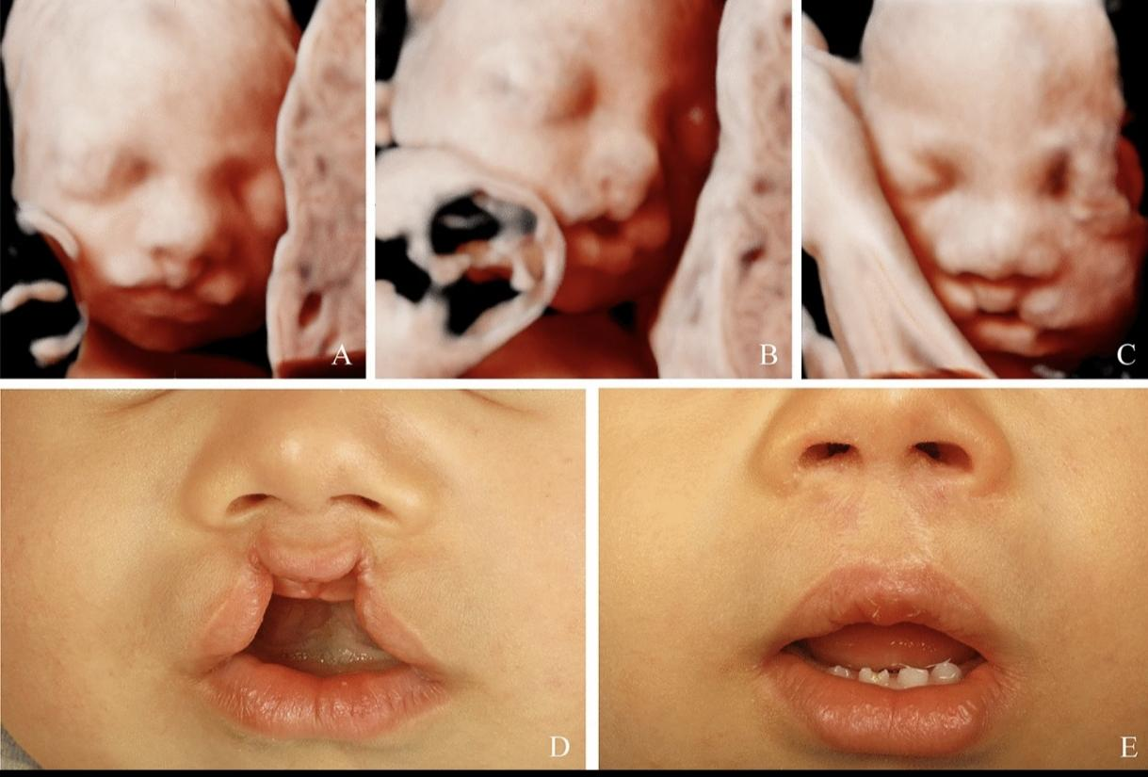
Fig 1: Bilateral cleft lip visualized on ultrasound during the prenatal period in 3D (A–C). Postnatal preoperative (D) and postoperative (E) result ⁴

Genetic screening techniques, including non-invasive prenatal testing (NIPT) and chromosomal microarray analysis, assist in identifying syndromic associations that may influence craniofacial growth and dental development. ³ Although isolated cleft palate remains difficult to detect prenatally, combining imaging with genetic insights enables early multidisciplinary planning and improved treatment sequencing from infancy.

Genetic and Molecular Basis

CLP is a multifactorial condition resulting from complex interactions between genetic and environmental factors. Key genes such as IRF6, MSX1, PAX9, TGFB3, and TBX22 regulate craniofacial development, including epithelial differentiation, mesenchymal proliferation, and palatal shelf fusion. ⁵ Disruptions in molecular pathways like Wnt, Sonic Hedgehog, and BMP signaling can impair maxillary growth and alveolar bone formation, influencing occlusion and eruption patterns.
eruption patterns.

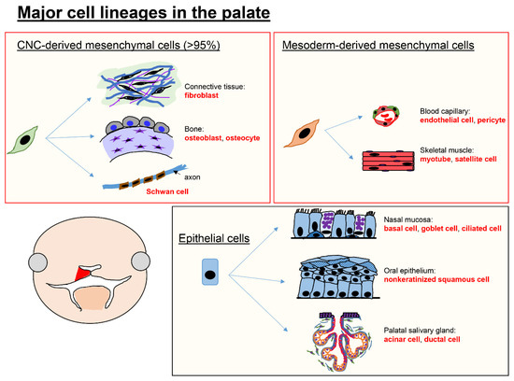
Fig 2: Major cell types in the palate. ⁶

Epigenetic mechanisms and environmental influences, including maternal smoking, nutritional deficiencies, and teratogenic exposure, further contribute to variability in cleft presentation and severity. Advances in next-generation sequencing and CRISPR-based technologies have enhanced understanding of these mechanisms, offering potential for personalized risk assessment. ⁷
However, direct gene therapy for CLP remains largely experimental due to the complexity of craniofacial development and ethical considerations. Current applications are primarily focused on early diagnosis and risk prediction rather than clinical intervention. ⁸

Digital Dentistry and 3D Printing in Cleft Care

The integration of digital workflows and 3D printing has revolutionized cleft management by enabling precision-based, patient-specific solutions. In presurgical orthopedics, intraoral scanning has replaced conventional impression techniques, allowing safe and accurate digital capture of neonatal oral structures.
These digital models are used to fabricate customized NAM appliances with improved fit, retention, and controlled force application. ⁹ Compared to traditional methods, digital workflows significantly reduce fabrication time and allow batch production of sequential appliances, improving treatment efficiency and standardization.

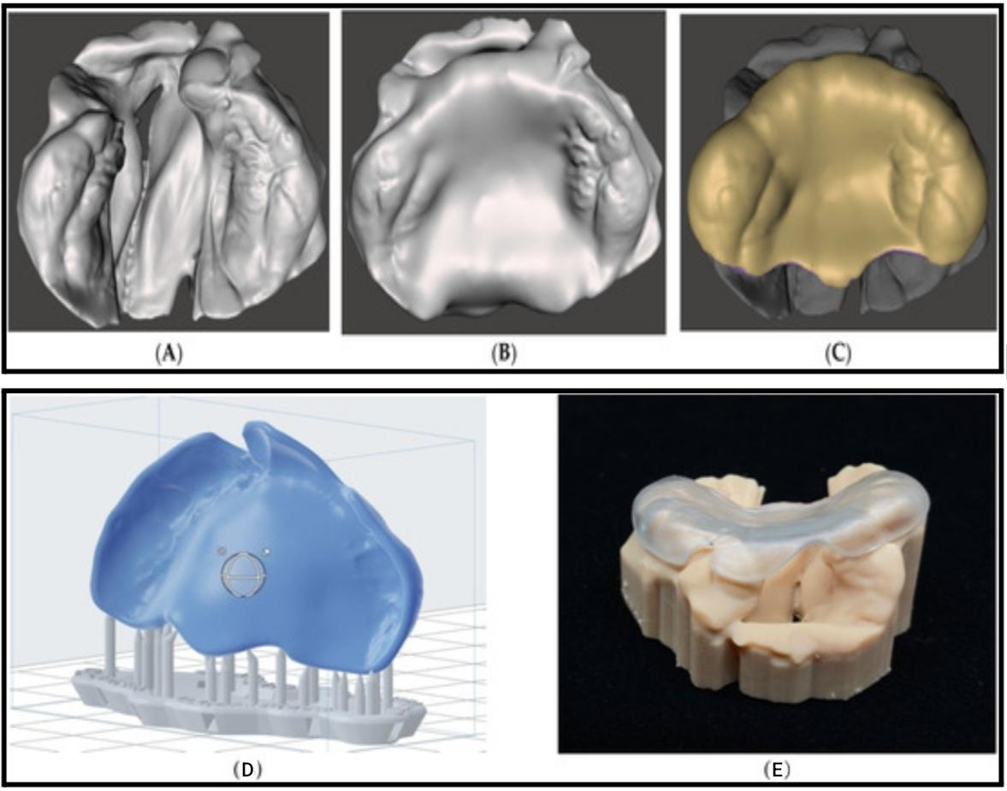
Fig 3. Unilateral cleft lip and palate model (A) as imported; (B) with blocked cleft area to mimic a normal palatal shape; (C) final passive presurgical orthopedic plate ready for 3D printing. (D) Manual-orientation of the presurgical plate and auto-generation of the support structure. (E) Digitally designed and 3D printed passive presurgical plate with corresponding anatomical cleft model. ⁹

3D printing has also transformed feeding management through the development of customized palatal obturators, which restore oral function and improve nutritional outcomes in neonates. In surgical planning, patient-specific anatomical models and surgical guides enhance precision, reduce operative time, and improve outcomes in procedures such as alveolar bone grafting and maxillary reconstruction. ¹²
While these digital and 3D printing technologies primarily focus on appliance fabrication and surgical planning, newer advances such as bioprinting extend these concepts further into tissue regeneration.

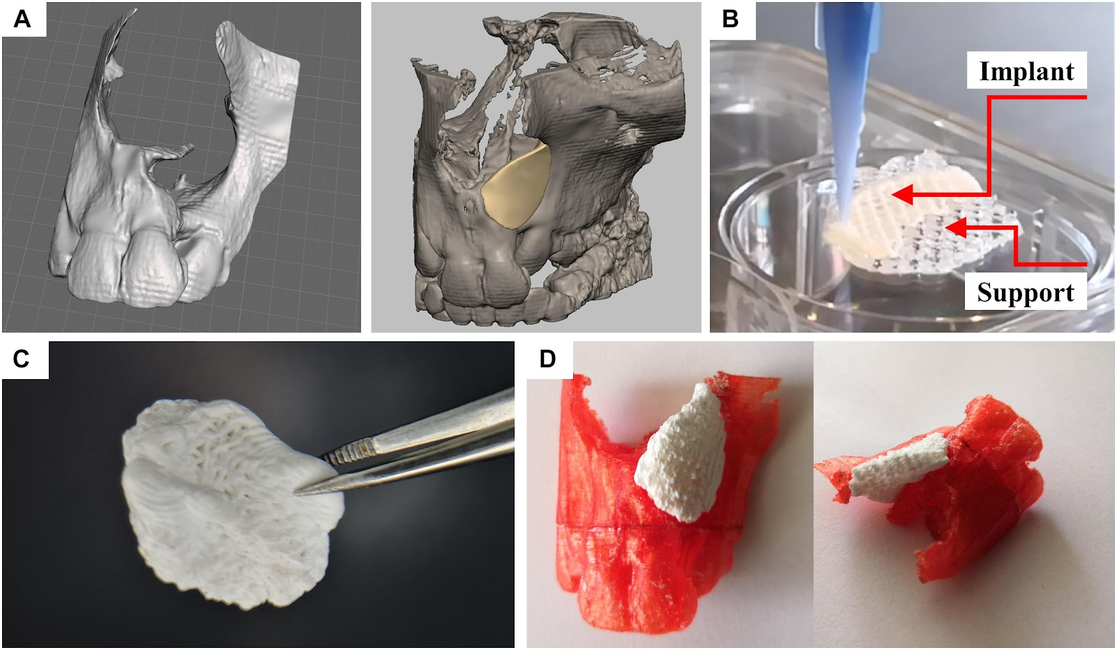
Fig 4. Design and fabrication process of a patient-specific implant consisting of a calcium phosphate cement. (A) Three-dimensional reconstruction of a CT scan of a patient and a designed model of a perfectly fitting implant. (B) Fabrication process by multichannel 3D plotting of a sacrificial ink and the CPC. (C) Photograph of the implant, after the sacrificial ink was washed away. (D) The hardened implant fits perfectly into the defect of the patient. Red: Plastic model of the maxilla with incisors, white: 3D plotted CPC implant. ¹⁰

The integration of 3D printing with telemedicine is emerging as a valuable advancement in cleft care, enabling remote and more accessible treatment delivery. Digital impressions of an infant’s oral cavity can be captured using scanners at peripheral centers or through caregiver-assisted methods at home, and then shared with specialized units for fabrication of customized appliances. These appliances can be produced remotely and delivered directly to patients, reducing the need for repeated hospital visits. This approach is particularly beneficial for families in rural or underserved areas, as it improves access to care, follow-up compliance, and reduces both financial and emotional burden.
Additionally, digital workflows allow parents to visualize treatment progress through 3D models and simulations, enhancing their understanding, involvement, and overall treatment compliance.

IMAGE 1. Flowchart of digital workflow in 3D printing of Appliance ¹¹
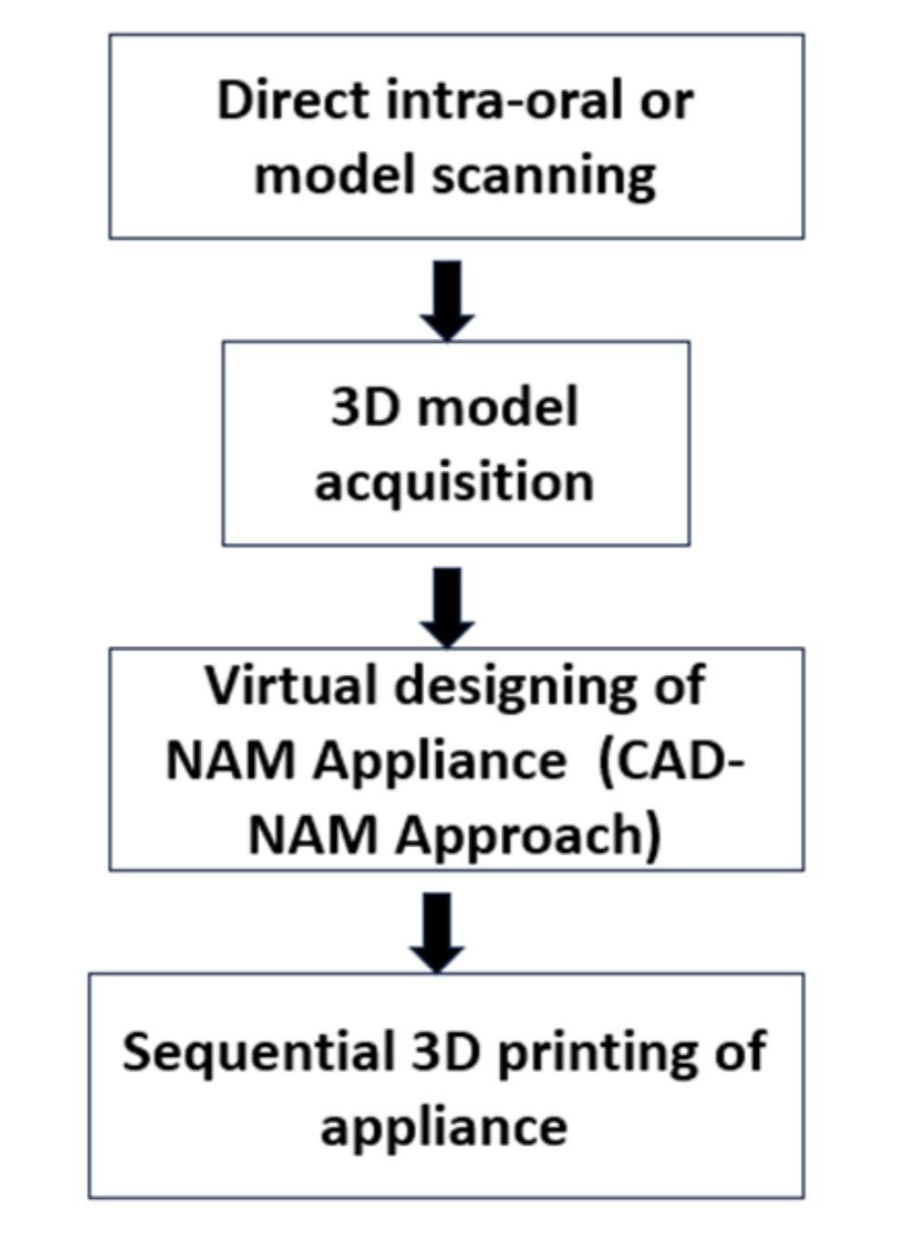

3D and 4D Bioprinting

3D bioprinting enables fabrication of highly precise, patient-specific scaffolds that replicate the complex geometry of alveolar and palatal defects. Integration of CAD and additive manufacturing allows controlled porosity, architecture, and mechanical strength, promoting osteogenesis and vascularization. Incorporation of stem cells and growth factors further enhances tissue regeneration, accelerates alveolar bone healing, and improves timing of orthodontic loading and eruption guidance.
4D bioprinting introduces dynamic, growth-responsive scaffolds capable of altering shape, stiffness, or bioactive molecule release in response to physiological stimuli. These smart materials accommodate craniofacial growth, reducing repeated interventions and supporting continuous orthodontic guidance. Additionally, in situ 4D printing during surgery improves anatomical adaptation, enhances vascularization, and enables localized molecular delivery, facilitating both bone and soft tissue integration essential for maintaining arch form, occlusal stability, and eruption timing. ¹³’¹⁴

Tissue Engineering and Regenerative Medicine

Tissue engineering has emerged as a key approach in alveolar bone reconstruction in cleft lip and palate (CLP), with direct implications for orthodontic treatment. Biocompatible scaffolds derived from synthetic polymers (PLA, PCL) and natural materials (collagen, chitosan) support cellular infiltration, vascularization, and osteogenesis, enabling improved alveolar continuity and facilitating timely tooth eruption. ¹⁵
Mesenchymal stem cells (MSCs), sourced from bone marrow, adipose tissue, or dental pulp, further enhance bone regeneration when combined with these scaffolds, reducing dependence on autologous bone grafts. The addition of growth factors such as BMPs and VEGF accelerates osteoblastic activity and bone formation, improving alveolar ridge stability. ¹⁵’¹⁶
These regenerative strategies collectively provide adequate bone volume for orthodontic space management, eruption guidance, and arch stabilization, thereby enhancing the predictability and outcomes of orthodontic interventions in CLP patients.

Nanotechnology and Targeted Delivery

Nanotechnology-based approaches offer precise, localized delivery of osteoinductive and angiogenic molecules (BMP-2, VEGF, FGF) to alveolar defects, promoting bone formation and ridge stability. Nanoparticle-mediated scaffolds and hydrogels enhance stem cell proliferation, osteogenesis, and soft tissue healing, which is particularly important for supporting orthodontic appliances and guiding eruption.¹⁷’¹⁸ Electrospun nanofiber scaffolds improve mucosal regeneration and reduce fibrosis, creating a more favorable environment for tooth movement and arch development.
Integration of nanotechnology with stem cells and tissue-engineered scaffolds allows personalized regenerative strategies, optimizing alveolar volume and shape for predictable orthodontic intervention while reducing post-operative complications.

Innovative Presurgical Orthopedic Approaches

Recent advancements in presurgical orthopedics focus on improving efficiency, accessibility, and patient compliance. Modified presurgical alveolar molding (PAM) appliances incorporating controlled force systems and extraoral elastics allow gradual approximation of cleft segments with improved precision and reduced treatment duration.

A study presents a rare and innovative clinical approach for managing a Tessier No. 0 craniofacial cleft, which typically involves the upper lip, nose, and palate. The authors describe the use of a modified Presurgical Alveolar Moulding (PAM) appliance as an alternative to conventional methods for approximating cleft segments prior to surgery.
Unlike standard PAM devices, this modified version featured reciprocal parts connected by a helix, with midline V-shaped stripping to allow gradual segment approximation. Extraoral elastics were employed to apply the necessary forces. Over 8 weeks, the anterior cleft gap reduced dramatically from 13 mm to 3 mm, marking a significant improvement in pre-surgical anatomy.
Importantly, at a 21-month follow-up, the reshaped alveolar segments remained stable, indicating long-term success of the oral moulding achieved. This method demonstrates how innovative appliance design can effectively reduce cleft severity preoperatively, potentially simplifying surgical closure and improving functional and aesthetic outcomes. ²⁰

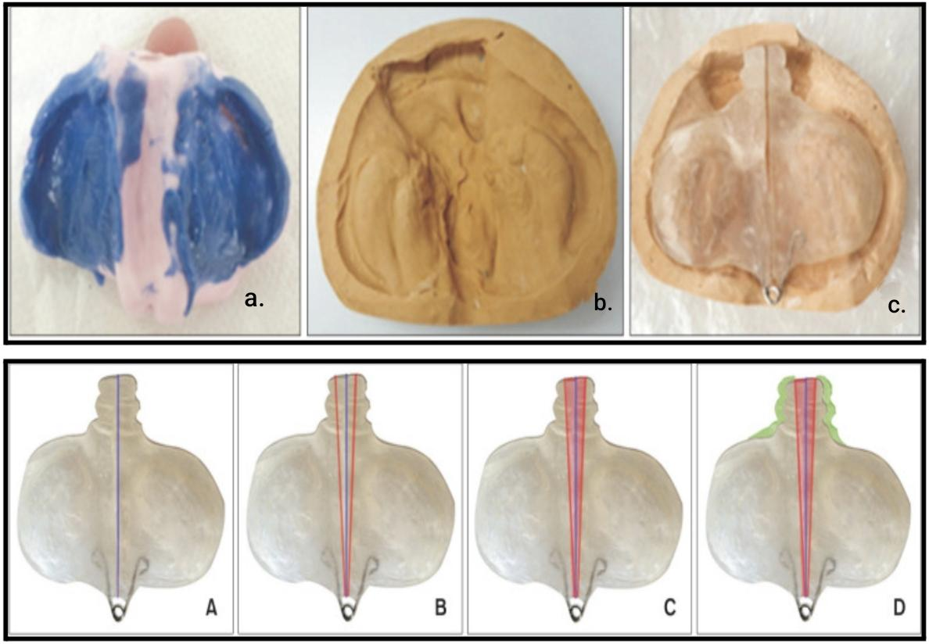

Fig 5. a. Polyvinyl siloxane impression of the infant’s maxilla, b. Stone cast, c. Modified presurgical alveolar molding appliance. A.Procedure of the modified presurgical alveolar molding (PAM) appliance. The purple line demonstrates that the PAM appliance consists of two reciprocal parts, B. The red line demonstrates the boundaries of the acrylic area to be stripped, C. The red area demonstrates the acrylic region that has been removed, D. The green area demonstrates the acrylic region where additions were made. ²⁰

Alternative approaches such as the DynaCleft system and nasal elevators provide less technique-sensitive options for nasal cartilage molding and alveolar alignment, particularly in resource-limited settings. These methods reduce the need for frequent adjustments and can be combined with telemonitoring for improved accessibility.
Collectively, these innovations contribute to better surgical outcomes by reducing cleft severity, improving nasal symmetry, and facilitating tension-free closure.

Emerging Surgical Approaches and Adjunctive Strategies

Advancements in surgical techniques in cleft care increasingly focus on functional reconstruction with minimal tissue trauma. Procedures such as functional cheiloplasty, refined palatoplasty, including techniques like Furlow Z-plasty, and precise muscle repositioning contribute to improved speech outcomes and reduced scar formation. The use of resorbable sutures and biomaterials has further minimized tissue damage compared to conventional methods. Additionally, while traditional alveolar bone grafting relied on autologous bone harvested from the iliac crest, current research is exploring stem cell–based and synthetic graft alternatives, aiming to eliminate donor-site morbidity and enhance long-term regenerative outcomes.

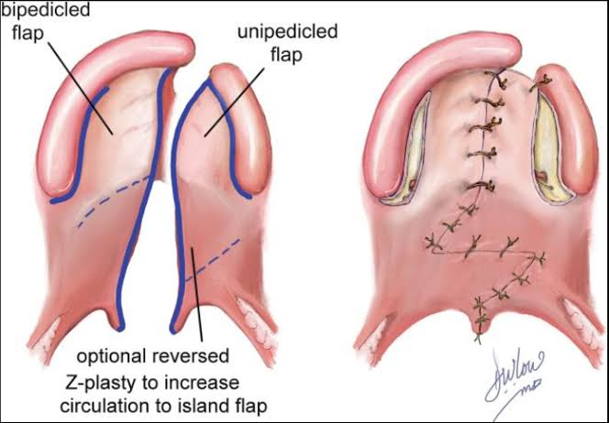
Fig 6. Cleft palate repair through Furlow double-opposing Z-plasty. ²¹

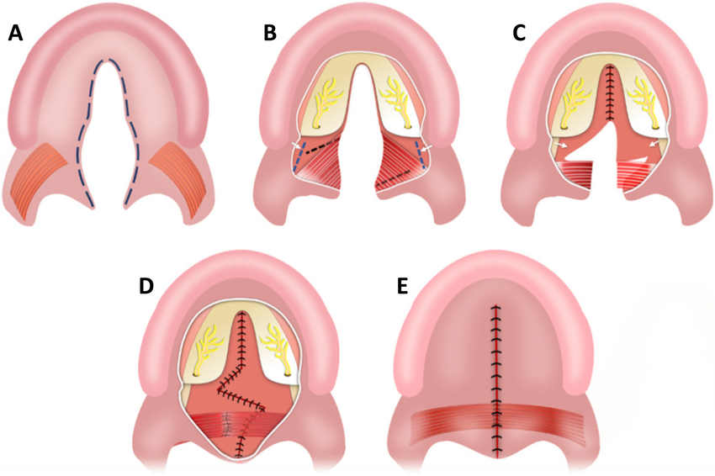
Fig 7. Sommerlad-Furlow modified technique: (A) An incision was made along the cleft margins to separate the oral and nasal mucosal layers. (B) A wide mucoperiosteal flap was elevated from the hard palate, with release of the greater palatine neurovascular pedicles, and a nasopharyngeal incision was made at the medial pterygoid plate using an electrotome. (C) The nasal mucoperiosteum was peeled anteriorly from the palatine bone and medially from the pterygoid plate toward the cranial base, followed by suturing of the nasal layer of the hard palate. Radical muscle dissection was done, and Z-plasty pflaps were designed on the nasal layer of the soft palate. (D) The nasal layer of the soft palate and palatal muscles were completely sutured. (E) Finally, the oral layer was closed without any relaxing incisions. ²²

Recent approaches also explore minimally invasive and growth-preserving interventions, aiming to reduce interference with maxillary development. The use of patient-specific surgical guides derived from 3D imaging enhances intraoperative precision.

Adjunctive strategies such as platelet-rich plasma (PRP) and platelet-rich fibrin (PRF) enhance bone and soft tissue regeneration during alveolar grafting, improving ridge volume for timely eruption of permanent teeth and predictable space maintenance. ²³ Laser-assisted therapies improve soft tissue healing, reducing scarring and facilitating appliance placement. Hydrogel-based or nanomaterial-assisted grafting allows precise delivery of growth factors, accelerating bone regeneration and supporting orthodontic mechanics. ²⁴
Such minimally invasive techniques maintain alveolar continuity, arch form, and tooth alignment, bridging regenerative innovations with orthodontic treatment. This integration enables more precise timing of orthodontic interventions, reduces the need for repeated interventions, and improves long-term functional and aesthetic outcomes for CLP patients.

Multidisciplinary and Holistic Care

Contemporary CLP management emphasizes a team-based approach involving orthodontists, surgeons, speech therapists, audiologists, and psychologists. This collaborative model ensures comprehensive care addressing functional, aesthetic, and psychosocial aspects.
Digital tools and telehealth platforms further enhance coordination, improve patient compliance, and support long-term follow-up.

Artificial Intelligence and Future Innovations

Artificial intelligence (AI) is rapidly transforming the landscape of cleft lip and palate (CLP) management by introducing data-driven precision into diagnosis, treatment planning, and long-term follow-up. Advanced machine learning algorithms can analyze large datasets from imaging modalities such as CBCT, 3D facial scans, and intraoral scans to enable early detection of cleft severity, prediction of craniofacial growth patterns, and assessment of treatment outcomes. AI-based tools are also being developed for automated landmark identification, orthodontic treatment simulation, and prediction of tooth eruption patterns, thereby enhancing clinical decision-making and reducing operator dependency.
In orthodontics, AI integration with digital workflows allows for personalized appliance design, optimized force systems, and improved treatment timing based on individual growth and regenerative responses. Additionally, AI-driven speech analysis systems are emerging as valuable tools for evaluating velopharyngeal function and monitoring post-surgical speech outcomes, offering objective and reproducible assessments.
Future innovations are expected to combine AI with regenerative medicine, including gene-modulated therapies, stem cell–based interventions, and smart biomaterials capable of responding to physiological stimuli. The integration of AI with genetic profiling may further enable risk prediction, early intervention strategies, and individualized treatment protocols. Moreover, advancements in fetal imaging and potential intrauterine interventions may open new avenues for early-stage correction and prevention. ⁴⁸
Despite its promising potential, challenges such as data standardization, ethical considerations, algorithm transparency, and the need for high-quality clinical validation remain. Nevertheless, the incorporation of AI into multidisciplinary cleft care represents a significant step toward more predictive, personalized, and efficient management, ultimately improving both functional and aesthetic outcomes in CLP patients.

Critical Analysis of Literature

Although significant advancements have been made in cleft care, several limitations remain. Conventional approaches such as autologous bone grafting are effective but associated with donor-site morbidity and variable resorption rates. Emerging regenerative techniques, including stem cell therapy and bioprinting, show promising outcomes; however, most evidence is based on preclinical or early clinical studies with limited long-term data. Additionally, variability in treatment protocols and patient-specific factors can influence outcomes. Therefore, while innovative approaches enhance treatment potential, further standardized clinical trials are necessary to establish their long-term efficacy and integration into routine orthodontic practice.

Future Scope and Limitations

Despite significant advancements, several limitations continue to affect the clinical translation of emerging strategies in cleft care. Most regenerative approaches, including stem cell–based therapies and bioprinted scaffolds, are supported predominantly by preclinical studies or limited early-phase clinical trials, with insufficient long-term evidence regarding alveolar bone stability, tooth eruption patterns, and occlusal outcomes. The biological behavior of regenerated tissues under orthodontic forces also remains incompletely understood, raising concerns regarding relapse, delayed eruption, or compromised arch stability.
Additionally, the high cost of advanced technologies such as 3D/4D bioprinting, AI-driven planning systems, and customized biomaterials limits their accessibility, particularly in resource-constrained settings. The requirement for specialized infrastructure, technical expertise, and interdisciplinary coordination further restricts widespread clinical implementation. Variability in patient-specific factors—including genetic background, growth patterns, and tissue response—can also lead to inconsistent outcomes, necessitating individualized treatment planning and close monitoring.
Furthermore, the lack of standardized clinical protocols and uniform outcome measures across studies makes it difficult to directly compare results and establish evidence-based guidelines. Ethical considerations related to gene therapy, stem cell applications, and prenatal interventions also remain areas of ongoing debate. These challenges highlight the need for well-designed, long-term clinical trials and protocol standardization to ensure safe, predictable, and reproducible integration of regenerative approaches into routine orthodontic practice.

CONCLUSION

Cleft lip and palate management is evolving toward a more precise, regenerative, and digitally driven model of care. Advances in tissue engineering, bioprinting, nanotechnology, and artificial intelligence are enhancing alveolar bone regeneration and orthodontic outcomes by improving eruption guidance, arch stability, and overall treatment predictability. Although challenges related to cost, accessibility, and limited long-term evidence persist, these developments are paving the way for more personalized and growth-adaptive cleft care.

Disclaimer (Artificial intelligence)

Author(s) hereby declare that NO generative AI technologies such as Large Language Models (ChatGPT, COPILOT, etc.) and text-to-image generators have been used during the writing or editing of this manuscript.

References

- Brăila AD, Damian CM, Albu CC, Botoacă O, Dȋră LM, Albu ŞD, Brăila MG, Bănățeanu AM, Poalelungi CV, Bogdan-Andreescu CF. Prenatal diagnosis of cleft lip and palate: a retrospective study. J Clin Med. 2024;13(16):4804. doi:10.3390/jcm13164804
- Lee MS, Cho JY, Kim SY, Kim SH, Park JS, Jun JK. Value of sagittal color Doppler ultrasonography as a supplementary tool in the differential diagnosis of fetal cleft lip and palate. Ultrasonography. 2017;36(1):53–59. doi:10.14366/usg.16025
- Baeza-Pagador A, Tejero-Martínez A, Salom-Alonso L, Camañes-Gonzalvo S, García-Sanz V, Paredes-Gallardo V. Diagnostic methods for the prenatal detection of cleft lip and palate: a systematic review. J Clin Med. 2024;13(7):2090. doi:10.3390/jcm13072090
- Vibert F, Schmidt G, Löffler K, et al. Accuracy of prenatal detection of facial clefts and relation between facial clefts, additional malformations and chromosomal abnormalities: a large referral-center cohort. Arch Gynecol Obstet. 2024;309:1971–1980. doi:10.1007/s00404-023-07084-8
- Babai A, Irving M. Orofacial clefts: genetics of cleft lip and palate. Genes. 2023;14(8):1603. doi:10.3390/genes14081603
- Iwaya C, Suzuki A, Iwata J. MicroRNAs and gene regulatory networks related to cleft lip and palate. Int J Mol Sci. 2023;24(4):3552. doi:10.3390/ijms24043552
- Oliver JD, Jia S, Halpern LR, Graham EM, Turner EC, Colombo JS, Grainger DW, D'Souza RN. Innovative molecular and cellular therapeutics in cleft palate tissue engineering. Tissue Eng Part B Rev. 2021;27(3):215–237. doi:10.1089/ten.TEB.2020.0181
- Dziedzic A, Kubina R, Skonieczna M, Madej M, Fiegler-Rudol J, Abid M, Nadhim D, Tanasiewicz M. CRISPR genome editing in personalized therapy for oral and maxillofacial diseases: a scoping review. Biomedicines. 2025;13(11):2745. doi:10.3390/biomedicines13112745
- Zarean P, Thieringer FM, Mueller AA, et al. A point-of-care digital workflow for 3D printed passive presurgical orthopedic plates in cleft care. Children (Basel). 2022;9(8):1261. doi:10.3390/children9081261
- Korn P, von Strauwitz Né Ahlfeld T, Lahmeyer F, et al. 3D printing of bone grafts for cleft alveolar osteoplasty – in vivo evaluation in a preclinical model. Front Bioeng Biotechnol. 2020;8:217. doi:10.3389/fbioe.2020.00217
- Singh D, Tripathi T, Rai P. 3D nasoalveolar moulding: a complete digital workflow model. Int J Sci Res Arch. 2024;11:1713–1718. doi:10.30574/ijsra.2024.11.2.0665
- Ergül T, Güleç A, Göymen M. The use of 3D printers in orthodontics: a narrative review. Turk J Orthod. 2023;36(2):134–142. doi:10.4274/TurkJOrthod.2022.2021.0074
- Brézulier D, Chaigneau L, Jeanne S, Lebullenger R. The challenge of 3D bioprinting of composite natural polymers PLA/bioglass: trends and benefits in cleft palate surgery. Biomedicines. 2021;9(11):1553. doi:10.3390/biomedicines9111553
- Luo D, Chen B, Chen Y. Stem cells-loaded 3D-printed scaffolds for the reconstruction of alveolar cleft. Front Bioeng Biotechnol. 2022;10:939199. doi:10.3389/fbioe.2022.939199
- Francisco I, Paula AB, Oliveiros B, et al. Regenerative strategies in cleft palate: an umbrella review. Bioengineering. 2021;8(6):76. doi:10.3390/bioengineering8060076
- Ali YH, El-Shazly M, Taha A, et al. Tissue engineering strategies in cleft palate. In: Fayyaz GQ, editor. Surgical Atlas of Cleft Palate and Palatal Fistulae. Singapore: Springer; 2022. doi:10.1007/978-981-15-3889-6_127-1
- Matić A, Sher EK, Farhat EK, et al. Nanostructured materials for drug delivery and tissue engineering applications. Mol Biotechnol. 2023. doi:10.1007/s12033-023-00784-1
- Li Y, Xu C, Lei C. The delivery and activation of growth factors using nanomaterials for bone repair. Pharmaceutics. 2023;15(3):1017. doi:10.3390/pharmaceutics15031017
- Funda G, Taschieri S, Bruno GA, Grecchi E, Paolo S, Girolamo D, Del Fabbro M. Nanotechnology scaffolds for alveolar bone regeneration. Materials (Basel). 2020;13(1):201. doi:10.3390/ma13010201
- Gonca M, Ozel MB. A modified presurgical alveolar molding technique for treatment of cleft in Down syndrome. Korean J Orthod. 2021;51(6):428–434. doi:10.4041/kjod.2021.51.6.428
- Birgfeld C, Obiri-Yeboah S. Cleft palate repair: double-opposing Z-plasty technique. Global Cleft Care Low Res Sett. 2021;3:189–199.
- Elayah S, Yin J, Al-Gumaei W, et al. A comparison of maxillofacial growth in Chinese children with isolated cleft palate treated with two different palatoplasty techniques without relaxing incisions: a preliminary study. BMC Oral Health. 2023;23:914. doi:10.1186/s12903-023-03588-6
- Eslami N, Heidarian Miri H, Rastegar M, Sabzevari B. Effect of platelet-rich plasma on the clinical success of alveolar grafts in patients with cleft lip and palate: a systematic review and meta-analysis. J Craniofac Surg. 2023;34(4):1246–1251. doi:10.1097/SCS.0000000000009315
- Sun Y, Li Z, Qi X, et al. Laser therapy for treating cleft lip and/or palate scarring: a systematic review and meta-analysis. Lasers Med Sci. 2024;39(1):160. doi:10.1007/s10103-024-04082-3
- Zhou Y, Suzuki Y, Uchida K, Tominaga M. Identification of a splice variant of mouse TRPA1 that regulates TRPA1 activity. Nat Commun. 2013;4:2399. doi:10.1038/ncomms3399
- Thierry M, Chatet A, Fournier E, Tharreau D, Ioos R. A PCR, qPCR, and LAMP toolkit for the detection of the wheat blast pathogen in seeds. Plants (Basel). 2020;9(2):277. doi:10.3390/plants9020277
- Gonseth S, Shaw G, Roy R, et al. Epigenomic profiling of newborns with isolated orofacial clefts reveals widespread DNA methylation changes and implicates metastable epiallele regions in disease risk. Epigenetics. 2019;14:198–213.
- Stavast CJ, Erkeland SJ. The non-canonical aspects of microRNAs: many roads to gene regulation. Cells. 2019;8:1465.
- Wu X, Lu Y, Duan X, Zhang D, Deng W. Design and DOF analysis of a novel compliant parallel mechanism for large load. Sensors (Basel). 2019;19(4):828. doi:10.3390/s19040828
- Huang CH, Hsieh CY, Wang CW, et al. Associations and interactions between heavy metals with white blood cell and eosinophil count. Int J Med Sci. 2022;19(2):331–337. doi:10.7150/ijms.68945
- Li N, Liu X, Zhang P, et al. The effects of early life lead exposure on the expression of interleukin (IL)-1β, IL-6, and glial fibrillary acidic protein in the hippocampus of mouse pups. Hum Exp Toxicol. 2015;34:357–363. doi:10.1177/0960327114529451
- Bitter K. Latham’s appliance for presurgical repositioning of the protruded premaxilla in bilateral cleft lip and palate. J Craniomaxillofac Surg. 1992;20(3):99–110. doi:10.1016/s1010-5182(05)80091-5
- Kalaskar R, Bhaje P, Balasubramanian S, Kalaskar A. Effectiveness of the novel impression tray “cleftray” for infants with cleft lip and palate: a randomized controlled clinical trial. J Korean Assoc Oral Maxillofac Surg. 2021;47(2):82–90. doi:10.5125/jkaoms.2021.47.2.82
- Kaushik G, Jasoria G, Jeswani R, Bhushan P, Gangil K. Latham’s appliance: a comprehensive review. TMU J Dent. 2020;7(4):22–26.
- Pu P, Bao S, Gao J, Jiao Y, Wang F, Zhao H, Hou Y, Zhan Y. Efficacy of the maxillary anterior segmental distraction osteogenesis in patients with cleft lip and palate. BMC Oral Health. 2024;24(1):1409. doi:10.1186/s12903-024-05208-3
- Almarshadi R, Hamdi S, Hadi F, et al. Redefining digital dentistry: multidisciplinary applications of 3D printing for personalized dental care. Cureus. 2025;17(6):e86791. doi:10.7759/cureus.86791
- Bühling S, Stuhlfelder J, Xandt H, et al. The impact of integrating 3D-printed phantom heads of newborns with cleft lip and palate into an undergraduate orthodontic curriculum: a comparison of learning outcomes and student perception. Dent J (Basel). 2025;13(7):323. doi:10.3390/dj13070323
- Jar A, Alabbas A, Alotaibi A, et al. Breastfeeding in children with cleft lip and palate and its effect on surgical outcomes. Int J Community Med Public Health. 2023;10. doi:10.18203/2394-6040.ijcmph20233522
- Rachmiel A. Treatment of maxillary cleft palate: distraction osteogenesis versus orthognathic surgery—part one: maxillary distraction. J Oral Maxillofac Surg. 2007;65:753–757. doi:10.1016/j.joms.2006.08.010
- Pitkanen VV, Geneid A, Saarikko AM, Hakli S, Alaluusua SA. Diagnosing and managing velopharyngeal insufficiency in patients with cleft palate after primary palatoplasty. J Craniofac Surg. 2025;36(3):1008–1016. doi:10.1097/SCS.0000000000009822
- Witt PD, D’Antonio LL. Velopharyngeal insufficiency and secondary palatal management. Clin Plast Surg. 1993;20(4):707–721.
- Sweeney T, Sell D. Relationship between perceptual ratings of nasality and nasometry in children/adolescents with cleft palate and/or velopharyngeal dysfunction. Int J Lang Commun Disord. 2008;43(3):265–282.
- Hariri F, Yoong Chin S, Rengarajoo J, et al. Distraction osteogenesis in oral and craniomaxillofacial reconstructive surgery. In: Osteogenesis and Bone Regeneration. IntechOpen; 2019. doi:10.5772/intechopen.81055
- Aycart MA, Caterson EJ. Advances in cleft lip and palate surgery. Medicina (Kaunas). 2023;59(11):1932. doi:10.3390/medicina59111932
- Gamble C, Persson C, Willadsen E, et al. Timing of primary surgery for cleft palate. N Engl J Med. 2023;389(9):795–807.
- Stein MJ, Zhang Z, Fell M, Mercer N, Malic C. Determining postoperative outcomes after cleft palate repair: a systematic review and meta-analysis. J Plast Reconstr Aesthet Surg. 2019;72(1):85–91.
- Naidu P, Plonkowski AT, Yao CA, Magee WP III. Evolution of cleft lip and palate surgery and the pursuit for consensus on standardized algorithms of care. Plast Reconstr Surg Glob Open. 2025;13(3):e6643. doi:10.1097/GOX.0000000000006643
- Nguyen TM, Huynh UNT, Vo TTT, Wu YC, Tseng CF, Lee IT. Artificial intelligence applications in the diagnosis and management of cleft lip and palate: an updated review. J Dent Sci. 2026;21(1):22–30. doi:10.1016/j.jds.2025.09.014
- Ha JH, Lee H, Kwon SM, et al. Deep learning-based diagnostic system for velopharyngeal insufficiency based on videofluoroscopy in patients with repaired cleft palates. J Craniofac Surg. 2023;34:2369–2375.
- Mann RJ, Fisher DM. Bilateral buccal flaps with double opposing Z-plasty for wider palatal clefts. Plast Reconstr Surg. 1997;100:1139–1143.

