Case report

ENDOCROWNS AS A PARADIGM SHIFT IN POST-ENDODONTIC REHABILITATION: A CASE STUDY
Abstract
Restorative management of endodontically treated teeth has long been a subject of debate, owing to the need to balance preservation of remaining tooth structure with adequate retention and resistance form. Traditionally, post-and-core systems have been employed to reinforce such teeth; however, these approaches often require additional removal of radicular dentin and may predispose the tooth to structural compromise. With the advent of advanced adhesive systems and improvements in restorative materials, there has been a paradigm shift toward more conservative and biomimetic treatment strategies.
Endocrowns have emerged as a contemporary and effective alternative for the rehabilitation of endodontically treated teeth, particularly in posterior regions. By utilizing the pulp chamber for macromechanical retention along with adhesive bonding for micromechanical retention, endocrowns eliminate the need for intraradicular posts and cores. This not only simplifies the clinical procedure and reduces chairside time but also preserves sound tooth structure and minimizes the risk of root fracture. Additionally, the use of high-strength ceramic and resin-based materials enhances the functional performance and esthetic outcomes of these restorations.
Consequently, endocrowns represent a reliable, minimally invasive, and clinically efficient restorative option, aligning with the principles of modern adhesive dentistry while ensuring long-term success in the rehabilitation of endodontically treated teeth.
This manuscript contributes to the scientific community by critically highlighting the clinical relevance of endocrowns as a minimally invasive and biomimetic alternative for restoring endodontically treated teeth. It supports the ongoing shift toward adhesive dentistry by emphasizing techniques that preserve tooth structure while maintaining functional durability. Additionally, it provides valuable insight into contemporary restorative strategies, aiding clinicians in evidence-based decision-making. Overall, the work helps bridge the gap between traditional concepts and modern advancements in restorative dentistry.
Keywords: Endocrowns, Rehabilitation, Post-Endodontic, Paradigm Shift
Introduction
Post-endodontic restoration aims to preserve and protect the remaining tooth structure while effectively restoring esthetics, anatomical form, and functional integrity. Contemporary restorative philosophy emphasizes minimally invasive preparation designs that maximize conservation of sound dental tissues.¹ Preserving residual tooth structure enhances the mechanical stability of the tooth–restoration complex and increases the available surface area for adhesive bonding, thereby improving long-term prognosis.²
Despite these advancements, the optimal restorative approach for endodontically treated teeth remains controversial. Conventional post-and-core systems, although widely used, often require additional removal of radicular dentin and may increase the risk of root fracture, thereby compromising the long-term survival of the tooth. Furthermore, these techniques involve multiple clinical steps and may not always align with the principles of minimally invasive dentistry.
The selection of an appropriate restorative modality depends primarily on the remaining structural integrity of the tooth, the magnitude of functional loading, and esthetic requirements. In this context, the endocrown has emerged as a conservative and clinically effective alternative to the conventional post-and-core supported full-coverage crown, particularly in endodontically treated teeth with reduced clinical crown height but adequate coronal tissue for adhesive retention. By utilizing the pulp chamber for macromechanical retention and adhesive bonding for micromechanical stabilization, the endocrown design reduces the need for radicular post placement and preserves radicular dentin.³
The objective of this manuscript is to evaluate the clinical rationale, indications, advantages, and limitations of endocrowns as a restorative option for endodontically treated teeth, and to highlight their role in contemporary minimally invasive dentistry.
Case Presentation:
Case 1:
A 21-year-old male patient presented to the Department of Conservative Dentistry and Endodontics with a chief complaint of pain in the lower left posterior region persisting for two weeks. The pain was of sudden onset, exacerbated by mastication, and alleviated with medication. Clinical examination revealed deep Class I caries with buccal surface involvement in relation to tooth 36 (Fig. 1). Radiographic evaluation of tooth 36 demonstrated a radiolucent lesion involving the enamel, dentine, and pulp, with an immature open apex in the distal root. Associated periapical changes suggestive of apical periodontitis were also observed (Fig. 2). Based on clinical and radiographic findings, a diagnosis of symptomatic irreversible pulpitis with apical periodontitis was established for tooth 36.
Considering the presence of an open apex, apexification using Biodentine was planned for the distal root, followed by conventional root canal treatment. Access cavity preparation was performed using an Endo access bur (Mani burs) under rubber dam isolation and local anaesthesia with 2% lidocaine containing 1:100,000 epinephrine (Fig. 3). Apical patency was established using a size 15 K-file, and the working length was determined with an apex locator (Root ZX Mini, J. Morita, Saitama, Japan) and confirmed radiographically (Fig. 4). Cleaning and shaping were carried out using hand K-files (Mani, New Delhi, India) and ProTaper Universal rotary instruments (Dentsply Maillefer). Irrigation was performed with 3% sodium hypochlorite (Hyposol; PrevestDenPro, Jammu, India), 17% EDTA (NeoEDTA; Orikam, Gurgaon, India), and saline, followed by drying with sterile paper points. Calcium hydroxide (RC Cal; Prime Dental, Thane, India) was placed as an intracanal medicament for two weeks. At the subsequent visit, the canals were re-irrigated with 3% sodium hypochlorite. Biodentine was then prepared according to the manufacturer’s instructions and placed apically using a suitable carrier to form a 3–4 mm apical plug in the distal root (Fig. 5), which was radiographically verified. Obturation was subsequently completed using the lateral condensation technique (Fig. 6).
Following successful endodontic therapy, gutta-percha was removed to approximately 2 mm below the canal orifices. The coronal orifices and pulp chamber were sealed with a 2 mm layer of Type II glass ionomer cement (GC Corporation, Tokyo, Japan). Tooth preparation involved approximately 2 mm of occlusal reduction, a butt joint margin design, preservation of peripheral enamel, and utilisation of the pulp chamber for internal retention (Fig. 7). A putty impression was obtained, and the endocrown was fabricated in the laboratory (Fig. 8). At the subsequent appointment, the fit of the zirconia (ZrO₂)-based ceramic endocrown was evaluated (Fig. 9), followed by definitive cementation using a self-adhesive dual-cure resin cement (Variolink N, Ivoclar Vivadent, Liechtenstein) under adequate isolation. The final restoration exhibited satisfactory marginal adaptation and occlusal harmony (Fig. 10). The patient was reviewed after three months, demonstrating favourable clinical outcomes (Fig. 10a).

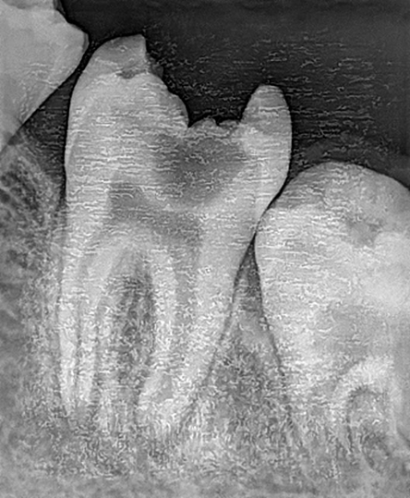
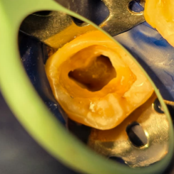
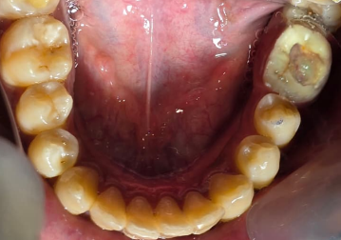

Fig 2
Fig 3
Fig 1
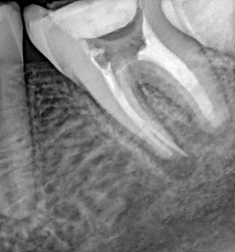
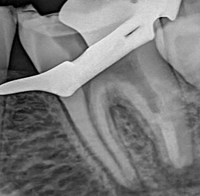
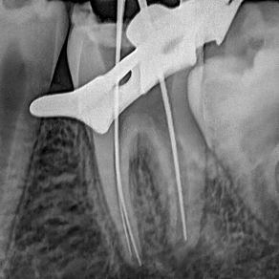

Fig 6
Fig 5
Fig 4
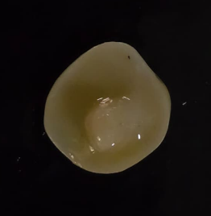
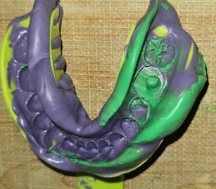
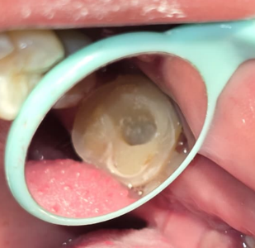

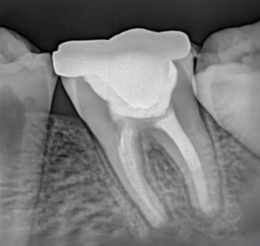
Fig 9
Fig 8 888288
Fig 7
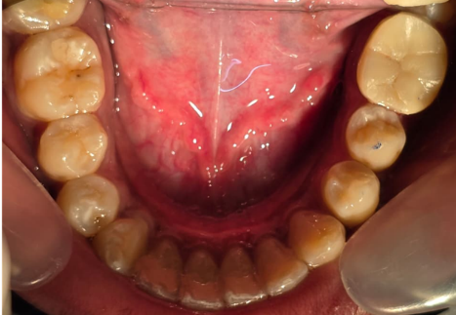

Fig 11
Fig 10
Fig 1and 2 -Preoperative clinical photo and radiograph Fig 3- access opening Fig 4-working length determination Fig 5-MTA apical plug Fig 6-Obturation Fig 7-Endocrown preparartion Fig 8-Putty impression Fig 9-Endocrown fabricated in lab Fig 10- Post operative clinical photographs Fig 11: - Post operative radiographs

CASE REPORT 2
A 28-year-old male patient presented to the Department of Conservative Dentistry and Endodontics with a chief complaint of severe nocturnal pain in the lower right posterior region for a duration of two weeks. Clinical examination revealed a fractured restoration associated with secondary caries in relation to tooth 47 (Fig. 11).
Following clinical and radiographic assessment, a diagnosis of symptomatic irreversible pulpitis with apical periodontitis was established, and root canal treatment was initiated for tooth 47 (Fig. 12). Access cavity preparation was performed using an Endo access bur (Mani burs) under rubber dam isolation and local anaesthesia with 2% lidocaine containing 1:100,000 epinephrine (Fig. 13). Apical patency was achieved using a size 15 K-file, and the working length was determined with an apex locator (Root ZX Mini, J. Morita, Saitama, Japan) and confirmed radiographically (Fig. 14). Cleaning and shaping were carried out using hand K-files (Mani, New Delhi, India) in conjunction with ProTaper Universal rotary instruments (Dentsply Maillefer). The root canals were irrigated with 3% sodium hypochlorite (Hyposol; PrevestDenPro, Jammu, India), 17% EDTA (NeoEDTA; Orikam, Gurgaon, India), and saline, followed by drying with sterile paper points. Biomechanical preparation was completed under copious irrigation with saline and sodium hypochlorite. Master cone fit was verified, and obturation was subsequently performed (Fig. 15). This was followed by placement of an intra-orifice glass ionomer cement (GIC) barrier (Fig. 16).
Considering the extent of remaining tooth structure and the thickness of the residual walls, a post-endodontic restoration using a zirconia endocrown was planned. A shade of 2M2 was selected, and the preparation and cementation procedures were carried out in accordance with the protocol described in the previous case.

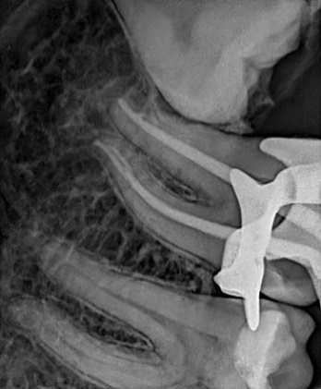
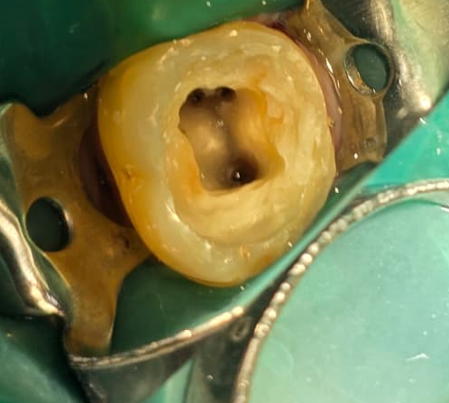
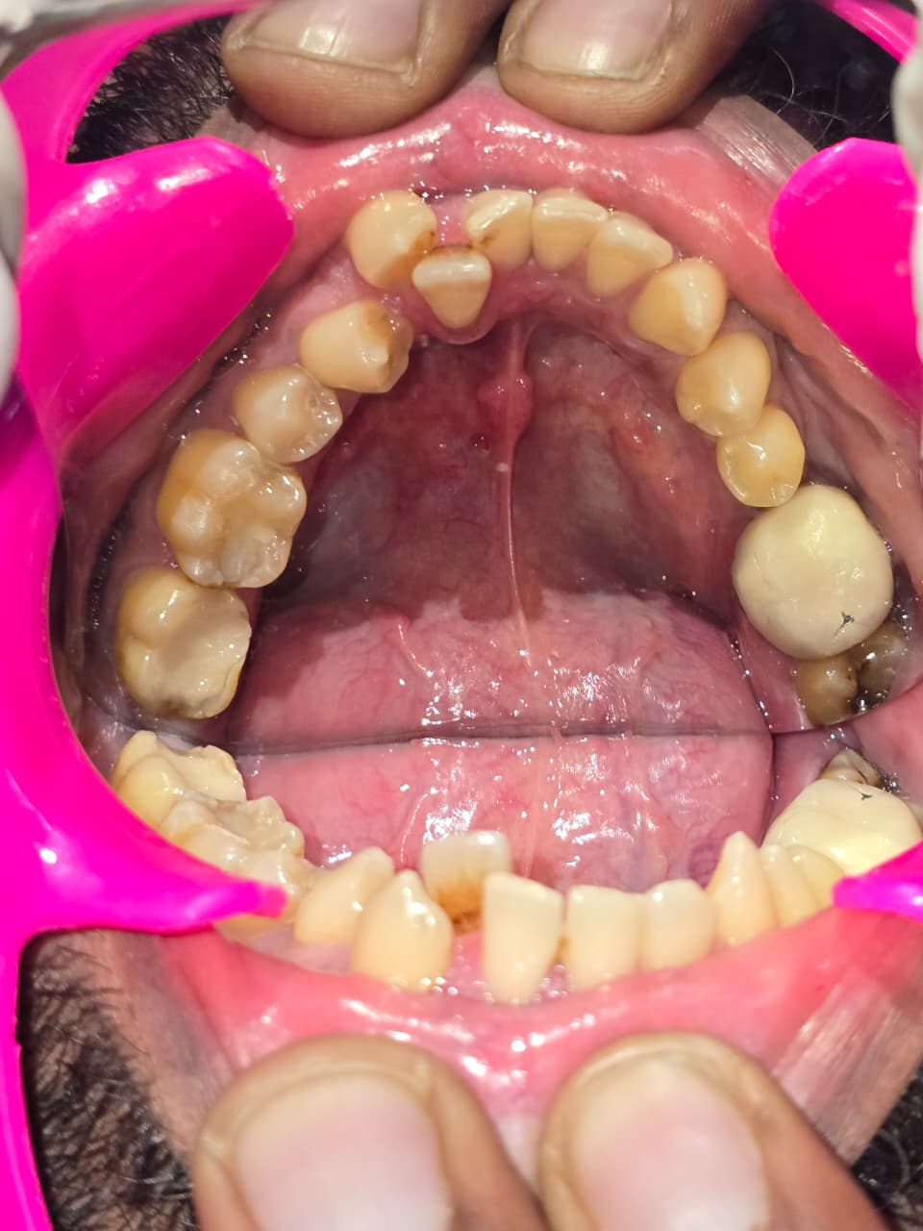

Fig 13

Fig 11
Fig 15

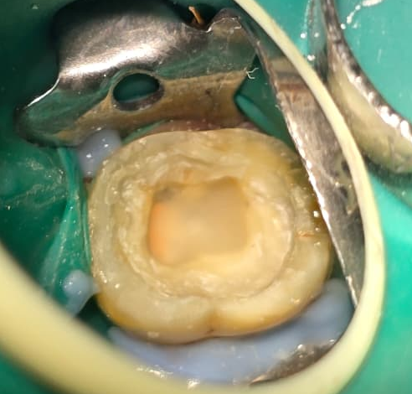
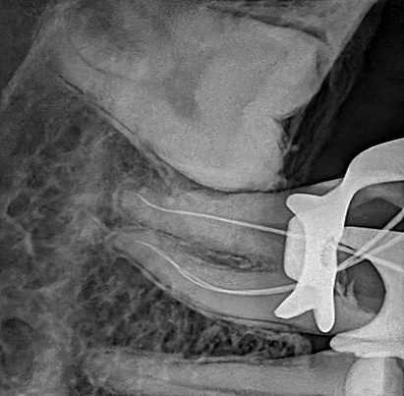
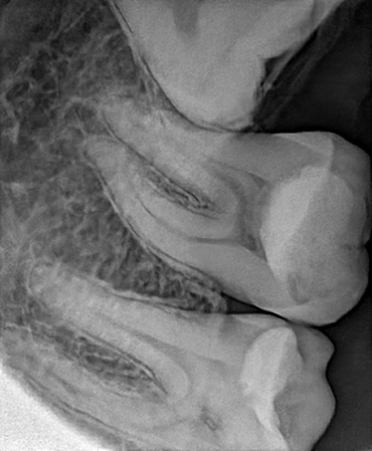

Fig 16

Fig 14

Fig 12

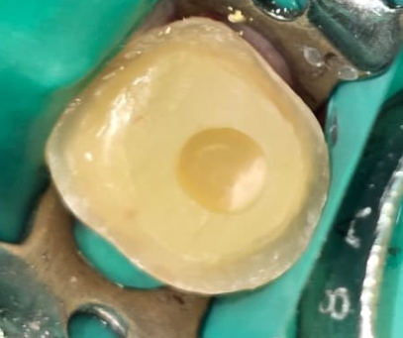
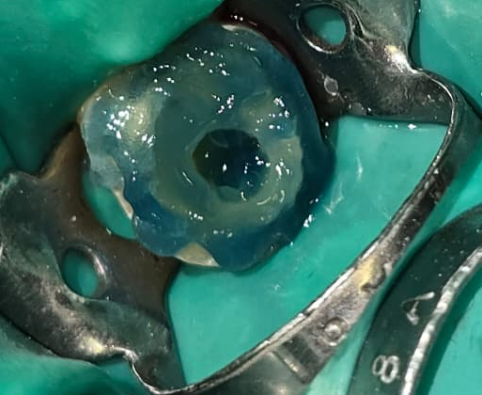
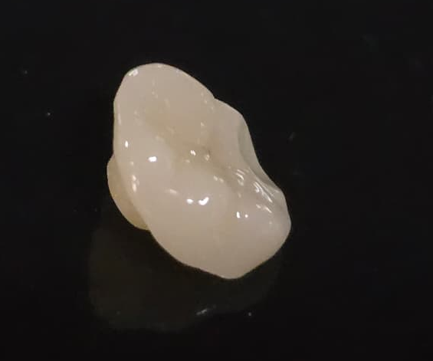

Fig 17

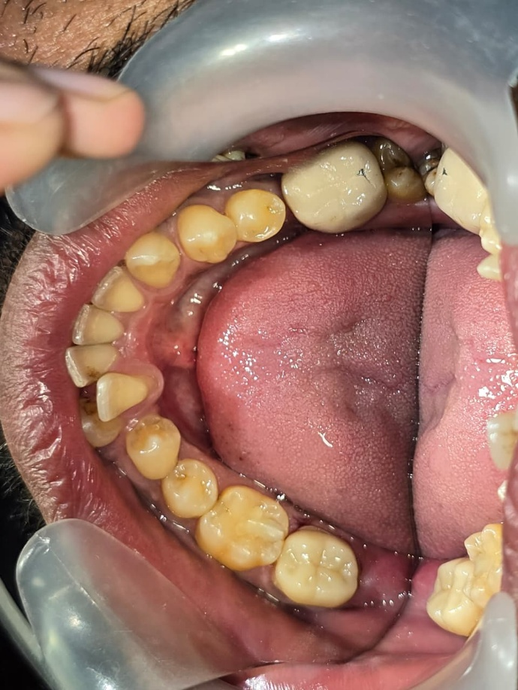
Fig 19

Fig 18

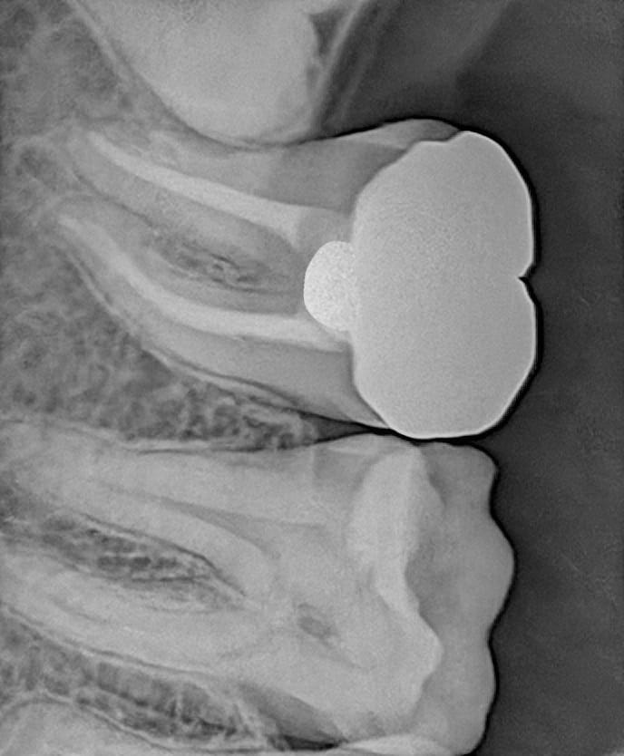

Fig 21 :PPost operative

Fig 20

Fig 11and 12 -Preoperative clinical photo and readiograph Fig 13- access opening Fig 14-working length determination Fig 15-Obturation Fig 16-GIC orifice barrier Fig 17-Endocrown preparation Fig 18-Etching Fig 19-Endocrown fabricated in lab Fig 20- Post operative clinical photographs Fig 21 - Post operative radiographs

Discussion
In the contemporary era of adhesive dentistry, the endocrown has emerged as a conservative, practical, and reliable alternative to traditional post-and-core restorations. Designed for endodontically treated posterior teeth, the endocrown derives retention from the internal walls of the pulp chamber and the cavity margins. This design provides macromechanical retention through engagement of the pulpal walls, while micromechanical retention is achieved via adhesive cementation. Furthermore, the technique is relatively straightforward, requires reduced chairside time, and is generally well accepted by patients, making it an advantageous option among available restorative modalities. Clinical studies have reported high success rates with endocrowns, and the restorative concept has been described as both simple and clinically feasible, as noted by Bindl et al.³
Additionally, a two-year clinical evaluation conducted by Bernhart et al.concluded that endocrowns represent a highly promising restorative alternative for endodontically treated molars, demonstrating favorable functional and clinical performance.⁴The endocrown technique is considered simple, clinically advantageous, and protective of the surrounding periodontal tissues. Ceramic materials used for endocrowns offer additional benefits, as they possess a wear coefficient similar to that of natural enamel, along with excellent biocompatibility and biomimetic properties.⁵
In posterior teeth, particularly molars, compressive forces predominate during mastication. Therefore, it is essential to design a preparation with a broad and stable surface capable of effectively resisting these stresses.Preparing the pulpal floor parallel to the occlusal plane enhances stress distribution along the long axis of the tooth, thereby improving resistance to functional loading.⁶Compared to conventional prosthetic crowns, which may concentrate higher stress levels within the restored structure, endocrowns demonstrate more favorable stress distribution patterns, contributing to their biomechanical advantage.⁷Thus, Zirconia endocrown is a reliable option for the restoration of root canal-treated posterior teeth. Long-term follow-up and longitudinal clinical studies are required to study their long-term success.^{8,9}
Conclusion
Endocrowns represent a simple, conservative, and clinically effective restorative option for posterior teeth exhibiting extensive coronal destruction. This restorative approach adheres to the principles of minimally invasive dentistry by preserving maximum sound tooth structure and eliminating the need for intraradicular post placement. Compared to conventional post-and-core supported crowns, endocrowns require less chairside time, reduced clinical steps, and are generally more cost-effective, while still providing excellent functional and esthetic outcomes.¹¹
Additionally, the preparation design of endocrowns typically allows for supragingival margins, which contributes to better periodontal health. By avoiding subgingival margin placement, the restoration minimizes irritation to the surrounding soft tissues, facilitates oral hygiene maintenance, and reduces the risk of periodontal complications. ¹²Consequently, endocrowns not only restore structural integrity and esthetics but also support long-term biological and periodontal preservation.¹³
Summary
Endocrowns should be considered a reliable and minimally invasive alternative for the restoration of endodontically treated teeth, provided that appropriate case selection, strict adherence to adhesive protocols, and careful evaluation of occlusal factors are ensured to achieve optimal long-term clinical success.

Consent
As per international standards or university standards, patient(s) written consent has been collected and preserved by the author(s).
Ethical Approval:

As per international standards or university standards written ethical approval has been collected and preserved by the author(s).

Disclaimer (Artificial intelligence)
Author(s) hereby declare that NO generative AI technologies such as Large Language Models (ChatGPT, COPILOT, etc.) and text-to-image generators have been used during the writing or editing of this manuscript.

References
Gupta R, Thakur S, Pandey NK, Roopa B, Fares KT. Endocrown - A Paradigm Shift in Rehabilitation: A Report of Two Cases. Contemp Clin Dent. 2021 Apr-Jun;12(2):195-198. doi: 10.4103/ccd.ccd_557_20. Epub 2021 Jun 14. PMID: 34220164; PMCID: PMC8237820.
2Rao BS, Bandekar S, Kshirsagar S, Naman S. Endocrown – a unique way of retention: case report. J Adv Med Med Res. 2017;22(3):1–5.
3.Bindl A, Mörmann WH. Clinical evaluation of adhesively placed Cerec endocrowns after 2 years – preliminary results. J Adhes Dent. 1999;1(3):255–265.
4.Endocrown: An Approach Towards Management of Endodontically Treated Teeth - A Case Report. International Journal of Current Research and Review. 2021; doi:10.31782/IJCRR.2021.131231
5. Selvanathan MJV, Balasubramanian S, Mahalaxmi S. “Endocrown”—an effective viable esthetic option for expurgated endodontically treated teeth: two case reports.
6.Tzimas K, Tsiafitsa M, Gerasimou P, Tsitrou E. Endocrown restorations for extensively damaged posterior teeth: clinical performance of three cases. Restor Dent Endod. 2018 Aug 22;43(4):e38. doi: 10.5395/rde.2018.43.e38. PMID: 30483462; PMCID: PMC6237728.
7. Huong CQ , Duc NM , Hai TD . Restoration of Severely Damaged Tooth by Zirconia based Endocrown: Case Series. Kathmandu Univ Med J (KUMJ). 2023 Jul-Sep;21(83):342-344. PMID: 39206660.
8..Kamaal M, Shukla S, Raisinghani D, Prasad AB, Sejra A, Chaudhari R. Endocrown: a minimal intervention approach for grossly decayed teeth. People’s J Sci Res. 2019;12(2).
9 Rocca GT, Krejci I. Crown and post-free adhesive restorations for endodontically treated posterior teeth: From direct composite to endocrowns. Eur J Esthet Dent. 2013;8(2):156–179.
10.Ferrari M, Vichi A, Fadda GM, Cagidiaco MC, Tay FR, Breschi L, et al. A randomized controlled trial of endodontically treated and restored premolars. J Dent Res. 2012;91(7 Suppl):72S–78S.
11. Biacchi GR, Basting RT. Comparison of fracture strength of endocrowns and glass fiber post-retained conventional crowns. Oper Dent. 2012;37(2):130–136.
12.Belleflamme MM, Geerts SO, Louwette MM, Grenade CF, Vanheusden AJ, Mainjot AK. No post-no core approach to restore severely damaged posterior teeth: An up to 10-year retrospective study of documented endocrown cases. J Dent. 2017;63:1–7.
13.Sedrez-Porto JA, da Rosa WL, da Silva AF, Münchow EA, Pereira-Cenci T. Endocrown restorations: A systematic review and meta-analysis. J Dent. 2016;52:8–14
14. Krishna Prasada L, Gunjan Chawla, Julia Jacob and Narendra Babu. SEALING THE FUTURE: APEXIFICATION WITH BIODENTINE – A CASE REPORT. Int. J. Adv. Res. 13(08), August-2025, 350-354

