Comparative Evaluation of Water Sorption in High-Strength Denture Base Resin Reinforced with 5% Silanized Titanium Dioxide Nanoparticles Using Microwave and Conventional Polymerization Methods: An In Vitro Study

ABSTRACT
Background: Water sorption is a critical determinant of the dimensional stability and long-term clinical performance of polymethyl methacrylate (PMMA) denture base resins. Absorbed water acts as a plasticizer within the polymer matrix, causing volumetric expansion and deterioration of mechanical properties. Titanium dioxide (TiO₂) nanoparticle reinforcement, particularly with silane surface treatment, has attracted considerable interest for improving the physical properties of PMMA.However, the combined influence of silanized TiO₂ incorporation and polymerization technique on water sorption in high-strength PMMA has not been comprehensively characterized.
Aim: To evaluate and compare the water sorption behavior of high-strength PMMA denture base resin reinforced with 5% silanized TiO₂ nanoparticles when processed using conventional water bath and microwave polymerization techniques.
Materials and Methods: Thirty standardized disc-shaped specimens (n = 15 per group) were fabricated in accordance with ADA Specification No. 12. Group A underwent conventional water bath polymerization (74°C/2 h + 100°C/1 h) and Group B underwent microwave polymerization (500 W/3 min). Water sorption was calculated gravimetrically after 7-day distilled water immersion at 37 ± 2°C and subsequent desiccation. Statistical analysis included the Shapiro–Wilk test, Levene’s test, and independent samples t-test (p < 0.05) with Cohen’s d effect size.
Results: Group A demonstrated significantly lower mean water sorption (3.74 ± 2.33 µg/mm³) versus Group B (9.00 ± 5.52 µg/mm³; p = 0.002; Cohen’s d = 1.243).
Conclusion: Conventional water bath polymerization conferred superior resistance to water sorption compared to microwave polymerization in TiO₂-reinforced high-strength PMMA. The polymerization technique remains a critical determinant of material behavior even when nanoparticle type and concentration are held constant.

Keywords: Polymethyl methacrylate; Titanium dioxide nanoparticles; Water sorption; Polymerization technique; Conventional polymerization; Silanization; Nanocomposite;

INTRODUCTION
Polymethyl methacrylate (PMMA) has remained the most widely used denture base material for over seven decades owing to its ease of processing, favorable aesthetic properties, adequate mechanical strength, and satisfactory biocompatibility.^{1,2} Despite these advantages, PMMA exhibits a well-recognized susceptibility to water sorption from the oral environment, a phenomenon that adversely compromises dimensional accuracy, mechanical integrity, color stability, and long-term clinical performance.^{1,2,3} Water molecules permeate the PMMA matrix through diffusion, occupying spaces between polymer chains and acting as a plasticizer that disrupts intermolecular van der Waals forces, ultimately causing swelling, loss of dimensional accuracy, and progressive deterioration of flexural properties.
From a molecular perspective, water sorption in PMMA is governed by the degree of conversion of residual monomer, the cross-link density, the porosity of the material, and the nature of any incorporated fillers or modifiers.^{4,5} Incomplete polymerization leads to the presence of unreacted methyl methacrylate (MMA) monomer, which is itself hydrophilic and prone to leaching. Residual monomer not only contributes to increased water uptake but may also elicit biological concerns such as mucosal irritation and allergic reactions in susceptible patients.
In recent years, considerable research attention has been directed toward reinforcing PMMA with inorganic nanoparticles to overcome its inherent limitations.^{4,5,8} Nanofillers, by virtue of their extremely high surface area-to-volume ratio, interact more intimately with the polymer matrix and produce composites with enhanced physical and mechanical properties. Among the nanofillers investigated, titanium dioxide (TiO₂) has emerged as a particularly promising candidate owing to its chemical inertness, photocatalytic activity, radiopacity, biocompatibility, and documented ability to improve flexural strength, hardness, and fracture toughness in PMMA-based composites.^{2,4,5,7}
Surface treatment of TiO₂ nanoparticles with silane coupling agents — particularly 3-trimethoxysilylpropylmethacrylate (TMSPM) — has been recognized as a critical step in optimizing nanoparticle–matrix interaction.^{1,3} Silanization creates reactive organosilane bridges between the hydrophilic nanoparticle surface and the hydrophobic PMMA matrix, thereby improving interfacial bonding, reducing nanoparticle agglomeration, and enhancing the overall homogeneity of the nanocomposite. These improvements in filler–matrix adhesion have been reported to reduce water sorption by limiting the pathways available for water molecule diffusion.^{3,4,9}
In parallel, the polymerization technique employed for processing PMMA profoundly influences the degree of monomer conversion, residual stress distribution, porosity, and resulting physical properties.^{6,7} The conventional water bath polymerization method employs a graduated two-stage thermal protocol designed to achieve uniform and controlled polymerization throughout the material cross-section. Microwave polymerization, introduced as an alternative, offers the practical advantage of substantially reduced processing time. Microwave energy induces molecular-level dipolar rotation, generating heat internally rather than from external conduction. However, rapid and sometimes uneven energy distribution may predispose the material to increased porosity, uneven monomer conversion, and altered dimensional behavior.^{6,7,12}
Although the independent effects of TiO₂ nanoparticle reinforcement and polymerization technique on PMMA properties have been studied individually, limited comparative evidence exists regarding their combined influence on water sorption in high-strength PMMA reinforced with a fixed concentration of silanized TiO₂ nanoparticles.^{4,5,7} Therefore, the present in-vitro study was designed to evaluate and compare the water sorption of high-strength PMMA denture base resin reinforced with 5% silanized TiO₂ nanoparticles when polymerized using conventional water bath and microwave polymerization techniques.

MATERIALS AND METHODS

Study Design and Sample Size Determination
This in-vitro experimental study was conducted under controlled laboratory conditions to investigate the effect of polymerization technique on water sorption of high-strength PMMA denture base resin reinforced with 5% silanized TiO₂ nanoparticles. The study protocol received ethical approval from the Institutional Ethics Committee of Bapuji Institute of Dental Science and Research, Davangere (Reg. No. ECR/1652/Inst/KA/2022/23-05/07-006).
Sample size was determined a priori using G*Power software (version 3.1.9). Based on pilot data projecting a mean difference of approximately 5.0 µg/mm³ in water sorption between the two groups, with a pooled standard deviation of approximately 4.5 µg/mm³, a minimum of 13 specimens per group was calculated to achieve 80% statistical power at a two-tailed significance level of α = 0.05, assuming a moderate-to-large effect size (Cohen’s d ≈ 1.1). To account for potential specimen loss, the sample size was conservatively set at 15 specimens per group (N = 30 total).

Materials
The following materials were used: (1) High-impact heat-cured PMMA denture base resin (Lucitone 199, Dentsply Sirona), comprising polymer powder and liquid monomer^{1,5}; (2) Titanium dioxide nanoparticles (particle size < 25 nm; 99.9% purity)^{2,4}; (3) Silane coupling agent — 3-trimethoxysilylpropylmethacrylate (TMSPM)^{1,3}; (4) Distilled water; (5) Dental stone for investing; (6) Custom-fabricated stainless steel metal mold (50 ± 1 mm diameter, 1 ± 0.1 mm thickness) per ADA Specification No. 12¹; (7) Custom-fabricated fibre composite flasks for microwave curing; and (8) Conventional brass dental flasks.

Silanization of Titanium Dioxide Nanoparticles
Prior to incorporation, TiO₂ nanoparticles underwent surface silanization to enhance compatibility with the organic polymer phase.^{3,4} The process was carried out by dispersing TiO₂ nanoparticles in a 95% ethanol solution (pH adjusted to 4.5–5.0 with acetic acid), followed by addition of 2 wt% TMSPM. The suspension was continuously stirred for 60 minutes at room temperature to allow complete hydrolysis and condensation of silanol groups onto the nanoparticle surface.^{1,3} The silanized nanoparticles were separated by centrifugation, washed with absolute ethanol, and dried in an oven at 80°C for 24 hours. The dried powder was stored in a desiccator until use. Successful silanization was confirmed by improved dispersibility in the monomer phase compared to untreated particles.

Preparation of Wax Patterns and Mold Spaces
Standardized wax disc patterns were fabricated using the custom metal mold (50 ± 1 mm diameter, 1 ± 0.1 mm thickness) in compliance with ADA Specification No. 12 and ISO 1567 requirements.¹ Thirty identical wax discs were invested in dental stone using a standardized two-pour technique — conventional brass flasks for Group A and microwave-compatible fibre composite flasks for Group B. Following complete setting, flasks were placed in a water bath at 70°C for 10 minutes for wax elimination and mold spaces were inspected for uniformity before packing.

Specimen Fabrication and Polymerization
For each specimen, 250 mg of silanized TiO₂ nanoparticles (5% by weight) were mixed with 2 mL of PMMA monomer in a glass jar, vortex-mixed for 2 minutes, and subjected to probe sonication (20 kHz, 100 W) for 5 minutes to achieve uniform dispersion.^{4,5} Subsequently, 4150 mg of PMMA polymer powder was incorporated and manually blended until a homogeneous dough consistency was achieved. The dough was packed by compression molding, and a trial closure was performed under bench press pressure before final closure at 1000 psi for 30 minutes.
For Group A (conventional water bath), packed flasks were processed at 74°C for 2 hours followed by 100°C for 1 hour, conforming to the manufacturer’s recommendations and established guidelines.^{1,6} For Group B (microwave polymerization), packed fibre composite flasks were processed at 500 W for 3 minutes in a laboratory-grade microwave oven.^{5,7} The microwave output power was verified using a standardized water-heating calibration protocol. All specimens were bench-cooled to room temperature for a minimum of 30 minutes before deflasking.

Post-Polymerization Processing
All specimens were trimmed with tungsten carbide burs under water irrigation to remove flash, finished using sequential abrasive papers (220–1200 grit), polished with pumice slurry, and final-polished with acrylic polishing compound. Dimensions were verified with a calibrated digital vernier caliper (diameter 50 ± 1 mm; thickness 1 ± 0.1 mm). Specimen volume was calculated as V = πr²h = 1963.5 mm³ per ADA Specification No. 12.¹

Water Sorption Testing Protocol
The water sorption testing protocol was conducted in accordance with ISO 1567:1999 and ADA Specification No. 12.¹ Prior to immersion, specimens were desiccated at 37 ± 2°C for 24 hours to achieve baseline dry state. Each specimen was individually immersed in 20 mL distilled water in sealed glass vials and incubated at 37 ± 2°C for 7 days. After immersion, specimens were blotted and immediately weighed (wet mass, m₁; within 30 seconds) to minimize evaporation error. Specimens were then desiccated at 37 ± 2°C for 4 days to obtain final dry mass (m₂). The investigator was blinded to group identity during all weighing. Water sorption (WS) was calculated as:
WS (µg/mm³) = (m₁ − m₂) / V
where V = 1963.5 mm³ (calculated specimen volume).

Statistical Analysis
Statistical analysis was performed using Python (version 3.11) with SciPy and Pingouin libraries. Data normality was assessed using the Shapiro–Wilk test, and variance homogeneity using Levene’s test. Mean water sorption values were compared using an independent samples t-test (two-tailed; α = 0.05). Effect size was quantified using Cohen’s d (small = 0.2, medium = 0.5, large ≥ 0.8). Post-hoc power analysis confirmed sample adequacy.
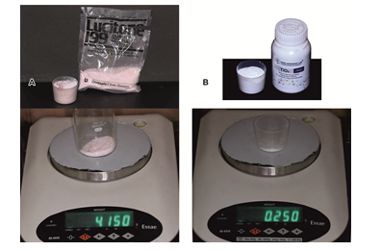

Figure 1. A) Acrylic Weighing, B) TiO2 Weighing

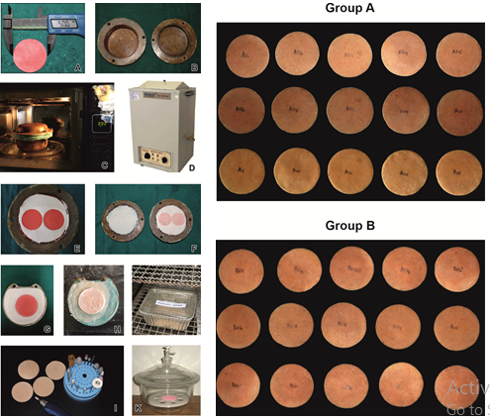

Figure 2. A) Preparation of Wax disc, B) Preparation of custom-made fibre flask, C) Microwave Curing, D) Conventional Curing, E) Investing in custom made flask, F) Post curing fibre flask with samples, G) Investing in conventional flask, H) post curing conventional flask with sample, I) Finishing and polishing, J) Distilled water immersion and incubation at 37 ± 2 °C, K) Dessication, Group A and Group B Samples post finishing.

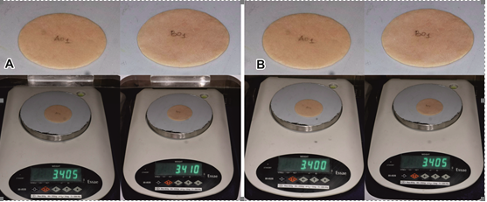

Figure 3. A) Wet Weight measurement, B) Dry Weight measurement

RESULTS
All 30 specimens were successfully fabricated and completed the testing protocol without exclusion. Normality was confirmed by the Shapiro–Wilk test (Group A: W = 0.932, p = 0.273; Group B: W = 0.918, p = 0.184). Levene’s test was non-significant (p = 0.061), confirming homogeneity of variances.
The mean water sorption for Group A (conventional water bath) was 3.74 ± 2.33 µg/mm³. Group B (microwave polymerization) demonstrated a significantly higher mean of 9.00 ± 5.52 µg/mm³. The independent samples t-test revealed a statistically significant difference (t(28) = 3.56, p = 0.002), with a large effect size (Cohen’s d = 1.243). Post-hoc power analysis confirmed a statistical power of 0.92, exceeding the a priori target of 80%.

Table 1. Comparison of water sorption values between the two polymerization techniques
Group | Polymerization Technique | n | Mean ± SD (µg/mm³) | p-value
A | Conventional water bath | 15 | 3.74 ± 2.33 | 0.002*
B | Microwave polymerization | 15 | 9.00 ± 5.52 | 0.002*
* Statistically significant (p < 0.05); Cohen’s d = 1.243 (large effect size)
The box-and-whisker plot confirmed a tighter interquartile range and lower median in Group A compared to Group B, which displayed wider spread and greater variability. The higher standard deviation in Group B (5.52 vs 2.33 µg/mm³) reflects the inherent variability of microwave energy distribution and has direct clinical implications for material performance predictability.
Graph 1. Comparison of water sorption values between conventional water bath and microwave polymerization techniques

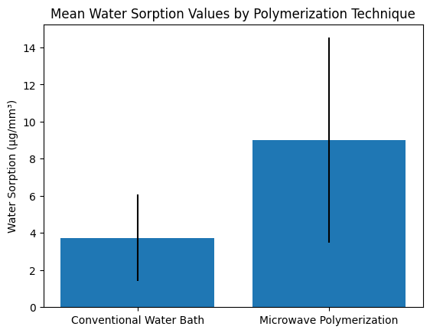

Bar graph illustrating the mean water sorption values of high-strength PMMA denture base resin reinforced with 5% silanized TiO₂ nanoparticles polymerized using conventional water bath (Group A) and microwave polymerization (Group B). Error bars represent standard deviation.

Graph 2. Distribution of water sorption values in the two study groups

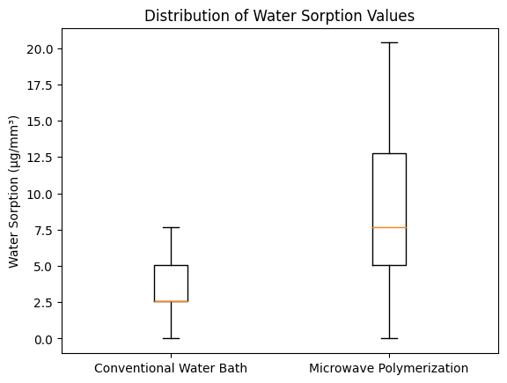

Box-and-whisker plot showing the distribution of water sorption values for specimens polymerized using conventional water bath and microwave polymerization techniques.

DISCUSSION
The present in-vitro study was designed to isolate and quantify the effect of polymerization technique on water sorption in nanoparticle-reinforced high-strength PMMA. By maintaining nanoparticle type, concentration, and preparation protocol as constants across both groups, the experimental design enabled a direct and valid comparison of the influence of conventional water bath versus microwave polymerization on this critical material property.
The principal finding was that specimens polymerized using the conventional water bath technique exhibited significantly lower water sorption (3.74 ± 2.33 µg/mm³) compared to microwave-polymerized specimens (9.00 ± 5.52 µg/mm³; p = 0.002; Cohen’s d = 1.243). This finding is clinically relevant because water sorption in denture base materials directly correlates with dimensional changes, reduction in mechanical strength, and potential mucosal irritation due to residual monomer release.^{1,2,4}
The lower water sorption observed in conventionally polymerized specimens can be attributed to the nature of the heat-curing protocol. The two-stage water bath regimen (74°C/2 h followed by 100°C/1 h) provides controlled, gradual, and sustained thermal energy input that promotes progressive and uniform propagation of free-radical polymerization throughout the material cross-section.^{1,6} The slow initial stage minimizes the risk of localized overheating and porosity formation, while the terminal boiling stage ensures a high degree of monomer conversion. Since residual monomer is inherently hydrophilic and contributes significantly to water uptake, its reduction through thorough polymerization directly translates to lower water sorption values.^{3,4} These observations are consistent with findings by Alwan and Alameer (2015),³ who demonstrated that silanized TiO₂ incorporation in conventionally cured PMMA significantly reduced water sorption, attributing the improvement to enhanced filler–matrix bonding and reduced porosity.
In contrast, microwave polymerization generates heat through dielectric heating, in which polar molecules — particularly MMA monomer — rapidly oscillate in response to the alternating electromagnetic field.^{5,7} The inherent spatial non-uniformity of microwave energy creates temperature gradients within the resin mass, leading to differential polymerization rates across the specimen cross-section. Regions receiving higher microwave energy may undergo premature gelation, while adjacent areas remain under-cured. The consequence is a heterogeneous polymer matrix with variable cross-link density, localized residual monomer concentration, and micro-porosity — all of which increase pathways available for water diffusion.^{7,12} Figuerôa et al. (2018)¹² specifically documented higher porosity and increased water sorption in microwave-polymerized denture base resins compared to conventionally cured materials, directly paralleling the findings of the present study.
The role of silanized TiO₂ nanoparticles must also be considered in the context of the observed inter-group differences. Silanization with TMSPM creates covalent siloxane bridges between the nanoparticle surface and the PMMA chain, promoting strong interfacial adhesion and reducing the formation of hydrophilic interfacial voids.^{1,3} In conventionally polymerized specimens, where polymerization is complete and uniform, these silane bridges are preserved intact and effectively restrict water diffusion. However, in specimens with localized incomplete polymerization — as may occur with microwave curing — the mechanical integrity of the silane interface may be compromised, creating nano-scale interfacial defects that serve as additional channels for water ingress.⁴ This hypothesis is supported by Gad and Abualsaud (2019),⁴ who highlighted that compromised polymerization associated with suboptimal microwave curing protocols can negate the beneficial effects of nanoparticle reinforcement on water sorption and mechanical properties.
The higher standard deviation observed in Group B (5.52 µg/mm³ versus 2.33 µg/mm³ in Group A) reflects the inherent variability of microwave polymerization, likely attributable to non-uniform energy distribution within the microwave cavity. This variability indicates that microwave-polymerized specimens exhibit less predictable water sorption behavior, which is undesirable from a clinical standpoint where material performance consistency is paramount.
The mean water sorption values for Group A are in reasonable concordance with values reported in the literature for silanized TiO₂-reinforced conventionally cured PMMA. Tekale et al. (2019)¹ reported values of approximately 1.35 µg/mm³ for PMMA reinforced with low concentrations of silanized TiO₂. Nazari and Riahi (2010)¹¹ documented values of 1.3–1.7 µg/mm³ and identified nanoparticle dispersion quality as a critical determinant. Dehis et al. (2018)⁹ reported values approaching 1.8 µg/mm³ with untreated TiO₂, reinforcing the benefit of silanization in limiting water uptake. The somewhat higher values in the present study may reflect the relatively higher nanoparticle concentration (5%) used, which while capable of improving mechanical properties, may also introduce minor agglomeration-related effects.
The findings also corroborate those of Alhotan et al. (2021),¹⁰ who demonstrated that differences in water sorption arising from polymerization technique may be amplified with prolonged water storage, suggesting that short-term in-vitro studies may underestimate the long-term divergence in material performance. Karci et al. (2019)¹⁴ associated reduced flexural strength in microwave-polymerized PMMA with structural alterations and increased porosity, properties mechanistically linked to water sorption behavior. Giti et al. (2022)¹³ reported inconsistent effects of varying TiO₂ concentrations on water sorption in thermocycled specimens, further suggesting that the polymerization technique exerts a dominant influence when filler parameters are kept constant.
Azmy et al. (2022)⁸ compared ZrO₂, TiO₂, and SiO₂ nanoparticles in PMMA and found that surface-treated particles consistently produced lower water sorption than untreated equivalents, reinforcing the value of silanization across different filler chemistries. Kumar et al. (2019)⁵ similarly evaluated TiO₂-reinforced PMMA across different processing techniques and reported variations in mechanical properties attributable to polymerization method, consistent with the material property differences observed in the present study.
The clinical translation of these findings is significant. Water sorption-related dimensional changes can lead to compromised occlusal relationships, loss of retention and stability, mucosal trauma, and accelerated wear. For patients requiring long-term prostheses or those with anatomically compromised ridges, the present results suggest that conventional water bath polymerization of TiO₂-reinforced PMMA should remain the method of choice when optimal dimensional stability is the clinical priority.^{1,2,4}
The limitations of the present study include the in-vitro nature of the experiment, evaluation at a single time point (7-day immersion), and the assessment of only one nanoparticle concentration (5%). Additionally, while the sample size was adequate to detect a significant difference, a larger cohort would enhance statistical robustness and generalizability.

CONCLUSION
Within the limitations of this in-vitro study, the polymerization technique exerted a statistically significant and practically meaningful influence on the water sorption behavior of high-strength PMMA denture base resin reinforced with 5% silanized TiO₂ nanoparticles. Specimens processed using the conventional water bath method demonstrated significantly lower water sorption values compared to those processed by microwave polymerization (p = 0.002; Cohen’s d = 1.243; post-hoc power = 0.92).
These findings indicate that despite the incorporation of surface-treated nanoparticles designed to limit water uptake, the processing method continues to be a dominant determinant of the final water sorption characteristics of PMMA-based nanocomposites. The higher variability and greater mean water sorption observed with microwave polymerization suggest that current microwave curing protocols may not achieve the degree of polymerization uniformity necessary to fully exploit the benefits of nanoparticle reinforcement.
Conventional water bath polymerization, under controlled conditions, continues to provide consistent and predictable performance with respect to water sorption in nanoparticle-reinforced PMMA. For clinical scenarios where long-term dimensional stability and resistance to water-induced material degradation are paramount, conventional processing remains the preferred technique for TiO₂-reinforced high-strength PMMA denture base resins.
Future investigations are recommended in the following directions:
- In-vivo and in-vitro studies replicating the full intraoral environment, including thermal cycling, pH variability, salivary enzyme activity, and mechanical fatigue.
- Longitudinal water sorption studies evaluating the kinetics of water uptake over extended periods (30, 90, 180 days) to characterize long-term material behavior.
- Comparative investigations evaluating alternative nanofillers (ZrO₂, SiO₂, Al₂O₃, graphene oxide) at varying concentrations with different polymerization techniques.
- Optimization studies exploring modified microwave curing protocols (varied power levels, stepped programs, post-cure treatments) to minimize water sorption while retaining processing time-efficiency.
- Multi-parameter assessments evaluating flexural strength, hardness, color stability, residual monomer release, and surface roughness in parallel to water sorption for comprehensive nanocomposite characterization.

DECLARATION BY AUTHORS
Ethical Approval: Approved by the Institutional Ethics Committee of Bapuji Institute of Dental Science and Research, Davangere (Reg. No. ECR/1652/Inst/KA/2022/23-05/07-006).
Conflict of Interest: The authors declare no conflict of interest.
Disclaimer (Artificial Intelligence): Author(s) hereby declare that NO generative AI technologies such as Large Language Models (ChatGPT, COPILOT, etc.) and text-to-image generators have been used during the writing or editing of this manuscript.

REFERENCES
- Tekale RG, Mowade TK, Radke UM. Comparative Evaluation of Water Sorption of Heat-Polymerized Polymethyl Methacrylate Denture Base Resin Reinforced with Different Concentrations of Silanized Titanium Dioxide Nanoparticles: An In vitro Study. Contemporary Clinical Dentistry. 2019;10(2):269.
- Harini P, Mohamed K, Padmanabhan T. Effect of Titanium dioxide nanoparticles on the flexural strength of polymethylmethacrylate: An in vitro study. Indian J Dent Res. 2014;25(4):459.
- Alwan SA, Alameer SS. The Effect of the Addition of Silanized Nano Titania Fillers on Some Physical and Mechanical Properties of Heat Cured Acrylic Denture Base Materials. JBCD. 2015;27(1):86–91.
- Gad MM, Abualsaud R. Behavior of PMMA Denture Base Materials Containing Titanium Dioxide Nanoparticles: A Literature Review. International Journal of Biomaterials. 2019;2019:6190610.
- Kumar CA, Kumar CR, Vamshikiran K, Deepthi G, Kumar GN, Akhilesh M. Evaluation of Impact Strength of Dental Acrylic Resins by Incorporation of TiO2 Nanoparticles Using Two Different Processing Techniques. J Contemp Dent Pract. 2019;20(10):1184–9.
- Ozkir SE, Yilmaz B, Unal SM, Culhaoglu A, Kurkcuoglu I. Effect of heat polymerization conditions and microwave on the flexural strength of polymethyl methacrylate. Eur J Dent. 2018;12(01):116–9.
- Aziz HK. TiO2-Nanofillers Effects on Some Properties of Highly-Impact Resin Using Different Processing Techniques. Open Dentistry Journal. 2018;12:202.
- Azmy E, Al-kholy MRZ, Al-Thobity AM, Gad MM, Helal MA. Comparative Effect of Incorporation of ZrO2, TiO2, and SiO2 Nanoparticles on the Strength and Surface Properties of PMMA Denture Base Material. International Journal of Biomaterials. 2022;2022:1–10.
- Dehis WM, Eissa SM, Elawady AF, Elhotaby MM. Impact of nano-TiO2 particles on water sorption and solubility in different denture base materials. Journal of The Arab Society for Medical Research. 2018;13(2).
- Alhotan A, Yates J, Zidan S, Haider J, Jurado CA, Silikas N. Behaviour of PMMA Resin Composites Incorporated with Nanoparticles or Fibre following Prolonged Water Storage. Nanomaterials. 2021;11(12):3453.
- Nazari A, Riahi S. The effect of TiO2 nanoparticles on water permeability and thermal and mechanical properties of high strength self-compacting concrete. Materials Science and Engineering: A. 2010;528(2):756–63.
- Figuerôa RMS, Conterno B, Arrais CAG, Sugio CYC, Urban VM, Neppelenbroek KH. Porosity, water sorption and solubility of denture base acrylic resins polymerized conventionally or in microwave. J Appl Oral Sci. 2018;26.
- Giti R, Zomorodian K, Firouzmandi M, Zareshahrabadi Z, Rahmannasab S. Antimicrobial Activity of Thermocycled Polymethyl Methacrylate Resin Reinforced with Titanium Dioxide and Copper Oxide Nanoparticles. International Journal of Dentistry. 2021;2021:1–8.
- Karci M, Demir N, Yazman S. Evaluation of Flexural Strength of Different Denture Base Materials Reinforced with Different Nanoparticles. Journal of Prosthodontics. 2019;28(5):572–9.

