Assessment of Facial and Dental Esthetic Parameters in Smile Analysis : A Cross Sectional Study
Abstract
Background:Smile harmony is greatly influenced by facial and dental aesthetics, which also have an impact on patient satisfaction and prosthodontic treatment results. A scientific foundation for esthetic rehabilitation is provided by the objective evaluation of smiling components.
Aim: To evaluate selected facial and dental esthetic parameters related to smile harmony and analyze their distribution among the study population.
Materials and Methods: A cross‑sectional observational study was conducted using standardized frontal smile photographs. Esthetic parameters including facial and dental midline congruence, relation between angulation of maxillary central incisors and facial midline, parallelism of canine line–bipupillary line,Exposure of upper front teeth by upper lip during smiling, parallelism of lower lip line dental arch of upper anterior teeth,relation of gingival contour, interdental papilla position, continuity of upper dental arch, angulation of upper teeth, proximal contact position, and width‑height ratio of maxillary central incisors were assessed using a validated scoring system. Descriptive statistics were used for analysis.
Results: The majority of participants demonstrated favorable esthetic characteristics, particularly parallelism of the canine line with the bipupillar line (83.3%), ideal exposure of maxillary anterior teeth during smiling (76.7%), and acceptable angulation of maxillary anterior teeth (73.3%). Variations were noted in gingival contour and interdental papilla position, indicating areas of esthetic compromise.
Conclusion: Smile esthetics are multifactorial, with most individuals exhibiting acceptable facial and dental harmony. However, subtle discrepancies in gingival and interdental parameters highlight the need for comprehensive esthetic evaluation during prosthodontic and restorative treatment planning.
keywords: Dental esthetic screening index (DESI),maxillary anterior teeth, gingival contour, tooth angulation, bipupillary line,

Introduction
In restorative and prosthodontic dentistry, dento-facial aesthetics is crucial because it directly affects patient satisfaction, self-confidence, and facial harmony. Conventional aesthetic evaluation techniques frequently depend on subjective assessment, which could result in inconsistent diagnosis and treatment recommendations. The Dental Esthetic Screening Index (DESI), a structured and objective instrument for evaluating dento-facial esthetics in restorative dentistry, was developed in order to get around this restriction (1).The DESI framework incorporates dental criteria such as proximal contact placement, anterior tooth angulation, and continuity of the upper dental arch, all of which contribute to smile harmony (1).The DESI emphasizes the importance of evaluating midline congruence before initiating restorative procedures, as even minor deviations may be perceived negatively in the anterior esthetic zone. Similarly, the angulation of maxillary central incisors relative to the facial midline contributes to the visual balance of the smile and is a key parameter within the DESI scoring system (1).By combining face, oral, and gingival criteria into a unified screening framework, DESI enables medical professionals to methodically find aesthetic disparities and rank treatment need.The facial midline is considered a fundamental reference in esthetic analysis, as discrepancies between facial and dental midlines can significantly affect smile symmetry and perceived attractiveness (1,2).In smile analysis, horizontal reference lines are just as crucial. One important factor that determines smile harmony and facial balance is the parallelism between the maxillary canine line and the interpupillary line (1,3).All things considered, the Dental Esthetic Screening Index offers a thorough, repeatable, and practically useful approach to dento-facial esthetic evaluation. DESI promotes communication between doctors and patients and increases diagnosis accuracy by integrating face, oral, and gingival data into a single screening instrument. Its use in restorative dentistry promotes more predictable and aesthetically acceptable results by facilitating objective treatment planning (1,4).In order to improve predictability in aesthetic rehabilitation, DESI uses this metric to determine whether dental features match face landmarks adequately. Furthermore, the degree of maxillary anterior tooth exposure during smiling is thought to be a crucial element of grin beauty, impacting both aesthetic appeal and youthfulness (4).
The DESI tool goes into great detail about gingival architecture, which is a crucial component of dento-facial aesthetics. The perceived continuity of the smile is greatly influenced by gingival shape, symmetry, and the location of interdental papillae (1,5). Even in cases where dental proportions are optimal, loss or asymmetry of interdental papillae can lead to unsightly "black triangles," which can jeopardize restorative results. Clinicians can ensure that soft tissue considerations are incorporated into restorative planning by using the DESI to rigorously assess these gingival factors.While properly positioned proximal contacts promote both periodontal health and aesthetics, proper arch continuity and tooth angulation produce a smooth visual flow throughout the smile. Furthermore, DESI incorporates tooth proportion—specifically, the width-to-height ratio of maxillary central incisors—as a quantitative criterion for anterior tooth evaluation. This is a well-established guideline in aesthetic dentistry (3,6).

A multicenter interracial investigation highlighted that aesthetic standards cannot be applied universally by demonstrating quantifiable variations in extraoral factors among racial groups, such as facial height proportions, lip length, and grin expression (7).Incisor position and angulation are intimately related to dental aesthetics. Perceived beauty is greatly influenced by changes in incisor inclination, where even little angular deviations can change the harmony of a smile (8).Reproducibility and reliability in esthetic analysis are improved by objective quantification of dental appearance using photographic evaluation (9). Standardized clinical examination is available for a number of indices, including the Implant Crown Aesthetic Index (10), Ryge criteria (11), FDI criteria (12,13), Index of Orthodontic Treatment Priority (14), Dental Aesthetic Index (15), and Prosthetic Esthetic Index (16).

Assessing the psychosocial effects of dental appearance in young adults and adolescents has been made possible by the creation of validated questionnaires (17,18).Good statistical approach is necessary for trustworthy research in aesthetic dentistry. Reproducibility, validity testing, and proper statistical design are crucial for effective clinical interpretation, according to Altman (19). Reliability in aesthetic study is strengthened by objective statistical methods. Perceived attractiveness is significantly impacted by slight changes in incisor angulation and facial features (20,21). Standardization has been improved by clinical indices such the Pink Esthetic Score, photographic scales, and dental appearance indexes (22,23).That certain anterior tooth proportions in line with traditional aesthetic theories are preferred by dentists. The therapeutic significance of proportionate guidelines in anterior restorations is supported by their findings (24).In order to improve objectivity in orthodontic outcome studies and enable constant evaluation comparisons, Peerlings et al. created a photographic scale to quantify facial attractiveness (25).Subjective and objective smile evaluations differ, according to comparative studies (26–28).Careful smile line assessment is necessary for implant therapy in the aesthetic zone because high smile lines make gingival discrepancies and restorative margins more visible, which directly affects patient satisfaction (29). Careful evaluation of the smile line is necessary for implant therapy in the esthetic zone. Extensive analyses highlight proportionate harmony as a crucial factor in determining the attractiveness of a smile (30).
Materials and Methods
A cross-sectional observational study was conducted on a sample of 30 subjects who met the inclusion criteria of having complete maxillary anterior dentition and no gross facial asymmetry. Subjects with previous orthodontic treatment, extensive prosthodontic restorations, or conditions affecting smile esthetics were excluded. Standardized frontal smile photographs were obtained under controlled conditions.
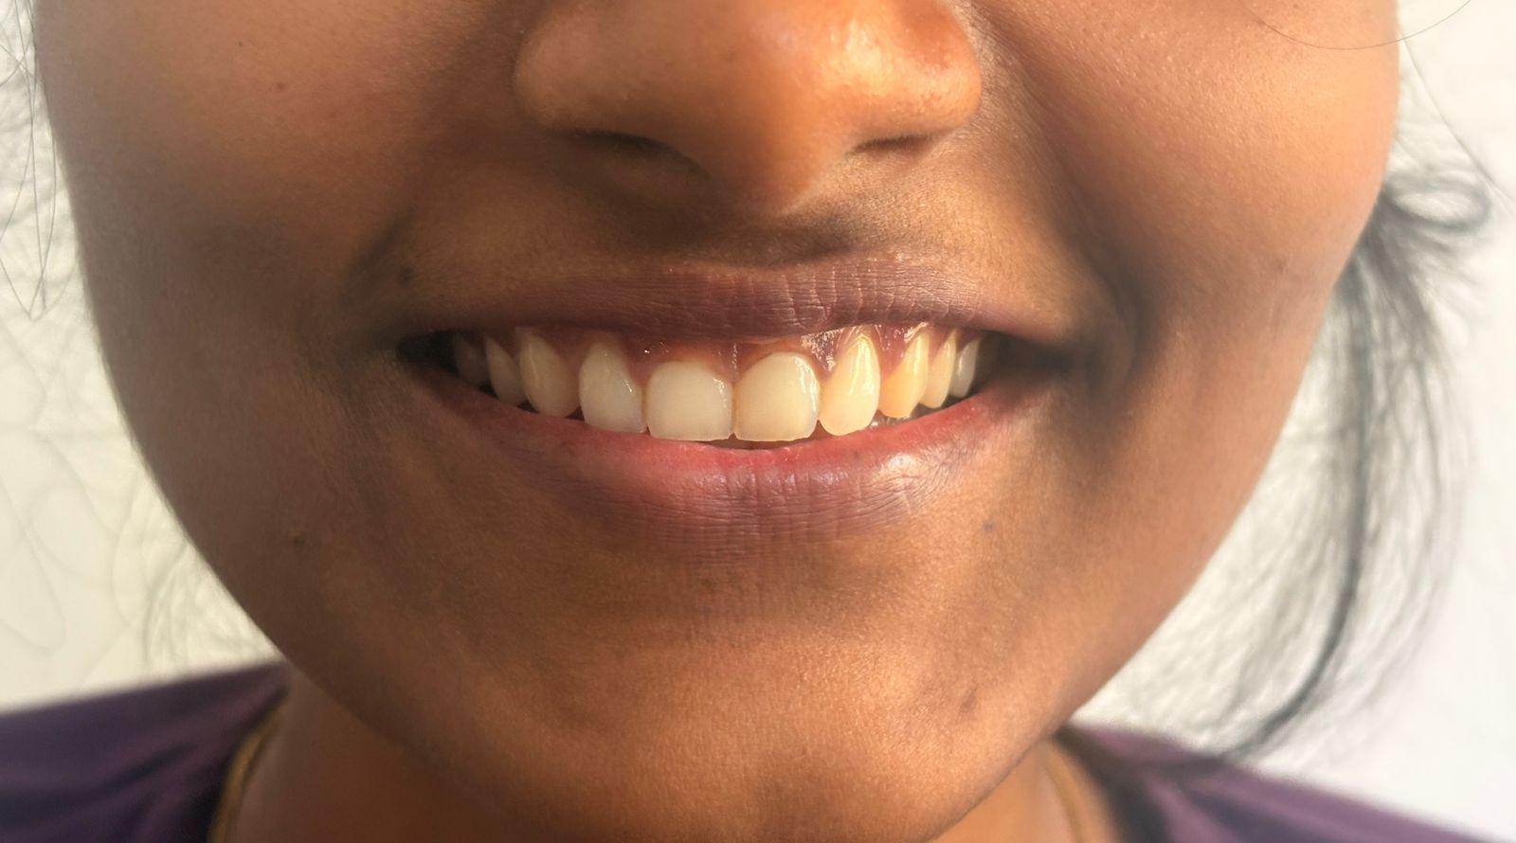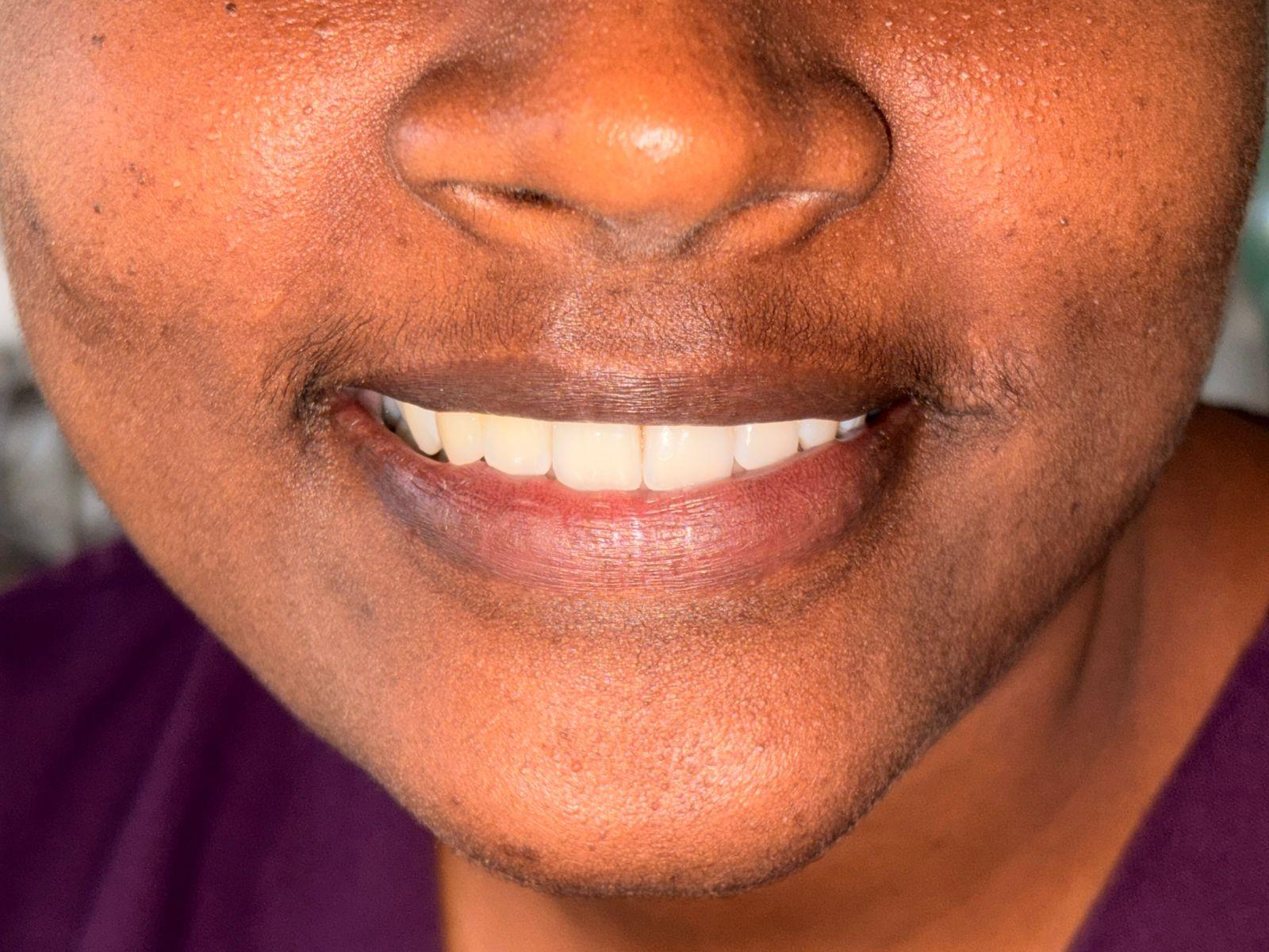Fig 1 : Standardised frontal smile photographs
Gingival contour relationship, interdental papilla position, continuity of the upper dental arch, angulation of upper anterior teeth, position of proximal contacts, width-to-height ratio of maxillary central incisors, congruence of facial and dental midline, angulation of maxillary central incisors relative to the facial midline, parallelism of the canine line with the bipupillary line, exposure of maxillary anterior teeth during smiling, and parallelism of the lower lip line with the maxillary anterior dental arch were among the aesthetic parameters assessed. A uniform scale was used to score each characteristic. Descriptive statistics were used to assess the data, and frequency and percentage distributions were computed.
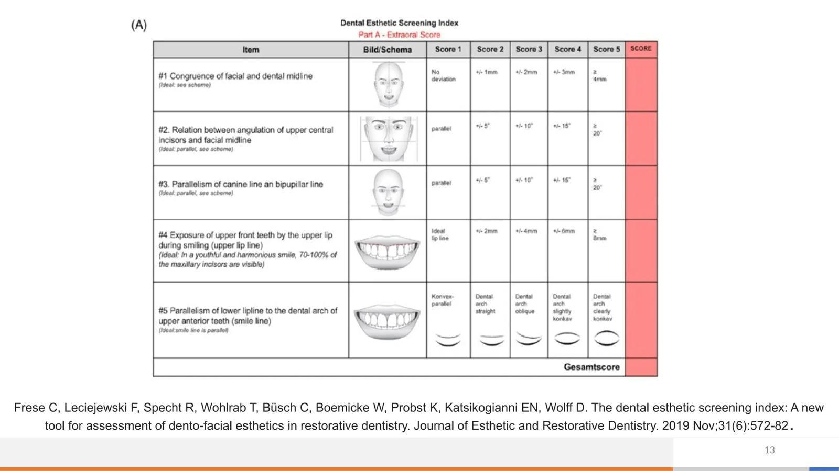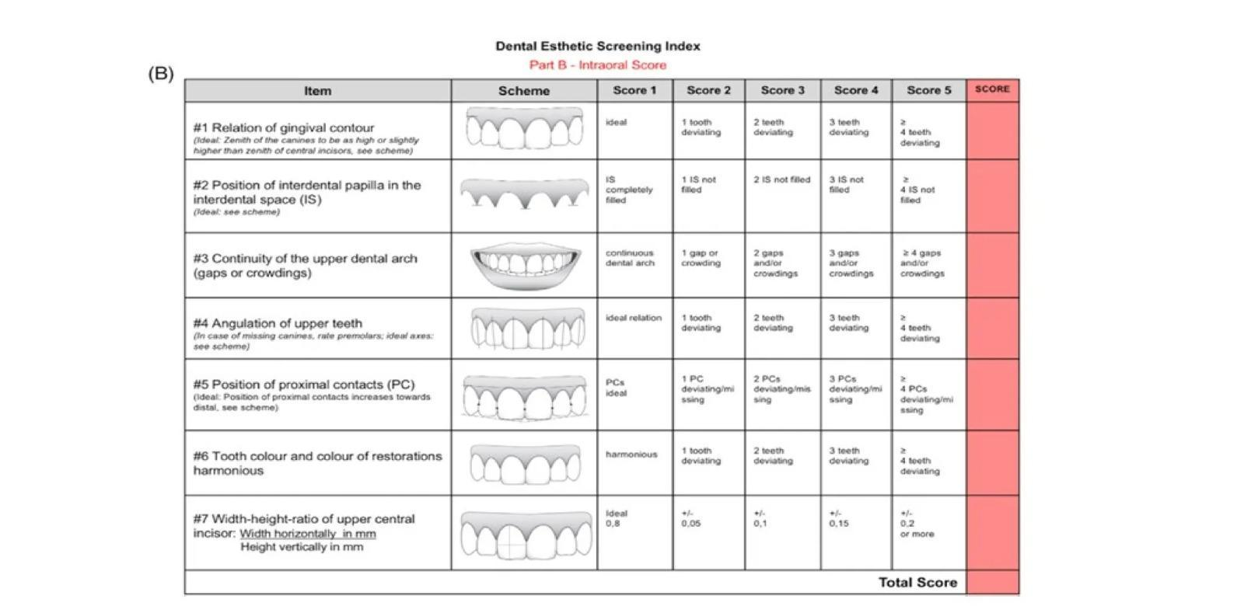
Fig 2 : Dental Esthetic Screening Index
(A) Extraoral score of the DESI with five items.. Measuring scales using millimeter or degree subdivisions were applied to quantify or count esthetic deviance from the ideal. Sum of extraoral items: 5-25 points; a low sum score represents excellent esthetics, whereas the highest sum score represents poor esthetics. (B) Intraoral score of the DESI with six items. Measuring scales using numeric subdivisions were applied to quantify or count esthetic deviance from the ideal. Sum of intraoral items: 7-30 points; a low sum score represents excellent esthetics, whereas the highest sum score represents poor esthetics.(C) Grading scales to interpret the sum scores of the intraoral, extraoral, and overall assessment. A low sum score represents excellent esthetics, whereas The highest sum score represents poor esthetics . Sum of extraoral items: 5-25 points; sum of intraoral items: 7-30 points; overall sum: 10-55 points.
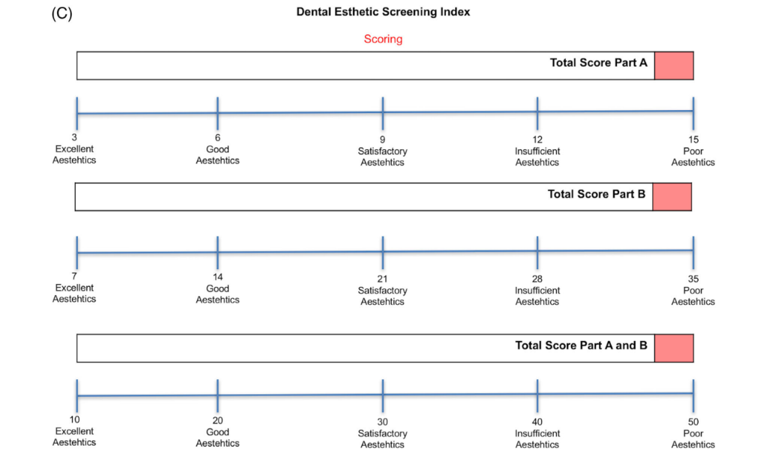
Fig 3 : Dental Esthetic Screening Index Scoring
Study Design
A cross‑sectional observational study was carried out on standardized frontal smile records.
Study Sample
A total of 30 subjects were included in the study. Inclusion criteria comprised individuals with complete maxillary anterior dentition and absence of gross facial asymmetry. Subjects with previous orthodontic or extensive prosthodontic treatment affecting smile esthetics were excluded.
Parameters Assessed
The following esthetic parameters were evaluated using a predefined scoring scale:
1. Congruence of facial and dental midline
2. Relation between angulation of maxillary central incisors and facial midline 3. Parallelism of canine line with bipupillar line
4. Exposure of maxillary anterior teeth by the upper lip during smiling 5. Parallelism of lower lip line with maxillary anterior dental teeth
6. Relation of Gingival contour
7. Position of interdental papilla within interdental space
8. Continuity of upper dental arch
9. Angulation of upper anterior teeth
10. Position of proximal contacts
11. Width‑height ratio of maxillary central incisors width in mm/height in mm
Fig 4
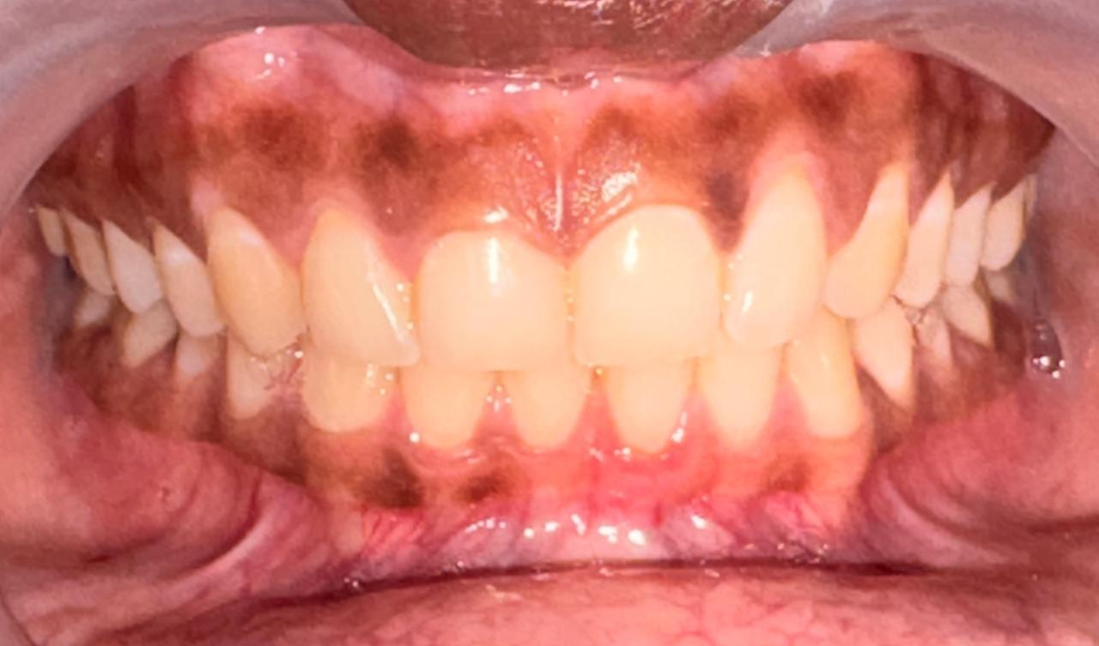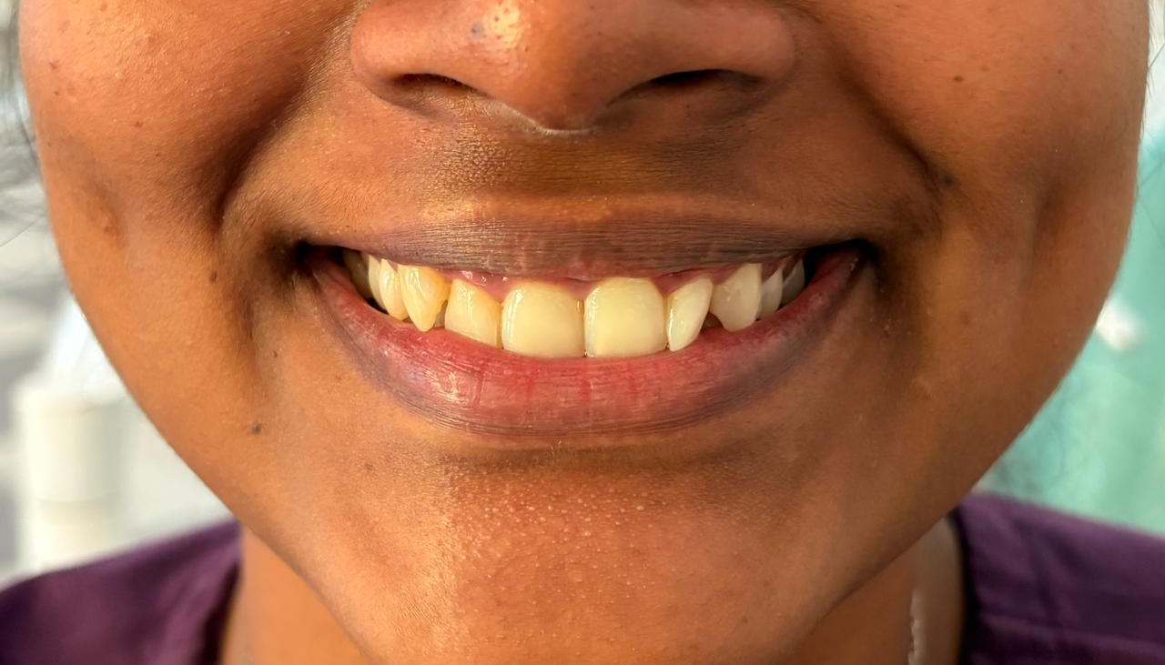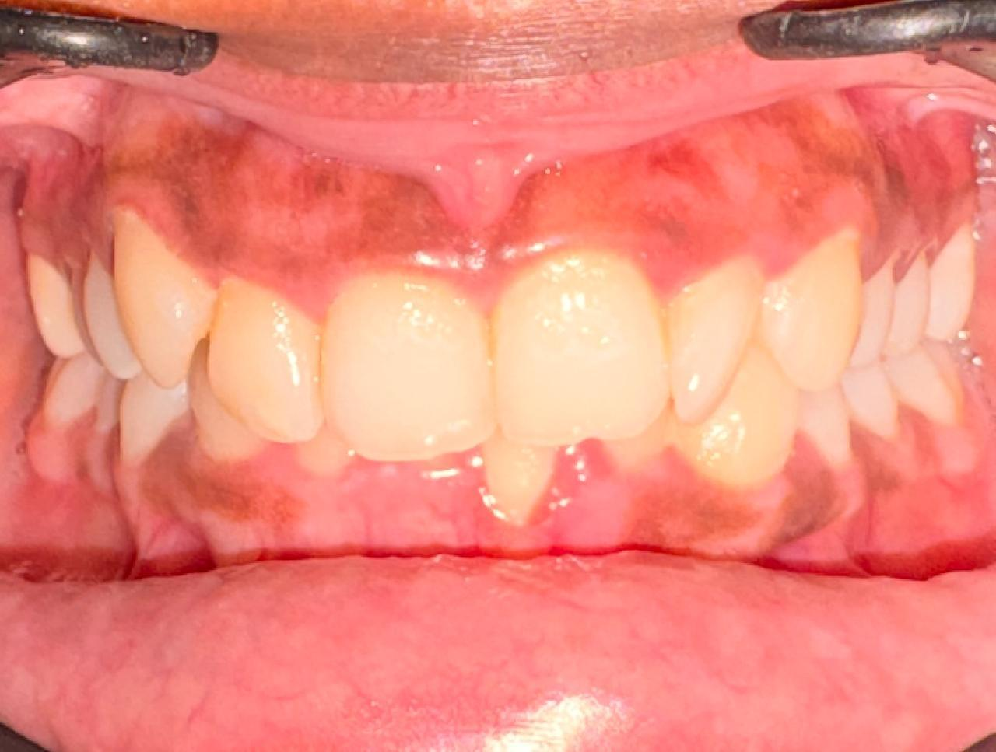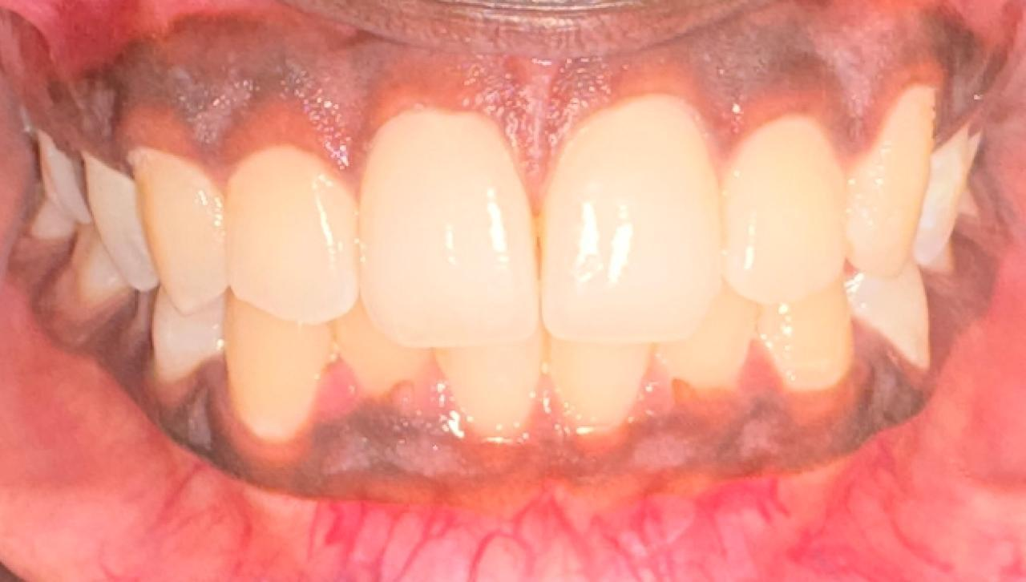
Fig 5
Fig 6
Fig 4, 5 and 6: Aesthetic parameters estimated
Statistical Analysis
Data were tabulated and analyzed using descriptive statistics. Frequency and percentage distributions were calculated for each parameter.
Table 1 : Distribution of Frequency and Percentage for various parameters

Items |  | Frequency | Percent
Congruence of facial and dental midline | 1 | 14 | 46.7
Congruence of facial and dental midline | 2 | 9 | 30.0
Congruence of facial and dental midline | 3 | 6 | 20.0
Congruence of facial and dental midline | 4 | 1 | 3.3
Relation between angulation of upper central incisors and facial midline | 1 | 14 | 46.7
 | 2 | 16 | 53.3
Parallelism of canine line and bipupillary line | 1 | 25 | 83.3
Parallelism of canine line and bipupillary line | 2 | 5 | 16.7
Exposure of upper front teeth by the upper lip during smiling | 3 | 1 | 3.3
 | 4 | 6 | 20.0
 | 5 | 23 | 76.7
Parallelism of lower lip line dental arch of upper anterior teeth | 1 | 22 | 73.3
 | 2 | 7 | 23.3
 | 3 | 1 | 3.3
Relation of gingival contour | 1  2 | 3  7 | 10.0  23.3
Relation of gingival contour | 3 | 6 | 20.0
Relation of gingival contour | 4 | 5 | 16.7
Relation of gingival contour | 5 | 9 | 30.0
Position of interdental papilla in the interdental space | 1 | 2 | 6.7
Position of interdental papilla in the interdental space | 2 | 7 | 23.3
Position of interdental papilla in the interdental space | 3 | 9 | 30.0
Position of interdental papilla in the interdental space | 4 | 6 | 20.0
Position of interdental papilla in the interdental space | 5 | 6 | 20.0
Continuity of upper dental arch | 1 | 16 | 53.3
Continuity of upper dental arch | 2 | 9 | 30.0

 | 3 | 2 | 6.7
 | 4 | 2 | 6.7
 | 5 | 1 | 3.3
Angulation of upper teeth | 1 | 22 | 73.3
Angulation of upper teeth | 2 | 6 | 20.0
Angulation of upper teeth | 3 | 2 | 6.7
Position of proximal contacts | 1 | 15 | 50.0
Position of proximal contacts | 2 | 10 | 33.3
Position of proximal contacts | 3 | 2 | 6.7
Position of proximal contacts | 4 | 1 | 3.3
Position of proximal contacts | 5 | 2 | 6.7
Width height ratio of upper central incisor width in mm/height in mm | 1 | 20 | 66.7
 | 5 | 10 | 33.3

Results
In 46.7% of patients, congruence between the facial and dental midlines demonstrated perfect alignment; in the other cases, modest to severe discrepancies were noted. In 53.3% of cases, the maxillary central incisors' angulation with respect to the midline of the face was deemed appropriate.
In 83.3% of participants, there was parallelism between the canine and bipupillar lines, indicating a significant horizontal smile harmony. 76.7% of people showed optimal maxillary anterior tooth exposure when smiling.
In 73.3% of instances, the maxillary anterior dental arch was parallel to the lower lip line. Just 30% of gingival contours had perfect outlines, indicating variability. Thirty percent of the participants had the ideal position of the interdental papilla, while the remaining subjects had incomplete or insufficient fill.
More than half of the participants (53.3%) found the upper dental arch to be satisfactorily continuous. Seventy-three percent of the upper anterior teeth had acceptable angulation. Fifty percent of individuals had optimal proximal contact locations. In 66.7% of the study population, the maxillary central incisors' width-to-height ratio fell within optimal bounds.
Discussion
Smile esthetics is a multifactorial concept influenced by dental, gingival, and facial parameters. The study found that canine line and bipupillary line parallelism were quite prevalent.Despite generally positive dental characteristics, there were noticeable variations in gingival shape and interdental papilla location.Anterior esthetics has been found to be significantly influenced by gingival architecture, and even little variations can negatively impact how a smile is perceived, particularly in individuals with prominent smile lines (1,2).This validates earlier research highlighting the significance of horizontal reference lines in grin analysis (3).The majority of participants in this study showed appropriate proportions, supporting the therapeutic significance of the well-established anterior aesthetics guideline for the width-to-height ratio of maxillary central incisors (3).Smile beauty and perceived youthfulness are known to be positively impacted by proper maxillary anterior tooth exposure, which was visible in the majority of respondents (4).A thorough smile analysis helps achieve predictable and desirable aesthetic results by enabling doctors to spot small aesthetic disharmonies that might not be seen during a normal checkup (4).Based on the distance between the contact point and the alveolar bone crest, Tarnow et al. (5) offered clinically significant recommendations for predicting the occurrence of interdental papilla.Concurrently, Lombardi (6) stressed the need for dental aesthetics to adhere to universal principles of visual perception.Standardized cephalometric standards may not be globally relevant, according to interracial facial research (7).Smile aesthetics heavily depend on incisor angulation, with even little variations affecting perception (8).Photographic evaluation enables quantitative examination of aesthetic changes and enhances documentation accuracy (9).Clinicians can objectively assess both hard and soft tissue characteristics using contemporary implant indices like ICAI (10).
The current study's results are consistent with earlier research emphasizing the significance of soft tissue factors in cosmetic dental rehabilitation.The basis for systematic assessment was established by conventional restoration evaluation techniques such the Ryge criteria (11). By including aesthetic, biological, and functional factors, the revised FDI criteria considerably enhanced clinical evaluation standards (12,13).
This facilitates accurate torque control during prosthesis or orthodontic rehabilitationPublic health applications were made possible by the introduction of population-based measurements of aesthetic impairment by orthodontic indices (14,15). Standardized assessment of definite prosthodontic results is guaranteed by the Prosthetic Esthetic Index (16).The emotional influence of dental appearance is measured by psychosocial instruments (17,18), highlighting the need of patient-centered care.The sensitivity of smile perception is confirmed by the large changes in beauty judgments caused by small changes in incisor angulation (20).
Gingival shape, dental arrangement, and facial proportions must all be precisely coordinated for a smile to be aesthetically pleasing.Previous study has shown that gingival contour and interdental papilla position frequently vary, indicating that soft tissue properties are crucial factors in determining smile aesthetics. Even though they are modest, these differences can have a big impact on how appealing a grin is, especially for people who have a high smile line.Coordinated facial elements are necessary for face harmony and thorough analyses emphasize the significance of symmetry and proportion (21,30).Thus, a more thorough evaluation framework is produced by integrating computational analysis, expert review, and patient-reported results.While smile line examination is essential in esthetic zone implant therapy, clinical indices such as the Pink Esthetic Score standardize implant soft tissue evaluation (22,29).Their results demonstrated how crucial proportionate harmony is to anterior restorative dentistry.Research and clinical recording are made easier by the index's structured classification of dental discolouration and surface abnormalities (23).That when evaluating the beauty of a grin, physicians typically favor particular width-to-length ratios and proportional correlations (24).Consistent photographic views enhance objectivity and enable comparison between several evaluators, the authors stressed (25).Evaluation techniques that are scientific and subjective may not always align (26–28).
Overall, the results emphasize the importance of individual assessment, especially when considering aesthetic prosthodontic or restorative operations, even though the majority of people come with acceptable esthetic parameters.
Conclusion
Within the limitations of this study, it can be concluded that:
● Most individuals exhibit satisfactory facial and dental esthetic harmony.
● The most variable parameters affect smile esthetics, because of gingival contour and interdental papilla positions.
● For achieving predictable esthetic outcomes in clinical practice, Comprehensive smile analysis is essential.
Involving the patient in the estimation of aesthetic dental treatment may be enhanced by the DESI.To find out if the DESI is a reliable and accurate instrument in large-scale clinical trials, more clinical research should be done.It may be possible to determine smile attractiveness in future research with wider sample numbers and the inclusion of subjective aesthetic assessments.

Ethical Approval
The study was conducted at the department of prosthodontics and implantology. Participants were recruited from adults who attended the department during study period.The study was approved by the institutional ethics committee prior to commencement (IEC NO: ECR/1742/APDCH/PROSTHO/UG 01/TN OCT 2025).
Consent
As per international standards or university standards, Participants’ written consent has been collected and preserved by the author(s).
References
1.Belser UC, Coachman C, Magne P. Dental Esthetic Screening Index (DESI): A new tool for assessment of dento-facial esthetics in restorative dentistry. Int J Esthet Dent. 2015;10(2):220–236.
2.Ahmad I. Anterior dental aesthetics: facial perspective. Br Dent J. 2005;199:15–21.
3.Fradeani M. Esthetic Rehabilitation in Fixed Prosthodontics. Quintessence Publishing; 2004.
4.Coachman C, Calamita M. Digital smile design: a tool for treatment planning and communication. Int J Esthet Dent. 2012;7(1):112–125.
5.Tarnow DP, Magner AW, Fletcher P. The effect of the distance from the contact point to the crest of bone on the presence or absence of the interproximal dental papilla. J Periodontol. 1992;63:995–996.
6.Lombardi RE. The principles of visual perception and their clinical application to denture esthetics. J Prosthet Dent. 1973;29:358–382.
7.Owens EG, Goodacre CJ, Loh PL, et al. A multicenter interracial study of facial appearance. Part 1: a comparison of extraoral parameters. Int J Prosthodont. 2002;15:273-282.
8. Wolfart S, Brunzel S, Freitag S, Kern M. Assessment of dental appearance following changes in incisor angulation. Int J Prosthodont. 2004;17:150-154.
9.Rosenstiel SF, Pappas M, Pulido MT, Rashid RG. Quantification of the esthetics of dentists' before and after photographs. J Dent. 2009;3(Suppl 1):e64-e69.
10.Meijer HJ, Stellingsma K, Meijndert L, Raghoebar GM. A new index for rating aesthetics of implant-supported single crowns and adjacent soft tissues--the implant crown aesthetic index. Clin Oral Implants Res.2005;16:645-649.
11.Ryge G, Snyder M. Evaluating the clinical quality of restorations. J Am Dent Assoc.1973;87:369-377.
12.Hickel R, Peschke A, Tyas M, et al. FDI world dental federation: clinical criteria for the
evaluation of direct and indirect restorations update and clinical examples.Clin Oral Investig.
13.Hickel R, Peschke A, Tyas M, et al. FDI world dental federation - clinical criteria for the
evaluation of direct and indirect restorations.Update and clinical examples. JAdhes Dent. 2010;12:259-272.
14.Brook PH, Shaw WC. The development of an index of orthodontic treatment priority. Eur J Orthod. 1989;11:309-320.
15.Cons NC, Jenny J, Kohout FJ, DDS YS, Jotikastira D. Utility of the dental aesthetic index in industrialized and developing countries.J Public Health Dent. 1989;49:163-166.
16. Ozhayat EB, Dannemand K. Validation of the prosthetic esthetic index. Clin Oral Invest. 2014;18:1447-1456.
17.Klages U, Claus N, Wehrbein H, Zentner A. Development of a questionnaire for assessment of the psychosocial impact of dental aesthetics in young adults. Eur J Orthod. 2006;28:103-111.
18.klages U, Erbe C, Sandru SD, Brüllman D, Wehrbein H. Psychosocial impact of dental aesthetics in adolescence: validity and reliability of a questionnaire across age-groups. Qual Life Res. 2015;24:379-390.
19.Altman D. Practical Statistics for Medical Research. Boca Raton: Chapman & Hall; 1991.
20. Brunzel S, Kern M, Freitag S, Wolfart S. Aesthetic effect of minor changes in incisor angulation: an internet evaluation. J Oral Rehabil.2006;33:430-435.
21.Faure JC, Rieffe C, Maltha JC. The influence of different facial components on facial aesthetics. Eur J Orthod. 2002;24:1-7.
22.Furhauser R, Florescu D, Benesch T, et al. Evaluation of soft tissue around single-tooth implant crowns: the pink esthetic score. Clin Oral Implants Res. 2005;16:639-644.
23.Modi S, Williams L, Greenwood R, et al. Development of an illustrated index of tooth appearance-perception-based quantification of tooth discoloration and surface defects. Int J Paediatr Dent.2010;20:293-304.
24.Rosenstiel SF, Ward DH, Rashid RG. Dentists' preferences of anterior tooth proportion--a web-based study. J Prosthodont. 2000;9:123-136.
25.Peerlings RH, Kuijpers-Jagtman AM, Hoeksma JB. A photographic scale to measure facial aesthetics. Eur J Orthod. 1995;17:101-109.
26. Schabel BJ, Franchi L, Baccetti T, McNamara JA Jr. Subjective vs objective evaluations of smile esthetics. Am J Orthod Dentofacial Orthop. 2009;135:S72-S79.
27.Schabel BJ, McNamara JA Jr, Franchi L, Baccetti T. Q-sort assessment vs visual analog scale in the evaluation of smile esthetics. Am J Orthod Dentofacial Orthop. 2009;135:S61-S71.
28.basting RT, da Trindade de C, Florio FM. Comparative study of smile analysis by subjective and computerized methods. Oper Dent. 2006;31:652-659.
29. Kourkouta S. Implant therapy in the esthetic zone: smile line assessment. Int J Periodontics Restorative Dent. 2011;31:195-201.
30.Dong JK, Jin TH, Cho HW, Oh SC. The esthetics of the smile:a review of some recent studies. Int J Prosthodont. 1999;12:9-19

