Case report
Coinciding Realignment of Complex Zygomatic and Parasymphysial Mandibular Fractures Following Motor Vehicle Collision: A Case Report

.
ABSTRACT

Fractures of the mandible are the most common encountered injuries of the facial skeleton and are often the result of high-energy trauma. Zygomatic fractures, also frequent in maxillofacial trauma, can significantly compromise the symmetry of the face, ocular function, and masticatory mechanics. This report describes a case of a 25-year-old male who presented to the emergency department after being transferred from a primary care facility following a high-velocity motor vehicle collision. He sustained a classic “dashboard injury,” leading to a closed, unstable right parasymphysial mandibular fracture accompanied by a zygomatic fracture. In this patient, malocclusion, restricted oral opening, right-sided periorbital edema and ecchymosis, and conjunctival hyperemia have been observed. The management of both fractures proceeded with closed reduction techniques that resulted in stable alignment and the restoration of normal occlusion. The postoperative course was uneventful; functional and aesthetic recoveries have been reached without complication. This case points out the importance of an early assessment and timely closed reduction in the management of combined mandible and zygomatic injuries for the optimization of outcomes.

Keywords: Maxillofacial trauma; Zygomatic fracture; Mandibular parasymphysial fracture; Operative management;

1. INTRODUCTION

Because of their prominent position, facial fractures most commonly affect the mandible and the zygoma. Because the zygomaticomaxillary complex (ZMC) fracture is the second most common midfacial injury, it usually arises from road-traffic accidents among young men, followed by assaults, falls, and sports injuries. Classic "tetrapod/tripod" fracture patterns are produced due to the usual zygomatic bone fracture along four articulation points, where the zygomatic arch usually goes together with the infraorbital rim [1]. Infraorbital numbness, diplopia, pain, flattening of the cheek, periorbital bruising, subconjunctival hemorrhage, palpable step deformities, and trismus due to the impingement of the arch are common presentations. If not diagnosed promptly [2], complications of ZMC fractures may include early ones like retrobulbar hemorrhage and optic nerve injury, whereas later ones include diplopia, enophthalmos, chronic sinusitis, and infraorbital nerve dysfunction. The diagnosis involves detailed extraoral and intraoral examination [3]. Even though plain X-rays may be helpful, a multidetector CT scan represents the diagnostic standard of care because of its ability to provide highly detailed 3D assessment [4]. The system of Knight and North classification is widely used for the categorization of these fractures when treatment planning is needed. The Knight and North Classification (1961) is widely used to categorize ZMC fracture based on the direction of displacement and rotation, which aids in treatment planning (Table 1) [5].

Table 1: Knight and North Classification of Zygomatic Fractures.
Group | Description
Group I | Undisplaced fractures.
Group II | Isolated zygomatic arch fractures.
Group III | Unrotated body fractures.
Group IV | Medially rotated body fractures.
Group V | Laterally rotated body fractures.
Group VI | Complex fractures (comminuted).

Preoperative assessment of the eye is essential for ZMC fractures to record the vision and differentiate trauma-related deficits from surgical complications. Subconjunctival hemorrhage and diplopia are some of the signs that need to be documented for medicolegal purposes [6]. Depending on the severity of the fracture, treatment ranges from conservative management in nondisplaced fractures to isolated or simple fractures with closed reduction and unstable or comminuted fractures with open reduction and internal fixation using titanium plates [7].

The mandible is the most common facial bone to be fractured, next to the nasal bone, because of the increasing incidence of road traffic accidents, assaults, and falls [8]. Parasymphysial fractures are particularly important since bilateral injuries can threaten the airway and disturb occlusion [9]. Treatment aims to restore normal occlusion and function using conservative care, closed reduction, or open reduction internal fixation, depending on the displacement and stability [10].

2. Case presentation

2.1. Patient Information and Mechanism of Injury: A 25-year-old male was referred to our emergency clinic from a primary health care unit following a road traffic accident. History from the patient and witnesses revealed that he was the front-seat passenger in a vehicle involved in a collision. The patient was unrestrained at the time of impact. Sudden deceleration caused his body to project forward, leading to a high-velocity impact of his face against the dashboard.

2.2. General Examination: The patient was alert and conscious with an admission Glasgow Coma Scale of 15/15. He was normotensive and afebrile. There was a patent airway with no evidence of distress, normal respiratory rate, and symmetrical chest movements. Abdominal examination revealed a lax, freely mobile anterolateral abdominal wall that excluded thoraco-abdominal injuries. The extremities did not show fracture or neurovascular deficits.

2.3. Local Examination: Extraoral examination showed the presence of mild right hemifacial edema. Right periorbital oedema and ecchymosis were observed with red right eye. Hypoesthesia was detected infraorbitally indicating injury of the infraorbital nerve. Moreover, few interrupted sutures were present in the lateral aspect of the periorbital region. Other sutures were also have been used to restore the continuity of a chin wound about 5 cm, in addition to scattered multiple abrasions and contusions involving both the central and lateral facial regions. The patient expressed pain in the right infraorbital region with tenderness upon examination. Mild flattening of the right periorbital region was observed. Right red eyes with lacrimation were also presented (Figures 1,2).

Intraoral examination revealed reduced oral opening due to reduction of the volume of the Temporomandibular joint (TMJ) because of the depressed zygoma. A right parasymphysial mandibular fracture was detected which was stable and closed. The right central and lateral incisors were lost on both sides of the mandible; therefore, the fracture was finally diagnosed as a right parasymphysial, closed, unstable, type C fracture mandible. Furthermore, absorbable sutures (catgut) were observed in the oral vestibule securing a wound involving the mucosal covering of the mandibular gingiva and the lower lip (Figure 3). No associated wounds involving the tongue or other soft tissues of the oral cavity.

2.4. Ophthalmological consultation: the visual acuity was not affected. Orbital examination was free with no injuries or complications.

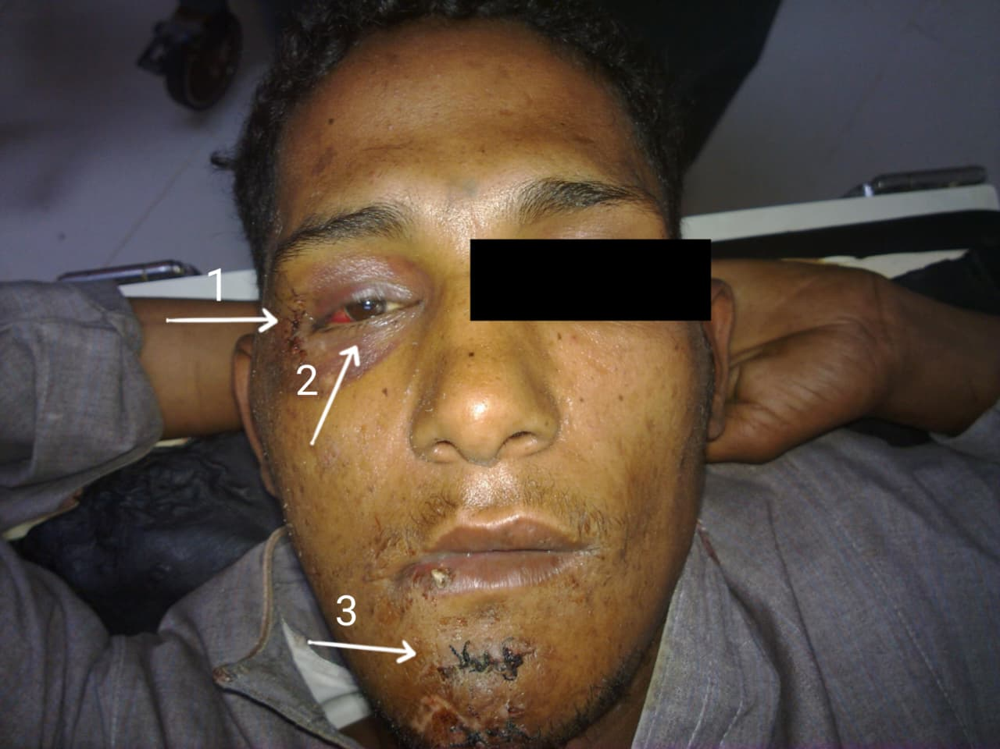

Figure 1. Interrupted sutures in the lateral aspect of the right periorbital region (1), periorbital ecchymosis and red eye (2), sutures chin wound (3). Anterior view.

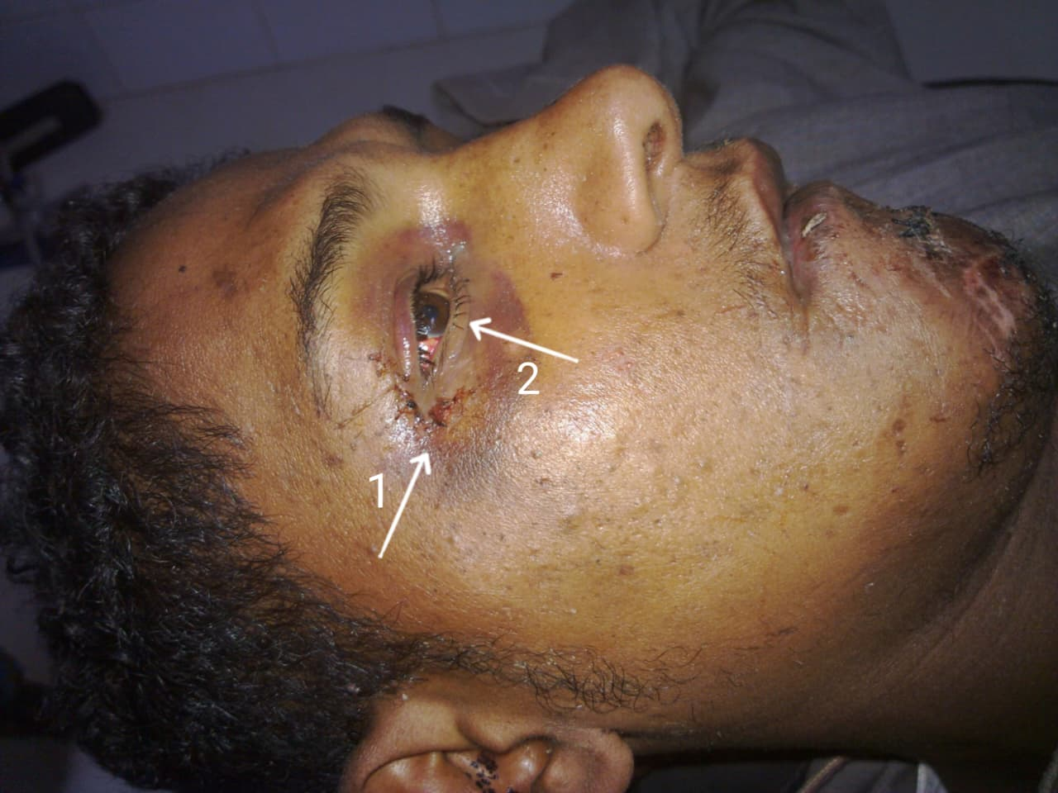

Figure 2. Right periorbital ecchymosis (1) red eye (2), while the sutures have been removed. Lateral view.

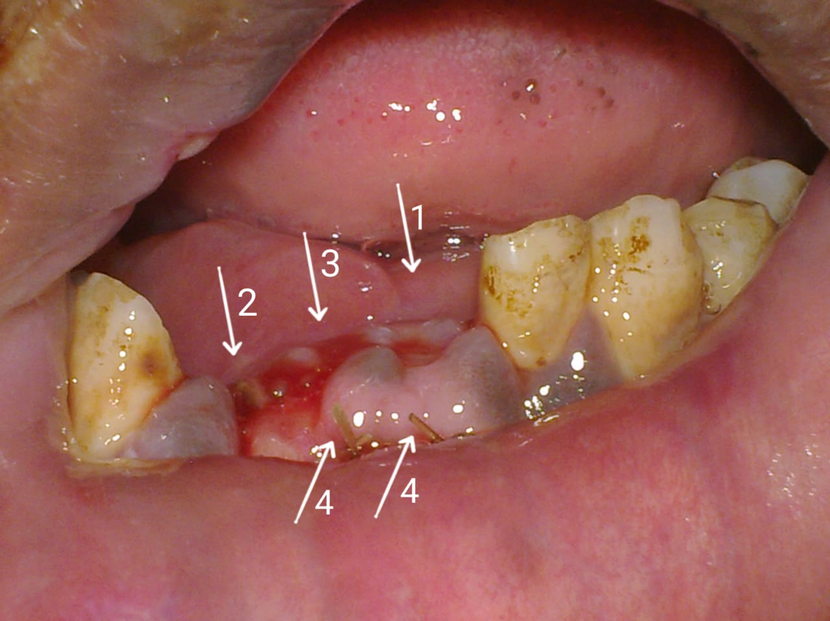

Figure 3: lost central incisor (1), lateral incisor (2), fracture line (3) and the ends of catgut sutures which were used to suture the intraoral wound (4).

2.5. Radiographical Assessment
Radiographic evaluation was done to confirm the clinical diagnosis. Panoramic X-ray, demonstrated the presence of a right parasymphysial, closed, unstable, type C fracture mandible (Figure 4). In addition, MultiDetector Computerized Tomography (MDCT) 3D cuts (both anteroposterior and lateral views) confirmed the presnsce of the right parasymphysial, closed, unstable, fracture mandible, lost right hemi-mandibular central and lateral incisors, fracture complex zygomatic fracture as well as compression of the mandibular condyle head by the zygomatic arch (figure 5,6A,6 B) reducing the oral cavity opening.

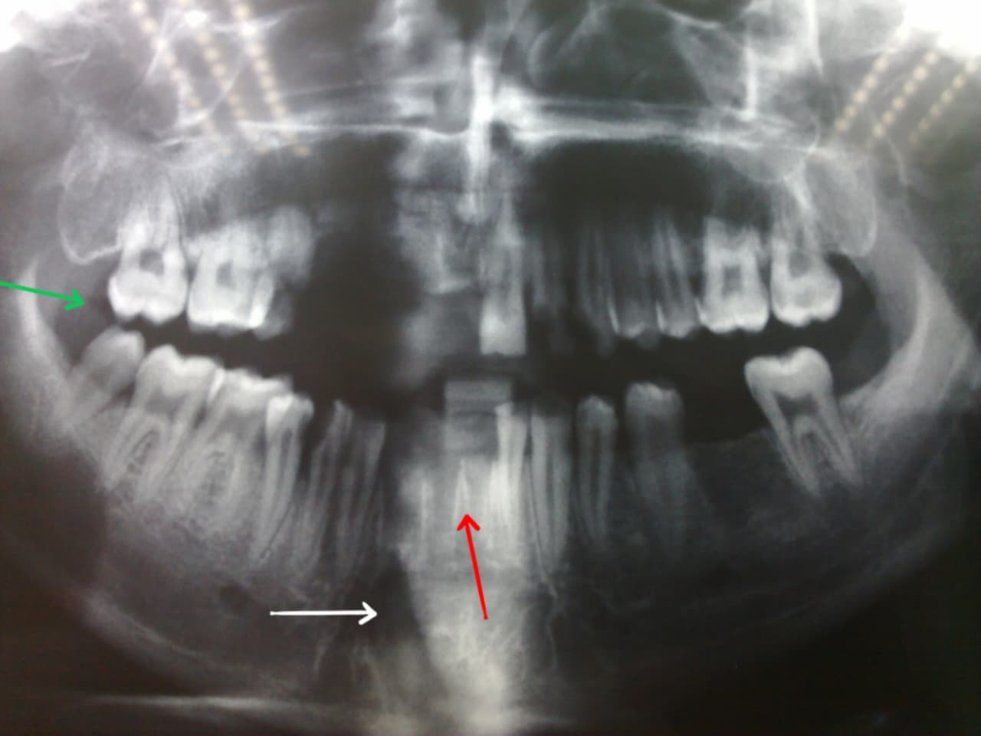

Figure 4: Orth-odontograph (Panoramic view) illustrating a right parasymphysial, closed, stable, fracture mandible (white arrow), lost right mandibular central and lateral incisors (red arrows) and reduction of the oral cavity opening manifested by reduced space in-between maxillary and mandibular molars on the right side (green arrow) in comparison to the left side.

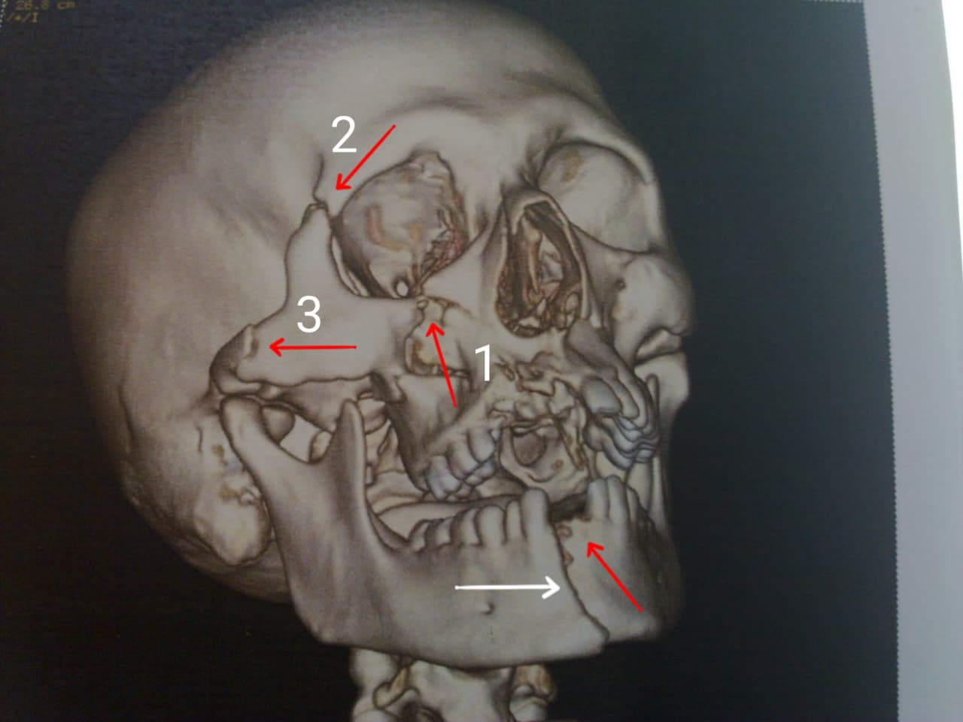

Figure 5: MDCT AP view illustrating the a right parasymphysial, closed, stable, fracture mandible (white arrow), lost right mandibular central and lateral incisors (red arrows) and fracture complex, fracture (orbital process (1), frontal process (2), temporal process (3).

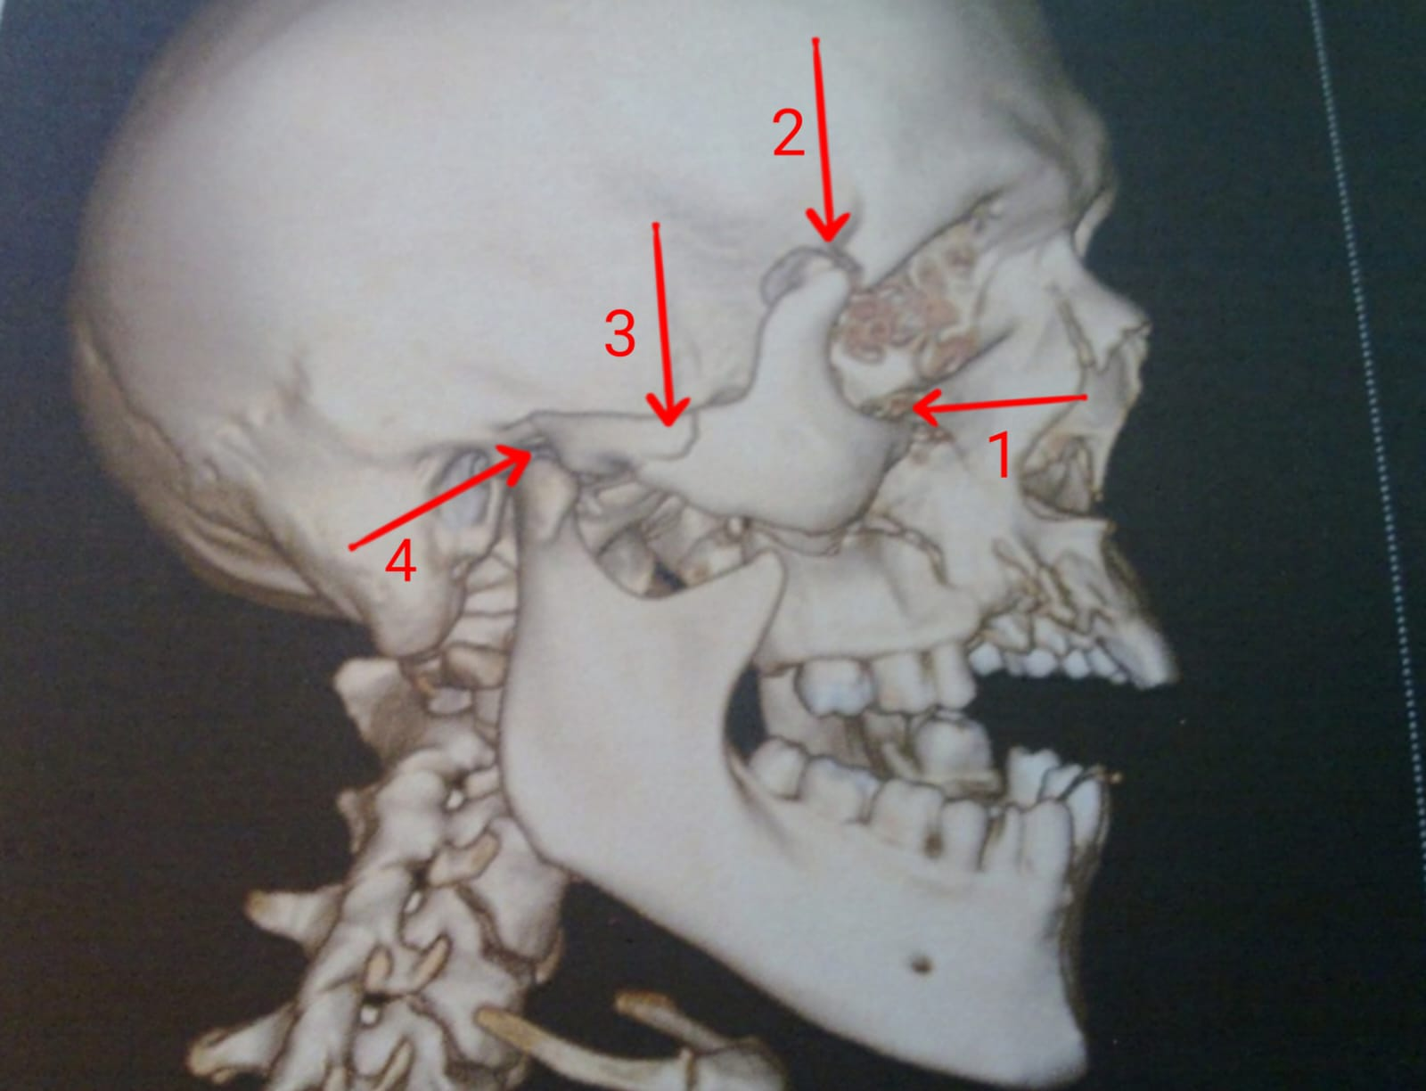

Figure 6 A: MDCT lateral view illustrating fracture complex zygomatic fracture (orbital process (1), frontal process (2), temporal process (3) and the comprised mandibular condyle (4).
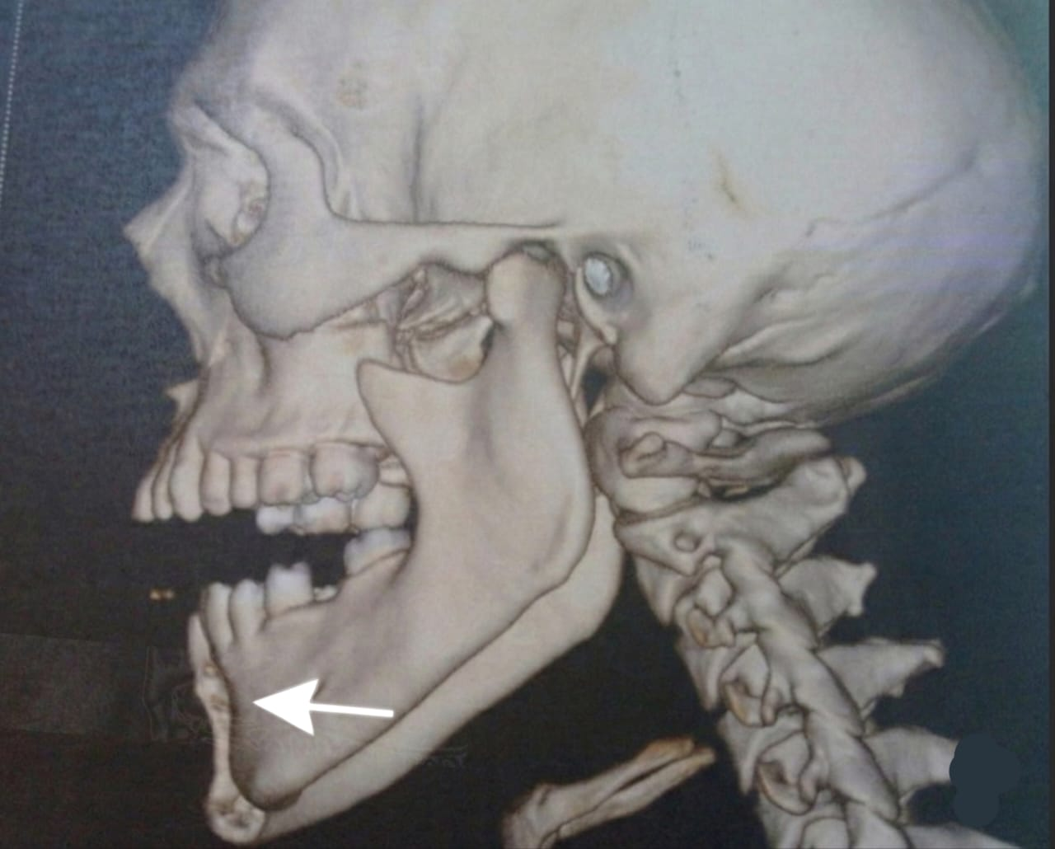

Figure 6 B: MDCT lateral view illustrating the a right parasymphysial, closed, unstable, fracture mandible (white arrow).

The decision was for simultaneous closed reduction fixation for both fractures.

3. Surgical procedure

3.1. Patient position: Supine with extended neck and head titled backwards by a pillow beneath.
3.2. Anesthesia: General anesthesia was induced via nasotracheal intubation for free access to the oral cavity.

3.3. Securing the air ways: An oral pack i.e., a piece of gauze was inserted in the oropharynx securing the airways against aspiration by saliva and blood during the surgical procedure.

3.4. Procedure: Before starting our procedure, the sutures of the previously mentioned two sutured facial wounds were removed and fine cosmetic repair was done using thinner suture materials. The zygoma was closely reduced using a surgical hook (Figure 7) inserted below the lower border of the right zygomatic bone achieving both reduction of the fracture as well as releasing the trapped mandibular condyle. The hook was inserted through puncture incision at the lower border of the zygoma which was sutured after reduction using a single non-absorbable suture material (Figure 8). Due to the stability and minimal displacement of the zygomatic ZMC fracture, ORIF was not indicated which is uncommon situation in such type of zygomatic fractures.
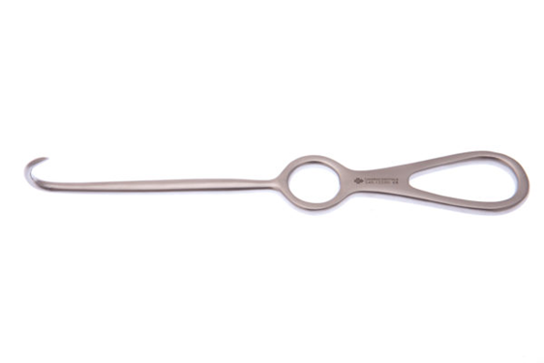
Figure 7: Langenbeck bone hook 7.75″ 197mm [11]
https://surgical.saharan.co.uk/wp-content/uploads/2016/08/S45.12250.jpg

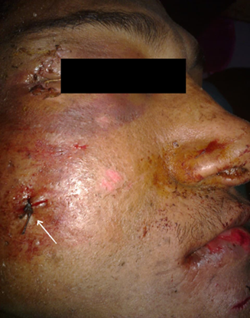

Figure 8: Single suture closure of the surgical approach done by the hook.
Using digital manipulation, the displaced parasymphysial fractures were anatomically reduced, verifying the restoration of proper occlusion and mandibular symmetry. Stainless steel arch bars were adapted and secured to the maxillary and mandibular dental arches using 0.5 mm trans-dental wires. IMF was achieved with elastic traction stretched between the hooks of the upper and lower arches in order to maintain the reduction (Figure 9). The instruments used for closed reduction (arch bars, 0.5 mm wires, wire holder, and wire cutter) are illustrated (Figure 10A, B, C, D).

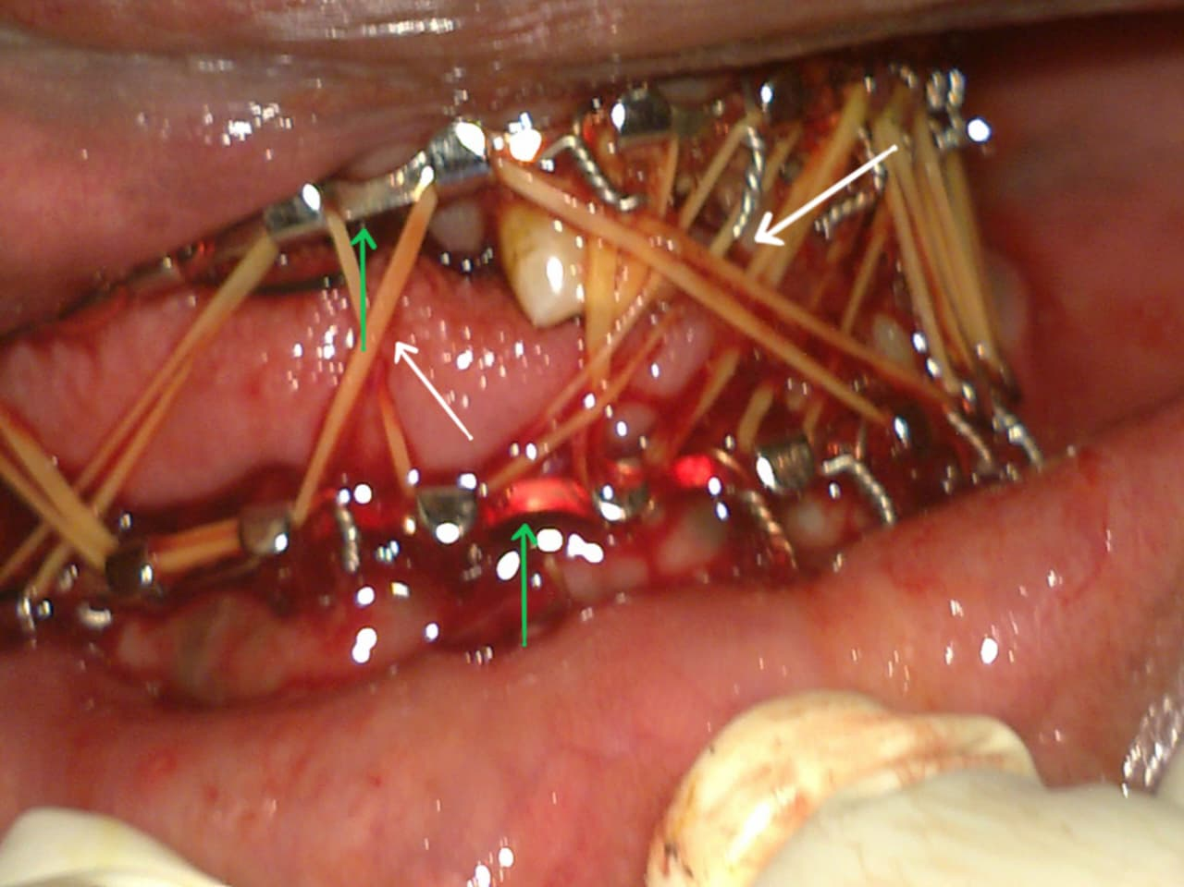

Figure 9: IMF; Arch bars (green arrows), Elastics (white arrow)

Figure 10A: Arch bars [12]
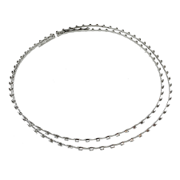
https://share.google/OXI1fRrzaOWokGeW0
Figure 10b: 0.5 mml wires [13]
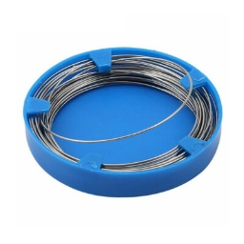
https://share.google/KfMS8Konwkk0JTtvx

Figure 10c: Wire holder [14]
https://surtex-instruments.com/product/wire-ligature-cutter/
Figure 10d: Wire cutter [15]
https://www.gdcdental.com/product-wire-twister-1165.php

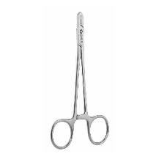
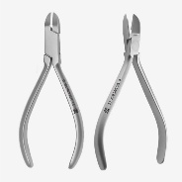

The oral pack was removed. Anesthetic reverse was administrated.
Operative-time: 30 minutes.

3.5 Follow-up and Outcomes: The patient had a smooth recovery. Oral fluids were started 4 h postoperatively using a 50 ml syringe through the retromolar space. A postoperative panoramic radiograph confirmed satisfactory alignment and normal occlusion.
During the postoperative hospital admission, the patient continued his oral feeding by the same maneuver with addition of blindered semisolids starting from the 2nd day. Furthermore, the patient was instructed for regular oral hygiene, avoid removal 0f the elastics as well as avoid leaning and sleeping on the right side guarding against the possibility of zygomatic immobilization even minimal.
The patient was discharged on the 5th postoperative day with no immediate complications. The patient was instructed to maintain oral feeding in the same maneuver, avoiding removal of elastic materials, maintaing regular oral hygiene and for attending scheduled follow-ups at the outpatients’ clinic.
At the 2nd week of the postoperative period, the patient attended the outpatients' clinic; no complications were recorded. The elastics were removed. One month later, the arch bars were removed. The patient attended monthly visits for 6 months until bone healing was achieved, with no complications and no recurrence. He was then referred to an orthodontist (to realign the remaining teeth and create proper space before prosthodontic replacement of his lost incisors).

4. discussion

Management of facial fractures depends on the location, degree of displacement, and functional impact on occlusion, vision, and facial aesthetics. Mandibular fractures are commonly treated either by closed reduction with intermaxillary fixation (IMF) or by open reduction and internal fixation (ORIF) using plates and screws [16]. The choice between these approaches is guided by fracture stability, the presence of comminution, and the condition of the overlying soft tissues. In the present case, closed reduction was sufficient for the right parasymphysial mandibular fracture because the fracture was nondisplaced after manual reduction, and proper occlusion was achieved and maintained with arch bars and elastic traction. This finding supports the literature demonstrating that arch bars and elastic IMF can effectively restore alignment in selected mandibular fractures, particularly when adequate dentition is present to secure the fixation [17].

Zygomaticomaxillary complex (ZMC) fractures frequently accompany mandibular injuries in high-energy trauma, as seen in this patient. These fractures require careful reduction to maintain facial contour, orbital volume, and ocular function. While minimally displaced or isolated zygomatic arch fractures may be managed conservatively or with closed reduction, displaced, rotated, or comminuted fractures typically require ORIF with titanium plates to prevent late enophthalmos, diplopia, and facial asymmetry [18]. According to the Knight-North classification, our patient presented with a Group VI (complex) ZMC fracture involving the orbital, frontal, and temporal processes. Despite this complexity, the fracture was only minimally displaced, and the zygomatic bone was easily mobilized and reduced using a percutaneous hook. Because intraoperative assessment showed no tendency for redisplacement and the infraorbital rim was anatomically aligned, we elected to avoid ORIF. This decision is consistent with reports that selected complex ZMC fractures without significant comminution or rotation can be successfully treated with closed reduction, especially when the fracture is “greenstick” in nature or when the periosteum remains partially intact [7,18].

The role of dental occlusion and the presence of teeth cannot be overemphasized in achieving functional alignment. The loss of the right mandibular central and lateral incisors created an unstable occlusal relationship; however, the remaining dentition provided sufficient anchorage for arch bars. This allowed us to re-establish a reproducible occlusion. For the future, the patient has been referred for orthodontic treatment and prosthetic rehabilitation to replace the missing teeth. This highlights the need for a multidisciplinary approach that includes restorative dentistry in the long-term care of maxillofacial trauma patients [19].

Limitations. This report has several limitations. First, as a single case report, the findings cannot be generalized to all patients with combined mandibular and ZMC fractures. Second, we were unable to obtain true axial, sagittal, and coronal CT cuts because the original DICOM data from the referring primary care facility were not available; only 3D reconstructions and panoramic radiographs were provided. Third, no routine postoperative radiograph was taken at 6 weeks to confirm bony healing, although clinical examination at the 6-month follow-up showed stable occlusion, painless function, and no facial asymmetry. Fourth, ophthalmologic follow-up beyond the immediate consultation was not performed, so subtle diplopia or infraorbital nerve dysfunction cannot be completely excluded. Finally, the long-term aesthetic and functional outcomes beyond 6 months have not been assessed.

Clinical recommendations. Based on this experience, we suggest that in resource-limited settings or when ORIF is not readily available, closed reduction with IMF and percutaneous zygomatic elevation can be a viable option for carefully selected patients with combined mandibular and ZMC fractures. Key selection criteria include minimal displacement of the zygomatic fracture, the ability to achieve a stable reduction intraoperatively, and the presence of sufficient dentition for arch bar fixation. Close clinical follow-up is essential to detect late complications.

5. Conclusion

This case highlights the typical presentation and effective management of combined mandibular and zygomatic fractures in a young adult male following high-energy trauma. Comprehensive preoperative assessment, including clinical examination and advanced imaging such as multidetector CT, allowed accurate identification of fracture patterns and displacement. Timely intervention using closed reduction for the mandible and zygoma successfully restored dental occlusion, midfacial contour, and orbital alignment, while minimizing surgical morbidity. Early management is crucial to prevent long-term complications, including malunion, persistent malocclusion, enophthalmos, diplopia, infraorbital nerve dysfunction, and cosmetic deformities. The case underscores the importance of integrating functional, aesthetic, and dental considerations in the management of complex facial fractures to optimize both outcomes and patient quality of life.

Competing interests

The authors declare that they have no competing interests.

Consent

Written informed consent was obtained from the patient for this case report and accompanying images. All procedures were conducted in accordance with institutional ethical standards and the Declaration of Helsinki.

Definitions, Acronyms, Abbreviations

ZMC: Zygomaticomaxillary Complex
ORIF: Open Reduction and Internal Fixation
CT: Computed Tomography
CBCT: Cone Beam Computed Tomography
IMF: Intermaxillary Fixation
TMJ: Temporomandibular Joint

Disclaimer (Artificial intelligence)

Authors hereby declare that NO generative AI technologies such as Large Language Models (ChatGPT, COPILOT, etc.) and text-to-image generators have been used during the writing or editing of this manuscript.

References

- Wang HD, Dillon J. Contemporary management of zygomaticomaxillary complex fractures. Semin Plast Surg. 2021;35(4):256-262. doi:10.1055/s-0041-1735812
- Aman HM, Alenezi A, Ducic Y, Reddy LV. Secondary reconstruction of the zygomaticomaxillary complex. Semin Plast Surg. 2020;34(4):254-259. doi:10.1055/s-0040-1721761
- Mekhaeel SF, Salem MAES, Protasov AV, Elshliby AGZ, Taha NAME. Rehabilitation of pediatric mandibular fracture following dashboard injury: Case report. Asian J Case Rep Surg. 2025;8(1):155-161. doi:10.9734/ajcrs/2025/v8i1616
- Bergeron JM, Hohman MH, Raggio BS. Zygomatic arch fracture. In: StatPearls [Internet]. Treasure Island (FL): StatPearls Publishing; 2024. Available from: https://www.ncbi.nlm.nih.gov/books/NBK553190/
- Mekhaeel SF, Salem MAES, Protasov AV, Taha NAME, Elshliby AGZ. Pediatric facial wolf bite involving Stenson's duct: Consequences and management. Asian J Case Rep Surg. 2025;8(1):147-154. doi:10.9734/ajcrs/2025/v8i1614
- Salem MAES, Mekhaeel SF, Protasov AV, Taha NAME, Elshliby AGZ. Management of pediatric fracture mandible by closed reduction technique: A case report. Asian J Case Rep Surg. 2025;8(1):119-126. doi:10.9734/ajcrs/2025/v8i1609
- Mekhaeel SF, Salem MAES, Protasov AV, Taha NAME, Elshliby AGZ. Refracture and realignment of a malunited mandibular fracture: A case report. Asian J Case Rep Surg. 2025;8(1):185-191. doi:10.9734/ajcrs/2025/v8i1621
- Arjmand H, Fialkov JA, Whyne CM. Modeling stability post zygomatic fracture reconstruction. J Plast Reconstr Aesthet Surg. 2024; 91:241-248. doi: 10.1016/j.bjps.2024.02.002
- Lee JH, Ryu JY, Lee JS, Yang JD, Chung HY, Cho BC, et al. Treatment of sagittal fracture of the zygomatic arch root. J Craniofac Surg. 2023;34(8):2252-2256. doi:10.1097/SCS.0000000000009534
- Mekhaeel SF, Salem MAES, Hassan MKTY, Jahanbekam A, Hassannezhad Neissi F, Sharifzadeh Ghazani A, et al. Displaced mandibular body fracture in a preschool child: A case managed by closed reduction. Asian J Case Rep Surg. 2025;8(2):838-845. doi:10.9734/ajcrs/2025/v8i2727
- Beck Instruments. Arch bar (36") [Internet]. [cited 2026 Apr 27]. Available from: https://beckinstruments.com/product/arch-bar-36
- Anonymous. Dental surgical instrument [Internet]. [cited 2026 Apr 27]. Available from: https://www.ebay.com/itm/335432355726
- Saharan Surgical Ltd. Langenbeck bone hook 7.75" (197 mm) [Internet]. [cited 2026 Apr 27]. Available from: https://surgical.saharan.co.uk/product/langled-enbeck-bone-hook-7-75-197mm/
- Surtex Instruments. Wire ligature cutter [Internet]. [cited 2026 Apr 27]. Available from: https://surtex-instruments.com/product/wire-ligature-cutter/
- Saharan Surgical Ltd. Surgical instrument image [Internet]. [cited 2026 Apr 27]. Available from: https://surgical.saharan.co.uk/wp-content/uploads/2016/08/S45.12250.jpg
- Swift WM, Tollefson TT. Optimizing outcomes in zygomaticomaxillary complex fractures. Facial Plast Surg Clin North Am. 2025;33(3):337-350. doi: 10.1016/j.fsc.2025.03.006
- Salem S, Mekhaeel M, Protasov A, Taha N, Arafa M, Noureldin S. Outcomes of a pediatric facial fracture reconstruction: Case report. Arch EuroMedica. 2024;14(6). doi:10.35630/2024/14/6.604
- van Hout WMMT, de Kort WWB, Ten Harkel TC, Van Cann EM, Rosenberg AJWP. Zygomaticomaxillary complex fracture repair with intraoperative CBCT imaging. A prospective cohort study. J Craniomaxillofac Surg. 2022;50(1):54-60. doi: 10.1016/j.jcms.2021.09.009
- Park JK, Kim SW. Zygomaticomaxillary complex fracture after two-jaw surgery. Arch Craniofac Surg. 2020;21(5):301-304. doi:10.7181/acfs.2020.00276

