Case report

ABSTRACTA RARE CASE OF INTRATHYROID PARATHYROID ADENOMA

ABSTRACT

Primary hyperparathyroidism (PHPT)¹ is an endocrine disease that affects 0.1–0.7% of the general population. Surgery to completely remove the pathologic tissue is the only curative and is the gold standard treatment of the disease. Ectopic and supernumerary parathyroid glands are uncommon but present, inferior ectopic are more common compared to superior glands. Their preoperative localization is of utmost importance for proper planning of the causative tissue,thereby avoiding persistent and recurrent symptoms.
This is a case presentation of middle aged female who presented with features of osteitis fibrosa cystica involving left femur which was diagnosed on MRI showed raised Calcium and Parathyroid hormone level in serum.Her radiological investigations including specific parathyroid localization studies showed lesion in right lobe of thyroid with normal parathyroid glands with respect to their position and size. The patient underwent right hemithyroidectomy for the lesion. Post operative decrease in parathyroid hormone level and histopathology specimen of hemithyroidectomy specimen confirmed presence of ectopic parathyroid adenoma inside right lobe of thyroid.
Keywords:
Parathyroid adenoma,Ectopic parathyroid gland,Primary hyperparathyroidism, Hypercalcemia
Parathyroid hormone (PTH), Intraoperative PTH monitoring

INTRODUCTION-
Primary hyperparathyroidism (PHPT)¹ is an endocrine disease that affects 0.1–0.7% of the general population. Primary hyperparathyroidism is characterized by excessive secretion of parathyroid hormone due to parathyroid adenoma, hyperplasia or rarely a parathyroid cancer. Asymptomatic presentation is not uncommon. Surgical treatment remains the gold standard for management. After the establishment of diagnosis of PHPT, the localization of the pathological parathyroid gland(s) should be investigated². Parathyroid tumours are usually located in the neck region especially on the posterior capsule of the thyroid or in ectopic locations. Only a few of them are ectopically occurred in the mediastinum due to the migratory pathways of embryologic parathyroid tissue ³.
The ectopic parathyroid adenoma is an important cause of refractory and recurrent hyperparathyroidism⁴. The success of treatment of PHPT largely depends on accurate identification and complete excision of the causative parathyroid glands. Historically, this was achieved through bilateral neck exploration due to the lack of reliable localization techniques. In modern days advancement in radiology like 4D computed tomography and nuclear scans has made localization of culprit gland more precise and easier⁵. This has made the treatment of choice for PHPT is isolated removal of adenomatous gland with preservation of rest of glands either by open or endoscopic approach. Refractory or recurrent primary hyperparathyroidism is most commonly attributed to inadequate initial resection or the development of a second adenoma or, rarely, missed ectopic parathyroid tissue and its tumor.
Case Summary:
History : A 35year old female presented with chief complaints of pain in left leg which was refractory to analgesics since 4 months, insidious in onset, progressive in severity to the state of difficulty in walking and sitting. Patient started to walk with limp on left side since 1 month. Patient is otherwise nil comorbid with no significant surgical history and denies any addiction.
On clinical examination, Patient is moderately built and nourished with no significant findings on systemic examination. Local examination of left leg revealed no deformity or swelling with normal vascular examination. There was restriction of abduction and external rotation at left hip, extension at left knee
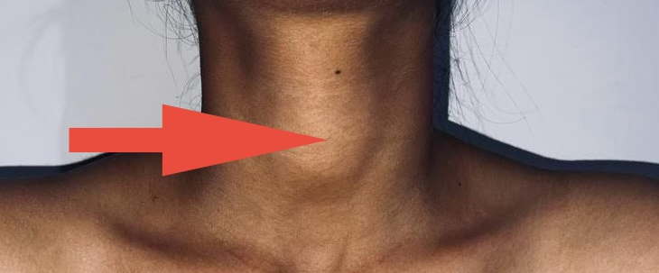
On examination of neck, a small swelling measuring about 3x2x2cm felt in midline slightly on right with smooth surface, regular border and soft in consistency, swelling was moving with deglutition but not with protrusion tongue. Overlying skin shows no scars or dilated veins. No lymph nodes were palpable.

Fig 1 : Clinical picture of patient showing neck swelling

Patient then went to consult orthopaedic doctor, who advised X-ray and Serum Calcium which showed raised total calcium (12.5mg/dL) with ionic Ca²⁺ level- 6.2mg/dL. On x-ray there was bowing of left femur seen with multiple cystic lesions in femur shaft and patella.MRI done which revealed multiple aneurysmal cysts in left femur and patella.
Parathyroid adenoma was suspected and ultrasound of neck advised. Ultrasonography of neck- showed bulky right lobe of thyroid measuring about 5x3.5x3cm -TIRADS - II lesion. Her thyroid profile were within normal limits .Parathyroid hormone levels checked which was -16,000IU.
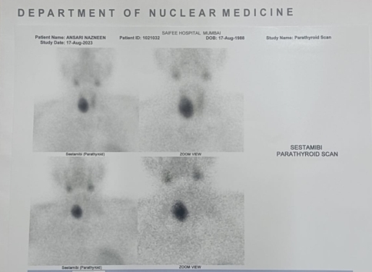
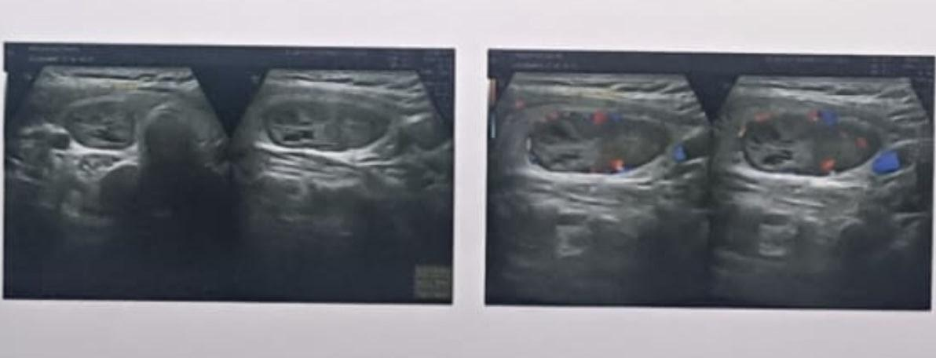
Fig 3 : Sestamibi scan showing uptake in lower part of right lobe of thyroid
Fig 2 : Ultrasonography of neck showing TIRADS II lesion

Sestamibi scan done which showed increased uptake in relation to lower pole of right lobe of thyroid gland ?parathyroid adenoma of right inferior parathyroid gland.
4D CT done suggested of hypo-dense lesion in right thyroid lobe measuring about 2.1x2.5x3.5cm- hypo-dense lesion, which shows heterogenous post contrast enhancement with few non enhancing cystic areas within.? intrathyroid parathyroid adenoma.
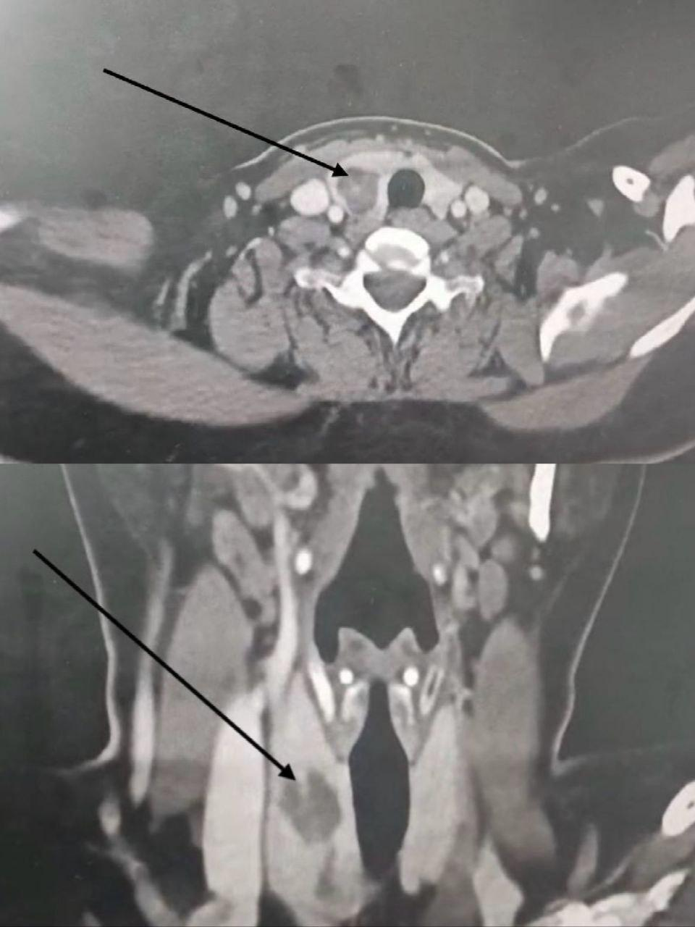
Fig 4 : 4D CT cut sections showing lesion in right lobe of thyroid

The patient is planned for excision of parathyroid adenoma..Intraoperatively right lobe of thyroid gland seems to be enlarged(6 X 4 X 3CM), soft in consistency with smooth surface and regular border. After dissecting out the right lobe and reflecting, inferior and superior parathyroid gland visualised and were not enlarged.

Decision taken to do right hemithyroidectomy.Right lobe of thyroid gland along with isthmus divided from left thyroid lobe.Superior and inferior pole identified and cut carefully after ligation with careful preservation of parathyroid glands and their vascularity.Specimen labelled and sent for HPE of fresh frozen section. After 20min of removal specimen patients venous sample sent for calcium (11.2mg) and parathyroid hormone level (64IU). Frozen section examination confirmed ectopic intrathyroid parathyroid adenoma. POD2-patient complaints of weakness and stiffness of fingers of bilateral upperlimb.On examination Chvostek’s and Trousseau’s signs positive. Repeated serum calcium -8.5mg/dl and PTH-24IU.Patient started on oral calcium supplements. Patient’s complaints resolved.
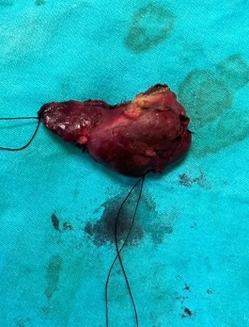

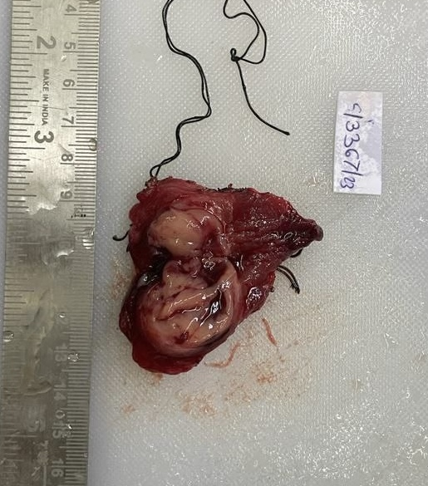

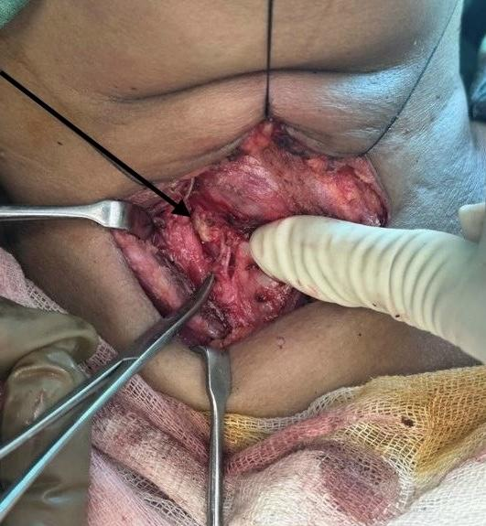
Fig 5 : Intraoperative and postoperative pictures showing enlarged right lobe of thyroid gland land

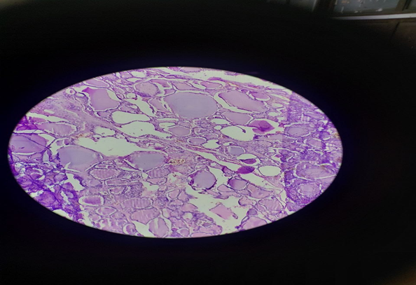
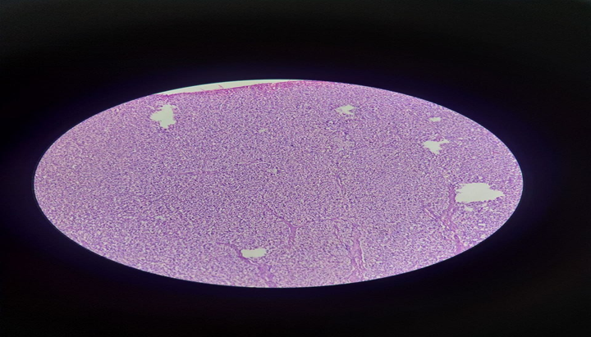
Fig 6 : Histopathology slides showing parathyroid glands in between thyroid follicles

Discussion:
The parathyroid glands were first described in 1852 by Sir Richard Owen during his examination of an Indian rhinoceros in London, where he identified a small, yellowish glandular structure attached to the thyroid¹. Later, Ivar Sandstorm established that these glands were anatomically independent of the thyroid and introduced the term “epithelkörperchen.”Until then, the parathyroid glands were believed to be part of the thyroid². The first successful isolation of an active parathyroid extract was reported by Hanson in 1923 through experiments in cattle³.
The embryological development of the thyroid and parathyroid glands plays a crucial role in determining their anatomical location and variations, which is of significant surgical importance. The parathyroid glands typically develop from the third and fourth pharyngeal pouches between the fifth and twelfth weeks of gestation⁴. The inferior parathyroid glands arise from the third pharyngeal pouch along with the thymus and descend caudally, often resulting in a more variable anatomical position. In contrast, the superior parathyroid glands originate from the fourth pouch and exhibit relatively consistent positioning. Due to this differential migration, inferior glands may be located anywhere along their descent path, whereas superior glands are usually found near the posterior aspect of the thyroid, close to the junction of the inferior thyroid artery and the recurrent laryngeal nerve.
Ectopic parathyroid glands are not uncommon, with approximately 13% of individuals exhibiting aberrant locations and about 5% having supernumerary glands. Common ectopic sites include the retro-oesophageal and para-esophageal regions (~30%), intrathyroidal location (~20%), carotid sheath (~17.5%), thyrothymic ligament (~17%), and tracheoesophageal groove (~5%)⁵. Intrathyroidal parathyroid adenomas, although rare, present a diagnostic challenge as they can mimic thyroid nodules both clinically and radiologically.
Historically, preoperative localisation studies were considered less critical than the expertise of the surgeon, as emphasised by John Doppman, who famously stated that the only localisation required was that of an experienced parathyroid surgeon⁶. However, with the evolution from conventional bilateral neck exploration to minimally invasive parathyroidectomy, accurate preoperative localisation has become essential⁷. Non-invasive imaging modalities such as neck ultrasonography and technetium-99m sestamibi scanning are commonly used as first-line investigations, although their sensitivity is limited when used independently. Advanced imaging techniques, including SPECT and SPECT/CT, as well as four-dimensional computed tomography (4D-CT), significantly enhance localisation accuracy, particularly in cases of ectopic or intrathyroidal glands⁸.
Invasive localisation techniques, including ultrasound- or CT-guided fine-needle aspiration with parathyroid hormone (PTH) assay, selective venous sampling, and parathyroid angiography, are generally reserved for recurrent or complex cases. Radio-guided minimally invasive parathyroidectomy, combined with intraoperative PTH (ioPTH) monitoring, has markedly improved surgical outcomes. A significant intraoperative decline in PTH levels confirms successful excision of the hyper-functioning gland⁹.
Parathyroidectomy remains the gold standard treatment for symptomatic primary hyperparathyroidism. Indications for surgery include nephrolithiasis, hypercalciuria, reduced renal function, osteoporosis, fragility fractures, pancreatitis, gastrointestinal manifestations, and neuropsychiatric symptoms¹⁰. Preoperative localisation facilitates targeted removal of the pathological gland while preserving normal parathyroid tissue. In cases where localisation is inconclusive, systematic intraoperative exploration should include common ectopic sites such as the tracheoesophageal groove for missing superior glands and the thymus for inferior glands.
Postoperative hypocalcemia is the most common complication, typically resulting from a sudden drop in PTH levels following gland removal. This is usually transient and can be managed with calcium and vitamin D supplementation.
A multidisciplinary approach involving radiologists, surgeons, endocrinologists, and pathologists is essential for optimal management. This collaborative strategy enhances the accuracy of localisation and excision, reduces the risk of persistent or recurrent hyperparathyroidism, and helps preserve normal parathyroid tissue, thereby minimising the likelihood of permanent hypocalcemia and lifelong dependence on supplementation
Conclusion
The diagnosis of intrathyroidal parathyroid adenoma, similar to our case report, is more difficult. Brown tumours of the long bones may commonly involve femur and tibia, rarely involve humerus in association with primary hyperparathyroidism. Ectopic parathyroid adenomas of our patient had an unusual location of this disorder. Surgery is the cornerstone of the treatment. A better chance to cure this disease is conditioned by complete surgical resection with negative margins microscopically, that was the case of our patient.
This case demonstrates that in the setting of inconclusive imaging, one’s clinical acumen, and anatomical and embryologic knowledge must be utilized in a systematic approach to identifying parathyroid adenomas. After other ectopic locations are excluded, a thyroid lobectomy should be considered to treat a completely intrathyroidal parathyroid adenoma.

Ethical issues: Written informed consent was obtained from the patient for publication of this case report and accompanying images

Disclaimer (Artificial intelligence)

Author(s) hereby declare that NO generative AI technologies such as Large Language Models (ChatGPT, COPILOT, etc.) and text-to-image generators have been used during the writing or editing of this manuscript.

References: .

1. Walker MD, Silverberg SJ. Primary hyperparathyroidism. Nat Rev Endocrinol 2018; 14:115–25. Google ScholarCrossrefPubMedWorldCat
2. Embryology,Pharyngeal Pouch.Miles B,et al.2023 Apr3.In: StatPearls [Internet]. Treasure Island (FL): StatPearls Publishing; 2023 Jan–. PMID:32491656 Free Books & Documents
3. Cakmak H, Tokat AO, Karasu S, Ozkan M. Giant mediastinal parathyroid adenoma. Tuberk Toraks 2011; 59:263–5. Google ScholarCrossrefPubMedWorldCat
4. Recurrent or persistent hyperparathyroidism.
Wells SA Jr, Debenedetti MK, Doherty GM.J Bone Miner Res. 2002 Nov;17 Suppl 2:N158-62.PMID: 12412795Review.

- 5. Preoperative localization and radioguided parathyroid surgery.
Mariani G, Gulec SA, Rubello D, Boni G, Puccini M, Pelizzo MR, Manca G, Casara D, Sotti G, Erba P, Volterrani D, Giuliano AE.J Nucl Med. 2003 Sep;44(9):1443-58.PMID: 12960191Review.

6. 1.Medvei VC. Lancaster: MTP Press Ltd; 1982. A history of endocrinology. [Google Scholar]

7.Casale J, Giwa AO. StatPearls [Internet]. StatPearls Publishing; Treasure Island (FL): Aug 8, 2023. Embryology, Branchial Arches. [PubMed]

8. Georgakopoulos B, Al Khalili Y. StatPearls [Internet]. StatPearls Publishing; Treasure Island (FL): Jul 17, 2023. Anatomy, Head and Neck, Parathyroid, Ectopic Glands. [PubMed]

9. Yeh R., Tay Y.-K.D., Tabacco G., Dercle L., Kuo J.H., Bandeira L., McManus C., Leung D.K., Lee J.A., Bilezikian J.P. Diagnostic Performance of 4D CT and Sestamibi SPECT/CT in Localizing Parathyroid Adenomas in Primary Hyperparathyroidism. Radiology. 2019;291:469–476. doi: 10.1148/radiol.2019182122. [DOI] [PMC free article] [PubMed] [Google Scholar]

10. Main Surgical Principles and Methods in Surgical Treatment of Primary Hyperparathyroidism.
Uludağ M, Aygün N, İşgör A.Sisli Etfal Hastan Tip Bul. 2019 Dec 3;53(4):337-352. doi: 10.14744/SEMB.2019.67944. eCollection 2019.PMID: 32377107Free PMC article.Review.

