Case report
Superior Iliac Hip Dislocation: A Rare Entity Case Report and Literature Review

Abstract
Background:
Superior iliac hip dislocation is an extremely rare subtype of traumatic hip dislocation. Because of its unusual presentation and mechanism, it may be difficult to diagnose, and current management principles are mainly derived from isolated case reports in the literature.
Case presentation:
We report the case of a 22-year-old man admitted to the emergency department following a high-energy road traffic accident involving a motorcycle collision with direct trauma to the right hip. Symptoms began approximately three hours before admission. Clinical examination revealed a painful fixed deformity of the right hip maintained in abduction and external rotation, with complete functional impairment. Distal neurovascular examination was normal.
Plain radiographs demonstrated a superior iliac dislocation of the right femoral head. Pelvic computed tomography demonstrated bony lesions involving the posterior and superior walls of the acetabulum, without intra-articular fragments or associated injury of the proximal femur.
Urgent closed reduction was performed under general anesthesia using longitudinal traction with the hip in slight flexion. Post-reduction radiographs confirmed a concentric reduction, and stability testing showed a stable hip up to 90° of flexion.
Conclusion:
Superior iliac hip dislocation is a rare injury that requires early diagnosis and prompt reduction. Computed tomography is essential to detect associated acetabular lesions. Long-term follow-up is recommended because of the potential risk of femoral head osteonecrosis and secondary osteoarthritis.
Keywords:
Superior iliac; Road traffic accident; Closed reduction; Hip Dislocation
Introduction
Hip dislocation is an orthopedic emergency that requires urgent reduction to prevent serious complications such as femoral head osteonecrosis and post-traumatic arthritis. It usually occurs after high-energy trauma, most commonly road traffic accidents. Posterior dislocations are the most frequent, whereas anterior dislocations are uncommon and include inferior (obturator) and superior (pubic or iliac) types.
Superior iliac hip dislocation is an exceptionally rare injury pattern and has been reported only in a limited number of cases in the literature. Because of its unusual clinical presentation and atypical radiological appearance, it may be misdiagnosed or overlooked during the initial assessment.
In this report, we present a case of superior iliac hip dislocation following high-energy trauma, highlighting its clinical and radiological characteristics, discussing potential diagnostic pitfalls, and reviewing the principles of management of this rare injury.
Case presentation
We report the case of a 22-year-old male patient admitted to the emergency department following a high-energy road traffic accident involving a motorcycle collision with a car, resulting in direct trauma to the right hip. Symptoms began approximately three hours before admission. The patient sustained a closed right hip injury resulting in a superior iliac hip dislocation, with no other clinically evident associated injuries. The patient had no relevant past medical history.
On initial assessment, the patient was alert and cooperative with a Glasgow Coma Scale score of 15/15. Hemodynamic and respiratory parameters were stable. Physical examination of the pelvis and right lower limb revealed a painful fixed deformity of the right hip maintained in abduction and external rotation, associated with complete functional impairment. No skin lesions or open wounds were noted. Distal neurovascular examination was normal, with preserved peripheral pulses and no sensory or motor deficits (Fig. 1).
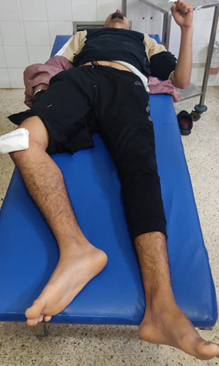
Fig.1: Pre-reduction clinical photograph showing right lower limb shortening with external rotation of the limb

Plain anteroposterior pelvic radiographs demonstrated a superior dislocation of the right femoral head, displaced superiorly and adjacent to the iliac bone, without clearly identifiable associated fractures (Fig. 2).
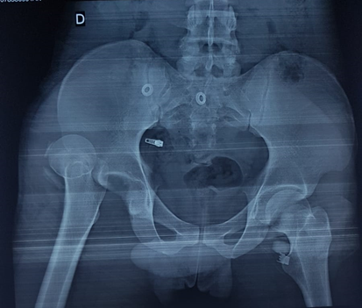
Fig.2: Radiograph showing superior dislocation of the right femoral head

After appropriate preoperative preparation, urgent closed reduction was performed under general anesthesia. The patient was placed in the supine position on a firm table. Counter-traction was applied to the pelvis while longitudinal traction was applied along the femoral axis with the hip maintained in slight flexion (approximately 30°) and the knee flexed. Reduction was achieved without difficulty, with restoration of limb length and alignment.
Following reduction, stability testing demonstrated a stable hip up to 90° of flexion without redislocation. Immediate post-reduction anteroposterior pelvic radiographs subsequently confirmed a concentric reduction of the hip joint (Fig. 3).
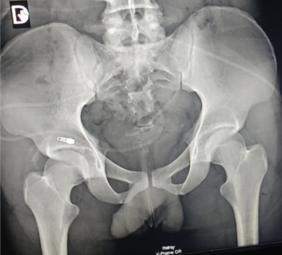
Fig.3: Post-reduction radiographic control
Pelvic computed tomography performed after reduction revealed bony lesions of the posterior and superior acetabular walls with small detached bony fragments, without intra-articular fragments or proximal femoral involvement (Fig. 4)
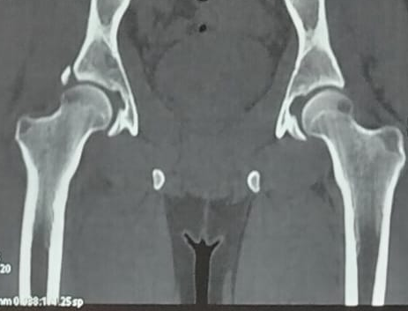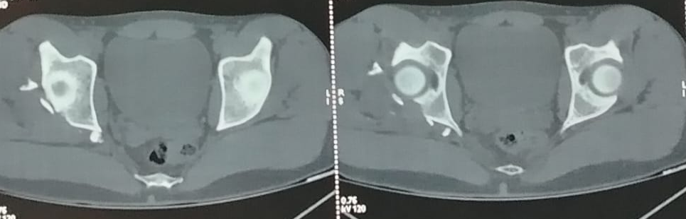
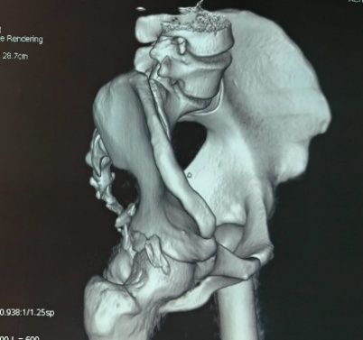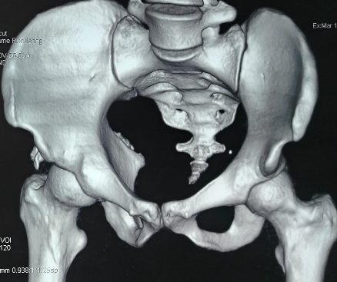
Fig.4: Pelvic CT scan demonstrating bony lesions of the posterior and superior walls of the acetabulum with small detached bony fragments, without intra-articular fragments or involvement of the proximal femur

Post-reduction management consisted of initial bed rest followed by non-weight-bearing ambulation for six weeks. Medical treatment included step II analgesics and prophylactic low-molecular-weight heparin. Clinical and radiological follow-up was planned to monitor functional recovery and to screen for potential late complications, particularly femoral head osteonecrosis and secondary osteoarthritis.
Methods
We report the case of a patient admitted to our emergency department following high-energy trauma, who was subsequently diagnosed with a superior iliac hip dislocation. The patient was managed in a specialized orthopedic trauma unit.
Initial assessment included a thorough clinical examination and standard pelvic radiographs, which established the diagnosis of hip dislocation. Urgent closed reduction was performed under general anesthesia according to institutional trauma protocols.
Post-reduction radiographs were obtained to confirm concentric reduction of the femoral head. Pelvic computed tomography was subsequently performed after reduction to evaluate the acetabulum, detect possible associated bony lesions, and exclude intra-articular fragments.
The patient underwent clinical and radiological follow-up to assess functional recovery and to monitor for potential late complications, particularly avascular necrosis of the femoral head and secondary osteoarthritis.
DISCUSSION
Superior iliac hip dislocation represents an exceptionally rare subtype of traumatic hip dislocation. In contrast to posterior dislocations, which account for nearly 85–90% of traumatic hip dislocations, superior displacement of the femoral head toward the iliac wing is only rarely reported in clinical practice. Because of its rarity, the current literature consists mainly of isolated case reports and small case series, limiting the establishment of standardized treatment guidelines and reliable prognostic data. Recent reports by Mourya et al. and radiologic observations by Jia and Crim further confirmed the exceptional incidence of anterior-superior variants among all hip dislocations. (1–4)
The diagnosis may be challenging in emergency settings because this injury can be mistaken for the more common posterior dislocation. Careful clinical examination therefore remains essential. In our patient, the affected limb was held in abduction and external rotation with complete functional impairment, findings consistent with an anterior or superior displacement mechanism. This differs from the classic posture of posterior dislocation, which usually combines flexion, adduction, and internal rotation. Graber et al. emphasized that anterior hip dislocations classically present with abduction and external rotation deformity. (2,5)
Plain radiographs usually provide rapid diagnosis and remain the first-line imaging modality in the acute setting. In our case, anteroposterior pelvic radiographs demonstrated superior displacement of the femoral head adjacent to the iliac wing, confirming the diagnosis. However, plain radiographs may underestimate associated osteochondral or acetabular injuries. For this reason, computed tomography is strongly recommended after reduction to evaluate joint congruency, identify occult fractures, and detect intra-articular fragments. Jia and Crim highlighted the important contribution of CT in accurately characterizing rare anterior-superior dislocations and associated lesions. (4,5,6)
Post-reduction pelvic CT in our patient revealed fractures of the posterior and superior acetabular walls with small detached bony fragments, without proximal femoral injury or intra-articular incarceration. These findings illustrate the importance of systematic cross-sectional imaging following hip dislocation. Similar fracture-associated patterns have been described in previous reports. Jindal and Sankhala reported a superior hip dislocation associated with an anterior column acetabular fracture that required open reduction and internal fixation using a twin-incision technique. (3)
Traumatic hip dislocation usually results from high-energy trauma, most commonly road traffic accidents. In the present case, a motorcycle collision with direct impact to the right hip was the probable mechanism. Superior iliac dislocation is thought to occur through a combination of forced abduction, external rotation, and axial loading, causing superior and lateral displacement of the femoral head toward the iliac wing. Comparable mechanisms have been suggested in previously published cases. (1,3,5)
Urgent reduction remains the cornerstone of treatment for all traumatic hip dislocations. Delayed reduction has consistently been associated with a higher risk of femoral head osteonecrosis and poorer functional outcomes. Most authors recommend reduction as early as possible, ideally within six hours after injury whenever feasible. In our patient, reduction was achieved within the early hours following trauma, which constitutes a favorable prognostic factor regarding preservation of femoral head vascularity. (2,5,7,8)
Closed reduction under general anesthesia remains the preferred first-line treatment when the dislocation is reducible and no major fracture requires fixation. In our patient, reduction was successfully obtained using longitudinal traction along the femoral axis with pelvic counter-traction while maintaining slight hip flexion. This maneuver allowed atraumatic concentric reduction while minimizing the risk of iatrogenic chondral or osseous damage. Open reduction should be reserved for irreducible dislocations, incarcerated osteochondral fragments, unstable reductions, or associated fracture-dislocations. Cases such as that reported by Jindal et al. demonstrate that surgical fixation may be necessary when acetabular fractures coexist. (3,5,7)
Following reduction, our patient demonstrated a stable hip up to 90° of flexion without redislocation, and post-reduction radiographs confirmed concentric reduction. These findings supported conservative post-reduction management.
Despite successful reduction, traumatic hip dislocation may be associated with substantial soft tissue injury, including capsular disruption, labral tears, and rupture of the ligamentum teres. Such lesions may contribute to persistent pain, instability, or secondary degenerative changes. MRI may therefore be useful in selected patients presenting with persistent pain or mechanical symptoms during follow-up. (6,9)
Post-reduction protocols remain debated. Historically, prolonged traction and immobilization were frequently recommended. However, contemporary evidence suggests that routine traction after uncomplicated hip dislocation may not provide additional benefit compared with progressive mobilization and protected weight-bearing. In our patient, treatment consisted of initial bed rest followed by non-weight-bearing ambulation for six weeks, allowing soft tissue recovery after high-energy trauma. Thromboprophylaxis with low-molecular-weight heparin was also administered because of temporary immobilization and increased venous thromboembolism risk. (7,10)
The most feared long-term complications remain avascular necrosis of the femoral head and post-traumatic osteoarthritis, which may occur even after apparently successful early reduction. Recurrent instability and chronic pain are less common but clinically relevant sequelae. These risks justify prolonged clinical and radiological surveillance. In our patient, early reduction represents a favorable prognostic factor, although continued follow-up remains mandatory. (2,5,7,8)
Given the extreme rarity of superior iliac hip dislocation, each additional case contributes valuable information regarding mechanism of injury, imaging findings, reduction techniques, and outcomes. Further accumulation of cases and multicenter analyses are needed to improve understanding of this uncommon entity and help establish evidence-based management recommendations. (1,3,4)
Conclusion
Superior iliac hip dislocation is an exceptionally rare injury pattern and remains a diagnostic and therapeutic challenge in emergency trauma care. Our case highlights the importance of early recognition based on careful clinical assessment and prompt radiological evaluation to avoid misdiagnosis and delayed management.
Urgent closed reduction under general anesthesia remains the cornerstone of treatment and can achieve satisfactory joint reduction and stability in most cases. Post-reduction computed tomography is essential to identify associated acetabular lesions that may not be visible on plain radiographs.
Despite successful reduction and an initially stable hip joint, long-term clinical and radiological follow-up is mandatory because of the potential risk of late complications, particularly femoral head osteonecrosis and secondary osteoarthritis. Reporting such rare cases contributes to improving the understanding of this uncommon injury and may help guide future management strategies.

Data availability statement
The data generated or analyzed during this study are available from the corresponding author upon request.
Ethical approval
NA
Informed consent
Written informed consent was obtained from the patient for this case report and accompanying images.
Conflicts of interest
The authors declare no conflict of interest.

Disclaimer (Artificial intelligence)

Author(s) hereby declare that NO generative AI technologies such as Large Language Models (ChatGPT, COPILOT, etc.) and text-to-image generators have been used during the writing or editing of this manuscript.
Author contributions
ACHRAF LAHJOUJI: patient management, data collection, manuscript writing and revision.
All authors contributed equally to the preparation of this case report.

References
- Mourya P, Adhikari N, Dharmshaktu G. Superior iliac hip dislocation: A rare injury and literature review. J Orthop Spine. 2020;8(2):123-125. doi:10.4103/JOASP.JOASP_12_20.
- Graber M, Marino DV, Johnson DE. Anterior Hip Dislocation. In: StatPearls [Internet]. Treasure Island (FL): StatPearls Publishing; Updated 2023 Jul 25. Available from: https://www.ncbi.nlm.nih.gov/books/NBK507814/
- Jindal N, Sankhala SS. Superior dislocation hip with anterior column acetabular fracture - open reduction and internal fixation using a twin incision technique. Pan Afr Med J. 2012;12:41.
- Jia C, Crim J. Understanding a Rare Injury: An Observational Study of Anterior-Superior Hip Dislocations. AJR Am J Roentgenol. 2020;214(3):624-629. doi:10.2214/AJR.19.22122.
- Dawson-Amoah K, Raszewski J, Duplantier N, Waddell BS. Dislocation of the hip: a review of types, causes, and treatment. Ochsner J. 2018;18(3):242-252.
- Funk FJ, Srinivasan A, Crim J. Traumatic anterior hip dislocation: imaging and management update. Emerg Radiol. 2021;28:755-762.
- Kellam P, Ostrum RF. Hip dislocation: current treatment regimens. J Am Acad Orthop Surg. 2016;24(10):e95-e105.
- Hougaard K, Thomsen PB. Traumatic posterior dislocation of the hip. Prognostic factors influencing the incidence of avascular necrosis. Arch Orthop Trauma Surg. 1986;106:32-35.
- Sahin V, Karakas ES, Aksu S, Atlihan D, Turk CY, Halici M. Traumatic dislocation and fracture-dislocation of the hip: long-term follow-up. J Trauma. 2003;54:520-529.
- Mehlman CT, Hubbard GW, Crawford AH, Roy DR, Wall EJ. Traumatic hip dislocation in children and adolescents: long-term follow-up. Clin Orthop Relat Res. 2000;376:68-79.

