Case report
Primary Central Nervous System Lymphoma Presenting As A Space-Occupying Lesion: A Case Report

.

ABSTRACT

Primary central nervous system lymphoma (PCNSL) is an aggressive and rare subtype of diffuse large B-cell lymphoma, which is specifically confined to the central nervous system (CNS). As a mature B-cell neoplasm, PCNSL's unique features often result in nonspecific clinical presentations, making diagnosis challenging. Here, we present a case of a 62-year-old woman who presented with a 1-week history of right-sided body weakness, altered behaviour, incoherent speech, and facial asymmetry. A Computed Tomography (CT) scan of the brain revealed a space-occupying lesion in the frontoparietal region with associated mass effect and midline shift. The patient underwent an emergency craniotomy with tumour resection, after which she made a good recovery and was discharged home a few days later. Histopathological examination confirmed the diagnosis of primary CNS diffuse large B-cell lymphoma. This case highlights the diagnostic and management challenges associated with PCNSL, which will be discussed in detail.

Keywords: Primary central nervous system lymphoma; Diffuse large B-cell lymphoma; Central nervous system; Brain tumour; Chemotherapy

INTRODUCTION

Lymphoma involving the central nervous system (CNS), whether primary or secondary in origin, constitutes a rare yet highly aggressive subset of extra-nodal non-Hodgkin lymphoma (NHL), accounting for approximately 2.2% of all CNS tumours [1]. Primary central nervous system lymphoma (PCNSL) may arise at any location along the neuraxis, encompassing the orbits, dura mater, leptomeninges, brain parenchyma, cranial nerves, and spinal cord. In contrast, secondary CNS lymphoma refers to systemic NHL that has subsequently disseminated to involve the CNS [2].

Histopathologically, diffuse large B-cell lymphoma (DLBCL) represents the predominant subtype of PCNSL, comprising nearly 95% of cases. This form is most commonly localised within the brain parenchyma, although involvement of other CNS compartments, as noted above, is also well documented. The remaining approximately 5% of cases include less common histological variants such as T-cell lymphomas, Burkitt lymphoma, lymphoblastic lymphoma, and marginal zone lymphomas [3].
PCNSL occurs in both immunocompetent and immunodeficient patients and are more associated with leptomeningeal involvement. Hence primary/congenital and acquired immunodeficiency (particularly HIV and post-transplant conditions) are an important risk factor for PCNSL.^{[2][3]} Patients typically present with an intracranial mass lesion, with a combination of generalized symptoms including increased intracranial pressure associated with non-specific such as headache, cognitive decline, confusion, behavioural disruption, lethargy and lateralizing deficits such as hemiparesis, hemisensory loss or ataxia. However, systemic symptoms such as fever of unknown origin, night sweats and weight loss which are a common presentation in systemic lymphoma may not be present in PCNSL.^{[3][4]} Furthermore, leptomeningeal disease may cause cranial neuropathies or symptoms localizing to the cauda equina presenting as urinary retention or saddle anaesthesia. Direct nerve invasion can cause a painful radiculopathy. Ocular involvement may happen in as many as 25% of patients and they may present with report of frank visual deficit.^{[2]}

Following these symptoms, further evaluation would follow by neuroimaging, either with MRI or CT scan. Once diagnosis is made, treatment of PCNSL may include surgery, chemotherapy and radiotherapy. In some cases, a combination of corticosteroids, chemotherapy and radiotherapy may be curative or provide long-lasting palliation for patients in good clinical condition.^{[5]} The prognosis of PCNSL remains poor despite evolvement of treatment options. Median survival described between 17-45 months after symptomatic treatment.^{[6]} This case report reviews the presentation, diagnosis, treatment, and prognosis of PCNSL, contributing to the growing body of literature on this challenging disease.

CASE PRESENTATION

We report a case of a 62-year-old lady with no known medical illness previously. She presented with right sided body weakness for a week and associated with altered behaviour, incoherent speech and facial asymmetry. She denied headache, nausea, vomiting, trauma, unsteady gait or seizures. Clinical examination noted she is alert with Glasgow coma scale (GCS) was 15 and pupils 3mm bilaterally reactive. There was presence of weakness of her right side of body with muscle power of 4 out of 5. CT brain was done for her which showed a left frontoparietal space occupying lesion with perilesional oedema and midline shift and mass effect.

OPERATIVE FINDINGS

She was admitted and underwent emergency surgery craniotomy and tumour excision. Intraoperatively the tumour size was 4x3cm, appeared pale and highly vascular, and was completely excised. Otherwise, the surrounding brain parenchyma was pulsatile.

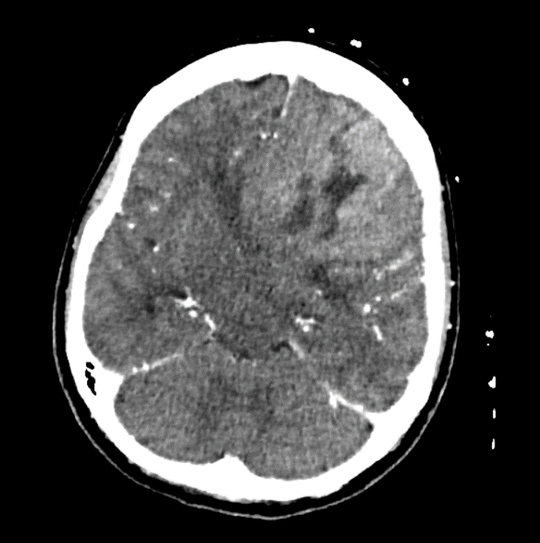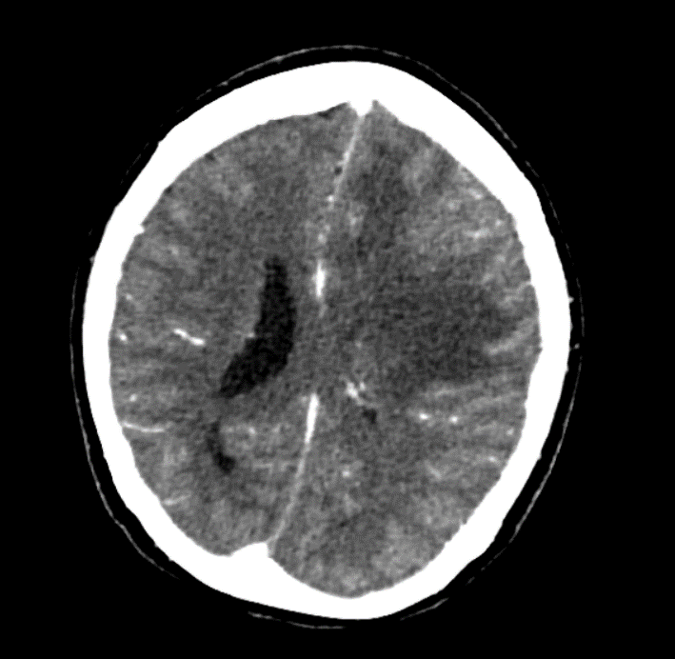
Figure 1: CT contrast showed isodense mass at left frontal lobe which appears intra-axial and demonstrate enhancement. Within the lesions, there are areas of hypodensities likely necrosis. No calcification noted. There is associated cerebral oedema, mass effect, midline shift and obstructive hydrocephalus, suspicious of primary brain tumour with differential of glioma.

TREATMENT AND FOLLOW-UP

Post operatively, she has good recovery. GCS remains full with slight improvement of power over her right side of body. CT brain post operatively showed improving midline shift. She was allowed discharge with dexamethasone on a tapering dosage. In clinic review she has much improved recovery, ambulating without aid or assistance and no residual neurological deficit. Histopathological examination confirmed diffuse large B-cell lymphoma. Immunohistochemical stains showed that the tumour cells are positive for CD20, BCL-6, MUM-1and BCL2; negative for CKAE1/AE3, GFAP, CD3, CD10 (<30%) and C-MYC; Ki-67 proliferation index high ~90%. She was then referred to haematology team for further management. Evaluation by haematology team, proceeded with pre-chemo workup and PET CT and bone marrow aspiration and trephine biopsy (BMAT). Results of BMAT showed no lymphomatous infiltration. PET scan showed hypermetabolic area involving residual left frontal lobe and left parietal lobe causing midline shift, no FDG avid disease elsewhere. She was then started on her first cycle of chemotherapy with rituximab, methotrexate, procarbazine, and vincristine (R-MPV). She showed marked improvement after the first cycle of chemotherapy and was continued on subsequent cycles with intrathecal therapy.

During follow up, she underwent MRI brain after the first chemotherapy, which showed left enhancing solid component within the surgical cavity measuring 3.4x3.2x4.0cm which demonstrated T2W/FLAIR hyperintense signal with patchy enhancement at the posterior aspect of the lesion, suggesting residual tumour. She was then continued on for further chemotherapy cycle.
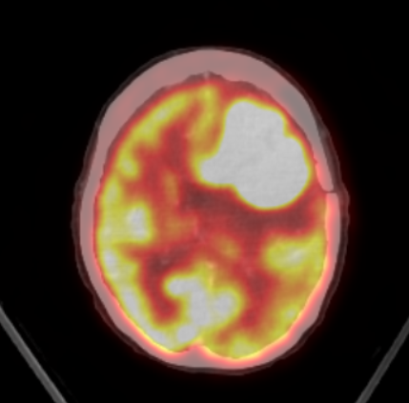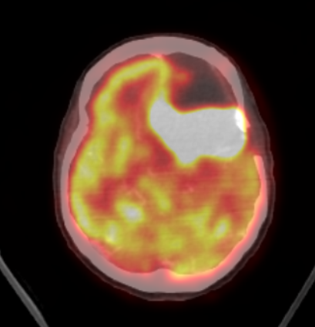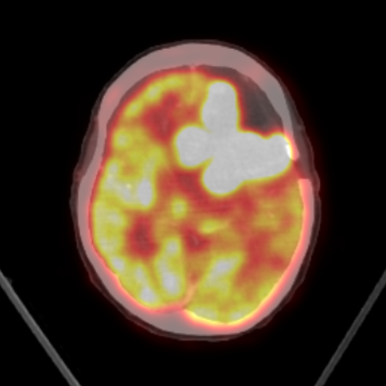
Figure 2: post-operative PET scan showed hypermetabolic area involving residual left frontal lobe and left parietal lobe causing midline shift

DISCUSSION

Primary central nervous system lymphoma (PCNSL), most commonly of the diffuse large B-cell lymphoma (DLBCL) subtype, is an exceedingly rare neoplasm characterised by highly aggressive clinical behaviour. Its clinical and radiological presentation may closely resemble other intracranial tumours, such as gliomas or metastatic lesions, thereby posing significant challenges to early and accurate diagnosis.

Although PCNSL has historically been associated with immunocompromised states, an increasing incidence has been reported among immunocompetent individuals. In the present case, the patient did not exhibit any evidence of underlying immunodeficiency. Epidemiological studies indicate that, in immunocompetent populations, the median age at diagnosis ranges between 53 and 57 years, with a slight male predominance (male-to-female ratio of approximately 1.2:1). In contrast, among immunocompromised patients, PCNSL tends to occur at a younger median age of 31–35 years and demonstrates a markedly higher male predominance, with a reported male-to-female ratio of 7.38:1 [6].
The diagnosis of primary central nervous system lymphoma (PCNSL) requires a comprehensive integration of clinical presentation, radiological assessment, and histopathological confirmation through tissue biopsy [7]. As clinical manifestations are often non-specific and insufficient for definitive diagnosis, the identification of a radiologically evident lesion is crucial to facilitate timely brain biopsy and accurate histological evaluation.

Computed tomography (CT) and magnetic resonance imaging (MRI) are typically employed as initial imaging modalities. On unenhanced CT, PCNSL lesions generally appear hyperattenuated or isoattenuated, whereas contrast-enhanced CT often demonstrates homogeneously enhancing lesions, frequently located in periventricular regions and characteristically lacking central necrosis, resulting in diffuse enhancement patterns. The degree of surrounding oedema is variable. Lesions are solitary in approximately 60–70% of patients, while the remainder present with multiple lesions; notably, multiple lesions are more commonly observed in immunocompromised individuals at the time of diagnosis.

Magnetic resonance imaging is considered superior and represents the imaging modality of choice. However, conventional MRI findings may not reliably distinguish PCNSL from other intracranial pathologies, including metastatic tumours, high-grade gliomas, meningiomas, or non-neoplastic conditions such as multiple sclerosis, cerebrovascular accidents, and pyogenic abscesses, as these entities may also exhibit marked contrast enhancement on both CT and MRI [8].

Advanced imaging techniques, particularly contrast-enhanced MRI with perfusion-weighted imaging using gadolinium, provide improved diagnostic accuracy and are therefore preferred. Radiologically, PCNSL most commonly presents as a single lesion, often located within the cerebral hemispheres, basal ganglia, corpus callosum, or periventricular regions (approximately 66% of cases), with a predominance in supratentorial locations (87%) and the frontoparietal lobes (39%). Less commonly, involvement may extend to the eyes (15–25%) and cerebrospinal fluid (7–42%), while spinal cord involvement remains rare. Additionally, functional imaging modalities such as fluorodeoxyglucose positron emission tomography (FDG-PET) may further assist in differentiating PCNSL from other intracranial lesions [8].

In the present case, a postoperative positron emission tomography (PET) scan demonstrated a hypermetabolic focus involving the residual left frontal and left parietal lobes, accompanied by a midline shift. Importantly, no additional areas of significant hypermetabolic activity were identified elsewhere, thereby reducing the likelihood of systemic dissemination or distant metastasis.

In typical primary central nervous system lymphoma (PCNSL), PET imaging characteristically reveals a markedly increased and relatively homogeneous uptake of ^18F-fluorodeoxyglucose (FDG), predominantly within subcortical regions. This hypermetabolic pattern is often accentuated on visual analysis due to the relative hypometabolism observed in the surrounding cortex, which may result from tumour-induced compression or associated oedema. Notably, similar metabolic patterns may also be observed in cases of disease recurrence.

Beyond its diagnostic utility, FDG-PET plays a critical role in both the initial staging and subsequent follow-up of PCNSL. It offers greater sensitivity than conventional imaging modalities for detecting occult systemic involvement and is particularly valuable in excluding systemic non-Hodgkin lymphoma at the time of presentation [1]. In this context, a study by Mohile et al. reported that approximately 7% of patients with presumed PCNSL were subsequently found to have systemic non-Hodgkin lymphoma on whole-body FDG-PET, despite negative findings on computed tomography and bone marrow biopsy [9]. Furthermore, FDG-PET has demonstrated utility in restaging, with positive findings in approximately 27% of patients evaluated for suspected disease recurrence.

However, interpretation of PET findings in the CNS can be challenging due to the inherently high physiological FDG uptake in regions such as the basal ganglia, cerebral cortex, and thalamus, which may obscure or mimic pathological activity. Consequently, despite the significant advances in imaging techniques, histopathological confirmation through tissue diagnosis remains the gold standard for definitive diagnosis [1,3].
Tissue diagnosis can be obtained either through biopsy or through surgical resection. Studies compare the outcomes of surgical resection vs biopsy. From a systematic review by Chojak et al noted there are few studies that indicate surgical resection may improve overall survival and progression free survival, while other studies found that no significant difference between resection and biopsy.^{[10]} Especially if the patients are over 70, with multiple or deep-seated lesions, or with low Karnofsky Performance Status (KPS). On the contrary, study by Schellekes et al. found that patients under 70 with superficially located single lesions and a postoperative KPS >70 benefited significantly from resection.^{[11]} Often, patients selected for biopsy are those that have multiple or deep-seated lesions; they are older and not fit for surgery.^{[10]} In a separate study, surgical resection is important for management of PCNSL especially when in combination with chemotherapy and radiotherapy.^{[6]} Complications from both either surgical resection and biopsy includes surgical site infection, meningitis, cerebrospinal fluid leak, intracranial bleeding, seizure, focal deficit and brain infarction. In a study by Morell et al, showed that biopsy have low rate of complications.^{[12]} On the other hand, study by Chojak et al showed there are no significant difference of complications between surgery and biopsy.^{[10]}
Primary central nervous system lymphoma (PCNSL) is highly sensitive to both chemotherapy and radiation, which can improve patient survival. High-dose methotrexate (HD-MTX)-based chemotherapy is the recommended first-line treatment.^{[10][13]} However, while effective, relapse is common. Up to half of patients may have relapse and 10% to 15% have primary refractory disease.^{[14]} In our case, haematology team started her on a chemotherapy regimen of rituximab, methotrexate, procarbazine, and vincristine (R-MPV). In a trial involving treatment with R-MPV, there is a complete response rate of 47-79% in patient receiving 5-7 cycles of chemotherapy respectively.^{[1]} Standard treatments for other lymphomas, like diffuse large B-cell lymphoma (DLBCL), are ineffective for PCNSL due to poor penetration across the blood-brain barrier (BBB).^{[14]} Some studies report a 90% response rate and a median survival of 60 months with combinations like HD-MTX and procarbazine. Meanwhile, temozolomide, which crosses the BBB, has also shown effectiveness and may be used in refractory cases.^{[6]} Stem cell transplant (ASCT) can help address chemoresistance and in cases of relapse or refractory.^{[13][14]} As for radiation therapy, whole brain irradiation of 40–50 Gy followed by localized irradiation of 60 Gy on regions of oedema is recommended as the best regimen.^{[6]} Previously whole-brain radiotherapy (WBRT) has been used to treat newly diagnosed PCNSL. Overall response rates (ORRs) reached 90%, but overall survival (OS) was limited to 12 to 18 months. When it is added to the HD-MTX treatment, it enhanced and prolonged survival in PCNSL.^{[14]}

LIMITATION

This case report is limited by its single-patient design and short follow-up period, which restrict generalizability and long-term outcome assessment. In addition to this, we did not proceed with any molecular studies which may be valuable in providing further prognostic insights.

Conclusion

In conclusion, primary central nervous system lymphoma (PCNSL) is a rare but aggressive form of diffuse large B-cell lymphoma, with a challenging diagnosis due to its nonspecific clinical presentation. While advancements in neuroimaging, biopsy techniques, and treatments, including chemotherapy and radiotherapy, have improved management, PCNSL remains a difficult disease to treat, especially due to frequent relapses and its resistance to conventional systemic therapies. This case underscores the importance of early diagnosis and a multidisciplinary approach to optimize outcomes, though the prognosis for PCNSL continues to be poor despite evolving therapeutic options.

Consent
As per international standards or university standards, patient(s) written consent has been collected and preserved by the author(s).

DISCLAIMER (Artificial intelligence)

Author(s) hereby declare that NO generative AI technologies such as Large Language Models (ChatGPT, COPILOT, etc.) and text-to-image generators have been used during the writing or editing of this manuscript.

References

- Phillips, E. H., Fox, C. P., & Cwynarski, K. (2014). Primary CNS Lymphoma. Current Hematologic Malignancy Reports, 9(3), 243–253. doi:10.1007/s11899-014-0217-2
- Green K, Munakomi S, Hogg JP. Central Nervous System Lymphoma. [Updated 2024 May 28]. In: StatPearls [Internet]. Treasure Island (FL): StatPearls Publishing; 2024 Jan-. Available from: https://www.ncbi.nlm.nih.gov/books/NBK545145/
- Chiavazza C, Pellerino A, Ferrio F, Cistaro A, Soffietti R, Rudà R. Primary CNS Lymphomas: Challenges in Diagnosis and Monitoring. Biomed Res Int. 2018 Jun 21;2018:3606970. doi: 10.1155/2018/3606970. PMID: 30035121; PMCID: PMC6033255.
- Deckert M, Engert A, Brück W, Ferreri AJ, Finke J, Illerhaus G, Klapper W, Korfel A, Küppers R, Maarouf M, Montesinos-Rongen M, Paulus W, Schlegel U, Lassmann H, Wiestler OD, Siebert R, DeAngelis LM. Modern concepts in the biology, diagnosis, differential diagnosis and treatment of primary central nervous system lymphoma. Leukemia. 2011 Dec;25(12):1797-807. doi: 10.1038/leu.2011.169. Epub 2011 Aug 5. PMID: 21818113.
- Van Westrhenen A, Smidt LCA, Seute T, Nierkens S, Stork ACJ, Minnema MC, Snijders TJ. Diagnostic markers for CNS lymphoma in blood and cerebrospinal fluid: a systematic review. Br J Haematol. 2018 Aug;182(3):384-403. doi: 10.1111/bjh.15410. Epub 2018 May 29. PMID: 29808930; PMCID: PMC6099264.
- Chen D, Gu W, Li W, Liu X, Yang X. Primary diffuse large B-cell lymphoma of the central nervous system: A case report and literature review. Oncol Lett. 2016 May;11(5):3085-3090. doi: 10.3892/ol.2016.4365. Epub 2016 Mar 22. PMID: 27123068; PMCID: PMC4840863.
- Mandal S, Shah S, Gami S, Ray B, Poulose J. A Case Report on Primary Central Nervous System Lymphoma in Immunocompetent Individual. Cureus. 2021 Jun 28;13(6):e15990. doi: 10.7759/cureus.15990. PMID: 34336481; PMCID: PMC8318614.
- Haldorsen, I. S., Kråkenes, J., Krossnes, B. K., Mella, O., & Espeland, A. (2009). CT and MR Imaging Features of Primary Central Nervous System Lymphoma in Norway, 1989–2003. American Journal of Neuroradiology, 30(4), 744–751. doi:10.3174/ajnr.a1447
- Mohile NA, Deangelis LM, Abrey LE. The utility of body FDG PET in staging primary central nervous system lymphoma. Neuro Oncol. 2008 Apr;10(2):223-8. doi: 10.1215/15228517-2007-061. Epub 2008 Feb 20. PMID: 18287338; PMCID: PMC2613825.
- Chojak R, Koźba-Gosztyła M, Polańska K, Rojek M, Chojko A, Bogacz R, Skorupa N, Więcław J, Czapiga B. Surgical resection versus biopsy in the treatment of primary central nervous system lymphoma: a systematic review and meta-analysis. J Neurooncol. 2022 Dec;160(3):753-761. doi:
- Schellekes N, Barbotti A, Abramov Y, Sitt R, Di Meco F, Ram Z, Grossman R. Resection of primary central nervous system lymphoma: impact of patient selection on overall survival. J Neurosurg. 2021 Feb 26;135(4):1016-1025. doi: 10.3171/2020.9.JNS201980. PMID: 33636699.
- Morell AA, Shah AH, Cavallo C, Eichberg DG, Sarkiss CA, Benveniste R, Ivan ME, Komotar RJ. Diagnosis of primary central nervous system lymphoma: a systematic review of the utility of CSF screening and the role of early brain biopsy. Neurooncol Pract. 2019 Dec;6(6):415-423. doi: 10.1093/nop/npz015. Epub 2019 Apr 27. PMID: 31832211; PMCID: PMC6899047.
- Steffanoni S, Calimeri T, Marktel S, Nitti R, Foppoli M, Ferreri AJM. Diagnosis and Treatment Using Autologous Stem-Cell Transplantation in Primary Central Nervous System Lymphoma: A Systematic Review. Cancers (Basel). 2023 Jan 15;15(2):526. doi: 10.3390/cancers15020526. PMID: 36672475; PMCID: PMC9856418.
- Grommes C, DeAngelis LM. Primary CNS Lymphoma. J Clin Oncol. 2017 Jul 20;35(21):2410-2418. doi: 10.1200/JCO.2017.72.7602. Epub 2017 Jun 22. PMID: 28640701; PMCID: PMC5516483.

