LIMB RECONSTRUCTION SYSTEM IN THE PRIMARY MANAGEMENT OF OPEN SEGMENTAL TIBIAL SHAFT FRACTURE : A CASE REPORT

ABSTRACT
Background: An open segmental shaft fracture is one of the most complex types of orthopedic injuries, usually caused by high-energy trauma and associated with soft tissue damage, compromised vascularity, and a high risk of infection and non-union. Achieving stable fixation remains a significant challenge. The Limb Reconstruction System (LRS) is based on the principles of biological fixation and distraction osteogenesis and provides a minimally invasive option that allows stable fixation, effective wound management, and early mobilization.
CASE PRESENTATION : A 23-year-old male patient presented with an open segmental fracture of the right tibial shaft following a road traffic accident. Clinical findings revealed an anteromedial open wound with exposed bone and soft tissue contamination. Radiographs confirmed a segmental tibial fracture with an associated fibular fracture (Gustilo-Anderson Type IIIA).
MANAGEMENT : Initial management included resuscitation, intravenous antibiotics, and tetanus prophylaxis, followed by urgent surgical intervention. Thorough wound debridement was performed, and stabilization was achieved using LRS fixation. Early mobilization and weight-bearing were initiated. Follow-up showed progressive healing, with complete radiological union at one year. The patient achieved excellent recovery with full range of motion of the knee and ankle and no complications such as infection, pin tract issues, non-union, or limb length discrepancy.
RESULT :The Limb Reconstruction System is a safe and effective modality for managing complex open segmental tibial fractures. It provides stable fixation, preserves the biological environment, enables early rehabilitation, and results in excellent functional and radiological outcomes with minimal complications. It can be considered a preferred alternative in the management of high-risk fractures.
Keywords: Limb Reconstruction System,Tibial Shaft, Trauma Surgery, Fracture

INTRODUCTION
Tibial shaft fracture is the most common long bone fracture, (Sharr PJ,et al.2014) making them one of the most frequent long bone injuries encountered in orthopedic treatment, because the tibia is located subcutaneously(Shen M et al 2024), especially in the anteromedial surfaces, these fractures are linked to open injuries(Cannada LK et al 2008). Due to inadequate soft tissue covering, impaired vascularity, and a significantly higher risk of infection and nonunion, open or complex tibial fractures provide substantial therapeutic problems.(Templeman DC et al 2009)

A more severe category of these injuries are segmental tibial fractures, which are characterized by multiple fractures located within the same bone and are frequently brought on by severe trauma like auto accidents.(Corey RM et al 2018) These fractures are linked to significant soft tissue injury, instability, and challenges in attaining the best possible fracture healing. In these situations, it may not always be appropriate to use traditional fixation techniques such plating or intramedullary nailing, particularly if there is soft tissue loss and an infection risk.(Shen M et al 2024)

Based on the concepts of compression distraction histogenesis and distraction osteogenesis, the limb reconstruction system is a flexible external fixation tool that will result in stable fixation while maintaining the biological milieu of the fracture site(UIKEY et al 2022). Effective wound care, early mobilization, and weight bearing are all made possible by the Limb Reconstruction System, which enhances functional results and lowers problems.(Mylsamy et al 2025)

In this case study a young male had a complex segmental tibial shift fracture that was treated with LRS fixation. The purpose of the paper is to demonstrate the clinical efficacy of this method in attaining fracture union, preserving limb length, and minimally complicating the restoration of mobility.

CASE PRESENTATION

A 23-year-old male patient came to the hospital with the complaints of severe pain, swelling, and bleeding from his right leg due to a road traffic accident. The injury was sustained due to high velocity trauma, and the patient was brought to the emergency department shortly after the incident. (Figure 1)
On initial examination, the patient was conscious and oriented and was hemodynamically stable. Local examination of the right leg revealed an open wound over the anteromedial aspect of the tibia with active bleeding and a visible bone fragment. (Figure 1). There was a soft tissue injury with contamination of the wound. The affected limb was tender with abnormal mobility and crepitus on the fracture site. Distal neurovascular status was intact, with palpable dorsal is pedis and posterior tibial pulses and no sensory and motor deficit.
The injury was provisionally diagnosed as an open segmental fracture of the tibial shaft with an associated fibular fracture; based upon the clinical findings, it was categorized under the Gustilo-Anderson classification (Type IIIA).
Radiographic evaluation of the anteroposterior and lateral views of the leg confirmed a segmental fracture of the tibia shaft with a fracture of the fibula (Figure 2) with no additional injuries of the skeleton identified. Emergency management was initiated as per advanced Trauma Life Support protocol. The patient received intravenous fluid, IV Ceftriaxone, and tetanus prophylaxis. Urgent surgical intervention was planned.
Under anesthesia, wound debridement was performed using a copious amount of normal saline to remove devitalized tissue and other contamination. after adequate debridement. An LRS fixator was applied, and care was taken to place the pins away from the zone of injury to allow for proper wound care and to prevent risk of infection. The fixator was applied to achieve optimal alignment and stability, and after the compression was applied at the fracture site to reduce the fracture gap.Soft tissue management was carried out meticulously, considering the high risk of infection associated with open fractures. Thorough surgical debridement was performed to remove all devitalized and contaminated tissue, followed by copious irrigation. The wound was carefully assessed, and viable soft tissue was preserved to maintain vascularity. Appropriate sterile dressings were applied, and regular wound inspections were conducted to monitor healing. The use of external fixation facilitated easy access to the wound for ongoing care and helped in preventing further soft tissue compromise. Adequate soft tissue management played a crucial role in preventing infection and promoting successful fracture healing.
Postoperative radiography shows proper alignment and fixation with the LSR external fixator (Figure 3 and Figure 4). The limb was immobilized with the LRS fixator in situ. Postoperatively, the patient was started on IV Ceftriaxone and Tramadol. Early mobilization was encouraged with partial weight-bearing initiated as tolerated, along with active and passive range of motion exercise of the knee and ankle joint to prevent stiffness (Figure 5, Figure 6, Figure 7).
The patient was discharged in stable condition with advice for regular follow-up after 1 month, 3 months, 6 months, and 1 year postoperatively. By 1 year, a good functional outcome was seen (figure 8).
Functionally the patient showed excellent recovery. At the final follow-up, the range of motion was
Knee: 0 to 135
Ankle plantar flexion: 0 to 45
Ankle dorsiflexion: 0 to 20.
There were no postoperative complications such as pain, tract infection, loosening or breakage of pins, joint stiffness, neurovascular compromise, chronic osteomyelitis, or limb length discrepancy.

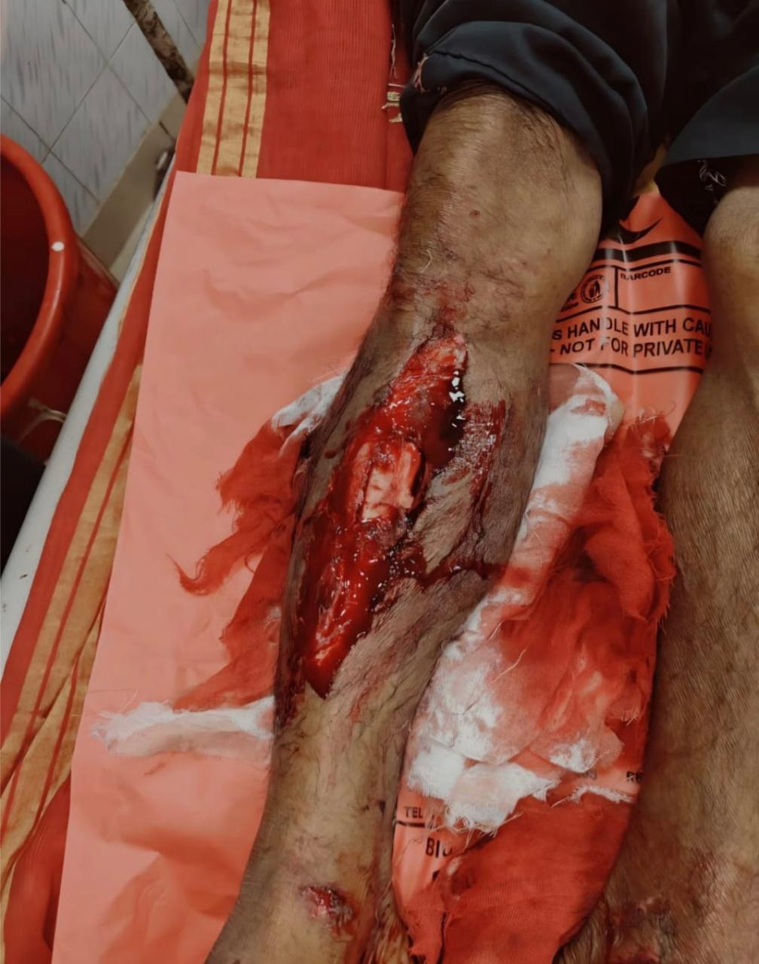
Fig 1: Open segmental fracture of right tibial shaft with exposed bone.

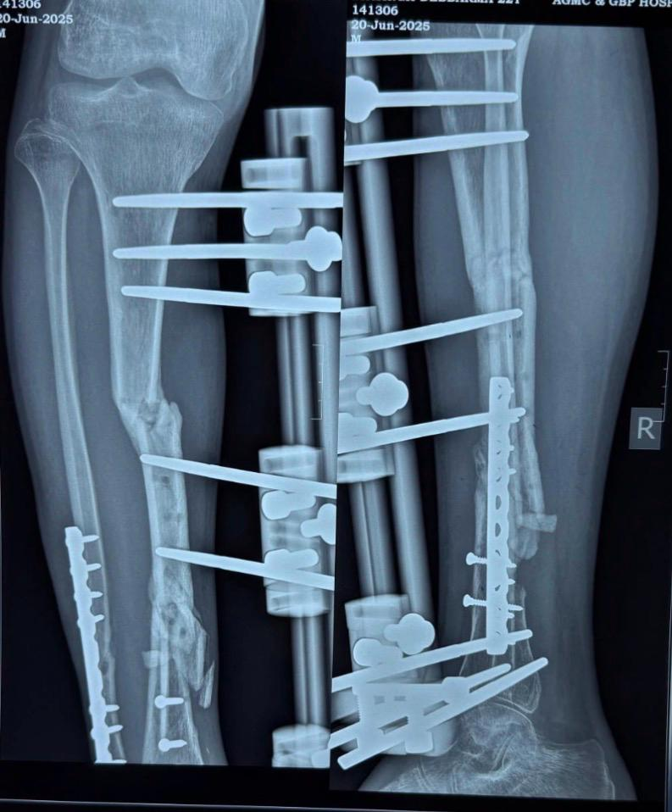
Fig 3: Postoperative radiograph showing alignment of tibial shaft fracture with LRS fixator in situ.

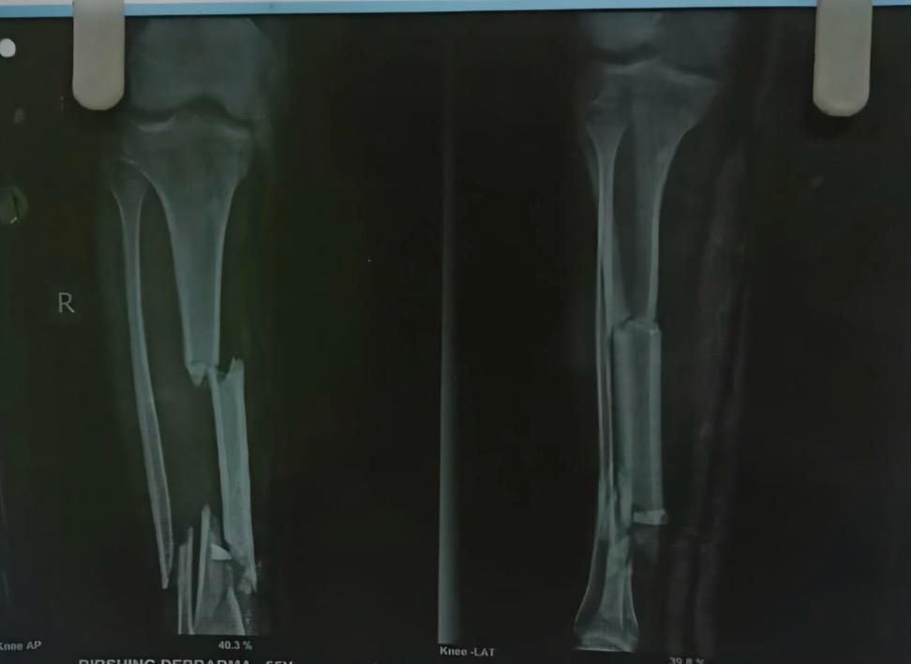
Fig 2 : Anteroposterior and lateral radiographs showing segmental fracture of tibial shaft with associated fibular fracture.

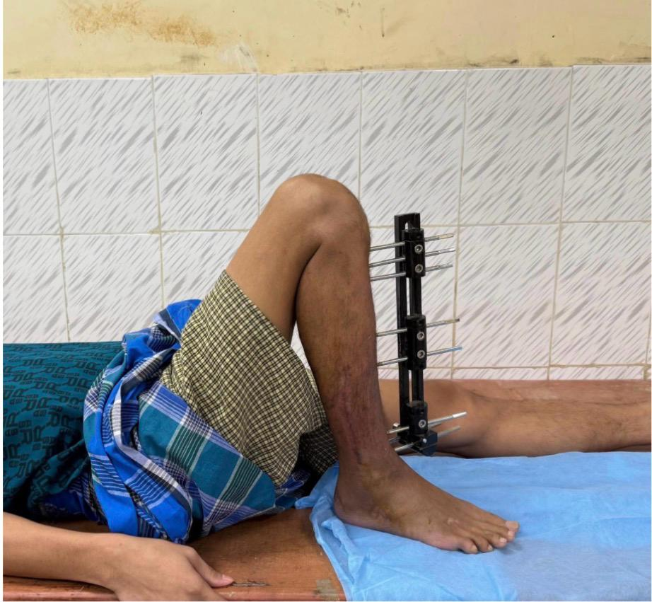
Fig 5: Early postoperative clinical image showing LRS fixator in situ.

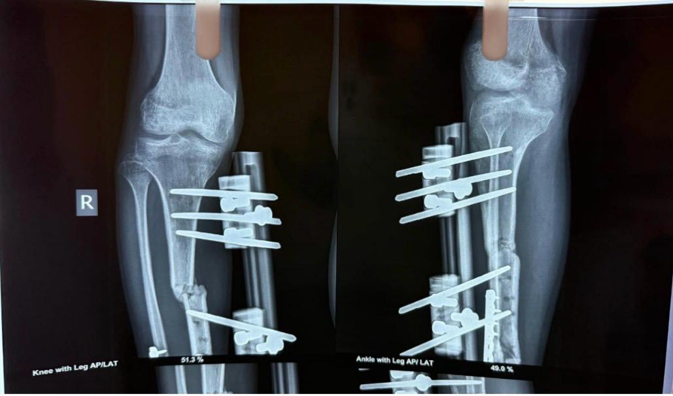
Fig 4:Postoperative radiograph showing stabilization of tibial fracture with LRS fixator.
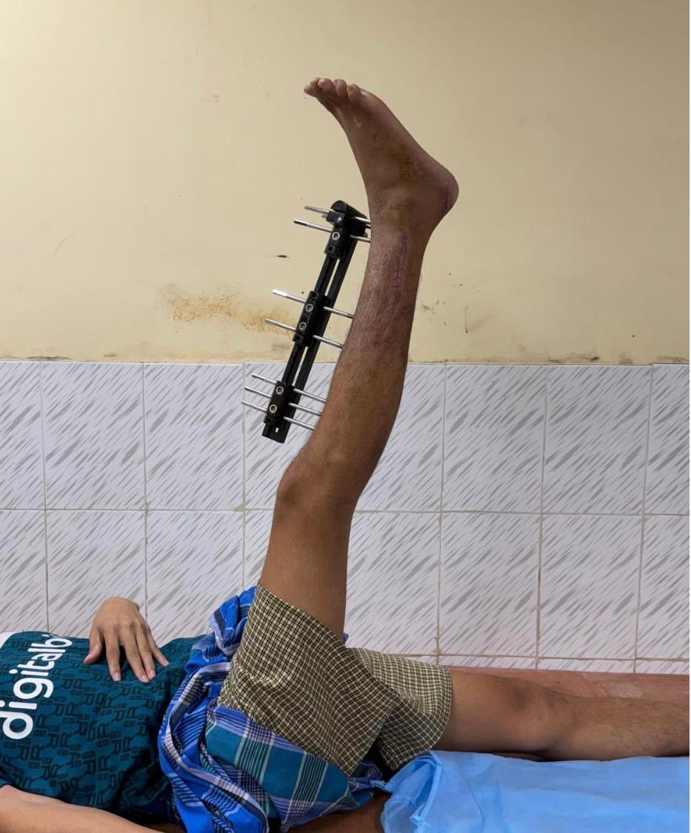
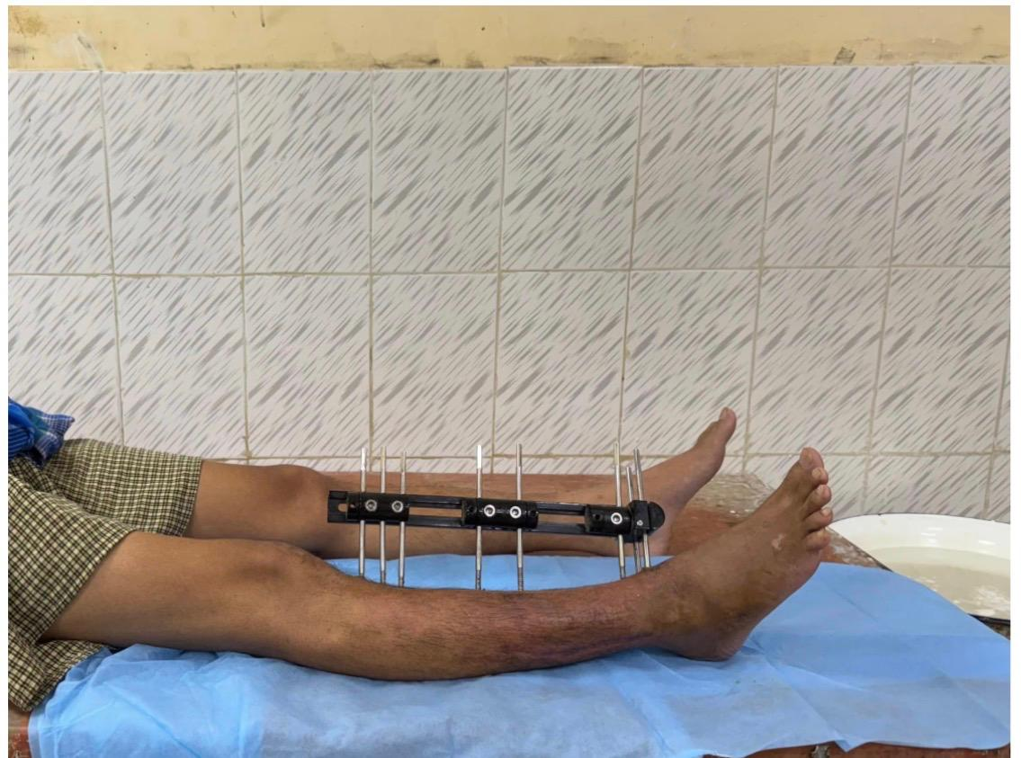
Fig 7: Follow-up image showing progression towards fracture healing.
Fig 6: Follow-up image showing maintained alignment with LRS fixator.

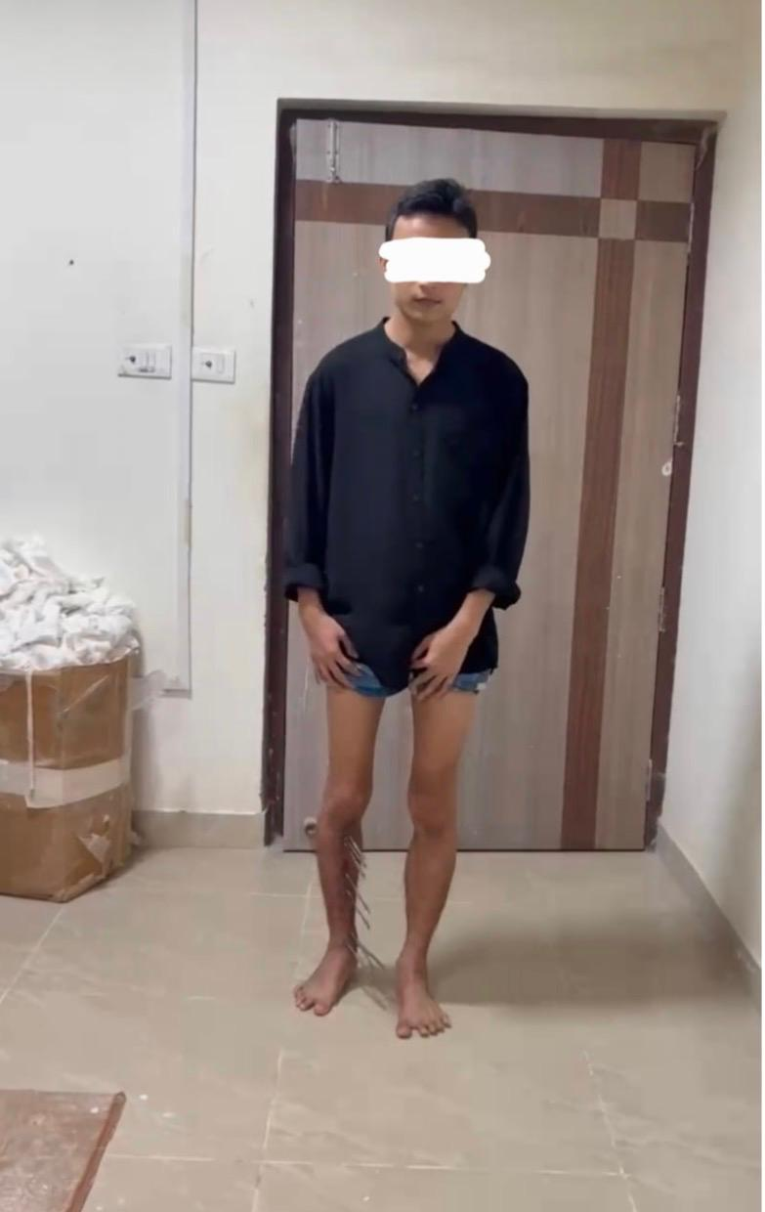
Fig 8: Final follow-up showing complete union of tibial shaft fracture.

DISCUSSION
he management of open segmental tibial fractures remains challenging, as achieving stable fixation while minimizing complications is difficult due to extensive soft tissue damage and bone comminution (Stone JP et al 1980). These injuries are associated with a high risk of infection, delayed union, and non-union, making the choice of fixation method crucial for optimal outcomes. In the present case, the use of the Limb Reconstruction System (LRS) resulted in satisfactory fracture union and excellent functional recovery. A 23-year-old male patient with an open segmental tibial shaft fracture was managed with thorough debridement followed by stabilization using LRS, which demonstrated complete radiological union at one year without any complications.
The surgical procedure involved meticulous wound debridement to remove all devitalized tissue, followed by the application of a monolateral external fixator (LRS). Schanz pins were inserted in the proximal and distal fragments away from the zone of injury, ensuring adequate stability and alignment. Compression was applied at the fracture site to promote union while maintaining limb length and alignment. This technique not only provided rigid stabilization but also preserved the biological environment essential for fracture healing. Proper pin placement facilitated effective wound care and minimized the risk of infection, which is a critical concern in open fractures.
These findings are consistent with previously published literature supporting the effectiveness of LRS in managing open tibial fractures.( Patil MY et al 2016) reported outcomes in 54 patients with open tibial fractures treated with LRS, demonstrating a high union rate and excellent results based on ASAMI criteria. Their study concluded that LRS provides stable fixation while preserving the biological environment necessary for fracture healing, which aligns with the findings of the present case.
(Bishnoi S et al. 2025) evaluated LRS in compound tibial fractures and reported excellent outcomes in approximately 70% of patients, with low complication rates and minimal incidence of pin tract infection and joint stiffness. (Mangukiya HJ et al.b 2018) compared LRS with AO monolateral external fixators and reported better functional and radiological outcomes with LRS, particularly in terms of fracture alignment and patient comfort. In the present case, a full range of motion at the knee and ankle joint was achieved, further highlighting the advantage of LRS in enabling early mobilization and functional recovery.
Adherence to the principles of open fracture management including early and thorough debridement, appropriate antibiotic therapy, stable fixation, and early rehabilitation contributed significantly to the successful outcome in this case (Minehara H et al 2023). Early stabilization combined with preservation of blood supply plays a vital role in reducing complications and promoting timely union. The LRS external fixator stabilizes the fracture while preserving blood supply and promoting callus formation, thereby enhancing bone healing (Paulino et al 2022). Additionally, placing the pins away from the zone of injury reduces the risk of infection (Shakir et al 2018).However, as this is a single case report, certain limitations exist. The findings cannot be generalized to a larger population, and no comparison with alternative treatment modalities was performed. Further studies with larger sample sizes are required to better establish the role of LRS in the management of complex open tibial fractures.
In summary, this case demonstrates that early debridement combined with LRS external fixation is a safe and effective treatment option for open segmental tibial fractures. It provides stable fixation, allows effective soft tissue management, enables early rehabilitation, and results in good functional and radiological outcomes with minimal complications when performed following standard surgical principles.
CONCLUSION
This case highlights the effectiveness of the Limb Reconstruction System (LRS) in the management of open segmental tibial fractures, which are complex injuries associated with a high risk of complications. Early and thorough debridement, appropriate soft tissue management, and stable fixation using LRS played a crucial role in achieving successful fracture union and excellent functional recovery in this patient. The LRS provides a reliable method of stabilization while preserving the biological environment, allowing early mobilization and facilitating wound care. Its minimally invasive nature and ability to maintain alignment and limb length make it a valuable option in the management of high-energy open fractures.Although this is a single case, the favorable outcome supports the use of LRS as an effective treatment modality in selected cases of open tibial fractures. Further studies with larger sample sizes are recommended to validate these findings
CONFLICT OF INTEREST: None
CONSET: As per international standards or university standards, patient(s) written consent has been collected and preserved by the author(s).
AUTHOR CONTRIBUTION: Sekhar collected all the details, performed literature review and drafted the manuscript, Bhumika assisted in dsatac interpretation and revised the manuscript. Dr Prantik performed the surgery, contributed to clinical management and supervised the study with final approval of the manuscript.

Disclaimer (Artificial intelligence)

Author(s) hereby declare that NO generative AI technologies such as Large Language Models (ChatGPT, COPILOT, etc.) and text-to-image generators have been used during the writing or editing of this manuscript.

REFERENCES

- Sharr PJ, Buckley RE. Current concepts review: open tibial fractures. Acta Chir Orthop Traumatol Cech. 2014;81(2):95–107.
- Shen M, Tejwani N. Open tibial shaft fracture fixation strategies: intramedullary nailing, external fixation, and plating. OTA Int. 2024;7(4 Suppl):e316. doi:10.1097/OI9.0000000000000316
- Cannada LK, Anglen JO, Archdeacon MT, Herscovici D Jr, Ostrum RF. Avoiding complications in the care of fractures of the tibia. J Bone Joint Surg Am. 2008;90(8):1760–1768.
- Templeman DC, Anglen JO, Schmidt AH. The management of complications associated with tibial fractures. Instr Course Lect. 2009;58:47–60.
- Corey RM, Park NK, Cannada LK. Segmental tibia fractures: an analysis of complication and healing rates. J Orthop Trauma. 2018;32(6):296–300. doi:10.1097/BOT.0000000000001132
- Uikey K, Bhalavi M, Saiyam S, Jhunjhunwala HR. Management of complicated trauma by limb reconstruction system (mono-lateral external fixator) in lower extremity. Asian J Pharm Clin Res. 2022;15(12):157–161. doi:10.22159/ajpcr.2022.v15i12.46302
- Mylsamy A, Sengodan V. Functional outcome of limb reconstruction system in lower limb compound fractures: a prospective study. Indian J Orthop Surg. 2025;11:48–55. doi:10.18231/j.ijos.2025.010
- Stone JP, Mears DC, Jarrett J. The management of open and complex fractures of the tibia. Bull N Y Acad Med. 1980;56(3):323–340.
- Patil MY, Gupta SM, Kurupati SK, Agarwal S, Chandarana V. Definitive management of open tibia fractures using limb reconstruction system. J Clin Diagn Res. 2016;10(7):RC01–RC04. doi:10.7860/JCDR/2016/17978.8124
- Bishnoi S, Gupta S, Saraf A, Singh SK, Parakh NK, Kumar SK. Functional and radiological outcome of Ilizarov ring fixator versus limb reconstruction system in compound tibial diaphyseal fractures grade II, IIIA, and IIIB. J Orthop Case Rep. 2025;15(11):339–349. doi:10.13107/jocr.2025.v15.i11.6398
- Mangukiya HJ, Mahajan NP, Pawar ED, Mane A, Manna J. Functional and radiological outcome in management of compound tibia diaphyseal fracture with AO monolateral fixator versus limb reconstruction system. J Orthop. 2018;15(1):275–281. doi:10.1016/j.jor.2018.01.041
- Minehara H, Maruo A, Amadei R, Contini A, Braile A, Kelly M, Jenner L, Schemitsch GW, Schemitsch EH, Miclau T 3rd. Open fractures: current treatment perspective. OTA Int. 2023;6(3 Suppl):e240. doi:10.1097/OI9.0000000000000240
- Paulino MF, Roseiro LM, Balacó I, Neto MA, Amaro AM. Evaluation of bone consolidation in external fixation with an electromechanical system. Appl Sci. 2022;12(5):2328. doi:10.3390/app12052328
- Shakir IM, Ganash RB, Watson JT. Lower extremity nontensioned traction pins: is it a benign procedure? Curr Orthop Pract. 2018;29(1):63–67. doi:10.1097/BCO.0000000000000572

