TRANSDUCTAL SIALOLITHOTOMY: MINIMALLY INVASIVE APPROACH FOR SUBMANDIBULAR DUCT SIALOLITH - A CASE REPORT

.
ABSTRACT

Submandibular sialolithiasis is characterized by salivary duct obstruction leading to recurrent pain and swelling. Modern management emphasizes gland preservation through minimally invasive methods such as intraoral removal and sialendoscopy, guided by precise imaging. Individualized treatment not only ensures complete stone clearance but also restores normal salivary function and improves long-term patient outcomes.
Case presentation: A 55-year-old male patient presented with pain and swelling in the right floor of the mouth associated with pus discharge during meals for three days. Extraoral examination revealed diffuse swelling in the right submandibular region. Intraoral examination showed an inflamed Wharton’s duct opening with purulent discharge and a firm swelling measuring approximately 1.2 × 0.7 cm in the floor of the mouth. Radiographic evaluation using mandibular occlusal radiograph and CBCT confirmed a calcified sialolith in the right Wharton’s duct. Under local anesthesia, a transductal intraoral approach was performed and the sialolith was removed in a single piece. postoperative follow-up showed normal salivary flow and satisfactory healing.

Conclusion:
Transductal sialolithotomy is a simple and effective treatment for submandibular duct stones, providing good clinical outcomes with minimal complications.

.

Keywords Submandibular sialolithiasis, Salivary gland calculi, Wharton’s duct, Sialolith, Sialendoscopy, Transoral sialolithotomy, Minimally invasive surgery, Salivary gland preservation.

INTRODUCTION

Sialolithiasis represents the most prevalent pathological condition of the salivary glands, accounting for approximately 1.2% of unilateral swellings in the major salivary glands. The submandibular gland exhibits the highest predilection for sialolith formation, comprising nearly 80% of reported cases, followed by the parotid gland at 19% and the sublingual gland at approximately 1% ^{(1,2}). The submandibular duct is longer and positioned at a more acute angle than other excretory ducts in the salivary glands. This anatomical configuration creates areas of saliva retention, which can promote crystal accumulation and contribute to lithogenesis ^{[3].} The submandibular duct secretes a higher concentration of minerals, particularly calcium, compared to other salivary components. This increased mineral content makes the duct more susceptible to crystallization. Additionally, the presence of sialomicroliths in asymptomatic individuals may play a role in the pathogenesis of salivary stones ^{[4].} Dehydration leads to an increase in the viscosity of saliva, which further facilitates the formation of salivary calculi ^{[5].} Operative management should be considered when stones are inaccessible or larger in size, and options include sialendoscopy, laser lithotripsy, extracorporeal shockwave lithotripsy, transoral surgery, and submandibular gland adenectomy.

CASE REPORT
Patient History:
- 55year old male patient presented to the Department of oral and maxillofacial surgery with a chief complaint of pain, swelling and pus discharge while having food on the right side of the floor of the mouth since 3days. Pain and swelling that worsen during meals indicate obstruction of salivary flow, which is characteristic of sialolithiasis. Pus discharge suggests secondary bacterial infection due to salivary stasis.
- On extra oral examination A diffused swelling over the right submandibular region was found. Diffuse swelling in the submandibular region indicates involvement of the submandibular gland, commonly affected in salivary duct obstruction. On bimanual palpation the lesion was firm and tender on the right side of the anterior floor of the mouth. Firmness suggests a calcified mass (sialolith), while tenderness indicates associated inflammation or infection of the gland or duct.
- Clinical examination:Intraorally right submandibular duct opening was inflamed and erythematous along with discharge of pus. Inflammation and purulent discharge at the duct orifice confirm ductal obstruction with secondary infection (acute sialadenitis). A solitary swelling is present in floor of the mouth towards right side. A localized, well-defined swelling supports the presence of a single sialolith within Wharton’s duct.
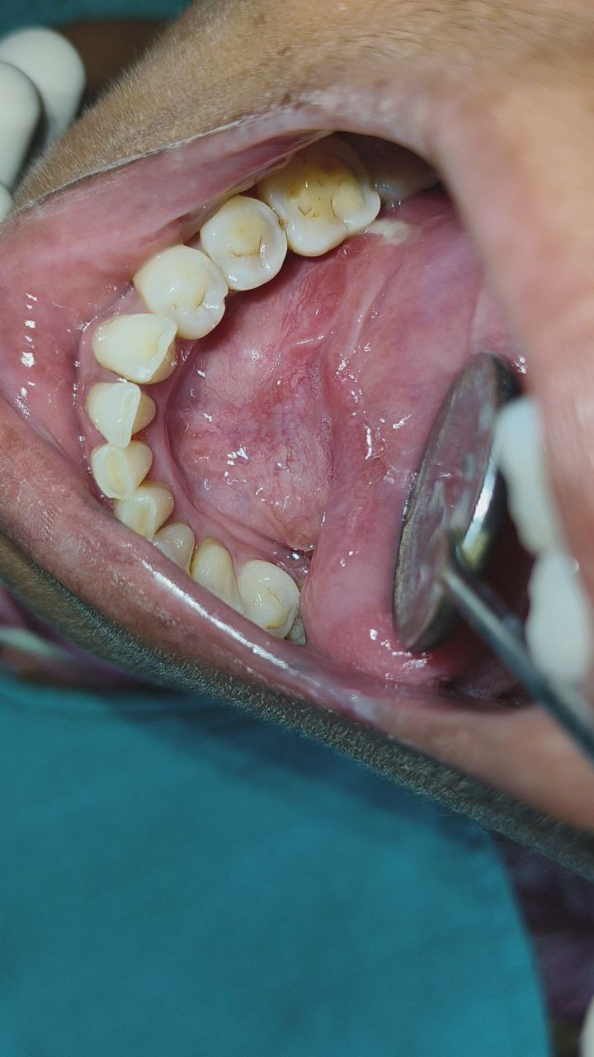

(fig.1) Presence of a single sialolith within Wharton’s duct

Radiographic examination:
cone beam computed tomography& mandibular occlusal radiograph reveals one calcified lesions in the posterior region of right Wharton’s duct. Radiographic detection of a calcified mass confirms the diagnosis of sialolithiasis and helps localize the stone within the duct.

(fig.2) Calcified lesions in the posterior region of right Wharton’s duct
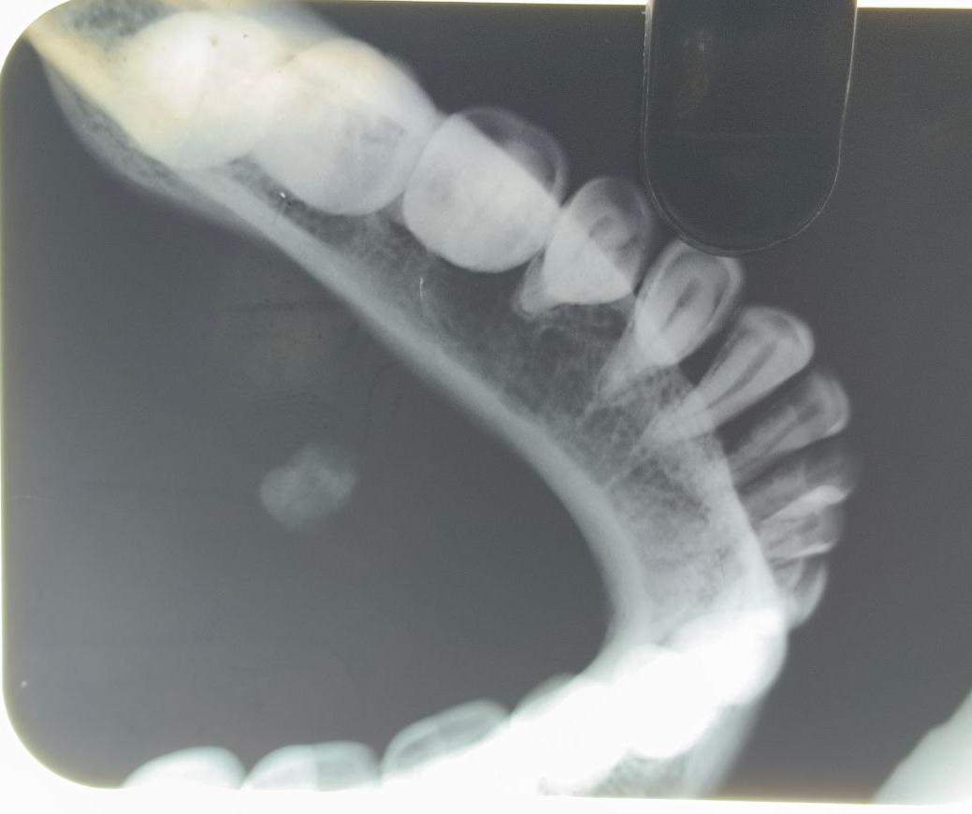
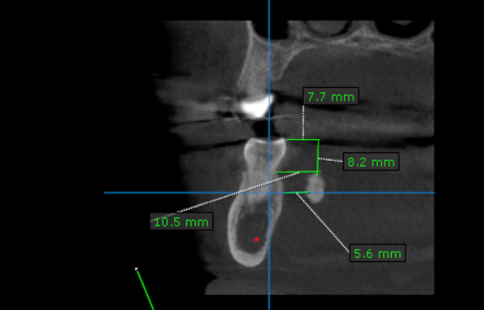

(fig.3) Radiographic finding confirming the diagnosis of sialolithiasis

- The distance from the mesiolingual cusp to the floor of the mouth is 7.7 mm. This measurement helps determine the vertical position of the stone and assists in planning the surgical approach.
- The sialolith is located at a depth of 8.2 mm from the occlusal surface. Depth assessment is essential to avoid excessive tissue trauma during intraoral surgical access.
- The sialolith lies 10.5 mm below the cemento-enamel junction (CEJ). The relation to the CEJ provides an additional anatomical reference point for precise localization.
- The sialolith is positioned 5.6 mm from the lingual cortex. Knowing the distance from the lingual cortex helps prevent injury to the lingual nerve and adjacent structures during surgery.
Investigations:
Routine hematological and serological investigations were performed prior to surgical excision. The complete blood picture (CBP) was within normal limits, and the coagulation profile, including clotting time (CT) and bleeding time (BT), was normal. Serological testing for infectious diseases revealed that hepatitis B surface antigen (hbsag) was negative and HIV Tridot test was also negative.
Surgical procedure:
Under sterile aseptic conditions, Betadine painting was done. 2% lignocaine HCl with 1:80,000 adrenaline was administered as local infiltrations. Lignocaine provides anesthesia, while adrenaline causes vasoconstriction, reducing bleeding and improving surgical visibility. Two stay sutures placed. Stay sutures aid in tissue retraction and stabilization during the procedure.One is anterior to the tongue for retraction, tongue retraction improves access and visibility of the floor of the mouth. Another one posterior to sialolith where incision was planned. This prevents posterior displacement of the stone and stabilizes the duct during incision(fig.4).

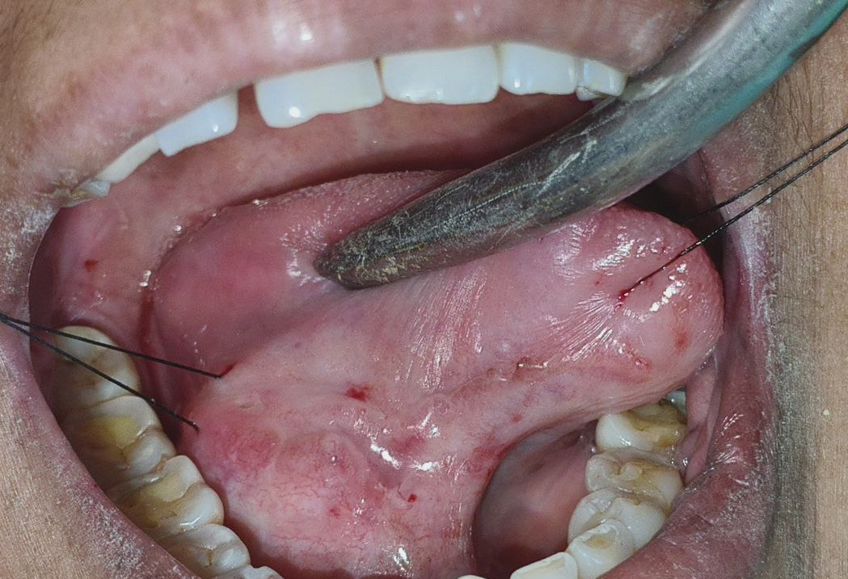

(fig.4) Tongue retraction

Intraoral incision was made in the floor of the mouth irt 45,46. The incision site corresponds to the anatomical location of the stone within Wharton’s duct.
The duct was opened (fig. 5) and sialolith was removed in a single piece. Removal of the stone restores ductal patency and relieves obstruction.1.2x0.7cm sialolith removed(fig.9). Size documentation is important for records and confirms correlation with clinical and radiographic findings. Irrigation was done with betadine and saline solution. Irrigation removes debris and bacteria, promoting healing and reducing infection risk.Incision in the duct is not sutured and mucosal suturing was done with 3-0 silk. Leaving the duct unsutured prevents ductal stenosis and allows free salivary flow, while mucosal closure supports healing. (fig.7). post operative oneday after followup(fig.8)

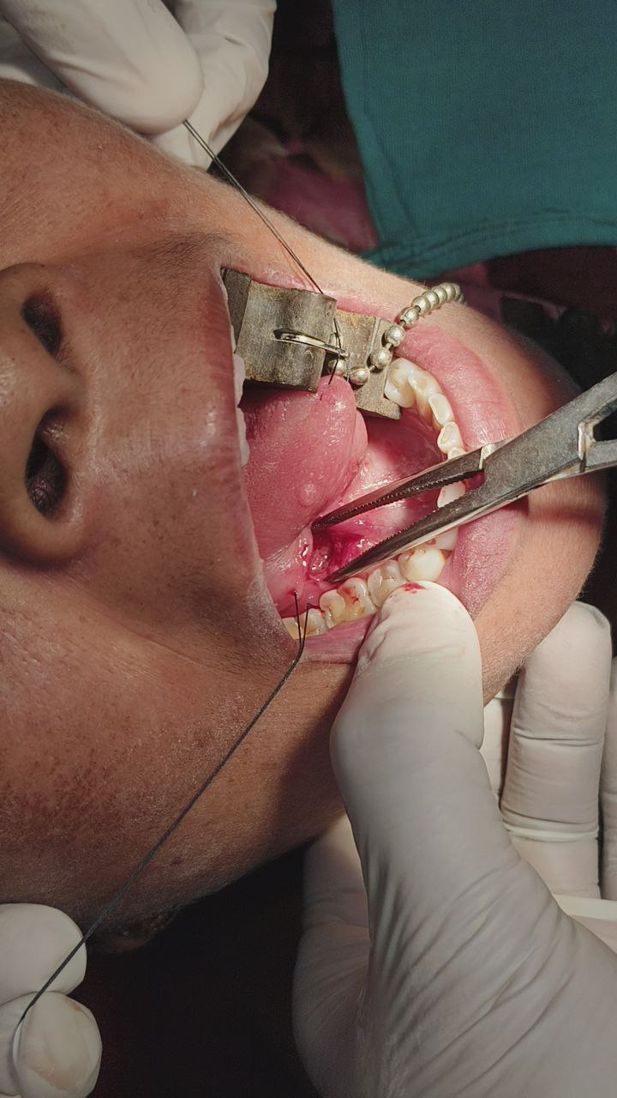
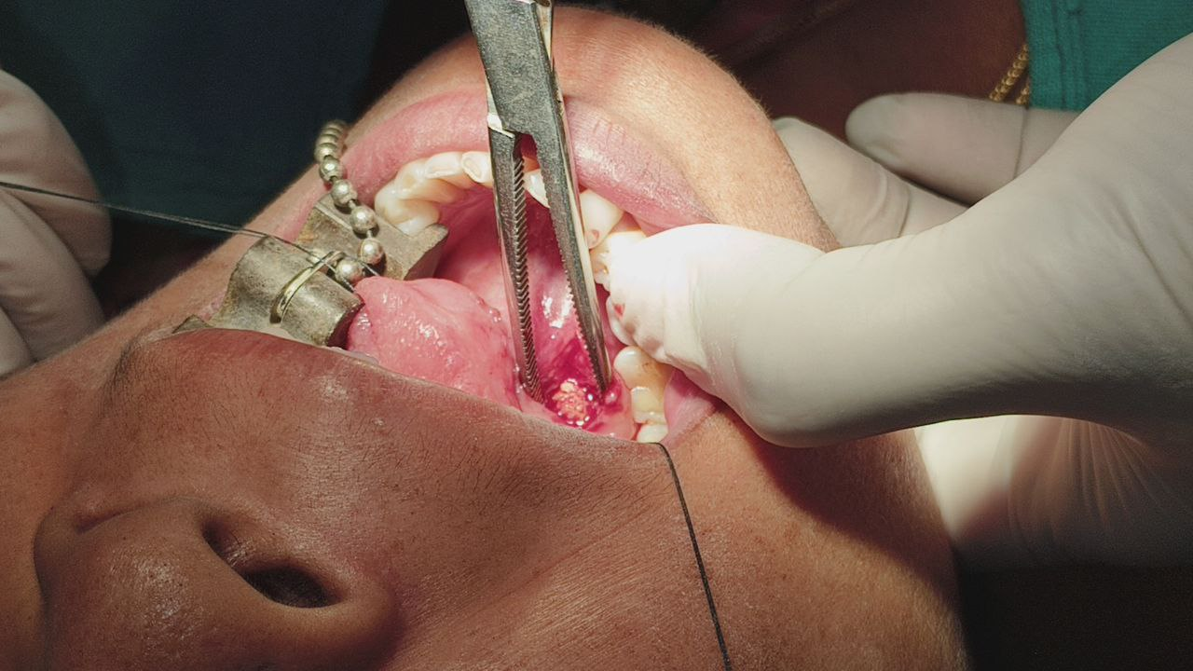

(fig.5) Wharton’s duct remained opened
(fig.6) After removal of sialolith

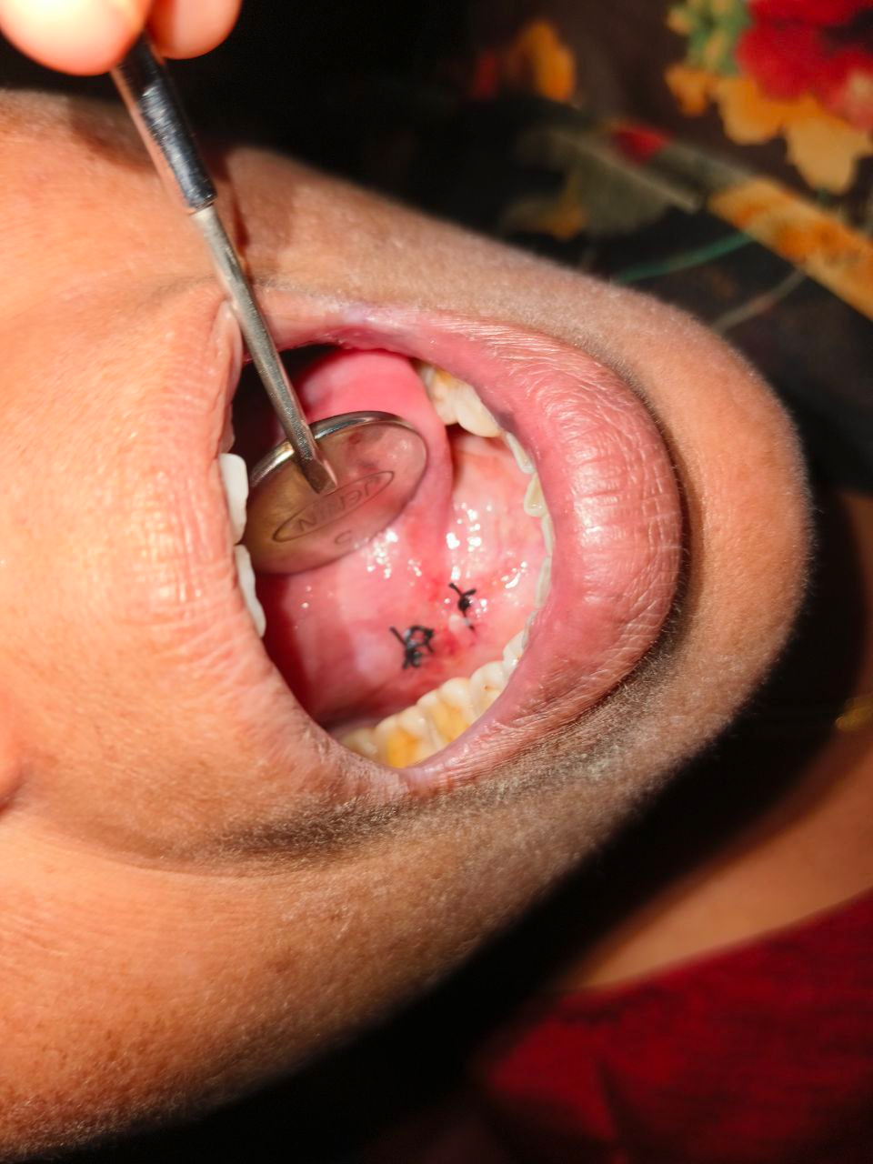

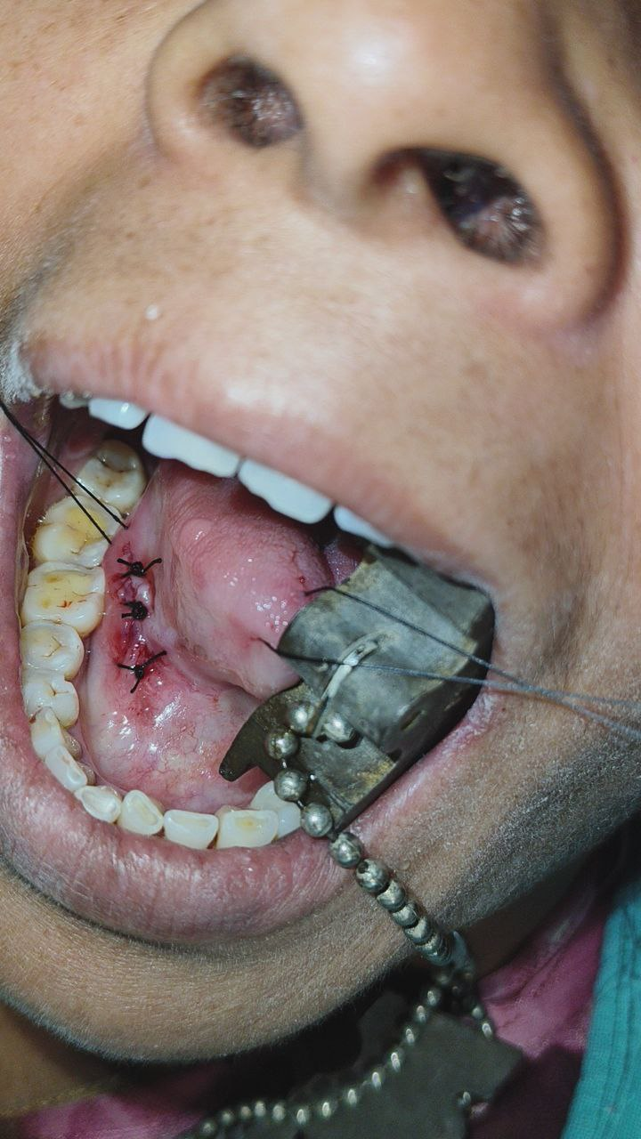

(fig.7) Mucosal suturing (fig.8) post-operative follow-up

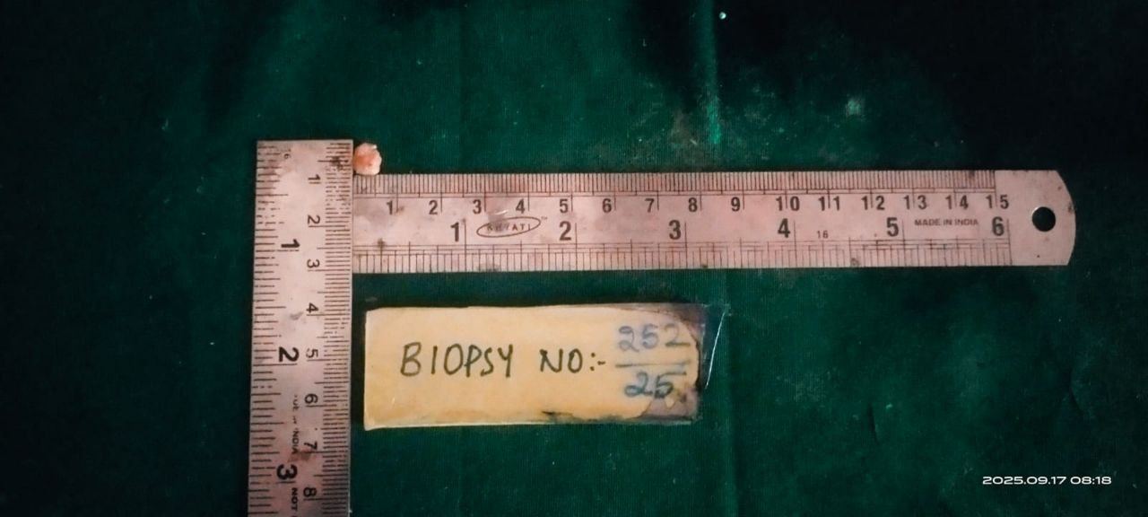

(fig.9) sialolith removed

Final Diagnosis:
Submandibular Duct Sialolith
post-operative findings at 1-week follow-up (after transductal sialolithotomy) Absence of pain indicates resolution of inflammation and successful surgical outcome.:(fig.10)
- No pain or tenderness on palpation.
- No swelling in the floor of mouth/region of gland. Reduction of swelling confirms resolution of obstruction and infection.
- Normal salivary flow from the duct orifice. Normal salivary flow indicates restoration of ductal function.
- Surgical site shows satisfactory healing, no discharge or infection. This reflects effective surgical technique and postoperative care.
- Duct orifice appears patent with no signs of stenosis or obstruction. Patency confirms long-term success of transductal sialolithotomy.
- Surrounding mucosa healthy, no erythema or induration. Healthy mucosa indicates complete resolution of inflammation and optimal healing.

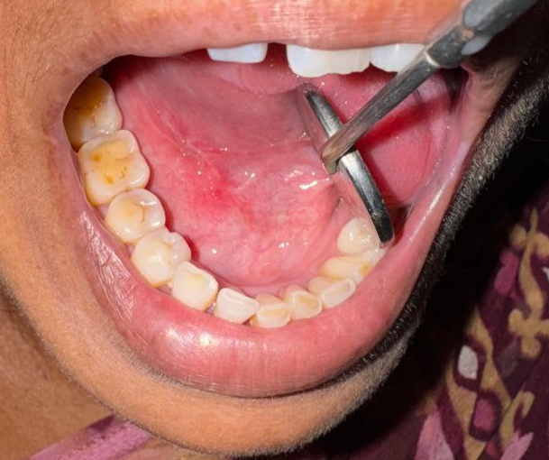

(fig.10) Healthy mucosa

Discussion
Sialolithiasis refers to the development of calcified structures within the parenchyma or ductal system of major or minor salivary glands. The submandibular gland is most frequently affected, accounting for approximately 80% of cases, followed by the parotid gland (19%) and the sublingual gland (1%). The condition predominantly occurs between 30 and 60 years of age and is relatively uncommon in children, representing only about 3% of all reported cases in the pediatric population. A male predilection has been noted, with men affected nearly twice as often as women^{(2).} The high incidence in the submandibular gland is attributed to the mixed, viscous nature of its secretions, their higher inorganic content, and the uphill, tortuous course of Wharton’s duct. The calculi are mainly composed of inorganic calcium and sodium phosphate salts, which deposit around a nidus of organic debris within the ductal lumen^{(6).} Clinical presentation of sialolithiasis typically includes pain and swelling of the affected gland. The pain demonstrates a classical relationship with meals, becoming more pronounced during salivary stimulation. In cases of complete ductal obstruction, symptoms are more severe. Prolonged obstruction often results in retrograde infection, producing features of chronic sialadenitis such as purulent discharge and reduced salivary flow. On clinical examination, the calculus may be palpable as a hard, calcified mass. In the submandibular gland, bimanual palpation of the gland and duct often reveals the presence of calculi. Radiographically, calculi within the submandibular duct are best visualized on mandibular occlusal radiographs, while those located in the hilum are more evident on lateral oblique views of the mandible. Management of sialolithiasis may be conservative or surgical, depending on the size, location, and mobility of the stone^{(7).} Conservative approaches include the use of antibiotics, nonsteroidal anti-inflammatory drugs (NSAIDs), gland massage, and sialogogues. Antibiotic therapy is particularly indicated in the presence of acute infection, characterized by cervical lymphadenopathy, purulent ductal discharge, or peri-ductal erythema. Definitive surgical intervention is usually undertaken once the acute phase has resolved^{(7).} Traditional management protocols recommend sialadenectomy for proximal, hilar, or intraparenchymal calculi, while ductal dilatation, incision, or dissection is reserved for distal stones. In selected cases, sialodochoplasty may also be performed to restore ductal patency^{(8).} Traditional surgical approaches are associated with certain risks, including permanent mandibular nerve palsy (1–8%) and lingual nerve palsy (1–5%). Consequently, these have largely been replaced by minimally invasive, gland-preserving techniques. These include shock-wave lithotripsy, refined methods of transoral duct surgery (TDS), diagnostic and interventional sialendoscopy (intSE^{)(9),} and robot-assisted sialolithotomy combined with sialendoscopy^{(10).} These modalities may be employed individually or in combination, significantly reducing the need for gland excision and its associated complications. Moreover, they help preserve glandular function and ensure complete clinical recovery in over 80% of patients(11). With regard to the type of anesthesia, it should be noted thatThe choice of treatment for sialolithiasis depends on the size, location, palpability of the calculus, and functional status of the gland.Anteriorly located and palpable stones can usually be managed under local anesthesia.Posteriorly located palpable calculi are generally treated under general anesthesia due to limited access and patient comfort considerations.Sialendoscopy is primarily indicated for small calculi measuring less than 4 mm in diameter; however, it may also be used for stones in various ductal locations under either local or general anesthesia.Calculi smaller than 4 mm can often be retrieved using a basket probe, whereas larger stones may require intracanal fragmentation using endoscopic laser techniques or external fragmentation through extracorporeal lithotripsy(13-16). Submandibulectomy, performed exclusively under general anesthesia, is reserved for stones located at the hilar region of the gland, recurrent cases, or when there is complete loss of salivary gland function.The currently recommended treatment modalities for the management of sialolithiasis include the following:Conservative medical therapy, consisting of antispasmodic agents to facilitate ductal drainage and antibiotics in cases of associated infection or following invasive procedures (commonly amoxicillin or macrolides). Surgical management through intraoral or extraoral approaches, involving removal of the calculus or excision of the affected gland when necessary.Extracorporeal lithotripsy, which fragments the stone using ultrasound or laser energy. Sialendoscopy, a minimally invasive technique that enables visualization and retrieval or fragmentation of the stone using an endoscope with specialized instruments such as basket probes.Adjunctive conservative measures, including gland massage and the use of sialogogues to enhance salivary secretion and promote spontaneous stone expulsion(12).
^{CONCLUSION:}
Transductal sialolitomy is a simple, safe, and minimally invasive procedure for salivary stone removal. It preserves the salivary gland, has minimal complications, and allows faster recovery.
^{Ethical Approval and Consent:}
Informed patient consent was obtained. Patient confidentiality was maintained. The author declares no conflict of interest, and the manuscript is original and not under consideration elsewhere.

^{LIMITATIONS OF THE STUDY}
This report represents a single clinical case, which limits the generalization of outcomes to a wider population. Long-term follow-up was limited, and recurrence or delayed complications could not be fully assessed. The minimally invasive transductal sialolithotomy technique is most suitable for selected cases with palpable and accessible ductal stones, and may not be applicable for multiple, or intraglandular calculi. Further studies with larger sample sizes and longer follow-up are required to validate the effectiveness, safety, and reproducibility of this approach.

REFERENCES:
1.Ayrancı F, Ömezli MM, Torul D, Sunar Ç, Koç L: Sialolith of the submandibular gland: a case report. BSJ Health Sc. 2020, 6:407-11. 10.19127/mbsjohs.817042.
2. Pachisia S, Mandal G, Sahu S, Ghosh S: Submandibular sialolithiasis: a series of three case reports with review of literature. Clin Pract. 2019, 9:1119. 10.4081/cp.2019.1119.
3.Arquez HF : Anatomical variation of the submandibular gland duct. a unreported anomaly . Int Arch Med. 2017, 10:268.
4. Sodnom-Ish B, Eo MY, Cho YJ, et al.: Identification of biological components for sialolith formation organized in circular multi-layers. Sci Rep. 2023, 13:12277. 10.1038/s41598-023-37462-w
5. Villa A, Connell CL, Abati S: Diagnosis and management of xerostomia and hyposalivation. Ther Clin Risk Manag. 2015, 11:45-51. 10.2147/TCRM.S76282.
6.Jardim EC, Ponzoni D, de Carvalho PS, Demétrio MR, Aranega AM. Sialolithiasis of the submandibular gland. J Craniofac Surg. 2011 May;22(3):1128-31.
7.Hammett JT, Walker C. Sialolithiasis. 2022 Sep 26. In: StatPearls [Internet]. Treasure Island (FL): StatPearls Publishing; 2022 Jan.
8. Zenk J, Constantinidis J, Al-Kadah B, Iro H. Transoral removal of submandibular stones. Arch Otolaryngol Head Neck Surg. 2001 Apr;127(4):432-6.
9.Katz P. New techniques for the treatment of salivary lithiasis: sialoendoscopy and extracorporal lithotripsy: 1773 cases]. Ann Otolaryngol Chir Cervicofac. 2004 Jun;121(3):123-32. French.
10. Razavi C, Pascheles C, Samara G, Marzouk M. Robot-assisted sialolithotomy with sialendoscopy for the management of large submandibular gland stones. Laryngoscope. 2016 Feb;126(2):345-51.
11. Capaccio P, Torretta S, Pignataro L, Koch M. Salivary lithotripsy in the era of sialendoscopy. Acta Otorhinolaryngol Ital. 2017 Apr;37(2):113-121.
12.Submandibular gland excision . [ May; 2024 ]. 2024. https://www.hopkinsmedicine.org/health/treatment-tests-and-therapies/submandibular-gland-excision https://www.hopkinsmedicine.org/health/treatment-tests-and-therapies/submandibular-gland-excision.
13. 7.Hammett JT, Walker C. Continuing Education Activity. Treasure Island, FL: StatPearls [Internet], StatPearls Publishing; [ May; 2024 ]. 2024. Sialolithiasis. [PubMed] [Google Scholar]
14.Contemporary review of submandibular gland sialolithiasis and surgical management options. Badash I, Raskin J, Pei M, Soldatova L, Rassekh C. Cureus. 2022;14:0. doi: 10.7759/cureus.28147. [DOI] [PMC free article] [PubMed] [Google Scholar]
15.Salivary stones: symptoms, aetiology, biochemical composition and treatment. Kraaij S, Karagozoglu KH, Forouzanfar T, Veerman EC, Brand HS. Br Dent J. 2014;217:0. doi: 10.1038/sj.bdj.2014.1054. [DOI] [PubMed] [Google Scholar]
16.Salivary stones. [ May; 2024 ]. 2022. https://my.clevelandclinic.org/health/diseases/24344-sialolithiasis https://my.clevelandclinic.org/health/diseases/24344-sialolithiasis

