Segmental Gangrene in an Hourglass Gallbladder: A Rare Morphological Variant with Surgical Implications
Abstract
Background
Hourglass gallbladder is a rare anatomical variant characterized by a constriction dividing the gallbladder into two compartments. It may be congenital or acquired and is frequently associated with chronic inflammation. Compartmentalized pathology within such a variant is exceedingly uncommon.

Case Presentation
A 70-year-old male presented with a one-day history of right upper quadrant pain, fever, and vomiting. Ultrasonography suggested acute cholecystitis with a bilobed gallbladder. Magnetic resonance imaging demonstrated an hourglass configuration with a constricted mid-body separating the fundal and neck compartments.

Management and Outcome
The patient underwent laparoscopic cholecystectomy. Intraoperatively, gangrene was confined to the fundal compartment, while the distal segment remained viable. The critical view of safety was achieved, and the procedure was completed laparoscopically without complications. Histopathological examination confirmed segmental gangrenous cholecystitis.

Conclusion
Selective segmental gangrene in an hourglass gallbladder is an extremely rare entity and poses diagnostic as well as intraoperative challenges. This case underscores the importance of recognizing anatomical variants, correlating preoperative imaging with intraoperative findings, and adhering to meticulous surgical technique to ensure safe outcomes.

Key words- hourglass gallbladder, anatomical variation gall bladder, segmental gangrene, acquired gall bladder stricture

Introduction
Anatomical variations of the gallbladder are uncommon but clinically important because they may alter both the presentation of biliary disease and the technical conduct of surgery. The gallbladder can show a range of morphologic variants, including septations, bilobed configuration, Phrygian cap deformity, and hourglass deformity, some of which are discovered incidentally on imaging or at surgery. Among these, the hourglass gallbladder is a rare variant characterized by a constriction of the gallbladder body that divides it into two compartments, creating a partially compartmentalized biliary reservoir. This morphology may be congenital or acquired, with chronic inflammation, fibrosis, and related wall remodeling being implicated in acquired forms.¹
While acute cholecystitis is a common surgical condition, gangrenous transformation typically involves the entire gallbladder. Segmental gangrene confined to a single compartment of an hourglass gallbladder is exceptionally rare and poorly described in literature.² Such cases are important due to their potential to mislead both radiological interpretation and intraoperative decision-making.³
Although acute cholecystitis is common, gangrenous transformation of the gallbladder is a severe and potentially life-threatening complication that usually reflects progressive ischemia and wall necrosis. Imaging features associated with gangrenous cholecystitis include gallbladder distension, intraluminal membranes, mural striation, irregular wall contour, and absent or decreased mural enhancement. In most reports, necrosis is diffuse or extensive rather than restricted to a single segment of the gallbladder. For that reason, selective gangrene confined to one compartment of an hourglass gallbladder is exceptionally unusual and may not be anticipated preoperatively.⁴
This unusual combination is clinically relevant for two reasons. First, compartmental anatomy may produce nonuniform disease, allowing one segment to become gangrenous while the other remains viable, thereby creating discordance between symptoms, imaging, and operative appearance. Second, distorted biliary anatomy can increase the risk of misidentification during laparoscopic cholecystectomy, especially in inflamed or fibrotic Calot’s triangle.

We present a rare case of selective gangrene in the fundal compartment of an hourglass gallbladder and discuss its clinical, diagnostic, and surgical implications.
Case Report
A 70-year-old male presented with acute onset right upper quadrant abdominal pain of one-day duration, associated with fever and vomiting. There was no history of jaundice or previous similar episodes. No known past medical comorbidity was present.

On examination, the patient was febrile with localized tenderness in the right hypochondrium and a positive Murphy’s sign. Laboratory investigations revealed leukocytosis with neutrophilia. Liver function tests were within normal limits.

Ultrasonography demonstrated a distended gallbladder with wall thickening and internal echoes suggestive of acute cholecystitis. A bilobed morphology with a possible mid-body constriction was noted.

Magnetic resonance imaging provided better anatomical delineation, revealing an hourglass configuration with a distinct narrowing separating the fundal and neck compartments. The fundal compartment appeared more distended and inflamed.(Image 1)

The patient was taken up for laparoscopic cholecystectomy. Intraoperatively, the gallbladder showed a characteristic hourglass deformity with a fibrotic constriction. The fundal compartment was edematous and gangrenous, whereas the distal compartment appeared relatively normal. (IMAGE 2) Adhesions were carefully lysed.

Meticulous dissection was performed to achieve the critical view of safety. The cystic duct and artery were identified, clipped, and divided. Laparoscopic cholecystectomy was completed successfully without complications.

The postoperative period was uneventful. Histopathological examination confirmed transmural necrosis in the fundal compartment consistent with gangrenous cholecystitis, while the distal segment showed mild inflammation.
Discussion
Clinical Significance
This case highlights an important but underrecognized concept: anatomical variations can fundamentally alter disease behavior. In an hourglass gallbladder, the constriction creates two partially independent compartments, which may differ in distensibility, bile drainage, pressure dynamics, and inflammatory progression. Such compartmentalization offers a plausible explanation for the segmental nature of the gangrene in our patient, with necrosis confined to the fundal compartment while the distal segment remained viable. This pattern is unusual because gangrenous cholecystitis is typically a diffuse process resulting from progressive vascular compromise of the gallbladder wall.⁴ This may result in discordance between clinical severity and imaging findings.
Pathophysiology and Mechanism of Segmental Gangrene
The pathophysiology of gangrenous cholecystitis is multifactorial and includes sustained cystic duct obstruction, rising intraluminal pressure, venous congestion, arterial insufficiency, and secondary ischemic necrosis. The gallbladder fundus is especially vulnerable because it is the farthest portion from the cystic arterial inflow and may be the first region to suffer ischemic change in severe inflammation.⁵ In a compartmentalized gallbladder, localized stasis and pressure effects may be amplified in one chamber, producing a segment-specific ischemic pattern rather than uniform necrosis. This mechanism is consistent with our operative finding of a gangrenous fundal compartment and a relatively preserved distal segment.⁶
Diagnostic Challenges
Preoperative diagnosis remains difficult even when gangrenous cholecystitis is suspected. Ultrasonography is often the first imaging modality and may detect gallbladder distension, wall thickening, intraluminal echoes, or a bilobed appearance, but it may not reliably define a constricted hourglass configuration or predict compartment-specific necrosis. Cross-sectional imaging, particularly MRI/MRCP, provides superior anatomic delineation and may better demonstrate a narrowed waist separating two gallbladder compartments. However, even advanced imaging cannot always define which segment is gangrenous, especially when inflammatory changes are asymmetric.⁷ For that reason, the surgeon must remain prepared for unexpected intraoperative anatomy and variable tissue viability.⁶
Surgical Implications
The operative significance of this case lies in the increased risk of biliary misidentification in the setting of anatomical distortion and acute inflammation. The presence of an hourglass deformity can make the gallbladder appear partially normal, potentially masking the severity of pathology in one segment and complicating traction and dissection. In such situations, safe dissection principles become especially important, and achieving the critical view of safety remains central to preventing bile duct injury.⁸ When anatomy is unclear, meticulous adhesiolysis, careful exposure of the hepatocystic triangle, and avoidance of premature clipping are essential. Our case demonstrates that even in the presence of gangrene confined to one compartment, laparoscopic completion is feasible when anatomy can be clearly defined and the critical view of safety is obtained.⁹
Review of World Literature and Rarity
Hourglass gallbladder is rarely reported, and literature largely focuses on congenital anomalies or septate gallbladder.¹⁰ Reports describing compartment-specific pathology are extremely limited, and segmental gangrene is scarcely documented.² Most cases of gangrenous cholecystitis involve diffuse necrosis and are associated with delayed presentation and vascular compromise.⁵ This rarity also means that preoperative radiologic suspicion may be low, and the diagnosis may only become fully evident at surgery or on histopathological examination.⁶ In that sense, the case adds to the limited body of evidence showing that anatomical variants can meaningfully shape the pattern of gallbladder disease.¹⁰

Key Clinical Message
Anatomical variations such as hourglass gallbladder can lead to compartmentalized disease processes, necessitating heightened diagnostic suspicion and meticulous surgical technique to ensure safe outcomes.
Conclusion
Segmental gangrene in an hourglass gallbladder is an exceptionally rare entity. This case underscores the importance of recognizing anatomical variations, understanding their pathophysiological implications, and adhering to sound surgical principles. Awareness of such presentations is essential to avoid diagnostic pitfalls and intraoperative complications.

Disclaimer (Artificial intelligence)

Author(s) hereby declare that NO generative AI technologies such as Large Language Models (ChatGPT, COPILOT, etc.) and text-to-image generators have been used during the writing or editing of this manuscript.

References
- Wong HYF, Lee KH. The hourglass gallbladder. Abdom Radiol (NY). 2018;43(5):1268-1269.
- Arza A, Stitzlein E, Jen J, Park JY, Ramachandra P. Bilobed gallbladder: a rare anatomical variation discovered during laparoscopic cholecystectomy. Cureus. 2024;16(10):e72300.
- Kim SH, Kwon YS, Kim SH, Shin HJ, Shim CS. Hourglass gall bladder associated with milk of calcium bile at fundal compartment: case report. J Korean Radiol Soc. 1987;23(1):96-99.
- Kay TJ, Wallace L, Ryland N, Bull N. Challenges in accurate clinical prediction of gangrenous cholecystitis: a single-centre retrospective analysis of operative cases. J Surg. 2023;8:1968.
- Bennett GL, Rusinek H, Lisi V, Israel GM, Krinsky GA, Slywotzky CM, et al. CT findings in acute gangrenous cholecystitis. AJR Am J Roentgenol. 2002;178(2):275-281.
- Merriam LT, Kanaan SA, Dawes LG, Angelos P, Prystowsky JB, Rege RV, Joehl RJ. Gangrenous cholecystitis: analysis of risk factors and experience with laparoscopic cholecystectomy. Surgery. 1999 Oct;126(4):680-5;
- Bonatti M, Vezzali N, Lombardo F, et al. Gallbladder adenomyomatosis: imaging findings, tricks and pitfalls. Insights Imaging. 2017;8(2):243-253.
- Strasberg SM. Error traps and vasculobiliary injury in laparoscopic and open cholecystectomy. J Hepatobiliary Pancreat Surg. 2008;15(3):284-292.
- Hugh TB. New strategies to prevent laparoscopic bile duct injury—surgeons can learn from pilots. Surgery. 2002;132(5):826-835.
- Park JY, Arza A, Jen J, Ramachandra P. Bilobed (V-shaped) gallbladder: Harlaftis type 1b variant diagnosed intraoperatively. Cureus. 2024;16(10):e72300.

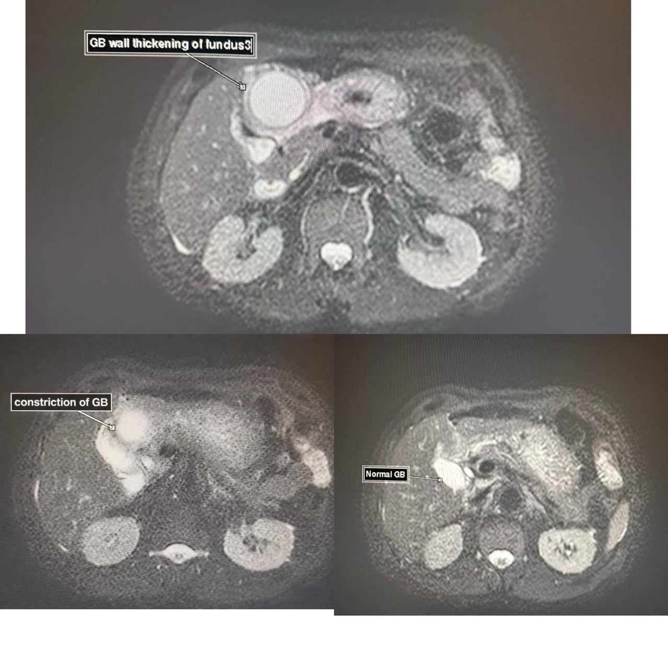

Figure 1 : Distended and inflamed fundal compartment
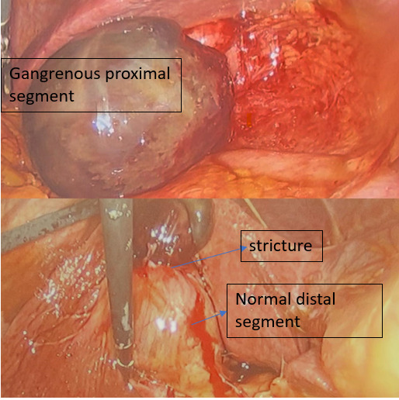
Fig 2 : Edematous and gangrenous fundal compartment and normal distal compartment

