Small bowel obstruction due to a primary ileo-mesenteric adhesion in an elderly patient with no prior surgery: a case report and literature review

Abstract :

Background: Primary adhesive bands are thought to arise from aberrant embryological peritoneal attachments or de novo fibrous formations and can lead to luminal obstruction, vascular compromise, or closed-loop obstruction if they entrap bowel segments.
Case Report: A 72-year-old man with type 2 diabetes and hypertension, but no surgical history, presented with four days of abdominal distension and obstipation. Examination revealed a tympanitic, distended abdomen; laboratory results were notable for mild leukocytosis and an episode of diabetic ketoacidosis. Computed Tomography (CT) imaging demonstrated dilated ileal loops with air–fluid levels,
a transition point with a “beak sign,” distal ileal wall thickening, adjacent mesenteric fat infiltration, multiple small mesenteric lymph nodes, and collapsed distal bowel loops. No pneumatosis or free air was observed. A midline laparotomy revealed a retro-umbilical ileo-epiploic adhesion causing small bowel strangulation. Adhesiolysis restored bowel viability, and the patient recovered uneventfully, being discharged on postoperative day 4.

Discussion: Primary adhesive bands are a rare cause of Small bowel obstruction (SBO) in a virgin abdomen, posing diagnostic challenges as preoperative imaging rarely identifies the band itself. CT imaging is crucial for assessing obstruction, closed-loop configuration, and bowel viability. Management depends on obstruction severity and viability: non-operative approaches may succeed in partial obstruction, whereas complete or closed-loop obstructions require urgent surgical intervention. Definitive treatment involves adhesiolysis, with segmental bowel resection reserved for non-viable segments. Laparoscopic approaches are increasingly feasible, offering reduced morbidity in selected patients.

Conclusion: Although uncommon, primary ileo-mesenteric adhesions should be considered in elderly patients presenting with SBO without prior abdominal surgery. Early recognition, prompt imaging, and timely surgical intervention are critical to prevent ischemic complications and ensure favorable outcomes.

Keywords: Primary adhesive bands, ileo-mesenteric adhesions, ischemic complications, hypoglycaemic agents
Introduction

Small bowel obstruction (SBO) is a common surgical emergency, accounting for up to 12–
16% of all surgical admissions and approximately 20% of emergency laparotomies worldwide. The predominant cause is intraperitoneal adhesions, most commonly arising after previous abdominal surgery, which account for 55–75% of cases. However, SBO can occasionally occur in patients with a “virgin abdomen,” where no prior surgical intervention has been performed. In such cases, congenital or primary adhesive bands are a rare but recognised aetiology, and arise due to congenital or primary adhesive bands.[1,2]

Primary adhesive bands are thought to arise from aberrant embryological peritoneal attachments or de novo fibrous formations and can lead to luminal obstruction, vascular compromise, or closed-loop obstruction if they entrap bowel segments. Although uncommon, these bands may present with acute abdominal symptoms, mimicking the clinical and radiological features of postoperative adhesive SBO, and often pose a diagnostic challenge due to their rarity and nonspecific presentation [1,2].
It is important for surgeons and radiologists to know that adhesive SBO can occur without a
surgical history, an entity often overlooked in elderly patients. The report demonstrates the critical role of CT in identifying closed-loop obstruction and the need for timely surgical intervention to prevent ischemic complications. For the scientific community, it adds a valuable educational example to the limited literature on primary peritoneal bands in the elderly and supports the importance of considering this diagnosis even in virgin abdomens.

Case Presentation

We report the case of a 72-year-old patient with a medical history of type 2 diabetes mellitus managed with oral hypoglycaemic agents, and arterial hypertension under treatment. He had no previous surgical history. He presented to the Emergency Department with abdominal distension. The patient reported an absence of stool and flatus for four days.

Abdominal examination revealed a distended, tympanitic abdomen, with no guarding or rigidity. Laboratory investigations showed a normal C-reactive protein level, a white blood cell count of 11,000/mm³, and an episode of diabetic ketoacidosis. The patient was admitted to the Intensive Care Unit for stabilisation of the ketoacidosis.

An abdominopelvic CT scan demonstrated dilated ileal loops measuring up to 39 mm in maximal diameter, with air–fluid levels, upstream of a transition point showing a “beak sign”.

➤ Circumferential and regular ileal wall thickening distal to the transition point, associated with infiltration of the adjacent mesenteric fat.
➤ Infiltration of the mesenteric root fat, which also contained multiple subcentimetric lymph
nodes.
➤ Collapsed jejunal, ileal, and colonic loops distal to the transition point.
➤ No evidence of pneumatosis intestinalis or pneumoperitoneum.
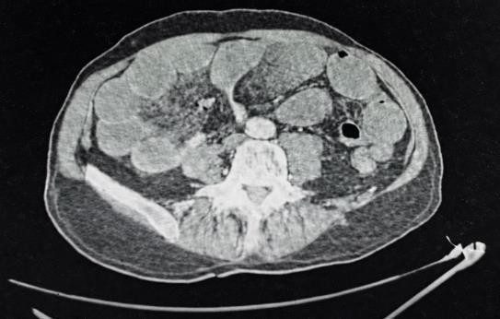

Image 1 : axial projection of a Ct scan showing small bowel obstruction secondary to an adhesion band, showing distal ileal wall thickening with adjacent mesenteric fat infiltration, multiple small mesenteric lymph nodes, and collapsed distal jejunal, ileal, and colonic loops,
without pneumatosis or free air.

The diagnosis of a closed-loop small bowel obstruction, most likely secondary to adhesions, without perforation or bowel wall pneumatosis, was established.

A midline laparotomy incision, centred on the umbilicus, was performed. Intraoperative Exploration revealed a retro-umbilical ileo-epiploic adhesion, located approximately 1 metre from the first jejunal loop, causing strangulation of the small bowel. The affected bowel was markedly dilated and hyperaemic, with a moderate serous peritoneal effusion.

We performed an adhesiolysis, after wich the affected loop regained normal colour and peristalsis. The remainder of the exploration revealed no perforation. A Redon drain was placed in the pouch of Douglas.
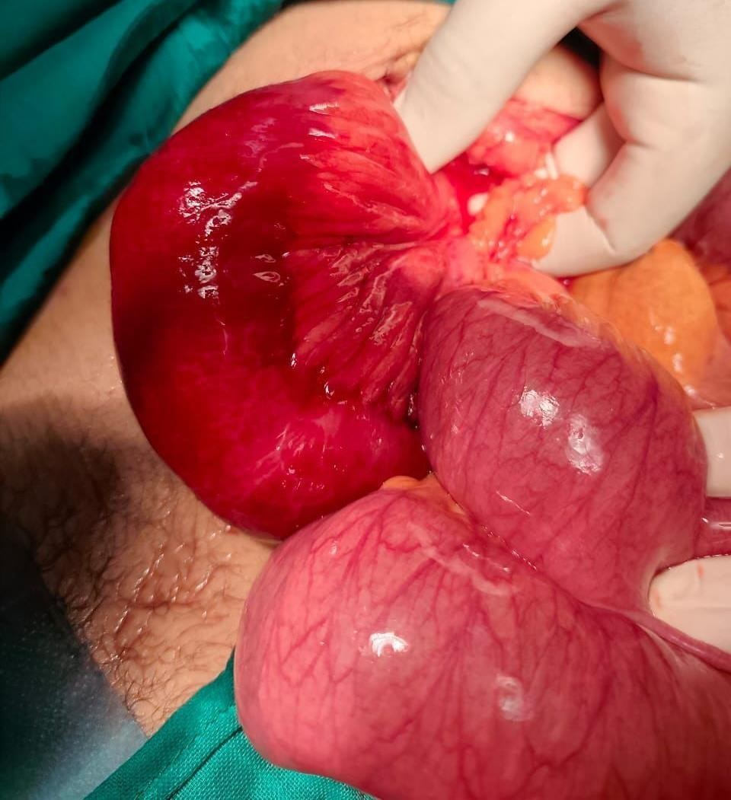

Image 2: intraoperative view showing and ileo-mesenteric band
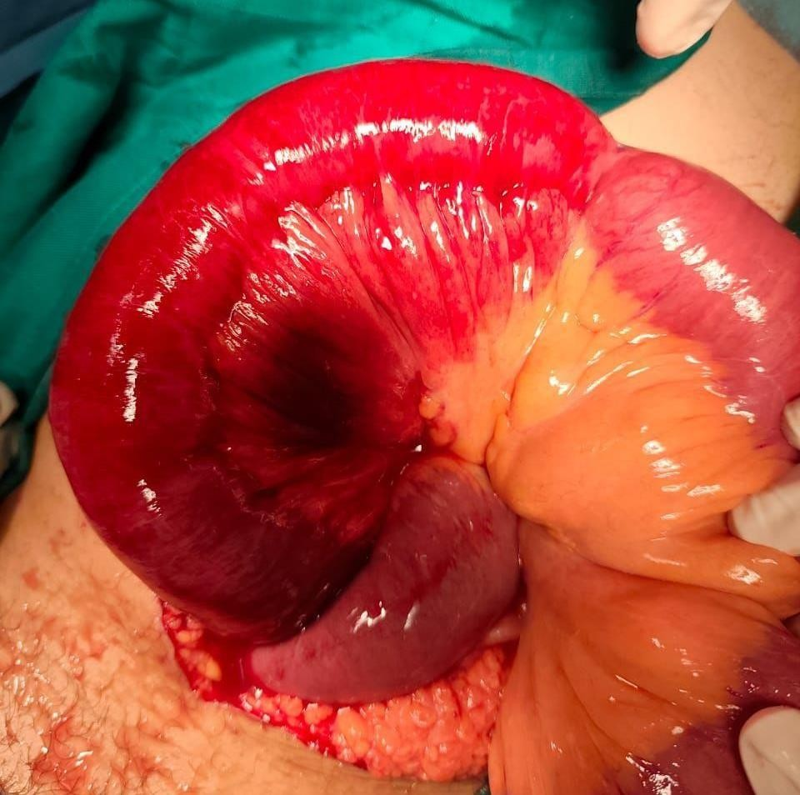

Image 3: intraoperative view showing the band’s resolution.

The patient was discharged at post-operative day 4, the follow ups found no, further complication.
Discussion

Small bowel obstruction (SBO) is a frequent surgical emergency, representing up to 12–16% of surgical admissions and ~20% of emergency laparotomies worldwide. The predominant etiology globally remains intraperitoneal adhesions, accounting for 55–75% of mechanical SBO cases in most series. Most adhesive SBO (ASBO) cases arise after previous abdominal surgery, with
~80–90% of patients having a surgical history; however, obstruction from adhesions can also occur
in a virgin abdomen, suggesting non-operative or congenital origins can rarely be causative.[1]

Although congenital adhesive bands are exceptionally rare relative to postoperative adhesions, case reports and cohort analyses confirm they are a valid etiology of SBO in patients without prior surgery, including ileo-ileal bands that compress or form a closed loop around the small bowel.[2]

INTRA-ABDOMINAL ADHESIONS CAN be congenital or acquired, incomplete or complete, and single or matted. Adhesive SBO results from fibrous bands that form abnormal connections between loops of bowel, mesentery, or peritoneum, leading to luminal obstruction, vascular compromise, and potential closed-loop obstruction. Postoperative adhesions are initiated by peritoneal injury triggering inflammation, fibrin deposition, and fibroblast proliferation. In contrast, congenital or primary adhesive bands are believed to represent aberrant peritoneal attachments from embryologic developmental anomalies or de novo fibrous formations in the virgin abdomen without prior surgical insult.they are uncommon (3%), often asymptomatic, and can present as an incidental finding in all ages [2,3]

At sites where adhesions form, intestines can kink or twist, resulting in incomplete or complete mechanical SBO. In incomplete (partial or low grade) obstruction, some fluid or gas is still able to pass, whereas in complete (high grade) obstruction, no fluid or gas can pass beyond the site of obstruction. [2]

Once an adhesive band compresses the small bowel, it can obstruct transit and venous outflow, leading to bowel wall edema, ischemia, and necrosis if not relieved. Closed loop pathology poses a particularly high risk for ischemia due to compromised arterial and venous flow within a segment isolated at two points.[4]

Diagnosing adhesive SBO begins with clinical suspicion in patients with abdominal pain, distension, vomiting, and inability to pass flatus. In cases without prior surgery, diagnosis may be delayed due to low clinical suspicion. Imaging is crucial:

Plain abdominal radiography can demonstrate air-fluid levels and dilated loops
consistent with SBO but has limited specificity. [1,5]

Computed tomography (CT) has become the diagnostic modality of choice for SBO, identifying the transition point, site of obstruction, evidence of closed-loop obstruction, and signs of strangulation or ischemia. CT is particularly valuable when the etiology is unclear or in virgin abdomens, as it guides management decisions. [1,5]
Ultrasound : It has limited value in diagnosing ASBO. It is highly operator- dependent, air may obscure the underlying findings and be difficult to perform in obese patients. But maybe particularly important in pregnancy and to rule out other diagnoses. [1]

Water-Soluble Contrast (Gastrografin) Study (WSCS) : A hyperosmolar, water-soluble contrast agent, meglumine amidotrizoate (Gastrografin), has proven to be valuable in the management of patients undergoing initial non-operative treatment for adhesive small bowel obstruction (ASBO). It possesses both diagnostic and therapeutic properties. Mechanistically, it promotes the osmotic movement of water into the intestinal lumen, thereby reducing bowel wall oedema and enhancing smooth muscle contractility. This, in turn, facilitates effective peristalsis, which may aid in resolving the obstruction.
The administration of Gastrografin can be undertaken either at the time of admission or following an initial trial of conventional conservative management. From a diagnostic perspective, it assists in differentiating between partial and complete obstruction and serves as a prognostic indicator for the need for surgical intervention. Specifically, failure of the contrast medium to reach the colon within 24 hours is generally indicative of a complete obstruction and is associated with a higher likelihood of requiring operative management [1].

For primary ileo-ileal adhesive bands, preoperative radiologic identification of the adhesive band itself is challenging; thus definitive diagnosis often occurs at exploratory surgery. Endoscopy and contrast studies may play a supplementary role but are less definitive.[1]

Management of adhesive SBO can be broadly categorized into non-operative and operative
strategies.

Partial ASBO and without signs of of ischemia or peritonitis can safely undergo the initial trial of non-operative management with success in about 60% to 85% of patients. This typically includes:

Bowel rest and nil per os (NPO),

Gastric and/or long-tube decompression,

Intravenous fluid resuscitation and electrolyte correction,

Use of water-soluble contrast agents (e.g., Gastrografin) that can aid both diagnosis and resolution in select patients.

Non-operative management avoids the morbidity of surgery; when safe to pursue. Failure of clinical improvement or signs of strangulation, perforation, ischemia or peritonitis require urgent surgery. [6,7]

Surgical intervention is indicated in the presence of peritonitis, strangulation, ischemia, closed-loop obstruction, or failed non-operative therapy. The operative approach typically involves adhesiolysis and release of the obstructing band; bowel resection is only required if non- viability is encountered.[8,9]

A midline laparotomy with adhesiolysis is the gold standard approach. However, laparotomy has higher risks of wound infection, incisional hernia, and future adhesions. With advances in minimal access technology and increasing experience, LAL is recommended. Laparoscopic
adhesiolysis reduces the duration of surgery by 50%, postoperative pain, length of stay, and adhesion formation compared to open laparotomy when technically feasible. [2,6,9]

The use of laparoscopy in the management of bowel obstruction is associated with certain inherent limitations, including technical difficulty in handling distended bowel loops, reduced visualisation of the underlying cause of obstruction, and comparatively higher procedural costs. Despite these constraints, evidence from meta-analytical studies indicates that laparoscopic and open surgical approaches demonstrate no significant differences in key clinical outcomes, including rates of intraoperative bowel injury, wound infection, and overall mortality. Furthermore, both approaches have been reported to yield comparable results with respect to the incidence of adhesion reformation and overall adhesion scores, suggesting equivalent long-term outcomes in this regard. [2,6]

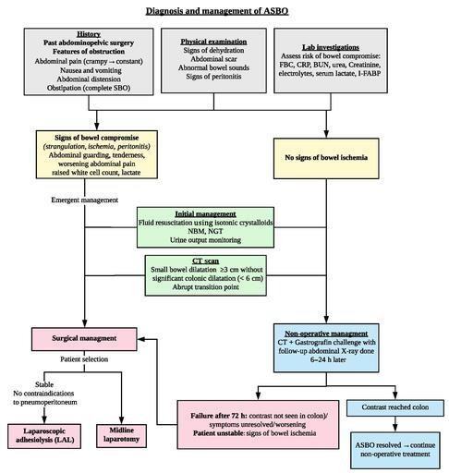For primary ileo-ileal bands specifically, definitive resolution generally requires surgical excision of the band, with segmental resection only if strangulation or non-viable bowel is present. Several recent case reports reinforce the feasibility of laparoscopic band division in appropriate
cases, particularly in stable patients with localized obstruction.[2]

Image 4: Approach to adhesive small bowel obstruction (ASBO) evaluation and management.[2]

While postoperative adhesion prevention strategies (e.g., minimally invasive surgery, adhesion barriers) aim to reduce future SBO risk, they do not apply in congenital or primary bands
but may be considered in patients undergoing operations for recurrent adhesive disease. Recurrence remains a concern after SBO surgery, and long-term follow-up is advisable.[1]

Conclusion

Primary ileo-mesenteric adhesive bands is a rare but importante cause of small bowel obstruction in patients without prior abdominal surgery. Clinical presentation can be nonspecific, and preoperative diagnosis is often challenging, with CT imaging serving as a key tool to identify obstruction, closed-loop configuration, and signs of bowel compromise. Definitive management requires timely surgical intervention, typically via adhesiolysis, with bowel resection reserved for non-viable segments. Awareness of this entity is essential to prevent delayed diagnosis, reduce the risk of ischemic complications, and achieve favourable postoperative outcomes

Consent
As per international standards or university standards, patient(s) written consent has been collected and preserved by the author(s).
Ethical Approval:

As per international standards or university standards written ethical approval has been collected and preserved by the author(s).

Disclaimer (Artificial intelligence)

Author(s) hereby declare that NO generative AI technologies such as Large Language Models (ChatGPT, COPILOT, etc.) and text-to-image generators have been used during the writing or editing of this manuscript.

References

1. Ghimire P, Maharjan S. Adhesive Small Bowel Obstruction: A Review. J Nepal Med Assoc.
2023;61(260):390–396.

2. Lan Q et al. Acute small bowel obstruction caused by a fan-shaped congenital band. Front
Pediatr. 2025.

3. Tong VW et al. Adhesive small bowel obstruction – an update. Surg Update. 2018

4. Detz DJ et al. Small bowel obstruction. Abdom Emerg Surg. 2021
5. ten Broek RPG et al. Bologna guidelines for diagnosis and management of ASBO. World J Emerg Surg. 2018

6. Evidence-based conservative and surgical management of SBO. JACS. 2025.

7. Di Saverio S, Coccolini F, Galati M, Smerieri N, Biffl WL, Ansaloni L, et al. Bologna guidelines for diagnosis and management of adhesive small bowel obstruction (ASBO): 2013 update of the evidence-based guidelines from the world society of emergency surgery ASBO working group. World J Emerg Surg. 2013 Oct 10;8(1):42. doi: 10.1186/1749-7922-8-42.

8. ASBO guidelines emphasize operative criteria and timing. World J Emerg Surg. 2018

9. Zielinski MD, Bannon MP: Current management of small bowel obstruction. Adv in Surg. 2011,
45: 1-29. 10.1016/j.yasu.2011.03.017.

