1
Case report
2 Trapped in the Cocoon :
3 A Rare Case of Small Bowel Obstruction

15 .
16 ABSTRACT
17
Introduction: Abdominal cocoon syndrome (ACS), or encapsulating peritoneal sclerosis (EPS), is a rare cause of small bowel obstruction characterized by fibrous encapsulation of the intestines. Its nonspecific clinical and radiological presentation makes it easily overlooked and delayed diagnosis can lead to significant worse patient outcomes. This case report aims to raise clinical awareness of ACS and underscore the importance of maintaining a high index of suspicion in patients presenting with small bowel obstruction.
Case Presentation: A 58-year-old male presented with clinical signs of complete small bowel obstruction. CT imaging revealed clustered small bowel loops within a sac-like structure. Exploratory laparotomy, performed for abdominal cocoon with small bowel obstruction, demonstrated that the small bowel was encased in a thick fibrocollagenous membrane with dense adhesions, without evidence of ischemia. Adhesiolysis was successfully performed to release the trapped bowel. Histopathology confirmed EPS without evidence of malignancy or tuberculosis. The patient remained asymptomatic at one-year follow-up.
Discussion: Preoperative diagnosis of the ACS remains challenging due to its uncertain clinical and radiological presentation. Although CT imaging may suggest the condition through characteristic findings, definitive diagnosis is typically made intraoperatively. Surgical excision of the fibrous membrane with meticulous adhesiolysis remains the treatment of choice, as non-operative management is rarely successful. Timely surgical intervention is key to preserve bowel viability and improve patient’s outcomes. Histopathologic evaluation is essential for diagnosis with subsequent management guided by the histopathologic findings.

Conclusion: Abdominal cocoon syndrome (ACS) is a rare but clinically significant cause of small bowel obstruction. Its characteristic findings from CT imaging plays a crucial role in preoperative diagnosis while early recognition and prompt surgical intervention with meticulous adheolysis resulted in complete resolution of obstruction and satisfactory outcomes.
18
- Keywords: Abdominal Cocoon Syndrome, Small bowel obstruction, Contrast-enhanced computed tomography, Cauliflower sign, Membrane excision, Adhesiolysis, Fibrocollagenous membrane

26

1. INTRODUCTION

- Abdominal cocoon syndrome (ACS), also known as encapsulating peritoneal sclerosis
- (EPS), is a rare condition characterized by the progressive formation of a dense
- fibrocollagenous membrane encasing the small bowel within the peritoneal cavity, leading to
- reduce interbowel loop space, impaired peristalsis and intestinal obstruction (1, 2), arising
- from recurrent episodes of low grade or subclinical peritonitis (1). Over time, this condition
- progresses to sclerosis and thick membrane formation, leading to the development of a
- cocoon-like structure (1).
- The syndrome is classified into two types: primary (idiopathic) and secondary. Idiopathic
- ACS, more prevalent in tropical and subtropical regions, commonly affects young
- individuals—particularly females—without any identifiable predisposing factors (1, 3). In
- contrast, secondary ACS arises as a consequence of chronic peritoneal inflammation
- associated with conditions such as prior abdominal surgery, peritoneal dialysis, intra-
- abdominal infections (including tuberculosis), organ transplantation, autoimmune disease, or
- prolonged medication use (1, 2).
- Preoperative diagnosis of ACS remains challenging due to its nonspecific clinical
- presentation, often mimicking other causes of small bowel obstruction. Patients typically
- present with recurrent episodes of abdominal pain, nausea, vomiting, distension, and
- constipation (clinical small bowel obstruction) (2, 21). Although computed tomography (CT) and
- magnetic resonance imaging (MRI) may demonstrate suggestive findings—such as
- clustered small bowel loops encapsulated within a sac-like structure or the characteristic
- “cauliflower sign”—definitive diagnosis is usually established intraoperatively (4, 5, 21).
- Awareness of this rare entity is crucial, as timely surgical intervention with excision of the
- fibrous membrane and adhesiolysis - whether performed laparoscopically or via open
- surgery, and in both elective and urgent settings - can significantly improve patient outcomes
- and prevent unnecessary bowel resection when obstruction occurs (1).
54

2. CASE PRESENTATION
- A 58-year-old male, a known case of abdominal cocoon diagnosed by CT scan due to
- chronic abdominal pain, presented to the Acute Care Surgery service with progressive
- generalized abdominal pain, nausea, vomiting and obstipation persisting for more than 6
- hours. Physical examination revealed that he was afebrile with stable vital signs. Abdominal

- examination showed mild distention with hyperactive bowel sounds above the umbilicus and
- a palpable bowel loop, but no tenderness or peritoneal signs. Digital rectal examination
- revealed an empty rectum. Laboratory investigations were within normal limits except for
- mild metabolic acidosis (bicarbonate 20 mmol/L). Abdominal radiographs showed a soft
- tissue mass-like lesion at left-sided abdomen and multiple air-fluid levels at mid abdomen
- (Fig.1). Complete small bowel obstruction was diagnosed, and contrast-enhanced CT was
- performed, revealing a sac-like encapsulated area in the left to mid-abdomen with enhancing
- peritoneal lining—findings that are consistent with abdominal cocoon syndrome. There was
- also a closed-loop small bowel obstruction within the sac (Fig 2). The patient underwent
- exploratory laparotomy with adhesiolysis and incidental appendectomy. Intraoperatively, the
- entire small bowel was encased in a thick fibrous whitish capsule with dense adhesions and
- a transition point at the distal jejunum; bowel was viable with no masses or lesions.
- Approximately 50 mL of clear yellow ascites was noted (Fig 3). The postoperative course
- was uneventful, and the patient was safely discharged home without recurrence at 1-year
- follow-up. Histopathological examination revealed thickened fibrocollagenous tissue with
- lymphoplasmacytic infiltration, compatible with encapsulated peritoneal sclerosis, without
- granuloma, TB-related, malignancy, or features of IgG4-related disease. The patients’ data
- are summarized along with a literature review in Table 1.
78
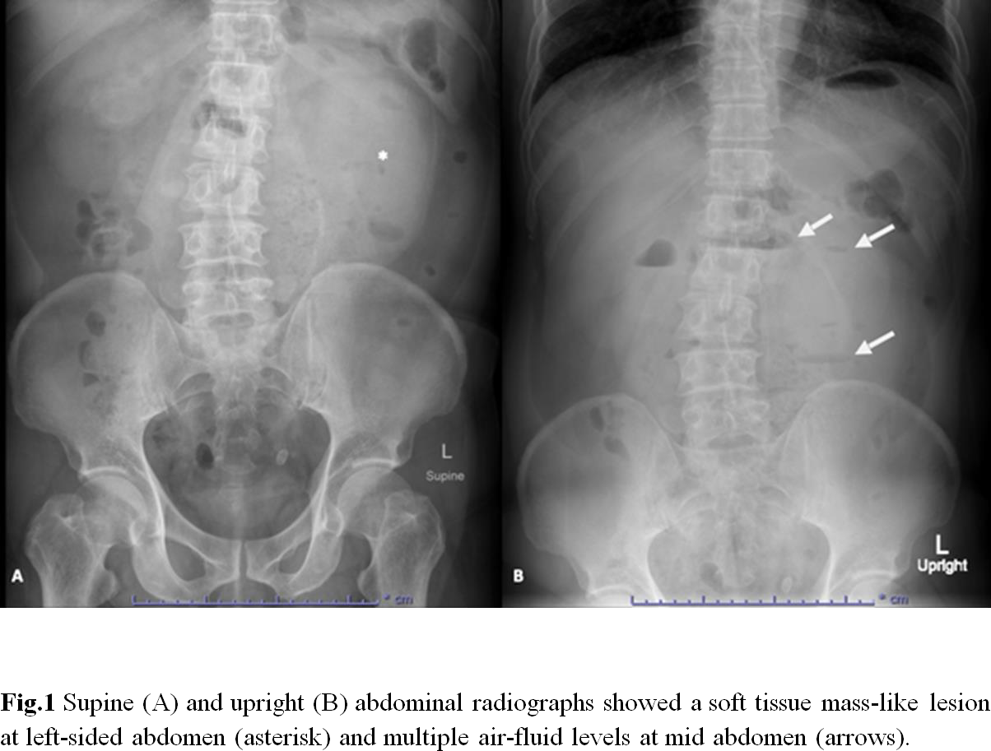
79
80

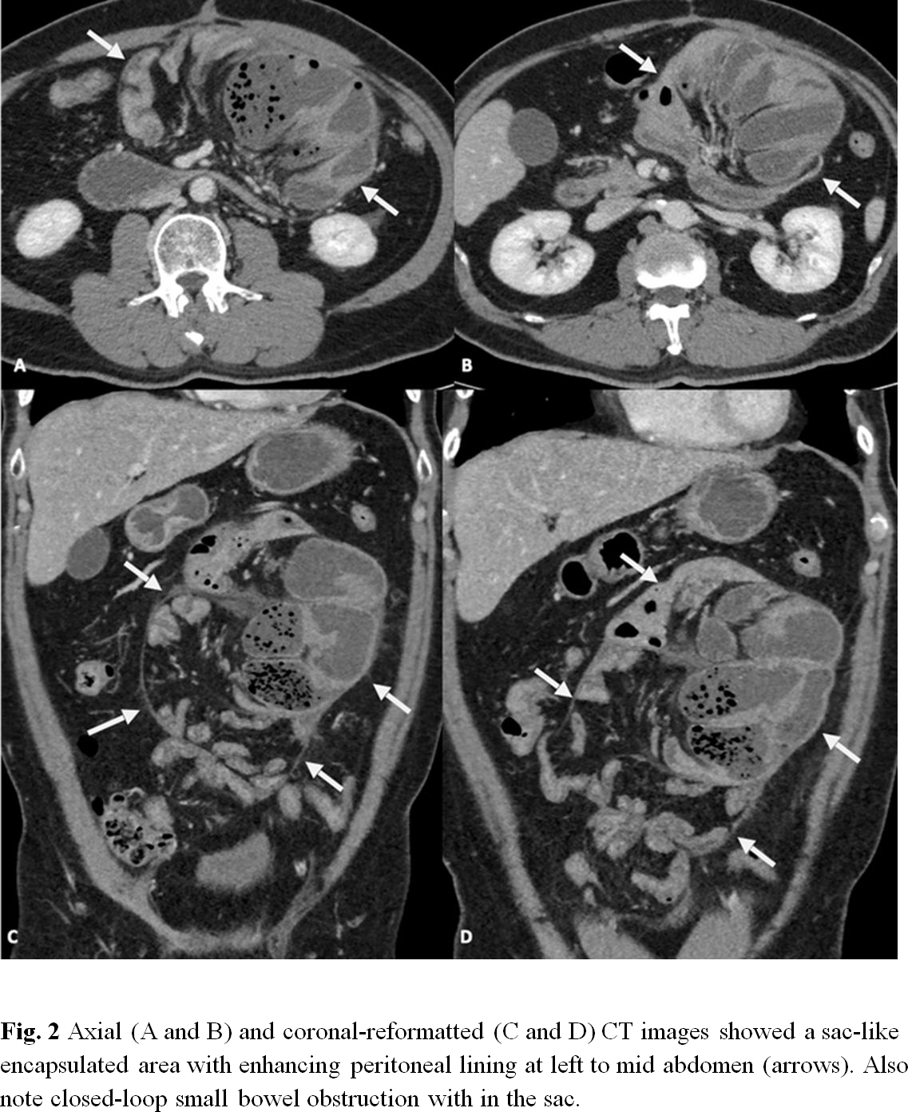
81

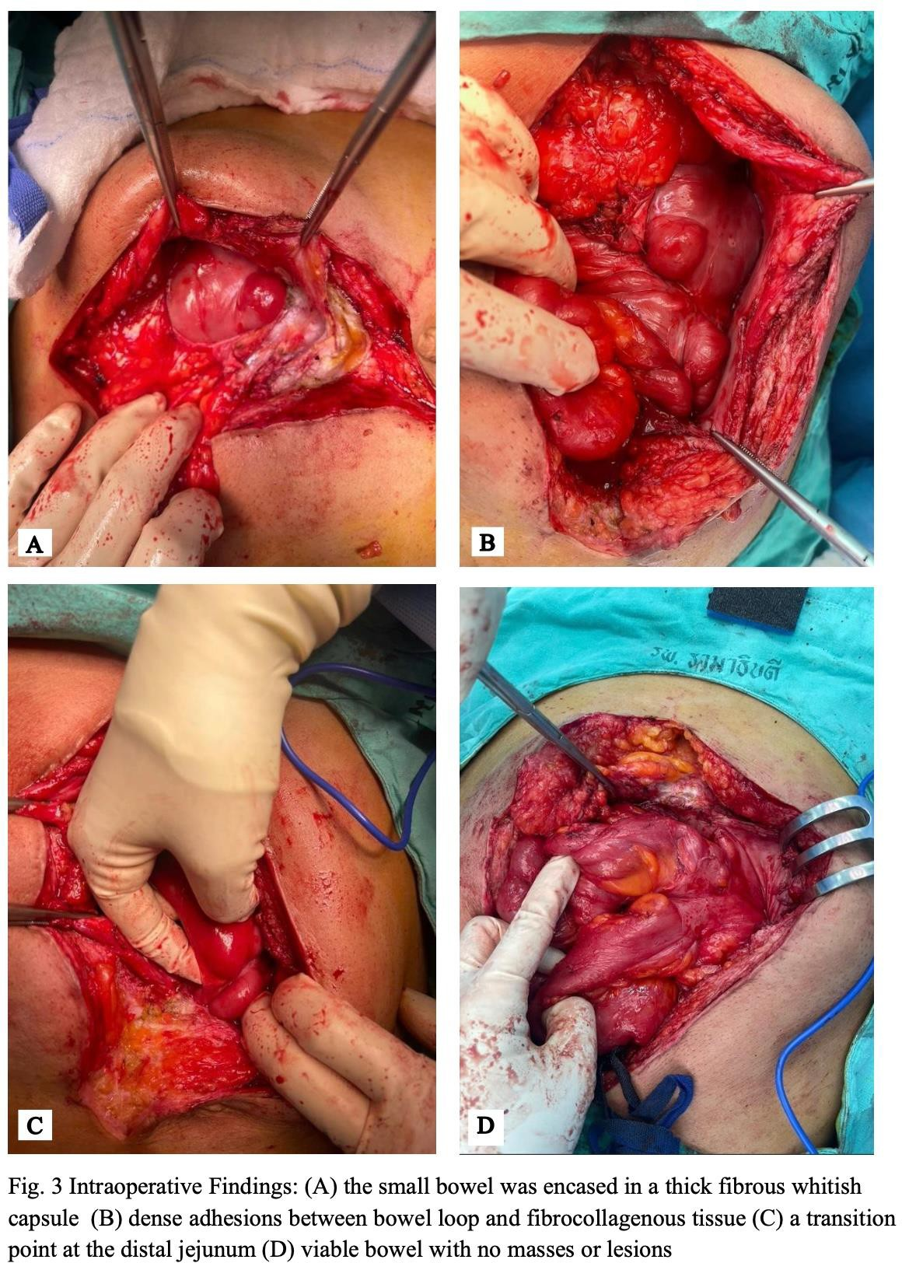
82
83

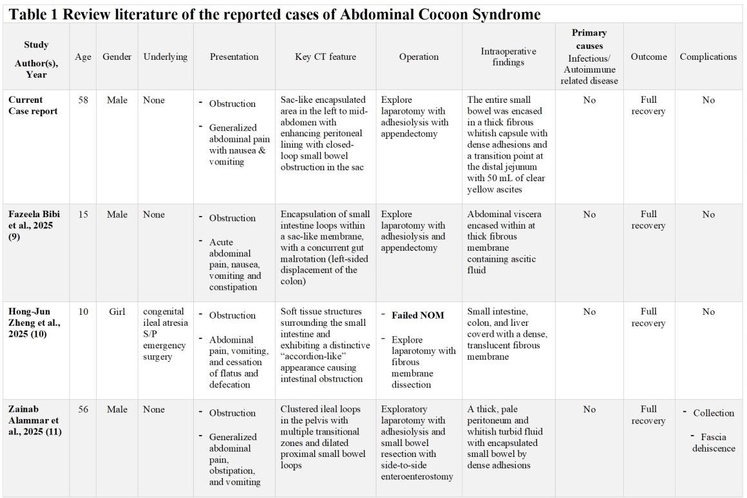
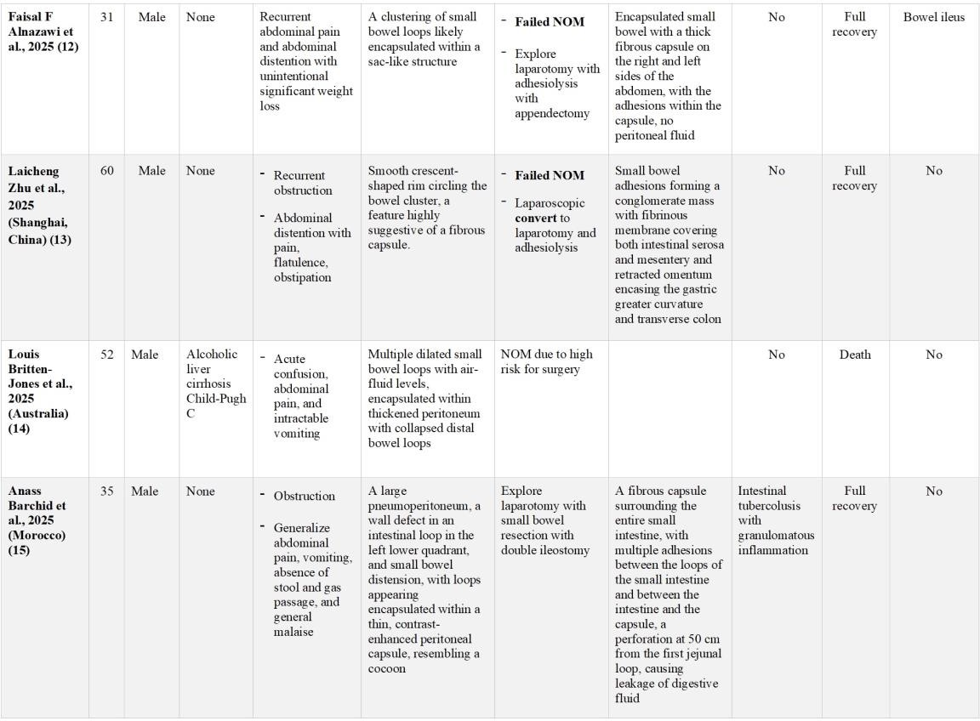
84

85

86
87
88
89
90
91
92
93
94
95
96
97
98
99
100
101
102
103
104
105
106
107
108
109

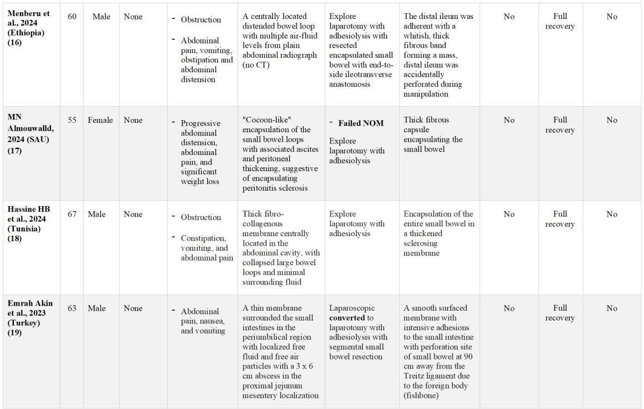
DISCUSSION

Abdominal cocoon syndrome (ACS), also known as encapsulat peritoneal sclerosis (EPS) is a rare disease characterized by partial or complete encasement of the small intestine by a thick, fibrocollagenous membrane, resulting in varying degrees of intestinal obstruction (1). Despite over a century since its initial description, EPS remains a diagnostic challenge owing to its rarity and nonspecific clinical presentation. Patients typically present with symptoms of small bowel obstruction which often mimic those of more common causes of obstruction (1). A summary of the literature review on the presentations, imaging, management, causes, and outcomes of EPS is presented in Table 1 (9-19). Our literature review found that the age of onset varies widely, ranging from 10 to 67 years, although most cases occur after the age of 40, with a mean age of 42 years. The predominant clinical presentation, observed uniformly across reported cases, is small bowel obstruction including our reported case.
Preoperative diagnosis of EPS is notoriously difficult due to the nonspecific nature of clinical and imaging findings. While plain abdominal radiographs often show features consistent with bowel obstruction, they are not diagnostic. Contrast-enhanced computed tomography (CECT) remains the modality of choice for preoperative assessment (4).
From the review and our reported case, we found typical CT finding of clustered small bowel loops encased by a thin or thick membrane, the presence of ascitic fluid between bowel loops, peritoneal thickening, and occasionally the cauliflower sign—a dilated second and third part of the duodenum caused by distal encasement (3, 4) which can assist in establishing the diagnosis. In our reported case, CT imaging demonstrated a sac-like

  - encapsulated small bowel segment with a transition point at the distal duodenum and
  - reduced wall enhancement, findings highly suggestive of EPS.
  - Non-operative management of small bowel obstruction in EPS is rarely successful and
  - carries a high risk of recurrent or complete obstruction. In large reviews of primary EPS, 99.4%
  - of symptomatic patients ultimately required surgery after failed conservative management (1).
  - Based on our review, exploratory laparotomy remains the operative approach of choice, as
  - laparoscopic attempts are often unsuccessful and frequently require conversion to open
  - surgery. Definitive diagnosis is typically made intraoperatively, as most patients are
  - diagnosed during exploratory laparotomy. Intraoperative findings commonly include the small
  - bowel completely or partially enclosed by a whitish, fibrotic membrane, often accompanied by
  - serous ascites and dense interloop adhesions. The principal surgical objective is the careful
  - excision of the fibrous encapsulating membrane and meticulous adhesiolysis to free the
  - entrapped bowel loops while preserving intestinal integrity. Resection of the bowel is indicated only
  - if it is nonviable. Manipulation during surgery should be light and soft to avoid injury to the intestinal
  - serosa. (21) In some study, additional appendectomy is also worth recommending because the
  - AC surgery would be difficult if appendicitis were to occur (21).
  - Histopathology remains the gold standard for confirming the diagnosis and distinguishing
  - EPS from mimicking conditions such as peritoneal carcinomatosis and tuberculous
  - peritonitis. In endemic regions, tuberculosis must always be excluded, as peritoneal TB can
  - present with a thick fibrinous exudate mimicking the fibrotic cocoon seen in EPS.
  - From the review, pathologic reports indicate that most cases arise from primary cause
  - (idiopathic) including our reported case. EPS is classified into two forms: primary (idiopathic)
  - and secondary. The idiopathic form occurs without an identifiable underlying cause and is
  - most frequently reported in young men in tropical and subtropical regions (1). Current
  - understanding of the pathogenesis remains unclear, though theories suggest the involvement
  - of cytokine-mediated fibroblast activation and angiogenic factors leading to peritoneal fibrosis.
  - Potential causes include retrograde menstruation, viral infections, retrograde peritonitis, and
  - immune system damage, all of which can lead to inflammation and fibrosis, However, some studies
  - have suggested a possible link to vascular anomalies and omental hypoplasia (20, 21). Secondary
  - EPS, on the other hand, develops secondary to chronic peritoneal inflammation associated with
  - previous abdominal surgery, peritoneal dialysis, recurrent peritonitis, tuberculosis, liver
  - transplantation, or prolonged medication use, such as β-blockers (1). Further dedicated research
  - into the molecular pathogenesis of the idiopathic form is warranted, as a deeper understanding of
  - these processes may ultimately pave the way for more targeted and potentially less invasive
  - therapeutic approaches beyond surgical intervention.
  - Postoperative complications include transient ileus, early postoperative bowel obstruction,
  - and surgical site infection, which are generally self-limiting (7, 8). For secondary EPS,
  - treatment of the underlying cause remains essential. Currently, there are no established
  - protocols for management of secondary EPS. Early prophylaxis of EPS is recommended,
  - focusing on glucocorticoids, tamoxifen and immunosuppressive agents (1). However, dosing
  - and duration of these medical interventions are not well-defined due to the limited evidence
  - of large clinical trials. Therefore, the management of both primary and secondary
  - EPS requires a comprehensive, multidisciplinary approach tailored to each patient’s clinical
  - condition, underlying etiology, and disease severity.
  - This case report has several limitations. First, as a single-case report, the findings and conclusions
  - cannot be generalized to a broader patient population. However, a series of EPS case reports were
  - reviewed and discussed in order to wider perspective. Second, one-year follow-up duration may be
  - insufficient to capture late recurrence or delayed postoperative complications, and extended
  - surveillance is warranted. Third, the idiopathic nature of this case means that the underlying
  - etiological trigger remains unidentified, which limits any mechanistic conclusions that can be drawn.
  - Finally, advanced molecular and immunohistochemical workup beyond routine histopathology was
  - not performed, which restricts further insight into the pathophysiological processes driving
  - peritoneal fibrosis in the idiopathic form of this disease.

  - 4. CONCLUSION
  - Abdominal cocoon syndrome (ACS) causing small bowel obstruction is a rare condition. While
  - characteristic CT findings can assist in preoperative diagnosis, definitive diagnosis is established
  - intraoperatively. Non-operative management is generally unsuccessful and may lead to complete
  - obstruction or bowel ischemia. The condition is predominantly idiopathic, and postoperative
  - outcomes are generally favorable.

  - COMPETING INTERESTS
175 Authors have declared that no competing interests exist.

171 CONSENT
172
- All authors declare that ‘written informed consent was obtained from the patient for
- this case report and accompanying images. A copy of the written consent is
- available for review by the Editorial office/Chief Editor/Editorial Board members of this
- journal.
177
178

179 ETHICAL APPROVAL
180
- All authors hereby declare that all experiments have been examined and approved by the
- appropriate ethics committee and have therefore been performed in accordance with the
- ethical standards laid down in the 1964 Declaration of Helsinki.

- Disclaimer (Artificial intelligence)

- Author(s) hereby declare that NO generative AI technologies such as Large Language Models (ChatGPT, COPILOT, etc.) and text-to-image generators have been used during the writing or editing of this manuscript.

184
185 REFERENCES
186
- 1.Vipudhamorn W, Juthasilaparut T, Sutharat P, Sanmee S, Supatrakul E, Chowsilpa S, et
- al. Unraveling the enigma of sclerosing encapsulating peritonitis: a comprehensive review.
- Ann Coloproctol. 2025;41(3):175–89.
- 2.Akbulut S. Accurate definition and management of idiopathic sclerosing encapsulating
- peritonitis. World J Gastroenterol. 2015;21(2):675–87.
- 3.Endeshaw Menberu, Guteta S, Bekele T, Mengistu SM, Yonathan Aliye, Merga Daba, et al. Abdominal cocoon syndrome, a rare and interesting cause of intestinal obstruction: A case report. Clinical Case Reports. 2024 Aug 1;12(8).
- ‌4.Singhal M, Krishna S, Lal A, Narayanasamy S, Bal A, Yadav TD, et al. Encapsulating
- Peritoneal Sclerosis: The Abdominal Cocoon. Radiographics. 2019;39(1):62–77.
- 5.Ethiraj D IV. Abdominal Cocoon: "Cauliflower Sign" on Contrast-Enhanced Computed
- Tomography Scan. GE Port J Gastroenterol. 2020;Dec 28(1):76–84.
- 6.Alsadery HA, Busbait S, AlBlowi A, Alsawidan M, AlBisher HM, Alshammary S. Abdominal
- cocoon syndrome (idiopathic sclerosing encapsulating peritonitis): An extremely rare cause
- of small bowel obstruction-Two case reports and a review of literature. Front Med
- (Lausanne). 2022;9:1003775.

- 7.Li N, Zhu W, Li Y, Gong J, Gu L, Li M, et al. Surgical treatment and perioperative
- management of idiopathic abdominal cocoon: single-center review of 65 cases. World J
- Surg. 2014;38(7):1860–7.
- 8.Akbulut S, Yagmur Y, Babur M. Coexistence of abdominal cocoon, intestinal perforation
- and incarcerated Meckel's diverticulum in an inguinal hernia: A troublesome condition. World
- J Gastrointest Surg. 2014;6(3):51–4.
- 9.Bibi F, Ibrahim M, Khan U, Rahman SU, El Abdi K, Khan MA, et al. Abdominal cocoon
- syndrome: a case report. J Surg Case Rep. 2025;2025(9):rjaf696.
- 10.Zheng HJ, Zhang JD, Wang ZC, Yao LY. Abdominal cocoon syndrome in a 10-year-old
- young adolescent after abdominal operation: A case report and review of literature. World J
- Clin Cases. 2025;13(22):106122.
- 11.Alammar Z, Alnajjar JS, Almarzooq MA, Alquaimi M. Idiopathic cocoon syndrome
- presenting as small bowel obstruction with asymptomatic postoperative intra-abdominal
- collection: a case report. J Surg Case Rep. 2025;2025(8):rjaf595.
- 12.Alnazawi FF, Bnqadim AT, Chapra SM. Primary Encapsulating Peritoneal Sclerosis: An
- Extremely Rare Cause of Small Bowel Obstruction. Cureus. 2025;17(5):e84065.
- 13.Zhu L, Zhao F, Liu W, Bao A, Wang G, Zong Y, et al. Fibrous membrane stripping
- combined with nasointestinal ileus tube for abdominal cocoon: A case report and literature
- review. Sci Prog. 2025;108(2):368504251350076.
- 14.Britten-Jones L, Chui J, Wu MY, Chu G, Knox R, Wijayawardana R. Sclerosing
- encapsulating peritonitis in advanced liver cirrhosis presenting with acute small bowel
- obstruction: a case report and literature review. J Surg Case Rep. 2025;2025(3):rjaf159.
- 15.Barchid A, Fadil W, Ahallat A, Aggouri Y, Aitlaalim S. Cocoon Syndrome: A Rare Cause
- of Bowel Obstruction Revealing Hidden Intestinal Tuberculosis. Cureus. 2025;17(1):e77090.
- 16.Menberu E, Guteta S, Bekele T, Mengistu SM, Aliye Y, Daba M, et al. Abdominal cocoon
- syndrome, a rare and interesting cause of intestinal obstruction: A case report. Clin Case
- Rep. 2024;12(8):e9264.
- 17.Almouwalld MN. An Idiopathic Case of Sclerosing Encapsulating Peritonitis: A Case
- Report. Cureus. 2024;16(2):e53667.
- 18.Hassine HB, Chaouch MA, Touir W, Jabra SB, Zouari K, Noomen F. A case report of
- idiopathic sclerosing encapsulating peritonitis causing an acute bowel occlusion in adult. Int
- J Surg Case Rep. 2024;115:109249.
- 19.Akin E, Altintoprak F, Gonullu E, Yilmaz F, Alper Yildiz Y. Coexisting of small bowel
- perforation and abdominal cocoon syndrome: A case report. Turk J Surg. 2023;39(3):274–7.
- 20.Tannoury JN. Idiopathic sclerosing encapsulating peritonitis: Abdominal cocoon. World Journal of Gastroenterology. 2012;18(17):1999.
- ‌21. Wei B, Wei HB, Guo WP, Zheng ZH, Huang Y, Hu BG, et al. Diagnosis and treatment of abdominal cocoon: a report of 24 cases. The American Journal of Surgery. 2009 Sep;198(3):348–53.
- ‌

237

238
239
240
241

DEFINITIONS, ACRONYMS, ABBREVIATIONS

ACS: Abdominal Cocoon syndrome, EPS: encapsulating peritoneal sclerosis
NOM: Non-operative Management

