Bilobed Gallbladder Presenting as a Double Hartmann’s Pouch: A Rare Anatomical Variant During Laparoscopic Cholecystectomy

Abstract
Anatomical variations of the gallbladder may increase the risk of biliary injury during cholecystectomy if unrecognized. We report a rare intraoperative finding of a bilobed gallbladder presenting as a double Hartmann’s pouch in a patient undergoing laparoscopic cholecystectomy for symptomatic cholelithiasis. Preoperative ultrasonography did not reveal this anomaly. Intraoperatively, two prominent pouch-like outpouchings were noted at the gallbladder neck. Careful dissection of Calot’s triangle enabled clear delineation of anatomy, revealing a single cystic duct and artery. The critical view of safety was achieved prior to division of structures. The procedure was completed laparoscopically without complications. This case highlights the importance of recognizing atypical gallbladder morphology and adhering to safe surgical principles to prevent bile duct injury.
Keywords
Gallbladder Abnormalities; Laparoscopic Cholecystectomy; Biliary Tract ; Cholelithiasis; Bile Ducts

Introduction
Anatomical variations of the gallbladder are well recognized and include anomalies in number, shape, position, and ductal anatomy. These include duplication, septate gallbladder, Phrygian cap deformity, and diverticula. Such variations are clinically significant because they may distort the anatomy of Calot’s triangle and increase the risk of bile duct injury during cholecystectomy[1].
Hartmann’s pouch is an outpouching at the junction of the gallbladder neck and cystic duct and is commonly associated with gallstone disease. However, the presence of two distinct Hartmann’s pouches within a single gallbladder is extremely rare and poorly described in literature. This entity may represent a variant of bilobed gallbladder or an exaggerated morphological change secondary to chronic inflammation.
Recognition of such rare anatomical patterns is essential for surgeons to avoid misidentification of biliary structures and to ensure safe operative outcomes.

CASE PRESENTATION
A 32 year old male patient presented with intermittent episodes of epigastric and right hypochondrial pain of several months’ duration. The pain was colicky in nature and occasionally associated with nausea. There was no history of jaundice, fever, or previous abdominal surgery.
Clinical examination revealed mild tenderness in the right hypochondrium, with no palpable mass or signs of peritonitis. The patient had no significant comorbidities.
Based on clinical and radiological findings, a diagnosis of symptomatic cholelithiasis was made, and the patient was scheduled for elective laparoscopic cholecystectomy.
INVESTIGATIONS
- Ultrasonography of the abdomen revealed cholelithiasis with a largest calculus measuring approximately 11 mm
- Common bile duct was normal in caliber
- Liver function tests were within normal limits
No anatomical abnormality of the gallbladder was identified preoperatively.

TREATMENT
Standard four-port laparoscopic cholecystectomy was performed.
Intraoperatively, the gallbladder demonstrated two distinct pouch-like outpouchings at the infundibulum, giving the appearance of a double Hartmann’s pouch and a bilobed morphology (Figure 1). This unusual anatomy raised concern for possible duplication or aberrant biliary anatomy.
Meticulous dissection of Calot’s triangle was undertaken. The peritoneal folds were carefully cleared, and the hepatocytic triangle was defined. The critical view of safety was achieved, confirming the presence of a single cystic duct and a single cystic artery entering the gallbladder.
Both structures were clipped and divided. The gallbladder was dissected off the liver bed and retrieved laparoscopically (Figure 2). No intraoperative complications occurred.

OUTCOME AND FOLLOW-UP
The postoperative period was uneventful. The patient resumed oral intake on the same day and was discharged within 24 hours.
On follow-up, the patient remained asymptomatic with normal recovery and return to daily activities.
Histopathological examination confirmed chronic calculous cholecystitis.
DISCUSSION
Hartmann’s pouch is traditionally described as an outpouching at the gallbladder neck, often associated with gallstones and chronic inflammation. It is considered by many authors to be an acquired morphological change rather than a true congenital structure [2].
Congenital anomalies of the gallbladder, including duplication and bilobed variants, arise due to aberrations in the development of the hepatic diverticulum. A bilobed gallbladder represents incomplete division of the gallbladder primordium and typically drains via a single cystic duct [3].
The present case demonstrated a unique morphology with two prominent Hartmann’s pouches in a single gallbladder with a single cystic duct and artery [4]. This presentation lies at the intersection of:
- Bilobed gallbladder
- Prominent infundibular diverticula
- Inflammatory morphological changes
Differentiating between these entities intraoperatively can be challenging. Importantly, such variations may mimic:
- Gallbladder duplication
- Septate gallbladder
- Diverticular disease
The key surgical implication is the increased risk of bile duct injury due to misidentification of anatomy. In such scenarios, reliance on visual assumptions can be dangerous [5].
The cornerstone of safe management remains:
- Meticulous dissection
- Identification of only two structures entering the gallbladder
- Strict adherence to the critical view of safety, as described by Strasberg
A comprehensive review of the available literature, including PubMed-indexed case reports and series on gallbladder anomalies, reveals that while bilobed gallbladder and gallbladder duplication have been sporadically reported (Table 1), descriptions specifically detailing a double Hartmann’s pouch within a single gallbladder with a single cystic duct and artery are exceedingly scarce. Most reported cases of bilobed gallbladder describe either partial septation or external lobulation, without distinct duplication of the infundibular pouch. Similarly, diverticular and pseudo diverticular changes of the gallbladder have been described, but these typically involve localized mucosal outpouchings rather than two well-formed infundibular pouches.
To the best of our knowledge, after an extensive literature search, no previously published case has clearly documented this exact morphological configuration, making this case a rare addition to the spectrum of gallbladder anatomical variations. However, given the possibility of underreporting or variations in terminology, this finding should be interpreted with caution and viewed as a potentially unique or extremely rare presentation rather than an absolute first occurrence.
Table 1: Reported Cases of Bilobed Gallbladder
Author (Year) | Journal | Patient Demographics | Presentation | Diagnostic Modality | Biliary Anatomy | Management | Key Findings
Sharma et al. (2024) [6] | Archives of Medicine and Health Sciences | 34-year female | Acute abdominal pain | Ultrasound + MRCP | Bilobed gallbladder (H-type) with two cystic ducts | Laparoscopic cholecystectomy | Importance of detailed preoperative imaging to avoid complications
Alam et al. (2011) [1] | J Coll Physicians Surg Pak | 17-year female | Right hypochondrial pain (3 months) | Ultrasound | Bilobed gallbladder (intraoperative diagnosis) | Laparoscopic cholecystectomy | Complete removal essential to prevent recurrence
Oyar et al. (2003) [7] | Comput Med Imaging Graph | Adult (not specified) | Incidental finding | USG + Oral cholecystography + CT | Duplication of fundus and body with single cystic duct | Conservative / imaging-based diagnosis | Highlights variability based on degree of fusion and duct anatomy
Plewman et al. (2021) [8] | J Surg Case Rep | Adult (not specified) | Symptomatic cholelithiasis | Ultrasound | Bilobed gallbladder with single cystic duct (intraoperative discovery) | Laparoscopic cholecystectomy | Rare anomaly; only ~24 cases reported; importance of intraoperative recognition
Arza et al. (2024) [3] | Cureus | 22-year male | Acute RUQ pain, acute cholecystitis | Ultrasound + MRCP | Bilobed gallbladder with single cystic duct | Laparoscopic cholecystectomy (dome-down approach) | Difficulty in preoperative diagnosis; CVS critical
Kumar et al. (2018) [9] | BMJ Case Reports | Adult (not specified) | Symptomatic gallstones | Ultrasound | Bilobed gallbladder | Laparoscopic cholecystectomy | Imaging may be misleading; surgical awareness essential
Kannan et al. (2014) [5] | J Clin Diagn Res | Adult (not specified) | Calculus cholecystitis | MRI + cholescintigraphy | Bilobed gallbladder with Phrygian cap in both lobes | Laparoscopic cholecystectomy | Ultrasound may be inconclusive; advanced imaging useful
Martinoli et al. (1993) [10] | Br J Radiol / J Clin Ultrasound | Adult (not specified) | Incidental | CT + USG + oral cholecystography | Deeply cleft bilobed gallbladder with single cystic duct | Imaging diagnosis | Demonstrated anatomical classification and imaging features
Ozmen et al. (2003) [11] | Surg Laparosc Endosc Percutan Tech | Adult (not specified) | Symptomatic gallstones | Ultrasound | Bilobed gallbladder | Laparoscopic cholecystectomy | Early report confirming feasibility of laparoscopic management
This case report has certain limitations. Preoperative imaging with ultrasound failed to identify the anatomical variation, likely due to its operator dependence and limited ability to delineate complex biliary morphology. Additionally, no advanced preoperative imaging was performed, which could have better characterized the anomaly. Modalities such as MRCP or contrast-enhanced CT may serve as useful alternatives for preoperative diagnosis in cases where atypical anatomy is suspected.

Conclusion
Bilobed gallbladder presenting as a double Hartmann’s pouch with a single cystic duct and artery is an extremely rare anatomical variant that may not be detected on preoperative imaging. Such unusual morphology can increase the risk of biliary injury if unrecognized. This case highlights the importance of maintaining a high index of suspicion, performing meticulous dissection, and strictly adhering to the critical view of safety during laparoscopic cholecystectomy. Awareness of these rare variants is essential for ensuring safe surgical outcomes.

LEARNING POINTS
- Bilobed gallbladder presenting as double Hartmann’s pouch is an extremely rare anatomical variant.
- Preoperative imaging may fail to detect such anomalies.
- Unusual gallbladder neck anatomy increases the risk of biliary injury during cholecystectomy.
- Achievement of the critical view of safety is essential for safe surgical management.
- Surgeons should maintain a high index of suspicion when encountering atypical gallbladder morphology.

Disclaimer (Artificial intelligence)

Author(s) hereby declare that NO generative AI technologies such as Large Language Models (ChatGPT, COPILOT, etc.) and text-to-image generators have been used during the writing or editing of this manuscript.

Ethical Approval and Consent :

Written informed consent was obtained from the patient for this case report and any accompanying images. All efforts have been made to ensure the patient’s privacy, confidentiality, and anonymity, and no identifying information has been disclosed in the manuscript. The study was conducted in accordance with ethical standards and institutional guidelines. The authors declare that there is no conflict of interest related to this publication.

REFERENCES
1. Alam MT, Qaiser B, Jamaluddin M, Abbas Hussain SM. Bilobed gallbladder. J Coll Physicians Surg--Pak JCPSP. 2011;21(6):367-368.
2. ANDERSON RE, ROSS WT. Congenital Bilobed Gallbladder. AMA Arch Surg. 1958;76(1):7-12. doi:10.1001/archsurg.1958.01280190009002
3. Arza A, Stitzlein E, Jen J, et al. Bilobed Gallbladder: A Rare Anatomical Variation Discovered During Laparoscopic Cholecystectomy. Cureus. 2024;16. doi:10.7759/cureus.72300
4. Bajwa M. Bilobed Gall Bladder: A Rare Hepatobilliary Anomaly.
5. Kannan NS, Kannan U, Babu CPG. Congenital Bilobed Gallbladder with Phrygian Cap Presenting as Calculus Cholecystitis. J Clin Diagn Res JCDR. 2014;8(8):ND05-ND06. doi:10.7860/JCDR/2014/9057.4724
6. Sharma P, Prakash V, Chaudhary B. A Rare Case of Bilobed Gallbladder with Two Cystic Ducts. Arch Med Health Sci. 2024;12(1):116. doi:10.4103/amhs.amhs_109_23
7. Oyar O, Yesildag A, Gulsoy U, Sengul N, Isler M. Bilobed gallbladder diagnosed by oral cholecysto-CT. Comput Med Imaging Graph. 2003;27(4):315-319. doi:10.1016/S0895-6111(02)00023-X
8. Plewman D, Kudrna R, Rojas O, Ford J, Smith-Singares E. Bilobed gallbladder discovered during laparoscopic cholecystectomy: a tale of two lobes and one duct. J Surg Case Rep. 2021;2021(12):rjab579. doi:10.1093/jscr/rjab579
9. Kumar M, Adhikari D, Kumar V, Dharap S. Bilobed gallbladder: a rare congenital anomaly. BMJ Case Rep. 2018;2018:bcr2017222783. doi:10.1136/bcr-2017-222783
10. Martinoli C, Derchi LE, Pastorino C, Cittadini G JR. Imaging of a bilobed gallbladder. Br J Radiol. 1993;66(788):734-736. doi:10.1259/0007-1285-66-788-734
11. Ozmen V, Gorgun E, Unal ES, Polat C, Ozmen T. Laparoscopic Treatment of a Bilobed Gallbladder: A Case Report and Review of the Literature. Surg Laparosc Endosc Percutan Tech. 2003;13(5):345.

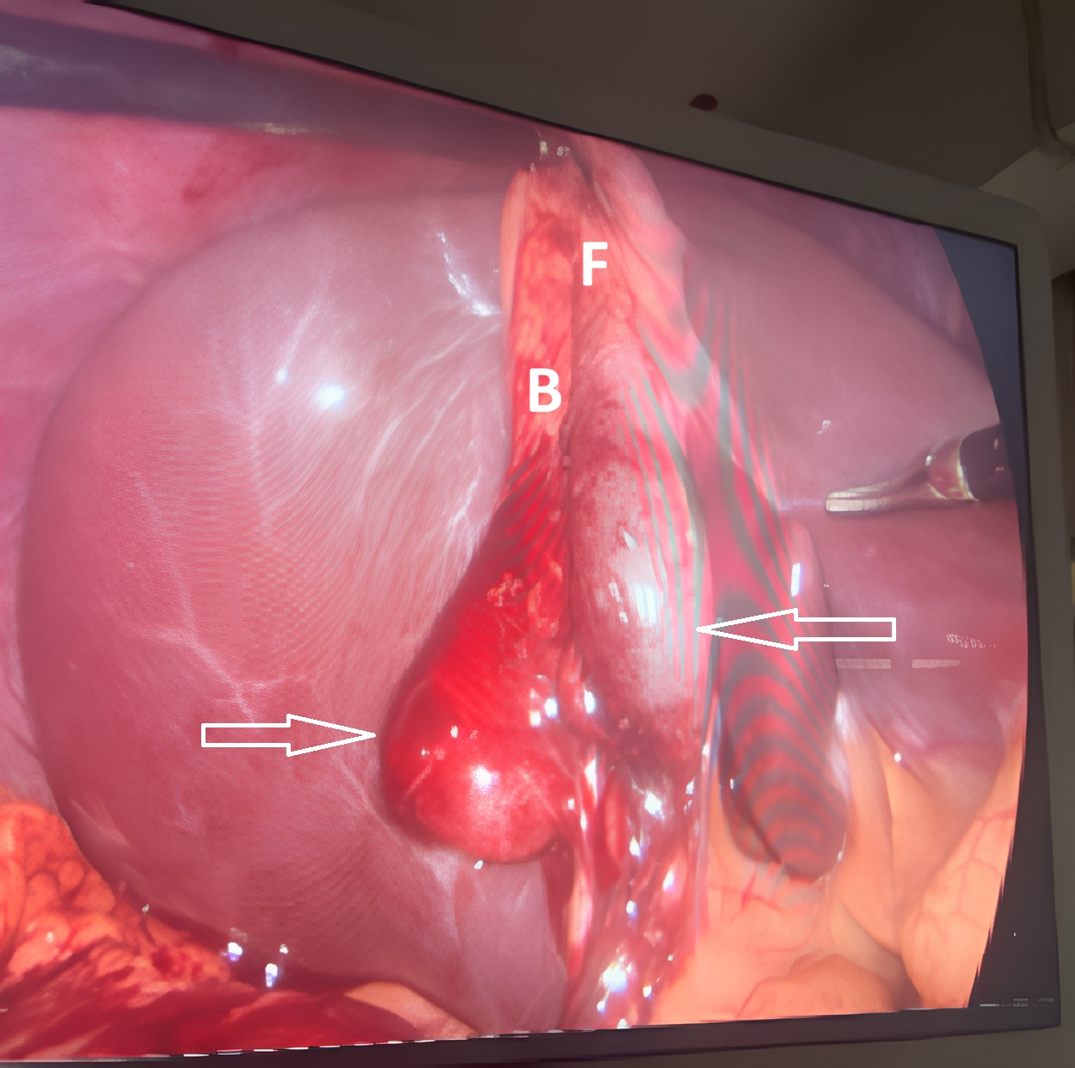
Figure 1: Intraoperative laparoscopic view demonstrating a bilobed gallbladder with two prominent infundibular outpouchings (double Hartmann’s pouch) (white arrows). The gallbladder fundus (F) and body (B) are visualized superiorly, while the infundibular region shows bifid morphology. Surrounding adhesions have been partially cleared to delineate anatomy.
(Image is author’s own work.)

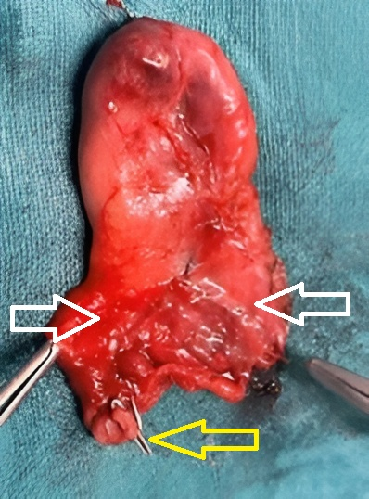
Figure 2: Gross specimen of the resected gallbladder showing bilobed morphology with two distinct infundibular pouches (double Hartmann’s pouch) (white arrows) and single cystic duct (yellow arrow). The lumen was found to contain calculi on sectioning.
(Image is author’s own work.)

