Case report
Primary adenoid cystic carcinoma of the liver: A rare case report
Abstract
Adenoid cystic carcinoma is a malignant epithelial tumor most commonly arising from the major and minor salivary glands and less frequently occurring in organs such as the trachea and breast. A 35-year-old woman with no history of liver disease was found to have a large mass in the left lobe of her liver. Imaging suggested primary liver cancer such as intrahepatic cholangiocarcinoma. She underwent left hepatectomy with removal of suspected peritoneal implants. The final histopathology and immunohistochemistry confirmed adenoid cystic carcinoma, a tumor that almost never arises in the liver. We describe her presentation, investigations, surgery, and early outcomes and briefly review the diagnostic challenges of this rare entity.
Keywords: Adenoid Cystic Carcinoma, Primary, Hepatectomy, Histopathology, Immunohistochemistry
INTRODUCTION
Adenoid cystic carcinoma is a malignant epithelial tumor most commonly arising from the major and minor salivary glands.[1-4] Less frequently, it occurs in organs such as the trachea, breast, and lacrimal glands.[2,5,6] Primary liver involvement is extremely rare.[7] Due to overlapping clinical and imaging features with common liver tumors, diagnosis is challenging and often established only after resection and histopathological analysis.[7-9]
We report a case of a 35 year old woman with a large left-lobe liver mass, initially suspected to be intrahepatic cholangiocarcinoma, later diagnosed as primary adenoid cystic carcinoma of the liver.
CASE PRESENTATION
Patient and symptoms
A 35 year old woman without chronic liver disease presented with dull aching upper abdominal pain and fullness for one month, mainly in the epigastrium and right upper abdomen, sometimes associated with early satiety. There was no jaundice, gastrointestinal bleeding, alcohol use, or viral hepatitis history.
Examination showed a hemodynamically stable, afebrile, non-jaundiced patient. A firm, non-tender mass was palpable from the epigastrium to the left upper quadrant, moving with respiration. No ascites or signs of chronic liver disease were present.
Investigations
Laboratory tests
Blood tests showed anemia (Hb 8.3 g/dL) and leukocytosis (12,500/µL), with normal platelet count. Liver and kidney function were preserved: bilirubin 0.56 mg/dL, AST 29 U/L, ALT 22 U/L, albumin 3.8 g/dL, INR 1.09, creatinine 0.6 mg/dL, and mildly elevated alkaline phosphatase (181 U/L).
Hepatitis B and C markers were negative. Tumor markers (AFP, CEA, CA 125) were normal. These findings indicated a non-cirrhotic liver with preserved function and non-specific tumor markers despite a large mass.
Imaging
MRI liver with contrast (Figure 1 and 2)
An enlarged non-cirrhotic liver (~21 cm) showed a large mass (~18 × 13 × 10 cm) replacing most of the left lobe with extension into segment VIII. The lesion was T1 hypointense, T2 hyperintense with diffusion restriction, heterogeneous arterial enhancement, delayed enhancement, necrosis, and capsular retraction.
It encased the middle hepatic vein, completely involved the left hepatic vein, and infiltrated the left portal vein. Right portal vein and hepatic artery were normal. No biliary dilatation, ascites, or lymphadenopathy was seen. Imaging favored a primary malignant liver tumor, likely intrahepatic cholangiocarcinoma.
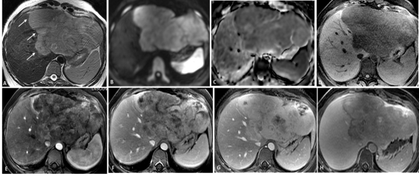
Figure 1: Contrast Enhanced MRI of Abdomen
Figure legend: (A-H): Dynamic contrast enhanced MRI in 35-year-old female patient with liver mass. Axial T2- Weighted images (A) show large lobulated mass in left lobe of liver (Arrows) extending to segment VIII showing T2 hyperintense signal with diffusion restriction demonstrating hyperintense signal on diffusion weighted images (B) and hypointense signal on ADC maps (C). The mass is showing T1 hypointense signal (D) with heterogeneous early arterial phase enhancement, more in periphery (E), progressing in portal venous phase images (F) with heterogeneous hyperenhancement compared to remaining liver parenchyma on five-minutes delayed venous phase images (G). The mass shows relative hypoenhancement on delayed hepatobiliary phase images (H).PET CT (Figure 2)
A large FDG avid left-lobe mass (~18.5 × 9.7 × 13.9 cm; SUV max 10.1) was seen, encasing hepatic veins with extension to segment VIII. No other FDG avid lesions were detected.
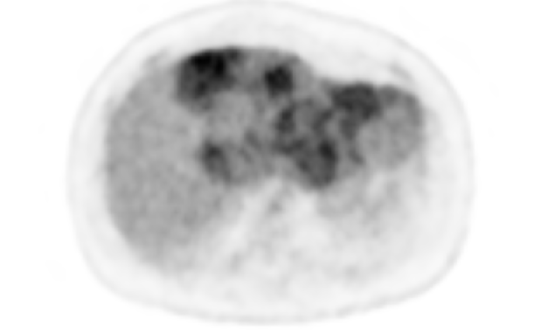
Figure 2: PET-CT of Liver
Figure legend: FDG PET-CT demonstrates a large FDG-avid left hepatic lobe mass with heterogeneous uptake (SUVmax approximately 10.1), with extension toward segment VIII and encasement of the left and middle hepatic veins. No other definite FDG-avid lesions are identified elsewhere.
Pre-operative diagnosis
The working diagnosis was intrahepatic cholangiocarcinoma. Differentials included fibrolamellar hepatocellular carcinoma, epithelioid hemangioendothelioma, sarcomatoid tumor, and neuroendocrine tumor. With no extrahepatic disease and adequate future liver remnant, left hepatectomy with curative intent was planned.
Management – Surgical procedure
Diagnostic laparoscopy followed by open resection included:
- Left hepatectomy (segments II, III, IV with middle hepatic vein removal)
- Cholecystectomy
- Excision biopsy of peritoneal and diaphragmatic lesions
- Frozen section analysises
Frozen section suggested malignant epithelial tumor with possible neuroendocrine differentiation but was inconclusive. Surgery was completed without complications.
Histopathology and final diagnosis
Microscopy showed a diffusely infiltrating malignant epithelial tumor with biphasic luminal and abluminal differentiation in cribriform, tubular, and focal solid patterns (<10% solid). (Figure 3)
Features included gland-like and cribriform structures with basophilic material, perineural and lymphovascular invasion. Background liver showed obstructive changes without cirrhosis. Margins, gallbladder, and cystic duct were tumor-free.
Peritoneal and diaphragmatic biopsies showed metastatic deposits.
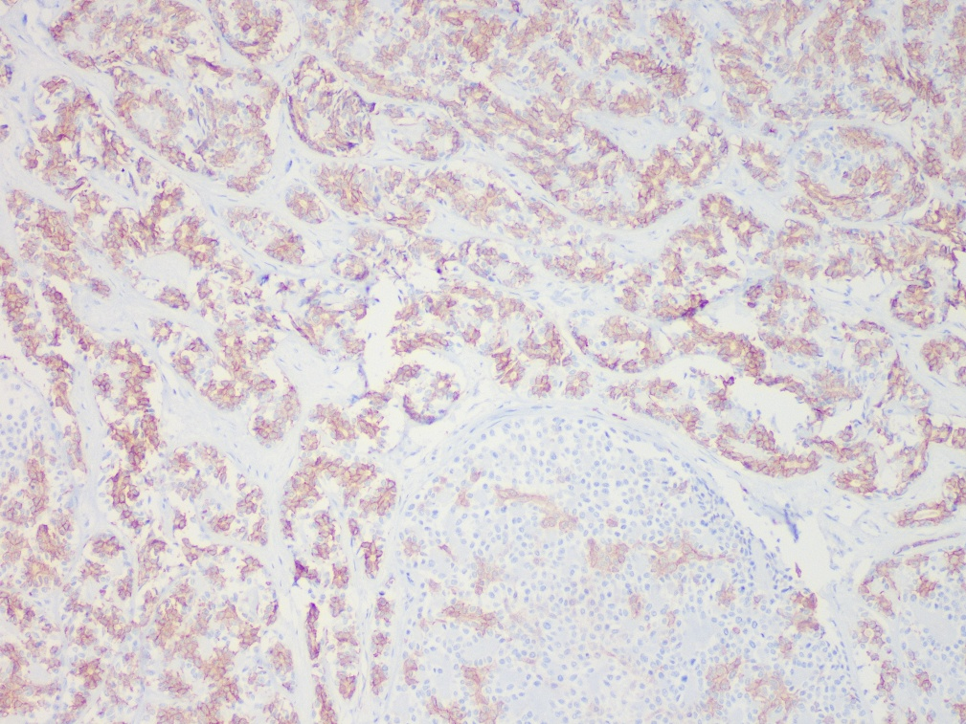
Figure 3: Histopathological Picture of Liver Lesion
Figure legend: Histopathology of the resected liver mass shows features consistent with adenoid cystic carcinoma. Microscopy demonstrates a malignant epithelial neoplasm with characteristic architectural patterns, supported by immunohistochemistry, confirming the diagnosis of primary adenoid cystic carcinoma of the liver.
Immunohistochemistry
Tumor cells were positive for PanCK, CK7, CK19, CD117 (c-Kit), and p63, supporting biphasic epithelial–myoepithelial differentiation.
They were negative for CK20, Arginase 1, HepPar 1, glypican 3, PAX 8, CDX 2, CD34, synaptophysin, chromogranin, INSM1, inhibin, DOG1, p16, and β-catenin. Ki-67 was ~25–30%, and p53 showed wild-type pattern.
These findings confirmed adenoid cystic carcinoma. Absence of a primary tumor elsewhere established the diagnosis of primary hepatic ACC with metastases.
Outcome and follow up
Postoperatively, the patient remained stable with preserved liver function and no complications. She tolerated oral intake and mobilized gradually.
At early follow-up, she was clinically well without jaundice or decompensation. Multidisciplinary evaluation for adjuvant therapy was planned. Long-term surveillance with imaging is recommended due to risk of late recurrence and metastasis.
DISCUSSION
Adenoid cystic carcinoma (ACC) is a malignant epithelial tumor most commonly arising from salivary glands, with well-described behavior, patterns of spread, and histological features [1–4]. It has also been reported in other organs such as the trachea, breast, and lacrimal glands [2,5,6]. However, primary involvement of the liver is exceedingly rare, with only a handful of cases described in the literature [7,12,13]. In contrast, the liver is more frequently a site of metastasis from extrahepatic primaries, necessitating thorough evaluation to exclude a distant source [1,2,5,6].
Previously reported cases, including those by Wu et al. [7] and other isolated reports [12,13], describe presentations similar to our patient, typically involving large hepatic masses in non-cirrhotic livers with non-specific clinical and biochemical findings. A consistent challenge across these cases is the lack of distinctive radiological features. Imaging often mimics more common hepatic malignancies such as intrahepatic cholangiocarcinoma or, less frequently, hepatocellular carcinoma, owing to features like heterogeneous enhancement, necrosis, and capsular retraction [8,9]. Tumor markers are usually non-contributory, further compounding diagnostic uncertainty.
As in our case, preoperative diagnosis is rarely established. Definitive diagnosis relies on histopathological examination demonstrating characteristic cribriform and tubular patterns with biphasic epithelial–myoepithelial differentiation, supported by immunohistochemistry [3,6]. Exclusion of an extrahepatic primary tumor remains a critical step and has been emphasized in all previously reported cases [7,12,13].
Due to the rarity of primary hepatic ACC, there are no standardized management guidelines. Surgical resection with negative margins remains the mainstay of treatment when feasible and is associated with improved outcomes following hepatic surgery [10,11]. The role of adjuvant therapy is unclear and should be individualized.
In summary, this case, consistent with prior reports, highlights the significant diagnostic challenges posed by primary hepatic ACC and underscores the importance of histopathology in establishing the diagnosis.

Abbreviations:
ACC: Adenoid Cystic Carcinoma
AFP: Alfafetoprotein
ALT: Alanine Aminotransferase
AST: Aspartate Aminotransferase
CEA: Carcinoembryonic Antigen
FDG: Fluorodeoxyglucose
IVC: Inferior Vena Cava
MRI: Magnetic Resonance Imaging
PET-CT: Positron Emission Tomography-Computed Tomography

CONCLUSION
We report a rare case of primary adenoid cystic carcinoma of the liver in a young woman with a large left-lobe mass in a non-cirrhotic liver. Diagnosis relies on histopathology and immunohistochemistry. Surgical resection remains the mainstay of treatment, and long-term follow-up is essential due to the risk of recurrence.
Conflict of Interest declaration:
There is no Conflict of Interest.
Ethical Approval: All research was conducted in accordance with both the Declarations of Helsinki and Istanbul
Consent
As per international standards or university standards, patient(s) written consent has been collected and preserved by the author(s).
Disclaimer (Artificial intelligence): Author(s) hereby declare that NO generative AI technologies such as Large Language Models (ChatGPT, COPILOT, etc.) and text-to-image generators have been used during the writing or editing of this manuscript.

References
1. Coca-Pelaz A, Rodrigo JP, Bradley PJ, et al. Adenoid cystic carcinoma of the head and neck—an update. Oral Oncol. 2015;51(7):652-661.
2. Bradley PJ. Adenoid cystic carcinoma of the head and neck: a review. Curr Opin Otolaryngol Head Neck Surg. 2004;12(2):127-132.
3. Seethala RR. An update on grading of salivary gland carcinomas. Head Neck Pathol. 2009;3(1):69-77.
4. Ellis GL, Auclair PL. Tumors of the salivary glands. Atlas Tumor Pathol, 4th Series, Fascicle. Washington, DC: Armed Forces Institute of Pathology. 2008.
5. Garden AS, El-Naggar AK, Morrison WH, et al. Adenoid cystic carcinoma of the head and neck: long-term outcomes and patterns of failure. Cancer. 1995;75(7):2073-2081.
6. Gadodia A, Sharma R, Thakar A, Goyal A, Seith A. Extrapulmonary adenoid cystic carcinoma: imaging features with histopathologic correlation. Clin Radiol. 2010;65(8):647-654.
7. Wu P, Fang X, Zhuge Y, et al. Primary adenoid cystic carcinoma of the liver: a case report and literature review. Med (Baltim). 2017;96(15):e6602.
8. Brancatelli G, Federle MP, Vilgrain V, et al. Intrahepatic cholangiocarcinoma: spectrum of CT findings. AJR Am J Roentgenol. 2002;181(3):579-584.
9. Vilgrain V, Esvan M, Ronot M, Caumont-Prim A, Zappa M, d’Assignies G. Hepatic tumors: CT and MRI features and radiologic–pathologic correlations. Diagn Interv Imaging. 2014;95(5):401-412.
10. Belghiti J, Hiramatsu K, Benoist S, Massault PP, Sauvanet A, Farges O. Seven hundred forty-seven hepatectomies in the 1990s: an update to evaluate the actual risk of liver resection. J Am Coll Surg. 2000;191(1):38-46.
11. Jarnagin WR, Gonen M, Fong Y, et al. Improvement in perioperative outcome after hepatic resection: analysis of 1,803 consecutive cases over the past decade. Ann Surg. 2002;236(4):397-406; discussion 406-7.
12. Harish, K., & Mangala Gouri, S. R. (2004). Adenoid cystic carcinoma of the parotid metastasizing to liver: case report. BMC cancer, 4(1), 41.

13. Coupland, A., Sewpaul, A., Darne, A., & White, S. (2014). Adenoid cystic carcinoma of the submandibular gland, locoregional recurrence, and a solitary liver metastasis more than 30 years since primary diagnosis. Case Reports in Surgery, 2014(1), 581823.

