Case report
Periampullary Brunner’s Gland Hyperplasia Mimicking Carcinoma: A Diagnostic Dilemma for Surgeons and Review of Current Evidence

Abstract
Brunner's gland hyperplasia is a rare benign proliferative lesion of the duodenal submucosa that occasionally presents as a periampullary mass with biliary obstruction, closely mimicking carcinoma. We report a 70-year-old woman who presented with recurrent upper abdominal pain without jaundice, weight loss or gastrointestinal bleeding. Ultrasonography showed marked dilatation of the common bile duct with intrahepatic biliary radicle dilatation. Cross-sectional imaging with contrast-enhanced computed tomography and magnetic resonance cholangiopancreatography revealed a heterogeneously enhancing periampullary lesion measuring approximately 10 × 10 × 14 mm involving the distal common bile duct, ampulla and medial duodenal wall. The pancreatic duct measured approximately 4 mm producing a classical double-duct sign strongly suggestive of
periampullary carcinoma. In view of these findings, the patient underwent pancreaticoduodenectomy. Histopathological examination of the resected specimen revealed Brunner’s gland hyperplasia without dysplasia or malignancy. Although nearly 200 cases of Brunner’s gland hyperplasia have been reported worldwide, periampullary localisation producing biliary obstruction and a double-duct sign is exceptionally uncommon and may closely mimic periampullary carcinoma, occasionally leading to radical surgery. This case highlights an important diagnostic pitfall and discusses imaging clues that may help differentiate benign periampullary lesions from malignancy.
Keywords: Brunner's gland hyperplasia; periampullary carcinoma; double-duct sign; pancreaticoduodenectomy; ampulla of Vater

- Introduction
Brunner's glands are mucus-secreting glands located predominantly in the proximal duodenum, where they secrete alkaline mucus that neutralises gastric acid and protects the duodenal mucosa.¹ Hyperplastic or hamartomatous proliferation of these glands represents a rare benign entity, accounting for approximately 5–10% of benign duodenal tumours, with an estimated incidence of less than 0.01% in endoscopic series.²˒³ Most Brunner's gland lesions are small, asymptomatic and detected incidentally on endoscopy or imaging; larger lesions may present with abdominal pain, gastrointestinal bleeding, gastric outlet obstruction or, rarely, biliary obstruction.³˒⁴˒⁵
When these lesions arise near the ampulla of Vater, they can closely mimic periampullary carcinoma both clinically and radiologically, particularly when associated with biliary dilatation or the double-duct sign. Only a very small number of cases have been reported in which periampullary Brunner’s gland hyperplasia produced biliary obstruction or a double-duct sign leading to pancreaticoduodenectomy for presumed malignancy.⁴˒⁵˒⁶ The double-duct sign is traditionally regarded as highly suggestive of malignant periampullary obstruction, and in the appropriate clinical context it often leads to pancreaticoduodenectomy.⁵˒⁶˒⁷
For surgeons, the key challenge is to balance the risk of missing a potentially curable periampullary malignancy against the morbidity of unnecessary radical resection.⁶˒⁹ We describe a case of periampullary Brunner's gland hyperplasia in a 70-year-old woman that simulated carcinoma radiologically and led to pancreaticoduodenectomy, and we discuss imaging and endoscopic clues that may help differentiate this benign lesion from malignancy.

- Case Presentation
A 70-year-old female presented with recurrent episodes of upper abdominal pain of several months duration. There was no history of jaundice, gastrointestinal bleeding, or significant weight loss. Physical examination was unremarkable.
Initial abdominal ultrasonography demonstrated dilatation of the common bile duct measuring approximately 16 mm with intrahepatic biliary radicle dilatation. No gallstones or obvious pancreatic mass were visualized.
Upper GI endoscopy showed mild prominence of the papilla.
Contrast-enhanced computed tomography of the abdomen revealed a heterogeneously enhancing lesion in the periampullary region measuring approximately 10 × 10 × 14 mm involving the distal common bile duct, ampulla, and medial wall of the duodenum with upstream dilatation of the common bile duct. The pancreatic duct measured approximately 4 mm producing the classical double-duct sign (IMAGE 1 and 2).
Magnetic resonance cholangiopancreatography confirmed distal biliary obstruction with abrupt narrowing at the periampullary region. No evidence of distant metastasis or regional lymphadenopathy was identified.
Based on these imaging findings, a diagnosis of periampullary carcinoma was made and the patient underwent pancreaticoduodenectomy (Whipple procedure). Intraoperatively, a small periampullary lesion was identified without evidence of metastatic disease.
Histopathological examination revealed nodular proliferation of Brunner’s glands within the duodenal submucosa forming hyperplastic lobules separated by fibrous septa, dilated ducts and smooth muscle fibres without dysplasia or malignancy, confirming the diagnosis of Brunner’s gland hyperplasia , images at high and low power showing the same (Image 3 and 4).

- Discussion
3.1 Overview of Brunner’s Gland Hyperplasia and Periampullary Lesions
Brunner’s gland hyperplasia is an uncommon benign proliferative lesion arising from the duodenal submucosa, most frequently in the proximal duodenum. The exact pathogenesis remains unclear; proposed mechanisms include chronic acid stimulation, Helicobacter pylori-associated inflammation, pancreatic exocrine stimulation, and chronic mucosal injury.¹˒²˒³
Proliferative Brunner's lesions are variably termed hyperplasia, hamartoma or adenoma, with some authors using size criteria (hyperplasia <10 mm, hamartoma ≥10 mm) and others emphasizing histoarchitectural features.¹˒²˒¹⁰
Clinically, most lesions are asymptomatic (50–70%) or present with non-specific symptoms such as abdominal pain or dyspepsia (20–40%). Less commonly, patients may develop gastrointestinal bleeding (10–20%) or gastric outlet obstruction (5–10%). Periampullary localisation causing biliary obstruction is exceedingly rare but clinically significant, as it may closely mimic periampullary carcinoma and create a diagnostic dilemma.

3.2. Imaging Clues and Their Limitations
Cross-sectional imaging with contrast-enhanced CT and MRCP plays a central role in evaluating periampullary lesions. Features favouring a benign etiology include a well-circumscribed lesion, preserved fat planes, absence of vascular invasion, and lack of regional lymphadenopathy.⁷˒¹⁰ Smooth tapering of the distal bile duct may also suggest a benign process.⁷

Radiographically, Brunner’s gland hyperplasia demonstrates a spectrum of appearances ranging from focal submucosal masses and sessile polyps to diffuse mucosal nodularity, often correlating with histopathological findings.¹⁶ However, these features frequently overlap with malignant lesions, limiting diagnostic specificity.
Importantly, the presence of biliary obstruction with a double-duct sign, although strongly suggestive of malignancy, is not pathognomonic, as a proportion of cases may have benign pathology.⁶˒⁸ In the present case, the combination of obstructive biliopathy, a heterogeneously enhancing periampullary lesion, and a double-duct sign strongly favoured carcinoma.

3.3. Diagnostic and Therapeutic Approach: Surgical Perspective
A pragmatic diagnostic algorithm for periampullary masses begins with cross-sectional imaging. In cases demonstrating classical features of resectable malignancy—such as a periampullary mass with biliary obstruction and double-duct sign—proceeding directly to surgery is appropriate. EUS is best reserved for indeterminate lesions or when tissue diagnosis is likely to alter management.⁷˒¹³˒¹⁵
Although EUS provides valuable information regarding layer of origin and lesion characteristics, tissue sampling may be limited in submucosal lesions, with frequent non-diagnostic or false-negative results.¹⁰ In the present case, EUS was not pursued as imaging findings strongly suggested resectable malignancy, and biopsy results would not have influenced management.
From a surgical standpoint, pancreaticoduodenectomy remains justified when malignancy cannot be excluded, given the risk of missing a potentially curable cancer. Notably, a proportion of such resections reveal benign pathology, including Brunner’s gland hyperplasia.¹⁴ However, increased awareness of Brunner's gland lesions among surgeons, radiologists and endoscopists, along with judicious use of EUS and endoscopic resection where available, may help avoid unnecessary Whipple procedures in select patients.¹⁵

4. Limitations
The primary limitation of this study is the inability to establish a definitive preoperative diagnosis, reflecting the inherent limitations of current imaging and biopsy techniques in differentiating benign from malignant periampullary lesions. Although nearly 200 cases of Brunner’s gland hyperplasia have been reported worldwide, only a very small number of cases have been described in which the lesion mimicked periampullary carcinoma and led to pancreaticoduodenectomy. Selected reported cases are summarised in Table 1.

Table 1: Selected reported cases
Author (Year) | Age/Sex | Location | Presentation & Imaging | Preoperative Diagnosis | Treatment | Final Pathology
Janes et al. (2005)12 | 46/M | Ampulla of Vater | Abdominal pain, vomiting; periampullary mass on CT | Periampullary malignancy | Whipple resection | Brunner’s gland hyperplasia
Kostalas et al. (2016)⁶ | 52/F | Periampullary (D1–D2) | Weight loss, abnormal LFTs; double-duct sign on CT/MRCP | Ampullary/pancreatic carcinoma | Pylorus-preserving pancreatico  duodenectomy | Brunner’s gland hamartoma
McCafferty et al. (2021)⁴ | 73/F | Second part of duodenum | Obstructive symptoms, large duodenal mass | Duodenal adenocarcinoma | Duodenal adenocarcinoma | Brunner’s gland hyperplasia
Wu et al. (2021)⁵ | 63/M | Ampulla of Vater | Epigastric pain, periampullary lesion on EUS | Benign ampullary tumour | Endoscopic/local excision | Brunner’s gland hyperplasia
Rao et al. (2014)⁸ | 55/F | Periampullary (D2) | Duodenal thickening on CT | Periampullary carcinoma | Whipple procedure | Brunner’s gland hamartoma
.
5.Conclusion
Although Brunner’s gland hyperplasia is a rare benign lesion, periampullary localisation producing biliary obstruction and a double-duct sign is exceptionally uncommon and may closely mimic periampullary carcinoma on imaging. Recognition of this rare entity is important because it may prevent misdiagnosis of periampullary carcinoma and unnecessary radical surgery in selected patients.
Consent
As per international standards or university standards, patient(s) written consent has been collected and preserved by the author(s).
Ethical Approval:

As per international standards or university standards written ethical approval has been collected and preserved by the author(s).

Disclaimer (Artificial intelligence)

Author(s) hereby declare that NO generative AI technologies such as Large Language Models (ChatGPT, COPILOT, etc.) and text-to-image generators have been used during the writing or editing of this manuscript.

References
1. Stokes JF, Turnberg LA, Hawksley JC. Hyperplasia of Brunner's glands. Gut. 1964;5:459-62.
2. Patel ND, Levy AD, Mehrotra AK, Sobin LH, Ziminski KE, Abbott RM. Brunner's gland hyperplasia and hamartoma: imaging features with clinicopathologic correlation. AJR Am J Roentgenol. 2006;187(6):1491-8.
3. Tanabe H, Iwashita A, Hara S, Ando T, Sugimoto H, Ozeki K. Endoscopic mucosal resection of a large duodenal Brunner's gland hamartoma. Case Rep Gastroenterol. 2013;7(3):456-61.
4. McCafferty J, Tokhi A, Pande G. Case report of Brunner's gland hyperplasia: a rare "mimic" of malignant pathology. Int J Surg Case Rep. 2021;81:105775.
5. Wu YH, Wang HP, Su WC, Chen CY, Yang TH, Chen TH. An unusual cause of epigastric pain: Brunner's gland hyperplasia of the ampulla of Vater. Int Arch Intern Med. 2021;5(1):031-3.
6. O'Shea D, Kostalas M, Omorogbe J, Menon A, Steed H, Dennison AR. Brunner's gland hamartoma: a cause of the double-duct sign. Ann R Coll Surg Engl. 2016;98(5):e73-5.
7. Kim JH, Eun HW, Kim YJ, Lee JY, Park HS, Han JK, Choi BI. Imaging features of benign and malignant ampullary and periampullary lesions. Radiographics. 2014;34(3):624-41.
8. Rao RV, Kumar A, Sikri M, Gupta V, Yadav TD, Rao KL. Brunner gland hamartoma masquerading as malignancy: a rare case report. J Clin Diagn Res. 2014;8(10):FD13-4.

9 Peloso A, Viganò J, Vanoli A, Dominioni T, Zonta S, Bugada D, et al. Saving from unnecessary pancreaticoduodenectomy: Brunner’s gland hamartoma—case report on a rare duodenal lesion and exhaustive literature review. Ann Med Surg (Lond). 2017;17:43-49.
10. AlKhatib A, Lakhtakia S, Ramchandani M, Basha J, Nageshwar Reddy D. Brunner's gland hyperplasia: a massive duodenal lesion. Cureus. 2020;12(4):e7542.
11. Nakatsubo T, Ueda T, Matsuura Y, Ito T, Kachi K, Kawabe N. Adenocarcinoma in situ arising from Brunner's gland treated by endoscopic mucosal resection. Clin J Gastroenterol. 2017;10(3):259-63.
12. Janes SE, Zaitoun AM, Rahman S, Scott N, Shenoy HG. Brunner's gland hyperplasia at the ampulla of Vater. JOP. 2005;7(6):627-30.
13. Catalano MF, Linder JD, Chak A, Sivak MV Jr, Raijman I, Geenen JE. Endoscopic management of adenoma of the major duodenal papilla. Gastrointest Endosc. 2004;59(3):225-32.
14. Bhargav PR, Devi NV, Suresh V, Pawar S, Kumar KS. Benign pathologies encountered in the Whipple specimens: a review. Int Surg J. 2021;8(5):1532-7.
15. Gurusamy KS, Pamecha V, Sharma D, Nagala P, Davidson BR, Fusai G. Diagnostic accuracy of cross-sectional and endoscopic imaging in ampullary tumours: systematic review. Br J Surg. 2024;111(1):znad432.
16.Merine D, Jones B, Ghahremani GG, Hamilton SR, Bayless TM. Hyperplasia of Brunner glands: the spectrum of its radiographic manifestations. Gastrointest Radiol. 1991;16:104–108.

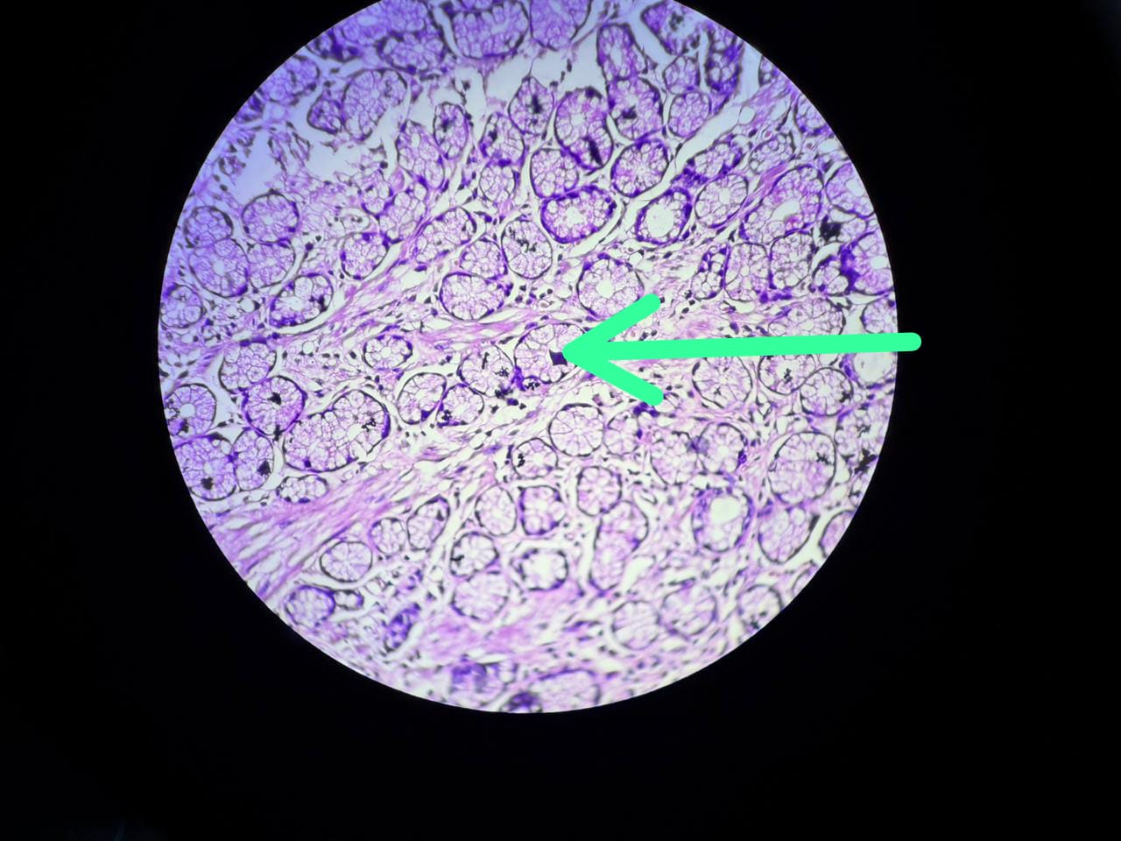
Proliferation of Brunners glands (arrow),H&E,40x. (IMAGE 1)

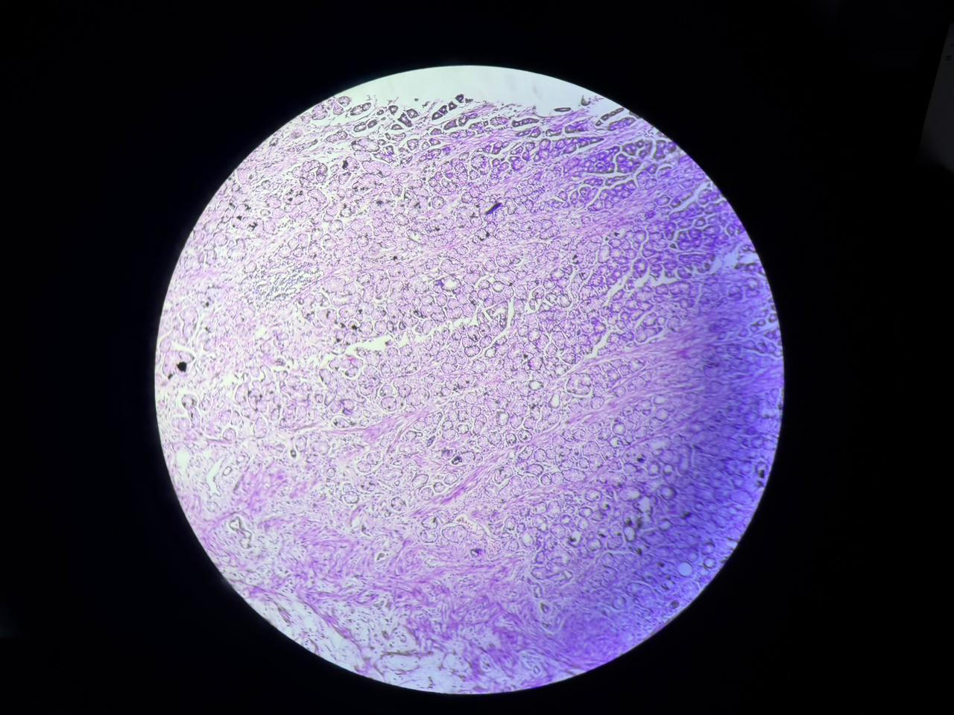Microscopic examination from periampullary lesion using H&E staining demonstrating brunners glands in submucosa atlow power field 10x. (image 2)

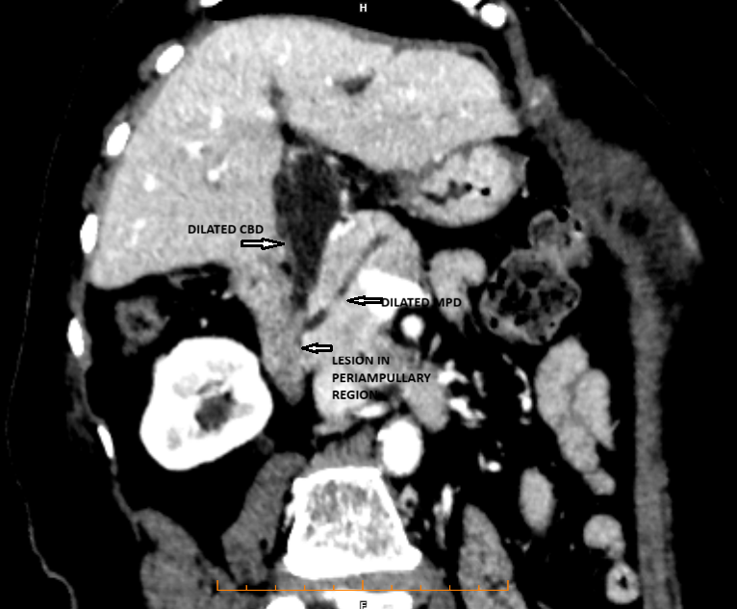
Image 3 Brunner’s gland hyperplasia (images at high power)

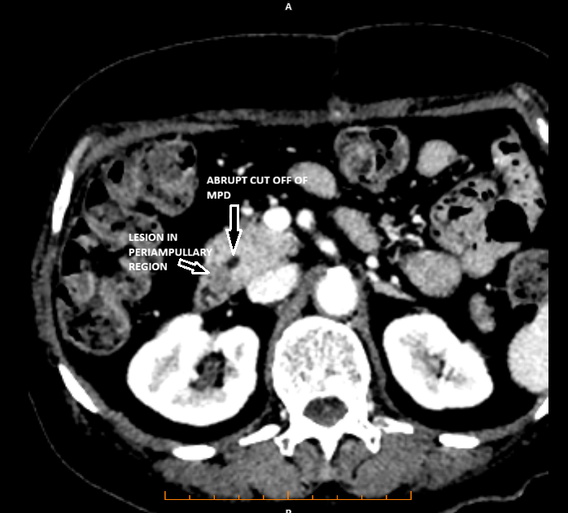
Image 4 Brunner’s gland hyperplasia (images at low power)

