Case report

FIBROLIPOMATOUS HAMARTOMA OF THE PALM: A DIAGNOSTIC MIMICKER OF SOFT TISSUE TUMORS
ABSTRACT
Fibrolipomatous hamartoma, also known as Neurolipoma or lipomatosis of nerve, is a rare, non-cancerous growth that happens when fibro-fatty tissue grows around peripheral nerves. It most often affects the median nerve and may show up as a soft tissue swelling that slowly gets bigger and is linked to symptoms of compression. It can be hard to make a diagnosis before surgery, especially with cytology, because the signs are similar to those of other benign spindle cell lesions. We describe a case involving a 48-year-old male who exhibited a 3-month history of swelling in the right hand, accompanied by numbness and tenderness. A clinical exam showed a swelling. Fine needle aspiration cytology revealed aggregates of small, benign spindle cells, indicating a diagnosis of benign spindle cell lesion. Histopathological analysis of the excised specimen demonstrated fibro-fatty tissue containing distinctive nerve bundles situated within fibrocollagenous stroma and adipose tissue, indicative of Fibrolipomatous hamartoma. The case is presented due to its rarity, diagnostic challenges in cytology, and distinctive histopathological characteristics.
Keywords: Neurolipoma, fibrolipomatous hamartoma, lipomatosis of nerve, spindle cell lesion, peripheral nerve tumor
Introduction
Fibrolipomatous hamartoma (FLH), also referred to as neurolipoma or lipomatosis of nerve, is a rare benign lesion characterized by abnormal proliferation of mature adipose and fibrous tissue infiltrating the epineurium and perineurium of peripheral nerves ^{1,2}. The damaged nerve and its fascicles gradually grow as a result, frequently giving histology and imaging a distinctive "coaxial cable" appearance^{2,3}. Although other nerves like the ulnar, radial, and plantar nerves may also be impacted, the disorder most frequently affects the median nerve, especially in the carpal tunnel ^{3,4}.
Clinically, FLH usually manifests as a painless, slowly expanding mass that may subsequently be linked to nerve compression symptoms as paresthesia, numbness, or pain ^{4,5}. It can happen alone or in conjunction with macrodactyly, also known as macrodystrophia lipomatosa . Although the lesion is typically discovered in infancy or early adulthood, late presentations have occasionally been reported, which adds to the confusion surrounding the diagnosis ⁵. Due to shared characteristics with other benign spindle cell tumors, such as neurofibroma and schwannoma, cytological examination with fine needle aspiration (FNAC) is sometimes inconclusive. Histopathological analysis, which shows fibrofatty infiltration encasing and segregating nerve bundles within a collagenous stroma, is therefore necessary for a conclusive diagnosis. FLH remains a diagnostic challenge for both pathologists and clinicians due to its rarity, risk for misdiagnosis, and cytological characteristics that overlap with other peripheral nerve sheath cancers ⁶. Understanding its clinicopathological spectrum is crucial for guiding optimal care and preventing needless invasive surgical operations. In this rare case we discuss the clinical course of the patient presented with the median nerve compression symptoms. In this case, we report a rare presentation of fibrolipomatous hamartoma involving the hand in a middle-aged male, highlighting the diagnostic challenges encountered on cytology and emphasizing the role of histopathological examination in establishing a definitive diagnosis.
Case presentation
A 48-year-old male presented with a gradually progressive swelling over the right hand for a duration of three months, associated with numbness and mild tenderness. There was no history of trauma or systemic disease. Clinical examination revealed a 3 × 3 cm edema on the palmar side of the right hand. The lesion was non-pulsatile and mildly painful, with no overlying skin alterations. Sensory testing revealed modest hypoesthesia in the spread of the affected nerve. Based on the location and related sensory symptoms, a benign soft tissue lesion with potential neurological involvement was proposed. Ultrasonography of Right Palm was done which showed ill-defined enlargement of the nerve with altered echotexture showing interspersed hypoechoic and echogenic areas. These findings were inconclusive and MRI correlation was advised for further characterization. Due to financial and resource constraints magnetic resonance imaging (MRI) was not performed. Fine needle aspiration cytology (FNAC) was then done. Cytological smears revealed clusters of tiny, benign-looking spindle cells against a backdrop of sparse stromal debris. No substantial atypia, mitotic activity, or necrosis were found. Based on these observations, a benign spindle cell lesion was diagnosed; however, cytological confirmation of the diagnosis was not possible.
The patient received surgical removal of the lesion. The gross examination revealed a fibrofatty tissue mass measuring 3.5 × 3 cm. The cut section surface was yellowish, with localized patches of bleeding and interspersed hard whitish regions.
The microscopic examination revealed fibro-fatty tissue with many nerve fascicles buried in a dense fibrocollagenous stroma. The lesion had a distinct "coaxial cable" appearance, with mature adipose tissue infiltrating and encircling the nerve bundles, resulting in fascicle separation. The spindle cells were cytologically unremarkable, with elongated nuclei and small nucleoli. There were no signs of nuclear atypia, enhanced mitotic activity, or necrosis. These histomorphology traits supported a diagnosis of fibrolipomatous hamartoma (neurolipoma). Post operatively patient is not showing symptom of the neurological deficit or any postsurgical complication.
Discussion
Fibrolipomatous hamartoma is a rare benign tumor-like lesion of peripheral nerves, characterized by an overgrowth of fibrous and mature adipose tissue around and within the nerve sheath, especially involving the epineurium and perineurium. Histologically, the lesion shows nerve bundles splayed apart by infiltrating adipose tissue and fibrous tissue, which is the key diagnostic feature seen in the present case. (7,8)
This lesion most commonly affects the median nerve, particularly in the hand and wrist region, although involvement of digital nerves and unusual sites has also been reported. Patients may present with a mass lesion, pain, numbness, paresthesia, or symptoms related to compressive neuropathy. The patient in the present case had a right-hand swelling associated with numbness and tenderness, which fits with the known clinical spectrum of the disease (7-9). A major diagnostic issue is the inconsistent terminology used in the literature. Neural fibrolipoma, fibrolipomatous hamartoma, and lipomatosis of nerve have all been used for this lesion. More recent literature distinguishes fibrolipomatous hamartoma/lipomatosis of nerve from intraneural lipoma, the latter being a circumscribed lesion with different clinical, radiological, and surgical implications ². FNAC may be of limited diagnostic utility, as aspirates can be scant and nonspecific, often showing only benign spindle cells or fibroadipose fragments. In the present case, cytology suggested a benign spindle cell lesion, which was understandable given the sampling limitations. Definitive diagnosis was achieved only on histopathology, which demonstrated the characteristic admixture of fibrocollagenous tissue, mature adipose tissue, and entrapped nerve fascicles ⁵.
The important histological differentials include neurofibroma, schwannoma, and intraneural lipoma. Neurofibroma and schwannoma do not show the same pattern of diffuse fibro-fatty infiltration splaying nerve fascicles. Intraneural lipoma, on the other hand, is generally more circumscribed and lacks the diffuse infiltrative pattern seen in fibrolipomatous hamartoma. Correct recognition is important because aggressive excision of a nerve-based lesion may risk neurological deficit (9,10).
Microscopic surgery is the primary treatment for suspected neurolipomas. Typically, an exploratory operation with excisional biopsy was performed to confirm the diagnosis. Surgeons attempt to retain critical nerve branches when removing a neurolipoma, as radical nerve resection is not indicated. Extensive intraneural dissection is associated with a substantial risk of neurological damage from ischemic consequences (10).
Because of its rarity, unusual presentation as a hand swelling, and the availability of cytological as well as histopathological correlation, the present case adds to the limited literature on this entity.
Conclusion
Neurolipoma is a rare benign peripheral nerve lesion that may present as a painful or tender swelling of the hand with associated sensory symptoms. Preoperative cytological diagnosis may be challenging and may only suggest a benign spindle cell lesion. Histopathological examination is crucial for definitive diagnosis. Awareness of this entity is important to avoid diagnostic confusion with other spindle cell and lipomatous lesions of the hand. This case is limited by the overlap with other benign peripheral nerve sheath lesions, inconsistent terminology in the literature, and the limited diagnostic utility of cytology, which often yields non-specific findings.

Consent
Written informed consent was obtained from the patient for publication of this case report and the accompanying images.
Ethical Approval
Ethical approval was not required for this case report, as per the institutional guidelines of our hospital, provided that written informed consent was obtained from the patient.
Disclaimer (Artificial intelligence)
Author(s) hereby declare that NO generative AI technologies such as Large Language Models (ChatGPT, COPILOT, etc.) and text-to-image generators have been used during the writing or editing of this manuscript.
Competing Interests
Authors have declared that no competing interests exist.

References
1. Senger JL, Classen D, Bruce G, Kanthan R. Fibrolipomatous hamartoma of the median nerve: A cause of acute bilateral carpal tunnel syndrome in a three-year-old child: A case report and comprehensive literature review. Plastic Surgery. 2014;22(3):201. PubMed PMID: 25332651.
2. Malan L, Bezuidenhout AF, Banderker E. Fibrolipomatous hamartoma of the median nerve. South African Journal of Radiology. 2015;19(2). doi:10.4102/sajr.v19i2.886
3. Toms AP, Anastakis D, Bleakney RR, Marshall TJ. Lipofibromatous hamartoma of the upper extremity: a review of the radiologic findings for 15 patients. AJR Am J Roentgenol. 2006 Mar;186(3):805–11. doi:10.2214/AJR.04.1717 PubMed PMID: 16498111.
4. Dry S. Updates in Peripheral Nerve Sheath and Adipocytic Tumors. Modern Pathology. 2026 Jan 1;39(1). doi:10.1016/j.modpat.2025.100929 PubMed PMID: 41183597.
5. Azeemuddin M, Waheed AA, Khan N, Sayani R, Ahmed A. Fibrolipomatous Hamartoma of the Median Nerve with Macrodystrophia Lipomatosa. Cureus. 2018 Mar 9. doi:10.7759/cureus.2293
6. Siegal GP, Bloem JL, Cates JMM HM. Soft Tissue and Bone Tumours. WHO Iarc. WORLD HEALTH ORGANIZATION; 2020. 472–474 p.

- Venkatesh K, Saini ML, Rangaswamy R, Murthy S. Neural fibrolipoma without macrodactyly: a subcutaneous rare benign tumor. J Cutan Pathol. 2009 May;36(5):594-6. doi: 10.1111/j.1600-0560.2008.01088.x. Epub 2008 Mar 30. PMID: 19476532.
- Mam P, Lewis EB, Song T, Bakotic BW. Fibrolipomatous hamartoma of nerve in the great toe. J Am Podiatr Med Assoc. 2014 Sep-Oct;104(5):531-4. doi: 10.7547/0003-0538-104.5.531. PMID: 25275745.
- Okubo T, Saito T, Mitomi H, Takagi T, Torigoe T, Suehara Y, Katagiri H, Murata H, Takahashi M, Ito I, Yao T, Kaneko K. Intraneural lipomatous tumor of the median nerve: Three case reports with a review of literature. Int J Surg Case Rep. 2012;3(9):407-11. doi: 10.1016/j.ijscr.2012.05.007. Epub 2012 May 23. PMID: 22705575; PMCID: PMC3397293.
- Cui Q, Chhabra AB, Leo BM, Pannunzio ME. Lipofibromatous hamartoma of a digital nerve. Am J Orthop, 2008 Aug 1; 37(8): E146-8.

Figures:
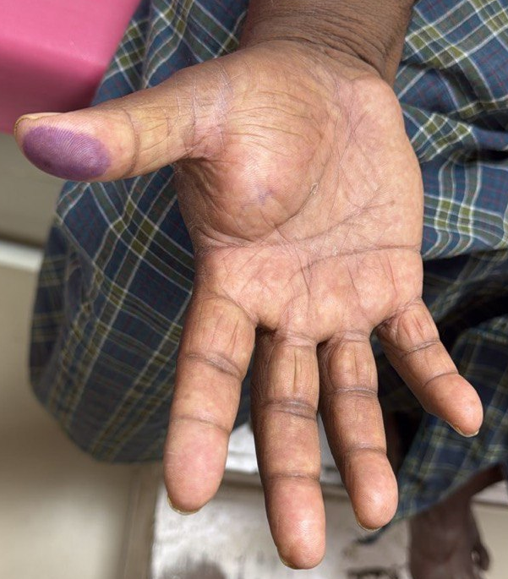
Figure 1: Clinical photograph of the right palm showing a diffuse, ill-defined soft tissue swelling involving the thenar region, producing fullness of the palm. The overlying skin appears unremarkable without ulceration.
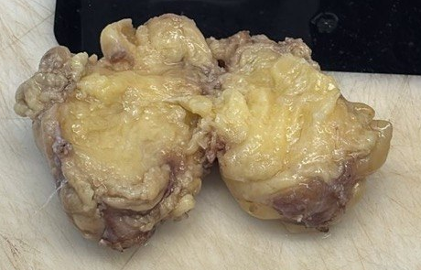
Figure 2: Gross specimen showing an ill-defined, lobulated, yellowish mass with a greasy cut surface. The lesion appears infiltrative with fibrofatty tissue interspersed within the specimen
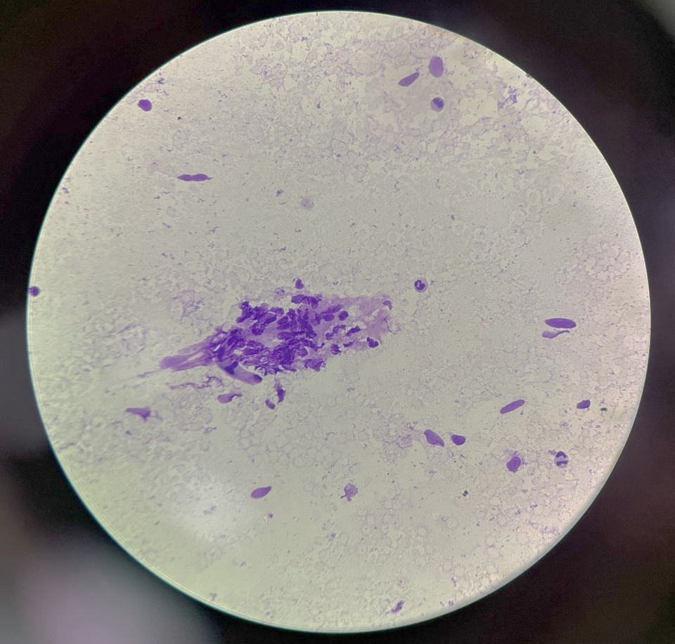
Figure 3: Cytology smear showing clusters of spindle-shaped cells with elongated nuclei embedded in a fibrillary stroma, admixed with adipocytic background (MGG Stain, 400x).

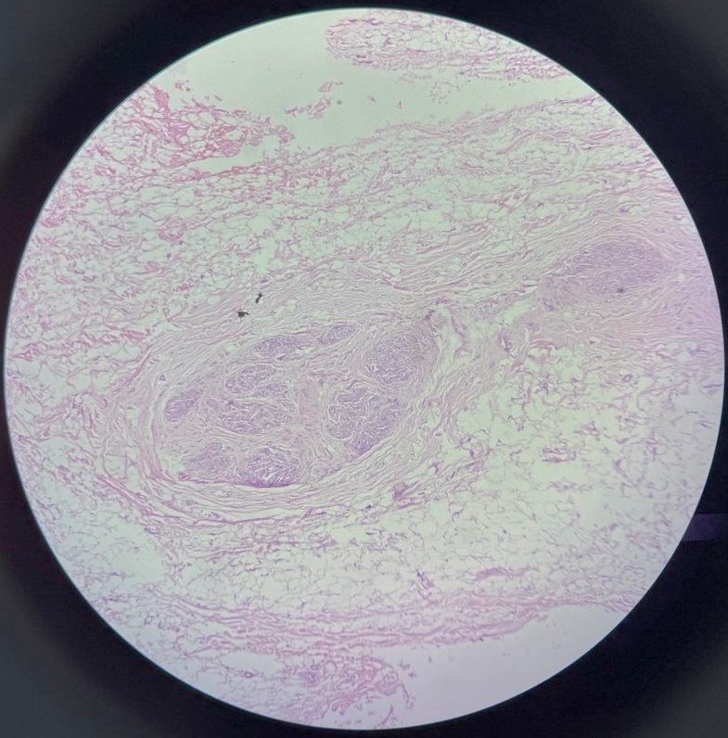
Figure 4: Photomicrograph (H&E), 100x, showing a peripheral nerve bundle with marked fibrofatty proliferation.
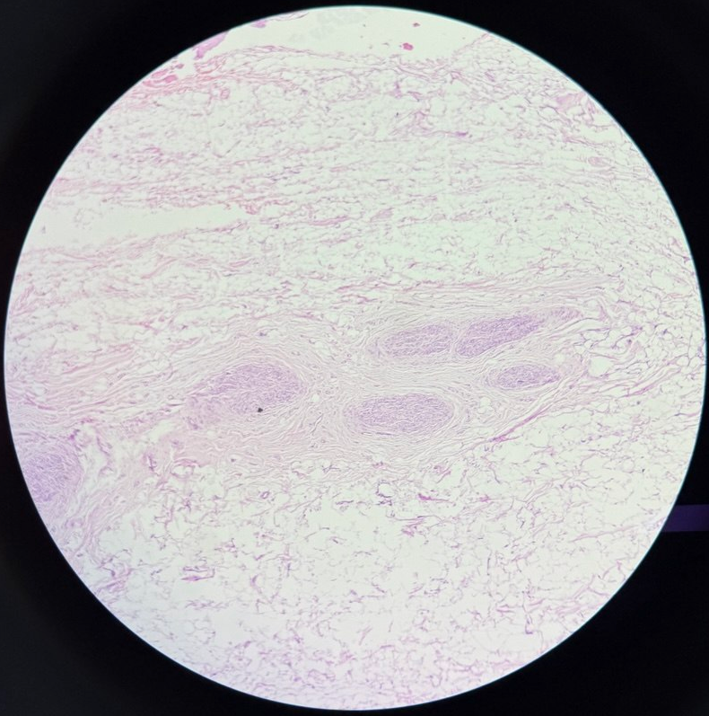
Figure 5 : Photomicrograph (H&E), 200x, showing mature adipose tissue infiltrates and surrounds the nerve fascicles.

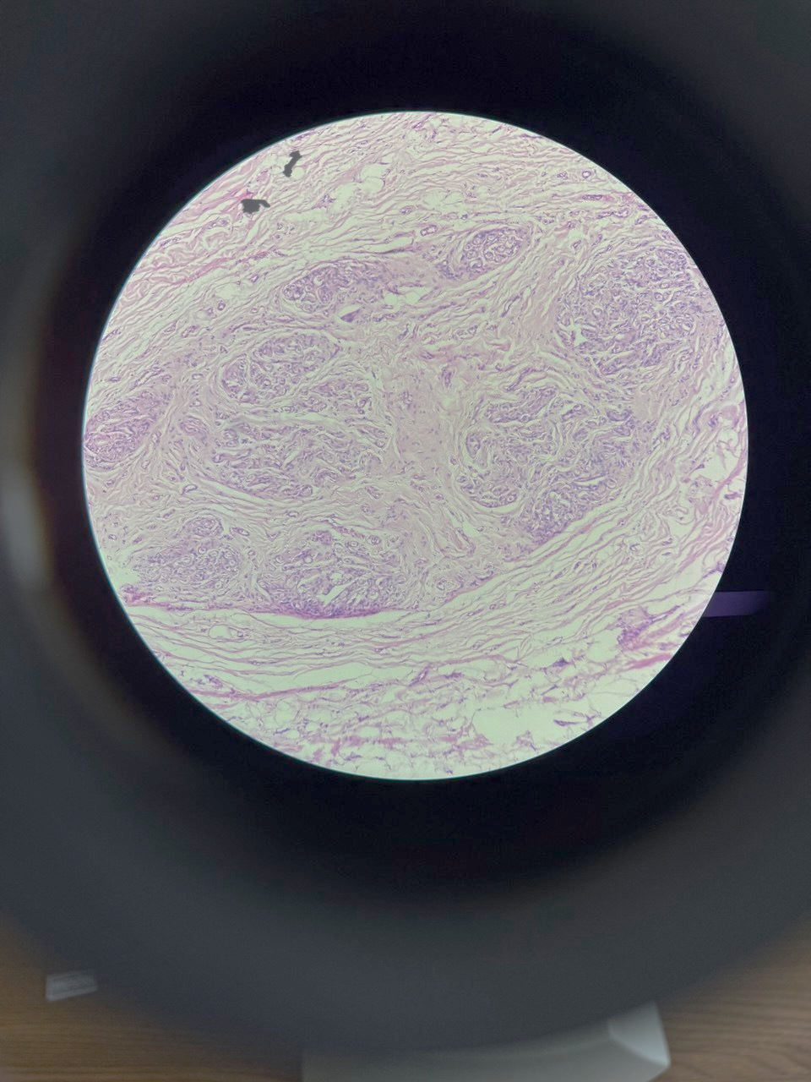
Figure 6: Photomicrograph (H&E), 400x, showing a peripheral nerve bundle with marked fibrofatty proliferation. Mature adipose tissue infiltrates and surrounds the nerve fascicles, which are separated by fibrous septae, producing a characteristic “coaxial cable” appearance.

