Case report

Delayed Presentation of Traumatic Diaphragmatic Hernia

.
ABSTRACT

Aims: To highlight traumatic diaphragmatic hernias, their delayed presentations, and successful laparoscopic repair.
Case Presentation: We report a 36-year-old man with delayed presentation of TDH, 18 months after blunt thoraco-abdominal trauma. He presented with acute intestinal obstruction. Imaging revealed a 30 × 30 mm left diaphragmatic defect with herniation of the splenic flexure and omentum, complicated by obstruction and perforation. Laparoscopic exploration demonstrated a 3.5-cm defect with ischaemic colon and two perforations. The defect was repaired with non-absorbable sutures, and the ischaemic colon was resected with creation of a double-barrel colostomy. The postoperative course was uneventful, and the patient was discharged with a planned colostomy closure done at 8 weeks.
Discussion: Traumatic diaphragmatic hernia (TDH) in adults is uncommon and often under-diagnosed, with delayed presentations posing significant risk of morbidity and mortality. Early surgical repair is advocated in most cases. Primary repair of the defect is sufficient, and in select cases a mesh repair is preferred. With the advent of minimal access surgery, laparoscopic repairs are now the standard of care.
Conclusion: In stable patients, laparoscopic repair of TDH is a safe and effective approach, combining diagnostic accuracy with therapeutic benefit. Early recognition and intervention are crucial to prevent complications.

Keywords: Traumatic diaphragmatic hernia, Delayed presentation, Laparoscopy, Blunt trauma, Case report

1. INTRODUCTION

Traumatic diaphragmatic rupture is an uncommon but potentially life-threatening injury, most frequently associated with vehicular accidents [Hanna WC,2009]. Diagnosis in the acute phase is difficult, as signs may be masked by other thoraco-abdominal injuries and radiographic findings are often nonspecific [Testini M,2017]. Missed injuries may present months or years later with complications such as obstruction, strangulation, or perforation [Safdar G,2013; Iadicola D,2019; Ercan M,2016].
Traditionally, diaphragmatic repair has been performed via laparotomy or thoracotomy, depending on associated injuries and surgeon expertise [Hanna WC,2009; Kishore A,2018]. However, minimally invasive approaches, particularly laparoscopy, are increasingly utilised in hemodynamically stable patients [Safdar G,2013; Nguyen P,2017]. We discuss a case of delayed presentation of a traumatic diaphragmatic hernia with colonic strangulation and perforation managed successfully with laparoscopic repair.

2. Case Presentation

A 36-year-old man presented with 4 days of abdominal pain, distension, vomiting, and obstipation. He had sustained blunt thoracoabdominal trauma in a motorcycle accident 18 months earlier. On admission, he was stable with diminished breath sounds on the left and audible bowel sounds over the chest.
Chest radiography revealed healed rib fractures and an intra-thoracic gas shadow (Figure 1). CT demonstrated a 30 × 30 mm left hemidiaphragmatic defect with herniation of the splenic flexure and omentum, complicated by obstruction and mild pleural effusion.
Emergency laparoscopy revealed a 3.5-cm diaphragmatic defect containing ischaemic colon and omentum, and colonic perforations at two locations(Figure 2). The contents were reduced and the sac excised (Figure 3), and after confirming diaphragmatic tissue viability with Indocyanine green dye under infrared vision mode(Figure 4), the defect was closed with continuous non-absorbable V-Lock sutures (Figure 5). In the presence of colonic perforations and the defect size within 5cm, decision was taken to perform a primary repair of the defect without mesh reinforcement. Intra-operative intravenous 5mg of Indocyanine green dye confirmed poor colonic vascularity under infrared ICG vision, and resection with double-barrel colostomy was performed through a subcostal incision.
The patient required 6 days of ICU care and was discharged on postoperative day 10. Colostomy closure was performed at 8 weeks post-op.

3. discussion

TDH is often under-diagnosed, particularly in the absence of herniation [Testini M,2017]. Left-sided ruptures predominate (80–90%) due to relative weakness of the left hemidiaphragm and relative protection on the right by the Liver [Ercan M,2016]. Presentations range from asymptomatic to acute respiratory or gastrointestinal compromise, with delayed cases carrying high complication rates [Safdar G,2013; Iadicola D,2019; Ercan M,2016].
Chest radiography is frequently the first-line investigation but lacks sensitivity, with up to half of cases reported as normal [Hanna WC,2009, Safdar G,2013; Iadicola D,2019]. CT is the current diagnostic gold standard, allowing assessment of defect size and herniated contents [Chao PH,2011], with sensitivity 14–82% and specificity 87% [Kurniawan N,2013]. In cases with herniation, oral contrast CT achieves sensitivities up to 95% [Iadicola D,2019; Testini M,2017].
Surgical repair is mandatory once diagnosed, as delayed complications increase mortality [Kishore A,2018]. Primary closure with non-absorbable sutures is adequate in most cases [Hanna WC,2009; Soper NJ,2013]. Mesh reinforcement is reserved for large or chronic defects; however, prosthetic mesh in the acute setting carries infection risk [Hanna WC,2009]. Biologic mesh offers advantages but lacks robust evidence [Antoniou SA,2015; Coccolini F,2012].AAST-OIS scale American Association for the Surgery of Trauma - Organ Injury scale is used for grading of traumatic diaphragmatic injuries.
Choice of surgical approach depends on stability and associated injuries. Laparotomy and thoracotomy are traditional [Hanna WC,2009; Kishore A,2018], but laparoscopy is now increasingly favoured in stable patients for its combined diagnostic and therapeutic value, better visualisation of visceral injuries, shorter recovery, and reduced morbidity [Safdar G,2013; Kishore A,2018; Nguyen P,2017]. Thoracoscopic repair is less common, limited by technical challenges and higher recurrence rates [Gander JW,2011; Lansdale N,2010; Tsao K,2011]. A recent systematic review by Major EE et al. compares minimally invasive techniques (laparoscopic/thoracoscopic) with open surgery, noting shorter hospital stays and fewer complications for minimally invasive surgery in stable patients[Major EE, 2025].
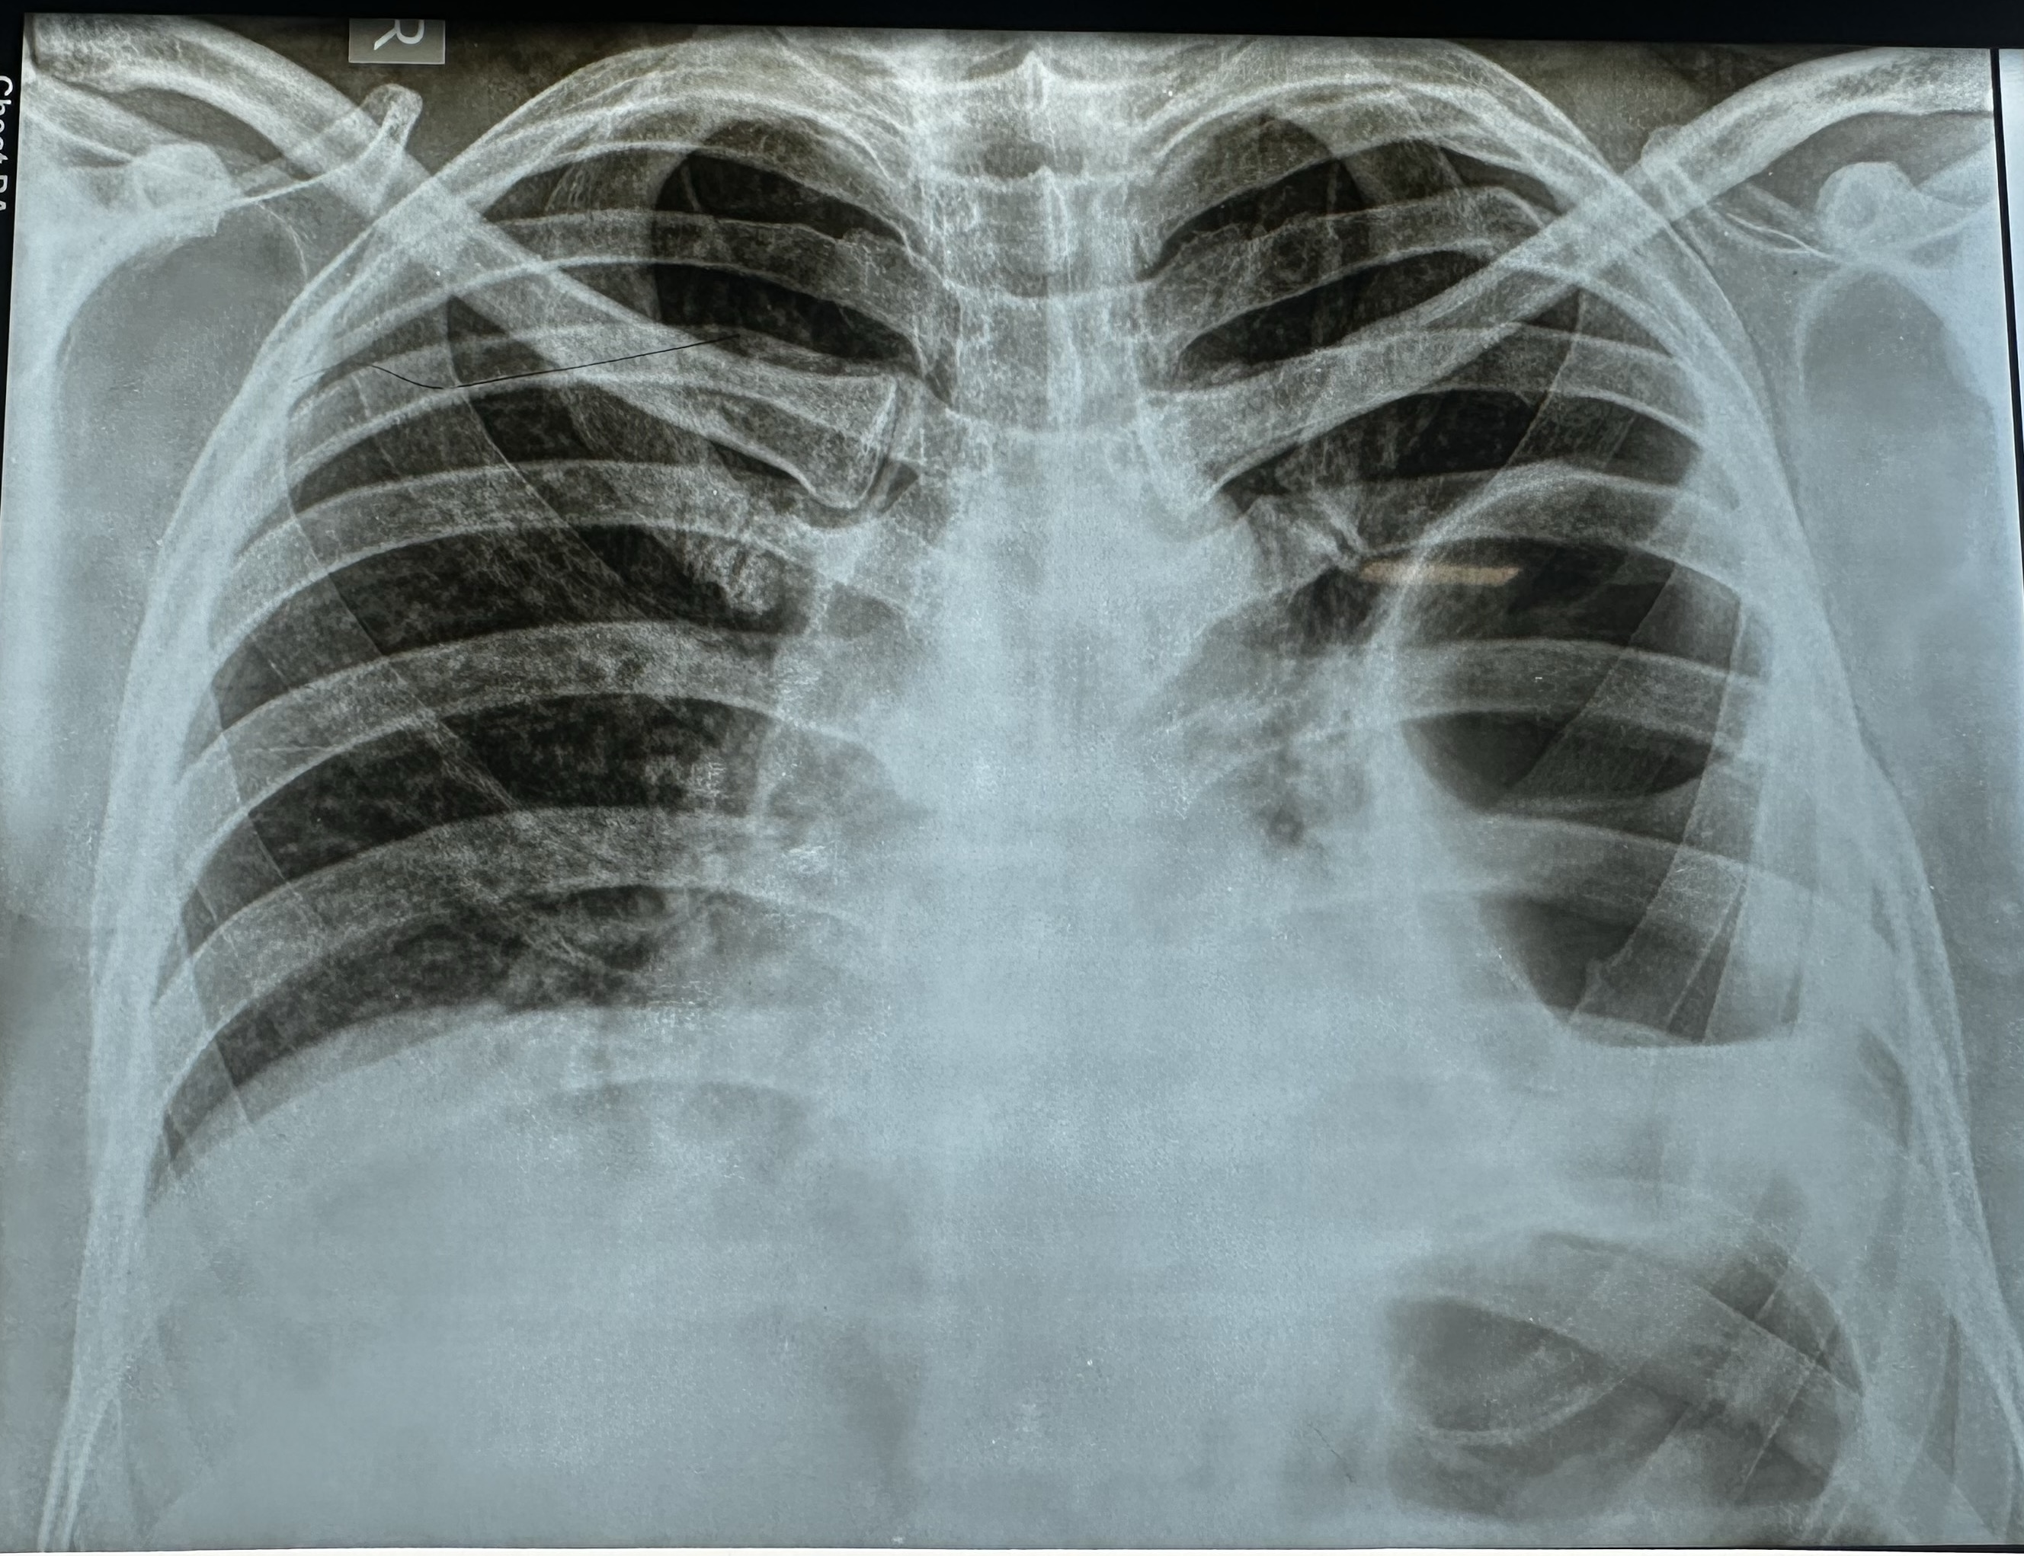
Mortality ranges from 18–40%, largely determined by associated injuries [Hanna WC,2009]. Early recognition and timely repair are essential to improve outcomes. Giangrosso et al. highlight the high (31%) mortality of latent hernias and the importance of follow-up imaging in trauma survivors[Giangrosso GV Jr, 2025]. One of the largest recent cohorts (40 cases) of delayed TDH by Zhao et al. concluded on careful assessment of history and physical examinations being vital, and also introduced CT reconstruction as a useful modality for diagnosis [Zhao L,2019].
Fig. 1. Chest Radiograph on presentation
Note suspicious gas shadow in left hemithorax - due to herniated splenic flexure of colon.

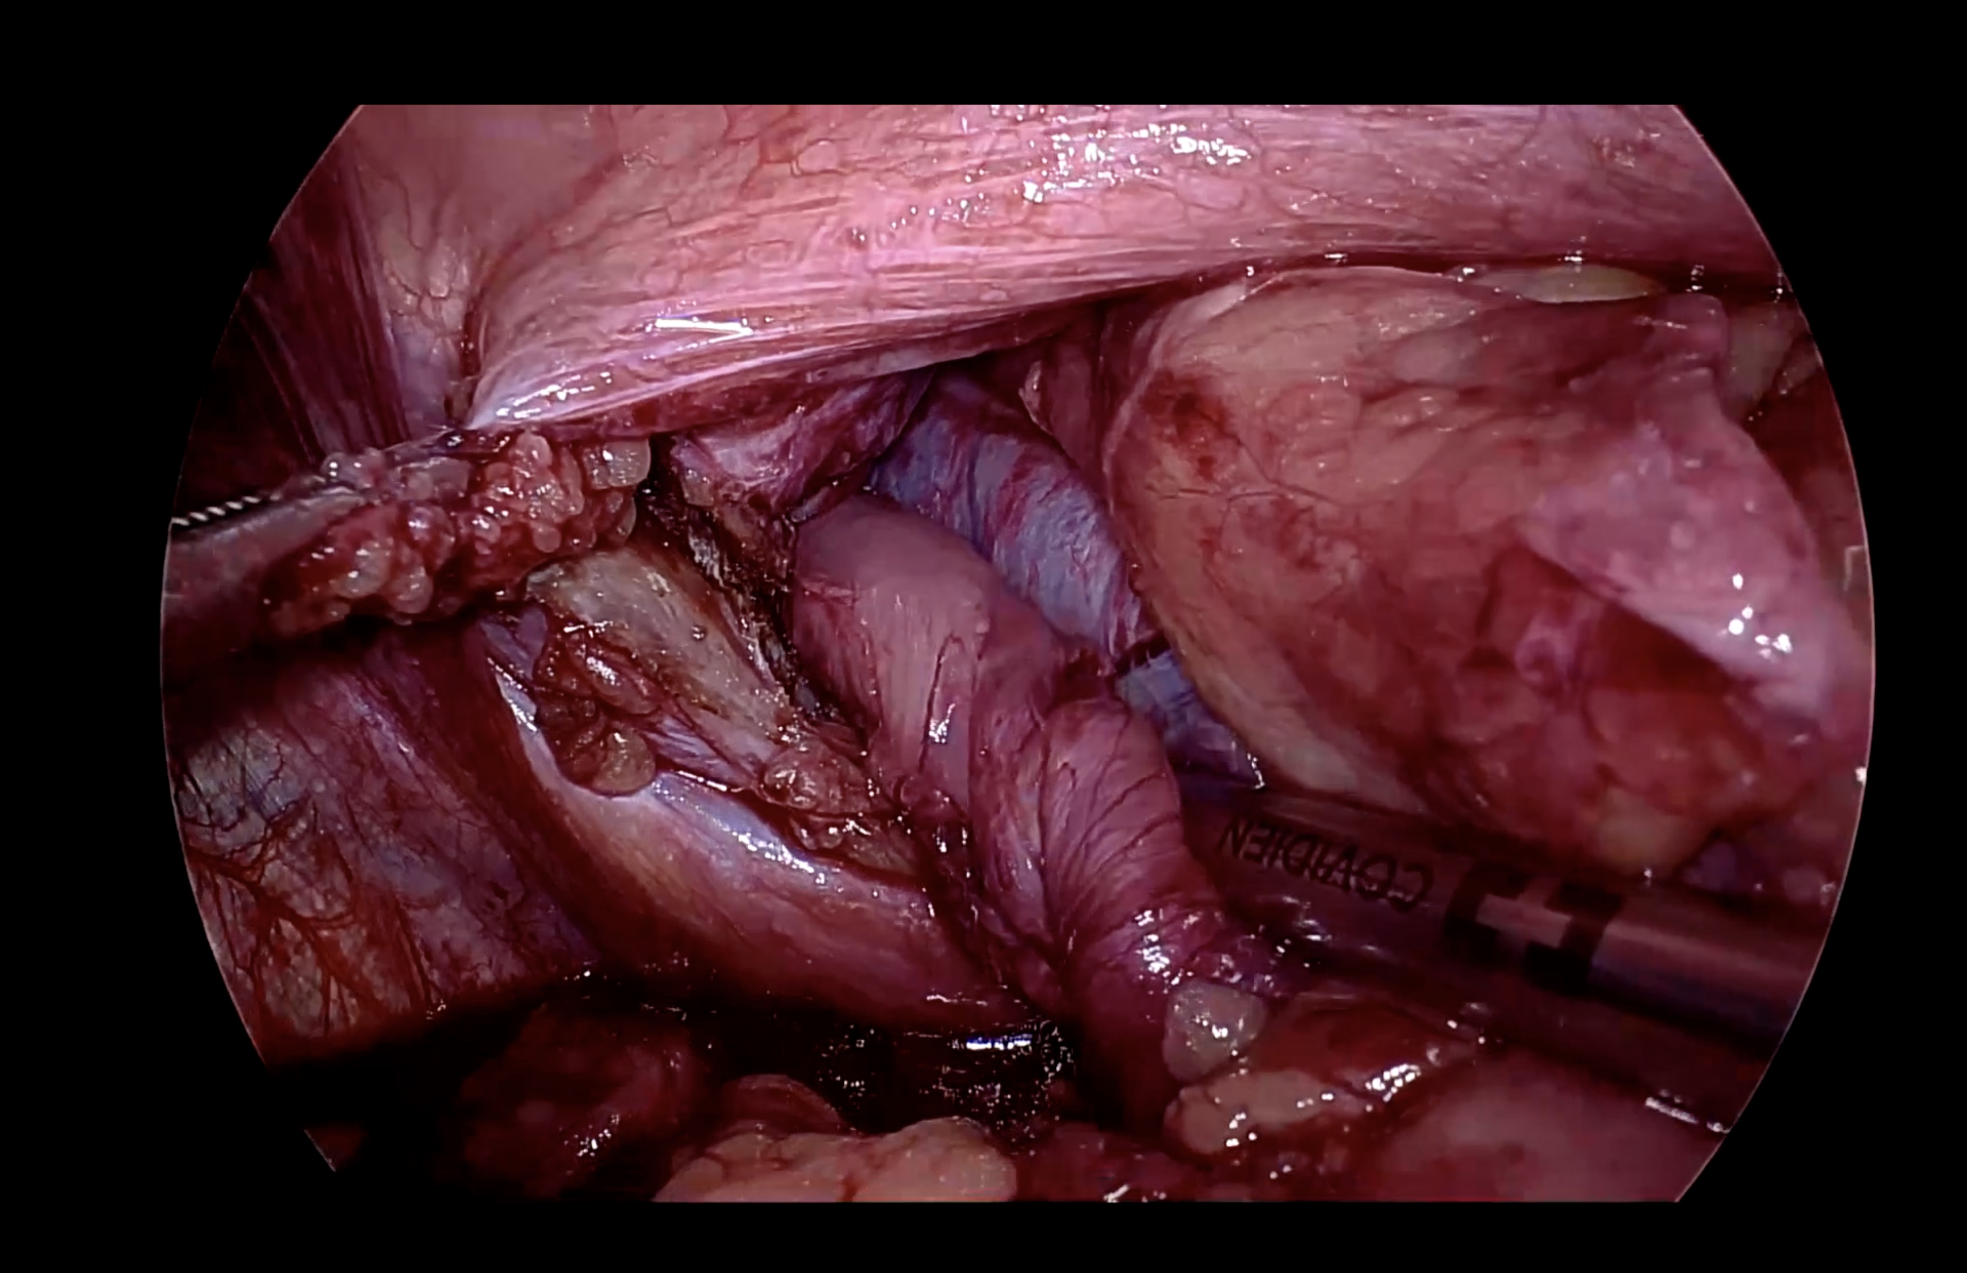
Fig. 2. Diaphragmatic defect containing ischaemic colon and omentum

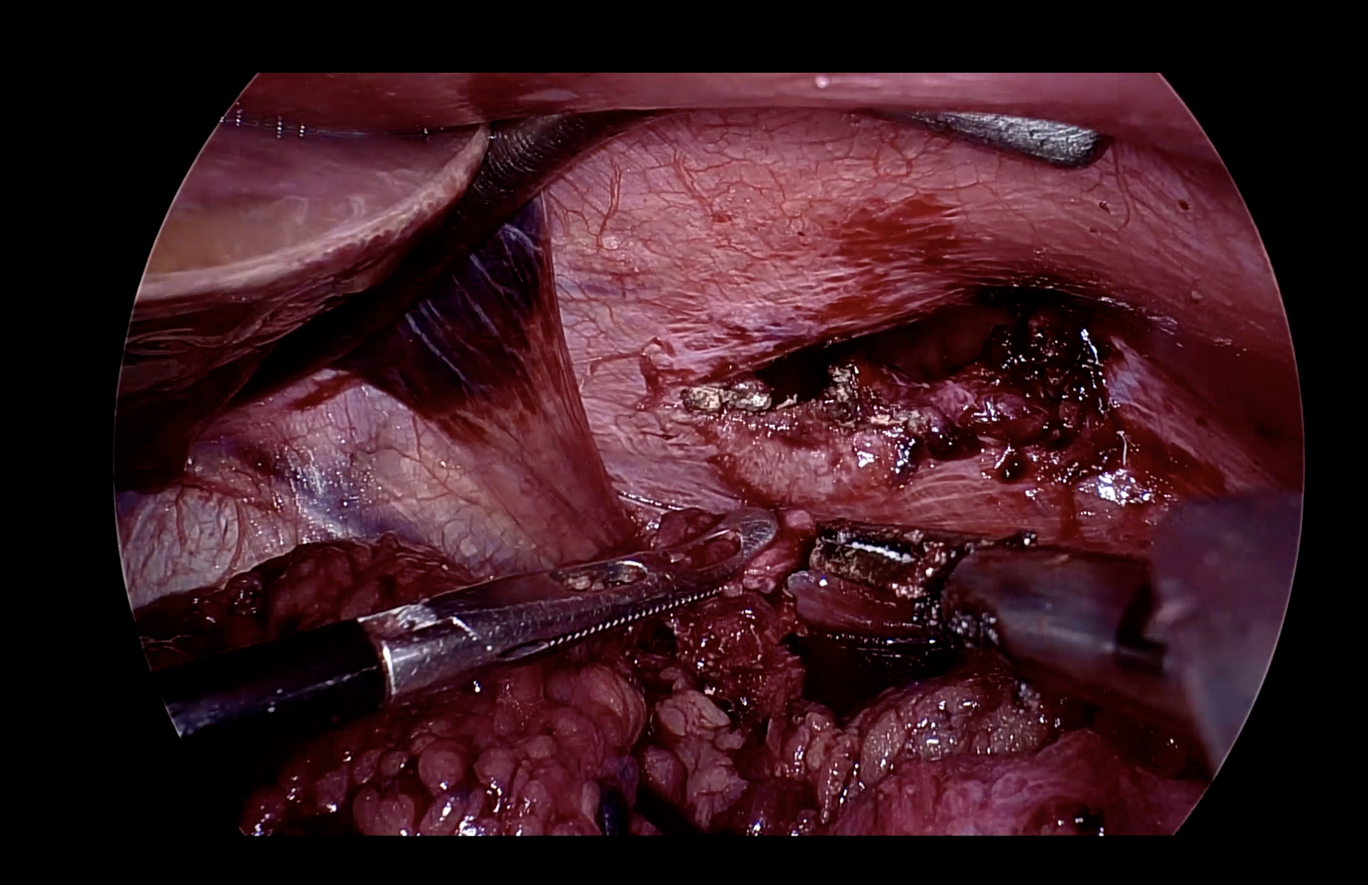
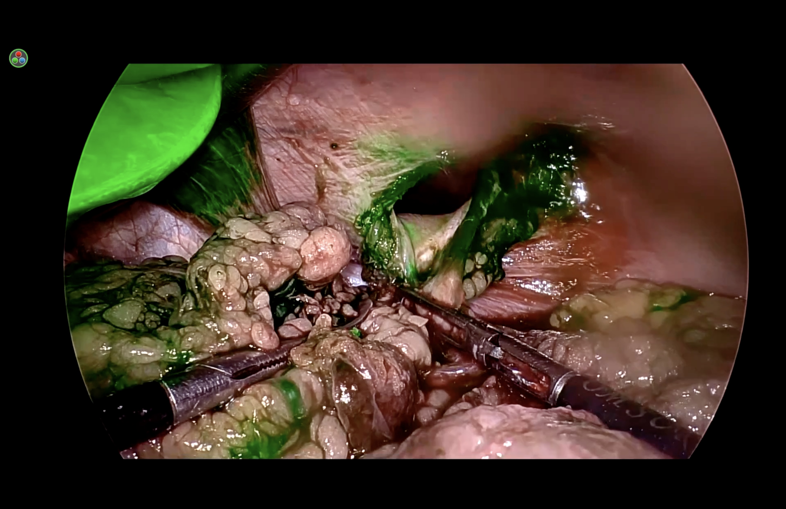

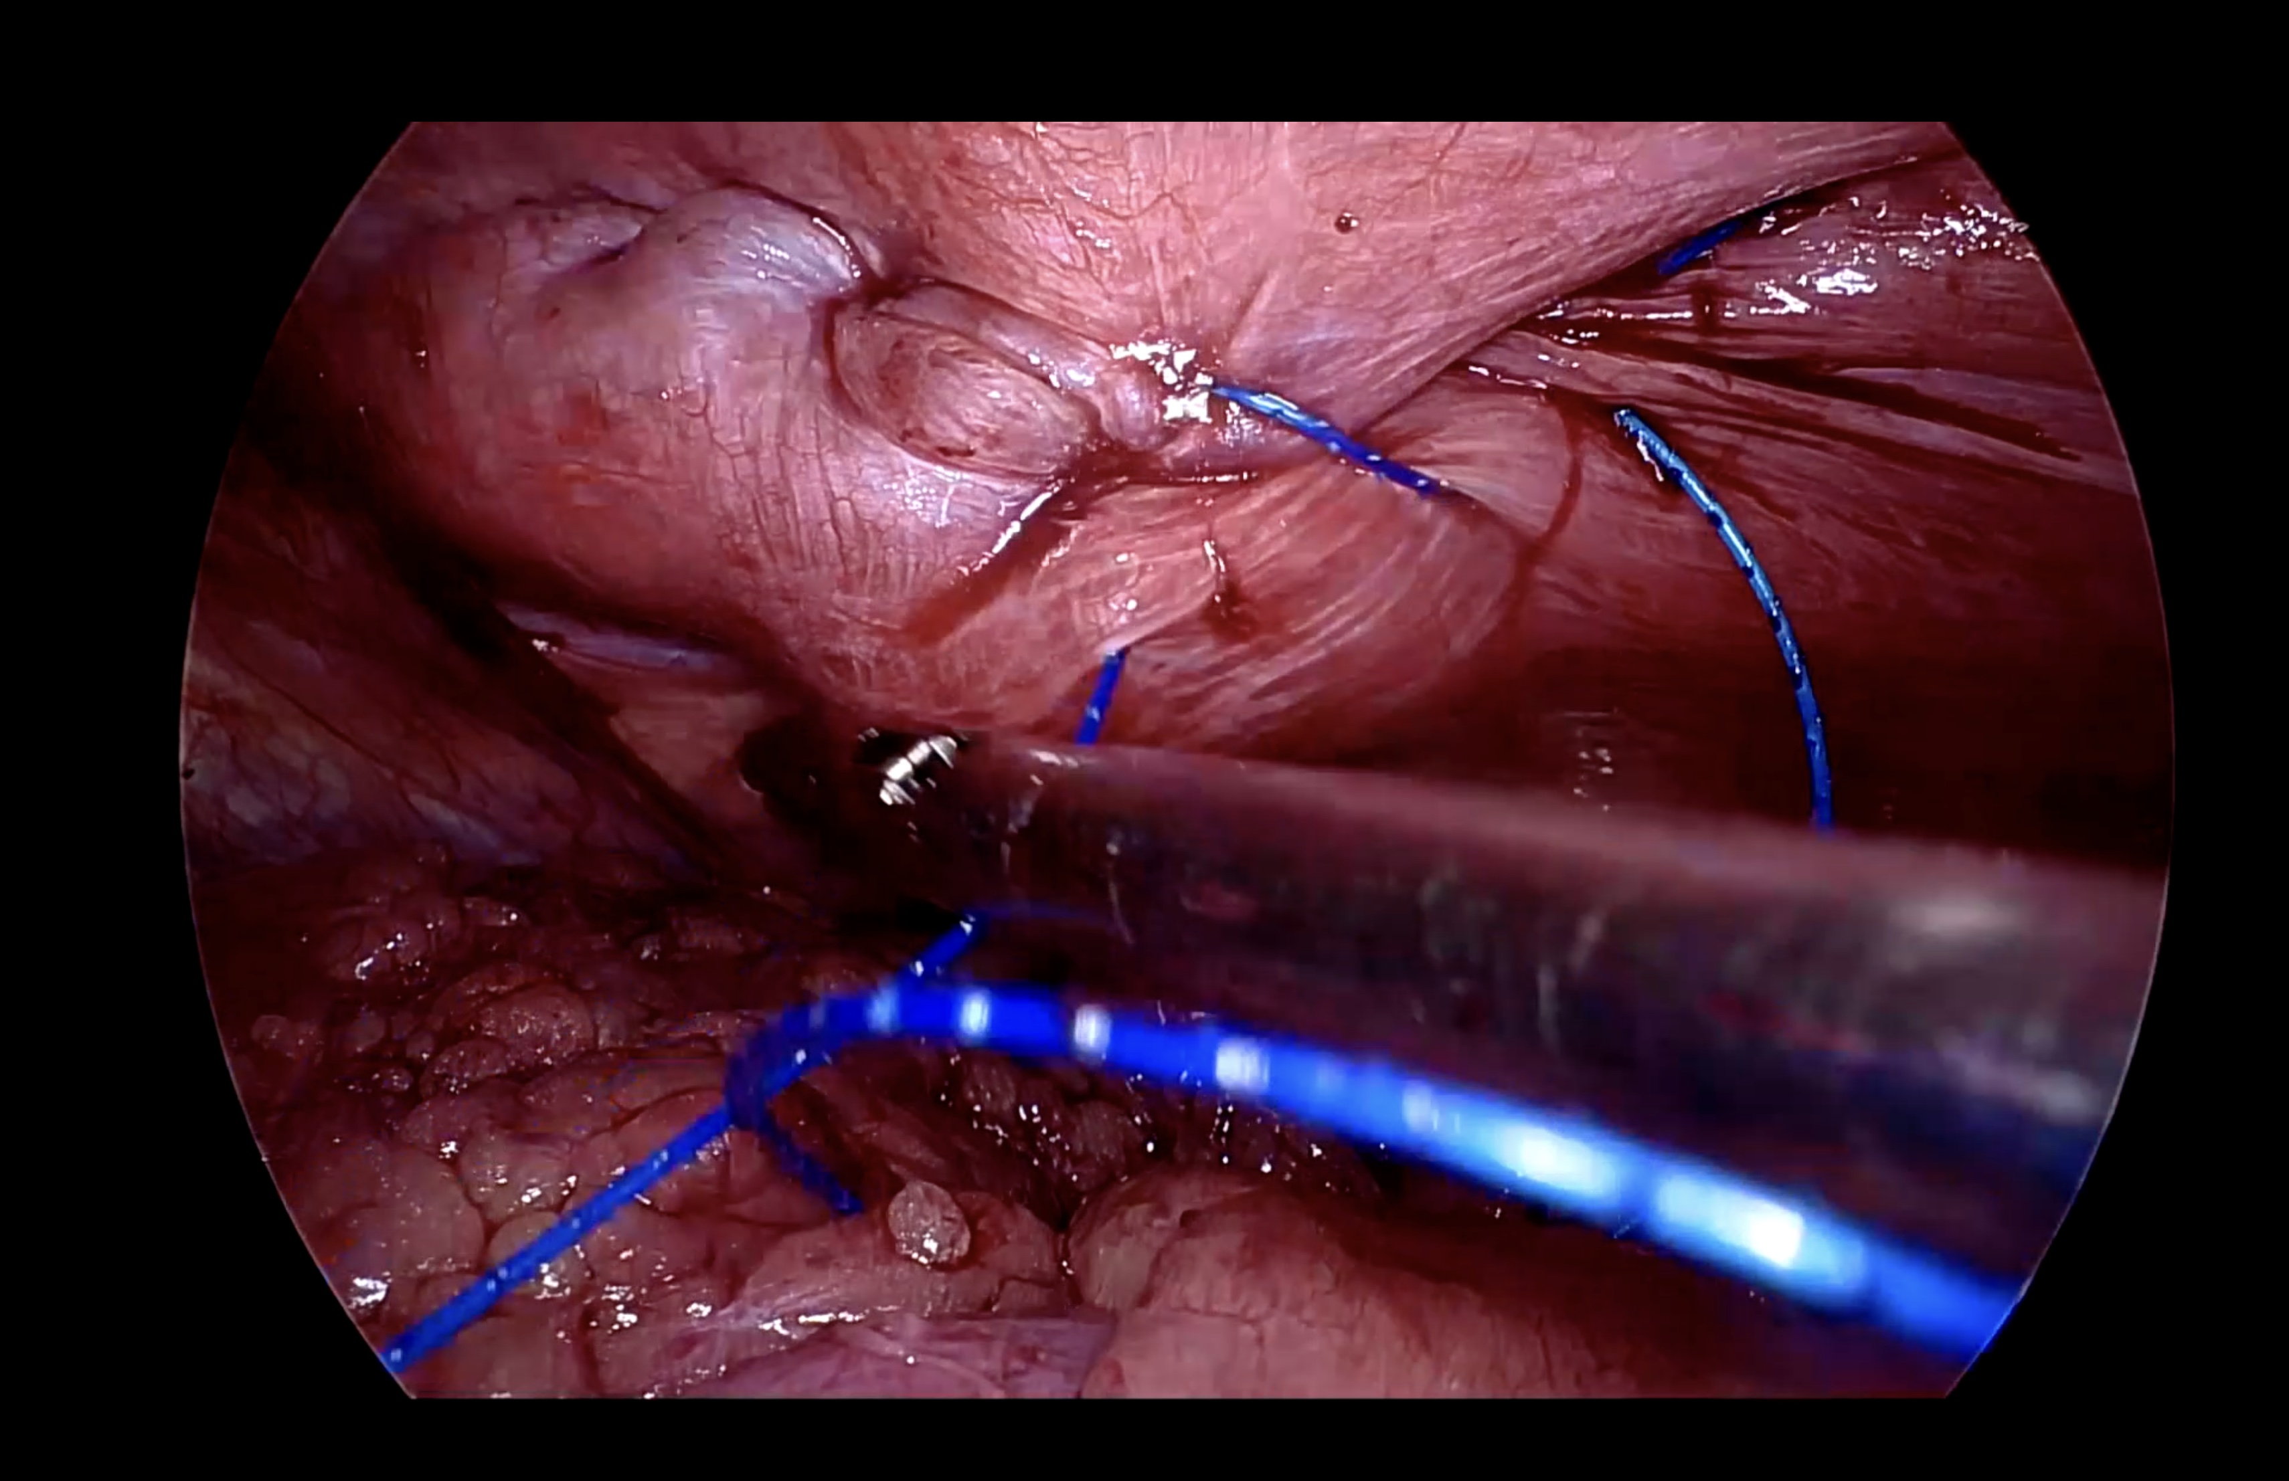

Fig. 3. Diaphragmatic defect after reduction of contents

Fig. 4. Assessment of Tissue viability with Indocyanine Green dye under fluorescent vision.

Fig. 5. Repair of defect using non-absorbable barbed sutures

4. Conclusion

Delayed presentation of traumatic diaphragmatic hernias can involve life-threatening complications. A high index of suspicion, appropriate imaging, and timely surgical intervention are critical. In stable patients, laparoscopy offers a safe and effective approach for both diagnosis and repair.

Disclaimer (Artificial intelligence)

Author(s) hereby declare that NO generative AI technologies such as Large Language Models (ChatGPT, COPILOT, etc.) and text-to-image generators have been used during the writing or editing of this manuscript.

References

1. Hanna WC, Ferri LE: Acute traumatic diaphragmatic injury. Thorac Surg Clin. 2009;19:485–9. doi:10.1016/j.thorsurg.2009.07.008
2. Safdar G, Slater R, Garner JP: Laparoscopically assisted repair of an acute traumatic diaphragmatic hernia. BMJ Case Rep. 2013;2013:bcr2013009415. doi:10.1136/bcr-2013-009415
3. Iadicola D, Branca M, Lupo M, et al: Double traumatic diaphragmatic injury: a case report. Int J Surg Case Rep. 2019;61:82–85. doi:10.1016/j.ijscr.2019.07.030
4. Ercan M, Aziret M, Karaman K, et al: Dual mesh repair for a large diaphragmatic hernia defect: an unusual case report. Int J Surg Case Rep. 2016;28:266–269. doi:10.1016/j.ijscr.2016.10.015
5. Testini M, Girardi A, Isernia RM, et al: Emergency surgery due to diaphragmatic hernia: case series and review. World J Emerg Surg. 2017;12:23. doi:10.1186/s13017-017-0134-5
6. Kishore A, Singh A, Jain A: Traumatic diaphragmatic hernia: a case report. Int Surg J. 2018;5:2378–2382. doi:10.18203/2349-2902.isj20182259
7. Nguyen P, Davis B, Tran DD: Laparoscopic repair of diaphragmatic rupture: a case report with radiological and surgical correlation. Case Rep Surg. 2017;2017:4159108. doi:10.1155/2017/4159108
8. Chao PH, Chuang JH, Lee SY, Huang HC. Bochdalek hernia in an adolescent: case report. Acta Paediatr. 2011;100:425–8.
9. Kurniawan N, Verheyen L, Ceulemans. Acute chest pain while exercising: a case report of Bochdalek hernia in an adolescent. Acta Chir Belg. 2013;113(4):290–2.
10. Antoniou SA, Rudolph P. The use of biological meshes in diaphragmatic defects: an evidence-based review. Front Surg. 2015;2:56.
11. Coccolini F, Agresta F, Bassi A, et al. Proposal for a decisional model in using biological prosthesis. World J Emerg Surg. 2012;7:34.
12. Soper NJ, Teitelbaum EN. Laparoscopic paraesophageal hernia repair: current controversies. Surg Laparosc Endosc Percutan Tech. 2013;23(5):442–5.
13. Gander JW, Fisher JC, Gross ER, et al. Early recurrence of congenital diaphragmatic hernia after thoracoscopic repair. J Pediatr Surg. 2011;46(7):1303–8.
14. Lansdale N, Alam S, Losty PD, Jesudason EC. Neonatal endosurgical congenital diaphragmatic hernia repair: a systematic review. Ann Surg. 2010;252(1):20–6.
15. Tsao K, Lally PA, Lally KP. Minimally invasive repair of congenital diaphragmatic hernia. J Pediatr Surg. 2011;46(6):1158–64.
16. Major EE, Chen B, Al Mahrizi AD, Ezenwanne C, Gill H, Mossolem F, Siddique SA, Valladares C. Minimally Invasive vs. Open Surgical Repair in Traumatic Diaphragmatic Hernia: A Systematic Review of 8,990 Patients. Cureus. 2025 Apr 16;17(4):e82371. doi: 10.7759/cureus.82371. PMID: 40385927; PMCID: PMC12085974.
17. Giangrosso GV Jr, Cassier T, Nakao Y, Denning D, Weaver AJ. Delayed Traumatic Diaphragmatic Hernias: Tomorrow's Emergency. Cureus. 2025 Sep 1;17(9):e91424. doi: 10.7759/cureus.91424. PMID: 41040790; PMCID: PMC12487990.
18. Zhao L, Han Z, Liu H, Zhang Z, Li S. Delayed traumatic diaphragmatic rupture: diagnosis and surgical treatment. J Thorac Dis. 2019 Jul;11(7):2774-2777. doi: 10.21037/jtd.2019.07.14. PMID: 31463105; PMCID: PMC6687985.

