Laparoscopic Management of Small Bowel Perforation Following Blunt Abdominal Trauma from a Steering Wheel
Case report

Abstract
Steering wheel impact during a motor vehicle accident can cause blunt abdominal trauma, which may lead to small bowel perforation. This injury typically occurs due to rapid compression, shearing forces, or increased intraluminal pressure, creating a “blow-out” effect or crushing force that pins the bowel against the vertebral column. The jejunum and proximal ileum are the most commonly injured sites because of their relatively fixed anatomical position. Early evaluation with CT scan of the abdomen is essential to detect free intraperitoneal air or fluid, which may indicate bowel perforation. However, isolated small bowel injuries following blunt steering wheel trauma are rare. Laparoscopic management of small bowel perforation resulting from steering wheel injury is considered a safe, effective, and both diagnostic and therapeutic approach in hemodynamically stable patients. Surgical procedures may include primary repair of the perforation or resection of the affected bowel segment, performed using intracorporeal suturing or laparoscopic-assisted extracorporeal techniques.
We report a rare case of small bowel perforation in a 35-year-old man who sustained blunt abdominal trauma following a tractor wheel injury to the abdomen. The diagnosis was made by X-ray chest and abdomen and CT scan of the abdomen showing free intraperitoneal air and fluid, and the patient was successfully managed laparoscopically. The patient had an uneventful postoperative recovery and was discharged on the fifth postoperative day in stable condition.
The study therefore concluded that, compared with open surgery, laparoscopic management is associated with less postoperative pain, faster recovery, shorter hospital stays, and potentially lower morbidity.

Key Words
Blunt abdominal trauma (BATs), Laparoscopic management, Small bowel perforation, Steering wheel injury

Introduction
Small bowel perforation is the third most common injury associated with blunt abdominal trauma (BAT), although it occurs in less than 1% of such cases. It refers to a disruption in the integrity of the bowel wall and may arise from various causes, including trauma, iatrogenic injury, diverticular disease, duodenal ulcer, ischemia, or neoplasms [11,12]. Blunt abdominal trauma can result in life-threatening surgical emergencies, including liver and splenic lacerations, perforated viscus, diaphragmatic rupture, and intra-abdominal hematoma [13]. The first documented case of intestinal perforation following blunt abdominal trauma was reported by Samuel Annan in 1937.[1,2,3]
Steering wheel injuries that lead to lower abdominal trauma may cause contusions or lacerations of the mesentery of the small or large bowel, although these are also uncommon. Isolated mesenteric injuries of the small bowel are particularly rare and may remain undiagnosed after blunt abdominal trauma. [2,3]
It most commonly occurs along the antimesenteric border, which is more vulnerable due to its relatively thinner wall and reduced vascular supply. These injuries are believed to result from a sudden increase in intraluminal pressure within fluid- or air-filled bowel loops, leading to a burst or “blow-out” type injury. [1,2,3]
UNDER PEER REVIEW
Small bowel perforation (SBP) in blunt abdominal trauma presents with persistent abdominal pain, tenderness, guarding, and often, signs of peritonitis. Common indicators include seat belt signs (abdominal ecchymosis), distension, nausea, and, in cases of delay, fever or shock. Due to its rarity, it requires high suspicion with CT scans in cases of unexplained diagnosis which can be challenging.
Radiographic evidence of free intraperitoneal air (pneumoperitoneum) on plain abdominal or chest X-ray may suggest bowel perforation. However, contrast-enhanced CT scan of the abdomen is considered the gold standard for evaluating bowel injuries, as it can detect perforations, mesenteric tears, and other intra-abdominal pathologies with high sensitivity. [5,6,7]
Surgical intervention remains the definitive treatment for small bowel perforation, and the choice of procedure depends on the extent of the injury. Surgical options include primary repair of the perforation or resection of the injured bowel segment followed by anastomosis. Both open and laparoscopic approaches are utilized, with laparoscopy being a safe and effective option in hemodynamically stable patients. [3,4,5]

Case Report
A 35-year-old male patient was admitted to the hospital on 13/12/2025 with complaints of abdominal pain, abdominal distension, and guarding following a tractor wheel injury to the abdomen. On clinical examination, the patient presented with signs suggestive of intestinal perforation, including diffuse abdominal tenderness, guarding and rigidity. His temperature was 104°F, pulse rate was 110 beats per minute, and the total leukocyte count on admission was 12,500.
A plain X-ray of the abdomen revealed gas under the right dome of the diaphragm, suggestive of pneumoperitoneum. A CT scan of the abdomen demonstrated extraluminal gas (pneumoperitoneum) and free fluid within the peritoneal cavity, with no evidence of solid organ injury to the liver or spleen. These findings were consistent with small bowel perforation with peritonitis.
Based on the diagnosis of intestinal perforation, we proceeded with emergency laparoscopic exploration. A nasogastric tube was inserted for gastric decompression, and broad-spectrum intravenous antibiotics were administered. Under general anesthesia, diagnostic laparoscopy was performed. Pneumoperitoneum was established using a Veress needle, followed by insertion of a 10- mm umbilical trocar, maintaining an intra-abdominal pressure of 14 mmHg. Two additional 5-mm trocars were placed in the right and left iliac fossae.
Using a 30-degree laparoscope, free fluid was noted in Morrison’s pouch and the pelvic cavity, which was aspirated. Inspection of the abdomen revealed normal liver and spleen. Further exploration identified an isolated 1.5 × 1 cm perforation on the antimesenteric border of the terminal or distal ileum. The perforation site was thoroughly irrigated and cleaned with a suction canula, and the defect was closed in two layers using 2-0 Vicryl sutures with a round-body needle.
A pelvic drain was placed at the end of the procedure and was removed on the third postoperative day. The patient had an uneventful postoperative recovery and was discharged on the

fifth postoperative day in stable condition. On follow-up on the 10th postoperative day, the surgical wounds healed well, and the abdomen was soft with normal bowel habits. (Fig 1.-10)
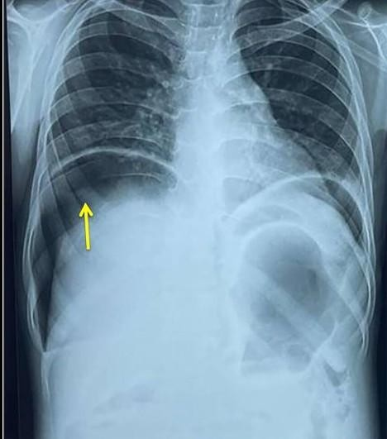
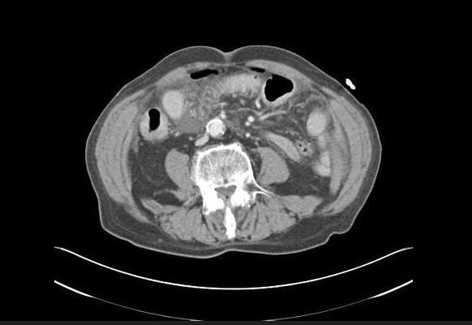


Fig-1 X-ray chest and abdomen shows gas under diaphragm s/o perforation
Fig-2 CT scan shows pneumoperitoneum and moderate amount of intraperitoneal free fluid reviled with small bowel perforation

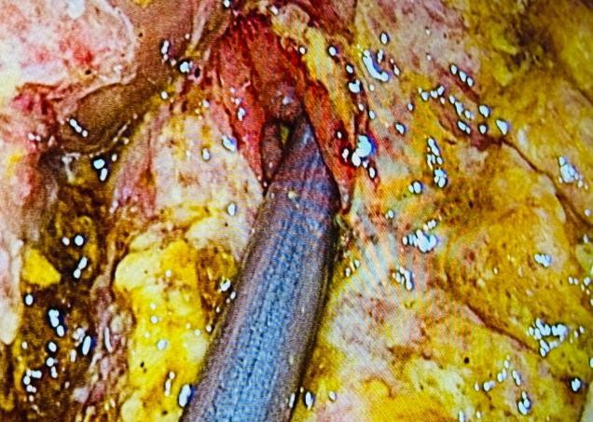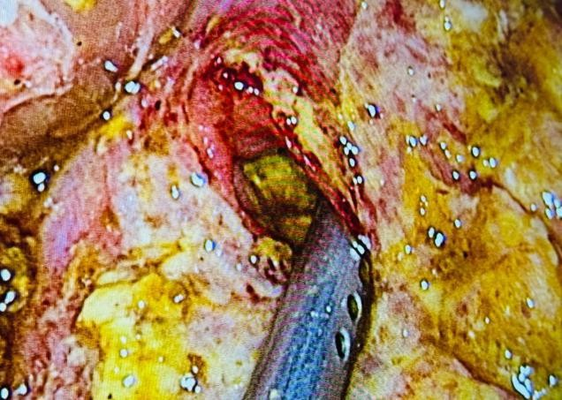

Fig-3 Laparoscopic photograph showing perforation at distal end of small bowel
UNDER PEER REVIEW

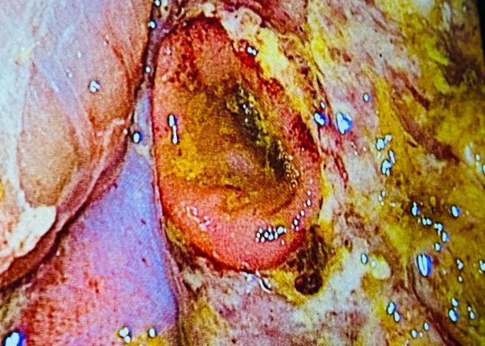
Fig-5 Laparoscopic photograph showing post traumatic steering wheel injury to distal small bowel leading to perforation measuring 1.5x1 cm
Fig-4 Laparoscopic photograph showing perforation at distal end of small bowel
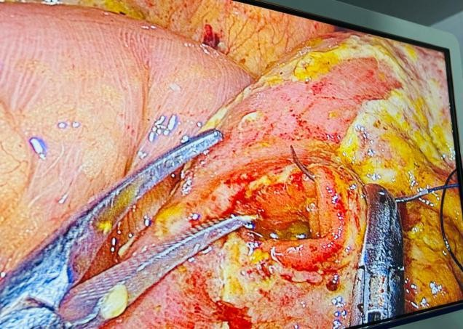
Fig-6 Laparoscopic photograph showing suturing of small bowel perforation with 2.0 Vicryl

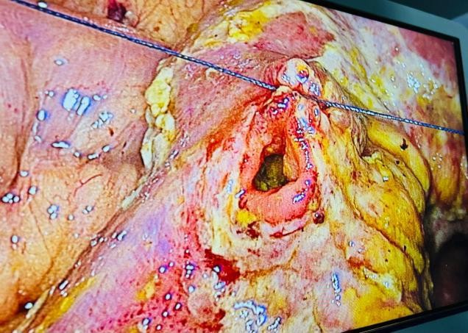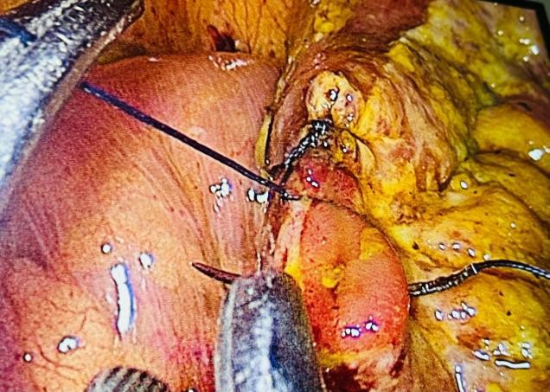

Fig-7 Laparoscopic photograph showing suturing of small bowel perforation with 2.0 Vicryl
Fig-8 Laparoscopic photograph showing suturing of perforation first layer

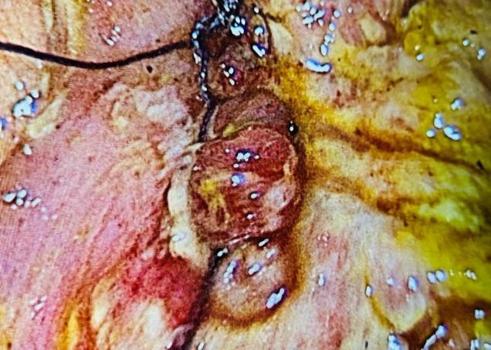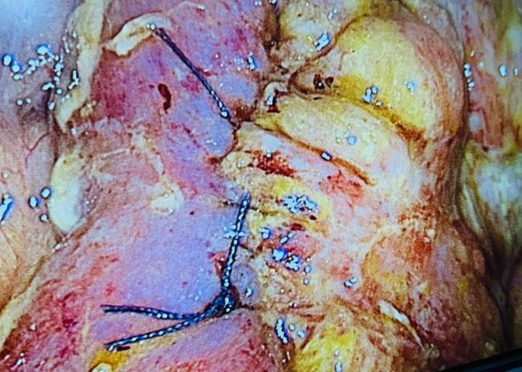

Fig-9 Laparoscopic photograph showing suturing of perforation first layer completed
Fig-10 Laparoscopic photograph showing suturing of perforation second layer completed

UNDER PEER REVIEW

Discussion
Pathophysiology of Small Bowel Perforation in Blunt Abdominal Trauma (BAT)
Small bowel perforation following blunt abdominal trauma (BAT) is a rare but serious injury, with an incidence of less than 1%. It is most commonly associated with motor vehicle accidents, particularly from impacts involving seat belts, handlebars, or steering wheels. The injury primarily results from rapid compression, shearing forces, or rupture due to sudden increases in intraluminal pressure, often producing a “blow-out” perforation at the antimesenteric border of the bowel. Clinical presentation may occur immediately after trauma or may be delayed, especially in cases where ischemic necrosis develops due to mesenteric vascular injury. [1,2,3]

Pathophysiological Mechanisms
UNDER PEER REVIEW
- Sudden Compression (Crush Injury)
In this mechanism, the small bowel is compressed between the external force of impact (such as a seat belt, handlebar, or steering wheel) and the lumbar spine. This compression leads to a rapid increase in intraluminal pressure, which may cause a blow-out perforation, most commonly along the antimesenteric border, where the bowel wall is relatively weaker.

Deceleration and Shearing Forces
Rapid deceleration during trauma can create significant shearing forces at fixed points of the intestine, such as the ligament of Treitz and the ileocecal junction. These forces may result in bowel transection, mesenteric tears, or vascular injury.

Ischemic Necrosis (Delayed Perforation)
Trauma to the mesentery may cause hematoma formation or disruption of mesenteric vessels, leading to compromised blood supply to the bowel segment. Over time, this can result in ischemia and necrosis, ultimately causing delayed bowel perforation, which may occur hours or even days after the initial injury.

Closed-Loop Mechanism
When both ends of a bowel segment become temporarily obstructed, intraluminal pressure rapidly increases within the closed segment. This progressive pressure buildup may lead to rupture of the bowel wall. [4,5,6,7]

Surgical Management
The management of small bowel perforation depends primarily on the hemodynamic status of the patient and the extent of the injury. In hemodynamically stable patients, laparoscopic surgery can be performed and offers advantages such as reduced postoperative pain, shorter hospital stays, and faster recovery. In hemodynamically unstable patients, emergency open damage control laparotomy is required to control contamination and stabilize the patient. [1,2,3,5]

Open Laparotomy
Open laparotomy remains the standard treatment for unstable patients or those with extensive injuries. Early surgical intervention is critical, as delays beyond 24 hours significantly increase morbidity and mortality due to sepsis and peritonitis.

Treatment options include:
- Primary repair:
Small, single perforations can often be closed primarily with sutures.

Resection and anastomosis:
In cases of large, complex, or multiple injuries, the damaged bowel segment is resected, followed by primary end-to-end anastomosis.

Stoma formation (Exteriorization):
In situations involving severe contamination, extensive bowel damage, or hemodynamic

instability, a temporary ileostomy or colostomy may be created as part of damage control surgery.
UNDER PEER REVIEW
Mesenteric injuries may require resection of the affected bowel segment if the blood supply is compromised. During laparotomy, thorough exploration, drainage of contaminated peritoneal fluid, and saline lavage of the abdominal cavity are essential. Broad-spectrum prophylactic antibiotics are also administered. Delayed diagnosis of small bowel perforation can lead to severe complications, including sepsis and death, highlighting the importance of early recognition and prompt surgical intervention. [6,7,8]

Laparoscopic Surgery
Laparoscopic management of small bowel perforation, particularly following steering wheel injuries, has emerged as a safe, feasible, and effective approach in hemodynamically stable patients. It serves both diagnostic and therapeutic purposes.

Key steps include:
- Diagnostic exploration:
Complete inspection of the entire small bowel from the ligament of Treitz to the ileocecal valve to identify perforations or mesenteric injuries.

Intracorporeal suturing:
Small perforations can be closed using laparoscopic needle holders with 2-0 Vicryl sutures.

Laparoscopic-assisted repair:
The injured bowel segment may be exteriorized through a small incision or an extended umbilical port for repair.

Resection and anastomosis:
In cases of severely damaged or de-vascularized bowel, resection and anastomosis can be performed laparoscopically or through a mini-laparotomy, often using stapled anastomosis.
Laparoscopy provides excellent visualization of the abdominal cavity, enabling precise identification and management of bowel injuries while minimizing surgical trauma and improving postoperative recovery. [1,2,3,4,5]

Conclusion
Small bowel perforation resulting from steering wheel injury is a rare but serious consequence of blunt abdominal trauma (BAT). In carefully selected patients, particularly those who are hemodynamically stable, laparoscopy serves as a safe and effective modality for both diagnosis and treatment.
Small bowel perforations can be successfully repaired using intracorporeal or extracorporeal suturing techniques, offering an effective alternative to traditional open surgical repair. Compared with open surgery, laparoscopic management is associated with reduced postoperative pain, faster recovery, shorter hospital stays, and potentially lower morbidity.

References
UNDER PEER REVIEW
- Di Buono G, Maienza E, Buscemi S, Gulotta L, Romano G, Agrusa A. Laparoscopic treatment of mesenteric avulsion and intestinal perforation after blunt abdominal trauma: A report of a case. Int J Surg Case Rep. 2020;77S(Suppl):S116-S120. doi: 10.1016/j.ijscr.2020.10.033. Epub 2020 Oct
12. PMID: 33191192; PMCID: PMC7876738.

- Elgeldawy, Mohamed M, Reham F Alfelakawi, Fahad Alabhoul, and Ali H Dokhi. 2025.
“Laparoscopic Repair of Ileal Perforation Post Blunt Abdominal Trauma: A Case Report”. Asian Journal of Case Reports in Surgery 8 (1):11-15. https://doi.org/10.9734/ajcrs/2025/v8i1591.

- Wani I, Bhat RA, Wani S, Khan N, Wani RA, Parray FQ. Isolated small bowel mesentery injury after steering wheel trauma. Trauma Mon. 2012 Summer;17(2):279-81. doi: 10.5812/traumamon.4960. Epub 2012 Jul 31. PMID: 24350106; PMCID: PMC3860640.

- Patel, J., & Patel, P. (2016). Laparoscopic approach for small - bowel perforation -early outcome for 20 patients. International Surgery Journal, 3(4), 2191–2195. https://doi.org/10.18203/2349- 2902.isj20163599

- Saber M, Le L, Bell D, Small bowel perforation. Reference article, Radiopaedia.org (Accessed on 08 Mar 2026) https://doi.org/10.53347/rID-86544

- Das, Bhuban Mohan, Srikant Patro, Suraj Ethiraj, and Ramapada Mohapatra. 2021. “Delayed Small Bowel Perforation Following Blunt Abdominal Trauma As a Rare Cause of Acute Abdomen: A Case Report”. Asian Journal of Case Reports in Surgery 4 (2):460-64. https://journalajcrs.com/index.php/AJCRS/article/view/122.

- Mukhopadhyay M. Intestinal injury from blunt abdominal trauma: a study of 47 cases. Oman Med
J. 2009 Oct;24(4):256-9. doi: 10.5001/omj.2009.52. PMID: 22216378; PMCID: PMC3243872.

- Raju Badipati, Lakshmi Durga Kasinikota, Delayed presentation of an entrapped small bowel loop stricture in a case of seat belt injury with the seat belt sign: laparoscopic resection and anastomosis, Int J Gastrointest Interv 2024; 13(1): 26-28, January 31,
2024 https://doi.org/10.18528/ijgii230017 Copyright © International Journal of Gastrointestinal Intervention.

- Skelhorne-Gross G, Kenny J. Blunt and Penetrating Injury to the Bowel: A Review. Clin Colon Rectal Surg. 2023 Dec 20;37(6):424-429. doi: 10.1055/s-0043-1777668. PMID: 39399140; PMCID: PMC11466513.
UNDER PEER REVIEW

- Staab, V.; Naganathan, S.; McGuire, M.; Pinto, J.M.; Pall, H. Gastrointestinal Perforation with Blunt Abdominal Trauma in Children. Children 2024, 11, 612. https://doi.org/10.3390/children11060612

- Baker, N., & Woolridge, D. (2013). Emerging concepts in pediatric emergency radiology. Pediatric Clinics of North America, 60(5), 1139-1151.

- Kumar, A., Sridhar, R., Kumar, H., Hakeem S, A., Khan, A. V., & Anwer, M. (2025). Blunt abdominal trauma: a retrospective study on clinical insights and treatment outcomes. Journal of trauma and injury, 38(3), 221–231. https://doi.org/10.20408/jti.2025.0045

- Nagpal, S., Berry, D., Magacha, H., & Nunley-Gorman, D. (2024). Outpatient management of small bowel perforation: A case report and review of literature. The American Journal of Gastroenterology, 119(10 Suppl), S1959–S1960. https://doi.org/10.14309/01.ajg.0001040736.92758.ea

