Case report

Pediatric Intra-Abdominal Lymphoma Mimicking Surgical Abdominal Mass: Imaging-Pathology Correlation in a 13-Year-Old Male

Abstract
“Pediatric intra-abdominal lymphoma is a rare malignancy, yet it remains a clinically valuable entity with vague symptomatology, resulting in delayed diagnosis”. Such early diagnosis is essential for timely therapy and better prognosis. The authors report a case of a 13-year-old boy who presented with constitutional symptoms and abdominal pathology. A Contrast-enhanced computed tomography (CECT) scan showed conglomerate nodal masses with vascular encasement and the typical sandwich sign. The positron emission tomography-computed tomography (PET-CT) showed an “uptake” intensity relating to the metabolism, indicating an active lymphomatous component. Histopathology examination revealed lymphoma. The use of multimodality imaging, especially PET-CT is highlighted in such cases in the context of disease characterization, staging, and treatment planning. The report provides certain characteristic points that would aid clinicians in the early recognition of pediatric abdominal lymphoma based on imaging findings with various modalities.

Key words: Paediatric lymphoma, Intraabdominal mass, PET-CT, Histopathology, Sandwich sign

Introduction
Lymphoma represents one of the most common malignancies in the pediatric population, accounting for approximately 10-15% of childhood cancers. Lymphoma has also been divided into Hodgkin lymphoma and non-Hodgkin lymphoma (NHL), with NHL having many extra nodal involvements. Abdominal affection is typical in pediatric patients with lymphoma, especially in more malignant subtypes like Burkitt lymphoma and diffuse large B-cell lymphoma.
Some of the clinical manifestations of pediatric intra-abdominal lymphoma may include abdominal pain and distension, fever, and weight loss, and gastrointestinal disorders. However, the symptoms are often nonspecific which may delay diagnosis. Therefore, early detection is necessary because pediatric lymphomas, although aggressive, are very sensitive to chemotherapy if diagnosed early enough.
Radiological imaging is crucial in detection, staging, and therapeutic response assessments. For abdominal lymphadenopathy, organ infiltration, and vascular involvement, contrast-enhanced computed tomography (CECT) remains the frontline imaging technique. One of the classical features described in abdominal lymphoma in imaging is encasement of mesenteric vessels by enlarged lymph nodes called the “sandwich sign”.
More recently, PET-CT has emerged as an essential imaging modality that yields metabolic information besides anatomical information. It helps in accurate staging, assessment of treatment response, and identification of residual or recurrent disease. However, histopathological examination is still considered the gold standard for providing any definitive diagnosis.
This case report therefore emphasizes the complementary roles that CECT, PET-CT, and histopathology could play in the diagnosis of pediatric intra-abdominal lymphoma.

Case Presentation
The pediatric outpatient department received a 13-year-old boy whose main symptoms were intermittent fever and noticeable weight loss within a month. The patient also complained of a general feeling of weakness and mild abdominal pain. There was no history of vomiting, altered bowel movements, or any prior chronic illness.
Clinical Examination
On physical examination, the patient appeared cachectic and febrile. Abdominal examination revealed a mild fullness in the upper abdomen with no definite palpable mass. There was no hepatosplenomegaly or peripheral lymphadenopathy. There was mild anemia, and inflammatory markers were elevated in laboratory investigations.

Imaging Findings
Contrast-Enhanced CT Abdomen
CECT of the abdomen showed multiple large, well-demarcated, heterogeneously enhancing lesions involving the peritoneal and retroperitoneal areas. There was conglomeration of several lymph nodes in the form of a nodal mass measuring ~ 8.5 × 5.0 × 4.2 cm.
The nodal mass was in close contact with adjacent organs, the left lobe of the liver and pancreas included. The lesion showed encasement of major vessels in the abdomen, including the superior mesenteric artery, celiac axis, splenic artery, and the bilateral renal vessels. This appearance was deemed to represent the classical sandwich sign, which is believed to be characteristic of mesenteric lymphomatous involvement.
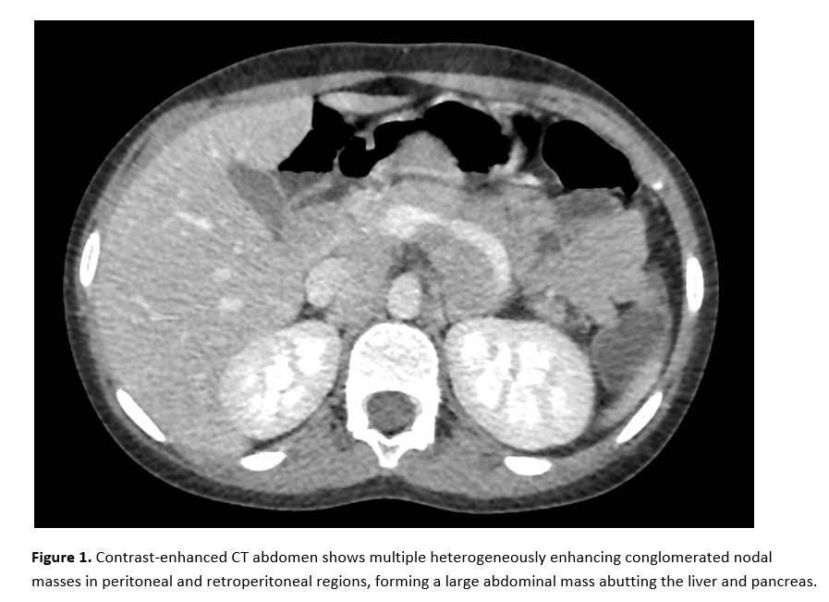
Narrowing of the splenic vein and left renal vein was noted without signs of intraluminal thrombosis. Loss of intervening fat planes between the mass and adjacent organs such as the stomach, pancreas, liver and anterior abdominal wall were suggestive of aggressive disease infiltration. No evidence of bowel obstruction or ascites was noted.

MRI Abdomen Findings
MRI showed a large lobulated mass in the peritoneal and retroperitoneal areas with intermediate T1 signal and mildly hyperintense T2 signal with diffusion restriction. There was close abutment with the left hepatic lobe, stomach, duodenum, and pancreatic body with loss of intervening fat planes but without definite organ invasion. Vascular encasement was noted in association with CT correlation of lymphomatous nodal conglomeration.
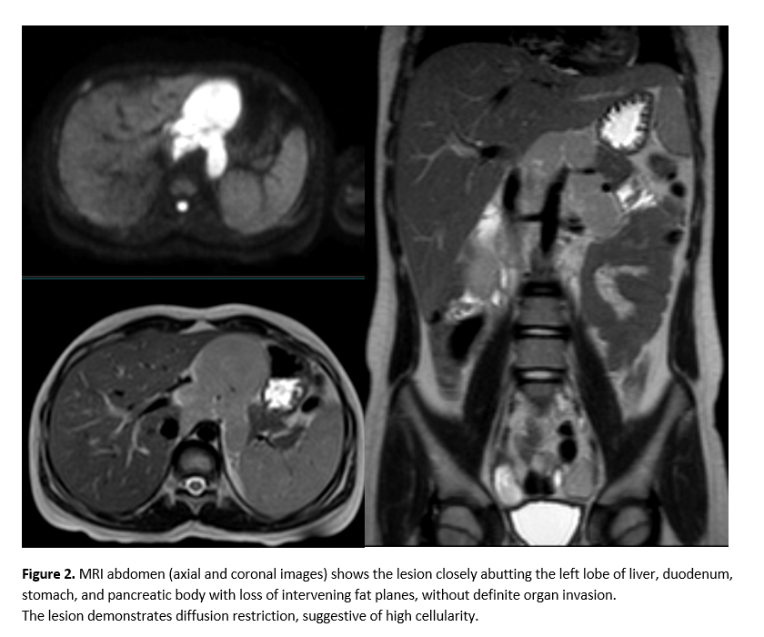

PET-CT Findings
The PET-CT showed intense FDG uptake in abdominal nodal masses of a conglomerate form involving several nodal stations, with a maximum SUV of 14.14, indicating metabolically active lymphomatous disease. Left supraclavicular and para-aortic nodes were also noted to be FDG avid, helping in staging and demonstrating the distribution of the disease.

Histopathological Examination
Histopathological examination revealed diffuse effacement of the normal architecture by sheets of atypical lymphoid cells with complete loss of the native nodal/parenchymal structure. The tumor cells were predominantly medium to large sized, exhibiting scant to moderate cytoplasm, irregular to round vesicular nuclei, coarse chromatin and prominent nucleoli. Numerous mitotic figures and apoptotic bodies were identified. Scattered tangible body macrophages were present, along with focal areas of necrosis. No evidence of granuloma formation or reactive follicular architecture was noted. The overall features were consistent with lymphoma.
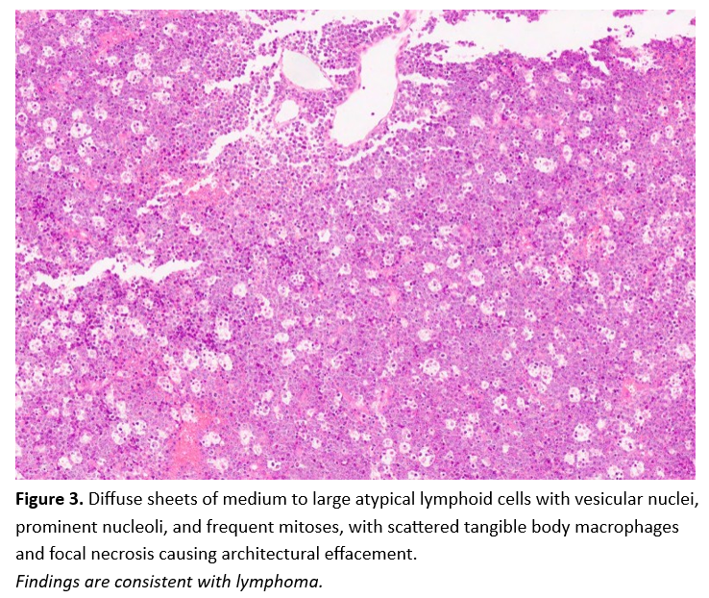
Based on the radiological and histopathological findings, the patient was diagnosed with pediatric intra-abdominal lymphoma, referred for oncological management and chemotherapy was initiated.

Discussion
Pediatric lymphoma has clinical and radiological manifestations different from adult lymphoma. Non-Hodgkin lymphoma is more common with extranodal involvement and rapid tumor growth. The abdomen is one of the popular extranodal sites with the involvement of mesenteric, retroperitoneal, and peritoneal lymph nodes.
Clinical Presentation
Symptoms of lymphoma in the abdomen are often vague and nonspecific. Common constitutional symptoms are fever, weight loss, and fatigue and are referred to as B symptoms. Imaging, therefore, plays a major role in early identification of the disease given that diagnosis is usually delayed because of inadequate clinical findings.
Role of Imaging
Computed Tomography
CECT remains the cornerstone imaging modality for evaluation of abdominal lymphoma. Second, it assesses nodal size, distribution, organ spread, and vascular relationships with its high spatial resolution.
The sandwich sign is a well-recognized CT finding in mesenteric lymphoma and is used to describe mesenteric vessels enclosed by enlarged lymph nodes. This indicates the sandwich sign is strongly suggestive of lymphomatous involvement and aids in differentiating lymphoma from other abdominal neoplasms.
CT also assists in identifying complications like bowel obstruction, vascular compression, and organ infiltration that are essential for treatment planning.
PET-CT
PET-CT has been a major breakthrough in lymphoma imaging because of the need for a metabolic and anatomical evaluation. Since PET scanning is based on the physical elements involved in tumor metabolism, the fusion technology is able to identify viable tumor tissue even before morphological changes are identifiable.
PET-CT and its role in:
Initial staging, Occult disease detection, Response assessment, Detection of residual or recurrent disease, Prognostic stratification.
Several studies demonstrated that PET-CT helped improve staging accuracy and therapeutic decisions in pediatric lymphoma. Early metabolic response assessment using PET-CT has also been linked to improved clinical outcomes.
Differential Diagnosis
The differential diagnosis of pediatric intra-abdominal nodal masses includes tuberculosis, metastatic disease, sarcoma, and inflammatory masses. Tuberculous lymphadenitis may mimic lymphoma but necrosis and calcification are common in tuberculosis. Hence, histopathology confirmation is paramount.
Histopathological Correlation
For a final diagnosis and subtype classification, histopathological examination remains the gold standard. Immunohistochemistry further assists in differentiating lymphoma subtypes, which is essential to select the appropriate chemotherapy protocol.
Prognostic Implications
Pediatric lymphoma generally offers a good prognosis when diagnosed early and subjected to timely treatment. Multimodality imaging allows accurate staging, and therapy guidance, thus improving survival outcomes.
This case brings out the importance of recognizing features such as nodal conglomeration, vascular encasement, and sandwich sign. The anatomical findings are well supplemented by metabolic information provided by PET-CT, which enables an overall assessment of the disease process.
Conclusion
Pediatric intra-abdominal lymphoma is an important differential diagnosis in children who present with constitutional symptoms and abdominal masses. Imaging of different modalities is of great importance in early detection, staging, and treatment plans. CECT gives an in-depth anatomical evaluation, while PET-CT provides metabolic characterization and enhances staging accuracy. Histopathological confirmation remains essential to make the final diagnosis. Early recognition and proper management have a huge bearing on clinical outcomes of pediatric lymphoma.
Ethical Approval and Consent
Written informed consent was obtained from the patient’s guardian for publication of clinical details and imaging findings.
As per international standards or university standards written ethical approval has been collected and preserved by the author(s).

Conflict of Interest
The authors declare no potential conflict of interest.

Disclaimer (Artificial Intelligence)
Author(s) hereby declare that NO generative AI technologies such as Large Language Models (ChatGPT, Copilot, etc.) and text-to-image generators have been used during the writing or editing of this manuscript.

References
- Biko DM, Anupindi SA, Hernandez A, Kersun LS. Childhood lymphoma: imaging features and staging. Radiographics. 2012;32(5):1545-1560.
- Cheson BD, Fisher RI, Barrington SF, Cavalli F, Schwartz LH, Zucca E, et al. Recommendations for initial evaluation, staging, and response assessment of lymphoma. J Clin Oncol. 2014;32(27):3059-3068.
- Barrington SF, Mikhaeel NG, Kostakoglu L, Meignan M, Hutchings M, Mueller SP, et al. Role of imaging in the staging and response assessment of lymphoma. Lancet Oncol. 2014;15(10):e452-e462.
- Adams HJA, Nievelstein RAJ, Kwee TC. Prognostic value of FDG PET in pediatric lymphoma. Eur J Nucl Med Mol Imaging. 2015;42(1):48-57.
- O’Connor OA, Tobinai K. PET-CT in lymphoma: improving staging and treatment response assessment. Blood. 2019;133(19):2025-2034.
- Minard-Colin V, Brugieres L, Reiter A, et al. Non-Hodgkin lymphoma in children and adolescents: progress through effective collaboration. Cancer Treat Rev. 2015;41(8):728-735.
- Kluge R, Chavdarova L, Hoffmann M, et al. FDG PET/CT in staging and response evaluation of pediatric lymphoma. Eur J Nucl Med Mol Imaging. 2018;45(10):1777-1788.
- Ghazi FM, Shafiei S, SeyedAlinaghi SA. Advances in FDG PET imaging for staging and prognostic assessment in pediatric lymphoma: a systematic review. Pediatr Radiol. 2026;56(1):78-100.
- Linguanti F, Abenavoli E, Berti V, Lopci E. Current and future trends of 18F-FDG PET/CT in pediatric Hodgkin lymphoma. Q J Nucl Med Mol Imaging. 2025;69(4):298-307.
- Liu C, Zhao J, Zhang H, Ni X. Diagnostic value of 18F-FDG PET/CT radiomics in lymphoma: a systematic review and meta-analysis. Technol Cancer Res Treat. 2025;24:15330338251342860.
- Albano D, Bosio G, Bertoli M, Petrilli G, Bertagna F, Giubbini R. 18F-FDG PET/CT in pediatric lymphoma: diagnostic performance and clinical impact. Eur J Nucl Med Mol Imaging. 2022;49(3):987-996.
- Meignan M, Gallamini A, Haioun C. Report on the First International Workshop on Interim-PET Scan in Lymphoma. Leuk Lymphoma. 2021;62(4):823-831.
- Lopci E, Ceriani L, Nanni C, et al. The role of FDG PET/CT in treatment response assessment and prognostic stratification in lymphoma. Eur J Nucl Med Mol Imaging. 2023;50(5):1327-1340.
- Kluge R, Chavdarova L, Hoffmann M, et al. FDG PET/CT for therapy monitoring and outcome prediction in pediatric non-Hodgkin lymphoma. Eur J Nucl Med Mol Imaging. 2021;48(9):2860-2869.

