Case Report

AN OVERLOOKED MASS IN THE NASAL CAVITY - A CASE OF SINONASAL ADENOID CYSTIC CARCINOMA

ABSTRACT

Background:
Adenoid cystic carcinoma (ACC) is a rare malignant neoplasm of salivary gland origin, accounting for approximately 1% of head and neck malignancies. Sinonasal involvement is uncommon and often presents diagnostic challenges due to its indolent growth, nonspecific symptoms, and late presentation. ACC is characterized by perineural invasion, local aggressiveness, and a propensity for distant metastasis.

Case Presentation:
We report a case of a 35-year-old male who presented with unilateral left-sided nasal obstruction of one-year duration without epistaxis or facial pain. Diagnostic nasal endoscopy revealed a non-tender, non-bleeding mass arising from the lateral wall of the left nasal cavity. Contrast-enhanced CT and MRI showed a well-defined enhancing lesion originating from the inferior turbinate with preserved bony margins, suggestive of a benign tumor. The patient underwent endoscopic surgical debulking. Histopathological examination demonstrated a cribriform pattern with pseudostratified columnar epithelium, consistent with adenoid cystic carcinoma, without evidence of perineural or lymphovascular invasion.

Management and Outcome:
Postoperative PET-CT showed low FDG uptake without distant metastasis. The patient received adjuvant external beam radiotherapy using a linear accelerator along with concurrent weekly cisplatin chemotherapy. At six months follow-up, nasal endoscopy and PET-CT showed complete disease clearance.
Conclusion:
Sinonasal ACC can masquerade as a benign lesion due to its slow growth and subtle presentation. Early diagnosis, surgical debulking, and adjuvant chemoradiation play a crucial role in achieving locoregional control. Long-term follow-up is essential due to the risk of late recurrence and distant metastasis.
Keywords:
Adenoid Cystic Carcinoma, Radiotherapy, Chemotherapy, Sinonasal Malignancy

BACKGROUND

Adenoid cystic carcinoma (ACC) is a quite rare malignancy most commonly seen involving the salivary glands. It accounts for approximately 1% of all malignancies of the head and neck region. It is the most common tumor of the minor salivary glands and also has been established as the second most common tumor of the major salivary glands. On the whole, it makes up 10% of all salivary gland tumors [1].

The tumor by itself is slow-growing compared to other types of carcinomas. It has a strong tendency for perineural invasion and hematogenous spread to distant organs as well. It usually presents in older age, majorly the 5th decade of life [2].

One of the defining point in the diagnosis of an ACC as compared to other squamous and basal cell carcinomas is that the etiology does not include use of tobacco or alcohol. It has, although, been linked to several genetic mutations [3].

It shows a predominance in females over males (60:40) with an overall age-adjusted rate of 4.5 cases per one lakh individuals [4].

Although salivary glands are the most common areas of origin, it can also present from the mucosa of the nasal cavity and nasopharynx. Other areas of the head and neck include the external auditory canal, lacrimal apparatus and tongue. Areas out of the head and neck include the breast, reproductive system, lungs, trachea and skin. These presentations, although uncommon, still behave similar to the regular ACC and have the same prognosis.

Since most ACCs are slow growing, painless and do not bleed, diagnosis is usually made late [5]. In some cases where pain is a symptom, it can be because of the perineural infiltration. As reported in previous literature, about one third of the cases can lead to metastasis [1].

CASE REPORT

A 35 year old male presented to the Department of Otorhinolaryngology with the chief complaints of nasal obstruction in the left nasal cavity for 1 year. It was sudden in onset and mildly progressive without causing disturbance in sleep. There were no complaints of nasal discharge, nasal bleed, headache, facial pain or sneezing. He noticed a mass in left nasal cavity over 5 years ago but did not visit a doctor as it was asymptomatic. Examination of the ear and throat were normal and so was the systemic examination.

On Nasal Endoscopy, a non tender pink to white mass was seen on the lateral wall of the left nasal cavity abutting the septum. Probing was possible medially and it did not bleed on touch. On Contrast Computed Tomography (CT), a patchily enhancing soft tissue lesion was seen measuring 15*16*21 mm arising from the left inferior turbinate extending and scalloping the left nasal bone and occluding the nasal cavity (Image 1). MRI revealed a well defined T2 hyper-intensity and T1 iso-intensity lesion (Image 2).

The working diagnosis formed based on this was of a benign tumor of the nasal cavity since bony margins were retained and there was no cervical lymphadenopathy palpable.

The patient was taken up for Endoscopic Sinus Surgery under General Anaesthesia with an anticipation of Lateral Rhinotomy as a salvage procedure. The mass was identified with a 0 degree Hopkin’s rod and HD camera (Image 3). A few bits were taken for biopsy and the rest was debulked with a Microdebrider till the periosteum. The suspicious points were Coablated. The procedure was uneventful, nasal pack with Merocel was placed for 2 days and patient was discharged after pack removal.

Histopathological Examination (HPE) revealed tumor tissue with cribriform pattern and tubules with luminal/mucinous material lined by pseudostratified columnar epithelium (Image 4). Individual cells were round to oval with high N:C ratio, intervening stroma showed focal oedema and mild hyalinization. Perineural and Lymphovascular invasion was not seen. This went in favour of Adenoid Cystic Carcinoma.

Hence, the patient was subjected to a PET-CT which showed mild FDG avid to non FDG avid soft tissue thickening in the left nasal cavity with an SUV max of 2.6.

The patient underwent External Beam Radiotherapy at 56 Gy (Varian Linear Accelerator) and Chemotherapy (Cisplatin) at 50 mg per week for 8 weeks.

The post-treatment DNE and PET-CT was normal at 6 months follow up showing total clearance of disease.

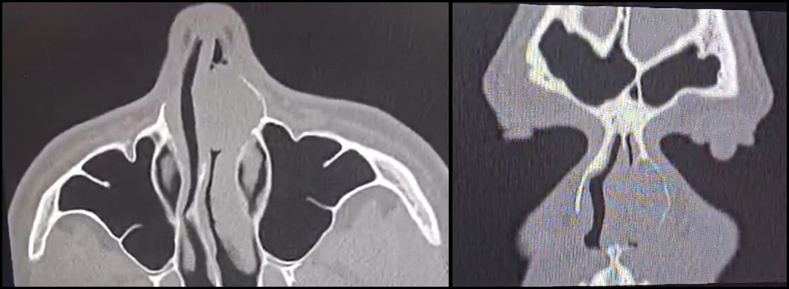

Image 1 - Axial and Coronal CT showing the mass in left nasal cavity where it has scalloped the left nasal bone without infiltrating
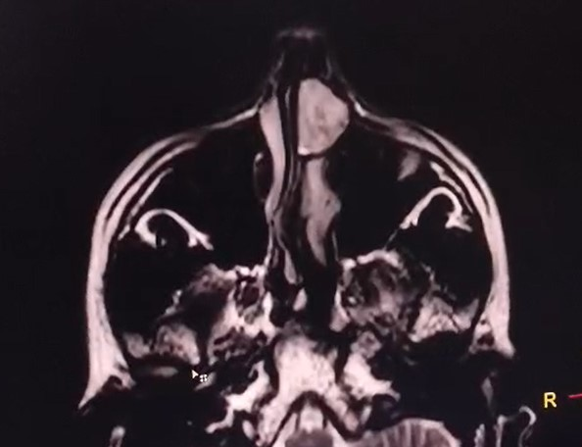

Image 2 - MRI showing the enhancing lesion in left nasal cavity showing the homogenous mass along the lateral wall

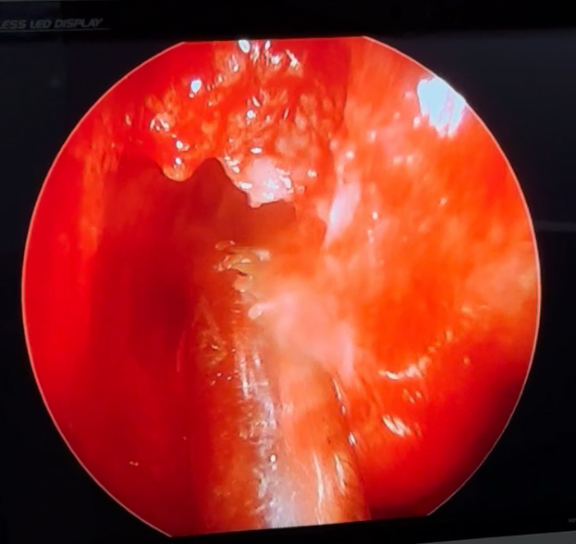

Image 3 - Microdebider debulking the mass in left nasal cavity

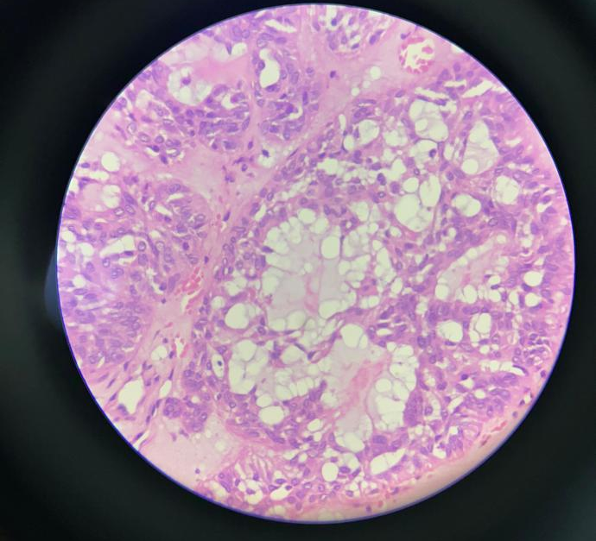
Image 4 - Histopathological Image showing cribriform pattern and tubules with luminal/mucinous material lined by pseudostratified columnar epithelium

DISCUSSION

ACC is a relatively hard entity to manage considering it’s propensity for perineural invasion (PNI) and bone involvement. In this case, since there was no such invasion, the prognosis turned out to be good.

A study by Boeckman et al in 2005 [6] stated that cisplatin and ionizing radiation form a good combination in the management of ACC since these two agents provide considerable synergy during treatment. Chen et al in 2006 [7] stated that combined-modality therapy with surgery followed by radiation to doses in excess of 60 Gy should be considered the standard of care for adenoid cystic carcinoma of the head and neck. The plan of management in our scenario related well with the aforementioned studies.

Wang et al in 2022 [8] evaluated the clinical data of 105 patients with sinonasal ACC and found that the presence of PNI increases the risk of distant metastasis in patients with sinonasal ACC. Compared with patients with PNI-negative, the prognosis of patients with PNI-positive was relatively poor, and surgery combined with radiotherapy for PNI-positive sinonasal ACC results in good clinical outcomes.

Lee et al in 2018 stated that primary surgery as the initial therapy provides better locoregional control and survival for patients with sinonasal adenoid cystic carcinoma [9]. The same debulking was followed in our case.

Michel et al in 2013 [10] concluded from their research that the 5-year overall survival rate was 63% and the 5-year disease-free survival rate was 43% for sinonasal ACC. Thus, all patients must be kept on regular follow-up.

Another case reported in 2026 by Yang et al [11] used surgery followed by radiotherapy at a dose of 54.72 Gy in a case of sinonasal intestinal-type adenocarcinoma. There was a recurrence treatment was stopped after 25 sessions because of the risk to damage the optic nerve. During the recurrence period, treatment with albumin-bound paclitaxel, cisplatin and camrelizumab for 4 cycles, followed by 12 cycles of maintenance therapy with camrelizumab was given for better compliance. In this case, a concurrent chemoradiation was given to prevent recurrence.

In the case of exte nsive involvement of vital structures (e.g., carotid artery, cavernous sinus, optic nerve, Meckel's cave) or when radical surgery could affect the patient's quality of life, a function-preserving subtotal removal of the tumor followed by irradiation can be done. The role of surgery is limited to a biopsy in unresectable lesions that are more suitable for exclusive chemoradiation [12].

In our case, the spread to the nasal bone could have been via the frontal process of the maxilla without causing bony destruction. The surgery helped in debulking the tumor and since access was good an external approach was not required.

CONCLUSION

Sinonasal Adenoid Cystic Carcinoma, although rare, has a high rate of recurrence because of the perineural and haematogenic spread. Surgery followed by concurrent Chemoradiation forms the cornerstone of management which helps in prolonging the survival rate. The patient should be given a guarded prognosis because of the tumor’s behaviour and kept on a regular follow-up.

LIMITATIONS

The limitation of the management of the case could have only been in one regard. A complete endoscopic approach was used instead of an exteral Lateral Rhinotomy approach.

Disclaimer (Artificial intelligence)
Author(s) hereby declare that NO generative AI technologies such as Large Language Models (ChatGPT, COPILOT, etc.) and text-to-image generators have been used during the writing or editing of this manuscript.

CONFLICT OF INTEREST: Nil.
FUNDING: Nil.
INFORMED CONSENT: Taken from the patient and immediate family.
REFERENCES

- Dillon PM, Chakraborty S, Moskaluk CA, Joshi PJ, Thomas CY. Adenoid cystic carcinoma: A review of recent advances, molecular targets, and clinical trials. Head Neck. 2016;38(4):620-627.
- Chummun S, McLean NR, Kelly CG, et al. Adenoid cystic carcinoma of the head and neck. Br J Plast Surg. 2001;54(6):476-480.
- Ammad Ud Din M, Shaikh H. Adenoid Cystic Cancer. [Updated 2023 Apr 14]. In: StatPearls [Internet]. Treasure Island (FL): StatPearls Publishing; 2025 Jan-. Available from: https://www.ncbi.nlm.nih.gov/books/NBK557855/
- Chae YK, Chung SY, Davis AA, Carneiro BA, Chandra S, Kaplan J, Kalyan A, Giles FJ. Adenoid cystic carcinoma: current therapy and potential therapeutic advances based on genomic profiling. Oncotarget. 2015 Nov 10;6(35):37117-34.
- Martínez-Rodríguez N, Leco-Berrocal I, Rubio-Alonso L, Arias-Irimia O, Martínez-González JM. Epidemiology and treatment of adenoid cystic carcinoma of the minor salivary glands: a meta-analytic study. Med Oral Patol Oral Cir Bucal. 2011;16(7):e884-e889.
- Boeckman HJ, Trego KS, Turchi JJ. Cisplatin sensitizes cancer cells to ionizing radiation via inhibition of nonhomologous end joining. Mol Cancer Res. 2005;3(5):277-285.
- Chen AM, Bucci MK, Weinberg V, et al. Adenoid cystic carcinoma of the head and neck treated by surgery with or without postoperative radiation therapy: prognostic features of recurrence. Int J Radiat Oncol Biol Phys. 2006;66(1):152-159.
- Wang ZK, Zhang JH, Chen XS, et al. Zhonghua Zhong Liu Za Zhi. 2022;44(2):185-191.
- Lee YC, Lee TJ, Tsang NM, et al. Cavernous sinus involvement is not a risk factor for the primary tumor site treatment outcome of Sinonasal adenoid cystic carcinoma. J Otolaryngol Head Neck Surg. 2018;47(1):12.
- Michel G, Joubert M, Delemazure AS, Espitalier F, Durand N, Malard O. Adenoid cystic carcinoma of the paranasal sinuses: retrospective series and review of the literature. Eur Ann Otorhinolaryngol Head Neck Dis. 2013;130(5):257-262.
- Yang L, Zhao Q, Yi F, et al. Comprehensive treatment for intracranial invasive sinonasal intestinal-type adenocarcinoma with a focus on radiotherapy dosage and immunological combination therapy: A case report. Oncol Lett. 2026;31(6):216. Published 2026 Apr 2.
- Castelnuovo P, Turri-Zanoni M. Adenoid Cystic Carcinoma. Adv Otorhinolaryngol. 2020;84:197-209.

