Case report
Immediate Implant Placement in a Type 2 Extraction Socket Using the Ice Cream Cone Technique: A Case Report

Abstract
Immediate implant placement in extraction sockets with buccal plate deficiency presents clinical and aesthetic challenges. The ice cream cone technique is a flapless guided bone regeneration approach designed to stabilize graft material and preserve soft tissue contours. This case report describes immediate implant placement in a Type 2 extraction socket using a Fix-Guide membrane shaped as an ice cream cone and an organic bovine bone graft (A-OSS), achieving adequate primary stability and favourable aesthetic outcome. Clinical and radiographic evaluation in this case report demonstrated successful osseointegration, stable peri-implant soft tissues, and preservation of ridge contours
Keywords
Immediate implant placement; Ice cream cone technique; Type 2 extraction socket; Guided bone regeneration
Introduction
Type 2 extraction sockets [10] characterized by the presence of intact soft tissue architecture with partial or complete loss of the buccal plate following tooth extraction. Immediate implant placement in type 2 extraction socket is technique-sensitive due to compromised buccal bone.
Owing to the buccal plate deficiency and the need for simultaneous ridge preservation, the Ice Cream Cone technique was selected as a minimally invasive regenerative approach to stabilize graft material and support hard- and soft-tissue healing. Studies have shown that implants placed immediately into sockets with periapical pathology can achieve predictable outcomes when meticulous debridement and appropriate regenerative techniques are employed [3,4].
The aim of this case report was to demonstrate the clinical application and outcome of immediate implant placement in a Type 2 extraction socket using a new regenerative approach of Ice Cream Cone technique.
The ice cream cone technique is a flapless guided bone regeneration method that uses a resorbable membrane shaped to seal the socket internally, supporting graft stability and soft tissue preservation [9,10]. This technique has shown favourable outcomes in immediate implant placement, including sockets with periapical pathology [4]. The ice cream cone technique provides internal socket sealing without flap elevation, minimizing surgical trauma and supporting graft stability [9,10]. An organic bovine bone grafts have demonstrated reliable outcomes in immediate implant placement, particularly in the esthetic zone [7]. The present case report demonstrates the application of this technique in the anterior maxilla.
Case Presentation
A 30-year-old male patient presented with mobility of tooth 21. Clinical examination revealed Grade III mobility, and radiographic evaluation showed a periapical radiolucency associated with the tooth (Figure 1).
Diagnosis
Localized Stage III, Grade B periodontitis involving tooth 21
Treatment Planning
Immediate implant placement following atraumatic extraction was planned to meet esthetic demands and reduce overall treatment duration. The socket was classified as a Type 2 extraction socket due to partial buccal bone deficiency. To manage the defect and maintain ridge contours, the ice cream cone technique was selected [9,10].
Surgical Procedure
The patient was explained about the treatment procedure and informed consent was obtained.
Atraumatic extraction of tooth 21 was performed (Figure 1), followed by thorough debridement and curettage to eliminate granulation tissue, as recommended for immediate implant placement in infected sites [3,4]. Sequential drilling and osteotomy site preparation were carried out using Densah burs, engaging the palatal wall (Figure 2A).

The peri-implant defect was grafted with A-OSS, an organic bovine bone graft (Figure 2B).
A Noris implant (4.2 × 13 mm) was placed in the prepared osteotomy site (Figure 2C), achieving a primary stability of 40 Ncm, which is considered favorable for immediate implant placement [1,2].
Guided Bone Regeneration
A Fix-Guide membrane was trimmed and shaped into a cone configuration and placed within the socket to seal the defect and stabilize the graft material (Figure 3A). The membrane was extended palatally to ensure graft containment. A collagen sponge was then placed, and the soft tissues were approximated without tension (Figure 3B).

Prosthetic Phase
Immediate temporization was performed with the provisional restoration kept out of occlusion (Figure 4A). After a healing period of four months, a healing abutment was placed (Figure 4B), followed by emergence profile development (Figure 4C). A definitive abutment was then placed (Figure 4D), and a cement-retained zirconia crown was delivered (Figure 4E), achieving satisfactory esthetic integration.

Results
Clinical and radiographic evaluation demonstrated successful osseointegration, stable peri-implant soft tissues, and preservation of ridge contours (Figure 4). No postoperative complications or implant failure were observed. The final restoration exhibited a harmonious emergence profile.
Discussion
The success of immediate implant placement in Type 2 extraction sockets is influenced by three-dimensional implant positioning. In the present case, palatal engagement during osteotomy preparation allowed optimal implant positioning while compensating for buccal bone deficiency. This approach is consistent with previous reports emphasizing palatal anchorage to achieve primary stability and reduce the risk of buccal plate perforation in the esthetic zone [1,2].
The biological principle of the Ice Cream Cone technique in achieving simultaneous socket closure and ridge preservation which significantly improves tissue contour stability and esthetic healing [13].
Primary stability remains a decisive prerequisite for immediate implant placement and provisionalization. The achievement of 40 Ncm insertion torque in this case confirms adequate mechanical stability, which has been associated with improved osseointegration and reduced micromotion during early healing phases [1,5]. High primary stability also enables better maintenance of peri-implant tissues, particularly when combined with regenerative procedures.
The management of the peri-implant gap or “jumping distance” is another important consideration in immediate implant placement. Although spontaneous bone healing may occur in small gaps larger defects, especially in sockets with buccal bone loss require grafting to maintain ridge dimensions [7,8]. In this case, the use of A-OSS anorganic bovine bone graft provided an osteoconductive scaffold that supported new bone formation while preserving ridge volume.
The ice cream cone technique offers a distinct advantage by allowing internal stabilization of the graft material without flap elevation. In a clinical trial, Ice Cream Cone technique is used as a flapless guided bone regeneration approach with immediate implant placement in sites with labial plate dehiscence demonstrated favourable clinical healing, graft stabilization, and maintenance of peri-implant hard tissue contours [11]. By shaping the Fix-Guide membrane into a cone and extending it palatally, graft migration was prevented and space maintenance was ensured. This flapless approach reduces surgical trauma, preserves blood supply, and minimizes postoperative soft tissue recession, which is particularly critical in the anterior maxilla [9,10].
Immediate temporization, when performed under non-functional loading conditions, plays a significant role in maintaining soft tissue contours and emergence profile. In the present case, provisionalization aided in soft tissue support during healing, contributing to an esthetically favorable final outcome. Similar observations have been reported in immediate implant cases in the esthetic zone [2,7]. A1-year randomized clinical trial observed that the Ice Cream Cone technique was effective in preserving both hard and soft tissue dimensions following immediate implant placement in sockets with labial plate defects [12].
Finally, although the extraction socket was associated with a periapical lesion, thorough debridement and socket disinfection allowed successful immediate implant placement. Recent evidence supports that the presence of periapical pathology does not contraindicate immediate implant placement, provided strict surgical protocols and regenerative measures are followed [3,4].
Conclusion
Within the limitations of a single clinical case, immediate implant placement in a Type 2 extraction socket using the Ice Cream Cone technique may be considered a predictable and effective treatment option. The use of a Fix-Guide membrane and A-OSS bone graft appeared to support guided bone regeneration, maintain soft tissue architecture, and contribute to favourable aesthetic and functional outcomes.
LIMITATIONS
The Ice Cream Cone technique is technique-sensitive, case-selection dependent, and supported mainly by limited short-term evidence. Further Clinical trials required for the technique.
Consent
As per international standards or university standards, patient(s) written consent has been collected and preserved by the author(s).

Ethical Approval:

As per international standards or university standards written ethical approval has been collected and preserved by the author(s).

COMPETING INTERESTS DISCLAIMER:
Authors have declared that they have no known competing financial interests OR non-financial interests OR personal relationships that could have appeared to influence the work reported in this paper.

Disclaimer (Artificial intelligence)

Author(s) hereby declare that NO generative AI technologies such as Large Language Models (ChatGPT, COPILOT, etc.) and text-to-image generators have been used during the writing or editing of this manuscript.

References
- Patil KP, Joshi V, Kanakdande VD, Bhosekar M, Nayyar AS. Immediate implant placement in fresh extraction site: a case report. J Indian Prosthodont Soc. 2012;12(2):120-122. doi:10.1007/s13191-012-0120-2.
- Sekar AC, Praveen M, Saxena A, Çolak AG, Demirsoy M. Immediate implant placement: a case report. BMC Oral Health. 2023;23:304. doi:10.1186/s12903-023-02986-0.
- Çolak S, Demirsoy MS. Retrospective analysis of dental implants immediately placed in extraction sockets with periapical pathology: immediate implant placement in infected areas. BMC Oral Health. 2023;23:304.
- Basualdo J, Ivankovic M, Kuzmicic J, Fernández E. Atraumatic extraction and immediate implant placement into infected site with the “ice cream cone” technique and L-PRF: a case report. Revista Clínica de Periodoncia, Implantología y Rehabilitación Oral. 2018;11(1):43–46.
- Ragucci GM, Elnayef B, Criado-Cámara E, Suárez-López Del Amo F, Hernández-Alfaro F. Immediate implant placement in molar extraction sockets: a systematic review and meta-analysis. International Journal of Implant Dentistry. 2020;6(1):40.
- Lim JH, Jun SH, Tallarico M, Hwang KG, Park CJ. A randomized controlled trial of guided bone regeneration for peri-implant dehiscence defects with two anorganic bovine bone materials covered by titanium meshes. Materials. 2022;15(15):5294.
- Dai Y, Xu J, Han XH, Cui FZ, Zhang DS, Huang SY. Clinical efficacy of mineralized collagen versus anorganic bovine bone for immediate implant placement in esthetic area: a single-center retrospective study. Rev Clin Periodoncia Implantol Rehabil Oral. 2018;11(1):43-46. doi:10.4067/S0719-01072018000100043.
- George A, Zahran A, Elbattawy W. Socket preservation using the ice cream cone technique versus spontaneous healing in fresh extraction sockets. Egyptian Dental Journal. 2023;69(1):285–300.
- Sheejith M, Viswanath S, Nazar A. Ice cream cone technique: a flapless bone regeneration technique. Egyptian Dental Journal. 2023;69:285-300. doi:10.21608/edj.2022.162342.2257.
- Elian N, Cho SC, Froum S, Smith RB, Tarnow DP. A simplified socket classification and repair technique. Pract Proced Aesthet Dent. 2007;19(2):99-104.
- Amagad M, et al. Evaluation of Ice Cream Cone Technique as a flapless guided bone regenerative method with immediate implant placement in management of patients with labial plate dehiscence: a case series. ClinicalTrials.gov. 2020;NCT04679766.
- Sharaf A, et al. Evaluation of soft and hard tissue changes following immediate implant using immediate dentoalveolar restoration versus Ice Cream Cone technique in cases with labial plate dehiscence: a 1-year randomized clinical trial. ClinicalTrials.gov. 2023;NCT05946954.
- Elgendi MM, et al. Peri-implant soft tissue conditioning of immediate posterior implants by CAD-CAM socket sealing abutments: a randomized clinical trial. BMC Oral Health. 2025;25:83. doi:10.1186/s12903-024-05417-w.

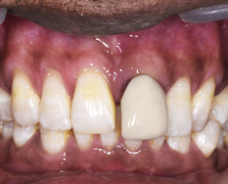
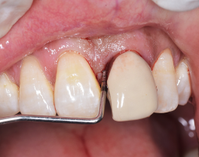
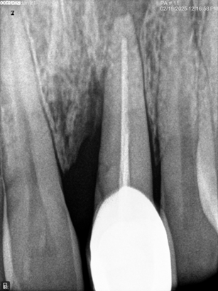
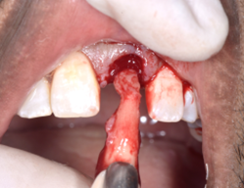
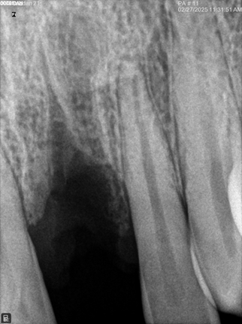
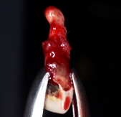
FIGURES
ASSESSMENT -21 AND ATRUAMATIC EXTRACTION OF 21
FIGURE 1- PRE OPERATIVE

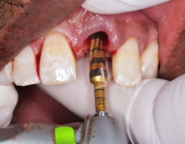
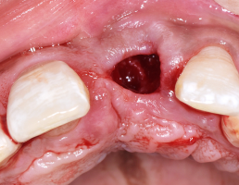
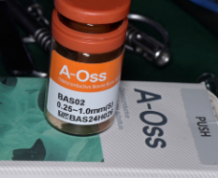
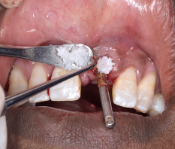
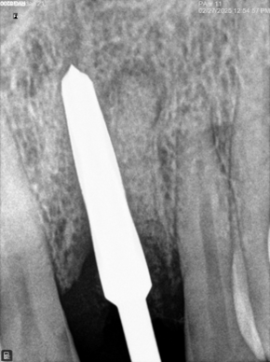
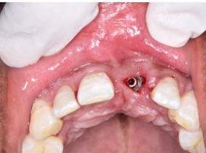
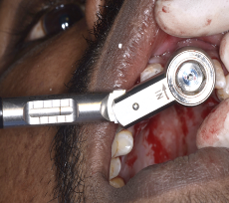
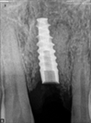
2A SEQUENTIAL DRILLING AND OSTEOTOMY SITE PREPARATION -21
2B A-OSS BONE GRAFT PLACED IN DEFCT-21
2C NORIS IMPLANT PLACED - SIZE 4.2×13MM PRIMARY STABILITY OF 40 NCM
FIGURE 2- SURGICAL

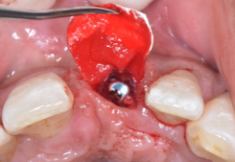
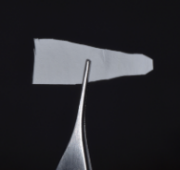
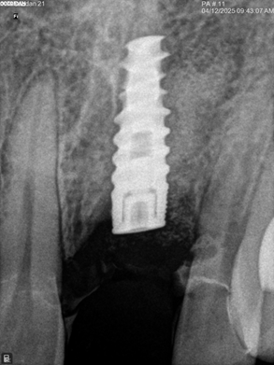
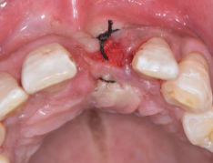
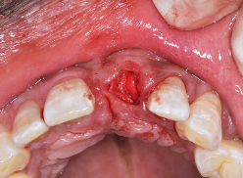
3A FIX-GIDE MEMBRANE AS ICE CREAM CONE INSERTED AND THE JUMPING DISTANCE GRAFTED
3B COLLAGEN SPONGE PLACED AND FLAP APROXIMATED
FIGURE 3- MEMBRANE PLACEMENT

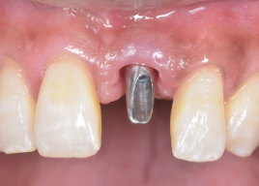
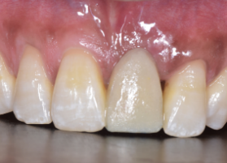
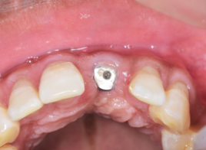
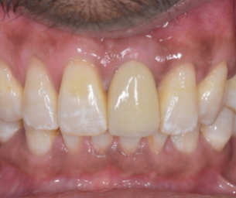
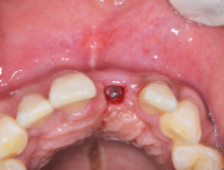
4DABUTMENT PLACED IN 21
4A IMMEDIATE TEMPORIZATION IN 21
4B HEALING ABUTMENT AFTER 4 MONTHS
4E CEMENT RETAINED ZIRCONIA CROWN IN 21
4C EMERGENCE PROFILE EVIDENT
FIGURE 4- POST OPERATIVE

