Histochemical Characterization of Salacia korthalsiana Miq. (Polipog) Root

Abstract

Salacia korthalsiana Miq., locally known in the Philippines as Polipog, is a wild climbing shrub traditionally valued for its anti-inflammatory, antiseptic, and antimicrobial properties. While indigenous communities utilize its leaves, stems, and roots to treat ailments ranging from respiratory issues to hypertension, scientific mapping of its bioactive compounds within specific tissues remains limited. This study performed a histochemical characterization of Polipog root to localize secondary metabolites in situ, providing a visual and chemical basis for its medicinal use. Methodology involved free-hand sectioning of plant parts followed by specific staining reagents, including Dragendorff’s reagent for alkaloids, antimony trichloride for steroids, and Toluidine Blue for tannins. Results from the root analysis revealed a significant accumulation of bioactive compounds. Alkaloids (golden yellow) were localized in the pith and endodermis, while steroids (yellow) were detected in the pith, phloem, and endodermis. Tannins (green/greenish-blue) showed the widest distribution, appearing in the cortex, endodermis, phloem, pith, and pericycle. Notably, tests for terpenoids yielded negative results in the root samples. These findings correlate the presence of alkaloids and tannins with the plant’s reported analgesic and antimicrobial efficacy. By identifying the specific tissues where these pharmacological precursors reside, this research validates the ethnobotanical importance of S. korthalsiana and provides essential data for the standardization of herbal preparations and future drug extraction.

Keywords: Salacia korthalsiana, Histochemistry, Alkaloids, Tannins, Pharmacognosy

I. Introduction
Salacia korthalsiana Miq. is a wild climbing shrub (Celastraceae) reaching 10–18 m in length (occasionally forming small trees ~10 m). Locally known as “Polipog” (Belga et al., 2021) in Northern Samar, Philippines and parts of Southeast Asia, it is harvested from the wild as both a food (fruit pulp) and a traditional medicine. Indigenous community in Northern Samar use the leaves, stems, and roots of Polipog to treat a wide range of ailments. Preparations include decoctions, poultices, and fresh applications of plant parts. According to ethnobotanical surveys, Polipog is used for menstrual disorders, skin wounds and itchiness, fevers, coughs and colds, hypertension, asthma and other inflammatory conditions. In popular lore it is regarded as antiseptic, anti-inflammatory and antimicrobial. For example, Cui-Lim et al. (2020) report that Polipog is traditionally applied for inflammation and infection control.
Phytochemical screenings confirm that Polipog contains diverse bioactive classes. Aljon Nibalvos (2019) found that a leaf or root decoction of Polipog tested positive for flavonoids, phenolic compounds, phytosterols, proteins, saponins and tannins, while alkaloids, carbohydrates and glycosides were not detected. Similarly, Madario et al. (2023) reported the root decoction to be rich in steroids and saponins – compounds known for their expectorant/antitussive effects – explaining its cough-relief use. Additionally, Intal (2011) reported that among the secondary metabolites triterpene, and (flavonoid)-benzopyrene were present through phytochemical screening of polipog leaves, barks and roots decoction, but negative for alkaloid metabolites. By comparison, other Salacia species (e.g. S. reticulata, S. oblonga) are known to contain glycosides such as salacinol, kotalanol, dulcitol and related sulfonium compounds (Udayan & Raghu, 2017), which have anti-diabetic and anti-inflammatory activities. It is plausible that similar glycosides or terpenoids occur in S. korthalsiana, although detailed isolation has not yet been reported.
These chemical constituents align with measured bioactivities. Polipog root extracts have shown strong antimicrobial effects – notably against Gram-negative bacteria – and analgesic efficacy comparable to standard painkillers (Alvarez et al., 2020). In one study, an acetic-acid writhing test in mice demonstrated that Polipog root decoction significantly reduced pain behaviors, performing on par with commercial analgesic drugs. Taken together, these data support the traditional uses of Polipog: its saponins and flavonoids may explain anti-inflammatory and expectorant effects, while other constituents provide antimicrobial and pain-relieving activity.
To advance the scientific basis of Polipog use, we propose applying histochemical analysis to localize active compounds in the plant’s tissues. Histochemistry uses specific stains and microscopy to reveal the in-situ distribution of chemical classes within cells (Mahendra et al. 2021). It has a long history in biology and medicine and remains “one of the most objective methods” for tissue analysis. Histochemical staining is rapid, reproducible and cost-effective, attributes that make it valuable for pharmacognosy as well as clinical diagnostics.
By mapping Polipog’s phytochemicals at the cellular level, histochemistry can guide the choice of plant part for drug extraction and help standardize herbal preparations. In this work, we will perform parallel phytochemical screening and histochemical staining on Polipog roots. The objective is to correlate the traditional claims with laboratory evidence-identifying which tissues harbor anti-inflammatory or analgesic compounds, for instance. This combined approach will validate Polipog’s ethnobotanical importance and yield practical data for future medicinal use.

II. Methodology
Plant Collection and Preparation

Fresh samples of Salacia korthalsiana (Polipog) roots collected from Barangay Diyo, Mondragon, Northern Samar, Philippines. The collection site represents a natural habitat where the plant is traditionally harvested and utilized by local communities, thereby ensuring ecological and ethnobotanical relevance of the specimens. The collected plant materials were immediately transported to the College of Science Laboratory of the University of Eastern Philippines for processing.

Upon arrival, roots were thoroughly washed with distilled water to remove adhering soil particles, debris, and potential contaminants. This step is critical to prevent interference during histochemical staining, as extraneous materials may produce false-positive or false-negative results. No chemical fixatives were applied prior to sectioning in order to preserve the native state of secondary metabolites within the tissues. This approach aligns with standard pharmacognostic practices, where minimal chemical alteration is preferred to maintain the integrity and localization of bioactive compounds.

Histochemical Analysis

Histochemical analysis was employed to localize secondary metabolites in situ within plant tissues. This technique utilizes specific staining reagents that react with target chemical groups, producing characteristic color changes observable under light microscopy (Musumeci 2015). Histochemistry is widely recognized as a rapid, cost-effective, and reliable method for visualizing the distribution of phytochemicals at the cellular level, making it particularly valuable in pharmacognostic investigations of medicinal plants (Sulistyaningsih 2017).

Free-Hand Sectioning Technique

Free-hand sectioning was adopted due to its practicality, accessibility, and suitability for fresh plant materials. Although this technique inherently produces sections of variable thickness, it remains a widely accepted method in preliminary histochemical studies, especially when microtome facilities are unavailable. Care was taken to obtain the thinnest possible sections, as thinner sections allow better penetration of staining reagents and improved visualization of cellular structures.

All cutting instruments, including razor blades and cutters, were thoroughly rinsed with warm tap water prior to use to remove grease and contaminants that could interfere with section quality or staining reactions. Sections were prepared under moist conditions to prevent tissue desiccation and structural distortion.

Root Sectioning

Root samples were sectioned using a new double-edged razor blade or cutter. The root segments were cut into several thin transverse sections in quick succession. Due to the inherent variability in free-hand sectioning, sections differed in thickness; therefore, only the thinnest and most translucent sections were selected for histochemical analysis, following the protocol of O’Brien et al. (1964).

The selected sections were carefully transferred onto clean glass slides using fine forceps or a brush to avoid mechanical damage. Maintaining structural integrity during transfer is essential for accurate localization of metabolites, as tissue disruption may lead to diffusion or loss of chemical constituents.

Histochemical Tests

Test for Alkaloids

Alkaloids were detected using Dragendorff’s reagent, a classical histochemical stain that reacts with nitrogen-containing compounds to produce a characteristic golden-yellow to orange precipitate. Transverse sections of roots were immersed in Dragendorff’s reagent for approximately one minute to allow sufficient interaction between the reagent and tissue-bound alkaloids.

Following staining, the sections were mounted in a glycerine-water solution (10:90, v/v), which serves as a mounting medium that preserves tissue hydration and enhances optical clarity. The presence of alkaloids was confirmed by the appearance of golden-yellow coloration in specific cells or tissues. This method is widely used in pharmacognosy due to its sensitivity to a broad range of alkaloid structures.

Test for Steroids

Steroids were identified using antimony trichloride, a reagent known to react with sterol and triterpenoid compounds, producing a yellow coloration. Plant sections were immersed in the reagent for one minute and subsequently mounted in glycerine-water solution (10:90, v/v).
The development of a yellow color within the tissues was interpreted as a positive indication of steroidal compounds. The localization of this coloration provides insight into the distribution of phytosterols within plant tissues, which are known to contribute to anti-inflammatory and membrane-stabilizing functions.

Test for Tannins

Tannins were detected using Toluidine Blue, a metachromatic stain that binds to phenolic compounds and produces color variations depending on the chemical composition and concentration. Thin sections were placed on clean glass slides and flooded with Toluidine Blue reagent for one minute.

Excess stain was carefully removed using filter paper, followed by gentle rinsing with distilled water to eliminate background staining. This washing step was repeated until the surrounding area of the tissue appeared clear. A drop of distilled water was then added before placing a cover slip over the preparation. Excess mounting medium was removed by blotting the edges of the cover slip with filter paper.

Under microscopic examination, tannins were identified by the presence of green, greenish-blue, or bright blue coloration within the cells, consistent with established histochemical protocols (O’Brien et al., 1964). The use of Toluidine Blue is particularly advantageous due to its ability to differentiate phenolic compounds based on metachromasia, thereby enhancing specificity.

Test for Terpenoids

Terpenoids were assessed using the 2,4-dinitrophenylhydrazine (DNPH) test, which detects carbonyl-containing compounds through the formation of orange-yellow hydrazone derivatives. Transverse sections of plant tissues were immersed in the DNPH reagent for one minute and mounted in glycerine-water solution (10:90, v/v).

The appearance of an orange-yellow coloration was considered indicative of terpenoid presence. However, it should be noted that this method primarily detects carbonyl groups and may not capture all classes of terpenoids, particularly those lacking reactive carbonyl functionalities. As such, negative results should be interpreted with caution, as they may reflect methodological limitations rather than true absence of terpenoids.

Microscopic Examination and Interpretation
All prepared slides were examined under a light microscope at appropriate magnifications to observe cellular structures and staining patterns. Observations focused on identifying the specific tissues (e.g., cortex, endodermis, phloem, pith, and pericycle) exhibiting positive staining reactions. The localization of color changes was carefully recorded, as this provides critical information on the distribution of secondary metabolites within the plant.

III. Results

Figure 1 shows the result for the test of Alkaloids. In figure A, it represents the root when the staining reagent was not yet added, while in figure B, it shows the result when it is already treated of the staining reagent. In test for alkaloids, the cell that shows a positive indication is in pith and endodermis.
B. Treated with staining reagent
A. Untreated with staining reagent

Figure 1. Test for Alkaloids

Figure 2 shows the result for the test of steroids. In figure A, it shows when there is no staining reagent added, while in figure B, it shows the result when a sample was treated with suitable staining reagent. The result indicated that steroids are present in root tissue of Salacia korthalsiana Miq., which is in the endodermis, pith and phloem.

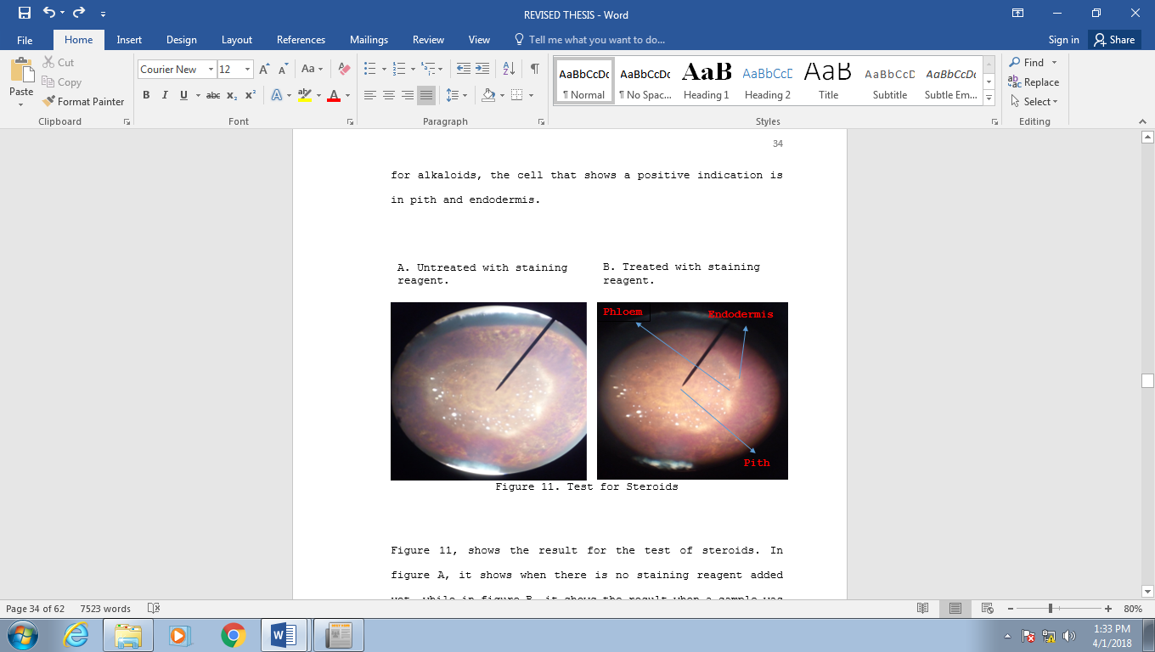
B. Treated with staining reagent
A. Untreated with staining reagent

Figure 2. Test for Steroids
Figure 3 shows the result for the test of tannin. In figure A, it shows the picture of the roots sample without the staining reagent, while in figure B, it shows when a root sample was already treated with staining reagent. In plate B, it is indicated that in cortex, endodermis, phloem, pith and pericycle where the tannin was observed.

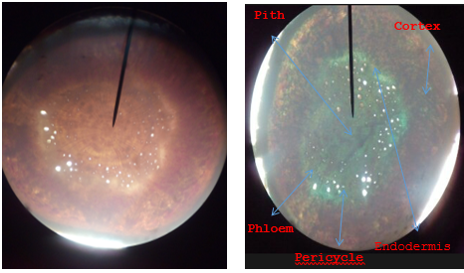
- Untreated with staining reagent
- Treated with staining reagent
Figure 3. Test for Tannins

Figure 4, it shows the result for the test of terpenoids. In picture A, it represents the image of the cross section of the roots, untreated with the staining reagent, while in picture B, it represents the image of the root section that already treated with staining reagent. In terpenoids test, there is no change of the color of the tissues of the plant sample was observed.

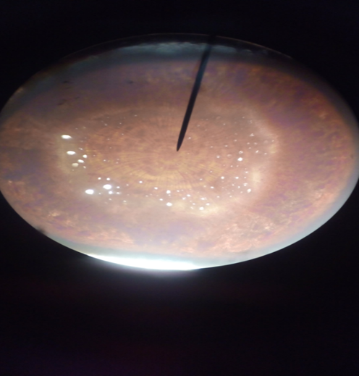
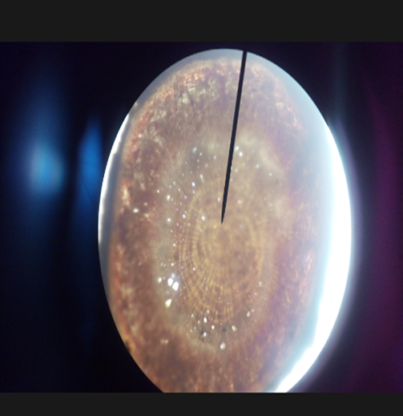
B. Treated with staining reagent
A. Untreated with staining reagent
Figure 4. Test for Terpenoids

Table 1. Histochemical Test of the Roots Sample

Active components | Observation | Tissue of a sample that indicates a positive result
Alkaloids | Appearance of golden-yellow color in a tissue | Pith and endodermis
Steroids | Appearance of yellow color in the cells | Pith, phloem and endodermis
Tannins | Appearance of green, greenish color in the cells | Endodermis, cortex, phloem, pith and pericycle
Terpenoids | No change of the color was observed | Negative

In histochemical test for the roots sample, only the terpenoids indicates a negative result. In alkaloids test the appearance of golden yellow color in a cell observed. Then for steroids test, appearance of yellow color in a cell of the plant sample also observed. In tannins test, a green and greenish color of the cell was also showed a positive indication of a test.

IV. Discussion
The present study provides a histochemical basis for the ethnomedicinal use of Salacia korthalsiana, particularly by demonstrating the spatial localization of key secondary metabolites within root tissues. The detection of alkaloids, steroids, and tannins in specific anatomical regions—namely the pith, endodermis, phloem, cortex, and pericycle—supports the hypothesis that the root serves as a major reservoir of pharmacologically active compounds .
Histochemical localization revealed that alkaloids are concentrated in the pith and endodermis. These tissues are associated with internal transport regulation and selective permeability, suggesting that alkaloids may play a role not only in plant defense but also in internal biochemical regulation. Alkaloids are widely reported to exhibit analgesic and antimicrobial properties, which aligns with prior pharmacological findings showing that S. korthalsiana root extracts demonstrate significant pain-relieving activity comparable to standard analgesics (Alvarez et al., 2020). The localization of these compounds in inner tissues may indicate a protective storage strategy against herbivory and environmental stress, a pattern similarly observed in other medicinal plants subjected to histochemical analysis.
Steroids were observed in the pith, phloem, and endodermis, indicating a broader distribution across both transport and storage tissues. This distribution is consistent with the role of plant steroids (phytosterols) in membrane stability and signaling, as well as their known anti-inflammatory effects. The presence of steroids corroborates earlier phytochemical screenings of Polipog roots, which identified steroidal compounds as contributors to its traditional use in treating respiratory conditions and inflammation (Madario et al., 2023). From a histochemical perspective, the presence of these compounds in vascular-associated tissues such as the phloem suggests potential mobility or systemic distribution within the plant.
Among the detected metabolites, tannins exhibited the widest distribution, occurring in nearly all root tissues examined. This extensive localization—including cortex, endodermis, phloem, pith, and pericycle—highlights their fundamental role in plant defense. Tannins are well-documented for their antimicrobial and antioxidant properties, which supports the observed efficacy of Polipog in treating infections and inflammatory conditions. The widespread presence of tannins also suggests that multiple tissue layers contribute to the plant’s therapeutic potency, reinforcing its effectiveness in crude or minimally processed preparations commonly used in traditional medicine (Edeoga 2007).
Interestingly, the absence of terpenoids in the root samples contrasts with findings from other species within the genus Salacia, such as S. reticulata and S. oblonga, which are known to contain bioactive terpenoid and glycosidic compounds like salacinol and kotalanol (Udayan and Raghu, 2017). This discrepancy may be attributed to species-specific metabolic pathways, environmental influences, or methodological limitations in detection sensitivity. Alternatively, terpenoids in S. korthalsiana may be localized in other plant organs (e.g., leaves or stems) or present in concentrations below histochemical detection thresholds. Similar observations have been reported in histochemical studies of other medicinal plants, where certain metabolites are selectively localized or undetectable depending on tissue type and developmental stage.
The findings of this study are consistent with broader histochemical research, which emphasizes the value of in situ localization in understanding plant pharmacological potential. For instance, Mahendra et al. demonstrated that secondary metabolites in Salacia macrosperma are differentially distributed across tissues, influencing both extraction efficiency and therapeutic application. Such parallels reinforce the importance of histochemistry as a tool for pharmacognostic standardization, particularly for underexplored medicinal plants like Polipog.
This study bridges ethnobotanical knowledge and laboratory-based evidence by demonstrating that the therapeutic properties of S. korthalsiana are underpinned by the localized accumulation of bioactive compounds within root tissues. The concentration of alkaloids, steroids, and tannins in specific anatomical regions provides a scientific rationale for the preferential use of roots in traditional preparations.
Beyond confirming the presence and localization of key metabolites, the findings of this study underscore the need for more comprehensive pharmacological and chemical investigations. While histochemistry provides critical spatial insight, it does not quantify bioactivity nor identify specific molecular structures. Therefore, it is strongly recommended that future studies on S. korthalsiana incorporate a suite of bioactivity assays to validate and expand upon the observed histochemical patterns.
Specifically, antimicrobial assays (e.g., disk diffusion and minimum inhibitory concentration tests) should be conducted to quantify the antibacterial efficacy of root extracts against both Gram-positive and Gram-negative organisms. Anti-inflammatory activity may be evaluated through in vitro assays such as cyclooxygenase (COX) inhibition or nitric oxide suppression in macrophage models, while analgesic potential can be further validated using established in vivo models such as the acetic acid-induced writhing test. Additionally, antioxidant capacity assays (e.g., DPPH, ABTS, and FRAP) would be valuable in assessing the functional role of tannins and phenolic compounds. These bioassays will provide functional confirmation of the pharmacological relevance of the metabolites localized in this study.
Complementary to bioactivity testing, detailed functional group analysis is essential for characterizing the chemical nature of the detected metabolites. Techniques such as Fourier Transform Infrared Spectroscopy (FTIR) can be employed to identify characteristic functional groups (e.g., hydroxyl, carbonyl, and amine groups) associated with tannins, alkaloids, and steroids. Ultraviolet-visible (UV-Vis) spectroscopy may also be used to detect conjugated systems typical of phenolic compounds (De Oliveira, 2013). These preliminary analyses would serve as a bridge between histochemical detection and advanced structural identification.
For definitive compound identification, advanced structural elucidation techniques are necessary. Chromatographic methods such as High-Performance Liquid Chromatography (HPLC) and Liquid Chromatography–Mass Spectrometry (LC-MS) should be employed to separate and profile the chemical constituents of S. korthalsiana extracts. Furthermore, Nuclear Magnetic Resonance (NMR) spectroscopy (¹H and ¹³C NMR) is crucial for determining the precise molecular structures of isolated compounds. These approaches would enable the identification of novel or known bioactive molecules, including potential analogs of salacinol-like compounds reported in other Salacia species. Integrating these techniques would significantly advance the pharmacognostic and phytochemical understanding of Polipog.
Moreover, correlating histochemical localization with compound isolation could provide insights into tissue-specific biosynthesis and accumulation pathways. For instance, isolating compounds specifically from the pith or endodermis may yield higher concentrations of alkaloids, thereby improving extraction efficiency and guiding targeted drug development strategies. Such an integrated approach—combining histochemistry, bioactivity assays, and structural elucidation—represents a comprehensive framework for validating and harnessing the medicinal potential of S. korthalsiana.

V. Conclusions
The histochemical analysis conducted in this study was limited to the root samples of Salacia korthalsiana, which revealed positive reactions for alkaloids, steroids, and tannins. The presence of these bioactive compounds within the root tissues suggests that this part of the plant serves as a significant site for the accumulation of secondary metabolites associated with various pharmacological activities. Alkaloids are widely recognized for their therapeutic properties, including analgesic, antimicrobial, and antidiabetic effects, while steroids are known to contribute to anti-inflammatory and hormonal activities. Tannins, on the other hand, possess antioxidant and antimicrobial properties, further supporting the medicinal potential of the plant.

Disclaimer (Artificial intelligence)

Author(s) hereby declare that NO generative AI technologies such as Large Language Models (ChatGPT, COPILOT, etc.) and text-to-image generators have been used during the writing or editing of this manuscript.

References

- Alvarez, M. L. C., Lim, K. M. C., & Tonog, M. N. (2020). Analgesic activity of Salacia korthalsiana Miq (Polipog). Journal of Pharmaceutical Research International, 32(36), 58–61. https://doi.org/10.9734/JPRI/2020/v32i3630992
- Belga, R. O., Mahinay, F. P., & Vicencio, M. C. G. (2021). Utilization of Salacia korthalsiana Miq (Polipog) of Mamanwa Tribe in Las Navas, Northern Samar. Asian Journal of Biology, 11(1), 22–28. https://doi.org/10.9734/ajob/2021/v11i130133
- Cui-Lim, K. M. R., Dagalea, F. M. S., Doncillo, M. L., & Ultra, C. I. (2020). Preparation and application of Salacia korthalsiana Miq. (Polipog) root extract. Solid State Technology, 63(2s), 1435–1443.
- De Oliveira. 2013. Structure, Histochemistry and Phytochemical profile of the bark of the sobol and aerial stem of Tonteleamicrantha (Celastraceae-Hippocrateoideae). Annals of the Brazilian Academy of Sciences, pp 1167-1179.
- Edeoga. 2007. Microscopic Anatomy and Histochemistry of the Stem and Root of some Mimosa species, Plant Sciences. 688-691.
- Intal AJ. 2011. Partial Characterization of Connarussemid (Polipog) Leaves, Barks, and Roots. Unpublished Research Paper, College of Science, University of Eastern Philippines, University Town, Catarman Northern Samar.
- Madario, M. J., Tonog, M. N., & Lim, K. M. C. (2023). Screening and partial characterization of secondary metabolite of Salacia korthalsiana Miq. (Polipog) root decocted extract. Asian Plant Research Journal, 11(2), 50–55. https://doi.org/10.9734/aprj/2023/v11i2209
- Mahendra, C., Sudarshana, M. S., & Jagannath, S. (2021). Histochemical localization of secondary metabolites in vivo, in vitro leaf and leaf derived callus of Salacia macrosperma Wight. Tropical Plant Research, 8(1), 13–21. https://doi.org/10.22271/tpr.2021.v8.i1.003
- Musumeci G. 2015. The old and the new concepts of Histochemistry, Histology and Histophatology.
- Nibalvos, A. V. G. (2019). Phytochemical screening of Polipog decoction. Indian Journal of Science and Technology, 12(10), 1–5. https://doi.org/10.17485/ijst/2019/v12i10/141750
- O'Brien, T.P., Feder, N. & McCully, M.E. Polychromatic staining of plant cell walls by toluidine blue O. Protoplasma 59, 368–373 (1964). https://doi.org/10.1007/BF01248568
- Sulistyaningsih. 2017. Secretory Structure, Histochemistry and Phytochemistry Analyses of Stimulant Plant, pp 1-8.
- Udayan, P. S., & Raghu, A. V. (2017). Phytochemical studies of six Salacia species using liquid chromatography mass spectroscopic analysis. International Journal of Chemical Science, 1(2), 07–08.

