Original Research Article
Synergistic Hepatorenal Antioxidant Effects of Combined Aqueous Extracts of Hibiscus sabdariffa and Zingiber officinale in Streptozotocin-Administered Rats
Abstract
Streptozotocin administration causes hyperglycaemia and oxidative stress in the form of reactive oxygen species, which causes oxidative damage to hepatorenal tissues. In this study, the in vivo antioxidant potentials of combined Hibiscus sabdariffa and Zingiber officinale aqueous extracts were assessed. Lyophilized extracts were reconstituted and orally administered (400 mg/kg) at ratios of 95:5, 90:10, and 80:20 for 14 days following STZ induction (60 mg/kg). Metformin served as the reference. The results showed that superoxide dismutase activity was significantly (p < 0.05) restored from the diabetic control (liver: 0.90±0.05; kidney: 1.18±0.03) to 2.23±0.08 and 2.28±0.14 in the 80% HS + 20% ZO group. Catalase levels were markedly elevated from the diabetic baseline (liver: 4.41±0.16; kidney: 8.55±0.32) to 8.07±0.56 and 15.63±0.82 in the 80:20 treated group. Glutathione peroxidase activity improved from the untreated state (liver: 1.28±0.04; kidney: 1.30±0.05) to 2.34±0.04 and 2.50±0.10 respectively. Specific activity of Glutathione-s-peroxidase was successfully replenished from the diabetic control (liver: 0.23±0.01; kidney: 0.31±0.01) to 0.50±0.02 and 0.41±0.01 in the 80:20 group. Reduced glutathione concentrations were significantly increased (p < 0.05) over the diabetic control (liver: 62.25±0.43; kidney: 38.25±0.85) to 90.25±6.55 and 53.50±6.02. Finally, malondialdehyde levels were significantly reduced from the diabetic state (liver: 7.88±0.38; kidney: 3.55±0.15) to 2.70±0.24 and 2.52±0.30 in the 80:20 group. The findings indicate that the combined extracts exert strong hepatorenal antioxidant effects, likely mediated by synergistic phytochemicals. Assessment of liver and kidney function test are recommended to explore the hepatoprotective and nephroprotective potentials of these combined extracts.
Keywords: Diabetes, H. sabdariffa, Z. officinale, Combined, Antioxidant
1.0 Introduction
Streptozotocin (STZ) administration is a major mode of induction of diabetes mellitus (DM), a chronic metabolic condition that arises due to uncontrolled hyperglycemia caused by insulin secretion defects, insulin action defects, or both (ADA, 2023). Diabetes is a significant issue in global public health, affecting an estimated 537 million adults (20-79 years) in 2021, with the number expected to reach 783 million by 2045 (IDF, 2021). In 2023, the World Health Organization stated that diabetes was the leading cause of death, accounting for approximately 1.6 million annually, and the prevalence of diabetes in the low- and middle-income countries was growing considerably (WHO, 2024). The pathophysiology of diabetes involves impaired glucose metabolism resulting from pancreatic β-cell dysfunction and insulin resistance. A critical aspect of its progression is oxidative stress, primarily driven by excessive production of reactive oxygen species (ROS) and reduced antioxidant defenses (Kaur et al., 2025). Elevated ROS disrupt cellular signaling, damage lipids and proteins, and impair insulin signaling pathways, contributing to complications affecting vital organs such as the liver and kidneys (Forbes et al., 2022; Zhang et al., 2023). Common symptoms of diabetes mellitus include polyuria, polydipsia, polyphagia, unexplained weight loss, blurred vision, fatigue, and delayed wound healing (ADA, 2023). The current treatment options are focused on glycemic control based on lifestyle modification and pharmacological tools, including insulin therapy, metformin, sulfonylureas, DPP-4, SGLT2, and GLP-1 receptor agonists (Davies et al., 2023). Although conventional antidiabetic medications such as metformin are effective in glycaemic control, their use is commonly associated with adverse effects, particularly gastrointestinal symptoms such as diarrhea, abdominal pain, and nausea, which can limit treatment adherence (Nabrdalik et al., 2024). Furthermore, the long-term effectiveness of many antidiabetic therapies is limited by progressive β-cell dysfunction and persistent insulin resistance, while the high cost of chronic treatment remains a major barrier to sustained diabetes management (McGill et al., 2024; Gkrinia et al., 2023). This has stimulated interest in plant-based therapies that have antioxidant and hypoglycemic properties (El-Tantawy, 2022). In STZ-induced diabetes, hyperglycemia leads to the production of ROS in the liver and kidneys (Sudarshan et al., 2025). In normal physiology, the action of SOD converts superoxide radicals to hydrogen peroxide. However, the reduced activity of SOD results in the accumulation of superoxide radicals, leading to mitochondrial dysfunction and inflammation (Zheng et al., 2023). CAT and GPx detoxify hydrogen peroxide and lipid hydroperoxides. However, the reduced activity of these enzymes results in the accumulation of hydroxyl radicals and lipid hydroperoxides, leading to cell injury (Hewitt & Degnan, 2023). The increase in the level of MDA, a product of lipid peroxidation, indicates the degree of tissue injury to the hepatocyte and renal tubular cell membranes (Shabalala et al., 2022). Thus, the changes in the activities of SOD, CAT, GPx, and the level of MDA in the liver and kidneys are not just markers of oxidative stress but also play an important role in the pathogenesis of diabetic hepatorenal dysfunction and the normalization of these parameters indicates the restoration of the balance between oxidative stress (Mousavi et al., 2022). Hibiscus sabdariffa is a source of anthocyanin, flavonoid and phenolic compounds that have been recognized to be antioxidants, anti-inflammatory and hypolipidemic (Ali et al., 2023). Gingerols, shogaols, and paradols are the bioactive compounds found in Zingiber officinale with antioxidant, antidiabetic, and hepatoprotective properties (Kumar et al., 2024). Hibiscus sabdariffa and Zingiber officinale may act synergistically with regard to free radical scavenging and antioxidant enzyme activity leading to a better protection against hepatic and renal oxidative damage caused by diabetes. While the individual antioxidant properties of both plants have been established, their interactive effects in vivo are not well comprehended, especially to counteract the oxidative stress related to hepatic and renal dysfunction in diabetes. Therefore, this study investigated the in vivo hepatorenal antioxidant activity of the combined extracts of Hibiscus sabdariffa and Zingiber officinale on streptozotocin-induced diabetic rats.

2.0 MATERIALS AND METHODS
2.1 Materials
Hibiscus sabdariffa calyx, Zingiber officinale rhizome and Allium sativum bulbs were purchased from Oja-Oba Market in Ilorin, Nigeria (lat. 8.49664 and long. 4.54214). The plants studied were identified and authenticated at the Herbarium, Department of Plant biology, University of Ilorin, where voucher numbers; UILH/001/1589/2023 for Hibiscus sabdariffa, UILH/002/1590/2023 for Zingiber officinale and UILH/003/1591/2023 for Allium sativum were given. Forty-two rats were obtained from the animal holding unit of Research Fulcrum Laboratory in Tanke, Ilorin, Nigeria, and they were acclimatized for two weeks prior to the experiment. Metformin used as standard was a product of Denk Pharma (Munich, Germany). All reagents used were all products of Sigma-Aldrich (St. Louis, MO, USA) and were of analytical grade.
For the instruments used, the analytical procedures were conducted using a T10 basic ULTRA-TURRAX homogenizer (IKA, Staufen, Germany), a Heraeus Megafuge 16R refrigerated centrifuge (Thermo Fisher Scientific, Waltham, MA, USA), and a UV-1900i UV-Vis Spectrophotometer (Shimadzu Corporation, Kyoto, Japan). Precise measurements and preparation were facilitated by Finnpipette F2 adjustable micropipettes (Thermo Fisher Scientific, Vantaa, Finland), a SevenCompact S210 pH meter (Mettler Toledo, Zurich, Switzerland), and a FreeZone 4.5 Liter Benchtop Lyophilizer (Labconco, Kansas City, MO, USA). Additionally, an AE200 analytical balance (Mettler Toledo, Columbus, OH, USA) and a Stuart SBS40 shaking water bath (Cole-Parmer, St. Neots, UK) were utilized throughout the experimental phase.

2.2 Methods
2.2.1 Preparation of Extracts
Different compositions of extracts were prepared using the method described by Abdulrahman-Orire et al. (2026). Briefly, H. sabdariffa calyces, Z. officinale roots and A. sativum bulbs were air-dried, and separately ground into fine powder. Then 1000 g of each sample was boiled for 20 minutes. Each mixture was sieved and filtered. The filtrate of each mixture was lyophilized to obtain concentrated extracts. For the H. sabdariffa (HS) and Z. officinale (ZO) combination, 95 g of the concentrated H. sabdariffa (HS) was mixed with 5 g of the concentrated Z. officinale (95% HS + 5% ZO). For the 95% HS + 5% ZO composition, 90 g of the concentrated H. sabdariffa (HS) and 10 g of the concentrated Z. officinale (ZO) were mixed together, while 80 g of the concentrated H. sabdariffa (HS) and 20 g of the concentrated Z. officinale (ZO) were mixed together to form the 80% HS + 20% ZO composition. The mixtures were then kept in a refrigerator for further use.

2.2.2 Experimental Design
The 42 rats were housed in a tidy six-compartment ventilated cage at the Research Fulcrum Laboratory in Tanke, Ilorin, Nigeria. The rats were randomly grouped into 6 of 7 rats. Groups 1 were the non-diabetic control group that was treated with distilled water. The second group was the diabetic rats induced using 60 mg/kg body weight (b.wt.) of streptozotocin (Zaky et al., 2022), and it was the negative control group. Group 3 was treated using 14.3 mg/kg b.wt. of Metformin. The fourth to the sixth group was the test group treated with a combination of Hibiscus sabdariffa extract with Zingiber officinale at varied doses: 95% + 5%, 90% + 10% concentration levels, and 80% + 20% respectively. These were given in a single oral dose per day for 14 days using the intubation technique. Since Z. officinale has been reported to possess little or no toxicity (Sulaiman et al., 2014), and H. sabdariffa has been reported to be safe at 400 mg/kg body weight (Gheller et al., 2017), the mixtures of the Hibiscus sabdariffa extract powder and the Zingiber officinale powder were given in a fixed dose of 400 mg/kg body weight to assess the in vivo antioxidant potentials of the combined extract at a uniform dose. This was done by using distilled water as the vehicle.
2.2.3 Administration of Streptozotocin
Groups 4, 5 and 6 rats were administered single intraperitoneal injection of 40 mg/kg body weight streptozotocin (STZ) solution freshly prepared in 0.1 M citrate buffer at pH 4.5 (Sevda et al., 2017). Thereafter, they were allowed access to feed and water ad libitum.
2.2.4 Collection of Tissue Homogenates
Experimental rats were sacrificed at the end of the experiment by euthanizing in diethyl ether and the livers and kidneys were excised. The organs were then homogenized in cold citrate buffer using mortar and pestle. The resultant solution was centrifuged at 3,000 rpm for 10 minutes. The supernatant obtained was then used for biochemical analyses (Muritala et al., 2025).
2.2.5 In vivo Antioxidant Assays
2.2.5.1 Superoxide Dismutase
The method described by Misra and Fridovich (1972), was used to assay for superoxide dismutase (SOD) in pancreatic tissues. Concisely, 0.5 mL portion of tissue homogenate was diluted with 4.5 mL of distilled water, resulting in a 1:10 dilution factor. Then, 0.2 mL of the diluted serum sample was mixed with 2.5 mL of 0.05 M carbonate buffer (pH 10.2) in a spectrophotometric cuvette for equilibration. The reaction was initiated by adding 0.3 mL of 0.3 mM epinephrine along with 0.2 mL of distilled water. Absorbance at 480 nm was recorded every 30 seconds over a 150-second period. SOD activity was then estimated using the following equations:
$$Increase in absorbance per minute=\frac{A1 - A0}{2.5}$$
Where A0 = absorbance after 30seconds, A1 = absorbance after 150 seconds.
$$\% inhibition =100- \frac{(100 ×increase in absorbance for substrate)}{Increase in absorbance for blank}$$
$$Enzyme activity \left(nmol/mL\right)= \frac{\% inhibition×1000×df}{50×0.1}$$
Where:
df = dilution factor
0.1 = volume in mL of tissue homogenate
50% = inhibition of the rate of cytochrome c reduction as per unit definition
1000 = the factor introduced to enable enzyme activity be expressed in nmol/min/mL
The specific enzyme activity was calculated using the formula
Specific enzyme activity (nmol/min/mg protein = $\frac{Enzyme Activity}{Protein Concentration}$
2.2.5.2 Catalase
An assay for catalase (CAT) activity in pancreases was carried out using the method reported by Beers and Sizer (1952). Succinctly, 2.9 mL volume of 0.036% (w/w) hydrogen peroxide was added to 0.1 mL of appropriately diluted homogenate and thoroughly mixed. A blank was prepared using 3.0 mL of 50 mM potassium phosphate buffer (pH 7.0). The time taken for the absorbance at 240 nm to decrease from 0.45 to 0.40 was recorded. The activity and specific activity of catalase was calculated using the expression
Enzyme Activity (nmol/min/mL) = $\frac{3.45×1000×df}{min×v}$
Where:
3.45 - Corresponds to the decomposition of 3.45 micromoles of hydrogen peroxide in a 3.0 mL reaction mixture producing a decrease in the A_{240nm} from 0.45 to 0.40 absorbance units
df - Dilution factor
min - Time (minutes) required for the A_{240nm} to decrease from 0.45 to 0.40 absorbance units
v -Volume (mL) of the sample used
1000 - The factor introduced to enable enzyme activity to be expressed in nmol/min/mL
The specific enzyme activity was calculated using the expression:
Specific Enzyme Activity (nmol/min/mg protein) = $\frac{Enzyme Activity}{Protein Concentration}$

2.2.5.3 Reduced Glutathione
The concentrations of reduced glutathione (GSH) in the pancreases were determined using the method of Ellman (2022). In brief, 1.0 mL of pancreas homogenate was mixed with 0.1 mL of 25% trichloroacetic acid (TCA), and the mixture was centrifuged at 5,000 g for 10 minutes to remove the precipitate. Then, 0.1 mL of the supernatant was added to 2 mL of 0.6 mM DTNB prepared in 0.2 M sodium phosphate buffer (pH 8.0). The absorbance was recorded at 412 nm, and the GSH concentration was determined using a standard GSH curve from the assay kit.
2.2.5.4 Malondialdehyde
Malondialdehyde (MDA) levels in the pancreases were evaluated using the methods reported by and Grotto et al. (2010), Concisely, 2 mL portion of 0.7% thiobarbituric acid (TBA) reagent and 1 mL of trichloroacetic acid (TCA) were added to 2 mL of the sample. The mixture was heated in a 100°C water bath for 20 minutes, then allowed to cool before being centrifuged at 78 g (4000 rpm) for 10 minutes. The absorbance of the supernatant was measured at 540 nm against a distilled water blank after an additional 10-minute centrifugation.
Conc. of MDA $= \frac{Abs}{Extinction Coefficient}$
Where Extinction Coeff. Of MDA = 1.56 x 10⁵ nm⁻¹cm⁻¹.
2.2.6 Statistical Analysis
Statistical analysis was performed using one-way Analysis of Variance (ANOVA), and differences were considered significant at a probability level of p < 0.05. Data were expressed as mean ± standard error of the mean (SEM) of four replicates (n=4). The analysis was conducted using GraphPad Prism software, version 8.0.2 (GraphPad Software, Inc., San Diego, California, USA).
3.0 RESULTS
There was no significant difference (p < 0.05) in the liver SOD activity of the Normal Control, PC (14.3 mg/kg b.wt Metformin), and 95% HS + 5% ZO (400 mg/kg b.wt) groups (Figure 1). The liver SOD activity of the Diabetic Control group was significantly lower (p < 0.05) than all other groups. The liver SOD activity of the 90% HS + 10% ZO and 80% HS + 20% ZO (400 mg/kg b.wt) groups showed no significant difference (p < 0.05) between each other, and their SOD activities were significantly higher (p < 0.05) compared to the Normal Control, Metformin, and 95% HS + 5% ZO groups.

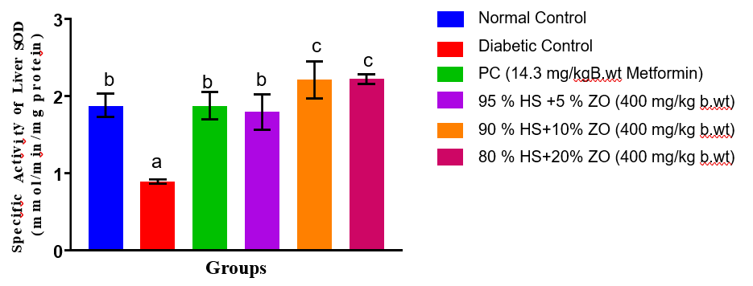
Figure 1. Specific Activity of Superoxide Dismutase (SOD) in the Liver of Streptozotocin-Induced Diabetic Rats Administered Combined Extracts of Hibiscus sabdariffa and Zingiber officinale
Values are expressed as Mean ± SEM of three replicates, and bars with different superscripts are significantly different (p < 0.05).
There was no significant difference (p < 0.05) in the kidney SOD activity of Normal Control, PC (14.3 mg/kg B.wt Metformin), and 80% HS + 20% ZO (400 mg/kg b.wt) groups (Figure 2). The kidney SOD activity of the Diabetic Control group was significantly lower (p < 0.05) than all other groups. The kidney SOD activity of the 95% HS + 5% ZO and 90% HS + 10% ZO groups showed no significant difference (p < 0.05) between each other, and their SOD activities were significantly lower (p < 0.05) compared to the Normal Control, Metformin, and 80% HS + 20% ZO groups.
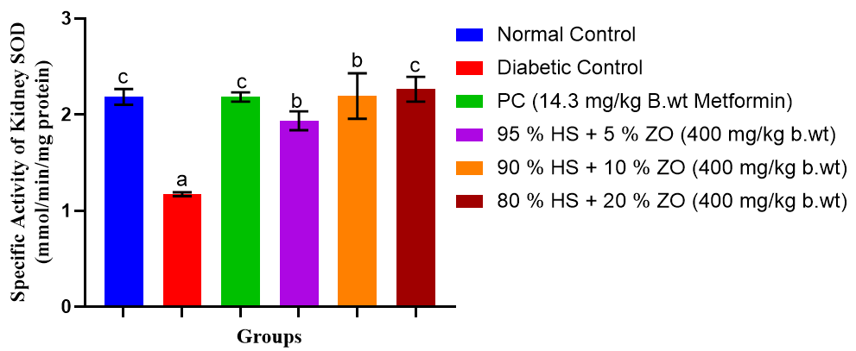
Figure 2. Specific Activity of Superoxide Dismutase (SOD) in the Kidney of Streptozotocin-Induced Diabetic Rats Administered Combined Extracts of Hibiscus sabdariffa and Zingiber officinale
Values are expressed as Mean ± SEM of three replicates, and bars with different superscripts are significantly different (p < 0.05)
There was no significant difference (p < 0.05) in the liver catalase activity of Normal Control, 95% HS + 5% ZO, 90% HS + 10% ZO, and 80% HS + 20% ZO (400 mg/kg b.wt) groups. Their liver catalase activities were significantly lower (p < 0.05) compared to the PC (14.3 mg/kg B.wt Metformin) group. The liver catalase activity of the Diabetic Control group was significantly lower (p < 0.05) compared to the Normal Control, Metformin, and all HS + ZO treated groups (Figure 3). The liver catalase activity of the PC (Metformin) group was significantly higher (p < 0.05) compared to all other groups.
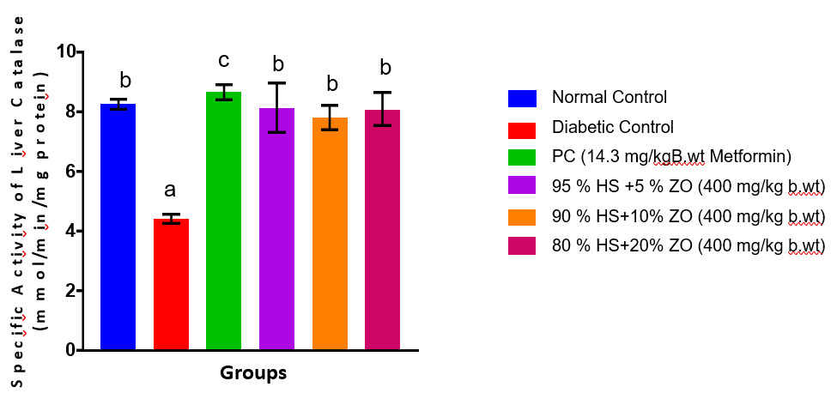
Figure 3. Specific Activity of Catalase (CAT) in the Liver of Streptozotocin-Induced Diabetic Rats Administered Combined Extracts of Hibiscus sabdariffa and Zingiber officinale
Values are expressed as Mean ± SEM of three replicates, and bars with different superscripts are significantly different (p < 0.05)
There was no significant difference (p < 0.05) in the kidney catalase activity of Normal Control, PC (14.3 mg/kg B.wt Metformin), 95% HS + 5% ZO, 90% HS + 10% ZO, and 80% HS + 20% ZO (400 mg/kg b.wt) groups (Figure 4). The kidney catalase activity of the Diabetic Control group was significantly lower (p < 0.05) compared to all other groups.
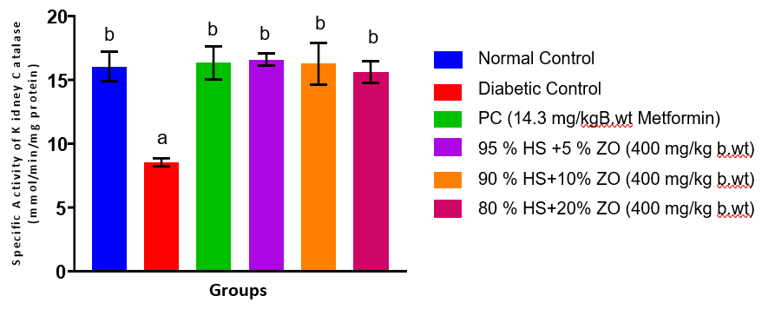
Figure 4. Specific Activity of Catalase (CAT) in the Kidney of Streptozotocin-Induced Diabetic Rats Administered Combined Extracts of Hibiscus sabdariffa and Zingiber officinale
Values are expressed as Mean ± SEM of three replicates, and bars with different superscripts are significantly different (p < 0.05)
There was no significant difference (p < 0.05) in the liver GPx activity of Normal Control, PC (14.3 mg/kg B.wt Metformin), 95% HS + 5% ZO, 90% HS + 10% ZO, and 80% HS + 20% ZO (400 mg/kg b.wt) groups (Figure 5). The liver GPx activity of the Diabetic Control group was significantly lower (p < 0.05) compared to all other groups.
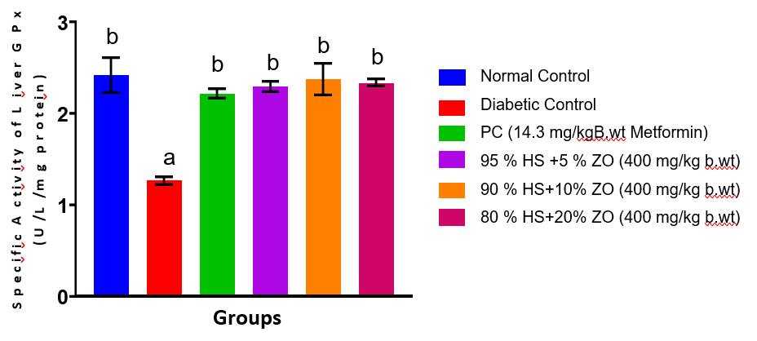
Figure 5. Specific Activity of Glutathione Peroxidase (GPx) in the Liver of Streptozotocin-Induced Diabetic Rats Administered Combined Extracts of Hibiscus sabdariffa and Zingiber officinale
Values are expressed as Mean ± SEM of three replicates, and bars with different superscripts are significantly different (p < 0.05)
There was no significant difference (p < 0.05) in the kidney GPx activity of Normal Control, PC (14.3 mg/kg B.wt Metformin), 90% HS + 10% ZO (400 mg/kg b.wt), and 80% HS + 20% ZO (400 mg/kg b.wt) groups, and their GPx concentrations were significantly lower (p < 0.05) compared to 95% HS + 5% ZO (400 mg/kg b.wt). The kidney GPx activity of the Diabetic Control group was significantly lower (p < 0.05) than all other groups (Figure 6). The kidney GPx activity of the 95% HS + 5% ZO (400 mg/kg b.wt) group was significantly higher (p < 0.05) compared to all other groups.
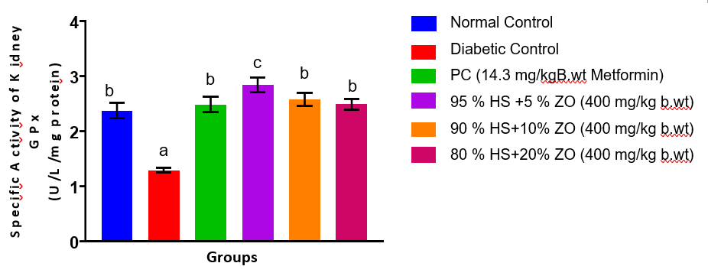
Figure 6. Specific Activity of Glutathione Peroxidase (GPx) in the Kidney of Streptozotocin-Induced Diabetic Rats Administered Combined Extracts of Hibiscus sabdariffa and Zingiber officinale
Values are expressed as Mean ± SEM of three replicates, and bars with different superscripts are significantly different (p < 0.05)
There was no significant difference (p < 0.05) in the liver GST activity of PC (14.3 mg/kg B.wt Metformin), 95% HS + 5% ZO, 90% HS + 10% ZO, and 80% HS + 20% ZO (400 mg/kg b.wt) groups (Figure 7), and their GST concentrations were significantly lower (p < 0.05) compared to the Normal Control group. The liver GST activity of the Diabetic Control group was significantly lower (p < 0.05) than all other groups. The liver GST activity of the Normal Control group was significantly higher (p < 0.05) compared to all other groups.

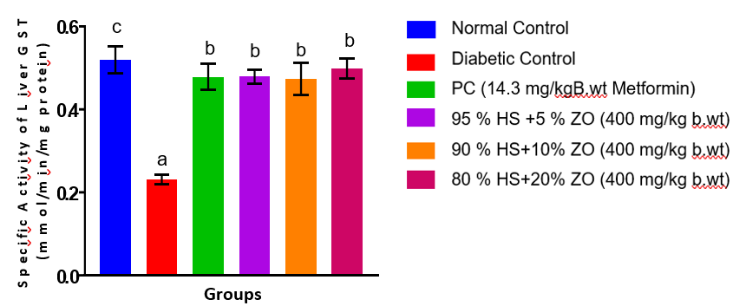
Figure 7. Specific Activity of Glutathione S-Transferase (GST) in the Liver of Streptozotocin-Induced Diabetic Rats Administered Combined Extracts of Hibiscus sabdariffa and Zingiber officinale
Values are expressed as Mean ± SEM of three replicates, and bars with different superscripts are significantly different (p < 0.05)
There was no significant difference (p < 0.05) in the kidney GST activity of Normal Control, PC (14.3 mg/kg B.wt Metformin), 95 % HS + 5 % ZO, 90 % HS + 10 % ZO, and 80 % HS + 20 % ZO (400 mg/kg b.wt) groups (Figure 8). The kidney GST activity of the Diabetic Control group was significantly lower (p < 0.05) than all other groups.
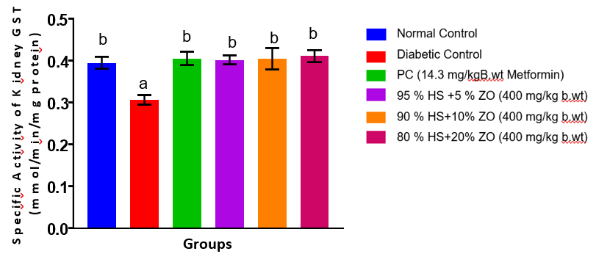
Figure 8. Specific Activity of Glutathione S-Transferase (GST) in the Kidney of Streptozotocin-Induced Diabetic Rats Administered Combined Extracts of Hibiscus sabdariffa and Zingiber officinale
Values are expressed as Mean ± SEM of three replicates, and bars with different superscripts are significantly different (p < 0.05)
There was no significant difference (p < 0.05) in the liver reduced glutathione levels of PC (14.3 mg/kg B.wt Metformin), 95% HS + 5% ZO, 90% HS + 10% ZO, and 80% HS + 20% ZO (400 mg/kg b.wt) groups (Figure 9), and their glutathione concentrations were significantly lower (p < 0.05) compared to the Normal Control group. The liver reduced glutathione level of the Diabetic Control group was significantly lower (p < 0.05) than all other groups. The liver reduced glutathione level of the Normal Control group was significantly higher (p < 0.05) compared to all other groups.
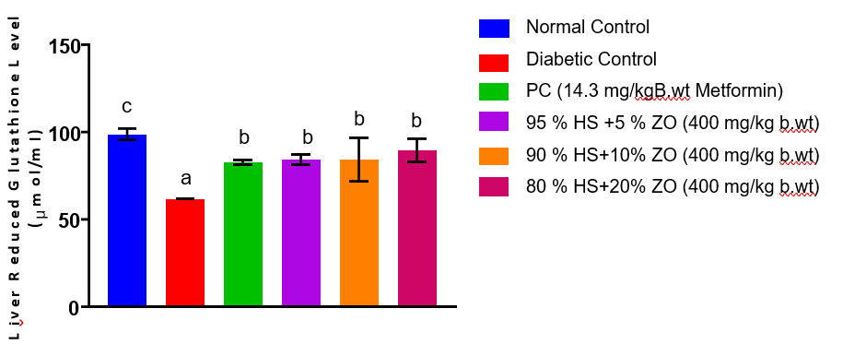

Figure 9. Reduced Glutathione (GSH) Concentrations in the Liver of Streptozotocin-Induced Diabetic Rats Administered Combined Extracts of Hibiscus sabdariffa and Zingiber officinale
Values are expressed as Mean ± SEM of three replicates, and bars with different superscripts are significantly different (p < 0.05).
There was no significant difference (p < 0.05) in the kidney reduced glutathione levels of Normal Control, PC (14.3 mg/kg B.wt Metformin), and 80 % HS + 20 % ZO (400 mg/kg b.wt) groups. Their kidney reduced glutathione concentrations were significantly higher (p < 0.05) compared to the 95 % HS + 5 % ZO and 90 % HS + 10 % ZO groups (Figure 10). The kidney reduced glutathione level of the Diabetic Control group was significantly lower (p < 0.05) than all other groups. There was no significant difference (p < 0.05) in the kidney reduced glutathione levels of the 95 % HS + 5 % ZO and 90 % HS + 10 % ZO groups.

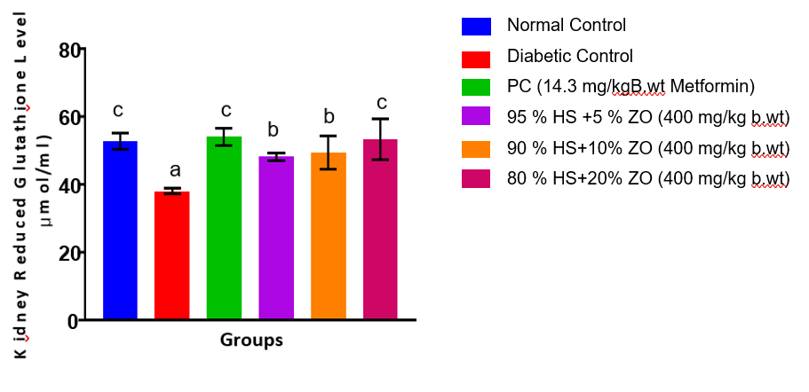

Figure 10. Reduced Glutathione (GSH) Concentrations in the Kidney of Streptozotocin-Induced Diabetic Rats Administered Combined Extracts of Hibiscus sabdariffa and Zingiber officinale
Values are expressed as Mean ± SEM of three replicates, and bars with different superscripts are significantly different (p < 0.05).
There was no significant difference (p < 0.05) in the liver malondialdehyde levels of Normal Control, PC (14.3 mg/kg B.wt Metformin), and 80 % HS + 20 % ZO (400 mg/kg b.wt) groups (Figure 11). Their liver malondialdehyde concentrations were significantly lower (p < 0.05) compared to the 95 % HS + 5 % ZO and 90 % HS + 10 % ZO groups. The liver malondialdehyde level of the Diabetic Control group was significantly higher (p < 0.05) than all other groups. There was no significant difference (p < 0.05) in the liver malondialdehyde levels of the 95 % HS + 5 % ZO and 90 % HS + 10 % ZO groups, and their concentrations were significantly lower (p < 0.05) compared to the Diabetic Control group.
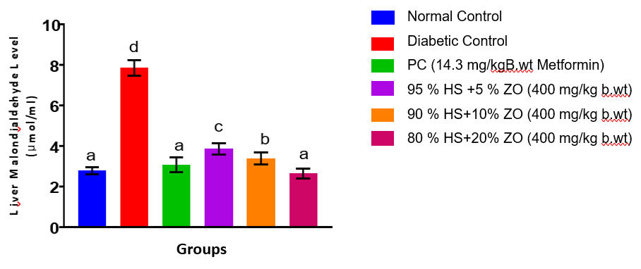
Figure 11. Malondialdehyde (MDA) Concentrations in the Liver of Streptozotocin-Induced Diabetic Rats Administered Combined Extracts of Hibiscus sabdariffa and Zingiber officinale
Values are expressed as Mean ± SEM of three replicates, and bars with different superscripts are significantly different (p < 0.05)
There was no significant difference (p < 0.05) in the kidney malondialdehyde levels of Normal Control, PC (14.3 mg/kg B.wt Metformin), 95 % HS + 5 % ZO, 90 % HS + 10 % ZO, and 80 % HS + 20 % ZO (400 mg/kg b.wt) groups (Figure 12). Their kidney malondialdehyde concentrations were significantly lower (p < 0.05) compared to the Diabetic Control group. The kidney malondialdehyde level of the Diabetic Control group was significantly higher (p < 0.05) than all other groups.
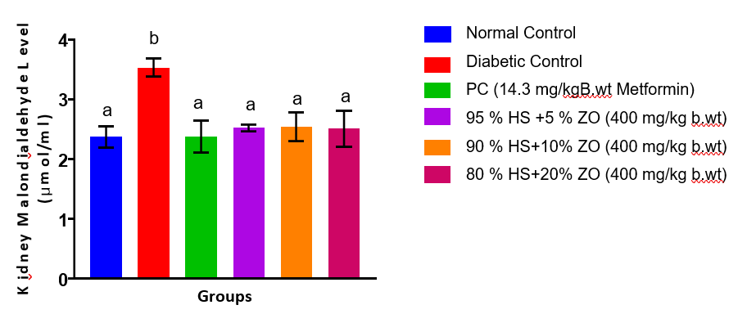
Figure 12. Malondialdehyde (MDA) Concentrations in the Kidney of Streptozotocin-Induced Diabetic Rats Administered Combined Extracts of Hibiscus sabdariffa and Zingiber officinale
Values are expressed as Mean ± SEM of three replicates, and bars with different superscripts are significantly different (p < 0.05)
4.0 DISCUSSION
Streptozotocin administration has been linked to diabetes mellitus, a disease that facilitates the overproduction of reactive oxygen species (ROS) via the autoxidation of glucose, protein glycation, and polyol and hexosamine pathways. Diabetes caused by streptozotocin is specifically linked to mitochondrial dysfunction and β-cell destruction leading to oxidative stress as a result of the imbalance between the formation of ROS and the antioxidant defenses (Rains & Jain, 2011; Giacco and Brownlee, 2010). Continuous oxidative stress is at the forefront leading to the pathogenesis of diabetic complications by initiating lipid peroxidation, protein oxidation, and DNA damage in metabolically active organs like the liver and kidney.
Superoxide dismutase (SOD) is a first line antioxidant enzyme that dismutates superoxide radicals to hydrogen peroxide thus restricting cellular damage caused by superoxides. SOD activity is lower in the case of suppressing the antioxidants defense, which is more vulnerable to oxidation (Ighodaro & Akinloye, 2018). The decreased liver and kidney SOD activities in the diabetic untreated group represents the loss of detoxification of superoxide in diabetic conditions. The reinstatement of the hepatic and renal SOD activity in the extract-treated and the metformin-treated groups relate to the possibility of increased antioxidant protection and through the up-regulation of the endogenous antioxidant enzymes. It is worth mentioning that the high liver SOD activity in the 90% HS + 10% ZO and 80% HS + 20% ZO groups in comparison with the normal control group and the metformin one could indicate an adaptation of enzymatic activity that is triggered by phytochemicals introduced in Hibiscus sabdariffa and Zingiber officinale, i.e., anthocyanins, flavonoids, and gingerols, which are capable of activating the antioxidant pathways (Lin et al., 2007). Although there was limited information on animal studies assessing the synergistic effect of the exact combinations examined in this study, mixtures containing either Z. officinale or H. sabdariffa have been reported to attenuate hepatorenal oxidative stress induced by diabetes via improvement of SOD and CAT activities and amelioration of MDA levels (Gad et al., 2025). It is noteworthy that based on the available literature, there is a paucity of information on the potential of these combined spices to ameliorate hepatorenal damage induced by STZ administration in rats.
Catalase (CAT) is a vital enzyme in the process of hydrogen peroxide detoxification which transforms hydrogen peroxide to water and molecular oxygen and as such, inhibits the formation of hydroxyl radicals through the Fenton reaction. A decrease in catalase activity is widely correlated with excessive oxidative load in diabetes (Maritim et al., 2003). The diabetic control group showed a possible lack of clearance of hydrogen peroxide as suggested by the reduced liver and kidney catalase activities in the group. The observation of normalization of catalase activity in extract treated groups indicates that the joint extracts maintained enzymatic antioxidant activity. The catalase activity in the metformin-treated group is much more pronounced than all others in the liver, which is correlated with reports that metformin has some antioxidant effects due to mitochondrial ROS inhibition (Foretz et al., 2019). The antioxidant effect of these combinations may be attributable to the possible postprandial antidiabetic effect of H. sabdariffa which has been previously reported, thereby reducing hepatic and renal complications of the disease (Abdulrahman-Orire et al., 2026).
Glutathione peroxidase (GPx) is a selenium-dependent enzyme, which breaks hydrogen peroxide and lipid hydro peroxides with reduced glutathione (GSH) as its substrate in the process of preventing peroxidative damage to membranes. Reduced GPx activity is an indication of impaired peroxide detoxification and increased risk of lipid peroxidation (Brigelius-Flohe and Maiorino, 2013). Oxidative stress-induced loss in antioxidant enzymes is emphasized by the marked reduction of the GPx activity in both liver and kidney tissues of the diabetic untreated group. The high kidney GPx activity of the 95% HS + 5% ZO group as compared to all other groups is indicative of dose-dependent effect of the combined extract on antioxidant enzymes, potentially due to tissue-specific bioavailability or synergistic interaction of the plant components.
Glutathione S-transferase (GST) is a detoxification system in cells, through which reduced glutathione is conjugated with electrophilic molecules, thereby making them easy to get rid of. A decrease in GST activity impairs the defense of cells against oxidative and xenobiotic stress (Hayes et al., 2020). In the current study, the reduced liver and kidney GST activities in the diabetic control group suggests the inability to perform detoxification due to diabetic conditions. This finding is in line with the reports that plant extracts that contain polyphenols are able to regulate the expression and activity of GST (Kaur et al., 2021).
Reduced glutathione (GSH) is one of the key non-enzymatic antioxidants that preserve redox homeostasis, scavenge free radicals and are substrates of GPx and GST. One of the characteristics of oxidative stress in diabetes is the depletion of GSH (Lu, 2013). Enhanced oxidative stress and glutathione consumption are attested by the much lower liver and kidney GSH levels of the diabetic untreated group in this study. There was an indication of better redox balance and higher glutathione regeneration as suggested by the GSH concentrations in the treated groups. Such effects could be explained by the fact that bioactive compounds which are able to maintain the level of glutathione synthesis or to decrease its use by restraining the generation of ROS could be present.
Malondialdehyde (MDA) is a popular biomarker of lipid peroxidation and oxidative membrane damage. The presence of high levels of MDA indicates an increased degradation of the polyunsaturated fatty acids by ROS (Ayala et al., 2014). These higher liver and kidney MDA levels in the diabetic untreated group show that the hyperglycaemia-related oxidative stress leads to severe lipid peroxidation. The high level of attenuation of lipid peroxidation manifests itself by the substantial decrease in the MDA levels during metformin and extract-treated groups. Specifically, the similarity of the MDA levels of the normal control and the 80% HS + 20% ZO group in the liver indicates that there are very strong membrane-protective properties of the combined extract at higher concentrations of Z. officinale. Interestingly, there were compensatory stress responses in catalase and glutathione peroxidase activities in treatment groups, making the catalase and glutathione peroxidase activities in normal control group lower compared to the standard control group.
Collectively, the experimentally recorded enhancement of the antioxidant enzyme activities, the increase in the reduced glutathione pools, and the decrease in the lipid peroxidation products in the extract-treated animals suggest that the combined aqueous extracts of Hibiscus sabdariffa and Zingiber officinale have strong hepatorenal antioxidant effects in streptozotocin-induced diabetic rats. These effects may be attributable to the synergistic effects of polyphenols, flavonoids, anthocyanins and gingerols, which increases endogenous antioxidant defenses and inhibits the production of ROS. This agrees with the findings of Ayustaningwarno et al. (2024) who reported the antioxidant activity of Z. officinale. The findings in this current study are also consistent with the work of Salem et al. (2022) who unraveled the antioxidant potential of H. sabdariffa. Although this current has limitations such as the unaddressed liver and kidney function tests, the results indicate that combined plant extracts have therapeutic effects as complementary therapies in alleviating complications of diabetes mellitus related to oxidative stress.
CONCLUSION
In this paper, streptozotocin-induced diabetes mellitus was linked to severe oxidative stress in the liver and kidney tissues, reflected by the loss of antioxidant enzyme activities, reduced glutathione concentration, and increasing levels of lipid peroxidation. These alterations signify a state of imbalance between the production of reactive oxygen species and the endogenous antioxidant mechanisms, and they cause diabetic tissue damage. Co-administration of the aqueous extracts of Zingiber officinale and Hibiscus sabdariffa showed great significance in antioxidant status to restore the enzymatic antioxidants, glutathione availability, and malondialdehyde in liver and kidney tissues. The effects were similar to that of metformin-treated animals and surpassed the effects in certain parameters indicating that there was good regulation of oxidative stress pathways. Comprehensively, the results suggest that the extracts have antioxidative and tissue-protective properties in experimental diabetes when combined. Nevertheless, additional research on molecular effects and active components as well as long-term safety is demanded to warrant therapeutic significance.
Ethical Approval
All authors hereby declare that Principles of laboratory animal care (NIH publication No. 85-23, revised 1985) were followed, as well as specific national laws where applicable. All experiments have been examined and approved by the appropriate ethics committee. Before carrying out the experiment, the study protocol was assessed and approved by the Centre for Research and Development (CR&D), Kwara State University, Malete, Nigeria, with approval number KWASU/CR&D/REA/2025/01175.
COMPETING INTERESTS DISCLAIMER:
Authors have declared that they have no known competing financial interests OR non-financial interests OR personal relationships that could have appeared to influence the work reported in this paper.

References
- Abdulrahman-Orire, R. A., Alli, A. O., Salaudeen, K. A., & Hassan, R. I. (2026). Combinations of Hibiscus sabdariffa with Zingiber officinale and Allium sativum inhibit alpha-amylase and alpha-glucosidase: A guide to docking of H. sabdariffa constituents. FUDMA Journal of Sciences, 10(1), 73–82. https://doi.org/10.33003/fjs-2026-1001-4157
- Ali, B. H., Al-Wabel, N., Blunden, G., & Nemmar, A. (2005). Phytochemical, pharmacological and toxicological aspects of Hibiscus sabdariffa L.: A review. Phytotherapy Research, 19(5), 369–375. https://doi.org/10.1002/ptr.1628
- American Diabetes Association Professional Practice Committee. (2025). Standards of Care in Diabetes—2025. Diabetes Care, 48(Supplement_1), S1–S320. https://doi.org/10.2337/dc25-SINT
- Ayala, A., Muñoz, M. F., & Argüelles, S. (2014). Lipid peroxidation: Production, metabolism, and signaling mechanisms of malondialdehyde and 4-hydroxy-2-nonenal. Oxidative Medicine and Cellular Longevity, 2014, 360438.
https://doi.org/10.1155/2014/360438
- Ayustaningwarno F, Anjani G, Ayu AM and Fogliano V (2024) A critical review of Ginger’s (Zingiber officinale) antioxidant, anti-inflammatory, and immunomodulatory activities. Front. Nutr. 11:1364836. https://doi:10.3389/fnut.2024.1364836
- Beers, R. F., Jr., & Sizer, I. W. (1952). A spectrophotometric method for measuring the breakdown of hydrogen peroxide by catalase. Journal of Biological Chemistry, 195(1), 133–140.
- Brigelius-Flohé, R., & Maiorino, M. (2013). Glutathione peroxidases. Biochimica et Biophysica Acta (BBA) – General Subjects, 1830(5), 3289–3303.
https://doi.org/10.1016/j.bbagen.2012.11.020
- Davies, M. J., Aroda, V. R., Collins, B. S., et al. (2023). Management of hyperglycaemia in type 2 diabetes, 2023. Diabetologia, 66, 129–176.
https://doi.org/10.1007/s00125-022-05787-2
- Ellman, G. L. (1959). Tissue sulfhydryl groups. Archives of Biochemistry and Biophysics, 82(1), 70–77.
https://doi.org/10.1016/0003-9861(59)90090-6
- El-Tantawy, W. H. (2022). Antioxidant effects of medicinal plants in diabetes mellitus. Journal of Traditional and Complementary Medicine, 12(3), 259–268
https://doi.org/10.1016/j.jtcme.2021.10.003
- Foretz, M., Guigas, B., & Viollet, B. (2019). Understanding the glucoregulatory mechanisms of metformin in type 2 diabetes mellitus. Nature Reviews Endocrinology, 15(10), 569–589.
https://doi.org/10.1038/s41574-019-0242-2
- Gad, S. F., Manawy, S. M., Moustafa, M., Mohammed, D. A., & Kamal, K. M. (2025). Nephroprotective potential of ginger, diosmin, and their combination on induced diabetic nephropathy in a rat model: Light and electron microscopic observations. The Egyptian Journal of Histology, 48(4), 1273–1288. https://doi.org/10.21608/ejh.2023.230784.1972
- Gheller, A.C., Kerkhoff, J., Vieira-Junior, G.M., deCampos, K.E. and Sugui, M.M. (2017). Antimutagenic Effect of Hibiscus sabdariffa L. Aqueous Extract on Rats Treated with Monosodium Glutamate. ScientificWorld Journal. https://doi.10.1155/2017/9393532
- Giacco, F., & Brownlee, M. (2010). Oxidative stress and diabetic complications. Circulation Research, 107(9), 1058–1070.
https://doi.org/10.1161/CIRCRESAHA.110.223545
- Gkrinia, E. M., Faour, A. K., Belančić, A., Bazile, J., Marland, E., & Vitezić, D. (2023). Economic burden of insulin therapy in type 2 diabetes: A systematic review. Diabetology, 4(4), 38.
https://doi.org/10.3390/diabetology4040038
- Grotto, D., Santa Maria, L. D., Boeira, S., Valentini, J., Charão, M. F., Moro, A. M., Garcia, S. C., Pomblum, V. J., & Farina, M. (2010). Importance of lipid peroxidation biomarkers and methodological aspects for malondialdehyde quantification. Methods in Molecular Biology, 594, 77–86. https://doi.org/10.1007/978-1-60761-411-1_6
- Habig, W. H., Pabst, M. J., & Jakoby, W. B. (1974). Glutathione S-transferases: The first enzymatic step in mercapturic acid formation. Journal of Biological Chemistry, 249(22), 7130–7139.
- Hayes, J. D., Dinkova-Kostova, A. T., & Tew, K. D. (2020). Oxidative stress in cancer. Cancer Cell, 38(2), 167–197.
https://doi.org/10.1016/j.ccell.2020.06.001
- Hewitt, O. H., & Degnan, S. M. (2023). Antioxidant enzymes that target hydrogen peroxide are conserved across the animal kingdom, from sponges to mammals. Scientific Reports, 13(1), Article 2510. https://doi.org/10.1038/s41598-023-29304-6
- IDF. (2021). IDF diabetes atlas (10th ed.). International Diabetes Federation.
- Ighodaro, O. M., & Akinloye, O. A. (2018). First-line defence antioxidants—Superoxide dismutase, catalase and glutathione peroxidase. Alexandria Journal of Medicine, 54(4), 287–293.
https://doi.org/10.1016/j.ajme.2017.09.001
- Imam, A.L., Okesina, A.A., Sulaimon, F.A., Imam, A., Ibiyeye, R.Y., Oyewole4, L.A., Biliaminu, S.A., Shehu, M., Alli, A.O., Omoola, O.O. and Ajao, S.M. (2024). Thymoquinone ameliorate oxidative stress,GABAergic neuronal depletion and memory impairment through Nrf2/ARE signaling pathway in the dentate gyrus following cypermethrin administration. BMC Neuroscience. 25(45): 1-10. https://doi.org/10.1186/s12868-024-00896-7
- Kaur, H., Chauhan, A., & Singh, R. (2025). Oxidative stress in type 2 diabetes mellitus: From pathogenesis to therapeutic strategies. Oxidative Medicine and Cellular Longevity, 2025, 3762323. https://doi.org/10.1155/2025/3762323
- Kaur, S., Mondal, P., & Banerjee, S. (2021). Modulation of phase II detoxifying enzymes by dietary polyphenols. Journal of Food Biochemistry, 45(1), e13501. https://doi.org/10.1111/jfbc.13501
- Kumar, S., Sharma, R., & Singh, V. (2024). Therapeutic potential of ginger (Zingiber officinale) in metabolic disorders. Journal of Ethnopharmacology, 322, 116065.
https://doi.org/10.1016/j.jep.2023.116065
- Lin, H. H., Chen, J. H., Kuo, W. H., & Wang, C. J. (2007). Chemopreventive properties and molecular mechanisms of the Hibiscus sabdariffa polyphenols. Archives of Toxicology, 81(11), 737–745. https://doi.org/10.1007/s00204-007-0202-5
- Lu, S. C. (2013). Glutathione synthesis. Biochimica et Biophysica Acta, 1830(5), 3143–3153.
https://doi.org/10.1016/j.bbagen.2012.09.008
- Maritim, A. C., Sanders, R. A., & Watkins, J. B. (2003). Diabetes, oxidative stress, and antioxidants. Journal of Biochemical and Molecular Toxicology, 17(1), 24–38.
https://doi.org/10.1002/jbt.10058
- McGill, J. B., Hirsch, I. B., Parkin, C. G., Aleppo, G., Levy, C. J., & Gavin, J. R. (2024). Current and future role of insulin therapy in type 2 diabetes. Diabetes Therapy, 15(5), 1085–1098.
https://doi.org/10.1007/s13300-024-01569-8
- Misra, H. P., & Fridovich, I. (1972). The role of superoxide anion in the autoxidation of epinephrine. Journal of Biological Chemistry, 247(10), 3170–3175.
- Mousavi, M., Abedimanesh, N., Mohammadnejad, K., Sharini, E., Nikkhah, M., Eskandari, M. R., Motlagh, B., Mohammadnejad, J., Khodabandehloo, H., Fathi, M., & Talebi, M. (2022). Betanin alleviates oxidative stress through the Nrf2 signaling pathway in the liver of STZ-induced diabetic rats. Molecular Biology Reports, 49(10), 9345–9354. https://doi.org/10.1007/s11033-022-07781-8
- Muritala, H. F., Yusuf, A. B., Alli, A. O., Quadri, L. A., & Oni, S. F. (2025). Pausinystalia yohimbe ethanolic extract restores erectile and cardiac functions in paroxetine-induced erectile dysfunctional rats. Science World Journal, 20(3), 1124. https://doi.org/10.4314/swj.v20i3.29
- Nabrdalik, K., Hendel, M., Irlik, K., et al. (2024). Gastrointestinal adverse events of metformin treatment. BMC Endocrine Disorders, 24, 206.
https://doi.org/10.1186/s12902-024-01727-w
- Rains, J. L., & Jain, S. K. (2011). Oxidative stress, insulin signaling, and diabetes. Free Radical Biology and Medicine, 50(5), 567–575.
https://doi.org/10.1016/j.freeradbiomed.2010.12.006
- Salem, M.A., Zayed, A. and Beshay, M.E. (2022). Hibiscus sabdariffa L.: phytoconstituents, nutritive, and pharmacological applications. ADV TRADIT MED (ADTM) 22, 497–507 https://doi.org/10.1007/s13596-020-00542-7
- Sevda, G., Khosrow, K. and Asghar, G., (2017). Biomedicine and Pharmacotherapy. 95: 605613
- Shabalala, S. C., Johnson, R., Basson, A. K., Ziqubu, K., Hlengwa, N., Mthembu, S. X. H., Mabhida, S. E., Mazibuko-Mbeje, S. E., Hanser, S., Cirilli, I., Tiano, L., & Dludla, P. V. (2022). Detrimental Effects of Lipid Peroxidation in Type 2 Diabetes: Exploring the Neutralizing Influence of Antioxidants. Antioxidants, 11(10), 2071. https://doi.org/10.3390/antiox11102071
- Sies, H., & Stetina, P. (2024). Selenium and glutathione peroxidases in diabetes and cardiovascular health. Nature Reviews Endocrinology, 20(4), 215–231. https://doi.org/10.1038/s41574-023-00921-y
- Sudarshan, M., Akansha, L., & Sharan, S. (2025). Modeling diabetes mellitus using streptozotocin: Review approach for future diabetic research. IOSR Journal of Biotechnology and Biochemistry, 11(3), 13–21. https://www.iosrjournals.org
- Sulaiman, F.A., Kazeem, M.O., Waheed, A.M., Temowo, S.O., Azeez, I.O., Zubair, F.I., Adeyemi, T.A., Nyang, A. and Adeyemi, O.S. Antimicrobial and toxic potential of aqueous extracts of Allium sativum and Hibiscus sabdariffa in Male Wistar Rats. Journal of Taibah University for Science. 8(4): 315-322. https://doi.org/10.1016/j.jtusci.2014.05.004
- World Health Organization. (2024). Diabetes fact sheet. WHO.
- Zaky, A. A., El-Sayed, A. S. A., & Hassan, A. M. (2022). Streptozotocin-induced diabetic rat model. Journal of Diabetes Research, 2022, 9876543.
https://doi.org/10.1155/2022/9876543
- Zhang, Y., Li, W., & Liu, J. (2023). Oxidative stress and insulin resistance. Frontiers in Endocrinology, 14, 1189452.
https://doi.org/10.3389/fendo.2023.1189452
- Zhang, Y., Liu, Y., & Tang, J. (2024). Mitochondrial quality control in diabetic kidney disease: Mechanisms and therapeutic prospects. Frontiers in Endocrinology, 15, 1345678. https://doi.org/10.3389/fendo.2024.1345678
- Zheng, M., Liu, Y., Zhang, G., Yang, Z., Xu, W., & Chen, Q. (2023). The Applications and Mechanisms of Superoxide Dismutase in Medicine, Food, and Cosmetics. Antioxidants, 12(9), 1675. https://doi.org/10.3390/antiox12091675

