Exploring the Role of Quantum Dot–Based Nanotechnologies for Nematode Detection and Management: A Review

Abstract
Nematodes constitute a highly diverse and widely distributed group of metazoans, inhabiting a variety of environments such as soil, freshwater and marine ecosystems. Despite their ecological importance, their study is often constrained by their microscopic size and the limited availability of tools for observing their behavior under real-time conditions. In agricultural systems, the management of plant-parasitic nematodes continues to depend largely on chemical nematicides, which raise concerns due to their adverse effects on the environment and human health. In recent years, carbon quantum dots (CQDs) have emerged as a promising nanomaterial with potential applications in nematology. This review synthesizes current research on the use of CQDs in nematode detection, visualization and management. Evidence from studies on plant-parasitic nematodes (Bursaphelenchus xylophilus), entomopathogenic nematodes (Steinernema spp.) and the model organism (Caenorhabditis elegans) suggests that CQDs exhibit concentration-dependent behavior. At lower concentrations, they act as effective and biocompatible fluorescent probes, facilitating in vivo tracking without causing significant adverse effects. However, at higher concentrations, CQDs may induce physiological stress, likely associated with prolonged exposure and accumulation within the organism. Taken together, CQDs present a useful platform for integrating detection and management approaches in nematology. Nevertheless, further investigation is needed to better understand their long-term effects, optimize their application and ensure their safe use in agricultural systems.

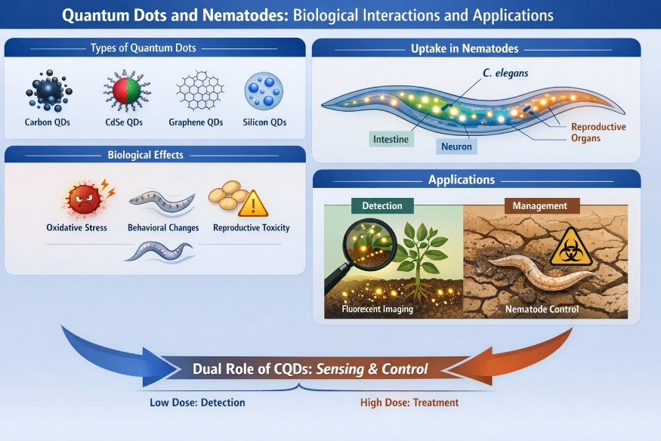

Graphical Abstract

Keywords- Quantum dots, nematode detection, nanotoxicology, xenobiotic metabolism sustainable nematode management
1. Introduction
Nematodes are among the most abundant multicellular organisms in soil ecosystems, with population densities often reaching millions per square meter, and they play key roles in global soil processes (van den Hoogen et al., 2019). They occupy diverse ecological niches and contribute significantly to nutrient cycling, soil health, and plant–microbe interactions. In agricultural systems, nematodes include both beneficial and harmful groups. Free-living species aid in nutrient mineralization, while entomopathogenic nematodes such as Steinernema and Heterorhabditis spp. are widely used as biological control agents. In contrast, plant-parasitic nematodes, including Meloidogyne spp. and Bursaphelenchus xylophilus, are responsible for substantial yield losses in crops and forest systems (Haizer et al., 2024; Jones et al., 2013; Kikuchi et al., 2011).
Despite their ecological and agricultural importance, nematode research faces several methodological challenges. Identification and monitoring still rely largely on morphological and molecular approaches, which are often time-consuming and require specialized expertise. In recent years, nanotechnology has emerged as a promising tool for enhancing agricultural productivity and sustainability, with quantum dots being increasingly explored for a range of applications in modern agriculture (Wan Azamuddin et al., 2025). Advanced fluorescence-based sensing systems utilizing quantum dots have also been developed for the sensitive detection of analytes in agricultural systems (Wang et al., 2019). Additionally, recent advances in nano biosensor-based technologies offer promising alternatives for the rapid and sensitive detection of plant-parasitic nematodes (Sabry, 2023; El-Abeid et al., 2024). However, these methods are not always suitable for large-scale field applications.
Studying nematode movement, survival, and interactions in soil remains particularly challenging due to the lack of efficient in vivo visualization techniques. Model organisms such as Caenorhabditis elegans have been extensively used to investigate uptake, bioaccumulation, and the toxicological effects of nanomaterials, owing to their well-characterized biology and sensitivity to environmental stressors (Silva et al., 2025). Nano-sensor technologies further enable early and accurate diagnosis of plant-parasitic nematodes, offering clear advantages over conventional detection methods (Sabry, 2023). However, translating these findings to complex soil environments and plant-associated nematodes continues to be a significant challenge. Traditionally, nematode management has relied on chemical nematicides, including organophosphates, carbamates, and macrocyclic lactones. Although effective, their use is increasingly restricted due to concerns about environmental persistence, toxicity to non-target organisms, and potential risks to human health. In this context, nanotechnology is gaining attention as a promising approach for improving both detection and management strategies in agriculture (Farhangi-Abriz & Torabian, 2025). In particular, quantum dots are being actively explored due to their multifunctional properties (Gupta et al., 2022). Nanomaterials possess unique physicochemical characteristics that enable novel applications in biological systems (Lim et al., 2015). Earlier generations of quantum dots, particularly those based on cadmium and selenium, demonstrated strong imaging capabilities but raised significant concerns regarding toxicity and environmental safety (Filice et al., 2016; Liang et al., 2022). More recently, carbon quantum dots (CQDs), composed primarily of carbon, hydrogen, and oxygen, have been proposed as relatively safer alternatives due to their good biocompatibility and fluorescence properties. In many cases, the fluorescence behavior of quantum dots changes due to interactions with nearby materials, and these changes are not always fully explained by classical Förster energy transfer concepts (Aldeek et al., 2013).
2. Carbon Quantum Dots: Properties and Synthesis- Carbon quantum dots (CQDs) are a class of carbon-based nanomaterials that have gained considerable attention due to their small size, tunable fluorescence, and relatively low toxicity (Wang & Hu, 2014; Cui et al., 2021). They are characterized by their nanoscale dimensions, typically less than 10 nm in diameter, along with versatile surface chemistry and unique optical properties (Wang & Hu, 2014). These features make CQDs highly suitable for a wide range of biological applications. Their fluorescence behavior, which can be tuned by modifying synthesis conditions or surface functionalization, enables their use as effective imaging and sensing agents.
Carbon quantum dots have been widely explored for their potential to improve plant growth, soil quality, and photosynthetic efficiency, making them valuable tools in sustainable agricultural practices (Chowmasundaram et al., 2023; Andleeb et al., 2025; Cunha Serafim et al., 2026; Wan Azamuddin et al., 2025; Parrish et al., 2021; Dong et al., 2024). This growing interest highlights their role in enhancing agricultural productivity while maintaining environmental sustainability. CQDs are generally synthesized using two main approaches: top-down and bottom-up methods. Top-down approaches involve the breakdown of larger carbon structures, such as graphite or carbon nanotubes, through techniques like laser ablation, electrochemical oxidation, or chemical exfoliation. In contrast, bottom-up methods involve the carbonization of small organic molecules or natural precursors, including carbohydrates, citric acid, plant extracts, and biowaste materials such as fruit peels (Atchudan et al., 2020), using processes such as hydrothermal treatment, pyrolysis, or microwave-assisted synthesis. In recent years, agricultural wastes have increasingly been used as sustainable precursors for the green synthesis of quantum dots, offering an environmentally friendly and cost-effective approach (Khan et al., 2025; Dong et al., 2024; Atanasio et al., 2024). Among these methods, bottom-up approaches are more commonly preferred due to their simplicity, cost-effectiveness, and environmental compatibility. Carbon quantum dots (CQDs) are also known for their strong and tunable photoluminescence properties (Sun et al., 2006). Surface functionalization plays a crucial role in determining their properties and performance. The presence of functional groups such as hydroxyl, carboxyl, and amino groups enhances their solubility, stability, and interaction with biological systems. These surface characteristics also contribute to their biocompatibility and reduced toxicity compared to traditional semiconductor quantum dots. In addition to their optical properties, CQDs exhibit high photostability, resistance to photobleaching, and efficient electron transfer capabilities. These features make them particularly useful in biological imaging, drug delivery, and environmental sensing. Their relatively low toxicity further supports their potential application in agricultural systems, where safety and environmental impact are critical considerations.
3. Quantum Dots Used in Nematology: Types, Properties and Biological Relevance
3.1 Types of Quantum Dots Applied in Nematode Research
A range of quantum dots has been explored in nematode-based nanobiotechnology studies, often using Caenorhabditis elegans as a model organism to evaluate uptake, bioaccumulation, and transgenerational effects. Based on their composition and structure, quantum dots can be broadly categorized into carbon-based, metal-based semiconductor, graphene-derived, silicon-based, and polymer-functionalized types. Among these, carbon quantum dots (CQDs) are the most extensively investigated in nematology. Their low intrinsic toxicity, high water solubility, and stable fluorescence make them highly suitable for biological applications. CQDs synthesized from precursors such as glucose, citric acid, and biomass have been successfully used for in vivo labeling, long-term tracking, and physiological studies in C. elegans, Bursaphelenchus xylophilus, and entomopathogenic nematodes (Steinernema spp.). Their biological effects are generally concentration-dependent, with lower doses showing minimal toxicity and higher exposures inducing measurable physiological responses (Han et al., 2021; San-Blas et al., 2025). Metal-based semiconductor quantum dots, including CdS, CdSe, CdTe, and CdS/ZnS core–shell structures, have also been evaluated in nematode systems, primarily in the context of nanotoxicology. Studies using C. elegans indicate that these materials can induce oxidative stress, developmental delays, reduced fertility, and shortened lifespan. These effects are largely attributed to cadmium ion release and the generation of reactive oxygen species. Although these quantum dots possess strong optical properties, their potential toxicity limits their suitability for agricultural or environmental applications. Specifically, metal-based quantum dots have been reported to induce oxidative stress, neurotoxicity, and impair neuronal function and development (Zhao et al., 2015; Liang et al., 2022; Silva et al., 2025; Li et al., 2021). Graphene quantum dots (GQDs), composed of nanoscale graphene fragments, have been studied as an alternative with improved biocompatibility compared to metal-based quantum dots. In C. elegans, GQDs generally exhibit lower toxicity than cadmium-based counterparts but may still induce oxidative stress and behavioral changes at higher concentrations, particularly when surface-modified or oxidized. Silicon quantum dots (Si-QDs) have received comparatively less attention in nematode research. Available studies focus mainly on biosafety assessment, suggesting lower toxicity than cadmium-based quantum dots. However, their relatively weaker fluorescence limits their effectiveness in imaging applications, and most findings are restricted to controlled laboratory conditions. In addition, surface-functionalized and polymer-coated quantum dots, including PEGylated and ligand-modified systems, have been investigated to improve biocompatibility. Surface modification can reduce acute toxicity and enhance stability; however, it does not completely eliminate concerns related to bioaccumulation and long-term biological effects (Feliu et al., 2016).

Quantum Dots Used in Nematology
Surface-Functionalized QDs
• PEGylated
• Amino-functionalized
Semiconductor QDs
• CdSe
• CdTe
• ZnS
Carbon-Based QDs
• Carbon Quantum Dots (CQDs)
• Graphene Quantum Dots (GQDs)

Doped Quantum Dots
• N-doped
• S-doped

Figure 1 – Classification of Quantum Dots Used in Nematology

Type of QD | Composition | Main Model Nematode | Primary Application | Toxicity Level
CQDs | Carbon-based | C. elegans, B. xylophilus, Steinernema spp. | Imaging, dual role | Low–Moderate
CdSe/CdTe QDs | Cadmium-based | C. elegans | Nanotoxicology | High
GQDs | Graphene-based | C. elegans | Oxidative stress study | Moderate
Si-QDs | Silicon-based | C. elegans | Comparative biosafety | Low
Table 1. Types of quantum dots investigated in nematode research and their biological relevance

3.2 Quantum Dots and Carbon Quantum Dots: Properties Relevant to Nematode Studies
Quantum dots are nanoscale particles, typically less than 20 nm in size, that exhibit quantum confinement effects, resulting in size-dependent optical and electronic properties, such as changes in energy levels and emission behavior (Brus, 1983; Ekimov et al., 1985). Their high fluorescence intensity, resistance to photobleaching, and broad excitation with narrow emission profiles have contributed to their widespread use in bioimaging and sensing applications (Cao et al., 2012). Carbon quantum dots (CQDs) differ from metal-based quantum dots in both composition and toxicity profile. They are commonly synthesized through hydrothermal, microwave-assisted, or pyrolytic methods using precursors such as glucose, citric acid, urea, or various biomass sources. The presence of diverse surface functional groups enhances their water solubility and facilitates interactions with biological systems, where nanoparticles can undergo transformation and influence biological processes (Lim et al., 2015; Stürzenbaum et al., 2013). Compared to cadmium-based quantum dots, CQDs generally exhibit lower cytotoxicity across a range of biological models, including zebrafish, mice, and nematodes (Fu et al., 2023). In nematode research, CQDs offer several practical advantages. Their strong intrinsic fluorescence allows effective visualization in transparent organisms, while high photostability supports prolonged observation. Additionally, their tunable size and surface chemistry enable controlled interactions with biological systems, influencing uptake, distribution, and physiological responses (Xu et al., 2018). Their effects, however, remain dependent on concentration and exposure conditions, highlighting the importance of careful experimental design when applying CQDs in biological studies.
4. Carbon Quantum Dots for In Vivo Labelling and Visualisation: Case Studies
4.1 Labelling of Entomopathogenic Nematodes
The study by San-Blas et al. (2025) demonstrated the successful use of two types of carbon quantum dots (CQDs) for in vivo labeling of infective juveniles (IJs) of Steinernema feltiae. During in vitro exposure, fluorescence intensity increased progressively, with CQDs primarily accumulating in lysosome-like organelles within the intestinal cells. The fluorescence signal reached its peak after approximately 14 days and remained detectable for several months, even after transferring the nematodes to clean water. Importantly, no lethal, sublethal, or transgenerational effects were observed, as key biological parameters remained unchanged across generations. This contrasts with conventional fluorescent dyes and heavy metal-based quantum dots, which are often associated with adverse effects on nematode fitness and rapid photobleaching (Shaner et al., 2005). The study further highlighted the practical applicability of this approach, showing that even non-specialists could reliably distinguish and separate labeled entomopathogenic nematodes (EPNs) from unlabelled or morphologically similar species, including under soil conditions.
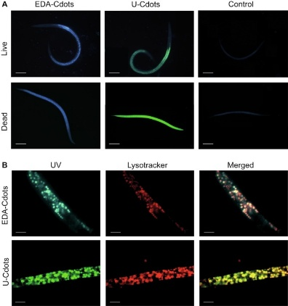

Figure 2. Fluorescence microscopy image of Steinernema feltiae infective juveniles after being treated with carbon quantum dots (CQDs) in vivo. The intestinal region is brightly fluorescent, which suggests that the carbon quantum dots have accumulated inside lysosome, like organelles. This picture shows that the nematodes not only successfully ingested the dots but also that the fluorescence remained stable inside them. Thus, carbon quantum dots can be used as bioimaging probes for long, term in vivo studies. Adopted from San-Blas et al.,(2025)

4.2 Semiconductor Quantum Dot–Labelled Nanocarriers for In Vivo Imaging in Nematodes –
A notable example of semiconductor quantum dot-assisted imaging in nematodes is the study by Stavitskaya et al. (2021), which investigated the in vivo distribution of CdS and Cd₀.₇Zn₀.₃S quantum dot-labeled halloysite nanotubes (HNTs) in Caenorhabditis elegans. In this study, HNTs were functionalized with fluorescent semiconductor quantum dots and introduced into the nematodes through feeding. Fluorescence microscopy enabled real-time visualization of nanoparticle uptake and internal distribution within the organism. Similar uptake and transport of quantum dots have also been reported in plant systems, demonstrating their ability to traverse biological barriers and tissues (Koo et al., 2015). The strongest fluorescence signals were observed in the pharyngeal region and tail, indicating both ingestion and subsequent transport of the nanocomposites. Combined optical and fluorescence imaging, along with merged overlays, confirmed the presence of CdS/HNT-, Cd₀.₇Zn₀.₃S/HNT-, and azine-modified nanocomposites within the nematodes. In contrast, pristine halloysite nanotubes exhibited only weak fluorescence, highlighting the role of quantum dot functionalization in enhancing detectability. Overall, this approach demonstrates that semiconductor quantum dot-functionalized nanotubes can serve as effective tools for in vivo tracking, biodistribution analysis, and nanotoxicological studies in nematodes. Such strategies provide high sensitivity and valuable insights into nanoparticle delivery and interactions within biological systems.

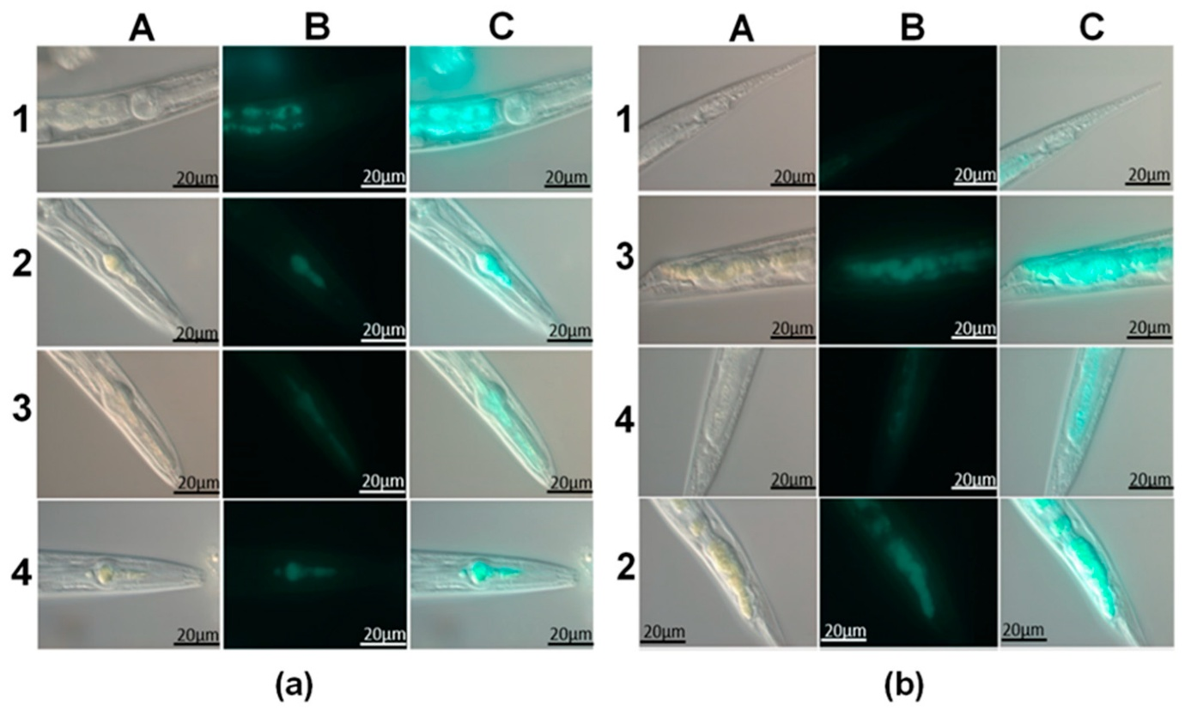

Figure 3. Representative micrographs of Caenorhabditis elegans following ingestion of fluorescently labelled halloysite nanotubes. (a) Pharyngeal region and (b) tail region of the nematodes. For each treatment: A- bright-field (optical) images; B- fluorescence images; C- merged images showing alignment of optical and fluorescence signals. Treatments include (1) pristine halloysite, (2) CdS/HNT-Azine, (3) Cd₀.₇Zn₀.₃S/HNT-Azine, (4) CdS/HNT-NH₂ nanocomposites. Adapted from Stavitskaya et al.,(2021)
4.3 Implications for Ecological and Applied Research
The ability to label and track nematodes in large numbers using cost-effective approaches represents a significant advancement for both ecological research and applied nematode management. Traditionally, nematology studies relied on direct observation and indirect diagnostic methods, which limited detailed understanding of nematode movement and behavior (Smits, 1996). The introduction of nanotechnology, particularly fluorescent nanoparticle-based tools, has greatly enhanced the precision and scope of such investigations.
Recent studies demonstrate that labeling entomopathogenic nematodes with carbon quantum dots (CQDs) is both efficient and minimally disruptive. CQDs enable visualization of nematode movement and persistence in soil and aquatic environments without detectable toxic effects (San-Blas et al., 2025). Beyond imaging, nanomaterial-based approaches, including CQDs and other engineered nanoparticles, are being explored for nematode management. For example, some studies report nematicidal effects against larval and egg stages, indicating the potential to integrate detection and control within a single framework (Fakheri et al., 2025). Overall, the integration of quantum dot-based imaging with environmentally compatible nematode management strategies reflects a shift from conventional approaches toward more precise and versatile tools, benefiting both scientific research and biological control applications.
5. Carbon Quantum Dots as Stress-Inducing and Nematicidal Agents: Case Studies
5.1 Physiological and Behavioural Effects in Bursaphelenchus xylophilus
The research conducted by Han and collaborators (2021) provides one of the most comprehensive studies on CQD toxicity in plant-parasitic nematodes. The study employed glucose-derived carbon quantum dots (CQDs) to investigate their impact on Bursaphelenchus xylophilus, focusing on lifespan, locomotion, reproductive performance, biodistribution, and gene expression. Bioimaging revealed that CQDs distributed throughout the nematode’s body, with the intestine identified as the primary site of accumulation. Similar effects on lifespan, reproduction, growth, and locomotion have also been observed in Caenorhabditis elegans exposed to nanoparticles, underscoring the broader biological impact of nanomaterials across nematode species (Contreras et al., 2014). Comparable physiological and behavioral impairments, including neural damage, have been reported in C. elegans exposed to graphene-based quantum dots (Xu et al., 2021) and other quantum dots (Liang et al., 2022). Behavioral tests in the study demonstrated that both the concentration of CQDs and the duration of exposure strongly influenced the observed outcomes. Specifically, the study found that exposure to CQDs at concentrations above 4 mg mL⁻¹ for more than 72 hours resulted in decreased survival rates, reduced thrashing activity, and significantly impaired egg-laying ability. Comparative analyses indicated that the effects of CQDs were consistent with previous findings on heavy-metal quantum dots, suggesting similar mechanisms of action and biological impact on nematodes.
5.2 Transcriptomic Insights into CQD-Induced Stress
Analysis of transcriptome data identified more than 1,600 genes that were differentially expressed following CQD treatment, revealing strong activation of detoxification pathways. The study reported significant upregulation of genes encoding cytochrome P450s, glutathione S-transferases, and UDP-glucuronosyltransferases, indicating that CQD exposure triggered xenobiotic metabolism pathways involving these detoxification systems, which are known to play key roles in nematode parasitism and stress adaptation (Han et al., 2021; Espada et al., 2016). Additionally, the study demonstrated that nanoparticle-induced stress enhanced fatty-acid β-oxidation and energy metabolism through the overexpression of associated genes.
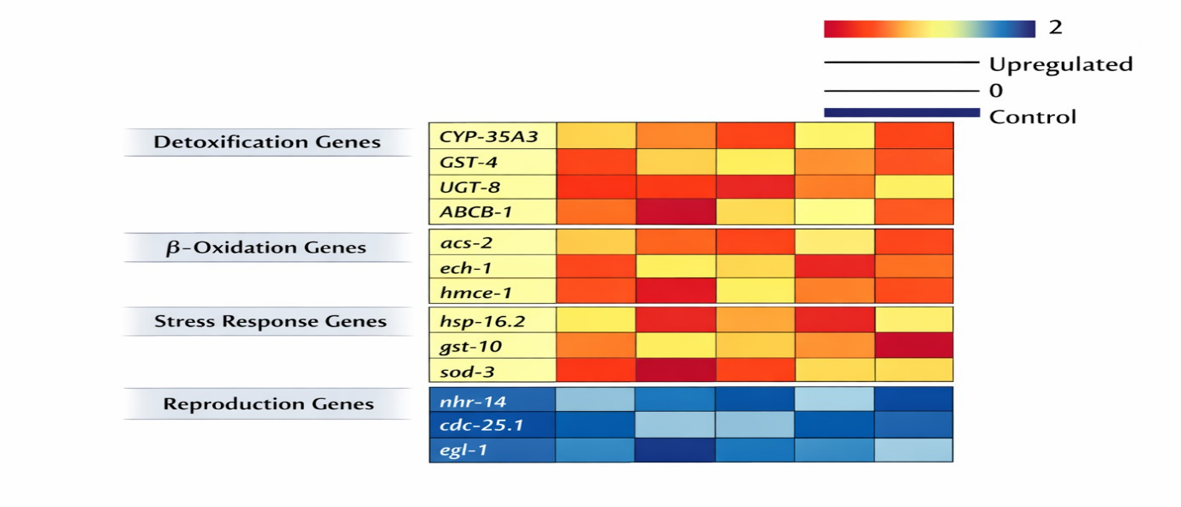
Figure 4- Differential gene expression pattern in nematode exposed to high concentration of CQDs
The study found that genes linked to locomotion and reproduction showed different expression patterns which established a genetic foundation for the detected changes in behaviour. The research found that Caenorhabditis elegans and zebrafish exhibited similar detoxification mechanisms after they were exposed to graphene and carbon-based quantum dots, which demonstrated the widespread nature of these biological processes.
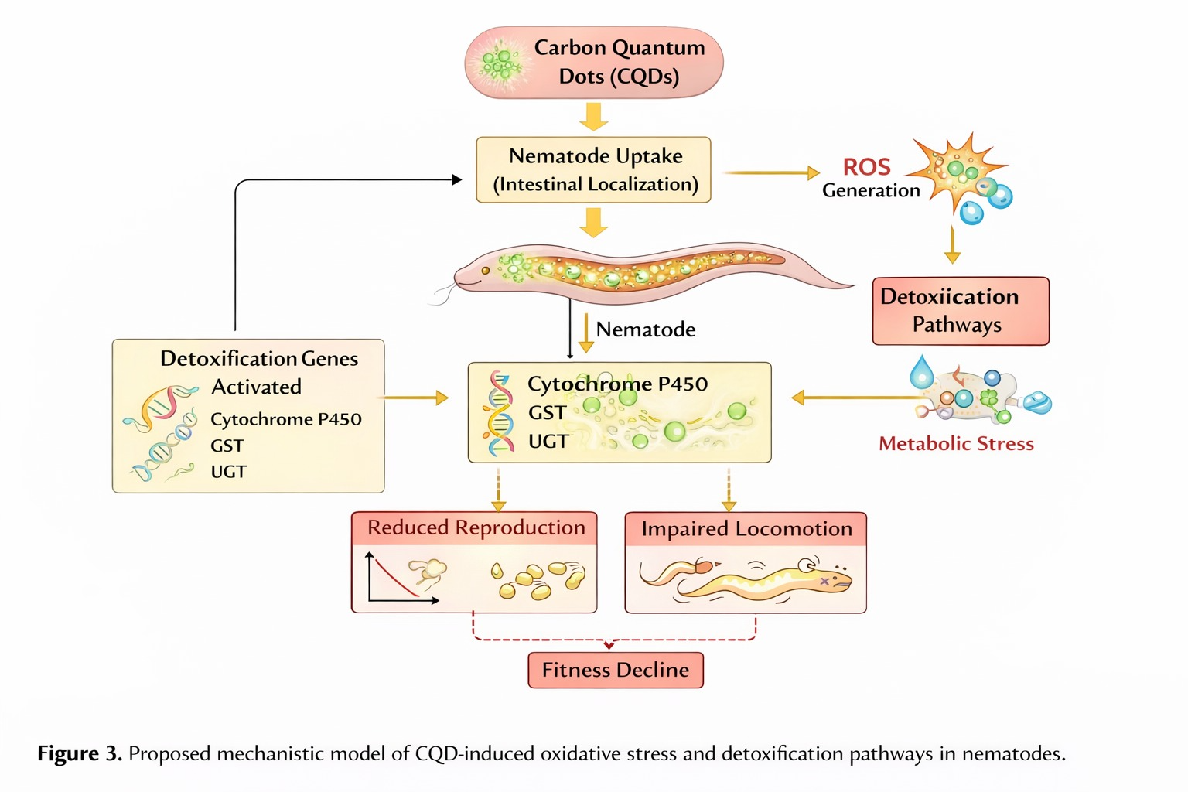
Figure 5- Proposed mechanistic model of CQD-induced oxidative stress and detoxification pathways in nematodes
Nematode Species | CQD Concentration | Exposure Duration | Observed Effect | Mechanism Involved | Reference
B. xylophilus | >4 mg/mL | 72 h | Reduced survival | ROS, detox gene activation | Han et al., 2021
C. elegans | Variable | Multigenerational | Reproduction decline | P450 upregulation
Steinernema feltiae | Low dose | Long-term | No toxicity, stable fluorescence | Biocompatible labeling | San-Blas et al., 2025
Table 2. Concentration-dependent biological effects of carbon quantum dots in nematodes

6. Detection versus Management: A Concentration-Dependent Dual Role of CQDs
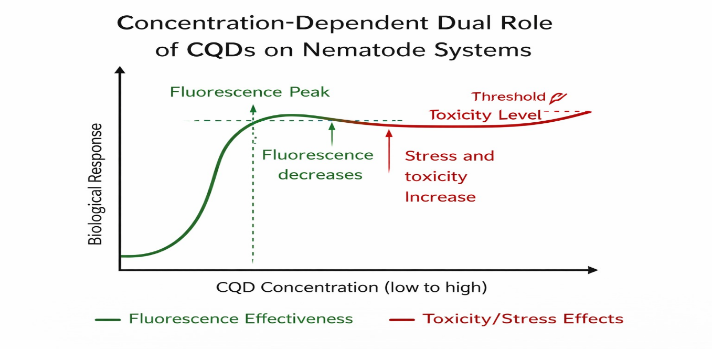

Figure 6 – Concentration-Dependent Dual Role Model
Current findings suggest that carbon quantum dots (CQDs) exhibit a dual or ambivalent role depending on their concentration, acting as beneficial agents at lower levels and potentially inducing stress at higher exposures (Cheng et al., 2026). At low and optimized concentrations, CQDs have been shown to function as biocompatible fluorescent tracers, enabling long-term in vivo labeling and ecological investigations of nematodes (San-Blas et al., 2025). In contrast, at higher concentrations, CQDs and their composites may exert inhibitory or lethal effects on nematodes, supporting their potential role as green nematicidal agents (Fakheri et al., 2025).
Exposure to high doses or prolonged contact with CQDs can trigger chronic physiological stress, resulting in altered behavior and reproduction, activation of detoxification pathways, and ultimately reduced nematode fitness. This dual behavior is particularly relevant for sustainable agriculture, as CQDs enable the tracking of entomopathogenic nematodes in soil while simultaneously offering potential pest management applications. The interaction of quantum dots with living organisms may involve complex biological transformations, as demonstrated in in vivo systems (Stürzenbaum et al., 2013). The potential adverse effects of conventional quantum dots, especially those containing heavy metals, underscore the need for safer alternatives such as carbon-based nanomaterials (Xu et al., 2016). The ability of CQDs to translocate within biological systems further emphasizes their ecological impact and bioavailability (Koo et al., 2015). However, since CQDs can induce stress in plant-parasitic nematodes, their use as green nematicidal agents—or as part of integrated pest management strategies should be carefully considered, ensuring that impacts on non-target organisms are thoroughly assessed.

Application | Advantage | Limitation | Research Gap
In vivo labeling | Stable fluorescence | Environmental fate unknown | Soil persistence studies needed
Stress induction | Potential green nematicide | Non-target risk | Field validation
Transcriptomics | Mechanistic clarity | Cost | Omics-field integration

Table 3. Opportunities and challenges of CQDs in nematode detection and management
7. Conclusions
Carbon quantum dots offer an adaptable nanotechnology platform for advancing the study of nematodes. Several case studies have shown that CQDs can be employed as non, toxic, stable fluorescence tags for live detection and ecological tracking as well as being able to induce stress and, at the proper dose, have a nematicidal effect. By combining detection and management, the application of CQD in the technologies is highly desirable in the deepening of ecological knowledge, increasing the effectiveness of biological control measures and transitioning to more sustainable methods of dealing with nematode problems in crop and forest production.
8. Future Perspectives and Challenges
Carbon quantum dots (CQDs) represent a promising tool for nematode research and management, although several important challenges must be addressed before their broader application. To ensure reproducibility across different studies, standardization of synthesis, characterization, and dosing protocols is essential. Systematic investigation of long-term environmental fate, interactions with soil microbiota, and effects on non-target organisms is also warranted (Contreras et al., 2014). Quantum dot-based technologies are expected to play a significant role in advancing sustainable agriculture by improving efficiency and reducing environmental impact (Sirohi et al., 2024). In the coming years, research should integrate CQD labeling with high-resolution imaging, molecular biology tools, and field experiments. Additionally, functionalized and doped CQDs could be employed to facilitate targeted interactions or enhance fluorescence properties, further expanding their utility as versatile tools in nematology and agricultural applications.
Acknowledgments
The authors sincerely thank Dr. Shashi Kant Thakur and Dr. Nishi Keshari for their guidance and valuable suggestions throughout the preparation of this review. We also acknowledge Dr. Manish Kumar and Dr. Nangki Tagi for their support and insightful discussions. The authors acknowledge support from the ICAR-NTS-PG Fellowship, which provided access to resources and literature.
Disclaimer (Artificial intelligence)
Author(s) hereby declares that NO generative AI technologies such as Large Language Models (ChatGPT, COPILOT, etc.) and text-to-image generators have been used during the writing or editing of this manuscript.

References
- Aldeek, F., Ji, X., & Mattoussi, H. (2013). Quenching of quantum dot emission by fluorescent gold clusters: What it does and does not share with the Förster formalism. The Journal of Physical Chemistry C, 117(29), 15429–15437. https://doi.org/10.1021/jp404952x
- Andleeb, N., Zafar, S., Rahim, Z., Iqbal, M. M., Lal, R., & Farooq, M. A. (2025). Carbon quantum dots as versatile nanomaterials for improving soil health and plant stress tolerance: A comprehensive review. Planta, 262(2), 44. https://doi.org/10.1007/s00425-025-04758-2
- Atanasio, P., Zampiva, R. Y. S., Buccini, L., Di Conzo, C., Proietti, A., Mura, F., Aurora, A., Marrani, A. G., Passeri, D., Rossi, M., Pasquali, M., & Scaramuzzo, F. A. (2024). Graphene Quantum Dots from Agricultural Wastes: Green Synthesis and Advanced Applications for Energy Storage. Molecules, 29(23), 5666. https://doi.org/10.3390/molecules29235666
- Atchudan, R., Edison, T. N. J. I., Perumal, S., Muthuchamy, N., & Lee, Y. R. (2020). Hydrophilic nitrogen-doped carbon dots from biowaste using dwarf banana peel for environmental and biological applications. Fuel, 275, 117821. https://doi.org/10.1016/j.fuel.2020.117821
- Brus, L. E. (1983). A simple model for the ionization potential, electron affinity and aqueous redox potentials of small semiconductor crystallites. The Journal of Chemical Physics, 79(11), 5566–5571. https://doi.org/10.1063/1.445676
- Cao, L., Meziani, M. J., Sahu, S., & Sun, Y.-P. (2012). Photoluminescence properties of graphene versus other carbon nanomaterials. Accounts of Chemical Research, 46(1), 171–180. https://doi.org/10.1021/ar300128j
- Cheng, H., Xu, Y., Ibrahim, A., Gao, Y., Wang, H., Mosa, A., & Ling, W. (2026). Plant enrichment effects of quantum dots in agroecosystems: A double-edged sword. Environmental Science: Nano, 13, 38–57. https://doi.org/10.1039/D5EN00548E
- Chowmasundaram, Y. A. P., Tan, T. L., Nulit, R., Jusoh, M., & Rashid, S. A. (2023). Recent developments, applications and challenges for carbon quantum dots as a photosynthesis enhancer in agriculture. RSC Advances, 13(36), 25093–25117. https://doi.org/10.1039/D3RA01217D
- Contreras, E. Q., Puppala, H. L., Escalera, G., Zhong, W., & Colvin, V. L. (2014). Size-dependent impacts of silver nanoparticles on the lifespan, fertility, growth, and locomotion of Caenorhabditis elegans. Environmental Toxicology and Chemistry, 33(12), 2716–2723. https://doi.org/10.1002/etc.2705
- Cunha Serafim, A. C., Siqueira, A. de P. C., Castilho, M., Soares, M. R. dos S., Fortuna, A. T. X., Terziotti, R. S., Therézio, E. M., Gomes, D. G., Oliveira, H. C., Terezo, A. J., & Siqueira, A. B. (2026). Plant growth enhancement using carbon dots synthesized from swine effluent: A sustainable approach. ACS Agricultural Science & Technology, 6(1), 116–129. https://doi.org/10.1021/acsagscitech.5c00411
- Cui, L., Ren, X., Sun, M., Liu, H., & Xia, L. (2021). Carbon dots: Synthesis, properties and applications. Nanomaterials, 11(12), 3419. https://doi.org/10.3390/nano11123419
- Dong, Z., Qi, J., Yue, L., Zhou, H., Chen, L., Gu, J., He, Y., & Wu, H. (2024). Biomass-based carbon quantum dots and their agricultural applications. Plant Stress, 11, 100411. https://doi.org/10.1016/j.stress.2024.100411
- El-Abeid, S.E., Mosa, M.A., Boudaden, J. et al. Nanobiosensors: A powerful Technology for Early Detection of Plant Parasitic Nematodes. Sens Imaging 25, 23 (2024). https://doi.org/10.1007/s11220-024-00470-9
- Ekimov, A. I., Efros, A. L., & Onushchenko, A. A. (1985). Quantum size effect in semiconductor microcrystals. Solid State Communications, 56(11), 921–924. https://doi.org/10.1016/S0038-1098(85)80025-9
- Espada, M., Silva, A. C., van den Akker, S. E., Cock, P. J., Mota, M., & Jones, J. T. (2016). Identification and characterization of parasitism genes from the pinewood nematode Bursaphelenchus xylophilus reveals a multilayered detoxification strategy. Molecular Plant Pathology, 17(2), 286–295. https://doi.org/10.1111/mpp.12280
- Fakheri, A., Esmaeilnejad, B., Akbari, H., & Molaei, R. (2025). In vitro evaluation of anthelmintic activity of biocompatible carbon quantum dot nanocomposite against egg and larval stages of equine strongyles. BMC Veterinary Research, 21(1), 32. https://doi.org/10.1186/s12917-025-04494-5
- Farhangi-Abriz, S., & Torabian, S. (2025). Quantum dots and nanoparticles in agricultural research. In A. Husen (Ed.), Handbook of nanotechnology in agriculture. Springer. https://doi.org/10.1007/978-981-96-4489-6_8-1
- Feliu, N., Docter, D., Heine, M., del Pino, P., Ashraf, S., Kolosnjaj-Tabi, J., Macchiarini, P., Nielsen, P., Alloyeau, D., Gazeau, F., Stauber, R. H., & Parak, W. J. (2016). In vivo degeneration and the fate of inorganic nanoparticles. Chemical Society Reviews, 45(9), 2440–2457. https://doi.org/10.1039/C5CS00699F
- Fu, C., Qin, X., Zhang, J., Zhang, T., Song, Y., Yang, J., Wu, G., Luo, D., Jiang, N., & Bikker, F. J. (2023). In vitro and in vivo toxicological evaluation of carbon quantum dots originating from Spinacia oleracea. Heliyon, 9(2), e13422. https://doi.org/10.1016/j.heliyon.2023.e13422
- Gupta, A., Mehta, S. K., Kunal, K., Mukhopadhyay, K., & Singh, S. (2022). Quantum dots as promising nanomaterials in agriculture. In Agricultural nanobiotechnology: Biogenic nanoparticles, nanofertilizers and nanoscale biocontrol agents (pp. 243–296). Elsevier. https://doi.org/10.1016/B978-0-323-91908-1.00016-X
- Han, Y., Han, Y., Du, G., Zhang, T., Guo, Q., Yang, H., Li, R., & Xu, Y. (2021). Physiological effect of colloidal carbon quantum dots on Bursaphelenchus xylophilus. RSC Advances, 11, 6212–6220. https://doi.org/10.1039/D0RA10144C
- Jones, J.T., Haegeman, A., Danchin, E.G.J., Gaur, H.S., Helder, J., Jones, M. G. K., … Perry, R. N. (2013). Top 10 plant-parasitic nematodes in molecular plant pathology. Molecular Plant Pathology, 14(9), 946–961. https://doi.org/10.1111/mpp.12057
- Kang, S., Herzberg, M., Rodrigues, D. F., & Elimelech, M. (2012). Antibacterial effects of carbon nanotubes: Size does matter! Langmuir, 24(13), 6409–6413. https://doi.org/10.1021/la800951v
- Khan, Q., Wang, A., Li, P., & Hu, J. (2025). Quantum dots illuminating the future of greenhouse agriculture. Advanced Sustainable Systems, 9, 2401015. https://doi.org/10.1002/adsu.202401015
- Kikuchi, T., Cotton, J. A., Dalzell, J. J., Hasegawa, K., Kanzaki, N., McVeigh, P., … Jones, J. T. (2011). Genomic insights into the origin of parasitism in the emerging plant pathogen Bursaphelenchus xylophilus. PLoS Pathogens, 7(9), e1002219. https://doi.org/10.1371/journal.ppat.1002219
- Koo, Y., Wang, J., Zhang, Q., Zhu, H., Chehab, E. W., Colvin, V. L., Alvarez, P. J. J., & Braam, J. (2015). Fluorescence reports intact quantum dot uptake into roots and translocation to leaves of Arabidopsis thaliana and subsequent ingestion by insect herbivores. Environmental Science & Technology, 49(1), 626–632. https://doi.org/10.1021/es5050562
- Li, Y., Zhong, L., Zhang, L., Shen, X., Kong, L., & Wu, T. (2021). Research advances on the adverse effects of nanomaterials in a model organism, Caenorhabditis elegans. Environmental Toxicology and Chemistry, 40(9), 2406–2424. https://doi.org/10.1002/etc.5133
- Liang, X., Wang, X., Cheng, J., et al. (2022). Ag₂Se quantum dots damage the nervous system of nematode Caenorhabditis elegans. Bulletin of Environmental Contamination and Toxicology, 109, 279–285. https://doi.org/10.1007/s00128-022-03560-0
- Liang, Y., Liu, H., Xia, W., & Chen, Z. (2022). Environmental behavior and toxicity of quantum dots. Environmental Pollution, 292, 118357. https://doi.org/10.1016/j.envpol.2021.118357
- Lim, S. Y., Shen, W., & Gao, Z. (2015). Carbon quantum dots and their applications. Chemical Society Reviews, 44(1), 362–381. https://doi.org/10.1039/C4CS00269E
- Parrish, C. H., II, Hebert, D., Jackson, A., Ramasamy, K., McDaniel, H., Giacomelli, G. A., & Bergren, M. R. (2021). Optimizing spectral quality with quantum dots to enhance crop yield in controlled environments. Communications Biology, 4, 124. https://doi.org/10.1038/s42003-021-01623-7
- Sabry, Ak.H. (2023). Nematode Disease Diagnosis: Application of Nano-Sensors. In: Khan, M.R. (eds) Novel Biological and Biotechnological Applications in Plant Nematode Management. Springer, Singapore. https://doi.org/10.1007/978-981-99-2893-4_11
- San-Blas, E., Cornejo, M. J., Guerra, M., Olivares, M., Faundez, S., Bastidas, B., Morales-Montero, P., Pizarro, L., Aponte, H., Castaneda-Alvarez, C., & Lankin, G. (2025). Where are my nematodes? Labelling and visualising entomopathogenic nematodes in vivo using carbon quantum dots. Journal of Invertebrate Pathology, 211, 108317. https://doi.org/10.1016/j.jip.2025.108317
- Shaner, N. C., Steinbach, P. A., & Tsien, R. Y. (2005). A guide to choosing fluorescent proteins. Nature Methods, 2(12), 905–909. https://doi.org/10.1038/nmeth819
- Silva, A., Viçozzi, G., Farina, M., & Ávila, D. (2025). Caenorhabditis elegans as a model for evaluating the toxicology of inorganic nanoparticles. Journal of Applied Toxicology, 45(7), 1124–1164. https://doi.org/10.1002/jat.4704
- Sirohi, S., Vats, N., Kumar, S., Srivastava, V., & Kumar, J. (2024). Quantum dots and its significance in sustainable agriculture: A review. African Journal of Biological Sciences, 6(14), 2110–2130. https://doi.org/10.48047/AFJBS.6.14.2024.2110-2130
- Smits, P. H. (1996). Post-application Persistence of Entomopathogenic Nematodes. Biocontrol Science and Technology, 6(3), 379–388. https://doi.org/10.1080/09583159631352
- Stavitskaya, A., Fakhrullina, G., Nigamatzyanova, L., Sitmukhanova, E., Khusnetdenova, E., Fakhrullin, R., & Vinokurov, V. (2021). Biodistribution of Quantum Dots-Labelled Halloysite Nanotubes: A Caenorhabditis elegans In Vivo Study. Materials, 14(19), 5469. https://doi.org/10.3390/ma14195469
- Stürzenbaum, S., Höckner, M., Panneerselvam, A., et al. (2013). Biosynthesis of luminescent quantum dots in an earthworm. Nature Nanotechnology, 8, 57–60. https://doi.org/10.1038/nnano.2012.232
- Sun, Y.-P., Zhou, B., Lin, Y., Wang, W., Fernando, K. A. S., Pathak, P., … Wang, H. (2006). Quantum-sized carbon dots for bright and colorful photoluminescence. Journal of the American Chemical Society, 128(24), 7756–7757. https://doi.org/10.1021/ja062677d
- van den Hoogen, J., Geisen, S., Routh, D., Ferris, H., Traunspurger, W., Wardle, D. A., … Crowther, T. W. (2019). Soil nematode abundance and functional group composition at a global scale. Nature, 572, 194–198. https://doi.org/10.1038/s41586-019-1418-6
- Wan Azamuddin, W. N. Z., Abdullah, J. O., Mohamad Azzeme, A., et al. (2025). A multidimensional review of the applications and implications of quantum dots in modern agriculture. Discover Materials, 5, 218. https://doi.org/10.1007/s43939-025-00403-7
- Wang, D. (2016). Biological effects, translocation, and metabolism of quantum dots in the nematode Caenorhabditis elegans. Toxicology Research, 5(4), 1003–1011. https://doi.org/10.1039/c6tx00056h
- Wang, Y., Xu, J., Qiu, Y., Li, P., Liu, B., Yang, L., Barnych, B., Hammock, B. D., & Zhang, C. (2019). Highly specific monoclonal antibody and sensitive quantum dot beads-based fluorescence immunochromatographic test strip for tebuconazole assay in agricultural products. Journal of Agricultural and Food Chemistry, 67(32), 9096–9103. https://doi.org/10.1021/acs.jafc.9b02832
- Wang, Y., & Hu, A. (2014). Carbon quantum dots: Synthesis, properties and applications. Journal of Materials Chemistry C, 2(34), 6921–6939. https://doi.org/10.1039/C4TC00988F
- Xu, H., Wang, X., Zhang, X., Cheng, J., Zhang, J., Chen, M., & Wu, T. (2021). A deep learning analysis reveals nitrogen-doped graphene quantum dots damage neurons of nematode Caenorhabditis elegans. Nanomaterials, 11(12), 3314. https://doi.org/10.3390/nano11123314
- Xu, G., Lin, G., Lin, S., Wu, N., Deng, Y., Feng, G., Chen, Q., Qu, J., Chen, D., Chen, S., Niu, H., Mei, S., Yong, K. T., & Wang, X. (2016). The reproductive toxicity of CdSe/ZnS quantum dots on the in vivo ovarian function and in vitro fertilization. Scientific Reports, 6, 37677. https://doi.org/10.1038/srep37677
- Xu, J., Wang, L., Mu, Y., Zhang, Y., Wang, M., Wang, Q., Wang, K., Guan, S., & Li, J. (2018). Carbon quantum dots as fluorescent probes for imaging and detecting free radicals in Caenorhabditis elegans. Journal of Nanoscience and Nanotechnology, 18(2), 763–771. https://doi.org/10.1166/jnn.2018.15190
- Zhao, Y., Wang, X., Wu, Q., Li, Y., & Wang, D. (2015). Translocation and neurotoxicity of CdTe quantum dots in RMEs motor neurons in nematode Caenorhabditis elegans. Journal of Hazardous Materials, 283, 480–489. https://doi.org/10.1016/j.jhazmat.2014.09.063

