Original Research Article

ASSESSMENT OF GROUNDWATER QUALITY IN A SELECTED RESIDENTIAL AREA OF IBADAN

Abstract
Groundwater is a vital source of drinking water in Nigeria, particularly in peri-urban areas where public water supply is limited. This study evaluated groundwater quality in Awotan Asunle, Ibadan, for domestic use by analysing physicochemical parameters and selected heavy metals (Fe, Cu, Zn) from ten sampling points consisting of five wells (W1–W5) and five boreholes (B1–B5). Key parameters analysed included pH, turbidity, alkalinity, hardness, chloride, sulphate, dissolved oxygen (DO), biochemical oxygen demand (BOD), and chemical oxygen demand (COD), and the results were compared with standards established by the World Health Organization (WHO), Nigerian Standard for Drinking Water Quality (NSDWQ), and the European Union (EU).Most parameters were within permissible limits, indicating generally good water quality with minimal organic and metal contamination. Low turbidity confirmed effective natural filtration, while low BOD and COD suggested negligible organic pollution. Metal concentrations were below guideline values, indicating no significant health risk. However, pH values (5.65–6.65) revealed slightly acidic conditions that may corrode plumbing systems, and elevated chloride in one well suggested localized anthropogenic influence. Dissolved oxygen levels were generally acceptable with minor variations among sampling points. The study concludes that groundwater in Awotan Asunle is largely suitable for domestic use but remains vulnerable to localized contamination and acidity. Regular monitoring, improved sanitation, and appropriate treatment measures are recommended to safeguard water quality and support sustainable groundwater management in rapidly developing peri-urban communities.

Keywords: Groundwater quality; physicochemical parameters; Heavy metals; Water quality assessment; Awotan Asunle.
1.0 Introduction
Water is an indispensable natural resource that plays a fundamental role in sustaining human life, maintaining ecological balance, and supporting socio-economic development. It is required for domestic consumption, agriculture, industrial processes, and environmental sustainability. Despite its importance, access to safe and adequate water remains a global challenge, particularly in developing countries where rapid population growth, urbanization, and climate variability continue to exert pressure on available freshwater resources (UN-Water, 2021; World Health Organization, 2022; Vörösmarty et al., 2021). Groundwater, in particular, has become a critical source of potable water due to its relative protection from surface contamination and its year-round availability, making it a dependable resource for millions of people worldwide (Lall et al., 2020; Thomas, 2023). In Nigeria, groundwater constitutes a major source of water supply for both rural and urban populations, largely due to inadequate infrastructure for treated pipe-borne water. Many households depend on wells and boreholes for drinking, cooking, and other domestic purposes (Oyelakin et al., 2020). However, the increasing reliance on groundwater has raised concerns regarding its quality, as the resource is not entirely immune to contamination. Both natural processes, such as mineral dissolution and geochemical interactions, and anthropogenic activities, including agricultural practices, industrial discharges, poor waste management, and septic system leakage, significantly influence groundwater composition (Egbueri & Unigwe, 2020; Alli et al., 2025). Groundwater contamination has become a major environmental and public health concern, particularly in rapidly urbanizing regions. Pollutants such as nitrates, chlorides, heavy metals, and organic compounds can infiltrate aquifers through leachate migration, surface runoff, and soil-water interactions, thereby altering the physicochemical characteristics of water and reducing its suitability for human consumption (Adimalla & Li, 2019. Heavy metals such as iron, copper, and zinc, although essential in trace amounts, may pose health risks when present in elevated concentrations, leading to both acute and chronic health effects (World Health Organization, 2022; Alli et al., 2025). Heavy metal contamination in water systems has been widely reported as a serious environmental and public health concern, particularly in areas influenced by anthropogenic activities, where elevated concentrations can pose significant risks to human health (Jiménez-Oyola et al., 2023). Furthermore, parameters such as pH, turbidity, dissolved oxygen, and biochemical oxygen demand provide critical insights into the overall quality, chemical stability, and level of pollution in groundwater systems (Marghade et al., 2021).
In peri-urban communities such as Awotan Asunle in Ibadan, the situation is particularly critical due to increasing population density and unregulated land-use activities. The expansion of residential areas, coupled with inadequate waste disposal systems and poor sanitation practices, has heightened the risk of groundwater contamination. Residents in such areas rely heavily on shallow wells and boreholes, which are more susceptible to pollution from nearby septic tanks, refuse dumps, and agricultural activities (Oyelakin et al., 2020). In addition, the absence of routine water quality monitoring and limited awareness of water treatment practices further increase the vulnerability of the population to waterborne diseases and long-term health risks.Recent studies in Ibadan and other parts of southwestern Nigeria have emphasized the need for continuous assessment of groundwater quality using physicochemical and heavy metal analyses, as well as integrated evaluation methods such as water quality indices (WQI) and statistical tools (Thomas, 2023; Egbueri & Unigwe, 2020). These approaches provide a comprehensive understanding of water quality status and help identify potential sources of contamination. Similarly, research by Alli et al. (2025), which includes Abolarin Oluwatunmise Peter as a co-author, highlights the influence of anthropogenic activities on water quality and the importance of monitoring trace metals due to their environmental and public health implications. Given these concerns, there is a pressing need to evaluate groundwater quality in Awotan Asunle to ensure its safety for domestic use and to support sustainable water resource management. Therefore, this study assesses the physicochemical and heavy metal characteristics of groundwater in the study area, comparing the results with established standards such as those of the World Health Organization (WHO), European Union (EU), and Nigerian Standard for Drinking Water Quality (NSDWQ). The findings of this research will contribute to existing knowledge on groundwater quality and provide a basis for policy formulation, public health protection, and improved water management strategies in similar developing communities.
AIM: The aim of this study is to assess the quality of groundwater in Awotan Asunle, Ibadan, by evaluating its physicochemical and heavy metal characteristics and comparing the results with established standards such as WHO, EU, and NSDWQ.

2.0 Methodology
The assessment of groundwater quality is essential for ensuring safe drinking water and the sustainable management of water resources. This study adopted a systematic approach involving sample collection and laboratory analysis to evaluate groundwater quality in selected locations within Awotan Asunle, Ibadan.In the study area, households rely mainly on groundwater sources for domestic use. However, the type of source varies among residences, as some houses depend on boreholes while others depend on hand-dug wells due to differences in availability, cost of installation, and water supply reliability. Therefore, samples were collected from both wells and boreholes to ensure that the study adequately represented the major groundwater sources used by residents.Groundwater samples were collected using a systematic sampling approach across the study area to achieve good spatial coverage. Sampling locations were selected along accessible residential areas where groundwater sources were present. The distance between consecutive sampling points was measured, and samples were collected at intervals of 15 m, 14 m, 16 m, 18 m, 16 m, 20 m, 17 m, 18 m, 16 m, and 17 m, respectively. These intervals represent the spacing between the sampled wells and boreholes within the community. The variation in distances occurred because groundwater sources in residential areas are not evenly distributed; therefore, the nearest available well or borehole within the sampling route was selected at each measured interval. This approach ensured that the samples were spread across the study area and reduced the likelihood of concentrating samples in a single location.The collected water samples were properly preserved and transported to the laboratory for analysis. In the laboratory, the samples were analysed for key physicochemical parameters and selected heavy metals using standard analytical procedures. The results obtained were then compared with established drinking water standards, including those of the World Health Organization (WHO), European Union (EU), and Nigerian Standard for Drinking Water Quality (NSDWQ), in order to determine the suitability of the groundwater for domestic use.

2.1 Description of the Study Area
The study was carried out in Awotan Asunle, a rapidly developing peri-urban community located in Ibadan, Oyo State, Southwestern Nigeria. The area lies within the Ibadan metropolis and is characterized by increasing residential development due to population growth and urban expansion as shown in Figure 1. Awotan Asunle is largely a low- to medium-density settlement, with a mix of old and newly developed buildings. The study area experiences a tropical climate, with two distinct seasons: the wet season (April to October) and the dry season (November to March). Rainfall during the wet season contributes significantly to groundwater recharge, making groundwater sources such as wells and boreholes the primary means of water supply for residents. Due to limited access to centralized pipe-borne water, households in the area depend heavily on these groundwater sources for domestic activities including drinking, cooking, and sanitation. Geologically, the area falls within the basement complex formation typical of southwestern Nigeria, where groundwater occurs mainly in weathered and fractured rock zones. This geological setting influences both the availability and quality of groundwater in the area. However, rapid urbanisation, poor waste disposal practices and the presence of septic systems pose potential risks of groundwater contamination through leachate infiltration. Awotan Asunle is also characterised by inconsistent water supply and varying levels of sanitation infrastructure, which further necessitates regular assessment of groundwater quality. The combination of growing population, reliance on untreated groundwater and environmental pressures makes the area suitable for evaluating groundwater quality and its implications for public health and sustainable water management.

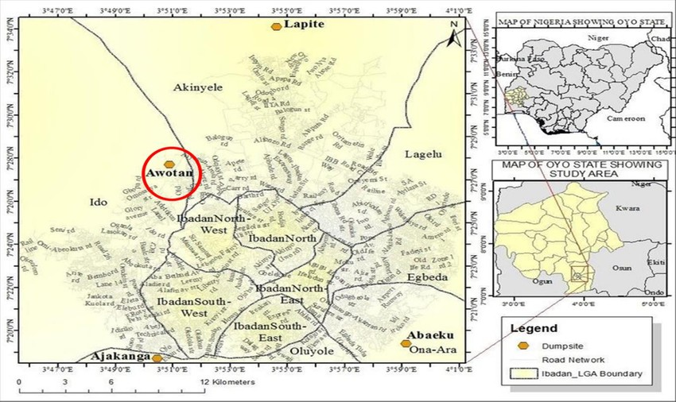
Figure 1: Map showing the study area
Source: Adapted from Abdus-Salam, et al. (2024)

2.2 Sampling Collection and Preservation for Physicochemical Analysis
Groundwater samples were collected from selected wells and boreholes within Awotan Asunle, Ibadan. A total of ten (10) sampling points were used in the study, comprising five wells (W1–W5) and five boreholes (B1–B5) located in different parts of the residential area. The field sampling procedures and some of the sampling locations are shown in Plate 1, Plate 2, Plate 3, plate 4, plate 5 and plate 6. These sources were selected because groundwater from wells and boreholes serves as the primary water supply for many households in the community. The sampling points were chosen using a systematic approach to provide good coverage of the study area. The distances between successive sampling locations were measured as 15 m, 14 m, 16 m, 18 m, 16 m, 20 m, 17 m, 18 m, 16 m, and 17 m. The slight variation in spacing reflects the natural distribution of available wells and boreholes within the neighbourhood. Borehole samples were collected directly from outlet pipes connected to storage tanks, while well samples were obtained using clean sampling containers. All samples were collected in washed and labelled sterile plastic bottles that were rinsed with the sample water before collection to minimize contamination. After collection, the bottles were tightly sealed, kept away from direct sunlight, and transported to the Civil Engineering Water Laboratory, Lead City University, for analysis. The samples were preserved at 4 °C and analysed within 48 hours to maintain their quality. Laboratory analysis followed standard procedures. The parameters analysed included pH, turbidity, alkalinity, total hardness, chloride, dissolved oxygen, sulphate, biochemical oxygen demand (BOD), and chemical oxygen demand (COD). These analyses ensured that the results obtained were accurate and representative of the groundwater quality within the study area.

2.3 Sampling Collection and Preservation for Heavy metal Analysis
Groundwater samples for heavy metal analysis were collected from the same ten (10) sampling points used in the study area, consisting of five wells (W1–W5) and five boreholes (B1–B5) located within Awotan Asunle, Ibadan. These sampling points represent the main groundwater sources used by households in the community. Borehole samples were obtained directly from outlet pipes as shown in plate 1 and plate 3, while well samples were collected using clean sampling containers, as shown in plate 2 and plate 4. The samples were stored in acid-washed and labelled polyethylene bottles to minimize contamination and reduce the possibility of metal adsorption onto the container walls. Before sampling, the bottles were rinsed with the sample water to maintain consistency. Immediately after collection, a small quantity of nitric acid (HNO₃) was added to the samples to preserve the dissolved metals and prevent chemical changes such as precipitation or microbial activity. The samples were then placed in ice-packed containers, protected from light, and transported to the laboratory for analysis. All samples were preserved at 4 °C and analysed within the recommended holding time. Heavy metal analysis was conducted using standard laboratory procedures to determine the concentrations of selected metals, namely iron (Fe), copper (Cu), and zinc (Zn). The analysis was carried out using an Atomic Absorption Spectrophotometer (AAS). These metals were selected because of their importance in assessing environmental water quality and their potential health implications when present in elevated concentrations. The analytical procedures ensured that the results obtained were accurate and reflective of the heavy metal condition of groundwater in the study area.

2.4 Field Sampling Activities
Field sampling was carried out at ten sampling points, comprising five wells (W1–W5) and five boreholes (B1–B5) within Awotan Asunle, Ibadan. The plates below illustrate some of these sampling points.
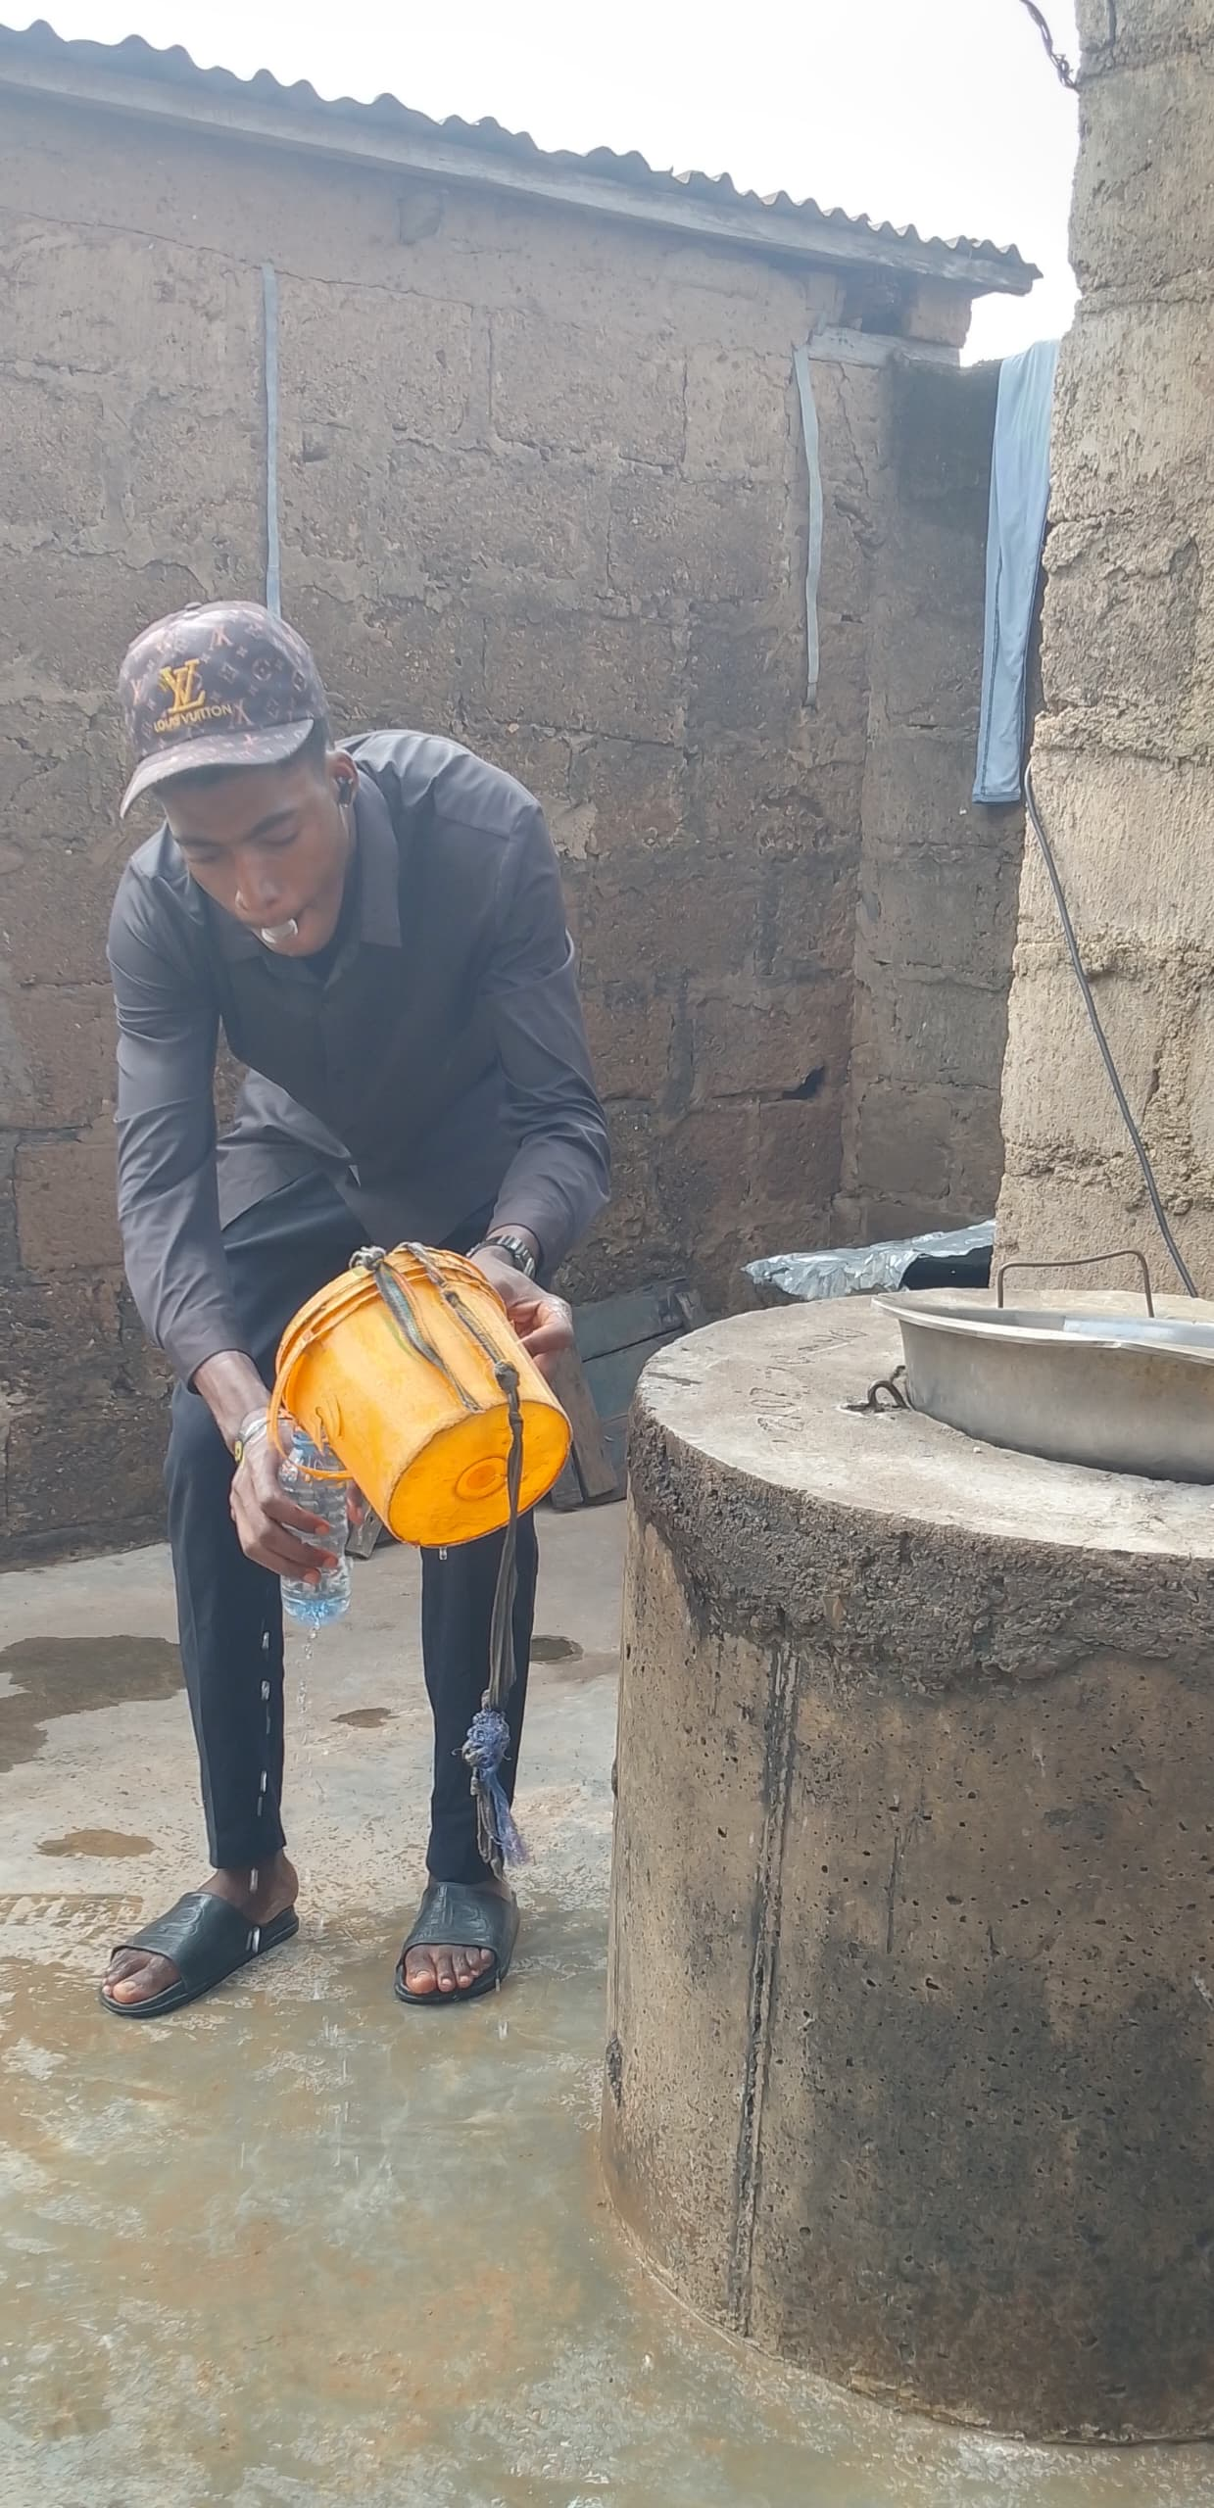
Plate 2: Collection of groundwater sample from a hand-dug well using a sampling container during fieldwork.
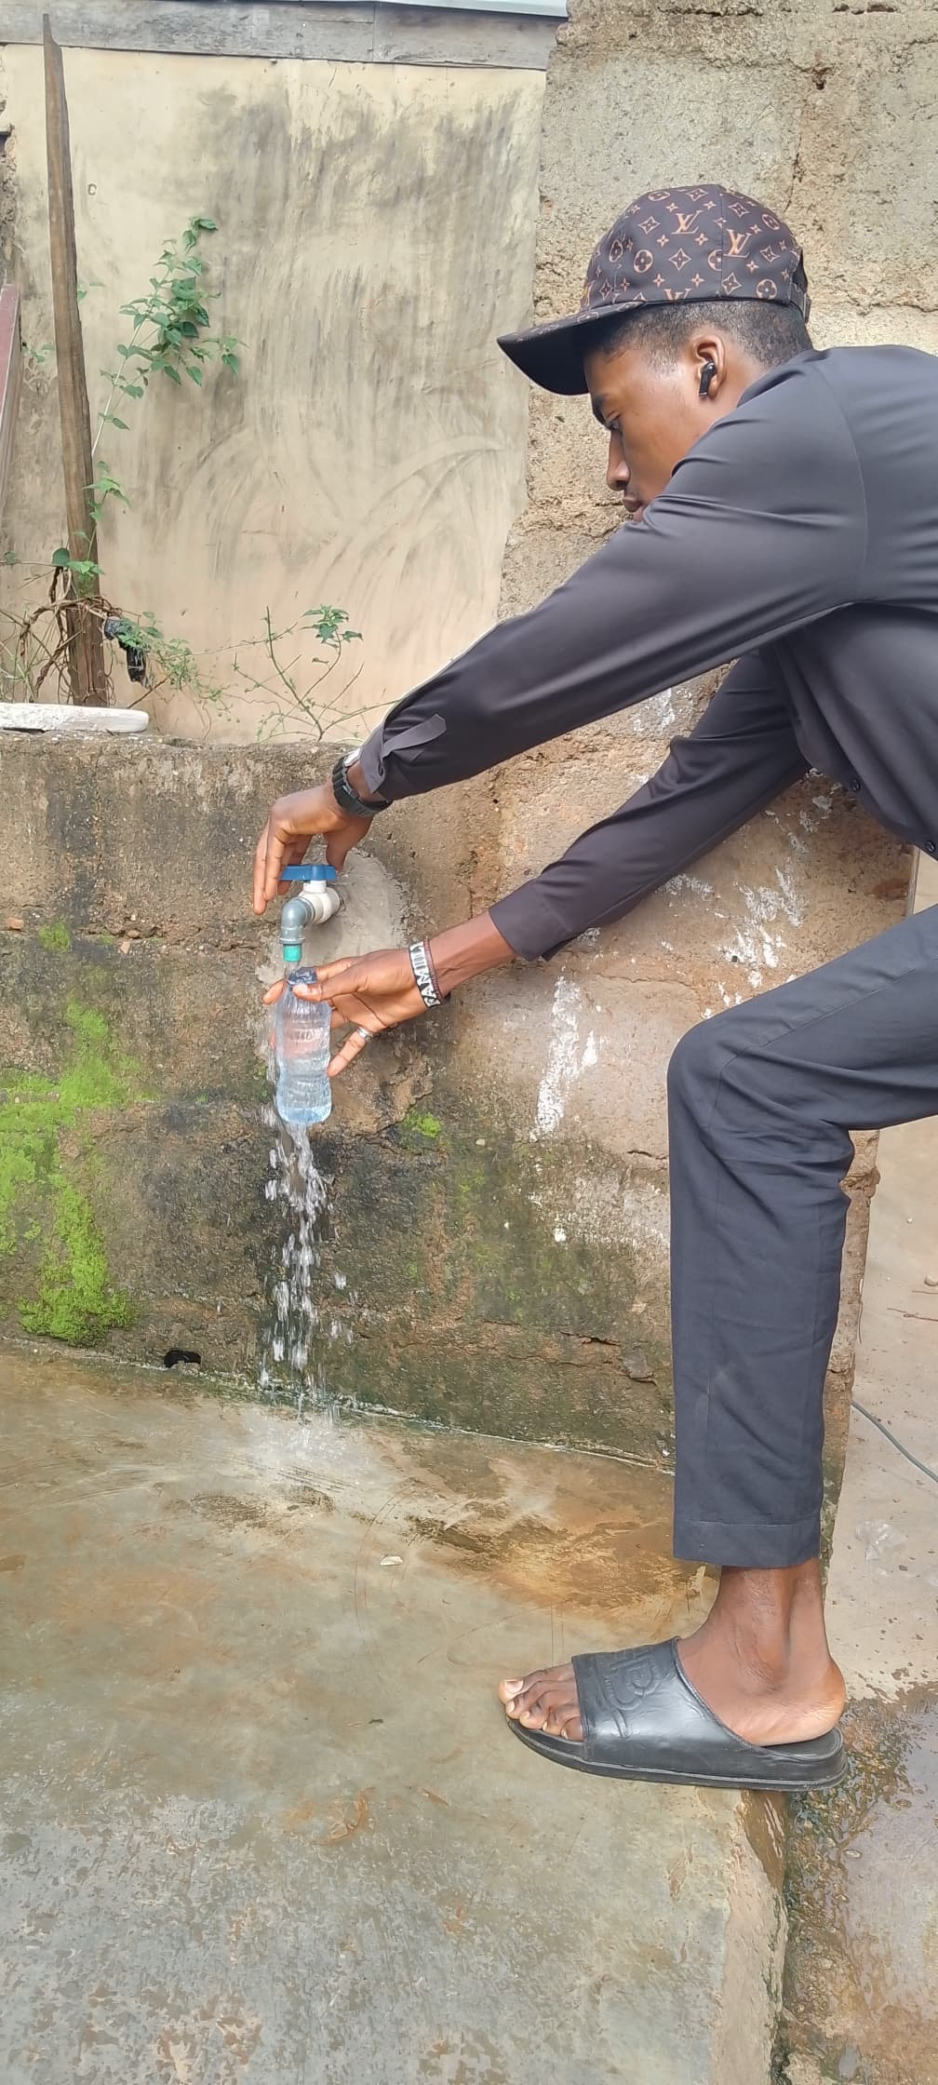
Plate 1: Collection of groundwater sample from a borehole outlet pipe at a sampling location in Awotan Asunle, Ibadan.

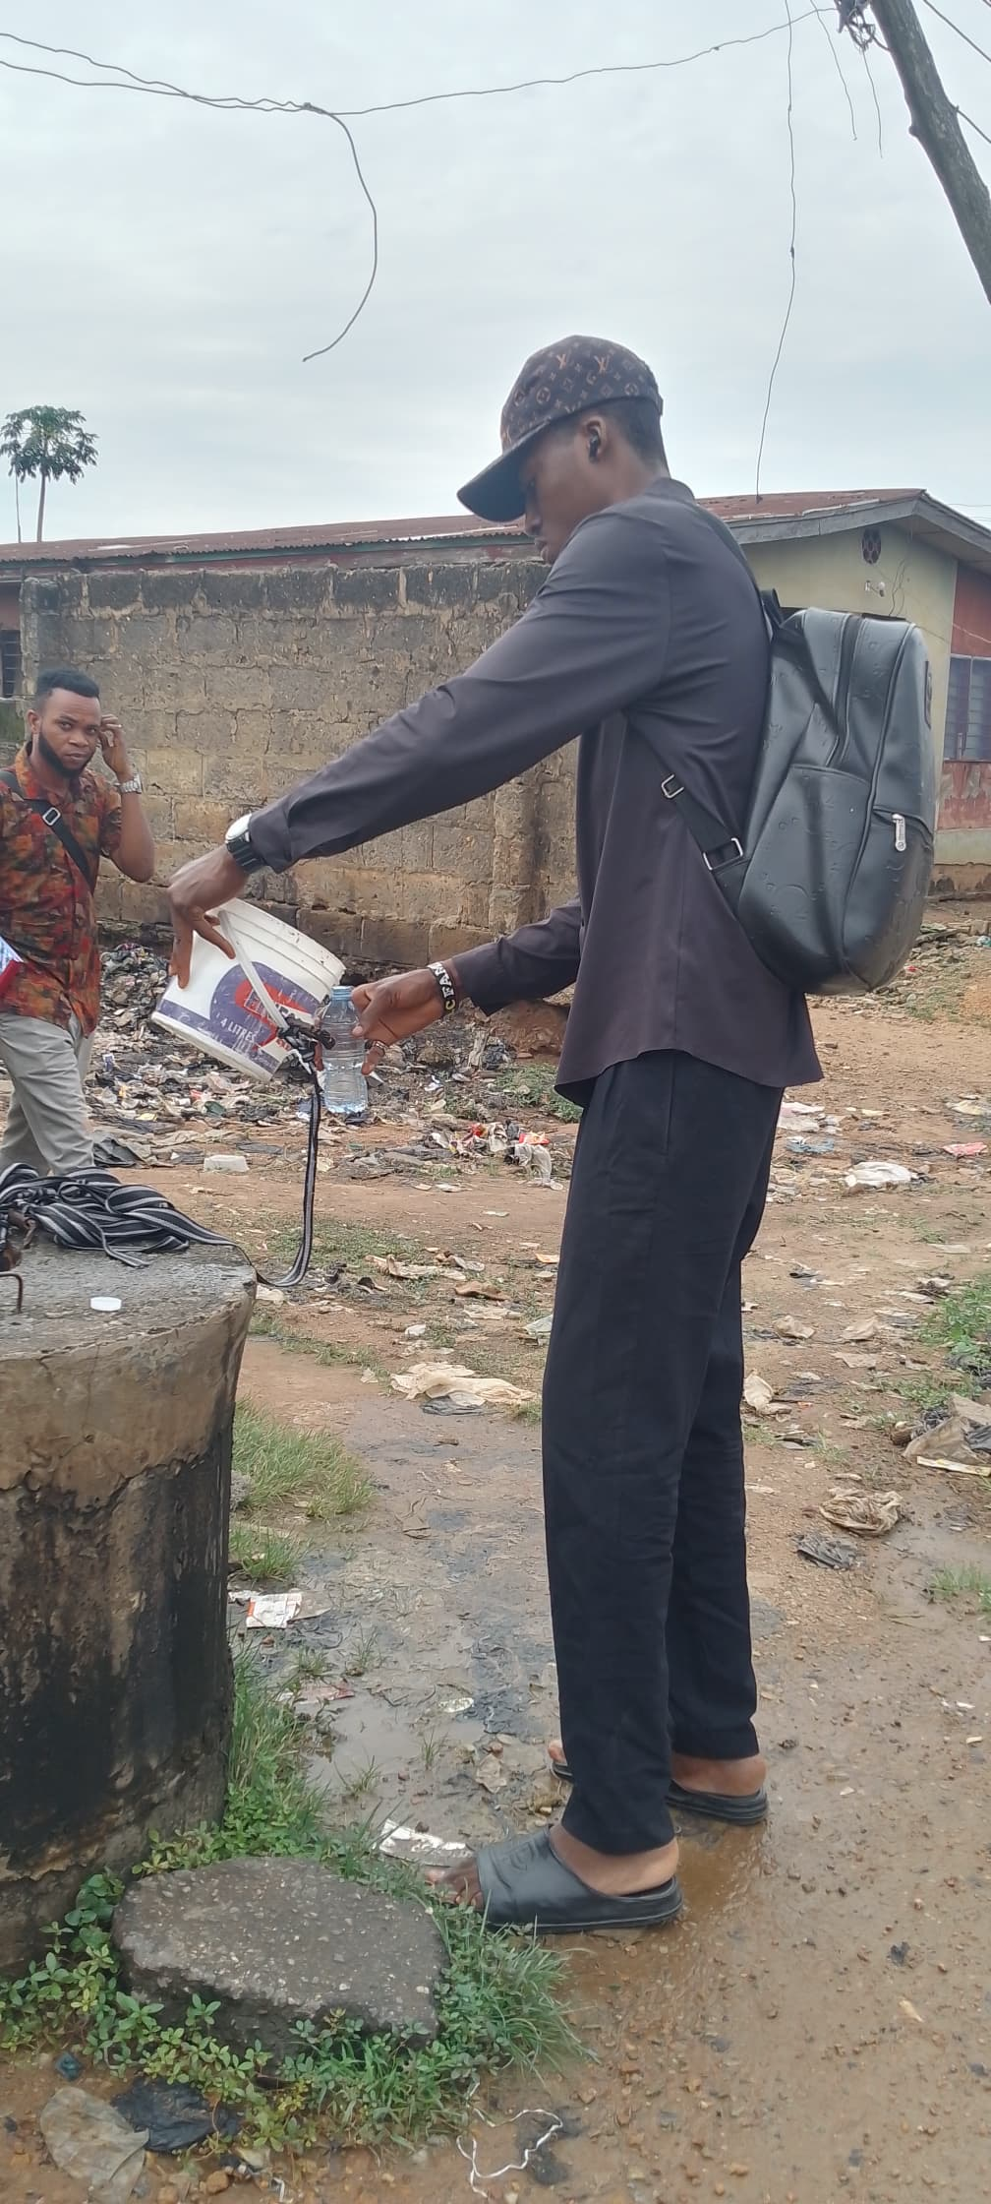
Plate 4: Sampling activity at a well location within the study area during field survey.

Plate 3: Groundwater sample collection from a borehole tap connected to a household water supply system.
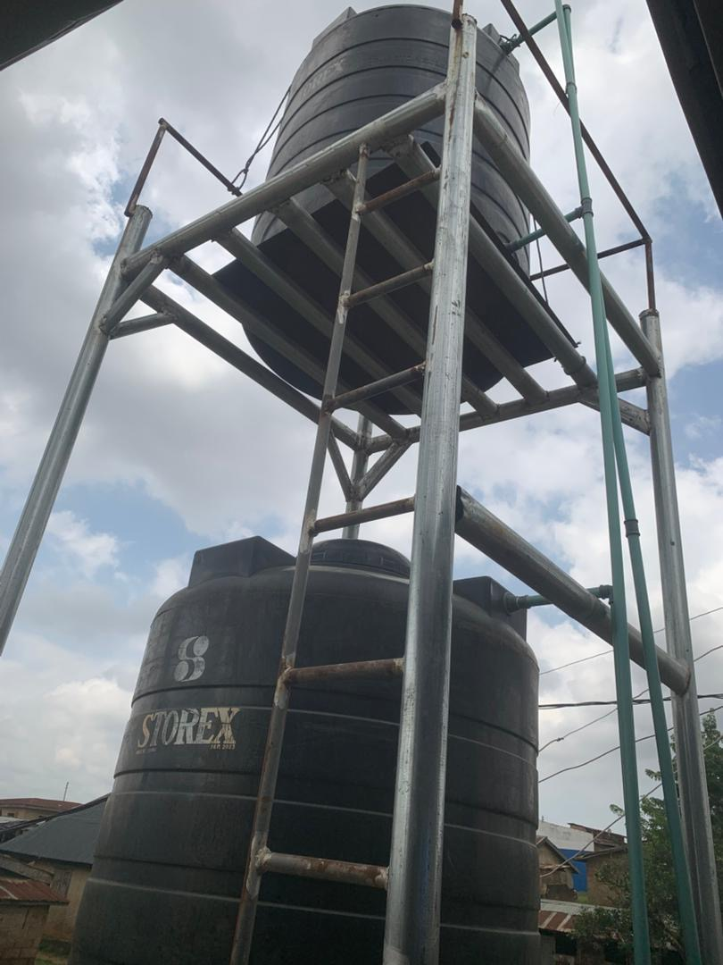
Plate 6: Elevated storage tanks connected to borehole systems supplying groundwater to households in Awotan Asunle.
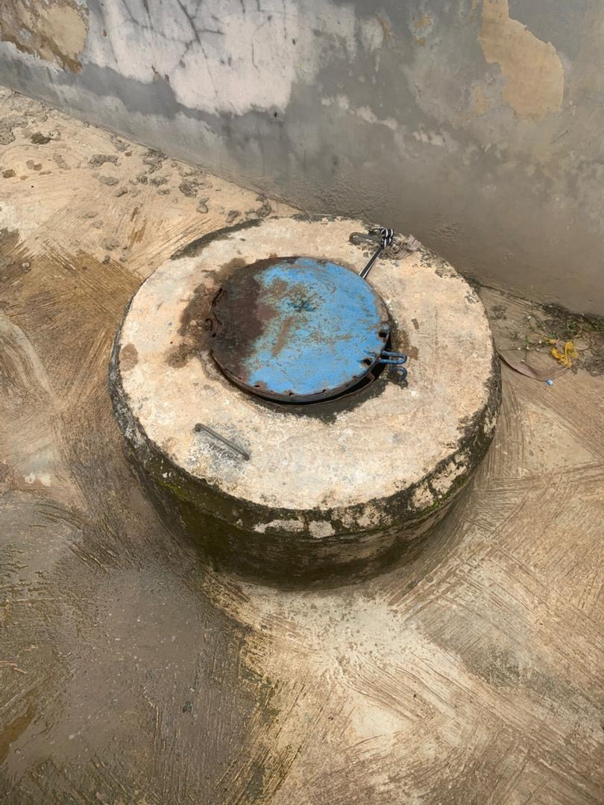 Plate 5: Covered hand-dug well used as one of the groundwater sampling points in the study area.

Table 1. Summary of Physicochemical and Heavy Metal Parameters in Water Samples Compared with Standards
Parameter | W1 | W2 | W3 | W4 | W5 | B1 | B2 | B3 | B4 | B5 | WHO | NSDWQ | EU | Compliance | Implication | Remarks
Turbidity (NTU) | 0.01 | 0.01 | 0.01 | 0.02 | 0.04 | 0.00 | 0.00 | 0.01 | 0.01 | 0.00 | ≤5 | ≤5 | ≤1 | Complies | Clear water | No particulate issue
pH | 5.79 | 5.96 | 5.65 | 5.72 | 5.93 | 6.62 | 6.14 | 5.93 | 5.80 | 6.65 | 6.5–8.5 | 6.5–8.5 | 6.5–9.5 | Non-compliant | Acidic | Corrosion risk
Alkalinity (mg/L) | 56 | 42 | 26 | 50 | 44 | 30 | 36 | 20 | 18 | 152 | No limit | No limit | No limit | Operational | Buffering/Scaling | BH5 high
Hardness (mg/L) | 190.00 | 122.00 | 200.00 | 180.00 | 244.00 | 180.00 | 186.00 | 250.00 | 206.00 | 216.00 | No health limit | No health limit | No health limit | Acceptable | Scaling | Hard water
Chloride (mg/L) | 340.35 | 141.81 | 184.36 | 141.81 | 141.81 | 141.81 | 241.08 | 127.63 | 127.63 | 170.17 | 250 | 250 | 250 | Well 1 fails | Taste/corrosion | Leachate effect
Iron (mg/L) | 0.036 | 0.022 | 0.018 | 0.020 | 0.031 | 0.026 | 0.019 | 0.022 | 0.016 | 0.013 | 0.3 | 0.3 | 0.2 | Complies | No staining | Low iron
Sulphate (mg/L) | 1.08 | 0.14 | 0.10 | 0.16 | 0.19 | 0.18 | 0.14 | 0.22 | 0.17 | 0.11 | 500 | 100 | 250 | Complies | No laxative effect | Safe
Copper (mg/L) | 0.007 | 0.006 | 0.005 | 0.007 | 0.013 | 0.011 | 0.012 | 0.009 | 0.008 | 0.010 | 2.0 | 1.0 | 2.0 | Complies | Essential metal | Safe
Zinc (mg/L) | 0.014 | 0.01 | 0.011 | 0.008 | 0.013 | 0.009 | 0.012 | 0.01 | 0.008 | 0.0016 | 3.0 | 3.0 | 5.0 | Complies | Taste threshold | Safe
DO (mg/L) | 5.00 | 4.00 | 4.50 | 5.40 | 5.60 | 5.30 | 5.40 | 5.50 | 5.85 | 5.80 | ≥5 | ≥5 | — | Marginal | Aquatic stress | Moderate
BOD (mg/L) | 2.12 | 2.20 | 2.00 | 1.85 | 2.40 | 1.85 | 1.30 | 2.10 | 1.95 | 1.93 | ≤5 | ≤5 | ≤5 | Complies | Low pollution | Good
COD (mg/L) | 6.25 | 7.92 | 8.33 | 6.67 | 7.08 | 6.67 | 6.25 | 7.50 | 7.92 | 7.08 | ≤10 | ≤10 | ≤10 | Complies | Low organic load | Good

3.0 Results and Discussion
The results obtained from the laboratory analysis of groundwater samples collected from selected wells and boreholes in Awotan Asunle, Ibadan. A total of ten sampling points, consisting of five wells and five boreholes, were analyzed to evaluate the physicochemical characteristics and heavy metal concentrations of the groundwater sources used by residents for domestic purposes. The results provide insight into the current quality status of groundwater in the study area and its suitability for consumption. Groundwater quality assessment is essential for identifying possible contamination sources and understanding the hydrogeochemical processes influencing water composition. Parameters such as pH, turbidity, alkalinity, hardness, chloride, sulphate, dissolved oxygen, biochemical oxygen demand (BOD), chemical oxygen demand (COD), and selected heavy metals (Fe, Cu, and Zn) were examined because they serve as important indicators of water quality and potential health risks (World Health Organization, 2022; Marghade et al., 2021). The results obtained were compared with guideline values established by the World Health Organization (WHO), Nigerian Standard for Drinking Water Quality (NSDWQ), and the European Union (EU) to determine whether the groundwater meets recommended standards for potable water. Variations observed among the sampling points may be attributed to natural geological conditions, aquifer characteristics, and localized human activities within the area. In rapidly developing peri-urban communities such as Awotan Asunle, factors such as population growth, waste disposal practices, septic system leakage, and land-use changes can influence groundwater quality over time (Adimalla & Li, 2019; Lall et al., 2020).Therefore, analyzing both physicochemical parameters and heavy metals provides a comprehensive understanding of groundwater conditions in the study area. The results obtained from the analyses are presented and discussed in the following subsections, beginning with the physicochemical characteristics of the groundwater samples

3.1 Physicochemical Analysis of Water
Physicochemical analysis is a fundamental approach used to evaluate the quality, composition, and suitability of water for domestic, agricultural, and industrial use. It involves the measurement of key parameters such as pH, turbidity, electrical conductivity, total dissolved solids (TDS), alkalinity, hardness, dissolved oxygen (DO), biochemical oxygen demand (BOD), and concentrations of major ions and trace metals. These parameters provide critical information on the chemical stability, mineral content, and potential contamination of water sources (World Health Organization, 2022). Physicochemical characteristics of water are influenced by both natural processes, such as rock–water interactions, weathering, and hydrogeological conditions, and anthropogenic activities, including waste disposal, agricultural runoff, and industrial effluents (Oyelakin et al., 2020). For instance, parameters like pH and alkalinity indicate the acid–base balance and buffering capacity, while hardness reflects the presence of calcium and magnesium ions. Similarly, elevated levels of BOD and COD may suggest organic pollution, whereas trace metals such as iron, copper, and zinc can indicate geogenic or anthropogenic contamination sources (Alli et al., 2025).
Regular physicochemical analysis is essential for ensuring that water meets established standards such as those set by the World Health Organization (WHO) and national regulatory bodies. It also supports public health protection, environmental sustainability, and effective water resource management, particularly in regions that depend heavily on groundwater for daily use (UN-Water, 2021).
3.1.1 Turbidity
Groundwater samples from Awotan Asunle exhibited very low turbidity values ranging from 0.00 to 0.04 NTU. The turbidity values recorded for Well 1 – Well 5 were 0.01, 0.01, 0.01, 0.02, and 0.04 NTU, respectively, while Borehole 1 – Borehole 5 recorded 0.00, 0.00, 0.01, 0.01, and 0.00 NTU, as shown in Table 1. These values are significantly lower than the limits recommended by the World Health Organization (≤5 NTU) and the European Union (≤1 NTU), indicating that the groundwater sources in the study area are exceptionally clear (World Health Organization, 2022; 2017).Low turbidity is an important indicator of good water quality because it reflects a minimal presence of suspended particles such as silt, clay, organic matter, and microorganisms. Water with low turbidity reduces the likelihood of pathogen attachment and transmission, thereby lowering the risk of waterborne diseases among consumers. The very low turbidity observed in both wells and boreholes suggests that natural filtration through soil and aquifer materials is effective within the study area.Similar low turbidity values have been reported in groundwater studies conducted in Ibadan, where average turbidity levels were about 0.03 NTU, further confirming the efficiency of subsurface filtration processes in the region (Isibor et al., 2023). In contrast, higher turbidity levels in groundwater are often associated with poorly protected wells, surface runoff intrusion, or anthropogenic disturbances (Abubakar et al., 2018).The turbidity levels recorded in Awotan Asunle indicate that the groundwater is aesthetically acceptable and of good quality, with minimal suspended solids and limited environmental disturbance.
3.1.2 pH
Groundwater samples from Awotan Asunle recorded pH values ranged 5.65 to 6.65, indicating that most of the water sources are slightly acidic. The well samples ranged from 5.65–5.96, while the borehole samples ranged 5.80–6.65, see Table 1. These values suggest mild acidity in the groundwater within the study area. When compared with international drinking water standards, most of the recorded values fall slightly below the recommended limits. The World Health Organization (WHO) and the Nigerian Standard for Drinking Water Quality (NSDWQ) recommend a pH range of 6.5–8.5, while the European Union (EU) allows 6.5–9.5 (World Health Organization, 2022). In this study, only Borehole 1 (6.62) and Borehole 5 (6.65) fall within the acceptable range, while the remaining samples are slightly below the minimum guideline value. The pH level of drinking water is a key indicator of its chemical condition and corrosion potential. Water that is slightly acidic can promote the corrosion of pipes and plumbing infrastructure, increasing the release of metals such as iron, copper, and lead into the water supply. Although mildly acidic water generally does not pose immediate health threats, long-term exposure may degrade water quality by facilitating metal mobilization within distribution systems (Lall et al., 2020). The slightly acidic groundwater observed in Awotan Asunle may be attributed to natural hydrogeochemical processes, including the dissolution of carbon dioxide forming weak carbonic acid, weathering of basement complex rocks, and the decomposition of organic matter in soils. Similar slightly acidic groundwater conditions have been reported in Ibadan and other parts of Southwestern Nigeria, reflecting the influence of local geology and subsurface geochemical reactions (Isibor et al., 2023; Lim et al., 2025).
3.1.3 Alkalinity
Groundwater samples from Awotan Asunle recorded alkalinity values ranging from 18 to 152 mg/L as CaCO₃. The values for Well 1– Well 5 were 56, 42, 26, 50, and 44 mg/L, while Borehole 1– Borehole 5 recorded 30, 36, 20, 18, and 152 mg/L, respectively as shown in Table 1. These values indicate the acid-neutralizing capacity of groundwater, mainly influenced by dissolved bicarbonates and carbonates. Unlike many other water quality parameters, no maximum permissible limit for alkalinity is specified by the World Health Organization (WHO), the Nigerian Standard for Drinking Water Quality (NSDWQ), or the European Union (EU) because alkalinity at natural levels generally does not pose direct health risks (World Health Organization, 2022).
Instead, it indicates the water’s ability to buffer against sudden pH changes. Most groundwater samples exhibited low to moderate alkalinity, indicating a moderate buffering capacity. However, Borehole 5 (152 mg/L) showed a comparatively higher value, probably resulting from enhanced dissolution of carbonate minerals in the aquifer (Lall et al., 2020). Adequate alkalinity helps maintain stable pH conditions in water systems, supporting aquatic processes and chemical stability. Similar alkalinity ranges have been reported in groundwater studies across Southwestern Nigeria, reflecting natural hydrogeochemical processes in basement complex terrains (Isibor et al., 2023; Lim et al., 2025).
3.1.4 Total Hardness
Groundwater samples from Awotan Asunle recorded total hardness values ranging from 122 to 250 mg/L as CaCO₃. The values for Well 1 – Well 5 were 190, 122, 200, 180, and 244 mg/L, while Borehole 1–Borehole 5 recorded 180, 186, 250, 206, and 216 mg/L, respectively as shown in Table 1. These values reflect the concentration of dissolved calcium (Ca²⁺) and magnesium (Mg²⁺) ions, which are the main contributors to water hardness. Total hardness does not have a strict maximum permissible limit in drinking water standards established by the World Health Organization (WHO), NSDWQ, and the European Union (EU) because it generally does not pose direct health risks at natural concentrations (World Health Organization, 2022). However, hardness is an important aesthetic and operational parameter, as it can affect water taste, soap usage, and scale formation in pipes and household appliances. Based on standard classifications, most groundwater samples in the study area fall within the hard to very hard category. This phenomenon is primarily driven by natural geological processes, as groundwater interacts with and dissolves minerals rich in calcium and magnesium while flowing through soil and rock formations (Lall et al., 2020). Similar hardness levels have been reported in groundwater studies across Ibadan and other parts of Nigeria, reflecting the influence of mineral dissolution and groundwater–rock interactions within aquifers (Isibor et al., 2023; Lim et al., 2025). Although hard water may cause scaling in pipes and appliances, it can also provide beneficial minerals such as calcium and magnesium for human health.
3.1.5 Chloride
Groundwater samples from Awotan Asunle recorded chloride concentrations ranging from 127.63 to 340.35 mg/L. The values for Well 1–Well 5 were 340.35, 141.81, 184.36, 141.81, and 141.81 mg/L, while Borehole 1–Borehole 5 recorded 141.81, 241.08, 127.63, 127.63, and 170.17 mg/L, respectively see Table 1. Chloride is a naturally occurring ion in groundwater, mainly derived from rock weathering, mineral dissolution, and surface contamination sources. The World Health Organization (WHO), Nigerian Standard for Drinking Water Quality (NSDWQ), and the European Union (EU) recommend a maximum permissible limit of 250 mg/L for chloride in drinking water (World Health Organization, 2022). Most samples in this study fall within the acceptable limit, except Well 1 (340.35 mg/L), which exceeds the guideline value. Chloride is an important indicator of water quality because it affects the taste and corrosiveness of water. Although moderate chloride concentrations typically do not present significant health risks, elevated levels can impart a salty taste and accelerate pipe corrosion, potentially causing metals to leach into the drinking water supply (Lall et al., 2020). The elevated chloride level in Well 1 may be linked to local geological conditions or anthropogenic activities, such as wastewater infiltration, septic leakage, or agricultural runoff. Similar chloride concentrations have been reported in groundwater studies across Ibadan and other parts of Nigeria, reflecting the influence of both natural geochemical processes and human activities (Isibor et al., 2023; Lim et al., 2025).
3.1.6 Sulphate
Groundwater samples from Awotan Asunle recorded sulphate (SO₄²⁻) concentrations ranging from 0.10 to 1.08 mg/L. From Table 1, The values for Well 1 – Well 5 were 1.08, 0.14, 0.10, 0.16, and 0.19 mg/L, while Borehole 1–Borehole 5 recorded 0.18, 0.14, 0.22, 0.17, and 0.11 mg/L, respectively. These results indicate very low sulphate concentrations in the groundwater sources within the study area. All measured sulphate values fall well below recommended drinking water standards. The World Health Organization (WHO) guideline is 500 mg/L, the Nigerian Standard for Drinking Water Quality (NSDWQ) recommends 100 mg/L, and the European Union (EU) sets a limit of 250 mg/L (World Health Organization, 2022). Since the highest value recorded was only 1.08 mg/L, all samples fully comply with these standards, indicating no sulphate-related risk to consumers. Sulphate in groundwater typically originates from the weathering and dissolution of sulphate-bearing minerals and, in some cases, from anthropogenic inputs such as industrial effluents and agricultural activities. The extremely low concentrations observed in this study suggest minimal influence of sulphate-rich minerals and limited anthropogenic contamination, reflecting the relatively protected nature of the aquifer system (Adimalla & Li, 2019; Marghade et al., 2021).Similar findings of low sulphate concentrations have been reported in recent groundwater studies within Nigeria and other basement complex regions, where natural filtration and hydrogeological characteristics restrict sulphate accumulation (Egbueri & Unigwe, 2020; Isibor et al., 2023). Low sulphate levels are generally desirable, as high concentrations can cause laxative effects, unpleasant taste, and scaling in water systems (World Health Organization, 2022). The sulphate concentrations in Awotan Asunle groundwater indicate good chemical quality, absence of significant sulphate pollution, and suitability of the water for domestic use without any health or aesthetic concerns.
3.1.7 Dissolved Oxygen (DO)
Groundwater samples from Awotan Asunle recorded dissolved oxygen (DO) concentrations ranging from 4.00 to 5.85 mg/L. The values for Well 1–Well 5 were 5.00, 4.00, 4.50, 5.40, and 5.60 mg/L, while Borehole 1– Borehole 5 recorded 5.30, 5.40, 5.50, 5.85, and 5.80 mg/L as shown in Table 1. Dissolved oxygen is an important indicator of water quality, reflecting the level of aeration and the balance between oxygen-consuming and oxygen-producing processes in water. According to recommended guidelines, a minimum DO level of 5 mg/L is considered indicative of good water quality (World Health Organization, 2022). Most of the samples meet or slightly exceed this threshold, particularly the borehole samples, which show consistently higher values. However, Well 2 (4.00 mg/L) and Well 3 (4.50 mg/L) fall slightly below the recommended limit, suggesting relatively lower oxygen availability in these locations.DO levels in groundwater are influenced by factors such as recharge conditions, temperature, microbial activity, and the presence of organic matter. Lower DO values may indicate increased microbial respiration or organic matter decomposition, which consume dissolved oxygen within the aquifer system (Adimalla & Li, 2019; Egbueri & Unigwe, 2020). In contrast, higher DO levels, as observed in most boreholes, suggest better aeration and reduced organic pollution. Adequate dissolved oxygen is essential in preventing the development of anaerobic conditions, which can lead to the formation of undesirable substances such as hydrogen sulphide and methane (Marghade et al., 2021). Recent studies in similar hydrogeological settings have reported DO values within the range of 4–6 mg/L, reflecting typical subsurface conditions where oxygen levels are naturally lower than in surface waters (Isibor et al., 2023; Gyamfi et al., 2020). The results obtained in this study are therefore consistent with existing findings and indicate a generally stable groundwater system. The dissolved oxygen levels in Awotan Asunle groundwater are generally acceptable, with only minor variations in a few wells. The results suggest that the groundwater is adequately oxygenated, particularly in boreholes, and suitable for domestic use without significant risk of oxygen-related water quality issues.
3.1.8 Biochemical Oxygen Demand (BOD)
Groundwater samples from Awotan Asunle recorded biochemical oxygen demand (BOD) values ranging from 1.30 to 2.40 mg/L. The values for Well 1 – Well 5 were 2.12, 2.20, 2.00, 1.85, and 2.40 mg/L see Table 1, while Borehole 1–Borehole 5 recorded 1.85, 1.30, 2.10, 1.95, and 1.93 mg/L. BOD is an important indicator of water quality, as it measures the amount of oxygen required by microorganisms to decompose organic matter, thereby reflecting the level of biodegradable pollution present in water.All measured BOD values are well below the recommended limit of ≤5 mg/L set by the World Health Organization (WHO), Nigerian Standard for Drinking Water Quality (NSDWQ), and the European Union (EU) (World Health Organization, 2022). This indicates that the groundwater contains very low levels of organic matter and is not significantly impacted by organic pollution. Low BOD values are characteristic of good-quality groundwater, as natural filtration processes within soil and rock layers effectively remove organic contaminants before water reaches the aquifer (Adimalla and Li, 2019; Marghade et al., 2021). The slight variations observed among wells and boreholes may be attributed to localized influences, such as minor surface runoff infiltration, organic waste inputs, or differences in well construction and maintenance (Egbueri and Unigwe, 2020). Comparable studies in Southwestern Nigeria and similar hydrogeological environments have reported BOD values within the range of 1–3 mg/L, indicating minimal organic pollution and good groundwater quality (Isibor et al., 2023; Gyamfi et al., 2020). These findings are consistent with the results obtained in this study and further support the reliability of the groundwater system. The BOD levels in Awotan Asunle groundwater indicate excellent water quality with minimal biodegradable organic contamination. The water is therefore suitable for domestic use; however, regular monitoring is recommended to ensure that organic pollution levels remain low, especially in the face of increasing urbanization and human activities in the area.

3.1.9 Chemical Oxygen Demand (COD)
Groundwater samples from Awotan Asunle recorded chemical oxygen demand (COD) values ranging from 6.25 to 8.33 mg/L. The values obtained for Well 1 – Well 5 were 7.14, 6.67, 6.25, 7.50, and 6.94 mg/L, while Borehole 1 – Borehole 5 recorded 6.67, 7.14, 6.67, 7.50, and 8.33 mg/L, respectively, as shown in Table 1. These values are below the maximum permissible limit of ≤10 mg/L recommended by the World Health Organization (WHO), Nigerian Standard for Drinking Water Quality (NSDWQ), and the European Union (EU) (World Health Organization, 2022), indicating low levels of oxidizable substances in the groundwater.Chemical oxygen demand is an important indicator of water quality because it measures the amount of oxygen required to chemically oxidize both organic and inorganic materials present in water. Low COD values generally reflect good chemical quality, as they suggest minimal pollution and a reduced likelihood of oxygen depletion in water systems (Adimalla & Li, 2019; Marghade et al., 2021).The relatively narrow range observed among the wells and boreholes suggests similar groundwater conditions across the study area and limited influence of contamination sources. These findings are consistent with previous groundwater studies conducted in Southwestern Nigeria and similar hydrogeological settings, where COD values are typically below 10 mg/L due to natural filtration processes and low anthropogenic impact (Isibor et al., 2023; Egbueri & Unigwe, 2020).The COD levels indicate that groundwater in Awotan Asunle is chemically stable and suitable for domestic use. Nevertheless, regular monitoring is recommended to ensure that increasing urbanization and human activities do not adversely affect groundwater quality in the future.
3.2 Heavy Metal Analysis of Water
Groundwater samples from Awotan Asunle were analysed for selected heavy metals in order to evaluate their suitability for domestic use. The analysis focused on trace metals such as iron (Fe), copper (Cu), and zinc (Zn) collected from ten sampling points consisting of Well 1 – Well 5 and Borehole 1 – Borehole 5, as presented in Table 1. These metals were selected because they commonly occur in groundwater and can influence water quality when present in elevated concentrations. Heavy metals in groundwater may originate from natural geological processes such as the weathering and dissolution of rocks and minerals within the aquifer system. In addition, human activities including waste disposal, agricultural practices, and urban development can introduce trace metals into groundwater sources (Alli et al., 2025). Although some metals such as iron, copper, and zinc are required in small amounts for biological functions, excessive concentrations may pose health concerns and affect water quality (World Health Organization, 2022).The concentrations obtained from the wells and boreholes were compared with recommended drinking water standards provided by the World Health Organization (WHO) and the Nigerian Standard for Drinking Water Quality (NSDWQ) to assess potential health risks. The analysis was carried out using Atomic Absorption Spectrophotometry (AAS), which is widely used for detecting metals in water due to its high sensitivity and accuracy. Studies have shown that heavy metal contamination in groundwater is often associated with increasing anthropogenic activities, particularly in rapidly developing communities (Oyelakin et al., 2020; Alli et al., 2025). Therefore, monitoring heavy metals in groundwater is important for protecting public health and ensuring sustainable management of water resources, especially in areas where wells and boreholes serve as the main sources of drinking water.
3.2.1 Iron
Groundwater samples from Awotan Asunle recorded iron (Fe) concentrations ranging from 0.013 to 0.036 mg/L. The values for Well 1–Well 5 were 0.036, 0.022, 0.018, 0.020, and 0.031 mg/L, while Borehole 1–Borehole 5 recorded 0.026, 0.019, 0.022, 0.016, and 0.013 mg/L, respectively as shown in Table 1. These results indicate low concentrations of dissolved iron in the groundwater sources within the study area. All recorded iron values fall well below the permissible limits recommended by international standards. The World Health Organization (WHO) and Nigerian Standard for Drinking Water Quality (NSDWQ) set a guideline value of 0.3 mg/L, while the European Union (EU) recommends 0.2 mg/L (World Health Organization, 2022). With a maximum value of only 0.036 mg/L, all samples fully comply with these standards, indicating no risk of iron contamination. Iron in groundwater typically originates from the weathering and dissolution of iron-bearing minerals in rocks and soils. Its concentration is influenced by factors such as pH, redox conditions, and aquifer characteristics, which control its mobility and solubility in groundwater systems (Adimalla & Li, 2019; Egbueri & Unigwe, 2020). The low concentrations observed in this study suggest favorable hydrogeochemical conditions and minimal mobilization of iron within the aquifer. Similar low iron levels have been reported in recent groundwater studies in Ibadan and other parts of Nigeria, where natural filtration processes and stable subsurface conditions limit metal accumulation (Isibor et al., 2023; Lim et al., 2025). Low iron concentrations are generally desirable, as elevated levels can lead to aesthetic issues such as discoloration, metallic taste, and staining of household materials, as well as operational problems in water systems (World Health Organization, 2022). The iron concentrations in Awotan Asunle groundwater indicate good water quality, absence of significant iron-related contamination, and suitability of the water for domestic use without aesthetic or health concerns.
3.2.2 Copper
Groundwater samples from Awotan Asunle recorded copper (Cu) concentrations ranging from 0.005 to 0.013 mg/L. The values for Well 1–Well 5 were 0.007, 0.006, 0.005, 0.007, and 0.013 mg/L, while Borehole 1– Borehole 5 recorded 0.011, 0.012, 0.009, 0.008, and 0.010 mg/L, respectively see Table 1. These results indicate very low concentrations of dissolved copper in the groundwater sources within the study area. All measured copper values fall well below recommended drinking water standards. The World Health Organization (WHO) guideline value is 2.0 mg/L, the Nigerian Standard for Drinking Water Quality (NSDWQ) recommends 1.0 mg/L, and the European Union (EU) sets a limit of 2.0 mg/L (World Health Organization, 2022). With a maximum value of only 0.013 mg/L, all samples fully comply with these standards, indicating no risk of copper contamination. Copper in groundwater typically originates from the weathering of copper-bearing minerals in rocks and soils, and in some cases from corrosion of plumbing systems, especially under acidic conditions. The very low concentrations observed in this study suggest limited geochemical mobilization and minimal anthropogenic influence, indicating that the aquifer system is relatively protected from copper contamination (Adimalla & Li, 2019; Egbueri & Unigwe, 2020). Recent studies in similar hydrogeological settings have reported comparably low copper concentrations, reflecting the influence of natural filtration processes and stable groundwater chemistry (Isibor et al., 2023). Low copper levels are generally beneficial, as excessive concentrations can lead to taste issues, staining, and potential health effects such as gastrointestinal disturbances when present in high amounts (World Health Organization, 2022). The copper concentrations in Awotan Asunle groundwater indicate excellent water quality, absence of significant copper-related contamination, and suitability of the water for domestic use without any health or aesthetic concerns.
3.2.3 Zinc
Groundwater samples from Awotan Asunle recorded zinc (Zn) concentrations ranging from 0.0016 to 0.014 mg/L. The values for Well 1–Well 5 were 0.014, 0.010, 0.011, 0.008, and 0.013 mg/L, while Borehole 1–Borehole 5 recorded 0.009, 0.012, 0.010, 0.008, and 0.0016 mg/L, respectively as shown in Table 1. These results indicate very low concentrations of dissolved zinc in the groundwater sources. All measured zinc concentrations fall well below established drinking water standards. The World Health Organization (WHO) and Nigerian Standard for Drinking Water Quality (NSDWQ) recommend a limit of 3.0 mg/L, while the European Union (EU) allows up to 5.0 mg/L (World Health Organization, 2022). Since the highest value recorded in this study was only 0.014 mg/L, all samples fully comply with these guidelines, indicating no zinc-related health concerns. Zinc in groundwater typically originates from the weathering of zinc-bearing minerals and natural geochemical processes within aquifers. The very low concentrations observed suggest limited mineral dissolution and minimal anthropogenic input, reflecting favorable hydrogeochemical conditions in the study area (Adimalla & Li, 2019; Egbueri & Unigwe, 2020). In some cases, zinc may also enter water systems through corrosion of metallic pipes, but such contributions appear negligible in this study. Recent groundwater studies in Southwestern Nigeria and similar environments have reported comparable low zinc levels, largely due to natural filtration processes and the relatively stable chemistry of basement complex aquifers (Isibor et al., 2023. Although zinc is an essential trace element, elevated concentrations can lead to undesirable taste and potential health effects, making its low presence in groundwater desirable (World Health Organization, 2022). The zinc concentrations in Awotan Asunle groundwater indicate excellent water quality, absence of significant zinc contamination, and suitability of the water for domestic use without environmental or health risks.
4.0 Conclusion
This study assessed groundwater quality and availability in Awotan Asunle, Ibadan, and found it to be the main and most reliable water source, though its quality and supply vary across locations. Most physicochemical parameters and heavy metals were within WHO, NSDWQ, and EU limits, indicating generally safe water with low turbidity and minimal contamination. However, slightly acidic pH levels may cause pipe corrosion, and elevated chloride in some areas suggests localized pollution from human activities. Groundwater characteristics are largely influenced by natural geological processes, with moderate alkalinity and hardness that may affect household systems but not health. Despite widespread wells and boreholes, water supply is often inconsistent due to population growth and lack of pipe-borne water.
Overall, groundwater is suitable for domestic use but requires regular monitoring, improved sanitation, and proper management to ensure long-term sustainability.
5.0 Recommendations
Based on the findings of this study on groundwater quality and availability in Awotan Asunle, Ibadan, regular monitoring should be carried out to maintain safe water quality. Simple treatment methods, including filtration and pH correction, should be adopted to improve water quality. Sanitation and waste management practices should be enhanced to prevent contamination, while wells and boreholes must be properly constructed and maintained. Regulations on borehole drilling and land use should be enforced to protect groundwater resources. Public awareness of safe water practices should also be promoted. Additionally, alternative water sources such as pipe-borne water and rainwater harvesting should be developed to reduce reliance on groundwater. Overall, integrated water management and further research are essential for sustainable groundwater use.
Disclaimer (Artificial intelligence)
Author(s) hereby declare that NO generative AI technologies such as Large Language Models (ChatGPT, COPILOT, etc.) and text-to-image generators have been used during the writing or editing of this manuscript.

REFERENCES
Abdus-Salam, M., Adekunle, M., & Akinsanya, Y. (2024). Determination of water quality for groundwater near municipal dumpsite in Ibadan, Southwest Nigeria. International Journal of Innovative Science and Research Technology (IJISRT), 9(7), 500–505. https://doi.org/10.38124/ijisrt/IJISRT24JUL877
Abubakar, S., Bello, M. A., & Usman, A. B. (2018). Evaluation of physicochemical characteristics of groundwater in Unguwa Uku, Kano Metropolitan, Nigeria. International Journal of Biomedical Materials Research, 6(1), 8–12. https://doi.org/10.11648/j.ijbmr.20180601.12
Adimalla, N., & Li, P. (2019). Occurrence, health risks, and geochemical mechanisms of fluoride and nitrate in groundwater of the rock-dominant semi-arid region, Telangana State, India. Human and Ecological Risk Assessment: An International Journal, 25(1–2), 81–103. https://doi.org/10.1080/10807039.2018.1480353
Alli, P. A., Fasasi-Aleshinloye, A. O., Adefisoye, S. A., & Abolarin, O. P. (2025). Assessing anthropogenic influence and heavy metal contamination in the Ona River using pollution and risk indices. International Journal of Latest Technology in Engineering, Management & Applied Science (IJLTEMAS), 14(10), 748–761. https://doi.org/10.51583/IJLTEMAS.2025.1410000090.
Adimalla, N., & Li, P. (2019). Groundwater quality evaluation for drinking and irrigation purposes using hydrochemical analysis and GIS techniques in semi-arid regions. Environmental Monitoring and Assessment, 191, 1–18. https://doi.org/10.1007/s10661-019-7288-8
Egbueri, J. C., Ameh, P. D., & Unigwe, C. O. (2020). Appraising drinking water quality in Ikem rural area (Nigeria) based on chemometrics and multiple indexical methods. Environmental Monitoring and Assessment, 192(10), 308. https://doi.org/10.1007/s10661-020-08277-3.
Isibor, R. A., Aderogbin, J. A., & Ogundiran, M. O. (2023). Potability and health risk assessment of some potentially toxic elements in groundwater around some residential areas in Ibadan Southwestern Nigeria. Ajayi Crowther Journal of Pure and Applied Sciences, 2(2), 87–106. https://doi.org/10.56534/acjpas.v2i2.90.
Jiménez-Oyola, S., Valverde-Armas, P. E., Romero-Crespo, P., Capa, D., Valdivieso, A., Coronel-León, J., & Chavez, E. (2023). Heavy metal(loid)s contamination in water and sediments in a mining area in Ecuador: A comprehensive assessment for drinking water quality and human health risk. Environmental Geochemistry and Health, 45(7), 4929–4949. https://doi.org/10.1007/s10653-022-01368-8
Lall, U., Josset, L., & Russo, T. (2020). A snapshot of the world’s groundwater challenges. Annual Review of Environment and Resources, 45, 171–194. https://doi.org/10.1146/annurev-environ-102017-025800.
Marghade, D., Malpe, D. B., Duraisamy, K., Patil, P. D., & Li, P. (2021). Groundwater quality assessment for drinking purposes. Environmental Nanotechnology, Monitoring & Management, 15, 100424. https://doi.org/10.1016/j.enmm.2020.100424.
Oyelakin, J. F., Ahmad, S. M., Aiyelokun, O. O., Odetoyinbo, A. O., & Layi-Adigun, B. O. (2021). Water quality assessment of groundwater in selected potable water sources for household use in Ibadan, Southwest, Nigeria. International Journal of Energy and Water Resources, 5(2), 125–132. https://doi.org/10.1007/s42108-020-00090-5.
Thomas, E. O. (2023). Evaluation of groundwater quality using multivariate, parametric and non-parametric statistics, and GWQI in Ibadan, Nigeria. Water Science, 37(1), 117–130. https://doi.org/10.1080/23570008.2023.2221493
UN-Water. (2021). Summary Progress Update 2021: SDG 6 – Water and Sanitation for All. United Nations. https://www.unwater.org/publications.
Vörösmarty, C. J., Stewart-Koster, B., Green, P. A., Boone, E. L., Flörke, M., Fischer, G., Wiberg, D. A., Bunn, S. E., Bhaduri, A., McIntyre, P. B., Sadoff, C., Liu, H., & Stifel, D. (2021). A green-gray path to global water security and sustainable infrastructure. Global Environmental Change, 70, 102344. https://doi.org/10.1016/j.gloenvcha.2021.102344.
World Health Organization. (2017). Turbidity: Information for regulators and operators of water supplies. Geneva: World Health Organization. https://www.who.int/publications/i/item/WHO-FWC-WSH-17.01.
World Health Organization. (2022). Guidelines for drinking-water quality (4th ed.). Geneva: World Health Organization. https://www.who.int/publications/i/item/9789240045064.
Lall, U., Josset, L., & Russo, T. (2020). A snapshot of the world’s groundwater challenges. Annual Review of Environment and Resources, 45, 171–194. https://doi.org/10.1146/annurev-environ-102017-025800.
Lall, U., Johnson, T., & Colohan, P. (2020). Groundwater sustainability and urban water supply challenges. Nature Water, 1(1), 15–23.
Marghade, D., Malpe, D., & Zade, A. (2021). Hydrochemical evaluation of groundwater quality and its suitability for drinking purposes. Environmental Monitoring and Assessment, 193(4), Article 236.

