Determinants of Famers’ Perception and Adoption of Integrated Pest Management in Vegetable Production: Evidence from Kavrepalanchowk District, Nepal

Abstract
The high use of agricultural chemicals, a hallmark of the green revolution, initially increased food production but has proven unsustainable, with adverse impacts on ecosystems, the environment, and human, animal, and plant health. This has led to the search for integrated measures for plant protection, such as Integrated Pest Management (IPM). Although the net consumption of chemical pesticides in Nepal is relatively low (0.396 a.i. kg/ha) compared to developed countries, careless, unsystematic, and unnecessary use has created a significant chemical pesticide hazard, demanding an expansion of IPM practices. This study, conducted in the vegetable-growing area of Kavrepalanchok district, focused on farmers' perceptions and the economic differences resulting from IPM practices. A survey was administered to 241 vegetable growers, divided into IPM and non-IPM adopters. Data were analyzed using descriptive statistics, t-tests, and a logit regression model. The results revealed a higher benefit-cost ratio for IPM practices compared to non-IPM practices. Factors such as training, livestock holding (LSU), membership in farmer groups, credit availability, government support, education level of the household head, and access to marketing and other agricultural information were found to significantly affect IPM adoption. Conversely, family size, age of the household head, and land-holding size were not found to be significant factors in the adoption of IPM practices. The findings suggest that institutional development, including market management for IPM products, certification, and the commercial production and availability of biopesticides and other eco-friendly tools, is essential for promoting the wider adoption of IPM.
Keywords: Integrated Pest Management, biopesticides, farmers' field school, benefit-cost ratio, pesticide hazard, adoption, Nepal

1. Introduction
Global food security and the promotion of a healthy lifestyle are pressing contemporary issues. The use of chemical inputs in agriculture has historically contributed to increased production and productivity, feeding a growing global population. However, the extensive use of pesticides has resulted in harmful effects on public health, animals, plants, and the environment. The negative impacts of chemical pesticides necessitate a shift towards sustainable and ecological approaches that are safer for both humans and the environment. The high-input, high-yield production systems initiated by the green revolution have led to new pest problems, diseases, nutrient crises, and water resource management challenges.
In the past, chemical pesticides dominated plant protection strategies. Pesticides are responsible for numerous chronic and acute human health problems, as well as adverse impacts on the environment and ecosystems. Exposure for a longer period, although in small quantities, can result into suppressing immune system, disrupting the hormonal system, harsh in intelligence, reproductive abnormalities and even increasing the possibility of cancer. Farmers often rely on chemical solutions for disease and pest problems, sometimes ignoring the environmental impact and applying pesticides at regular intervals for preventive purposes, not taking into account the damage. This continuous and irresponsible pesticide application has raised significant concerns among concerned stakeholders worldwide. The injudicious and haphazard use of agrochemicals has led to several adverse impacts, including declining soil fertility and the emergence of new pest outbreaks.
Pesticide application per area of cropland was reported to be around 1.8 kg/ha per year globally as stated by the Food and Agriculture Organization of the United Nations (FAO). On a per capita, pesticide application was around 0.37 kg/person. Total pesticide trade in 2020 was reported to be approximately 7.2 Mt, with a value of USD 41.1 billion. In Nepal, the import of pesticides was approximately 454 tons (a.i.) in 2017 [2], with approximate sharing of insecticides comprising 33%, fungicides 49%, herbicides 14%, and others 4% [3]. The risk of pesticide exposure to farmers as well as consumers due to pesticide residues in food has been alarming for food safety issues. Maximum residue limits (MRL) in food as a reference limit are established in Nepal for pesticides in food products, which are mainly limited to cereal grains, pulses, infant foods and bottled water. The average chemical pesticide application in Nepal increased from 0.142 kg a.i./ha in 1995 to 0.396 kg a.i./ha in 2014 which is still much less compared to other countries and the global scenario. However, usage is much more intensive in commercial fruit, vegetables, tea, and cotton-growing areas with greater market access. Commercial vegetable farming, in particular, is associated with a more serious pesticide hazard, as over 85% of imported pesticides are used on vegetable crops 1.20 kg a.i./ha [4].
Integrated Pest Management (IPM) is an ecology based approach that integrates all pest control methods such as cultural, biological, mechanical, behavioral, and chemical methods to balance pest populations below the economic injury level and also minimizes risks to human health and the environment, with chemical pesticides used only as a last option. IPM was introduced in Nepal in the late 1990s, beginning with Farmers Field Schools in 1997 and later expanding through several national programs supported by policy frameworks such as the Agriculture Perspective Plan, Agriculture Development Strategy, Pesticide Management Act (2019), and National Environment Policy (2019) [5, 6].
This study aims to provide a clear picture of Integrated Pest Management (IPM) based on a primary investigation in the Kavre[alanchok district of Nepal. The specific objectives of this study are:
- To assess the farmers’ perception of Integrated Pest Management.
- To analyze how much IPM technology has an impact on the household economy.
- To compare IPM and Non-IPM farming systems on production and the livelihood of farmers.
- To analyze the factors affecting the adoption of IPM practices.
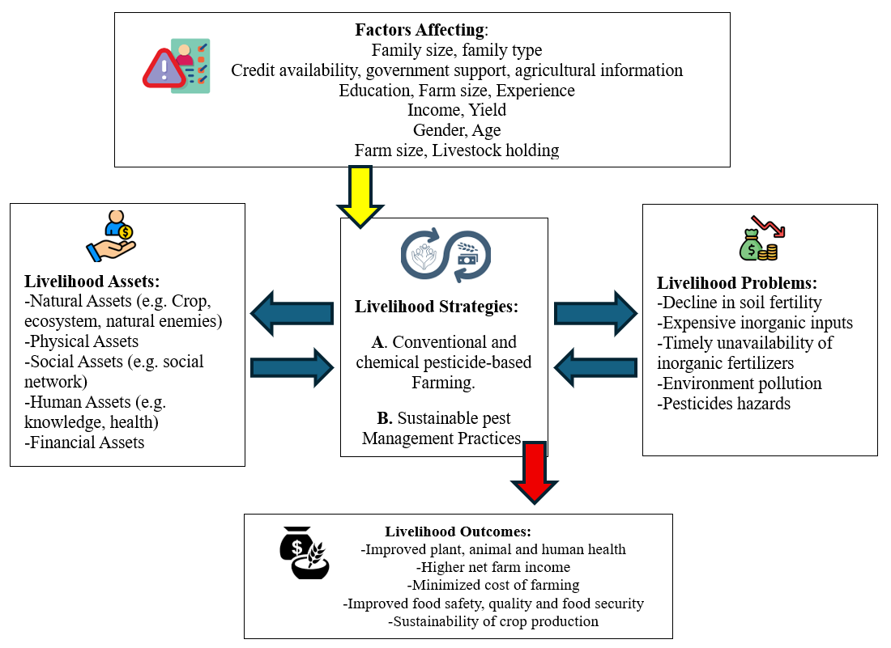
The conceptual framework for this study (Figure 1) illustrates the relationships between farmers' livelihood assets, the livelihood strategies they employ (conventional vs. sustainable IPM practices), the problems they face, and the resulting livelihood outcomes. This framework guided the selection of variables and the overall analysis of factors influencing IPM adoption.

Figure 1. Conceptual Framework of the Study

2. Research Methodology

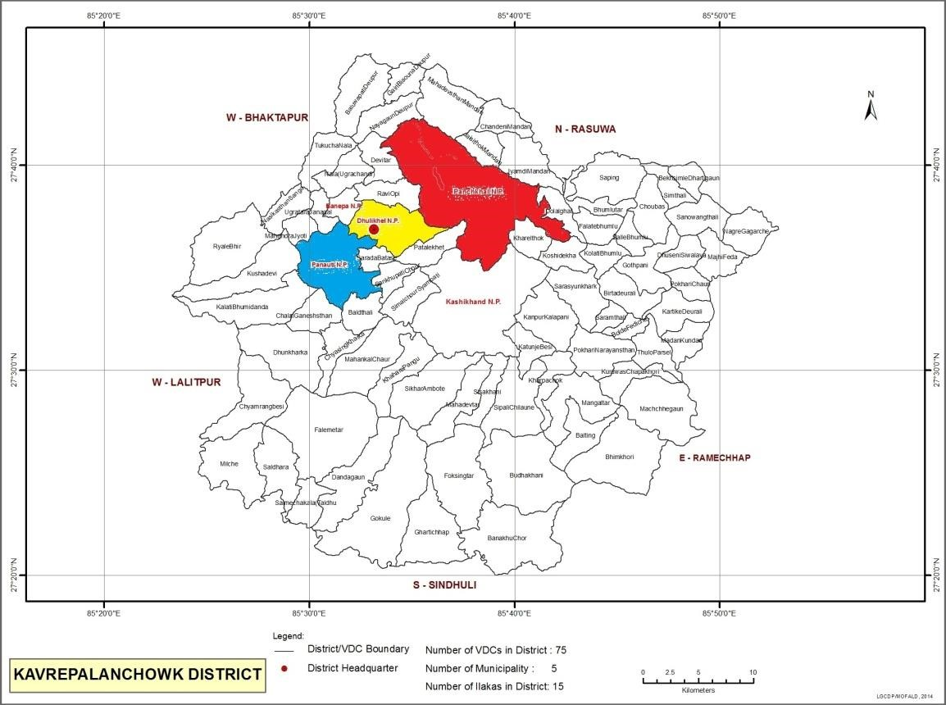
2.1. Study Area
Figure 2. Geographical Map of the Study Area
This research was conducted in the Kavrepalanchok district of Nepal, a major vegetable-producing region (Figure 2). The district is characterized by about 80% farmland and 20% forest, and it is an area where IPM programs have been actively implemented. Three key vegetable production areas—Dhulikhel, Panchkhal, and Panauti municipalities—were purposively selected for this study, with a primary focus on vegetable growers.

2.2. Sampling and Data Collection
Respondents were divided into two groups purposively: farmers who had participated in IPM training or Farmers Field School (FFS) (IPM adopters) and those who had not (non-IPM adopters). A total of 241 vegetable growers were randomly selected for the study, comprising 138 IPM adopters and 103 non-IPM adopters.
Primary data was collected through a structured survey using a pre-tested questionnaire. Interviews were conducted to gather information on various types of biopesticide use along with other types of IPM practices, farm and household status of farmers, perceived impacts of IPM, levels of technology adoption, and suggestions for improving adoption and sustainability. Focus Group Discussions (FGDs) were also held in all three municipalities to gather consensus-based information and verify individual interview responses.
Secondary data was collected by reviewing published articles, reports from government offices such as the District Agriculture Development Office (DADO), the Ministry of Agriculture (MOA), the National Agriculture Research Council (NARC), and the Central Bureau of Statistics (CBS), as well as publications from national as well as international non-governmental organizations (NGOs and INGOs).

2.3. Data Analysis
The collected data were first entered in Excel and then coded and analyzed using statistical packages for the social sciences (SPSS) and STATA 12. Both descriptive and analytical statistics were employed. Descriptive analysis included frequency counts, percentages, means, and standard deviations to describe socioeconomic and farm characteristics.
A logit regression model was used to quantify the probability of different factors affecting the level of adoption of IPM practices. The model is specified as:
Pr = f(b₀ + b₁X₁ + b₂X₂ + ... + b₁₀X₁₀)
Where:
- Pr = Probability score of adopting IPM practices
- X₁ = Family size
- X₂ = Number of schooling years of household head
- X₃ = Land holding size (ropani)
- X₄ = Age of household head (years)
- X₅ = Training received (Dummy)
- X₆ = Livestock Standard Unit (LSU)
- X₇ = Membership in farmers group (Dummy)
- X₈ = Credit availability (Dummy)
- X₉ = Support from government sector (Dummy)
- X₁₀ = Access to market and other agriculture-related information (Dummy)
- b₁, b₂, ..., b₁₀ = Logit coefficients
- b₀ = Regression coefficient

3. Results

3.1. Socio-economic and Demographic Information
The age and gender distribution of household heads were similar in both IPM and non-IPM groups, with males being the dominant decision-makers (Table 1). The mean age of household heads was approximately 50 years. Farmers practicing IPM were found to be comparatively more educated than those not practicing IPM technologies (Table 2). This data informs the male domination in decision making process and increasing average age of farmers in Nepali agriculture sector.
Table 1: Age and gender distribution of household head
Characteristics | IPM | Non-IPM | Total
Minimum age (Yrs) | 25.00 | 26.00 | 25.00
Maximum age (Yrs) | 82.00 | 85.00 | 85.00
Mean age (Yrs) | 49.21 | 51.17 | 50.05
Male (%) | 76.09 | 76.7 | 76.35
Female (%) | 23.91 | 23.3 | 23.65
Total | 138 | 103 | 241
Table 2: Education level of household head
Education Level | IPM (%) | Non-IPM (%) | Total (%)
Uneducated | 15.22 | 33.01 | 22.82
Primary | 39.86 | 29.13 | 35.27
Secondary | 37.68 | 36.89 | 37.34
Higher Secondary | 7.25 | 0.97 | 4.56

3.2. Institutional Characteristics and IPM Experience

A significant difference was observed in the organizational participation between the two groups. As shown in Figure 2, all 138 farmers in the IPM group were members of a farmers' group, whereas only 40% of the non-IPM group (41 out of 103) held memberships. This highlights the strong link between group participation and IPM adoption, which provides a platform for knowledge sharing and collective action. Generally, farmer groups or IPM farmer groups are semi-formal organizations generated by governmental or non-governmental organizations for agricultural extension usually registered in Municipalities or Rural Municipalities or District Agricultural Development Offices.

Membership
Non-membership
138

41
62
Membership Demographic on IPM and NON IPM
IPM
Non-IPM
Figure 3. Status of Membership in Farmer Groups
Furthermore, the experience level of IPM adopters varied. Many households had been practicing IPM farming for 3-5 years, indicating a period of sustained adoption following initial training and outreach programs. However, the presence of farmers in the 1–2-year category shows that new adoption is still occurring (Figure 3).
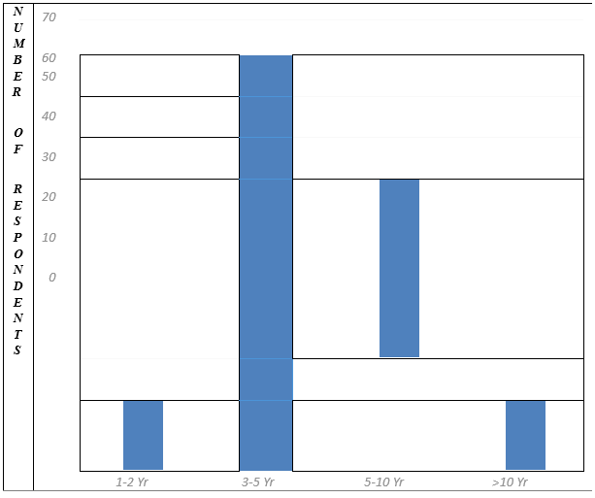

Figure 4. Number of Years of Farming with IPM Practices

3.3. Reasons for Adoption and Non-Adoption of IPM Practices
The primary reasons for adopting IPM practices were lower pesticide exposure (99.1%), sustainability (98.3%), and higher net benefits (97.5%) (Table 3). The awareness about health encourages for IPM adoption followed by other reasons. For non-adopters, the main reasons for not adopting IPM were the unavailability of appropriate alternatives to chemical pesticides (97.2%), difficult insect and disease management (98.3%), and a lack of knowledge about IPM practices (97.5%) (Table 4). The easiness to buy and spray pesticide in controlling pests have decisive role over unavailability or difficulty in searching for various tools and techniques. Lower access to extension agents about IPM practice is also hindering the process of adoption.
Table 3: Reasons for Adoption of IPM Practices by IPM Adopters
Reasons | Frequency | Percentage %
Low pesticide exposure | 119 | 99.1
Sustainability | 118 | 98.3
Higher net benefit | 117 | 97.5
Sense of good citizen | 98 | 81.7
Easy to market | 83 | 69.2
Adaptation to climatic adversities | 59 | 49.2

Table 4: Reasons for Non-Adoption of IPM Practices by IPM Non-Adopters
Reasons | Frequency | Percentage%
Difficult insect and disease management | 97 | 98.3
Lack of knowledge to IPM practices | 90 | 97.5
Unavailability of appropriate alternative to chemical pesticide | 100 | 97.2
Unavailability of IPM tools | 80 | 81.7
Boring and complex process | 71 | 69.2

3.4. Comparative Economics of Vegetable Cultivation
The annual income of IPM farmers was significantly higher compared to that of non-IPM farmers. For IPM farmers, the highest earnings were from vegetables, followed by livestock. The total annual income for IPM farmers was 380,986.76 NRs, compared to 314,817.08 NRs for non-IPM farmers (Table 5).
A comparative economic analysis of tomato, cauliflower, and potato cultivation revealed that IPM practices were more profitable. For instance, in tomato cultivation, the total cost of cultivation was lower for IPM farmers, and the average cost per kg was 17.35 NRs for IPM adopters compared to 20.34 NRs for non-IPM adopters. Similar trends were observed for cauliflower and potato cultivation. Eventhough, integration of various components and tools of IPM are not easy, the final profit sharing by IPM practice is higher than that of non-IPM practice.

Table 5: Share of Agricultural Income to Annual Income
Source of income | IPM (NRs) | % Share | Non-IPM (NRs) | % Share | Mean diff
Vegetables | 155,580.96 | 40.84 | 125,608.34 | 39.90 | 29,972.62***
Livestock | 122,471.01 | 32.15 | 74,160.19 | 23.56 | 48,310.82***
Cereals | 39,746.38 | 10.43 | 31,844.66 | 10.12 | 7,901.72**
Total from Agriculture | 317,798.36 | 83.41 | 231,613.19 | 73.57 | 86,185.16***
Other Sources | 63,188.41 | 16.59 | 83,203.88 | 26.43 | -20,015.48
Total Annual Income | 380,986.76 | 100.00 | 314,817.08 | 100.00 | 66,169.68*
Note: *** Significant at 1% level, ** Significant at 5% level

3.5. Factors Affecting the Level of Adoption of IPM Practices
The logit regression analysis identified several factors that significantly influence the adoption of IPM practices (Table 6). The pseudo-R² value of the model was 0.375. The year of schooling of the household head was positively significant, indicating that higher education levels contribute to the adoption of IPM practices. Training, access to credit, government support, and access to agricultural information were also positively and significantly associated with IPM adoption. Membership in farmer groups and livestock holding (LSU) were found to be highly significant factors. Conversely, family size, land holding size, and the age of the household head were not found to have a significant effect on the adoption of IPM practices. From this study, we clearly can observe that education level, institutional access or exposure to extension workers, awareness activities and technical and resource management supports are crucial for adoption to modern technologies including Integrated Pest Management practices.
Table 6: Factors affecting the level of adoption of IPM by logit model
Variables | Coefficients | P>|z| | Standard error | dy/dx | S.E.
Family size | -0.04 | 0.665 | 0.092 | -0.009 | 0.022
Year of Schooling (HH) | 0.098** | 0.025 | 0.043 | 0.023 | 0.010
Land holding | 0.066 | 0.071 | 0.036 | 0.016 | 0.008
Age of household head | -0.025 | 0.098 | 0.15 | -0.006 | 0.003
Training | 0.923** | 0.017 | 0.388 | 0.226 | 0.092
LSU | 0.316*** | 0.001 | 0.095 | 0.076 | 0.023
Membership | 3.16*** | 0.000 | 0.664 | 0.607 | 0.066
Access to credit | 0.814** | 0.018 | 0.344 | 0.198 | 0.083
Government support | 1.014** | 0.026 | 0.456 | 0.248 | 0.107
Agriculture info | 1.395*** | 0.001 | 0.418 | 0.335 | 0.093
Constant | -6.227 | 0.000 | 1.292 | - | -
Note: *** Significant at 1% level, ** Significant at 5% level

4. Discussion
Our study shows that average age of Nepali farmers is above 50 years, which indicates the low engagement of youths in farming practice. IPM farmers are of average lower age, but it seems not significant. Perceived perception to Low income in farming compared to other business and jobs and low share of contribution for economic transformation by farm involvement as well as perception of lower recognition or prestige of farmers compared to other economic societies are the reasons to be less attraction of youth in agriculture sector [7]. Collaborative effort if federal, provincial as well local governments and private as well as non-governmental sector can promote the understanding and engagement of youth in the farming business community development process by enhancing extension activities, agricultural education, encouraging to appropriate technology including IPM and organic agriculture, agri-tourism, financial support etc. Compared to traditional farming practice, new technology followers including IPM farmers are found to be institutionally more attached. After training or orientation as well by following other prospective farmers, some are changing towards more integrated farming practices including IPM practices [8, 9].

This study provides valuable insights into the perception and adoption of IPM practices among vegetable farmers in Nepal. The findings align with existing literature suggest a positive correlation between education, training, and the adoption of new agricultural technologies. The higher income levels among IPM farmers can be attributed to a combination of factors, including lower input costs (particularly for pesticides), and better market access for produce that is perceived as safer. The reasons cited for non-adoption highlight critical barriers that need to be addressed to promote IPM. The lack of reliable alternatives to chemical pesticides, coupled with difficulties in managing pests and diseases and a knowledge gap, underscores the need for enhanced research and extension services. The significant influence of institutional factors such as membership in farmer groups, access to credit, and government support emphasizes the importance of a supportive ecosystem for the adoption of sustainable farming practices. Farmer groups, as shown in Figure 3, serve as crucial platforms for knowledge sharing and accessing resources, which is reflected in the 100% membership rate among IPM adopters. The non-significance of factors like family size, land holding, and age of the household head suggests that IPM practices can be adopted by a wide range of farmers, regardless of their demographic or farm size characteristics. This is an encouraging finding, as it implies that IPM is not exclusive to a particular segment of the farming community. Our results comply with various previous articles which suggest that Over the past 29 years, IPM initiatives have been found to improve farmer awareness, trained large numbers of farmers and facilitators, and established biopesticide production facilities; however, nationwide adoption remains limited, pesticide use continues to rise, and only about 29% of local wards are fully aware of pesticide safety. The difficulty in getting bio-pesticides but very easy chemical pesticides availability was also reported as the constraint for the adoption of IPM practices. Greater participation in training participation, higher education levels, and increased extension agents’ intervention in farming society have found significantly influenced the adoption of IPM practices in vegetable cultivation [9]. Our findings for major barriers include limited ecological knowledge, perception of IPM as complex and costly, easy access to synthetic pesticides, weak regulation, insufficient research funding, lack of incentives and market support, small farm sizes, and weak institutional coordination [5, 9-13]. Enhancing adoption demands a multifaceted strategy that combines farmer education through field-based training and demonstration plots, a well-planned community-level extension systems, and improving access to a fair priced IPM inputs such as biopesticides and pheromone traps. While integrating local pest management expertise with scientific IPM techniques, we should focus on local acceptance, financial incentives and market connections for safe or organic products that can lower perceived risks and encourage producers. Timely decision-making by supporting legislation, implementing regulations of hazardous pesticides, and the use of digital advising systems such as mobile-based pest alerts can also increase the IPM adoption to cope for Nepal's susceptibility to changing pest dynamics and climate change [14-17]. Long-run integration of local pest management expertise with scientific IPM techniques, implementation of good agriculture practices (GAP) will boost local acceptance, financial incentives and market connections for safe, chemical free or organic produce which will ultimate promote for long run adoption of integrated technologies including IPM practices.

5. Conclusion and Recommendations

5.1. Conclusion
Integrated Pest Management has been successful in raising awareness among both producers and consumers about the benefits of sustainable agriculture. The application of IPM tools is significantly higher among trained farmers. A positive perception of IPM was found, but the adoption rate is not as high as it could be.
The study confirms that IPM practices offer a higher benefit-cost ratio than non-IPM practices. Key factors significantly affecting IPM adoption include training, livestock holding, membership in farmer groups, credit availability, government support, education level, and access to marketing and agricultural information.
The restricted adoption of IPM practices is largely due to the unavailability of reliable alternatives to chemical plant protection, the lack of a distinct market for IPM products, and non-significant price differences. Therefore, direct support for IPM tools and institutional development is essential. Enhancing farmers' knowledge about the preparation of organic fertilizers, organic pesticides, cultural pest management tools, and soil management practices is also crucial.

5.2. Recommendations
Based on the findings of this study, the following recommendations are proposed:
- Research and Development: Initiate research and development activities to assess effective methods for biological pest control and to increase the productivity of organic vegetables. The need for reliable alternatives to chemical pesticides is a priority.
- Institutional Development: Focus on institutional development, including market management of IPM products, certification of IPM products, and easy access to IPM plant protection measures.
- Support for Farmers: Support farmers in adopting IPM practices by providing biopesticides, pheromones, lures, and organic fertilizers, along with micronutrients and technology.
- Industrial Development: The state should focus on the industrial development of biopesticides.
Further Research: Conduct in-depth studies on the impact of integrated pest management practices in cereals, fruits, and other crops, in addition to vegetables.

Data Availability Statement
- The raw survey data supporting the conclusions of this article cannot be made publicly available due to confidentiality agreements with participants. An anonymized version of the dataset, along with statistical code, is available from the corresponding author upon reasonable request.
- Disclaimer (Artificial intelligence)
- Author(s) hereby declare that NO generative AI technologies such as Large Language Models (ChatGPT, COPILOT, etc.) and text-to-image generators have been used during the writing or editing of this manuscript.

References
1. Brief, F.A., Pesticides use, pesticides trade and pesticides indicators. FAO, Rome, Italy, 2022.
2. Fao, R., Pesticide residues in food. 1968.
3. Parajuli, S., et al., Scenario of pesticide import, formulation, consumption and the residue status among agricultural crops in nepal. Big Data in Agriculture (BDA), 2021. 3(2): p. 94-99.
4. Harirar Bhawan, L., Study on national pesticide consumption statistics in Nepal. Ministry of Agriculture, Government of Nepal, 2014: p. 1-84.
5. Adhikari, S., et al., Twenty-five years of integrated pest management in Nepali agriculture: lessons, gaps, and the way forward in the context of climate change. Journal of Integrated Pest Management, 2024. 15(1): p. 40.
6. Gc, Y.D., Integrated Pest Management efforts for eco-friendly agricultural production in Nepal: a perspective. 2018.
7. Khanal, S., P. Dhital, and S. Christian, Farming the future: Youth enthusiasm and transforming Nepal’s economy through agriculture. Journal of Agriculture, Food Systems, and Community Development, 2021. 10(2): p. 359-372.
8. Adhikari, M., S. Acharya, and P.R. Dhital, Impact of IPM training on pest management practices in major vegetables in Palpa, Nepal. Archives of Agriculture and Environmental Science, 2024. 9(2): p. 359-366.
9. Shrestha, S., et al., Adoption status of integrated pest management (IPM) practices among vegetable growers of Lamjung district of Nepal. Heliyon, 2024. 10(18).
10. Alwang, J., G. Norton, and C. Larochelle, Obstacles to widespread diffusion of IPM in developing countries: lessons from the field. Journal of Integrated Pest Management, 2019. 10(1): p. 10.
11. Ghimire, B. and N. Kafle, Integrated pest management practice and its adoption determinants among apple farmers in Mustang District of Nepal. Scholars Journal of Agriculture and Veterinary Sciences, 2014. 1(2): p. 83-89.
12. Nyaupane, S., Use of insecticides in Nepal, its impact and alternatives of insecticides for Nepalese farmers. 2021.
13. Paudel, S., et al., Conservation agriculture and integrated pest management practices improve yield and income while reducing labor, pests, diseases and chemical pesticide use in smallholder vegetable farms in Nepal. Sustainability, 2020. 12(16): p. 6418.
14. Aryal, K.K., et al., Health effects of pesticide among vegetable farmers and the adaptation level of integrated pest management program in Nepal, 2014. 2016, Nepal Health Research Council.
15. Budal, P., L. Sah, and B.P. Chaulagain, Adoption and Impact of Integrated Pest Management in Tomato Cultivation in Lalitpur and Bhaktapur Nepal. Nepalese Journal of Agricultural Sciences, 2025. 28: p. 103-110.
16. Pretty, J. and Z. Pervez Bharucha, Integrated pest management for sustainable intensification of agriculture in Asia and Africa. Insects, 2015. 6(1): p. 152-182.
17. Rai, D.M., Integrated pest management practices in organic framing: a case study of Chandragiri municipality Thankot. 2024.

