Opportunities, Investments and Barriers in Climate-Smart Livestock Farming in Africa: A Focus on East Africa
ABSTRACT
Livestock production is indispensable to African livelihoods, bolstering food security and significantly contributing to agricultural GDP. However, climate change presents a formidable challenge, with rising temperatures, recurrent droughts, and proliferating diseases severely impacting productivity and the sustainability of pastoral systems. Climate-smart livestock (CSL) farming emerges as a promising solution, offering a triple-win strategy: enhancing adaptation to climate shocks, sustainably increasing livestock production, and reducing greenhouse gas emissions. This article delves into the critical investment needs and significant barriers hindering the widespread adoption of CSL practices across Africa, with a specific focus on East Africa region. It highlights the importance of strategic investments in genetic improvement of climate-resilient breeds, enhancing animal health and disease resistance, promoting sustainable feed and forage systems, and fostering market integration through improved infrastructure and digital technologies. The central argument underscores that context-specific and inclusive investments are paramount for transforming the sector, ensuring benefits reach marginalized communities. The article addresses counterarguments, including concerns about the high costs associated with CSL interventions and the perception that livestock production inherently contributes to greenhouse gas emissions. It emphasizes that CSL can be economically viable for smallholder farmers through diversified approaches and that Africa's overall contribution to global livestock emissions remains relatively low. The analysis concludes that a coordinated, multi-stakeholder engagement linking science, policy, and community action is essential to unlock the transformative potential of CSL. This approach can pave the way for resilient, productive, and environmentally sustainable livestock systems, driving inclusive growth, enhancing food security, and fostering climate resilience across the African continent.
Keywords: African Livestock Production Systems; Climate Change Adaptation; Climate-Smart Livestock Farming; Opportunities, Investments and Barriers to Climate-Smart Livestock Farming
- INTRODUCTION
Livestock production is central to the livelihoods of many in Africa, significantly contributing to employment, food security, and GDP. The livestock sector in Africa supports more than 800 million residents and contributes to 15-80% of agricultural GDP in many sub-Saharan African countries (FAO, 2024). Beyond providing food and income, livestock plays a crucial role in providing manure for soil fertility and draft power, as well as contributing to social and cultural capital, making them a vital asset in the social framework of African communities.
However, this vital industry faces a significant threat from the amplified implications of climate change. Increased temperatures, reduced productivity, recurrent droughts, and the proliferation of livestock diseases are weakening the productivity, food security, and economic sustainability of pastoral and agro-pastoral farmers (Thornton et al., 2024). In this context, climate-smart livestock (CSL) farming offers an approach that aims to achieve the triple-win objectives: enhancing adaptation to climate shocks and variability, sustainably increasing livestock production, and reducing greenhouse gas (GHG) emissions. This approach aligns with the main concept of Climate-Smart Agriculture promoted by FAO, but CSL has a unique role in contributing to and being affected by climate change, and can also be a strategy for reducing GHG emissions like methane, carbon dioxide, and nitrous oxide (World Bank, 2023).
Investing in Climate-Smart Agriculture (CSA) has become increasingly critical. A report from the World Bank (2023) indicates that the annual funding gap in climate-smart agriculture in Africa exceeds USD 15 billion, with livestock investment remaining particularly financially challenged. This deprivation persists despite growing evidence that low-emission and adaptive systems can remarkably minimize poverty, enhance food security, and reinforce national economies. Successful interventions require both public and private sector engagement (PPS), supported by enabling policies, innovative funding mechanisms, and research-driven technologies that promote sustainable livestock production.
However, several barriers hinder the progress of CSL production on the African continent. These include weak institutions, fragmented policy implementation, low access to credit, and limited market infrastructure. Furthermore, socio-cultural and gender inequalities constrain youth and women, who play essential roles in livestock value chains, such as milking and processing milk and meat products (Walter Svinurai, 2023).
Therefore, this article provides critical insight into the investment needs and barriers in the pursuit of climate-smart livestock production in Africa with a particular focus on East Africa region. It argues that the sustainable transformation of the sector relies on inclusive, context-specific, and strategic investments that address socio-economic, institutional, and technological gaps.
- MAIN ARGUMENTS
  - Genetic Improvement and Climate-Adaptive Livestock Breeds Investments
Genetic resources of livestock are an essential, yet underutilized, component of Africa’s climate adaptation capability. Native livestock breeds have evolved over centuries to tolerate harsh climatic conditions, disease prevalence, and shifting feed resources. However, these genetic resources are increasingly threatened by unsystematic breeding, environmental degradation, and constrained research funding (FAO, 2024). Improving climate-adaptable livestock breeds requires a measured approach that integrates crossbreeding, synthetic animals, reserved local animals, selective breeding, and genomic approaches, such as interbreeding livestock that can withstand hot conditions.
Investments in genetic resource improvement can strengthen productivity and adaptive capacity. For example, a study in African countries like Kenya and Ethiopia shows that breeding exotic and indigenous cattle can increase milk yield by up to 40% and improve tolerance to higher temperatures and diseases (Rege et al., 2020). Moreover, genetic engineering tools can be leveraged to identify genetic markers related to feed efficiency, reduced methane production, and drought tolerance, accelerating the breeding of livestock breeds that can withstand harsh conditions.
Nonetheless, genetic improvement programs need to be context-specific. Investment should target communities based on breeding programs, researchers, and international organizations (Mapiye et al., 2019). Where possible, gene banks should be established for preserving the genetic resources of African breeds, such as Boran, Mpwapwa, and Tswana cattle, which can withstand increased temperatures and have higher productivity (Figure 1).
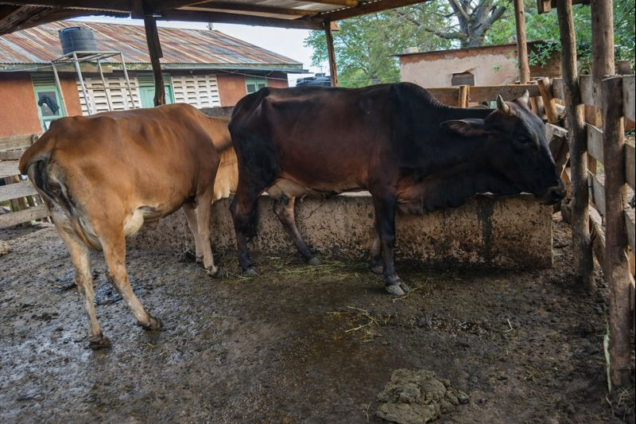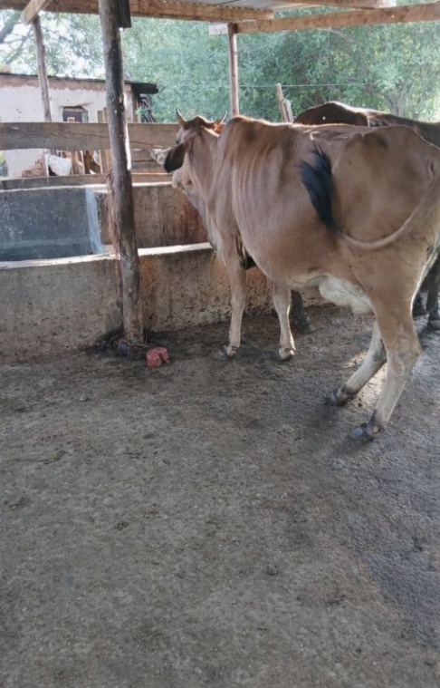
Figure 1: Mpwapwa breed cattle that can withstand harsh conditions in Tanzania
2.2 Enhancing the Health and Disease Resistance of Animal
Climate change is accelerating the proliferation of vector-transmitted and transboundary diseases such as African horse sickness, Rift Valley fever, blue tongue, and other tick-borne diseases (FAO, 2018). These diseases not only lead to direct production losses but also hamper livelihood stability, food security, and trade. Investing in disease-resilient livestock is therefore indispensable for sustaining production and resilient livestock. Key areas for investment include improving veterinary services delivery, especially in pastoral communities; reinforcing disease surveillance systems; diversifying the production and distribution of thermostable vaccines for use in tropical locations; and strengthening regional coordination through entities such as the African Union–Interafrican Bureau for Animal Resources (AU-IBAR, 2019). Investing in these systems can create synergies between climate adaptation and disease management, supporting both livestock and human health under the One Health framework.
2.3 Sustainable Forage and Feed systems for Producing Low Emission Livestock
Feed availability and quality remain major challenges for livestock production in sub-Saharan Africa. Seasonal feed fluctuations caused by recurring droughts and the deterioration of rangelands have significantly reduced livestock productivity and elevated emission intensity per unit of output (Thornton et al., 2024). There is a need for investment in eco-friendly feeds and forage systems to enhance livestock productivity while also reducing greenhouse gas (GHG) emissions. Key investment areas include the integration of crop and livestock systems, the development of climate-resilient forages, and advanced feed conservation technologies such as hay and silage making. Studies conducted in semi-arid regions of East Africa have shown that forages like Cenchrus ciliaris and Chloris gayana can produce high biomass yields and persist under drought conditions (Togo et al., 2025). Promoting these grasses and improved grazing management, like rotational grazing, can enhance feed availability and increase carbon sequestration in the soil.
Moreover, processing feed and supplementation using locally available by-products such as molasses and legume leaf meals may improve feed efficiency and reduce methane emissions per unit of product (Kuwi et al., 2024). Regional research institutions and private sector partnerships can play a key role in scaling up these innovations through contract farming, forage seed systems, and capacity building for pastoral communities.
2.4 Market, Value Chain Integration and Infrastructure Investments
For the advancement of a climate-smart livestock industry, a desirable market and an effective value chain are essential. However, many African pastoralists are isolated from valuable markets due to restricted market information, poor institutional collaborations, and weak infrastructure. These restrictions discourage investments and reduce financial support for adopting sustainable practices (Fushai et al., 2025). Investment in value chain integration is thus crucial. Developing climate-resilient infrastructure such as cold chains, processing facilities, and rural roads can minimize post-harvest losses and improve product quality. Furthermore, digital platforms that connect farmers to markets and provide climate information can enhance decision-making and transparency. Another key area involves promoting inclusive business models, such as contract farming, cooperative marketing, and public–private partnerships (PPPs), which can attract private investment and share risks among stakeholders. Integrating environmental certification and carbon-credit schemes into livestock value chains may also unlock new revenue streams for smallholders adopting low-emission practices.

3. COUNTER-AGUMENT AND REBUTTAL
3.1 Criticism 1: Investing in Climate-Smart Livestock is too Costly with Limited Funds
The majority of livestock keepers believe that climate-smart livestock interventions, such as advanced forage and feed systems, low-emission technologies, and genetic improvement, require higher capital that developing countries in Africa cannot afford. While studies show that the initial cost of CSL can be high, the economic return for the investment is long-term, and vulnerability costs may be reduced. CSL has also increased productivity through lessened mortality, disease prevention, and improved feed efficiency. These outcomes have been observed in Tanzania, Uganda, Ethiopia, and Kenya (Rugerri, 2024). Therefore, CSL doesn’t necessarily require significant investment due to different approaches that can be adopted by smallholder farmers, such as diversification of livestock, integration of livestock and crops, and keeping native species. All these approaches are suitable for farmers with low incomes (Amole & Ayantunde, 2016).
3.2 Criticism2: Livestock Production is Intrinsically Unstable due to Greenhouse Gas Emissions
Critics argue that some livestock groups, particularly ruminants, are major contributors of methane and nitrous oxide and cause other environmental degradation, recommending that minimizing livestock numbers is the most constructive strategy (IPCC, 2021). Some climate activists suggest shifting from animal protein to crop protein may reduce GHG emissions from livestock (Houzer et al., 2021). While Africa's share of global livestock emissions is estimated to be no more than 7%, this means that African livestock production's contribution to global GHG emissions is not significant (Zhu et al., 2016). Moreover, livestock in Africa are multifunctional assets that provide income through the sale of milk, skin, eggs, and meat; nutrition; manure; and other ecosystem services. Instead of eliminating the sector, there is a need to optimize it for a balanced solution, such as providing feeds with low emissions (e.g., legumes) and maintaining animal health. Therefore, CSL is a pathway to achieving the triple win: reducing GHGs, increasing production, and adapting to climate shocks (Figure 2) (Hyland et al., 2016).
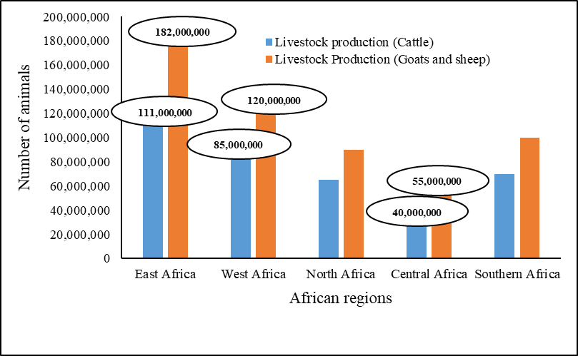
Figure 2: Livestock Production in Africa

3.3 Criticism3: Climate-Smart Livestock Ignores Socio-Cultural Aspects and Concentrates Much on Advanced Technology
A key critique of Climate-Smart Livestock (CSL) frameworks is that they often prioritize technological innovations, such as improved livestock breeds, feed efficiency, and emission tracking, while neglecting indigenous knowledge, cultural traditions, and long-standing pastoral systems that have sustained communities for generations (Leslie & McCabe, 2013). Critics warn that externally imposed models risk disrupting social cohesion, customary grazing rights, and the mobility crucial for maintaining rangeland health. However, this critique highlights the need to contextualize innovation rather than reject it. Successful CSL initiatives across Africa demonstrate that blending local knowledge with scientific advances yields the best outcomes. For example, community-based rangeland management in Ethiopia and Kenya integrates traditional grazing calendars with modern climate forecasts to enhance pasture management and prevent degradation (Crane et al., 2022). By incorporating tools such as early warning systems, participatory breeding, and weather-index insurance, CSL can complement and strengthen traditional resilience practices. Embedding indigenous approaches within policy frameworks is therefore vital to ensure CSL strategies remain culturally relevant and socially inclusive.
3.4 Criticism4: Climate-Smart Livestock Favors Commercial Farms and Underrepresents Smallholders
Arguments suggest that climate-smart livestock (CSL) initiatives often conveniently benefit wealthy commercial farms capable of investing in advanced technologies and carbon-credit programs, while leaving behind smallholders and pastoralists who face financial and informational constraints (Thornton et al., 2024). This imbalance could widen social inequities and threaten traditional livestock systems. However, this concern is only partly valid. Evidence from participatory breeding initiatives in Ethiopia, Tanzania, and Kenya shows that community-driven approaches can enhance breed resilience and local ownership (Kathambi et al., 2025). Likewise, small-scale feed cooperatives and forage seed enterprises in Kenya demonstrate how inclusive collective action can equitably scale CSL innovations (Wambu & Gichuki, 2024). Ultimately, the success of CSL interventions hinges on inclusive institutions, gender-responsive policies, and community engagement, ensuring that benefits reach marginalized producers rather than concentrating among elites.
- CONCLUSION
Climate-smart livestock production stands as a pivotal solution for achieving resilient, productive, and environmentally sustainable agricultural systems across Africa. As climate variability intensifies, the livestock sector faces unprecedented challenges—from recurrent droughts and degraded rangelands to disease outbreaks and feed shortages—that threaten livelihoods and food security. This article demonstrates that investing in Climate-Smart Livestock (CSL) systems provides a transformative opportunity to address these vulnerabilities while advancing adaptation, mitigation, and productivity goals simultaneously.
Key to this transformation is the strategic investment in climate-adapted livestock breeds, sustainable feed and forage systems, and disease surveillance mechanisms that safeguard animal and human health. Equally, enabling policies and inclusive institutions are essential to ensure equitable participation of pastoralists, women, and youth—groups that are often marginalized in livestock value chains but are central to their sustainability. Incorporating indigenous knowledge and participatory approaches into CSL design ensures that innovations remain context-specific, culturally appropriate, and locally owned.
Strengthening market access, digital technologies, and value chain integration can enhance profitability and resilience among producers. Public–private partnerships, coupled with regional research collaborations, will play a critical role in scaling up these innovations and unlocking climate finance to bridge the existing investment gap. Ultimately, the success of climate-smart livestock production in Africa depends on coordinated multi-stakeholder engagement that links science, policy, and community action. When effectively implemented, CSL has the potential to transform African livestock systems into engines of inclusive growth, food security, and climate resilience, paving the way for a sustainable agricultural future that benefits both people and the planet.
DISCLAIMER (ARTIFICIAL INTELIGENCE)
There is no generative AI technologies like large language models (ChatGTP, COPILOT, CHATBOT etc.) and text-to-image generators that have been used during writing and editing the manuscript.
REFERENCES
- Amole, T. A., & Ayantunde, A. (2016). Amole TA, Ayantunde AA. 2016. Climate-smart livestock interventions in West Africa: A review. CCAFS Working Paper no. 178. 178, 53. www.ccafs.cgiar.org%0ATitles
- AU-IBAR. (2019). The African Union – Interafrican Bureau for Animal Resources (AU-IBAR). International Scientific Council for Trypanosomiasis Research and Control (ISCTRC) Abuja Declaration, July.
- Crane, T., Habermann, B., Marty, E., Arndt, C., Leitner, S., Worku, T., & Gichuki, L. (2022). Climate change adaptation and mitigation in extensive livestock systems in East Africa. Findings from the Programme for Climate-Smart Livestock Systems. GIZ, Eschborn. Findings from the Programme for Climate-Smart Livestock Systems.
- FAO. (2018). Starting the change. Climate Change and Transboundary Pest and Diseses, 86–98. https://doi.org/10.1057/978-1-352-00132-7_5
- FAO. (2024). FAO in Africa: Highlights in 2023. Food and Agriculture Organization of the United Nations Accra.
- Fushai, F., Chitura, T., & Oke, O. E. (2025). Climate-smart livestock nutrition in semi-arid Southern African agricultural systems. Frontiers in Veterinary Science, 12(February). https://doi.org/10.3389/fvets.2025.1507152
- Houzer, E., Scoones, I., Production, F. A. O. A., & Jacquemot, P. P. (2021). Are livestock always bad for the planet ? https://doi.org/10.19088/STEPS.2021.003
- Hyland, J. J., Styles, D., Jones, D. L., & Williams, A. P. (2016). Improving livestock production efficiencies presents a major opportunity to reduce sectoral greenhouse gas emissions. Agricultural Systems, 147, 123–131. https://doi.org/10.1016/j.agsy.2016.06.006
- IPCC. (2021). Introducing the Topical Collection: ‘Climate change communication and the IPCC.’ In Climatic Change (Vol. 169, Issues 3–4). https://doi.org/10.1007/s10584-021-03253-3
- Kathambi, E. K., Sonstegard, T. S., & Larsen, P. A. (2025). Review: Cross-breeding, advanced reproductive technologies, and genetic selection in twelve dairy production systems in Africa. Animal, 19(3), 101424. https://doi.org/10.1016/j.animal.2025.101424
- Kuwi, S. O., Kamwangire, D. F., Kasiba, B., Katabazi, L. V, Lyahama, O. J., Fupi, G. F., Kajuna, J. A., Mgalula, J. R., Munisi, W. G., & Moto, E. A. (2024). Effects of supplementing Leucaena pallida based multi-nutrient block on feed intake and body weight performance of goats fed poor-quality forage in semi-arid Tanzania during dry season. 94(July), 652–655.
- Leslie, P., & McCabe, J. T. (2013). Response diversity and resilience in social-ecological systems. Current Anthropology, 54(2), 114–143. https://doi.org/10.1086/669563
- Mapiye, C., Chikwanha, O. C., Chimonyo, M., & Dzama, K. (2019). Strategies for sustainable use of indigenous cattle genetic resources in Southern Africa. Diversity, 11(11), 1–14. https://doi.org/10.3390/d11110214
- Rege, J. E. O., Ochieng, J., & Hanotte, O. (2020). Livestock genetics and breeding. The Impact of the International Livestock Research Institute, 59–102. https://doi.org/10.1079/9781789241853.0059
- Rugerri, M. (2024). Livestock Sector Climate Finance Flows in Ethiopia, Kenya, Tanzania and Uganda. May.
- Thornton, P. K., Wollenberg, E. K., & Cramer, L. K. (2024). Livestock and Climate Change: Outlook for a more sustainable and equitable future. December. https://hdl.handle.net/10568/172688
- Togo, B. G., Kuwi, S. O., Mussa, N. J., Kajuna, J. A., Fupi, G. F., Kasiba, B. R., Mgalula, J. R., Felix, D. K., Katabazi, L. V, & Mtei, E. P. (2025). Climate Change and Livestock Production in Semi-Arid Regions : The Untapped Potential of Climate-Resilient Forages. 25(10), 45–52.
- Walter Svinurai. (2023). Livestock production and greenhouse gas emissions in the Southern African Development Community: 2000-2020. https://www.researchgate.net/publication/374288633_Livestock_production_and_greenhouse_gas_emissions_in_the_Southern_African_Development_Community_2000-2020?_tp=eyJjb250ZXh0Ijp7ImZpcnN0UGFnZSI6Il9kaXJlY3QiLCJwYWdlIjoiX2RpcmVjdCJ9fQ
- Wambu, C., & Gichuki, C. (2024). Leveraging on Agricultural Cooperatives in Feed and Fodder Production Among Smallholder Dairy Farmers in Meru County, Kenya. Journal of the Kenya National Commission for UNESCO, 5(1), 1–18. https://doi.org/10.62049/jkncu.v5i1.180
- World Bank. (2023). Kenya Country Climate and Development Report. Kenya Country Climate and Development Report. https://doi.org/10.1596/40572
- Zhu, B., Kros, J., Lesschen, J. P., Staritsky, I. G., & de Vries, W. (2016). Assessment of uncertainties in greenhouse gas emission profiles of livestock sectors in Africa, Latin America and Europe. Regional Environmental Change, 16(6), 1571–1582. https://doi.org/10.1007/s10113-015-0896-9

