Original Research Article

Study on Mineralization of Fully Solid-Waste-Based Artificial Aggregate

Abstract: To optimize the CO₂ mineralization process of full-solid-waste artificial aggregates and improve their mineralization efficiency and comprehensive performance, artificial aggregates were prepared by cold-bonding pelletization using 20% fly ash, 60% slag, 10% carbide slag and 10% desulfurization gypsum as raw materials. Curing humidity, CO₂ concentration, curing pressure and mineralization curing time were taken as key variables to systematically investigate their effects on the CO₂ mineralization behavior of aggregates, clarify the influencing mechanism, and determine the optimal process combination. The results show that curing humidity, CO₂ concentration, curing pressure and mineralization time all exert significant influences on mineralization efficiency. Excessively low or high humidity, excessive concentration and overly high curing pressure inhibit the mineralization reaction, while insufficient curing time results in incomplete reaction, which tends to stabilize after 12 hours. The optimal mineralization parameters are determined as follows: curing humidity of 57%, CO₂ concentration of 40%, curing pressure of 0.4 MPa, and mineralization curing time of 12 h. Under these conditions, the artificial aggregates exhibit excellent mineralization performance with desirable carbon sequestration capacity and mechanical properties. This study provides technical support for the industrial application of CO₂ mineralization technology for full-solid-waste artificial aggregates, and offers a reference for the resource utilization of solid waste and the green and low-carbon development of the aggregate industry.
Keywords: CO₂ mineralization; strength; full-solid-waste artificial aggregate.
- Introduction
With the development of global science and technology, carbon dioxide emissions have gradually increased and the El Niño phenomenon has intensified. For the sustainable development of humanity, carbon reduction and emission mitigation have become current focal concerns^{[1]}. The principle of carbon dioxide mineralization technology is to react alkaline mineral components with CO₂ to form stable carbonates, thereby achieving permanent sequestration of carbon dioxide ^{[2]}. Replacing conventional concrete curing with CO₂ mineralization curing is applicable to most concrete products and can improve the strength and durability of mineralized products. CO₂ mineralization is currently an effective approach for permanent carbon sequestration and carbon neutrality ^{[3]}.Excessive exploitation of natural resources, especially stone and sand gravel, has damaged natural landforms. To protect the environment, many countries have issued corresponding restrictive policies ^{[4–8]}. However, in recent years, with the expansion of construction and urbanization, the consumption of stone and sand gravel has continued to rise, depleting large amounts of natural resources, particularly coarse and fine aggregates commonly used in concrete ^{[6,7,9–11]}. Studies have shown that sand and gravel used in construction and transportation infrastructure account for 79% of the total ^{[5,7,12]}. Consumption increased annually from 2015 to 2020, with global demand for construction aggregates ranging from 4 to 5 billion tons ^{[7,13,14]}.
Amid accelerating urbanization and growing aggregate demand, coupled with national legal and policy restrictions, natural aggregate extraction is gradually being replaced by artificial aggregates (AAs) to meet construction needs ^{[15,16]}. Therefore, the research and development of AAs has long been a focus for scholars.Preparation methods for AAs mainly include high-temperature sintering and cold-bonding pelletization. Although artificial aggregates produced by high-temperature sintering exhibit stronger bonding, the process is energy-intensive and unfavorable for carbon neutrality. At present, cold-bonding pelletization is more widely adopted for preparing AAs ^{[17]}. In this study, full-solid-waste artificial aggregates were prepared via cold-bonding pelletization and subjected to carbonation tests.
- Test Materials and Performance Indicators
The raw materials used for preparing full-solid-waste artificial aggregate include fly ash, granulated blast furnace slag, desulfurization gypsum, carbide slag, CO₂, and water.
2.1 Experimental Raw Materials
（1）Fly Ash
The fly ash used in the test was analyzed by X-ray fluorescence (XRF), and the results are presented in Table 1. It can be seen that the mass fractions of Al₂O₃ and SiO₂ are relatively high, reaching 80%, and the content of Fe is also relatively high.
Chemical Composition | Na₂O | MgO | Al₂O₃ | SiO₂ | SO₃ | CaO | TiO₂ | Fe₂O₃
Content/% | 0.950 | 1.079 | 34.057 | 50.204 | 1.334 | 3.821 | 1.324 | 4.649
Table. 1 Chemical composition of fly ash

According to Fly Ash Used for Cement and Concrete (GB/T 1596-2017), the fly ash is classified as Grade Ⅱ fly ash, with detailed performance indicators listed in Table 2.
Performance Index | Standard Value (Grade II) | Measured Value
Density /（g/cm³） | ≤2.6 | 2.5
Activity Index/% | ≥70.0 | 89.2
Fineness (45 µm sieve residue, %)/% | ≤30.0 | 21.36
Loss on Ignition（LOI）/% | ≤8.0 | 5.5
Table. 2Performance index of fly ash

（2）Granulated Blast Furnace Slag Powder
The granulated blast furnace slag (referred to as slag for short) used in the test was tested in accordance with Ground Granulated Blast Furnace Slag for Cement, Mortar and Concrete (GB/T 18046-2017), and the test data are shown in Table 3. The results indicate that the material fully meets the performance requirements of S95 grade ground granulated blast furnace slag powder.
Performance Index | Standard Value (S95 Grade) | Measured Value
Density/（g/cm³） | ≥2.8 | 2.93
Specific Surface Area/（m²/kg） | ≥400 | 623
Activity Index/% | ≥95 | 98.3
Loss on Ignition（LOI） | ≤1.0 | 0.63
Table. 3 Performance index of granulated blast furnace slag powder

The granulated blast furnace slag powder was analyzed by XRF. As shown in Table 3, its main chemical components include CaO, SiO₂, Al₂O₃, MgO, etc., with a total mass fraction of more than 95%.
Chemical Composition | Na₂O | MgO | Al₂O₃ | SiO₂ | SO₃ | CaO | TiO₂ | MnO
Content/% | 0.541 | 10.114 | 18.23 | 32.312 | 2.125 | 34.719 | 0.672 | 0.497
Table. 4 Chemical composition of granulated blast furnace slag powder
（3）Carbide slag
The chemical composition of the carbide slag sample was determined by XRF, and the results are shown in Table 5.The analysis indicates that this batch of carbide slag is mainly composed of calcium oxide (CaO) as an industrial by-product.In addition to CaO, the contents of Mg, Al and Si are relatively high.
Chemical Composition | MgO | Al₂O₃ | SiO₂ | CaO | SO₃ | Fe₂O₃
Content/% | 2.027 | 0.62 | 0.811 | 95.667 | 0.344 | 0.385
Table.5 Ash analysis of calcium carbide slag samples
（4）Desulfurization gypsum
The desulfurization gypsum used in the test was analyzed by XRF. As shown in Table 6, its main components include SO₃, CaO, etc., with a total mass fraction exceeding 85%.
Chemical Composition | F | Na₂O | MgO | Al₂O₃ | SiO₂ | SO₃ | K₂O | CaO
Content/% | 2.065 | 0.116 | 2.234 | 1.559 | 3.258 | 51.655 | 0.267 | 38.002
Table. 6 Chemical Composition Analysis of Desulfurized Gypsum Samples
（5）CO₂
A canned CO₂ cylinder was adopted, with a CO₂ concentration of 99%.
2.2 Performance Indicators
（1）Carbon Sequestration Rate
The carbon sequestration effect of artificial aggregates is mainly characterized by investigating their carbon sequestration rate^{[18]}. The carbon sequestration rate refers to the mass change rate of artificial aggregates after mineralization treatment. It is determined by weighing the mass of artificial aggregates before and after the reaction, and the calculation formula is given in Equation (2-1).
(2-1)
Where:
— carbon sequestration rate, %;
— mass of artificial aggregate before mineralization, g;
— mass of artificial aggregate after mineralization, g.
（2）Single-particle compressive strength
The test was carried out using a universal testing machine. The prepared aggregate was placed at the center of the parallel plates of the machine. The universal testing machine was started to lower the upper pressure plate slowly until it contacted the particle surface. At this point, the distance between the pressure surface and the upper pressure plate was measured. The instrument was then operated continuously, and the artificial aggregate was compressed until it fractured, at which point loading was stopped and the peak pressure was recorded. The calculation method for single-particle compressive strength is given in Equation (2-2).
(2-2)
Where:
— single-particle compressive strength of artificial aggregate, MPa;
— peak pressure at failure of artificial aggregate, N;
— distance between the upper and lower pressure plates at the onset of loading, cm.
- CO₂ Mineralization Reaction Apparatus
Figure 1 shows the carbon dioxide mineralization device used in this study, which consists of five components:a gas mixing chamber connected to the CO₂ cylinder for mixing CO₂ and air, equipped with a CO₂ concentration detector to realize adjustable CO₂ concentration;a central carbon dioxide program control unit for setting experimental schemes and controlling the instrument to operate automatically;a rotary vane vacuum pump for evacuating the reactor to eliminate the influence of residual gas on the experimental concentration;a high-pressure reactor serving as the reaction site for artificial aggregate carbonation, with a maximum working pressure of 0.8 MPa;and an air compressor for pressurizing the mixed gas into the high-pressure reactor to conduct the experiment.
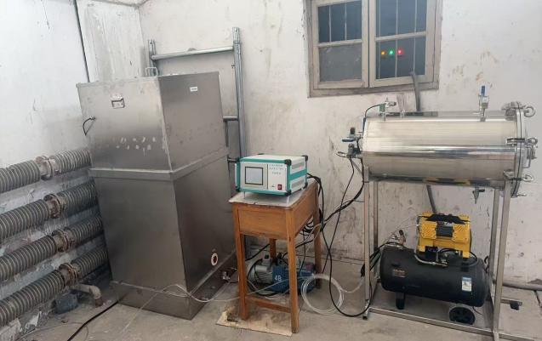
Fig. 1 CO₂ mineralization reactor

4.Mineralization Test Design and Results
CO₂ mineralization of artificial aggregate is a green building material technology that uses industrial solid wastes as raw materials to prepare artificial aggregates, and then generates stable carbonate minerals through CO₂ mineralization reaction, thereby significantly improving the physical and mechanical properties and carbon sequestration potential of aggregates. In this process, different mineralization conditions directly affect the degree of mineralization reaction, product composition and microstructure evolution of aggregates, which ultimately determine key properties such as strength and carbon sequestration rate. Among them, curing humidity, CO₂ concentration, curing pressure and mineralization curing time are the core parameters regulating the mineralization process in this chapter.
The fully solid-waste artificial aggregate was prepared by cold-bonding pelletization with 20% fly ash, 60% granulated blast furnace slag, 10% carbide slag, 10% desulfurization gypsum, and a water-binder ratio of 0.2. After preparation, it was allowed to stand for 1 day to prevent agglomeration and subjected to steam curing at 85 ℃ for 12 h, followed by CO₂ mineralization test. After mineralization, the samples were cured in a standard curing chamber for 28 days.

4.1Curing Humidity
CO₂-mineralized fully solid-waste artificial aggregate is essentially formed by the carbonation reaction between CO₂ and active components such as CaO and MgO in the aggregate body, producing stable carbonate minerals. This reaction is a gas–solid–liquid three-phase synergistic reaction, and curing humidity acts as an important medium regulating the three-phase reaction. In this study, different saturated solutions were used to control humidity, and the specific solutions are listed in Table 6. Other mineralization parameters were set as follows: CO₂ concentration of 20%, pressure of 0.2 MPa, and mineralization curing time of 8 h.

Table 7. Humidity % in saturated salt solutions
saturated salt solution | MgCl₂ | K₂CO₃ | NaBr | NaCl | KCl
humidity / % | 33±2 | 44±2 | 57±2 | 75±2 | 86±2
As shown in Figure 2, with increasing curing humidity, the carbon sequestration rate and compressive strength of the fully solid-waste artificial aggregate first increase and then decrease, reaching the maximum at a curing humidity of 57%. At this point, the carbon sequestration rate of the artificial aggregate is 1.7%, and the single-particle compressive strength is 5.67 MPa. Therefore, the optimal curing humidity is determined to be 57%.
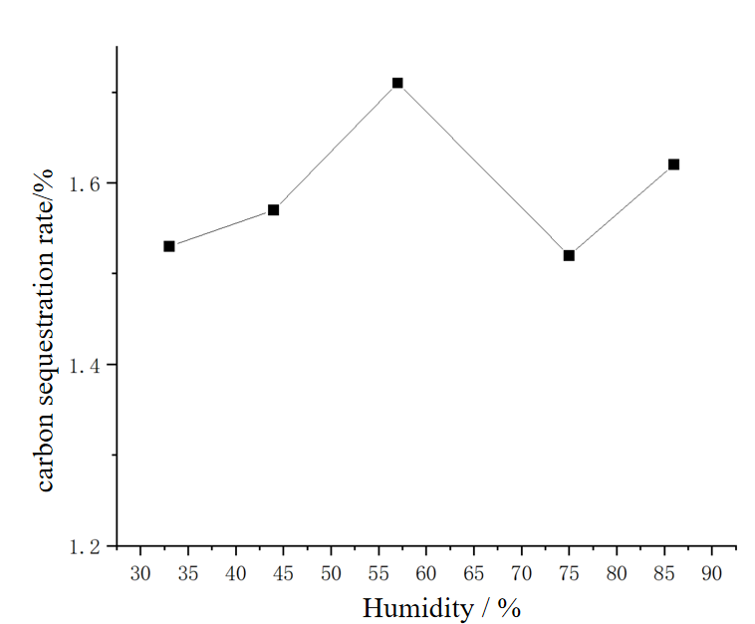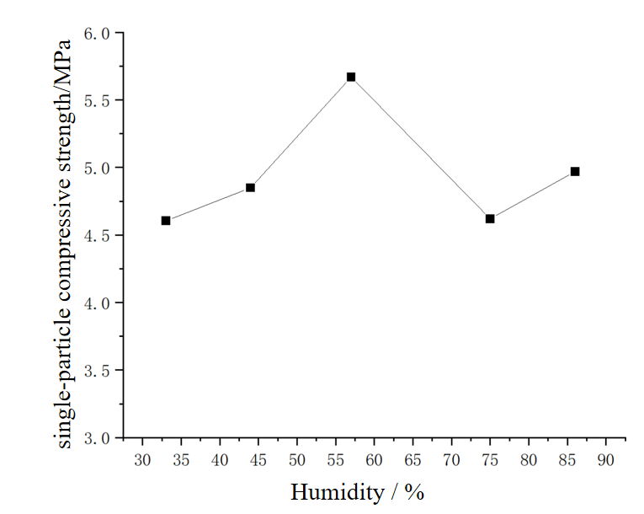
(a) (b)
Fig. 2 Effect of different curing humidity on carbonation performance of artificial aggregate (a) CO₂ fixation rate，(b) Compressive strength after carbonation

4.2 CO₂ Concentration
CO₂ concentration is a core external condition that determines the mineralization reaction rate, carbon sequestration capacity, and product development degree. Within a certain range, an increase in CO₂ concentration significantly promotes the mineralization effect. After the CO₂ concentration reaches a certain value, the mineralization effect gradually weakens, the reaction rate rises slowly, and it may even hinder strength development. In addition, an excessively high CO₂ concentration increases the experimental cost. The mineralization reactor used in this study allows direct adjustment of CO₂ concentration. The CO₂ concentration was set in the range of 10%–60%, with a curing humidity of 57%, a curing pressure of 0.2 MPa, and a curing time of 8 h.
As shown in Figure 3, increasing the CO₂ concentration within an appropriate range improves the carbon sequestration rate and compressive strength of artificial aggregate. The carbon sequestration rate of the fully solid-waste artificial aggregate reaches the maximum at a CO₂ concentration of 40%. Beyond 40%, the single-particle compressive strength begins to decrease. Considering both the carbon sequestration rate and single-particle compressive strength, the optimal CO₂ concentration is determined to be 40%.
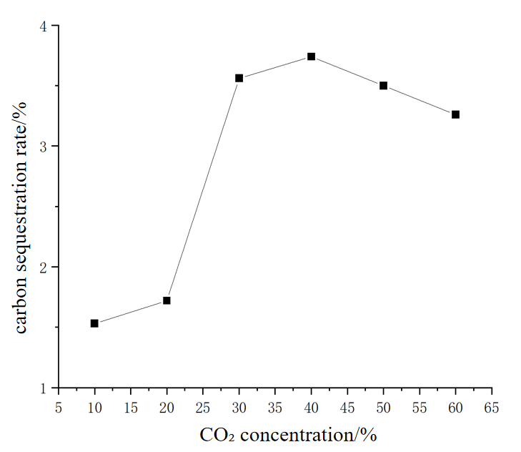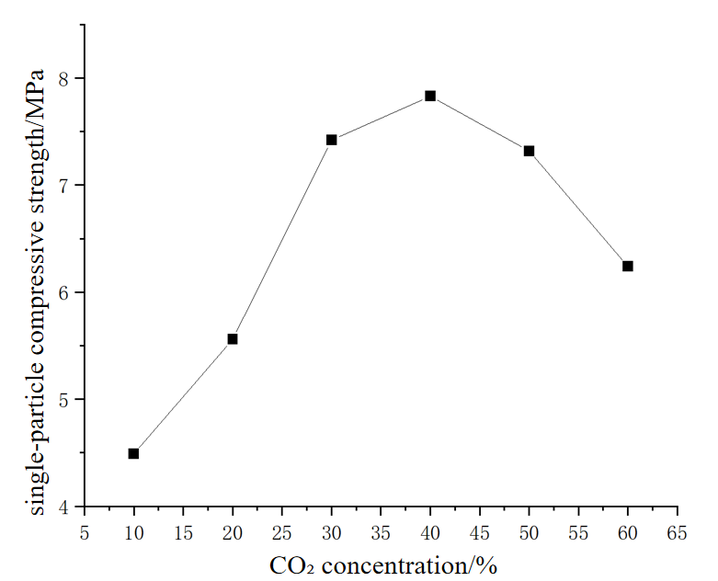
- (b)
Fig. 3 Effect of different CO₂ concentrations on mineralization performance of artificial aggregate (a) CO₂ fixation rate(b) Compressive strength after carbonation

4.3 Curing Pressure
Mineralization curing pressure is a key process parameter affecting the carbonation reaction efficiency and product structure of artificial aggregate. Increasing the curing pressure enhances the driving force for CO₂ gas diffusion into the internal pores of the aggregate, allowing it to penetrate internal reaction sites more easily, thus significantly improving the depth and uniformity of the mineralization reaction. The curing pressure was set in the range of 0.1 MPa–0.5 MPa. Other mineralization conditions were: curing humidity 57%, CO₂ concentration 40%, and curing time 8 h.
As shown in Figure 4, with increasing curing pressure, the carbon sequestration rate of the fully solid-waste artificial aggregate increases rapidly, while the compressive strength first rises and then falls, reaching the maximum at 0.4 MPa. Considering both the carbon sequestration rate and single-particle compressive strength, the optimal curing pressure is determined to be 0.4 MPa.
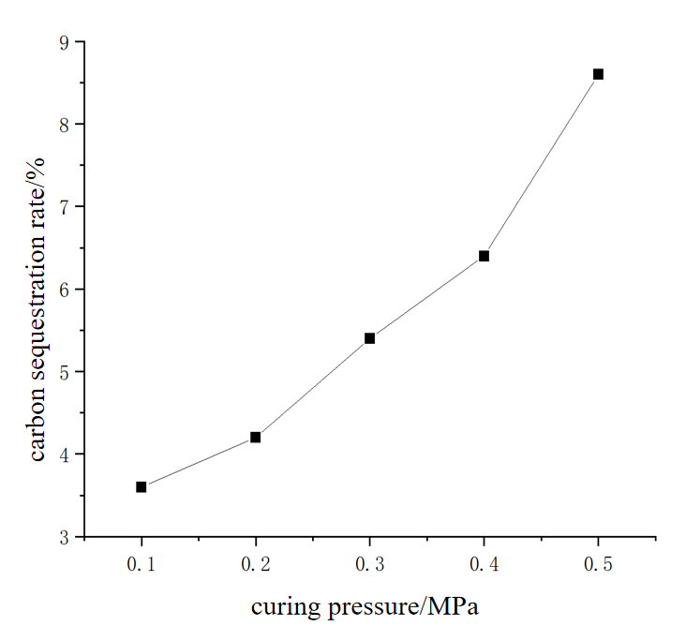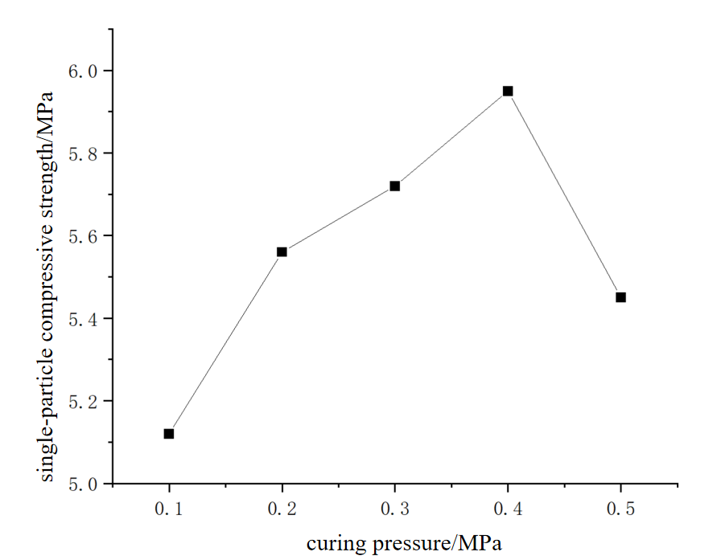
- (b)
Fig. 4 Effect of different curing pressures on the mineralization effect of artificial aggregates
(a) CO₂ fixation rate (b) Compressive strength after carbonation
4.4 Curing Time
Mineralization curing time is a key process parameter determining the mineralization degree, microstructure development and macroscopic mechanical properties of fully solid-waste artificial aggregate. The properties of the aggregate increase initially and then tend to stabilize with prolonged mineralization curing time. In this study, the curing time was set from 6 h to 14 h. Other mineralization parameters were: curing humidity 57%, CO₂ concentration 40%, and curing pressure 0.4 MPa.
As shown in Figure 5, the carbon sequestration rate, compressive strength and bulk density of the artificial aggregate increase with the extension of curing time, and tend to stabilize after 12 h. Therefore, the optimal curing time is determined to be 12 h.
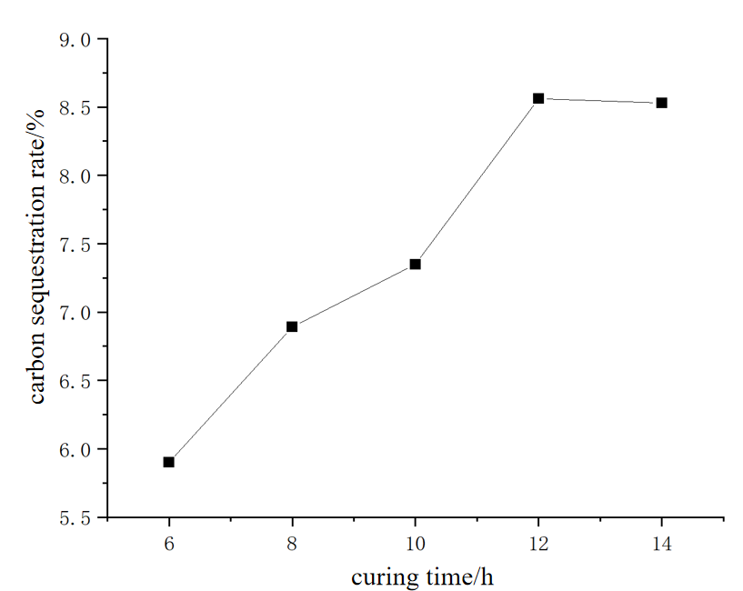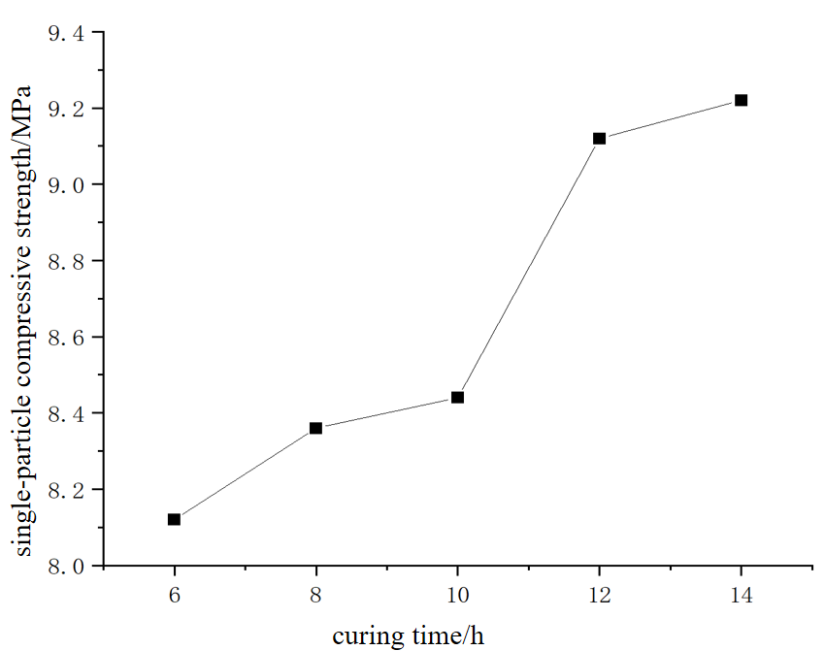
- (b)
Fig. 5 Effect of different curing time on mineralization performance of artificial aggregate
(a) CO₂ fixation rate(b) Compressive strength after carbonation
5. Conclusion
In this study, artificial aggregates were prepared using industrial solid waste as raw materials via cold-bonding granulation technology. The influence rules of four core process parameters—curing humidity, CO₂ concentration, curing pressure, and mineralization curing time—on the CO₂ mineralization effect were systematically investigated, and the optimal mineralization process parameters were finally determined. The raw material ratio of the aggregates used in the experiment was 20% fly ash, 60% slag, 10% carbide slag, and 10% desulfurized gypsum, with a water-cement ratio of 0.2. After preparation, the aggregates were left to stand for 1 day to prevent adhesion, followed by steam curing at 85℃ for 12 hours. Subsequently, CO₂ mineralization tests were conducted, and the samples were cured in a standard curing box until 28 days. Based on the test results and analysis, the main conclusions are as follows:
（1）Curing Humidity
When the curing humidity was low, both the carbon sequestration rate and the single-particle compressive strength were relatively low. This is because the insufficient moisture content in the internal pore structure of the system failed to form a stable CO₂ dissolution medium, making it difficult for CO₂ to convert from the gas phase to the liquid phase to participate in the mineralization reaction. With the increase of curing humidity, sufficient free water was provided inside the artificial aggregate. As a carrier for active ions, free water could promote the rapid dissolution of Ca²⁺, Mg²⁺ and other ions from the interior of the aggregate and their migration to the reaction sites. Meanwhile, CO₂ could dissolve to generate sufficient CO₃²⁻ ions, which combined quickly with active ions to accelerate the mineralization reaction and increase the carbon sequestration rate. However, when the curing humidity was excessively high, a large amount of water would pour into the pore channels of the aggregate to form a water film, hindering the diffusion and penetration of CO₂ gas. Due to the limited solubility of CO₂ in water and its diffusion rate much lower than that in air, only a small amount of CO₂ gas could reach the reaction sites, limiting the mineralization rate.
（2）CO₂ Concentration
When the CO₂ concentration was low, the number of CO₂ gas molecules participating in the reaction was small, and the driving force for diffusion into the aggregate was insufficient. At the same time, the amount of CO₃²⁻ ions generated by the dissolution of CO₂ in water was limited, resulting in a slow reaction rate. The Ca²⁺ and Mg²⁺ ions in the aggregate were not fully consumed, leading to low mineralization degree and low carbon sequestration rate. With the increase of CO₂ concentration, the number of CO₃²⁻ ions generated by the dissolution of CO₂ in water gradually increased, and the diffusion driving force was also guaranteed to a certain extent. This allowed the full reaction of Ca²⁺ and Mg²⁺ ions in the aggregate, increasing the content of generated carbonates, as well as the carbon sequestration rate and compressive strength. At this stage, CO₂ concentration played a dominant role. When the CO₂ concentration was excessive, the reaction was no longer limited by the gas concentration, and the diffusion rate and quantity of ions became the dominant factors. The slight decrease in carbon sequestration rate was due to the excessively high CO₂ concentration, which accelerated the carbonation reaction on the surface of the aggregate, generating a large amount of CaCO₃ in the pores and hindering the diffusion of CO₂ gas into the interior of the aggregate.
（3）Curing Pressure
With the increase of curing pressure, the carbon sequestration rate of the all-solid-waste artificial aggregate increased rapidly. This is because the increase of curing pressure could significantly enhance the diffusion driving force of CO₂ molecules from the outside to the inside of the aggregate, making the mineralization reaction more sufficient and improving the overall mineralization degree. It could also increase the solubility of CO₂ in free water, leading to more CO₃²⁻ ions. However, when the curing pressure was too high, the mineralization reaction became overly intense, and CaCO₃ crystals had no time to grow in an orderly manner, resulting in uneven reaction and failure to form a stable skeleton structure through interconnection. The rapid formation of irregular and high-hardness CaCO₃ crystals would cause concentrated stress locally in the aggregate, leading to a decrease in compressive strength.
（4）Curing Time
In the stage of curing time ranging from 6h to 12h, insufficient curing time led to inadequate diffusion of CO₂ and incomplete dissolution of Ca²⁺, Mg²⁺ and other ions. The number of generated CaCO₃ crystals was small, which could not effectively fill the internal pores of the aggregate. When the curing time reached 12h, the active mineral components inside the aggregate fully participated in the mineralization reaction, a large number of stable CaCO₃ crystals were generated, and the pores were effectively filled, resulting in the maximum carbon sequestration rate and compressive strength. When the curing time exceeded 12h, the active components inside the aggregate were basically completely reacted, and the mineralization reaction terminated. Extending the curing time had little effect on the carbon sequestration rate, compressive strength, and bulk density of the aggregate.
In summary, the optimal process parameter combination for CO₂ mineralization of the all-solid-waste artificial aggregate prepared in this experiment is: curing humidity of 57%, CO₂ concentration of 40%, curing pressure of 0.4MPa, and mineralization curing time of 12h. Under these parameters, the aggregate can achieve excellent mineralization effect, with ideal carbon sequestration capacity and mechanical properties.
6 Limitations
This study mainly focuses on the optimization of preparation technology at the laboratory scale. Pilot-scale and industrial-scale amplification experiments have not yet been carried out. The industrial applicability of cold-bonding granulation efficiency and the scale-control effect of carbonation reaction uniformity lack verification under actual production conditions, making it difficult to fully reflect the complex working conditions in industrial production.
The research and development of continuous production equipment is still at the preliminary exploration stage, and mature complete sets of equipment suitable for large-scale production have not been developed. Key issues such as operational stability and energy consumption control have not been systematically investigated, which is insufficient to support the efficiency requirements of batch production.
Only theoretical analysis and estimation were conducted for production cost control, without accurate accounting combined with actual industrial factors such as material loss, equipment depreciation, and labor costs. Therefore, the actual cost-reduction effect in large-scale production may deviate from expectations.
Disclaimer (Artificial intelligence)
Author(s) hereby declare that NO generative AI technologies such as Large Language Models (ChatGPT, COPILOT, etc.) and text-to-image generators have been used during the writing or editing of this manuscript.

Reference
[1]Chen Shoukai, Bai Weifeng, Zheng Yongjie, et al. Effect of Recycled Aggregate Replacement Ratio on Uniaxial Compressive Mechanical Properties of Concrete[J]. Journal of Basic Science and Engineering, 2022, 30(3): 764-775.
[2]Meng Ercong, Yu Yalin, Yuan Jun, et al. Effect of Temperature on Triaxial Compressive Properties and Failure Criterion of Fully Recycled Concrete[J]. Journal of Basic Science and Engineering, 2019, 27(6): 1370-1380.
[3]Han Dandan, Chen Yonghui, Kong Gangqiang, et al. Study on Mechanical Properties of Solid Waste-Based Artificial Aggregate Concrete[J/OL]. Journal of Building Materials, 1-12 [2024-12-07].
[4]Li Yancang, Chu Qingtao, Wang Yude, et al. Study on Preparation and Properties of Artificial Aggregate from Solidified Reservoir Sediment[J/OL]. China Rural Water and Hydropower, 1-17 [2024-12-07].
[5]Shi Haoliang. Study on Preparation and Properties of Unburned Aggregate by Wet Extrusion Granulation of Dredged Sediment[D]. Tianjin: Tianjin University of Science & Technology, 2019.
[6]LI X G , HE C H, LV Y , et al. .Effect of sintering temperature and dwelling time on the characteristics of lightweight aggregate produced from sewage sludge and waste glass powder[J].Ceramics International,2021,47(23):33435-33443.
[7] LIAO Y C, HUANG C Y, CHEN Y M. Lightweight aggregates from water reservoir sediment with added sodium hydroxide[J]. Construction and Building Materials, 2013, 46: 79–85.
[8]Bekkeri,G.B., Shetty, K. K., & Nayak, G. (2024). Effects of cold-bonded artificial aggregate properties on the behaviour of concrete. Materials Research Express,11(8).
[9]Shang Xiaoyu, Huang Wenyi, Fang Zeyu, et al. Preparation and Properties of High-Strength Concrete with Artificial Cold-Bonded Lightweight Aggregate[J/OL]. Acta Materiae Compositae Sinica, 1-11 [2024-12-07].
[10]Jin, H., Cheng, L., Liu, J., Chen, C., & Xing, F. (2024). Converting municipal solid waste incineration bottom ash into the value-added artificial lightweight aggregates through cold-bonded granulation technology. Construction and Building Materials,438.
[11] Ge Shixian, Cheng Shengming. Difficulties and Countermeasures of Preparing Artificial Sand and Aggregate for Roller Compacted Concrete from Tuff[J]. Hydropower and New Energy, 2015, (01): 63-65.
[12] Askci Consulting Co., Ltd. Market Size and Development Prospect Forecast Analysis of China's Industrial Solid Waste Treatment Industry in 2022[R]. 2022.
[13] Weng Xiaohan, Han Tao, Feng Wei, et al. Research status and progress of negative carbon emission technologies[J]. Journal of Clean Coal Technology, 2024, 30(10): 159-174. DOI:10.13226/j.issn.1006-6772.CCUS24051201.
[14] Andersson R，Hakan S，Gustafsson T，et al.Carbonation as a method to improve climate performance for cement-based mate－ rial[J].Cement and Concrete Research，2019，124（20）：105819.
[15]Chiang P C，Pan S Y.Carbon dioxide mineralization and utiliza－ tion[M].Springer Singapore，2017，9（19）：6673-6684.
[16]Seishi G，Kenzo S，Takeshi K.Calcium silicate carbonation prod－ ucts [J].Journal of the American Ceramic Society，1995，78（11）： 2867-2872.
[17] Zou Xiangbo, Chen Gongda, Rao Mumin, et al. Experimental study on carbon dioxide mineralization maintenance of all-solid waste lightweight aggregates[J/OL]. Clean Coal Technology, 1-14[2024-12-07].
[18] Liu Songhui, Wang Heng, Guan Xuemao, et al. Influence mechanism of sodium gluconate on the carbonation behavior of magnesium slag[J/OL]. Journal of Building Materials, 1-13[2026-02-12].

