Factors explaining population growth in the central district of Abomey-Calavi, Benin

Abstract
This study aims to examine the dynamics of population growth in the central district of Calavi and the impacts this has on spatial organization and living conditions. Population growth is driven by natural increase, characterized by a high birth rate, as well as by the region’s attractiveness due to socio-economic opportunities, thereby placing considerable pressure on infrastructure and urban space. In this context, the methodology adopted will be mixed, incorporating both secondary data and information collected in the field, notably through questionnaires, interviews with key informants, and direct observations. The sample will include 52 randomly selected households, representing 1%, as well as 20 key informants, for a total of 72 participants to whom a questionnaire will be distributed. The data obtained will be analyzed using statistical and geospatial tools such as Excel and QGIS. The demographic projection will be based on an exponential model, while the interpretation of the results will rely on the PEIR model. Thus, the results indicate a rapid and uncontrolled urbanization process, marked by a lack of infrastructure and services, which reinforces the need for sustainable urban planning to adapt to demographic growth trends.

Keywords : Population growth, Abomey-Calavi, Migration dynamics, Urban management.

Introduction
1.1 Rationale and Problem Framing
Urbanization is currently one of the main drivers of land-use change on a global scale. According to the United Nations, more than half of the world’s population now lives in urban areas, and this proportion is expected to increase in the coming decades [12]. This phenomenon is particularly pronounced in developing countries, where rapid population growth is accompanied by urbanization that is often poorly planned [9; 3]. Although cities are hubs of economic, social, and cultural opportunities, they also face numerous challenges, particularly regarding access to essential services, land management, housing, and urban planning. Urbanization in sub-Saharan Africa is characterized by rapid and often unplanned expansion of urban areas. This phenomenon is primarily due to high natural population growth as well as significant migration from rural areas [11; 4]. Nevertheless, this transformation is taking place in a context where institutions lack resources and urban infrastructure is inadequate. Consequently, the expansion of urban areas often occurs without adequate planning, leading to disorderly land use, the emergence of slums, the saturation of public services, as well as a lack of sanitation systems and increased vulnerability of populations to environmental risks [8]. In West Africa, this issue is particularly alarming. For example, in Benin, the population grew from 6,769,914 in 2002 to 9,983,884 in 2013, representing a growth rate of 3.5% between the two censuses [6]. This trend is accompanied by an increasingly significant concentration of residents in urban areas, drawn by employment opportunities, infrastructure, and services. However, Benin’s cities are not always able to adequately accommodate this additional population. Consequently, pressure is mounting on housing, transportation networks, educational and health infrastructure, as well as land availability [7]. Among the municipalities most affected by this trend, the municipality of Abomey-Calavi holds a special place. Located on the outskirts of Cotonou, it is the main growth hub of the Cotonou metropolitan area. Its rapid population growth is fueled by a high birth rate and significant migration from other regions and departments of the country [6; 1]. This situation is particularly evident in downtown Calavi, where rapid population growth has coincided with rampant urbanization. However, this population growth has not been accompanied by adequate land-use planning or commensurate infrastructure development. Currently, downtown Calavi faces significant housing densification, disorderly land use, limited access roads, wastewater management issues, increased pressure on public services, and a gradual decline in the quality of life. Construction often encroaches on areas designated for infrastructure or on unsuitable land, which increases the risks of flooding, traffic congestion, and unsanitary conditions. Thus, the challenge lies not only in population growth itself, but above all in the municipality’s ability to manage and structure this expansion. Indeed, how can a municipality attracting so many new residents effectively meet the growing needs for housing, infrastructure, and urban services, while preserving territorial balance and the quality of life for its residents? What are the main factors explaining the population growth in the central district of Calavi? And how does this growth affect the organization of urban space, access to services, and residents’ living conditions? These questions highlight a disconnect between demographic trends and the municipality’s planning capacity. The lack of a thorough understanding of the factors driving this growth and its spatial consequences risks exacerbating existing urban imbalances. In this context, it is essential to examine the factors driving population growth in the central district of Calavi and to consider its repercussions on urban organization and residents’ living conditions. This will enable the proposal of solutions that promote more sustainable urban planning better suited to local realities.

1.2. Definition of Population Growth
Population growth is the sum of the natural increase and the net migration, generally calculated over a one-year period. A population increases when there are more births than deaths (natural increase) and more migrants arriving than leaving (net migration). The annual growth rate is the ratio of the change in population over the course of a year to its size at midyear.
The population of the central district of Calavi has doubled, with an annual intercensal growth rate of 6.7%, compared to a growth rate of 9.43% between 1992 and 2002. It is therefore important to identify the factors driving population growth in the central district of Calavi (migration or natural increase). The population growth observed in Calavi is highly concentrated given the rapid pace of population change; it is therefore necessary to understand and identify the reasons for this population growth. Generally speaking, population growth can be explained, on the one hand, by the saturation of habitable space and, on the other hand, by the process of urbanization, as cities have become major centers of attraction.
1.3. Scope and Objectives of This Article
This article aims to examine the demographic and spatial dynamics in the central district of Calavi, which is part of the municipality of Abomey-Calavi. Its approach is both scientific and practical. From a scientific perspective, the objective is to deepen the understanding of the mechanisms behind the significant demographic growth experienced by this rapidly evolving urban area. From a practical standpoint, the aim is to highlight the consequences of this growth on urban spatial planning, in order to provide useful insights to decision-makers involved in urban planning and development [15; 16]. The analysis focuses on the links between population dynamics, migration patterns, land use, infrastructure availability, and residents’ living conditions. It also examines the various forms of urbanization emerging in the central district of Calavi, such as housing densification, uncontrolled expansion of construction, and pressure on public facilities and urban services [17; 18]. The main objective of this article is to explore the factors influencing population growth in the central district of Calavi, while assessing the repercussions of this growth on the organization of urban space [14; 17].
Specifically:
- Identify the factors contributing to population growth in downtown Calavi.
- Analyze changes in population size as well as migration patterns.
- Assess the impact of this population growth on housing, infrastructure, and essential services.
2. Materials and Methods
2.1. Study Area

The Abomey-Calavi district is located in the Municipality of Abomey-Calavi between 6°24'46" and 6°30'49“ north latitude and between 2°18'28” and 2°22'42" east longitude. It is bordered to the north by the district of Akassato, to the south by the district of Goดomey, to the east by the municipality of Sô-Ava, and to the west by the district of Togba. The district of Abomey-Calavi is the seat of the Municipality of Abomey-Calavi. Covering an area of 49.05 km² , it comprises 20 city neighborhoods, namely: Aganmandin, Tokpa-Zoungo, Agori, Gbodjo, Kansounkpa, Sèmè, Tokpa-Zoungo North, Tokpa-Zoungo South, Aïfa, Aïtché- dji, Alédjo, Cité de la Victoire, Cité les Palmiers, Fandji, Finafa, Tankpè, Tchinangbégbo, Zopa, Zoundja, and Zog֊badjè. The population grew rapidly between 1979 and 2013, mainly due to a dynamic youth population and its proximity to the city of Cotonou (Figure 1). The Abomey-Calavi district has a sub-equatorial climate characterized by two rainy seasons and two dry seasons. The annual average temperature is 28 °C, and minimum temperatures range between 20 °C and 25 °C [20]. The hottest months, from February to April, see temperatures reaching up to 35 °C, signaling the approach of the rain season. Two soil types have been identified in the Abomey-Calavi district: ferrallitic soils, which are predominant, and hydromorphic soils localized in the east [19].
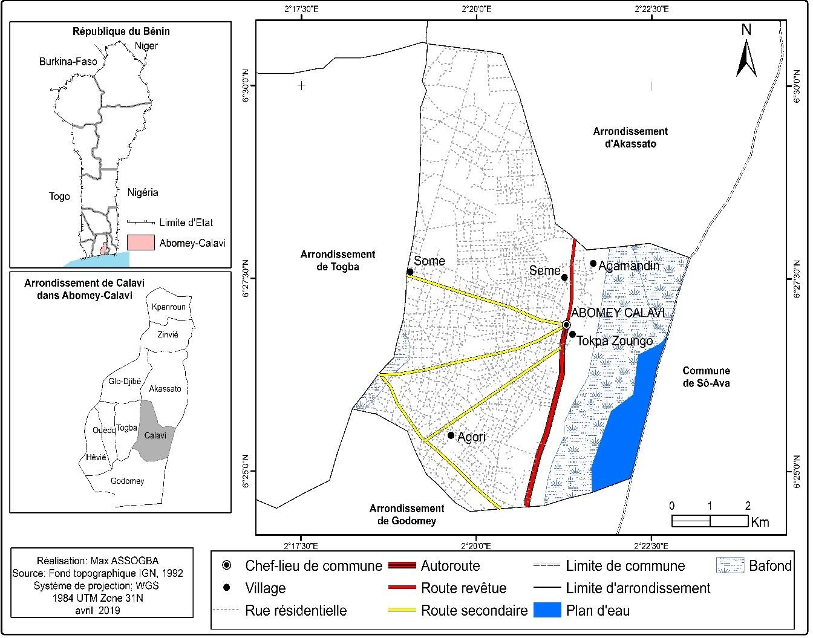
Figure 1: Geographical location of the municipality of Abomey-Calavi
2.2. Data and Materials Used
This research employs a mixed-methods approach that combines both quantitative and qualitative data. Secondary data were obtained from institutional sources and academic publications. As for the primary data, it was collected through questionnaires, semi-structured interviews, and direct observations. The sample was constituted by surveying 1% of the 5,200 households in the central district of Calavi, representing a total of 52 households. These households were selected using simple random sampling, beginning with a random draw of the first household, followed by selection at regular intervals. The questionnaire covered various aspects such as household characteristics, migration, housing conditions, and access to essential services. Subsequently, twenty key informants were included, bringing the total number of participants to 72.
2.3. Data Processing and Analysis Methods
The data collected were analyzed using quantitative, qualitative, and spatial methods. The quantitative data, obtained from surveys, were entered and analyzed using Microsoft Excel to determine key indicators, such as rates, frequencies, and proportions, thereby enabling the creation of tables and graphs. Spatial analysis was conducted using QGIS to map population distribution, track changes in land use, and identify the areas most affected by demographic pressure. The demographic projection was carried out using an exponential model based on the annual growth rate.
$$P_{t}=P_{0}{\left(1+r\right)}^{t}$$
In this formulation, $P_{t}$ represents the estimated population, while $P_{0}$ denotes the initial population. The symbol $r$ efers to the growth rate, and 𝑡 indicates the projection period.
The qualitative data collected during the interviews were analyzed using a thematic approach to highlight the perceptions of various stakeholders regarding population growth and its repercussions. In conclusion, the overall analysis of the results was based on the PEIR model, which made it possible to examine the relationships between population growth, environmental pressures, health impacts, and the responses that were implemented.
3. Results
3.1. Dynamics of Population Growth in the Central District of Calavi
The results indicate that the population growth in the central district of Calavi is largely due to a favorable natural increase, reflected in a higher number of births than deaths. Indeed, an analysis of data from the RGPH3 [6] reveals a high fertility rate in the municipality of Abomey-Calavi. Although the total fertility rate has declined gradually, it remains relatively high, falling from 7.2 children per woman in 1979 to 5.7 in 2002, and then to 3.5 in 2010 [5]. This trend illustrates an ongoing demographic transition, though one that has not yet been fully realized. Furthermore, the crude birth rate remains significant, contributing substantially to population growth. On the other hand, although the crude death rate remains high, it is gradually declining. This decline in mortality, combined with a consistently high birth rate, reinforces the imbalance between births and deaths, which explains the continued population growth in this region.
3.2. Mortality Trends

In recent years, there has been a decline in the crude death rate in the central district of Calavi. This decline has been accompanied by a gradual improvement in access to healthcare, driven in particular by major vaccination campaigns. These efforts have had a significant impact on reducing child mortality. It should be noted that the population of this region is particularly young, characterized by high fertility and infant mortality, which, although declining, remains a cause for concern. The age pyramid illustrates this situation: a broad base reflects the youth of the population, followed by a curve that narrows from the first decades of life [5].

3.1.3. Age Structure of the Population

In 2002, the data provided by the RGPH3 made it possible to analyze the demographic structure of Abomey-Calavi by age and sex, using the age pyramid, a fundamental tool in demography. This tool provides a visual representation of the population based on two essential parameters: age and sex. It provides an overview of demographic dynamics, including the size of different age groups, as well as trends in birth and death rates, while also providing some insight into migration flows. In practice, this pyramid reveals a predominantly young population, with a broad base indicating a high fertility rate. This profile suggests continuous generational renewal and dynamic growth.

Conversely, the narrowness of the older age groups reflects high mortality rates among the elderly, accompanied by a relatively low life expectancy. The municipality appears to be in a transitional phase, where mortality is gradually declining, while fertility remains high. This type of balance indicates an ongoing evolution, without any real break. The future trajectory will depend on the strategies adopted in the areas of health and education.

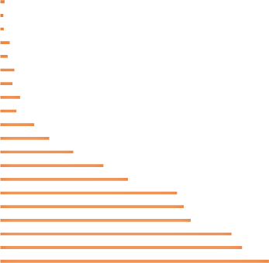
Figure 2 presents the age pyramid of the municipality of Abomey-Calavi based on data from the 2002 census.
Women Male
100 et +
(95-99
(90-94)
(85-89)
(80-84)
(75-79)
(70-74)
(65-69)
(60-64)
(55-59)
(50-54)
(45-49)
(40-44)
(35-39)
(30-34)
(25-29)
(20-24)
(15-19)
(10-14)
(5-9)
(0-4)
-30000
-20000
-10000
0
10000
20000
30000

Figure 2 : Age pyramid of the municipality of Abomey-Calavi in ​​2002
Source : INSAE/RGPH3 (2003)
An examination of the age pyramid reveals a very broad base accompanied by a narrow peak, indicating that the population is predominantly young, while life expectancy remains relatively low. Such a configuration of the age pyramid is typical of countries with a dynamic lifestyle, where families continue to have many children, despite a high infant mortality rate, although there is also a high proportion of older individuals living long lives. This type of demographic structure raises significant development challenges. The first challenge is to meet the growing needs of young people in terms of education, access to employment, healthcare, and infrastructure. The second challenge involves improving living conditions and health services to ensure that life expectancy reaches adequate standards.
3.1.4. Migration Dynamics
The data indicate that population growth in downtown Calavi is largely driven by migration, particularly from Cotonou. This attraction can be attributed to geographical proximity, the relatively high availability of land, and the settlement opportunities offered by the municipality.
Table I: Migration Flows and Net Migration in the Municipality of Abomey-Calavi
Municipality | Emigrants | Immigrants | Net migration | Outflow rate (%)
Abomey-Calavi | 44 187 | 125 948 | 81 761 | 3,76
Source : INSAE, RGPH3, 2013

3.1.5. Demographic Trends in the Central District of Calavi
The demographic trends in downtown Calavi are part of a broader context characterized by the interplay between natural population changes, such as births and deaths, and migratory movements. This highlights the profound transformations in the municipality’s socio-economic and territorial structures. The data reveal sustained population growth, with an estimated average intercensal growth rate of 6.7%. This trend indicates significant population growth, resulting from both a relatively high fertility rate and the region’s appeal to newcomers. Furthermore, an analysis of demographic trends from 2002 to 2025 shows continuous growth, highlighting the central role of downtown Calavi as an area with high population density and rapid urban development. The attached graph illustrates the demographic evolution of this area between 2002 and 2025.
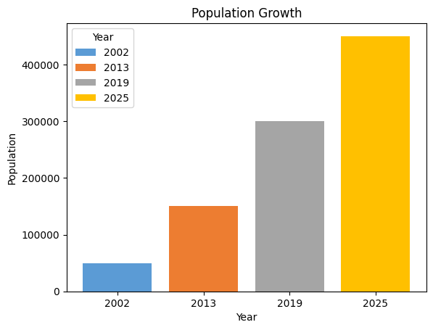
Figure 3 : Population projection for the central district of Calavi to 2025
Source : Field surveys, 2019

An analysis of demographic projections reveals that, if current trends continue, the population of downtown Calavi could double in about 23 years. This expansion, characterized by remarkable vitality, is the result of a high birth rate as well as significant migration. It poses significant challenges in terms of urban planning and infrastructure development. Among these challenges, improving healthcare infrastructure is a key priority for supporting this growth and ensuring a sustainable improvement in residents’ living conditions.
3.1.5. Reasons for Travel Within Abomey-Calavi
Travel is characterized by the underlying reasons, which are closely linked to activities. The farther apart the locations of these activities are, the more important the characteristics of the trip and the organizational strategy become. The reasons for travel between Abomey-Calavi and Cotonou are diverse. Four main categories can be identified: access to facilities, commerce, work, and family visits.

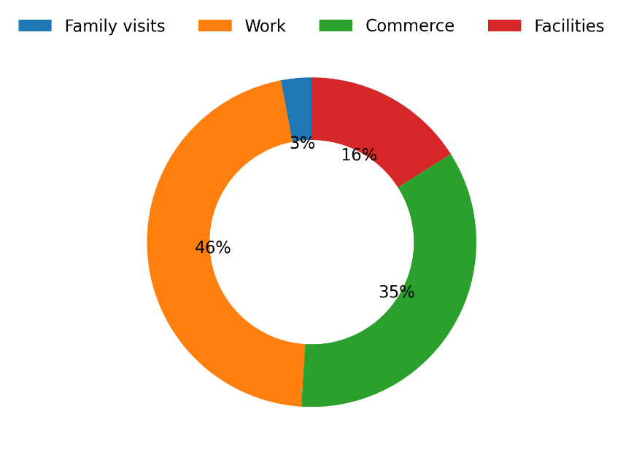
Figure 4: Breakdown of trips by purpose.
Infrastructure includes places of worship, educational institutions such as elementary schools, high schools, and middle schools, as well as parks and beaches. In the commercial sector, it is important to consider small retailers who source their goods from the Dantokpa market to resell their products in the Abomey-Calavi municipality. Nevertheless, the main motivation for travel between Abomey-Calavi and Cotonou is work-related. Consequently, commercial activities account for 35% of the reasons for these trips, while access to facilities in Cotonou accounts for 16%, and family visits account for only 3% of the reasons for travel between these two locations. Traffic flows were observed on several secondary routes, notably Cococodji-Hêvié, Calavi-Kpota-Ouèdo, Missessinto-Zinvié, Togoudo-Maria-Gléta, IITA intersection-Tankpè, Arconville-Regional Hospital, Aglouza-Womey intersection, Concorde Pharmacy-Cocotomey intersection, as well as the Transmission Camp-Zopah intersection, Adjagbo-Adjagbo Cemetery intersection, Mathieu Kérékou-Zopah intersection, and Bidossessi-Bakita intersection. Table XIX shows the average number of workers and vehicles in circulation on the main roadways during the morning.
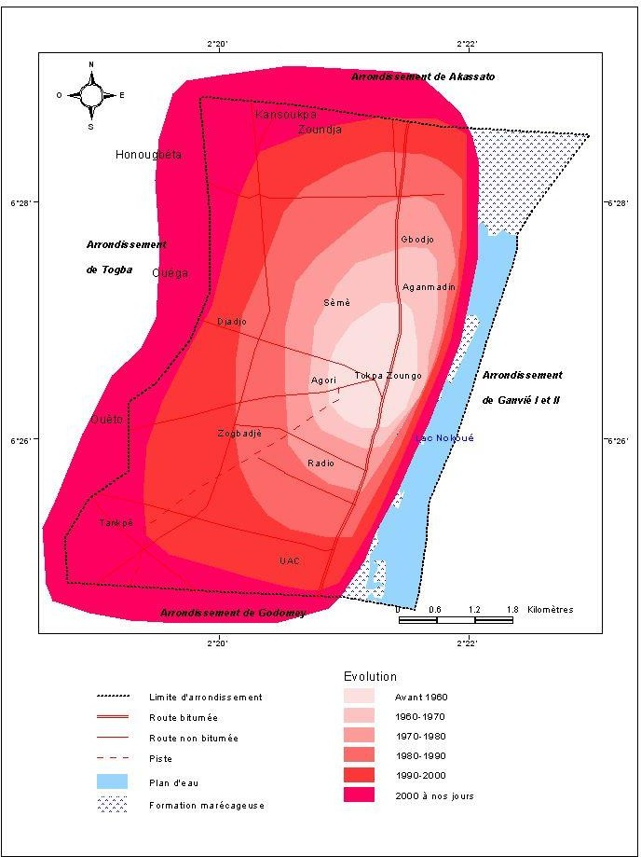
Figure 5 : Evolution of the urban space of the Abomey-Calavi district
The illustration shows the evolution of the spatial expansion of downtown Calavi throughout the various phases of urbanization. An examination of the color variations highlights a gradual progression of urban development, starting from an old core established before 1980 and extending to increasingly widespread urbanization toward peripheral areas, particularly observable from the 1990s to the present. This spatial transformation reflects a phenomenon of continuous urban sprawl, marked by densification in the city center (light-colored areas) and rapid expansion of peripheral areas (red and pink areas).
This trend is largely driven by the proximity to Cotonou, which exerts a significant pull, attracting new residents in search of space and opportunities. Furthermore, urbanization essentially follows the road network, highlighting the importance of transportation infrastructure in the organization of urban space. The areas adjacent to major thoroughfares are the most densely populated, while those further back are undergoing gradual urbanization. This trend suggests that, in the medium to long term, the downtown area of Calavi could transform into a nearly continuous urban expanse, creating a conurbation with Cotonou. Nevertheless, this rapid growth poses significant challenges in terms of urban planning, resource management, and infrastructure development, particularly in recently urbanized areas.
4- Discussion
The results of this study highlight a steady increase in the population in the heart of Calavi, driven by a combination of two complementary factors: a still-high birth rate and significant migration inflows. This trend reflects developments observed in many cities in sub-Saharan Africa, where urban growth is fueled by relatively high fertility rates as well as by the concentration of economic, administrative, and social opportunities in urban areas [11; 4]. The central district of Calavi thus stands out as a major center of attraction within the Greater Nokoué urban system. At the national level, several studies conducted in Benin corroborate this finding. Studies [6] conducted by various researchers show [1] that, over the decades, Abomey-Calavi has become the main area of urban expansion for the Cotonou metropolitan area. Its proximity to Cotonou, the country’s economic capital, combined with the relative availability of land and lower settlement costs, encourages the arrival of new residents. This appeal is further enhanced by the gradual development of road infrastructure and transportation systems, which facilitate daily commutes between Calavi and Cotonou. Thus, the central district of Calavi serves both a residential and an urban hub function, welcoming households from other neighborhoods within the municipality as well as from other departments of Benin. The clearly positive net migration observed in the study area reflects a phenomenon of spatial redistribution of the population within the Greater Nokoué region. This process is part of a trend of urban decentralization, in which residents are gradually leaving the central areas of Cotonou, which have become more densely populated and expensive, to settle in neighboring suburbs, notably in Abomey-Calavi. This phenomenon, already noted by various researchers [1] and [6], explains the sharp increase in population in the central neighborhoods of Calavi. It also points to a transformation in urban functions, with Calavi no longer limited to being a mere residential suburb of Cotonou, but becoming a true secondary center with its own economic, commercial, and administrative activities. In parallel with migration, the population continues to grow due to a high birth rate. Although a gradual decline in the fertility rate has been observed in Benin in recent decades, it remains relatively high in the municipality of Abomey-Calavi and in the study area. This reality reflects a demographic transition that is still incomplete, typical of many developing countries [5]. In fact, as some studies [2] point out, the decline in mortality, driven by improved health conditions and expanded access to healthcare, has progressed more rapidly than the decline in birth rates. This disparity results in a significant natural increase, as the number of births remains far higher than the number of deaths. The persistence of a high birth rate can be attributed to various sociocultural and economic factors. Among these are the value placed on large families, low awareness of family planning in certain social groups, early marriages, and insufficient education for many categories of women. Research conducted in Benin reveals that education, particularly that of women, has a significant impact on fertility and the use of contraceptive methods [2; 5]. In the central district of Calavi, the presence of a young population—often newly settled—as well as households that still adhere to traditional demographic patterns, supports significant natural population growth. An examination of the age structure confirms this trend, with a majority of young people in the population. The high proportion of children, adolescents, and young adults in the study area [7] is consistent with national demographic trends. This young population represents significant potential, as it could generate a substantial demographic dividend. If these young people have access to quality education, relevant vocational training, and productive jobs, they could become drivers of economic growth and social change. Nevertheless, this potential depends on the authorities’ ability to support this growth. As certain studies point out [9], a rapidly expanding young population can become a source of tension, particularly in the face of high unemployment, precarious living conditions, insufficient educational and health infrastructure, or housing access issues. In the central district of Calavi, demographic pressure is already being felt through the overburdening of existing infrastructure: schools are seeing their enrollment rise, health centers are becoming increasingly overwhelmed, and difficulties are emerging with the supply of drinking water, as well as with sanitation networks and urban mobility. These challenges are likely to intensify if population growth continues at this rate. The territorial expansion observed in the central district of Calavi is another consequence of this demographic trend. The results [1; 8] show a rapid process of urban sprawl, with a continuous expansion of the built environment toward the outskirts. This phenomenon is consistent with the analyses of several Beninese and West African researchers regarding unplanned urbanization. In many cases, this extensive urbanization develops spontaneously, without adequate urban planning oversight. It is concentrated mainly along transportation corridors and access roads, promoting linear urbanization. This form of urbanization raises several challenges. On the one hand, it leads to the rapid consumption of agricultural land and surrounding natural areas. On the other hand, it leads to the creation of poorly equipped neighborhoods, where water, electricity, sanitation, and road networks are often limited. New urban areas frequently attract low-income populations who settle on cheaper land that is, however, more vulnerable to flooding, erosion, or unsanitary conditions. These observations align with those of numerous studies on rapidly expanding African cities, which conclude that population growth, without appropriate urban planning policies, increases environmental and health vulnerabilities [8]. Population projections reinforce these concerns. The prospect of the population of Calavi’s central district doubling over the next two decades points to a growing need for housing, community facilities, infrastructure, and jobs. If preventive measures are not put in place, this trend could exacerbate the imbalances already observed: increased land pressure, a rise in illegal occupations, traffic congestion, the expansion of informal settlements, and a deterioration in living conditions. The results of this study are therefore consistent with the conclusions of several studies conducted in Benin, which emphasize that rapid population growth is now one of the main challenges of urban governance [6; 1]. In this context, the findings suggest that downtown Calavi is currently undergoing a process of rapid urban transformation, typical of evolving cities in West Africa. Population dynamics and urban expansion can no longer be viewed as isolated events; they influence one another and generate cumulative repercussions on spatial organization, living conditions, and residents’ expectations. It has therefore become essential to adopt an integrated urban planning approach. This should be based on better consideration of demographic trends in land-use strategies, on controlling land use, on strengthening infrastructure and essential social services, as well as on an appropriate land and housing policy. Such an approach would not only help mitigate the negative impacts of urban expansion, but also transform the demographic potential of Calavi’s downtown area into a true driver of sustainable and inclusive development.
Conclusion
This study has highlighted the main factors and implications of population growth in downtown Calavi. The results indicate that this population growth stems both from a still-high birth rate and significant migration flows, primarily from Cotonou. This combination of factors is leading to rapid population growth as well as a gradual transformation of the urban environment. An examination of the population structure reveals that it is primarily composed of young people. This observation represents considerable potential for future development, but it also creates growing needs in terms of education, health, employment, and infrastructure.
Furthermore, the observed spatial expansion reflects a process of rapid urbanization, often poorly regulated, characterized by disorderly land use and increased pressure on urban services, such as sanitation, access to drinking water, sanitary facilities, and roadways. Demographic projections suggest that the neighborhood’s population could double in the medium term if current trends continue. In the absence of appropriate public policies, this growth could lead to a deterioration in living conditions, an intensification of socio-spatial inequalities, and an increase in environmental risks.
Thus, the situation in downtown Calavi highlights the major challenges associated with rapid urbanization in African cities. It underscores the importance of integrating demographic dynamics into urban development strategies to promote planning that is sustainable, inclusive, and resilient.
5- Limitations
The limitations of this study are primarily related to the availability and reliability of recent demographic data concerning the central district of Calavi. Some of the statistics used come from secondary sources, whose collection periods and methods vary, which may lead to variations in the interpretation of the observed trends. Furthermore, the study is based in part on surveys conducted among a limited sample of households and local stakeholders. Although this sample made it possible to identify the main dynamics, it does not always provide an accurate representation of the neighborhood’s entire population. Furthermore, the high mobility of residents, as well as the sometimes informal nature of space occupation, complicate the accurate estimation of migration flows and the actual number of residents. Some temporary or unregistered households may have been omitted from the analysis. The study is also limited to the central district of Calavi, which limits the possibility of generalizing the conclusions to the entire municipality of Abomey-Calavi or to other towns in Benin that may have distinct characteristics. Finally, constraints related to time, financial resources, and access to the field prevented the conduct of a longitudinal study of population growth. Thus, the results presented reflect a situation at a given point in time, without offering an in-depth assessment of future trends.
Disclaimer (Artificial intelligence)
Author(s) hereby declare that NO generative AI technologies such as Large Language Models (ChatGPT, COPILOT, etc.) and text-to-image generators have been used during the writing or editing of this manuscript.

References
[1] Adjakpa A. Urban Dynamics and Land Use in the Municipality of Abomey-Calavi. Master's Thesis. Abomey-Calavi: University of Abomey-Calavi; 2018.
[2] Baloubi R. Analysis of Demographic Dynamics and Their Socio-Economic Impacts in Benin. Master's Thesis. Abomey-Calavi: University of Abomey-Calavi; 2010.
[3] World Bank. World Development Report: The Changing Nature of Work. Washington (DC): World Bank; 2019.
[4] Cohen B. Urbanization in Developing Countries: Current Trends, Future Projections, and Key Challenges for Sustainability. Technol Soc. 2006;28(1-2):63–80.
[5] National Institute of Statistics and Economic Analysis (INSAE). Demographic and Health Survey (DHS) Benin. Cotonou: INSAE; 2006.
[6] National Institute of Statistics and Economic Analysis (INSAE). Fourth General Population and Housing Census (RGPH4): Final Results. Cotonou: INSAE; 2013.
[7] National Institute of Statistics and Economic Analysis (INSAE). Demographic Outlook for Benin. Cotonou: INSAE; 2015.
[8] Jagun A. Urban expansion and infrastructure challenges in West African cities. Afr Urban Stud J. 2023;12(2):45–62.
[9] United Nations Development Programme (UNDP). Human Development Report. New York: UNDP; 2011.
[10] Souiah SA, Toutain J. Demographic Analysis and Population Dynamics. Paris: Armand Colin; 2005.
[11] UN-Habitat. The State of African Cities 2014: Re-imagining sustainable urban transitions. Nairobi: United Nations Human Settlements Programme; 2014.
[12] UN-Habitat. World Cities Report 2020: The value of sustainable urbanization. Nairobi: United Nations Human Settlements Programme; 2020.
[13] Antoine, P. and Bocquier, P. (1999). Urbanization in Sub-Saharan Africa. Paris: Karthala.
[14] Gnohossou, P. and Aholoukpè, H. (2017). “Population Growth and Urban Expansion in the Municipality of Abomey-Calavi.” Revue de Géographie du Bénin, 22, 45–58.
[15] Toko, I. I. and Dossou-Yovo, E. R. (2016). “Population Pressure and Access to Public Facilities in the Outlying Municipalities of Cotonou.” Annals of the University of Abomey-Calavi, 18(2), 103–118.
[16] UN-Habitat. (2020). World Cities Report 2020: The Value of Sustainable Urbanization. Nairobi.
[17] N’Bessa, B. and Houssou, C. (2018). “Land Use and Urban Dynamics in the Municipality of Abomey-Calavi.” European Scientific Journal, 14(26), 312–329.
[18] Ahouansou, M. and Tchiwanou, M. (2019). “Effects of Urban Growth on Spatial Organization in Abomey-Calavi.” Revue Africaine d’Aménagement du Territoire, 5(1), 67–81.
[19] IGN, 2002. Carte pédologique de reconnaissance de la République du Bénin à 1/200 000, feuille de Porto-Novo.
[20] MÉTÉO-BÉNIN, 2018. Données climatologiques de la commune d’Abomey-Calavi, Cotonou, Bénin.

