Original Research Article

Continuous Low-Level Chlorine Dioxide Gas Exposure and Curing Treatment on Sweet Potato Spoilage during Storage: A Pilot Study under Practical Warehouse Conditions

ABSTRACT

Background :Postharvest losses of sweet potatoes remain substantial due to microbial spoilage and suboptimal storage conditions, with curing commonly used to enhance wound healing and reduce decay.
Aims: This pilot study compared spoilage incidence of sweet potatoes (Ipomoea batatas cv. 'Beniharuka') stored under continuous low-level chlorine dioxide (ClO₂) gas exposure with and without curing treatment.
Study Design: A two-by-two treatment arrangement in a single non-replicated pilot trial. ClO₂-exposed and non-exposed sweet potatoes were stored in separate warehouse compartments, with cured and non-cured lots placed within each compartment.
Place and Duration of Study: Two agricultural warehouses in Ibaraki Prefecture, Japan, from 12 December 2024 to 24 January 2025.
Methodology: A total of 507 tubers (80 kg) were allocated to four groups according to the presence or absence of ClO₂ exposure (mean concentration 0.039 ppm for the first 14 days; reduced thereafter due to equipment malfunction) and curing (40 °C, 100% RH, 90 h). Temperature, relative humidity, and ClO₂ concentration were monitored continuously. Spoilage was assessed weekly by visual inspection and palpation, and risk ratios (RR) with 95% confidence intervals were calculated using Fisher's exact test.
Results: During weeks 3–6, spoilage incidence was lower in the ClO₂ exposure group than in the non-exposure group (12/236 vs 58/235; RR = 0.206, 95% CI 0.114–0.373, P < .001), whereas curing was associated with higher spoilage incidence (48/253 vs 22/218; RR = 1.88, 95% CI 1.17–3.01, P = .009). However, the ClO₂ compartment was operated at lower temperature (−1.9 °C) and relative humidity (−18.5 percentage points) than the control; therefore, the observed reduction cannot be attributed to ClO₂ exposure alone.
Conclusion: In this single pilot warehouse trial, continuous low-level ClO₂ exposure at concentrations below the OSHA occupational exposure limit (TWA 0.10 ppm) was associated with reduced sweet potato spoilage. Because environmental conditions differed between compartments, further trials under controlled conditions are needed to isolate the effect of ClO₂ from that of temperature and humidity.

Keywords: chlorine dioxide gas exposure, curing treatment, postharvest spoilage, sweet potato, storage stability

1. INTRODUCTION

Postharvest disposal rates of sweet potatoes are estimated at 20–25% during storage, 5–15% during distribution, and 10–15% at the consumer stage (Edmunds et al., 2025). Taken together, cumulative losses can become substantial across the postharvest supply chain before sweet potatoes reach consumers (Edmunds et al., 2025). As one method to address this food loss issue, curing treatment aimed at promoting wound healing and suppressing storage diseases in sweet potatoes is widely used (Ray and Ravi, 2005; Edmunds et al., 2025). The outcome of curing treatment varies depending on treatment conditions and the type of pathogen involved. Major microbial agents responsible for postharvest spoilage of sweet potatoes include Aspergillus spp., Lasiodiplodia theobromae (syn. Botryodiplodia theobromae), Ceratocystis fimbriata, Fusarium spp., and Rhizopus spp. (Paul et al., 2021; Edmunds et al., 2025). Curing promotes wound healing of storage roots and is widely used to suppress microbial spoilage, typically under conditions of approximately 32–35 °C and 80–95% relative humidity (Ray and Ravi, 2005). Among these pathogens, Rhizopus spp. are major causal agents of soft rot in stored sweet potatoes (Ray and Ravi, 2005). As many storage pathogens are sensitive to elevated temperature, heat treatment around 35 °C has been reported to improve resistance of sweet potatoes to soft rot during storage (Wu et al., 2023). Kaneta et al. (2021) investigated the effects of curing and high-temperature treatment during long-distance maritime transport of sweet potatoes. Curing at 35 °C for 72 hours after washing and pre-shipment preparation did not show a statistically significant reduction in spoilage and disposal rates compared with the untreated group; however, high-temperature treatment at 42 °C for 36 hours reduced spoilage and disposal rates, and the disposal rate was suppressed to 0.7% after 52 days of storage (Kaneta et al., 2021). Based on previous studies, higher-temperature curing treatments have shown potential to improve sweet potato storability under experimental conditions (Kaneta et al., 2021). However, curing responses appear to vary with cultivar, curing regime, and subsequent storage conditions (Yu et al., 2018; Schultheis et al., 2026). Similarly, storage temperature and relative humidity strongly influence postharvest quality and storability; for example, Makungu et al. (2021) reported that sweet potato roots stored at 12–13 °C and 80–90% relative humidity showed lower nutrient losses than roots stored under warmer and drier conditions. In addition, improper or excessive curing may adversely affect storage performance and quality by increasing sprouting, weight loss, shortening shelf life, or causing other quality changes (Edmunds et al., 2025).
Accordingly, because the effectiveness of curing depends on treatment conditions and may not always provide the intended protection, complementary postharvest preservation strategies also warrant consideration. One such approach is chlorine dioxide (ClO₂), a broad-spectrum antimicrobial that has been widely used in postharvest handling of fresh produce (Zhu et al., 2024). Unlike curing, which primarily promotes wound healing in harvested roots (Ji et al., 2022), ClO₂ treatment is intended to suppress microbial growth during storage (Zhu et al., 2024). In sweet potato, recent studies have shown that gaseous ClO₂ can inhibit storage pathogens and reduce disease development (Lee et al., 2019; Mitani et al., 2024; Lu et al., 2024). For example, Mitani et al. (2024) reported that continuous circulation of low-concentration gaseous ClO₂ in a sealed container suppressed the growth of Rhizopus stolonifer and reduced mold incidence during one month of storage. Likewise, Lee et al. (2019) showed that gaseous ClO₂ inhibited Diaporthe batatas and reduced dry rot development in sweet potato, and Lu et al. (2024) further demonstrated inhibitory effects of ClO₂ fumigation against Ceratocystis fimbriata and black rot in postharvest sweet potato. In addition, aqueous ClO₂ has been reported to reduce foodborne bacterial contamination on sweet potato surfaces, indicating that ClO₂ may also contribute to postharvest hygiene management during handling and washing processes (Luu et al., 2020).
However, the available sweet potato literature has evaluated these interventions largely in isolation: aqueous ClO₂ has been used mainly to reduce bacterial contamination and cross-contamination during postharvest washing, whereas gaseous or fumigation-based ClO₂ has been examined for suppression of storage fungi and rot development (Luu et al., 2020; Lee et al., 2019; Mitani et al., 2024; Lu et al., 2024). Moreover, these studies were conducted mainly in washing systems, in vitro/in vivo inoculation assays, or sealed-container experiments rather than under practical warehouse storage conditions where temperature and humidity fluctuate over time (Luu et al., 2020; Lee et al., 2019; Mitani et al., 2024; Lu et al., 2024). Thus, the effectiveness of combining low-concentration gaseous ClO₂ exposure with curing under practical storage conditions remains unclear. We hypothesized that low-concentration gaseous ClO₂ exposure would be associated with lower spoilage incidence during storage. Therefore, the objective of this pilot study was to compare spoilage incidence under chlorine dioxide gas exposure and curing treatment in a practical warehouse setting.

2. material and methods

2.1 Materials
Sweet potatoes produced in Miyazaki Prefecture (Ipomoea batatas cv. Beniharuka, unwashed with soil attached) weighing 80 kg (507 tubers) were used in this study. All samples were harvested from the same field on the same date in mid-December 2024 and shipped in two lots: one cured by the supplier (40 °C, 100% RH, 90 h) and one uncured. The postharvest transport route, transport duration, temperature and humidity control conditions during transport, and handling after arrival were standardised across both lots. After transport, the samples were stored under identical conditions until the start of the experiment.

2.2 Experimental design
This study was conducted as a single pilot storage experiment from 12 December 2024 to 24 January 2025 under practical warehouse conditions. The experiment followed a 2 × 2 factorial treatment structure, with chlorine dioxide (ClO₂) gas exposure (+/-) and curing treatment (+/-) as the two factors (Fig. 1). Samples were divided into four groups of approximately 20 kg each according to the presence or absence of chlorine dioxide gas exposure and curing treatment: chlorine dioxide with curing (141 tubers), chlorine dioxide without curing (116 tubers), no chlorine dioxide with curing (131 tubers), and no chlorine dioxide without curing (119 tubers).
Curing was performed by the supplier prior to shipment at 40 °C and 100% relative humidity for 90 hours, in accordance with their standard commercial protocol. Both curing and non-curing groups were placed at predetermined positions within the warehouse (described below) immediately after transport. The ClO₂ exposure and control groups were each housed in a separate agricultural warehouse (one compartment per treatment); therefore, treatment effects were not independently replicated at the compartment level. The use of separate compartments of different sizes reflected practical facility constraints at the commercial storage site.
This experiment consisted of a single experimental run and did not include independent temporal or compartment-level replication. The experimental units for curing treatment were the commercial tuber lots assigned to curing or non-curing conditions, whereas the ClO₂ treatment was applied at the compartment level. Because only one compartment was available for each ClO₂ condition, the observed effect of ClO₂ should be interpreted cautiously, as it may include compartment-specific environmental influences. In addition, allocation of the lots was constrained by commercial handling and warehouse logistics and was therefore not fully randomized. Accordingly, this study should be regarded as a preliminary investigation under practical storage conditions, designed to provide exploratory evidence rather than a fully controlled confirmation of treatment effects.

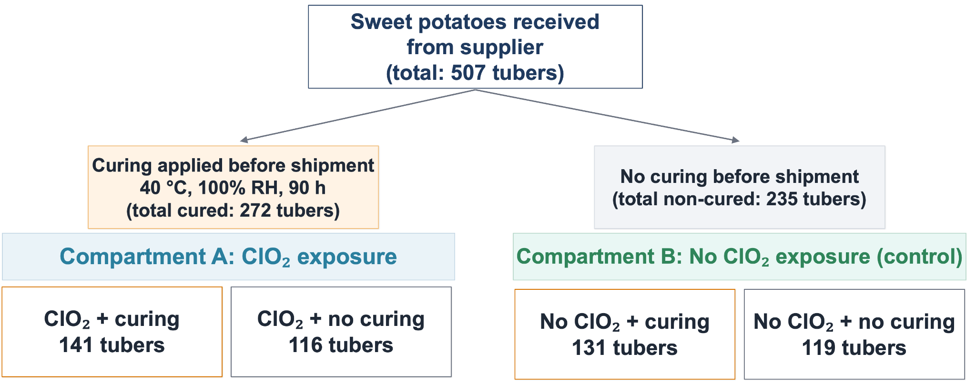
Fig. 1. Schematic diagram of the experimental setup.
Sweet potatoes were classified according to supplier-applied curing treatment (yes/no) and then stored in one of two warehouse compartments assigned to chlorine dioxide (ClO₂) exposure or no exposure. This created four study groups: ClO₂ with curing, ClO₂ without curing, no ClO₂ with curing, and no ClO₂ without curing. One compartment was used for each ClO₂ condition; therefore, there was no independent replication at the compartment level.

2.3 Chlorine dioxide exposure method
In the exposure area, an ultrasonic humidifier A (Mist Saver, Miyagawa Shoten Co., Ltd., Nagahama, Shiga, Japan) was installed as the chlorine dioxide gas spraying device, and a 30 mmol/L chlorine dioxide aqueous solution (prepared by dissolving sodium chlorite and citric acid in 30 L of purified water to achieve concentrations of 37.5 mmol/L and 10.0 mmol/L, respectively) was sprayed. The spray rate was set at 1 L/h (nominal value), and a cycle of 20 minutes of spraying followed by 100 minutes of standby was repeated under timer control. In addition, ultrasonic humidifier B (YX-L03810L, 520 Co., Ltd., Minato-ku, Tokyo, Japan) was filled with water and operated continuously for humidification. In the control area, chlorine dioxide gas was not sprayed, and only ultrasonic humidifier C (KWX-304, Doshisha Co., Ltd., Osaka, Japan) was operated continuously for humidification. Industrial fans were installed in both areas to continuously agitate the air. On day 14, ultrasonic humidifier A malfunctioned; the contingency measures and resulting concentration changes are described in Section 3.2.

2.4 Storage environmental conditions
The experimental layout is shown in Figure 1. The exposure area had internal dimensions of approximately 4 m × 10 m with a ceiling height of 3 m (gas-phase volume = 120 m³), and the control area had internal dimensions of approximately 2 m × 4 m with a ceiling height of 2 m (16 m³). The two areas were independent agricultural warehouses and were not interconnected. Mechanical ventilation was not performed in either area, and operation was conducted under practical warehouse conditions including opening and closing of entrances, loading, and human movement associated with routine work. Other agricultural products (e.g., yacon roots) were stored concurrently under these routine conditions.
As the experimental period (described below) occurred during winter, the exposure area was heated using an air conditioner and the control area was heated using an electric heater. Within each area, samples were further divided into two groups according to the presence or absence of curing treatment and were placed in perforated containers (49 cm × 33 cm × height 30 cm).
In both exposure and control areas, two temperature and relative humidity sensors (TR43A, T&D Corporation, Matsumoto, Nagano, Japan) were installed to measure and record temperature and humidity at 30-minute intervals. In the centre of the exposure area, a chlorine dioxide gas sensor (BW Solo ClO2, Honeywell, Charlotte, NC, USA) was installed to measure and record concentration at 1-minute intervals. These sensors were arranged according to the layout shown in Figure 2 and were used for continuous measurement. The positions of the sprayers, fans, and measurement devices were fixed and were not relocated during the observation period.

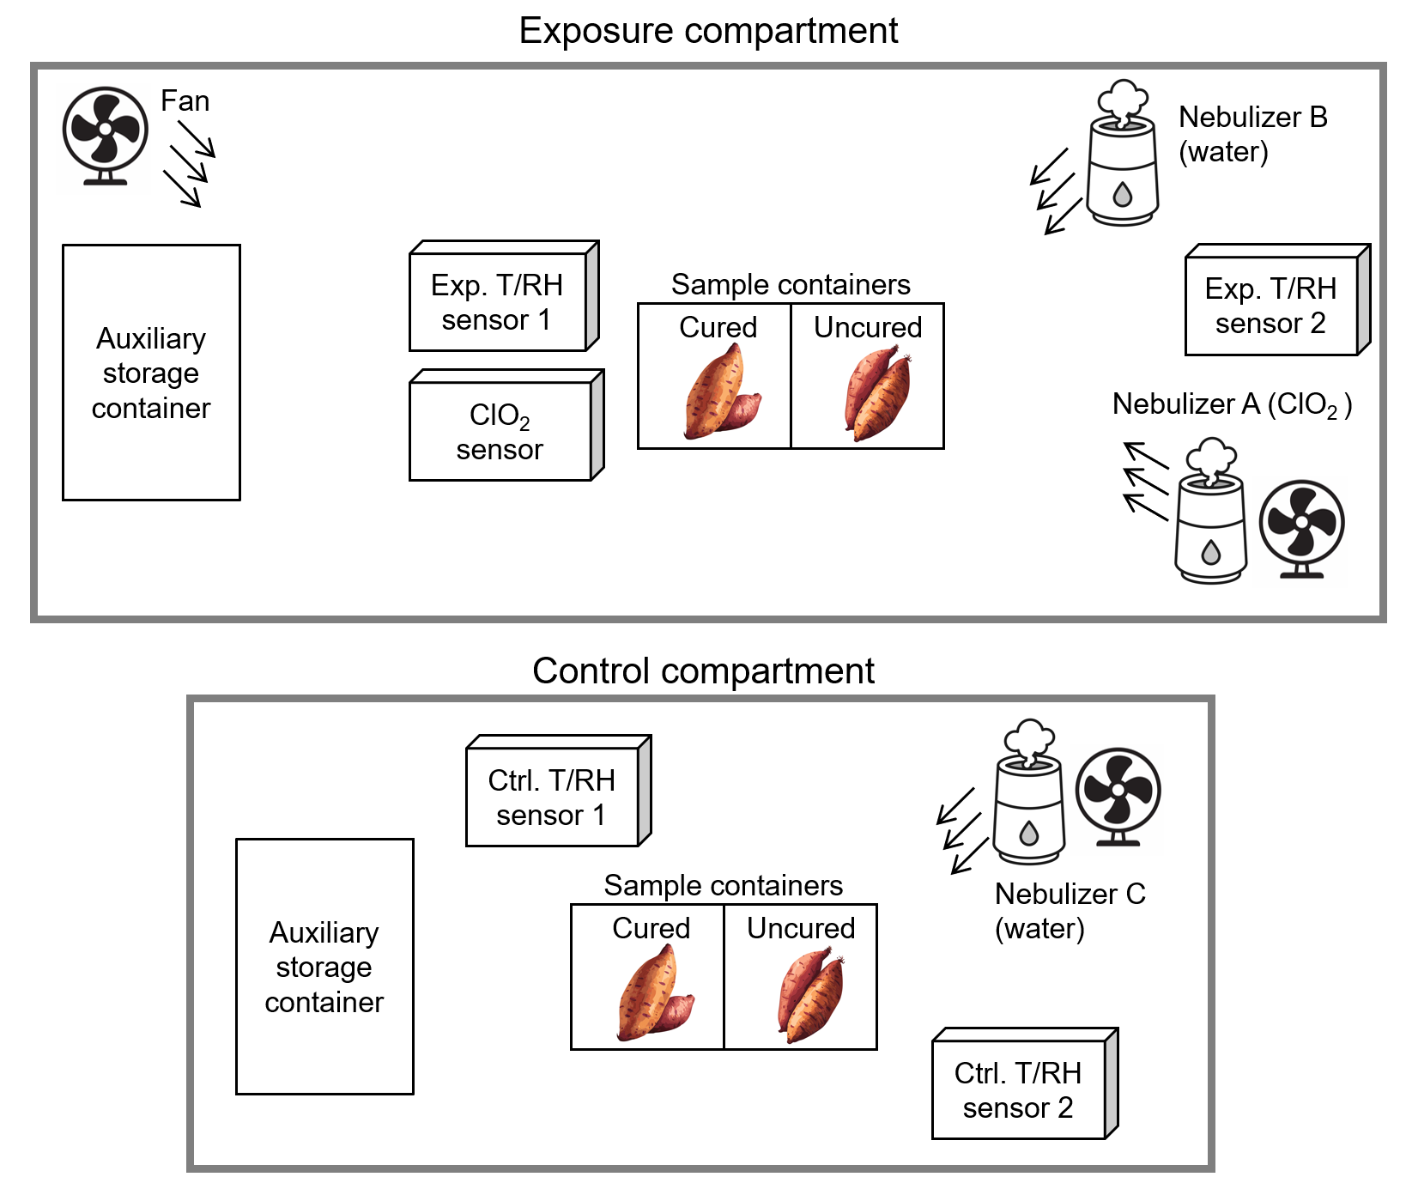
Fig. 2 Experimental environment
The ClO₂ exposure compartment (4 m × 10 m × 3 m; 120 m³) was equipped with a ClO₂ nebulizer (Na ClO₂ 37.5 mmol L⁻¹ and citric acid 10.0 mmol L⁻¹ in 30 L of pure water; spraying rate 1 L h⁻¹, operated in 20-min spray/100-min standby cycles) and fans for gas mixing. Cured and uncured ‘Beniharuka’ sweet potato samples (unwashed) were placed on racks with minimal tuber contact. Ambient conditions were logged with two temperature-and-relative-humidity sensors, hereafter referred to as Exp. T/RH sensor, in addition to ClO₂ sensor monitoring gas concentration. The control compartment (2 m × 4 m × 2 m; 16 m³) had no ClO₂ supply but was equipped with a water nebulizer to maintain comparable humidity levels and housed parallel cured and uncured samples. Environmental conditions were recorded by sensors, hereafter referred to as Ctrl. T/RH sensor. The experiment was conducted under routine warehouse conditions where other agricultural products (e.g., yacon roots used for storage purposes) were stored concurrently.

2.5 Spoilage assessment
During the experimental period, the condition of all samples was checked once per week, and spoilage was assessed by visual inspection and palpation. Assessment was performed by an experienced producer (25 years of agricultural experience), and the criterion was defined as a condition in which the tissue became soft and could be indented by finger pressure. The assessor was not blinded to treatment allocation. Samples judged to be spoiled were promptly removed from the area and excluded from subsequent observation.
The number of spoiled samples each week in each area and the number of remaining samples at the beginning of each week were recorded. The early distribution period (approximately within the first two weeks) was considered to be strongly influenced by mechanical injury during transport and initial individual variability, resulting in reduced detection power of treatment effects, therefore the primary analysis period was defined as Weeks 3–6. The risk set at the start of Week 3 was defined as the number of remaining samples after excluding those judged as spoiled during Weeks 1–2, and the number of newly spoiled samples during Weeks 3–6 was treated as events for calculating incidence.

2.6 Statistical analysis
The values from two temperature and humidity sensors installed in each area were averaged within each area and mean and median values were calculated for temperature and relative humidity. Between-group comparisons were performed using unpaired t-tests, and equivalence between groups was examined using the two one-side tests (TOST), with ±1 °C for temperature and ±5% for relative humidity defined as equivalence margins.
The primary analysis used data from Weeks 3–6, and a sensitivity analysis used cumulative incidence over Weeks 1–6. Effect sizes were expressed as risk ratios (RRs) with 95% confidence intervals. Between-group comparisons were performed using Fisher’s exact test. Stratified analyses were conducted to assess confounding and interaction, with adjusted RRs estimated using the Mantel–Haenszel method and homogeneity between strata evaluated using Woolf’s test. All tests were two-sided, with a significance level of 0.01. Statistical analyses were performed using Python 3.11.8, pandas 1.5.3, matplotlib 3.6.3, SciPy 1.14.1, and statsmodels 0.13.5.

3. results and discussion

3.1 Differences in storage environmental conditions (temperature and humidity)
Figure 3 shows the temperature trends in the exposure and control compartments during the observation period. The mean temperature in the exposure compartment (Exp. T/RH sensor) was 12.31 °C (median 12.50 °C), which was lower than that in the control compartment (Ctrl. T/RH sensor), with a mean of 14.25 °C (median 13.80 °C). An unpaired t-test indicated a difference between groups (P < .001). The TOST equivalence test showed that the values did not fall within the ±1 °C equivalence margin; therefore, the exposure compartment was operated under lower temperature conditions than the control.
Figure 4 shows the relative humidity trends in the exposure and control compartments. The mean relative humidity in the exposure compartment was 66.65% (median 66.00%), which was lower than that in the control compartment (mean 85.19%, median 86.00%). An unpaired t-test indicated a difference between groups (P < .001). The TOST equivalence test showed that the values did not fall within the ±5% equivalence margin; therefore, the exposure compartment was operated under lower humidity conditions than the control.
These differences in storage environment are relevant to the interpretation of the subsequent findings. Sweetpotatoes are generally recommended to be stored at around 13 °C and 85–90% relative humidity with adequate ventilation, and variation from these conditions may affect storability and quality (Edmunds et al., 2025). In this study, the exposure compartment was operated at a lower temperature and lower relative humidity than the control compartment. Therefore, these environmental differences should be considered as background conditions in the interpretation of the treatment-related results discussed below.
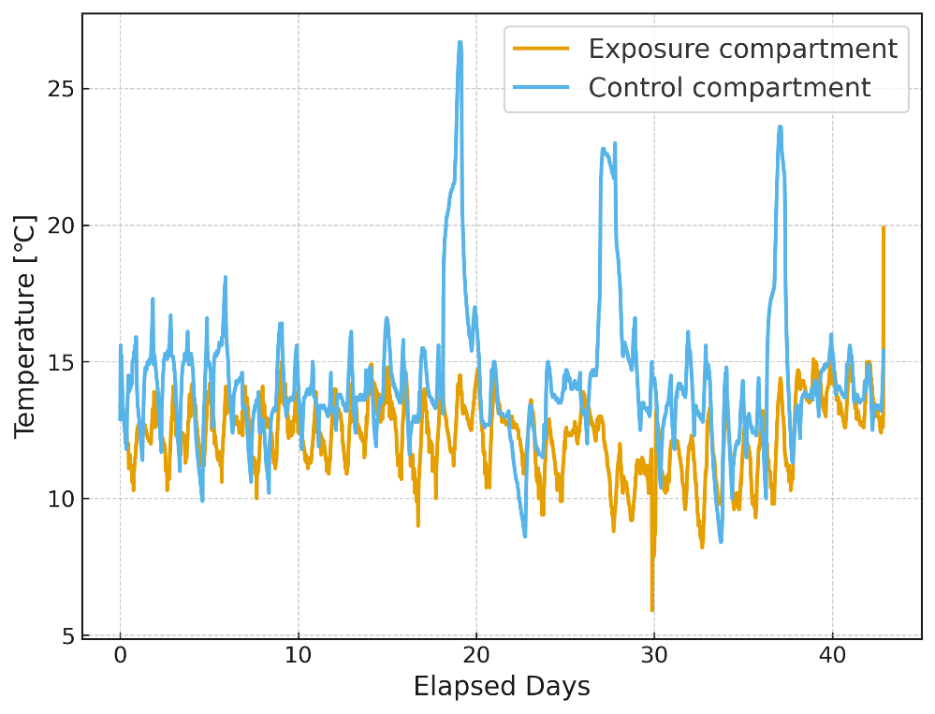
Fig. 3 Temperature time series in exposure and control compartments during the observation period
The ClO₂ exposure compartment (Exp. T/RH sensors 1–2) had a significantly lower temperature than the control compartment (Ctrl. T/RH sensors 1–2), with a mean of 12.3 °C (median, 12.5 °C) versus 14.3 °C (median, 13.8 °C). The difference was significant in an unpaired t-test (P < .001), and a TOST equivalence test confirmed that the two groups did not fall within the predefined ±1 °C equivalence margin. Thus, the exposure compartment was consistently operated under lower temperature conditions compared with the control.

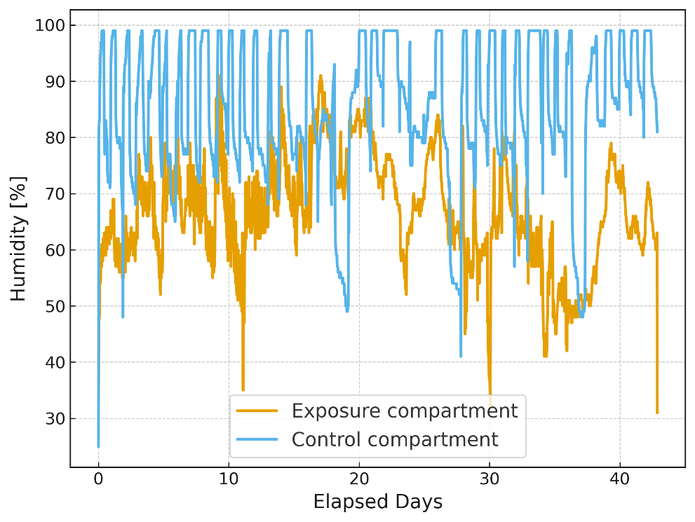
Fig. 4 Relative humidity time series in exposure and control compartments during the observation period
The mean relative humidity in the ClO₂ exposure compartment was 66.7% (median 66.0%), which was significantly lower than that in the control compartment (85.2%, median 86.0%). An unpaired t-test revealed a significant difference between compartments (P < .001), and a TOST equivalence test with a ±5% margin also indicated non-equivalence. Accordingly, the exposure compartment was maintained under drier conditions than the control, which may have contributed to differences in spoilage incidence.

3.2 ClO₂ concentration dynamics and C×t evaluation
The measurements obtained from the chlorine dioxide sensor installed in the exposure compartment are shown in Figure 5. On day 14 of the observation period, ultrasonic humidifier A malfunctioned and chlorine dioxide nebulisation stopped. Therefore, the installation locations of ultrasonic humidifiers B and C were exchanged, and chlorine dioxide aqueous solution was provisionally set in ultrasonic humidifier C to resume nebulisation. The spray rate of ultrasonic humidifier C was set at 100 mL/h (nominal value), which was approximately one-tenth of that of ultrasonic humidifier A (1 L/h, nominal). Accordingly, ultrasonic humidifier C was operated continuously without timer control.
In the overall observation period shown in Figure 5(a) (12 December 2024–24 January 2025), the mean concentration was 0.0214 ppm. However, the overall average appeared lower because the concentration markedly decreased after day 14 due to malfunction. The mean concentration during the first 14 days, when chlorine dioxide was sufficiently supplied, was 0.0389 ppm. The enlarged view of days 2–3 in Figure 5(b) shows a sawtooth concentration pattern corresponding to intermittent operation, confirming that the measurement functioned properly.
Compared with previous sweetpotato studies, the ClO₂ exposure achieved in the present study should be regarded as prolonged, very-low-level exposure under practical warehouse conditions rather than short-term fumigation at a fixed concentration. Lee et al. (2019) evaluated much higher gaseous ClO₂ concentrations, using 1–20 ppm for 0–60 min in vitro and 20–40 ppm for 0–60 min on inoculated roots, whereas Mitani et al. (2024) maintained lower but still sub-ppm concentrations of 500–1000 ppb in a container system for 3 days to 1 month. Lu et al. (2024) also examined ClO₂ fumigation against Ceratocystis fimbriata and black rot in in vitro and in vivo systems. In this context, the mean concentration during the first 14 days of the present study (0.0389 ppm) was lower than those reported in previous sweetpotato experiments, although the cumulative exposure (C×t) was within the same order of magnitude as some short-term treatments reported previously. Recent reviews have emphasized that the antimicrobial performance of ClO₂ depends strongly on application mode, concentration, and exposure time, and that practical implementation requires stable gas generation and concentration control. Therefore, the concentration profile observed in this study, including the intermittent sawtooth pattern during normal operation and the marked decline after humidifier malfunction, is informative in showing both the feasibility and the technical limitations of low-level ClO₂ delivery in a practical warehouse setting.

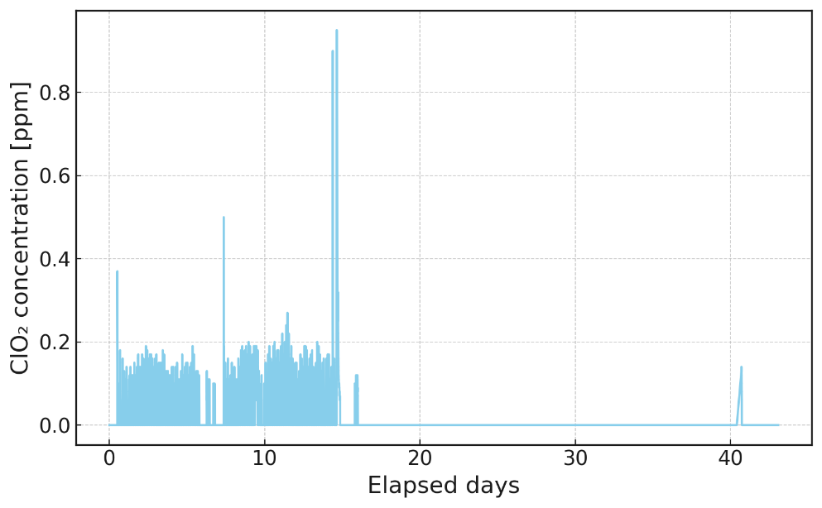
(a)
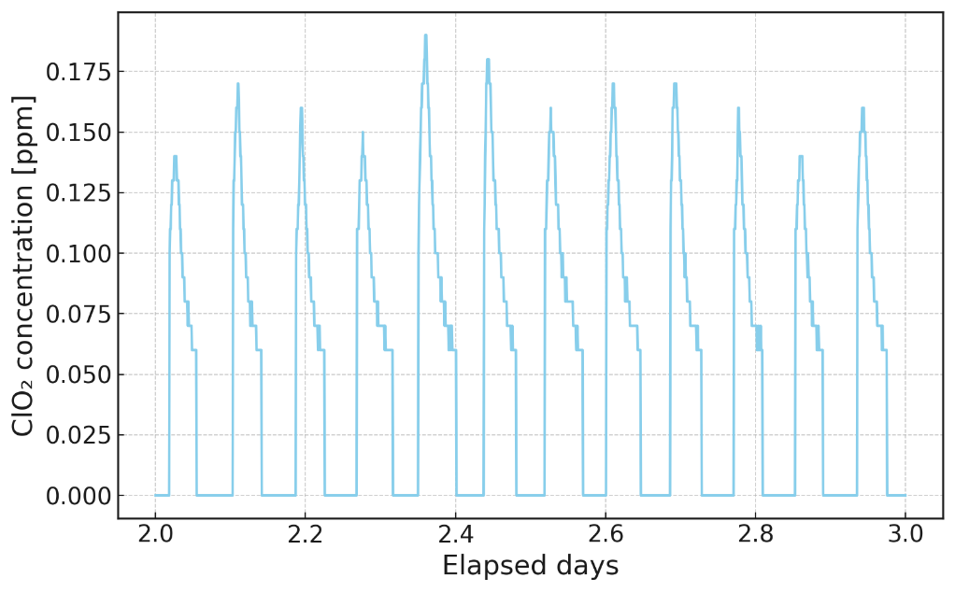
(b)
Fig. 5 ClO₂ concentration time series in the exposure compartment.
(a) Concentration dynamics throughout the entire observation period (December 12, 2024–January 24, 2025). Note that ClO₂ nebulization was unintentionally stopped after approximately day 14 due to a malfunction of the medium-sized ultrasonic humidifier, resulting in a decline of measured concentrations in the later period. (b) Enlarged view of days 2–3 to highlight short-term fluctuations.

3.3 Comparison of spoilage risk by treatment condition
Under the exposure concentration conditions described above, the association between treatment conditions and spoilage incidence was examined across four groups defined by the presence or absence of ClO₂ exposure and curing treatment. Weekly spoilage counts by group are shown in Table 1, and statistical results calculated from these counts are presented in Table 2.

Table 1 Weekly spoilage counts by ClO₂ exposure and curing status
Group | Initial N | Week 1 | Week 2 | Week 3 | Week 4 | Week 5 | Week 6
ClO₂ (+), Curing (+) | 141 | 0 | 11 | 2 | 1 | 1 | 4
ClO₂ (+), Curing (-) | 116 | 0 | 10 | 0 | 2 | 0 | 2
ClO₂ (-), Curing (+) | 131 | 0 | 8 | 15 | 7 | 8 | 10
ClO₂ (-), Curing (-) | 119 | 0 | 7 | 5 | 10 | 1 | 2
“Initial N” denotes the number of tubers allocated to each group at baseline (post-transport). “Week 1” – “Week 6” are incident spoilage counts newly identified in each week; once classified as spoiled (soft on finger pressure by a trained assessor), samples were removed and did not contribute to subsequent weeks. Group codes: ClO₂ (+) = stored under chlorine dioxide exposure; ClO₂ (-) = no exposure; Curing (+) = cured prior to storage; Curing (-) = no curing. Operational parameters are specified in Methods. All samples were ‘Beniharuka’ sweet potatoes (unwashed), harvested from a single lot and stored from mid-December 2024 to late-January 2025 under real-world warehouse conditions.

Table 2 Summary of statistical tests for spoilage risk and cumulative incidence
Analysis Type | Comparison | Data | RR  (95% CI) | P-values
Primary  (Weeks 3–6) | ClO₂ (+) vs ClO₂ (-) | 12/236 vs 58/235 | 0.206 (0.114–0.373) | P < .001
Primary  (Weeks 3–6) | Curing (+) vs Curing (-) | 48/253 vs 22/218 | 1.88 (1.17–3.01) | P = .009
Sensitivity (Weeks 1–6 cumulative) | ClO₂ (+) vs ClO₂ (-) | 33/257 vs 73/250 | 0.440 (0.303–0.638) | P < .001
 | Curing (+) vs Curing (-) | 67/272 vs 39/235 | 1.48  (1.04–2.11) | P = .029
Stratified (MH) | ClO₂ effect stratified by curing | — | 0.203 (0.112–0.367) | Woolf’s test P = .56
"Primary analysis" covers Weeks 3–6; "Sensitivity analysis" covers Weeks 1–6 cumulative. "Data" shows spoiled/at-risk tubers. RR < 1 = spoilage-suppressive; RR > 1 = increased risk. All tests two-sided, α = 0.01.

During the primary analysis period (Weeks 3–6), the spoilage incidence was lower in the ClO₂ exposure group than in the non-exposure group (12/236 vs 58/235; RR = 0.206, 95% CI 0.114–0.373; Fisher’s exact test P < .001). In contrast, spoilage incidence was higher in the curing group than in the non-curing group (48/253 vs 22/218; RR = 1.88, 95% CI 1.17–3.01; Fisher’s exact test P =.009).
Sensitivity analysis (Weeks 1–6 cumulative) showed a broadly similar pattern. ClO₂ exposure was associated with lower cumulative spoilage incidence (33/257 vs 73/250; RR = 0.440, 95% CI 0.303–0.638; Fisher’s exact test P < .001). Curing treatment was also associated with higher cumulative spoilage incidence (67/272 vs 39/235; RR = 1.48, 95% CI 1.04–2.11; Fisher's exact test P = .029), although this did not reach the α = 0.01 significance level.
Stratified analysis was conducted to assess confounding and interaction. The stratified RR for ClO₂ exposure did not differ substantially according to curing status (Mantel–Haenszel method adjusted RR = 0.203, 95% CI 0.112–0.367, Woolf’s test P = .56). Similarly, the stratified RR for curing did not differ substantially according to ClO₂ exposure status (Mantel–Haenszel method adjusted RR = 1.96, 95% CI 1.24–3.09, Woolf’s test P = .56). These findings suggest no marked interaction between the two treatments.
The lower spoilage risk observed in the ClO₂ exposure group is broadly consistent with recent studies showing that gaseous or fumigation-based ClO₂ can suppress important postharvest pathogens of sweet potato. Lee et al. (2019) reported inhibitory effects of gaseous ClO₂ against Diaporthe batatas, Mitani et al. (2024) showed that continuous exposure to low-concentration gaseous ClO₂ reduced Rhizopus stolonifer growth during storage, and Lu et al. (2024) demonstrated that ClO₂ fumigation inhibited Ceratocystis fimbriata and reduced black rot development. Recent reviews have also emphasized that the antimicrobial performance of ClO₂ depends on application mode, concentration, exposure time, and target microorganism (Zhu et al., 2024). In this context, the present findings support the possibility that prolonged low-level ClO₂ exposure may contribute to suppression of spoilage under storage conditions. In the present study, ClO₂ was supplied continuously at a low mean concentration for more than 14 days before equipment malfunction, suggesting that prolonged exposure may be relevant even when the nominal concentration is low. However, the exposure compartment was also operated at a lower temperature and markedly lower relative humidity than the control compartment. Compared with the recommended storage temperature and relative humidity (~13 °C and 85–90%) for sweetpotatoes storage, the lower temperature and humidity in the exposure compartment may have reduced pathogen activity and disease spread, whereas the lower humidity may also have increased the risk of water loss and quality deterioration (Edmunds et al., 2025; Makungu et al., 2021). Therefore, the lower spoilage risk observed in the ClO₂ group cannot be attributed to ClO₂ exposure alone.
By contrast, the higher spoilage risk observed in the curing group was not in the expected direction based on previous sweet potato studies. Curing is generally considered beneficial because it promotes wound healing in storage roots, thereby reducing susceptibility to pathogen invasion (Ji et al., 2022; Park et al., 2025). However, recent studies also indicate that the effect of curing is not uniform and may vary depending on cultivar and treatment conditions. Schultheis et al. (2026) demonstrated cultivar-dependent responses to curing conditions, and Kaneta et al. (2021) reported that the effect of curing depended on the temperature-time combination, with limited benefit at 35 °C for 72 h but greater effectiveness at 42 °C for 36 h. The curing condition used in the present study (40 °C, 100% RH, 90 h) followed the supplier’s standard commercial protocol and differed from the regimens used in previous controlled studies. This difference in treatment regimen may partly explain why the observed association was not consistent with the generally protective effect of curing reported in the literature, because recent studies suggest that the effects of curing can vary with both treatment conditions and cultivar (Kaneta et al., 2021; Schultheis et al., 2026). Therefore, the unexpected association between curing and higher spoilage incidence should be interpreted cautiously, as the present result may reflect uncontrolled variation under practical commercial conditions, including lot-specific differences, environmental heterogeneity within compartments, and possible differences in initial tuber condition, rather than a uniformly adverse effect of curing itself.
The stratified analysis did not suggest marked interaction between ClO₂ exposure and curing treatment. Potential contributions of storage-environment differences and study-design limitations to these associations are considered separately in the following section.

3.4 Confounding and study limitations
Interpretation of the treatment-associated spoilage risk should be made in the context of substantial environmental differences between the two storage compartments. Recent sweet potato studies indicate that storage environments are associated with differences in both fungal community structure and product quality, and recent reviews of sweet potato black rot further show that temperature, humidity, and wounding influence disease dispersal (Li et al., 2023; Liu et al., 2023). Since the ClO₂ compartment and the control compartment differed in volume, temperature, and relative humidity, the present study cannot fully disentangle the association with ClO₂ exposure from compartment-specific environmental effects. Although stratified analysis suggested a similar direction of association, separation of the ClO₂ exposure effect from environmental effects remains difficult. This issue is particularly important because previous sweet potato studies on gaseous or fumigation-based ClO₂ were performed under defined container or inoculation systems with tighter environmental control (Lee et al., 2019; Mitani et al., 2024; Lu et al., 2024).
A further limitation is the lack of microbiological identification. Recent sweet potato studies have evaluated specific pathogens such as Rhizopus stolonifer, Diaporthe batatas, and Ceratocystis fimbriata, or have directly characterized storage-associated fungal communities (Lee et al., 2019; Mitani et al., 2024; Lu et al., 2024; Li et al., 2023). By contrast, the causative microorganisms in the present study were not isolated or identified; therefore, the mechanism of spoilage suppression remains speculative, and the results cannot be linked to pathogen-specific susceptibility. Moreover, the presence of other stored root crops may have contributed to the background microbial load, and cross-contamination via airborne or contact-mediated transmission of storage fungi cannot be excluded. Comparison with minimum inhibitory concentrations for major sweet potato pathogens would be needed to evaluate whether the observed ClO₂ levels were sufficient for direct antimicrobial activity.
In addition, baseline tuber condition was not formally quantified before storage. Therefore, pre-existing differences in wound status, physiological condition, or latent infection among treatment lots cannot be excluded as contributing factors to the observed spoilage outcomes. This study was also limited by pseudoreplication, because each ClO₂ condition was assigned to a single warehouse compartment without independent replication. As a result, the reported P-values and confidence intervals are likely anti-conservative. Moreover, the experiment consisted of a single storage run conducted from 12 December 2024 to 24 January 2025 and did not include independent temporal replication. Therefore, the observed differences among treatment groups may also reflect batch- or season-specific conditions. In addition, treatment allocation was constrained by commercial handling and warehouse logistics rather than by full randomization, which may have introduced further uncontrolled variation among groups. Spoilage assessment was conducted by a single unblinded assessor, and ClO₂ supply declined markedly after nebuliser malfunction. Accordingly, the present findings should be interpreted as hypothesis-generating observations from a pilot warehouse study rather than definitive estimates of independent treatment effects.

3.5 Practical implications and future optimisation
From a practical perspective, the present pilot study suggests that prolonged very-low-level gaseous ClO₂ delivery in a warehouse setting is technically feasible, but that engineering stability is critical. In practical application, this includes reliable gas generation, continuous delivery, and routine monitoring to maintain the intended exposure profile throughout storage (Zhu et al., 2024; Thakur et al., 2026). Since ClO₂ delivery declined after nebuliser malfunction, the present study cannot determine whether a stable exposure profile maintained throughout the storage period would have produced a stronger or more sustained protective effect. Recent reviews emphasize that the postharvest performance of ClO₂ depends not only on nominal concentration but also on application mode, exposure time, target microorganism, and the stability of gas generation and controlled delivery (Zhu et al., 2024; Thakur et al., 2026). In the present study, the mean concentration during the first 14 days was below the current OSHA exposure limits for chlorine dioxide (8-h TWA 0.1 ppm; STEL 0.3 ppm), which supports the practical relevance of exploring low-level exposure strategies for storage environments (OSHA, 2024). This also indicates that measurable low-level exposure was achievable under commercial warehouse conditions, at least during the initial phase before equipment malfunction. However, because earlier sweet potato studies demonstrating efficacy were conducted under controlled experimental systems (Lee et al., 2019; Mitani et al., 2024; Lu et al., 2024), translation to commercial storage practice requires further validation.
Future studies should therefore adopt replicated factorial designs under matched environmental control, ideally using climate-controlled chambers or warehouse compartments of identical volume. They should also incorporate culture-based isolation and molecular identification of dominant spoilage fungi and bacteria, so that treatment effects can be interpreted in relation to actual target organisms. In addition, future optimisation should consider ClO₂ concentration, exposure duration, temperature, relative humidity, and curing conditions together, while monitoring both spoilage and quality traits, because recent studies indicate that curing contributes to wound healing and postharvest quality maintenance, and that sweetpotato responses to curing may vary with cultivar and storage context (Park et al., 2025; Schultheis et al., 2026). Such an approach would provide a stronger basis for defining practical operating conditions that balance spoilage suppression, product quality, and worker safety.

4. Conclusion
This study evaluated the potential of low-concentration chlorine dioxide gas exposure and curing treatment for suppressing sweet potato spoilage under practical warehouse conditions. Low-concentration chlorine dioxide gas exposure was associated with reduced spoilage incidence, whereas curing treatment under the present conditions did not show a protective effect. However, because environmental conditions differed between compartments and the experiment used a non-replicated design, the independent effect of chlorine dioxide could not be conclusively determined. Future studies should optimise chlorine dioxide concentration, temperature, humidity, and curing duration under controlled and replicated conditions to isolate treatment effects and define operational parameters that balance spoilage suppression and quality maintenance.

Disclaimer (Artificial intelligence)

Author(s) hereby declare that generative AI technologies such as Large Language Models, etc. have been used during the writing or editing of manuscripts. This explanation will include the name, version, model, and source of the generative AI technology and as well as all input prompts provided to the generative AI technology
Details of the AI usage are given below:

The authors acknowledge the use of ChatGPT (OpenAI) for limited language editing and text refinement during manuscript preparation. All scientific content and final wording were reviewed and approved by the authors.

Competing interests AND Funding
This study was supported by research funding from NSW Inc. Some authors are employees of NSW Inc.; however, the company had no role in the study design, data analysis, or interpretation of the results.

References
- Edmunds, B. A., Boyette, M. D., Clark, C. A., Ferrin, D. M., Smith, T. P., & Holmes, G. J. (2025). Postharvest handling of sweetpotatoes: NC State Extension Publications. https://content.ces.ncsu.edu/postharvest-handling-of-sweetpotatoes
- Ray, R. C., & Ravi, V. (2005). Post harvest spoilage of sweetpotato in tropics and control measures: Critical Reviews in Food Science and Nutrition, 45(7–8), 623–644. https://doi.org/10.1080/10408390500455516
- Paul, N. C., Park, S., Liu, H., Lee, J. G., Han, G. H., Kim, H., & Sang, H. (2021). Fungi associated with postharvest diseases of sweet potato storage roots and in vitro antagonistic assay of Trichoderma harzianum against the diseases: Journal of Fungi, 7(11), 927. https://doi.org/10.3390/jof7110927
- Wu, J., Zhang, J., Ni, W., Xu, X., George, M., & Lu, G. (2023). Effect of heat treatment on the quality and soft rot resistance of sweet potato during long-term storage: Foods, 12(23), 4352. https://doi.org/10.3390/foods12234352
- Kaneta, T., Nakamura, N., Shiina, T., & Baba, T. (2021). High-temperature curing treatment improves storage stability of sweet potato ‘Kokei No.14’ (Naruto-Kintoki): Food Preservation Science, 47(2), 67–75. https://doi.org/10.5891/jafps.47.67
- Yu, G.-D., Lee, H.-U., Nam, S.-S., Hwang, U.-J., Yang, J.-W., Paul, N. C., Lee, K.-B., Ko, S., & Kang, Y.-G. (2018). Difference of storability according to the curing treatment in Korean sweetpotato varieties: Journal of the Korean Society of International Agriculture, 30(1), 44–50. https://doi.org/10.12719/KSIA.2018.30.1.44
- Schultheis, J. R., LaBonte, D. R., Clark, C. A., Holmes, G. J., Yencho, G. C., & Pecota, K. V. (2026). Cultivars and curing conditions affect sweetpotato chilling injury: HortScience, 61(3), 640–646. https://doi.org/10.21273/HORTSCI19180-25
- Makungu, V., Wandayi, O. M., & Elizabeth, W. (2021). Effect of washing, packaging material and storage period on the quality of sweetpotato roots: East African Journal of Science, Technology and Innovation, 2. https://doi.org/10.37425/eajsti.v2i.340
- Zhu, X., Hui, S., Huang, H., Liu, R., Wang, S., & Huang, C. (2024). Antimicrobial mechanism of chlorine dioxide and its impacts on postharvest management in horticultural produce: A review. Postharvest Biology and Technology, 213, 112921. https://doi.org/10.1016/j.postharvbio.2024.112921
- Ji, C. Y., Kim, Y.-H., Lee, C.-J., Park, S.-U., Lee, H.-U., Kwak, S.-S., & Kim, H. S. (2022). Comparative transcriptome profiling of sweetpotato storage roots during curing-mediated wound healing: Gene, 833, 146592. https://doi.org/10.1016/j.gene.2022.146592
- Mitani, R., Yamanaka, H., Ishigaki, Y., Nakayama, D., Sakamoto, M., Watanabe, C., Mori, T., & Okuda, T. (2024). Microbiostatic effect of indoor air quality management with low-concentration gaseous chlorine dioxide on fungal growth: Asian Journal of Atmospheric Environment, 18(1), Article 24. https://doi.org/10.1007/s44273-024-00047-8
- Lee, Y. J., Jeong, J.-J., Jin, H., Kim, W., Yu, G.-D., & Kim, K. D. (2019). In vitro and in vivo inhibitory effects of gaseous chlorine dioxide against Diaporthe batatas isolated from stored sweetpotato: The Plant Pathology Journal, 35(1), 77–83. https://doi.org/10.5423/PPJ.OA.09.2018.0184
- Lu, X., Yu, S., Yu, B., Chen, L., Wang, Y., Huang, Y., Lu, G., Cheng, J., Guan, Y., Yin, L., Yang, M., & Pang, L. (2024). Biochemical mechanism of chlorine dioxide fumigation in inhibiting Ceratocystis fimbriata and black rot in postharvest sweetpotato: Food Chemistry, 461, 140952. https://doi.org/10.1016/j.foodchem.2024.140952
- Luu, P., Chhetri, V. S., Janes, M. E., King, J. M., & Adhikari, A. (2020). Effectiveness of aqueous chlorine dioxide in minimizing food safety risk associated with Salmonella, E. coli O157:H7, and Listeria monocytogenes on sweet potatoes: Foods, 9(9), 1259. https://doi.org/10.3390/foods9091259
- Park, S.-U., Ji, C.-Y., Lee, K.-L., Nam, K. J., Kim, H. S., & Kim, Y.-H. (2025). Post-harvest curing treatment maintains the quality of sweetpotato storage roots by regulating reactive oxygen species homeostasis and nitric oxide metabolism: Plant Biotechnology Reports, 19, 961–970. https://doi.org/10.1007/s11816-025-00994-w
- Scruggs, A. C., & Quesada-Ocampo, L. M. (2016). Cultural, chemical, and alternative control strategies for Rhizopus soft rot of sweetpotato: Plant Disease, 100(8), 1532–1540. https://doi.org/10.1094/PDIS-01-16-0051-RE
- Li, L., Sun, H.-N., Zhang, M., Mu, T.-H., Khan, N. M., Ahmad, S., & Validov, S. Z. (2023). Fungal communities, nutritional, physiological and sensory characteristics of sweet potato under three Chinese representative storages: Postharvest Biology and Technology, 201, 112366. https://doi.org/10.1016/j.postharvbio.2023.112366
- Liu, M., Meng, Q., Wang, S., Yang, K., & Tian, J. (2023). Research progress on postharvest sweet potato spoilage fungi Ceratocystis fimbriata and control measures: Food Bioscience, 53, 102627. https://doi.org/10.1016/j.fbio.2023.102627
- Thakur, S., Rani, R., Junaid, P. M., Sharma, R., Mohanta, G. C., Nayak, M. K., & Patel, M. K. (2026). A critical review of chlorine dioxide as a versatile food preservative: Mechanisms, generation methods, potential applications, opportunities, and challenges: Food and Bioprocess Technology, 19, 196. https://doi.org/10.1007/s11947-026-04279-0
- Occupational Safety and Health Administration (OSHA). (2024). Chlorine dioxide. https://www.osha.gov/chemicaldata/16

