Physicochemical characterization and evaluation of antibiofilm activity against nosocomial pathogens

Abstract
Zinc oxide nanoparticles (ZnO NPs) were biosynthesized using Eucalyptus globulus essential oil as a green stabilizing agent and zinc acetate dihydrate as the precursor. The synthesized ZnO NPs were characterized by X-ray diffraction (XRD), Fourier transform infrared spectroscopy (FTIR), UV–Visible spectroscopy, dynamic light scattering (DLS), scanning electron microscopy (SEM), transmission electron microscopy (TEM), and energy dispersive X-ray spectroscopy (EDS). XRD analysis confirmed the formation of crystalline hexagonal wurtzite ZnO with an average crystallite size of ~24 nm.
The antibacterial activity of ZnO NPs was evaluated against clinically isolated nosocomial pathogens using agar well diffusion and broth microdilution methods. The nanoparticles exhibited broad-spectrum antibacterial activity, with minimum inhibitory concentration (MIC) values ranging from 0.5 to 128 µg/mL. Antibiofilm activity was assessed using a 96-well microtiter plate assay against Escherichia coli and Pseudomonas aeruginosa. The ZnO NPs significantly inhibited biofilm formation in a concentration-dependent manner, with maximum inhibition of 95% against E. coli and 97% against P. aeruginosa. Overall, the findings demonstrate that Eucalyptus globulus essential oil-mediated ZnO nanoparticles represent an eco-friendly and effective antibiofilm agent with potential applications in controlling nosocomial infections.

Keywords: Green synthesis; Eucalyptus globulus; Zinc oxide nanoparticles (ZnO NPs); Nosocomial pathogens; Antibacterial activity; Antibiofilm activity

1. Introduction

The rapid emergence of antimicrobial resistance (AMR), largely driven by excessive and inappropriate use of antibiotics, has become a major global health concern and a significant contributor to hospital-acquired (nosocomial) infections. AMR is associated with prolonged hospitalization, increased healthcare costs, and higher morbidity and mortality worldwide [1,2]. In addition, many clinically important pathogens possess the ability to form biofilms, which are structured microbial communities embedded in an extracellular polymeric matrix. Biofilm-associated infections are particularly difficult to treat because they promote persistent colonization, enhance resistance to antimicrobial agents, and facilitate immune evasion [3,4]. Therefore, there is an urgent need to develop alternative antimicrobial strategies that can effectively overcome resistance mechanisms and inhibit biofilm formation.

Nanomaterials have emerged as promising candidates for antimicrobial applications due to their unique physicochemical properties, including nanoscale size, high surface area, and tunable morphology, which enable strong interactions with microbial cells [5,6]. Among them, zinc oxide nanoparticles (ZnO NPs) have attracted considerable attention because of their broad-spectrum antibacterial activity, chemical stability, cost-effectiveness, and relatively good biocompatibility [7,8]. ZnO NPs are known to inhibit microbial growth and biofilm formation through multiple mechanisms, such as reactive oxygen species (ROS) generation, membrane disruption, and interference with microbial adhesion and quorum sensing [9,10].

Conventional methods for synthesizing ZnO nanoparticles, including sol–gel, coprecipitation, and hydrothermal techniques, can provide controlled synthesis; however, these approaches often involve toxic chemicals, high energy consumption, and environmental concerns [11–13]. In contrast, green synthesis using biological resources has emerged as an eco-friendly and sustainable alternative. Plant extracts and essential oils are particularly attractive for nanoparticle synthesis due to their rich content of bioactive compounds, such as phenolics, flavonoids, and terpenoids, which can act as reducing and stabilizing agents under mild conditions [14–16].

Eucalyptus globulus (Myrtaceae), commonly known as blue gum, is a medicinal plant with well-documented antimicrobial, antioxidant, and antibiofilm properties. Its essential oil is rich in 1,8-cineole (eucalyptol), along with α-pinene, globulol, and other oxygenated monoterpenes, which contribute to its biological activity [17–20]. The use of Eucalyptus globulus essential oil in nanoparticle synthesis offers a dual advantage by enabling eco-friendly fabrication while imparting bioactive surface properties to the nanoparticles.

Accordingly, the present study aimed to synthesize ZnO nanoparticles using Eucalyptus globulus essential oil as a green stabilizing agent and to characterize the synthesized nanoparticles using XRD, FTIR, UV–Visible spectroscopy, SEM, TEM, DLS, and EDS. Furthermore, the antibacterial and antibiofilm activities of the ZnO nanoparticles were evaluated against clinically isolated nosocomial pathogens.

2. Materials and Methods

2.1. Chemicals and reagents

Zinc acetate dihydrate (Zn(CH₃COO)₂·2H₂O, ≥99%) and acetone (≥99.5%) were purchased from Sigma-Aldrich (USA). All reagents used were of analytical grade, and solutions were prepared using deionized water. Mueller–Hinton agar (MHA) and Mueller–Hinton broth (MHB) were used for antimicrobial assays in accordance with standard microbiological guidelines [21,22].

2.2. Plant material and essential oil extraction
Fresh leaves of Eucalyptus globulus were collected in April 2024. The essential oil was extracted by hydrodistillation using a Clevenger-type apparatus, which is a widely used and standardized method for isolating volatile oils from medicinal plants [23]. Briefly, 300 g of fresh leaves were subjected to hydrodistillation for 6 h, yielding approximately 3 mL of essential oil. The collected oil was dehydrated using anhydrous sodium sulfate, transferred to amber vials, and stored at 4 °C until further use in nanoparticle synthesis.

2.3. GC–MS profiling of Eucalyptus globulus essential oil
The chemical composition of the essential oil was analyzed using GC–MS. Separation was carried out on an HP-5MS column (30 m × 0.25 mm; 0.25 µm). The oven temperature was programmed from 50 to 300 °C at 2 °C/min. Helium was used as the carrier gas (0.8 mL/min). Compounds were identified by comparison with NIST library spectra and retention indices [24,25].
2.4. Green synthesis of ZnO nanoparticles using Eucalyptus globulus essential oil
Zinc oxide nanoparticles (ZnO NPs) were synthesized using Eucalyptus globulus essential oil as a natural stabilizing and surface-functionalizing agent. Zinc acetate dihydrate was used as the precursor due to its high solubility and suitability for plant-mediated ZnO synthesis [26–28]. The essential oil was diluted in acetone (1:170, v/v) and added dropwise to the zinc precursor solution under continuous magnetic stirring. The reaction mixture was maintained at 100 °C and adjusted to pH 7. The formation of ZnO nanoparticles was indicated by a visible color change to light yellow, consistent with previous reports of green synthesis of ZnO nanoparticles [26,29].
The resulting mixture was centrifuged at 8000 rpm for 10 min, and the obtained precipitate was washed several times with deionized water to remove residual impurities. The product was then dried at 100 °C and calcined at 550 °C for 5 h to enhance crystallinity and remove organic residues, as reported in earlier studies [27,30,31].

2.5. Physicochemical characterization of ZnO nanoparticles
2.5.1. X-ray diffraction (XRD)
X-ray diffraction (XRD) analysis was performed to determine the crystalline structure and phase purity of the synthesized ZnO nanoparticles. Diffraction patterns were recorded over a 2θ range of 20–80°. The average crystallite size was calculated using the Debye–Scherrer equation, which is widely applied for estimating the size of nanocrystalline materials [32].
2.5.2. Fourier transform infrared spectroscopy (FTIR)
Fourier transform infrared (FTIR) spectroscopy was carried out in the range of 400–4000 cm⁻¹ to identify functional groups and confirm Zn–O bond formation. The analysis also provided information on phytochemical compounds associated with nanoparticle surface capping, as commonly reported in plant-mediated ZnO nanoparticle synthesis [26,33].
2.5.3. UV–Visible spectroscopy
UV–Visible spectroscopy was used to evaluate the optical properties of the synthesized ZnO nanoparticles. Spectra were recorded in the wavelength range of 200–800 nm to confirm the characteristic absorption band of ZnO nanoparticles in the UV region, consistent with previously reported studies [34].
2.5.4. Dynamic light scattering (DLS)
The hydrodynamic size distribution of ZnO nanoparticles was determined using dynamic light scattering (DLS). The nanopowder was dispersed in deionized water followed by sonication to minimize aggregation. DLS is widely employed for assessing particle size distribution and colloidal stability in suspension [35].
2.5.5. Scanning electron microscopy (SEM) and EDS
The surface morphology and structural features of ZnO nanoparticles were examined using scanning electron microscopy (SEM). Elemental composition and purity were further analyzed using energy dispersive X-ray spectroscopy (EDS), which confirms the presence of Zn and O and detects possible impurities [36].
2.5.6. Transmission electron microscopy (TEM)
Transmission electron microscopy (TEM) analysis was conducted to obtain detailed information on nanoparticle morphology and primary particle size. The ZnO nanopowder was dispersed in ethanol, sonicated, and drop-cast onto carbon-coated copper grids prior to imaging. TEM is considered one of the most reliable techniques for nanoscale structural characterization [37].
2.6. Bacterial strains and culture conditions
All bacterial strains used in this study were clinical isolates presumed to be responsible for nosocomial infections. Isolates were obtained from clinical specimens and hospital environmental sources. Cultures were maintained on Mueller–Hinton agar and subcultured in Mueller–Hinton broth at 37 °C before antimicrobial and antibiofilm experiments, following standard clinical microbiology practices [21,22].
2.7. Antibacterial activity assays
2.7.1. Agar well diffusion assay
The antibacterial activity of ZnO nanoparticles was initially evaluated using the agar well diffusion method. Fresh bacterial cultures of Escherichia coli and Pseudomonas aeruginosa were adjusted to a 0.5 McFarland standard and uniformly spread onto Mueller–Hinton agar (MHA) plates. Wells of 6 mm diameter were prepared using a sterile cork borer, and ZnO nanoparticle suspensions were carefully introduced into each well. The plates were incubated at 37 °C for 24 h, after which the zones of inhibition were measured in millimeters. All experiments were performed in triplicate. This method is widely used as a preliminary screening technique for evaluating the antibacterial activity of nanomaterials [38,39].
2.7.2. Minimum inhibitory concentration (MIC)
The minimum inhibitory concentration (MIC) of ZnO nanoparticles was determined using the broth microdilution method in sterile 96-well microplates, following CLSI/EUCAST guidelines [21,22]. Twofold serial dilutions of ZnO nanoparticle suspensions were prepared in Mueller–Hinton broth. Standardized bacterial inocula (0.5 McFarland) were added to each well and incubated at 37 °C for 18–24 h. MIC was defined as the lowest concentration of ZnO nanoparticles that showed no visible bacterial growth. All assays were carried out in triplicate to ensure reproducibility.
2.8. Antibiofilm assay (crystal violet microtiter plate method)
The antibiofilm activity of ZnO nanoparticles was evaluated using the crystal violet microtiter plate assay, a widely accepted method for quantifying total biofilm biomass [40,41]. Briefly, standardized bacterial suspensions of E. coli and P. aeruginosa were inoculated into sterile 96-well plates and treated with different concentrations of ZnO nanoparticles. The plates were incubated at 37 °C for 24 h to allow biofilm formation.
Following incubation, the planktonic cells were carefully removed, and the wells were gently washed with sterile phosphate-buffered saline (PBS) to remove non-adherent cells. The remaining biofilms were stained with 0.1% crystal violet for 15 min, followed by washing to remove excess stain. The bound dye was then solubilized using ethanol, and absorbance was measured at 570 nm using a microplate reader. Biofilm inhibition (%) was calculated relative to untreated control wells. All experiments were conducted in triplicate.

2.9 Statistical Analysis
All experiments were performed in triplicate, and the results are expressed as mean ± standard deviation (SD).
3. Results
3.1. GC–MS chemical profiling of Eucalyptus globulus essential oil
GC–MS analysis revealed that the essential oil of Eucalyptus globulus comprised a complex mixture of volatile compounds, with seventeen constituents identified, accounting for 99.7% of the total composition (Table 1). The oil was predominantly composed of oxygenated monoterpenes, with 1,8-cineole (eucalyptol) as the major component (56.83%). Other significant constituents included L-pinocarveol (10.42%), α-pinene (9.47%), and globulol (7.69%). Minor components such as p-cymene (3.80%), γ-terpinene (2.40%), 4-terpineol (1.70%), carvacrol (1.59%), and α-terpineol (1.50%) were also detected. Overall, the results indicate that the oil is rich in cineole and dominated by monoterpenes.
Table 1: Chemical composition of Eucalyptus globulus essential oil determined by GC–MS.
Compound | Relative abundance (%)
1,8-Cineole (Eucalyptol) | 56.83
L-Pinocarveol | 10.42
α-Pinene | 9.47
Globulol | 7.69
p-Cymene | 3.80
γ-Terpinene | 2.40
4-Terpineol | 1.70
Carvacrol | 1.59
α-Terpineol | 1.50
Myrcene | 0.90
Pinocarvone | 0.70
Viridiflorol | 0.70
Aromadendrene | 0.60
Terpinolene | 0.50
β-Pinene | 0.40
Germacrene B | 0.30
Camphene | 0.20
Total identified compounds | 99.70
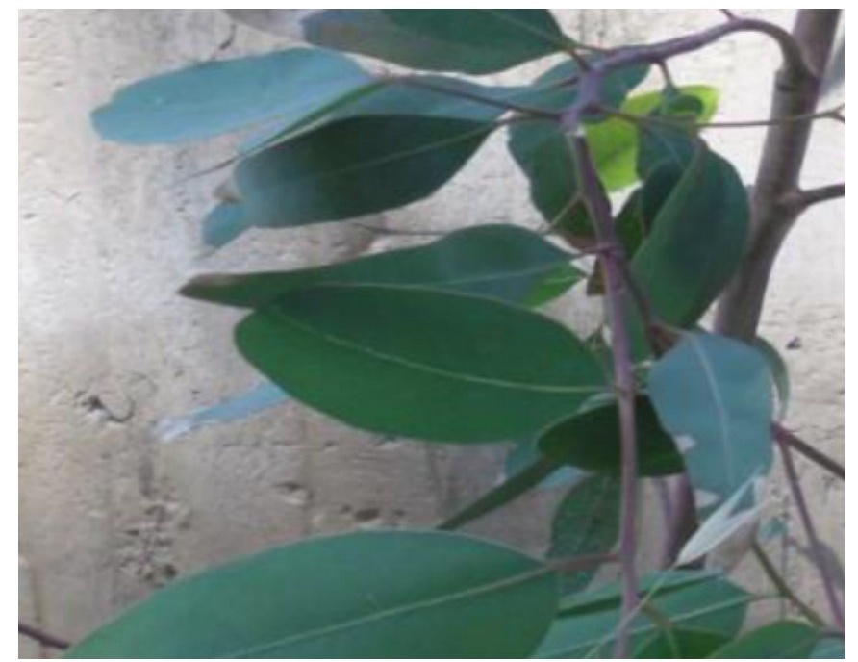

Fig. 1. Photograph of leaves of Eucalyptus globulus.
3.2. UV–Visible spectroscopy
The UV–Visible absorption spectrum of the biosynthesized ZnO nanoparticles is shown in Fig. 2. A distinct absorption peak was observed at approximately 360 nm, which is characteristic of ZnO nanoparticles and confirms their successful formation in the nanoscale range.

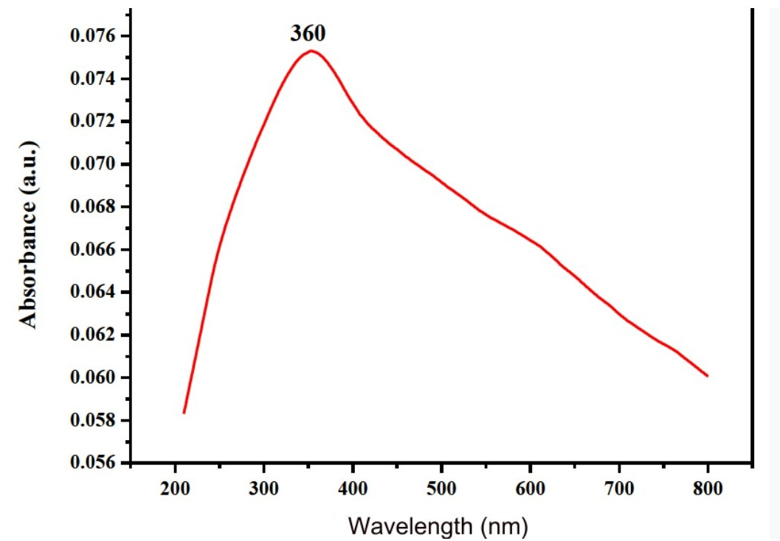
Fig. 2. UV–Visible absorption spectrum of ZnO nanoparticles biosynthesized using Eucalyptus globulus essential oil.

3.3. FTIR spectroscopy (Results)
The Fourier Transform Infrared (FTIR) spectrum of the biosynthesised ZnO nanoparticles is presented in Fig. 3, providing insight into their structural characteristics and surface functionalisation. A distinct absorption band observed at 422 cm⁻¹ is attributed to the Zn–O stretching vibration, which serves as a definitive indicator of ZnO nanoparticle formation.
In addition to this characteristic peak, the spectrum exhibits absorption bands at 1097 cm⁻¹ and 1419 cm⁻¹, corresponding to C–O and C=O stretching vibrations, respectively. These functional groups are likely derived from organic moieties associated with the biological synthesis process. Furthermore, a broad absorption band centred around 3379 cm⁻¹ is assigned to O–H stretching vibrations, suggesting the presence of hydroxyl groups. This feature indicates that residual phytochemical constituents may be adsorbed onto the nanoparticle surface, potentially acting as stabilising and capping agents during synthesis.
Collectively, the FTIR analysis not only confirms the successful synthesis of ZnO nanoparticles but also highlights the role of biomolecules in their stabilisation and surface modification.

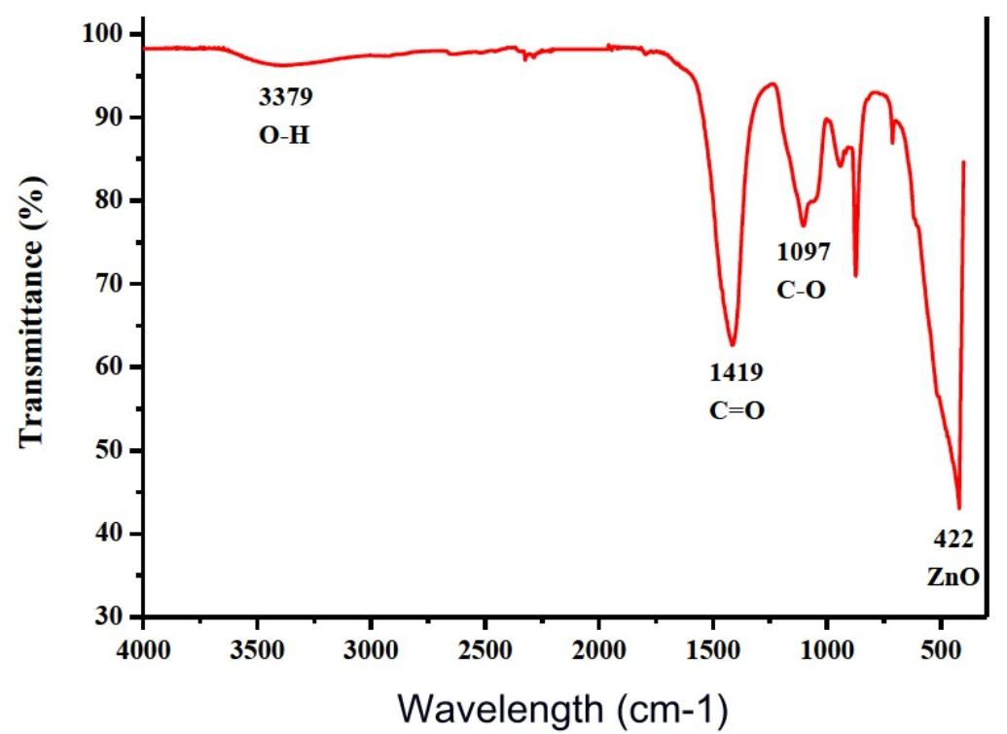
Fig. 3. FTIR spectrum of ZnO nanoparticles biosynthesized using Eucalyptus globulus essential oil.

3.2. XRD analysis of ZnO nanoparticles
The crystalline structure and phase purity of the biosynthesized ZnO nanoparticles were analyzed by X-ray diffraction (XRD), as shown in Fig. 4,table 2. The diffraction pattern exhibited distinct peaks at 2θ values of 31.74°, 34.38°, 36.21°, 47.49°, 56.54°, 62.86°, 66.43°, 67.89°, 68.99°, 72.76°, and 76.94°, corresponding to the (100), (002), (101), (102), (110), (103), (200), (112), (201), (004), and (202) planes of hexagonal wurtzite ZnO. All observed peaks matched the standard ZnO pattern (JCPDS card No. 36-1451), confirming the formation of pure and crystalline ZnO nanoparticles without detectable impurity phases. The average crystallite size, calculated using the Debye–Scherrer equation, was approximately 24 nm, indicating the formation of nanocrystalline ZnO.
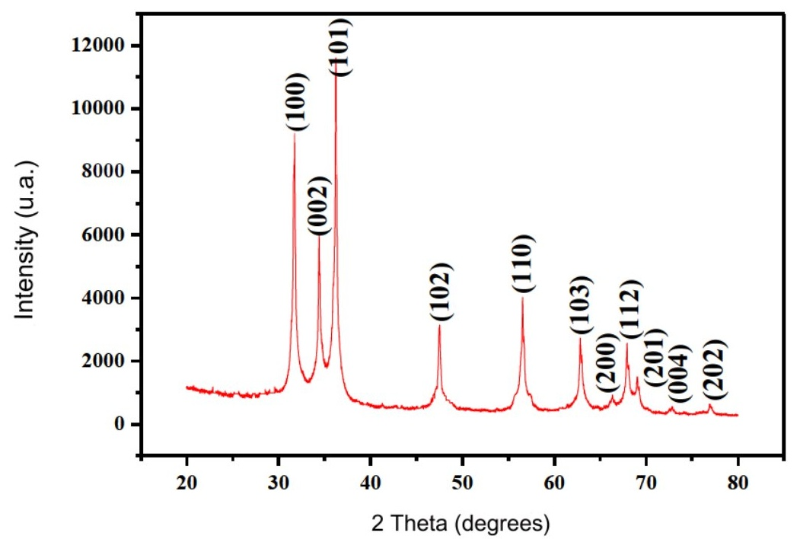
Fig. 4. XRD pattern of ZnO nanoparticles biosynthesized using Eucalyptus globulus essential oil.

2θ (°) | Plane (hkl)
31.74 | (100)
34.38 | (002)
36.21 | (101)
47.49 | (102)
56.54 | (110)
62.86 | (103)
66.43 | (200)
67.89 | (112)
68.99 | (201)
72.76 | (004)
76.94 | (202)
Table 2: XRD peak analysis

3.4. DLS particle size distribution
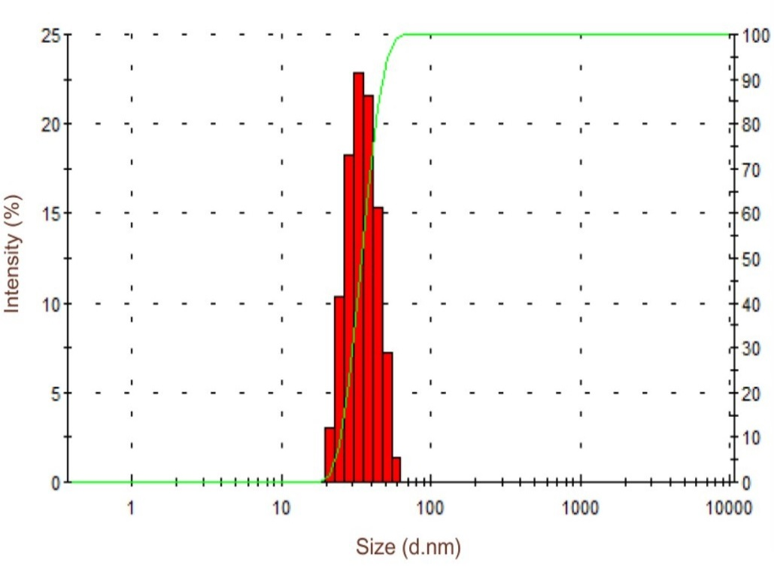
The hydrodynamic size distribution of the biosynthesized ZnO nanoparticles was analyzed using dynamic light scattering (DLS), as shown in Fig. 5. The nanoparticles exhibited a mean hydrodynamic diameter of approximately 40 nm, indicating a nanoscale size distribution in aqueous suspension. The observed particle size is slightly larger than the crystallite size obtained from XRD analysis, which may be attributed to particle aggregation and the presence of a hydration layer in suspension.
Fig. 5. DLS size distribution of ZnO nanoparticles biosynthesized using Eucalyptus globulus essential oil.

3.6. SEM–EDS analysis
SEM micrographs revealed that the biosynthesized ZnO nanoparticles exhibited an agglomerated morphology with a combination of spherical and needle-like structures, as shown in Fig. 6a–c. The observed agglomeration may be attributed to the high surface energy and nanoscale nature of the particles.
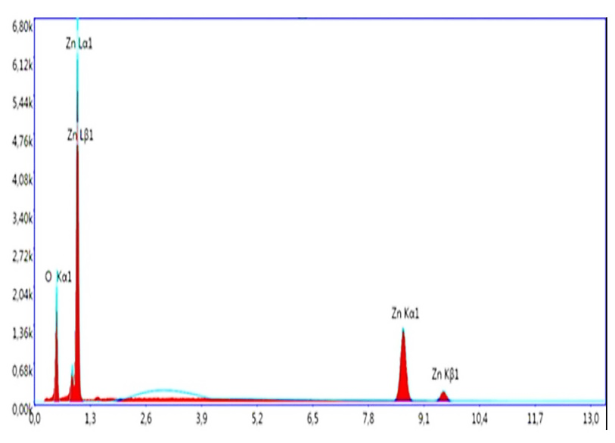
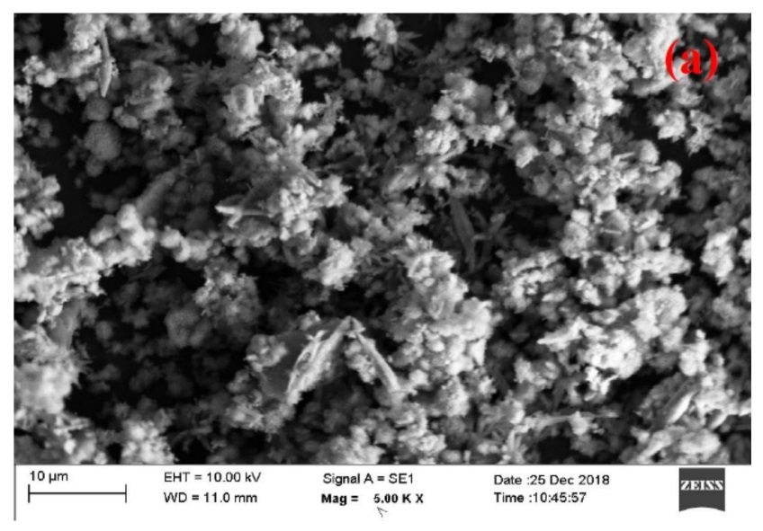
Energy dispersive X-ray spectroscopy (EDS) analysis confirmed the elemental composition of the nanoparticles, showing distinct peaks corresponding to zinc (Zn) and oxygen (O), with no detectable impurity elements (Fig. 6). These results indicate the successful formation of pure ZnO nanoparticles.

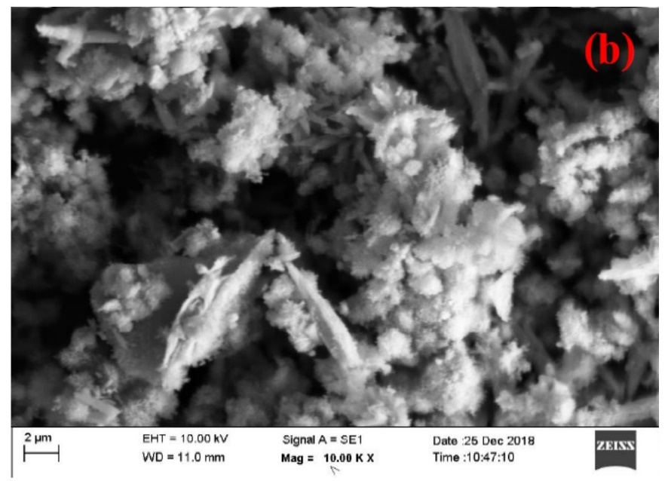
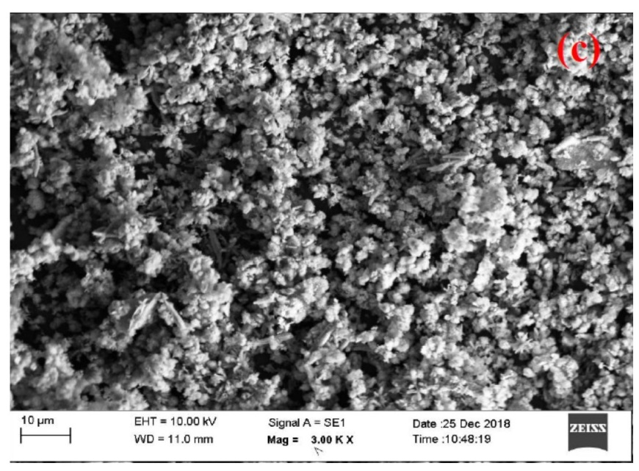
Fig. 6. SEM micrographs and EDS spectrum of ZnO nanoparticles biosynthesized using Eucalyptus globulus essential oil.

3.7. TEM analysis
Transmission electron microscopy (TEM) was used to further examine the morphology and size of the biosynthesized ZnO nanoparticles. As shown in Fig. 7a,b, the nanoparticles exhibited predominantly irregular spherical and rod/needle-like shapes. The particles were observed in the nanoscale range, confirming the successful formation of ZnO nanoparticles. Slight agglomeration of particles was also observed, which is typical for nanomaterials due to high surface energy.
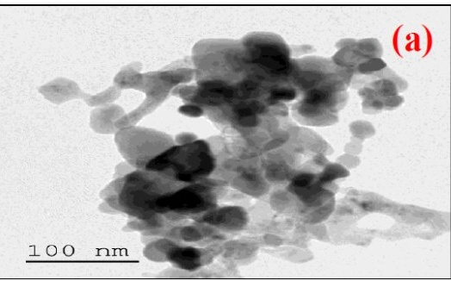
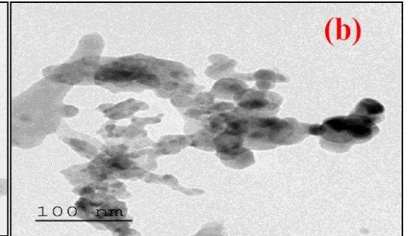
Fig. 7. TEM images of ZnO nanoparticles biosynthesized using Eucalyptus globulus essential oil.

3.8 Antibacterial activity
The biosynthesized ZnO nanoparticles exhibited significant antibacterial activity against the tested clinical isolates. The minimum inhibitory concentration (MIC) values ranged from 0.5 to 128 µg/mL, depending on the bacterial strain. Among the tested pathogens, Escherichia coli showed greater sensitivity to ZnO nanoparticles compared to Pseudomonas aeruginosa. The MIC values for the tested strains are presented in Table 3.

Table 3. Antibacterial activity (MIC) of biosynthesized ZnO nanoparticles

Bacterial Strain | Gram Type | MIC Range (µg/mL)
E. coli | Gram-negative | 0.5–64
P. aeruginosa | Gram-negative | 1–128

3.9 Antibiofilm activity
The ZnO nanoparticles demonstrated strong antibiofilm activity against the tested pathogens in a concentration-dependent manner. Maximum biofilm inhibition was observed at higher nanoparticle concentrations, reaching approximately 95% for E. coli and 97% for P. aeruginosa. The percentage of biofilm inhibition is summarized in Table 4.
Table 4. Antibiofilm activity of biosynthesized ZnO nanoparticles
Bacterial Strain | ZnO NP Concentration (µg/mL) | Biofilm Inhibition (%)
E. coli | 128 | 95
P. aeruginosa | 128 | 97

4. Discussion
GC–MS analysis demonstrated that the essential oil of Eucalyptus globulus is predominantly composed of oxygenated monoterpenes, with 1,8-cineole (eucalyptol) as the major constituent, followed by L-pinocarveol, α-pinene, and globulol. This chemical profile is consistent with previously reported compositions of Eucalyptus essential oils, where cineole is recognized as the principal bioactive compound contributing to antimicrobial activity [17,18]. In addition, these phytochemicals are known to play a significant role in nanoparticle synthesis by acting as reducing, stabilizing, and capping agents, thereby influencing nucleation and growth processes [14,19].
XRD analysis confirmed the formation of highly crystalline ZnO nanoparticles with a hexagonal wurtzite structure. The diffraction peaks matched the standard ZnO reference pattern (JCPDS card No. 36-1451), and no secondary phases were detected, indicating high purity. The calculated crystallite size (~24 nm) falls within the typical range reported for plant-mediated ZnO nanoparticles (10–50 nm), depending on synthesis conditions and biological sources [25,28,30]. These findings demonstrate that Eucalyptus globulus essential oil can effectively facilitate the formation of nanocrystalline ZnO through an environmentally friendly approach, consistent with recent reports on green synthesis of ZnO nanoparticles using plant-derived materials [25,28,42].
FTIR analysis further supported the successful synthesis of ZnO nanoparticles by confirming the presence of Zn–O stretching vibrations (~422 cm⁻¹). The detection of O–H, C–O, and C=O functional groups suggests that phytochemical residues remain associated with the nanoparticle surface, even after purification and calcination. Such surface functionalization is commonly observed in green-synthesized nanoparticles and is known to enhance stability and influence biological interactions [14,26].
The DLS results indicated an average hydrodynamic diameter of approximately 40 nm, which is larger than the crystallite size obtained from XRD analysis. This difference is expected, as DLS measures particle size in a hydrated state, including aggregation and solvation effects, whereas XRD estimates the size of crystalline domains. Similar discrepancies have been widely reported for green-synthesized ZnO nanoparticles [34]. Additionally, UV–Visible spectroscopy revealed a characteristic absorption peak at ~360 nm, confirming the formation of ZnO nanoparticles with typical optical properties [33].
Biological evaluation demonstrated that the biosynthesized ZnO nanoparticles exhibit significant antibacterial activity against clinically relevant nosocomial pathogens, with MIC values ranging from 0.5 to 128 µg/mL. This antibacterial effect is consistent with previous studies, which attribute ZnO nanoparticle activity to mechanisms such as reactive oxygen species (ROS) generation, membrane disruption, and Zn²⁺ ion release, leading to interference with intracellular processes [8,10,43]. Recent studies have also reported strong antibacterial and antibiofilm activity of green-synthesized ZnO nanoparticles, supporting the findings of the present study [44]. Notably, Escherichia coli showed greater sensitivity compared to Pseudomonas aeruginosa, which may be attributed to differences in cell wall structure and intrinsic resistance mechanisms.
The ZnO nanoparticles also exhibited strong antibiofilm activity, with inhibition levels reaching 95–97% at higher concentrations. This finding is in agreement with earlier reports demonstrating the ability of ZnO nanoparticles to disrupt biofilm formation, particularly in Gram-negative bacteria [9,45]. The enhanced antibiofilm activity observed in this study may be attributed to the combined effects of ZnO nanoparticles and essential oil-derived surface compounds. Eucalyptus globulus essential oil has been reported to possess antibiofilm and anti-quorum-sensing properties, which may contribute synergistically to the observed activity [46].
Despite these promising results, the study has several limitations. Mechanistic investigations, including ROS quantification, membrane integrity analysis, and Zn²⁺ ion release profiling, were not conducted and should be explored in future work. Furthermore, antibiofilm evaluation was limited to biomass quantification; advanced imaging techniques such as confocal laser scanning microscopy (CLSM) or SEM-based biofilm analysis would provide deeper insight into biofilm disruption. Finally, in vivo studies are necessary to validate the clinical applicability of these nanoparticles.
Conclusion
In this study, zinc oxide nanoparticles (ZnO NPs) were successfully biosynthesized using Eucalyptus globulus essential oil via a green and sustainable approach. The synthesized nanoparticles exhibited a crystalline wurtzite structure with nanoscale dimensions, as confirmed by XRD, FTIR, UV–Vis, and DLS analyses. The ZnO nanoparticles demonstrated significant antibacterial and antibiofilm activity against clinically relevant nosocomial pathogens, particularly Escherichia coli and Pseudomonas aeruginosa. These findings highlight the potential of Eucalyptus globulus-mediated ZnO nanoparticles as an effective, eco-friendly nanomaterial for controlling bacterial infections and biofilm formation. Further studies focusing on detailed mechanisms of action and in vivo validation are required to advance their biomedical applications.
Conflict of Interest
The authors declare that they have no known competing financial interests or personal relationships that could have appeared to influence the work reported in this paper.
Disclaimer (Artificial Intelligence)
The authors declare that no generative artificial intelligence tools were used in the design, analysis, or interpretation of the study. Any language editing assistance, if applicable, was limited to improving clarity and did not influence the scientific content of the manuscript.

References
- World Health Organization. (2017). Global action plan on antimicrobial resistance. Geneva: WHO; 2015.
- O'Neill, J. (2016). Tackling drug-resistant infections globally: final report and recommendations.
- Flemming, H., & Wingender, J. (2010). The biofilm matrix. Nat. Publ. Gr. 8, 623–633.
- Høiby, N., Bjarnsholt, T., Givskov, M., Molin, S., & Ciofu, O. (2010). Antibiotic resistance of bacterial biofilms. International journal of antimicrobial agents, 35(4), 322-332.
- Pelgrift, R. Y., & Friedman, A. J. (2013). Nanotechnology as a therapeutic tool to combat microbial resistance. Advanced drug delivery reviews, 65(13-14), 1803-1815.
- Allahverdiyev, A. M., Kon, K. V., Abamor, E. S., Bagirova, M., & Rafailovich, M. (2011). Coping with antibiotic resistance: combining nanoparticles with antibiotics and other antimicrobial agents. Expert review of anti-infective therapy, 9(11), 1035-1052.
- Sirelkhatim, A., Mahmud, S., Seeni, A., Kaus, N. H. M., Ann, L. C., Bakhori, S. K. M., ... & Mohamad, D. (2015). Review on zinc oxide nanoparticles: antibacterial activity and toxicity mechanism. Nano-micro letters, 7(3), 219-242.
- Raghupathi, K. R., Koodali, R. T., & Manna, A. C. (2011). Size-dependent bacterial growth inhibition and mechanism of antibacterial activity of zinc oxide nanoparticles. Langmuir, 27(7), 4020-4028.
- Dwivedi, S., Wahab, R., Khan, F., Mishra, Y. K., Musarrat, J., & Al-Khedhairy, A. A. (2014). Reactive oxygen species mediated bacterial biofilm inhibition via zinc oxide nanoparticles and their statistical determination. PloS one, 9(11), e111289.
- Jones N, Ray B, Ranjit KT, Manna AC. Antibacterial activity of ZnO nanoparticle suspensions on a broad spectrum of microorganisms. FEMS Microbiol Lett. 2008;279(1):71–76.
- De la Rosa E, Sepúlveda-Guzmán S, Reeja-Jayan B, et al. Sol–gel synthesis of ZnO nanoparticles and their antibacterial activity. J Sol-Gel Sci Technol. 2010;55:83–89.
- Devi HS, Velu AS. Synthesis of ZnO nanoparticles by precipitation method and its characterization. Mater Today Proc. 2016;3:189–195.
- Mohan, S., Vellakkat, M., Aravind, A., & U, R. (2020). Hydrothermal synthesis and characterization of Zinc Oxide nanoparticles of various shapes under different reaction conditions. Nano Express, 1(3), 030028.
- Ahmed, S., Chaudhry, S. A., & Ikram, S. (2017). A review on biogenic synthesis of ZnO nanoparticles using plant extracts and microbes: a prospect towards green chemistry. Journal of Photochemistry and Photobiology B: Biology, 166, 272-284.
- Rajan, R., Chandran, K., Harper, S. L., Yun, S. I., & Kalaichelvan, P. T. (2015). Plant extract synthesized silver nanoparticles: An ongoing source of novel biocompatible materials. Industrial Crops and Products, 70, 356-373.
- Carrapiço, A., Martins, M. R., Caldeira, A. T., Mirão, J., & Dias, L. (2023). Biosynthesis of metal and metal oxide nanoparticles using microbial cultures: Mechanisms, antimicrobial activity and applications to cultural heritage. Microorganisms, 11(2), 378.
- Dhakad, A. K., Pandey, V. V., Beg, S., Rawat, J. M., & Singh, A. (2018). Biological, medicinal and toxicological significance of Eucalyptus leaf essential oil: a review. Journal of the Science of Food and Agriculture, 98(3), 833-848.
- Luís, Â., Duarte, A., Gominho, J., Domingues, F., & Duarte, A. P. (2016). Chemical composition, antioxidant, antibacterial and anti-quorum sensing activities of Eucalyptus globulus and Eucalyptus radiata essential oils. Industrial Crops and Products, 79, 274-282.
- Čmiková, N., Galovičová, L., Schwarzová, M., Vukic, M. D., Vukovic, N. L., Kowalczewski, P. Ł., ... & Kačániová, M. (2023). Chemical composition and biological activities of Eucalyptus globulus essential oil. Plants, 12(5), 1076.
- Bachir, R. G., & Benali, M. (2012). Antibacterial activity of the essential oils from the leaves of Eucalyptus globulus against Escherichia coli and Staphylococcus aureus. Asian Pacific journal of tropical biomedicine, 2(9), 739-742.
- Wayne, P. (2020). CLSI performance standards for antimicrobial susceptibility testing. CLSI supplements M, 100, 20-30.
- Giske, C. G., Turnidge, J., Cantón, R., & Kahlmeter, G. (2022). Update from the European committee on antimicrobial susceptibility testing (EUCAST). Journal of clinical microbiology, 60(3), e00276-21.
- Clevenger, J. F. (1928). Apparatus for the determination of volatile oil. The Journal of the American Pharmaceutical Association (1912), 17(4), 345-349.
- Adams, R. P. (2017). Identification of essential oil components by gas chromatography/mass spectrometry (4th ed.). Allured Publishing.
- El-Saadony, M. T., Fang, G., Yan, S., Alkafaas, S. S., El Nasharty, M. A., Khedr, S. A., ... & AbuQamar, S. F. (2024). Green synthesis of zinc oxide nanoparticles: preparation, characterization, and biomedical applications-a review. International journal of nanomedicine,19, 12889-12937.
- Matinise, N., Fuku, X. G., Kaviyarasu, K., Mayedwa, N., & Maaza, M. J. A. S. S. (2017). ZnO nanoparticles via Moringa oleifera green synthesis: Physical properties & mechanism of formation. Applied surface science, 406, 339-347.
- Ali, M., Ikram, M., Ijaz, M., Ul-Hamid, A., Avais, M., & Anjum, A. A. (2020). Green synthesis and evaluation of n-type ZnO nanoparticles doped with plant extract for use as alternative antibacterials. Applied Nanoscience, 10(10), 3787-3803.
- Barzinjy, A. A., & Azeez, H. H. (2020). Green synthesis and characterization of zinc oxide nanoparticles using Eucalyptus globulus Labill. leaf extract and zinc nitrate hexahydrate salt. SN Applied Sciences, 2(5), 991.
- Azizi, S., Mohamad, R., Bahadoran, A., Bayat, S., Rahim, R. A., Ariff, A., & Saad, W. Z. (2016). Effect of annealing temperature on antimicrobial and structural properties of bio-synthesized zinc oxide nanoparticles using flower extract of Anchusa italica. Journal of Photochemistry and Photobiology B: Biology, 161, 441-449.
- Fakhari, S., Jamzad, M., & Kabiri Fard, H. (2019). Green synthesis of zinc oxide nanoparticles: a comparison. Green chemistry letters and reviews, 12(1), 19-24.
- Patterson, A. L. (1939). The Scherrer formula for X-ray particle size determination. Physical review, 56(10), 978.
- Dobrucka, R., & Długaszewska, J. (2016). Biosynthesis and antibacterial activity of ZnO nanoparticles using Trifolium pratense flower extract. Saudi journal of biological sciences, 23(4), 517-523.
- Srikant, V., & Clarke, D. R. (1998). On the optical band gap of zinc oxide. Journal of applied physics, 83(10), 5447-5451.
- Stetefeld, J., McKenna, S. A., & Patel, T. R. (2016). Dynamic light scattering: a practical guide and applications in biomedical sciences. Biophysical reviews, 8(4), 409-427.
- Goldstein, J. I., Newbury, D. E., Michael, J. R., Ritchie, N. W., Scott, J. H. J., & Joy, D. C. (2017). Scanning electron microscopy and X-ray microanalysis. springer.
- Carter, D. B. W. C. B. (2009). Transmission electron microscopy A textbook for materials science.
- Balouiri, M., Sadiki, M., & Ibnsouda, S. K. (2016). Methods for in vitro evaluating antimicrobial activity: A review. Journal of pharmaceutical analysis, 6(2), 71-79.
- Bauer, A. W., Kirby, W. M., Sherris, J. C., & Turck, M. (1966). Antibiotic susceptibility testing by a standardized single disk method. American journal of clinical pathology, 45(4_ts), 493-496.
- Stepanović, S., Vuković, D., Hola, V., Bonaventura, G. D., Djukić, S., Ćirković, I., & Ruzicka, F. (2007). Quantification of biofilm in microtiter plates: overview of testing conditions and practical recommendations for assessment of biofilm production by staphylococci. Apmis, 115(8), 891-899.
- O'Toole, G. A. (2011). Microtiter dish biofilm formation assay. Journal of visualized experiments: JoVE, (47), 2437.
- Brand-Williams, W., Cuvelier, M. E., & Berset, C. L. W. T. (1995). Use of a free radical method to evaluate antioxidant activity. LWT-Food science and Technology, 28(1), 25-30.
- Bouttier-Figueroa, D. C., Cortez-Valadez, M., Flores-Acosta, M., & Robles-Zepeda, R. E. (2024). Green synthesis of zinc oxide nanoparticles using plant extracts and their antimicrobial activity. BioNanoScience, 14(3), 3385-3400.
- Franklin, N. M., Rogers, N. J., Apte, S. C., Batley, G. E., Gadd, G. E., & Casey, P. S. (2007). Comparative toxicity of nanoparticulate ZnO, bulk ZnO, and ZnCl2 to a freshwater microalga (Pseudokirchneriella subcapitata): the importance of particle solubility. Environmental science & technology, 41(24), 8484-8490.
- Udayagiri, H., Sana, S. S., Dogiparthi, L. K., Vadde, R., Varma, R. S., Koduru, J. R., ... & Karri, R. R. (2024). Phytochemical fabrication of ZnO nanoparticles and their antibacterial and anti-biofilm activity. Scientific Reports, 14(1), 19714.
- Lebeaux, D., Ghigo, J. M., & Beloin, C. (2014). Biofilm-related infections: bridging the gap between clinical management and fundamental aspects of recalcitrance toward antibiotics. Microbiology and Molecular Biology Reviews, 78(3), 510-543.
- Merghni, A., Noumi, E., Hadded, O., Dridi, N., Panwar, H., Ceylan, O., ... & Snoussi, M. (2018). Assessment of the antibiofilm and antiquorum sensing activities of Eucalyptus globulus essential oil and its main component 1, 8-cineole against methicillin-resistant Staphylococcus aureus strains. Microbial pathogenesis, 118, 74-80.

