Review Article

Agricultural Extension Systems: Global review and Policy recommendations for India

Abstract
Agricultural extension systems bridge researcher clients and various other stakeholders. In the Indian context, majorly, extension services are being delivered through public extension, other players identified are private firms, NGOs, producer organizations, and ICT platforms. This review synthesizes global evidence (2020–2025) on agricultural extension systems through a systematic literature review (SLR) of Scopus-indexed publications, supported by bibliometric analysis and other software. Reviews reveal that globally pluralistic extension governance encompassing public, private, non-governmental, and producer-led actors has become the dominant paradigm. ICT-based extension models, including mobile advisories, social media, and call centres, have expanded extension capacity in temporal and geographical context, whereas challenges of inclusivity, sustainability, and localized facilitation persist. Bibliometric analysis indicates the emerging themes such as ICT adoption, capacity building, pluralistic governance, and sustainability, while co-authorship and keyword co-occurrence networks illustrate increasing global collaboration, especially across Asia and Africa. In the Indian context, the agricultural extension system has historically relied on state-driven institutions such as Training and Visit, Agricultural Technology Management Agencies (ATMA), and Krishi Vigyan Kendras (KVKs). Recent years have witnessed a shift toward pluralism, showing growing roles of agri-tech firms, farmer-producer organisations (FPOs), and NGOs. Current condition clearly depicts challenges in the field as: high farmer-to-extension worker ratios (1:1000 versus the FAO-recommended 1:400), fragmented governance, financial instability, and equity gaps among the communities. This synthesis recommends farmer-centric, ICT-enabled, and community-integrated models, supported by predictable financing and professionalized extension personnel. Lessons from global systems emphasise the need for hybrid governance, resilient financing strategies, and adaptive learning mechanisms. The findings offer pathways for strengthening India’s extension architecture and ensuring inclusive, sustainable agricultural development.
Keywords: Agricultural extension systems; Pluralistic governance; ICT-enabled extension; Human resource capacity; Systematic literature review; Bibliometric analysis

- INTRODUCTION
Agriculture continues to play a pivotal role in India’s economy despite undergoing structural changes over the decades. Its share in the national GDP is about 15–18% in recent years. However, the sector remains the largest source of livelihood, employing nearly 45–50% of India’s workforce, and acts as the backbone of rural communities by supporting allied industries (IBEF 2022). Apart from income upliftment and livelihood generation, the agricultural sector ensures economic and nutritional security as well. In the above view, agricultural extension s the branch or field which proves to bridge the existing gap between information generators and information seekers through various institutes and platforms as Krishi Vigyan Kendras and digital initiatives such as mKisan others. Extension services also facilitate access to, timely information, quality inputs, credit, and government schemes, thereby enabling farmers to adopt innovations, increase productivity, and build resilience in the face of challenges.
The historical trajectory of Indian extension has been shaped by landmark policy interventions such as the establishment of the Training and Visit (T&V) system in the 1970s, the creation of Krishi Vigyan Kendras (KVKs) under the Indian Council of Agricultural Research (ICAR), and later, decentralization reforms through the Agricultural Technology Management Agency (ATMA) in the 1990s and early 2000s. After all the efforts put forward to increase the outreach of the extension services yet the credibility of the services provided to clients are to be verified. Researchers indicate that pluralism in extension is often accompanied by fragmentation, duplication of services, and uneven coordination across federal, state, and local levels (Rivera & Sulaiman, 2009; Anderson, 2020). In India, extension services have evolved from highly centralized, state-led models to more pluralistic arrangements involving public institutions, private enterprises, non-governmental organizations (NGOs), and increasingly, digital platforms (Norton & Alwang, 2020). The above evaluation of the extension system discussed indicates global level at boarder terms. India’s agricultural extension system distinctive and is one of its own kind because of vast range of agricultural topography and regional and societal diversity, which make India’s extension system as the complexity of its governance arrangements.
The central idea of the study is to study and analyse the organizational and governance structures of institutes and departments that deals with extension services in India as well as comparing and analysing the existing conditions with other more developed models and infrastructure at global levels as a case study. When comparing we found that majority of developed countries have single ministry to govern the extension system but in Indian context we have decentralized system with multiple level of decision making central , state and district level with various ministries and line department to ensure overall development and well-being of agricultural sector and population related with. Within states, departments of agriculture, horticulture, animal husbandry, and allied sectors run parallel extension services, while research institutions, universities, cooperatives, and private actors contribute additional layers (Reddy, 2016). Along with the flexibility of decision making and policy implementation the multiplicity raises concerns about coordination and governance among the related institutes and organizations, especially in ensuring that services are responsive to farmers’ needs.
In this context, analyzing the human resource capacity and staffing of the extension system becomes crucial. Staffing levels, competencies, and training opportunities for the extension personnels significantly affect the quality and reach of extension services. India faces challenges in both the quantity and quality of extension personnel. Ratios of extension workers to farmers remain far below recommended levels, with some estimates suggesting one extension worker serves more than 1,000 farmers, compared to the recommended 1:400 ratio (Swanson & Rajalahti, 2010). Moreover, capacity development remains uneven; while some extension agents are trained in modern technologies and ICT-enabled approaches, many continue to operate with outdated skills. Scholars in their research findings emphasize that weak human resource systems and undermine competencies not only low the service delivery but also put interrogative remark on organizational accountability and trust with farming communities.
Equally important is the question of resource allocation and financial sustainability of extension services. Public expenditure on agricultural extension in India has historically been modest, constituting less than 1 percent of agricultural GDP (Joshi et al., 2015, Surya 2022). This underinvestment contrasts with the expanding expectations placed on extension to address climate resilience, market linkages, food security, and digital inclusion and many more including the need specific tailored plan. Donor agencies and public-private partnerships (PPPs) have supplemented public funding in recent decades, but the sustainability of such arrangements remains uncertain (Norton & Alwang, 2020). The reviews and literature clearly reveals that PPP based extension model focuses majorly on supply chain domain of agricultural sector and extension prioritise the commercial side over broader perspective. There exists a pressing need for sustainable financial framework for extension system in Indian system. The above can be achieved by balancing public and private partnership in budget allocation in extension domain. The economic stability in extension system will ensure the equitable access for resources and services to small and marginal farmers.
Apart from funding and human resource capacity in the extension, success and effectiveness of the extension delivery system. Traditional person to person mode of extension delivery methods are highly complimented by ICT based extension system and digital intervention in extension services (Lv & Li, 2024). Though scalability, timeliness, and personalization, are the promising attributes of digital interventions but it also risks exclusion of the population who are not able to access the technology, creating digital divide. Farmer field schools, participatory rural appraisal, and gender-sensitive extension approaches have been introduced to make extension more inclusive and responsive (Davis & Sulaiman, 2014). Mwololo et al. (2019) indicates that farmers’ socio-economic characteristics significantly influence their preference for agricultural extension methods. The study indicates the pressing need to adopt tailor extension approaches for farmer’s advisory for improved effectiveness and adoption rate of prescribed farming practices.Recent trend shows Indian innovations—such as e-NAM (electronic National Agricultural Market), agri-tech startups, and mobile advisory apps—demonstrate how digital platforms can be leveraged, yet there exists evaluations reports highlighting uneven adoption and gender gaps, requiring closer integration with local intermediaries like Farmer Producer Organizations (FPOs) and self-help groups (Veesam, Nikam, & Chand, 2025). However, systematic evaluations show mixed results in terms of adoption, yield impact, and long-term sustainability of the extension model and innovation diffused in the social system (Abubakari et al., 2023).
The pluralism of extension actors in India is public, private, and third sector—reflects a vibrant ecosystem, but it also generates coordination challenges among themselves. Extension services are often criticized for being supply-driven rather than demand-led or farmer-led, with farmers having limited to negligible participation in the programs and policy design. Governance structures that enable accountability, transparency, and farmer participation are thus essential. ATMA was envisioned as a mechanism to decentralize extension governance and ensure convergence across allied departments yet evidence suggests its performance has been uneven across states due to inadequate staffing, limited budgets, and bureaucratic hurdles (Birner et al., 2009; Swanson & Rajalahti, 2010; Chaudhary and Kabir 2024).
Despite these challenges, recent years have seen promising innovations in the delivery mechanisms of extension services and coordination among line departments. The use of ICT and mobile platforms has broadened the reach of extension to previously underserved farmers, particularly in remote areas. The growing involvement of private agri-tech firms, startups, and NGOs has also diversified extension service delivery. These changes mirror global trends in the field yet there exists risk of insufficiency in resources, inconsistency in services and lack of up-to-mark capacity.(Abubakari et al., 2023; Mudzielwana, Phophi, & Mafongoya, 2024).
As per the reviews, India’s agricultural extension depicts a dynamic transition—struggling with staffing and financing, yet innovating through ICT and pluralism within both national and international contexts, framing it as a system. While aligning with SDGs and global references, India’s extension services can be reimagined and strengthened as more inclusive, farmer-centric, and sustainable (Sahoo, Ghosh, & Rout, 2024; Gebremariam et al., 2025).
These developments highlight both opportunities and risks: while pluralism enhances innovation and competition, it may also intensify inequalities unless accompanied by robust governance coordination and regulation (Abubakari et al., 2023; Kante, 2024).
A systematic review of India’s agricultural extension system is therefore timely. By examining organizational and governance structures, assessing human resource capacity, evaluating resource allocation and financial sustainability, and analysing the effectiveness of extension service delivery mechanisms, this review seeks to provide a comprehensive understanding of the system’s strengths and limitations. Importantly, this review draws on the Scopus-indexed literature from year 2020 onwards , which reflects both global and India-specific insights into extension.
In synthesizing this body of work, several key themes emerge. First, governance reforms are critical to ensure accountability and coordination in a highly fragmented system. Second, its highly credible to invest in the capacity development of human resources. Third, to ensure inclusivity and equity in service provision, there should be a balance between public and private funding system and service deliveries. Finally, the effectiveness in service delivery should be achieved by integration of ICTs, participatory approaches, and context-specific innovations that align with farmers’ realities.
Taken together, these insights underline the urgent need for a more coherent, sustainable, and farmer-centred, needs-based extension system in India. As the country grapples with challenges of climate change, food security, and rural transformation, strengthening extension services becomes not just a policy imperative but also a cornerstone of inclusive development.

The primary research questions of the study are as follows:
- What are the existing organizational and governance structures of agricultural extension systems in India?
- How effectively do they coordinate multiple actors and institutions?
- What is the status of human resource capacity in India’s agricultural extension systems, and to enquire about staffing and training mechanisms of extension personnels?
- How are resources allocated to agricultural extension services in India, and to what extent are these arrangements financially sustainable?
- How effective are the existing extension system?

2. METHODOLOGY:
2.1 Materials and Methods
Present study aims to review of Scopus data base using bibliometric analysis (BA) that provides an inclusive assessment of “agricultural extension systems” from yr 2020 to yr 2025. A systematic review enables the scholar to identify, select, and synthesis relevant literature while ensuring transparency and reproducibility of the literature and data (Page et al., 2021). At the same time bibliometric analysis complements review study by quantitatively mapping scientific outputs, citation structures, collaboration patterns, and thematic clusters within the literature database studied and reviewed (Aria & Cuccurullo, 2017) and VOS viewer (Van Eck & Waltman, 2010), widely used tools for visual representation of networks analysed within the database and thematic mapping is usually used to reveal patterns of collaboration, citation, and knowledge clustering within the database studied. The above mentioned methods allows scholars to seek broader and effective evaluating recent developments in area of interest. In present study areas as extension systems, particularly in relation to governance, human resource capacity, resource allocation, and service delivery mechanisms in the topic for analysis and evaluation.
The combination of PRISMA guidelines for systematic review and advanced bibliometric tools such as Bibliometrix (R package) proved to be a methodological rigor. PRISMA 2020 enables the researcher to adopt a widely accepted protocol for evidence-based synthesis (Page et al., 2021). Bibliometrix offers strong bibliometric data extraction and analysis (Aria & Cuccurullo, 2017).

2.2 Search Strategy and Data Sources
The data source was extracted exclusively from the Scopus database, which is well known platform for its comprehensive coverage of peer-reviewed scientific literature across various disciplines, including agricultural sciences, extension, health, sociology and rural development. The temporal scope was limited to yr 2020 to July 2025 to study and analyse the recent studies in extension service models, governance mechanisms and extension delivery methods.
To ensure precision, three search equations (Eq. 1–3) were developed and applied using boolean operators. These equations were designed to reflect the study’s four key objectives of the study and cover the major dimensions of agricultural extension systems.
Table 1: Equation 1 (Governance and Organizational focus)
Keywords used for searching in Scopus Database | Results found | Results found after filtration
“Agricultural extension system” AND  “Public extension” OR “Private extension” OR “NGO” OR “Non-Governmental Organization” OR “Cooperatives” OR “Pluralistic Extension”. | 207 | 56

Table 2: Equation 2 (Human resource focus)
Keywords used for searching in Scopus Database | Results found | Results found after filtration
“Agricultural extension system”  AND  “Extension staff” OR “Extension personnel”. | 189 | 56

Table 3: Equation 3 (Service delivery focus with ICT)
Keywords used for searching in Scopus Database | Results found | Results found after filtration
(“Agricultural extension system” OR “extension mechanism”  AND  “ICT in extension” OR “digital extension”. | 16 | 8

These equations were tested iteratively to refine sensitivity and specificity. All retrieved references were downloaded in both BibTeX and RData formats, enabling seamless integration with Bibliometrix in R.

2.3 Inclusion and Exclusion Criteria
A set of predefined inclusion and exclusion criteria were applied to maintain methodological precision and significance.
Inclusion criteria included:
- Articles published between 2020 and 2025.
- Peer-reviewed journal articles, systematic reviews, or conference proceedings.
- Studies clearly focused agricultural extension systems and related themes.
Exclusion criteria:
- Editorials, letters, and non-peer-reviewed literature.
- Grey literature such as policy briefs and reports.
- Duplicates retrieved across multiple queries.
- Studies including outside the thematic scope (e.g., general agricultural technologies without extension context).
- Language other than English.
These criteria ensured consistency and enhanced comparability across studies.
Table 4 – Inclusion and Exclusion Criteria Summary
Criterion | Inclusion | Exclusion
Time Frame | Publications from January 2020 – June 2025 | Studies published before 2020 or after June 2025
Language | English | Non-English publications
Document Type | Peer-reviewed journal articles, systematic reviews, conference proceedings | Editorials, letters, book reviews, thesis, grey literature
Content Relevance | Articles explicitly addressing agricultural extension systems (governance, HR, resources, service delivery) | Articles on general agriculture not linked to extension systems
Data Source | Indexed in Scopus database | Articles not retrievable from Scopus
Population/Context | Studies involving extension systems, staff, governance, ICT, delivery | Studies unrelated to agricultural extension or advisory services
Duplicates | Only unique studies retained | Duplicate records removed

2.4 Study Screening Process
The review process followed in the PRISMA 2020 framework, which includes four major phases: identification, screening, eligibility, and inclusion (Page et al., 2021).
- Identification: All records obtained through the three search equations were compiled into Bibliometrix.
- Screening: Duplicate entries were removed, and titles and abstracts were screened by reviewer.
- Eligibility: Full texts of possibly relevant articles were retrieved and assessed for arrangement with inclusion criteria.
- Inclusion: Final studies that clears the pre-determined that met the criteria were retained for synthesis and bibliometric analysis.
There exists no disagreements between reviewers during screening or eligibility assessment and consensus was reached by discussion.

Identification of studies via databases and registers

Records identified from*:
Search Equation#1= 207
Search Equation#2=189
Search Equation#3=16
Databases (n =562 )

Identification

Records excluded on the basis on inclusion / exclusion criteria
(n=292)

Records obtained according to inclusion / exclusion criteria
(n = 120)

Records excluded after screening title and abstract (n=0)

Screening

Records found after screening title and abstract (n=120)

Duplicate documents excluded (n=2)

Studies included in review
(n = 118)

Included

Figure 1 – PRISMA Flow Diagram showing the selection process

This shows systematic approach of systematic review of data set and ensured transparency, minimized bias and enhanced reproducibility of the results.

2.5. Data Extraction and Management
Data management of the extracted data base was conducted using Bibliometrix (R package, version 4.0) and its web-based interface Biblioshiny was employed for the purpose. The workflow consisted of following three stages:
- Data conversion and import: Scopus data exports in BibTeX and RData formats were converted into bibliographic data frames using convert2df.
- Data cleaning: Duplicate entries were removed, author names were standardized and keywords were harmonized (e.g., “extension service” vs. “extension services”).
- Data extraction: Key variables were extracted, including author names, titles, publication year, journal, institutional affiliation, keywords, and citation counts.
3. RESULTS AND DISCUSSION:
The scholar conducted the review of total 120 publications extracted from Scopus database. The bibliometric analysis of 120 Scopus-indexed publications from 2020 to 2025 provides a complete preview of recent research trends on theme “agricultural extension systems”. The publication trend on the selected remained relatively stable across the period, with notable peaks in year 2020 with 24 articles and year 2024 with 22 articles. These peaks in the publication scenario correspond to the heightened the attention paid to agricultural extension sector during the COVID-19 pandemic, when disruptions tends to weakens the existing to traditional service delivery and triggered innovations in digital and community-based extension mechanisms. (Olayiwola, 2022; Oluoch et al., 2024) suggests that these significant peaks in the publication may be influenced by global disruptions caused by the COVID-19 pandemic, which prompted both researchers and policymakers to explore alternative modes of extension service and delivery methods particularly digital and community-based delivery. Scholarly output is concentrated in leading journals such as the Journal of Agricultural Education and Extension, Frontiers in Sustainable Food Systems, and Cogent Food and Agriculture, which together highlight the interdisciplinary nature of the field, bridging education, sustainability, and rural development. The views are in lined with (Landrigan et al., 2020) which states the journals which demonstrate and are inclined towards interdisciplinary nature of study as extension research, bridging agricultural sciences, education, sustainability, and rural development are usually ranked top in citation. Notably, journal named Annals of Global Health—also featured prominently as one of the top cited and trusted source for information seeking and publishing reflecting the recognition of agricultural extension as part of broader food systems and public health debates

Authorship analysis reveals varied and diversed geographic representation, with recurring contributions from scholars such as Zulu L.C., Mungai L.M., Nikam V., and Snapp S.S., whose work emphasizes African and Asian area perspectives. This underscores the global but also regionally rooted character of extension research, reflecting both local challenges and international collaboration. The above findings are similar with previous findings which suggests that there exists a significant research footprint reflecting extension scholars from Africa and Asia being provided funding, which reflects donor spending in these areas as well as the global South's reliance on agriculture for livelihoods. Whereas North American and European academics make more specialized contributions in the studied area frequently working together on policy studies, sustainability, and ICT uptake. In addition to highlighting the local significance of extension systems regional focus clearly defines how extension discussions are becoming more globally intertwined (Mungai et al., 2024; Nikam et al., 2023). The thematic map further enriches the understandings of the findings by illustrating pictorial presentation of the intellectual structure of the field studied i.e. “Agricultural extension systems” with the emerging niche areas in the major topic of the research. Motor themes in the visuals such as agricultural workers, human capacity, and digital innovation indicates that human resources and ICT-enabled delivery mechanisms are central to ongoing debates. Basic themes such as agricultural extension, agricultural technology, and community engagement represent the foundational pillars of the agricultural extension systems, while niche themes such as agricultural robotics, personnel training, and economics reveal specialized areas of inquiry that are rapidly developing but not yet central. Emerging or declining themes such as extension agent networks, efficiency, and COVID-19-related advisory services suggest either fading priorities or nascent areas of exploration. Taken together, the results indicate that pluralistic governance, human resource development, resource sustainability, and digital service delivery are the main areas of extension research in the period under review.
3.1 Most relevant sources
Descriptive bibliometrics were applied to provide a quantitative overview of the dataset. The data analysed depicts the metrics showing the trends in annual scientific production, most prolific authors, highly cited documents, leading journals, and country-level contributions. These indicators allowed the researcher to identify the trends in scholarly interest and productivity within the timeframe of the databased studied. Based on the citation analysis of the 118 reviewed materials, several journals stand out as the most influential sources in the field of agricultural extension and related studies. Figures showed that Annals of Global Health leads with 487 citations, reflecting the intersection between agricultural systems and global health concerns. This is followed by Applied Economic Perspectives and Policy with 205 citations, emphasizing the strong role of economic analysis in shaping extension policies and adoption decisions. Specialized outlets such as the International Journal of Robotics Research (94) and Precision Agriculture (64) highlight the growing integration of technology and automation into extension discourses. Meanwhile, interdisciplinary journals like Agroforestry Systems (46), Sustainability (Switzerland) (43), and Frontiers in Sustainable Food Systems (41) demonstrate the emphasis on sustainability and innovation. Finally, the presence of Journal of Rural Studies (37) and American Journal of Public Health (30) underscores the relevance of rural development and health perspectives in shaping the broader agricultural extension landscape.
The inclusion of publications from fields other than traditional agricultural extension indicates the significance of the subject and multifaced and interdisciplinary nature extension when it comes to addressing the connections between food systems, climate, health and society.
Table 5 – Top cited journals

Journal title | Cited by
Annals of Global Health | 487
Applied Economic Perspectives and Policy | 205
International Journal of Robotics Research | 94
Precision Agriculture | 64
Agroforestry Systems | 46
Sustainability (Switzerland) | 43
American Journal of Clinical Nutrition | 43
Frontiers in Sustainable Food Systems | 41
Journal of Rural Studies | 37
American Journal of Public Health | 30

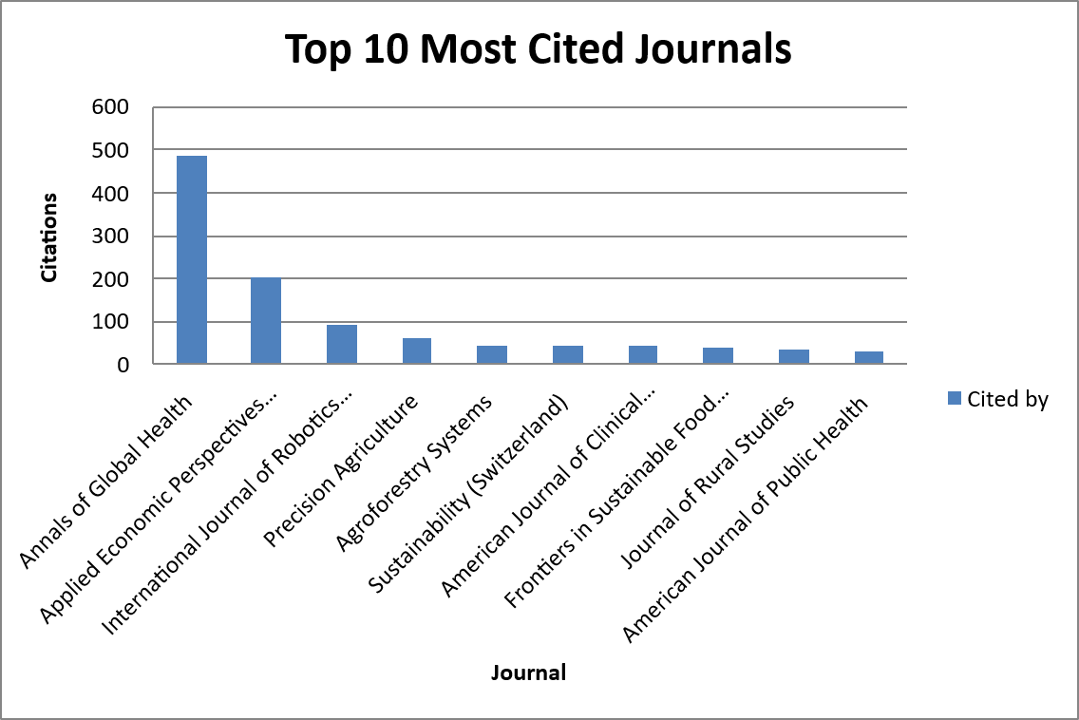
Fig 2:Top 10 citated journal

Table 6: Top 10 cited authors
Author | Cited by
Giuliano L. | 487
Mu J. | 487
Czerucka D. | 487
Corra L. | 487
Mustapha A. | 487
Hahn M.E. | 487
Chevalier N. | 487
Hamdoun A. | 487
Pedrotti M.L. | 487
Rocklöv J. | 487

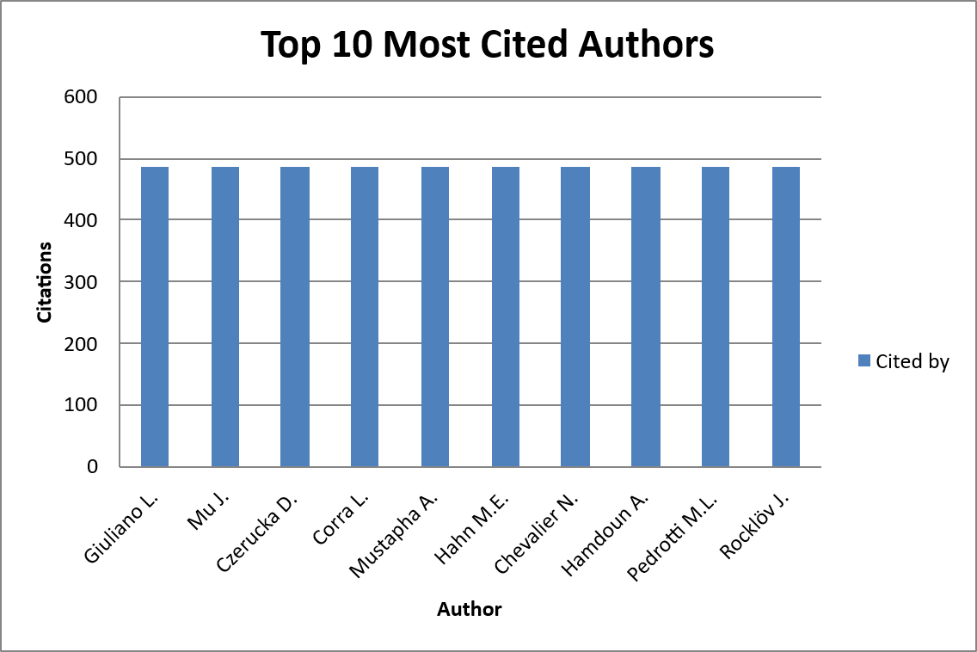
Fig 3: Top 10 most cited authors
3.2 Emerging trends and themes in agricultural extension service
To synchronise the bibliometric findings with the study’s objectives, a thematic mapping approach was applied using Bibliometrix’s thematic Map function. This technique identifies and categorizes themes as per the centrality i.e. (relevance within the field) and density i.e. (development level).
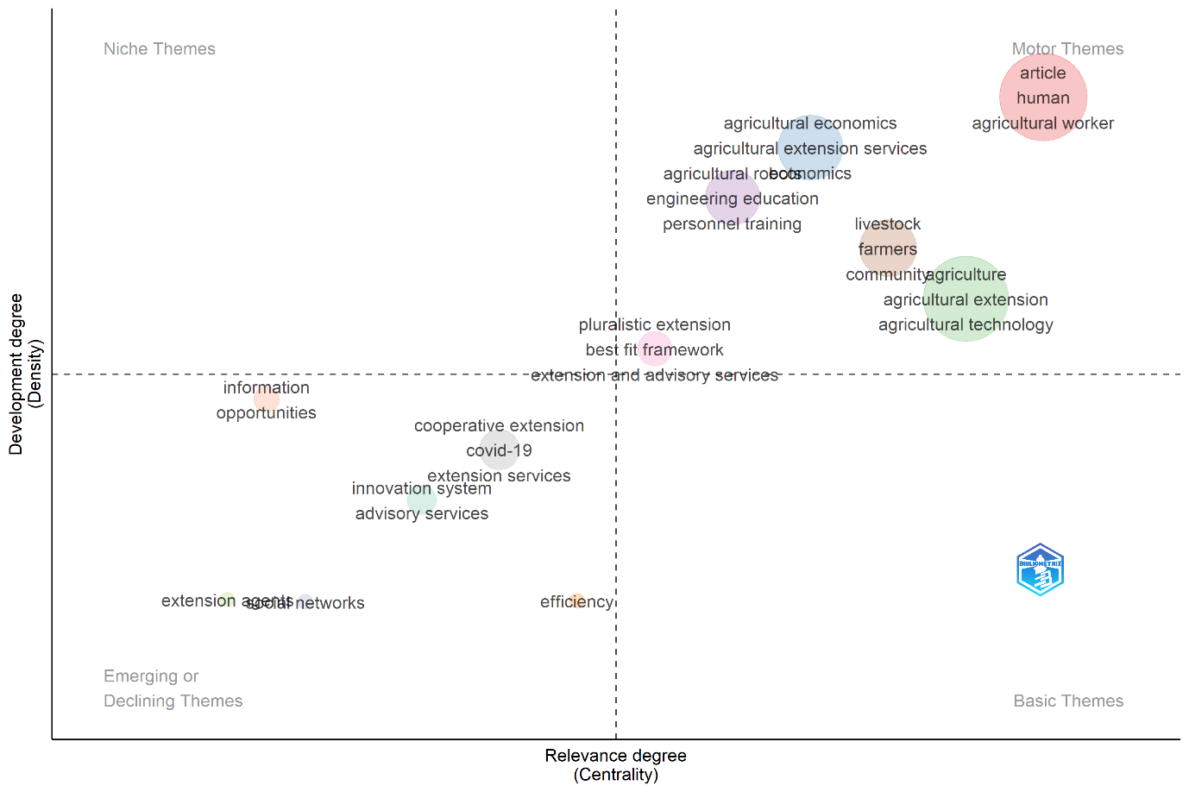

Figure 4 – Thematic Cluster Map from Bibliometrix
This process of thematic analysis allowed the scholar for systematic synthesis of bibliometric clusters within the conceptual framework of the review.
Thematic Cluster Map generated depicts Clusters focusing on robotics and precision agriculture represent as niche but rapidly growing subfield indicates the increasing technologization in field agricultural field and extension domain.
3.2 Network visualisation of co-authorship among organizations
The co-authorship analysis using network analysis reveals strong collaborative linkages across universities, research institutes, and international organizations in the field of agricultural extension and related studies. The co-authorship network derived from the dataset highlights a dynamic pattern of collaboration across global institutions. In this network, nodes represent organizations or institutions such as universities, research centers and others while the links i.e. (Internodes) imply collaborative ties established when scholars from different institutions co-author publications. The analysis reveals a total of 395 organizational nodes connected through 1,439 co-authorship links, emphasizing a strong web of academic collaboration. The most concentrated partnership was observed between the Department of Geography and the Environment at the University of Alabama, USA, and the Department of Geography, Environment, and Spatial Sciences at Michigan State University, USA, which co-authored the maximum number of papers (two) within this dataset. Overall, the trends suggest an increasing degree of international collaboration in agricultural extension research, with prominent regional clusters such as West African universities working together on ICT and e-agriculture, and Asian institutions like Universiti Putra Malaysia partnering with multiple regional and global collaborators. Moreover, global research bodies such as the International Livestock Research Institute (ILRI) and other CGIAR centres act as crucial nodes, linking institutions in developing countries with universities in North America and Europe. This pattern validates that agricultural extension research is becoming progressively networked, interdisciplinary and cross-border in nature thereby expanding and strengthening the scope and impact of knowledge dissemination. For instance, scholars from Nanjing Agricultural University (China) co-authored with partners in information management, while researchers from the Centre National de la Recherche Scientifique et Technologique (Burkina Faso) contributed to ICT adoption studies. Teams from Universiti Putra Malaysia (UPM) worked together with colleagues in Nigeria and Pakistan, showing South–South academic collaboration. Similarly, contributions from the University of Ghana and allied institutions highlighted regional networks within West Africa. International actors such as the International Livestock Research Institute (ILRI, Ethiopia) partnered with local universities, reflecting the integration of global and local expertise. This pattern highlights that agricultural extension research is increasingly shaped by cross-institutional and cross-border collaboration, enhancing the diversity and reach of knowledge production.
There are also clear examples of South-South cooperation, with Asian colleges like Universiti Putra Malaysia collaborating with South Asian counterparts and West African universities working together on ICT adoption studies. Given the importance of networking in inter organizational collaborative works to global development, this pattern shows how agricultural extension research is intensively networked, interdisciplinary, and cross-border (Gebremariam et al., 2025; Mudzielwana et al., 2024).
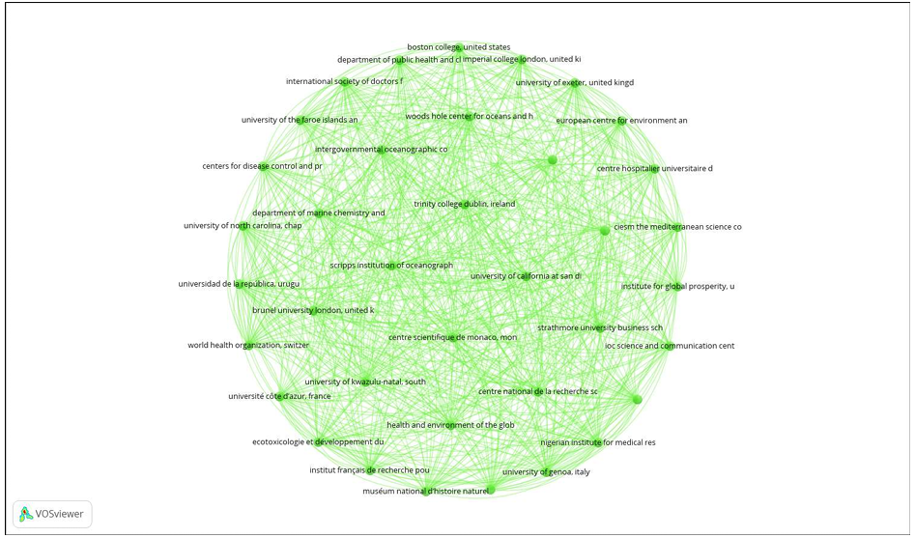
Fig5: Representation of co-authorship among organizations
3.3 Network visualisation of keyword co-occurrence
The VOSviewer keyword co-occurrence map provides a clear visual representation of the intellectual structure of research on agricultural extension. In the map provided , the size of nodes corresponds to keyword frequency, the larger nodes such as agriculture (17 occurrences), agricultural extension (14), agricultural technology (10), food security (9), and technology adoption (10) standing out as leading themes in the search areas. The proximity of nodes and the thickness of connecting lines indicate how frequently keywords co-occur, explaining strong relationships between sub areas as agricultural extension and food security, sustainability, ICT, and rural development. Clusters, represented by different colors, group related terms into thematic areas—for instance, one cluster highlights technology adoption, innovation, and ICT, while another highlights sustainability, rural development, and food security. This clustering helps to visually extricate the different subfields within extension research. Importantly, keywords such as farmers’ knowledge, smallholder farmers, and climate change appear as bridging nodes, connecting technological and socio-economic clusters, thus reflecting the multidisciplinary nature of the field. Consequently, the VOSviewer visualization not only quantifies keyword co-occurrences but also makes visible the dynamic and developing research trends, showing a shift toward integrated approaches linking agriculture, technology, and sustainable development.
The clustering of keywords around sustainability, innovation, and ICT indicates the multidisciplinary framing of extension research. Bridging terms such as “smallholder farmers,” “climate change,” and “farmers’ knowledge” connect technological and socio-economic clusters, stressing the fact that extension is simultaneously a technical, social, and environmental enterprise.
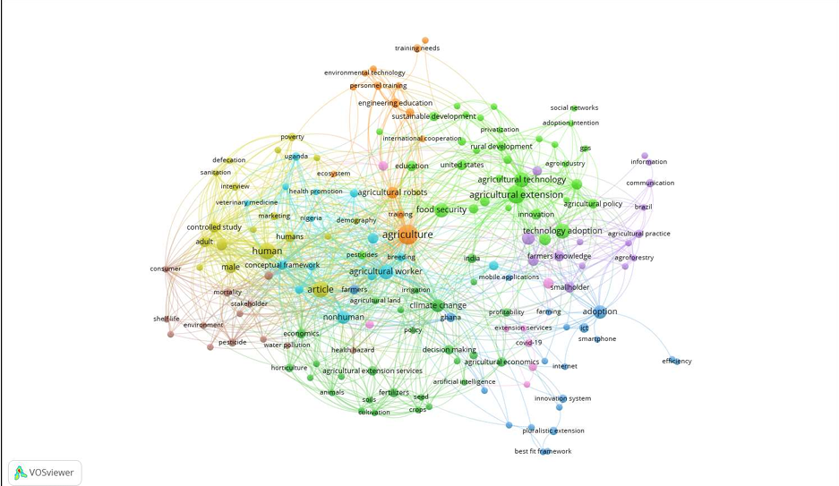Fig6: Cooccurrence of Keywords

DISCUSSION
This review clearly draws the trajectory of agricultural extension systems worldwide and at national level at Indian context within this dynamically evolving landscape. While India has made significant steps through institutional revolutionizations such as ATMA, KVKs, and ICT-based programs ,its extension system continues to face structural and organizational challenges that distinguish it from international counterparts.
When compared with the models from western countries such as USA , India’s model is more fragmented and decentralised. The U.S. system benefits from stable funding through federal and state co-financing and strong associations with land-grant universities (Buys & Rennekamp, 2020). In contrast, India’s system highly reliance on short-term projects and modest budget allocations (<1% of agricultural GDP) leads to instability and uneven service quality (Joshi et al., 2015; Surya, 2022).
The European Union (EU) presents that the Common Agricultural Policy (CAP), advisory services are surrounded within a broader agricultural governance framework (Pinheiro et al., 2022). This ensures both financing stability and farmer-centered pluralism in planning and service delivery. India, despite of adopting pluralism through various models as ATMA and PPPs, lacks structural coherence and continues to struggle with convergence across departments and their roles and service delivery.
African extension systems resemble to Indian extension system in their pluralism and donor dependence, yet India benefits from its stronger research–extension link through ICAR and state agricultural universities and other line departments. However, both the nations shares challenges in human resource shortages and weak inclusivity, in the client coverage. (Masere & Worth, 2021).
Case studies from Asian countries also provides useful insights in regarding study theme. China and Indonesia have swiftly mainstreamed ICT-based and digital platforms, cooperatives, and farmer field schools with state-led initiatives ensuring scale up the services (Chen et al., 2023). India’s digital ecosystem in extension service proves to be one of the vibrant players as eNAM, mKisan, and agri-tech startups are performing well in the field yet their adoption remains fragmented due to digital literacy gaps, poor connectivity in rural areas, and gender divides in digital access (Veesam et al., 2025).
One of the main theme emerging from these analysis and comparisons is “inclusivity”. In spite of major revolutions and progress in technology and other related areas, India’s extension services remain mostly partial and often fail to adequately address the needs of marginal client sections. International evidence highlights the significance of tailoring extension services to diverse audiences— for example the EU’s farmer-led innovation platforms or Africa’s participatory farmer field schools (Davis & Sulaiman, 2014). India’s challenge lies in scaling familiar inclusive approaches in practice.
Financing and funding remains another major bottleneck in the extension areas. When there exists sustained funding mechanisms in EU and U.S., India’s extension system majorly depends on donor agencies projects or limited central/state allocations. Sustainable and regular financing models, such as community-based cost-sharing, farmer cooperatives, and private-sector partnerships, need to be strengthened across the system to ensure continuity and stability of services (Norton & Alwang, 2020).
Finally, the existing digital gap represents a pressing challenge. ICT-based and digital extension promises efficiency and scalability but usually risks exclusion of clients such as women, elderly farmers, and communities with low literacy. International experience and case studies clearly indicates that digital tools are most effective when accompanied by local intermediaries—farmer producer organizations, cooperatives, or trained para-extension workers—who can bridge the last mile.

CONCLUSION
The review demonstrates that research on agricultural extension between the year 2020 and 2025 imitates a balance between association of traditional themes with exploration of new ideas and innovations. Consolidation is obvious in the determined emphasis on pluralistic governance, human resource development, and community-based extension models, which remain to serve as the backbone of extension scholarship and practice. At the mean time, innovation is reflected in the increasing adoption of ICT-based and digital advisory systems, testing with robotics, and increasing focus on efficiency and economics.
For policymakers, these findings highpoint the significance of strengthening governance structures that hold multiple stakeholders, investing in the skills and capacities of extension workers and personnel and designing sustainable financing and credit mechanisms that ensures long-term service delivery. For researchers, the relative negligence of economic efficiency and financial sustainability presents a great scope for further research and exploration, while the combining the technology and human factors invites new lines of review and analysis into the integration of digital platforms with community engagement. Ultimately, the path of agricultural extension reflects a dual responsibility and role: to preserve its traditional soul as role as a community-based knowledge intermediary while embracing the capacity of digital and systemic innovations that enhance resilience, inclusivity, and sustainability in an increasingly complex agricultural landscape.
Policy implications are obvious: strengthening and coordination among ministries and inline departments, ensuring sustainable credits and financing and building the capacity of extension staff showed that stable co-financing mechanisms and integrated governance frameworks are critical factors for long-term sustainability of extension system. India can adapt the above suggestions by enhancing central and state cost-sharing approach, embedding extension services into broader agricultural policy framework and incentivizing convergence of services and policies across line departments.
At the same time, ICT-driven innovations may not be visualised as silver bullets. To avoid expanding inequalities among the service provided digital platforms must be complemented with local intermediaries such as Farmer Producer Organizations (FPOs), self-help groups, and NGOs, which can ensure inclusivity and contextualization. Gender-sensitive extension, youth engagement, and tribal outreach must also be included as main focus areas into the program design.
IMPLICATIONS
The results convey significant implications for both research and practice. At the governance level, the evidence indicates the pressing need of pluralistic extension frameworks that incorporate all the existing players in extension services such as public agencies, private enterprises, non-governmental organizations, and farmer cooperatives. This infers that agricultural extension is no longer be observed as the sole responsibility of government but as a collaborative efforts which requires coordinated governance structures. Human resource capacity arises as another central pillar where role of extension workers consistently highlighted as motor themes in the field of study. This suggests that capacity development, digital literacy, and continuous professional training for extension staff are some of the themes that are indispensable to the effectiveness of extension systems.
The analysis also has suggestions to ensure resource allocation and financial sustainability in the extension system. Even though efficiency and agricultural economics appear as niche themes, their underdevelopment comparative to governance and human capacity implies that sustainable financing models remain an ignored dimension for a long period. Policymakers thus required to design innovative cost-sharing and constant funding frameworks that can promise continuity of services in resource-constrained settings. To conclude we can note that service delivery methods and mechanisms are undergoing rapid transformation, with ICT-based and digital platforms becoming central idea since the pandemic. This validates the fact that digital extension is no longer a marginal innovation but a robust and scalable mode of delivery that must be systematically integrated into extension practice.
Limitation
While inclusive, this synthesis is bound by several limitations. First, the dataset studied was restricted to publications indexed only in Scopus, which, although comprehensive, excludes contributions available in other databases such as Web of Science, AGRIS, grey literature or any other information source that may provide valuable policy insights. Second, the review process consider the documents only English-language publications which potentially overseeing regionally important studies published in other languages. Third, the focus on the 2020–2025 period ensured recency but excluded earlier foundational works that may be proved to be of historical continuity to the evolution of extension systems.
Methodological limitations also arise from high reliance on bibliometric techniques. Thematic mapping depends heavily on keyword co-occurrence, and consequently under-indexed or inconsistently tagged articles may be underrepresented in the analysis and results. Additionally, while bibliometric offer the objective clustering, the interpretation of thematic maps—such as the classification of motor, niche, and emerging themes—remains partly subjective. These limitations advocate that the results should be interpreted as indicative rather than exhaustive.

Highlights
- Pluralistic model dominates agricultural extension systems in global scenario.
- ICT tools expand outreach but equity and facilitation challenges remain major constraints
- India faces severe staff to client shortages and fragmented extension governance
- Hybrid financing strengthens sustainability but risks exclusionary effects
- ICT–community blended models improve adoption among smallholders and women

Disclaimer (Artificial intelligence)
Author(s) hereby declare that NO generative AI technologies such as Large Language Models (ChatGPT, COPILOT, etc.) and text-to-image generators have been used during the writing or editing of this manuscript.

REFERENCES
- Abbaszadegan M, Alum A, Kitajima M, Fujioka T, Matsui Y, Sano D, Katayama H (2025). Water Reuse—Retrospective Study On Sustainable Future Prospects. Water (Switzerland), 17(6), 789.
- Abubakari K, Dagunga G, Tetteh Anang B, Yevu M, Galyuon RM (2023). Toward e-agriculture in ghana: effect of mobile phone access and usage on household crop income. Cogent Food and Agriculture, 9(1), 2202893.
- Aguerre V, Bianco M (2023). Co-innovation and socio-technological niche development: the case of livestock farming on natural grassland in uruguay. Journal Of Rural Studies, 97, 81.
- Ali A, Tan Y, Medani K, Xia C, Abdullahi Nm, Mahmood I, Yang S (2025). Horticultural postharvest loss’ and its socio-economic and environmental impacts. Journal Of Environmental Management, 373, 123458.
- Ali A, Tan Y, Yang S, Xia C, Long W (2025). Optimizing farmers’ and intermediaries’ practices as determinants of food waste reduction across the supply chain. Foods, 14(13), 2351.
- Amrutsagar VM, Upadhye S, Pawar AB, Indi DV, Chary GR (2025). Blending traditional knowledge of farmers in agriculture with modern scientific technologies in semi-arid regions of maharashtra. Blending Indian Farmers' Traditional Knowledge In Agriculture With Modern Scientific Technologies: A Way Forward, 107.
- Arnold NL, Schonberger HL, Ferelli A, Murphy SI, Yang LL (2022). Revitalizing the future of food safety extension. Food protection trends, 42(3), 210.
- Atangongo, B., Teye-Kwadjo, E., & Larry-Afutu, J. (2024). Factors influencing career interests and choices of high school adolescents in Tamale, Northern Ghana. International Journal for the Advancement of Counselling, 46(2): 242.
- Audu, B.S. (2021). Assessment of farmers’ utilization of global system for mobile (GSM) for communication in the Fadama III program in Taraba State, Nigeria. Journal of Agriculture and Crops, 7(3): 108.
- Awolala, D.O., Mutemi, J., Adefisan, E., Antwi-Agyei, P., & Taylor, A. (2022). Profiling user needs for weather and climate information in fostering drought risk preparedness in central-southern Nigeria. Frontiers in Climate, 4: 787605.
- Aydoğdu, M.H., Cançelik, M., Sevinç, M.R., Çullu, M.A., Yenigün, K., Küçük, N., Karli, B., Ökten, Ş., Beyazgül, U., Doğan, H.P., Sevinç, G., Şahin, Z., Mutlu, N., Kaya, C., & Yenikale, A. (2021). Are you happy to be a farmer? Understanding indicators related to agricultural production and influencing factors: GAP-Şanlıurfa, Turkey. Sustainability, 13(22): 12663.
- Baig, M.B., Burgess, P.J., & Fike, J.H. (2021). Agroforestry for healthy ecosystems: Constraints, improvement strategies and extension in Pakistan. Agroforestry Systems, 95(5): 995.
- Barker, S.C.P. (2021). The impact of farming systems extension on Caribbean small-farm agriculture: The case of St Kitts and St Vincent. Tropical Agriculture, 98(3): 287.
- Becerra-Encinales, J.F., Bernal-Hernandez, P., Beltrán-Giraldo, J.A., Cooman, A.P., Reyes, L.H., & Cruz, J.C. (2024). Agricultural extension for adopting technological practices in developing countries: A scoping review of barriers and dimensions. Sustainability, 16(9): 3555.
- Bhattacharyya, T., Wani, S.P., & Tiwary, P. (2021). Empowerment of stakeholders for scaling-up: Digital technologies for agricultural extension. In: Scaling-up Solutions for Farmers: Technology, Partnerships and Convergence, pp. 121.
- Bloom, J.D., Lelekacs, J.M., Hofing, G.L., Stout, R., Marshall, M., & Davis, K. (2020). Integrating food systems and local food in family and consumer sciences: Perspectives from the pilot extension master food volunteer program. Journal of Agriculture, Food Systems, and Community Development, 9(2): 197.
- Boyaci, M., & Yildiz, O. (2024). Different extension organizations in Türkiye: Aegean region example. Ciencia Rural, 54(6): e20230228.
- Bryan, G.M., Franks, P.W., Klein, S.C., Peuchen, R.J., & Collins, S.H. (2021). A hip–knee–ankle exoskeleton emulator for studying gait assistance. International Journal of Robotics Research, 40: 722.
- Buys, D.R., & Rennekamp, R. (2020). Cooperative extension as a force for healthy, rural communities: Historical perspectives and future directions. American Journal of Public Health, 110(9): 1300.
- Campbell, C.G., & McAvoy, G. (2020). Florida fruit and vegetable growers’ adaptation and response to COVID-19. Journal of Agriculture, Food Systems, and Community Development, 9(4): 165.
- Carter, H., Francis, C.A., & Olson, R. (2024). Regional training workshops for sustainable agriculture. In: Developing and Extending Sustainable Agriculture: A New Social Contract, pp. 157.
- Chen, C., Gao, J., Cao, H., Chen, J., & Chen, F. (2023). From de-collectivization to re-collectivization: New transformation trend in agricultural production in Taicang City of eastern China. Chinese Geographical Science, 33(3): 531.
- Choudhary, D., Banskota, K., Khanal, N.P., McDonald, A.J., Krupnik, T.J., & Erenstein, O. (2022). Rice subsector development and farmer efficiency in Nepal: Implications for transformation and food security. Frontiers in Sustainable Food Systems, 5: 740546.
- Chowdhury, A., & Kabir, K.H. (2024). How do agricultural advisory services meet the needs of farmers? Applying Q-methodology in Ontario, Canada. Journal of Rural Studies, 105: 103186.
- Crist, C., & Canales, E. (2020). Multidisciplinary program approach to building food and business skills for agricultural entrepreneurs. Journal of Extension, 58(3): 1.
- Danielsen, S., Mur, R., Kleijn, W., Wan, M., Zhang, Y., Phiri, N., Chulu, B., Zhang, T., & Posthumus, H. (2020). Assessing information sharing from plant clinics through social network analysis. Journal of Agricultural Education and Extension, 26(3): 269.

