Review article

Keratin for Sustainable Textiles: Extraction, Applications and Impact

Abstract

The growing environmental concerns associated with synthetic polymers and resource-intensive textile processes have accelerated the search for sustainable, bio-based alternatives. Among these, keratin—a fibrous structural protein abundantly available from renewable waste sources such as feathers, wool, human hair, horns, and hooves—has emerged as a promising candidate for next-generation textile materials. This review provides a comprehensive analysis of keratin, encompassing its biological origins, structural classifications (α- and β-keratin), and physicochemical and mechanical properties that underpin its functional versatility. Various extraction methodologies, including chemical (acid, alkaline, oxidation, and reduction), enzymatic, and physical techniques (ultrasonication, microwave-assisted extraction, and steam explosion), are critically evaluated in terms of efficiency, environmental impact, and suitability for downstream applications. Particular emphasis is placed on green extraction approaches that preserve protein functionality while minimizing ecological footprint. The review further explores the diverse applications of keratin in textile and biomedical domains, highlighting its use in hydrogels, scaffolds, biofilms, and electrospun nanofibers, as well as its role as a functional biopolymer in textile printing, dyeing, and finishing processes. In addition, the paper examines current market trends, key industrial players, and emerging innovations in keratin-based materials, alongside their environmental, industrial, and socio-economic impacts. Despite promising laboratory-scale developments, a significant gap persists in translating these technologies to industrial-scale production. Therefore, this review identifies critical challenges related to scalability, cost-efficiency, and process standardization, and discusses potential strategies such as process intensification, biorefinery integration, and cross-sector collaboration to enable large-scale adoption. Overall, keratin demonstrates substantial potential to support circular economy principles and zero-waste strategies in the textile industry. Future research should focus on scalable green processing technologies, material optimization, and industrial integration to fully realize keratin’s role as a sustainable alternative to conventional textile polymers.

Key words: Keratin, sustainable textiles, biopolymers, circular economy, zero-waste strategy

1. Introduction
The modern textile industry is increasingly aligning with the global mandate for sustainable development. As consumers and regulators alike demand eco-friendly materials and processes, the industry seeks bio-based alternatives to reduce its ecological footprint. Keratin is a structural protein widely found in vertebrate integuments, classified into α-helices and β-pleated sheets. It forms fiber-reinforced composites consisting of crystalline intermediate filaments embedded in an amorphous protein matrix, providing mechanical strength to materials like skin, hair, wool and nails. The structure of keratin fibers comprises elongated cortical cells with highly ordered intermediate filaments (microfibrils) containing α-helices, embedded in a matrix of globular proteins and water (Serafini et al., 2024).
Interestingly, the mechanical properties of keratin-based materials vary significantly depending on their function and composition. For instance, nail keratin responds differently to hydration and urea exposure compared to stratum corneum keratin. Disulfide cross-links play a crucial role in keratin's mechanical properties with studies showing that their presence increases strength by 20% and toughness by 49% in keratin tetramers. However, this comes at the cost of losing α-helical structures under loading. Its mechanical properties are primarily determined by the interaction between the intermediate filaments and the surrounding matrix, as well as the presence of disulfide bonds. Understanding these structure-property relationships is crucial for developing bioinspired materials and addressing keratin-related skin diseases (Nayak et al., 2012; Du et al., 2022).
Keratins possess unique chemical properties that make them suitable for textile applications. Hydrolyzed feather keratin (HFK) contains more hydrophobic amino acids compared to hydrolyzed wool keratin (HWK), enhancing surface hydrophobicity and strength when applied to fibers. This hydrophobic nature can be advantageous in creating water-resistant textiles. Interestingly, while keratin hydrolysis produces low-molecular-weight peptides, the secondary structure of the protein remains largely intact. This preservation of structure contributes to keratin's ability to improve fiber properties. However, regenerated wool keratin fibers often exhibit poor mechanical stability, necessitating blending with other materials or post-processing to enhance performance (Pulidori et al., 2021). This review aims to provide a comprehensive exploration of keratin's extraction, properties, applications, and potential impact on the textile industry. It also evaluates current market trends and highlights pioneering companies leveraging keratin in their product development.

2. Sources and Types of Keratin

Keratin is a naturally occurring fibrous protein found in the epithelial cells of vertebrates and is abundantly present in structural body parts such as feathers, wool, hair, horns, and hooves. These biological materials are typically generated as waste products in agriculture, poultry and meat industries, making them cost-effective and sustainable sources of keratin for textile, cosmetic and biomedical applications.

2.1 Sources of Keratin

a. Feathers
Poultry feathers represent one of the largest untapped sources of keratin, particularly β-keratin. Each year, the global poultry industry produces millions of tons of feather waste, with approximately 90% of a feather's dry weight composed of keratin. β-keratin, found in avian feathers, is highly structured, comprising tightly packed β-sheets that offer rigidity and mechanical strength, making it ideal for reinforced composites, biomaterials, and biodegradable films. Due to their low density and lightweight nature, feathers are also suitable for aerogels, insulation textiles and high-performance fibers. The valorization of feather waste not only reduces the environmental load but also promotes circular resource utilization (Gupta and Sharma, 2026).

b. Wool

Wool is a primary source of α-keratin, characterized by its helical structure and rich cysteine content, which enables strong disulfide cross-linking. α-keratin from wool exhibits excellent elasticity, tensile strength, and spinnability, making it highly desirable for medical textiles, wound dressings, hydrogels and scaffolds in tissue engineering. Wool waste from textile mills or shearing processes offers a sustainable keratin source and has been successfully used in the fabrication of keratin-based nanofibers, films and bioactive coatings. Moreover, wool keratin contains high molecular weight protein fractions, which are particularly useful in biomedical formulations requiring intact structural proteins (Shavandi et al., 2017).

c. Human Hair
Human hair, a readily available waste product from salons and barbershops, serves as an eco-friendly and renewable keratin source. It contains α-keratin and is particularly rich in cysteine, which forms a dense network of disulfide bonds, giving hair its toughness and resistance to degradation. Human hair-derived keratin is widely used in cosmetic products (e.g., shampoos, conditioners, skin serums) and is gaining attention in biomedical and textile applications due to its compatibility with human tissue. Studies have shown that keratin extracted from human hair can be reconstituted into films, hydrogels, and bioadhesives, making it a viable option for surgical applications, wound healing, and wearable biomaterials (Tanabe et al., 2020).

d. Horns and Hooves
Horns and hooves, by-products of livestock and meat processing industries are another robust source of hard α-keratin, characterized by a high density of disulfide bridges. These structures are composed of highly cross-linked, sulfur-rich keratin, making them ideal for applications requiring mechanical durability, water resistance, and slow biodegradability. Keratin extracted from horns and hooves has been used in the development of biodegradable composites, fertilizers, animal feed supplements and advanced biomaterials. Because these materials are often underutilized or discarded as waste, their conversion into keratin-based products contributes to waste minimization and resource efficiency in animal agriculture (Tesfaye et al., 2017).
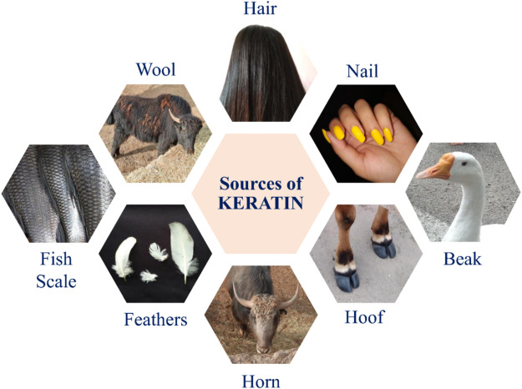

Fig 1: Source of Keratin

2.2 Types of Keratin

Keratin, a crucial structural protein, exists in two primary forms: alpha (α) and beta (β) keratin. α-Keratin, predominantly found in mammals is characterized by its helical structure. The polypeptide chains in α-keratin form right-handed alpha-helices which then pair into left-handed coiled coils. This unique arrangement contributes significantly to the protein's tensile strength and elasticity, making it ideal for flexible structures like hair and skin. In contrast, β-keratin, which is prevalent in birds and reptiles adopts a pleated sheet configuration. This structure imparts rigidity to the protein making β-keratin particularly suited for applications that require stiffness. As a result, β-keratin is often utilized in reinforced composites, leveraging its inherent structural properties to enhance material strength and durability. The distinct characteristics of these two keratin forms highlight the protein's versatility and its critical role in various biological and industrial applications (Esparza et al., 2018; Ghazal et al., 2024).

2.3 Structural Organization of Keratin
Keratin exhibits a complex hierarchical structure that directly governs its physicochemical and mechanical properties. At the molecular level, keratin is composed of polypeptide chains rich in cysteine residues, which form strong disulfide (–S–S–) bonds. These covalent cross-links provide structural stability, rigidity, and resistance to chemical and thermal degradation.
In α-keratin, predominantly found in mammals (e.g., wool, hair), the polypeptide chains adopt a right-handed α-helical configuration. Two α-helices twist together to form a coiled-coil dimer, which further assembles into protofilaments and intermediate filaments. These filaments are embedded in an amorphous protein matrix, forming a fiber-reinforced composite structure responsible for elasticity and tensile strength.
In contrast, β-keratin, found in avian and reptilian sources (e.g., feathers), consists of pleated β-sheet structures stabilized by hydrogen bonding. These sheets stack tightly, resulting in a more rigid and stiff configuration compared to α-keratin. This structural arrangement contributes to the high mechanical strength and lightweight nature of feather-based materials.
At a higher level of organization, keratin fibers consist of:
- Microfibrils: Bundles of aligned intermediate filaments
- Matrix proteins: Amorphous regions providing flexibility
- Cuticle layers: Protective outer covering (in hair/wool)
This hierarchical organization—from molecular chains to macroscopic fibers—enables keratin to exhibit a unique combination of strength, flexibility, durability, and biocompatibility, making it highly suitable for diverse textile and biomedical applications.
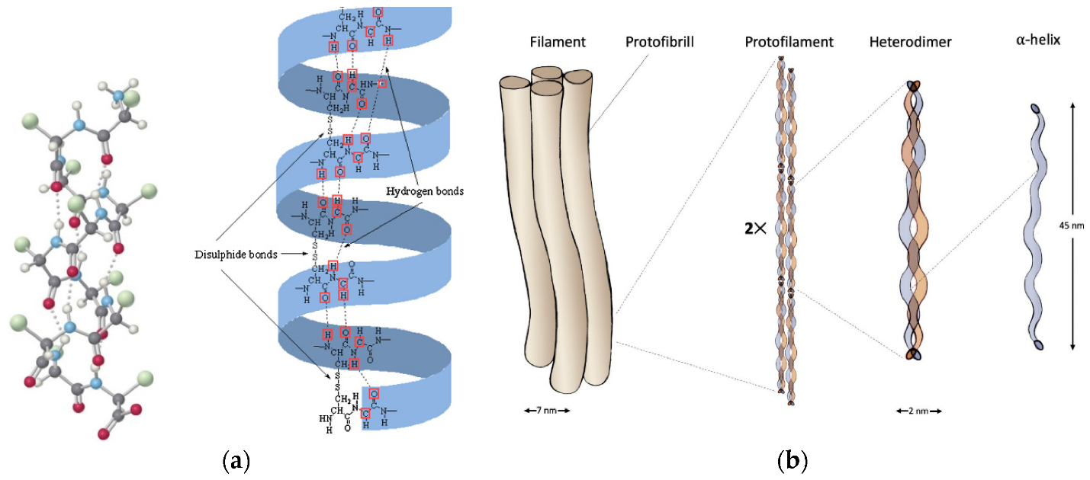
Fig. 2: Alpha structure of keratin

Source: Ghosh et al., 2022

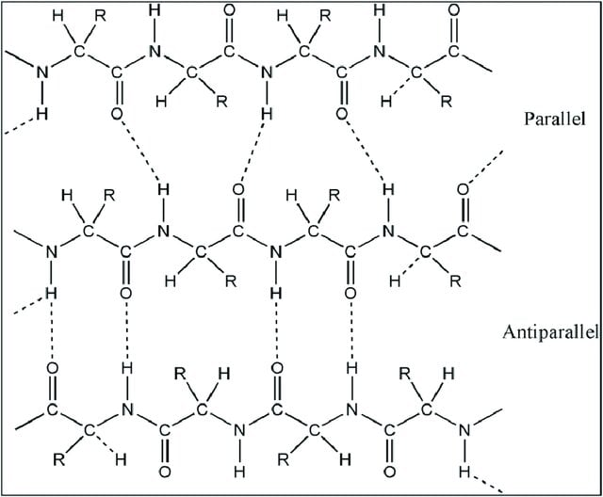
Fig. 3: Beta structure of keratin
Source: Aadil et al., 2024

3. Physicochemical and Mechanical Properties of Keratin

3.1 Physical Properties

Keratin exhibits remarkable physical properties that make it highly suitable for a variety of functional and technical textile applications. One of its most prominent attributes is its exceptional tensile strength and elasticity, which can be attributed to its complex hierarchical structure composed of alpha-helices or beta-sheets stabilized by extensive disulfide crosslinking. This structural organization not only contributes to its mechanical robustness but also provides resilience under stress, allowing keratin-based materials to stretch and recover without permanent deformation (Ghosh et al., 2022).

Additionally, keratin is highly insoluble in water and most organic solvents, which further enhances its durability and stability under varying environmental conditions, including humidity, UV exposure, and mechanical abrasion. These properties make keratin an ideal candidate for outdoor and performance textiles, where resistance to weathering and prolonged wear is crucial. Its physical resilience also supports its use in composite materials, biomedical dressings, and protective coatings, reinforcing its value as a sustainable alternative to synthetic polymers in demanding applications (Tanabe et al., 2020).

3.2 Chemical Properties
The unique chemical properties of keratin arise primarily from its rich and diverse amino acid composition, with cysteine playing a particularly critical role. Cysteine contains thiol (-SH) functional groups, which are highly reactive and capable of forming disulfide bonds (–S–S–) through oxidation. These covalent disulfide linkages create strong intermolecular and intramolecular cross-links within the keratin chains, contributing significantly to the protein’s chemical stability, rigidity, and resistance to degradation. The dense network of these disulfide bridges ensures that keratin maintains its structural integrity even under harsh chemical and thermal conditions, which is why it is often difficult to dissolve or break down using conventional solvents or enzymes (Rouse and Dyke, 2010).
Beyond cysteine, keratin contains other reactive amino acids such as lysine, arginine, glutamic acid, and aspartic acid, which present amino (–NH₂) and carboxyl (–COOH) groups capable of interacting with dyes, finishes, and crosslinking agents. These functional groups provide numerous reactive sites for chemical modification, enabling keratin to form stable complexes with colorants, bioactive compounds, and other polymers. This chemical versatility makes keratin an attractive material for use in textile dyeing, finishing, drug delivery systems, and the formulation of functional coatings. Overall, the chemistry of keratin not only enhances its natural resilience but also opens up opportunities for its functionalization and integration into advanced textile systems and biomaterials (Tesfaye et al., 2017).

3.3 Mechanical Properties
Keratin is renowned for its excellent mechanical performance, which stems from its complex protein structure and the nature of its molecular bonding. One of its key mechanical characteristics is its high elongation at break, meaning it can stretch significantly before rupturing. This makes keratin-based materials flexible and able to withstand mechanical stress, which is especially beneficial for textiles that require a balance of strength and pliability. Additionally, keratin demonstrates good elasticity, allowing it to return to its original shape after deformation, much like natural fibers such as wool or silk. This elasticity is crucial in applications where shape retention and comfort are important, such as in wearable textiles and biomedical dressings (Tonin et al., 2010).
Another vital mechanical attribute of keratin is its superior thermal resistance, with a high denaturation or melting point typically exceeding 215°C. This makes keratin stable under elevated temperatures, allowing it to be used in environments where heat resistance is necessary, such as in technical or protective fabrics. The mechanical behavior of keratin can vary depending on its biological source (e.g., feathers, wool, hair) and the extraction method used. For instance, keratin extracted through gentle enzymatic or reduction methods tends to retain higher molecular weight and structural integrity, resulting in stronger and more flexible materials. In contrast, harsh chemical treatments might degrade the protein chains, compromising strength and elasticity. Nevertheless, when appropriately processed, keratin-based materials can exhibit mechanical properties comparable to or even surpassing certain synthetic polymers, making them a promising, sustainable alternative for a wide range of textile and engineering applications (Shavandi et al., 2017; Fang et al., 2023).

4. Extraction Methods
The extraction method significantly influences the yield, purity and functionality of keratin. The methods are broadly categorized as chemical, enzymatic and physical.

4.1 Chemical Extraction

a. Acid Hydrolysis
Acid hydrolysis is one of the earliest and most commonly used methods for extracting keratin from natural sources such as feathers, wool, and hair. This method involves treating the keratinous material with strong mineral acids, typically hydrochloric acid (HCl) or sulfuric acid (H₂SO₄), under elevated temperatures. The acidic environment breaks the peptide bonds as well as the disulfide bonds that stabilize the keratin structure, leading to its solubilization. While this technique is relatively effective and inexpensive, it has notable drawbacks. The harsh conditions can result in the degradation of essential amino acids such as serine, tryptophan and others sensitive to low pH and high temperatures. This degradation not only reduces the nutritional and functional quality of the extracted keratin but also limits its application in fields requiring intact protein structures, such as biomedical and cosmetic formulations. Despite its limitations, acid hydrolysis is still used in cases where high purity is not critical and cost efficiency is prioritized (Serafini et al., 2024).

b. Alkaline Hydrolysis
Alkaline hydrolysis is a widely adopted chemical method that involves the use of strong bases such as sodium hydroxide (NaOH) or potassium hydroxide (KOH) to disrupt the structural integrity of keratin. The alkaline medium facilitates the cleavage of disulfide bonds and peptide linkages, enabling the protein to dissolve into the extraction solution. Compared to acid hydrolysis, this method tends to be gentler on amino acids, preserving many of them in a more functional state. However, sensitive amino acids like cysteine and methionine are still at risk of degradation under highly alkaline and prolonged treatment conditions. The success of this method depends heavily on the optimization of variables such as pH, temperature (typically 60–90°C) and reaction time. When well-controlled, alkaline hydrolysis provides a good balance between extraction efficiency and preservation of functional protein characteristics, making it suitable for textile, cosmetic and some biomedical applications (Aadil et al., 2024).

c. Oxidation Method
The oxidation method for keratin extraction employs oxidizing agents such as hydrogen peroxide (H₂O₂), peracetic acid, or performic acid to cleave the disulfide bonds present in keratin. These agents work by oxidizing cystine residues into cysteic acid, effectively breaking the cross-links that give keratin its structural rigidity. This disruption allows the protein to become soluble in aqueous solutions, facilitating its extraction. While this method is particularly effective for extracting keratin from highly cross-linked materials such as human hair or wool, it comes with certain limitations. Over-oxidation can lead to the modification or degradation of functional groups, reducing the protein’s reactivity and altering its chemical structure. Moreover, oxidative treatments often require long processing times and careful monitoring to prevent damage to the keratin molecules. As such, this method is more suitable for specific applications where modification of keratin’s chemical structure is acceptable or desired (Chilakamarry et al., 2021).

d. Reduction Method
The reduction method is one of the most preferred techniques for keratin extraction, especially when the goal is to preserve the protein's functional and bioactive properties. It involves the use of reducing agents such as 2-mercaptoethanol, sodium thioglycolate, dithiothreitol (DTT), or sodium metabisulfite. These agents specifically target and break the disulfide bonds that stabilize the keratin structure, converting them into free thiol groups (-SH) under relatively mild and controlled conditions. Unlike oxidative or hydrolytic methods, reduction preserves the amino acid sequence and side-chain functionalities, making the resulting keratin suitable for sensitive applications like biomedical devices, cosmetics and tissue engineering scaffolds. However, some of the reducing agents used can be toxic or environmentally hazardous, which raises concerns about waste disposal and process safety. Recent research is therefore exploring more eco-friendly reducing agents and greener solvents to enhance the sustainability of this effective extraction method (Donato and Mija, 2019).

4.2 Enzymatic Extraction
Enzymatic extraction of keratin is regarded as one of the most sustainable and eco-friendly methods available. This technique involves the use of proteolytic enzymes, such as alkaline proteases, keratinases, and neutral proteases, which selectively hydrolyze the peptide bonds in keratin-rich waste materials like feathers, wool, and hair. Unlike chemical methods, enzymatic hydrolysis is conducted under mild conditions of pH and temperature, thereby preserving the functional integrity and molecular structure of keratin. According to Eslahi et al. (2013), enzymatic hydrolysis using alkaline protease at pH 10 and 50°C significantly improved keratin yield from feather waste, maintaining bioactivity and showing promise for biomedical applications. The extracted keratin retained structural properties as confirmed through FTIR and UV-Vis spectroscopy.
Similarly, Sharma and Gupta (2016) emphasized that keratinases derived from microbial sources (e.g., Bacillus subtilis) are highly efficient in breaking down tough keratin matrices, especially in feathers, due to their ability to cleave disulfide bonds without harsh chemical degradation. Another study by Riffel et al. (2003) highlighted that enzymatic hydrolysis is scalable and can be adapted for industrial processing of poultry waste, resulting in high-purity keratin peptides suitable for use in fertilizers, cosmetics, and textiles. Thus, enzymatic extraction not only aligns with circular economy goals but also ensures a high-quality, bioactive product for various high-end applications.

4.3 Physical Extraction

a. Grinding/Boiling
Grinding and boiling are among the most basic and traditional methods for extracting keratin from protein-rich biomass such as feathers, wool and hair. These methods involve mechanical disruption through grinding, followed by thermal treatment (boiling) to soften or partially hydrolyze the keratin matrix. However, these approaches are not satisfactory because they do not break the strong disulfide bonds that hold the protein structure together. As a result, the yield is typically low, and the purity of the extracted keratin is often compromised due to incomplete protein solubilization and the co-extraction of impurities. Such methods are generally unsuitable for high-end applications but may serve as pre-treatment steps to enhance the efficacy of subsequent chemical or enzymatic processes (Dickerson et al., 2013).

b. Ultrasonication
Ultrasonication is a modern, energy-efficient technique that uses high-frequency sound waves (typically 20-40 kHz) to create microscopic cavitation bubbles in aqueous suspensions of keratinous materials. When these bubbles collapse, they release localized high energy and shear forces that break non-covalent bonds, disrupt the dense protein matrix, and facilitate the release of keratin into solution. Ultrasonication is often employed as a pre-treatment method to enhance the effectiveness of chemical or enzymatic extraction, reduce processing time, and increase keratin solubility without significantly damaging functional groups. However, optimization of sonication parameters (frequency, time, temperature) is crucial, as excessive sonication can cause heat-induced degradation of protein structure (Kumaran et al., 2017).

c. Microwave-Assisted Extraction (MAE)
Microwave-assisted extraction is a green, rapid, and scalable technology that utilizes microwave radiation to heat polar solvents and keratinous biomass. The microwaves cause rapid oscillation of water and polar molecules within the material, generating uniform internal heating. This disrupts hydrogen bonds and weakens disulfide cross-links, thereby enhancing the release of keratin chains into solution. MAE significantly reduces processing time and solvent consumption compared to conventional heating methods. However, there is a risk of thermal degradation if parameters like power, duration, and moisture content are not carefully optimized. MAE is often integrated with reducing agents for better solubilization and is particularly suitable for sustainable keratin recovery for use in bioplastics and nanomaterials (Soleymani and Karbasi, 2024).

d. Steam Explosion
The steam explosion method involves subjecting keratin-rich biomass such as feathers or wool to high-pressure saturated steam (1–3 MPa) at elevated temperatures (180–220°C) for a short period (5–30 minutes). After this thermal treatment, the pressure is rapidly released, causing the material to undergo explosive decompression. This sudden pressure drop disrupts the dense fibrous structure of keratin, breaking both hydrogen and disulfide bonds, which facilitates the subsequent solubilization of keratin in water or mild solvents. The primary advantage of this technique is its environmental friendliness, as it requires no toxic chemicals and produces minimal waste. However, if not carefully controlled, the high temperature and pressure may lead to partial degradation of the protein, reducing its suitability for high-end functional applications (Wang and Tong, 2022).

Table 1. Comparison of keratin extraction methods
Study | Source Material | Method Used | Key Advantages | Limitations | Relevance to Current Review
Shavandi et al. (2017) | Wool | Chemical (alkaline/reduction) | High yield, established method | Amino acid degradation, chemical waste | Basis for conventional extraction discussion
Chilakamarry et al. (2021) | Feathers, hair | Chemical + oxidation | Effective for rigid keratin | Structural modification risk | Highlights need for controlled processing
Eslahi et al. (2013) | Feathers | Enzymatic (protease) | Eco-friendly, preserves structure | Slower process, enzyme cost | Supports green extraction focus
Sharma & Gupta (2016) | Feathers | Microbial keratinase | High specificity, scalable potential | Process optimization required | Indicates industrial feasibility
Kumaran et al. (2017) | Feathers | Ultrasonication-assisted | Faster extraction, improved solubility | Risk of heat degradation | Demonstrates process intensification
Soleymani & Karbasi (2024) | Wool/feathers | Microwave-assisted | Reduced time, energy efficient | Parameter sensitivity | Promotes green scalable technologies
Wang & Tong (2022) | Feathers | Steam explosion | Chemical-free, eco-friendly | Partial degradation possible | Suitable for bulk processing

Comparative Insight
Compared to previous studies that primarily focus on single extraction techniques, this review uniquely integrates chemical, enzymatic, and advanced physical methods under a sustainability framework. It highlights that while chemical methods dominate industrial use, hybrid green approaches (e.g., enzymatic + microwave) offer a more viable pathway for scale-up with reduced environmental impact.

5. Applications in Textile and Biomedical Fields

5.1 Keratin Hydrogels

Keratin hydrogels are three-dimensional (3D) polymeric networks formed from keratin proteins extracted from natural sources such as feathers, wool, or hair. These hydrogels possess remarkable water-absorbing capacity due to the presence of numerous hydrophilic functional groups including hydroxyl (–OH), amino (–NH₂), and carboxyl (–COOH) groups which interact with water molecules via hydrogen bonding. This high swelling behavior allows keratin hydrogels to retain moisture, making them particularly suitable for moist wound healing environments.
One of the most significant advantages of keratin hydrogels is their excellent biocompatibility and non-toxic nature, which make them ideal candidates for biomedical and cosmetic applications. These hydrogels closely mimic the extracellular matrix (ECM), thereby promoting cell adhesion, proliferation, and migration. In tissue engineering, keratin hydrogels support the regeneration of skin, bone, and soft tissues.
Esparza et al. (2018) developed feather keratin hydrogels and reported higher viscoelasticity and cell proliferation compared to wool- or hair-derived keratin hydrogels. In another study, Husain et al. (2019) prepared keratin hydrogels by blending keratin with biocompatible polymers like chitosan and aloe vera, resulting in improved mechanical strength, water retention and antimicrobial activity. These composite hydrogels showed excellent potential in wound healing due to their ability to support fibroblast proliferation and provide controlled drug release.
Furthermore, Kumaran et al. (2017) synthesized wound-healing keratin hydrogels from poultry feathers and demonstrated their non-toxicity and moisture-maintaining ability, crucial for tissue regeneration. These findings collectively suggest that keratin hydrogels are low-cost, sustainable and highly functional biomaterials suitable for applications in medical textiles, wound dressings, drug delivery systems and even skin substitutes.
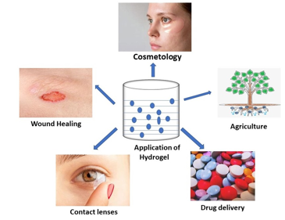
Fig 4: Application of Hydrogel

5.2 Keratin Scaffolds and Sponges
Keratin-based scaffolds are engineered three-dimensional (3D) porous structures designed to mimic the architecture and functionality of the extracellular matrix (ECM). Derived from keratin proteins extracted from renewable biological waste such as wool, feathers, and hair, these scaffolds possess key characteristics desirable for tissue engineering, such as biocompatibility, biodegradability, structural integrity and bioactivity. Their inherent ability to interact with cells and support tissue regeneration has made keratin scaffolds highly attractive for applications in skin, bone, cartilage and nerve tissue repair.
Keratin’s unique amino acid composition rich in cysteine, glycine, and glutamic acid allows for strong intermolecular bonding and natural cross-linking through disulfide bridges. This promotes not only mechanical strength but also biological responsiveness, enabling cellular adhesion, proliferation, and differentiation (Tsuda and Nomura, 2014).
To fabricate these scaffolds, several advanced techniques are employed:
- Electrospinning: Used to create nanofibrous keratin mats that resemble ECM and promote cellular interaction.
- Freeze-drying (lyophilization): Produces highly porous and interconnected structures essential for nutrient transport and tissue in-growth.
- 3D Printing: Allows for precision design and control over scaffold geometry, porosity, and mechanical strength.
Keratin scaffolds exhibit excellent biocompatibility and can be tailored for specific tissues by combining them with other natural or synthetic polymers like chitosan, gelatin, or polycaprolactone (PCL). These combinations enhance the mechanical robustness and biofunctionality of the scaffolds. The authors reviewed various scaffold types such as hydrogels, nanofibers, sponges, and films and confirmed their effectiveness in promoting cellular regeneration and tissue integration. Ghosh et al. (2022) demonstrated that keratin scaffolds derived from poultry feathers exhibited superior moisture retention and supported fibroblast cell growth, making them excellent candidates for skin grafts and wound healing applications. Their porous structure also facilitated the diffusion of nutrients and removal of waste, further enhancing tissue regeneration outcomes. These keratin scaffolds not only reduce dependency on synthetic biomaterials but also align with circular economy and waste valorization strategies, promoting environmental sustainability while advancing biomedical innovation.
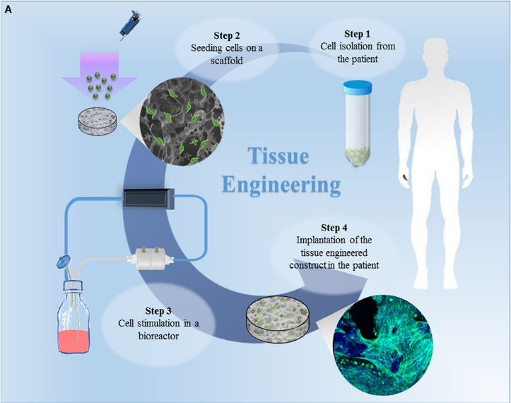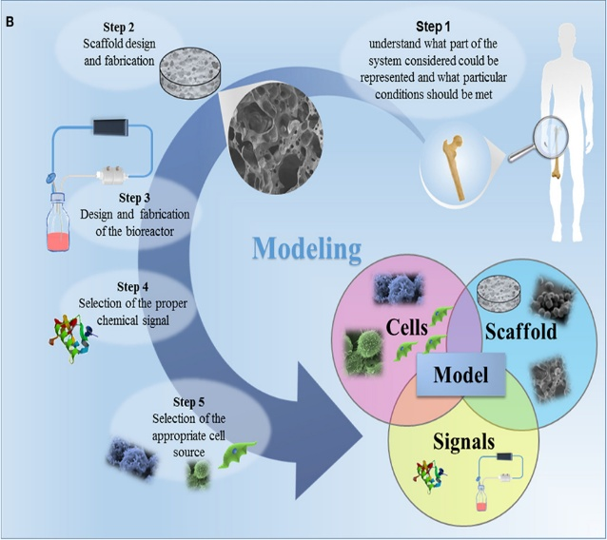
Fig: 5:Tissue Engineering and Modeling

5.3 Keratin Biofilms
Keratin biofilms are thin, continuous coatings formed from keratin proteins that are cast or deposited onto substrates, particularly textile materials. These biofilms leverage keratin’s film-forming capability, biocompatibility, and functional group richness to impart multifunctional properties to fabrics, making them highly suitable for medical, protective and smart textiles. Keratin’s structure includes numerous functional groups, such as hydroxyl (–OH), amino (–NH₂), carboxyl (–COOH), and thiol (–SH), which facilitate strong adhesion to fabric surfaces and enable interactions with dyes, drugs, and nanoparticles. These chemical groups also allow keratin biofilms to be easily modified or blended with other biopolymers or antimicrobial agents, further expanding their applicability.
Wang and Tong (2022) stated that keratin biofilms derived from wool and feather keratin show enhanced antimicrobial activity, UV resistance and moisture control when applied to textiles. These properties are especially valuable in cosmeceutical garments, wound dressing fabrics and baby clothing, where skin contact and hygiene are critical. Additionally, the porous and hydrophilic nature of keratin biofilms allows them to function as humidity sensors, capable of detecting moisture changes in wearable electronics and functional clothing.
Keratin biofilms have demonstrated significant adsorption capacity for pollutants, including heavy metals, dyes, and pharmaceuticals. This is attributed to the active binding sites present in the keratin matrix, which interact with pollutants through ionic exchange, hydrogen bonding and chelation mechanisms (Aluigi et al., 2013). Such features position keratin-based biofilms as sustainable materials not only for textiles but also for environmental remediation applications like water purification membranes and smart filtration systems. Recent advancements have also enabled the integration of keratin biofilms with nanomaterials or crosslinking agents (e.g., genipin or glutaraldehyde) to enhance their mechanical strength, thermal stability and functional responsiveness without compromising biodegradability.
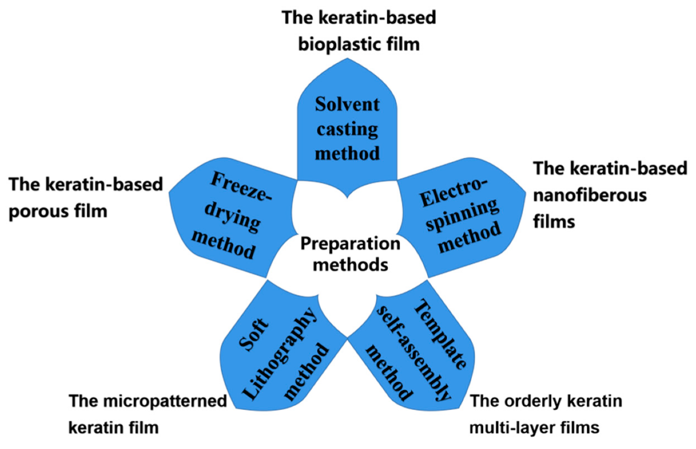

Fig. 6: Preparation method of keratin-based biofilms

Source: https://encyclopedia.pub/entry/36643

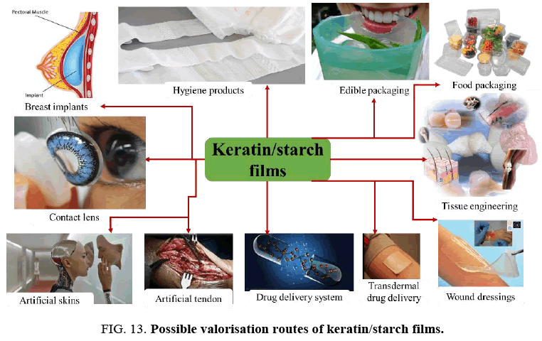

Fig. 7: Possible valorization routes of keratin/starch films

Source: https://encyclopedia.pub/entry/36643

5.4 Keratin Nanofibers
Keratin nanofibers are ultra-fine fibrous structures, typically ranging from 50 to 500 nanometers in diameter, fabricated from keratin protein using the electrospinning technique. Electrospinning employs a high-voltage electric field to draw a polymer solution containing keratin or keratin blends—into fine, continuous fibers that are collected as nonwoven mats. These nanofibers exhibit a high surface-area-to-volume ratio, high porosity and interconnected pore networks, making them highly suitable for biomedical and textile applications.
The production of pure keratin nanofibers is often challenged by the low molecular weight and poor spinnability of keratin alone. Therefore, keratin is commonly blended with synthetic or natural polymers such as polycaprolactone (PCL), polyvinyl alcohol (PVA), gelatin, or chitosan to enhance fiber formation, improve mechanical strength, and stabilize the fiber structure (Aadil et al., 2024). These composite nanofibers combine the biocompatibility and biodegradability of keratin with the processability and durability of the added polymers.
Keratin nanofibers have been widely explored for tissue engineering scaffolds due to their ability to mimic the extracellular matrix (ECM), thus promoting cell adhesion, proliferation and differentiation. Aadil et al. (2024) demonstrated that keratin/PCL nanofibers supported the regeneration of skin and nerve tissues by enhancing cell–matrix interactions. These nanofibers also show promise in drug delivery systems, as their porous structure enables the encapsulation and controlled release of therapeutic agents. In the textile sector, keratin nanofibers are emerging in the development of smart textiles, where they are utilized for moisture sensing, antimicrobial coatings and UV protection. Their natural origin, non-toxicity and sustainability further position them as viable alternatives to synthetic nanofibers in cosmetic patches, wearable devices, and environmental filters.
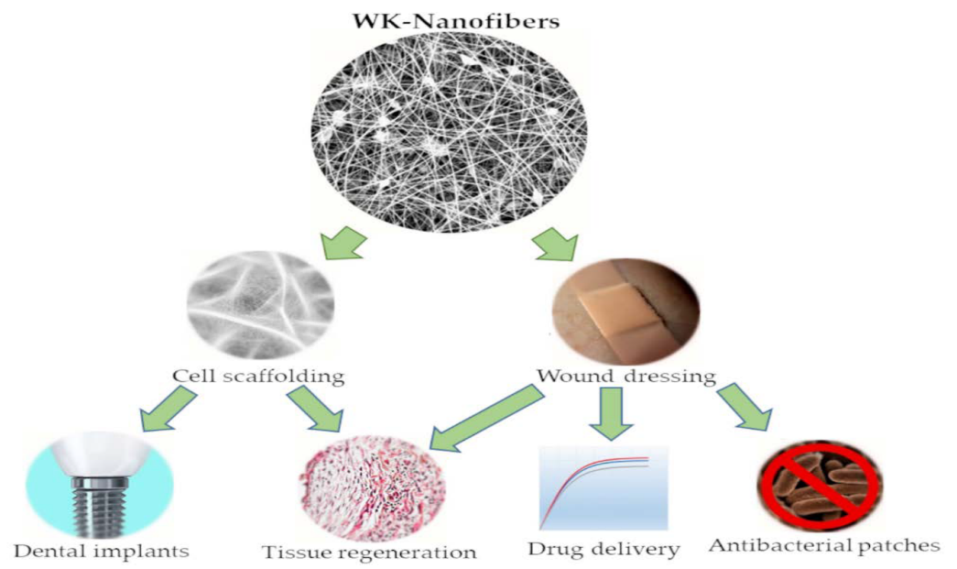

Fig. 8: Applications of nanofibers

6. Keratin as a Biopolymer in Textile Processing

6.1 Keratin in Textile Printing
Keratin’s natural film-forming ability makes it an effective biopolymer for use in eco-friendly textile printing. When applied to fabric surfaces, keratin forms a uniform, adherent layer that enhances the binding of pigments or dyes, especially in water-based printing systems. This improves color retention, wash fastness, and rub fastness, key parameters for high-quality printed textiles. Unlike synthetic binders derived from petroleum (e.g., acrylates or urethanes), keratin is biodegradable, non-toxic, and skin-compatible, making it particularly suitable for babywear, medical textiles, and sustainable fashion applications. Ghazal et al. (2024) demonstrated that keratin-based films not only improved pigment fixation on cotton and wool substrates but also provided additional benefits such as improved hand feel and resistance to abrasion. Therefore, keratin serves as a promising bio-based binder alternative in pigment printing formulations.

6.2 Keratin in Textile Dyeing
Keratin plays a crucial role in improving dye affinity and uptake when used as a pre-treatment agent. Its molecular structure is rich in amino groups (–NH₂) and carboxyl groups (–COOH), which act as reactive sites for bonding with acid, reactive and natural dyes. These groups facilitate ionic and covalent interactions with dye molecules, thereby enhancing dye absorption, penetration and fixation on the fiber surface. In natural dyeing, keratin can also act as a biomordant, eliminating the need for toxic metallic salts like alum or iron sulfate. According to Ghazal et al. (2024), keratin pre-treated cotton fabrics exhibited significantly higher color intensity (K/S values) and better light and wash fastness compared to untreated samples. Additionally, keratin treatments reduce the use of auxiliary chemicals, supporting cleaner production in textile dyeing processes.

6.3 Keratin in Textile Finishing

In the finishing stage, keratin is employed to enhance fabric performance and user comfort. Due to its natural compatibility with protein fibers like wool and silk, keratin acts similarly to a conditioning treatment, smoothing the surface, filling micro-gaps, and reducing friction between fibers. This results in a softer hand feel, improved drape, and wrinkle resistance. Moreover, keratin-based finishes impart antimicrobial, UV-protective, and moisture-regulating functionalities to textiles. These effects are largely due to keratin’s sulfur-rich composition, which inhibits microbial growth, and its hydrophilic groups, which regulate moisture absorption. Ghazal et al. (2024) reported that keratin-finished textiles showed a 30–50% increase in UV protection and a significant reduction in bacterial growth, making them suitable for healthcare, sportswear, and outdoor apparel. Furthermore, such finishes are biodegradable, non-allergenic, and free from formaldehyde or toxic resins.

Table 2. Comparison of keratin-based material applications
Study | Application Type | Material Form | Key Findings | Limitations | Advancement in Current Review
Esparza et al. (2018) | Hydrogels | Feather keratin | High cell proliferation, viscoelasticity | Limited mechanical strength | Compared across multiple keratin sources
Husain et al. (2019) | Hydrogels | Keratin blends | Improved antimicrobial & moisture retention | Requires polymer blending | Demonstrates composite strategies
Ghosh et al. (2022) | Scaffolds | Porous keratin | Supports fibroblast growth | Scale-up not addressed | Links to biomedical + textile use
Aadil et al. (2024) | Nanofibers | Keratin/PCL | Enhanced tissue regeneration | Synthetic blending required | Connects to smart textiles
Wang & Tong (2022) | Biofilms | Wool/feather | UV protection, antimicrobial | Durability concerns | Expands into textile finishing
Dickerson et al. (2013) | Nanofibers/films | Keratin-based | Antimicrobial textiles | Limited industrial data | Integrated with modern applications

Comparative Insight
Earlier studies typically focus on single applications (e.g., hydrogels or scaffolds), whereas this review provides a cross-domain integration of textile and biomedical uses. It advances the literature by demonstrating how keratin can function as a multi-purpose biopolymer, bridging functional textiles, smart materials, and regenerative medicine.

7. Market Overview and Key Players
The global keratin market has experienced significant growth in recent years, driven by increasing demand for biodegradable, protein-based materials in textiles, cosmetics, pharmaceuticals, and biomedical applications. According to a recent market analysis by Data Bridge Market Research (2024), the keratin market was valued at approximately USD 1.66 billion in 2024 and is expected to grow at a compound annual growth rate (CAGR) of 6.4%, reaching around USD 2.4 billion by 2030. This growth is fueled by rising consumer awareness of sustainability, growing preference for natural ingredients in personal care products, and innovations in bio-based materials.

a. Oceanit – KERTEX
One of the most innovative entrants in the keratin market is Oceanit, a U.S.-based technology company that has developed KERTEX, a keratin-based technical fabric derived from poultry feathers. KERTEX is being designed as a bio-based alternative to synthetic high-strength fabrics used in military and defense applications, including seat belts, uniforms and vehicle covers. Oceanit’s approach aligns with circular economy principles, valorizing waste from the poultry industry to produce high-performance textile composites. According to the company, KERTEX offers strength comparable to nylon and polyester but with lower environmental impact and enhanced biodegradability (Oceanit, 2023).

b. Fendi – Lab-Grown Keratin for Faux Fur
In the luxury fashion sector, Fendi, a brand under the LVMH Group, has partnered with Imperial College London and Central Saint Martins to explore lab-grown keratin produced through yeast fermentation. This synthetic biology initiative aims to create a plastic-free, cruelty-free alternative to animal fur, offering the softness, structure, and appearance of real fur without the use of animal-derived or petrochemical materials. This innovation represents a pioneering move toward regenerative and ethical fashion, positioning keratin as a biological building block for future textiles (Vogue Business, 2024).

c. Keraplast, BASF, Rejuvenol, and Wellgreen
Several global companies have emerged as key suppliers of keratin-based biomaterials, catering to sectors such as cosmetics, hair care, biomedical devices and textiles:
- Keraplast Technologies (New Zealand): Specializes in purified functional keratin proteins used in skin, wound healing, and haircare formulations. Their keracyte® and keragel® products are widely used in regenerative medicine.
- BASF SE (Germany): Offers hydrolyzed keratin derivatives for hair strengthening and skin barrier repair in personal care products. BASF is investing in bio-based and sustainable ingredients under its Care Chemicals division.
- Rejuvenol (USA): Known for keratin-based smoothing treatments and cosmetic-grade protein complexes for hair restoration and conditioning.
- Wellgreen Technology Co., Ltd. (China): Focuses on the production of plant and animal protein extracts, including keratin for pharmaceutical, food, and textile applications. They emphasize clean-label and eco-friendly production methods.
These players are continually expanding their portfolios to meet the increasing demand for natural, safe, and high-performance keratin products, contributing to the global shift toward green chemistry and sustainable innovation.

8. Impact Assessment
The use of keratin in sustainable textiles has far-reaching implications that extend beyond material functionality. Its environmental, industrial, and socio-economic impacts collectively support a transition toward a circular and bio-based textile economy.

8.1 Environmental Benefits
One of the most significant environmental advantages of keratin-based materials is their ability to convert agricultural and slaughterhouse waste such as feathers, wool scraps, hair, and hooves—into value-added products. Instead of being discarded in landfills or incinerated (both of which cause pollution), these keratin-rich wastes are upcycled into functional textiles, biomedical materials, and cosmetics. This waste valorization reduces the environmental burden of organic waste management while simultaneously providing renewable raw materials. Keratin is also biodegradable and non-toxic, meaning it breaks down naturally without releasing harmful residues into the environment. Unlike petroleum-derived polymers such as polyester or nylon, keratin decomposes under ambient or composting conditions, thereby minimizing microplastic pollution in aquatic and terrestrial ecosystems (Husain et al., 2019).
Furthermore, keratin-based alternatives reduce the textile industry's dependency on synthetic and petrochemical materials, which are not only non-renewable but also energy-intensive to produce. By replacing synthetic binders, finishes, and fibers with keratin, the environmental carbon and water footprints of textiles can be significantly reduced, contributing to global sustainability goals.

8.2 Industrial Impact
Keratin incorporation into textiles provides enhanced functional performance, including antimicrobial properties, UV resistance, moisture management, and improved dye uptake. These value-added features allow manufacturers to offer high-performance textiles without resorting to toxic chemical treatments, improving both product quality and safety. Keratin’s application in printing, dyeing, and finishing reduces overall energy and chemical consumption. For instance, keratin acts as a natural mordant in dyeing processes, decreasing the need for metal salts and harsh chemicals. In printing, its film-forming properties replace synthetic binders, further reducing reliance on petroleum-based inputs. Such efficiency in processing not only supports cleaner production practices but also translates into cost savings for manufacturers (Fang et al., 2023).
Keratin also plays a pivotal role in the development of smart and responsive textiles, which are gaining traction in healthcare, defense, and sportswear sectors. Its compatibility with nanomaterials and drug-delivery systems enables textiles to respond to stimuli (like pH, moisture, or temperature), facilitating innovations such as wearable biosensors, healing fabrics, and odor-neutralizing clothing. These advances represent a leap in textile technology, driven by sustainable bio-derived materials like keratin (Joki-Korpela and Pakkanen, 2011).

8.3 Social and Economic Impact
From a socio-economic standpoint, keratin extraction and application promote rural employment opportunities, particularly in regions where livestock farming and poultry processing generate abundant keratin-rich waste. Collection, sorting, and preliminary processing of feathers, wool, and hair provide income-generation avenues for rural and underprivileged communities, contributing to inclusive development. The growing market for bio-based materials supports the rise of green jobs and sustainable entrepreneurship, especially among start-ups and small enterprises focusing on eco-friendly products. These ventures not only stimulate economic growth but also foster innovation in materials science, agriculture, and textiles. Keratin-based innovations contribute to increased consumer awareness of sustainable living. As consumers become more informed about the environmental impacts of their clothing choices, demand for biodegradable, cruelty-free, and safe textile products is growing. Keratin, being natural, skin-friendly, and renewable, aligns with the values of eco-conscious consumers, thereby encouraging more responsible consumption patterns and reinforcing sustainability across the textile value chain (Du et al., 2022).
9. Bridging the Gap Between Laboratory Research and Industrial Scale-Up
Despite significant advancements in keratin extraction and application at the laboratory scale, the transition to large-scale industrial production remains a critical challenge. This gap arises due to factors such as high processing costs, variability in raw material quality, limited scalability of eco-friendly extraction techniques and insufficient integration with existing textile manufacturing systems. To bridge this divide, a multi-pronged approach is required. First, the development of scalable green extraction technologies, such as enzymatic hydrolysis combined with process intensification techniques (e.g., microwave- or ultrasound-assisted systems), can enhance yield while maintaining sustainability. Second, process optimization and standardization are essential to ensure consistent keratin quality across batches, especially when using heterogeneous waste sources like feathers or hair. Third, biorefinery-based models should be adopted, where keratin extraction is integrated with other biomass valorization processes to improve economic feasibility and reduce waste.
Collaboration between academia, industry, and policymakers is also crucial to accelerate commercialization. Investment in pilot-scale studies and techno-economic analyses will help validate the feasibility of keratin-based materials under real industrial conditions. Additionally, the development of keratin-polymer composites and blends can overcome limitations such as poor mechanical stability, making them more compatible with current textile processing infrastructure. Finally, supportive regulatory frameworks and market incentives promoting bio-based materials can drive industry adoption. By aligning scientific innovation with industrial requirements and sustainability goals, keratin has the potential to move from niche laboratory applications to mainstream textile manufacturing, contributing significantly to a circular and zero-waste economy.

Table 3. Comparison with existing review articles
Study | Focus Area | Strengths | Gaps Identified | Contribution of Current Review
Rouse & Van Dyke (2010) | Biomedical keratin | Strong biomaterial focus | Limited textile applications | Expands into textile processing
Donato & Mija (2019) | Polymer blends | Detailed polymer interactions | Less focus on sustainability | Adds circular economy perspective
Chilakamarry et al. (2021) | Extraction & applications | Broad overview | Limited scale-up discussion | Addresses industrial gap
Fang et al. (2023) | Textile fibers | Focus on fiber regeneration | Narrow application scope | Includes full textile processing chain
Schiller & Scheibel (2024) | Bioinspired fibers | Advanced material science | Limited waste valorization | Emphasizes waste-to-resource approach

Comparative Insight
Unlike prior reviews that are either application-specific or method-focused, the present review offers a holistic framework combining:
- Extraction techniques
- Material applications
- Industrial relevance
- Sustainability and circular economy
Most importantly, this paper explicitly addresses the lab-to-industry scale-up gap, which is largely overlooked in earlier literature.
10. Limitations of the Study
While this review provides a comprehensive overview of keratin as a sustainable biomaterial for textile applications, several limitations should be acknowledged. First, the study is primarily based on secondary literature sources, and therefore depends on the availability, quality, and scope of previously published data. Variations in experimental conditions, raw material sources, and characterization techniques across studies may affect the comparability and generalization of findings. Second, although multiple extraction methods are discussed, the review lacks quantitative comparative analysis (e.g., yield efficiency, cost metrics, life cycle assessment), which is essential for objectively evaluating the feasibility of different techniques at an industrial scale. Third, the paper highlights the potential of green and sustainable extraction processes; however, limited large-scale or pilot-scale data are available in the literature, restricting a detailed assessment of their industrial viability.
Additionally, the discussion on applications, particularly in textile processing and biomedical fields, is largely based on laboratory-scale studies, with relatively fewer examples of commercial implementation. This reflects the broader challenge of translating keratin technologies from research to real-world production. Furthermore, regional variations in raw material availability, infrastructure, and regulatory frameworks are not deeply explored, which may influence the scalability and adoption of keratin-based solutions globally. Finally, the rapidly evolving nature of biomaterials research means that emerging technologies and innovations may not be fully captured, potentially limiting the timeliness of certain insights. Future studies should address these gaps by incorporating experimental validation, techno-economic analysis, and life cycle assessment to provide a more holistic evaluation of keratin’s industrial potential

11. Conclusion
Keratin has emerged as a highly promising biomaterial for advancing sustainability in the textile industry due to its natural abundance, biodegradability, and versatile functional properties. Derived primarily from renewable waste sources such as feathers, wool, human hair, horns, and hooves, keratin represents a valuable opportunity for waste valorization and supports the transition toward a circular and resource-efficient economy. Its unique hierarchical structure, stabilized by disulfide cross-links and composed of α-helical or β-sheet arrangements, imparts excellent mechanical strength, elasticity, thermal stability, and chemical reactivity, making it suitable for a wide range of advanced applications. This review has systematically examined various keratin extraction methods, including chemical, enzymatic, and emerging physical techniques. While conventional chemical processes remain widely used due to their efficiency and scalability, they are often associated with environmental concerns and partial degradation of protein functionality. In contrast, enzymatic and green-assisted methods such as ultrasonication, microwave-assisted extraction, and steam explosion offer more sustainable alternatives, preserving bioactivity while reducing ecological impact. However, their large-scale implementation requires further optimization and economic validation.
The application potential of keratin has been extensively demonstrated across both textile and biomedical domains. Keratin-based hydrogels, scaffolds, biofilms, and nanofibers exhibit excellent biocompatibility, moisture retention, antimicrobial activity, and structural adaptability, enabling their use in wound healing, tissue engineering, smart textiles, and functional coatings. In textile processing, keratin serves as an eco-friendly biopolymer in printing, dyeing, and finishing, improving dye affinity, fabric performance, and user comfort while reducing reliance on synthetic chemicals. From an industrial and market perspective, the growing demand for bio-based and sustainable materials has accelerated innovation in keratin-based technologies, with several companies actively developing commercial products. Nevertheless, a critical gap persists between laboratory-scale research and industrial-scale production. Challenges such as raw material variability, process standardization, cost efficiency, and integration with existing manufacturing systems continue to hinder widespread adoption.
To bridge this gap, future research should prioritize the development of scalable and economically viable green extraction technologies, supported by pilot-scale studies, life cycle assessments, and techno-economic analyses. The integration of keratin extraction into biorefinery models, along with the development of keratin-based composites and hybrid materials, can further enhance performance and industrial compatibility. Additionally, interdisciplinary collaboration among researchers, industry stakeholders, and policymakers will be essential to accelerate commercialization and establish supportive regulatory frameworks.
In conclusion, keratin holds significant potential to transform the textile sector by offering a sustainable alternative to conventional synthetic polymers. By aligning material innovation with environmental and industrial requirements, keratin-based technologies can play a pivotal role in achieving zero-waste strategies, reducing environmental impact, and advancing the global transition toward sustainable and circular textile systems.

COMPETING INTERESTS DISCLAIMER:
Authors have declared that they have no known competing financial interests OR non-financial interests OR personal relationships that could have appeared to influence the work reported in this paper.

Disclaimer (Artificial intelligence)

Author(s) hereby declare that NO generative AI technologies such as Large Language Models (ChatGPT, COPILOT, etc.) and text-to-image generators have been used during the writing or editing of this manuscript.

References:
- Aadil, K. R., Bhange, K., Kumar, N., & Mishra, G. (2024). Keratin nanofibers in tissue engineering: Bridging nature and innovation. Biotechnology for Sustainable Materials, 1(1), 19-25.
- Aluigi, A., Corbellini, A., Rombaldoni, F., & Mazzuchetti, G. (2013). Wool-derived keratin nanofiber membranes for dynamic adsorption of heavy-metal ions from aqueous solutions. Textile Research Journal, 83(15), 1574-1586.
- BASF Care Chemicals. (2023). Sustainable Personal Care Ingredients Portfolio. https://www.basf.com/global/en/products/care-chemicals.html
- Chilakamarry, C. R., Mahmood, S., Saffe, S. N. B. M., Arifin, M. A. B., Gupta, A., Sikkandar, M. Y., & Narasaiah, B. (2021). Extraction and application of keratin from natural resources: A review. 3 Biotech, 11(5), 220-230.
- Data Bridge Market Research. (2024). Global Keratin Market – Industry Trends and Forecast to 2030. https://www.databridgemarketresearch.com/reports/global-keratin-market
- Dickerson, M. B., Sierra, A. A., Bedford, N. M., Lyon, W. J., Gruner, W. E., Mirau, P. A., & Naik, R. R. (2013). Keratin-based antimicrobial textiles, films, and nanofibers. Journal of Materials Chemistry B, 1(40), 5505-5514.
- Donato, R. K., & Mija, A. (2019). Keratin associations with synthetic, biosynthetic and natural polymers: An extensive review. Polymers, 12(1), 32-45.
- Du, W., Zhang, L., Zhang, C., Cao, J., Wang, D., Li, H., & Zeng, J. (2022). Green and highly efficient wool keratin extraction by microwave induction method. Frontiers in Materials, 8, 92-98.
- Eslahi, N., Dadashian, F., & Nejad, N. H. (2013). An investigation on keratin extraction from wool and feather waste by enzymatic hydrolysis. Preparative Biochemistry and Biotechnology, 43(7), 624-648.
- Esparza, Y., Bandara, N., Ullah, A., & Wu, J. (2018). Hydrogels from feather keratin show higher viscoelastic properties and cell proliferation than those from hair and wool keratins. Materials Science and Engineering: C, 90, 446-453.
- Fang, W., Fan, R., Aranko, A. S., Hummel, M., & Sixta, H. (2023). Upcycling of keratin wastes in sustainable textile fiber applications. ACS Sustainable Chemistry & Engineering, 11(40), 14807-14815.
- Feughelman, M. (2002). Natural protein fibers. Journal of Applied Polymer Science, 83(3), 489-507.
- Ghazal, H., Hegazy, B. M., Saad, F., Sedik, A., & Hassabo, A. G. (2024). Application of keratin biopolymer in the textile industry. Lett. Appl. NanoBioSci., 13(1), 43-55.
- Ghosh, S., Patra, C. R., & Roy, S. (2022). Fabrication and evaluation of keratin-based scaffolds derived from poultry feathers for tissue engineering. Journal of Biomaterials Applications, 36(5), 789–803.
- Gupta, S., & Sharma, S. (2026). Sustainable valorization of poultry waste through optimized keratin extraction and its prospective use in dye adsorption. BMC Chemistry, 20(1), 54.
- Husain, M. S. B., Gupta, A., & Alashwal, B. Y. (2019, November). Development of keratin-based hydrogels for biomedical applications. In IOP Conference Series: Materials Science and Engineering (Vol. 702, No. 1, p. 012031). IOP Publishing.
- Joki-Korpela, F., & Pakkanen, T. T. (2011). Incorporation of polydimethylsiloxane into polyurethanes and characterization of copolymers. European polymer journal, 47(8), 1694-1708.
- Keraplast Technologies. (2022). Functional Keratin Science for Skin, Hair and Tissue Regeneration. https://www.keraplast.com
- Kumaran, P., Gupta, A., & Sharma, S. (2017). Synthesis of wound-healing keratin hydrogels using chicken feathers proteins and its properties. International Journal of Pharma Science, 9(2), 171-178.
- Lebedytė, M., & Sun, D. (2022). A review: can waste wool keratin be regenerated as a novel textile fibre via the reduction method? The Journal of The Textile Institute, 113(8), 1750-1766.
- Nayak, R., Padhye, R., Kyratzis, I. L., Truong, Y. B., & Arnold, L. (2012). Recent advances in nanofibre fabrication techniques. Textile Research Journal, 82(2), 129-147.
- Oceanit. (2023). KERTEX: A Keratin-based Sustainable Textile Innovation. https://oceanit.com/products/kertex-keratin-based-performance-textile/
- Pulidori, E., Micalizzi, S., Bramanti, E., Bernazzani, L., Duce, C., De Maria, C., & Tinè, M. R. (2021). One-pot process: microwave-assisted keratin extraction and direct electrospinning to obtain keratin-based bioplastic. International Journal of Molecular Sciences, 22(17), 23-34.
- Rejuvenol Laboratories. (2022). Keratin-based Cosmetic Products. https://www.rejuvenol.com
- Riffel, A., Lucas, F., Heeb, P., & Brandelli, A. (2003). Characterization of a new keratinolytic bacterium that completely degrades native feather keratin. Archives of Microbiology, 179(4), 258-265.
- Rodriguez-Clavel, I. S., Paredes-Carrera, S. P., Flores-Valle, S. O., Paz-García, E. J., Sanchez-Ochoa, J. C., & Perez-Gutierrez, R. M. (2019). Effect of microwave or ultrasound irradiation in the extraction from feather keratin. Journal of Chemistry, 2019(1), 132-142.
- Rouse, J. G., & Van Dyke, M. E. (2010). A review of keratin-based biomaterials for biomedical applications. Materials, 3(2), 999-1014.
- Schiller, T., & Scheibel, T. (2024). Bioinspired and biomimetic protein-based fibers and their applications. Communications Materials, 5(1), 56-63.
- Serafini, I., Favero, G., Curini, R., Kavich, G. M., & Cleland, T. P. (2024). Development of a combined protein and dye extraction approach for the analysis of keratin-based textiles. Journal of Proteome Research, 23(9), 3890-3903.
- Sharma, S., & Gupta, A. (2016). Sustainable management of keratin waste biomass: applications and future perspectives. Brazilian Archives of Biology and Technology, 59, e16150684.
- Shavandi, A., Bekhit, A. E. D. A., Carne, A., & Bekhit, A. (2017). Evaluation of keratin extraction from wool by chemical methods for bio-polymer application. Journal of bioactive and compatible polymers, 32(2), 163-177.
- Soleymani Eil Bakhtiari, S., & Karbasi, S. (2024). Keratin-containing scaffolds for tissue engineering applications: A review. Journal of Biomaterials science, Polymer edition, 35(6), 916-965.
- Tanabe, T., Okitsu, N., Yamauchi, K., & Kobayashi, H. (2020). Keratin film prepared from human hair: characterization and biological activity. Materials Science and Engineering: C, 106, 110155.
- Tesfaye, T., Sithole, B., Ramjugernath, D., & Chunilall, V. (2017). Valorisation of chicken feathers: Application in paper production. Journal of cleaner production, 164, 1324-1331.
- Tonin, C., Aluigi, A., Varesano, A., & Vineis, C. (2010). Keratin-based nanofibres. Nanofibers, 1, 139-158.
- Tsuda, Y., & Nomura, Y. (2014). Properties of alkaline‐hydrolyzed waterfowl feather keratin. Animal science journal, 85(2), 180-185.
- Vogue Business. (2024). Fendi Opens the Door to Sustainable, Plastic-free Faux Fur. https://www.voguebusiness.com/sustainability/lvmh-fendi-open-the-door-to-sustainable-plastic-free-faux-fur
- Wang, R., & Tong, H. (2022). Preparation methods and functional characteristics of regenerated keratin-based biofilms. Polymers, 14(21), 4723.
- Wellgreen Technology Co., Ltd. (2023). Natural Extracts and Proteins for Industrial Use. https://www.wellgreenherb.com

