Optimizing Nitrogen Use Efficiency and Soil Fertility in Rice Through Partial Substitution of Conventional Urea with Nano Urea

Abstract
Sustainable rice production critically depends on improving nitrogen use efficiency, particularly in Bangladesh where conventional urea application is associated with substantial
nitrogen losses through volatilization and leaching. A field experiment was conducted to examine the effect of nano urea with normal urea and recommended doses of other fertilizers (RDF) on the growth, yield, grain quality and post-harvest soil fertility of rice. The experiment had seven treatments which included T0 (Control), T1 (100% RDF), T2 (Only nano urea), T3 (nano urea + rest of RDF excluding urea), T4 (50% urea, 50% nano urea + rest of RDF) and T5 (no urea, no nano urea+rest of RDF) and T6 (Only Urea). The findings demonstrated that integrated nitrogen management with nano urea was markedly more effective for all parameters measured compared to the control. Plant height was significant in T4 which showed better vegetative growth. Grain yield significantly increased from 4.4 t ha⁻¹ in the control to 9.3 t ha⁻¹ in T4; biological yield (31.1 t ha⁻¹) and harvest index (30%, under the same treatment T4, respectively). Mirroring this trend, maximum levels of chlorophyll a (P < 0.01) and chlorophyll b (P < 0.01), as well as total chlorophyll contents (P < 0.01), were found in T4, indicating higher nitrogen assimilation rate and photosynthetic efficiency. Grain quality was also enhanced, and T4 boasted the highest protein content (9.2%) among treatments. Post-harvest soil study also revealed the positive effect of T4 on organic matter (1.53%), total nitrogen (0.20%), available phosphorous (32.71 ppm), and sulphur (12.81 ppm) with a good stability of soil pH at harvest stage as compared to control soil sample. Results suggest that, 50% conventional urea + nano urea + RDF be an effective and sustainable N management strategy for rice to achieve higher crop productivity, grain nutritional quality as well as better soil health while decreasing its dependency on bulk urea fertilizer.

Keywords: Nano urea, rice cv. BRRI dhan29, rice yield, soil fertility, grain quality, nutrient management.

Introduction:
Rice, the staple food of more than half the world’s population, dominates agriculture in Bangladesh and its yield improvement is a top priority. Declining soil fertility and inefficient fertilizer uptake is the most yield limiting nutrient in rice (Kamuruzzaman et al., 2024) which makes achieving high yields challenging. Traditional prilled urea is still the predominant N fertilizer for rice in Bangladesh and South Asia, although having a very low agronomic efficiency (≈20–50% NUE) with considerable losses (volatilization, leaching etc.). This inefficiency leads to reduced yields and higher costs and pollution in intensive Boro rice fields. These issues are particularly salient in flood-irrigated Boro rice systems of Bangladesh (Al Asif et al., 2024; Kamuruzzaman et al., 2024).
Recently, nano-enabled fertilizers have entered the view as a potential option for enhancing nutrient efficiency and minimizing nutrient losses. These include nano urea which has received considerable interest due to its ultra-small particle size, increased surface area, improved leaf uptake and slow or synchronized release of nutrients. Recent studies showed that the use of nano urea can replace conventional urea by 25–50%, without any loss in grains yield, quality, or nutrient use efficiency in rice (Gondwal et al., 2024; Reddy et al., 2025; Swify et al., 2024).
According to a recent field study in Bangladesh conducted on Boro rice grown under flood irrigation, nano urea enhanced NUE by up to 70%, decreased nitrogen losses and increased rice productivity under farmers management practices (Al Asif et al., 2024, Kasim et al, 2024). Our prior work on rice soil nutrient management is a strong fit with this research direction. Earlier, Khan et al. (2006) described several physico-chemical properties of the paddy soils. In a broader sense, the applicability of nano nitrogen technology across cropping systems was explored by Hoque & Khan (2024) wherein improved growth and yield performance in potato established under integrated nano urea and conventional urea management. These results provide a strong rationale for applying nano urea research in rice under Bangladesh conditions.
However, its integrated effects on rice physiology and soil health are not well explored. The impact of N-fixing plant species on plant growth, chlorophyll content, biomass partitioning and grain protein is known but its effect on post-harvest soil fertility (with lower urea and balanced fertilization) have not been studied extensively. Thus, the study assesses nano-urea in combination with reduced prilled urea (along with balanced RDF) on growth, yield, grain quality and soil fertility of rice. Therefore, the present study aimed to evaluate the effects of partial substitution of conventional urea with nano urea on crop growth, yield, grain quality, and post-harvest soil fertility in rice.

Materials and Methods
Experimental Site and Soil Characteristics
Field experiment was conducted during Boro season (January–May 2024) at the research field of Hajee Mohammad Danesh Science and Technology University (HSTU),Dinajpur, Bangladesh (24.00° N, 90.25° E; 34 m above sea level). The Site is falling in the Old Himalayan Piedmont Plain Agro-Ecological Zone (AEZ-1). Rainshankail sandy loam as a Typic Hydragriud (Hapludalf) is the nona-calcareous characteristic of brown floodplain soils. The initial properties of the soil were: pH 6.9; organic matter 0.51%; total N 0.084%; available P:13.08 ppm; exchangeable K:0.30 meq 100 g⁻¹ soil The region has a subtropical climate with dry winter and pre-monsoon rainfall (the total precipitation during the cropping period was 83 mm, and relative humidity was 84%). The experiment was carried out with a randomized complete block design (RCBD) in seven treatments and three replications.
Plant Material
The test crop was cv. BRRI dhan29, a high-yielding rice (Oryza sativa L.) variety developed by the Bangladesh Rice Research Institute. Under irrigated Boro season conditions, this cultivar grows for 135–140 days and has a potential yield of 7.5 t ha⁻¹. On 25 January 2024, seedlings old of forty-days were transplanted at three per hill.
Experimental Design and Treatments
The experiment was designed using a randomized complete block design (RCBD) with seven treatments and three repetitions. Plots (1 m × 1 m each) were arranged according to the following treatment structure:
T0: Control (no fertilizer)
T1: 100% recommended dose of fertilizers (RDF)
T2: Only nano urea (4 ml per liter of water solution, 2 times)
T3: Nano urea + rest of RDF (excluding urea)
T4: 50% urea + nano urea (4 ml per liter of water solution, 2 times) + rest of RDF
T5: No urea, no nano urea + rest of RDF
T6: Only urea
The RDF used was 250 kg N ha⁻¹ (as urea), 100 kg P₂O₅ ha⁻¹ (as triple superphosphate), 200 kg K₂O ha⁻¹ (as muriate of potash) and 50 kg S ha⁻¹ (as gypsum). Urea was applied in three equal splits at 7, 30, and 60 DAT but nano urea (1237.62 mL ha⁻¹) was used as foliar sprays during critical growth stages (tillering and panicle initiation).
Crop Management
The land was prepared by repeated ploughing and puddling. Weeds were removed by hand at 20, 35 and 60 days after transplanting (DAT). During the growing period, irrigation was applied from groundwater to ensure 5–7 cm standing water. Insect pests and diseases were controlled with recommended pesticides and fungicides. The harvesting was carried out on the 26th of May at full crop maturity.
Physiological and Biochemical Measurements
Plant chlorophyll a, b and total chlorophyll were measured spectrophotometrically (Witham et al., 1986). Proteins were calculated by multiplying total N (Kjeldahl digestion) with a factor of 6.25 and carbohydrates contents were measured as per standard colorimetric methods.
Soil Sampling and Analysis
Before planting (all 41 plots averaged for composite sample) and after harvest (per plot), soil samples (0–15 cm depth) were collected. After which, samples were air-dried, sieved (<2 mm) and analyzed. Soil pH was measured by glass electrode pH meter of 1:2.5 soil–water suspension, organic matter by Walkley and Black method, total nitrogen by Kjeldahl method, available P according to Olsen method (0.5 M NaHCO₃ extraction, spectrophotometery at 660 nm), exchangeable K was determined using flame photometry and available S as CaCl₂ extracted.
Statistical Analysis
Data were analyzed by analysis of variance (ANOVA) through Statistix 10.0, and the means of treatments were separated by least significant difference (LSD) at p ≤ 0.05.
Results and Discussion:
Plant height
Effect of various nitrogen management practices using nano urea and conventional urea on rice plant height. T4 resulted in the highest plants among treatments, while T3 and T2 had similar impact (Figure 1). In contrast, the control (T0) and T5 were the shortest plants. According to this study, 100% RDF (T1) and only urea (T6) resulted in intermediate plant height.
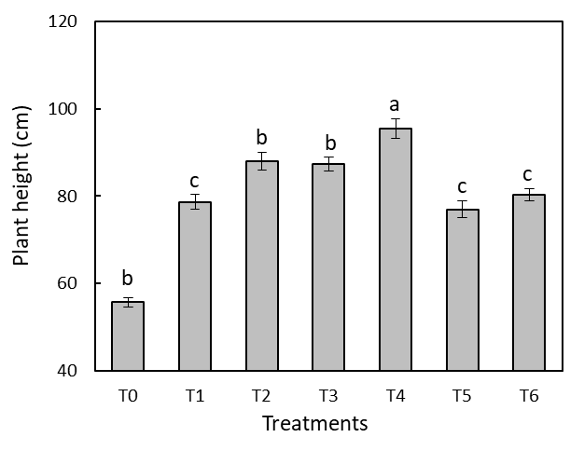

Figure 1: Plant height of rice before harvest. Values are mean ± standard error (n = 3). Different letters indicate significant differences among all treatments at P < 0.05.

This longer plant height was observed under T4, indicating that more accessibility of nitrogen during vegetative growth has been encountered in the integrated use of nano urea and partial amount of conventional urea, which could enhance a cell division, elongation, and leaf expansion. The probable increase in foliar nitrogen absorption efficiency (Kumar et al., 2022) and decrease in nitrogen loss among other benefits (Kaushik, et al., 2024; Bagri et al., 2018) had assisted as a continuous source of nitrogen during the active tillering and stem elongation stages. Another field experiment showed that applying two foliar sprays of nano urea resulted in significantly taller plants compared to conventional urea sprays, which was attributed to higher nitrogen use efficiency and greater nutrient accessibility (Islam et al., 2024). Another transplanted variety of rice study recorded the maximum plant height (108.7 cm) with integrated conventional nitrogen + nano urea spray which closely resembles the trend obtained by the present study (Bhargavi and Sundari 2023; Padhan et al., 2023).
Grain and straw yield
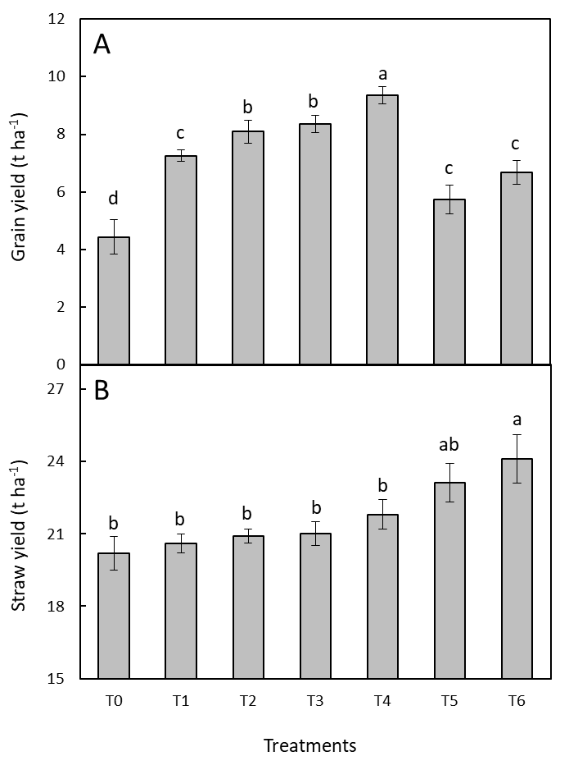
Rice grain yield ranged from approximately 4.4 t ha⁻¹ in T0 (control) to around 9.5 t ha⁻¹ in T4. Treatments T2 and T3 produced approximately 8.3–8.4 t ha⁻¹, which was significantly higher than that of T1 (7.0 t ha⁻¹), T6 (6.9 t ha⁻¹), and T5 (5.9 t ha⁻¹) (Figure 2A). The straw yield was about 20–24 t ha⁻¹. Tallest straw was found in T6 (24 t ha⁻¹), while the shortest straw was observed in T5 (23 t ha⁻¹). All other treatments (T0–T4) were close to 21–22 t ha⁻¹ (Figure 2B).

Figure 2. Grain (A) and straw (B) yield of rice after the experiment. Values are mean ± standard error (n = 3). Different letters indicate significant differences among all treatments at P < 0.05.
The higher grain yield observed in T4 suggests improved nitrogen utilization; however, the absence of NUE metrics limits the strength of this conclusion. Application of foliar nano urea not only synchronizes N supply with crop demand but also improves key growth traits such as chlorophyll and photosynthesis (Anushka et al., 2023; Mishra et al., 2025). In T4 this would have promoted stronger source activity (higher leaf chlorophyll) and determined an efficient N remobilization to grain (higher sink development), as also indicated by our chlorophyll and plant-height data. Along with previous reports indicating that the application of nano urea alone significantly improved NUE and yield in comparison to conventional urea (Bagri et al., 2025; Kaushik et al., 2024), similar results demonstrating that utilization of both types together gave better improvements over using just conventional urea.
In contrast, T6 and T5 were more vegetative (producing more straw compared with grains). These treatments resulted in luxury vegetative growth and late remobilization due to an absence of the balanced N management shown for T4. In T6, high straw (leaf/stem) production (24 t ha⁻¹) was achieved through availability of soil N and fertilizer, but N losses or lodging apparently constrained grain. With only one basal nitrogen level (cow dung), in T5, and without any urea application, grain was extremely N-limited in this treatment resulting in the production of more straw than grain. So T5 and T6 have high harvest index (biomass partitioning into straw) and low grain.
Biological yield and harvest index
Statistically significantly higher biological yield (31.1 t ha⁻¹) was registered with T4 (50% Urea + Nano Urea + Rest of RDF), which was statistically at par with rest of treatments, were being followed by T6 (30.8 t ha⁻¹), while numbers under the intermediate range included those of T3 (29.8 t ha⁻¹), T2 (29.1 t ha⁻¹),T5(28.8t ha⁻¹)andT1(27.8t ha-1). In control (T0), the lowest biological yield (25.7 t ha⁻¹) was measured (Figure 3A).
A similar trend was observed for harvest index. Intriguingly, a comparable pattern was recorded about harvest index where T4 registered maximum HI (30.0%) which, however, remained statistically c as good as T2 & T3 (28.1% and 29.6%, respectively) (Figure 3B). The least HI was in T5 (19.8%), T0 (21.1%), and T6 (21.7%); thus indicating that the nitrogen omission or sole conventional urea despite balanced integration reduced assimilate partitioning efficiency toward grain.

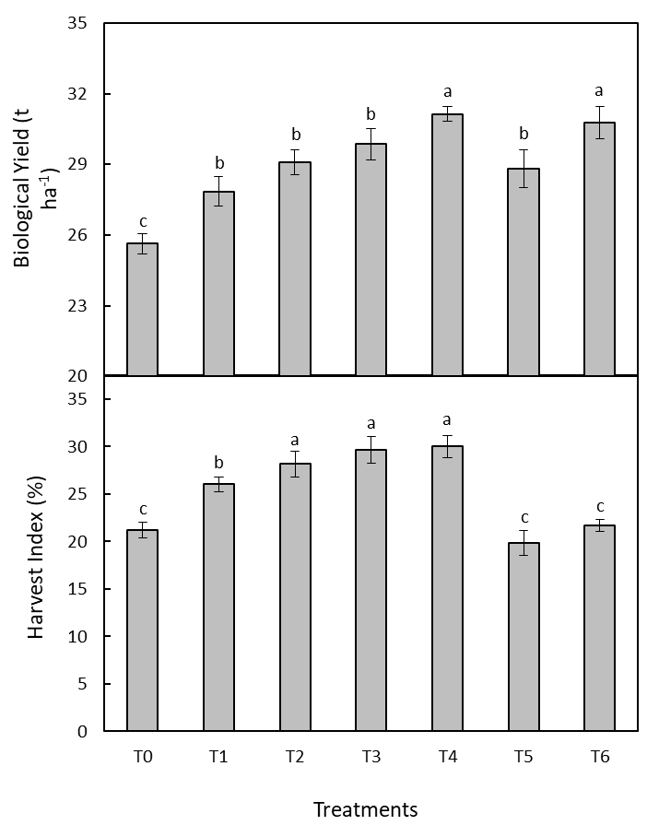

Figure 3. Biological yield (3A) and harvest index (3B) of rice. Values are mean ± standard error (n = 3). Different letters indicate significant differences among all treatments at P < 0.05.
Higher harvest index in T4 indicates that treatment is not only leads higher total biomass but also makes source–sink translocation more efficient, resulting to greater sharing of the photosynthats into grain. This could have been due to better nitrogen availability during the reproductive stages, leading to spikelet filling in grains and lower sterility. Bioactivity of nano-enabled nitrogen fertilizers is previously also reported to improve biomass conversion efficiency and assimilate partitioning towards economic yield in cereals (Islam et al., 2024; Anushka et al., 2023).
Chlorophyll content
Variation of chlorophyll a, b and total chlorophyll content in rice leaves due to nitrogen management practices having resulted from nano urea and conventional urea has been presented in Figure 4.
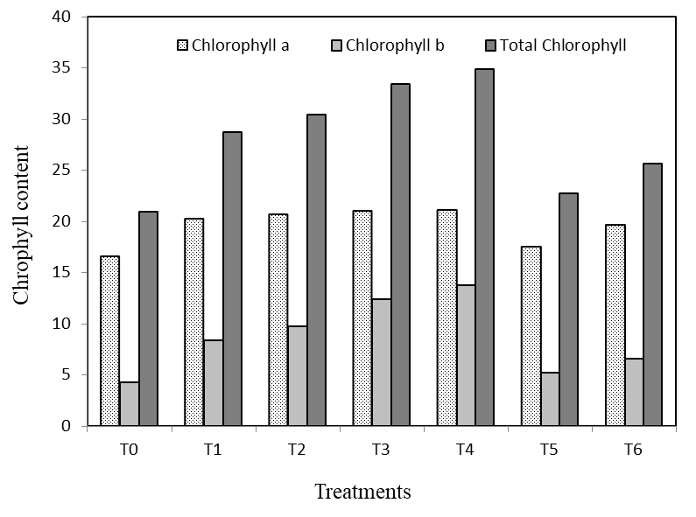

Figure 4. Chlorophyll a, chlorophyll b and total chlorophyll of rice leaves after harvest. Values are mean of three replications.
Of the different treatments, T4 showed the maximum values for chlorophyll a (21.1), chlorophyll b (13.8) and total chlorophyll (34.8), flanked by T3 and T2. On the other hand, T0 and T5 treatments showed the lowest chlorophyll. Chlorophyll content was higher for 125% RDF (T2), which did not differ significantly from the 100% RDF (T1) and only urea plots (T6) where moderate levels were observed but lower than those in the integrated nano urea treatments.
The spiking chlorophyll content observed under T4 was due to enhanced availability and utilization efficiency of nitrogen owing to partial substitution with nano urea that directly increased chlorophyll biosynthesis. Nitrogen is a core component of chlorophyll molecules and directly involved in photosynthetic processes.
The benefits of integrated nitrogen management (nano + conventional) observed in this study is supported by prior findings. For instance, application of nano urea in conjunction with reduced conventional nitrogen dramatically enhanced chlorophyll content, leaf area index and growth parameters in rice according to a recent study (Chudasama et al., 2024; Monica et al., 2024). Likewise, nano-fertilizers and conventional fertilizers also had greater effect on improving chlorophyll content and photosynthetic efficiency when used in combination rather than individual use due to prolonged nutrient supply and foliar absorption (Monica et al., 2024). Islam et al. (2024) showed that nano urea enhanced NUE 57–71% compared to much lower efficiency of conventional urea systems, which may have led to higher chlorophyll synthesis in the current study.
Grain protein content
A significant effect of nitrogen management on grain protein content was observed. The protein content in the isolates ranged from 4.9% (T0) to 9.2% (T4), confirming a significant biochemical reaction on nitrogen source and mode of application were observed (Figure 5). T4 recorded the highest protein content (9.2%) among all treatments that was statically higher than rest of the treatments. T3 came next with 8.0%, then T2 and T6, both at 7.4% protein. The control treatment (T0) had the lowest value 4.9%.
The higher performance of T4 suggests better availability of nitrogen in rice over growth periods due to partial replacement of traditional urea with nano urea leading to increased biosynthesis in grain tissues (Gondwal et al., 2024). Ample nitrogen supply could stimulate synthesis of amino acids and deposition of storage proteins, as the grain protein concentration was strongly associated with nitrogen uptake and remobilization during the grain filling period. Recent rice studies have demonstrated that the combined effect of conventional urea and nano urea on grain quality traits such as protein content was markedly superior (Azam et al., 2024).
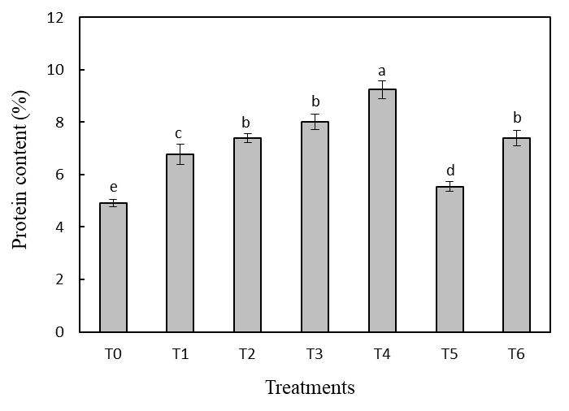

Figure 5. Protein content of rice grain after harvest. Values are mean ± standard error (n = 3). Different letters indicate significant differences among all treatments at P < 0.05.

Post-harvest soil properties
The post-harvest soil pH differed very slightly across treatments and varied between 6.11 to 6.17 (Table 1); irrespective of treatments nano urea application did not affect the soil reaction adversely. Soil organic matter also improved greatly with T4 recording the highest soil organic matter (1.53%), followed by T3 (1.21%). Control (T0) treatment contained the lowest amount of OM, only 0.93%. The increase in OM owing to integrated nano urea treatments could be ascribed to increased return of roots, stubble and crop residues because of the enhanced growth and biomass production recorded as shown from Figures 1–3. Better nitrogen nutrition enhances root growth and microbial activity. Higher levels of post-harvest soil Organic Carbon and OM on nano urea farm plots have also been reported as an impact of enhanced crop biomass retention and microbial turnover in nano urea amended plots (Al Asif et al., 2024).
Likewise, the total nitrogen content also increased significantly with increase of the application rates of nano urea which is observed to increase from 0.11% in T0 and upto 0.20% regardless at T4 confirming that it is due to residual nitrogen supplied by nano urea (Table 1). Higher residual N under T4 indicates that nano urea had better retention of nitrogen in the soil–plant system because it reduces losses through volatilization and leaching, which resulted in more available nitrogen being left in the soil after crop harvest.

Table 1. Effect of nano urea in post-harvest soil properties of pH, Organic Matter (%), Total Nitrogen (%), Phosphorus (ppm), Potassium (me/100g soil), and Sulphur (ppm).
Treatments | pH | Organic Matter (%) | Total Nitrogen (%) | Phosphorus (ppm) | Sulphur (ppm)
T0 | 6.12 | 0.93 e | 0.11 e | 29.0 e | 8.04 f
T1 | 6.17 | 1.05 c | 0.15 b | 31.7 b | 8.8 d
T2 | 6.11 | 1.08 c | 0.16 c | 29.5 c | 12.1c
T3 | 6.15 | 1.21 b | 0.17 b | 31.9 b | 12.3 b
T4 | 6.11 | 1.53 a | 0.20 a | 32.7 a | 12.8 a
T5 | 6.12 | 0.98 de | 0.14 d | 31.7 b | 8.5 e
T6 | 6.15 | 1.03 cd | 0.14 d | 29.2 d | 8.7 de
CV | 0.01 | 3.5 | 14.56 | 0.39 | 1.09
SD | 0.06 | 0.04 | 0.02 | 0.1 | 0.1

Available phosphorus responded positively to treatments, with the highest concentration (32.71 ppm) found in T4 which was followed by T3 (31.9 ppm) and the result of T1 /T5 treatment group were similar; being 31.7 ppm. Previous observations showed that nano urea increased the root growth, acidification of rhizosphere, and microbial mineralization activity which promoted P solublization while reducing fixation losses are responsible for promoting the higher availability of phosphorus under nano urea treatments.
Very importantly, the concentration of available sulphur also became significantly higher from T0 (8.04 ppm) to T4 (12.81 ppm) (Table 1). High sulphur content under T4 might suggest the better microbial activity and mineralization of organic sulphur fractions with a higher incorporation of residue and biological activities in the soil (Khan and Hoque 2025).
Genotypic variability between the residual soil fertility with applied T4 evidenced its highly significant positive impact on OM, total N, available P, and available S indicating that nano urea proved to be a yield-enhancer input as well as a technology for promoting soil health in sustainable rice production systems (Khan and Hoque 2025, Yashaswini et al., 2025)
Conclusion
The current study shows that applying nano urea with conventional urea and balanced RDF application considerably improved growth, physiological performance, yield, grains quality and post-harvest soil fertility of rice over sole urea, sole nano urea or N-deficient treatments. Overall, the T4 treatment resulted in significantly the highest plant height, chlorophyll content, grain yield, biological yield harvest index and grain protein content among nitrogen management strategies tested. This treatment significantly increased post-harvest soil organic matter, total nitrogen, available phosphorus and sulphur as well as remaining the stable soil pH. The integrated responses of growth, physiology, yield, grain quality and soil fertility indicate that nano urea a potentially promising nitrogen management strategy under the tested conditions. Especially, use of 50% conventional urea + nano urea + RDF was the most effective resource management strategy to enhance productivity and decrease on bulk urea fertilizer reliance and also benefit residual soil health. Thus, it can be said that a partial replacement of conventional urea with nano urea is a potential and sustainable way to nutrient management for rice in Bangladesh based on yield if not higher, nitrogen nutritional quality of grain soil fertility status in addition to mitigating fertilizer N loss into the environment.
Disclaimer (Artificial intelligence)

Author(s) hereby declare that NO generative AI technologies such as Large Language Models (ChatGPT, COPILOT, etc.) and text-to-image generators have been used during the writing or editing of this manuscript.
Acknowledgements
The authors team gratefully acknowledges the financial support from Institute of Research and Training (IRT), Hajee Mohammad Danesh Science and Technology University (HSTU), Dinajpur, Bangladesh. The nano urea was generously provided by Bangla Mark Ltd (manufactured at IFFCO). The authors extend their appreciation to the Department of Soil Science, HSTU for laboratory and field support.

References
Al Asif, M. A., Mahjabin, F., Singha, S. K., Jahangir, M. M. R. & Hoque, S. M. (2024). Application of nano-urea in conventional flood-irrigated Boro rice in Bangladesh and nitrogen losses investigation. Heliyon, 10 (17), e37150. https://doi.org/10.1016/j.heliyon.2024.e37150
Anushka, A. S., Kumari, P., Singh, R., and Verma, S. (2023). Studies on the effect of nano-urea on growth, yield and nutrient use efficiency in transplanted rice. International Journal of Environment and Climate Change, 13 (10), 1547–1554. https://doi.org/10.9734/ijecc/2023/v13i102810
Azam, K., Singh, A. K., Singh, N., Singh, V., Marufi, M. N., Kumar, N. (2024). Effect of crop establishment methods and nano urea compared to urea on quality and nutrient uptake in rice crop (Oryza sativa L.). Journal of Experimental Agriculture International, 46(7), 586–598. https://doi.org/10.9734/jeai/2024/v46i72612
Bagri, J. P., Sharma, R., Meena, K., & Yadav, R. (2025). Effect of nano urea on yield attributes characteristics in transplanted rice (Oryza sativa L.). International Journal of Plant & Soil Science, 37(10), 344–354. https://doi.org/10.9734/ijpss/2025/v37i105790
Bagri, J. P., Kumar, K., Siddiqui, M. Z., Yadav, R., Suryabhan, Mishra, A., Kumar, D. & Kumar, P. (2025). Effect of Nano Urea on Growth, Productivity and Economic Return in Transplanted Rice. Journal of Experimental Agriculture International, 47(10), 416–429. https://doi.org/10.9734/jeai/2025/v47i103825
Bhargavi, G., & Sundari, A. (2023). Effect of nano urea on the growth and yield of rice under SRI in the Cauvery delta zone of Tamil Nadu. Crop Research, 58, 112–118. https://doi.org/10.31830/2454-1761.2023.CR-885
Chudasama, S. D., Patel, H. R., & Parmar, K. B. (2024). Influence of liquid nano urea fertilizer on growth and yield of summer rice (Oryza sativa L.). International Journal of Environment and Climate Change, 14 (6), 355–364. https://doi.org/10.9734/ijecc/2024/v14i64235
Gondwal, P., Rana, M. K., Dhankar, A., Sahil, & Mohan, J. (2024). Role of nano-urea in optimizing nitrogen use efficiency, yield and quality of rice: A review. International Journal of Research in Agronomy, 7(10S), 182–187.
https://doi.org/10.33545/2618060X.2024.v7.i10Sc.1724
Hoque, M. R. & Khan, M. S. H. (2024). Greater growth and yield response of nano urea with conventional urea for potato (Solanum tuberosum) cultivation. International Journal of Biological Engineering and Agriculture, 3(3), 378-385. DOI: 10.51699/ijbea.v3i3.69
Kamuruzzaman, M., Rees, R. M., Islam, M. T., Drewer, J., Sutton, M., Bhatia, A., Bealey, W. J., & Hasan, M. M. (2024). Improving nitrogen fertilizer management for yield and N use efficiency in wetland rice cultivation in Bangladesh. Agronomy, 14(12), 2758. https://doi.org/10.3390/agronomy14122758
Kasim, A., Menon, S. S., Prameela, P., John, S., & Prasad, R. S. (2024). Nano fertilizers and its effect on nutrient use efficiency in rice. International Journal of Research in Agronomy, 7(6), 413–416. https://doi.org/10.33545/2618060X.2024.v7.i6f.902
Kaushik, T., Kashyap, T.L., Sonboir, H.L., Mirjha, P.R. & Sarika. (2024). Effect of foliar application of nano urea under different fertility levels on the growth, yield attributes and yield of rice (Oryza sativa L.). International Journal of Research in Agronomy, 7(8), 310–313. https://doi.org/10.33545/2618060X.2024.v7.i8e.1245
Kaushik, T., Kashyap, T. L., Rajput, A. S., & Sarika. (2024). Effect of foliar application of nano urea under different fertility levels on the yield and economics of rice (Oryza sativa L.). International Journal of Advanced Biochemistry Research, 8(8), 280–283.
DOI: https://doi.org/10.33545/26174693.2024.v8.i8d.1808
Khan, M. S. H., Abedin Mian, M. J., Akhter, A. & Khosruzzaman, M. (2006). Physico-chemical changes of paddy soils under long-term intensive fertilization. Asian J. Plant Sci, 5, 105-111. https://www.cabidigitallibrary.org/doi/full/10.5555/20063045771
Khan, M. S. H., & Hoque, M. R. (2025). Optimizing NPKS Fertilization for Onion Yield and Soil Health in Dinajpur, Bangladesh. International Journal of Plant & Soil Science, 37 (3), 87-95. https://doi.org/10.9734/ijpss/2025/v37i35350
Mishra, S., Gupta, S., Sharma. N., & Sinha, A. K. (2025). Effect of nano-urea application on growth and productivity of rice (Oryza sati va L) under Jammu region, Jammu and Kashmir. International Journal of Farm Sciences, 15(1), 94-98. https://doi.org/10.5958/2250-0499.2025.00017.4
Monica, S., Patel, R., & Sharma, N. (2024). Strategic management of nano-fertilizers for sustainable rice yield, grain quality, and soil health. Frontiers in Environmental Science, 12, 1420505. https://doi.org/10.3389/fenvs.2024.1420505
Padhan, S. R., Kar, I., Mohanty, A., Panigrahi, K. K., 2023. Nanofertilizers: Types, synthesis, methods, and mechanisms (pp. 61-98). In: Abd-Elsalam, K.A., Alghuthaymi, M.A. (Eds.), Nanofertilizers for Sustainable Agroecosystems. Springer Nature Switzerland, Cham. https://doi.org/10.1007/978-3-031-41329-2_3.
Reddy, K. S., Shivay, Y. S., Kumar, D., Pooniya, V., Prasanna, R., Mandi, S., Nayak, S., Baral, K., Alekhya, G. & Borate, R. B. (2025). Relative performance of granulated and nano urea on productivity and nitrogen use efficiency of wheat–rice sequence. Plant Nano Biology, 11, 100131. https://doi.org/10.1016/j.plana.2024.100131
Swify, S., Mažeika, R., Baltrusaitis, J., Drapanauskaite, D. & Barcauskait, K. (2024). Review: Modified urea fertilizers and their effects on improving nitrogen use efficiency. Sustainability, 16, 188. https://doi.org/10.3390/su16010188
Yashaswini, K. P., Reddy, M. S., & Prakash, V. (2025). Influence of nitrogenous fertilizers (urea and nano urea) on soil chemical properties: Post-harvest. International Journal of Advanced Chemistry Research, 7(6), 22–25. https://doi.org/10.33545/26646781.2025.v7.i6a.288

