Original Research Article

Attitudes Towards Utilization of Artificial Intelligence (AI)Among Radiologic Technology Students

.
ABSTRACT

Objectives: As artificial intelligence becomes a groundbreaking development in the modern world, understanding students’ perception towards its utilization helps identify its positive and negative effects on their academic performance. Limited research has specifically examined the attitudes towards the utilization of artificial intelligence among Radiologic Technology students in a private institution.
Methods: Data were generated from in-depth questionnaire and analyzed through the lens of self-determination theory. Descriptive statistics was applied to portray the demographics and professional traits of the study population and inferential statistics was utilized to evaluate the hypotheses and studied correlations among the variables.
Results: its is found out that 100% of the respondents are exposed to utilization of AI. Eight out of ten students have been using AI on a daily basis (82.40%), Furthermore, most respondents were using their cellphones to access AI tools (92.80%). However, few of the students had a prior orientation in utilization of AI (27.40%) seven out of ten respondents do have no prior orientation on using AI (72.60%). Lastly, most of the respondents have only moderate familiarity with AI uses (72.60%). Radiologic technology students have a positive attitude toward Artificial Intelligence positivity increasing by year level—from first year to fourth year students. It’s rejected the null hypothesis (Ho). Thus, it indicates that there is a high significant correlation between attitude toward AI and AI utilization.
Conclusion: It is concluded with regards to attitudes towards the utilization of artificial intelligence, that radiologic technology students showed a highly positive attitude whereas they perceiving to as a useful tool in integrating into their academic performance and future practice, also the respondent exhibit a balance perspective, and are committed in upholding the professional responsibility while embracing the potential of innovative efficiency of this AI.
Keywords: Radiologic Technology, Artificial Intelligence, Attitudes in Academic, AI Utilization, Student Perceptions

1. INTRODUCTION

Artificial Intelligence (AI) has become one of the world's transformational technologies in the education and healthcare domains. Globally, Artificial Intelligence (AI) applications include the following: for educational institutions, AI is classified as adaptive learning platforms and automated testing tools. (Wang et al., 2024; Hwang et al., 2024) In healthcare institutions, AI is used in diagnostic imaging and clinical decision support systems. While these innovations have the potential to improve efficiency, personalization, and outcome measures, they also raise concerns about over-reliance, ethical dilemmas, and the possible loss of critical thinking competencies (Krause et al., 2024; Stein et al., 2024).
Attitudes toward the utilization of artificial intelligence (AI) are directly connected to Sustainable Development Goals 4 and 6, which aims to ensure inclusive, fair, and quality education for all with the help of technology. Attitudes could help the adoption of AI-driven educational tools that enhance personalized and adaptive learning, improve accessibility, and bridge digital divides, thereby advancing equity in higher education. The integration of AI encourages innovative teaching practices, supports lifelong learning, and aligns education with evolving labor market demands, ultimately contributing to the achievement of SDG 4 by fostering skills development and educational inclusivity among the youth. Openness to AI use in education thus represents a critical factor for harnessing AI’s potential to transform education sustainably and equitably to achieving the goal of SDG 6.
On a national level, the Philippines has already been kick-starting the adoption of AI through government-driven initiatives like the adoption of the 2025 AI Fest as well as initiatives spearheaded by the Department of Science and Technology (DOST), highlighting the prospective benefits of AI in fields such as education, healthcare, and government itself (DOST, 2025; Lena, 2025). Empirical research shows that most youth in the Philippines and educational institutions are generally showing positive reactions to integrating AI as a tool; however, general difficulties over the need for infrastructure readiness, digital learning literacy, and policy coherence still persist (Truelogic 2025; Maghirang 2025).
Despite the growing prevalence of AI, empirical studies investigating the perceptions of and implementation of AI among Radiologic Technology students in the Philippines in their academic and clinical education are limited. This points to a need for significant study that examines attitudes and utilization patterns, especially across the different year levels.

This study aimed to determine the attitude and the utilization of AI by Radiologic Technology students at a private institution in Iloilo City
Specifically, it sought to answer the following questions:
- What is the profile of the respondents in terms of:
  - Year Level.
  - Access to AI tools.
  - Frequency of Internet Use.
  - Type of Device Used Most Often.
  - Prior Orientation on AI use.
  - Familiarity with AI Applications in Academics.
- What is the attitude towards AI among the respondents?
- What is the level of utilization of AI among the respondents?
- Is there a significant relationship between respondents' attitudes towards and utilization of AI?

This study is framed on the notion that students' perceptions and attitudes toward AI may influence the extent of their utilization in both academic and clinical contexts. Consequently, the independent variable is attitudes toward AI, while the utilization of AI would be expected to influence as the dependent variable, which pertains to attitudes towards utilization of artificial intelligence among Radiologic Technology students. Positive attitudes such as perceived usefulness and ease of use from the Technology Acceptance Model (TAM; Davis 1989) may foster greater AI adoption for academic purposes, while the negative attitudes, including the fears of dependency or ethical issues from the General Attitudes Toward Artificial Intelligence Scale (GAAIS; Schepman and Rodway 2020), could hinder the utilization frequency.

Figure 1
Relationship of the Variables under Study
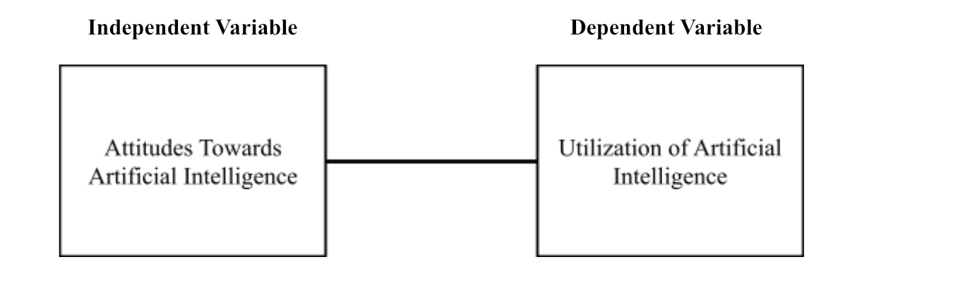
This framework suggests that students’ perceptions and attitudes toward AI may influence the extent of their utilization in both academic and clinical contexts.
This study focused on attitudes towards the use of Artificial Intelligence (AI) among radiologic technology students enrolled in a private institution in Iloilo City for the academic year 2025-2026. A descriptive-correlational research design is used to specifically evaluate attitudes toward the use of artificial intelligence, and also to investigate the relationship between attitudes towards AI as an independent variable, with the artificial intelligence utilization as the dependent variable.
The study focused solely on students enrolled in radiologic technology and excluded students from other institutions and other curricula in allied health programs, as well as practicing licensed radiologic technologists. In addition, this study's potential limitations include self-reporting, which introduced bias, and limited generalizability due to the participation of students from only one institution. These limitations could affect the generalizability of the results to a broader population of radiologic technology students. It was suggested to future researchers that most of the literature has focused chiefly on attitudes and utilization as separate domains, without making much effort to investigate the interaction between perception and practical adoption in particular socio-economic and infrastructural contexts. Furthermore, the impact of cultural differences, policy effectiveness, and digital inclusion on the relationship between attitudes and AI utilization has yet to be studied. Also, in the education context, this expands their scope by including multiple institutions, employing mixed-methods or observational research designs, and examining other factors such as mentorship styles, academic and clinical environments, and student diversity in their artificial intelligence use. This allows a better understanding of the attitude towards the use of artificial technology among radiologic technology students.

2. Methodology

This research used a descriptive-correlational research design. The descriptive component assesses the attitude of students towards artificial intelligence (AI) and evaluates the extent to which the utilization of AI is attained by the Radiologic Technology students. The correlational aspect of the study investigates whether there is a statistically significant relationship between the attitudes of students and their utilization of AI. This design is suitable because it allows us to describe current perceptions and usage patterns and at the same time, test relationships between variables without manipulating them. It was conducted at a private tertiary educational institution located in Iloilo City. The mentioned educational institution was suitable for this study as it offers a program of Radiologic Technology and has enough respondents to cover the number of Radiologic Technology students.

2.1 Population and Sampling Technique

The final number of respondents was determined using the Raosoft calculator, which included a 5% margin of error, a 95% confidence level, and 50% response distribution. The population size of 1832 radiologic technology students from 1st year to 4th year. After the sample was gathered, the study used stratified random sampling.
A stratified random sampling technique was utilized to ensure that all year levels was proportionally represented using the formula. The sampling technique was used to determine how many strata were included at each level. The total sample size was 318 respondents.
The population was divided into four strata based on year level, after which random sampling was applied within each stratum to determine the number of respondents per group. This technique ensured balanced representation and minimized sampling bias. The researchers used computer-generated randomization procedures.

List 1-
Distribution of respondents using stratified sampling formula.
Respondents | N | % | n
Year Level  1st Year  2nd Year  3rd year  4th year | 616  568  499  149 | 33.6%  31.0%  27.2%  8.1% | 107  98  87  26
Total | 1832 | 31.0% | 318

2.2 Research Instrument

The researchers utilized an adapted research online survey as a data-gathering instrument composed of 3 parts:
Part one. Demographics: This section is composed of 2 sub-parts. The first part is the personal information, where the respondent writes their complete name which is optional and the second part is the socio-demographic profile of the respondent classified according to their year level when enrolled when this research was conducted, access to AI tools, frequency of internet use, type of device used most often, prior orientation on AI use, and familiarity with AI applications in academics.
Part two. Attitude Towards AI: This section measures the attitude towards utilization of AI, adapted on the Schepman and Rodway’s (2020) General Attitudes Toward Artificial Intelligence Scale (GAAIS). Attitude refers to an individual's positive or negative evaluation of performing a behavior, it is composed of ten (10) statements that determine the attitudes towards artificial intelligence in relation to the characteristics of students towards the utilization of the artificial intelligence. The researchers used a five-point Likert scale to measure the responses, and the participants was given five (5) choices. From Strongly Disagree (1) to Strongly Agree (5).
Part three. Artificial Intelligence Utilization: Adapted from Technology Acceptance Model (TAM), this part is composed of ten (10) statements that determined the level of the student utilization of artificial intelligence tools. Items assessed how frequently students utilized AI tools in academic, clinical, research, and communication contexts. It is measured on a 5-point scale from Never (1) to Always (5).

2.3 Data Gathering Procedure

In this study, the data collection procedure observed the following stages:
First, after the researcher passed the proposal defense and met all the requirements, the paper was submitted for thorough checking of the researcher's paper. After the researcher obtains the clearance certificate, they write a letter addressed to the Dean of the College of Radiologic Technology, signed by the researchers, their course professor and the research adviser and they ask permission and administer the survey questionnaire for actual conduct using the help of google forms.
Second, following approval of the letter, and to IDIREC. The reliability test was conducted by 10% of the actual testing population of radiologic technology students, who were not the main respondents of the research and participated in the pilot test of the instrument's reliability. The researchers tallied and encoded the data they gathered after the pilot testing and submitted it to the statistician for analysis.
Third, following the pilot, the responses were tallied and encoded for reliability testing, typically determining Cronbach’s alpha. Any necessary revisions are made to ensure clarity and validity of the instrument based on pilot feedback. For the actual conduct of the study, the finalized questionnaires were distributed, and the data were gathered across all levels (first-fourth year) radiology students to assess their attitudes towards the utilization of artificial intelligence in radiologic technology. The researchers explained the objectives of the study and provided clear instructions on how to properly fill out the questionnaire.
Finally, after the questionnaires were completed, the researchers collated the responses for data analysis. It was totaled, encoded the information, and sent the final results to the statistician for further analysis. All questionnaires and data obtained were stored securely, and all statistical data were computer processed and analyzed.

3. Results and Discussion

3.1 Descriptive Analysis

3.1.1 Profile of the Respondents

Table 1 shows the demographic profile of the respondents who were randomly selected and willingly participated in this study. The majority of the respondents was first year students (33.60%), while the second year got have the one third of the total population (30.80%), the third year students have more than one- fourth of the population (27.40%) and the remaining fourth year level respondents got the lowest population (8.20%).
Surprisingly, all respondents claimed to have been using AI in their academic and clinical studies. Eight out of ten students have been using AI on a daily basis (82.40%), and some of the respondents only use it weekly (13.80%) and monthly (3.80%). Furthermore, most respondents were using their cellphones to access AI tools (92.80%). Moreover, seven out of ten respondents have no prior orientation on using AI (72.60%). Lastly, most of the respondents have only moderate familiarity with AI uses (72.60%).
Davis' TAM (1986) posits that AI adoption is driven by Perceived Usefulness and Ease of Use, where external factors like access, device type, and internet frequency act as critical enablers that lower technical barriers. Also, a user’s prior orientation, familiarity, and frequency of use create reinforcing feedback in adoption of artificial intelligence, as users become more comfortable with AI, their self-efficacy increases, which directly boosts their positive attitude and behavioral intention to integrate the technology into their daily routines.

Table 1
Distribution of respondents according to the demographic profile.

Demographic profile | f | %
Year Level  First Year  Second Year  Third Year  Fourth Year | 107  98  87  26 | 33.60  30.60  27.40  8.20
Access to AI Tools  Yes  No | 318  0 | 100.00  0
Frequency of Internet Use  Daily  Weekly  Monthly | 262  44  12 | 82.40  13.40  3.80
Type of Device Use  Cellphone  Laptop  Desktop  Tablet | 295  8  9  6 | 92.40  2.50  2.80  1.90
Prior Orientation to AI use  Yes  No | 87  231 | 27.40  72.60
Familiarity with AI applications  Low  Moderate  High | 33  231  54 | 10.40  72.00  17.00
Overall | 318 | 100

3.1.2 Attitudes towards Artificial Intelligence

Table 2a shows the level of respondents’ attitude towards artificial intelligence when taken as an entire group. Surprisingly, among the attitude indicators, the highest-ranked statement was which states that “AI helps me understand the lessons better” (M= 3.79) then there was the statement that “AI makes studying more efficient” (M=3.69) and finally, there was the statement that “AI motivates me to explore new ways of learning” (M=3.62). These findings suggest that the students can view AI as a tool of academic assistance that would improve understanding and effectiveness. The items that are ranked lower are AI improves my future professional skills (M=3.10) and AI causes me to become dependent and less analytical (M=3.08). Although students appreciate the value of AI, there are mixed feelings about its overuse and effects on the ability to think critically. This is a balanced view; students are always happy about the benefits of AI and are also aware of its shortcomings.
Studies about AI in education also emphasize that AI-based applications enhance individual learning, learning efficiency, and learning engagement (Saleem et al., 2025). AI systems positively affect the independence and motivation of learners, but researchers point out their worries about dependency and low analytical abilities in case of excessive use without the proper direction. This aids the two-sided belief in the results where AI is an effective academic resource and an associated danger in the wrong hands.
Moreover, students think artificial intelligence is more acceptable when it helps them in their academic development with the discretion on proper use.

Table 2a
Level of respondents’ Attitude towards Artificial Intelligence when taken as an entire group.
Questions | mean | sd | Interpretation
AI helps me understand lessons better. | 3.79 | 0.90 | Optimistic
AI makes studying more efficient. | 3.69 | 0.94 | Optimistic
AI motivates me to explore new learning methods. | 3.62 | 0.91 | Optimistic
AI improves my confidence in clinical practice. | 3.32 | 0.86 | Pragmatic
AI enhances my future professional skills. | 3.10 | 0.96 | Pragmatic
AI makes me dependent and less analytical. | 3.08 | 1.03 | Pragmatic
Overall | 3.34 | 0.67 | Pragmatic

Table 2b shows the level of attitude of respondents towards Artificial Intelligence when in a group. The overall mean attitude score of 3.34 (SD = 0.6692) shows that the attitude of radiologic technology students towards Artificial Intelligence is rather positive. When the mean scores are grouped based on the level of the year, the fourth-year students recorded the highest mean score (3.70) followed by third year (3.43) then the second year (3.42) and finally the first year (3.37). This pattern indicates that the attitude of students towards AI is more positive with their further academic progress. The rise to positivity in the higher year levels can be in part attributed to the increased exposure to clinical situations, imaging systems and professional uses where AI is found to be of an important role. The standard deviations used are also relatively consistent and hence shows homogeneity in responses across groups.
The results are in line with the Liesa-Orús et al. (2023) that assume that individuals are affected by perceptions of usefulness in their attitudes to the use of technology. The more the students are exposed to AI-involved tools in the area of healthcare and radiologic sciences, the more positive their views are, which makes them more likely to have positive attitudes. Health education studies also indicate that the older students are more likely to show greater acceptance of the emerging technologies due to their enhanced clinical awareness and professional preparedness.
Specifically, students who view AI as a practical asset for academic performance are significantly more inclined to develop a favorable opinion of it. The high rate of approval found in this research suggests that learners are prepared to integrate these tools into their workflow rather than dismiss them.

Table 2b
Level of respondents’ Attitude towards Artificial Intelligence when taken as a whole and when grouped according to year level.

Classification | mean | sd
Entire Group | 3.34 | 0.67
Year Level  First Year  Second Year  Third Year  Fourth Year | 3.37  3.42  3.43  3.70 | 0.63  0.66  0.72  0.66

3.1.3 Artificial Intelligence Utilization

Table 3a shows the level of respondents’ attitude towards artificial intelligence when taken as a group. The most common AI application was academic, including studying and doing assignments (M=3.45) and communication tools (M=3.39) and research purposes (M=3.28). This means that AI is mostly used in productivity and academic support. On the contrary, the lowest rank was on the use of AI in clinical practice or training (M=2.96), indicating that students do not integrate AI systems in clinical practice in a hands-on manner. The mean score in writing/editing (3.20) and collaborative learning (3.15) is moderate, which suggests that academic outputs as well as collaboration are also supported by AI.
It is demonstrated by Rajashekar (2025), students typically apply AI-based tools to produce content, edit it, and retrieve information, yet the clinical usage is not as widespread in the undergraduate education as access to hospital-based AI systems is limited and ethical guidelines related to patient care. Also, according to Sustaningrum & Haldaka (2025), students employ AI with caution, validating results based upon what they've learned through their textbooks or peer responses. Utilization of artificial intelligence is often used in studying; it is not yet helpful in actual training and solving real life problems that students encounter day by day.
In addition, even though artificial intelligence has been often used by students, there are many things that technology can’t do, but as it progresses it can make more helpful advances that might help more students and society.

Table 3a
Level of respondents’ Attitude towards Artificial Intelligence when taken as an entire group.
Questions | mean | sd | Interpretation
How often do you use AI tools for academic purposes (e.g., studying, assignments)? | 3.45 | 0.75 | Integrated
How often do you use AI tools for communication (e.g., chatbots, virtual assistants)? | 3.39 | 1.10 | Assistant
How often do you use AI tools for research purposes? | 3.28 | 0.92 | Assistant
How often do you use AI tools for writing or editing academic papers? | 3.20 | 0.94 | Assistant
How often do you use AI tools for collaborative learning or group projects? | 3.15 | 0.94 | Assistant
How often do you use AI tools for exam preparation or quizzes? | 3.06 | 1.08 | Assistant
How often do you use AI tools for problem solving  or decision-making tasks? | 3.03 | 1.02 | Assistant
How often do you use AI tools for clinical practice or training? | 2.96 | 0.91 | Assistant
Overall | 3.19 | 0.65 | Assistant

Table 3b shows respondents’ level of utilization of artificial intelligence when grouped, it interestingly reveals that the overall mean utilization score of 3.19 (sd = 0.65) shows that radiologic technology students use AI moderately. The highest utilization was again recorded among fourth year students (M=3.35), third year students recorded the lowest (M=3.14). This trend indicates that the use of AI goes up with the advancement of students in their educational course. Since older learners might have a greater academic load and be exposed to the use of technological applications in a radiologic practice, they may use AI tools more when it comes to research, studying exams, and making clinical decisions.
Research on the use of technology in healthcare education demonstrates that the rate of its adoption rises as the academic level rises, specifically within the programs that are associated with diagnostic imaging and data analysis (Wang et al., 2024). The adoption of AI in radiology has grown worldwide, and the technologies have helped in the interpretation of images and optimization of the workflow. The closer students are to a professional practice, the more likely they are to employ AI to improve the performance and efficiency.

Table 3b
Level of respondents’ Artificial Intelligence Utilization when taken as a whole and when grouped according to year level.
 | mean | sd
Entire Group | 3.19 | 0.65
Year Level  First Year  Second Year  Third Year  Fourth Year | 3.22  3.16  3.14  3.35 | 0.65  0.67  0.67  0.54

3.2 Inferential Analysis

The normality test was used for the correlation of test results to determine whether there is a correlation between Attitude towards Artificial Intelligence and Artificial Intelligence Utilization.
The results for the normality test done for Attitude towards Artificial Intelligence and Artificial Intelligence Utilization. The Kolmogorov-Smirnov test as well as the Shapiro-Wilk test gave important p-values (p < 0.05) to both Attitude Towards AI and AI Utilization which implies that the data are not distributed normally. Thus, the further analysis was right using non-parametric statistical techniques, which supported the use of Spearman rho correlation (Danish et al., 2025). Statistical literature suggests non-parametric tests like Spearman rho when they are not normative. Survey-based Likert-scale data often lead to non-normality in behavioral and educational studies.
Table 4 shows the Spearman rho coefficient of 0.595 with a p-value of 0.000, resulting that the null hypothesis is rejected, thus, alternative hypothesis is accepted meaning there is a statistically significant positive high relationship between attitude toward AI and AI utilization. This implies that students who have more positive views about AI are more likely to utilize AI tools. The relationship strength indicates that the perception and acceptance play a great role in driving real usage behavior among radiologic technology students.
This result closely aligns with the Mantello et al. (2023), which says that positive attitudes towards technology are the predictors of the increased actual use. The same study in health and medical education indicates that students who view AI as useful and helpful are more inclined to apply it to their academic and clinical practice. Also, this corresponds to the study of Gillissen (2022) claiming that the students who are formally taught about AI concepts, limitations, and interpretability have a higher level of AI literacy and more positive attitudes towards AI.
The findings imply that attitude has a significant impact on actual use. To put it another way, enhancing students' understanding of AI may directly promote more responsible and efficient use of the technology. Developing both positive and critical attitudes toward AI is crucial for preparing students for the future of clinical practice in the context of Radiologic Technology education, as AI applications become increasingly incorporated into imaging systems, workflow automation, and support.

Table 4
Correlation between Attitude towards Artificial Intelligence and Artificial Intelligence Utilization
 | AI Utilization | Remarks
Attitude towards AI  Spearman rho coefficient  P-value (2-tailed) | 0.595  0.000 | Positive High Correlation
*. Correlation is significant at the 0.05 level (2-tailed).

4. Conclusions

Most of the respondents are first-year students, one-third are second year, one-fourth are third year, and the lowest population are fourth-year students. The overall respondents reported having access to AI without formal training or structured orientation. AI can be accessed through mobile devices and used often, often daily. Most of them are familiar with various AI applications and prove a moderate to elevated level of exposure. Students show comparable patterns of AI engagement and accessibility at all year levels.
With regards to the aims, which aimed to find the attitude towards AI among the respondents, the second, third and fourth year level students have a higher acceptance attitude towards artificial compared to the pioneer years of academic and clinical studies. Most students agreed that AI is useful in enhancing their understanding of lessons, improving study efficiency, and supporting their overall learning experience. Most of the respondents expressed confidence in using different AI applications for educational purposes, while showing that artificial intelligence does not make them dependent and less analytical, which makes it a limitation of using artificial intelligence.
Aligned with the third goal, the majority level of Utilization of AI as an entire group, shows that respondents affirmed that AI helped a deeper understanding of lessons while simultaneously streamlining the study process. AI was accessed and often used by the students; however, use was more concentrated on academic support than clinical practice, showing that students perceived AI as a learning aid rather than a professional tool at this level of training.
In deciding the relationship between students' attitude and AI use, the findings imply that attitude has a significant impact on actual use. Most students with a more positive attitude toward AI reported higher levels of use. This shows that students' feelings and acceptance of AI have a considerable influence on how willing and effective they are at using these tools in their academic work. In conclusion, attitudes significantly influence AI adoption among Radiologic Technology students.

Competing interests

Some of the participants find hard to access our questionnaire thru google form because of connectivity issue, thus the researcher solves this problem by providing them with hotspots connecting using our phone. Other than that, there is no other major issue or problem we encounter during the period of the study.

Consent

The sample of Informed consent form used by the researchers could be found in the appendix A and it is standard to meet the criteria requirements according to published Law around the world

Definitions, Acronyms, Abbreviations
To understand and to make the study clearer, the following terms were conceptually and operationally defined:

AI - Artificial Intelligence

Attitude towards AI. Attitude is defined as a mental position with regard to a fact or state or a feeling or emotion toward a fact or state (Merriam-Webster, n.d.). In this study, attitude denotes perceptions, beliefs, and openness by the student radiologic technologists toward the use of artificial intelligence in their academic and clinical training.

Utilization of Artificial Intelligence. refers to using AI technologies in practical tasks to increase productivity, accuracy, and speed (Haenlein & Kaplan, 2019). In this study, this refers to the extent and the way in which the students of Radiologic Technology apply AI tools and resources to enhance their academic performance and clinical competence.

References

Danish, M. U., Rehman, U., & Grolinger, K. (2025). Leveraging Order-Theoretic Tournament Graphs for Assessing Internal Consistency in Survey-Based Instruments Across Diverse Scenarios. arXiv preprint arXiv:2502.05336.https://arxiv.org/abs/2502.05336

Davis, F. D. (1986). A technology acceptance model for empirically testing new end-user information systems: Theory and results (Doctoral dissertation, Massachusetts Institute of Technology). MIT DSpace. https://dspace.mit.edu/handle/1721.1/15192

Department of Science and Technology. (2025, August 24). 2025 AI Fest highlights future growth prospects for PH. DOST Philippines. https://www.dost.gov.ph/knowledge-resources/news/86-2025-news/4124-2025-ai-fest-highlights-future-growth-prospects-for-ph.html

Gillissen, A., Kochanek, T., Zupanic, M., & Ehlers, J. (2022). Medical Students' Perceptions towards Digitization and Artificial Intelligence: A Mixed-Methods Study. Healthcare (Basel, Switzerland), 10(4), 723. https://doi.org/10.3390/healthcare10040723

Hwang, G. J., Xie, H., Wah, B. W., & Gasevic, D. (2024). Vision, challenges, roles, and research issues of artificial intelligence in education. Computers & Education: Artificial Intelligence, 1, 100001.
Krause, S., Panchal, H.B., & Ubhe, N, (2024). The Evolution of Learning: Assessing the Transformative Impact of Generative AI on Higher Education https://doi.org/10.48550/arXiv.2404.10551
Lena, P. (2025). W. Visayas unveils AI development plan for 2025–2030. Philippine News Agency (PNA). https://www.pna.gov.ph/articles/1244101
Liesa-Orús, M., Latorre-Cosculluela, C., Sierra-Sánchez, V., & Vázquez-Toledo, S. (2023). Links between ease of use, perceived usefulness and attitudes towards technology in older people in university: A structural equation modelling approach. Education and Information Technologies, 28(3), 2419-2436.https://link.springer.com/article/10.1007/s10639-022-11292-1
Maghirang, T. (2025). State of AI in the Philippines in 2025: A range of perspectives. Philippine Institute for Development Studies (PIDS). https://www.pids.gov.ph/details/news/in-the-news/state-of-ai-in-the-philippines-in-2025-a-range-of-perspectives
Mantello, P., Ho, M. T., Nguyen, M. H., & Vuong, Q. H. (2023). Machines that feel behavioral determinants of attitude towards affect recognition technology—upgrading technology acceptance theory with the mindsponge model. Humanities and Social Sciences Communications, 10(1), 430.https://www.nature.com/articles/s41599-023-01837-1
Rajashekar, N. (2025). Generative Artificial Intelligence in Clinical Decision Support-Quantitative and Qualitative Analyses (Doctoral dissertation, Yale University).https://search.proquest.com/openview/08fb80530005ac47043c7acd8f8b01ba/1?pq-origsite=gscholar&cbl=18750&diss=y
Saleem, S., Aziz, M. U., Iqbal, M. J., & Abbas, S. (2025). AI in education: Personalized learning systems and their impact on student performance and engagement. The critical review of social sciences studies, 3(1), 2445-2459.https://thecrsss.com/index.php/Journal/article/view/328
Schepman, A., & Rodway, P. (2020). Initial validation of the general attitudes towards Artificial Intelligence Scale. Computers in Human Behavior Reports, 1, Article 100014. https://doi.org/10.1016/j.chbr.2020.100014
Stein, JP., Messingschlager, T., Gnambs, T. et al. Attitudes towards AI: measurement and associations with personality. Sci Rep 14, 2909 (2024). https://doi.org/10.1038/s41598-024-53335-2
Sustaningrum, R., & Haldaka, M. (2025). Student utilization and perceptions of AI technology for academic purposes: a mixed-method analysis. Cogent Education, 12(1). https://doi.org/10.1080/2331186X.2025.2553835
Truelogic. (2025, February 10). Adoption of AI in the Philippines: Episode 105 recap. Truelogic Marketing Philippines. https://www.truelogic.com.ph/blog/truelogic-episode-105-recap-adoption-of-ai-in-the-philippines/
Wang, D., Huai, B., Ma, X., Jin, B., Wang, Y., Chen, M., ... & Liu, R. (2024). Application of artificial intelligence-assisted image diagnosis software based on volume data reconstruction technique in medical imaging practice teaching. BMC Medical Education, 24(1), 405.https://link.springer.com/article/10.1186/s12909-024-05382-6

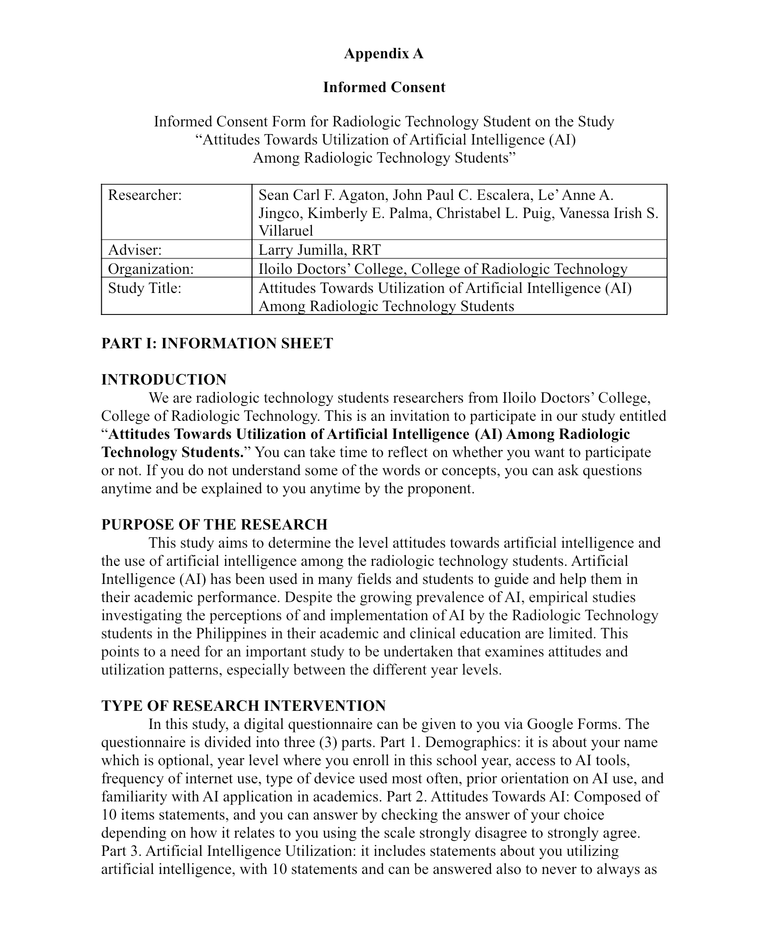
Appendix A
