Therapeutic management Schistosoma spindale-induced visceral Schistosomiasis in cattle: a case report

Abstract
Schistosomiasis is an economically important parasitic disease affecting livestock in tropical and subtropical regions, including India. Present study reports a clinical case of visceral schistosomiasis caused by Schistosoma spindale in a five-year-old crossbred cow from Patna, Bihar (India). The cow was presented with history of anorexia, reduced milk yield, and passage of blood and mucus mixed feces for five days. Clinical examination revealed pallor mucosa, dullness, and mild dehydration. Fecal examination using direct smear and sedimentation technique revealed characteristic spindle-shaped eggs of S. spindale, confirming the diagnosis. Hematological analysis revealed anemia with low hemoglobin (7.8 g/dl), packed cell volume (22%), and total erythrocyte count (4.62 × 10⁶/cumm). The cow was treated with oral praziquantel (@20 mg/kg, two doses at three week interval) along with supportive therapy including intravenous fluids, tranexamic acid and haematinics. A remarkable clinical improvement was observed within three days of treatment with restoration of normal feeding and fecal consistency. However, complete recovery was confirmed by negative fecal examination after three weeks post-treatment.
Key words: Cattle; faecal examination; Schistosoma spindale; treatment

1. Introduction:
Schistosomiasis is an economically significant parasitic disease affecting farmed animals in tropical and subtropical regions including India. The disease is prevalent in cattle, buffaloes, sheep, and goats in India. Although most infections in endemic areas are asymptomatic, increasing incidence results in significant losses in terms of growth, productivity, and increased susceptibility to other parasitic or bacterial diseases. The most common causes of visceral schistosomiasis in cattle are Schistosoma indicum and Schistosoma spindale (Digraskar et al., 2018). The snail, Indoplanorbis exustus is responsible for the transmission of Schistosoma nasale, Schistosoma spindale and Schistosoma indicum as well as other trematodes such as Echinostoma spp. and some spirorchids (Tigga et al., 2014). Ruminants are usually infected with cercaria (infective stage) through skin penetration; however, infection can be acquired orally while animals are drinking (Chandran et al. 2022). Clinically, cattle affected with S. spindale exhibited faeces with blood and mucus, loss of condition, non-febrile persistent diarrhea, dyspepsia, progressive anaemia, emaciation and death in severe cases (Jeyathilakan and Mamane, 2022). Further, it can also cause low milk yield and severe mortality with outbreaks leading to high death rates in cattle (Vijayasarathi et al., 2023). The chronic wasting illness caused by S. spindale contributing to substantial reduction of productivity, increased mortality and economic losses (Bulbul et al. 2019). Diagnosis of the schistosomiasis relies primarily on clinical symptoms, detecting parasite eggs in fecal samples or biopsy specimens from the infected animals (Abera et al. 2020). Detection of subclinical schistosomosis is difficult due to lack of obvious signs of disease, and animals act as carriers and continue the chain of transmission. Hence, it is critical to detect the disease in live animals so that they can be treated in order to minimize morbidity and economic losses. The present communication reports S. spindale-induced visceral Schistosomiasis in a Crossbred cow and its therapeutic management.
CASE PRESENTATION AND DIAGNOSIS
A five - year old crossbred cow weighing about 300 kg (Figure 1) was examined on request of owner at Haldi Chapra, Danapur, Patna, Bihar for anorexia, reduced milk yield and passing dung mixed with blood and mucus (Figure 2) for five days. The cow had a history of grazing in field. The clinical examination revealed temperature of 101.6⁰F, pale mucous membranes, dullness and mild dehydration as assessed by eye ball recession and reduced skin elasticity. The cattle was dewormed with fenbendazole bolus, but no clinical improvement was noticed. Based on the history and clinical signs, it was suspected that the cow might be suffering from a gastrointestinal infection or parasitic infestation. Further diagnosis included blood analysis and faecal examination to confirm the underlying cause. 5 ml of blood was collected in EDTA vial for blood smear examination and hematological analysis. The haematological parameters, haemoglobin concentration (Hb), packed cell volume (PCV), and total erythrocyte count (TEC) were studied. The concentration haemoglobin was estimated by Sahli’s method, packed cell volume (PCV) was determined by microhaematocrit method, and total erythrocyte count (TEC) was estimated using haemocytometer, as described by Jain (1986). The values of haemoglobin were expressed in gram per deciliter (g/dl), PCV as percentage (%) of total blood volume, and TEC as millions per cubic millimeter (×10⁶/cumm).Approximately two hundred grams of dung sample was collected in an air tight container. The direct and standard centrifugal sedimentation technique was used for fecal identification of eggs, described by Soulsby (1982). Briefly, the direct fecal examination was done by taking a small quantity of faeces placed on a slide, mixed with some droplets of water and a cover slip was placed on the fluid and examined under 10X objective lens. For centrifugal sedimentation technique, 2 g of fecal sample was emulsified in 20ml of water to form a homogenous suspension. The mixture was filtered through sieve and filtrate was transferred to the centrifuge tube. The filtrate was centrifuged at 2000 rpm for 3 min, after which the supernatant was discarded. The process was repeated till the supernatant becomes clear. Finally, a small amount of the sediment was placed on a glass slide and covered with a coverslip, and examined under low power objective lens (10X).
Treatment and Discussion:
Based on history, clinical signs and faecal examination demonstrated typical spindle shaped egg with terminal spine (Bulbul et al., 2019), confirmed visceral Schistosoma spindale infection. The treatment was prescribed with oral administration of Praziquantel @20mg/kg, two doses three week apart followed by supportive care as intravenous fluid therapy (3 liters of Dextrose Normal Saline and 2 liters of Ringer's Lactate) and injection Tranexamic Acid @ 5mg/kg intramuscularly for 3 days. The cattle showed marked clinical improvement with normal appearance of faeces and normal feeding after three days of treatment. Further, as follow up therapy, haematinics Sharkoferrol @ 50gm daily orally prescribed for 3 weeks to combat anemia. Complete recovery in present case was assessed on the basis of observed clinical improvement by normal feeding, watering and restoration of normal fecal consistency and a negative fecal examination after three weeks post treatment. The clinical signs in the present case is an agreement with the report of Demlew and Tessma (2022), who reported that animal suffering from diseased animals shown unthriftness, anorexia, intermittent diarrhea mixed with blood or mucous, dehydration, sunken eyes, pallor of mucus membrane. The microscopic examination of faecal sample by direct and sedimentation technique revealed the presence of spindle shaped egg with terminal spine, confirmed for S. spindale infection. The presence of spindle shaped eggs in fecal sample of cattle was also reported by Sakhare et al. (2025). The routine methods used for parasitological diagnosis include fecal smear, filtration method, sedimentation method, rectal and liver biopsy and miracidial hatching test. Among these, the most commonly used method for detection of fecal egg excretion under field condition is the sedimentation method (Aradaib et al. 1995). The main benefit of parasitological diagnosis is the confidence with which the species causing the disease can be determined and with which chemotherapy can be initiated. Parasitological techniques have proven reliable in both clinical diagnosis and epidemiological surveys of schistosomiasis, but they have some limitations (Aradaib et al. 1995). These techniques lack sensitivity for the diagnosis of Schistosoma eggs, which might be due to low infection intensity, day-to-day variation in egg output and uneven distribution of eggs in the faeces (Giovanoli Evack et al., 2020), hence, underestimate the true prevalence. Further, molecular diagnostic techniques including cDNA probes and PCR technology may improve the existing diagnostic techniques used for species-specific identification of schistosome. Examination of Giemsa-stained blood smear revealed no evidence of haemoparasitic infection. However, haematological analysis of affected cattle revealed decreased levels of haemoglobin (7.8 g/dl), packed cell volume (22.0%), and total erythrocyte count (4.62 × 10⁶/cumm) indicating anaemia (Digraskar et al., 2018 & Rathod et al. 2024), which might be due to haemorrhages caused by the terminal spines of the eggs. The presence of terminal spine eggs involves in the mechanical trauma of the mesenteric veins (phlebitis), intestinal mucosa and submucosa as well as lamina propria leading to acute intestinal syndrome or visceral schistosomosis (Sucharitha et al. 2024). For many years, antimonials (Anthiomaline), trichlorphon, and neguvon have been recognized as schistosomocidal activity, but they have also toxic properties against visceral Schistosome infection in cattle (Engdaw and Abuhay, 2015). Currently, Praziquantel is the drug of choice used worldwide to treat schistosomiasis in humans and animals, and reported to have high efficacy against Schistosomiasis (Niaz et al. 2015). Praziquantel increases the permeability of membranes of Schistosoma spp. cells towards calcium ions, resulting in severe spasms and paralysis of the parasites (Keiser and Utzinger, 2004). The recommended dose regimen of praziquantel in present case was in accordance with Digraskar et al. (2018), who suggested that Praziquantel @ 20mg/kg along with standard supportive therapeutic regimen is efficacious for the treatment of schistosomiasis in cattle.
Conclusion:
The present case showed that S. spindale infection can significantly affect the health and productivity of cattle. In clinical practice, early diagnosis and targeted treatment is essential in managing schistosomiasis in cattle. Praziquantel administered at 20 mg/kg, along with appropriate supportive therapy, proved to be highly effective in achieving rapid clinical recovery and parasitological clearance. Apart from parasitological diagnosis, other highly sensitive non-invasive diagnostics like molecular techniques together with wider sampling can enable a better assessment on the epidemiology of schistosomosis for effective control measures in cattle.

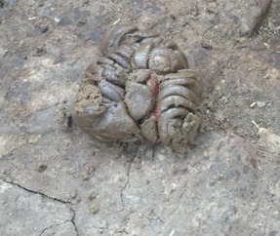
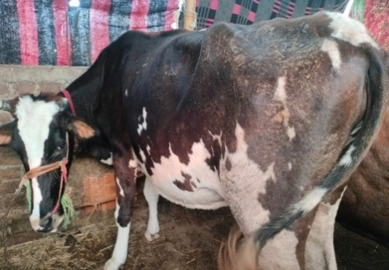
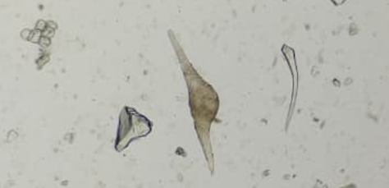
Fig.1. Cattle showing the signs of dullness and dehydration
Fig.2. Dung mixed with blood and mucous of affected cattle
Fig. 3. Arrow showing S. spindale eggs on 10x magnification (Direct smear method)
Fig. 4. Arrow showing S. spindale eggs on 10x magnification (Sedimentation method)

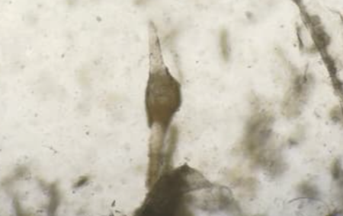

Disclaimer (Artificial intelligence)

Author(s) hereby declare that NO generative AI technologies such as Large Language Models (ChatGPT, COPILOT, etc.) and text-to-image generators have been used during the writing or editing of this manuscript.

References:
- Abera, M., Fentahun, G. & Peer, F. (2020). Prevalence of bovine schistosomiasis and its associated risk factors in and around Bahir Dar town, northwest Ethiopia. Daagu International Journal of Basic and Applied Research, 2, 66-74. https://dagujournal.org/index.php/dijbar/article/view/15/13
- Aradaib, I.E., Ahdelmageed, E.M., Ali, H.S. & Peter, R.H. (1995). A review on the diagnosis infection in cattle of Schistosoma bovis: current status and future prospects. Ciência Rural, 25(3), 493–498. doi:10.1590/S0103-84781995000300029
- Bulbul, K.H., Das, M., Islam, S., Sarmah, P.C., Tamuly, S., Borah P. & Roy, K. (2019). Molecular epidemiology of visceral schistosomosis caused by Schistosoma spindale infection in cattle of Assam, India, Biological Rhythm Research, DOI: 10.1080/09291016.2019.1616902
- Chandran, D., Lejaniya, A.S., Kumar, A.S., Rajan, A. & Edana, G.G. (2022). Clinical Diagnosis and Therapeutic Management of Schistosomosis (Schistosoma spindale) Infestation in Cattle: A Case Study. Acta Scientific Veterinary Sciences, 4 (8), 66-69. file:///D:/downloads/Shistosoma%20(1).pdf
- Demlew, B.A. & Tessma, A. K. (2020). Review on Bovine Schistosomiasis and Its Associated Risk Factors. South Asian Research Journal of Applied Medical Sciences, 2(5), 44-55. DOI: 10.36346/sarjams.2020.v02i05.001
- Digraskar, S., Shafi,T.A., Babasaheb, N. & Nithin, B.S.(2018). Successful medicinal management of visceral schistosomiasis in cattle. The Pharma Innovation Journal 2018; 7(2): 27-29. www.thepharmajournal.com
- Engdaw, T.A. & Abuhay, A.G. (2015). Overview on: schistosoma infection in cattle. World Journal of Pharmaceutical and Life Sciences. 1(3):1-11.www.wjpls.org.
- Giovanoli Evack, J., Kouadio, J.N., Achi, L., Balmer, O., Hattendorf, J., Bonfoh, B., Zinsstag, J., N’Goran, E. K. & Utzinger, J. (2020). Accuracy of the sedimentation and filtration methods for the diagnosis of schistosomiasis in cattle. Parasitology Research, 119, 1707-1712. doi: 10.1007/s00436-020-06660-0.
- Jain, N.C. (1986). Schalm’s Veterinary Haematology 4th edition. Lea and Febiger, Philadelphia.
- Jeyathilakan, N. & Mamane, S. (2022). Bovine Visceral Schistosomosis- An Insidious Debilitating Disease. Raksha Technical Review, 11(2), 11-12. krishikosh.egranth.ac.in
- Keiser, J. & Utzinger, J. (2004). Chemotherapy for major food-borne trematodes: a review. Expert Opinion on Pharmacotherapy, 5, 1711-1726. DOI: 10.1517/14656566.5.8.1711
- Niaz, S., Akhter, T., AbdEl-Salam, M.N., Ayaz, S., Shams, S., Ullah, R., Hussain, H. & Wasim, A. M. (2015). Treatment of schistosomiasis by seeds of lagenaria siceraria and its comparison with allopathic drugs in Buffaloes. Indian Journal of Animal Research. 50(2): 235-238. doi: 10.18805/ijar.5959.
- Rathod, Y., Biradar, R., Kasaralikar, V.R. & Halmandage, S. (2024). Diagnosis and therapeutic management of Schistosoma indicum infestation in a Bullock: A case report. International Journal of Veterinary Sciences and Animal Husbandry, 9(2), 388-390. https://doi.org/10.22271/veterinary.2024.v9.i2f.1224
- Sakhare, M.P., Siddiqui, M.F.M.F., Kalwaghe, S.T., Wakade, U.U., Shafi, T. A., Mujeeb, S.A. & Lingayat, S. (2025). Therapeutic Management of Acute Intestinal Schistosomiasis in A Red Kandhari Bullock”. Journal of Scientific Research and Reports, 31 (1), 434-39. https://doi.org/10.9734/jsrr/2025/v31i12786
- Soulsby, E.J.L. (1982). Helminths, arthropods and protozoa of domesticated animals. 7th ed. London: Bailliere, Tindall; p. 766.
- Sucharitha, A., Vijaya Sri, N.V.N. & Deepika K.G. (2024). A case report of Schistosoma indicum in a buffalo and its therapeutic management. International Journal of Veterinary Sciences andAnimalHusbandry,9(2),947-948. https://doi.org/10.22271/veterinary.2024.v9.i2m.133
- Tigga, M.N., Bauri, R.K., Deb, A.R. & Kullu, S.S. (2014). Prevalence of snail’s intermediate host infected with different trematodes cercariae in and around Ranchi. Veterinary World, 7(8), 630-634. www.veterinaryworld.org/Vol.7/August-2014/15.pdf
- Vijayasarathi, M.K., Latchumikanthan, A. & Velusamy, R. (2023).Occurrence of Schistosoma spindale in bovine calves in Thanjavur district of Tamil Nadu. Indian Journal of Veterinary and Animal Sciences Research, 52 (6), 107-109. https://doi.org/10.56093/ijvasr.v52i6.149504

