Original Research Article

EVALUATION OF GENETIC VARIATION IN WHEAT (Triticum aestivum L. and Triticum durum L.)

.
ABSTRACT

Background: Wheat is a globally important staple crop, contributing significantly to food security and human nutrition, particularly in densely populated countries like India. Understanding its genetic diversity is essential for developing improved, high-yielding, and stress-tolerant varieties.
Aims: The present study mainly focuses on diversity analysis in wheat cultivars using SSR molecular markers.
Methodology: The study was conducted in the 2020-21 crop seasons the Agronomy Instructional Farm, Sardarkrushinagar Dantiwada Agricultural University, Sardarkrushinagar, involving 30 wheat genotypes. The experiment utilized a randomized block design with four replications. Each genotype was sown in a single-row plot, 3.0 m long, with rows spaced 22.5 cm apart and plants within rows 10 cm apart employing standard agronomic practices. Molecular analyses were performed in biotechnology lab at Department of Plant Breeding and Genetics, Sardarkrushinagar Dantiwada Agricultural University, Sardarkrushinagar, India, located at 24.3°N latitude, 72.3°E longitude, and an elevation of 154.52 meters above mean sea level. For this study, 30 wheat genotypes were evaluated with 30 SSR markers to assess genetic diversity. Genomic DNA was extracted from fresh leaves using the CTAB method.
Results: Most markers showed high polymorphism, with PIC values ranging from 0.23 (WMC-28) to 0.66 (WMC-154), averaging 0.48. Resolving power (RP) varied from 1.00 (WMC-154) to 1.62 (WMC-28), with a mean of 1.29, indicating strong genotype differentiation. Genetic similarity coefficients spanned 0.20 to 1.0, with the lowest similarity between WH711 and HD2733 and the highest between HD2864 and DBW71. Cluster analysis grouped the genotypes into two main clusters, and principal component analysis aligned with genomic and taxonomic classifications. This significant genetic diversity among cultivars provides valuable resources for wheat breeding programs aimed at improving yield and resilience.
Conclusion: These markers are valuable for identifying wheat landraces and could be utilized for cultivar differentiation. In wheat, where other molecular markers often show low polymorphism rates, SSR markers stand out as a robust option. Their high polymorphism makes them an ideal choice for various breeding objectives, enhancing the ability to select diverse genotypes for crop improvement.

Keywords: Wheat, SSR markers, Genetic diversity, Yield

1. INTRODUCTION

Wheat (Triticum aestivum L.), a key cereal grass of the Poaceae family and Triticum genus, is the world’s foremost cereal crop. Renowned as the ‘King of Cereals’ for its extensive cultivation, high productivity, and pivotal role in global food trade, wheat occupies a central position in agriculture. It is a major source of calories and nutrients, supporting a wide range of products including bread, chapati, pasta, biscuits, and livestock feed. Worldwide, wheat is grown on 220.4 million hectares, producing approximately 798.97 million tonnes each year, contributing about 20% of global caloric intake (FAO, 2023). In India, it is cultivated across 30.28 million hectares, yielding 102.46 million tonnes annually (DA&FW, 2022).
Genetic markers are biological entities that exhibit allelic variation, serving as tools to monitor and trace specific traits, tissues, cells, nuclei, chromosomes, or genes. They are categorized into three main types: (a) Morphological markers, often referred to as “classical” or “visible” markers, which are observable phenotypic characteristics; (b) Biochemical markers, known as isozymes, which consist of allelic variants of enzymes; and (c) Molecular or DNA markers, which identify variations in DNA sequences (Raj et al., 2017; Kumar et al., 2016). Over the past two decades, molecular markers have played a crucial role in wheat genetics and breeding research. Simple Sequence Repeat (SSR) markers, also known as microsatellites, provide multiple advantages, including high polymorphism, locus-specificity, codominance, reproducibility, ease of use, and widespread distribution across the genome (Röder et al., 2004; Vargiya et al., 2025). SSR markers have proven to be a highly effective tool for assessing genetic variation in wheat (Landjeva et al., 2007; Kumar et al., 2016).
Given their high polymorphism and ease of use, SSR markers are widely applied in crop improvement programs. With these benefits in mind, this study aimed to assess genetic variation among different wheat varieties using SSR markers. The objective was to identify the most genetically diverse wheat genotypes, which could be utilized in hybridization efforts to develop genetically varied local wheat germplasm.

2. material and methods

The study was conducted in the 2020-21 crop seasons the Agronomy Instructional Farm, Sardarkrushinagar Dantiwada Agricultural University, Sardarkrushinagar, involving 30 wheat genotypes. The experiment utilized a randomized block design with four replications. Each genotype was sown in a single-row plot, 3.0 m long, with rows spaced 22.5 cm apart and plants within rows 10 cm apart employing standard agronomic practices. Molecular analyses were performed in biotechnology lab at Department of Plant Breeding and Genetics, Sardarkrushinagar Dantiwada Agricultural University, Sardarkrushinagar, India, located at 24.3°N latitude, 72.3°E longitude, and an elevation of 154.52 meters above mean sea level.
For this study, 30 wheat genotypes (Table 1) were evaluated to assess genetic diversity. Genomic DNA was extracted from fresh leaves using the CTAB method (Murray and Thompson, 1980). DNA concentration was measured via spectrophotometer at 260/280 nm absorbance and diluted to 50–100 ng/µL for PCR. Twenty-eight SSR markers, randomly selected from previously reported markers, were used to analyze genetic diversity. PCR amplification was conducted in a 15 µL reaction volume, containing 1.5 µL 10x Taq Buffer, 0.5 µL 10 mM dNTP mix, 1.0 µL each of forward and reverse primers, 0.1 µL Taq polymerase, 1 µL template DNA, and water to reach 15 µL. Reactions were performed in 0.2 mL thin-walled PCR tubes with the following thermal profile: initial denaturation at 94°C for 6 minutes, followed by 35 cycles of denaturation at 94°C for 1 minute, annealing at 42–58°C (based on primer melting temperature) for 40 seconds, and extension at 72°C for 2 minute, concluding with a final extension at 72°C for 10 minutes and storage at 4°C. Amplified products were separated on 1% agarose gels in 1X TAE buffer, and DNA fragments were visualized under a UV transilluminator using an Alpha Imager gel documentation system.

Table 1 List of genotypes
Sr. No. | Genotypes | Source | Sr. No. | Genotypes | Source
1 | VA2019-02 | SDAU, Vijapur, Gujarat | 16 | GW 366 | SDAU, Vijapur, Gujarat
2 | VA2019-03 | SDAU, Vijapur, Gujarat | 17 | GW 451 | SDAU, Vijapur, Gujarat
3 | VA2019-04 | SDAU, Vijapur, Gujarat | 18 | GW 496 | SDAU, Vijapur, Gujarat
4 | VA2019-17 | SDAU, Vijapur, Gujarat | 19 | GW 1339 | SDAU, Vijapur, Gujarat
5 | VA2019-18 | SDAU, Vijapur, Gujarat | 20 | HI 1544 | SDAU, Vijapur, Gujarat
6 | VA2019-19 | SDAU, Vijapur, Gujarat | 21 | HD 2932 | SDAU, Vijapur, Gujarat
7 | VA2019-34 | SDAU, Vijapur, Gujarat | 22 | HD 2864 | SDAU, Vijapur, Gujarat
8 | VA2019-35 | SDAU, Vijapur, Gujarat | 23 | LOK 1 | SDAU, Vijapur, Gujarat
9 | VA2019-36 | SDAU, Vijapur, Gujarat | 24 | MP 3288 | SDAU, Vijapur, Gujarat
10 | VA2019-37 | SDAU, Vijapur, Gujarat | 25 | DBW 110 | SDAU, Vijapur, Gujarat
11 | VA2016-22 | SDAU, Vijapur, Gujarat | 26 | GDW 1255 | SDAU, Vijapur, Gujarat
12 | VD2019-3 | SDAU, Vijapur, Gujarat | 27 | A-9-30-01 | SDAU, Vijapur, Gujarat
13 | VD2019-4 | SDAU, Vijapur, Gujarat | 28 | Agra Local | SDAU, Vijapur, Gujarat
14 | VD2019-5 | SDAU, Vijapur, Gujarat | 29 | Lal Bahadur | SDAU, Vijapur, Gujarat
15 | GW 322 | SDAU, Vijapur, Gujarat | 30 | A-206 | SDAU, Vijapur, Gujarat

2.1 Analysis and Data collection
Twenty-eight SSR primers were employed to generate reference data for evaluating primer effectiveness. A binary scoring matrix was created, assigning 1 for the presence and 0 for the absence of bands across all wheat genotypes for subsequent analysis. Genetic similarities were determined using the Jaccard similarity coefficient (Jaccard, 1908), and a dendrogram was constructed through clustering with the Unweighted Pair Group Method with Arithmetic Mean (UPGMA) algorithm, implemented via NTSYS-pc software version 2.11s (Rohlf, 2000). The resolving power (RP) of each primer was calculated to assess its ability to differentiate varieties, following Prevost and Wilkinson’s (1999) method, where RP = Ib (band informativeness) and computed as 1 - [2 × (0.5 - p)], with p representing the proportion of the 30 varieties exhibiting the band. Polymorphism information content (PIC) values were calculated using the formula by Anderson et al. (1993): PIC = 1 - ΣPij², where Pij denotes the frequency of the jth allele at the ith locus, summed across all alleles for that locus across all genotypes.

3. results and discussion
The erosion of genetic diversity in agriculturally significant crops poses a major challenge, particularly for bread wheat, where reduced variation hampers productivity and adaptability to breeding efforts (Stoeva et al., 2009). Molecular markers have gained prominence for assessing genetic diversity, enabling the estimation of genetic distances through allele frequency analysis, which is valuable for studying relationships among closely related lines (Uddin and Boerner, 2008; Huang et al., 2002). The presence of diverse and superior alleles is fundamental to crop improvement, facilitating the development of new wheat cultivars (Abouzied et al., 2013). SSR markers, noted for their high variability compared to other molecular markers, are particularly effective tools for evaluating genetic diversity in wheat germplasm, as highlighted by Haile et al. (2013).
3.1 Polymorphism of SSR markers
Of the 30 SSR primers tested (Table 2), 10 produced clear, reproducible bands and were deemed polymorphic, exhibiting 50.00% to 100% polymorphism, and were selected for further analysis.
Table 2 List of Primers
Sr. no. | Primer name |  | Sequence | Tm value (ºC) | %GC
1 | WMC 83 | F | TGGAGGAAACACAATGGATGCC | 60.25 | 50.00
1 | WMC 83 | R | GAGTATCGCCGACGAAAGGGAA | 62.12 | 54.55
2 | WMC 44 | F | GGTCTTCTGGGCTTTGATCCTG | 62.12 | 54.55
2 | WMC 44 | R | TGTTGCTAGGGACCCGTAGTGG | 63.98 | 59.09
3 | WMC 28 | F | ATCACGCATGTCTGCTATGTAT | 56.53 | 40.91
3 | WMC 28 | R | ATTAGACCATGAAGACGTGTAT | 54.66 | 36.36
4 | WMC 18 | F | CTGGGGCTTGGATCACGTCATT | 62.12 | 54.55
4 | WMC 18 | R | AGCCATGGACATGGTGTCCTTC | 62.12 | 54.55
5 | WMC 170 | F | ACATCCACGTTTATGTTGTTGC | 56.53 | 40.91
5 | WMC 170 | R | TTGGTTGCTCAACGTTTACTTC | 56.53 | 40.91
6 | WMC 154 | F | ATGCTCGTCAGTGTCATGTTTG | 58.39 | 45.45
6 | WMC 154 | R | AAACGGAACCTACCTCACTCTT | 58.39 | 45.45
7 | PSP 3200 | F | GTTCTGAAGACATTACGGATG | 55.92 | 42.86
7 | PSP 3200 | R | GAGAATAGCTGGTTTTGTGG | 55.25 | 45.00
8 | GWM 484 | F | AGTTCCGGTCATGGCTAGG | 58.82 | 57.89
8 | GWM 484 | R | ACATCGCTCTTCACAAACCC | 57.30 | 50.00
9 | GWM 429 | F | TTGTACATTAAGTTCCCATTA | 50.06 | 28.57
9 | GWM 429 | R | TTTAAGGACCTACATGACAC | 53.20 | 40.00
10 | GWM 410 | F | GCTTGAGACCGGCACAGT | 58.24 | 61.11
10 | GWM 410 | R | CGAGACCTTGAGGGTCTAGA | 59.35 | 55.00
11 | GWM 407 | F | CATATTTCCAAATCCCCAACTC | 56.53 | 40.91
11 | GWM 407 | R | GGTAATTCTAGGCTGACATATGCTC | 61.34 | 44.00
12 | GWM 397 | F | TGTCATGGATTATTTGGTCGG | 55.92 | 42.86
12 | GWM 397 | R | CTGCACTCTCGGTATACCAGC | 61.78 | 57.14
13 | GWM 368 | F | CCATTTCACCTAATGCCTGC | 57.30 | 50.00
13 | GWM 368 | R | AATAAAACCATGAGCTCACTTGC | 57.08 | 39.13
14 | GWM 294 | F | GCAGAGTGATCAATGCCAGA | 57.30 | 50.00
14 | GWM 294 | R | GGATTGGAGTTAAGAGAGAACCG | 60.65 | 47.83
15 | GWM 292 | F | TCACCGTGGTCACCGAC | 57.60 | 64.71
15 | GWM 292 | R | CCACCGAGCCGATAATGTAC | 59.35 | 55.00
16 | GWM 219 | F | GATGAGCGACACCTAGCCTC | 61.40 | 60.00
16 | GWM 219 | R | GGGGTCCGAGTCCACAAC | 60.52 | 66.67
17 | GWM 181 | F | TCATTGGTAATGAGGAGAGA | 53.20 | 40.00
17 | GWM 181 | R | GAACCATTCATGTGCATGTC | 55.25 | 45.00
18 | GWM 166 | F | ATAAAGCTGTCTCTTTAGTTCG | 54.66 | 36.36
18 | GWM 166 | R | GTTTTAACACATATGCATACCT | 52.80 | 31.82
19 | GWM 148 | F | GTGAGGCAGCAAGAGAGAAA | 57.30 | 50.00
19 | GWM 148 | R | CAAAGCTTGACTCAGACCAAA | 55.92 | 42.86
20 | GWM 11 | F | GGATAGTCAGACAATTCTTGTG | 56.53 | 40.91
20 | GWM 11 | R | GTGAATTGTGTCTTGTATGCTTCC | 59.30 | 41.67
21 | GWM 160 | F | TTCAATTCAGTCTTGGCTTGG | 55.92 | 42.86
21 | GWM 160 | R | CTGCAGGAAAAAAAGTACACCC | 58.39 | 45.45
22 | GWM 149 | F | CATTGTTTTCTGCCTCTAGCC | 57.87 | 47.62
22 | GWM 149 | R | CTAGCATCGAACCTGAACAAG | 57.87 | 47.62
23 | CFD 71 | F | CAATAAGTAGGCCGGGACAA | 57.30 | 50.00
23 | CFD 71 | R | TGTGCCAGTTGAGTTTGCTC | 57.30 | 50.00
24 | CFD 65 | F | AGACGATGAGAAGGAAGCCA | 55.25 | 45.00
24 | CFD 65 | R | CCTCCCTTGTTTTTGGGATT | 57.30 | 50.00
25 | CFA 2114 | F | ATTGGAAGGCCACGATACAC | 57.30 | 50.00
25 | CFA 2114 | R | CCCGTCGGGTTTTATCTAGC | 59.35 | 55.00
26 | CFA 2086 | F | TCTACTTTCAGGGCACCTCG | 59.35 | 55.00
26 | CFA 2086 | R | TCTCTCCAAACCTCCCTGTAA | 57.87 | 47.62
27 | BARC 98 | F | CCGTCCTATTCGCAAACCAGATT | 60.65 | 47.83
27 | BARC 98 | R | GCGGATATGTTCTCTAACTCAAGCA | 63.66 | 42.86
28 | BARC 146 | F | AAGGCGATGCTGCAGCTAAT | 57.30 | 50.00
28 | BARC 146 | R | GGCAATATGGAAACTGGAGAGAAAT | 59.70 | 40.00
Fig. 1 SSR primer GWM 181, profiling pattern of 30 wheat varieties along with 100bp to 500 bp DNA ladder

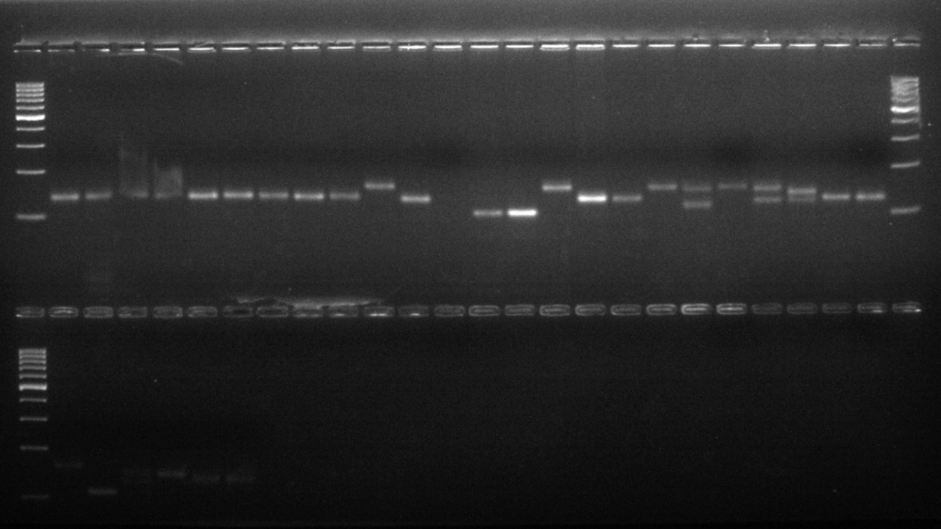
100 bp
500 bp
100 bp
200 bp
500 bp

These 10 primers amplified a total of 30 alleles across 30 wheat genotypes, with allele counts ranging from 2 to 4 per primer, averaging 3 alleles per primer (Fig. 1). This aligns with Liu et al. (2007), who reported an average of 1.9 polymorphic loci per reaction, and Wang et al. (2007), who found an average of 3.3 alleles per locus using 26 SSRs in 60 durum wheat genotypes.
Table 3 Result of SSR analysis in thirty genotypes of wheat

Sr. No. | Primer | Molecular band size (bp) | Total no. of amplified bands | Total no. of alleles | No. of polymorphic alleles | Polymorphism | PIC Value | Resolving power (RP) | Heterozygosity
1 | CFD-65 | 161-234 | 60 | 3 | 3 | Present | 0.54 | 1.42 | 0.62
2 | CFD-71 | 167-233 | 32 | 4 | 4 | Present | 0.64 | 1.24 | 0.69
3 | GWM-148 | 144-202 | 35 | 2 | 2 | Present | 0.29 | 1.45 | 0.35
4 | GWM-181 | 106-166 | 33 | 4 | 4 | Present | 0.64 | 1.00 | 0.70
5 | GWM-397 | 171-239 | 30 | 2 | 2 | Present | 0.31 | 1.28 | 0.39
6 | GWM-407 | 103-182 | 32 | 3 | 3 | Present | 0.58 | 1.20 | 0.66
7 | CFA-2114 | 209-247 | 23 | 3 | 2 | Present | 0.43 | 1.45 | 0.53
8 | WMC-28 | 181-234 | 24 | 2 | 2 | Present | 0.23 | 1.62 | 0.27
9 | WMC-154 | 122-224 | 30 | 4 | 3 | Present | 0.66 | 1.00 | 0.71
10 | WMC-170 | 209-263 | 33 | 3 | 3 | Present | 0.55 | 1.25 | 0.62
11 | Total |  | 332 | 30 | 28
12 | Average |  | 33.2 | 3.00 | 2.8 |  | 0.48 |  | 0.55

Fig. 2 Graphical Representation of PIC Values

Fig. 3 Graphical Representation of RP Values

The effectiveness of these molecular markers was evaluated using Polymorphism Information Content (PIC) and Resolving Power (RP) parameters, as described by Phougat et al. (2017). PIC values for the 10 polymorphic SSR primers are presented in Table 3 and illustrated in Figure 2. The PIC values ranged from 0.23 for primer WMC-28 to 0.66 for primer WMC-154, with an overall average of 0.48. These findings are consistent with Kumar et al. (2016), who used 17 polymorphic microsatellite markers to assess genetic diversity in hexaploid wheat, reporting a PIC value of 0.33, and similar results were noted by Abbasabad et al. (2017). Tekeu et al. (2017) investigated genetic diversity and structure in 17 bread wheat varieties using 11 microsatellite markers, identifying 77 alleles. A range of Polymorphism Information Content (PIC) values from 0.16 to 0.91 for SSRs was reported by Bohn et al. (1999). Similarly, Ahmad (2002) assessed 13 wheat cultivars of varied origins with 43 SSR markers, yielding comparable results. Marmar et al. (2013) studied 12 wheat cultivars for genetic diversity using 24 allele-specific SSR markers, with PIC values ranging from 0.16 to 0.89. In this study, alongside primer CWM-105, primers such as CWM-107, WMC-177, and XGWM-573-7B exhibited elevated PIC values. High mean PIC values reflect the primers’ effectiveness in detecting genetic variation, making them valuable for future taxonomic and genetic resource management studies. The resolving power (RP) of primers, indicating their capacity to differentiate germplasm and distinguish multiple genotypes (Provost and Wilkinson, 1999; Ablett et al., 2006), ranged from 0.92 (WMC-177) to 1.94 (WMS-169) across 10 polymorphic SSR primers, with an average of 1.29 (Table 3, Figure 3). Sharma et al. (2018) reported a similar average RP of 1.51 in wheat genotypes.
3.2 Cluster Analysis
Cluster analysis using the UPGMA method with SSR primers effectively distinguished wheat cultivars and elucidated genetic relationships among genotypes (Singh et al., 2018). A dendrogram was generated, dividing the 30 genotypes into two primary clusters: Cluster A and Cluster B (Figure 4).

Fig. 4 Dendrogram from UPGMA analysis based on Jaccard similarity coefficient of 30 wheat genotypes
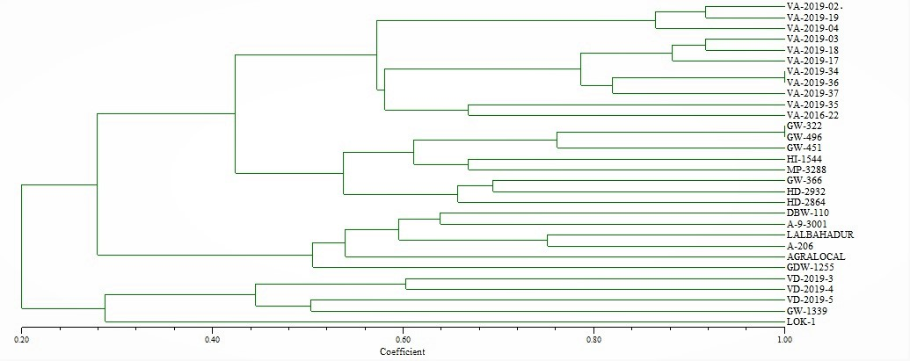
The cluster A was subdivided into two sub cluster A₁ and A₂. The sub cluster A₁ was further subdivided into sub clusters A₁₁ and A₁₂. The sub cluster A₁₁ included 11 genotypes viz., VA 2019-02, VA 2019-03, VA 2019-04, VA 2019-17, VA 2019-18, VA 2019-19, VA 2019-34, VA 2019-35, VA 2019-36, VA 2019-37, VA 2016-22 and sub cluster A₁₂ included 8 genotypes viz., GW 322, GW 366, GW 451, GW 496, HI 1544, MP 3288, HD 2932, HD 2864. Cluster A₂ included 6 genotypes viz., DBW 110, A-9-30-01, Lal bahadur, A-206, Agra local and GDW-1255. Cluster B was subdivided into two sub clusters B₁ and B₂. Sub cluster B₁ included 4 genotypes viz., VD2019-3, VD2019-4, VD2019-5, GW 1339 and sub cluster B₂ included only one genotype LOK 1. Cluster A₁ included all the bread wheat (Triticum aestivum) genotypes, while cluster B₁ included all the durum wheat (Triticum durum) genotypes. The clustering of genotypes is significant for future breeding programs (Sharma et al., 2010). Genetic similarity coefficients ranged from 0.20 to 1.0, with the lowest similarity between LOK-1 and VA-2019-02 and the highest between VA-2019-02 and VA-2019-19 (Fig. 4). Higher similarity values enhance the reliability of genetic diversity and relationship assessments. Microsatellite markers are valuable for characterizing and differentiating wheat genotypes, as noted by Islam et al. (2012). Diversity analysis is crucial for breeding improved varieties Al-Doss et al. (2011). In this study, SSR markers demonstrated high polymorphism and informativeness in wheat. The observed genetic diversity in Indian bread wheat provides valuable insights for planning wheat genome studies and offers guidance for breeders to manage cultivars effectively in future crop improvement initiatives.

Fig. 5 Two-dimensional (2D) plot of PCoA using SSR based primer

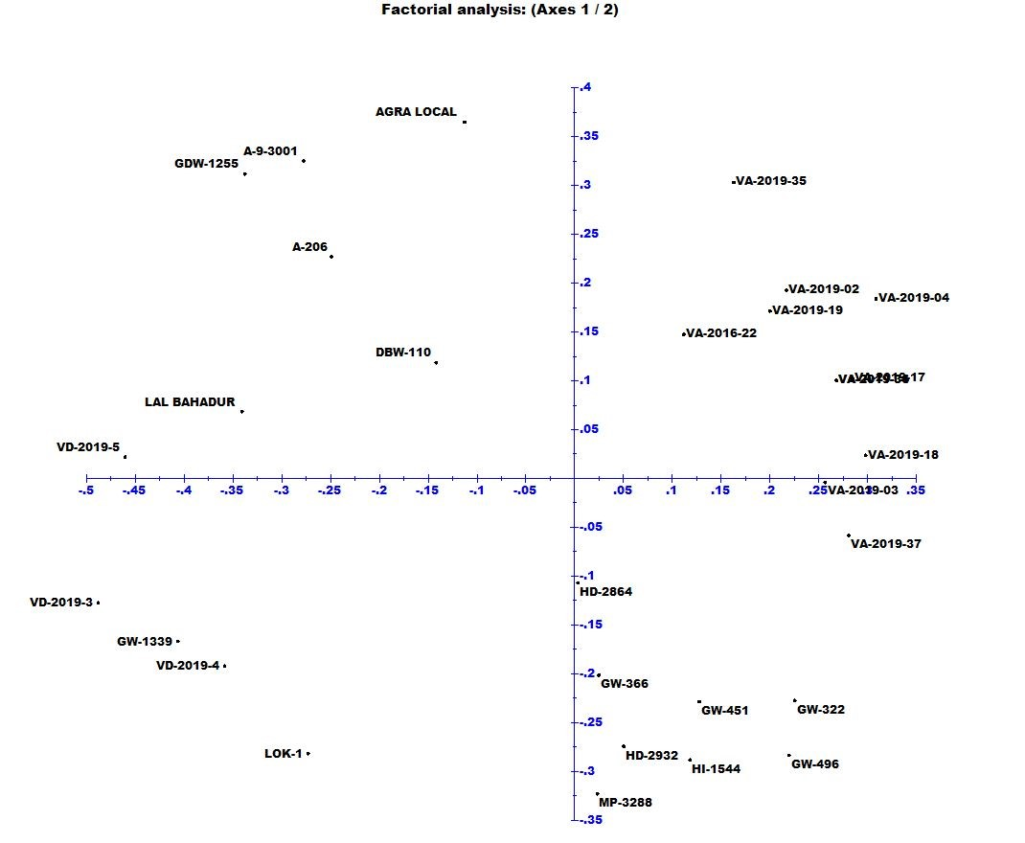

Principal coordinate analysis (PCoA) categorized 30 wheat accessions into three distinct groups (Fig. 5), aligning closely with results from UPGMA clustering. Compared to other methods, PCoA provides a clearer visualization of relationships among accessions. Accessions of Triticum durum grouped in same group, suggesting a strong genetic relationship. The analysis revealed significant genetic diversity within Triticum and Durum wheat genomes, offering valuable resources to expand the genetic base of common wheat. Additionally, a close genetic relationship was observed between VA series genotypes as they clustered together in the same group.

4. Conclusion

This study evaluated genetic diversity among thirty wheat cultivars using SSR markers. The findings indicated that the lowest genetic distance existed between cultivars LOK-1 and VA-2019-02 and the highest between VA-2019-02 and VA-2019-19. The results suggest that genetic variation among these cultivars is higher, indicating a high degree of diversity among them. SSR markers exhibit high polymorphism and reproducibility, making them effective for assessing genetic relationships within wheat varieties, even at the intra-specific level. These markers are valuable for identifying wheat landraces and could be utilized for cultivar differentiation. In wheat, where other molecular markers often show low polymorphism rates, SSR markers stand out as a robust option. Their high polymorphism makes them an ideal choice for various breeding objectives, enhancing the ability to select diverse genotypes for crop improvement.

Disclaimer (Artificial intelligence)

Author(s) hereby declare that NO generative AI technologies such as Large Language Models (ChatGPT, COPILOT, etc.) and text-to-image generators have been used during the writing or editing of this manuscript.

References
- Food and Agricultural Organisation. QCL Crops and livestock products 2023 [Internet]. 2023 [cited 2024 Oct 24]. Available from: www.fao.org.
- Department of Agriculture and Farmers Welfare. Agriculture statistics at a glance 2022 [Internet]. 2022 [cited 2024 Oct 24]. Available from: agriwelfare.gov.in.
- Raj SR, Vyas YS, Kumar MB, Joshi MN, Tyagi SN, Bagatharia SB. Ascertaining narrow genetic base in commercial accessions of wheat commonly grown in Gujarat via molecular markers. Electron J Plant Breed. 2017;8(2):512-8.
- Kumar P, Yadava RK, Kumar S, Kumar P. Molecular diversity analysis in wheat genotypes using SSR markers. Electron J Plant Breed. 2016;7(2):464-8.
- Röder MS, Huang XQ, Ganal MW. Wheat microsatellites: Potential and implications. In: Lörz H, Wenzel G, editors. Molecular Marker Systems in Plant Breeding and Crop Improvement. Berlin, Heidelberg: Springer; 2004. p. 255-66.
- Landjeva S, Korzun V, Börner A. Molecular markers: Actual and potential contributions to wheat genome characterization and breeding. Euphytica. 2007;156(3):271-96.
- Murray MG, Thompson WF. Rapid isolation of high molecular weight plant DNA. Nucleic Acids Res. 1980;8(19):4321-6.
- Jaccard P. Nouvelles recherches sur la distribution florale. Bull Soc Vaud Sci Nat. 1908; 44:223-70.
- Rohlf FJ. Statistical power comparisons among alternative morphometric methods. Am J Phys Anthropol. 2000;111(4):463-78.
- Prevost A, Wilkinson MJ. A new system of comparing PCR primers applied to ISSR fingerprinting of potato cultivars. Theor Appl Genet. 1999;98(1):107-12.
- Anderson JA, Churchill GA, Autrique JE, Tanksley SD, Sorrells ME. Optimizing parental selection for genetic linkage maps. Genome. 1993;36(1):181-6.
- Stoeva I, Chamurliyski P, Tsenov N. Investigation on Bulgarian and foreign common winter wheat varieties and lines with a view of their using in breeding for productivity and quality. Field Crops Stud. 2009;5(2):253-60.
- Uddin MS, Boerner A. Genetic diversity in hexaploid and tetraploid wheat genotypes using microsatellite markers. Plant Tissue Cult Biotechnol. 2008;18(1):65-73.
- Huang LR, Tegenfeldt JO, Kraeft JJ, Sturm JC, Austin RH, Cox EC. A DNA prism for high-speed continuous fractionation of large DNA molecules. Nat Biotechnol. 2002;20(10):1048-51.
- Abouzied HM, Eldemery SM, Abdellatif KF. SSR-based genetic diversity assessment in tetraploid and hexaploid wheat populations. Br Biotechnol J. 2013;3(3):390-404.
- Haile JK, Hammer K, Badebo A, Nachit MM, Röder MS. Genetic diversity assessment of Ethiopian tetraploid wheat landraces and improved durum wheat varieties using microsatellites and markers linked with stem rust resistance. Genet Resour Crop Evol. 2013;60(2):513-27.
- Liu J, Liu L, Hou N, Zhang A, Liu C. Genetic diversity of wheat gene pool of recurrent selection assessed by microsatellite markers and morphological traits. Euphytica. 2007;155(1):249-58.
- Wang H, Wang XE, Chen P, Liu D. Assessment of genetic diversity of Yunnan, Tibetan, and Xinjiang wheat using SSR markers. J Genet Genomics. 2007;34(7):623-33.
- Phougat D, Panwar IS, Saharan RP, Singh V, Godara A. Genetic diversity and association studies for yield attributing traits in bread wheat [Triticum aestivum (L.) em. Thell]. Res Crops. 2017;18(1):139-44.
- Abbasabad EZ, Mohammadi SA, Moghaddam M, Kamali MRJ. Analysis of genetic diversity, population structure and linkage disequilibrium in Iranian wheat landraces using SSR markers. Plant Genet Resour. 2017;15(4):327-34.
- Tékeu H, Ngonkeu EM, Djocgoué FP, Ellis A, Lendzemo V, Springfield L, et al. Genetic diversity of Cameroonian bread wheat (Triticum aestivum L.) cultivars revealed by microsatellite markers. Afr J Biotechnol. 2017;16(36):1832-39.
- Bohn M, Utz HF, Melchinger AE. Genetic similarities among winter wheat cultivars determined on the basis of RFLPs, AFLPs, and SSRs and their use for predicting progeny variance. Crop Sci. 1999;39(1):228-37.
- Ahmad M. Assessment of genomic diversity among wheat genotypes as determined by simple sequence repeats. Genome. 2002;45(4):646-51.
- Ablett G, Hill H, Henry RJ. Sequence polymorphism discovery in wheat microsatellite flanking regions using pyrophosphate sequencing. Mol Breed. 2006; 17:281-9.
- Al-Doss AA, Elshafei AA, Moustafa KA, Saleh M, Barakat MN. Comparative analysis of diversity based on morpho-agronomic traits and molecular markers in durum wheat under heat stress. Afr J Biotechnol. 2011;10(19):3671-81.
- Islam S, Haque MS, Emon RM, Islam MM, Begum SN. Molecular characterization of wheat (Triticum aestivum L.) genotypes through SSR markers. Bangladesh J Agric Res. 2012;37(3):389-98.
- Marmar A, Baenziger S, Dweikat I, El Hussein AA. Preliminary screening for water stress tolerance and genetic diversity in wheat (Triticum aestivum L.) cultivars from Sudan. J Genet Eng Biotechnol. 2013;11(2):87-94.
- Sharma P, Shefali, Pandey B, Muthusamy SK, Kumar S, Saharan MS, et al. Development and validation of microsatellite markers for Karnal bunt (Tilletia indica) and loose smut (Ustilago segetum tritici) of wheat from related fungal species. J Phytopathol. 2018;166(10):729-38.
- Sharma R, Deshpande SP, Senthilvel S, Rao VP, Rajaram V, Hash CT, et al. SSR allelic diversity in relation to morphological traits and resistance to grain mould in sorghum. Crop Pasture Sci. 2010;61(3):230-40.
- Singh AK, Chaurasia S, Kumar S, Singh R, Kumari J, Yadav MC, et al. Identification, analysis and development of salt responsive candidate gene based SSR markers in wheat. BMC Plant Biol. 2018; 18:249.
- Vargiya, S. V., Tiwari, C., Govindan, V., & Gundaniya, H. V. (2025). Genetic Evaluation of Wheat (Triticum aestivum L.) Genotypes in Malwa Region of India. Journal of Advances in Biology & Biotechnology, 28(10), 291–302. https://doi.org/10.9734/jabb/2025/v28i103057

