COMPARATIVE ANATOMICAL, PROXIMATE AND ELEMENTAL ANALYSES OF THE BARK OF THREE KHAYA SPECIES GROWING IN NIGERIA FOR MEDICINAL USE

ABSTRACT
Phytochemicals are chemical compounds that occur naturally in plants. The efficiency of medicinal plants for therapeutic purposes is often based on their organic constituents such as flavonoids, tannins, alkaloids and essential oils. Three Khaya species found in Nigeria are all from the family Meliaceae, namely Khaya senegalensis (KS), Khaya grandifoliola (KG) and Khaya ivorensis (KI). The three species are being used to treat diseases, among which includes malaria and sickle cell anaemia. All Khaya species are generally referred to as Oganwo by the Yoruba people of Nigeria. As much as being in used the traditional medical practitioners in Nigeria find it difficult to differentiate them because of their phenotypic similarities. There is a need, therefore, to identify differentiating characteristics to aid proper identification during collection and also to determine the putative quantitative and qualitative usefulness of these species in the treatment of diseases, hence this study.
Transverse sections, longitudinal sections, and macerates of stems and root bark were prepared for anatomical features. The proximate and elemental analysis of the bark was carried out using a standard procedure. The three Khaya species bark microscopic study reveals anatomical similarities and distinctive diagnostic means of identification. The cuticle shape and type, epidermal cell shape and cell inclusions show some similarities. The cuticle was striated, the shape of the cuticle ranges from circular, oval, polygonal and cylindrical elongated cells. Sclereids are present and prominent. However, there were characters that seemed to be species specific in the number of outer bark cell layers, cuticle thickness, numerosity of crystal druses, and types of sclereids present in the cell. The presence of stylliod crystal in the cell of Khaya grandifoliola distinguished it from the two other species. The proximate and elemental analysis shows the presence of nutritive values, essential micro and macro nutrients in the right quality and quantity that support their potency in their use for the treatment of diseases and for classification.

KEY WORDS: Khaya, Transverse, Longitudinal, Macerates, Proximate, Elemental, Standardization
INTRODUCTION
Medicinal plants represent a valuable source of antimicrobial agents and diverse phytochemical constituents, and they are increasingly utilised in the management of microbial infections as well as various disease conditions such as tuberculosis, anaemia, and trachoma. Plant-based remedies continue to play an important role in primary healthcare systems, particularly in developing regions where access to conventional medicines may be limited. The therapeutic potential of medicinal plants is largely attributed to their rich content of bioactive compounds, including alkaloids, flavonoids, tannins, and phenolic substances, which exhibit significant antimicrobial and pharmacological activities. Despite the extensive use of antibiotics, antimicrobial resistance remains a major global health concern and continues to threaten the effectiveness of available therapeutic agents. This challenge persists alongside widespread nutritional deficiencies, particularly in low- and middle-income countries, thereby increasing vulnerability to infectious diseases (Williams et al., 2019; Owusu et al., 2021). Consequently, there has been growing scientific interest in ethnomedicine, with researchers increasingly investigating traditional medicinal plants to validate their therapeutic efficacy and safety. Such studies aim to confirm the potency of plant-based remedies used by traditional medical practitioners in the treatment and management of various diseases, including sickle cell disease (SCD), as well as to standardise these preparations and develop them into scientifically acceptable dosage forms (Oyedapo et al., 2025). Khaya is a mahogany, family Meliaceae, native to tropical Africa and found along the Western Africa sub- region. They are found in Nigeria and called Oganwo by the Yoruba-speaking people of South Western Nigeria (Arbonier 2004). They are also found in Angola, Cameroon, Côte d'Ivoire, Gabon, Ghana and Liberia, where it grows primarily in lowland tropical rainforest. The three species found in Nigeria are Khaya senegalensis A.Juss, Khaya grandifoliola C.Dc. and Khaya ivorensis A.Chev. The bark, leave and seeds of the three Khaya species found in Nigeria are of ethno-medicinal importance. They are used in Nigeria to treat different types of diseases among the lower economic strata of the population. They are used for the treatment of the following sicknesses: headache, convulsion, cough and whooping cough, stomach ache, fever, threatened abortion, as a lotion for rheumatism, dermatomycosis, malaria fever and sickle cell diseases in Nigeria. When mixed with black pepper, corn is used to treat diarrhoea and dysentery. Bark decoction is used as a drink or bath for back pains, for treating syphilis, jaundice, as a laxative, for the treatment of mental illness, and as an aphrodisiac WAC 2004.
Scientists have been carrying out research to confirm the potency of Khaya species to manage array of diseases and even with the aim of standardizing them into forms and dosages.
Earlier research by Awe et.al 1992 ranked the anti-plasmodial activities of the three species as K.ivorensis> K.grandifoliola> K.senegalensis. Fall et.al 1999 reported the anti-sickling activity of K.senegalensis. Oyedapo et al 2016 and Oyedapo et al 2024 also confirmed the potency of the three Khaya species bark and leaves in the treatment of sickle cell diseases in the following order K.ivorensis> K.grandifoliola> K.senegalensis. As much as Khaya is used in the treatment of diseases, the traditional medical practitioners (TMP) found it very difficult to differentiate these three species from one another because they look so much alike phenotypically hence, they are all commonly called African mahogany (Oganwo). Therefore, the TMP generally used them for the purpose of managing diseases without being able to identify which of the three species is most potent. This study aimed to solve the problem of identifying these three species from one another using their bark and to also determine the putative content that supports their potency in their use for treatment of diseases quantitatively and qualitatively. Samples of the three Khaya species bark were collected and examined to determine the differences in their macro and micro morphologies. Diagnostic characters revealed in the barks of the three species Khaya senegalensis, Khaya grandifoliola and Khaya ivorensis were identified, reported and used in delineating them. For more clarification the proximate and the elemental analysis of the barks of the three species were carried out and reported to further corroborate their potency in treatment of diseases and also for purpose of standardization. With this study and reports the problems of identification were solved using the bark making it easy for our traditional medical practitioners to identify.

MATERIALS AND METHODS

Plant collection

Fresh samples of the bark, root and wood of the Khaya species were collected between December and January, (the year). The altitudes and geographical coordinates of the localities were taken using a GPS device. K. senegalensis (KS) (7°31'20.42''N, 4°31'20.93"E) at the Botanical Garden of the Obafemi Awolowo University (OAU), Ile- Ife. K. grandifoliola (KG) (7°19'11.18''N, 4°36'04.89"E), Abata Egba Village, Osun State while K. ivorensis (KI) (6°20'00''N, 5°16'00"E) Oke Ado, Okomu Forestry Reserve in Ovia LG Okada, Edo State, Nigeria. The samples were identified, authenticated and deposited at the IFE herbarium, Department of Botany, OAU, Ile-Ife, with voucher specimens 16289 IFE, 16348 IFE and 16343 IFE to KS, KG and KI, respectively.
Softening

Wood samples were cut into 4cm cube, boiled in 5% NaOH to soften the wood before sectioning.
Sectioning

Transverse section (TS), Longitudinal section (LS), Tangential longitudinal section (TLS) and Radial longitudinal section (RLS) of Khaya species were cut using sledge microtome at 10µm thickness and were preserved in 50% ethanol.
Maceration

Pen knife was used to slice the wood samples into small pieces which were macerated using Schultz ‘s fluid. This is obtained by mixing equal volume of 10% chromic acid [dissolved 1gm Potassium Nitrate (KNO3) in 50ml Conc. nitric acid (HNO3)] and 10% nitric acid in a beaker kept in the oven at 90oC for 8 hours. The samples were washed in five changes of water and preserved in 50% ethanol.
Staining

Sectioned wood, root, and stem bark were stained in Safranin O for 3minutes in a solid glass wash with lid to exclude dust and prevent evaporation of the stain and rinsed twice in water and counterstained for 3 minutes in Alcian Blue. These were treated with different strengths of ethanol (50%, 70%, 80%, 90%, and absolute ethanol). The dehydrated and differentiated sections were then washed in absolute xylene and mounted on glass slide, covered with slip and sealed with nail polish.
Microscopy

Each slide was observed under microscope and observations was recorded. Photomicrographs were taken using photomicroscope (Accuscope). Tissues and cell identification and description were done using microscope (Swift) according to Metcalfe and Chalk (1989), Esau (1977), Cutter (1978), Bilgrami et al (1983) and Falin (1997).
Proximate Analysis

Powdered leaf and bark of the three Khaya species were portioned each into six different fractions namely moisture, ash, crude fiber, ether extract, crude protein and nitrogen free extract and its analysis was done as described by the Official methods of Analysis of the Association of Official Analytical Chemistry (AOAC) of 1987 and 2006 revised edition, Washington D.C. United States of America.
Determination of Moisture Content

Powdered sample (2g) each were weighed into a platinum or ceramic crucible and transferred into hot-air oven, dried overnight at 70oC. They were allowed to cool in a desiccator afterwards. The final weight sample was taken with the aid of a Mettler- Toledo analytical balance (AOAC 2006) and calculated with the formular
% Moisture Content = Initial Weight (g) – Final Weight (g) X 100

Final weight (g)

Determination of Ash Content

Powdered samples of (2g) were weighed into a platinum or ceramic crucible and incinerated at 600oC for 3 hours; after cooling in a desiccator, the ash samples were weighed using Mettler-Toledo analytical balance (AP, 1986). The final weight is calculated using the formular below
% Ash content = (Weight of empty crucible + Ash (g)) – Weight of empty crucible (g) X 100

Weight of sample taken (g)

Determination of Total Crude Fiber

The acid-base method was used. Weighed two grams of different powdered samples were put into a 600ml beaker plus 200ml of 1.25% H2SO4, refluxed on a hot plate for 30 minutes and then filtered, rinsed with hot distilled water. The residue was scraped with spatula into a crucible and was transferred into the hot-air oven to dry overnight at 70oC. The dried sample was removed, cooled in a desiccator and weighed. The weighed sample was incinerated in a Murffle furnace at 600oC for 3 hours and final weight was taken (AOAC 2006), calculated using the formular
% Crude Fibre = Initial weight(g) – Final weight(g) × 100

Initial weight (g)
3.8.4 Determination of Ether Extract (% Fat, % Oil or % Lipid)

Dried sample of 2g were weighed and extracted into a Soxhlet extractor with a reflex condenser and a small flask. A fat-free extraction thimble‖ with cotton wool and the thimble were placed in the extractor. 125ml of Normal-Hexane was added until it siphons over once. The condenser was placed in a water bath, and connected to the tap water which as allowed to flow for 3hours at 50oC. When the n-hexane was short of siphoning over the thimble was removed to recover the solvent. The flask (which contained all the oil) was detached and dried in the hot air oven to a constant weight at 70oC overnight. The final weight of flask and oil was taken (AOAC
2006). Calculation:
% Ether extract = Weight of flask+oil (g) – Weight of flask (g) × 100

Weight of sample taken (g)

Determination of Total Crude Protein

This was done in 3 different stages namely:

i. Digestion
ii. Distillation
iii. Titration

Digestion

The dry sample (0.5g) was weighed into the Kjeldahl digestion flask and a little scoop of digestion catalyst/ mixture consisting [50g Anhydrous CuSO4 (blue), 500g of Anhydrous Na2SO4 and 0.5g of Selenium or Mercury oxide (HgO) or 0.5g of Mercury oxide HgO and
50g of Iron Sulphate] was added. 20ml of concentrated H2SO4 was carefully added into the

flask and transferred to Kjeldahl digestion system (Tecator digestion system 1007 digester) and heated for 2 hours which was cooled and made up to 50ml mark with distilled water (AOAC 2006).

Distillation

A 50ml of 2% boric acid was measured into a 200ml Erlemeyer/conical flask placed under the receiving tube of the distillation unit in a way that the end of the tube is below the level of the boric acid (H2BO3). 20ml of the digested sample was measured into a Kjeldahl digestion flask and 50ml of 40% NaOH was carefully added without shaking. The Boric acid and the indicator were put on the right-hand side, while the digested sample and NaOH were on the left-hand side of the Kjeldahl distilling unit after which the distilling unit was switched on. The distillation continues until the content level of the flask is 150ml (AOAC 2006).

Titration

The distillate was titrated with standard HCl, i.e. 0.1N HCl, 0.097N HCl until the end point was reached and a clear fluid was obtained without colour change. Titre value i.e. the net volume of acid used was determined.

List 1. Titration with Standard HCL
Sample Weight (g) Flask No Acid Dilution Initial Final Titre
Conc. factor reading reading value

A 0.5 X 0.1 2.5 0.0 3.0 3.0

Calculation:

% N = Titre value × Concentration of Acid × 0.014 × Dilution factor × 100

Weight of sample taken

Dilution factor = Volume of the digested sample = 50 = 2.5

Volume of sample taken 20

% Crude protein = % N × 6.25

% Dry Matter = 100 - % Moisture

% Nitrogen Free Extract = 100 – (% Moisture + % Ash + % Crude fibre + % Ether extract +

% Crude protein) While,

Total Carbohydrate = (% NFE + % Crude fibre)

Elemental Analysis Procedure

Determination of digestion for the determination of Minerals (Dry Ashing

Method).

Ash samples were treated with 5ml of 6NHCl and left for 30mins to digest. This was filtered into a 50ml conical flask using Whatman No 1 filter paper. The filtrate was made up to mark (50ml) with distilled water, shaked vigorously and was read with the aid of Atomic Absorption Spectrophotometer (AAS) (AOAC 2006).

RESULTS AND DISCUSSION

Macro- morphological study of Khaya species bark.

Table 1: Physical appearances of the three Khaya species Stem Bark.
 | Physical Appearance | Colour | Slash
Khaya senegalensis | Scaly | Dark grey | Dark brown/Pink
Khaya grandifoliola | Scaly | Dark brown | Reddish /Dark Pink
Khaya ivorensis | Scaly | Whitish brown | Pinkish red

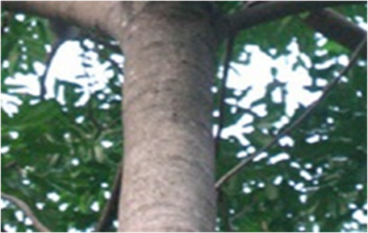 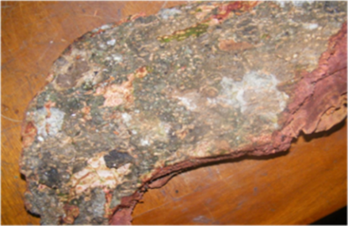 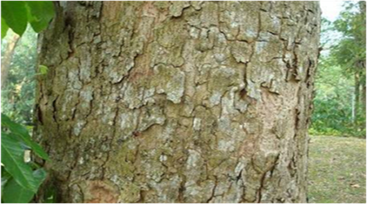 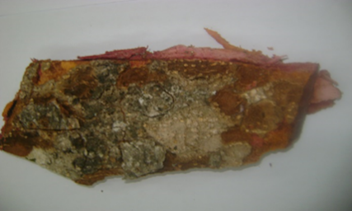 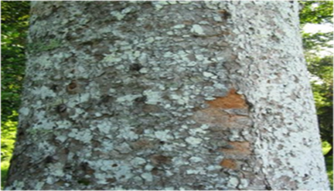 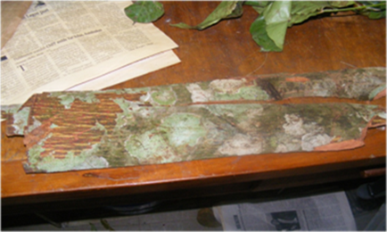
Plate 1: (a and b) Khaya senegalensis bark and bole
(c and d) Khaya grandifoliola bark and bole
(e and f) Khaya ivorensis bark and bole
F
E
C

D
B
A

Bark Anatomy of Khaya Species

Table 2: Features exhibited by longitudinal sections of the stem bark.
Character | K. senegalensis | K. grandifoliola | K. ivorensis
Outer Bark | 6-30 cell layers | 4-30 cell layers | 6-10 cell layers
Cuticle | Ranges from circular,  oval, polygonal and  cylindrical elongated  cell. | Ranges from circular,  oval, rectangular and  cylindrical cell. | Ranges from circular,  polygonal, oval,  rectangular and  cylindrical elongated  cell.
Tyloses | Present and  numerous | Present and  numerous | Present
Crystal Druses | Present and  numerous | Present | Present and many

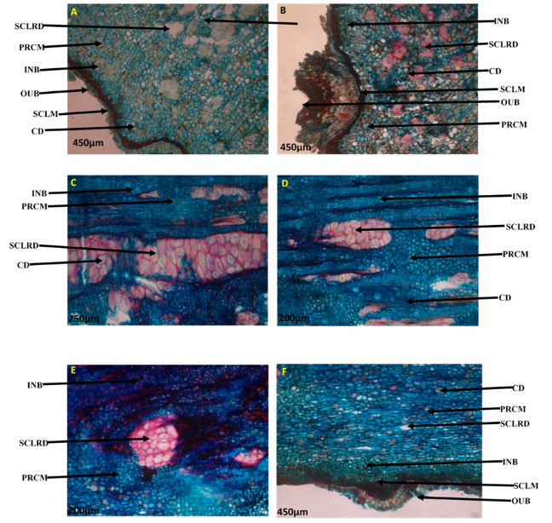

Plate 2: Comparative Characteristic features of longitudinal section of stem bark of Khaya species (a & b Khaya senegalensis; c & d Khaya grandifoliola; and e & f Khaya ivorensis).

Legend: OUB- Outer bark, INB- Inner bark, SCLM- Sclerenchyma cell, PRCM –

Parenchyma cell, TL- Tylose, SCLRD- Sclereids, CD- Crystal druses, PC- Prismatic

crystals, CTLE- Cuticle, TN-Tannin.

Longitudinal Section of Root Bark
Table 3: Characteristic features exhibited by Longitudinal Section of the
Khaya species Root Bark
Character | K. senegalensis | K. grandifoliola | K. ivorensis
Outer Bark | Made up of several  layers of dead  parenchyma cell  whose shape ranges  from circular to short  rectangular and  cylindrical cells. | Made up of several  layers of dead  parenchyma cells  whose shape ranges  from circular,  polygonal to short  rectangular and short  cylindrical cells. | Made up of several  layers of dead  parenchyma cells  whose shape ranges  from circular, oval,  polygonal to short  rectangular and short  cylindrical cells.
Inner Bark | Shapes ranges from  circular, polygonal,  short rectangular to  short cylindrical but  circular shape are  predominant. | Shapes ranges from  circular, polygonal,  short rectangular to  short and long  cylindrical cells. | Ranges from  circular, polygonal,  oval, rectangular and  cylindrical elongated  cell.
Cuticle | Not prominent. | Not prominent. | Not prominent.
Crystal Druses | Present and  numerous. | Present. | Present and many.
Tyloses | Present. | Present. | Present.
Prismatic Crystals | Present. | Absent. | Absent.
Crystal Sands | Absent. | Present. | Present.
Tannin | Bark very rich in tannin | Bark very rich in tannin | Bark very rich in tannin

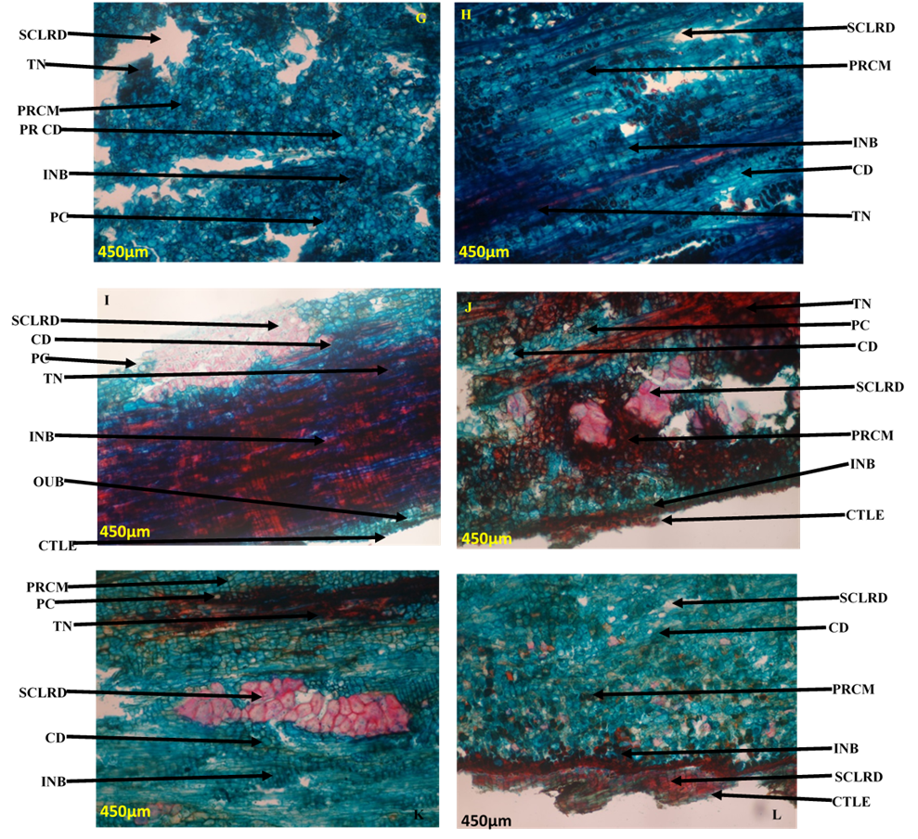 Plate 3: Features exhibited by longitudinal section of root bark of Khaya species (g & h Khaya senegalensis; i & j Khaya grandifoliola ; and k & l Khaya ivorensis).

Legend: OUB- Outer bark, INB- Inner bark, SCLM- Sclerenchyma cell, PRCM –
Parenchyma cell, TL- Tylose, SCLRD- Sclereids, CD- Crystal druses, PC- Prismatic
crystals, CTLE- Cuticle, TN-Tannin.

Transverse Section of Stem Bark
Table 4: Transverse Section of the Khaya species Stem Bark
Character | K. senegalensis | K. grandifoliola | K. ivorensis
Cuticle | Striated. | Striated. | Striated.
Cuticle Thickness | Average of 41.75µm  ± 14.07. | average of 36.40µm  ± 18.18 | average of 73.55µm  ± 14.12
Epidermal Cell | Several layers thick  of various shapes  from cylindrical,  circular and  polygonal cells. | They are polygonal,  circular to cylindrical  elongated. | They are  cylindrically  elongated, circular  and polygonal.
Phloem parenchyma | Shape varies from  circular to ova,  rectangular and  cylindrical elongated. | They are rectangular,  circular, ova and  cylindrically  elongated. | They are ova,  cylindrical elongated  and rectangular.
Sclereids | Present and  prominent. | Present. | Present and  prominent.
Styloids Crystals | Absent. | Present and  numerous. | Absent.
Tanin | Present. | Present. | Present

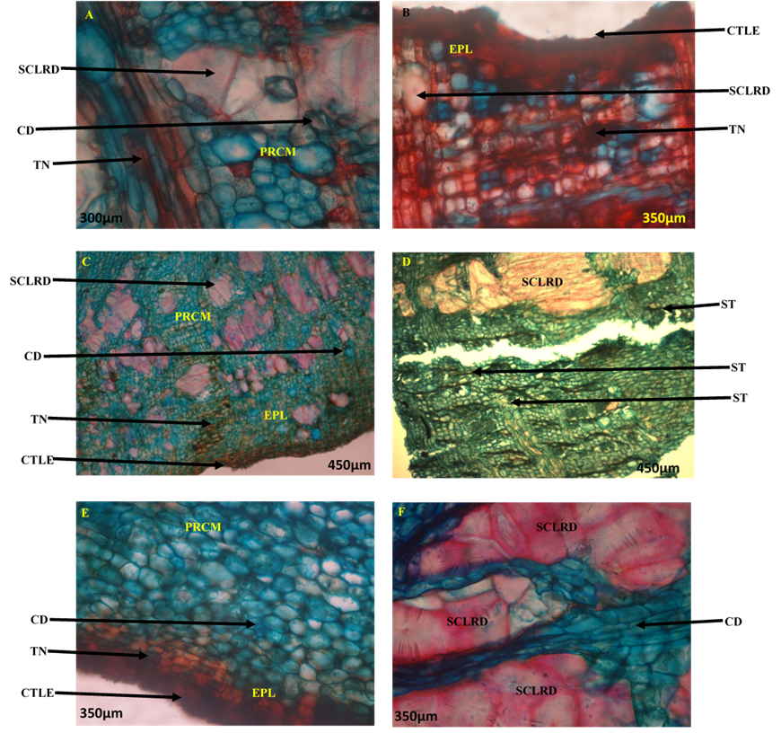

Plate 4: Comparative features exhibited by transverse section of stem bark of Khaya species (a & b); Khaya senegalensis; c & d Khaya grandifoliola; and e & f Khaya ivorensis).

Legend: EPL- Epidermal cell. PRCM- Parenchyma cell, COLCHM- Collenchyma cell,
TL- Tylose, SCLRD- Sclereids, CD- Crystal druses, PC- Prismatic crystal, CTLE Cuticle, TN-Tannin, ST- Styloid crystal.

Transverse Section of Root Bark
Table 5: Features of Transverse Section of the Khaya species Root Bark
Character | K. senegalensis | K. grandifoliola | K. ivorensis
Cuticle | Striated. | Striated. | Striated.
Cuticle Thickness | Average of 13.50µm  ± 7.20 | average of 12.60µm  ± 5.00 | average of 9.75µm ±  4.20
Epidermal Cell | 3-4 layers of  rectangular elongated  cells. | 4-7 layers of  elongated cylindrical  cells. | 4- Several layers.
Collenchyma Cells | 2-3 layers | Absent. | Absent.
Sclereids | Present | Present. | Present.
Styloids Crystals | Absent. | Present and  embedded in  epidermal cells | Absent.
Crystal Druses | Present and  numerous. | Present | Present but scanty

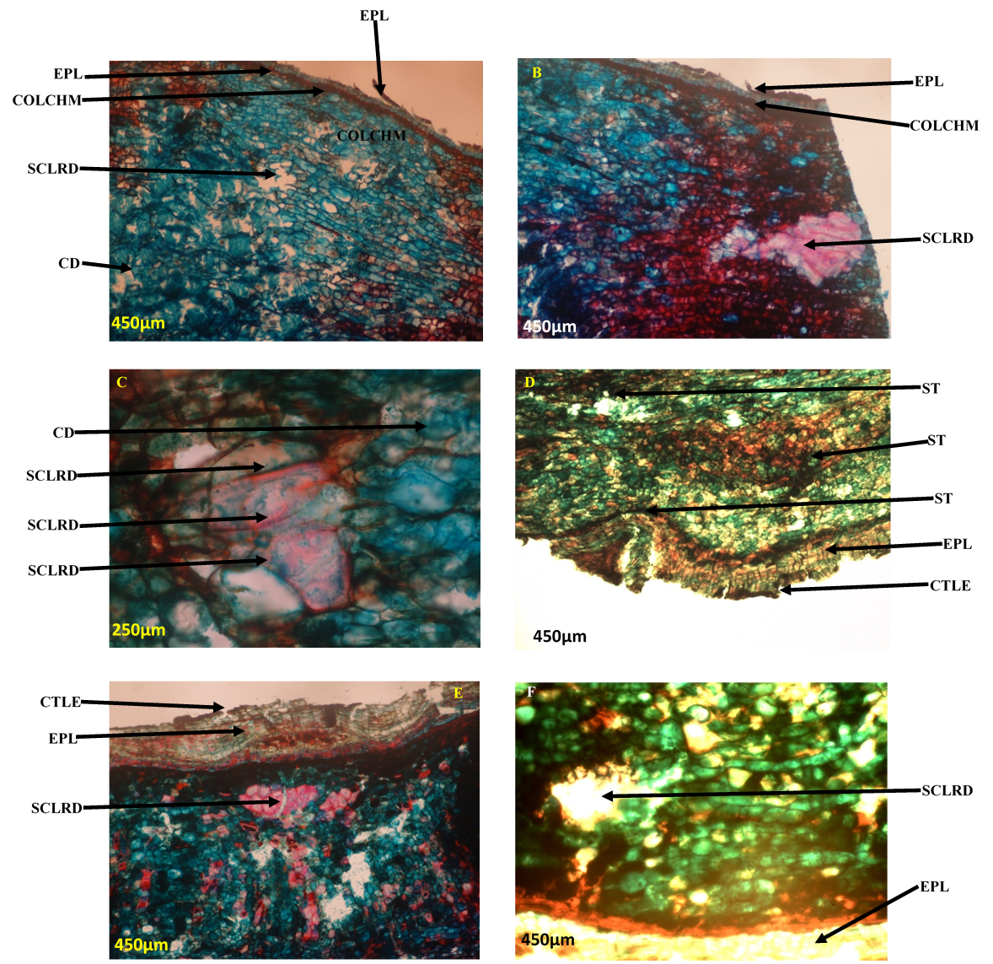

Plate 5: Longitudinal section of root bark of Khaya species (a & b Khaya senegalensis; c & d Khaya grandifoliola; and e & f Khaya ivorensis).
Legend: EPL- Epidermal cell. PRCM- Parenchyma cell, COLCHM- Collenchyma cell,
TL- Tylose, SCLRD- Sclereids, CD- Crystal druses, PC- Prismatic crystal, CTLE Cuticle, TN-Tannin, ST- Stylloid crystal.

Table 6: Summary of Comparative Features Exhibited by Stem Bark Macerates of the

Khaya Species

Character | K. senegalensis | K. grandifoliola | K. ivorensis
Sclereids | Present and plenty | Present and plenty | Present but are  scanty compared to  K.S and K. G
Brachysclereids | Present and more  compared to  Macro and osteosclereids. | Present and more in  number. | Present and  prominent.
Macrosclereids | Present but less in no  when compared to other two. | Present | Present, few and  scanty.
Osteosclereids | Present and more  than macro-sclereids. | Present | Present and  prominent.

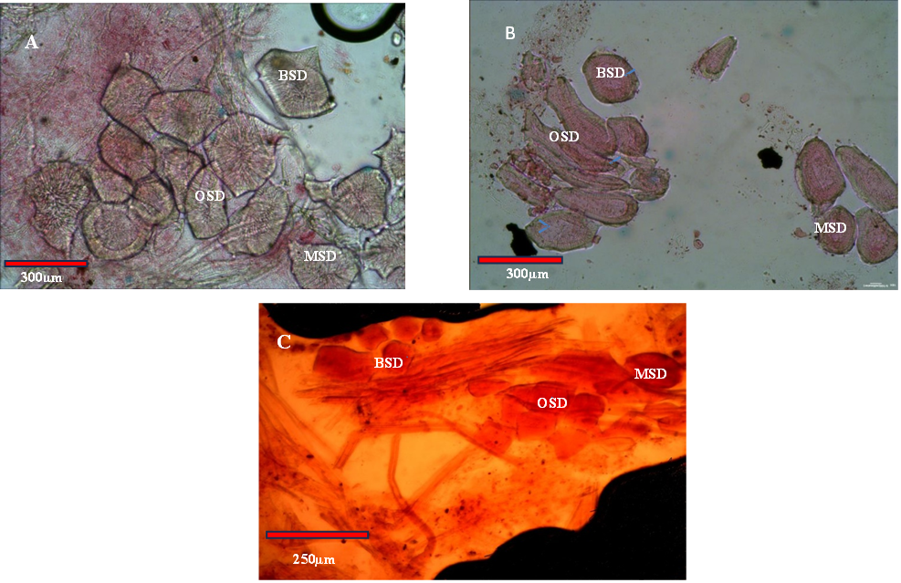

Plate 6: Comparative Features Exhibited by Stem Bark Macerates of the Khaya
Species K. senegalensis (A), K. grandifoliola (B), K. ivorensis (C).
Legend: MSD- Macro-sclereids, BSD- Brachy-sclereids, OSD- Osteo- sclereids.

Elemental / Mineral Analysis

Table 7: Elemental Analysis of the stem bark of the three Khaya species

 | Cu  (Copper) | Ni (Nickel) | Fe (Iron) | Zn (Zinc) | Mn (Manganese) | K (Potassium) | Cd  (Cadmium) | Na (Sodium | Cr  (Chromium) | Ca  (Calcium | Mg  (Magnesium) | Pb  (Lead)
K. senegalensis (KS) | 0.176 ±  0.002 | 0.024 ±  0.001 | 10.45 ±  0.038 | 0.317 ±  0.001 | 0.781 ±  0.003 | 3.434 ±  0.057 | 0.036 ±  0.003 | 0.112 ±  0.001 | 0.251 ±  0.020 | 9.489 ±  0.020 | 0.376 ±  0.000 | 0.022 ±  0.017
K. grandifoliola (KG) | 0.148  ±0.000 | 0.100±  0.007 | 8.345 ±  0.008 | 0.295 ±  0.003 | 0.611 ±  0.004 | 4.217 ±  0.431 | 0.047 ±  0.001 | 0.028 ±  0.000 | 0.254 ±  0.009 | 12.64 ±  0.092 | 0.252 ±  0.000 | 0.096 ±  0.008
K. ivorensis (KI) | 0.276 ±  0.001 | 0.092 ±  0.007 | 6.481 ±  0.015 | 0.437  ±0.003 | 0.598 ±  0.003 | 4.158 ±  0.036 | 0.067 ±  0.002 | 0.143 ±  0.001 | 0.463 ±  0.036 | 25.66 ±  0.074 | 0.621±  0.000 | 0.166 ±  0.007

Proximate Analysis

Table 8: Proximate Composition of the stem bark of the three Khaya species

Sample  Description | %  Moisture | %  Total  Ash | %  Crude  Fibre | %  Ether  Extract | %  Crude  Protein | %  Nitrogen Free Extract (NFE) | Total  Carbohydrate
Khaya  senegalensis  stem bark | 10.84 | 7.05 | 29.66 | 6.48 | 15.31 | 39.66 | 60.32
Khaya  grandifoliola  stem bark | 10.60 | 9.40 | 15.13 | 8.72 | 14.88 | 41.27 | 56.40
Khaya  ivorensis  stem bark | 10.21 | 12.66 | 20.22 | 4.34 | 12.69 | 39.88 | 60.1

Anatomical features have been used by many authors to delimit plants having difficulties in identifications due to physical similarities exhibited in members of their species, genus or families. Using anatomical studies to delimit species, genus and families Alakinde-Adenegan and Ojo (2025), Ojo et al. (2021 and 2023), Oyedapo et al. (2018), Ojo and Adenegan – Alakinde 2018, Arogundade and Onubogu (2018), Akinloye et al. (2015), Oladipo et al. (2016) have all used different characters or features exhibited by each plant to solve the problems which were documented and published in literatures. The case of Khaya species studied is not different.
In the stem bark anatomy of the three Khaya species studied, the longitudinal section of the
stem bark reveals that the outer bark of the three species has cell layers that ranges
from 6-30 cells for K. senegalensis, 4-30 cells for K. grandifoliola and 6-10 layers of cell for
K. ivorensis and the shapes of the cell varies from circular to oval, rectangular and
cylindrically elongated cell shapes. It was observed that there is a band of sclerenchyma cell
separating the outer bark from inner bark in K. senegalensis and this is absent in K.
grandifoliola and K. ivorensis. Sclereids are generally present in the three species with
brachy-sclereids more prominent and presented itself in various shape from polygonal,
circular to cylindrically elongated shape in all. Sclereids were numerous in K. senegalensis than the other two species K. grandifoliola and K. ivorensis. Other sclereid that was found in the three species were osteo-sclereids. Crystal druses are present in all the three species, numerous in
K. senegalensis, many in K.ivorensis but few in K. grandifoliola.
According to Trease and Evans, (1978) in their research stated that the barks of Khaya
species possessed calcium oxalate crystals, stone cells and phloem fibers as diagnostic
features and that sometime their dimension can be used to differentiate between species of the
same family. The difference in layers of the outer bark cells of the three species can be used
in differentiating the taxa, so also the types of sclereids presented in the various taxa. The
presence, variations in numerosity of crystal druses in the species cannot be over emphasized
in solving the taxonomical problems of Khaya species as Taba et al., 2012 has used the
presence of crystal druses in the mesophyll and cortex of leaves, petioles and stems in
stressing the taxonomical significance of anatomical characters in some species of the family
Myrtaceae.
The longitudinal Section of the root bark of the species studied present similarity in microscopical morphology which shows that the cuticle of the three species K. senegalensis, K. grandifoliola, K. ivorensis, are not prominent and the outer bark generally consist of dead cells layer of parenchyma cells whose shapes ranges from circular, oval, polygonal, short rectangular to short cylindrical. The inner bark also consists of parenchyma cell of various shapes circular, polygonal, short rectangular to short cylindrical, brachy-sclereids are present in all and their barks are very rich in tannin. Crystal druses and crystal sands are present in the three species but
prismatic crystals are found in K. senegalensis and this can be used as a
feature of identifying these species from each other. Edeoga et al., (1997) has used the
difference in shapes and forms of crystals localized in the epidermal cells of some Commelina
as a diagnostic feature and taxonomic purposes. He mentioned that the prismatic crystals
found in the epidermal cells of the leaf in Commelina erecta subsp. erecta and C. erecta
subsp. Livingstonii were different from the needle shaped crystals mostly found in the
epidermal cells of the leaf in C. benghalensis, C. erecta subsp. Livingstonii could however be
separated from C. erecta subsp. erecta in the acquisition of rhomboidal crystals in addition to
the usual needle like and prismatic crystal of the former.
In the transverse section of stem bark of the three species of Khaya studied result. It reveals that their cuticle is generally striated but with varied thickness average of 41.75µm ± 14.07 in K. senegalensis, 36.40µm ± 18.18 in K. grandifoliola, and 73.55µm ± 14.12 K. ivorensis. The epidermal cells are in layers having different shapes from cylindrical elongated, circular and polygonal. Parenchyma cells are ova, rectangular, circular and cylindrically elongated. Sclereids are present and most prominent is brachy-sclereids. Crystal druses are present and embedded in parenchyma cell. Tannin is generally present. It was observed that it is in K. grandifoliola alone that we have the presence of numerous styloid crystals which could be used as a diagnostic feature.
The root bark transverse section shows that the cuticles are generally striated and have
average thickness K. senegalensis 13.50µm ± 7.20, K. grandifoliola 12.60µm ± 5.00 and K.
ivorensis 9.75µm ± 4.20. Their epidermal cells are in layers with K. senegalensis having 3-4,
K. grandifoliola 4-7, and K. ivorensis 4-several layers. K. senegalensis present 2-3layers of
collenchyma cell layers and are absent in K. grandifoliola and K. ivorensis. Sclereids are
generally present in the three species especially brachy sclereids, astrosclereids in K.
senegalensis and K. ivorensis while it is absent in K. grandifoliola, so also is macrosclereids
present in K. grandifoliola and K. ivorensis whereas it is absent in K. senegalensis. It is also
observed that K. senegalensis has crystal druses which are absent in the other species studied
K. grandifoliola and K. ivorensis while only K. grandifoliola present the presense of stylloid
crystals in the epidermal cell.
The bark macerates of the three Khaya species studied consist of plenty number of sclereids in K. senegalensis and K. grandifoliola but sclereids are scanty in number in K. ivorensis. Brachysclereids are more prominent in all the three species studied than macro-sclereids and osteo-sclereids, this is followed by osteo-sclereids and least is macro-sclereids which is scanty in K. grandifoliola and K. ivorensis, this can serve as a distinct feature that differentiates K. senegalensis from K. grandifoliola and K. ivorensis. In K. senegalensis, brachy-sclereids are more in number when compared with that of K. grandifoliola and K. ivorensis. Osteo-sclereids and Brachy-sclereieds are generally present in the bark macerates of the three Khaya species. Macro-sclereids is present only K. senegalensis and absent in K. grandifoliola and K. ivorensi. The differences in some of the features presented by the three species studied can be additional information in solving their identification problem.
In addition, the importance of proximate parameters, macro and micro elements in human health were emphasized by the following researchers in their publications, this includes Oyedapo et al 2024 in her study of a comparative evaluation antisickling activites, proximate and elemental analysis of leaves of three Khaya species found in Nigeria, Illodibia and Igboabuchi 2017 evaluated phytochemical and nutritional potential of Talinum triangulare (Jacq.) Willd. leaf, stem and root on human health, Adenegan-Alakinde and Ojo 2018, 2022 and 2025 had carried out various researches on plants especially Basella; phytochemical and anti-oxidant properties of different forms of Basella, Proximate, vitamin and anti-nutritional properties of four forms of the genus Basella (Basellaceae) in South-western Nigeria and also assessment of macro and micro elements present in three commonly eaten vegetables in Nigeria.
The authors concluded that some of the elements when found in right proportions are essential for good human health while some are non-essential and may be deleterious. The elemental/mineral analysis of the three Khaya species was carried out with the view to also
complement its standardization one from another more so that the barks of these Khaya species are frequently more in use for drugs as concoction or herbs in treating different types of ailments. Elemental/mineral analysis is when a sample of some material (e.g., soil, drugs, herbs,
waste or drinking water, bodily fluids, minerals, chemical compounds) is analyzed to know its
elemental and sometimes isotopic composition/constituents. This was done using qualitative
(determining what elements are present), and quantitative (determining how much of
each are present). In this research both quantitative and qualitative analysis done were used as a parameter for standardization of the three Khaya species. The three Khaya species have essential elements equally referred to as macro-nutrients as well as non-essential nutrient (micro-nutrients) in different quantity and quality.
The essential elements contained in the three Khaya species includes calcium, iron, manganese, zinc, copper, magnesium, sodium and potassium while the non-essential/micro nutrients include chromium, cadmium, copper, nickel and lead.
The Calcium (Ca), Cadmium (Cd), Chromium (Cr) and Lead (Pb) contents in Khaya ivorensis (KI) bark is greater than that Khaya grandifoliola (KG) and that of KG greater than that of Khaya senegalensis (KS). The Magnesium (Mg), Sodium (Na), Zinc (Zn) and Copper (Cu) contents in KI > KS > KG. Manganese (Mn) and Iron (Fe) contents of KS > KG > KI. The Nickel (Ni) and Potassium (K) content in KG > KI > KS.
Therefore, quantitatively and in respect to classification of these three Khaya species, the quantitative content of these mineral elements varies from species to species when compared and this could be a very good tool or additional tool of classification of the three species one from another.
In another aspect, their qualitative content is also of importance in classifying Khaya species. It is also important to note that the three species bark contains both essential element (macro nutrients) and unessential (micro/trace nutrients) elements that are useful for the good growth and considerable good health management of a diseased patient in the right proportion for daily activities that is not injurious to body.
According to researches and findings Calcium, iron, manganese, zinc and copper are of great importance to our daily body functions due to the physiological and biological roles they play (Garcia-Rico et al., 2007). Manganese is also a vital mineral, needed for normal growth; it helps to breakdown fats, carbohydrates and proteins, and serves as co-factor for enzymes (Gomez et al., 2004). Zn is important for enzymatic function. It takes part in synthesis of DNA, protein, insulin. It is also essential for normal functioning of the cell including protein synthesis, carbohydrate metabolism, cell growth and cell division (Garcia-Rico et al., 2007, Gomez et al., 2004). Manganese (Mn) is essential for normal growth, skeletal formation and for normal
reproductive function in mammals and poultry.
According to Schroeder and his co-workers, Mn deficiency causes diabetes, nervous instability, disorder of bony cartilaginous growth in infant children and rheumatic arthritis in adults (Underwood, 1971). Rheumatic arthritis is a symptom in SCD patient then Mn supplement in medicinal herbs can alleviate this. Mn and Copper (Cu) are within permissible limit of RDA 1.5 to 3mg/day (Kaplan et al.,1993), in case of Mn the highest content is in the bark of K.S the K.S bark has 0.781 ± 0.003, then K.G bark 0.611 ± 0.004 and K.I bark 0.598± 0.003. Highest copper content occurred in the bark of K.I 0.276 ± 0.001, K.S Bark 0.176 ± 0.02 and K. G 0.148 ± 0.000 as the least in the species. These species can supply substantial portion of mineral requirement for those that find it difficult to source them from other rich sources.
Calcium is another important mineral present in the barks of three Khaya species studied.
The calcium content in stem barks of the Khaya is highest in K.I stem bark which contained 25.66 ± 0.074 mg/ml, followed by K.G stem bark 12.64 0.092 mg/ml, then K.S stem bark 9.489 ± 0.020 mg/ml. The presence of high calcium content in the stem bark of Khaya will help in building of strong bones for children, aged people and the sick. Sodium and potassium as another important mineral contribute to intracellular and extra cellular activities respectively and especially in the regulation of plasma volume, acid – base balance. The sodium content is highest in K.I stem bark 0.143 ± 0.001 mg/ml followed by K.S stem bark 0.112 ± 0.001 mg/ml, and the least in K.G stem bark 0.028 ± 0.000 mg/ml. Zn is also present in the barks of the Khaya. Khaya contains significant amount of Zinc (Zn) in their stem bark with an average of K.I 0.437 ± 0.003 mg/ml, K.S 0.317 ± 0.001 mg/ml and K.G having the least with 0.295 ± 0.003 mg/ml.
Zn is an intercellular Cat-ion present in all body tissues and fluids and next to iron, it is the second most abundant of the trace elements in humans. Zn is significant in enzymatic function and in DNA synthesis. Its presence in the herbs or drugs made from bark of Khaya species for an SCD patients will contribute to good health condition through replacements of worn-out cells for the sick and anemic. Magnesium (Mg) content in the species is as follows K.I stem bark 0.621 ± 0.000, K.S stem bark 0.376 ± 0.000 and K.G stem bark 0.252 ± 0.000.
Some heavy metals are also present in barks of the three species of Khaya studied, though this could be toxic and injurious if consumed in large quantity but in this study, they were found in small quantity below permissible limit and record daily intake. The quantity present is insignificant to have caused any health hazards. Those present includes lead (Pb), mercury (Hg),
cadmium (Cd), arsenium (As), and chromium (Cr). The analysis is as follows Lead (Pb) in K.I stem bark is 0.166 ± 0.007 mg/ml, K.G stem bark 0.096 ± 0.008 mg/ml, and K.S stem bark 0.022 ± 0.017 mg/ml. Chromium (Cr) in the stem bark of the Khaya, K.I stem bark 0.463 ± 0.036mg/ml, K.G 0.254 ± 0.009mg/ml and the least in K.S 0.251 ± 0.020mg/ml. Chromium in the body and the amounts needed for optimal health care are not well defined, yet it is required in trace amounts WHO (2003) considered that supplements with Cr should not exceed 250μg/day but the RDA set by FDA is 35μg/day.
Cadmium (Cd) in the bark of the Khaya is very low, K.I. 0.067 ± 0.002mg/ml, K.G 0.047 ± 0.001mg/ml, K.S 0.036 ± 0.003mg/ml (Table 7). Iron plays an important role in human body metabolism; it acts as a catalyst and is present in amount greater than that of any other trace elements. According to an estimate 57.6% of the body iron in human being is contained in hemoglobin and 8.9% in myoglobin. The cytochrome and catalase enzyme contained about 0.5% of iron (Jacob et al., 1970). The heme pigments, hemoglobin in erythrocytes and myoglobin in muscles functions as oxygen carriers. It is therefore important to note that iron rich dietary supplement and herbs will go a long way in replacing erythrocytes and hemoglobin to reduce anemia in diseased patients. However, it is observed that in the elemental analysis carried out for the Khaya species, the iron content in the bark is generally high, higher than any other element found in the stem bark. The K.S stem bark 10.45 ± 0.038, K.G stem bark 8.345 ± 0.008, and K.I. stem bark 6.481 ± 0.015. All the values obtained are still within National Research Council recommendation dietary allowance of iron for male 10-12mg, 15mg for female and 15mg for female during pregnancy and the recommendation limit of iron are up to 30mg (Kaplan, 1993). The mean daily recommendation of iron is ranges from about 10 to 50 mg/day (FAO/WHO, 1988).
Nickel (Ni) is another element screened in the Khaya species studied, Ni is used as alloys
product Nickel painting for anti-corrosion and in the manufacture of batteries. It is regarded
as an essential trace metal but toxic in large amount to human health and is considered as
carcinogenic to human. Ni content of the Khaya species screened is as follows K.G stem bark, 0.100 ± 0.007, K.I. stem bark 0.092 ± 0.007, and K.S stem bark 0.024 ± 0.001 the least. Conclusively, considering the amount of trace elements (both essential and non-essential) and
heavy metals present in the stem barks of the three Khaya species studied which
are within permissible limit for the body, the Khaya species can be developed to herbal remedy in management of ailments and diseases, this corroborate the research carried out by Oyedapo et al 2024 on comparative evaluation of antisickling, elemental and proximate analysis of the leaves of three Khaya species found in Nigeria. The study shows that trace element is generally within safe limit. The levels of phytochemicals found can serve as potent nutritive food supplements and drugs in combating ailments and diseases. The data obtained in this work will be valuable in complementing available food consumption and herbal remedy used in treating of ailments and diseases. It can also help in estimating dietary intakes of heavy metals in herbs of species of Khaya in Nigeria.
The importance and awareness of nutrition in public health issues has resulted in the
increased demand for knowledge of the nutrient in foods (Chinma et al., 2009). It is a fact that
health is wealth. The health of an individual depends on the qualities and quantities of
foodstuffs he consumes. The food requirements are simply needed to supply the minor
requirements of the six groups of nutrients e.g carbohydrates, fats, proteins, mineral elements,
vitamins and water (Alfred and Patrick, 1985). Vegetables contain nutrients which can be
absorbed by the body to be used as energy sources, body building, regulatory and protective
Physicochemical data of the stem barks of the Khaya species was carried out; the
analysis showed ash content for stem barks ranges between 7.05%-12.60% and that the ash content in the bark of the Khaya ivorensis stem bark (K.I) gave the highest 12.66%, followed by Khaya grandifoliola stem bark (K.G) 9.40%, and Khaya senegalensis (K.S) stem bark 7.05%. The ash content of 12.66% in K.I stem bark showed that it contained more mineral
content when compared to others in order of their increase (Table 8). Values are comparable
to other leafy vegetables reported such as I. hybridus, and C.peps, (Iheanaco et al., 2009).
The percentage moisture content (MC) showed generally revealed the highest MC % observed is in K.S stem bark was 10.84%, followed by K.G stem bark 10.60%, and K.I stem bark 10.21% as the least. The quantitative evaluation is an important parameter in setting standard of crude drugs and the physical constant parameters could be useful in detecting any adulterant in the drug. Musa et al., (2002), recorded that the result of MC that is not high indicated less chances of microbial degradation of the drug during storage and in this study the MC ranges between 9.32% -10.84% (Table 8). The general requirement of MC in crude drug is that it should not be more than 14% (British pharmacopoeia, 1980) and the value obtained in this research work is within the acceptable range.
The crude fiber/ dietary fiber help to prevent constipation, bowel problems and piles (Asaolu
et al., 2012). The crude fiber of the Khaya specie studied is within 15.13%-20.66%, the
highest % value observed in K.S stem bark 20.66%, followed by K.I stem bark 20.22% and the least in K.G bark 15.13%, This is within the allowed values of 8.50 - 20.90% for some Nigerian vegetables (Isong and Idiong, 1997).
The crude protein content ranged from 12.69% - 15.31%. K.S stem bark has the highest with 15.31%, K.G stem bark 14.88% and K.I stem bark 12.69%.
The crude protein is more than what was reported for some other green leafy vegetables such
as Mormodical balsamina (11.29%). Plants food that provides more than 12% of their calorific values from protein has been shown to be good source of protein (Ali, 2009). Besides this, the high protein content will help in replacing worn out tissues of a diseased patient thereby supporting their growth and healthiness.
The total carbohydrate content ranges between 56.40% - 60.32%. the highest was found in K. S
stem bark 60.32%, K.I stem bark 60.10%, K.G stem bark 56.40%. The carbohydrate content of these plants will supply necessary energy to a sick patient.
The % ether extract gave ranges between 4.34% - 8.72%, K.G stem bark 8.72%, K.S stem bark 6.48%, K.I stem bark 4.34% (Table 8).
The NFE gave K.G stem bark 41.27% which is the highest, followed by K.I stem bark 39.88% and K.S stem bark 39.66% as the least.
Considering the proximate analysis results/values given by Khaya species viz K.S, K.G
in this research that falls within the limit of standard nutritive values expected from a leafy vegetables when compared to others in this category; it could therefore be concluded that the Khaya species will form a good herbal remedy that can be used in the management of disease.
In addition to this, the physicochemical data would help in determining the richness and
usefulness of the Khaya species in combating ailments and diseases. It will go a long way in the identification of the drug from its substitute or adulterants.
CONCLUSION
From this study, it could be concluded that
- The three Khaya species bark studied, when compared only seem phenotypically the same but when studied, revealed that they are completely different macro-morphologically with regards to the bark physical appearance, color and slash of the bark.
- Micro-morphologically, the three species of Khaya studied are different, considering some diagnostic characters possessed by each of the species. These ranged from their cuticle thicknesses 41.75µm ±14.07 in K. senegalensis; 36.40µm ±18.18 in K.grandifoliola and 73.55µm ±14.12 in K. ivorensis; differences in the outer bark cell layers 6-30 cell layers in K. senegalensis, 4-30 cell layers in K. grandifoliola and 6-10 cell layers in K. ivorensis, inner bark cell type, cell inclusions, types of sclereids present in numbers/numerousity in each species. The diagnostic styloid crystals, which were numerously present and embedded in epidermal cell layers of K.grandifoliola only and also the presence of 2-3layers of collenchyma cells present only in K. senegalensis are all of anatomical tools that can be used to distinguish between the three species of Khaya studied, thereby solving their identification problems.
- The differences in elemental constituents and physicochemical data of these species is also of diagnostic and standardization importance. K. ivorensis is richer in copper (cu) having a value of 0.276 ±0.001, K. senegalensis 0.176 ±0.002 and K. grandifoliola 0.148 ±0.000; K.S has highest value in Manganese 0.781 ±0.003. K.G 0.611 ±0.004 and K.I 0.598 ±0.003. In Potassium K.G has highest content of 4.217 ±0.431 followed by 4.158 ±0.036 and K.S 3.434 ±0.057 and calcium content of the species with K.I having about twice to thrice calcium content of 25.66 ±0.074, K.G 12.64 ±0.092 and K.S 9.489 ±0.020, and the total ash content of K.I is 12.66, K.G 9.40 and K.S 7.05.
- Considering the amount of trace elements (both essential and non-essential) and
heavy metals present in the stem barks of the three Khaya species studied
are within permissible limit for the body), parts of the Khaya species can be developed to herbal remedy in management ailments and diseases.
- The levels of phytochemicals found can serve as potent nutritive food supplements and drugs in combating ailments and diseases.
- The data obtained will be valuable in complementing available food consumption and herbal remedy used in treating sick people which can help in estimating dietary intakes of heavy metals in herbs of species of Khaya in Nigeria
- The physicochemical data confirmed the richness and usefulness of the Khaya species in combating diseases.
- The phytochemicals and physicochemical data obtained in this study will help in classification and identification of the drug from its substitute or adulterants.
CONFLICT OF INTEREST
The authors declare that there are no conflicts of interest in relation to this article.

COMPETING INTERESTS DISCLAIMER:
Authors have declared that they have no known competing financial interests OR non-financial interests OR personal relationships that could have appeared to influence the work reported in this paper.
Disclaimer (Artificial intelligence)
Author(s) hereby declare that NO generative AI technologies such as Large Language Models (ChatGPT, COPILOT, etc.) and text-to-image generators have been used during the writing or editing of this manuscript.

REFERENCES
- Adenegan-Alakinde, T. A. and Ojo, F.M. 2018. Phytochemical and antioxidant properties of forms of Basella. Int J Vegetable Sci. https://do i.org/10.1080/19315260.2018.1524808
- Adenegan-Alakinde, T. A. and Ojo, F. M., 2022. Assessment of macro and micro elements present in three commonly eaten vegetables in Nigeria. International Journal of Biological and Chemical Sciences, (1): 430 439. doi: 10.4314/ijbcs. v16i1.36
- Adenegan-Alakinde, T. A. and Ojo, F.M., 2025. Stem anatomical studies of two species of Talinum occurring in South West, Nigeria. Ife Journal of Science vol. 27, no. 1 http://dx.doi.org/10.4314/ijs.v27i1.6
- Adenegan-Alakinde T.A. and Ojo, F. M., 2025. Proximate, vitamin and anti-nutritional properties of four forms of the genus Basella (Basellaceae) in South-western, Nigeria.
Vegetos https://doi.org/10.1007/s42535-025-01305-y
- Akinloye A. J., Borokini I., Adeniji K. and Akinnubi F. M., 2015. Comparative Anatomical Studies of Artocarpus altilis (Perkinson) and Fosberg and Artocarpus communis (J.R & G Forest) in Nigeria. Science in Cold Arid Regions, 7(6): 0709-0721.
- Ali, A., 2009. Proximate and mineral composition of the Marcubeh (Asparagus officinalis). World Dairy and Food Science, 4(2), 142-149.
- AOAC., 1987. Official methods of Analysis of the Association of Official Analytical Chemistry, 13th edition Washington D.C. P1094. United States of America.
- AOAC., 2006. Official methods of Analysis of the Association of Official Analytical Chemistry, Revised edition Washington D.C. United States of America.
- Arbonnier, M., 2004. Trees, shrubs and lianas of West African dry zones. CIRAD, Margraf Publishers Gmbh, MNHN, Paris, France. 573pp.
- Arogundade, O.O., and Onubogu, U. P., 2018. Comparative wood anatomy of some members of the genus Caesalpinia (Linn.) SW. Ife Journal of Science, doi: 10.4314/ijs.v20i2.6
- Asaolu, S.S., Adefemi, O., Oyakilome, I.G., Ajibulu, K.E., and Asaolu, M.F., 2012. Proximate and Mineral composition of Nigerian leafy vegetables. Journal of Food Research 1, (3).
- Awe S.O., Makinde, J.M., and Salako, L.A., 1992. Seasonal variation in the activity of Morinda lucida. 8th International Symposium on Natural Products organized by DRPU, Faculty of Pharmacy, Obafemi Awolowo University, Ile-Ife, Nigeria. Abstract 8.
- Bilgramiks, Srivastava L.M., and Shreemali J.L., 1982. Fundamentals of Botany 2nd Revised Edition.
- British Pharmacopoeia., 1980. Ash value, acid insoluble, water soluble, extractive and alcohol extractive, 11, appendix xii, His majesty ‘s Stationary Office, London, pp. 1276 – 1277.
- Chinma, C.E., and Igyor, M.A., 2009. Micronutrients and anti-nutritional contents of selected tropical vegetables grown in SouthEast, Nigeria. Nigerian Foods Journal, 25, (1).
- Edeoga, H.O., and Helen, N. Ugbo., 2007. Histochemical localization of calcium oxalate crystals in the leaf epidermis of some Commelina L. (Commelinaceae) and its bearing taxonomy. Acta Phytptax. Geobot. 48 (1): 23-30 (1997).
- Esau, K., 1977. Anatomy of Seed Plants, 2nd Edition.
- Fall, A.B., Vanhaelen-Fastre, R., Vanhaelen, M., Lo I, Toppet, M., Fester, A., and Fondu, P., 1999. In - vitro Anti-sickling Activity of a re-arranged Limonoid isolated from Khaya senegalensis. Planta Medica 65(3):209-12.
- Food and Agricultural Organisation, (FAO)., 1986. Some Medicinal Plants of Africa and Latin America. FAO Forestry Paper. 67. Rome.
- Garcia-Rico, L., Leyva-Perez, J., and Jara-Marini, M.E., 2007. Content and daily intake of copper, zinc, lead, cadmium and mercury from dietary supplements in Mexico. Food Chem Toxicol, 45:1599-1605.
- Gomez, M.R., Cerutti, S., Olsina, R.A., Silvia, M.F., and Martínez, L.D., 2004. Metal content monitoring in Hypericum perforatum pharmaceutical derivatives by atomic absorption and emission spectrometry. J Pharm Biomed Anal, 24:569-576.
- Iheanacho, K., and Ubebani, A.C., 2009. Nutritional composition of some leafy vegetables consumed in Imo state, Nigeria. J. Appl. Sci. Environ Manage. 13(3), 35-38.
- Ilodibia, C.V. and Igboabuchi, N.A., 2017. Evaluation of phytochemical and nutritional potential of Talinum triangulare (Jacq.) Willd. leaf, stem and root on human health. International Journal of Biological Research, 5(1): 6-9.
- Jacob, A., and Worwood, M. 1974. Blood and its disorders, R.M. hardesty and D.J Weatherall ed., Oxford, Blackwell, Oxford. United Kingdom, pp 135.
- Kaplan, L.A., Pesce, A.J., and Kazmierczak S.C., 1993. Theory, Analysis, Correlation, in Clinical Chemistry 4th ed. Published by Mosby. 707.
- Metcalfe, C.R., and Chalk, L., 1989. Anatomy of the Dicotyledons (2nd Ed.) Oxford, Charendon press. 1-46, 298-308.
- Musa, K.Y., Katasayi, U.A., Abdrahman, E.M., Ashok, M.B., and Abubakar, M.S.,2005. African journal Pharmaceutic Research Development, 2(1): 79-83.
- Ojo, F. M., Nwokeocha, C.C., and Faluyi, J.O., 2021. Foliar anatomical studies of Andropogon gayanus-Andropogontectorum complex in Southwestern Nigeria. Notulae Scientiae Biologicae,13(4): 11031-11031.
- Ojo, F.M., Adelalu, K.F., Ariyo, A.C. and Omoyeni, B.O., 2023. Comparative anatomical studies in four accessions of Bambusa vulgaris Schrad, ex J.C. Wendl. collected in Ile-Ife, Osun State, Nigeria. Science Letters, 11(1): 25-34.
- Oladipo, O.T., Akinsulire, O.P. and Illoh, H.C., 2016. Comparative Systematic wood anatomical study of eleven species in four Genera of the family Combretaceae in Nigeria. Nigerian Journal of Botany, 29(1):43–57.
- Oyedapo O.A., Agbedahunsi J.M., and Cyril-Olutayo C. M., 2016. Anti-sickling activities of the stem bark of three Khaya species found in Nigeria: K. senegalensis A. JUSS, K. grandifoliola (WELW) CDC, and K. ivorensis A. CHEV. Nigerian Journal of Natural Product and Medicines 20: 161-166.
- Oyedapo OA, Agbedahunsi JM, and Illoh HC., 2018. Comparative foliar anatomy of three Khaya species (Meliaceae) used in Nigeria as antisickling agent. Sciences in Cold and Arid Regions, 10(4): 0279–0285. DOI: 10.3724/SP.J.1226.2018.00279.
- Oyedapo, O.A., Cyril-Olutayo C.M., Agbedahunsi, J.M., Adenegan-Alakinde, T.A., and Baderinwa-Adejumo, A.O., 2024. A comparative evaluation of the antisickling, elemental and proximate analysis of the leaves of three Khaya species found in Nigeria. European Journal of Medicinal Plants 35 (6):139-49.https://doi.org/10.9734/ejmp/2024/v35i61214.
- Taha, Y., Al-Edany Sahar, A. A., and Malik, Al Saadi., 2012, Taxonomic significance of anatomical characters in some species of the family Myrtaceae. American Journal of plant Sciences, 3, 572-581. , Baillerie Tindall
- Trease, G.E., and Evans, W.C., 1978. Pharmacognosy Publication 11th Edition Pp 719-724, 776-780.
- World Agroforestry Centre., 2012. (AgroForestry Tree Database). [1].
- WHO., 1996. Trace elements in human nutrition and health, Geneva.
- Oyedapo, O. A., Ogunlowo, I. I., Ojo, F. M., & Adenegan–Alakinde, T. A. (2025). Characterization Of Three Khaya Species Used In Nigeria As A Medicinal Plants For Proper Identification Using Wood Anatomy. Ife Journal of Science, 27(3), 921.
- Owusu DA, Afedzi AEK, Quansah L. Phytochemical and proximate content of Carapa procera bark and its antimicrobial potential against selected pathogens. PLoS One. 2021 Dec 23;16(12):e0261755. doi: 10.1371/journal.pone.0261755. PMID: 34941952; PMCID: PMC8699910.
- Williams, Ezekiel Tagwi, Nachana’a Timothy, and Attama Chika. 2019. “Phytochemical Screening, Elemental and Proximate Analysis of Maerua Angolensis (Capparaceaea) Stem Bark”. International Journal of Biochemistry Research & Review 27 (4):1-10. https://doi.org/10.9734/ijbcrr/2019/v27i430126.

