Case Report

Single-Stage Reamed Intramedullary Nailing for the Management of Infected Tibial Nonunion: A Preliminary Case Report

.
ABSTRACT

Background: Complex cases are now recognised within the standardised diagnostic framework for Fracture-related Infection (FRI), which often leads to prolonged morbidity and reduced quality of life for patients. Managing infected tibial nonunions is among the most challenging issues in orthopaedic surgery.
Aim: To report the preliminary outcomes and surgical technique of a single-stage salvage strategy for a chronically infected tibial nonunion using aggressive mechanical debridement, sequential reaming, and autologous bone grafting in a resource-limited clinical setting.
Presentation of Case: A 61-year-old male presented with a non-healing wound, exposed hardware, and serosanguinous discharge on his left middle tibia, following a complex surgical history since 2018, including multiple ORIFs and external fixation. Clinical examination and laboratory tests (elevated WBC, ESR, and CRP) confirmed a chronic, low-grade FRI. The patient underwent a single-stage procedure involving removal of the colonised plate, aggressive debridement until the "paprika sign" was observed, and sequential intramedullary reaming. Stability was achieved using a reamed intramedullary nail, supplemented by an autologous cancellous bone graft harvested from the proximal tibia and a chipping osteotomy to create a "biological chamber" for healing.
Discussion: At the two-month follow-up, the surgical wound has healed by primary intention without recurrent sinus tracts. While radiographic union is pending and inflammatory markers remain elevated, this case suggests that a single-stage approach may provide a feasible pathway for combining rigid internal stability with biological restoration in specific clinical scenarios. The transition to a load-sharing intramedullary nail follows the Rittmann Principle, where stability serves as a potent anti-infective measure. Aggressive debridement and sequential reaming were critical for biofilm disruption, while the chipping osteotomy and autograft provided a necessary osteogenic environment.
Conclusion: A single-stage protocol involving aggressive debridement and chipping osteotomy is presented as a potentially viable and cost-effective alternative for managing infected tibial nonunions when advanced antimicrobial hardware is unavailable. However, its long-term efficacy remains to be confirmed, and prolonged follow-up is mandatory to ensure definitive union and eradication of infection.

Keywords: Nonunion, FRI, Intramedullary Nailing, Surgical Management

1. INTRODUCTION
Managing infected tibial nonunions is among the most challenging issues in orthopaedic surgery. Nonunion is the most frequent complication of the tibia as compared to other body bones. Other coexisting problems also contribute to complications associated with nonunion of the fracture [11, 12]. Contributing factors include open fractures, loss of muscle or bone tissue, post-fixation infections, persistent osteomyelitis with pathological fractures, and surgical removal of infected bone [1]. These complex cases are now recognised within the standardised diagnostic framework for FRI, which often leads to prolonged morbidity and reduced quality of life for patients [2,3]. FRI often refers to infection following fractures or during fracture treatment [13,14]. The overall FRI rate is about 5%, ranging from 1 to 2% after internal fixation of closed fractures to over 30% after open fracture fixation [2]. The tibia is particularly susceptible to FRI due to its limited soft-tissue coverage and blood supply. Nonunion occurs in about 12% of all tibia fractures, rising to 23% in open fractures [4]. Management is further complicated by bacterial biofilms on hardware, which protect pathogens from antibiotics and immune responses [4,5,15].
A single-stage approach removes infected hardware, performs thorough debridement, and implants new hardware in one surgical session. This method may potentially reduce the number of surgeries, shorten treatment duration, and lower healthcare costs [6]. In contrast, a two-stage revision is preferred for patients with sepsis, severe soft-tissue damage, or when multidisciplinary support is unavailable. This allows time for systemic and local antibiotics before final fixation[3,6].
This case report describes the preliminary findings of a single-stage approach used to manage a chronic, previously operated, infected tibial nonunion in a 61-year-old male, using aggressive debridement, intramedullary reaming, and autologous bone grafting from the proximal tibia.

2. CASE REPORT
A 61-year-old male presents with a chronic non-healing wound and exposed hardware on the anterior aspect of the left middle tibia. The patient's surgical history is extensive, beginning in 2018 with Open Reduction Internal Fixation (ORIF) for a tibia-fibula fracture. Six months postoperatively, the patient developed chronic osteomyelitis, requiring hardware removal and conversion to an external fixator on the left tibia for infection control. In 2021, following a period of perceived infection clearance, the external fixator was removed, and the patient underwent repeat ORIF on the left tibia for definitive stabilization. However, the patient now presents with a breakdown of the soft tissue envelope and direct exposure of the left tibia implant.
Physical examination shows a 2x1.5 cm skin defect over the middle third of the anterior tibia with a visible metallic implant and serosanguinous discharge. This presentation is a confirmatory sign of a chronic, low-grade FRI (Fig. 1). Distal pulses were palpable, and sensation was intact. Laboratory tests showed mild leukocytosis (WBC: 12.53 × 10^3/μL) and elevated inflammatory markers (ESR: 35 mm/hr; CRP: 17 mg/L), consistent with a chronic, low-grade infection-related nonunion. Anteroposterior and lateral radiographs of the left cruris revealed a plate-and-screw internal fixation construct on the middle third of the tibial shaft (Fig.2). A persistent fracture line is visible despite localized callus, indicating an infected nonunion. There is a completely healed (union) fracture of the proximal third of the left fibula.

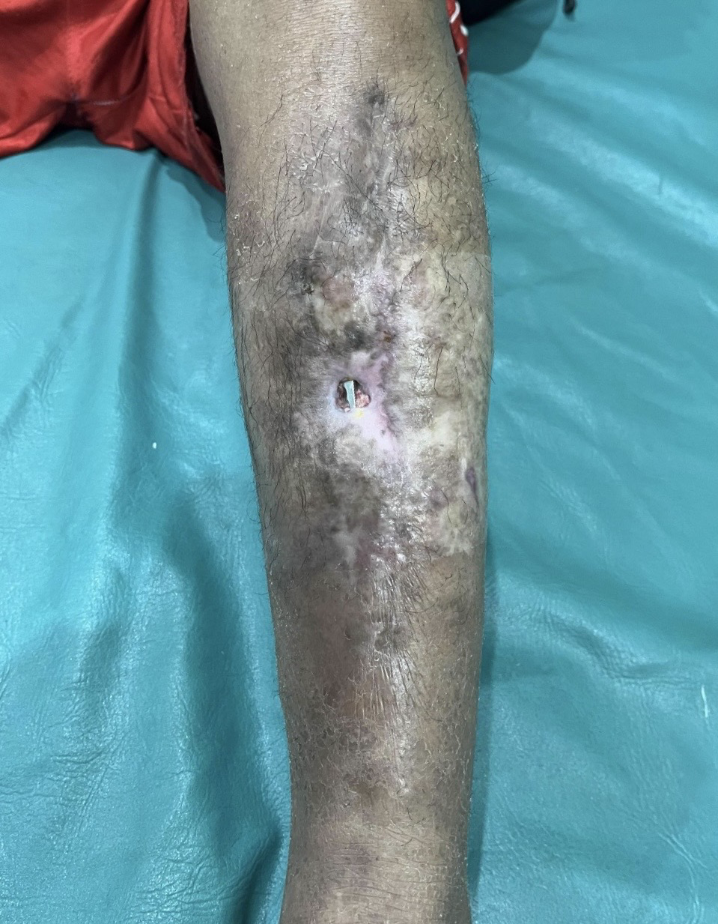 | 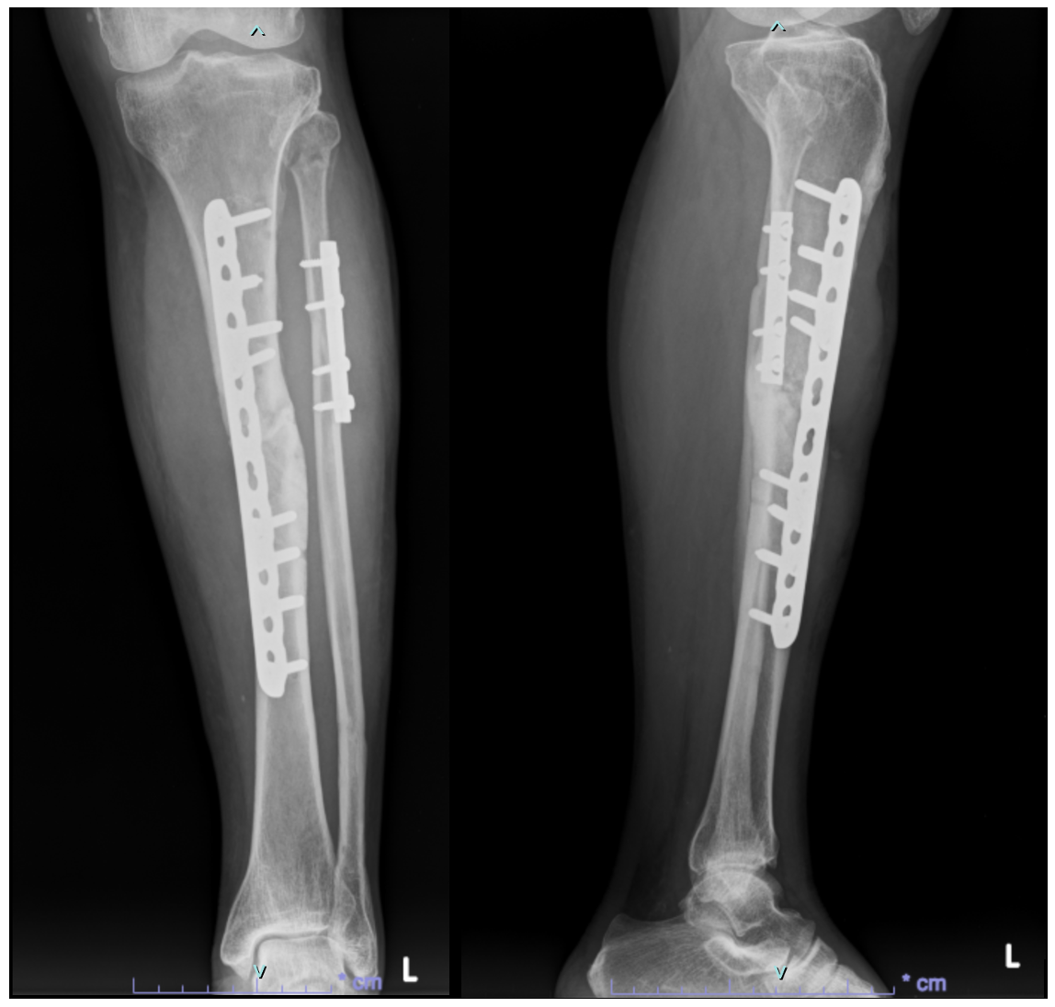
Fig 1. Left tibia implant exposed | Fig 2. Preoperative Xray
During the surgical procedure, the patient was positioned supine, and the procedure was performed under spinal anesthesia. Following the administration of intravenous prophylactic broad-spectrum antibiotics, the existing skin defect was cut out, and the colonized plating system was removed from the middle third of the left tibia.
At the nonunion site, a comprehensive debridement was performed, supplemented by irrigation with a solution of normal saline combined with 80 mg of Gentamycin. To optimize the biological environment, decortication of the bone ends was applied until the "paprika sign" (punctate cortical bleeding) (yellow arrow in Fig 3) was observed, ensuring the removal of sclerotic and avascular tissue. The medullary canal was then addressed via recanalization, establishing an open pathway between the proximal and distal fragments to restore endosteal blood flow. Access to the medullary canal was obtained through a standard infrapatellar approach.
Before nail insertion, to enhance the reproducibility of this single-stage salvage, three specific biological techniques were employed: (1) Autologous Bone Graft Harvesting: After the standard infrapatellar approach was made, an autologous cancellous bone graft was harvested directly from the entry point at the proximal tibia before nail insertion. This avoids secondary donor-site morbidity while providing high-quality osteogenic material. Sequential reaming was then performed in 0.5 mm increments to the final diameter. The canal was irrigated with normal saline to minimize the bacterial load and remove debris. (2) Chipping Osteotomy: Before graft placement, a chipping osteotomy was performed at the proximal and distal margins of the fracture site. Using a small chisel, thin bone chips were created from the cortical surface while ensuring they remained attached to the surrounding soft tissue or periosteum to maintain their blood supply. (3) Graft Placement and the "Biological Chamber": Once the reamed intramedullary nail was secured, the harvested cancellous autograft was packed into the nonunion gap. The previously chipped cortical fragments were then laid over the graft, effectively creating a "biological chamber" that protects the graft and increases the surface area for osteoinductive potential. Finally, primary closure was achieved over the hardware, ensuring tension-free coverage of the anterior tibia.
Definitive intraoperative microbiological cultures and pathogen identification were not performed in this case due to logistical and financial constraints within our resource-limited clinical setting. Consequently, the diagnosis of chronic FRI was established based on clinical criteria, including: a non-healing wound, exposed hardware, and serosanguinous discharge, and elevated inflammatory markers (WBC, ESR, and CRP).
In the absence of culture-specific data, an empirical antibiotic regimen was initiated to cover common pathogens associated with chronic osteomyelitis and FRI, such as Staphylococcus aureus. The patient received intravenous ceftriaxone 1g every 12 hours for 3 days postoperatively, followed by oral cefixime 200mg every 12 hours for one week upon discharge. This regimen was chosen for its broad-spectrum coverage and accessibility in the current clinical setting, with the patient’s clinical response and wound healing serving as the primary indicators for treatment efficacy. Moderate weight-bearing, supervised by a physiotherapist, was allowed the day after surgery, along with active physiotherapy to reestablish ankle and knee mobility until the range of motion was sufficient. Following discharge, the patient was monitored weekly for the first month.
The patient is currently in the early postoperative phase, with a total follow-up duration of 8 weeks (2 months). Clinical evaluation at this stage shows that the surgical wound has healed by primary intention without any signs of recurrent discharge, fluctuance, or sinus tract formation (Fig 4). Although the patient has commenced supervised moderate weight-bearing, radiographic evaluation at 2 months shows a stable hardware position without evidence of failure. Still, radiographic union has not yet been achieved (Fig 5), as expected at this time. Serial laboratory monitoring at the 8-week mark shows a stable white blood cell count. At the same time, the surgical wound appears healthy; the persistence of elevated inflammatory markers (ESR and CRP) at the 8-week mark is a significant concern that necessitates continued clinical vigilance and precludes a definitive claim of infection eradication at this stage.

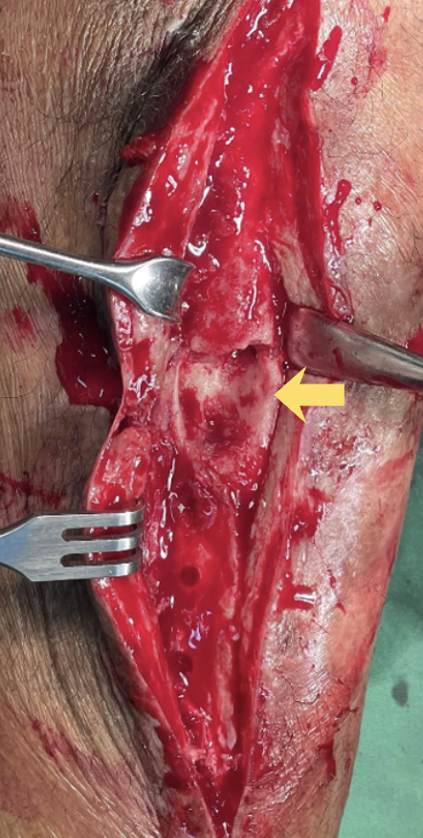 | 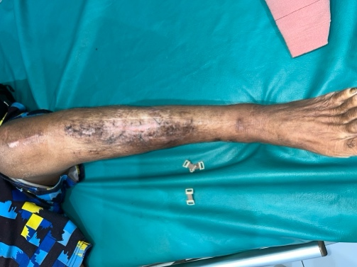 | 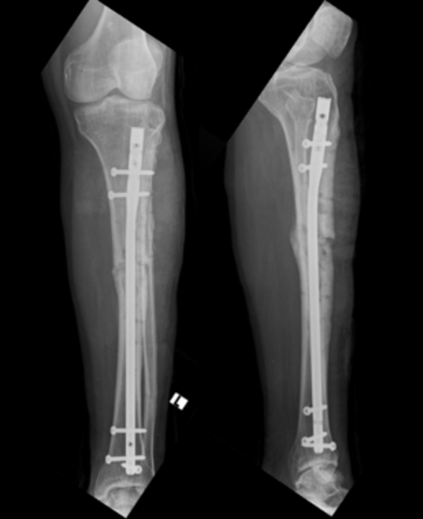
Fig 3. Intraoperative | Fig 4. Healing wound | Fig 5. Postoperative Xray

3. discussion
The extensive surgical history of this patient, involving multiple failed fixation procedures since 2018, underscores the profound difficulty of achieving union within a chronically infected environment. While a two-stage revision (consisting of hardware removal, antibiotic spacer placement, and delayed reconstruction) is traditionally regarded as the gold standard, emerging evidence suggests that a single-stage approach can achieve infection eradication and union rates comparable to those of the two-stage approach [6]. This observation is supported by a comprehensive systematic review by Jonathan S et al. (2025), which found similar mean bone-healing rates (80% for single-stage vs. 77% for two-stage) and infection eradication rates (87% vs. 81%) across 35 studies [7]. Single-stage protocols offer distinct advantages by reducing the total number of surgeries, shortening treatment duration, and lowering healthcare costs, particularly in resource-limited clinical settings. However, it is essential to note that the current literature remains heterogeneous and largely of poor-to-moderate methodological quality [6,7]. Therefore, our observations should be interpreted with caution and viewed as a preliminary illustration of this technique's feasibility in a resource-limited setting.
A key factor in the favorable initial clinical progression of this intervention appeared to be the combination of aggressive mechanical debridement, decortication, and medullary canal recanalization. Sequential reaming prepared the bone for the intramedullary nail and disrupted the endosteal biofilm, which protects bacteria from antibiotics [6,8,9]. Reestablishing canal patency and irrigating with saline and local Gentamicin significantly reduced the bacterial load. Where antibiotic-coated nails are unavailable, thorough mechanical debridement and canalization serve as the primary antimicrobial defense [9].
Beyond infection control, the biological restoration of the nonunion site was addressed through meticulous decortication and a chipping osteotomy [10]. As emphasized by Takahashi et al. (2024), in addition to infection control, biological restoration of the nonunion site was achieved through meticulous decortication and chipping osteotomy [10]. As Takahashi et al. (2024) note, chipping the cortical surface near the fracture creates thin bone fragments attached to the periosteum. This increases the healing surface area and forms a "biological chamber" that enhances osteoinductive potential[10].ive, osteoinductive, and osteogenic [1,4,10]. In a 61-year-old patient with a chronic nonunion, supplying native growth factors and osteoblasts is essential for bridging the defect in a compromised tibial bed.
Mechanically, switching from a load-bearing plate to a load-sharing intramedullary nail follows the "Rittmann Principle," which states that stability is a strong anti-infective measure. Rigid internal stability reduces micromotion at the fracture site, limiting bacterial proliferation [6]. This stability enables earlier mobilization and improved blood supply, both of which are essential for eradicating FRI and achieving cortical bridging [2,3].
The primary limitation of this case report is the short follow-up duration of two months. In contrast, definitive confirmation of infection eradication and radiographic union in complex fri typically requires a minimum of 6 to 12 months. Although aggressive surgical debridement was performed, the currently elevated inflammatory markers indicate that the biological environment is still in the process of stabilization; thus, this report should be viewed as a preliminary evaluation of the surgical technique rather than a definitive long-term success. Furthermore, the lack of intraoperative microbiological cultures and specialized infectious disease consultation meant that antibiotic therapy remained empirical, which may increase the risk of suboptimal infection control or resistance. While we have provided intraoperative photographs and detailed textual descriptions of the chipping osteotomy and bone grafting techniques, the absence of standardized schematic diagrams is a further limitation that we have addressed through comprehensive step-by-step surgical documentation to ensure reader understanding. Nevertheless, in resource-limited environments where advanced diagnostics and antimicrobial hardware are unavailable, this case is presented to illustrate that meticulous mechanical debridement combined with rigid internal stabilization may provide a starting point for clinical healing, though we emphasize that cautious, long-term monitoring is essential to detect any potential recurrence.

4. Conclusion
This case report provides a preliminary illustration of a single-stage protocol involving aggressive mechanical debridement, chipping osteotomy, and autologous grafting as a potentially viable and cost-effective alternative for managing infected tibial nonunions in resource-limited settings. However, given the early nature of the current clinical progression at the 2-month mark, it is essential to acknowledge that these results do not yet confirm long-term success. The persistence of elevated inflammatory markers and the absence of radiographic union at this stage preclude any definitive claims regarding the eradication of permanent infection or bone healing. Therefore, prolonged clinical and radiographic follow-up is mandatory to confirm definitive cortical bridging and to monitor for late infection recurrence. We emphasize that while this approach shows initial promise, its broader efficacy and safety require further validation through larger, high-quality prospective studies.

Consent (WHERever applicable)
All authors declare that written informed consent was obtained from the patient for publication of this case report and accompanying images. A copy of the written consent is available for review by the Editorial office/Chief Editor/Editorial Board members of this journal.

Ethical approval (whereVER APPLICABLE)
All authors hereby declare that all experiments have been examined and approved by the appropriate ethics committee and have therefore been performed in accordance with the ethical standards laid down in the 1964 Declaration of Helsinki

Disclaimer (Artificial intelligence)
The authors used generative AI tools (e.g., language models) to assist with language editing and manuscript text refinement. The authors confirm that all scientific content, interpretation of results, and conclusions were conceived, critically reviewed, and approved by the authors, who take full responsibility for the integrity and accuracy of the work.

References
[1] Akbar DrN, Khader DrFA, RV DrA, Mohan DrP, Kanna DrR, Ram DrD. Management of a case of infected nonunion tibia with IMIL Nail in situ by antibiotic exchange nailing. International Journal of Orthopaedics Sciences 2023;9:80–3. https://doi.org/10.22271/ortho.2023.v9.i4b.3472.
[2] Lourtet-Hascoët J, Bonnet E, Spera AM, Ascione T, Chan M, Esposito S, et al. Fracture-Related Infections: Current Status and Perspectives from the International Society of Antimicrobial Chemotherapy. Antibiotics 2025;14:1–19. https://doi.org/10.3390/antibiotics14111095.
[3] Govaert GAM, Kuehl R, Atkins BL, Trampuz A, Morgenstern M, Obremskey WT, et al. Diagnosing Fracture-Related Infection: Current Concepts and Recommendations. J Orthop Trauma 2020;34:8–17. https://doi.org/10.1097/BOT.0000000000001614.
[4] Cheyrou-Lagreze A, Severyns M, Rongieras F, Germaneau A, Odri GA, Bertani A, et al. Gentamicin-Coated Tibia Nail in Fractures and Nonunion to Reduce Fracture-Related Infections: A Systematic Review. Molecules 2020;18:524–32. https://doi.org/10.1111/os.12653.
[5] Henkelmann R, Frosch KH, Glaab R, Lill H, Schoepp C, Seybold D, et al. Infection following fractures of the proximal tibia - A systematic review of incidence and outcome. BMC Musculoskelet Disord 2017;18:1–8. https://doi.org/10.1186/s12891-017-1847-z.
[6] Jonathan S et al. Single- versus two-stage revision surgery in the case of fracture-related infection: a systematic review 2025:347–61.
[7] Cheyrou-Lagreze A, Severyns M, Rongieras F, Germaneau A, Odri GA, Bertani A. Secondary intramedullary nailing for open tibial shaft fractures. Comparison of a one-stage versus a two-stage surgical procedure. Orthopaedics and Traumatology: Surgery and Research 2022;108. https://doi.org/10.1016/j.otsr.2022.103391.
[8] Li J, Wang Q, Lu Y, Feng Q, He X, Li, MD Z, et al. Relationship Between Time to Surgical Debridement and the Incidence of Infection in Patients with Open Tibial Fractures. Orthop Surg 2020;12:524–32. https://doi.org/10.1111/os.12653.
[9] De Meo D, Cannari FM, Petriello L, Persiani P, Villani C. Gentamicin-Coated Tibia Nail in Fractures and Nonunion to Reduce Fracture-Related Infections: A Systematic Review. Molecules 2020;25. https://doi.org/10.3390/MOLECULES25225471.
[10] Takahashi M, Ito J, Sameshima T, Takagi M, Takakubo Y. Chipping corrective osteotomy and autologous bone graft for malrotation with nonunion of a subtrochanteric femoral fracture: A case report. JOS Case Reports 2024;3:205–8. https://doi.org/10.1016/j.joscr.2024.06.001.
[11] Hameed, M. H., Kakar, A. H., Saqlain, H. A. U., Hussain, S. S., Qureshi, M. A., Keerio, N. H., & Noor, S. S. (2021). Outcomes of Ilizarov Ring Fixator in Infected Nonunion of Tibia. Journal of Pharmaceutical Research International, 33(47A), 724–730. https://doi.org/10.9734/jpri/2021/v33i47A33067
[12] Armbruster, J., Thomas, B., Stengel, D., Spranger, N., Gruetzner, P. A., & Hackl, S. (2025). Managing Nonunions and Fracture-Related Infections—A Quarter Century of Knowledge, and Still Curious: A Narrative Review. Journal of Clinical Medicine, 14(21), 7767. https://doi.org/10.3390/jcm14217767
[13] He, S. Y., Yu, B., & Jiang, N. (2023). Current Concepts of Fracture-Related Infection. International journal of clinical practice, 2023, 4839701. https://doi.org/10.1155/2023/4839701
[14] Baertl, S., Metsemakers, W. J., Morgenstern, M., Alt, V., Richards, R. G., Moriarty, T. F., & Young, K. (2021). Fracture-related infection. Bone & joint research, 10(6), 351–353. https://doi.org/10.1302/2046-3758.106.BJR-2021-0167.R1
[15] Vicenti, G., Buono, C., Albano, F., Ladogana, T., Pesare, E., Colasuonno, G., Passarelli, A. C., & Solarino, G. (2024). Early Management for Fracture-Related Infection: A Literature Review. Healthcare, 12(13), 1306. https://doi.org/10.3390/healthcare12131306

