Case Report

Single-Stage Reamed Intramedullary Nailing for the Management of Infected Tibial Nonunion: A Case Report

.
ABSTRACT

Background: Complex cases are now recognised within the standardised diagnostic framework for Fracture-related Infection (FRI), which often leads to prolonged morbidity and reduced quality of life for patients. Managing infected tibial nonunions is among the most challenging issues in orthopaedic surgery. Aim: To present a successful single-stage salvage strategy for a chronically infected tibial nonunion using aggressive mechanical debridement, sequential reaming, and autologous bone grafting in a resource-limited clinical setting.
Presentation of Case: A 61-year-old male presented with a non-healing wound, exposed hardware, and serosanguinous discharge on his left middle tibia, following a complex surgical history since 2018, including multiple ORIFs and external fixation. Clinical examination and laboratory tests (elevated WBC, ESR, and CRP) confirmed a chronic, low-grade Fracture-Related Infection (FRI). The patient underwent a single-stage procedure involving removal of the colonised plate, aggressive debridement until the "paprika sign" was observed, and sequential intramedullary reaming. Stability was achieved using a reamed intramedullary nail, supplemented by an autologous cancellous bone graft harvested from the proximal tibia and a chipping osteotomy to create a "biological chamber" for healing.
Discussion: While two-stage revisions are often considered the standard for FRI, this case demonstrates that a single-stage approach can be effective by combining rigid internal stability with thorough biological restoration. The transition from load-bearing plating to load-sharing intramedullary nailing follows the Rittmann Principle, where stability serves as a potent anti-infective measure. Aggressive debridement and sequential reaming were critical in disrupting the bacterial biofilm, while the chipping osteotomy and autograft provided the necessary osteoinductive and osteogenic environment for bridging the nonunion.
Conclusion: A single-stage protocol involving aggressive debridement, reamed intramedullary nailing, and chipping osteotomy is a viable and cost-effective strategy for managing infected tibial nonunions, particularly when advanced antimicrobial hardware is unavailable. Further follow-up is recommended to assess postoperative outcomes.

Keywords: Non-union, FRI, Intramedullary Nailing, Surgical Management

1. INTRODUCTION
Managing infected tibial nonunions is among the most challenging issues in orthopaedic surgery. Non-union is the most frequent complication of the tibia as compared to other body bones. Other coexisting problems also contribute to complications related to nonunion of the fracture [11, 12]. Contributing factors include open fractures, loss of muscle or bone tissue, post-fixation infections, persistent osteomyelitis with pathological fractures, and surgical removal of infected bone [1]. These complex cases are now recognised within the standardised diagnostic framework for Fracture-related Infection (FRI), which often leads to prolonged morbidity and reduced quality of life for patients [2,3]. FRI often refers to infection following fractures or during the treatment process for fractures [13,14]. The overall FRI rate is about 5%, ranging from 1 to 2% after internal fixation of closed fractures to over 30% after open fracture fixation [2]. The tibia is especially susceptible to FRI due to its limited soft tissue coverage and blood supply. Nonunion occurs in about 12% of all tibia fractures, rising to 23% in open fractures [4]. Management is further complicated by bacterial biofilms on hardware, which protect pathogens from antibiotics and immune responses [4,5,15].
A single-stage approach removes infected hardware, performs thorough debridement, and implants new hardware in one surgical session. This method can reduce the number of surgeries, shorten treatment duration, and lower healthcare costs [6]. In contrast, a two-stage revision is preferred for patients with sepsis, severe soft-tissue damage, or when multidisciplinary support is unavailable. This allows time for systemic and local antibiotics before final fixation[3,6].
This case report presents a single-stage salvage of a chronic, previously operated, infected tibial nonunion in a 61-year-old male, using aggressive debridement, intramedullary reaming, and autologous bone grafting from the proximal tibia.

2. CASE REPORT
A 61-year-old male presents with a chronic non-healing wound and exposed hardware on the anterior aspect of the left middle tibia. The patient’s surgical history is extensive, beginning in 2018 with Open Reduction Internal Fixation (ORIF) for a tibia-fibula fracture. Six months post-operatively, the patient developed chronic osteomyelitis, requiring hardware removal and conversion to an external fixator on the left tibia for infection control. In 2021, following a period of perceived infection clearance, the external fixator was removed, and the patient underwent repeat ORIF on the left tibia for definitive stabilization. However, the patient now presents with a breakdown of the soft tissue envelope and direct exposure of the left tibia implant.
Physical examination (Fig.1) revealed a 2x1.5 cm skin defect over the middle third of the left tibia with visible metallic implant. Serosanguinous discharge was present, but there was no purulence, fluctuance, or cellulitis. Distal pulses were palpable and sensation was intact. Laboratory tests showed mild leukocytosis (WBC: 12.53 × 10^3/μL) and elevated inflammatory markers (ESR: 35 mm/hr; CRP: 17 mg/L), consistent with a chronic, low-grade infection-related nonunion.
Anteroposterior and lateral radiographs of the left cruris revealed (Fig.2) a plate and screw internal fixation construct in situ on the middle third of the tibial shaft, with a fracture line visible at the middle third of the tibia, despite the presence of localized callus formation, indicating an infected nonunion. There is a completely healed (union) fracture of the proximal third of the left fibula.

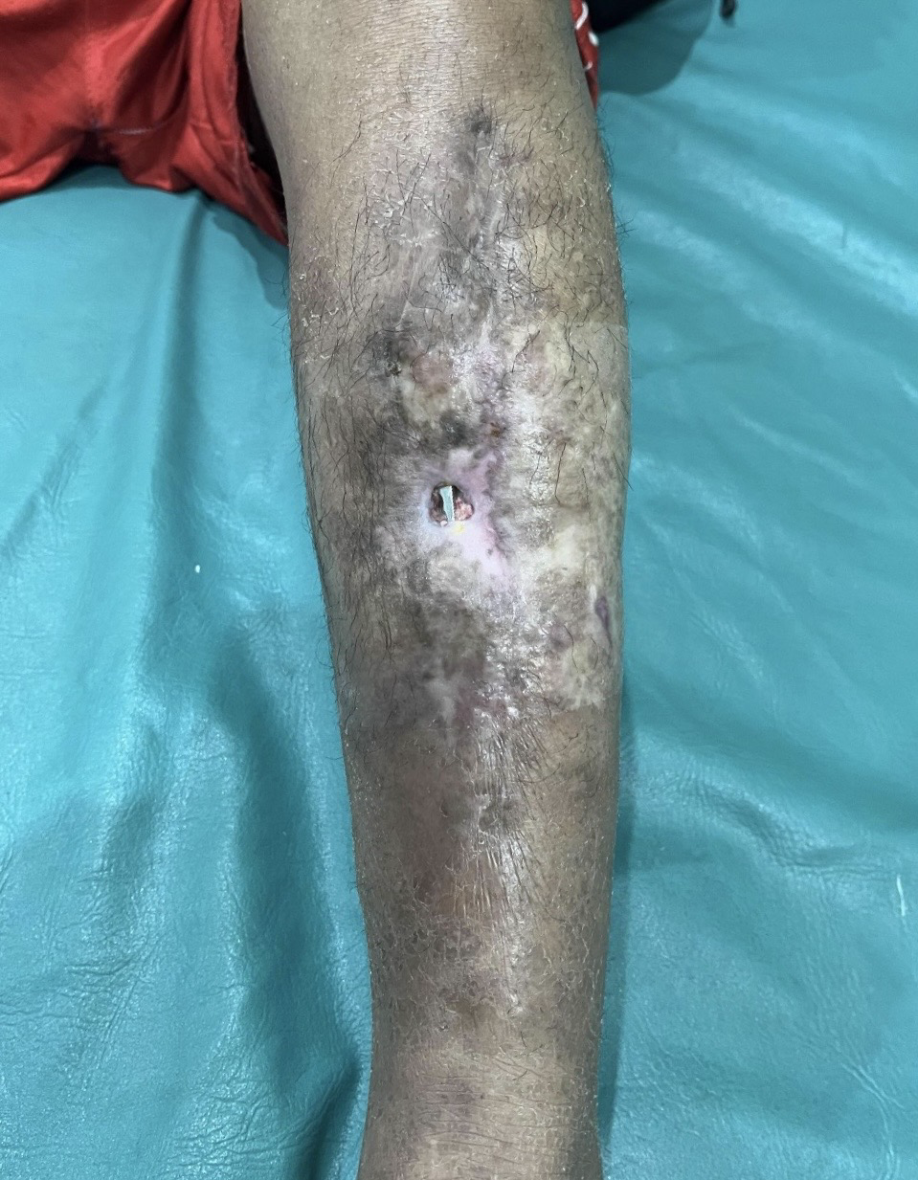 | 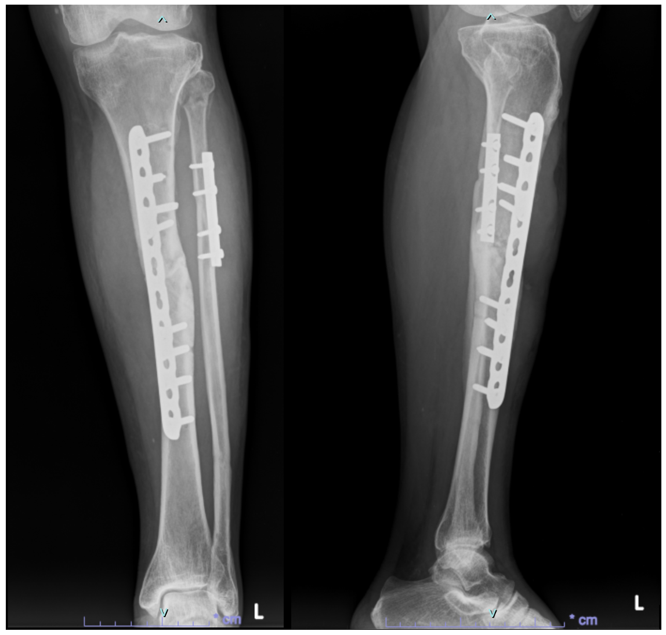
Fig 1. Left tibia implant exposed | Fig 2. Preoperative Xray
During the surgical procedure, the patient was positioned supine, and the procedure was performed under spinal anesthesia. Following the administration of intravenous prophylactic broad-spectrum antibiotics, the existing skin defect was cut out, and the colonized plating system was removed from the middle third of the left tibia.
At the non-union site, a comprehensive debridement was performed, supplemented by irrigation with a solution of normal saline combined with 80 mg of Gentamycin. To optimize the biological environment, decortication of the bone ends was applied until the "paprika sign" (punctate cortical bleeding) was observed, ensuring the removal of sclerotic and avascular tissue. The medullary canal was then addressed via recanalization, establishing an open pathway between the proximal and distal fragments to restore endosteal blood flow. Access to the medullary canal was obtained through a standard infrapatellar approach. Before nail insertion, an autologous cancellous bone graft was harvested directly from the entry point at the proximal tibia. Sequential reaming was then performed in 0.5 mm increments to the final diameter. The canal was irrigated with normal saline to minimize the bacterial load and remove debris.
Chipping osteotomy was performed at the proximal and distal margins of the fracture site before applying the bone graft. This technique involves using a chisel to create small, thin bone chips from the cortical surface while maintaining their attachment to the surrounding soft tissue or periosteum. After the reamed intramedullary nail was applied, the harvested autograft was then packed into the non-union site, protected by the chipped cortical fragments. Finally, primary closure was achieved over the hardware, ensuring tension-free coverage of the anterior tibia.

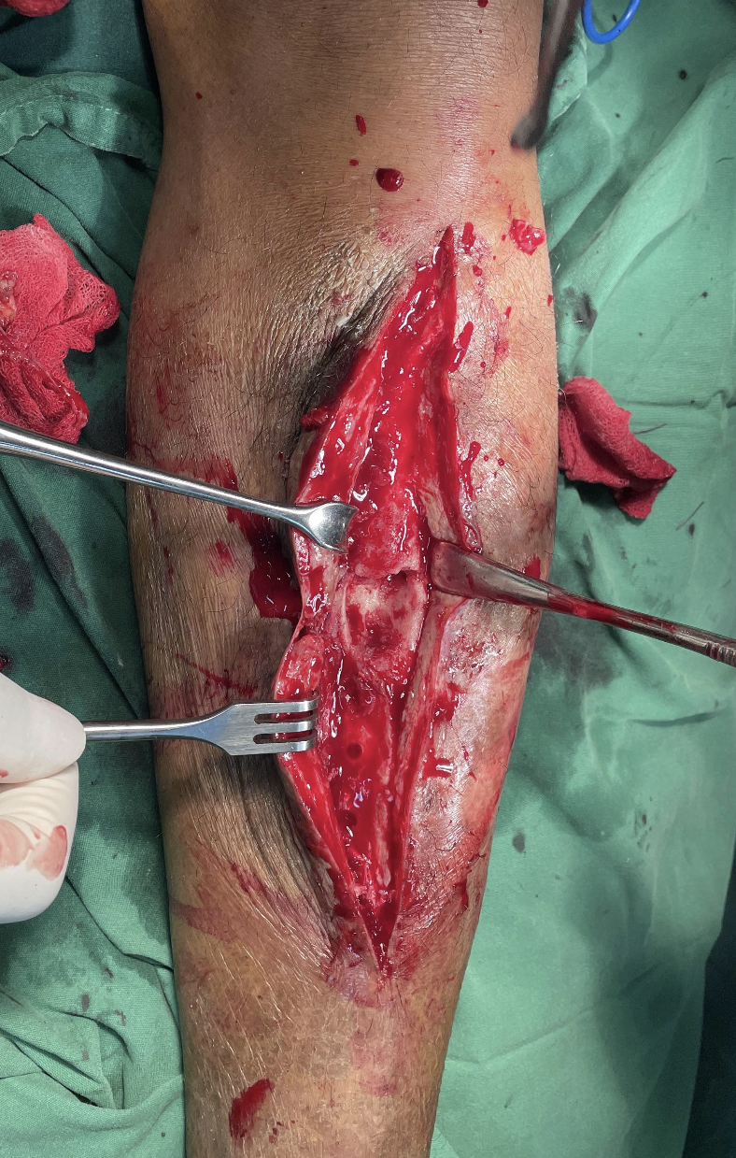 | 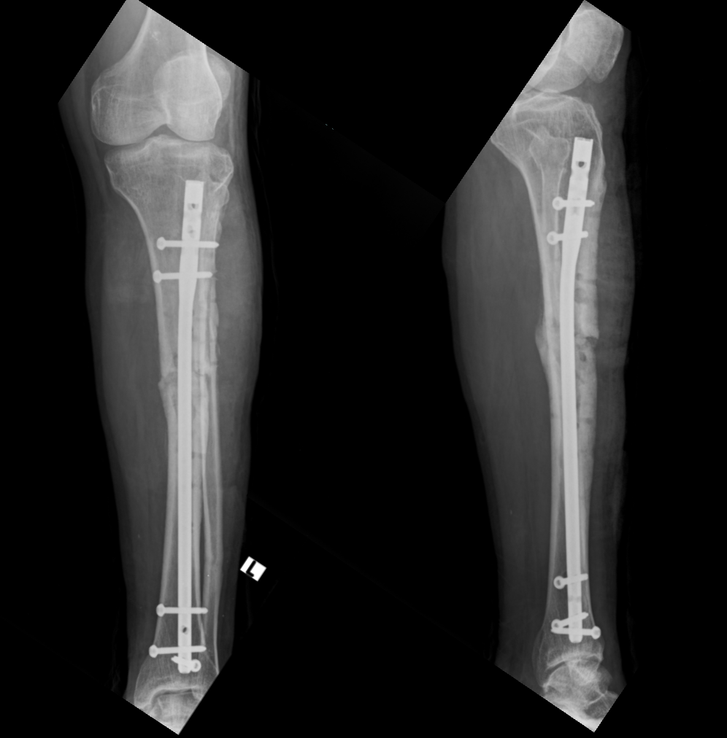 | 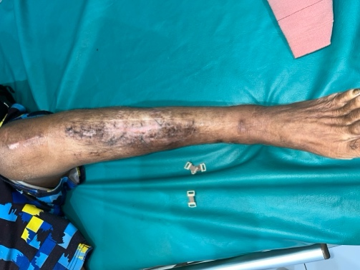
Fig 3. Intraoperative | Fig 4. Postoperative Xray | Fig 5. Healing wound

Following surgical care, the patient received intravenous ceftriaxone 1 g every 12 hours as an empirical antibiotic for 3 days, while the wound was examined every day. After hospital discharge, 200mg of cefixime was given orally every 12 hours for a week. Moderate weight-bearing, supervised by a physiotherapist, was allowed the day after surgery, along with active physiotherapy to reestablish ankle and knee mobility until the range of motion was sufficient. Following discharge, the patient was monitored weekly for the first month.

3. discussion
This patient’s repeated fixation procedures highlight the challenge of achieving union in a chronically infected environment. Traditionally, a two-stage procedure is the gold standard, involving hardware removal, antibiotic spacer placement, and delayed reconstruction. However, recent evidence shows that single-stage revision can achieve similar infection eradication and union rates [7]. Single-stage protocols reduce the number of surgeries, shorten treatment duration, and lower healthcare costs, which is especially important in resource-limited settings[6].
A key factor in the success of this single-stage intervention was aggressive mechanical debridement, decortication, and medullary canal recanalization. Sequential reaming prepared the bone for the intramedullary nail and disrupted the endosteal biofilm, which protects bacteria from antibiotics [6,8,9]. Reestablishing canal patency and irrigating with saline and local Gentamicin significantly reduced the bacterial load. Where antibiotic-coated nails are unavailable, thorough mechanical debridement and canalization serve as the main antimicrobial defense[9].
Beyond infection control, the biological restoration of the non-union site was addressed through meticulous decortication and a chipping osteotomy [10]. As emphasized by Takahashi et al. (2024), chiIn addition to infection control, biological restoration of the nonunion site was achieved through meticulous decortication and chipping osteotomy [10]. As Takahashi et al. (2024) note, chipping the cortical surface near the fracture creates thin bone fragments attached to the periosteum. This increases the healing surface area and forms a "biological chamber" that enhances osteoinductive potential[10].ive, osteoinductive, and osteogenic [1,4,10]. In a 61-year-old patient with a chronic non-union, supplying native growth factors and osteoblasts is essential for bridging the defect in a compromised tibial bed.
Mechanically, switching from a load-bearing plate to a load-sharing intramedullary nail follows the "Rittmann Principle," which states that stability is a strong anti-infective measure. Rigid internal stability reduces micromotion at the fracture site, limiting bacterial proliferation [6]. This stability enables earlier mobilization and improved blood supply, both essential for eradicating FRI and achieving cortical bridging[2,3].

4. Conclusion
This case demonstrates that a single-stage protocol with aggressive mechanical debridement, chipping osteotomy, and autologous grafting is a viable strategy for chronic infected tibial nonunion, especially where advanced antimicrobial technology is limited. Chipping osteotomy may be effective in infected nonunion fractures. Further follow-up is needed to assess postoperative outcomes.

Consent (where ever applicable)
All authors declare that written informed consent was obtained from the patient for publication of this case report and accompanying images. A copy of the written consent is available for review by the Editorial office/Chief Editor/Editorial Board members of this journal.

Ethical approval (where ever applicable)
All authors hereby declare that all experiments have been examined and approved by the appropriate ethics committee and have therefore been performed in accordance with the ethical standards laid down in the 1964 Declaration of Helsinki

Disclaimer (Artificial intelligence)
Author(s) hereby declare that NO generative AI technologies such as Large Language Models (ChatGPT, COPILOT, etc.) and text-to-image generators have been used during the writing or editing of this manuscript.

References
[1] Akbar DrN, Khader DrFA, RV DrA, Mohan DrP, Kanna DrR, Ram DrD. Management of a case of infected non-union tibia with IMIL Nail in-situ by antibiotic exchange nailing. International Journal of Orthopaedics Sciences 2023;9:80–3. https://doi.org/10.22271/ortho.2023.v9.i4b.3472.
[2] Lourtet-Hascoët J, Bonnet E, Spera AM, Ascione T, Chan M, Esposito S, et al. Fracture-Related Infections: Current Status and Perspectives from the International Society of Antimicrobial Chemotherapy. Antibiotics 2025;14:1–19. https://doi.org/10.3390/antibiotics14111095.
[3] Govaert GAM, Kuehl R, Atkins BL, Trampuz A, Morgenstern M, Obremskey WT, et al. Diagnosing Fracture-Related Infection: Current Concepts and Recommendations. J Orthop Trauma 2020;34:8–17. https://doi.org/10.1097/BOT.0000000000001614.
[4] Cheyrou-Lagreze A, Severyns M, Rongieras F, Germaneau A, Odri GA, Bertani A, et al. Gentamicin-Coated Tibia Nail in Fractures and Nonunion to Reduce Fracture-Related Infections: A Systematic Review. Molecules 2020;18:524–32. https://doi.org/10.1111/os.12653.
[5] Henkelmann R, Frosch KH, Glaab R, Lill H, Schoepp C, Seybold D, et al. Infection following fractures of the proximal tibia - A systematic review of incidence and outcome. BMC Musculoskelet Disord 2017;18:1–8. https://doi.org/10.1186/s12891-017-1847-z.
[6] Jonathan S et al. Single- versus two-stage revision surgery in the case of fracture-related infection: a systematic review 2025:347–61.
[7] Cheyrou-Lagreze A, Severyns M, Rongieras F, Germaneau A, Odri GA, Bertani A. Secondary intramedullary nailing for open tibial shaft fractures. Comparison of a one-stage versus two-stage surgical procedure. Orthopaedics and Traumatology: Surgery and Research 2022;108. https://doi.org/10.1016/j.otsr.2022.103391.
[8] Li J, Wang Q, Lu Y, Feng Q, He X, Li, MD Z, et al. Relationship Between Time to Surgical Debridement and the Incidence of Infection in Patients with Open Tibial Fractures. Orthop Surg 2020;12:524–32. https://doi.org/10.1111/os.12653.
[9] De Meo D, Cannari FM, Petriello L, Persiani P, Villani C. Gentamicin-Coated Tibia Nail in Fractures and Nonunion to Reduce Fracture-Related Infections: A Systematic Review. Molecules 2020;25. https://doi.org/10.3390/MOLECULES25225471.
[10] Takahashi M, Ito J, Sameshima T, Takagi M, Takakubo Y. Chipping corrective osteotomy and autologous bone graft for malrotation with nonunion of a subtrochanteric femoral fracture: A case report. JOS Case Reports 2024;3:205–8. https://doi.org/10.1016/j.joscr.2024.06.001.
[11] Hameed, M. H., Kakar, A. H., Saqlain, H. A. U., Hussain, S. S., Qureshi, M. A., Keerio, N. H., & Noor, S. S. (2021). Outcomes of Ilizarov Ring Fixator in Infected Nonunion of Tibia. Journal of Pharmaceutical Research International, 33(47A), 724–730. https://doi.org/10.9734/jpri/2021/v33i47A33067
[12] Armbruster, J., Thomas, B., Stengel, D., Spranger, N., Gruetzner, P. A., & Hackl, S. (2025). Managing Nonunions and Fracture-Related Infections—A Quarter Century of Knowledge, and Still Curious: A Narrative Review. Journal of Clinical Medicine, 14(21), 7767. https://doi.org/10.3390/jcm14217767
[13] He, S. Y., Yu, B., & Jiang, N. (2023). Current Concepts of Fracture-Related Infection. International journal of clinical practice, 2023, 4839701. https://doi.org/10.1155/2023/4839701
[14] Baertl, S., Metsemakers, W. J., Morgenstern, M., Alt, V., Richards, R. G., Moriarty, T. F., & Young, K. (2021). Fracture-related infection. Bone & joint research, 10(6), 351–353. https://doi.org/10.1302/2046-3758.106.BJR-2021-0167.R1
[15] Vicenti, G., Buono, C., Albano, F., Ladogana, T., Pesare, E., Colasuonno, G., Passarelli, A. C., & Solarino, G. (2024). Early Management for Fracture-Related Infection: A Literature Review. Healthcare, 12(13), 1306. https://doi.org/10.3390/healthcare12131306

