Original Research Article

EYELID ECZEMA CAN BE A SIGN OF OCULAR DEMODICOSIS

ABSTRACT
Aims:There are different types of eyelid eczema, and, though the symptoms often look similar, they have varying causes.We aimed to investigate the frequency of ocular Demodex infestation in patients with eyelid eczema without signs of blepharitis.
Methodology: Patients diagnosed with eyelid eczema were enrolled in the study from April 2024 to December2024. An age and gender matched control group was formed from healthy volunteers. Each patient underwent a complete eye exam, and had two lashes from each eye epilated; eyelashes were directly examined under a light microscope.
Results: A total of 58 patients with eyelid eczema and 46 healty controls were enrolled the study. Demographics were similar between groups. Demodex infestation was observed more frequently among patients with eyelid eczema than among controls (31% in the eczema group, 13% in the control group, p-value=0.03). The participants with Demodex infestation were 3 times more likely to have eyelid eczema than the controls
Conclusion: When evaluating eyelid eczema, Demodex infestation should not be overlooked.
Keywords: Demodex, eczema, periorbital dermatitis, ocular demodicosis, blepharitis.

Introduction
Skin on the eyelids is thinner than what’s on the rest of our body, which makes it more prone to irritation with the greatest environmental and cosmetic exposure. Inflammation in this area is known as eyelid dermatitis/eczema. Dermatitis and eczema are general terms to describe irritation of the epidermis, the outermost layer of skin.
The eyelids are susceptible to dermatitis owing to their very thin skin (0.55 mm compared to other facial areas that are about 2.0 mm thick), which allows for easier penetration of both contact and airborne allergens. Therefore, although an allergen may come in contact with other body areas, the eyelids alone may manifest a reaction (Ayala F, 2003).¹
Eyelid eczema is charecterized by inflammation of the skin of the eyelids.Patients present with scaly, erythematous and edematous eyelids, often with wrinkled, crepey skin changes. They complain of redness, itching and burning of their eyelids.
Eczema or dermatitis of the eyelids is a chronic condition characterized by periods of remission and exacerbation. If left untreated, it can result in long-term architectural changesand induration or thickening of the eyelids and unwanted skin changes (Feser A, 2008).² The diagnosis of eyelid eczema is made by reviewing the patient’s medical history and examining the patient’s eyes, and the skin of eyelids with a biomicroscope.
Distinguishing the cause of pruritic and inflamed eyelid skin may be challenging, and choosing the appropriate therapy will be as well.
There are different types of eyelid eczema, and, though the symptoms often look similar, they have varying causes.It may be a manifestation of endogenic diseases (eg, atopic dermatitis, seborrheic dermatitis) or the result of external exposure.
Demodex mites are saprophytic ectoparazites;Demodex folliculorum and Demodex brevis, are found on human skin, preferably in the facial skin and eyelids. Although D folliculorum resides mainly in the hair follicles, D brevisprincipally found in the sebaceous glands. Generally accepted opinion is that mites may be normal ocular surface fauna (commensalism with humans) that can turn pathogenic under overpopulation conditions related to an altered microenvironment (Cheng AM, 2015).³
An abnormal increase in the density of Demodex mites can cause several skin disorders grouped under the term demodicosis such as pityriasis folliculorum, perioral dermatitis, pustular folliculitis, seborrheic dermatitis, blepharitis, and rosacea (Huang W, 2024 and Paichitrojjana A, 2024).^{4,5}
Demodex infestation can cause both anterior and posterior blepharitis, dry eye, hordeolum and can even mimic sebaceous gland carcinoma (Sharma N, 2023).⁶
Blepharitis is a condition of eyelid inflammation and common in ophthalmology clinics. De Venecia et al. (2011) reported the prevalence of Demodex mites in blepharitis was 73% in their study.⁷
Demodex mites in the eyelash follicles may lead to epithelial hyperplasia, hyperkeratosis, and follicular widening by obstructing follicular ostia and sebaceous ducts. Inflammatory foreign body reaction caused by the Demodex mites and its metabolites also plays an important role in the pathogenesis of the ocular involvement (Sharma N, 2023).⁶ Demodex mites are also found in the pilosebaceous unit, causing inflammation and leading to immune reactions (Karincaoglu Y, 2009).⁸
In this study,we aimed to investigate the frequency of ocular demodex infestation in patients with eyelid eczema without signs of blepharitis.
Material and methods
A case-control study was reviewed and approved by the local ethics committee and all participants gave written informed consent. The study was carried out according to the principles expressed in the Declaration of Helsinki.
Patients diagnosed with eyelid eczema at our clinic between April and December 2024 were enrolled in this study. Diagnosis of the disease was made after a detailed anamnesis and ocular examination. Patients without clinically significant signs of blepharitis (such as crusting, lash debris, hyperemia of eyelid margin) included in the study. Eyelid eczema was diagnosed when patients had itchy, red, edematous and scaly eyelid skin (Figure 1).The patients who did not have any known dermatological, systemic, and ocular diseases were included in the control group.
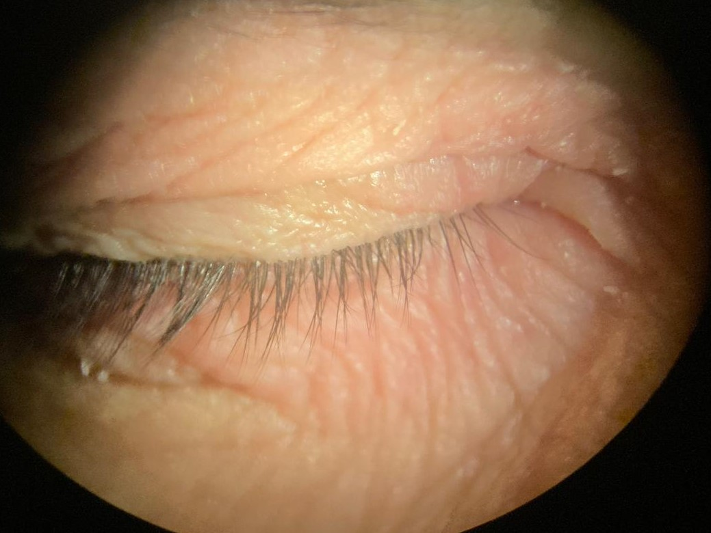
Figure 1. A patient’s picture taken by biomicroscope showing erythematous, edematous and scaly lesions on the upper and lower eyelids.
The patients’history of atopy,(defined as a personal or family history of eczema, asthma, or hay fever) was investigated, and those with a negative atopy history were included in the study.
Detailed ocular examinations of all subjects were performed by the same ophthalmologist with biomicroscopy. Two random eyelashes from each eye were epilated using forceps. The eyelashes were placed on the slide and then examined in the light microscopy with ×40 and ×100 objectives by using glycerin. When one or more Demodex mites were observed in the microscopic examination, the result was recorded as positive (Figure 2).
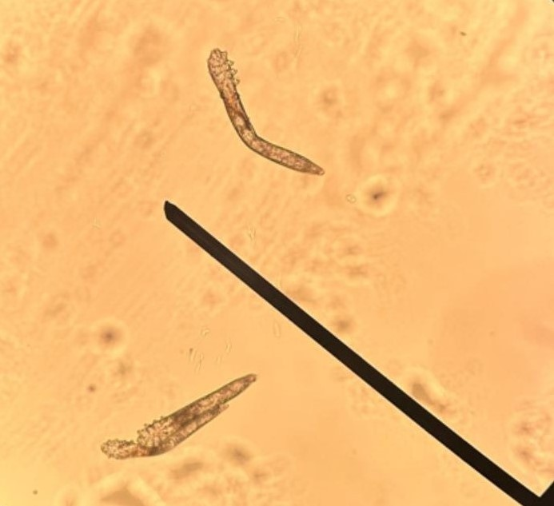
Figure 2. Demodex mites under light microscope.
Statistical analyses were performed using the SPSS software version 15. Presence of demodex and other categorical variables (sex, age groups) were compared between eyelid eczema and control groups by Chi-square test, and p value of <.05 was considered for statistical significance.We calculated odds ratios for the presence of demodex in each group and we compared them.
Results
A total of 104 individuals were included in the study: 46 healthy participants were enrolled in the control group, and 58 patients with eyelid eczema were enrolled in the eyelid eczema group. The mean age was 49.44 ±13.85 in eyelid eczema group (49 women, 9 men). The mean age was 49.43 ±12.83 in control group (39 women, 7men).
Age groups and sex of patients were not different between the eyelid eczema and control groups (Table 1).

Table 1. Comparison of sex and age groups between the patients with eyelid eczema and controls.
Variables |  | Groups |  | Pª
 |  | Eczema  N (%) | Control  N (%) | Pª
Sex | women | 49 (84.5) | 39 (84.8) | 0.96
 | men | 9 (15.5) | 7 (15.2) | 0.96
Age groups | 21-30 | 5 (8.6) | 3 (6.5) | 0.98
 | 3140 | 10 (17.2) | 8 (17.4) | 0.98
 | 41-50 | 14 (24.1) | 12 (26.1) | 0.98
 | 51-60 | 11 (19.0) | 8 (17.4) | 0.98
 | 61-70 | 14 (24.1) | 13 (28.3) | 0.98
 | 71-80 | 4 (6.9) | 2 (4.3) | 0.98

ª Chi-square test.

Eighteen out of fiftyeight patients in the eyelid eczema group (31%; with 95% confidence interval between 20 % and 42 %) were found to be infested with Demodex. And 6 out of 46 of the controls (13%; with 95% confidence interval between 4% and 22 %) were found to have Demodex infestation.
When we compared the eyelid eczema and the control group by ocular demodicosis, we found a significant difference (Chi-square; p=0.03) between the groups (Table 2).

Table 2. Comparison of eyelid eczema and control groups by the presence of demodex.

Groups | Demodex |  | Pª
Groups | Absent  N (%) | Present  N (%) | Pª
Eyelid Eczema | 40 (69) | 18 (31) | 0.03*
Control | 40 (87) | 6 (13) | 0.03*

*statistically significant difference
ª Chi-square test

Odds of the presence of demodex among the eyelid eczema group was 0.45; and odds of the presence of demodex within the control group was 0.15. Therefore the odds ratio of the presence of demodex between the eyelid eczema and control groups was 3.0, which means that the presence of oculardemodicosis was three times higher in the eyelid eczema group than in the control group.
We showed the difference between groups by a pie graph in Figure 3.

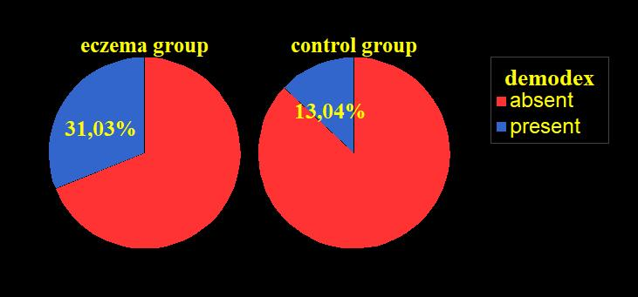
Figure 3. Pie graph of the presence of demodex between eyelid eczema and control groups.
Discussion
Our aim in this study was to determine the frequency of ocular demodicosis in the eyelid eczema patients and to draw the attention of the clinicians on the subject.
To the best of our knowledge, this is the the first study to investigate ocular demodicosis and eyelid eczema together.
Eyelid eczemas are clinically and therapeutically clearly delineated entity with different causes.The eyelid eczema can cause substantial suffering because of the disturbing symptoms and high aesthetic significance of this region. The tendency to recur, and resistance to therapy they pose a considerable diagnostic and therapeutic challenge to dermatologists and ophthalmologists. Patients with eyelid eczema oftenundergoes repeated therapies with topical corticosteroids, which tend to fail to achieve lasting improvement and can also involve steroid-induced side effects such as skin atrophy and telangiectasias (Murrell DF,2007).⁹
Generally distinguishing the cause of itching, red, edematous eyelids is often difficult eyelid eczema.
The most commonly reported cause of periocular eczema is contact allergy at 54 % (44 % due to direct contact; 10.2 % due to airborne contact dermatitis). Other causes of eczematoid periocular skin lesions include atopic dermatitis (25 %), irritant contact dermatitis (9.1 %), and secondary eczematous skin lesions such as periorbital rosacea (4.5 %), and allergic conjunctivitis (2.1 % ) (Feser A, 2008).²
Epidemiological studies on periocular dermatitisreported a significantly higher prevalence of periocular dermatitis among women (80.3% -84.9%).Age (≥40 years) has also been identified as a risk factor in periocular dermatitis(Feser A, 2008).²
Similary, in our study, 84.5 % of eyelid eczema patients were female, and 74.1% were 40 years old or older, which is consistent with findings in the literature.
High proportion of eyelid eczema patients aged 40 years or older may reflect age-dependent variations in stratum corneum thickness and hydration in the eyelid area (Gao YY, 2005).¹⁰
Ocular demodicosis, the infestation of eyelids by demodex mites, is often overlooked in clinical practice. The minimal number of demodex mites required to develop ocular demodicosis is not known either. Demodex mites are commonly found on the eyelids of asymptomatic older adults. Demodex colonization among otherwise healthy individuals has been widely reported. Our 31% colonization rate in eczema group and 13% colonization in control group were correlated with those from some other studies, such as the study by Gao et al, who observed Demodex infestation in 22% of patients with clean eyelashes.¹⁰The prevalence of Demodex of eyelid infestation varies greatly among studies and populations, ranging from 4% to 47% (Borzova E, 2024).¹¹
Presentations of ocular demodicosis include blepharitis, eyelash abnormalities (e.g. trichiasis), meibomian gland dysfunction, and recurrent chalazion formation, all of which are common ocular disorders (Luo X, 2017).¹²No significant correlation between Demodex mite count and the severity of ocular symptoms has been reported (Wesolowska M, 2014).¹³
Demodex mites penetrate into skin cells (particularly the keratinocytes that line pilosebaceous follicles) and ingest their contents. Demodex mites feed on the sebum and cellular proteins that are obtained by protease and lipase enzymes of the mites. The enzymatic process leads to degradation of the follicular epithelium, which may result in perifollicular inflammation. Although Demodex mites life-cycle are not fully understood, Demodex mites may spread throughout adjacent skin areas especially at night-time.
Demodex mites may also cause mechanical blockage of the follicle opening. Moreover, it is thought that extrafollicular mites may induce a granulomatous foreign body reaction through their chitinous exoskeleton. Dying mites are thought to trigger a delayed hypersensitivity reaction in the host by releasing their waste products and the chitinous exoskeletons ( Sharma N, 2023 and Akçınar UG, 2018).^{6,14}Demodex mites are also shown to affect the secretion of inflammatory cytokines, such as IL-8 and TNF-alpha (Koller B, 2011 and Taylor RC, 2006).^{15,16}
The reactivation of the immune system, inflammation and follicular changes caused by the Demodex mites might contribute in the development of the diseases such as eyelid eczema. This condition can be considered as a type of protein contact dermatitis.
Protein contact dermatitis (= IgE-mediated contact dermatitis) is an allergic skin reaction induced by plant or animal proteins. The reaction occurs with a delay after contact with the responsible protein. The clinical appearance is chronic dermatitis, the pathogenesis of which is attributed to IgE-mediated activation and allergen presentation of Langerhans cells and infiltration by T lymphocytes (Levin C, 2008).¹⁷
Demodicosis can present in various ways and may be mistaken for other skin conditions. The appearance of the symptoms can range from non-specific facial dermatitis to more severe manifestations, depending on personal genetics, immunity, and the density of mites.In many cases, it may only present as nonspecific facial dermatitis, leading to underdiagnosis or misdiagnosis. This is why demodicosis has a lower incidence than it should be despite many people being infested with Demodex mites (Paichitrojjana A, 2022 and Zhao YE, 2012).^{18,19}
In contrast to previous studies that found blepharitis to be highly associated with eyelash demodicosis, Udomwech et al, (2021) found various suggestive signs: eyelid erythema and eyelid telangiectasia. Their results showed that eyelid signs, including lid erythema (Demodex 28%, no Demodex 8%, p = 0.003), lid telangiectasia (Demodex 34%, no Demodex 6.67%, p < 0.001), were significantly associated with eyelash demodicosis.²⁰
In contrast to previous studies that found only blepharitis to be highly associated with eyelash demodicosis, we found different suggestive signs: red, edematous and scaly eyelid skin (eyelid eczema/dermatitis) without clinical signs of blepharitis. Approximately one-third (31%) of the studied population had mite colonization.In control group 13% of subjects hadasymptomatic mite colonization. Demodex infestation should therefore always be on the list of possible etiologies when treating patients with eyelid eczema.
Treatments for ocular demodicosis are targeted at the eradication of Demodex mites as well as the reduction of ocular symptoms. There is, at present, a lack of standardized therapeutic guidelines for ocular demodicosis. Tea tree oil or terpinen-4-ol was effective for mite eradication and symptom reduction (Navel V, 2019).²¹
Conclusion
About one-third (31 %) of the eyelid eczema group had ocular demodicosis in our study. Demodex infestation should therefore always be on the list of possible etiologies when treating patients with eyelid eczema or periorbital dermatitis. These results should be supported by future studies with larger sample sizes.

CONSENT
All participants gave written informed consent.
ETHICAL APPROVAL
The study was carried out according to the principles expressed in the Declaration of Helsinki, and approved by the local ethics committee.
REFERENCES
- Ayala F, Fabbrocini G, Bacchilega R et al. (2003). Eyelid dermatitis: an evaluation of 447 patients. Am J Contact Dermat, 14: 69-74.
- Feser A, Plaza T, Vogelgsang and Mahler V. (2008). Periorbital dermatitis-a recalcitrant disease: causes and differential diagnosis. British J Dermatology.159:858-863.
- Cheng AM, Sheha H, Tseng SC. (2015). Recent advances on ocular Demodex infestation. Curr Opin Ophthalmol.26(4):295–300
- Huang W, Huang C, Chu C, Hu F. (2024). Comorbidity of ocular and facial Demodicosis. Am J Ophthalmol. 257:201-211.
- Paichitrojjana A, Chalermchai T. The association between Acne Vulgaris,Acne Vulgaris with nonspecific facial dermatitis and Demodex mite presence. (2024). Clinical, Cosmetic and Investigational Dermatology.17:137-146
- Sharma N, Martin E, Pearce EI, Hagan S, Purslow C. (2023). Demodex blepharitis: A survey-based approach to investigate knowledge, attitudes, and practices among optometrists in India. Clin Optom 55–64.
- deVenecia AB, Lim Bon Siong R. (2011). Demodex sp. infestation in anterior blepharitis, meibomian-gland dysfunction and mixed blepharitis. Philipp J Ophthalmol. 36(1): 15-22.
- Karincaoglu Y, Tepe B, Kalayci B, Atambay M, Seyhan M. (2009). Is Demodex folliculorum an aetiological factor in seborrhoeic dermatitis? Clin Exp Dermatol. 34:e516-20.
- Murrell DF, Calvieri S, Ortonne JP, et al. (2007). A randomized controlled trial of pimecrolimus cream 1 % in adolescents and adults with head and neck atopic dermatitis and intolerant of, or dependent on, topical corticosteroids. Br J Dermatol 157: 954–9.
- Gao YY, Di Pascuale MA, Li W, et al. (2005). High prevalence of Demodex in eyelashes with cylindrical dandruff. Invest Ophthalmol Vis Sci. 46(9):3089–3094. doi: 10.1167/iovs.05-0275
- Borzova E, Snarskaya E, Brotkovskaya A. (2024). Eyelid dermatitis in patch-tested adult patients: a systemic review with a meta-analysis. Sci Reports 13;14(1)18791.
- Luo X, Li J, Chen C, Tseng S, Liang L. (2017). Ocular demodicosis as a potential cause of ocular surface inflammation. Cornea. 36(Suppl 1):S9–S14.
- Wesolowska M, Knysz B, Reich A, et al. (2014). Prevalence of Demodex spp. in eyelash follicles in different populations. Arch Med Sci. 10(2):319–324.
- Akçınar UG, Ünal E, Doğruman AF. (2018). Demodex spp. as a possible aetiopathogenic factor of acne and relation with acne severity and type. Postepy Dermatol Alergol. 35(2):174–181. doi:10.5114/ada.2018.75239
- Koller B, Muller Wiefel AS, Rupec R, Korting HC, Ruzicka T. (2011). Chitin modulates innate immune responses of keratinocytes. PLoS ONE. 6:e16594.
- Taylor RC, Richmond P, Upham JW. (2006). Toll-like receptor 2 ligands inhibit TH2 responses to mite allergen. J Allergy Clin Immunol. 117:1148-54.
- Levin C, Warshaw E. (2008). Protein contact dermatitis: allergens, pathogenesis, and management. Dermatitis 19: 241–51.
- Paichitrojjana A. (2022). Demodex: the worst enemies are the ones that used to be friends. Dermat Rep. 14(3):9339.
- Zhao YE, Hu L, Wu LP, et al. (2012). A meta-analysis of association between acne vulgaris and Demodex infestation. J Zhejiang Univ Sci B. 13 (3):192–202.
- Udomwech L, Phasuk N. (2021). Multiple eyelid signs are suggestive of Demodex infestation. Clin Ophthalmol 15:671-678.
- Navel V, Mulliez A, Benoist d’Azy C, et al. (2019). Efficacy of treatments for Demodex blepharitis: a systematic review and meta– analysis. Ocul Surf. 17(4):655–669.

