Original Research Article
Development and Evaluation of a Microcontroller-Based Precision Cotton Planter for Improved Seed Spacing and Metering Performance

Abstract
Precision planting plays a vital role in improving crop establishment and optimizing input utilization in modern agriculture. The present study focuses on the development and evaluation of a microcontroller-based electronic control unit (ECU) integrated with a cotton seed planter to achieve accurate seed placement. The system utilizes a DC tachogenerator to sense tractor forward speed and a pulse width modulation (PWM)-controlled DC motor to regulate the seed metering mechanism. Laboratory evaluation was conducted using a sticky belt test setup at different forward speeds and time delays. The results indicated that seed spacing increased with both forward speed and time delay, with optimum spacing close to the theoretical value achieved at 1.5 s delay and 1.5 km h⁻¹ and at 1.0 s delay and 2.0 km h⁻¹. The quality of feed index reached 100% at (be specific with that operation condition), while higher speeds and delays resulted in increased missing index. The developed system demonstrated improved precision in seed placement, reduced mechanical losses, and enhanced operational efficiency compared to conventional planters. This study highlights the potential of electronic control systems in advancing precision agriculture for small and marginal farmers.
Keywords: Precision planting, Microcontroller-based planter, Cotton, Seed metering, PWM control, Seed spacing.
1. INTRODUCTION
Cotton (Gossypium hirsutum L.) is India's most important commercial fiber crop. It plays a key role in the agricultural and industrial economy. Cotton's composition consists of lint or fiber at 35-45%, seed at 55-65%, seed oil at 10-12%, and meal and hull at 35-40%. Cotton is also supplied to the textile industry.
The cost of the cotton seed is very high and requires planting a single seed per hill to be planted precisely; otherwise, seed wastage will increase the cost of planting, resulting in a huge loss to the farmer. The commonly available planters do not precisely deliver 1 or 2 seeds per hill, which increases the seed rate. Some precision planters are available for cotton planting. However, they are very expensive and not affordable to small and marginal farmers.
Generally, cottonseed planting operations in India are performed from June 1st to the 15th of July in red soil and from July 1st to the 15th of August in black soil. Cottonseed sowing spacing varies based on the cotton variety. Different spacing recommendations like 90x45, 90x60, 120x45, and 120x60 cm are often used for Bt. hybrid variety (Source).
The traditional manual sowing methods have limitations, such as uneven seed distribution, poor depth control, high labor requirements, and uncertain seed rate. In the existing pulling-type planter, the operator has to pull the planter by watching the backside again and again to maintain a straight line and uniform sowing, which puts stress on the operator. Practically, two people are needed to operate this type of planter: one for pulling and another for balancing the planter and directing the operator. Turning with this type of planter in the field is also tedious. It does not even succeed in maintaining a straight line in a furrow and uniform depth of sowing, resulting in poor emergence of crops.
Agriculture mechanization implies the use of various power sources and improved farm machinery tools and equipment to reduce the drudgery of human beings and draught animals, to enhance the crop intensity, precision, and timelines, to efficient utilization of various crop inputs, and to reduce the losses at different stages of crop production. The main objective of farm mechanization is to enhance overall productivity at the lowest cost.
An electronically controlled planter can eliminate many of the inefficiencies that occur in a mechanical planter and can significantly increase productivity and yield. According to the researchers, a seed metering mechanism powered by electric or hydraulic motors can effectively prevent the seed irregularities caused by wheel slippage on the ground and vibrations, thereby increasing the working speed and improving seeding accuracy (Li et al., 2016). Electronic planters work with a sensor-based electronic tracking system that increases the accuracy of the work. The machine's sensor system helps to properly sow the seed and thus further reduces the losses. The seed quantity can be easily controlled with the speed controller, and it can be used for different seeds by changing the seed metering plate.
2. MATERIALS AND METHODS
2.1 Development of Microcontroller-Based Electronic Control Unit for Precision Cotton Seed Dropping
Precision planting is the act of placing a single seed at defined spacing and controlling planting depth in the row to create an environment for a crop that facilitates easy intercultural operations. In a conventional planter, the drive for the seed metering shaft was taken from the ground wheel through a sprocket and chain. This ordinary mechanical transmission system was less efficient and had several losses while operating in the field. It was also subjected to wear and tear due to mechanical vibration and friction during the field operation. In addition to this, ground wheel skids due to a lot of obstacles and stubble present in the field; due to this reason, the required seed rate and seed spacing were not uniformly achieved. To avoid non-uniform seed rate and seed spacing, the ordinary seed metering unit of the seed planter was replaced with an electronically controlled seed metering unit. The metering unit has a geared DC motor, DC tacho generator, and microcontroller working as the main components in the circuit.
The DC motor was capable of varying its speeds according to the forward speeds of the tractor and providing enough torque to rotate the seed metering shaft of the cotton seed planter. Pulse-width modulation method was used for speed control of the geared DC motor. For that purpose, a PWM-based DC tacho generator potentiometer was used to vary the rotational speed of the DC motor.
The electronic control units (ECU) should be widely used in agricultural fields to make the machines more efficient, compact, and light. Hence, an attempt was made to develop a microcontroller-based precision cotton planting system with the following components.

Main Components of an ECU unit:
      - Buck converter (step-down converter)
      - DC tachogenerator
      - Microcontroller
      - Transistors
      - Potentiometer (speed controller)
      - NE 555 timer IC
      - Pulse width modulation
      - Resistors
      - Capacitors
      - Metal oxide semiconductor FET (MOSFET)
      - Relay module
      - Geared DC motor
2.2 Working Procedure of the Developed ECU Unit
The developed circuit consists of various electronic components, which are used to control the seed metering mechanism by using a potentiometer and a DC motor with a pulse width modulation technique. The entire circuit received power from a 12 V battery. The required voltage is converted using a buck converter, which can be reduced from 12 V to 5 V for the operation of the circuit. The electronic circuit functions at a very low voltage. Explosive transducers mostly use the LM2596 IC to cover the voltage with inductors, diodes, capacitors, and switches. The plug converter's input side was linked to a 12 V battery power supply to lower the voltage needed to run the microcontroller.
A DC tachogenerator is used to synchronize the tractor's front wheel speed. The speed metering shaft is controlled by the geared DC motor, which rotates at the desired speed, stops when the tractor stops, and vice versa. The DC tachogenerator sends the signal to the microcontroller. The microcontroller receives the signal from the DC tachogenerator and sends the required signal to the relay module. MOSFET ICs regulate the voltage required to drive a geared DC motor at the desired speed. At the same time, pulse width modulation (timer NE 555) allows controlling the delay time of the speed of the seed metering shaft by delaying the distance between seeds, and to avoid continuous sowing.
The DC tachogenerator was mounted on the tractor front wheel via an anchor. As the tractor moves forward, the sensor moves and sends a signal to the microcontroller that helps to control the speed of the DC motor. The microcontroller program is only intended to drive the DC motor when the tractor is advancing. The DC motor does not operate when the tractor is in reverse direction or the stopping position. To accurately meter seeds at different forward speeds, the speed of the metering plate needs to be adjusted to match the desired seed rate. This was achieved using a rotary potentiometer. It involves calculating the theoretical speed of the plate based on the forward speed and desired seed spacing. The developed circuit is shown in Fig.1.
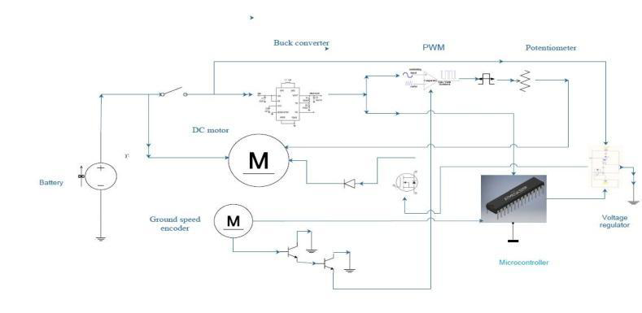
Fig. 1. Microcontroller Circuit
Pulse width modulation settings and tractor forward speeds are varied to test the seed metering plates to achieve the required seed spacing and the seed rate. The required values, such as the mean spacing, missing index, multiple index, and quality of feed index, were measured using a steel rule. This procedure was repeated three times for each speed with different pulse width modulation timings. The developed circuit incorporates two provisions for seed metering that are based on:
- Tractor forward speed
- Timer logic method
2.2.1. Based on Tractor Forward Speed
A tractor's forward speed is used to control the speed of a geared DC motor, which in turn controls the speed of a seed metering shaft. This control is implemented through a microcontroller program, meaning the relationship between tractor speed and DC motor/seed metering shaft speed is programmed and can be accessed by the microcontroller.
An electromechanical component is an integrated part that receives an electrical signal to create a physical movement to drive a mechanical device that performs a certain action. The circuit was designed in such a way that, when the tractor's forward speed is measured with a DC tachogenerator, which is powered by the tractor's front wheel and sends the signals to the microcontroller. The microcontroller gives a command to the driving unit according to the synchronization with the tractor's forward speed. The driving unit transmits a motion to the seed metering device through a drive shaft.
2.2.2. Based on the Timer Logic Method
The rotation of the seed metering mechanism is controlled by the delay time of the geared DC motor to run the seed metering shaft. The operating speed of the planter is synchronized with the geared DC motor mounted on the planter frame.
Pulse width modulation for controlling the time delay of revaluation of the DC motor by adjusting the pulse width controller and NE555 timer. The pulse width modulation is calculated by using the stoppage time of the DC motor based on the theoretically calculated speed of the tractor and the sticky belt, such as 1.5, 2.0, 2.5, and 3.0 km h⁻¹. The pulses were generated and noted as stoppage time with the help of the stopwatch as 0.5, 1.0, 1.5, and 2.0 s. Working procedure flowchart as shown in Fig. 2.

Fig. 2. Working procedure flowchart of the developed circuit

2.3 Integration of the Developed Seed Metering Mechanism and the Developed Electronic Circuit Unit
The planter worked with the help of a microcontroller that synchronizes with tractor speed by using a DC Tachogenerator attached to the tractor front wheel, which helps to receive the drive from the tractor front wheel and measure the forward speed of the tractor. The microcontroller receives signals from the DC Tachogenerator, and those signals are analyzed and transmitted to the DC motor through the relay module.
The developed cotton planter and electronic control units were integrated to work as a single unit for precisely planting cotton seeds at a required spacing and at a particular time. The developed electronic control unit was fitted on the cotton planter with suitable attachments. The step-by-step procedure used for the integration of the cotton seed planter and electronic control unit is given below:
- The geared DC motor was connected to the planter frame between two rows of the planter with angle iron rods by making a cross-section of a DC motor gearbox using nut and bolt arrangements.
- 12 V power is taken from the tractor battery to supply power to the ECU unit and DC motor.
- The ECU unit plastic box was fixed on the mudguard of the tractor rear wheel using nuts and bolts.
A mechatronic planter is a combined electrical circuit and cotton planter. For field testing, the developed planter is mounted to the 39.7 hp tractor shown in For laboratory testing, the geared DC motor and ECU unit were fastened to the sticky belt configuration using the appropriate nuts and bolts, as indicated in Fig. 3.

Fig. 3. Integration of the developed ECU unit and seed metering mechanism to the sticky belt
2.4 Laboratory Evaluation of Developed Microcontroller-Based Precision Planter
Testing of the tractor-mounted Microcontroller-based precision cotton planter was done by following the BIS test code IS 6316:1993 (reaffirmed 1999) and IS 9164:1979.
A. Evaluation of Sticky Belt
A sticky belt setup is used to determine the quality of seed placement and seed uniformity under laboratory conditions. A seed hopper of the seed planter fitted on the sticky belt setup with the help of fasteners for calculating the mean spacing, number of seeds per hill, and multiple indices. The sticky belt is a continuous, lubricated belt of length 8 m, width of 0.4 m, and thickness of 0.003 m, which was traveling under the seed hopper. The seeds will stick to the belt by applying the grease or lubrication without any displacement. The sticky belt was rotating on 4 rollers with dimensions 0.86 m x 0.74 m placed at a distance of 1.0 m from each other (Fig. 3.20). The rollers get drive motion from the variable speed motor with a variable speed of 1500 rpm and transmit to the drive with the help of chain and sprocket of 1:1 ratio. The seed metering plate will be run by a DC motor of 250 W at 360 rpm and 24 V power, which is inbuilt into the circuit. The Microcontroller-based electric circuit used for precision cotton planters has two conditions (Fig. 3).
The metering unit was synchronized with the forward speed of the tractor with the help of a DC Tachogenerator. The developed metering device was tested in the laboratory for different forward speeds. The seed-to-seed spacing, missing index, multiple index, and quality feed index are calculated using a lubricated sticky belt. The developed prototype mechatronic unit was evaluated in the laboratory as shown in Fig. 4.
Pulse width modulation for controlling the time delay of the revolution of the DC motor by adjusting the pulse width controller and NE555 timers. The pulse width modulation is theoretically calculated by using the stoppage time of the DC motor, which is based on the forward speed of the sticky belt and that of the tractor, at 1.5, 2.0, 2.5, and 3.0 km h⁻¹. The pulses are generated and noted as stoppage time with the help of the stopwatch at 0.5 s, 1.0 s, 1.5 s, and 2.0 s.
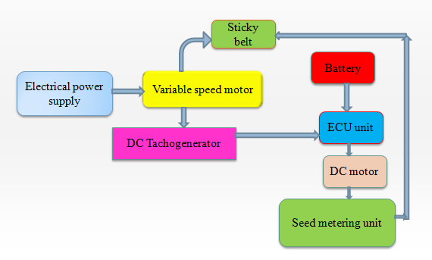
Fig. 4. Flowchart of microcontroller-based seed metering system working on test rig
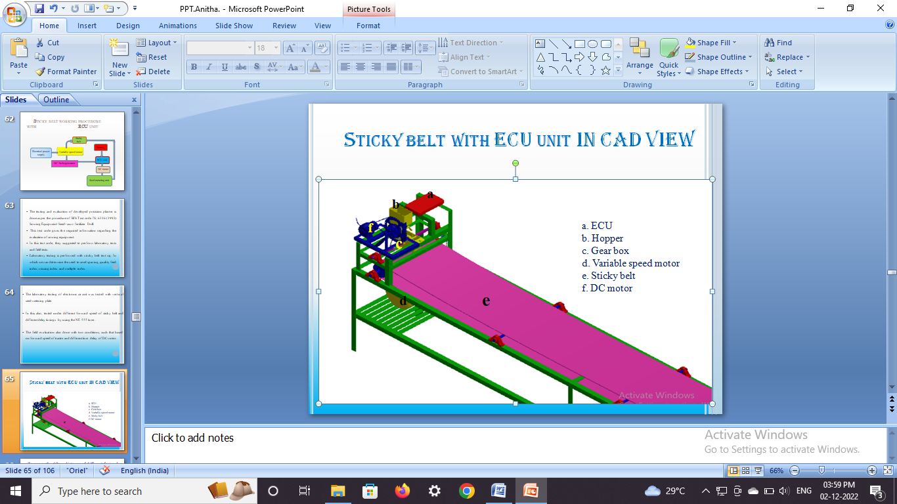
Fig. 5. Isometric view of the ECU on the sticky belt setup
2.5 Development of Electronic Control Unit
An electronic control unit (ECU) was developed for precision cotton seed dropping at a required distance based on time by detecting the forward speed of the tractor with the DC tachogenerator, and this forward speed signal goes to a microcontroller for controlling the geared DC motor speed, which controls the seed metering shaft.
The designed and developed cottonseed planter is a three-row planter. Hence, it consists of a DC motor for operating the three seed metering plates in the hoppers, and a microcontroller board for reading the forward speed of the DC tachogenerator. The signals from the tachogenerator activate both a relay module and the geared DC motor simultaneously. The process continues based on forward speed. The circuit of the developed electronic control unit is shown in Fig. 6.

Fig. 6. The Circuit of the Electronic Control Unit
2.6 Working principles of the Developed Microcontroller-based Electronic Seed Metering System
The microcontroller-based seed metering system for the cotton planter is used for direct dry-land sowing, based on time delay using the NE555 timer, and provides drive to the seed metering plate through a high-torque DC motor. The developed electronic circuit senses the ground speed of the tractor by using the DC tachogenerator and provides the signals to the microcontroller, and the change in speed is controlled manually by a potentiometer, which can change the speed of the high-torque motor. An automatic change in speed is controlled via pulse width modulation (PWM) by varying the width of the pulses generated by the NE555 timer.
The technique of pulse width modulation is used in an electronic circuit to control the speed of the DC motor, which drives the seed metering plate by a signal generated by the timer NE555. The pulse width modulation of the circuit is adjusted by a potentiometer to prevent continuous sowing of cotton seeds. The waveform shows how this controlled method works in both cases at the maximum (12V) and minimum (0V) signal voltages.
A waveform signal has a gap ratio between the marks of 1:1. The signal is 50% of the time 12V, and the average voltage is 6V, so the motor is running at half of the maximum speed in the waveform. The signal's duty cycle is 3:1. This means the 12 V output is 75% of the time. This translates to an output voltage of 9 V, so that the motor is running at 3/4 of its maximum speed. In a waveform, the signal has a duty cycle of 1:3, and 25% of the time provides an output signal of 12 V. The average output voltage of the signal is only 3V, so the motor runs at 1/4 of its maximum speed. The conceptual layout of the Micro microcontroller-based precision cotton planter is shown in Fig. 7.
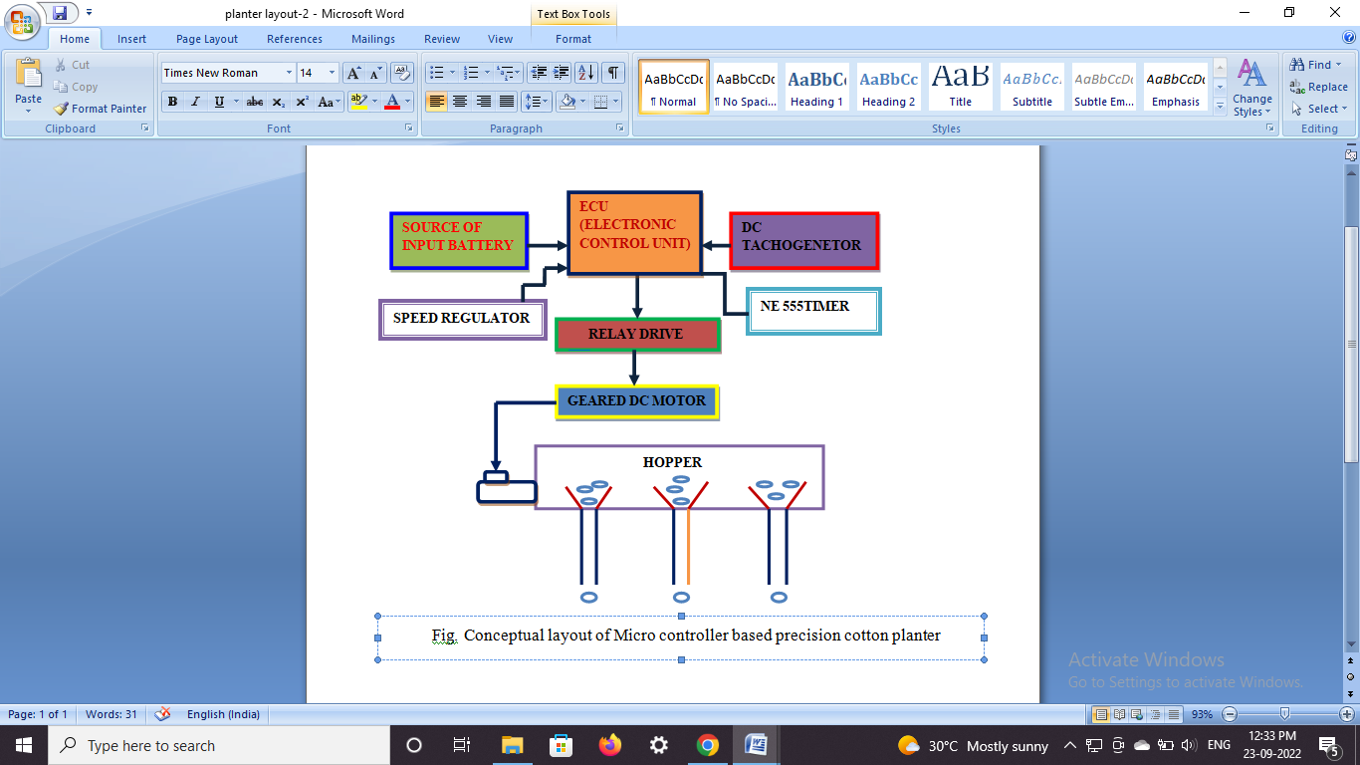
Fig. 7. Conceptual layout of Microcontroller-based precision cotton planter
2.7 Evaluation of Microcontroller-Based Electrical Circuit
The developed microcontroller-based single-cell vertical seed metering plate mechanism was evaluated under laboratory conditions as explained in section 3.5.5. The average seed spacing and quality feed index at different forward speeds and different delays of PWM were determined. The overall circuit diagram of the developed microcontroller-based electronic control unit.
3. RESULTS AND DISCUSSION
3.1 Effect of Forward Speed of Sticky BeltAnd Microcontroller-Based Metering Mechanism on Seed Spacing
….. Evaluation of Laboratory Test on Sticky Belt by Timer Logic Method
….A. Effect of forward speed of sticky belt and time delay of seed metering plate on seed spacing
The mean value of seed spacing at selected levels of variables, viz., forward speed, time delay of metering shaft, and vertical plate metering mechanism, was determined. The range of seed spacing was observed at different forward speeds with respect to different time delays, as discussed in the previous , make referenc to headings and a chapter..
The range of mean seed spacing at 1.5 km h⁻¹ forward speed was observed as 22 to 81 cm. The maximum seed spacing was 81 cm for a 2s time delay of the seed metering shaft, and the minimum seed spacing was 22 cm for a 0.5s time delay of the metering shaft. The required seed spacing is obtained as 61 cm at 1.5 s of time delay.
The range of mean seed spacing at 2.0 km h⁻¹ forward speed was observed as 30 to 111 cm. The maximum seed spacing was 111 cm for a 2s time delay of the seed metering shaft, and the minimum seed spacing was 30 cm for a 0.5s time delay of the metering shaft. The required seed spacing, close to the theoretical seed spacing, is obtained as 57 cm at 1.0 s time delay.
The range of mean seed spacing at 2.5 km h⁻¹ forward speed was observed as 35 to 166 cm. The maximum seed spacing was 166 cm for a 2s time delay of the seed metering shaft, and the minimum seed spacing was 35 cm for a 0.5s time delay of the metering shaft. The 67 cm seed spacing was observed at a 1.0 s time delay, which is near to the theoretical seed spacing.
The range of mean seed spacing at the 1.5 km h⁻¹ forward speed was observed as 41 to 166 cm. The maximum seed spacing was 166 cm for a 2 s time delay of the seed metering shaft, and the minimum seed spacing was 41 cm for a 0.5s time delay of the metering shaft. Both increasing forward speed and the time delay of the seed metering shaft can lead to greater seed spacing, as shown in Fig. 8.
The ANOVA test was performed to test the variation between the forward speed and time delay of the seed metering shaft at a 5% level of significance, and the results were presented in Table 4.20. There is also a need for testing the effect of different forward speeds and the time delay of the seed metering shaft on seed spacing. There is no significant difference at the 5% level of significance between speeds, time delay of metering shaft, and interactions between speed and time delay of metering shaft.
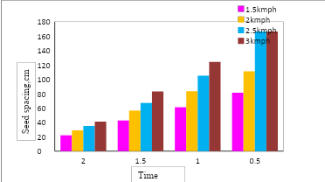
Fig. 8 Variation of seed spacing with different time delay and forward speed of sticky belt
B. Effect of forward speed of sticky belt and time delay of seed metering plate on missing index
It was observed that the missing index increased for all conditions with the increase in forward speed. In comparison with four types of time delay, there is no missing index with 0.5 s, 1.0 s, 1.5 s, and 2.0 s time delay in the single cell opening vertical seed metering plate at all four forward speeds of the sticky belt. This was because of easier seed pickup and dropping at a particular distance.
The range of missing index was observed as 0 to 100% at 3 km h⁻¹ with four different time delays of the seed metering shaft. The maximum missing index was 100% at 2.0 s and 1.5 s of time delay. The minimum missing index was 0% at 0.5 s and 1.0 s of time delays. The missing index was increasing with the forward speed and time delay increases.
C. Effect of forward speed of sticky belt and time delay of seed metering plate on multiple indices
The mean value of multiple indexes at selected levels of variables is forward speed and vertical seed metering plate, with the different time delays of 2.0 s,1.5 s, 1.0 s, and 0.5 s. The multiple index was observed at a 0.5s time delay of the metering shaft with all forward speeds of the sticky belt. The maximum 100% multiple index was obtained except for 3.0 km h⁻¹ forward speed. The multiple index was observed in all combinations of time delay and forward speed except 0.5 s time delay and 3.0 km h⁻¹ (Fig. 9). The reason is seeds are placed accurately at an equal distance.
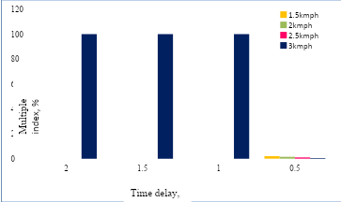
Fig. 9. Variation of multiple index with different time delays and forward speeds of the sticky belt
D. Effect of forward speed of sticky belt and time delay of seed metering plate on the quality of feed index
The quality of feed index is one of the parameters to evaluate the performance of a metering plate. In the electronic control seed metering plate metering mechanism, four different pulse control timings are discussed in the previous section.
The mean range of quality feed index was observed at 2 s delay of time as 100% for 1.5, 2.0, and 2.5 km h⁻¹ forward speed of the seed metering plate. The lowest quality feed index 0% at a forward speed of 3.0 km h⁻¹, as shown in . It was observed that the quality feed index decreased with an increase in forward speed of 3.0 km h⁻¹.
The mean quality of feed index was observed at a 1.5 s delay of time as 100% for 1.5, 2.0, and 2.5 km h⁻¹ forward speed of the seed metering plate. The lowest quality feed index is 0% at a forward speed of 3.0 km h-1, as shown in . It was observed that the quality feed index decreased with an increase in forward speed of 3.0 km h⁻¹.
The mean quality of feed index was observed at a 1.0 s delay of time as 100% for 1.5, 2.0, 2.5, and 3.0 km h⁻¹ forward speed of the seed metering plate. The quality of feed index at a 1.0 s time delay recorded at all forward speeds is at the same level, which is 100%.
The mean quality of feed index was observed at 0.5 s delay in time, as 0% for 1.5, 2.0, and 2.5 km h⁻¹ forward speed of the seed metering plate. The highest quality feed index was 100% at a forward speed of 3.0 km h⁻¹, as shown in Fig. 10. It was observed that the quality feed index increased with a decrease in forward speed of 3.0 km h⁻¹.
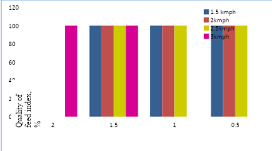
Fig. 10. Variation of quality of feed index with different time delay and forward speed of sticky belt
E. Effect of forward speed of sticky belt and seed metering plate on seed spacing
At different forward speeds of the tractor with respect to metering plate speed, no changes in seed uniformity were observed, because the forward speed of the tractor increases the DC motor speed. The minimum seed spacing was recorded as 60 cm at a forward speed of 1.5 km h⁻¹ and maximum as 62 cm at 3 km h⁻¹ forward speed. The changes in seed spacing are shown in Fig. 11.
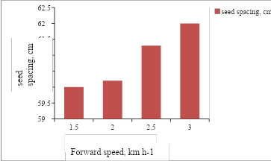
Fig. 11. Variation of seed spacing with different forward speeds of the sticky belt
5. CONCLUSION
Precision agriculture, a new concept, is being used for the sustainability of agriculture. It is defined as the application of technologies and principles to manage temporal and spatial variability related to all aspects of agricultural production. It enhances crop performance and environmental quality. The success of precision agriculture depends on how well it is applied to assess the current and potential capabilities of precision agriculture.
An electronics-supported experimental test rig was developed to evaluate the seed metering mechanism for their performance concerning seed spacing, seed rate, quality feed index, missing index, and multiple indexes at four different forward speeds of 1.5, 2, 2.5, and 3.0 km h⁻¹. A total of 60 experiments were conducted using the experimental test rig with selected levels of design values.
Results obtained with the timer logic method
- The spacing increased as the forward speed and delay times of the geared DC motor increased. It was observed that a spacing of 61 cm at 1.5 s, for a forward speed of 1.5 km h^{-1,} and 57 cm at 1.0 s for a forward speed of 2.0 km h⁻¹ are closer to the theoretical spacing of 60 cm.
- The missing index was observed at all combinations of the variables. Maximum missing index is 100% at 2.0s and 1.5s time delay of geared DC motor for a forward speed of 3.0 km h⁻¹.
- The multiple index was observed in all combinations of the variables. The maximum multiple index is 100% at a 0.5 s delay time of the geared DC motor for a forward speed of 1.5 km h⁻¹.
- The quality feed index was observed in all combinations of the variables. The maximum quality feed index is 100% at a 1.0 s delay time of geared DC motor for 1.5, 2.0, 2.5, and 3.0 km h⁻¹ forward speeds.
- The quality of feed index was observed at 3.0 km h⁻¹ forward speed minimum of zero at 2.0 and 1.5 s delay times of geared DC motor, and a maximum of 100% at 1.0 and 0.5 s delay times of geared DC motor.
- The seed rate slightly increased at a 5% level of significance. It was also observed that the seed rate decreased with the increase of forward speed up to optimum design values and increased thereafter. The seed rate of 2.17 kg ha⁻¹ was observed at the optimum design parameters.
References
Adetola, O and Akinmade, V. 2020. Development and Performance Evaluation of a Maize Planter. International Journal of Engineering Science and Application, 4(4): 157-164.
Aware, V.V and Aware S. V. 2014. Development of microprocessor based electronic metering mechanism for seed - an approach. Engineering and technology in India, 5(1): 26-31.
Aware, V.V and Manjarekar, R.G. 2005. Development of Electronic Metering Mechanism. Agricultural Engineering Abstracts, 23(3): 430.
Aware, V.V., Mane, S.A.S.N.D and Patil, R. 2008. Development of proximity distance sensor based electronic metering mechanism for three rows planter. Agriculture Update, 3(3): 296-299.
Baral, S.S., Budhe, V.K., Kumara, R and Swarnkar, R. 2019. Development of tractor drawn electronic multi-crop planter cum fertilizer applicator for precision farming. International Journal of Advances in Agricultural Science and Technology, 6(10): 1-16.
Charania, I and Li, X. 2020. Smart farming: Agriculture's shift from a labor intensive to technology native industry. Internet of Things, 9(1): 100142.
Gautam, P. V., Kushwaha, H. L., Kumar, A and Kushwaha, D. K. 2019. Mechatronics application in precision sowing: A review. International Journal of Current Microbiological Applied Science, 8(4): 1793-1807.
Kocher, M. F., Lan, Y., Chen, C and Smith, J.A. 1998. Opto-electronic Sensor system for rapid Evaluation of Planter Seed Spacing uniformity. International journal of American Society of Agricultural Engineers, 41(1): 237-245.
Koley, S., Bhatt, Y.C., Singh, G., Joshi, S and Jain, H.K. 2017. Development of Electronic Metering Mechanism for Precision Planting of Seeds. International Journal of Current Microbial Applied Sciences, 6(1): 3481-3487.
Lan, Y., Kocher, M.F and Smith, J.A. 1999. Opto-electronic sensor system for laboratory measurement of planter seed spacing with small seeds. Journal of agricultural engineering research, 72(2): 119-127.
Leela, C and Saravanakumar, M. 2019. Development of Electronically Meterized Maize Planter. International Journal of Current Microbiology and Applied Sciences, 8(4): 2319-7706.
Li, Y., Xiantao, H., Tao, C., Dongxing, Z., Song, S., Zhang, R and Mantao, W. 2016. Development of mechatronic driving system for seed meters equipped on conventional precision corn planter. International Journal of Agricultural and Biological Engineering, 8(4): 1-9.
Raheman, H and Singh, U. 2003. A sensor for seed flow from seed metering mechanisms. Biosystems IE (I) Journal-AG. 84: 6-8.
Rajaiah, P., Mani. I., Kumar. A., Lande, S.D., Parray, R.A., Singh, A.K and Vergese, C. 2018. Comparative Study of Mechanical and Electronic Paddy Planter for Direct Seeding. International Journal of Current Microbiology and Applied Sciences, 7(9): 1284-1294.
Rakesh, N., Prasad, G.V., Sarma, A and Kumar, H.H. 2018. Development and evaluation of small tractor drawn seed planter with battery operated seed metering mechanism. International Journal of Current Microbial Applied Sciences, 7(3): 1879-1886.
Shanwad, U.K., Patil, V.C and Gowda, H.H. 2004. Precision farming: dreams and realities for Indian agriculture. Map India conference.
Shirzadifar, A., Maharlooei, M., Bajwa, S.G., Oduor, P.G and Nowatzki, J.F. 2020. Mapping cropstand count and planting uniformity using high resolution imagery in a maize crop. Biosystems Engineering, 200(1): 377-390.
Tewari, V.K., Kumar, A.A., Nare, B., Prakash, S and Tyagi, A. 2014. Microcontroller based roller contact type herbicide applicator for weed control under row crops. Computers and Electronics in Agriculture, 104(1): 40-45.
Thokale, P.J., Mathur, S.M., Meena, S.S and Sunil, J. 2019. Development of mechatronic seed metering system for planter. Green Farming, 10(4): 468-473.

